Multifunctional in-memory logics based on a dual-gate antiambipolar transistor toward non-von Neumann computing architecture

Yoshitaka Shingaya†, Takuya Iwasaki†, Ryoma Hayakawa†*, Shu Nakaharai†, Kenji Watanabe‡, Takashi Taniguchi†, Junko Aimi§*, Yutaka Wakayama†*

†Research Center for Materials Nanoarchitectonics (MANA), National Institute for Materials Science (NIMS), 1-1 Namiki, Tsukuba, Ibaraki 305-0044, Japan
‡Research Center for Functional Materials, National Institute for Materials Science (NIMS), 1-1 Namiki, Tsukuba, Ibaraki 305-0044, Japan
§Research Center for Macromolecules and Biomaterials, National Institute for Materials Science (NIMS), 1-2-1 Sengen, Tsukuba, Ibaraki 305-0047, Japan

KEYWORDS: 2D materials, antiambipolar transistor, in-memory logic, neuromorphic device, nano-floating gate, non-von Neumann computing

ABSTRACT: In-memory computing may make it possible to realize non-von Neumann computing because the logic circuits are unified in the memory units. We investigated two types of in-memory logic operation, namely two-input logic circuits and multifunctional artificial synapses. These were realized in a dual-gate antiambipolar transistor (AAT) with an ReS₂/WSe₂ heterojunction, in which polystyrene with a zinc phthalocyanine core (ZnPc-PS₄) was incorporated as a memory layer. Here, reconfigurability is a key concept for both types of device operation and was achieved by merging the Λ-shaped transfer curve of the AAT and the nonvolatile memory effect of ZnPc-PS₄. First, we achieved electrically reconfigurable two-input logic circuits. Versatile logic circuits such as AND, OR, NAND, NOR, and XOR circuits were demonstrated by taking advantage of the Λ-shaped transfer curve of the dual-gate AAT. Importantly, the nonvolatile memory function provided the electrical switching of the individual circuits between AND/OR, NAND/NOR, and XOR/NAND circuits with constant input signals. Second, the memory effect was applied to multifunctional artificial synapses. The inhibitory/excitatory and long-term potentiation/depression synaptic operations were electrically reconfigured simply by controlling one parameter (readout voltage), making three distinct responses possible even with the same presynaptic signals. These findings provide hints that may lead to the realization of new in-memory computing architectures beyond the current von Neumann computers.
- INTRODUCTION
The development of high-performance edge computers such as artificial intelligence (AI) and neuromorphic devices has attracted considerable attention^{1, 2}. This trend has been further accelerated by the emergence of data-intensive applications represented by the Internet of Things and cloud computing systems³. However, the current technology based on von Neumann computing suffers from serious drawbacks related to long data latency and high power consumption, which hinder the realization of state-of-the-art edge computers. The drawbacks originate from the device architecture of modern computers where the processor and memory units are physically isolated from each other. This data-transfer problem between logic and memory devices is referred to as a “von Neumann bottleneck” or “memory wall” ^{4, 5}.
In-memory computing, where the logic circuits are integrated in the memory units⁶⁻⁹, has the potential to overcome the drawbacks of current computers. The integration of logic and memory devices is expected to achieve high throughput data processing and low power consumption. Then, the nonvolatile memory function will play a critical role in the realization of reconfigurable and energy-efficient AI computing systems. Individual logic circuits such as NAND and NOR circuits can be electrically reconfigured at the hardware level even after the integrated circuits have been manufactured¹⁰⁻¹². The in-memory functions can also be applied to neuromorphic devices^{7, 13}. Recently, versatile synaptic devices have been developed using emerging nonvolatile memories such as two-terminal memories¹⁴⁻¹⁸ and transistor-based memories¹⁹⁻²³. As a result, human-brain-like operations have been demonstrated, including complex pattern recognition, and long-term potentiation and depression. However, it should be noted that biological synapses exhibit diverse responses even for the same external stimulus. And the roles of respective synapses, e.g., inhibitory or excitatory synapses, are varied by commands from neuromodulators²⁴⁻²⁷. Meanwhile, conventional artificial neuromorphic devices show only unipolar carrier transport and so individual synaptic functions are operated by a simple external stimulus. Therefore, there is a strong need for the development of reconfigurable and multifunctional artificial synapses for the further evolution of AI systems that truly mimic the human brain.
We developed two types of unique in-memory logic operation: electrically reconfigurable two-input logic circuits and multifunctional artificial synapses. A dual-gate antiambipolar transistor (AAT) performed a central role. AATs are unique heterojunction transistors, where p-type and n-type semiconductors partially overlap in the transistor channel²⁸⁻³⁰. An important characteristic is that the AAT exhibits a Λ-shaped transfer curve. The drain current increases and then decreases in response to the monotonical increase in the gate voltage. The AAT was produced by stacking two-dimensional (2D) materials, namely rhenium disulfide (ReS₂), tungsten diselenide (WSe₂) and hexagonal boron nitride (h-BN). These were selected as the n-type and p-type semiconductors and the gate insulator, respectively. The 2D materials have advantages as regards producing the AAT because the 2D materials have surfaces that are atomically flat and free of dangling bonds ^{31, 32}. The van der Waals stacking thus makes it possible to form an ideal p–n heterojunction regardless of the lattice mismatch^{9, 33, 34}. As a result, large peak-to-valley ratios (PVRs) of 10³−10⁵ have been achieved in 2D material-based AATs ³⁵⁻³⁷. These advantages have enabled the development of multivalued logic circuits^{38, 39} and two-input logic circuits⁴⁰⁻⁴³. Another important constituent of our device is polystyrene with a zinc phthalocyanine core (ZnPc-PS₄), which works as a nano-floating gate. This material has a three-dimensional structure where a ZnPc core (semiconductor) is surrounded by four PS chains (insulator) to form a star-shaped polymer ⁴⁴⁻⁴⁶. Hence, carriers can be stably stored in the ZnPc core to provide a nonvolatile memory function.
First, we demonstrate electrically reconfigurable two-input logic circuits based on the dual-gate AAT. Various types of two-input logic circuits including AND, OR, NAND, NOR, and XOR circuits were successfully reconfigured in a single dual-gate AAT. The top-gate and bottom-gate voltages worked as two input signals, and the drain current was monitored as the output signal. Notably, the logic circuits were electrically switchable, e.g., the AND/OR, NAND/NOR, and XOR/NAND circuits, without any changes in the input signals. These operations were enabled by a carrier-trapping process in the ZnPc-PS₄ nano-floating gate. Second, the non-volatile memory function was applied to multifunctional artificial synapses. The two synaptic operations, namely inhibitory and excitatory synaptic operations, were reconfigured by controlling the carrier-trapping process in the ZnPc-PS₄ layer. Consequently, we achieved conversion between the inhibitory/excitatory and long-term potentiation/depression synaptic operations without changing the presynaptic signals. These logic concepts are expected to allow us explore new in-memory computing architectures with a view to realizing non-von Neumann-type computers.

- RESULTS and DISCUSSION
2.1 Fundamentals of Dual-Gate AAT Operation
Figure 1a shows a schematic illustration of a dual-gate AAT and the molecular structure of ZnPc-PS₄. The AAT was prepared by a bubble-free dry transfer technique ⁴⁷⁻⁴⁹. The film thicknesses of the WSe₂ (p-type) and ReS₂ (n-type) were estimated to be 13 nm and 11 nm, respectively, by atomic force microscope measurements (Figure S2 in the supporting information). These transition metal dichalcogenide (TMDC) layers were partially overlapped around the center of the transistor channel to form a p–n junction as illustrated in Figure 1a and depicted in the optical microscope image in the inset of Figure 1b. The AAT channel was 7.1 µm long. The flake widths were 5.1 µm for the WSe₂ channel and 1.6 µm for the ReS₂ channel. The ZnPc-PS₄ layer was spin-coated on all the TMDC layers to work as nano-floating gates. Finally, h-BN gate insulator and top-gate electrodes (Ti/Au) were stacked to form a dual-gate AAT. Figure 1c shows a top view image of a dual-gate AAT prepared in this way.
Figure 1d shows drain current (I_{d})−bottom-gate voltage (V_{bg}) curves of the dual-gate AAT (black line) and the separately formed ReS₂ (blue line) and WSe₂ (red line) transistors. The drain voltages (V_{d}) were −1.0 V for the dual-gate AAT, −1.0 V for the WSe₂ transistor and 1.0 V for the ReS₂ transistor. No top-gate voltage was applied (V_{tg}= 0 V) for any of the measurements. The ReS₂ transistor exhibited a typical n-type characteristic; I_{d} increased monotonically as V_{bg} increased. The electron mobility was estimated to be 4.7 cm²V⁻¹s⁻¹. The WSe₂ transistor exhibited an ambipolar characteristic, although the hole conduction was dominant. I_{d} decreased and thereafter increased with increasing V_{bg}. The hole and electron mobilities were calculated to be 4.9 cm²V⁻¹s⁻¹ and 2.4×10⁻² cm²V⁻¹s⁻¹, respectively. The dual-gate AAT produced a Λ-shaped transfer curve (black line). I_{d} increased sharply from a V_{bg} of −4.8 V and reached −70 nA at a V_{bg} of −9.8 V. These turn-on and peak voltages are defined as V_{on} and V_{peak}, respectively. Subsequently, I_{d} started decreasing as V_{bg} increased up to −15 V. Note that, the Λ-shaped transfer curve coincides with the overlap of the I_{d}−V_{bg} curves of the ReS₂ and WSe₂ transistors. This result shows clearly that the I_{d} of the dual-gate AAT is analogous to the shoot-through current in a complementary metal-oxide semiconductor (CMOS) inverter because the equivalent circuit of the AAT is given by the series circuit of the ReS₂ and WSe₂ transistors⁵⁰⁻⁵². These facts mean that the limiting factors of I_{d} in the AAT are different below and above V_{peak} (V_{bg} = −9.8 V). Below V_{peak}, I_{d} is limited by the electron current in the ReS₂ channel whereas that above V_{peak} is restricted by the hole current in the WSe₂ channel.
The V_{tg} effect in the dual-gate AAT is shown in Figure 1e, where V_{tg} was varied from 0 V to −0.9 V and V_{d} was fixed at −1.0 V. The Λ-shaped transfer curve was constantly shifted toward the positive V_{bg} range. To evaluate the variation in V_{peak} in detail, the three-dimensional (3D) |I_{d}| plots as a function of V_{bg} and V_{tg} are given in Figure 1f. V_{peak} was varied linearly from –12.5 V to −7.0 V by changing V_{tg} from 1.0 V to –1.4 V. It should be noted that the shifted V_{peak} returned to its original position after turning off V_{tg}, indicating that carriers are not trapped in the ZnPc-PS₄ nano-floating gate in the 1.0 V to –1.4 V V_{tg} range.

2.2 Reconfigurable Two-Input Logic Circuits
The dual-gate AAT is successfully applied to two-input logic circuits by the effective use of the Λ-shaped transfer characteristic. In these circuits, V_{tg} and V_{bg} were used as input signals 1 and 2, respectively, as shown in Figure 2a. I_{d} was monitored as the output signal. Figures 2b-2f show the 2D−|I_{d}| plots of the five logic circuits namely AND, OR, XOR, NAND, and NOR, respectively. Here, the 2D−|I_{d}| plots are binarized with a common threshold current of 46 nA to realize the five logic circuits with a single dual-gate AAT. The gray areas indicate an |I_{d}| of higher than 46 nA, representing logic state “1” in two-input logic circuits whereas the white areas indicate an |I_{d}| of less than 46 nA, representing logic state “0”.
In Figure 2b, the 2D–|I_{d}| plot shows that the dual-gate AAT acted as an AND circuit. Here, V_{tg} values of −1.6 V and −1.0 V are defined as the low V_{tg} (“0”) and high V_{tg} (“1”), and V_{bg} values of −10.0 V and −8.5 V are defined as the low V_{bg} (“0”) and the high V_{bg} (“1”), respectively. The high logic state “1” was output only when (V_{tg}, V_{bg}) were equal to (“1”, “1”). Similarly, the dual-gate AAT worked as OR, XOR, NAND, and NOR circuits as shown in Figures 2c-f, respectively. An important fact is that the above five logic circuits were reconfigured by selecting appropriate two-input signals with a single dual-gate AAT. These device operations agree well with our previous work⁴⁰.
One issue should be mentioned here, namely that the input voltages should be identical for all logic circuits for practical applications. However, the input signals must be varied to reconfigure the above-mentioned logic operations. A non-volatile memory function is used to address this issue. Our approach is that V_{peak} is shifted by the carrier-trapping effect in the ZnPc-PS₄ layer to reconfigure the respective logic operations even with identical input signals. Figure 3a shows the I_{d}−V_{tg} curves of the dual-gate AAT. The black line represents the initial I_{d}−V_{tg} curve. The blue line shows an I_{d}−V_{tg} curve that is shifted to the negative V_{tg} range by applying 4-times negative V_{tg} (−15 V) pulses with a pulse width (P_{width}) of 10 s. V_{peak} was varied from −0.50 V to −1.15 V. The 4-times positive V_{tg} pulse (V_{tg} = 15V, P_{width} = 10 s) induced the opposite shift in V_{peak} (red line); V_{peak} was changed from −0.50 V to −0.45 V. The respective peak voltages are denoted as V_{peak,i}, V_{peak,n} and V_{peak,p} in Figure 3a. These variations in V_{peak} are direct evidence of the carrier-trapping effect in the ZnPc-PS₄ layer. The switching property of V_{peak} is exhibited in the supporting information (Figure S3). As shown in Figure 3b, the conductive areas (gray areas) in the 2D−|I_{d}| plots were greatly changed along with the V_{peak} shift after applying the negative (Figure 3b(i)) and positive (Figure 3b(ii)) V_{tg} pulses. The repeatability of the variations in the 2D−|I_{d}| plots was confirmed with the corresponding V_{tg} pulses.
Figures 3c and 3d, show the trapped charges in the dual-gate AAT and the corresponding energy level alignments when applying negative and positive V_{tg} pulses, respectively. These figures are provided to allow a detailed discussion of the carrier-trapping mechanism in the ZnPc-PS₄ layer. Initially, no carriers are trapped in the ZnPc-PS₄ layer. When negative V_{tg} pulses of −15 V are applied, the WSe₂ channel is in the ON state, and therefore holes are injected from the valence band of WSe₂ to the highest occupied molecular orbital (HOMO) of the ZnPc core (Figure 3c (i), (ii)). As a result, V_{on} in the dual-gate AAT changed from 0.95 V (V_{on,i}) to 0.75 V (V_{on,n}) (Figure 3a). In contrast, the ReS₂ channel is in the OFF state at the same V_{tg} and, therefore, it is considered that there are no carriers in the ReS₂ channel layer. Nevertheless, the I_{d}−V_{tg} curve of the dual-gate AAT was entirely shifted to the negative V_{tg} range (blue line in Figure 3a), indicating that there are holes in the ZnPc-PS₄ layer above the ReS₂ channel. Given this result, we consider that electrons were transferred from the ZnPc to the conduction band of the ReS₂ channel, leaving holes in the HOMO of the ZnPc core, as seen in Figure 3c (iii). Consequently, holes are generated uniformly in the ZnPc-PS₄ layer as shown in Figure 3c (i). Meanwhile, both the ReS₂ and WSe₂ layers are in the ON state a positive V_{tg} pulse of 15 V is applied due to the n-type characteristic of the ReS₂ channel and the ambipolar characteristic of the WSe₂ channel. Hence, the electrons are injected from the conduction bands of both the ReS₂ and WSe₂ channels to the lowest unoccupied molecular orbital (LUMO) of the ZnPc core. These are shown in Figures 3d (i)-(iii). As seen in Figure 3a, a corresponding peak shift from −0.50 (V_{peak,i}) to −0.45 V (V_{peak,p}) was observed after applying a positive V_{tg} pulse of 15 V due to the electron trap in the ZnPc-PS₄ in the ReS₂ channel. On the other hand, no shift was induced in V_{on} by applying a positive V_{tg} pulse as indicated by V_{on,p} and V_{on,i} in Figure 3a. That is, the turn-on voltages in the WSe₂ channel were consistent; the value (V_{on,p} = 0.95 V) was the same as that of the initial I_{d}−V_{tg} curve (V_{on,i} = 0.95 V). This result probably originates from the short retention time of the trapped electrons in the ZnPc-PS₄ layer in the WSe₂ channel. The electrons would be released immediately after being trapped in the ZnPc-PS₄ layer. The corresponding retention properties of the hole and electrons trapped in the ZnPc-PS₄ layer in the ReS₂ and WSe₂ transistors are given in Figure S4 in the supporting information.
On the basis of the above argument regarding the carrier-trapping mechanism, we undertook the electrical switching of the respective logic circuits. Figure 4a (i) shows the 2D−|I_{d}| plot after applying 10-times positive V_{tg} pulses (V_{tg} = 15 V, P_{width} = 10 s), where electrons are trapped in the ZnPc-PS₄ layer as illustrated in Figure 3c (i). The threshold of the output signal is assigned as 2.5 nA. First, the two-input signals, V_{tg} and V_{bg}, are adjusted for the AND circuit (Figure 4a (i)). The low V_{tg} (“0”) and the high V_{tg} (“1”) are −4.9 V and −4.0 V, respectively; the low V_{bg} (“0”) and the high V_{bg} (“1”) are −12.9 V and −11.2 V, respectively. Figure 4b represents the AND circuit operation. The high logic state “1” was output only when (V_{tg}, V_{bg}) were equal to (“1”, “1”) in the 6 sec to 8 sec time period. Meanwhile, I_{d} exhibited the low logic state “0” with other input signal combinations. The 10-times negative V_{tg} pulse (V_{tg} = −15 V, P_{width} = 10 s) was then employed to inject holes into the ZnPc-PS₄ layer (Figure 3c). The corresponding 2D−|I_{d}| plot is shown in Figure 4a (ii). The conductive area (logic state “1”) in the 2D−|I_{d}| plot was expanded by applying the negative V_{tg} pulse, leading to electrical switching from AND to OR circuits. As depicted in Figure 4c, the high logic state “1” was output when either V_{tg} or V_{bg} was the “1” input signal in the time period from 4 sec to 10 sec. Significantly, the conductive area (logic state “1”) was alternately controlled by fine tuning the non-volatile memory functions, thus achieving the reconfiguration of AND and OR with identical input signals. The OR circuit thus produced was returned to an AND circuit by applying a 10-times positive V_{tg} pulse (V_{tg} = 15V, P_{width} = 10 s). The electrical switches between the logic circuits were reproducible and repeatedly induced by the negative and positive V_{tg} pulses. In this manner, we attained the conversion of the following two-input logic circuits: NAND/NOR, XOR/NAND, OR/NAND, and OR/XOR, without changing the input signals as shown in the supporting information (Figure S1).

2.3 Multifunctional artificial synapses
Artificial synapses are a key element as regards the development of non-von Neumann computing architecture. In this section, we demonstrate multifunctional synaptic operations based on a dual-gate AAT. Importantly, the inhibitory/excitatory and long-term potentiation/depression synaptic operations are electrically reconfigured simply by selecting an appropriate readout voltage. For the synaptic operation, the top gate and drain electrodes in the dual-gate AAT act as the presynaptic input and postsynaptic output terminals, respectively. I_{d} represents the postsynaptic current (PSC).
Figure 5a shows I_{d}−V_{tg} curves obtained after applying negative and positive V_{tg} pulses. These are duplicated in Figures 5d, g. The blue and red lines show the I_{d}−V_{tg} curves obtained after applying negative and positive V_{tg} pulses, respectively. Henceforth, the hole-trapped state induced by applying a 10-times negative presynaptic pulse (V_{tg} = −16 V, P_{width} = 10 s) is assigned as the initial state (blue line in Figure 5a). Here, holes are trapped in the ZnPc-PS₄ layer on both the ReS₂ and WSe₂ layers, as shown in Figure 3c (i).
First, we examined the conventional inhibitory and excitatory operations. Then, the polarity of the presynaptic pulse voltages was inverted for the respective operations. Figures 5b (i), 5c (i) show the variations in the PSC. The respective sequences of the applied voltages (V_{tg}, V_{bg}) for controlling PSC are shown in Figures 5b (ii), 5c (ii). A fixed V_{tg} of −4.0 V, which corresponds to the readout voltage (V_{read}), was constantly applied for both measurements. An additional V_{bg} of −10 V (black lines in Figures 5b (ii), 5c (ii)) was only necessary for yielding PSC signals. The first PSC in Figure 5b (i) was about −8.0 nA. Subsequently, each positive presynaptic V_{tg} pulse (V_{tg} = 15 V, P_{width} = 50 ms) reduced the PSCs in stages because the I_{d}−V_{tg} curve shifted from blue to red in Figure 5a. This decay in the PSC represents the inhibitory synaptic operation. Meanwhile, negative V_{tg} pulses (V_{tg} = −16 V, P_{width} = 50 ms) increased the PSC stepwise from –6.7 nA to −7.1 nA as shown in Figure 5c (i), which corresponds to the excitatory synaptic operation.
Next, the opposite synaptic responses were obtained as shown in Figures 5e, 5f. Here, the sequences and polarities of the applied voltages (V_{tg} and V_{bg} in Figures 5e (ii), 5f (ii)) were the same as those in Figures 5b (ii), 5c (ii). The only difference is the readout voltage (V_{read}), which was changed from −4.0 V to 1.5 V. Then, the magnitude relation of I_{d} was reversed; the I_{d} value after negative pulse application (red line) was larger than that in the initial state (blue line) at a V_{read} of 1.5 V. In consequence, the positive presynaptic pulse (V_{tg} = 15 V, P_{width} = 50 ms) increased the PSC to induce an excitatory synaptic operation (Figure 5e (i)). Whereas, the negative presynaptic pulse (V_{tg} = −16 V, P_{width} = 50 ms) reduced the PSC thus inducing an inhibitory synaptic operation (Figure 5f (i)).
A noteworthy feature of the dual-gate AAT is that the conversion between excitatory and inhibitory synaptic operations can be achieved without changing the polarity of the presynaptic pulse as shown in Figures 5h, 5i. For these measurements, the V_{read} was changed to −0.3 V but the applied voltage sequences were the same (Figures 5h (ii), 5i (ii)). Initially, the positive presynaptic pulse (V_{tg} = 13 V, P_{width} = 5 ms) increased the PSC, corresponding to an excitatory synaptic operation (Figure 5h (i)). Subsequently, further positive presynaptic pulses were repeatedly applied. As a result, the excitatory synaptic operation was transformed to an inhibitory operation; the PSC was then reduced even by consecutive positive presynaptic pulses as shown in Figure 5i (i). This unique electrical reconfiguration was achievable by setting the readout voltage (V_{read}) in between two peak voltages (V_{peak,n}, V_{peak,p}) as indicated by the dotted line in Figure 5g. This is possible owing to the Λ-shaped transfer curves and distinguishes this approach from conventional neuromorphic devices.
In addition, long-term potentiation (LTP) and long-term depression (LTD) were investigated as shown in Figure 6. Here, the PSCs are plotted as a function of applied pulse numbers. The PSC behaviors were clearly differentiated by changing the readout voltages, which were −4.0 V (Figure 6a), +1.5 V (Figure 6b) and −0.3 V (Figure 6c). In Figure 6a, the positive pulses induced a depression response (red dots) first and subsequent negative pulses transformed this to a potentiation response (blue dots). In contrast, reverse responses were observed by changing the readout voltage to + 1.5 V as shown in Figure 6b. Even though the polarities, applied voltages and pulse widths of the applied pulses were the same as those in Figure 6a, the potentiation and depression responses appeared in totally opposite orders. It is noteworthy that a similar transformation from LTP to LTD was realized even by the continuous application of positive presynaptic pulses as shown in Figure 6c. This operation was realized by setting the readout voltage at −0.3 V. This electrical switching of the synaptic operations was attained with the same analogy as those between the excitatory and inhibitory operations discussed in Figures 5h, 5i.
As discussed here, we realized reconfigurable and multifunctional synaptic operations, for example inhibitory/excitatory and LTP/LTD operations, employing presynaptic pulses with constant polarity. Although similar reconfigurable synaptic operations have already been reported using ambipolar transistors ⁵³⁻⁵⁶, the polarity inversion of the presynaptic pulses was necessary. In contrast, our transistor enabled different types of synaptic response, e.g., inhibitory/excitatory and LTP/LTD, simply by changing the readout voltage. These findings are beneficial in terms of truly mimicking the human brain.

- CONCLUSION
In summary, a multifunctional in-memory logic device was developed based on a dual-gate AAT with an ReS₂/WSe₂ heterojunction. The key features were the Λ-shaped transfer curve of the AAT and the memory function of the ZnPc-PS₄ layer, which were effectively merged. First, five two-input logic circuits, namely AND, OR, NAND, NOR, and XOR circuits, were constructed by adjusting the top-gate and bottom-gate voltages. Notably, individual logic circuits were electrically switched, for instance, from AND to OR circuits and from NAND to NOR circuits under constant input voltages thanks to the non-volatile memory function. Second, the Λ-shaped transfer curve was precisely controlled by the trapped carriers in the ZnPc-PS₄ layer. This feature achieved multifunctional synaptic operations. Various types of synaptic operations, such as inhibitory/excitatory and LTP/LTD operations, were realized simply by changing the readout voltage under constant presynaptic pulses. As shown here, we attained unique logic circuits such as reconfigurable logic circuits and versatile synaptic systems by integrating the non-volatile memory function with the dual-gate AAT, which is not achieved in conventional memory devices. These findings have the potential to lead to new computing architecture with a view to realizing non-von Neumann-type computing.

- EXPERIMENTAL SECTION
4.1 Process for forming dual-gate AATs.: A dual-gate AAT with two-dimensional materials was prepared by using a bubble-free dry transfer technique with a PPC/PDMS stamp⁴⁷⁻⁴⁹. ReS₂ and WSe₂ were employed for the n-type and p-type semiconductors, respectively. These films were prepared from commercial bulk crystals (HQ Graphene) by the mechanical exfoliation method. The home-built transfer system consisted of an optical microscope (BX53M, Olympus Co.), a manipulator, and a heater. First, an h-BN flake was transferred as the bottom-gate insulator on a highly doped Si substrate with a 90-nm-thick SiO₂ layer, and then ReS₂ and WSe₂ were stacked on the top of the h-BN film to construct a p–n heterojunction. The WSe₂ and ReS₂ were 13 nm and 11 nm thick, respectively. Then, Cr/Au (5/50 nm) electrodes were deposited on the ReS₂ channel. Meanwhile, Pd/Au (20/30 nm) electrodes were formed on the WSe₂ channel by combining electron-beam (EB) lithography and EB evaporation. After removing the resist residue with a contact-mode AFM system, the ZnPc-PS₄ layer was spin-coated as a nano-floating gate, followed by vacuum annealing at 100 °C for 1 hour to remove the solvent. As a result, a 20-nm-thick ZnPc-PS₄ film was formed on the ReS₂ and WSe₂ layers.
Subsequently, the h-BN layer was transferred onto the ZnPc-PS₄ film as the top-gate insulator. Further, a 100-nm-thick SiO₂ layer was deposited on the outside of the transistor channels to prevent the ZnPc-PS₄ layer from dissolving in the organic solvents used in the following EB lithography processes. Ti/Au (5/100 nm) electrodes were deposited as the top-gate electrode to complete the dual-gate AAT. The channel length of the AAT was estimated to be 7.1 µm, the channel widths were 5.1 µm for WSe₂ and 1.6 µm for ReS₂.

4.2 Transistor measurements.: The transistor measurements were performed at room temperature in a nitrogen atmosphere using a probe station. The current-voltage and current-time characteristics were measured using source-measurement units (Keysight Technology, B2912A and B2901A).
4.3 AFM measurements.: An AFM (MFP-3D, Oxford Instruments) was used to examine the surface morphology and the film thickness of the constituent materials in the dual-gate AAT. The corresponding AFM images are indicated in Figure S2 in the supporting information.

ASSOCIATED CONTENT
Supporting Information
The Supporting Information is available free of charge on the ACS Publications website.
Demonstration of electrical conversion between NAND/NOR, XOR/NAND, OR/NAND and OR/XOR; AFM images of the fabricated device; switching property of the dual-gate AAT with nano-floating gate; retention property of ZnPc-PS₄ nano-floating gate in the ReS₂ and WSe₂ transistors.

AUTHOR INFORMATION
Corresponding Authors
Yutaka Wakayama – Research Center for Materials Nanoarchitectonics (MANA), National Institute for Materials Science (NIMS), 1-1 Namiki, Tsukuba, Ibaraki 305-0044, Japan; orcid.org/0000-0002-0801-8884; Email: WAKAYAMA.Yutaka@nims.go.jp
Ryoma Hayakawa – Research Center for Materials Nanoarchitectonics (MANA), National Institute for Materials Science (NIMS), 1-1 Namiki, Tsukuba, Ibaraki 305-0044, Japan; orcid.org/0000-0002-1442-8230; Email: HAYAKAWA.Ryoma@nims.go.jp
Junko Aimi – Research Center for Macromolecules and Biomaterials, National Institute for Materials Science (NIMS), 1-2-1 Sengen, Tsukuba, Ibaraki 305-0047, Japan; orcid.org/0000-0003-1339-0581; Email: AIMI.Junko@nims.go.jp

Authors
Yoshitaka Shingaya – Research Center for Materials Nanoarchitectonics (MANA), National Institute for Materials Science (NIMS), 1-1 Namiki, Tsukuba, Ibaraki 305-0044, Japan; orcid.org/0000-0002-5926-3302
Takuya Iwasaki – Research Center for Materials Nanoarchitectonics (MANA), National Institute for Materials Science (NIMS), 1-1 Namiki, Tsukuba, Ibaraki 305-0044, Japan; orcid.org/0000-0002- 1103-2433
Shu Nakaharai – Research Center for Materials Nanoarchitectonics (MANA), National Institute for Materials Science (NIMS), 1-1 Namiki, Tsukuba, Ibaraki 305-0044, Japan; orcid.org/0000-0002-6329-3942
Kenji Watanabe – Research Center for Functional Materials, NIMS, Tsukuba, Ibaraki 305-0044, Japan; orcid.org/0000- 0003-3701-8119
Takashi Taniguchi– Research Center for Materials Nanoarchitectonics (MANA), National Institute for Materials Science (NIMS), 1-1 Namiki, Tsukuba, Ibaraki 305-0044, Japan; orcid.org/0000-0002-1467- 3105

Author Contributions
R. H., J. A., and Y. W. proposed the concept of in-memory logics based on a dual-gate AAT. J. A. synthesized the ZnPc-PS₄. Y. S. performed the experiments, including the sample formation, electrical measurements, and the analysis of the experimental results. T. I and S. N. established the bubble-free dry transfer technique with a PPC/PDMS stamp. This technique was used to form the dual-gate AAT with two-dimensional materials. T. T. and K. W provided the h-BN crystal. All authors contributed to the preparation of the manuscript.

Funding Sources
JSPS Kakenhi grant numbers 19H00866, 21F21052, 23H00269
JST SCICORP grant number 22480325
Canon Foundation

Notes
The authors declare no competing financial interest.

ACKNOWLEDGEMENTS
This research was supported by the World Premier International Center (WPI) for Materials Nanoarchitectonics (MANA) of the National Institute for Materials Science (NIMS), Tsukuba, Japan, and JSPS Kakenhi grant numbers 19H00866, 21F21052, 23H00269, JST SCICORP grant number 22480325 and the Canon Foundation. A part of this work was supported by "Advanced Research Infrastructure for Materials and Nanotechnology in Japan (ARIM)" of the Ministry of Education, Culture, Sports, Science and Technology (MEXT). Proposal Number JPMXP1223NM5255.

REFERENCES
(1) Pei, J.; Deng, L.; Song, S.; Zhao, M.; Zhang, Y.; Wu, S.; Wang, G.; Zou, Z.; Wu, Z.; He, W.; Chen, F.; Deng, N.; Wu, S.; Wang, Y.; Wu, Y.; Yang, Z.; Ma, C.; Li, G.; Han, W.; Li, H.; Wu, H.; Zhao, R.; Xie, Y.; Shi, L. Towards artificial general intelligence with hybrid Tianjic chip architecture. Nature 2019, 572 (7767), 106-111, DOI: 10.1038/s41586-019-1424-8
(2) Wang, X. F.; Han, Y. W.; Wang, C. Y.; Zhao, Q. Y.; Chen, X.; Chen, M. In-edge AI: Intelligentizing mobile edge computing, caching and communication by federated learning. IEEE Netw. 2019, 33 (5), 156-165, DOI: 10.1109/mnet.2019.1800286
(3) Deng, R. L.; Lu, R. X.; Lai, C. Z.; Luan, T. H.; Liang, H. Optimal workload allocation in fog-cloud computing toward balanced delay and power consumption. IEEE Internet Things J. 2016, 3 (6), 1171-1181, DOI: 10.1109/jiot.2016.2565516
(4) Liu, C.; Chen, H.; Wang, S.; Liu, Q.; Jiang, Y. G.; Zhang, D. W.; Liu, M.; Zhou, P. Two-dimensional materials for next-generation computing technologies. Nat. Nanotechnol. 2020, 15 (7), 545-557, DOI: 10.1038/s41565-020-0724-3
(5) Pronold, J.; Jordan, J.; Wylie, B. J. N.; Kitayama, I.; Diesmann, M.; Kunkel, S. Routing brain traffic through the von Neumann bottleneck: Efficient cache usage in spiking neural network simulation code on general purpose computers. Parallel Computing 2022, 113, 102952, DOI: 10.1016/j.parco.2022.102952
(6) Migliato Marega, G.; Zhao, Y.; Avsar, A.; Wang, Z.; Tripathi, M.; Radenovic, A.; Kis, A. Logic-in-memory based on an atomically thin semiconductor. Nature 2020, 587 (7832), 72-77, DOI: 10.1038/s41586-020-2861-0
(7) Wang, Y.; Tang, H.; Xie, Y.; Chen, X.; Ma, S.; Sun, Z.; Sun, Q.; Chen, L.; Zhu, H.; Wan, J.; Xu, Z.; Zhang, D. W.; Zhou, P.; Bao, W. An in-memory computing architecture based on two-dimensional semiconductors for multiply-accumulate operations. Nat. Commun. 2021, 12 (1), 3347, DOI: 10.1038/s41467-021-23719-3
(8) Le Gallo, M.; Sebastian, A.; Mathis, R.; Manica, M.; Giefers, H.; Tuma, T.; Bekas, C.; Curioni, A.; Eleftheriou, E. Mixed-precision in-memory computing. Nat. Electron. 2018, 1 (4), 246-253, DOI: 10.1038/s41928-018-0054-8
(9) Sun, X. X.; Zhu, C. G.; Yi, J. L.; Xiang, L.; Ma, C.; Liu, H. W.; Zheng, B. Y.; Liu, Y.; You, W. X.; Zhang, W. J.; Liang, D. L.; Shuai, Q.; Zhu, X. L.; Duan, H. G.; Liao, L.; Liu, Y.; Li, D.; Pan, A. L. Reconfigurable logic-in-memory architectures based on a two-dimensional van der Waals heterostructure device. Nat. Electron. 2022, 5 (11), 752-760, DOI: 10.1038/s41928-022-00858-z
(10) Sebastian, A.; Le Gallo, M.; Khaddam-Aljameh, R.; Eleftheriou, E. Memory devices and applications for in-memory computing. Nat. Nanotechnol. 2020, 15 (7), 529-544, DOI: 10.1038/s41565-020-0655-z
(11) You, W. X.; Huang, B. K.; Su, P. An alternative way for reconfigurable logic-in-memory with ferroelectric FET. IEEE Trans. Electron Devices 2022, 69 (1), 444-446, DOI: 10.1109/ted.2021.3130565
(12) Ielmini, D.; Wong, H. S. P. In-memory computing with resistive switching devices. Nat. Electron. 2018, 1 (6), 333-343, DOI: 10.1038/s41928-018-0092-2
(13) Yang, F. S.; Li, M.; Lee, M. P.; Ho, I. Y.; Chen, J. Y.; Ling, H.; Li, Y.; Chang, J. K.; Yang, S. H.; Chang, Y. M.; Lee, K. C.; Chou, Y. C.; Ho, C. H.; Li, W.; Lien, C. H.; Lin, Y. F. Oxidation-boosted charge trapping in ultra-sensitive van der Waals materials for artificial synaptic features. Nat. Commun. 2020, 11 (1), 2972, DOI: 10.1038/s41467-020-16766-9
(14) Jo, S. H.; Chang, T.; Ebong, I.; Bhadviya, B. B.; Mazumder, P.; Lu, W. Nanoscale memristor device as synapse in neuromorphic systems. Nano Lett. 2010, 10 (4), 1297-1301, DOI: 10.1021/nl904092h
(15) Chang, T.; Jo, S. H.; Lu, W. Short-term memory to long-term memory transition in a nanoscale memristor. ACS Nano 2011, 5 (9), 7669-7676, DOI: 10.1021/nn202983n
(16) Ohno, T.; Hasegawa, T.; Tsuruoka, T.; Terabe, K.; Gimzewski, J. K.; Aono, M. Short-term plasticity and long-term potentiation mimicked in single inorganic synapses. Nat. Mater. 2011, 10 (8), 591-595, DOI: 10.1038/nmat3054
(17) Sangwan, V. K.; Lee, H. S.; Bergeron, H.; Balla, I.; Beck, M. E.; Chen, K. S.; Hersam, M. C. Multi-terminal memtransistors from polycrystalline monolayer molybdenum disulfide. Nature 2018, 554 (7693), 500-504, DOI: 10.1038/nature25747
(18) Miyake, R.; Nagata, Z.; Adachi, K.; Hayashi, Y.; Tohei, T.; Sakai, A. Versatile functionality of four-terminal TiO_{2–x} memristive devices as artificial synapses for neuromorphic computing. ACS Appl. Electron. Mater. 2022, 4 (5), 2326-2336, DOI: 10.1021/acsaelm.2c00161
(19) van de Burgt, Y.; Lubberman, E.; Fuller, E. J.; Keene, S. T.; Faria, G. C.; Agarwal, S.; Marinella, M. J.; Talin, A. A.; Salleo, A. A non-volatile organic electrochemical device as a low-voltage artificial synapse for neuromorphic computing. Nat. Mater. 2017, 16 (4), 414-418, DOI: 10.1038/nmat4856
(20) Fuller, E. J.; El Gabaly, F.; Léonard, F.; Agarwal, S.; Plimpton, S. J.; Jacobs-Gedrim, R. B.; James, C. D.; Marinella, M. J.; Talin, A. A. Li-ion synaptic transistor for low power analog computing. Adv. Mater. 2017, 29 (4), 8, DOI: 10.1002/adma.201604310
(21) Wen, J.; Zhu, L. Q.; Fu, Y. M.; Xiao, H.; Guo, L. Q.; Wan, Q. Activity dependent synaptic plasticity mimicked on indium-tin-oxide electric-double-layer Transistor. ACS Appl. Mater. Interfaces 2017, 9 (42), 37064-37069, DOI: 10.1021/acsami.7b13215
(22) Yao, X.; Klyukin, K.; Lu, W.; Onen, M.; Ryu, S.; Kim, D.; Emond, N.; Waluyo, I.; Hunt, A.; del Alamo, J. A.; Li, J.; Yildiz, B. Protonic solid-state electrochemical synapse for physical neural networks. Nat. Commun. 2020, 11 (1), 3134, DOI: 10.1038/s41467-020-16866-6
(23) Zhu, L. Q.; Wan, C. J.; Guo, L. Q.; Shi, Y.; Wan, Q. Artificial synapse network on inorganic proton conductor for neuromorphic systems. Nat. Commun. 2014, 5, 3158, DOI: 10.1038/ncomms4158
(24) Hawkins, R. D.; Abrams, T. W.; Carew, T. J.; Kandel, E. R. A cellular mechanism of classical conditioning in Aplysia: activity-dependent amplification of presynaptic facilitation. Science 1983, 219 (4583), 400-405, DOI: 10.1126/science.6294833
(25) Antonov, I.; Antonova, I.; Kandel, E. R.; Hawkins, R. D. Activity-dependent presynaptic facilitation and Hebbian LTP are both required and interact during classical conditioning in Aplysia. Neuron 2003, 37 (1), 135-147, DOI: 10.1016/s0896-6273(02)01129-7
(26) Letellier, M.; Park, Y. K.; Chater, T. E.; Chipman, P. H.; Gautam, S. G.; Oshima-Takago, T.; Goda, Y. Astrocytes regulate heterogeneity of presynaptic strengths in hippocampal networks. Proc. Natl. Acad. Sci. U.S.A. 2016, 113 (19), E2685-2694, DOI: 10.1073/pnas.1523717113
(27) Bailey, C. H.; Giustetto, M.; Huang, Y. Y.; Hawkins, R. D.; Kandel, E. R. Is heterosynaptic modulation essential for stabilizing Hebbian plasticity and memory? Nat. Rev. Neurosci. 2000, 1 (1), 11-20, DOI: 10.1038/35036191
(28) Kobashi, K.; Hayakawa, R.; Chikyow, T.; Wakayama, Y. Negative differential resistance transistor with organic p-n heterojunction. Adv. Electron. Mater. 2017, 3 (8), 1700106, DOI: 10.1002/aelm.201700106
(29) Kobashi, K.; Hayakawa, R.; Chikyow, T.; Wakayama, Y. Device geometry engineering for controlling organic antiambipolar transistor properties. J. Phys. Chem. C 2018, 122 (12), 6943-6946, DOI: 10.1021/acs.jpcc.8b00015
(30) Wakayama, Y.; Hayakawa, R. Antiambipolar transistor: A newcomer for future flexible electronics. Adv. Funct. Mater. 2019, 30 (20), 1903724, DOI: 10.1002/adfm.201903724
(31) Radisavljevic, B.; Radenovic, A.; Brivio, J.; Giacometti, V.; Kis, A. Single-layer MoS₂ transistors. Nat. Nanotechnol. 2011, 6 (3), 147-150, DOI: 10.1038/nnano.2010.279
(32) Geim, A. K.; Grigorieva, I. V. Van der Waals heterostructures. Nature 2013, 499 (7459), 419-425, DOI: 10.1038/nature12385
(33) Wu, L. M.; Wang, A. W.; Shi, J. A.; Yan, J. H.; Zhou, Z.; Bian, C.; Ma, J. J.; Ma, R. S.; Liu, H. T.; Chen, J. C.; Huang, Y.; Zhou, W.; Bao, L. H.; Ouyang, M.; Pennycook, S. J.; Pantelides, S. T.; Gao, H. J. Atomically sharp interface enabled ultrahigh-speed non-volatile memory devices. Nat. Nanotechnol. 2021, 16 (8), 882-887, DOI: 10.1038/s41565-021-00904-5
(34) Mukherjee, B.; Zulkefli, A.; Watanabe, K.; Taniguchi, T.; Wakayama, Y.; Nakaharai, S. Laser‐assisted multilevel non‐volatile memory device based on 2D van‐der‐Waals few‐layer‐ReS₂/h‐BN/graphene heterostructures. Adv. Funct. Mater. 2020, 30 (42), 2001688, DOI: 10.1002/adfm.202001688
(35) Li, Y.; Wang, Y.; Huang, L.; Wang, X.; Li, X.; Deng, H.-X.; Wei, Z.; Li, J. Anti-ambipolar field-effect transistors based on few-layer 2D transition metal dichalcogenides. ACS Appl. Mater. Interfaces. 2016, 8 (24), 15574-15581, DOI: 10.1021/acsami.6b02513
(36) Paul Inbaraj, C. R.; Mathew, R. J.; Ulaganathan, R. K.; Sankar, R.; Kataria, M.; Lin, H. Y.; Chen, Y. T.; Hofmann, M.; Lee, C. H.; Chen, Y. F. A bi-anti-ambipolar field effect Ttansistor. ACS Nano 2021, 15 (5), 8686-8693, DOI: 10.1021/acsnano.1c00762
(37) Sangwan, V. K.; Beck, M. E.; Henning, A.; Luo, J.; Bergeron, H.; Kang, J.; Balla, I.; Inbar, H.; Lauhon, L. J.; Hersam, M. C. Self-aligned van der Waals heterojunction diodes and transistors. Nano Lett. 2018, 18 (2), 1421-1427, DOI: 10.1021/acs.nanolett.7b05177
(38) Kobashi, K.; Hayakawa, R.; Chikyow, T.; Wakayama, Y. Multi-valued logic circuits based on organic anti-ambipolar transistors. Nano Lett. 2018, 18 (7), 4355-4359, DOI: 10.1021/acs.nanolett.8b01357
(39) Panigrahi, D.; Hayakawa, R.; Zhong, X. H.; Aimi, J.; Wakayama, Y. Optically controllable organic logic-in-memory: An Innovative approach toward ternary data processing and storage. Nano Lett. 2023, 23 (1), 319-325, DOI: 10.1021/acs.nanolett.2c04415
(40) Shingaya, Y.; Zulkefli, A.; Iwasaki, T.; Hayakawa, R.; Nakaharai, S.; Watanabe, K.; Taniguchi, T.; Wakayama, Y. Dual-gate anti-ambipolar transistor with van der Waals ReS₂/WSe₂ heterojunction for reconfigurable logic operations. Adv. Electron. Mater. 2023, 9 (1), 2200704, DOI: 10.1002/aelm.202200704
(41) Hayakawa, R.; Takahashi, K.; Zhong, X.; Honma, K.; Panigrahi, D.; Aimi, J.; Kanai, K.; Wakayama, Y. Reconfigurable logic-in-memory constructed using an organic antiambipolar transistor. Nano Lett. 2023, 23 (17), 8339-8347, DOI: 10.1021/acs.nanolett.3c02726
(42) Hayakawa, R.; Honma, K.; Nakaharai, S.; Kanai, K.; Wakayama, Y. Electrically reconfigurable organic logic gates: A promising perspective on a dual-gate antiambipolar transistor. Adv. Mater. 2022, 34 (15), 2109491, DOI: 10.1002/adma.202109491
(43) Sang, W.; Xiang, D.; Cao, Y.; Tan, F.; Han, Z.; Songlu, W.; Zhou, P.; Liu, T. Highly reconfigurable logic‐in‐memory operations in tunable gaussian transistors for multifunctional image processing. Adv. Funct. Mater. 2023, 2307675, DOI: 10.1002/adfm.202307675
(44) Aimi, J.; Yasuda, T.; Huang, C.-F.; Yoshio, M.; Chen, W.-C. Fabrication of solution-processable OFET memory using a nano-floating gate based on a phthalocyanine-cored star-shaped polymer. Materials Advances 2022, 3 (7), 3128-3134, DOI: 10.1039/d1ma01081f
(45) Aimi, J.; Wang, P.-H.; Shih, C.-C.; Huang, C.-F.; Nakanishi, T.; Takeuchi, M.; Hsueh, H.-Y.; Chen, W.-C. A star polymer with a metallo-phthalocyanine core as a tunable charge storage material for nonvolatile transistor memory devices. J. Mater. Chem. C 2018, 6 (11), 2724-2732, DOI: 10.1039/c7tc05790c
(46) Aimi, J.; Lo, C. T.; Wu, H. C.; Huang, C. F.; Nakanishi, T.; Takeuchi, M.; Chen, W. C. Phthalocyanine‐cored star‐shaped polystyrene for nano floating gate in nonvolatile organic transistor memory device. Adv. Electron. Mater. 2015, 2 (2), 1500300, DOI: 10.1002/aelm.201500300
(47) Iwasaki, T.; Endo, K.; Watanabe, E.; Tsuya, D.; Morita, Y.; Nakaharai, S.; Noguchi, Y.; Wakayama, Y.; Watanabe, K.; Taniguchi, T.; Moriyama, S. Bubble-free transfer technique for high-quality graphene/hexagonal boron nitride van der Waals heterostructures. ACS Appl. Mater. Interfaces 2020, 12 (7), 8533-8538, DOI: 10.1021/acsami.9b19191
(48) Wang, L.; Meric, I.; Huang, P. Y.; Gao, Q.; Gao, Y.; Tran, H.; Taniguchi, T.; Watanabe, K.; Campos, L. M.; Muller, D. A.; Guo, J.; Kim, P.; Hone, J.; Shepard, K. L.; Dean, C. R. One-dimensional electrical contact to a two-dimensional material. Science 2013, 342 (6158), 614-617, DOI: 10.1126/science.1244358
(49) Pizzocchero, F.; Gammelgaard, L.; Jessen, B. S.; Caridad, J. M.; Wang, L.; Hone, J.; Boggild, P.; Booth, T. J. The hot pick-up technique for batch assembly of van der Waals heterostructures. Nat. Commun. 2016, 7, 11894, DOI: 10.1038/ncomms11894
(50) Yoo, H.; Kim, C. H. Unified compact model for thin-film heterojunction anti-ambipolar transistors. IEEE Electron. Device Lett. 2021, 42 (9), 1323-1326, DOI: 10.1109/led.2021.3102219
(51) Hayakawa, R.; Takeiri, S.; Yamada, Y.; Wakayama, Y.; Fukumoto, K. Carrier-transport mechanism in organic antiambipolar transistors unveiled by operando photoemission electron microscopy. Adv. Mater. 2022, 34 (30), 2201277, DOI: 10.1002/adma.202201277
(52) Hayakawa, R.; Takeiri, S.; Yamada, Y.; Wakayama, Y. Surface potential visualization in organic antiambipolar transistors using operando kelvin probe force microscopy for understanding the comprehensive carrier transport mechanism. Adv. Mater. Interfaces 2022, 10 (19), 2201857, DOI: 10.1002/admi.202201857
(53) Huang, C. H.; Zhang, Y.; Nomura, K. Reconfigurable artificial synapses with excitatory and inhibitory response enabled by an ambipolar oxide thin-film transistor. ACS Appl. Mater. Interfaces 2022, 14 (19), 22252-22262, DOI: 10.1021/acsami.1c24327
(54) Yao, C.; Wu, G.; Huang, M.; Wang, W.; Zhang, C.; Wu, J.; Liu, H.; Zheng, B.; Yi, J.; Zhu, C.; Tang, Z.; Wang, Y.; Huang, M.; Huang, L.; Li, Z.; Xiang, L.; Li, D.; Li, S.; Pan, A. Reconfigurable artificial synapse based on ambipolar floating gate memory. ACS Appl. Mater. Interfaces 2023, 15 (19), 23573-23582, DOI: 10.1021/acsami.3c00063
(55) Tian, H.; Cao, X.; Xie, Y. J.; Yan, X. D.; Kostelec, A.; DiMarzio, D.; Chang, C.; Zhao, L. D.; Wu, W.; Tice, J.; Cha, J. J.; Guo, J.; Wang, H. Emulating bilingual synaptic response using a junction-based artificial synaptic device. ACS Nano 2017, 11 (7), 7156-7163, DOI: 10.1021/acsnano.7b03033
(56) Wang, Y.; Liao, Q.; She, D.; Lv, Z.; Gong, Y.; Ding, G.; Ye, W.; Chen, J.; Xiong, Z.; Wang, G.; Zhou, Y.; Han, S. T. Modulation of binary neuroplasticity in a heterojunction-based ambipolar transistor. ACS Appl. Mater. Interfaces 2020, 12 (13), 15370-15379, DOI: 10.1021/acsami.0c00635

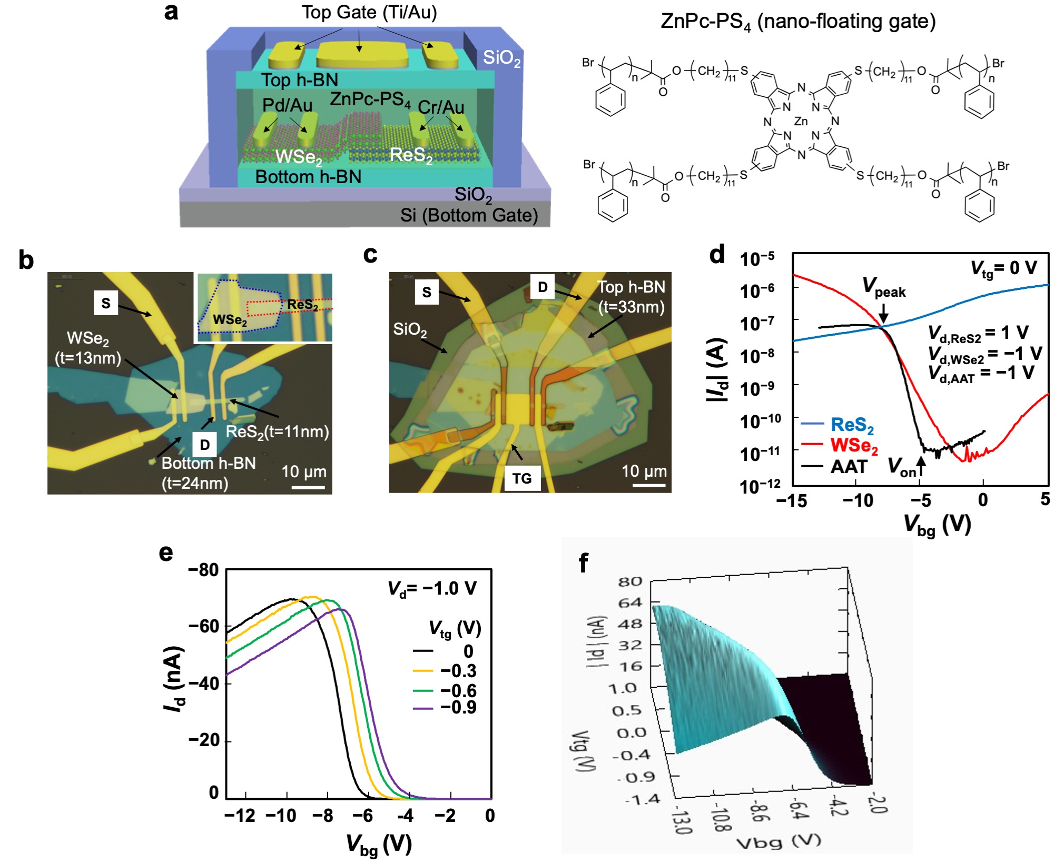
Figure 1. Fundamentals of dual-gate AAT operation. a, Schematic illustration of the dual-gate AAT and the chemical structure of ZnPc-cored star-shaped polystyrene (ZnPc-PS₄). b, c, Optical microscope images of (b) the bottom-gate AAT before forming the top-gate configuration and (c) the completed dual-gate AAT. The inset in (b) shows an enlarged view of the overlapping area of ReS₂ and WSe₂ channels. d, I_{d}–V_{bg} curves of the dual-gate AAT (black line), ReS₂ transistor (blue line) and WSe₂ transistor (red line) at a fixed V_{tg} of 0 V. e, I_{d}–V_{bg} curves of the dual-gate AAT with different V_{tg} values, where V_{d} was fixed at −1.0 V. f, 3D plots of |I_{d}| as a function of V_{tg} and V_{bg}.

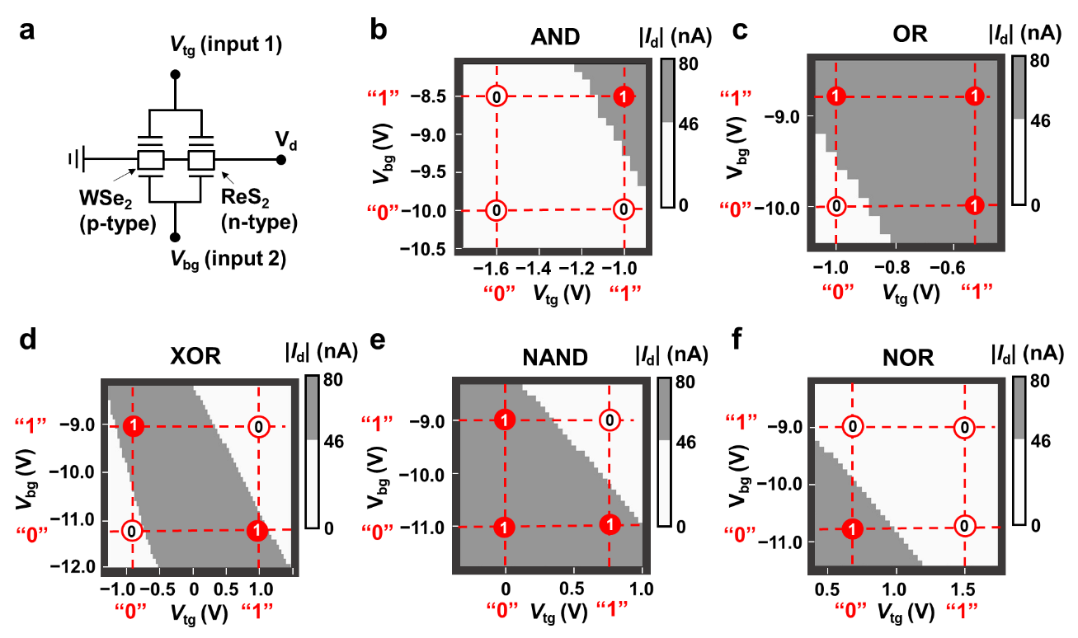
Figure 2. Two-input logic circuits based on a dual-gate AAT. a, Equivalent circuit of the two-input logic circuit. b-f, 2D–|I_{d}| plots as functions of V_{tg} and V_{bg}, corresponding to the following logic circuits: (b) AND, (c) OR (d) XOR, (e) NAND and (f) NOR circuits. The |I_{d}| plots were binarized with a threshold of −46 nA.

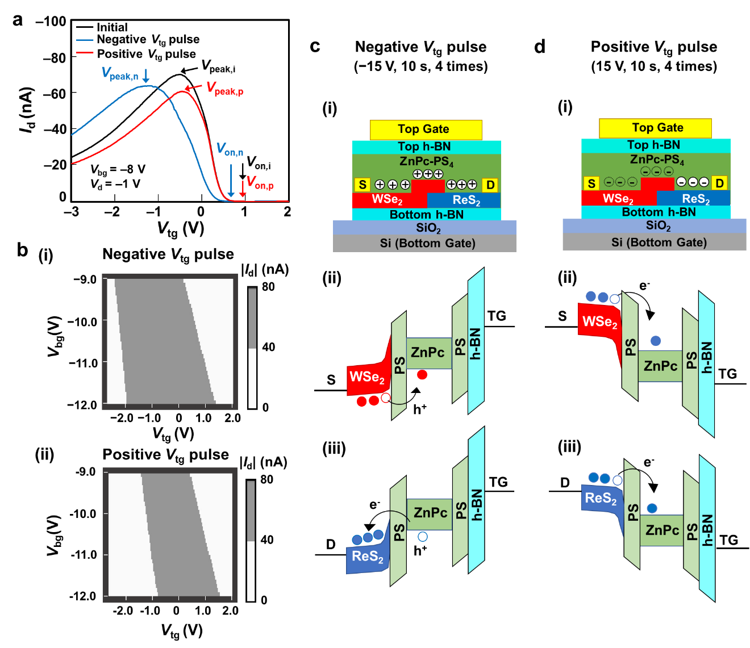
Figure 3. Nonvolatile memory functions induced by ZnPc-PS₄ layer. a, I_{d}–V_{bg} curves of a dual-gate AAT in the initial state (black line) and after applying 4-times negative (blue line) and positive (red line) V_{tg} pulses. The pulse amplitude and the pulse width, respectively, are −15 V and 10 s for the negative V_{tg} pulse, and 15 V and 10 s for the positive V_{tg} pulse. b, 2D–|I_{d}| plots after applying (i) negative and (ii) positive V_{tg} pulses. The V_{d} was fixed at −1.0 V. The |I_{d}| plots were binarized with a threshold of 40 nA. c, Hole-trapping processes with negative V_{tg} pulses: (i) a schematic illustration of the energy level alignments for hole-injection from (ii) WSe₂ and from (iii) ReS₂ channels into the ZnPc-PS₄ layer. d, Electron-trapping processes with positive V_{tg} pulses: (i) a schematic illustration of the energy level alignments for electron injection from (ii) WSe₂ and from (iii) ReS₂ channels into the ZnPc-PS₄ layer.

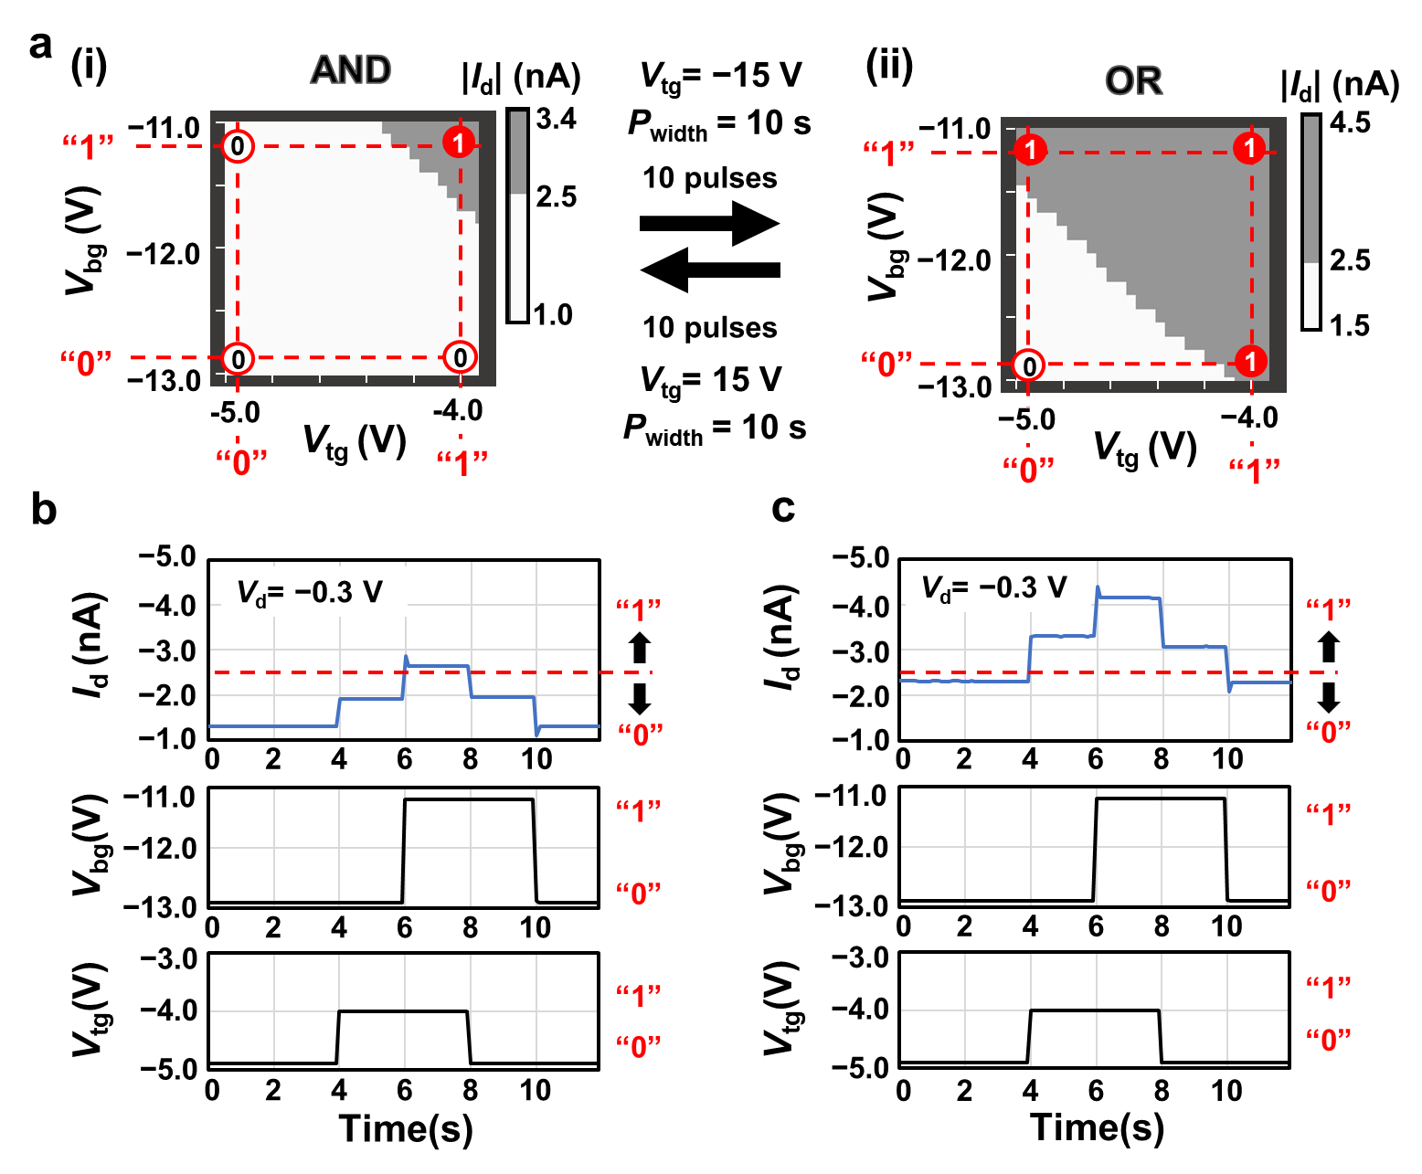
Figure 4. Reconfigurable two-input logic circuits. a, Electrical switching between (i) AND (ii) OR circuits induced by the carrier trapping effect in a dual-gate AAT. The 2D–|I_{d}| plots were binarized with a threshold of 2.5 nA. b, c, Logic operations of (b) AND (c) OR circuits. The output signal, “1” or “0”, is defined by an |I_{d}| of below or above 2.5 nA, respectively.

Figure 5. Inhibitory and excitatory synaptic operations. a, I_{d}−V_{tg} curves after 10-times negative (V_{tg} = −16 V, P_{width} = 10 s, blue line) and positive (V_{tg} = 15 V, P_{width} =10 s, red line) V_{tg} pulses, where V_{bg} and V_{d} are fixed at −10 and −0.5 V, respectively. b, c, Inhibitory synaptic operation with positive V_{tg} pulses (V_{tg} = 15 V and P_{width} = 50 ms) and excitatory synaptic operations with a negative V_{tg} pulse (V_{tg} = −15 V and P_{width} = 50 ms) were realized. The readout voltage (V_{read}) was set at −4.0 V for these measurements. d, I_{d}−V_{tg} curves duplicated from (a). The readout voltage (V_{read}) was changed to 1.5 V. e, f, Excitatory and inhibitory synaptic operations were observed, although the applied voltages were the same as those in (b) and (c). g, I_{d}−V_{tg} curves duplicated from (a). The readout voltage (V_{read}) was changed to −0.3 V. h, i, Excitatory and inhibitory synaptic operations were observed although consecutive positive V_{tg} pulses (V_{tg} = 13 V and P_{width} = 5 ms) were applied repeatedly.

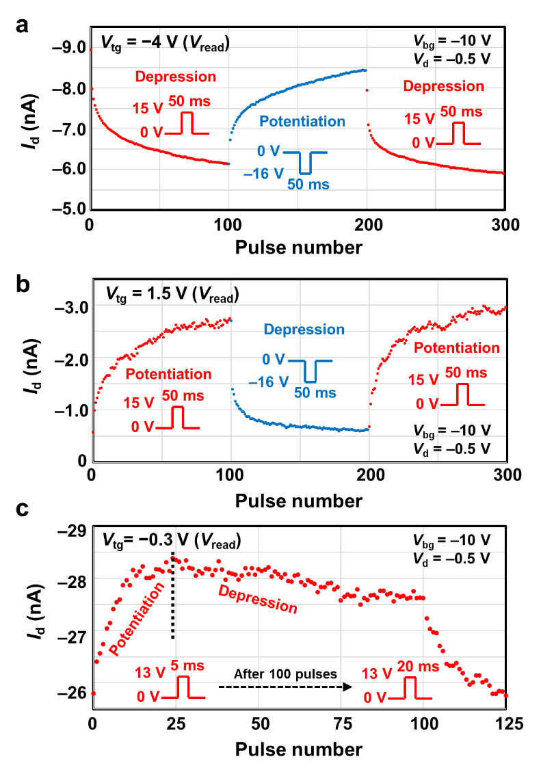
Figure 6. Long-term potentiation and depression. a, b, Long-term potentiation and depression operations as a function of applied pulse numbers. The depression and potentiation operations were observed with the opposite orders depending on the V_{read} at (a) −4.0 V or (b) 1.5 V. c, Transition from potentiation to depression induced by continuous pulse application. A similar transformation from potentiation to depression was even realized by the continuous application of positive presynaptic pulses with an appropriate V_{read} of −0.3 V.

TOC graphic

