Smart-cut-assisted fabrication of ultrathin diamond NEMS cantilevers
Guo Chen, Wen Zhao, Zhaozong Zhang, Satoshi Koizumi, Meiyong Liao
National Institute for Materials Science, Tsukuba, Ibaraki 305-0044, Japan

Ultrathin single-crystal diamond (SCD) cantilevers are highly promising for nanoelectromechanical systems (NEMS) because they combine nanoscale dimensions with exceptional mechanical robustness, low dissipation, and thermal stability. However, the reliable fabrication of sub-100 nm diamond cantilevers remains challenging. Here, we report a smart-cut-assisted thinning strategy for fabricating ultrathin diamond NEMS cantilevers with thicknesses down to ~50 nm.

As illustrated in Figure 1(a), the fabrication process starts from a microscale diamond cantilever, followed by sequential O₂ etching to the submicron scale and reactive ion etching (RIE) thinning to the nanoscale cantilever region. This two-step thinning process enables controlled thickness reduction while preserving structural integrity. The fabricated devices exhibit well-defined cantilever geometries, as confirmed by the three-dimensional (3D) surface profile in Figure 1(b), showing a representative cantilever with a length of 60 µm, width of 8 µm, and thickness of ~50 nm. The surface quality of the diamond epilayer is further verified by the AFM image in Figure 1(c), which reveals a smooth morphology with a root-mean-square (RMS) roughness of 1.7 nm, indicating that the thinning process preserves good surface quality, which is important for minimizing surface-related dissipation in ultrathin NEMS devices.

The fabricated ultrathin cantilevers also demonstrate stable resonant behavior. As shown in Figure 1(d), Allan deviation analysis gives a minimum value of 4.9×10⁻⁶ at a bandwidth of 1 Hz, confirming good frequency stability of the ~50 nm-thick cantilever. Based on the mass-sensing relation, the minimum detectable mass reaches 6.16 × 10⁻¹⁹ kg. These results demonstrate that the smart-cut-assisted thinning strategy provides a reliable route for batch fabrication of ultrathin diamond NEMS cantilevers, establishing a promising platform for high-performance nanomechanical sensing.

Keywords: single-crystal diamond, ultrathin cantilever, nanomechanical system, frequency stability

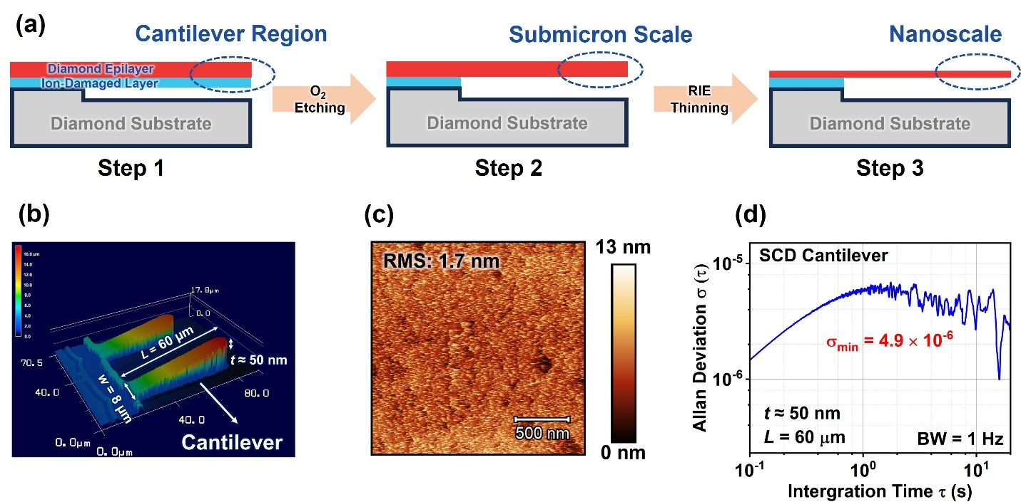
Figure 1. (a) Schematic illustration of the fabrication process for ultrathin diamond NEMS cantilevers. (b) Three-dimensional profile of the fabricated diamond NEMS cantilevers. (c) AFM images showing the surface morphology and roughness of the diamond NEMS epilayers. (d) Allan deviation of the diamond NEMS cantilever, showing a minimum Allan deviation of 4.9×10⁻⁶.

