Biocompatible pH sensor based on chitosan IPNs and polystyrene colloidal photonic crystal films

L. Podlucky*^{a, b}, H. Fudouzi^{c}, M. Bardosovaª
ªInstitute of Informatics, Slovak Academy of Sciences, Dúbravská cesta 9, 845 07 Bratislava, Slovak Republic; ^{b}Faculty of Electrical Engineering and Information Technology, Slovak University of Technology in Bratislava, Ilkovičova 3, 841 04 Bratislava, Slovak Republic, ^{c}National Institute for Materials Science, 305-0047 1-2-1 Sengen, Tsukuba, Ibaraki, Japan
*lubos.podlucky@stuba.sk

Abstract
Our research involves the fabrication of a pH-sensitive chitosan-tetraethyl orthosilicate-glutaraldehyde interpenetrating polymer network (Chi-TEOS-GA IPN) suitable for combination with polystyrene (PS) colloidal photonic crystal films to produce a device capable of showing a visual color change in response to a change in pH. The pH-sensitive properties of chitosan occur naturally due to its cationic polyelectrolyte structure. Cross-linking chitosan with TEOS and GA increases mechanical strength and PS photonic crystal films provide the means of optical detection. Monodisperse PS particles with various sizes were synthesized by emulsion polymerization of a styrene monomer in the presence of sodium dodecyl sulfate (SDS) as a surfactant. The PS colloid suspension was vertically deposited onto the flexible silicon rubber sheet to make a polystyrene (PS) photonic crystal film. The closely packed PS particles were infilled and cured multiple times with PDMS elastomer, which allows for reversible color change by elastic deformation. All Chi-TEOS-GA films were prepared by drop casting with constant experimental conditions such as temperature, substrate, and time. Chi-TEOS-GA films swelling studies show an increase in the size and weight of the films with decreasing pH. The PS photonic crystal films were put on top of the pH-sensitive films and enclosed in a solid frame to prevent swelling in unwanted directions. Investigation of spectrometry measurements shows a shift of the spectra to lower wavelengths with decreasing pH, resulting in a color change of the PS photonic crystal film. These results are discussed in terms of the potential use of this device in biomedical applications, such as wound dressings.

Keywords: Photonic crystals; chitosan; IPNs; pH sensing; polystyrene; thin films

INTRODUCTION
Chitosan is a non-toxic, biodegradable and commercially viable polymer derived from the deacetylation of chitin. Chitin is the second most naturally abundant polysaccharide contained within the exoskeletons of crustaceans and fungi. The deacetylation is done using alkali hydroxides such as sodium hydroxides. This process does not lead to 100% deacetylation. Typically, once the standard level of deacetylation exceeds 50%, the obtained polysaccharide is referred to as chitosan. [1,2] Chitosan has many advantages over chitin including increased solubility in acetic environment and increased flexibility, which makes it more prominent material for use in biomedical applications [3]. Chitosan displays many great attributes such as: antimicrobial [4] and antifungal [5] activity, pH sensitivity, and the ability to form various interpenetrating polymer networks [3]. Depending on the application, chitosan can be fabricated into different structures such as: nanoparticles, hydrogels, thin films, nanofibers [6] and composites. [1,2,3]
Chitosan thin film membranes, typically fabricated by cast dropping chitosan hydrogel, display pH sensitivity, but lack mechanical strength. This can be improved by introducing cross-linking into the chitosan hydrogel. [3] A cross-link is formed by a chemical reaction with any species which successfully bonds two polymer chains together, either covalently or ionically or by weaker bonding interactions [7]. Cross-linking is also applied to the formation of interpenetrating polymer network (IPN), which is a polymer comprising of two or more partially interlinked networks that are not covalently bonded to each other and cannot be broken unless chemical bonds are broken [8]. IPN synthesis is basically a reaction between a monomer and a crosslinker to form a polymer network. Cross-linkers such as tetraethylorthosilicate (TEOS), genipin, polyacrylamide, glutaraldehyde, etc. [9,10,11,12]; have been used to enhance the mechanical stability of chitosan membranes. Chitosan IPN membranes have improved hardness and mechanical properties, however, they appear to be more brittle than pure chitosan membranes [13].
Photonic crystals are materials constructed of self-assembled nanoscale colloidal particles forming an ordered crystal lattice structure. [14,15] Being on the order of the wavelength of visible light means that various light interactions occur, resulting in the observation of visible color from the photonic crystal, with the color observed depending on the diameter of the colloidal particles which form the crystal lattice structure. Synthetic opals are constructed by the bottom-up self-assembly of uniform colloidal particles, such as SiO₂, polystyrene (PS) or polymethyl methacrylate (PMMA), and the inverse of their structures is fabricated through the top-down approach. The primary approaches include controlled evaporation and layer-by-layer assembly. Photonic crystals composed of colloidal particles are utilized for their interesting optical properties as the regularly repeating crystal lattice interacts with light of different wavelengths depending on the dimensions of the crystal lattice [16].
Photonic crystals influence the propagation of photons. [17,18] Depending on the angle at which the light hits a material, some wavelengths cannot propagate through the material and are reflected, this is the color that is seen. Other wavelengths may propagate, but at different angles the color looks different. The wavelength of the light that is reflected by the material, which is known as the stop band or photonic band gap, is defined by the Bragg-Snell equation, (Eqn. 1)

mλ_{s} = 2D (n_{eff} ²-sin²θ)^{1/2} (1)

where m is the order of diffraction, λ_{s} is the wavelength of the stop band which corresponds to the observed color of the film, n_{eff} is the effective or average refractive index estimated from a weighted combination of the refractive indices of the particles and the material in between the particles, θ is the angle of incidence of the light as measured from a normal to the film’s surface and d is the spacing between the particles, which for a close packed array of particles is related to the diameter of the particles D, by the simple geometric relationship d = 0.86D. Therefore, it may be seen that at any given angle of incidence, there are two factors that may influence the position of the stop band – the effective refractive index and the value of d.
By depositing the colloidal photonic crystal on a flexible material such as rubber, one can obtain a flexible photonic crystal film capable of color change by elastic deformation. Applying this flexible photonic crystal film on top of the pH sensitive Chitosan IPNs thin film membranes, we can deform the photonic crystal by applying pH buffers. Fixing these 2 films into a solid frame and limiting the swelling capabilities of chitosan in the direction of the photonic crystal film, we obtain a device capable of sensing pH change by simple change in color. This paper focuses on developing this type of pH sensing device. We investigated two different types of Chitosan IPNs, their swelling characteristics and their influence on the color change of the pH sensing device.

materials and methods
Low molecular weight chitosan (Mw 50000–190000 g mol⁻¹, 75–85% deacetylated). Tetraethylorthosilicate (TEOS, ≥99%, 0.005 mol) and glutaraldehyde (GA, 25%) were purchased from Sigma-Aldrich, Ireland. Millipore deionized water (18 MΩ) was used to prepare aqueous solutions. Two types of chitosan-based hydrogel were synthesized and made into chi-TEOS films and chi-TEOS-GA films. IPN hydrogels are formed by a cationic solution polymerization technique in mildly acidic solution. Three separate solutions are prepared and allowed to stir at room temperature for 30 minutes: (1) 2.08 g chitosan in 65 mL H2O with 1 wt% CH3COOH, (2) 1.04 g TEOS in 15 mL EtOH, and (3) 25 mL H2O and 10 mL EtOH with 0.1 wt% conc. HCl. Solution 3 is then added to solution 2 with stirring. The resulting mixture and solution 1 are continuously stirred at room temperature for 24 h. After that, the chitosan solution is slowly added to the TEOS solution under continuous stirring. this final solution is then left to stir for a further 48 h. This method results in a 1:0.5 Chi-TEOS IPN. For preparation of Chi-TEOS-GA films, 0.5 ml of GA (25%) was added to 10 ml of water and stirred for 30 minutes. Then 0.2 ml of GA solution were added to 15 ml of Chi-TEOS hydrogel and allowed to stir for another 4 hours to ensure proper mixture. All films were prepared using the basic Petri dish drop cast method. 15 ml of hydrogel was cast into a Petri dish (50 mm diameter) ensuring a minimum production of bubbles and was spread thinly to cover the surface uniformly. The chitosan-based hydrogel was then dried in an oven at 40 °C for 24 hours. Once dry, the films were peeled off the surface and stored at room temperature.
Monodisperse 210 nm PS particles were synthesized by emulsion polymerization of a styrene monomer in the presence of sodium dodecyl sulfate (SDS) as a surfactant. [19, 20] The flexible rubber substrate, fixed on a sample holder, was immersed vertically into the suspension container filled with the polystyrene (PS) colloid suspension covered with a layer of silicone oil. The vertical stage ascended slowly while driven by the stepping motor thus depositing the PS photonic crystal film onto the substrate. The resulting closely packed colloidal crystal film was fixed with mixed PDMS precursor liquids, Sylgard 184 (Dow Corning, USA). [21] Two separate liquids consisting of the base material and the curing agent were used with the weight ratio between the base and the curing agent of 10:1. After curing, PDMS elastomer was infilled in 3D-arrayed PS colloidal particles. Then, closely packed PS particles were spaced out by additional filling and curing PDMS elastomer. PDMS precursor was diluted with silicone liquid (0.65 cSt, SH-200 series, i.e., hexamethyldisiloxane, HMDSO) with a (1:1) mass ratio. The PDMS elastomer was polymerized by cross-linking overnight in the oven at 60°C. The lattice distance of FCC (111) planes was increased in nanometer scale by repeating infilling PDMS elastomer for several times. This nanoscale spacing allows reversible structural color change by elastic deformation [22].
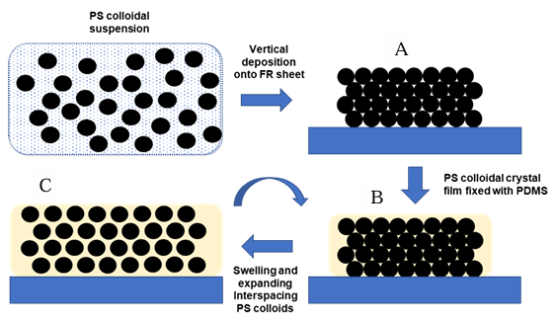
Figure 1 Fabrication process of PS colloidal crystal film, repeating the PDMS filling process increases the spacing between the PS colloidal crystals allowing reversible structural color change by elastic deformation.
The constructed device consisted of a polystyrene-based colloidal photonic crystal made on a flexible silicone rubber sheet and multiple chitosan IPN films underneath, which were held in a rigid frame. The rigid frame consisted of metal square with a hole in the middle on the top and a plastic mesh on the bottom to ensure the easy access of the pH solution to the chitosan IPN films. To minimize swelling in unwanted directions another plastic frame with a hole was inserted in-between the top and bottom frames and the chitosan IPN films were inserted inside this frame. A black cloth was added under the photonic crystal sheet to make the color change more visible. A dialysis cellulose membrane was inserted under the chitosan IPN films to ensure no chitosan IPN particles would leak out of the device. Submerging the device into a pH solution results in chitosan IPN film absorbing the solution and swelling, which deforms the photonic crystal membrane. This deformation then manifested itself as a color change arising from a change in the position of the stop band. The entire model is shown in Figure 2.

Figure 2 Model of the pH sensing device utilizing chitosan IPNs and PS photonic crystals for pH change imagining

results and discussion
The swelling of the chitosan film is a very important factor when considering medical device applications. A higher level of swelling can cause a decrease in elasticity and tensile strength, whereas a lower level of swelling would limit the functionality of the device. We investigated the swelling characteristics of chitosan IPNs under different pH conditions. Firstly, we determined the minimum time needed for the swelling to reach its maximum under different pH conditions. The percentage of swelling Q_{eq} (%) was calculated based on the following equation (2):
$Qeq\left(\%\right)=\frac{m_{2}-m_{1}}{m_{1}}*100$ (2)
where m₁ is the initial mass of the films before swelling, and m₂ is the mass of the films after swelling and drying. The pH values used in all experiments were: 2.5, 4, 7, and 9. To determine the necessary time for stabilization of the swelling of the chitosan base films, each sample was inserted into a pH solution for one minute, then removed, dried and weighed. This was repeated until the swelling in all pH was relatively constant. The results for Chi-TEOS-GA (1:0.5:0.02) are shown in Figure 3 a. For all pH values the swelling stabilization happened somewhat linearly. Swelling at pH 2.5 and 9 stabilized fastest in around 7 minutes. For pH 7 the stabilization happened after 9 minutes, and at pH 4 the stabilization took the longest at around 12 minutes.
a)b)
Figure 3 a) Relationship between swelling and time for Chi-TEOS-GA (1:0.5:0.02) film, b) Swelling characteristics of 2 different types of Chitosan IPNs: Chi TEOS (1:0.5) and Chi TEOS GA (1:0.5:0.02)
After determining the minimum time necessary for the stabilization of the swelling, the swelling capacity of 2 different types of Chitosan IPNs: Chi TEOS (1:0.5) and Chi TEOS GA (1:0.5:0.02) was analyzed, by submerging these films in a pH solution for 30 minutes, shown in Figure 3b. The percentage of swelling Q_{eq} is high in all cases. From figure 3b, it may be seen that for both samples the swelling decreases with an increasing pH and vice versa. The swelling at all pH values for Chi TEOS GA is lower than for the Chi TEOS samples. This confirms the fact that adding GA to Chi TEOS hydrogel furthermore increased the mechanical strength of the Chitosan IPN films, therefore decreasing their swelling capabilities. For the potential use of this device in wound dressing the most important pH values were 4 and 7. The difference between pH 4 and pH 7 was relatively low in the case of Chi TEOS GA sample.
The structural color change of the photonic crystal film during swelling of the fabricated device was investigated by optical spectroscopy performed with a fiber-optic reflection probe. Firstly, the influence of the number of Chi-TEOS-GA (1:0.5:0.02) dry film on the color change was measured by inserting 1,5, and 10 films into the device and inserting it into different pH solutions for 1-3 hours (shown in Figure 4 a). The film’s thickness was approximately 120 µm. It is evident that the change in wavelength peak center increases with increasing amount of chitosan IPN films in the device. This was to be expected as more chitosan IPN films means more swelling, therefore bigger elastic deformation of the photonic crystal membrane.
a)b)
Figure 4 a) Wavelength peak center of the pH sensing device with 1,5, and 10 Chi-TEOS-GA (1:0.5:0.02) films at different pH values and times, b) The difference between wavelength of the dry device and the device after inserting into different pH solutions for 1 and 3 hours.
The difference of the wavelength peak center between the dry device and the device after inserting into different pH solutions for 1 and 3 hours is shown in Figure 4b). It can be seen that the difference between the pH values for the device with only one chitosan IPN film is too low. The maximum shift between dry sample and pH 2.5 after 3 hours is only 24 nm and the peak shift between individual pH values is only 2 nm on average. The device with 5 chitosan IPN films showed better results with the maximum peak shift between dry and pH 2.5 of 32 nm, and the peak shift between individual pH values was 2.5-4 nm. The best results were obtained by inserting 10 chitosan IPN films into the device. The maximum peak shift between dry sample and pH 2.5 was ≈55 nm. The differences between different pH values were also more significant with the difference between pH 9 and pH 7 ≈14 nm, between pH 7 and pH 4 ≈7 nm and between pH 4 and pH 2.5 ≈5 nm.
a)b)
Figure 5 a) Comparison of the wavelength peak center of the pH sensing device with 10 Chi TEOS (1:0.5) and 10 Chi TEOS GA (1:0.5:0.02) films at different pH values after 3 hours, b) Peak shift between the dry device and the and the device after inserting into different pH solutions for 3 hours for Chi TEOS (1:0.5) and 10 Chi TEOS GA (1:0.5:0.02) films
Figure 5 a) and b) show the wavelength peak center and peak shift difference between the 2 investigated types of chitosan IPN films. The peak shift for the Chi TEOS (1:0.5) films was 28 nm between dry and pH 9, 9 nm between pH 9 and pH 7, 13 nm between pH 7 and pH 4, and only 2 nm between pH 4 and pH 2.5. For the Chi TEOS GA (1:0.5:0.02) films the peak shift was 29 nm between dry and pH 9, 14 nm between pH 9 and pH 7, 7 nm between pH 7 and pH 4, and 5 nm between pH 4 and pH 2.5. The biggest shift was for both chitosan IPN films between dry film and pH 9. In case of the device using Chi TEOS (1:0.5) films, during the time the device was inserted into any pH solution, the solution became murky. This could mean that the crosslinking of the Chi TEOS (1:0.5) films was weaker or the pressure inside the device during the swelling was too high, which made some of the chitosan leak out of the device. Therefore, even though the swelling capability of the Chi TEOS (1:0.5) film was much higher than the Chi-TEOS-GA (1:0.5:0.02) film, the peak shift for most pH values was higher for the device using Chi TEOS GA (1:0.5:0.02) films.
a) 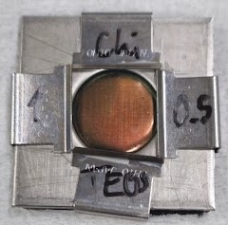 | b) 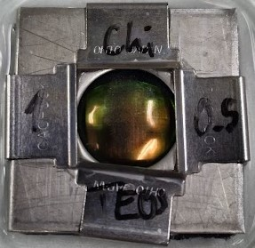
c) 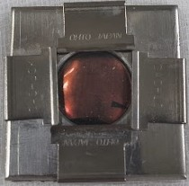 | d) 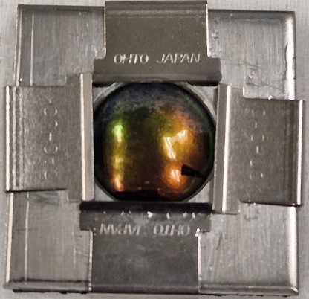
e) 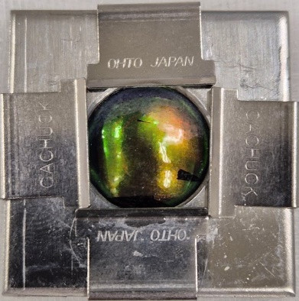 | f) 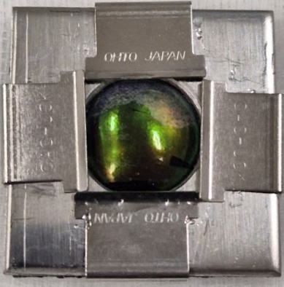
Figure 6 Photos of the pH sensing device using: a) Chi TEOS (1:0.5) films before swelling in any pH solution, b) Chi TEOS (1:0.5) films after swelling in pH 7 solution, c) Chi TEOS GA (1:0.5:0.02) films before swelling in any pH solution, d) Chi TEOS GA (1:0.5:0.02) films after swelling in pH 9 solution, e) Chi TEOS GA (1:0.5:0.02) films after swelling in pH 7 solution, e) Chi TEOS GA (1:0.5:0.02) films after swelling in pH 4 solution and pH 2.5 solution
Figure 6 shows the photos of the pH sensing device with 10 Chi TEOS (1:0.5) films and 10 Chi TEOS GA (1:0.5:0.02) films from the previous experiment. For the device with 10 Chi TEOS (1:0.5) films only 2 photos are available (Figure 6 a), b)). There is visible color change between the dry device and the device after inserting into a pH 7 solution for 3 hours. It can be seen that the color slightly shifted from red/orange to orange/green. For the device with 10 Chi TEOS GA (1:0.5:0.02) films, there are 4 photos available (Figure 6 c), d), e), f)). The change in color between the dry device and the device after inserting it into any pH solution for 3 hours is quite visible. With decreasing pH, the color changes from red/orange becoming more and more green with the decrease of the pH value. However, from the previous experiment, the peak shift between the device in pH 4 solution and pH 2.5 solution was only 5 nm, and the color change was also practically invisible to the naked eye.

Conclusion
The goal of this work was the fabrication of pH sensing device using chitosan IPN films and colloidal photonic crystal. The time stabilization of swelling of Chi-TEOS-GA (1:0.5:0.02) film at 4 different pH values was investigated. The swelling for all values stabilized after 7-12 minutes. The swelling capacity of 2 types of Chitosan IPNs: Chi TEOS (1:0.5) and Chi TEOS GA (1:0.5:0.02) was analyzed, by submerging these films in a pH solution for 30 minutes. The swelling for the Chi TEOS (1:0.5) film was much higher in all cases than the Chi TEOS GA (1:0.5:0.02) film swelling. The structural color change of the photonic crystal film during swelling of the fabricated device was investigated by optical spectroscopy. The influence of the number of Chi-TEOS-GA (1:0.5:0.02) films on the color change was investigated by inserting 1,5, and 10 films into the device and inserting it into different pH solutions for 1-3 hours. As expected, the change in wavelength peak center increases with increasing amount of chitosan IPN films in the device. Peak shift between the dry device and the and the device after inserting into different pH solutions for 3 hours for 10 Chi TEOS (1:0.5) and 10 Chi TEOS GA (1:0.5:0.02) films were also investigated. The peak shift for most pH values was higher for the device using Chi TEOS GA (1:0.5:0.02) films than for the Chi TEOS (1:0.5) films, possibly due to Chi TEOS (1:0.5) films having lower mechanical strength and some of the chitosan leaking out of the device during the stay in pH buffer solution. In terms of visible color change, the difference between dry films and films after 3 hours in different solutions is quite high, however there is a relatively small difference between different pH values.

Acknowledgements
This work was done in the laboratory of prof. Fudouzi at National Institute for Materials Science (NIMS) in Tsukuba, Japan. This work was supported by project H2020-MSCA-RISE-2019 SWORD-873123 by European Commission Research and Innovation.

References
- Rinaudo, M., “Chitin and chitosan: properties and applications,” Prog Polym Sci 31(7):603–632. (2006). doi:10.1016/j. progpolymsci.2006.06.001
- Ryan, C.C., Bardosova, M., Pemble, M.E., “Structural and mechanical properties of a range of chitosan-based hybrid networks loaded with colloidal silica and polystyrene particles,” Journal of Materials Science, 52(13): p. 8338-8347, (2017).
- Dash, M., Chiellini, F., Ottenbrite, R., Chiellini E., “Chitosan—a versatile semi-synthetic polymer in biomedical applications,” Prog Polym Sci 36(8):981–1014, (2011).
- Guarnieri, A., Triunfo, M., Scieuzo, C., “Antimicrobial properties of chitosan from different developmental stages of the bioconverter insect Hermetia illucens,” Sci Rep 12, 8084, (2022). https://doi.org/10.1038/s41598-022-12150-3
- Lopez-Moya, F., Suarez-Fernandez, M., Lopez-Llorca, LV., “Molecular Mechanisms of Chitosan Interactions with Fungi and Plants,” Int J Mol Sci. ;20(2):332, (2019).
- Cui, C., Sun, S., Wu, S., Chen, S., Ma, J., Zhou, F., “Electrospun chitosan nanofibers for wound healing application, Engineered Regeneration,” V. 2, P. 82-90, ISSN 2666-1381, (2021). https://doi.org/10.1016/j.engreg.2021.08.001.
- Ahmed, EM., “Hydrogel: preparation, characterization, and applications: a review,” J Adv Res 6(2):105–121, (2015). doi:10. 1016/j.jare.2013.07.006
- Jenkins, A., Kratochvil, P., Stepto, R., Suter, U., “Glossary of basic terms in polymer science (IUPAC Recommenda tions 1996),” Pure Appl Chem 68(12):2287–2311, (1996).
- Lien, S-M., Li, W-T., Huang, T-J., “Genipin-crosslinked gelatin scaffolds for articular cartilage tissue engineering with a novel crosslinking method,” Mater Sci Eng: C 28(1):36–43, (2008). doi: 10.1016/j.msec.2006.12.015
- Park, S-B., You, J-O., Park, H-Y., Haam, SJ., Kim, W-S., “A novel pH-sensitive membrane from chitosan—TEOS IPN; preparation and its drug permeation characteristics,” Bioma terials 22(4):323–330, (2001).
- Dragan, E. S., Perju, M. M., Dinu, M. V., “Preparation and characterization of IPN composite hydrogels based on polyacrylamide and chitosan and their interaction with ionic dyes,” Carbohydrate Polymers, V. 88, Issue 1, P. 270-281, ISSN 0144-8617, (2012). https://doi.org/10.1016/j.carbpol.2011.12.002.
- Muzzarelli, RA., El Mehtedi, M., Bottegoni, C., Aquili, A., Gigante, A., “Genipin-Crosslinked Chitosan Gels and Scaffolds for Tissue Engineering and Regeneration of Cartilage and Bone,” Mar Drugs;13(12):7314-38, (2015). doi: 10.3390/md13127068.
- Aryaei A., Jayatissa, AH., Jayasuriya, AC., “Nano and micro mechanical properties of uncross-linked and cross-linked chitosan films,” J Mech Behav Biomed Mater 5(1):82–89, (2012). doi: 10.1016/j.jmbbm.2011.08.006
- Fudouzi, H., “Optical properties caused by periodical array structure with colloidal particles and their applications,” Adv Powder Technol 20(5):502–508, (2009). doi: 10.1016/j.apt.2009.08.002
- Ryan, C., Delezuk, J., Pavinatto, A., Oliveira, O., Fudouzi, H., Pemble, M., Bardosova, M., “Silica-based photonic crystals embedded in a chitosan-TEOS matrix: preparation, properties and proposed applications,” Journal of Materials Science. 51, (2016). 10.1007/s10853-016-9841-7.
- Joannopoulos, JD., Johnson, SG., Winn, JN., Meade, RD. “Photonic crystals: molding the flow of light,” Princeton University Press, Princeton, (2011).
- Pemble, M.E., Bardosova, M., “Colloidal Photonic Crystal Architectures for Advanced Light Management Applications,” Nanomaterials and Nanoarchitectures, Dordrecht: Springer Netherlands, (2015).
- Pemble, O. J., “The design, synthesis and characterisation of selected chitosan-based thin films and studies of their use as materials for antimicrobial, heavy metal adsorption, and wound dressing applications,” PhD Thesis, University College Cork, (2022).
- Furumi, S., Fudouzi, H., Sawada, T., “Dynamic photoswitching of micropatterned lasing in colloidal crystals by the photochromic reaction,” Journal of Materials Chemistry, 22(40): p. 21519-21528, (2012).
- Fudouzi, H., “Colloidal Photonic Crystal Films: Fabrication and Tunable Structural Color and Applications,” Nanomaterials and Nanoarchitectures, Dordrecht: Springer Netherlands, (2015).
- Dow. SYLGARD™ 184 Silicone Elastomer Kit, (2022).
- Fudouzi, H., Sawada, T., “Photonic rubber sheets with tunable color by elastic deformation,” Langmuir, 22 [3]: p. 1365-1368, (2006).

