THEORETICAL INVESTIGATION OF OXIDATION MECHANISM IN Ti AND ITS ALLOYS
Ryoji Sahara¹, Somesh Kr. Bhattacharya¹, Kanika Kohli², Prasenjit Ghosh², Kyosuke Ueda³, and Takayuki Narushima³
1 1 National Institute for Materials Science (NIMS), Tsukuba 305-0047, Japan
2 Indian Institute of Science Education and Research, Pune 411008, India
3 Department of Materials Processing, Tohoku University, Sendai 980-8579, Japan

In the study, the mechanism of oxidation of Ti and its alloys are clarified using both of first principles calculations and machine learning.
First, using first-principles calculations, we identified the mechanisms of the oxidation of α-Ti surfaces. In addition to the case of pure Ti case, the effect of alloying elements was also systematically analyzed. It is shown that the result of oxidation resistivity of alloys can be analyzed with their electronegativity. Next, we built a machine learning model to predict the parabolic rate constant, k_{p}, for high temperature oxidation of Ti alloys. Exploring the experimental studies on high-temperature oxidation of Ti alloys, the dataset for machine learning was built. It is shown that the model can predict k_{p} well.
Keywords: high temperature oxidation, parabolic rate constant, first principles calculations, machine learning, electronegativity.

Introduction
Titanium (Ti) and its alloys are used for high-temperature components of jet engines, implants and sports equipment because of their superior mechanical properties with being light weight [1]. Their high affinity for oxygen, particularly at elevated temperatures, severely limits their application above 650℃. Therefore, it is important to develop oxidation-resistant Ti alloys. There are many basic researches through experiments to understand the effect of alloys elements in Ti alloys. For example, the oxidative behavior of Si-containing Ti-6Al-4V alloys in air was studied by Maeda et al. [2], and the effect of different alloying elements on the tensile strength and oxidation properties of α- and near α-Ti alloys has been outlined by Kitashima et al. [3]. While, it is important to perform theoretical investigation of oxidation mechanism in Ti and its alloys. In the study, the mechanism of oxidation of Ti and its alloys are clarified using both of first principles calculations based on density functional theory (DFT) and machine learning models.

Calculation

First principles calculation
To identify the mechanisms of the oxidation of α-Ti surfaces, first-principles calculations were performed [4-7] using the Vienna Ab initio Simulation Package [8] and Quantum Espresso [9]. We constructed an asymmetric 11-layer Ti slab to represent the α-Ti(0001) surface as shown in Fig. 1. Typically, each layer is constructed by 4×4 atoms. The four bottom layers of the slab were kept fixed at the bulk distance while other atoms were allowed to relax. A sufficient vacuum region (16-20 Å) was introduced in the [0001] direction to avoid any spurious interaction. In addition to the case of pure Ti case, the effect of alloying elements was also systematically analyzed considering their electronegativity. In the study, we considered alloying with Zr, Hf, Nb, and Mo (d-block) as well as Al, Ga, Si, and Ge (p-block) elements, which are most widely studied alloying elements for Ti. The segregation of alloying elements was studied by substituting Ti with alloying elements. They were substituted at different layers to understand the preferred substitution sites.
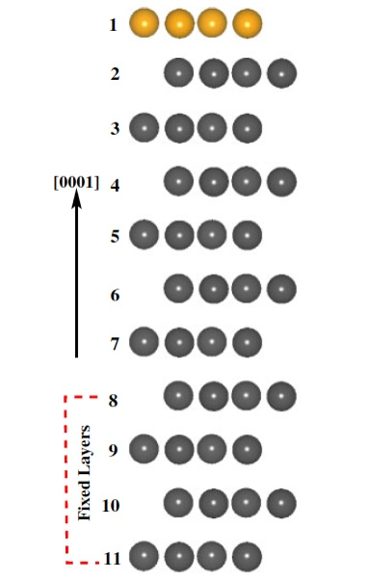

Figure 1. Side view of the α-Ti(0001) slab model [4-7].
To understand the stability of the adsorbed oxygen atom on the pure and alloyed Ti surface, the adsorption energies ($E_{ads}$) were estimated using the Eq. (1),
$E_{ads}=E_{\text{O}+\text{surf}}-E_{\text{surf}}-\frac{1}{2}E_{{\text{O}}_{2}}$ (1)
where $E_{O+surf}$, $E_{surf}$, and $E_{surf}$ are the total energies of the system containing the surface and the adsorbed species, the clean surface, and the O₂ molecule in the gas phase, respectively. To compute the minimum energy path and barriers for the diffusion of O atoms from the surface to the subsurface layer, the climbing image based nudged elastic band (CI-NEB) method [10] was performed. Results were analyzed using the electronegativity difference between Ti and alloying element.

Machine learning model
We built a machine learning model to predict the parabolic rate constant, $k_{p}$, for high temperature oxidation of Ti alloys [11-12]. Here, $k_{p}$ is defined by Eq. (2) in the unit of g²cm⁻⁴s⁻¹,
${(ΔM/A)}^{2}=k_{p}×t$ (2)
where $ΔM/A$ is the mass gain per unit area during oxidation and t is the time during which the oxidation was performed. Exploring the experimental studies on high-temperature oxidation of Ti alloys, we built our dataset for machine learning. Apart from the alloy composition, we included the constituent phase of the alloy, temperature of oxidation, time for oxidation, oxygen and moisture content, remaining atmosphere, and mode of oxidation testing as the independent features, while $k_{p}$ was predicted as the target feature.

Results and Discussion

First principles calculation
At first, by analyzing the segregation energy, it is found that all the alloying elements prefer to be present on the surface. Therefore, we constructed models where the alloying element is segregated at the surface. Then, Fig. 2 [7] shows the finally obtained relationship between diffusion barrier of oxygen atom from the surface to subsurface, $E_{act}$, and ΔEN, the electronegativity difference between Ti and the alloying element, at different oxygen coverages θ = 0.06, 0.50, and 1.00 ML (mono layer).
Figs. 2(a) and (b) show the case of d- and p-block elements, respectively. Generally, it is observed that $E_{act}$ reduces when θ increases. The lowering of the barrier as a function of ΔEN is due to the stronger (weaker) binding of the surface O atom in the presence of alloying elements that are less (more) electronegative than Ti, which suggest a stronger driving force for the diffusion process. This means that the results suggest that doping Ti with a more electropositive element will be more effective to hinder the early oxidation. It is shown that the relationship almost reproduces the experimental observation of the alloying element dependence of mass increase due to oxidation [3].

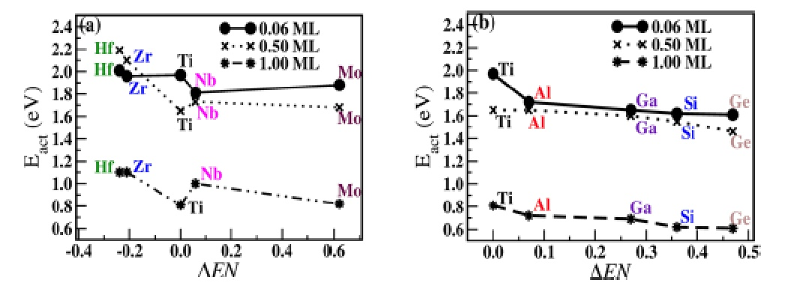

Figure 2. Relationship between diffusion barrier and ΔEN at different oxygen coverage. Plots for (a) d- and (b)p-block elements. [7].

Machine learning model
Fig. 3 shows the relationship between the experimental and predicted values of $k_{p}$ in the case of Gradient Boosting (GB) model [11], where the coefficient of determination R² of 0.92.
Figure 3. Relationship between the experimental and predicted values of $k_{p}$ for the Gradient Boosting (GB) [11].
Fig. 4 and 5 show the Pearson’s correlation coefficient (PCC), which measures the statistical relationship between two continuous variables and provide the information about the magnitude of the association. These Figs. indicate that alloying elements with a negative PCC such as Al, Zr, Si, Nb, and Ta increases the oxidation resistance while elements such as Fe, Cr, V show positive PCC showing that they have detrimental effect on the oxidation. It is shown that the predicted $k_{p}$ values for some Ti alloys using the model qualitatively agrees well with the corresponding experimental values [12].
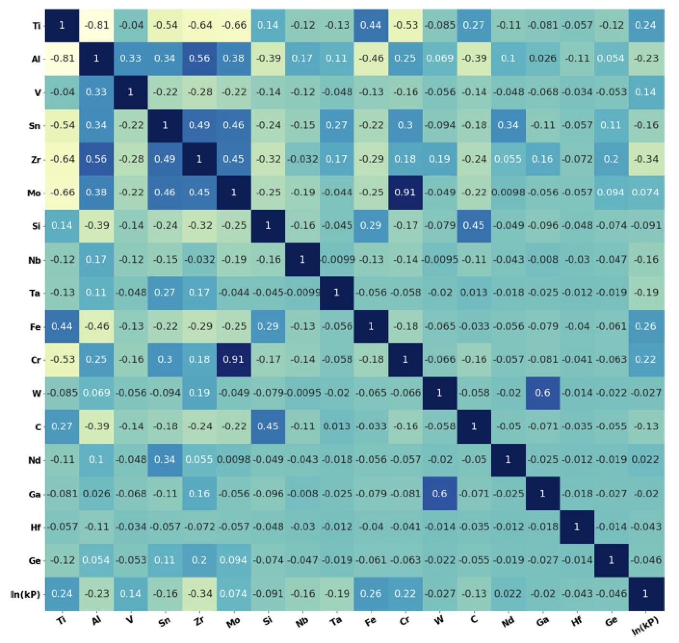

Figure 4. Graphical representation of the PCC between the alloying elements and ln(k_{p}) [11].
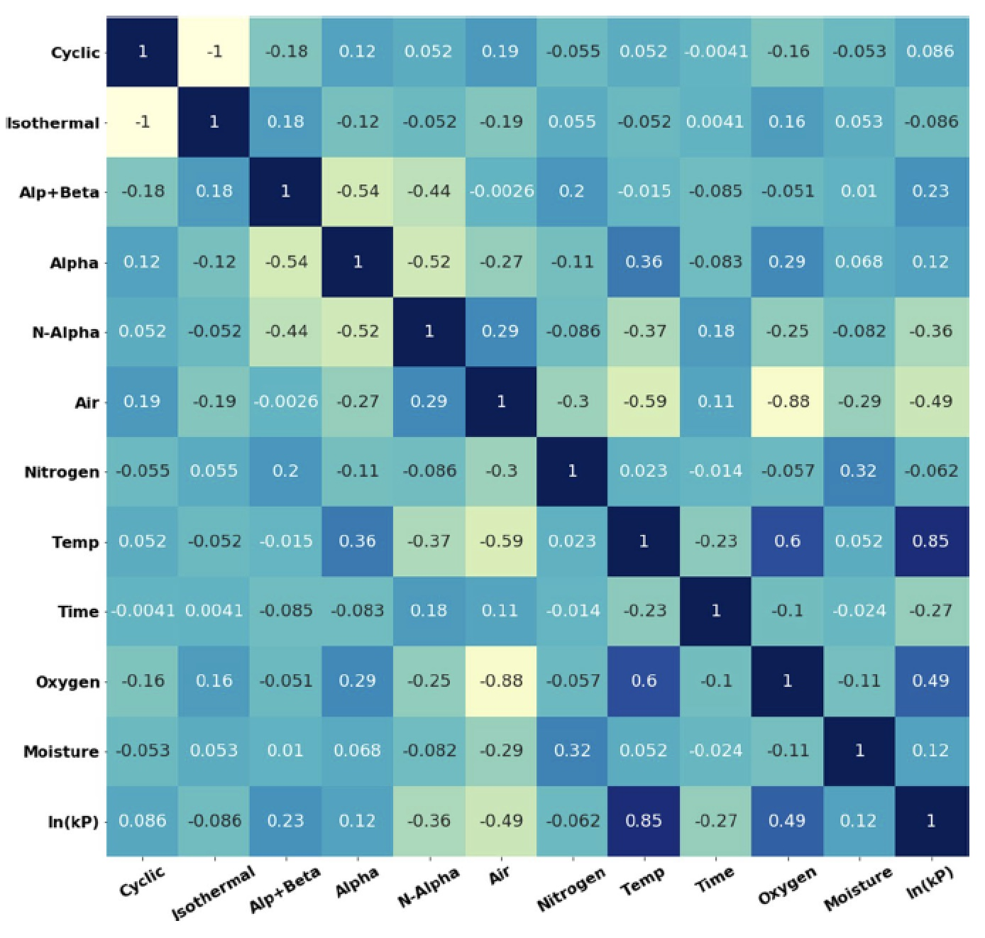

Figure 5. Graphical representation of the PCC between the different remaining features and ln(k_{p}) [11].

Summary
In the study, the mechanism of oxidation of Ti and its alloys are clarified using both of first principles calculations and machine learning model. The effect of alloying elements was systematically analyzed and showed that electronegativity can be used as a good indicator to oxidation resistance. Furthermore, it is shown that our machine learning model reproduces the experimental value well. The knowledge gained from the study can be used to design novel Ti alloys with excellent resistance towards high-temperature oxidation.

Acknowledgements
The calculations in the study were performed at the Numerical Materials Simulator at the National Institute for Materials Science (NIMS), the supercomputing system at the Institute for Materials Research (IMR), Tohoku University (Proposal No. 202012-SCKXX-0506), and the ITO system at Kyushu University under the HPCI system project (Project IDs: hp190014, hp190059, hp200040, hp210019, hp220017). The work was partially supported by the Japan Society for the promotion of Science KAKENHI grant (numbers 21H01607 and 21H04603).

References
- M. M. Klinger, F. Rahemtulla, C. W. Prince, L. C. Lucas, and J. E. Lemons, Crit. Rev. Oral Biol. Med. 9, 449-463 (1998).
- Kodai Maeda, Satoshi Suzuki, Kyosuke Ueda, Tomonori Kitashima, Somesh Kr. Bhattacharya, Ryoji Sahara, and Takayuki Narushima, J. Alloys Compd. 776 (2019) 519-528.
- T. Kitashima, Y. Yamabe-Mtarai, S. Iwasaki, and S. Kuroda, Proceedings of the 13th World Conference on Titanium; The Minerals, Metals & Materials Society, (2016) 479−483.
- Somesh Kr. Bhattacharya, Ryoji Sahara, Tomonori Kitashima, Kyosuke Ueda, and Takayuki Narushima, Jpn. J. Appl. Phys. 56 (2017) 125701.
- Somesh Kr. Bhattacharya, Ryoji Sahara, Kyosuke Ueda, and Takayuki Narushima, Sci. Tech. Adv. Mater. 18 (2017) 998-1004.
- Somesh Kr. Bhattacharya, Ryoji Sahara, Satoshi Suzuki, Kyosuke Ueda, and Takayuki Narushima, Appl. Surf. Sci. 463 (2019) 686-692.
- Kanika Kohli, Somesh Kr. Bhattacharya, Kyosuke Ueda, Takayuki Narushima, Ryoji Sahara, and Prasenjit Ghosh, Langmuir 38 (2022) 1448-1457.
- G. Kresse and J. Furthmüller, Comput. Mater. Sci. 6, (1996) 15-50.
- P. Giannozzi et al., J. Phys. Condens. Matter. 21 (2009) 395502.
- G. Henkelman and H. Jónsson, J. Chem. Phys. 111 (1999) 7010−7022.
- Somesh Kr. Bhattacharya, Ryoji Sahara, and Takayuki Narushima, Oxidation of Metals 94 (2020) 205-218.
- Takayuki Narushima, Satoshi Suzuki, Kyosuke Ueda, Somesh Kr. Bhattacharya, and Ryoji Sahara, ISIJ International 62 1512-1521.

