The variation of oxygen and cation vacancies in strontium titanate polycrystals flash-sintered under direct and alternating electric fields

Shunta Inagaki¹, Tomoharu Tokunaga¹, Kiyoshi Kobayashi², Takahisa Yamamoto¹ *

¹Department of Materials Design Innovation Engineering, Nagoya University, Furo-cho, Chikusa-ku, Nagoya, Aichi 464-8603, Japan

²Research Center for Electronic and Optical Materials, National Institute for Materials Science, 1-2-1 Sengen, Tsukuba, Ibaraki 305-0047, Japan

* Corresponding author: yamamoto.takahisa@material.nagoya-u.ac.jp

Abstract
Point defect formation was investigated based on the electron energy-loss near-edge structure observed within the grains and 10 nm from the grain boundaries of strontium titanate flash-sintered under direct (DC) and alternating (AC) electric fields with strengths of 100 and 200 V/cm. More oxygen vacancies were generated in both regions under the DC field than under no field, but the same behavior was only observed under the AC field of 200 V/cm. Similarly, strontium vacancies were generated in both regions under the DC field but only within the grains under the AC field. The discrepancies in vacancy formation may be related to their generation and annihilation rates at grain boundaries under AC electric fields. The intricacies of the electric field-induced vacancy formation mechanism require further elucidation, but this work underscores the importance of considering the roles of both oxygen and cation vacancies in the accelerated mass diffusion during flash sintering.

Keywords: flash sintering, strontium titanate, oxygen vacancies, strontium vacancies, electron energy-loss spectroscopy

1. Introduction
When a ceramic green compact is heated under an electric field above a threshold value, a phenomenon occurs in which the electric power exhibits a spike, known as a flash event [1]. An electric field can be leveraged to induce the flash event during the sintering to achieve more rapid densification at lower furnace temperatures than no-field sintering. The effectiveness of flash events in promoting densification has been confirmed in various ceramics [2-4].
During the flash sintering, mass diffusion is increased beyond what would be expected as a result of the Joule heat generated by electric power dissipation. For example, increased grain growth rates [5], rapid diffusion bonding [6-8], increased high-temperature plastic deformation rates [9], increased microcrack healing rates [10,11], and enhanced shrinkage [12, 13] have been experimentally confirmed. These previous reports mainly focused on the mass diffusion caused by intergranular and/or intragranular diffusion, but the mass diffusion due to surface diffusion has also been confirmed [14]; specifically, Katsuyama et al. investigated the step-terrace structure that formed on the (001) surface of SrTiO₃ single crystals after flash treatment (annealing under a flash event) and experimentally demonstrated that a high density of two-dimensional (2D) nuclei forms on the surface under both direct and alternating current (DC and AC) electric fields. They claimed that the increase in 2D nuclei density is due to the electric field-induced increase in mass diffusion at the surface.
The oxygen vacancies caused during flash sintering may promote mass diffusion [14-16], which is attributed to the relatively low diffusion barrier of cations adjacent to oxygen vacancies [17,18]. Furthermore, the formation of oxygen vacancies has been experimentally confirmed during flash sintering using a DC electric field [19-21]. Oxygen ion diffusion from the negative electrode to the positive electrode is caused under DC electric field, a unidirectional electric field, and thus, it is simply understandable why oxygen vacancies are formed and distributed during flash sintering under DC electric fields.
Conversely, oxygen vacancies are also formed under an AC electric field [22-25], in which the electric field alternates and the unidirectional driving force for oxygen diffusion is not always constant. For example, Raj et al. performed X-ray photoelectron spectroscopy (XPS) measurements on TiO₂ flash-sintered using an AC electric field and experimentally clarified the decrease in Ti valence due to the formation of oxygen vacancies [24]. XPS is highly sensitive to valence changes, reliably confirming the formation of oxygen vacancies under DC/AC electric fields. In the case of polycrystalline materials, the point defects caused during flash sintering are expected to involve grain boundaries, which act as sites for the generation and annihilation of point defects. Therefore, a distribution of point defect content is expected to occur within the grains. In our previous studies, we employed semi-quantitative estimations of the oxygen vacancy concentrations in SrTiO₃ polycrystals flash-sintered under DC and AC electric fields, using the fine structure variation of the Ti L₂₃-edge electron energy-loss near-edge structure (ELNES) as a diagnostic tool [26]. The electron energy-loss (EEL) measurement, combined with transmission electron microscopy (TEM), has the advantage of nanoscale region.
In this study, we conducted EEL measurements for SrTiO₃ flash-sintered using a DC/AC electric field to investigate the formation of oxygen and cation vacancies inside the grains and in the regions very close to the grain boundaries. The vacancy formation behaviors are discussed, highlighting the differences observed in the case of AC fields, as well as the importance of cation vacancies in mass diffusion.

2. Materials and methods
2.1. Sample preparation
Green compacts with dimensions of 3.5 mm × 3.5 mm × 15 mm were prepared using a conventional compacting method; we employed uniaxial pressing at 75 MPa and cold isostatic pressing at 100 MPa using commercially available SrTiO₃ powder (Sigma-Aldrich, St. Louis, MO, US) with a purity of > 99% and an average grain size of approximately 100 nm, according to the manufacturer’s report. Platinum sheets were used as the electrode materials, adhered with Pt paste on both longitudinal faces of the compact specimens. A voltage-to-current protocol that employs DC/AC electric fields was used for flash sintering [1]. Specifically, the green compacts adhered with Pt electrodes were heated at a rate of 5 °C/min under DC/AC electric fields using a high-temperature dilatometer (EVO2 TMA8301, Rigaku, Japan) that was modified to apply an electric field [27]. A stabilized power supply (Asterion AST-751, Ametek, Berwyn, PA, US) was driven at a constant voltage during the heating process. The initial DC and AC electric fields of 100 and 200 V/cm were applied to compare the data with the electric field conditions used in our previous report [26], in which the preset current limit for the DC electric fields was 300 mA (current density: ~24.5 mA/mm² for a green compact state), and the preset current limit for the AC electric field at 1 kHz was 170 mA (current density: ~13.9 mA/mm² for a green compact state). The electric fields and limit currents were taken as root-mean-square values for the AC electric fields. The respective limit currents were optimized such that the respective sample temperatures determined from the electric power dissipation during the steady state were similar, as described in the Results section (Fig. 1). When the electric current in the samples reached the preset current limit, the furnace ramp was stopped, and the power supply was automatically switched to a constant current control mode, driven at the respective limit current. The furnace temperature and electrical conditions were maintained for 60 min. After that, the furnace and the power supply were switched off, and the samples were furnace-cooled to approximately 200 °C at a rate of approximately 20 °C/min. For comparison, green compacts were thermally sintered at 1300 °C for 3 h without the application of an electric field. Hereafter, the samples are denoted as no-field, DC-100, DC-200, AC-100, and AC-200 samples, where 100 and 200 denote the field strength used during preparation.

2.2. Microstructure and electronic state analysis
Oxygen and cation vacancies were measured using an EEL spectrometer with an imaging filter system (Quantum ER, Gatan, Pleasanton, CA, US), installed in a scanning transmission electron microscope (ARM-200FC, JEOL, Tokyo, Japan).
The formation of oxygen and cation vacancies was evaluated using the fine structure variations of the Ti L₂₃-edges and O K-edges, respectively. At least 10 points were acquired from the grain interiors (the center region of grains) and the regions located approximately 10 nm away from the grain boundaries of each sample for both edge measurements. The EEL spectra were acquired under diffraction mode (camera length: 2 cm) using a 2 nm-diameter nanoprobe in the TEM illumination mode (energy dispersion: 0.1 eV/ch). Zero-loss peaks were also acquired at the same location that the core-loss spectra were acquired. Then, the background-subtracted EEL spectra were obtained by removing the effects of plural scattering using Digital Micrograph 2.3 software (Gatan, Pleasanton, CA, US). For EEL measurements, thin foils were prepared from a central region of the flash-sintered compacts by employing conventional Ar ion milling after mechanical grinding and polishing.

3. RESULTS
Figure 1 illustrates the process time dependence of the (a) electric power density, (b) relative density, and (c) electrical conductivity for SrTiO₃ during flash sintering under the corresponding electrical conditions. For reference, the furnace temperature is also indicated on the upper horizontal axis of Fig. 1(a). The electric power density exhibits a spike for both the DC and AC electric fields, followed by a period of relatively constant behavior. This is analogous to the typical behavior observed for the voltage-to-current protocol in flash sintering, as previously reported [1-4]. For all conditions, the electric power density remained constant at approximately 230–250 mW/mm³, following the spike. According to the blackbody radiation model [28, 29], the sample temperature in this constant state was estimated to be 1300–1350 °C. The current limit during flash sintering was optimized to ensure that the sample temperatures were approximately similar for each sample. As expected for the voltage-to-current protocol [1-4], a significant increase in relative density was observed along with a spike in the electric power density (Fig. 1(b)). However, for the DC-200 sample, no further densification was observed after the initial spike, remaining almost constant (arrow in Fig. 1(b)). This phenomenon is likely caused by preferential densification of the outer periphery of the compact, which has been observed during the flash sintering of fully stabilized zirconia polycrystals [30]. Except for the DC-200 sample, a densification of approximately 97% relative density was achieved for all samples. The difference in average grain size among the samples was within approximately 30%.
Figure 2 depicts typical examples of the Ti L₂₃-edges obtained at the grain interiors of no-field, DC-200, and AC-200 samples, which were used to estimate oxygen vacancies. The Ti L₂ and L₃ orbitals are split into e_{g} and t_{2g} orbitals because of the coordination between Ti and oxygen ions, respectively. Accordingly, the Ti L₂₃-edge comprises four distinct peaks [31]. When oxygen vacancies are formed, the splitting of this degeneracy becomes weakened, resulting in the widening of the e_{g} and t_{2g} peaks, which increases the intensity of the peak base (valley) composed of the corresponding peaks (arrows in Fig. 2) [32, 33]. Compared with the findings for the no-field sample shown in Fig. 2(a), the peak intensities at the arrow positions (the peak base between the L₃-e_{g} and t_{2g} peaks) are increased for both the DC-200 and AC-200 samples, suggesting that there are more oxygen vacancies in the DC-200 and AC-200 samples than in the no-field sample.
Li et al. estimated the number of oxygen vacancies from the fine structure variation of Ti L₂₃-edges using the following relationship [34]:
$r=\frac{A-C}{B-C}$, Eq. 1
where A is the L₃-e_{g} peak intensity, B is the L₃-t_{2g} peak intensity, and C is the intensity at the base between the L₃-e_{g} and t_{2g} peaks (the intensities at the arrow in Fig. 2). Figure 3 shows the r-values obtained using Eq. 1, which are taken from the (a) grain interiors and (b) regions located approximately 10 nm away from grain boundaries. The data acquired in the grain interiors of the no-field and DC/AC-100 samples (Fig. 3(a)) are replotted from our previous report [26]. In Fig. 3, a higher r-value means a higher oxygen vacancy content, and the median values of the distributed data are indicated by hollow circles (for reference, the average values are indicated by hollow rectangles).
For the data acquired at the grain interiors (Fig. 3(a)), the median r-value is ~2.1 for the no-field sample and increases for the DC flash-sintered samples. For the AC flash-sintered samples, the r-value of the AC-100 sample is similar to that of the no-field sample, but the r-value increases for the AC-200 sample and is comparable to that of the DC-200 sample. We previously showed that the oxygen vacancy content in the AC-100 sample was similar to that in the no-field sample [26], but in the present study, we found that relatively more oxygen vacancies are formed by increasing the AC electric field strength to 200 V/cm. Similarly, for the data acquired near the grain boundaries (Fig. 3(b)), the r-values of the DC-100/200 and AC-200 samples increase compared with that in the no-field sample, demonstrating a relative increase in the oxygen vacancy concentrations when prepared under an electric field.
Figure 4(a-c) shows typical examples of the O K-edges used to examine cation vacancy formation, taken at grain interiors of the (a) no-field, (b) DC-200, and (c) AC-200 samples. Fig. 4(d-f) shows the experimental O K-edge and theoretical partial density of states (PDOS) reported by Tomita et al. [35]. The O K-edge contains four main peaks, marked A–D in Fig. 4(a) and (d). Peaks A and B are attributed to the PDOS from Ti-d orbitals (Fig. 4(e)), and peaks C and D are attributed to the PDOS from Sr-d orbitals (Fig. 4(f)). Therefore, it can roughly be assumed that the intensity of peaks A and/or B decreases when Ti vacancies form and the intensity of peaks C and/or D decreases when Sr vacancies form. The shape of the O K-edge for the no-field sample shown in Fig. 4(a) is consistent with that shown in Fig. 4(d). By contrast, for the DC/AC-200 samples shown in Fig. 4(b) and (c), peaks A and B are similar to those of the no-field sample, but the shapes of peaks C and D differ from those of the no-field sample. Peak D becomes indistinct (arrows in Fig. 4(a-c)). Compared with the theoretical calculations shown in Fig. 4(e and f), this change in the shape of the O K-edge indicates that the PDOS contributed from the Sr-d orbital (Sr-d t2g) has decreased. In other words, the decrease in the peak D intensity suggests an increase in Sr vacancies, especially considering that this change in the O K-edge is consistent with the theoretical calculation for the change in O K-edge ELNES because of Sr vacancies in SrTiO₃, as reported by Mizoguchi et al. [36]. By contrast, no change was observed for peaks A and B in DC/AC-200 samples, suggesting that the cation vacancies that form in DC/AC flash-sintered SrTiO₃ polycrystals are Sr vacancies. This is consistent with previous reports showing that Sr vacancies are the dominant cation vacancies produced in SrTiO₃ during no-field annealing [37, 38].
The separation state of peaks C and D was evaluated semi-quantitatively using the following relationship:
$s=\frac{E}{C+D}$, Eq. 2
where C, D, and E are the corresponding peak intensities shown in Fig. 4(a). The estimation using Eq. 2 was conducted under the assumption that the effect of oxygen vacancies on the height of each peak ratio is ignorable. The s-values estimated using Eq. 2 are shown in Fig. 5, in which the median values of distributed data are indicated by hollow circles (for reference, the average values are indicated by hollow rectangles). In Fig. 5, a higher s-value indicates a higher Sr vacancy content.
Figure 5 shows that flash sintering performed under a DC or AC electric field varies the Sr vacancy content, unlike the constant vacancy content observed in no-field samples. The Sr vacancy content increases at grain interiors irrespective of DC/AC electric fields (Fig. 5(a)). As for the data acquired near the grain boundaries, the DC and AC samples showed different behaviors. In the DC samples, the Sr vacancy content increased more than that in the no-field sample, but in the AC samples, the Sr vacancy content was similar to that in the no-field sample.

4. DISCUSSION
Table 1 summarizes the variation in the oxygen and Sr vacancy contents shown in Figs. 3 and 5, relative to the vacancy content obtained in the no-field sample. The oxygen vacancy content increased in both regions in all field-assisted samples except for the AC-100 sample, which showed no relative increase in either region. The Sr vacancies increased within the grains in all samples, but in the region very close to the grain boundaries, the vacancy content increased only under the DC electric field; under the AC electric field, the Sr vacancy content was almost the same as that in the no-field sample, even using 200 V/cm.
The formation of oxygen vacancies under a DC electric field has been confirmed not only by XPS measurements but also by examining phenomena involving oxygen vacancies [39]. Rheinheimer et al. experimentally observed a reduced state for SrTiO₃ during DC flash sintering. Specifically, they found that the grain growth rate increased on the negative electrode side and attributed this increase to the formation of oxygen vacancies. They explained the relationship between oxygen vacancy formation during DC flash and the grain growth rate in terms of a space charge variation at the grain boundaries, which is caused by oxygen vacancy formation. A similar reduction caused by a DC electric field was confirmed in zirconia; blackening as a result of excess oxygen vacancy formation occurs in zirconia depending on the DC field conditions [40, 41]. The strongly reduced state caused by the DC electric field has also been observed to promote the nitridation of zirconia [42, 43]. Under a DC electric field, oxygen ions diffuse from the negative to the positive electrode owing to the forced diffusion of oxygen ions induced by the unidirectional electric field (drift-diffusion). Therefore, if the amount of oxygen taken into the material from the negative electrode (and/or grain boundaries) is less than the amount diffused by the electric field, a reduced state is formed [44], which explains why oxygen vacancies are generated under a DC electric field.
Oxygen vacancy formation has also been confirmed using AC electric fields, via XPS [22-25], but the electric field is alternating (not constantly applied), making the phenomena more difficult to describe. Moreover, experimental reports have indirectly shown the formation of oxygen vacancies during flash sintering under an AC electric field [45,46]. Ono et al. demonstrated that the photoluminescence (PL) emission intensity of flash-sintered Ga₂O₃ was significantly increased by processing under an AC electric field, likely because of the enhanced donor-acceptor transition [45]. They further investigated the effect of a DC electric field and confirmed that the PL emission intensity increases on the negative electrode side, predicting that the increase in PL emission intensity observed after sintering in an AC electric field is due to an increase in the oxygen vacancy concentration. However, it remains difficult to intuitively understand the mechanism of oxygen vacancy formation under an AC electric field.
In oxygen ion conductors, the migration of oxygen ions occurs in response to an applied electric field. Unidirectional migration occurs during half of the alternating cycle under an AC electric field. The migration distance $L_{0}$ during half of the alternating cycle is expressed by the following relation:
$L_{0}=m_{Vo}∙E_{eff}∙\frac{1}{2f}$, Eq. 3
where $m_{Vo}$ is the mobility of oxygen vacancies, $E_{eff}$ is the effective value of the AC electric field strength, and f is the frequency of the AC electric field. If the distance $L_{0}$ that oxygen ions can travel in one direction during half of the alternating cycle is greater than the distance between the negative/positive electrodes attached to both ends of the sample, a reduction state may occur, similar to that observed under a DC electric field. The mobility of divalent oxygen ions is estimated to be 1.1 × 10⁻² cm²/V･s based on the calculated sample temperature in the present study [47]. For a rough approximation, ignoring scattering at grain boundaries and other defects, the distance $L_{0}$ is approximately 7.9 × 10⁻³ mm under the AC electric field of 200 V/cm and a frequency of 1 kHz. Considering that this distance is significantly smaller than 15 mm (the distance between both electrodes), a reduced state is unlikely to form.
The formation of oxygen vacancies at the interior of polycrystalline grains occurs by the ejection of oxygen ions to the grain boundaries, including the polycrystal surface. Under AC electric fields, the ejection of oxygen ions to the grain boundary and the uptake of oxygen ions from the grain boundary to the grain interior both occur. If the probabilities of each process based on their energy barriers are ν_{out} and ν_{in}, and ν_{out} > ν_{in}, then it can be inferred that the region near the grain boundary exhibits a reduced state. The phenomenon caused by ν_{out} > ν_{in} has been described in terms of the asymmetrical electrode overvoltage in solid electrolytes with respect to the applied electric field [48]. For example, Fujiwara et al. reported that the current at a platinum electrode attached to yttria-stabilized zirconia is asymmetric with respect to the applied electrolytic direction [49]. Similarly, Mihara et al. reported that the current at a LaCoO₃ electrode fixed to a solid electrolyte, lanthanum silicate oxyapatite, was asymmetric with respect to the direction of the applied electric field [50]. If there exists an asymmetry (ν_{out} $≠$ ν_{in}) in the processes of oxygen ion ejection to grain boundaries and incorporation to grain interiors, and this asymmetry is ν_{out} > ν_{in}, reduction is likely to occur under AC electric fields. As shown in Fig. 3(b) (Table 1), the oxygen vacancy content in the region very close to the grain boundary increases, which is consistent with the above-mentioned consideration.
Grain boundaries act as sites for the generation and annihilation of point defects (oxygen and Sr vacancies). The rate of their generation and annihilation is considered to be related to the lattice coherency of the grain boundaries, which is expected to differ for each grain boundary. One of the reasons for the wide distribution of data shown in Figs. 3 and 5 may be the difference in the lattice coherency among the various grain boundaries.
The Sr vacancy content increased in both the interior of the grains and the regions near the grain boundaries under the DC electric field, compared with that in the no-field sintered compact. Conversely, in the presence of an AC electric field, there was a relative increase in the Sr vacancy content within the grains but not near the grain boundaries, regardless of the field strength investigated herein. The precise mechanism underlying the variation in Sr vacancy content during flash events remains to be fully elucidated. However, one possible explanation is presented as follows.
In the densification of powder compacts via rapid heating, such as flash sintering, the time spent in the temperature range where surface diffusion is dominant is significantly decreased. A reduction in the mass diffusion caused by surface diffusion leads to a suppression of the reduction in the driving force acting on the neck portions between powder particles. Consequently, grain and/or grain boundary diffusion occurring at a higher temperature range is effectively activated while the high diffusion driving force acting between powder particles is maintained [51]. The mass diffusion that occurs during the densification is attributable to an increase in the vacancy content, which is influenced by the radius of curvature present at the necks between powder particles [52]. The Sr vacancy content within the grains increased under both the DC and AC electric fields, compared with that under no field. This phenomenon potentially mirrors the rise in Sr vacancies that transpired during the accelerated heating process. It is hypothesized that the Sr vacancy content likely reverts to its equilibrium with the sample temperature during the process in which the flash event is sustained at a steady state. As illustrated in Fig. 5(b), the Sr vacancy content exhibits a comparable level to that of the no-field compact after processing under an AC electric field. It can be inferred that the effect of the AC electric field on the formation of Sr vacancies and the maintenance of their content is smaller than that of the DC electric field. Hence, it is imperative to consider the involvement of both the oxygen and cation vacancies in the enhanced mass diffusion that occurs during flash sintering.
The increase in the mass diffusion that is considered to occur during flash sintering requires further investigation. Raj et al. reported on the variation in the diffusion length caused by flash sintering using compositional analysis [53], claiming that the diffusion length (diffusion rate) was significantly increased under flash sintering. Accordingly, to clarify the mechanism and magnitude of the increase in mass diffusion that is expected to occur during flash sintering, it is preferable to directly examine the amount of mass diffusion (e.g., experiments using diffusion couples)].

5. CONCLUSIONS
SrTiO₃ polycrystals were flash-sintered under DC/AC electric fields, and the formation of oxygen and cation vacancies was investigated in terms of the Ti L₂₃-edge and O K-edge ELNES acquired by EEL measurements, particularly in the grain interiors and the regions very close to grain boundaries (approximately 10 nm away from grain boundaries). The results are summarized as follows.
- The oxygen vacancy formation was estimated semi-quantitatively using the L₃-e_{g} and L₃-t_{2g} peak separation in the Ti L₂₃-edge ELNES, confirming that the formation of oxygen vacancies was induced by flash sintering under DC electric fields of 100 and 200 V/cm, both within the grains and near grain boundaries. By contrast, flash sintering under AC fields at 100 V/cm produced similar results to no-field sintering, and the oxygen vacancy content only increased under the AC field of 200 V/cm, both within the grains and near grain boundaries.
- The oxygen vacancy formation that occurs during flash sintering under AC electric fields was inferred to be due, at least in part, to the higher probability of oxygen ejection from the grain interiors to the grain boundaries, as opposed to the probability of oxygen uptake from the grain boundaries into the grain interiors.
- The cation vacancy formation was estimated semi-quantitatively by considering the fine structure variation of the O K-edge ELNES. The cation vacancy caused by DC and AC electric fields was determined to be the Sr vacancy, based on the change in Sr-d t_{2g} orbitals before/after flash sintering under both DC and AC fields. Compared with the Sr vacancy content observed near the grain boundaries after no-field sintering, the DC electric field increased the content, whereas the AC electric field produced almost no change in the content, regardless of the field strength. Notably, the Sr vacancy content increased within the grains in all field-assisted samples, compared with the no-field samples. Further investigation is necessary to clarify the reason for Sr vacancy formation during flash sintering under DC/AC fields.
- To explain the excessive increase in mass diffusion, beyond what is expected from Joule heating alone, it may be necessary to account for cation vacancies (Sr vacancies in the case of SrTiO₃), in addition to the oxygen vacancies.

Acknowledgments
This study was financially supported by JSPS KAKENHI (Grant Number 24K01156) and CREST (JPMJCR1996) from the Japan Science and Technology Agency (JST). A part of this study was supported by Advanced Research Infrastructure for Materials and Nanotechnology in Japan (ARIM) of the Ministry of Education, Culture, Sports, Science and Technology (MEXT).

References
[1] M. Cologna, B. Rashkova, R. Raj, Flash sintering of nanograin zirconia in <5 s at 850°C, J. Am. Ceram. Soc. 93 (2010) 3556–3559. https://doi.org/10.1111/j.1551-2916.2010.04089.x.
[2] M. Yu, S. Grasso, R. Mckinnon, T. Saunders, M.J. Reece, Review of flash sintering: materials, mechanisms and modelling, Adv. Appl. Ceram. 116 (2017) 24–60. https://doi.org/10.1080/17436753.2016.1251051.
[3] O. Guillon, R.A.D. Souza, T.P. Mishra, W. Rheinheimer, Electric‑field‑assisted processing of ceramics: nonthermal effects and related mechanisms, MRS Bull. 46 (2021) 52–58. https://doi.org/10.1557/s43577-020-00008-w.
[4] M. Biesuz, V.M. Sglavo, Flash sintering of ceramics, J. Eur. Ceram. Soc. 39 (2019) 115-143. https://doi.org/10.1016/j.jeurceramsoc.2018.08.048.
[5] K. Ren, J. Xia, Y. Wang, Grain growth kinetics of 3 mol% yttria-stabilized zirconia during flash sintering, J. Eur. Ceram. Soc. 39 (2019) 1366–1373. https://doi.org/10.1016/j.jeurceramsoc.2018.11.032.
[6] T. Li, Y. Liu, G. Li, H. Zhou, K. Zhang, J. Yang, X. Liu, Z. Huang, High-performance flash joining of MgAl₂O₄ transparent ceramics, Ceram. Int. 48 (2022) 32561–5. https://doi.org/10.1016/j.ceramint.2022.07.336.
[7] K. Nambu, T. Kitaoka, K. Morita, K. Soga, T. Tokunaga, T. Yamamoto, H. Masuda, H. Yoshida, Flash self-joining of Y-TZP ceramics assisted with an AC electric field, J. Am. Ceram. Soc. 106 (2023) 2073–82. https://doi.org/10.1111/jace.18889.
[8] J. Xia, K. Ren, W. Liu, Y. Wang, Ultrafast joining of zirconia ceramics using electric field at low temperatures, J. Eur. Ceram. Soc. 39 (2019) 3173–9. https://doi.org/10.1016/j.jeurceramsoc.2019.04.023.
[9] Y. Sasaki, K. Morita, T. Yamamoto, K. Soga, H. Masuda, H. Yoshida, Electric current dependence of plastic flow behavior with large tensile elongation in tetragonal zirconia polycrystal under a DC field, Scr. Mater. 194 (2021) 113659. https://doi.org/10.1016/j.scriptamat.2020.113659.
[10] S. Takahashi, K. Morita, K. Nambu, D. Terada, K. Kobayashi, T. Tokunaga, T. Yamamoto, Effect of initial grain size on crack healing behavior under DC electric field of zirconia (8Y-CSZ) ceramic, Adv. Eng. Mater. 25 (2023) 2201807. https://doi.org/10.1002/adem.202201807.
[11] S. Kayukawa, Y. Katsuyama, A. Kodaira, T. Tokunaga, K. Morita, A. Nakamura, T. Yamamoto, Flash healing of Vickers microcracks formed on the (001) surface of cubic zirconia single crystals, J. Euro. Ceram. Soc. 43 (2023) 6272–8. https://doi.org/10.1016/j.jeurceramsoc.2023.06.001.
[12] P. Kumar M K, D. Yadav, J.-M. Lebrun, R. Raj, Flash sintering with current rate: A different approach, J. Am. Ceram. Soc. 102 (2019) 823–835. https://doi.org/10.1111/jace.16037.
[13] M. Koike, A. Kodaira, T. Tokunaga, T. Yamamoto, Shrinkage-rate controlled flash sintering for 3­10 mol%Y₂O₃-doped ZrO₂ polycrystals, J. Ceram. Soc. Jpn., 130 (2022) 906-912. https://doi.org/10.2109/jcersj2.22114.
[14] Y. Katsuyama, S. Kayukawa, T. Tokunaga, S. Kobayashi, S. Hidaka, A. Nakamura, T. Yamamoto, Variation of (001) surface structures of strontium titanate single crystals caused by flash event under direct/alternative current electric fields, Ceram. Inter. 50 (2024) 37366–72. https://doi.org/10.1016/j.ceramint.2024.05.055.
[15] H. Masuda, K. Morita, T. Tokunaga, T. Yamamoto, H. Yoshida, Anelasticity induced by AC flash processing of cubic zirconia, Acta Mater. 227 (2022) 117704. https://doi.org/10.1016/j.actamat.2022.117704.
[16] H. Masuda, T. Tokunaga, T. Yamamoto, H. Yoshida, Optical and mechanical properties of rutile TiO₂ subjected to AC flash processing, Scripta Mater. 246 (2024) 116088. https://doi.org/10.1016/j.scriptamat.2024.116088.
[17] A. Walsh, C. R.A. Catlow, A.G.H. Smith, A.A. Sokol, S.M. Woodley, Strontium migration assisted by oxygen vacancies in SrTiO₃ from classical and quantum mechanical simulations, Phys. Rev. B. 83 (2011) 220301. https://doi.org/10.1103/PhysRevB.83.220301.
[18] Y. Dong, L. Qi, A. Alvarez, J. Li, I.W. Chen, Enhanced mobility of cations and anions in the redox state: the polaronium mechanism, Acta Mater. 232 (2022) 117941. https://doi.org/10.1016/j.actamat.2022.117941.
[19] E. Gil-González, A. Taibi1, A. Perejón, P.E. Sánchez-Jiménez, L.A. Pérez-Maqueda, Plasma-flash sintering: Metastable phase stabilization and evidence of ionized species, J. Am. Ceram. Soc., 108 (2025) 20105. https://doi.org/10.1111/jace.20105.
[20] S. Jo, M. Kindelmann, D. Jennings, L. Balice, Y.J. Sohn, W.S Scheld, M. Bram, O. Guillon, J. Mayer, R. Raj, Flash-induced defects in single-crystal 8YSZ characterized by TEM, XRD, and Raman spectroscopy, J. Am. Ceram. Soc., 107 (2024) 5786–5800. https://doi.org/10.1111/jace.19915.
[21] W. Rheinheimer, X. L. Phuah, H. Wang, F. Lemke, M. J. Hoffmann, H. Wang, The role of point defects and defect gradients in flash sintering of perovskite oxides, Acta Mater. 165 (2019) 398-408. https://doi.org/10.1016/j.actamat.2018.12.007.
[22] K. Ren, S. Huanga, Y. Cao, G. Shao, Y. Wang, The densification behavior of flash sintered BaTiO₃, Scrip. Mater., 186 (2020) 362–365. https://doi.org/10.1016/j.scriptamat.2020.05.005.
[23] A. Nakamoto, K. Nambu, H. Masuda, H. Yoshida, Chemical bonding and crystal structure in flash sintered Y₂O₃ under DC or AC field, J. Euro. Ceram. Soc., 43 (2023) 3516–3523. https://doi.org/10.1016/j.jeurceramsoc.2023.01.062.
[24] A. Raj, S.K. Jha, Hyperdoping: doping TiO₂ beyond thermodynamic limits using flash sintering, J. Euro. Ceram. Soc., 44 (2024) 116720. https://doi.org/10.1016/j.jeurceramsoc.2024.116720.
[25] A. Raj, A. Thampi, B. N. Socha, S. K. Jha, Flash sintering enhanced co-doping TiO₂ with Fe and Cu to improve photocatalytic efficiency, J. Euro. Ceram. Soc., 45 (2025) 116960. https://doi.org/10.1016/j.jeurceramsoc.2024.116960.
[26] M. Seko, S. Inagaki, T. Tokunaga, S. Kobayashi, A. Nakamura, T. Yamamoto, Applying an alternating current to strontium titanate minimizes the change in oxidation state caused by flash sintering, J. Euro. Ceram. Soc. 44 (2024) 2965–2971. https://doi.org/10.1016/j.jeurceramsoc.2023.12.046.
[27] N. Morisaki, H. Yoshida, K. Matsui, T. Tokunaga, K. Sasaki, T. Yamamoto, Synthesis of zirconium oxynitride in air under DC electric fields, Appl. Phys. Lett. 109 (2016) 083104. https://doi.org/10.1063/1.4961624.
[28] F. Zhu, X. Peng, J. Liu, D. Liu, K. Ren, Y. Wang, Surface temperature distribution on dense 8YSZ ceramics during the steady stage in AC flash sintering, Ceram. Inter. 47 (2021) 2884. https://doi.org/10.1016/j.ceramint.2020.09.021.
[29] W. Ji, B. Parker, S. Falco, J.Y. Zhang, Z.Y. Fu, R.I. Todd, Ultra-fast firing: effect of heating rate on sintering of 3YSZ, with and without an electric field, J. Eur. Ceram. Soc. 37 (2017) 2547–2551. https://doi.org/10.1016/j.jeurceramsoc.2017.01.033.
[30] M. Seko, K. Hattori, Y. Ishino, A. Kodaira, T. Tokunaga, T. Yamamoto, Shell-like structure to limit further densification formed during flash sintering under alternative current electric field for 8 mol%Y₂O₃-doped ZrO₂, J. Ceram. Soc. Jpn. 130 (2022) 895–898. http://doi.org/10.2109/jcersj2.22109.
[31] Q. Zhao, X.L. Cheng, Study on the Ti K, L_{2,3}, and M Edges of SrTiO₃ and PbTiO₃, J. Phys. Chem. 124 (2020) 322-327. http://doi.org/10.1021/acs.jpca.9b09053.
[32] D.A. Muller, N. Nakagawa, A. Ohtomo, J.L. Grazul, H.Y. Hwang, Atomic-scale imaging of nanoengineered oxygen vacancy profiles in SrTiO₃, Nature. 430 (2004) 657–661. https://doi.org/10.1038/nature02756.
[33] H.W. Jang, D.A. Felker, C.W. Bark, Y. Wang, M.K. Niranjan, et al., Metallic and insulating oxide interfaces controlled by electronic correlations, Science. 331 (2011) 886–889. https://doi.org/10.1126/science.1198781.
[34] Y. Li, Q. Wang, M. An, K. Li, N. Wehbe, Q. Zhang, S. Dong, T. Wu, Nanoscale chemical and valence evolution at the metal/oxide interface: a case study of Ti/SrTiO₃, Adv. Mater. Interfaces. 3 (2016) 1600201. https://doi.org/10.1002/admi.201600201.
[35] K. Tomita, T. Miyata, W. Olovsson, T. Mizoguchi, Strong excitonic interactions in the oxygen K-edge of perovskite oxides, Ultramicroscopy. 178 (2017) 105–111. http://dx.doi.org/10.1016/j.ultramic.2016.04.006.
[36] T. Mizoguchi, Y. Sato, J.P. Buban, K. Matsunaga, T. Yamamoto, Y. Ikuhara, Sr vacancy segregation by heat treatment at SrTiO₃ grain boundary, Appl. Phys. Lett. 87 (2005) 241920. https://doi.org/10.1063/1.2146051.
[37] R. Moos, K.H. Hardtl, Defect chemistry of donor-doped and undoped strontium titanate ceramics between 1000° and 1400°C, J. Am. Ceram. Soc. 80 (1997) 2549–62. https://doi.org/10.1111/j.1151-2916.1997.tb03157.x.
[38] T. Shi, Y. Chen, X. Guo, Defect chemistry of alkaline earth metal (Sr/Ba) titanates, Prog. Mater. Sci. 80 (2016) 77–132. http://dx.doi.org/10.1016/j.pmatsci.2015.10.002.
[39] W. Rheinheimer, J.P. Parras, J.H. Preusker, R.A.D. Souza, M.J. Hoffmann, Grain growth in strontium titanate in electric fields: The impact of space-charge on the grain-boundary mobility, J. Am. Ceram. Soc. 102 (2018) 3779–3790. https://doi.org/10.1111/jace.16217.
[40] J. Janek, C. Korte, Electrochemical blackening of yttria-stabilized zirconia – morphological instability of the moving reaction front, Solid State Ionics. 116 (1999) 181–195.
https://doi.org/10.1016/S0167-2738(98)00415-9.
[41] J.D.A. Write, J.S. Thorp, A. Aypar, H.P. Buckley, Optical absorption in current-blackened yttria-stabilized zirconia, J. Mater. Sci. 8 (1973) 876–882. https://doi.org/10.1007/BF00553739.
[42] T. Kurachi, Y. Yamashita, T. Tokunaga, H. Yoshida, T. Yamamoto, Suppression of nitridation of yttria-doped zirconia during flash sintering, J. Am. Ceram. Soc. 103 (2020) 3002–3007. https://doi.org/10.1111/jace.16990.
[43] C. Bechteler, R.I. Todd, Lattice modification of ZrO₂-δ and formation of rocksalt structure ZrO and Zr(O,N) after DC electrical loading of 3YSZ, J. Euro. Ceram. Soc. 44 (2024) 1044–1052, https://doi.org/10.1016/j.jeurceramsoc.2023.09.014.
[44] Y. Fujiwara, T. Sakai, A. Kaimai, K. Yashiro, Y. Nigara, T. Kawada, J. Mizusaki, Effect of electrochemical polarization on the emission of O⁻ ions from the surface of YSZ, J. Electrochem. Soc. 150 (2003) E543–E547. https://doi.org/10.1149/1.1611495.
[45] R. Ono, A. Kodaira, T. Tokunaga, H. Yoshida, T. Yamamoto, A technique to modify the photoluminescence intensity of β-Ga₂O₃ polycrystals using an electric field during sintering, J. Lumin. 254 (2023) 119508. https://doi.org/10.1016/j.jlumin.2022.119508.
[46] A. Itoh, T. Tokunaga, A. Kodaira, H. Yoshida, T. Yamamoto, Variation of photoluminescence intensity depending on the timing of electric field application during isothermal flash sintering for 3mol%Y₂O₃–ZrO₂ polycrystal, Ceram. Int. 48 (2022) 28712–17. https://doi.org/10.1016/j.ceramint.2022.06.185.
[47] I. Denk, W. Munch, J. Maier, Partial conductivity in SrTiO3: Bulk polarization experiments, oxygen concentration cell measurements, and defect-chemical modeling, J. Am. Ceram. Soc. 78 (1995) 3265–72. https://doi.org/10.1111/j.1151-2916.1995.tb07963.x.
[48] B.A. van Hassel, B.A. Boukamp, A.J. Burggraaf, Oxygen transfer properties of ion-implanted yttria-stabilized zirconia, Solid State Ionics. 53–56 (1992) 890–903. https://doi.org/10.1016/0167-2738(92)90270-Y.
[49] Y. Fujiwara, T. Sakai, A. Kaimai, K. Yashiro, Y. Nigara, T. Kawada, J. Mizusaki, Effect of electrochemical polarization on the emission of O⁻ ions from the surface of YSZ, J. Electrochem. Soc. 150 (2003) E543–E547. https://doi.org/10.1149/1.1611495.
[50] S. Mihara, K. Kobayashi, T. Akashi, Y. Sakka, Chemical reactivity and cathode properties of LaCoO₃ on lanthanum silicate oxyapatite electrolyte, Key Eng. Mater. 616 (2014) 120–128. https://doi.org/10.4028/www.scientific.net/KEM.616.120.
[51] C. Wang, et.al., A general method to synthesize and sinter bulk ceramics in seconds, Science 368 (2020) 521–526. https://doi.org/10.1126/science.aaz7681.
[52] F.F. Lange, Densification of powder compacts: An unfinished story, J. Euro. Ceram. Soc., 28 (2008) 1509–1516. https://doi.org/10.1016/j.jeurceramsoc.2007.12.016.
[53] S. I. A. Jalalo, R. Raj, Reactive flash sintering in a bilayer of zirconia and lanthana: Measurement of the diffusion coefficient in real time, J. Am. Ceram. Soc., 106 (2023) 867–877. https://doi.org/10.1111/jace.18804.

FIGURES
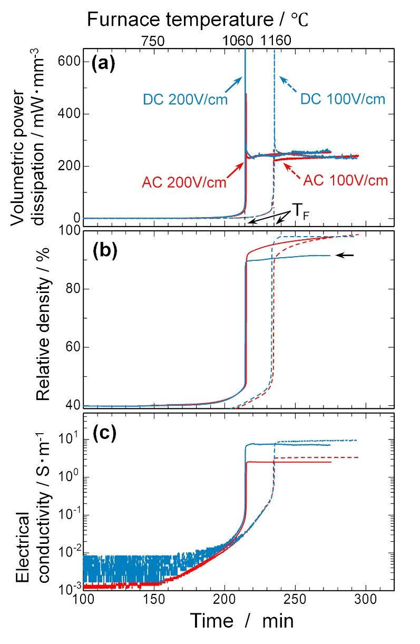

Figure 1. Variation of the (a) volumetric electric power dissipation, (b) relative density, and (c) electrical conductivity as a function of processing time. Furnace temperatures are presented on the upper horizontal axis for reference. The flash temperatures T_{F} are indicated in (a), defined as the furnace temperatures at which the volumetric power dissipation exhibits a spike.

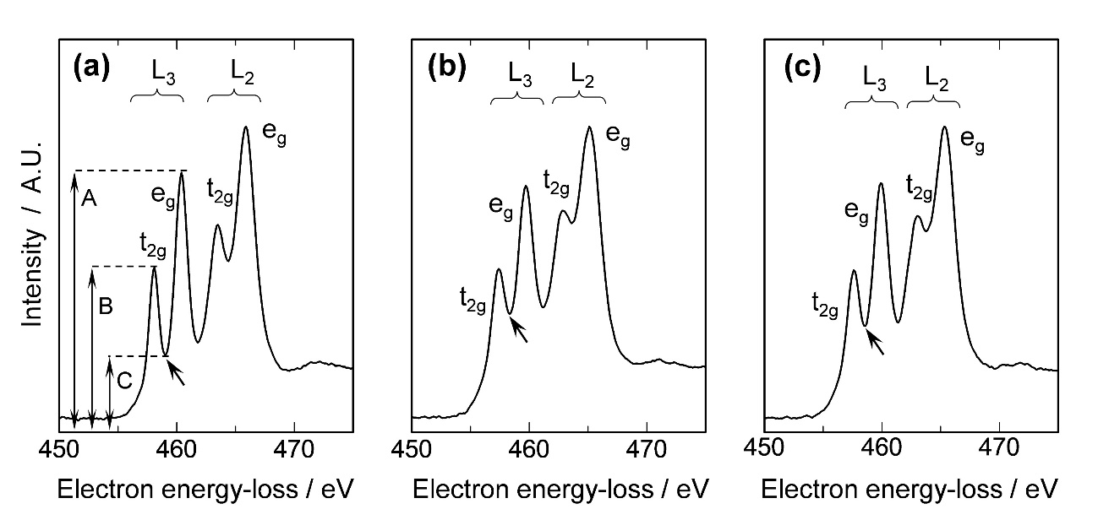

Figure 2. Ti L₂₃-edges taken from the grain interiors of (a) no-field, (b) DC-200, and (c) AC-200 samples. The black arrows mark the peak base between the L₃-e_{g} and t_{2g} peaks.

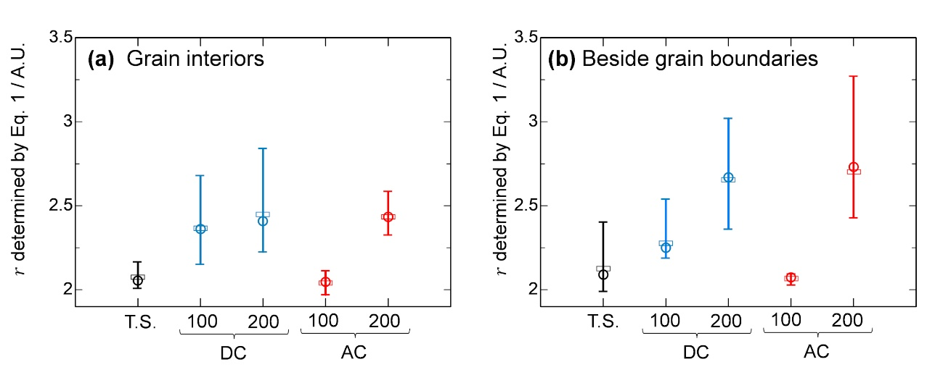

Figure 3. The $r$-values (the number of oxygen vacancies) were estimated using Eq. 1 for no-field (T.S.), DC-100, DC-200, AC-100, and AC-200 samples; (a) grain interior and (b) the region 10 nm away from grain boundaries. The hollow circles and rectangles show median and average values, respectively.

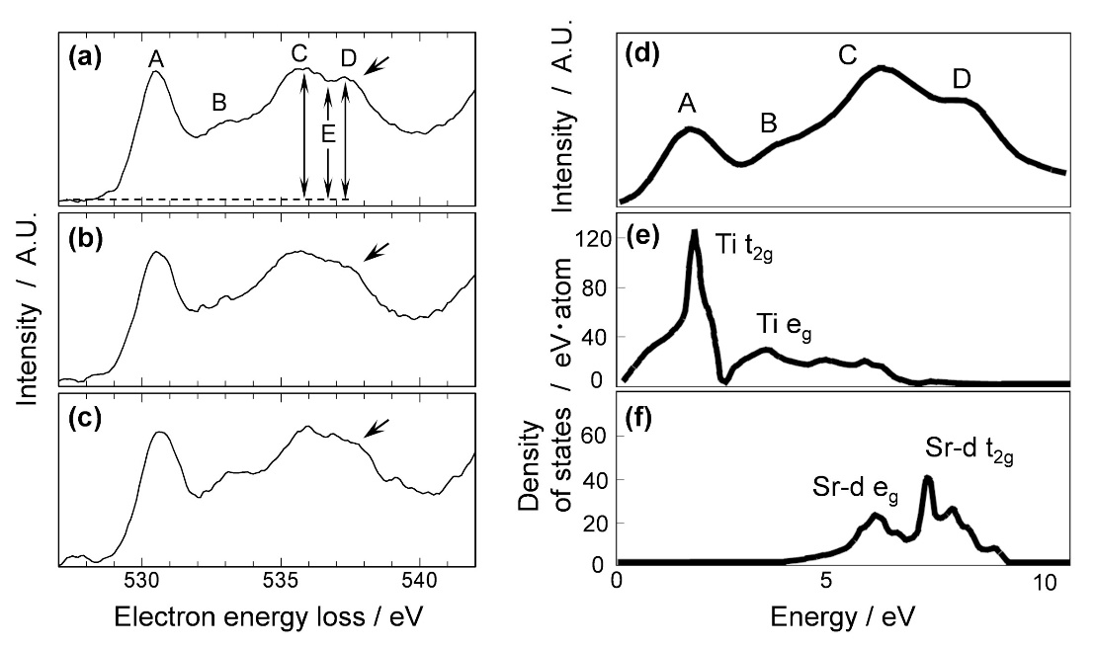

Figure 4. O K-edges taken from the grain interiors of (a) no-field, (b) DC-200, and (c) AC-200 samples. Referenced data replotted from Tomita et al. [30], showing (d) experimental O K-edge and theoretical PDOS for (e) Ti and (f) Sr.

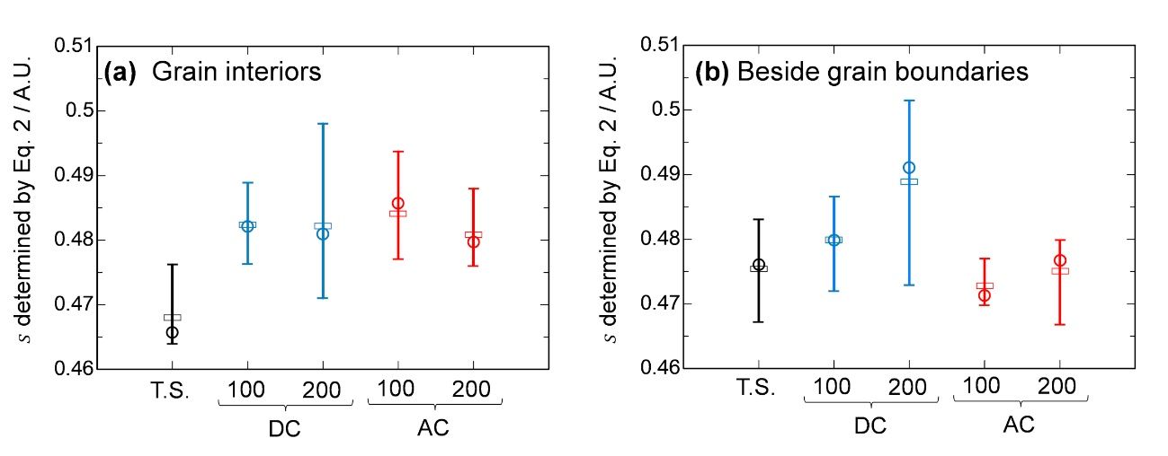

Figure 5. The $s$-values (the amount of Sr vacancies) were estimated using Eq. 2 for no-field (T.S.), DC-100, DC-200, AC-100, and AC-200 samples; (a) grain interior and (b) the region 10 nm away from grain boundaries. The hollow circles and rectangles show median and average values, respectively.

Table 1. Summary of the O and Sr vacancy variation after flash sintering.
A mark of ⤴ or → means that the vacancy content increases or remains similar to that observed in no-field samples, respectively.

 |  | DC electric field |  | AC electric field
 |  | 100 V/cm | 200 V/cm | 100 V/cm | 200 V/cm
V_{O} | GI | ⤴ | ⤴ | → | ⤴
V_{O} | Near GB | ⤴ | ⤴ | → | ⤴
V_{Sr} | GI | ⤴ | ⤴ | ⤴ | ⤴
V_{Sr} | Near GB | ⤴ | ⤴ | → | →

