Received 00th January 20xx,
- Center for Basic Research on Materials, National Institute for Materials Science, Sengen 1-2-1, Tsukuba, Ibaraki 305-0047, Japan. E-mail: ONODERA.Yohei@nims.go.jp
- Department of Materials and Chemistry, National Institute of Advanced Industrial Science and Technology, 1-8-31 Midorigaoka, Ikeda, Osaka 563-8577, Japan

Accepted 00th January 20xx
DOI: 10.1039/x0xx00000x

Formation of two distinct intermediate-range orders in P₂O₅ glass revealed through the combination of diffraction, modelling, and topological analysis
Yohei Onodera,*ª Hirokazu Masai ^{b,a} and Shinji Kohara ª
Phosphorus pentoxide (P₂O₅) is a representative network-forming oxide composed of Q³ tetrahedral motifs, in which each phosphorus atom is bonded to three bridging oxygens (BOs) and one non-bridging oxygen (NBO). To elucidate the intermediate-range order in P₂O₅ glass associated with diffraction peaks observed in neutron and X-ray data, we constructed a three-dimensional structure model that reproduces the experimental data accurately using a combination of reverse Monte Carlo and classical molecular dynamics simulations. Analysis of Faber–Ziman and Bhatia–Thornton partial structure factors reveals that the three diffraction peaks observed in the neutron structure factor consist of a doublet first sharp diffraction peak (FSDP) and a single principal peak. Ring size distributions show that P₂O₅ glass exhibits a broader distribution than SiO₂ glass with Q⁴ tetrahedral motifs, reflecting the presence of large rings associated with the Q³ network. Furthermore, the lower-Q FSDP (FSDP1) originates from periodic correlations in the P–BO network formed by the linkage of large rings, whereas the higher-Q FSDP (FSDP2) arises from shorter-range correlations associated with the formation of atomic arrangement of P and NBO atoms within these large rings. These results demonstrate the coexistence of two distinct intermediate-range orders with different characteristic length scales in P₂O₅ glass, providing a comprehensive topological understanding of its unique network structure.
- Introduction
Glass is one of the oldest known materials and remains widely utilized in modern industry. Its physicochemical properties depend strongly on composition and can be systematically tuned by incorporating network modifiers, such as alkali metal oxides and alkaline earth oxides, which are predominantly ionic, into network-forming oxides with strong covalent bonding. However, the fundamental properties of glasses, including transparency, mechanical strength, and chemical durability, are primarily governed by the network-forming oxides. Phosphorus pentoxide (P₂O₅) is classified as a prototypical network-forming oxide together with silica (SiO₂), boron trioxide (B₂O₃), and germanium dioxide (GeO₂).^{1–3} P₂O₅ glass exhibits characteristic properties, including low melting and softening temperatures,₄ high ultraviolet transmittance, and a high thermal expansion coefficient,⁵ but also shows poor chemical durability and pronounced hygroscopicity. Accordingly, P₂O₅-based (phosphate) glasses are archetypical oxide glasses with significant potential for applications, including lead-free low-temperature sealing glasses,^{6,7} biocompatible glasses,^{8,9} rare-earth-ion hosts for solid-state lasers,^{10–12} and rubber-like glasses exhibiting entropic elasticity.¹³
The structure of P₂O₅ glass has been extensively studied by neutron diffraction (ND),^{14,15} X-ray diffraction (XRD),¹⁶ Raman spectroscopy,¹⁷ and ³¹P MAS NMR spectroscopy.¹⁸ These studies have shown that the short-range structural units in P₂O₅ glass are PO₄ tetrahedra, and that the glass structure can be described as a network formed by corner-sharing PO₄ tetrahedra. Although this network structure is similar to that of other tetrahedral network glasses, such as SiO₂ and GeO₂, an important distinction of P₂O₅ glass is that each PO₄ tetrahedron contains one short P=O double bond and three longer P–O single bonds. The former oxygen terminates the network and is referred to as a non-bridging oxygen (NBO), whereas the latter three oxygens can be shared by other PO₄ tetrahedra to form corner-sharing P–O–P linkages and are referred to as bridging oxygens (BOs). The local structural and chemical order within the tetrahedral network is commonly described using Q^{n} species, where n denotes the number of BOs per tetrahedron. In the ideal network structure of P₂O₅ glass, each PO₄ tetrahedron possesses three BOs and one NBO, and is thus classified as Q³ units. From ND and high-energy XRD measurements,^{14–16} the short-range Q³ structure in P₂O₅ glass has been well established, with P=O and P–O bond lengths of 1.43 Å and 1.58 Å, respectively.
Elucidating glass structure beyond the first coordination distance, commonly referred to as intermediate-range order, remains challenging due to the absence of translational symmetry. In addition to molecular dynamics (MD) simulations, reverse Monte Carlo (RMC) modelling¹⁹ has been widely used to generate three-dimensional atomic configurations consistent with given diffraction data. To investigate the intermediate-range order of P₂O₅ glass, Hoppe performed RMC modelling on the basis of neutron and X-ray diffraction data, imposing geometric constraints on NBOs and BOs to reproduce Q³ units.²⁰ The resulting RMC model suggested the formation of flattened network cages and attributed the first peak observed at Q ~ 1.3 Å^{–1} in the X-ray and neutron structure factors to a characteristic lateral cage dimension of approximately 4.7 Å. However, although multiple diffraction peaks are observed in the structure factors of P₂O₅ glass, their structural origins remain unclear. In particular, while the lowest-Q peak has been attributed to cage-like structures, the origins of the other peaks have not been systematically clarified. This limitation largely stems from the lack of effective structural descriptors for analysing atomic configurations in disordered materials; however, recent advances in simulation and analytical techniques have enabled more detailed investigations of disordered arrangements,^{21,22} particularly through topological analyses for characterizing ring size distribution²³ and cavities.²⁴
In this work, we aim to elucidate the intermediate-range order in P₂O₅ glass by investigating the origin of the diffraction peaks. To this end, we construct a reliable structural model of P₂O₅ glass using combined RMC–MD modelling^{25,26} in conjunction with ND and high-energy XRD data. Ring size distribution and cavity analyses are applied to the resulting model to identify the structural origins of the diffraction peaks. Our results reveal the formation of two distinct intermediate-range orders with different length scales, arising from inter-ring and intra-ring correlations. Such coexistence has not been reported for typical network-forming oxides such as SiO₂ and is therefore considered a unique structural feature of P₂O₅ glass. Furthermore, these intermediate-range orders can be rationalized as emerging from Q³ structural units, which act as the fundamental motifs governing the short-range order in P₂O₅ glass. Understanding these structural origins is essential for linking diffraction pattens to network topology in disordered materials.
- Methods
2.1 Diffraction theory
High-quality ND and high-energy XRD data for P₂O₅^{14,16} and SiO₂²⁶ glasses were obtained from the literatures. According to the original report,²⁷ the P₂O₅ glass used in the diffraction experiments was prepared by a rapid quenching method. A high-purity P₄O₁₀ powder was quickly loaded into a SiO₂ glass tube, which was immediately evacuated and sealed to minimize water adsorption (estimated to be at most 0.04 mol%). The sealed tube was melted at 1050 ℃ for 2 h, tempered at 600 ℃, and then cooled down by switching off the oven. For the SiO₂ glass, synthetic fused SiO₂ purchased from Tosoh Corp. was used in the diffraction experiments. For binary glassy systems such as P₂O₅ (A₂X₅) and SiO₂ (AX₂), the normalized coherent scattering intensity obtained by ND and XRD can be expressed in terms of the total structure factor:

$\text{S}\left(\text{Q}\right)\text{ = 1 +}\frac{{\text{c}}_{\text{A}}^{\text{2}}{\text{w}}_{\text{A}}^{\text{2}}\text{(}\text{Q}\text{)}}{{\left|\left\langle \text{w}\text{(}\text{Q}\text{)}\right\rangle \right|}^{\text{2}}}\left[{\text{S}}_{\text{AA}}\text{(}\text{Q}\text{) – 1}\right]$
$\text{+}\frac{\text{2}{\text{c}}_{\text{A}}{\text{c}}_{\text{X}}{\text{w}}_{\text{A}}\text{(}\text{Q}\text{)}{\text{w}}_{\text{X}}\text{(}\text{Q}\text{)}}{{\left|〈\text{w}\text{(}\text{Q}\text{)}〉\right|}^{\text{2}}}\left[{\text{S}}_{\text{AX}}\text{(}\text{Q}\text{) – 1}\right]\text{+}\frac{{\text{c}}_{\text{X}}^{\text{2}}{\text{w}}_{\text{X}}^{\text{2}}\text{(}\text{Q}\text{)}}{{\left|〈\text{w}\text{(}\text{Q}\text{)}〉\right|}^{\text{2}}}\left[{\text{S}}_{\text{XX}}\text{(}\text{Q}\text{) – 1}\right]$, (1)

where c_{α} is the atomic fraction of chemical species α; w_{α}(Q) is either a Q-independent coherent scattering length in ND or a Q-dependent atomic form factor with dispersion terms in XRD and is generally a complex number; S_{αβ}(Q) is a Faber–Ziman (FZ)²⁸ partial structure factor; and ${\left|〈\text{w}\text{(}\text{Q}\text{)}〉\right|}^{\text{2}}\text{= }\sum_{\text{α}\text{=1}}^{\text{n}}{\sum_{\text{β}\text{=1}}^{\text{n}}{{\text{c}}_{\text{α}}{\text{c}}_{\text{β}}{\text{w}}_{\text{α}}^{\text{*}}\text{(}\text{Q}\text{)}{\text{w}}_{\text{β}}\text{(}\text{Q}\text{)}}}$. These partial structure factors are related to the partial pair-distribution functions, g_{αβ}(r), through the Fourier transform relation:

${\text{g}}_{\text{αβ}}\text{(}\text{r}\text{) = 1 + }\frac{\text{1}}{\text{2}{\text{π}}^{\text{2}}\text{rρ}}\int_{{\text{Q}}_{\text{min}}}^{{\text{Q}}_{\text{max}}}{\left[{\text{S}}_{\text{αβ}}\left(\text{Q}\right)\text{ – 1}\right]}\text{sin}\left(\text{Qr}\right)\text{d}\text{Q}$, (2)

where ρ is the atomic number density of the glass. The full set of S_{αβ}(Q) for P₂O₅ and SiO₂ glasses can be obtained from the Fourier transform of the g_{αβ}(r) extracted from the three-dimensional atomic configurations generated by our structure-modelling procedure:

${\text{S}}_{\text{αβ}}\left(\text{Q}\right)\text{ = 1 + }\int_{{\text{r}}_{\text{min}}}^{{\text{r}}_{\text{max}}}{\text{4π}{\text{r}}^{\text{2}}\text{ρ}\left[{\text{g}}_{\text{αβ}}\left(\text{r}\right)\text{ – 1}\right]}\frac{\text{sin}\left(\text{Qr}\right)}{\text{Qr}}{\text{d}\text{r}}$. (3)

The total structure factor can also be written in terms of the Bhatia–Thornton²⁹ number–number, concentration–concentration, and number–concentration partial structure factors, denoted by S_{NN}(Q), S_{CC}(Q), and S_{NC}(Q), respectively, where

$$\text{S}\left(\text{Q}\right)\text{ = }{\left\langle \text{w}\text{(}\text{Q}\text{)}\right\rangle }^{\text{2}}\left[{\text{S}}_{\text{NN}}\text{(}\text{Q}\text{) – 1}\right]$$
$$\text{+ }{\text{c}}_{\text{A}}{\text{c}}_{\text{X}}{\left({\text{w}}_{\text{A}}\left(\text{Q}\right)\text{ – }{\text{w}}_{\text{X}}\left(\text{Q}\right)\right)}^{\text{2}}\text{×}\left\{\left[{\text{S}}_{\text{CC}}\text{(}\text{Q}\text{)/}{\text{c}}_{\text{A}}{\text{c}}_{\text{X}}\right] \text{–} \text{1}\right\}$$
$\text{+ 2}\text{〈}\text{w}\text{(}\text{Q}\text{)}\text{〉}\left({\text{w}}_{\text{A}}\left(\text{Q}\right)\text{ – }{\text{w}}_{\text{X}}\left(\text{Q}\right)\right){\text{S}}_{\text{NC}}\text{(}\text{Q}\text{)}$, (4)

and $〈\text{w}\text{(}\text{Q}\text{)}〉\text{ = }{\text{c}}_{\text{A}}{\text{w}}_{\text{A}}\text{(}\text{Q}\text{)}+{\text{c}}_{\text{X}}{\text{w}}_{\text{X}}\text{(}\text{Q}\text{)}\text{.}$ The Bhatia–Thornton (BT) structure factors, S_{ij}(Q) (i, j = N, C), are related to the FZ partial structure factors S_{αβ}(Q) via the following relations:

${\text{S}}_{\text{NN}}\text{(}\text{Q}\text{) = }{\text{c}}_{\text{A}}{\text{S}}_{\text{AA}}\left(\text{Q}\right)\text{ + }{\text{c}}_{\text{X}}{\text{S}}_{\text{XX}}\left(\text{Q}\right)\text{ + 2}{\text{c}}_{\text{A}}{\text{c}}_{\text{X}}{\text{S}}_{\text{AX}}\left(\text{Q}\right)\text{,}$ (5)

${ \text{S}}_{\text{CC}}\text{(}\text{Q}\text{) = }{\text{c}}_{\text{A}}{\text{c}}_{\text{X}}\left\{\text{1 + }{\text{c}}_{\text{A}}{\text{c}}_{\text{X}}\left[{\text{S}}_{\text{AA}}\left(\text{Q}\right)\text{ + }{\text{S}}_{\text{XX}}\left(\text{Q}\right)\text{ – 2}{\text{S}}_{\text{AX}}\left(\text{Q}\right)\right]\right\}\text{,}$ (6)

${ \text{S}}_{\text{NC}}\text{(}\text{Q}\text{) = }{\text{c}}_{\text{A}}{\text{c}}_{\text{X}}\left\{{\text{c}}_{\text{A}}\left[{\text{S}}_{\text{AA}}\left(\text{Q}\right)\text{ – }{\text{S}}_{\text{AX}}\left(\text{Q}\right)\right] \text{– }{\text{c}}_{\text{X}}\left[{\text{S}}_{\text{XX}}\left(\text{Q}\right)\text{ – }{\text{S}}_{\text{AX}}\left(\text{Q}\right)\right]\right\}\text{.}$ (7)

S_{NN}(Q) describes correlations between atoms irrespective of chemical species, i.e., it provides information on topological order. S_{CC}(Q) provides information on the chemical ordering of species A (P or Si) and X (O). In contrast, S_{NC}(Q) represents the cross-correlation between number-density and concentration fluctuations, and therefore describes the coupling between topological and chemical ordering. A more detailed description, focused on AX₂ systems within the Bhatia–Thornton formalism, is given elsewhere.^{30,31}

2.2 Structure modelling
We combined classical MD simulation in the NVT ensemble with RMC modelling for structure modelling. MD simulations were performed using the large-scale atomic/molecular massively parallel simulator (LAMMPS) package³² and RMC modelling was carried out using the RMC++ code.³³
For P₂O₅ glass, the initial configuration, which contained 10500 particles (P: 3000, O: 7500), was generated using hard-sphere Monte Carlo (HSMC)²⁵ simulations. The atomic number density is 0.07083 Å^{–3}; this value corresponds to a mass density of 2.385 g cm^{–3}.¹⁵ The r-spacing for the calculations of the partial pair-distribution functions was set to 0.05 Å. Two types of constraints were applied: (i) the closest atom–atom approach to avoid unphysical spikes in the partial pair-distribution functions, and (ii) a P–O connectivity constraint requiring each phosphorus atom to be coordinated by four oxygen atoms within a cutoff distance of 1.75 Å that corresponds to the first minimum of the P–O peak in the pair distribution function of P₂O₅ glass. In addition, fixed-neighbour constraints³⁴ were applied for P–O distances (1.55–1.75 Å) and P=O distances (1.40–1.55 Å) to reproduce the Q³ network structure. The atomic configuration created by HSMC simulation was subsequently refined by RMC modelling to reproduce the neutron S(Q)¹⁴ and X-ray S(Q).¹⁶ Following the RMC modelling, the atomic configuration was optimised by energy minimisation using a Buckingham potential embedded in the MD simulator:

$\text{V}\left({\text{r}}_{\text{ij}}\right) \text{=} \frac{{\text{q}}_{\text{i}}{\text{q}}_{\text{j}}}{\text{4π}{\text{ε}}_{\text{0}}{\text{r}}_{\text{ij}}} \text{+} {\text{A}}_{\text{ij}}\text{exp}\left(\frac{\text{–}{\text{r}}_{\text{ij}}}{{\text{ρ}}_{\text{ij}}}\right) \text{–} \frac{{\text{C}}_{\text{ij}}}{{\text{r}}_{\text{ij}}^{\text{6}}}$, (8)

where r_{ij} is the interatomic distance and q_{i} is the effective charge on atom i (q_{P} = +2.80, q_{O} = –1.12). The potential parameter A_{ij} values are 27722 eV (P–O), 1992 eV (O–O) or zero (P–P); the parameter ρ_{ij} values are 0.1819 Å (P–O), 0.3436 Å (O–O) or zero (P–P); and the parameter C_{ij} values are 86.86 eV Å^{–6} (P–O), 192.58 eV Å^{–6} (O–O) or zero (P–P) (with ε₀ = 8.854 × 10^{–12} C² N^{–1} m^{–2}). The parameters A_{ij}, ρ_{ij}, and C_{ij} can be found in Ref. 35. The optimisation of the atomic configuration was performed by minimising the energy using the conjugate-gradient method within the MD framework. This energy minimisation was specifically introduced to physically relax local geometric distortions (such as unphysical bond lengths or bond angles) generated during the initial RMC process. Following this energy minimisation step, the atomic configuration was further refined by RMC modelling while constraining the P–O and O–P coordination numbers, O–P–O bond angle distribution, and partial pair-distribution functions within the first coordination distance. This multi-step protocol was specifically adopted for P₂O₅ glass because reproducing the pure Q³ network topology is challenging using classical pair potentials alone.
For comparison, a three-dimensional structure model of SiO₂ glass containing 9000 atoms (Si: 3000, O: 6000) was constructed using combined MD–RMC modelling using the protocols described in Ref. 36. The MD simulation employed a Born–Mayer type pair potential, with charges q_{Si} and q_{O} set to + 2.4 and –1.2, respectively. The B_{ij} values were 21.39 × 10⁻¹⁶ J (Si–O), 0.6246 × 10⁻¹⁶ J (O–O) or zero (Si–Si); the R_{ij} values were 0.174 Å (Si–O), 0.362 Å (O–O) or zero (Si–Si). The initial atomic configuration randomly distributed in a cubic cell at the experimental atomic number density (0.06615 Å^{–3}). The MD simulation was performed with a time step of 1 fs in the NVT ensemble. The system was equilibrated at 4000 K for 20,000 time-steps, cooled to 300 K over 200,000 time-steps, and then equilibrated at 300 K for 50,000 time-steps. A Nosé–Hoover thermostat was used to control the temperature. The resulting configuration was refined by RMC modelling with constraints on the Si–O coordination number, O–Si–O bond angle distribution, and partial pair-distribution functions within the first coordination shell. The cutoff distance for constraints on coordination number and bond angle distribution was set to 1.90 Å, corresponding to the first minimum of the Si–O peak in the pair distribution function of SiO₂ glass.
Further technical details of structure modelling and a detailed evaluation for the modelled intermediate-range networks, especially regarding ring statistics, are provided in the Supporting Information (Sections S1 and S2).

2.3 Topological analyses
The bond-angle distribution B(θ) was calculated as the number of bonds between θ and θ + Δθ, which is dependent on the solid angle ΔΩ ∝ sinθ subtended at that value of θ. Thus, each bond angle distribution was plotted as B(θ)/sinθ to compensate for the effect of ΔΩ. The primitive (P–O)_{n} and (Si–O)_{n} ring size distributions for P₂O₅ and SiO₂ glasses were calculated using the R.I.N.G.S. code²³ with cutoff distances r_{P–O} = 1.75 Å and r_{Si–O} = 1.90 Å. The surface cavity analysis was performed using the pyMolDyn code²⁴ with a cutoff distance r_{c} = 2.50 Å, as used in previous studies.^{26,36}
- Results and discussion
3.1 Total structure factors
Figures 1(a) and (b) show the neutron and X-ray total structure factors, S(Q), for P₂O₅ glass, together with those calculated from the RMC–MD model. For comparison, experimental and calculated S(Q) for SiO₂ glass are also shown. All calculated S(Q) data reproduce the experimental data well. The first sharp diffraction peak (FSDP),^{37–40} which arises from periodic correlations between network cages in the corner-sharing SiO₄ tetrahedral network,⁴¹ is observed at Q = 1.5 Å^{–1} in both the neutron and X-ray S(Q) for SiO₂ glass. The second principal peak (PP) is observed at Q = 2.9 Å^{–1} only in the neutron S(Q) for SiO₂ glass because it reflects the packing of oxygen atoms at the corners of SiO₄ tetrahedra,^{42,43} to which neutrons are more sensitive. In contrast, P₂O₅ glass exhibits characteristic diffraction peaks in the low-Q region, with three distinct diffraction peaks in the neutron S(Q) and two peaks in the X-ray S(Q). The two low-Q peaks in the neutron S(Q) correspond to the two peaks in the X-ray S(Q) at Q = 1.3 Å^{–1} and 2.1 Å^{–1}, respectively, and are located on the lower- and higher-Q sides of the FSDP of SiO₂ glass. In contrast, the third peak in the neutron S(Q), observed at Q = 2.9 Å^{–1}, is positioned close to the PP of SiO₂ glass. These results indicate that P₂O₅ glass exhibits a more complex intermediate-range structural signature, reflecting the presence of multiple structural orders with different length scales compared with SiO₂ glass. To elucidate the atomic correlations underlying each diffraction peak, the partial structure factors calculated from the RMC–MD model were analysed.

3.2 Partial structure factors
Figure 2(a) compares the FZ partial structure factors, S_{αβ}(Q), between P₂O₅ and SiO₂ glasses. Note that the magnitude of the scattering vector, Q, is scaled by multiplying it by r_{A–X} (first coordination distance) obtained by a Fourier transform of S(Q) to eliminate differences in atomic size. In SiO₂ glass, all S_{αβ}(Q) exhibit a positive peak at the FSDP position (Qr_{A–X} = 2.5), while at the PP position (Qr_{A–X} = 4.7), positive Si–Si and O–O peaks overlap with a negative Si–O peak. In contrast, in P₂O₅ glass, the positive peaks of P–P, P–O, and O–O at the two low-Q peak positions (Qr_{A–X} = 2.0 and 3.2) are less clearly observed. At the third peak position (Qr_{A–X} = 4.5) in the neutron S(Q), although the peaks are broadened, positive P–P and O–O peaks overlap with a negative P–O peak.
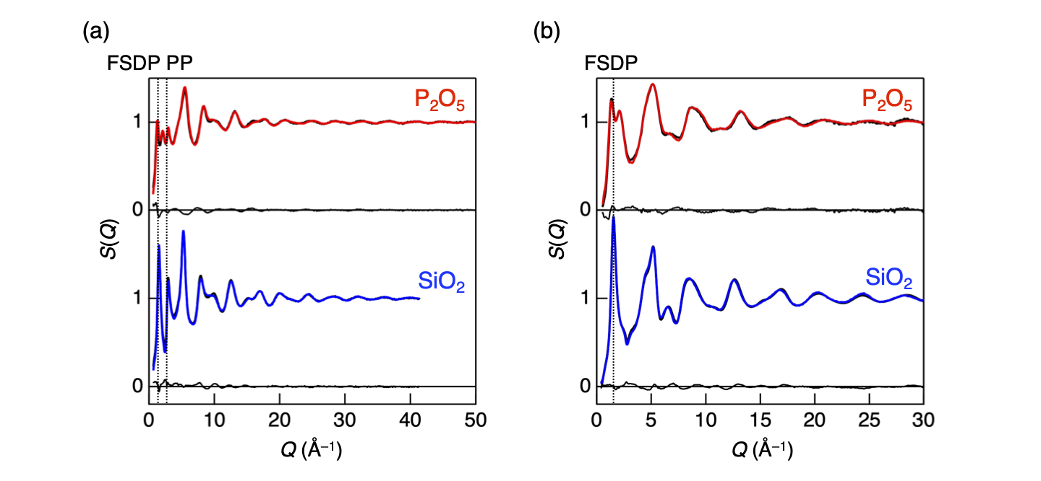
Fig. 1 (a) Neutron and (b) X-ray total structure factors, S(Q), for P₂O₅^{14,16} and SiO₂²⁶ glasses. Black solid curves represent experimental data, and coloured solid curves represent the calculated data obtained from the RMC–MD models, and the thin solid curves plotted at the bottom of each dataset represent the differences between the experimental and calculated data.
The partial pair distribution functions, g_{αβ}(r) (Fig. 2(b)), show very sharp P–O and Si–O peaks in both glasses; in particular, the P=O (NBO) bond at 1.42 Å and the P–O (BO) bond at 1.58 Å can be clearly distinguished in P₂O₅ glass. Table 1 summarizes the coordination-number distributions and polyhedral connections calculated from the RMC–MD model of P₂O₅ glass together with those for SiO₂ glass. For both glasses, the coordination number of oxygen atoms around phosphorus or silicon atoms (N_{A–X}) is 4.0. In contrast, the coordination number of phosphorus or silicon atoms around oxygen atoms (N_{X–A}) is 1.6 for P₂O₅ and 2.0 for SiO₂, reflecting the presence of NBOs in P₂O₅ glass. The fraction of NBOs in the total number of oxygen atoms is fixed at 40% based on previous experimental studies^{14–18} and is imposed as a constraint in the RMC–MD modelling. Consistently, each phosphorus atom is bonded to one NBO and three BOs (N_{P–NBO} = 1 and N_{P–BO} = 3), indicating that the ideal Q³ network structure of P₂O₅ glass is reliably reproduced in the present model. Furthermore, both PO₄ and SiO₄ tetrahedra are interconnected via 100% corner-sharing (Table 1), consistent with Zachariasen’s glass-forming rules.¹ To highlight the structural validity of the present model, it is worth comparing our results with the previously reported RMC model derived from the same datasets by Hoppe.²⁰ While the model achieved an excellent fit to the experimental structure factors, it reproduced only approximately 82% of the P atoms belonging to Q³ units. In contrast, our RMC–MD model successfully achieves a Q³ fraction of nearly 100%, which is much closer to the ideal network configuration of pure P₂O₅ glass. Furthermore, the physically unrealistic spikes that were observed in the partial g_{αβ}(r) of the previous study²⁰ have been completely eliminated in our model (Fig. 2(b)). These improvements explicitly demonstrate that our approach successfully constructs a markedly reasonable and physically consistent atomic arrangement in real space while maintaining the excellent fitting to the experimental structure factors. A detailed comparison with the previous RMC model is provided in the Supporting Information (Section S3, Figs. S1 and S2).
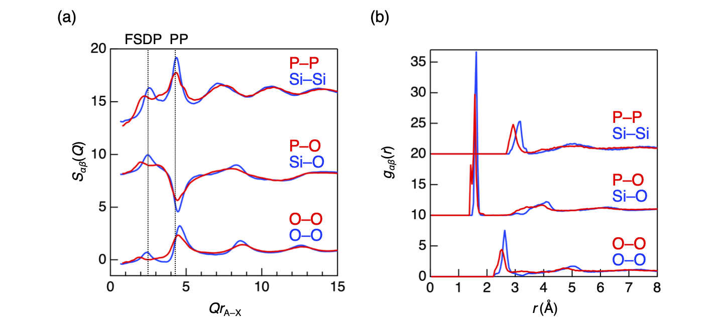
Fig. 2 (a) Faber–Ziman partial structure factors, S_{αβ}(Q), and (b) partial pair distribution functions, g_{αβ}(r), for P₂O₅ (red) and SiO₂ (blue) glasses. The magnitude of the scattering vector, Q, is scaled by multiplying it by r_{A–X} (the first coordination distance) in panel (a).
Table 1 Distributions of coordination number and polyhedral connection in P₂O₅ and SiO₂ glasses
 | N_{A–X} (%) |  |  | N_{X–A} (%) |  |  | Polyhedral connection (%)
 | 3 | 4 | 5 | 1 | 2 | 3 | Corner | Edge | Face
P₂O₅ glass | 0.1 | 99.9 | 0.1 | 40.0 | 60.0 | 0.0 | 100.0 | 0.0 | 0.0
SiO₂ glass | 0.1 | 99.8 | 0.1 | 0.0 | 99.9 | 0.1 | 100.0 | 0.0 | 0.0

The bond-angle distributions calculated from the RMC–MD models (Fig. 3(a)) show that both O–P–O and O–Si–O bond angles exhibit sharp peaks around 109°, indicating that PO₄ and SiO₄ tetrahedra retain nearly ideal tetrahedral geometry. In contrast, the other bond angles related to inter-tetrahedral correlations, particularly the P–P–P bond angles, are significantly broader in P₂O₅ glass than in SiO₂ glass, suggesting a higher degree of structural disorder at the intermediate-range scale. These results are consistent with the FZ partial structure factors (Fig. 2(a)), particularly at the characteristic peak positions in the low-Q region. Therefore, while well-defined PO₄ tetrahedra establish robust short-range order, the intermediate-range structure in P₂O₅ glass is more disordered than that in SiO₂ glass.
Figure 4 compares the BT partial structure factors, S_{ij}(Q) between P₂O₅ and SiO₂ glasses. In P₂O₅ glass, the S_{NN}(Q) exhibits a clear doublet peak close to the FSDP of SiO₂ glass, while the S_{CC}(Q) exhibits a peak close to the PP of SiO₂ glass, indicating that the two low-Q peaks in the neutron S(Q) (and the corresponding two peaks in the X-ray S(Q)) correspond to the FSDP, and the third peak observed only in the neutron S(Q) corresponds to the PP in P₂O₅ glass. In AX₂ network-forming glasses including SiO₂, the FSDP in S_{NN}(Q) reflects topological ordering, whereas chemical ordering is captured in S_{CC}(Q).^{30,44,45} In SiO₂ glass, the FSDP appears predominantly in the S_{NN}(Q), indicating that it originates from topological ordering of the SiO₄ tetrahedral network at the intermediate-range scale. The S_{CC}(Q) in SiO₂ glass exhibits a well-defined PP, demonstrating a high degree of chemical ordering associated with the alternating Si–O network, while the cross-correlation term S_{NC}(Q) is small, indicating weak coupling between number-density and concentration fluctuations. These features are consistent with the fully interconnected Q⁴ network of SiO₂ glass, resulting in a highly regular and uniform intermediate-range order with a single dominant length scale.
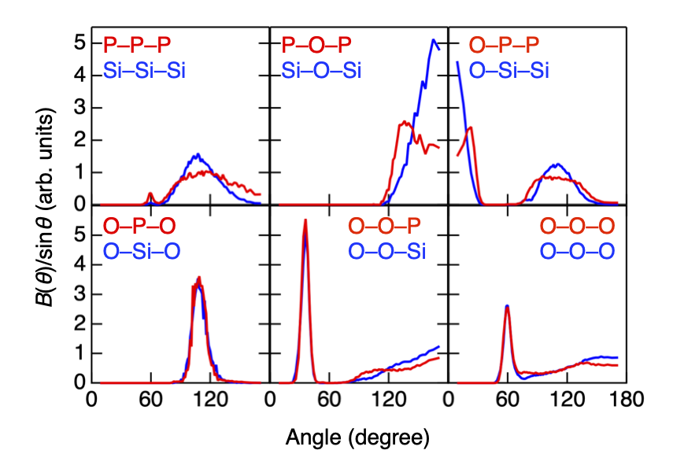
Fig. 3 Bond-angle distributions for P₂O₅ (red) and SiO₂ (blue) glasses.
In contrast, the present results for P₂O₅ glass reveal a qualitatively different behaviour. The doublet FSDP in S_{NN}(Q) indicates the coexistence of multiple topological ordering with distinct length scales. This topological ordering arises from the Q³ network, giving rise to distinct intermediate-range correlations. The presence of NBOs partially disrupts the PO₄ tetrahedral network, resulting in a distribution of intermediate-range correlations that is broader and less regular than the fully interconnected Q⁴ network in SiO₂ glass. Furthermore, the PP observed in the S_{CC}(Q) is primarily associated with chemical ordering, analogous to that in SiO₂ glass, but with a broader character, reflecting increased structural disorder in local environments due to the coexistence of BOs and NBOs. Thus, the Q³ structural motif in P₂O₅ glass establishes robust short-range tetrahedral order while simultaneously giving rise to multiple forms of topological ordering at the intermediate range, in sharp contrast to the uniform Q⁴ network of SiO₂ glass. These results highlight the greater structural complexity of P₂O₅ glass, arising from multiple intermediate-range orders manifested by the Q³ network, which will be explored in terms of ring size distributions and cavity analyses in the following sections.
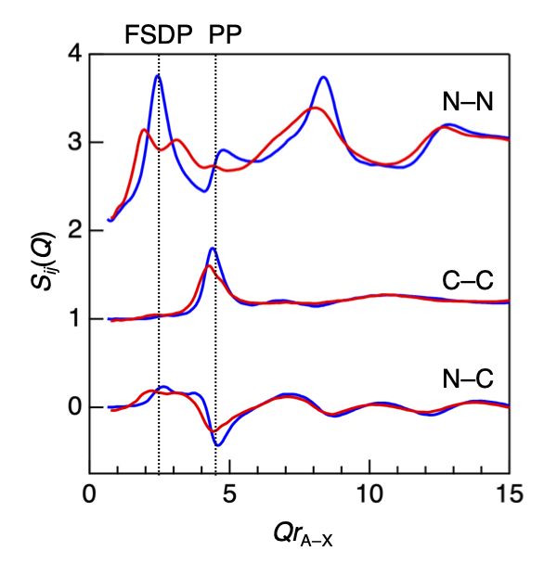
Fig. 4 Bhatia–Thornton partial structure factors, S_{ij}(Q), for P₂O₅ (red) and SiO₂ (blue) glasses. The magnitude of the scattering vector, Q, is scaled by multiplying it by r_{A–X} (the first coordination distance).
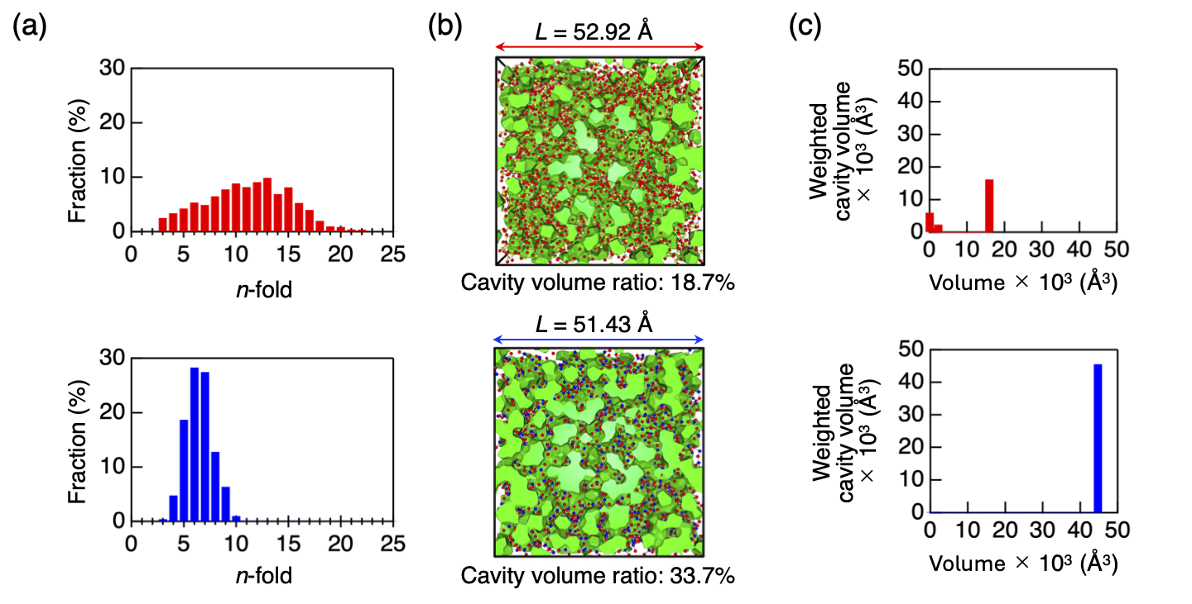
Fig. 5 (a) Primitive ring size distribution, (b) visualisation of surface-based cavities, and (c) weighted surface-based cavity volume distributions for P₂O₅ (upper panels) and SiO₂ (lower panels) glasses. In the visualisations, yellow, blue, and red spheres represent P, Si, and O atoms, respectively, and green regions represent the cavities.
3.3 Ring size distribution and cavity analyses
Figure 5(a) shows the primitive (P–O)_{n} and (Si–O)_{n} ring size distributions calculated from the RMC–MD models. The ring size distribution provides a direct representation of the topological features associated with the Q³ and Q⁴ networks. It is well known that SiO₂ glass shows a broad ring size distribution,⁴⁶ with six-fold rings, corresponding to the only possible ring structures in the crystalline phase with comparable density (cristobalite),⁴¹ being most frequent. This broad distribution is a key feature of glass and is often described as “topological disorder”.⁴⁷ Here, this term may be understood as reflecting the absence of a unique network topology and the resulting structural diversity at the intermediate-range scale. P₂O₅ glass exhibits an even broader distribution due to the presence of NBOs, which disrupt the PO₄ tetrahedral network, leading to the formation of large rings. Similar behaviour has been reported in silicate glasses, where the addition of alkali ions disrupts the Si–O network and generates NBOs, resulting in the formation of larger rings.²⁶ Notably, in P₂O₅ glass, the fraction of the larger rings (n ≥ 10) is approximately 65%, compared to only ~1% in SiO₂ glass. This broad and diverse ring size distribution highlights the significantly greater structural diversity at the intermediate-range in the Q³ network of P₂O₅ glass, which underlies the multiple forms of topological ordering observed in the S_{NN}(Q).
The surface-based cavities are visualised in Fig. 5(b). P₂O₅ glass exhibits a cavity volume ratio of 18.7%, whereas SiO₂ glass shows a larger, string-like cavity with a cavity volume ratio of 33.7%. Although the number density of P₂O₅ glass (0.07083 Å^{–3}) is greater than that of SiO₂ glass (0.06615 Å^{–3}), P₂O₅ glass contains a large number of large rings. Nevertheless, a significant reduction in the cavity volume ratio is observed in P₂O₅ glass compared with SiO₂ glass. In the cavity volume distributions (Fig. 5(c)), the volume of the largest cavity in P₂O₅ glass is 15483 Å³, whereas that in SiO₂ glass is 45600 Å³. Furthermore, the cavities in P₂O₅ glass are fragmented into smaller regions. These results suggest that the structure of P₂O₅ glass is more disordered. In particular, the significant reduction in the cavity volume ratio, despite the presence of larger rings, suggests that the ring geometry within the network is highly distorted in P₂O₅ glass, rather than forming open, continuous cavities. This implies that, although large rings are present, they do not contribute to extended cavities but instead form irregular and spatially constrained network topologies. These findings indicate that the complex topological ordering indicated by the S_{NN}(Q) for P₂O₅ glass is manifested in the formation of large, irregular rings, providing a real-space basis for the formation of the multiple intermediate-range orders in the Q³ network.

3.4 Two distinct intermediate-range orders in P₂O₅ glass
Figure 6(a) compares the neutron and X-ray total structure factors, S(Q), with the FZ partial structure factors, S_{αβ}(Q) for P₂O₅ glass. Note that S_{αβ}(Q) was calculated from the RMC–MD model by distinguishing BOs and NBOs to clarify the origins of the doublet FSDP. It is concluded that FSDP1, observed on the lower-Q side (Q = 1.3 Å^{–1}), arises from contributions from P–BO and BO–BO correlations, whereas FSDP2, observed on the higher-Q side (Q = 2.1 Å^{–1}), originates from P–NBO and NBO–NBO correlations. These results clearly demonstrate that the two FSDPs originate from distinct topological orderings associated with BO- and NBO-centred correlations. The associated intermediate-range orders have a periodicity of 2π/Q_{FSDP} and a coherence length of 2π/ΔQ_{FSDP}, where Q_{FSDP} and ΔQ_{FSDP} denote the position and the full width at half maximum of the FSDP.^{41,46,47} In the case of the two FSDPs in P₂O₅ glass, the periodicity and coherence length are 4.83 Å and 9.78 Å for FSDP1, and 3.00 Å and 5.01 Å for FSDP2, respectively. Based on these characteristic length scales, representative atomic configurations corresponding to the origins of the two FSDPs in P₂O₅ glass were extracted from the RMC–MD model (Figs. 6(b) and (c)). For FSDP1, the corresponding intermediate-range order can be interpreted as a periodic arrangement of the P–BO network extending across the cavities (highlighted in magenta in Fig. 6(b)). The flattened network cages reported by Hoppe²⁰ correspond to the cavities between the P–BO networks. This intermediate-range order is formed through inter-ring correlations and corresponds to the structure responsible for the FSDP in SiO₂ glass.⁴¹ In contrast, the intermediate-range order corresponding to FSDP2 can be identified as an intra-ring correlation associated with the atomic arrangement of P and NBO atoms within these larger rings. Figure 6(c) shows an enlarged view of the fourteen-fold ring highlighted in blue in Fig. 6(b). Periodic arrangements arising from P–NBO and NBO–NBO correlations give rise to an intermediate-range order with a shorter periodicity and coherence length (highlighted in blue in Fig. 6(c)), even though P and NBO atoms alone do not form a continuous network. These results provide a unified structural interpretation linking the doublet FSDP to two distinct topological ordering that exist on the intermediate-range scale in the Q³ network of P₂O₅ glass.
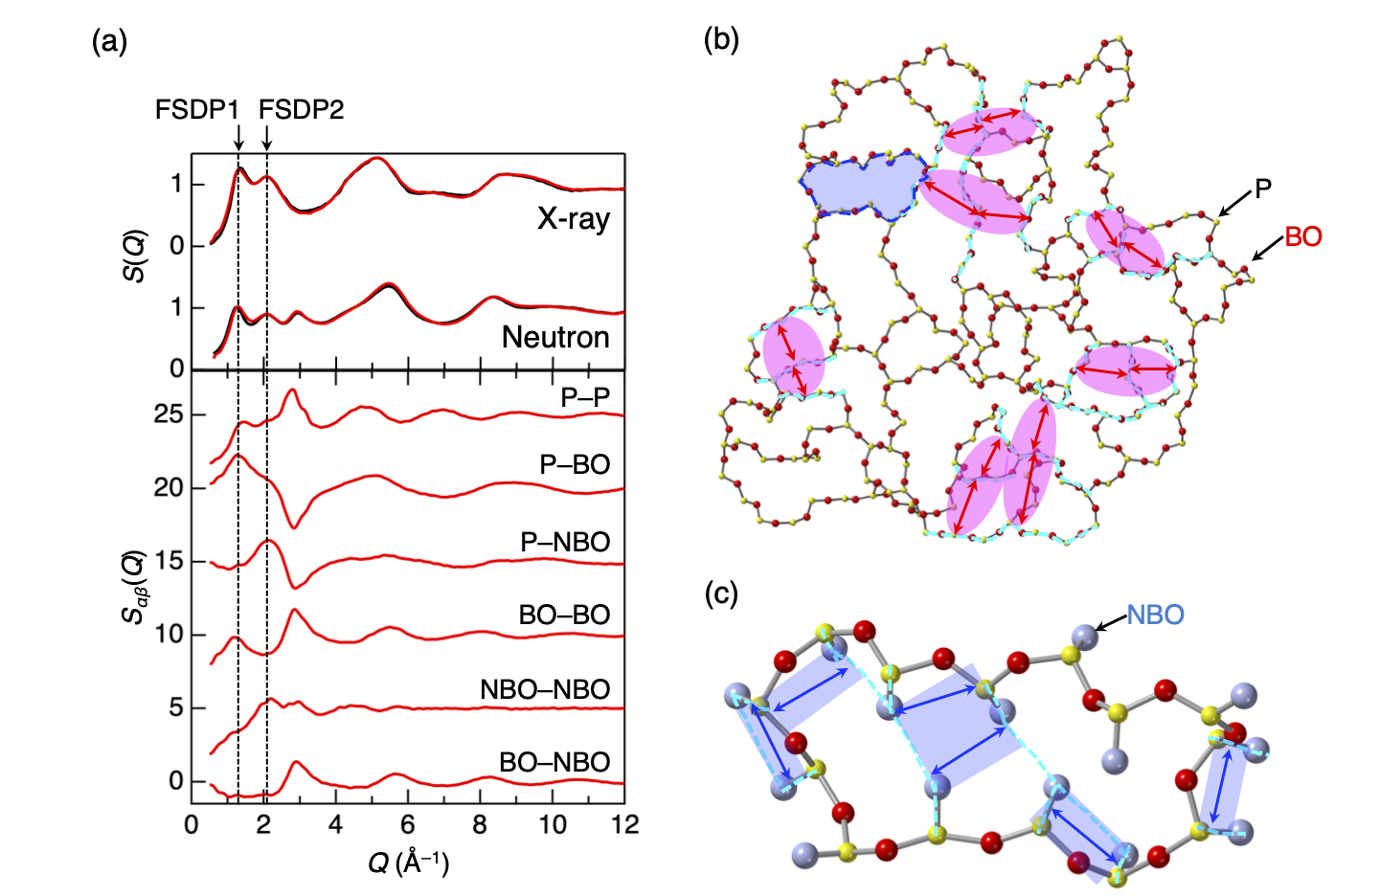
Fig. 6 (a) Neutron and X-ray total structure factors, S(Q), together with Faber–Ziman partial structure factors, S_{αβ}(Q). The S_{αβ}(Q) was calculated from the RMC–MD model by distinguishing bridging oxygen (BO) and non-bridging oxygen (NBO). Visualisation of (b) P–BO network and (c) fourteen-fold ring extracted from the RMC–MD-generated atomic configuration for P₂O₅ glass. The thickness of the cell is approximately 10 Å and only the atoms belonging to the network are shown in panel (b). In the visualisations, yellow, red, and light-blue spheres represent P, BO, and NBO, respectively. Red and blue arrows correspond to the periodicity of approximately 4.8 Å and 3.0 Å, respectively.
Our findings can be further discussed in relation to the densified low-hygroscopic form of P₂O₅ glass reported by Brazhkin et al.⁴⁸ In their study, the doublet FSDP observed under ambient conditions merges into a single peak upon high-pressure quenching, indicating a fundamental change in the intermediate-range structure. From the perspective of the present results, the doublet FSDP originates from two distinct intermediate-range orders associated with BO- and NBO-centred correlations, which exist on different length scales. The collapse of the doublet into a single FSDP upon densification therefore suggests that these two characteristic length scales converge into a more uniform intermediate-range order, analogous to that of SiO₂ glass. In this context, the coexistence of two distinct intermediate-range orders in P₂O₅ glass may be closely related to its hygroscopic nature, as the presence of large and irregular rings and cavities can facilitate water incorporation. Conversely, the emergence of a single intermediate-range order upon densification may underlie the enhanced water resistance of the glass. Although further experimental verification is required, the present results suggest that the nature of intermediate-range ordering, as reflected in the FSDP, provides a key structural descriptor linking the topology of the glass network to its macroscopic properties.
- Conclusions
In this study, we have revealed the structural origins of the diffraction peaks in P₂O₅ glass through combined neutron and X-ray diffraction data and reverse Monte Carlo–classical molecular dynamics modelling. The analysis of Faber–Ziman and Bhatia–Thornton partial structure factors demonstrates that the two FSDPs arise from distinct atomic correlations, indicating the coexistence of two different intermediate-range orders in the Q³ network of P₂O₅ glass. Ring size distribution and cavity analyses show that, despite the presence of large rings, P₂O₅ glass exhibits a reduced cavity volume and highly distorted ring geometries, indicating a more complex topological structure than that of SiO₂ glass. The characteristic length scales derived from the FSDPs further reveal that the FSDP at lower Q (FSDP1) corresponds to a longer-range periodicity associated with inter-ring correlations and cavity-spanning network structures, similar to the FSDP in SiO₂ glass. In contrast, the FSDP at higher Q (FSDP2) reflects a shorter-range ordering arising from intra-ring correlations involving non-bridging oxygens. This study provides a unified structural interpretation of the doublet FSDP in P₂O₅ glass, linking it to the coexistence of two distinct intermediate-range orders inherent to the Q³ network topology. While this study successfully establishes the topological baseline for the pure P₂O₅ glass dominated by Q³ units, practical phosphate glasses widely used in optical or biomedical applications typically contain network modifiers. Such modifiers disrupt the network to generate other species, such as Q² and Q¹ units, introducing chemical equilibria and spatial heterogeneities that are not directly captured in the current model. Nevertheless, the precise three-dimensional model developed here provides an indispensable prerequisite for modelling multi-component systems. Future research will envision extending this protocol by incorporating modifiers, allowing a systematic investigation of how the phosphate network topology evolves as it transitions from Q³ toward modifier-rich environments.
Author contributions
Y.O. and S.K. designed the study. Y.O. performed RMC–MD modelling. Y.O., H.M., and S.K. analysed the structural models. Y.O., H.M., and S.K. wrote the paper.
Conflicts of interest
The authors declare that they have no conflict of interest.
Data availability
The data that support the findings of this study are presented in the paper are available from the corresponding author upon reasonable request.
Acknowledgements
This work was partially supported by the Japan Society for the Promotion of Science (JSPS) Grant-in-Aid for Scientific Research (C) Number 19K05648, and JSPS Grant-in-Aid for Transformative Research Areas (A) "Hyper-Ordered Structures Science" (Grant Numbers 20H05878, 20H05881, and 20H05882). The authors are grateful to Prof. U. Hoppe for providing us with the experimental diffraction data.
References
- W. H. Zachariasen, J. Am. Chem. Soc, 1932, 54, 3841–3851.
- K. H. Sun, J. Am. Ceram. Soc., 1947, 30, 277–281.
- G. N. Greaves and S. Sen, Adv. Phys., 2007, 56, 1–166.
- S. W. Martin and C. A. Angell, J. Phys. Chem., 1986, 90, 6736–6740.
- E. T. Y. Lee and E. M. Taylor, in Trends in Optical Materials Research, ed. O. G. Gardens, Nova Science Publishers, Inc., New York, 2007, pp. 137–183.
- R. K. Brow and D. R. Tallant, J. Non-Cryst. Solids, 1997, 222, 396–406.
- T. Naito, A. Matsuda, D. Shiojiri, T. Aoyagi, Y. Sawai, T. Fujieda, S. Tachizono, K. Yoshimura, Y. Hashiba and M. Yoshimoto, J. Ceram. Soc. Jpn., 2013, 121, 452–456.
- L. L. Hench, R. J. Splinter and W. C. Allen, J. Biomed. Mater. Res., 1971, 2, 117–141.
- Ö. H. Andersson and K. H. Karlsson, J. Non-Cryst. Solids, 1991, 129, 145–151.
- J. H. Campbell and T. I. Suratwala, J. Non-Cryst. Solids, 2000, 263–264, 318–341.
- H. Masai, Y. Takahashi, T. Fujiwara, S. Matsumoto and T. Yoko, Appl. Phys. Express, 2010, 3, 082102.
- Y. C. Yan, A. J. Faber, H. de Waal, P. G. Kik and A. Polman, Appl. Phys. Lett., 1997, 71, 2922–2924.
- S. Inaba, H. Hosono and S. Ito, Nat. Mater., 2015, 14, 312–314.
- U. Hoppe, G. Walter, A. Barz, D. Stachel and A. C. Hannon, J. Phys. Condens. Matter, 1998, 10, 261–270.
- K. Suzuya, D. L. Price, C.-K. Loong and S. W. Martin, J. Non-Cryst. Solids, 1998, 232–234, 650–657.
- U. Hoppe, R. Kranold, A. Barz, D. Stachel and J, Neuefeind, Solid State Commun., 2000, 115, 559–562.
- F. L. Galeener and J. C. Mikkelsen Jr., Solid State Commun., 1979, 30, 505–510.
- R. K. Brow, D. R. Tallant, J. J. Hudgens, S. W. Martin and A. D. Irwin, J. Non-Cryst. Solids, 1994, 177, 221–228.
- R. L. McGreevy and L. Pusztai, Mol. Simulat., 1988, 1, 359–367.
- U. Hoppe, J. Phys. Condens. Matter, 2000, 12, 8809–8818.
- S. Kohara and P. S. Salmon, Adv. Phys.: X, 2016, 1, 640–660.
- S. Kohara, J. Ceram. Soc. Jpn., 2017, 125, 799–807.
- S. Le Roux and P. Jund., Comput. Mater. Sci., 2010, 49, 70–83.
- I. Heimbach, F. Rhiem, F. Beule, D. Knodt, J. Heinen and R. O. Jones, J. Comput. Chem., 2017, 38, 389–394.
- S. Kohara and L. Pusztai, in Computer Simulations of Glasses: Methodologies and Applications, ed. J. Du and A. N. Cormack, Wiley-American Ceramic Society, Hoboken, 2022, pp. 60–88.
- Y. Onodera, Y. Takimoto, H. Hijiya, T. Taniguchi, S. Urata, S. Inaba, S. Fujita, I. Obayashi, Y. Hiraoka and S. Kohara, NPG Asia Mater., 2019, 11, 75.
- K. Meyer, A. Barz and D. Stachel, J. Non-Cryst. Solids, 1995, 191, 71–78.
- T. E. Faber and J. M. Ziman, Phil. Mag., 1965, 11, 153–173.
- A. B. Bhatia and D. E. Thornton, Phys. Rev. B, 1970, 2, 3004.
- P. S. Salmon, Proc. R. Soc. Lond. A, 1992, 437, 591–606.
- P. S. Salmon, J. Phys.: Condens. Matter, 2007, 19, 455208.
- S. Plimpton, J. Comput. Phys., 1995, 117, 1–19.
- O. Gereben, P. Jóvári, L. Temleitner and L. Pusztai, J. Optelectron. Adv. Mater., 2007, 9, 3021–3027.
- G. Evrard and L. Pusztai, J. Phys. Condens. Matter, 2005, 17, S1–S13.
- E. B. Clark, R. N. Mead and G. Mountjoy, J. Phys.: Condens. Matter, 2006, 18, 6815.
- Y. Onodera, S. Kohara, P. S. Salmon, A. Hirata, N. Nishiyama, S. Kitani, A. Zeidler, M. Shiga, A. Masuno, H. Inoue, S. Tahara, A. Polidori, H. E. Fischer, T. Mori, S. Kojima, H. Kawaji, A. I. Kolesnikov, M. B. Stone, M. G. Tucker, M. T. McDonnell, A. C. Hanon, Y. Hiraoka, I. Obayashi, T. Nakamura, J. Akola, Y. Fujii, K. Ohara, T. Taniguchi and O. Sakata, NPG Asia Mater., 2020, 12, 85.
- D. L. Price, S. C. Moss, R. Reijers, M.-L. Saboungi and S. Susman, J. Phys. C Solid State Phys., 1988, 21, L1069–L1072.
- S. R. Elliott, Nature, 1991, 354, 445–452.
- P. S. Salmon, Proc. R. Soc. Lond. A, 1994, 445, 351–365.
- P. H. Gaskell and D. J. Wallis, Phys. Rev. Lett., 1996, 76, 66–69.
- Y. Onodera, S. Kohara, S. Tahara, A. Masuno, H. Inoue, M. Shiga, A. Hirata, K. Tsuchiya, Y. Hiraoka, I. Obayashi, K. Ohara, A. Mizuno and O. Sakata, J. Ceram. Soc. Jpn., 2019, 127, 853–863.
- P. S. Salmon and A. Zeidler, J. Stat. Mech. Theory E, 2019, 2019, 114006.
- P. S. Salmon, in Magmas Under Pressure: Advances in High-Pressure Experiments on Structure and Properties of Melts, ed. Y. Kono and C. Sanloup, Elsevier, Amsterdam, 2018, vol. 13, pp. 345–364.
- P. S. Salmon, R, A, Martin, P. E. Mason and G. J. Cuello, Nature, 2005, 435, 75–78.
- P. S. Salmon, A. C. Barnes, R. A. Martin and G. J. Cuello, Phys. Rev. lett., 2006, 96, 235502.
- S. Kohara, J. Akola, H. Morita, K. Suzuya, J. K. R. Weber, M. C. Wilding and C. J. Benmore, Proc. Natl. Acad. Sci. USA, 2011, 108, 14780–14785.
- P. K. Gupta and A. R. Cooper, J. Non-Cryst. Solids, 1990, 123, 14–21.
- V. V. Brazhkin, J. Akola, Y. Katayama, S. Kohara, M. V. Kondrin, A. G. Lyapin, S. G. Lyapin, G. Tricot and O. F. Yagaforav, J. Mater. Chem., 2011, 21, 10442.

