Tunable Heteroassembly of 2D CoNi LDH and Ti₃C₂ Nanosheets with Enhanced Electrocatalytic Activity for Oxygen Evolution

Xueyi Lu,^{a,†} Lulu Jia,^{b,†} Minchen Hou,ª Xuemin Wu,ª Chang Ni,ª
Gaofei Xiao,^{a,}* Renzhi Ma,^{b,}*, and Xia Lu^{a,}*

ªSchool of Materials, Sun Yat-sen University, Shenzhen 518107, P. R. China
^{b}Research Center for Materials Nanoarchitectonics, National Institute for Materials Science, Namiki 1-1, Tsukuba 305-0044, Japan
†These authors contribute equally to this work.

E-mails: xiaogf@mail.sysu.edu.cn; MA.Renzhi@nims.go.jp; luxia3@mail.sysu.edu.cn

Abstract: The sluggish kinetics of oxygen evolution reaction (OER) are bottlenecks to develop hydrogen energy based on water electrolysis, which can be significantly improved using high performance catalyst. In this context, the CoNi layered double hydroxide (LDH)/Ti₃C₂ heterostructures are obtained using electrostatic attraction of the positively charged LDH and negatively charged Ti₃C₂ nanosheets as catalyst to optimize the OER performance. Such alternately stacking exhibits good catalytic activity with a lower overpotential and a small Tafel slope, outperforming their individual components. The results by density functional theory (DFT) simulation find that the charge transfers from Ti₃C₂ to CoNi LDH, not only adjust the electron distribution, but also increase the electron density of the interfacial active sites, thus enhances the electron transfer efficiency inside the heterostructures. Moreover, the cobalt and nickel ions exhibit a synergistic effect in supplying more electrons to adsorb the adjacent intermediates with the active hydrogen and oxygen vacancies, to improve the adsorption capability and reduce the reaction energy barriers. These findings provide a rewarding avenue towards the design of highly efficient electrocatalysts for OER.

Keywords: Layered double hydroxide; Ti₃C₂; Heterostructure; Oxygen evolution reaction

1. Introduction
In the pursuit of carbon neutrality, the green hydrogen is considered as one of the cleanest energy sources due to its role as a clean and efficient energy carrier.¹ One of the most efficient methods for hydrogen production is the electrocatalytic water splitting, promising it an environmentally friendly and sustainable clean energy.² During the electrolysis of water for hydrogen production, the oxygen evolution reaction (OER) occurs at anode and hydrogen evolution reaction (HER) happens at cathode.³⁻⁵ Currently, the development of hydrogen energy is challenged by the OER due to the sluggish kinetics.⁶⁻⁸ Hence, the highly efficient catalysts are deserved to improve the OER kinetics for water electrolysis. Therefore, a majority of OER catalysts, such as the IrO₂ and RuO₂⁹⁻¹⁵ are made, while these valuable metal catalysts are limited and costly., which, in turn, put the low-cost and effective catalysts forward to be the central focus on developing high performance OER.
To this end, the layered double hydroxides made from non-precious metals possess unique physical and chemical properties, which are thermodynamically stable and versatile in compositions, interlayer anions and particle size.^{16, 17} Numerous studies have reported that the LDHs deliver high catalytic activity and stability towards OER, such as the NiFe LDH, CoFe LDH, and NiCr LDH,¹⁸⁻²³ which are considered as promising alternatives to precious metal electrocatalysts.^{24, 25} Although LDHs have shown unique advantages in electrocatalysis, their poor conductivity limits the charge transfer rate and their lamellae character tends to polymerize or agglomerate, which restricts the large-scale application of LDHs as efficient electrocatalysts.²⁶ Compositing various objects into heterostructures proves to be an efficient strategy to improve the performance, which can not only integrates the intrinsic advantages of each component, but also generates new particular physical or chemical properties.²⁷ In view of this, currently there have been some reports of heterostructures consisting of LDH and electroconductive components to improve the OER activity.²⁸⁻³¹ However, some heterostructures in previous reports are prepared by simple mixing, rarely considering their lattice compatibility and stack style, greatly discounting their synergy of catalytic activity. Moreover, some of the active and conductive components exist in multilayered structures, which can not be fully utilized in the catalytic process.
In this work, we report the synthesis of CoNi LDH/Ti₃C₂ superlattice heterostructures for OER to improve the electrochemical performance. As a typical two-dimensional (2D) transition metal carbide MXene³²⁻³⁵, the Ti₃C₂ is considered as an ideal material for widespread applications that features excellent electrical conductivity, chemical stability and large active surface area³⁶⁻³⁸. Based on this, the study combines the advantages of Ti₃C₂ and CoNi LDH to create a composite material by integrating monolayer CoNi LDH nanosheets with Ti₃C₂, resulting in the CoNi-LDH/Ti₃C₂ alternatively restacking. The combination of CoNi LDH and Ti₃C₂ not only reduces the internal electron transfer impedance within LDHs layers, but also suppresses their agglomeration, thereby enhancing the catalytic activity towards OER. Moreover, the similar layered structure, compatible crystal groups/crystal planes, and different charged groups of Ti₃C₂ and LDHs provide the LDHs- Ti₃C₂ composite material with high crystal lattice matching and structural stability. With significantly lower overpotential and a smaller Tafel slope, the CoNi-LDH/Ti₃C₂ composite material shows great potential for industrial applications.

2. Experimental Section

2.1. Preparation of catalysts
The multilayered CoNi LDH nanocones were prepared by a hydrothermal method. Firstly, the 2 mmol HMT (C6H12N4), 1.3 mmol SDS (C₁₂H₂₅SO₄Na) and stoichiometric 0.16 mmol Co(NO₃)₂∙6H₂O and 0.08 mmol Ni(NO₃)₂∙6H₂O were dispersed in 35 mL deionized water, followed by mixing homogeneously in a Teflon autoclave. Afterwards, the sealed autoclave was transferred into an oven and heated at 100 ℃ for 8 h. Next, the product was collected by centrifugation and rinsed by water and ethanol to remove residues. Finally, the sample was dried at 60 ℃ to attained the DS− intercalated CoNi LDH (nCo:nNi=2:1) nanocone powder.
The CoNi LDH nanosheets were prepared by exfoliating the as-prepared layered nanocones. First of all, the 0.05 g ion-intercalated hydroxide powder was firstly dispersed in 100 mL formamide and purged by N₂. Consequently, it was vibrated for 1 h to attain a homogeneous dispersion. The upper suspension was finally acquired by high-speed centrifugation (12000 rpm) for 20 min. The synthesis of Ti₃C₂ was conducted with Ti₃AlC₂ as the precursor. An appropriate quantity of Ti₃AlC₂ powder was added to 100 mL HF solution and stirred in a PTFE container for 48 hours. The resultant product was then diluted with deionized water, subject to centrifugation, and washed until the pH reached neutrality. The product was subsequently dried and stored for further use. Following this, the dried lamellar Ti₃C₂ was dispersed in deionized water and subject to sonication in an ice bath. This was followed by stirring in a shaker for a duration of 72 hours. The resultant suspension was then centrifuged and the supernatant was collected for freeze-drying to produce Ti₃C₂ nanosheets. The superlattice structured CoNi LDH/Ti₃C₂ was prepared by electrostatic attraction. The Ti₃C₂ nanosheet suspension was dropped into the CoNi LDH suspension under continuous stirring. The negatively charged Ti₃C₂ and positively charged LDH would self-assemble into superlattice structures. Then, the flocculate was collected by centrifugation and dried after rinsing by ethanol and deionized water for several times.

2.2. Characterizations of catalysts
The crystal structure was determined by the X-ray diffractometer (XRD, Rigaku ULTIMA IV) equipped with Cu target radiation (λ ~ 1.541 Å) with a power of 3.0 kW and a scanning speed of 5.0 degrees min⁻¹. The Hitachi SU8010 ultra-high-resolution field emission scanning electron microscope (FESEM) with an acceleration voltage of 200 kV was used to observe the morphology and microstructures of the samples. The high-performance HORIBA EX-350 energy spectrometer equipped on the SU8010 was applied to identify the composition and detect the element distribution. Simultaneously, the Bruker Dension Icon series Bruker AXS atomic force microscope (AFM) was used to analyze the obtained materials’ surface morphology, height and roughness. The zeta potential of nanosheets suspension was examined using a zeta potential and particle analyzer (Otsuka Electronics Co. Ltd). Surface compositions and chemical valences of the samples were analyzed using an Escalab 250 X-ray photoelectron spectrometer (Thermo Fisher Scientific, USA). Electron spin resonance (ESR/EPR) spectra were measured with a JES-FA300 spectrometer.

2.3. Electrochemical measurements
The prepared CoNi LDH, Ti₃C₂ nanosheets and CoNi LDH/Ti₃C₂ composite materials were subject to electrochemical tests by the three-electrode system in the 1 M KOH electrolyte with CHI760E constant potential rectifier. In the electrocatalytic OER test, the Hg/HgO and a solenoid-shaped Pt were used as the reference and counter electrode, respectively. The electrocatalysts ink was prepared by dispersing the product powder (10 mg) with Nafion (5%, 10 μL) homogeneously in a mixed solution (450 μL) containing deionized water and ethanol (V:V=4:1). A piece of 1×3 cm hydrophilic conductive carbon paper was cut to serve as the collector for the working electrode. Then, the catalyst slurry was drawn and slowly applied to the hydrophilic carbon paper dropwise with a surface loading of 0.25 mg cm⁻², where the applied area was controlled to be 1.0 × 1.0 cm. An infrared lamp was used for illumination drying.
The linear sweep voltammetry scanning test was conducted at a scan rate of 10 mV s^{‒1} with a rotation speed of 1600 rpm under the O₂ bubbling. Before the LSV measurement, the catalyst was pre-activated by cyclic voltammetry between 1.1 and 1.8 V (vs. RHE) at a scan rate of 10 mV s^{‒1}. After the LSV tests, the electrode potential was converted from a saturated calomel electrode to a reversible hydrogen electrode (RHE) potential using the following equation, E_{R}​ = E_{m} + E_{r} + 0.0592 × pH (1), whereas the E_{R} is the potential relative to the reversible hydrogen electrode; E_{m} is the actual measured electrode potential; E_{r} is the potential of the reference electrode under standard conditions; and the 0.0592 is a constant at the temperature of 25 °C and is used to convert pH to potential. The Tafel slope is obtained using the following formula, η = a + blog(i) (2). Here, the η is the overpotential; i is the current density; a and b are constants, where b is the Tafel slope. Electrochemical impedance spectra were performed in a frequency from 10⁵ to 1 Hz with an amplitude of 5 mV.

2.4. Theoretical calculations
The first principle simulation based on density functional theory (DFT) was employed for in-depth understandings of CoNi LDH/Ti₃C₂ composite materials using the Vienna Ab initio Simulation Package (VASP). The Perdew-Burke-Ernzerhof (PBE) generalized gradient approximation (GGA) was applied to handle the exchange-correlation energy density functions³⁹⁻⁴². Additionally, the DFT+U method was adopted to correct the local effects of electrons in the strongly correlated system, thereby achieving a more accurate electronic structure. The effective U values of Ti, Ni, and Co were set to 4.5, 6.45, and 2.0 eV, respectively.⁴³⁻⁴⁵ The conjugated gradient (CG) algorithm was used for optimization of the structure. The convergence of the force was set to 0.03 eV (k-point grid of 3×3×1), while the energy convergence accuracy was set to 10⁻⁵ eV with 520 eV as the cut-off energy. Dispersion correction was considered based on the weak Van der Waals interaction. The VESTA software⁴⁶ was used to construct the surface structure CoNi LDH structure. Referring to the optimized CoNi LDH unit cell, the (001) crystal surface of the CoNi LDH nanosheet was extracted and further optimized. Likewise, the (001) surface model of Ti₃C₂ was also obtained. Finally, the optimized CoNi LDH (001) surface model was layered on top of the Ti₃C₂ (001) surface model to construct a surface CoNi LDH/Ti₃C₂ structure with a 20 Å vacuum layer. In the relevant calculations, the lower layer was fixed.
The following formula was used to calculate the OER reaction mechanism:
H₂O + CoNi_{surface}/Ti₃C₂ → CoNi_{surface}/Ti₃C₂-OH + H⁺ + e (3)
CoNi_{surface}/Ti₃C₂-OH → CoNi_{surface}/Ti₃C₂-O + H⁺ + e (4)
H₂O (l) + CoNi_{surface}/Ti₃C₂-O → CoNi_{surface}/Ti₃C₂-OOH + H⁺ + e (5)
CoNi_{surface}/Ti₃C₂-OOH → CoNi_{surface}/Ti₃C₂ + O₂ + H⁺ + e (6)
where the asterisk indicates an active site, while the *OH, *O, and *OOH represent adsorption on the active site.
The calculation of adsorption energy (E_{ads}) of the OER reaction intermediate on the surface is as follows, E_{ads} = E_{ads+surface} - E_{surface} - E_{gas} (7). In the above formula, the E_{surface} is the surface relaxation energy; E_{gas} is the energy of free molecules; and E_{ads+surface} is the energy after adsorption. The free energy (G) is calculated using the following equation, G = E_{ads} + ZPE – TS (8). In the above formula, the G is the free energy; E_{ads} is the total energy; ZPE is the zero-point energy; and TS is the entropy contribution.

3. Results and discussion

3.1. Preparation and characterization of materials
The CoNi LDH are synthesized using a homogeneous precipitation method, during which the Co²⁺ and Ni²⁺ ions are partially oxidized to Co³⁺ and Ni³⁺ ions to form the layered double hydroxides with DS⁻ (C₁₂H₂₅SO₄⁻) as interlayer anion. As shown in Figure 1a-b, the synthesized CoNi LDH exhibites a uniform nanocone-like morphology with a transverse size of approx. 1 μm and a thickness in tens of nanometers. The XRD pattern displays the characteristics of a typical CoNi-LDH as reported^{47, 48} as shown in Figure 1c. Meanwhile, the elemental mapping results show that the Co and Ni ions are uniformly distributed in the CoNi LDH as shown in Figure 1d-g. After the subsequent formamide stripping, the layered CoNi LDH compounds are exfoliated to be the unilamellar nanosheets. Figure S1 (supporting information) presents the SEM images of the stripped CoNi LDH nanosheets which displays a fluffy structure by the stacking of nanosheet flocs of different sizes with minor surface cracks and slight bending at the edges. The uniform two-dimensional CoNi LDH nanosheets could also be clearly observed by TEM as shown in Figures 1h and S2. Further AFM observation of CoNi LDH nanosheets demonstrates the thickness to be ~0.9 nm as shown in Figure 2i, j. This thickness exceeds the crystallographic 0.48 nm of typical LDH laminates, which is possibly due to the adsorption of DS⁻ ions, water or formamide on the surface of CoNi LDH nanosheets. Moreover, following the freeze-drying process, the XRD analysis as present in Figure S3 shows that a series of basic diffraction peaks are observed to confirm the overlapped layered structure.

Figure 1. (a-c) SEM images and the XRD pattern, (d-g) elemental mappings, (h) TEM and (h, i) AFM image and the corresponding height profiles of the CoNi LDH nanosheets.

The Ti₃C₂ nanosheets are synthesized in accordance to the established method described in the literature.⁴⁹ The XRD patterns of Ti₃AlC₂ and the exfoliated Ti₃C₂ are displayed in Figures 2a and S4, respectively. Notably, the XRD analysis reveals the (002) diffraction peaks with significantly weaker intensity, which can be attributed to the stacking faults arising from the deposition of dispersed single-layer/few-layer Ti₃C₂ nanosheets onto the Si (100) substrate. Meanwhile, the XRD data indicates a close relationship between (001) reflection and the interlayer spacing.⁵⁰ The (002) reflection in the XRD pattern of Ti₃C₂ nanosheets shifts to a lower angle relative to Ti₃AlC₂. According to the Bragg equation (2 d sinθ = n λ), this interlayer spacing increases due to the weakened interaction between the laminates after the stripping of Ti₃AlC₂, resulting in the formation of few-layer nanosheets. In addition, the TEM images in Figure 2b, c clearly demonstrate the uniform structure of the Ti₃C₂ nanosheets, which exhibit highly transparent and consistent single-layer morphological characteristics. The elemental mappings confirm the uniform distribution of Ti and C as shown in Figure 2d. To further verify their 2D morphology, the AFM images are provided as shown in Figures 2e-f and S5. The results distinctly illustrate the thin 2D nature of Ti₃C₂ with a mean thickness of ~1.3 nm. These values align with the anticipated thickness of single or few-layer Ti₃C₂ nanosheets, thereby further substantiating their two-dimensional structural characteristics.⁵¹
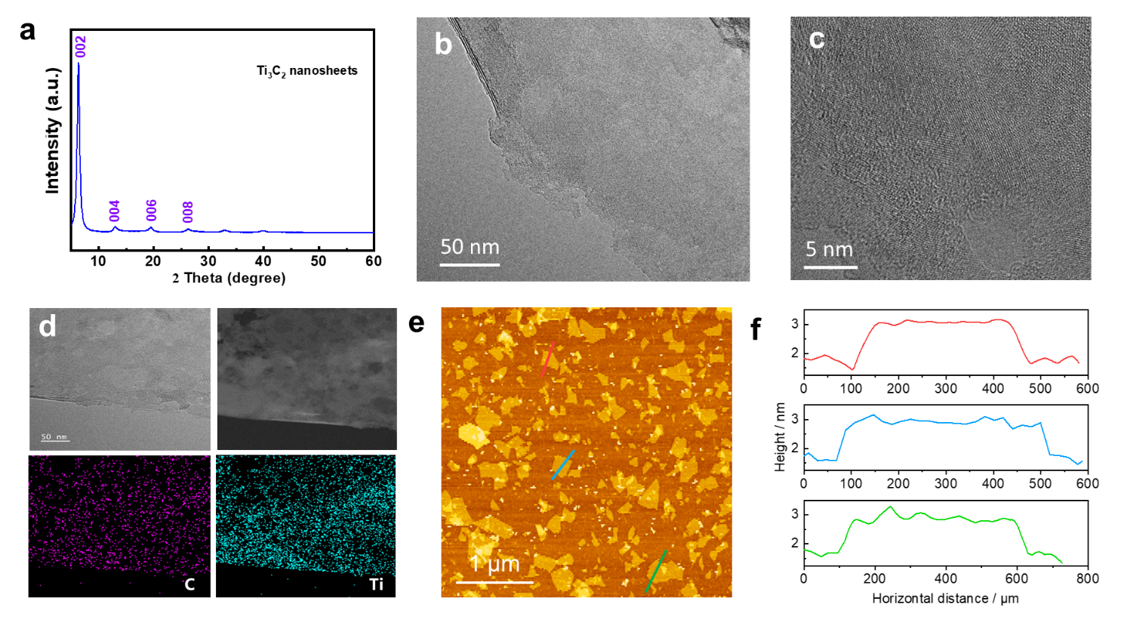

Figure 2. (a) The XRD pattern of exfoliated Ti₃C₂ nanosheets. (b-d) TEM images and elemental mapping of Ti₃C₂ nanosheets. (e-f) The AFM image and the corresponding height profile of Ti₃C₂ nanosheets.

The heterostructured CoNi LDH/Ti₃C₂ nanosheets are prepared by alternately delaminating the negatively charged Ti₃C₂ and positively charged LDH from their respective layered compounds as shown in Figure 3a. Zeta potential was examined to study the surface charge of nanosheets. As exhibited in Figure S6, the CoNi LDH and Ti₃C₂ displays a value of 59.5 and -34.6 mV, respectively. Therefore, upon the preparation, there is a strong electrostatic attraction between the negatively charged Ti₃C₂ nanosheets and the positively charged CoNi LDH nanosheets, which induces the spontaneous self-assembly of disparate nanosheets through electrostatic attraction after mixing with each other. In order to achieve a complete composite assembly and flocculation, the mass ratios of CoNi LDH nanosheets and Ti₃C₂ nanosheets are optimized to be 0.92 according to an area matching model as shown in Figure S7.
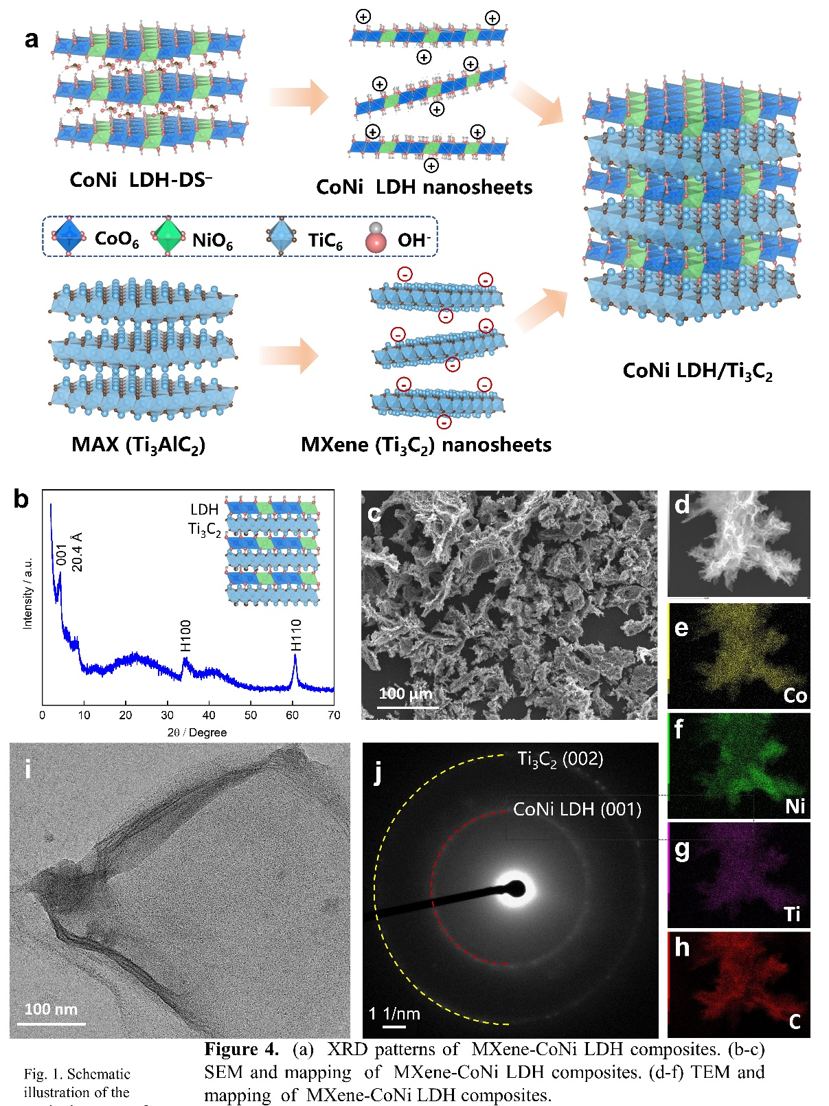
Figure 3. (a) Preparation, (b) XRD pattern, (c-h) SEM image and the elemental mapping, and (i-j) TEM image and SAED pattern of CoNi LDH/Ti₃C₂ composites.

Figure 3b illustrates the XRD pattern, where there is an intense peak with a d spacing value of 2.04 nm as the (001) plane of the as-prepared CoNi LDH/Ti₃C₂ heterostacks. As a matter of fact, the sum of the thicknesses of CoNi LDH nanosheets (0.9 nm) and Ti₃C₂ nanosheets (1.3 nm) is ~2.2 nm, which is very close to the 2.04 nm of plane (001), indicating that the CoNi LDH nanosheets are recombined with the Ti₃C₂ nanosheets to form an alternately stacked superlattice structure. Figure 3c shows the SEM image of the prepared CoNi LDH/Ti₃C₂, which manifests a fluffy flocculent structure with the alternate stacking of nanosheet flocs in different sizes and slight bending at edges. The flocculent structure has a larger specific surface area, which can expose a substantial number of defects as the active catalytic sites to accelerate the mass transfer for electrochemical reactions. Further, the SEM mappings confirm a uniform distribution of the elemental constituents within the CoNi LDH/Ti₃C₂ composite material, as depicted in Figure 3d-h. The TEM morphology and selective area electron diffraction (SAED) as shown in Figure 3i, j reveal both LDH (001) and Ti₂C₂ (002) planes in the layered CoNi LDH/Ti₃C₂ composite, which confirms the successful formation of heterostructures. Notably, the CoNi LDH/Ti₃C₂ composite material alternately restacked by positively charged and negatively charged nanosheets can effectively inhibit the agglomeration and greatly enhance the synergistic effect in the heterogeneous catalysis. XPS and EPR were performed to study the surface electronic structures of the heterostructures (Figure 4). The Co 2p spectra revealed peaks corresponding to Co²⁺ and Co³⁺ at 2p_{3/2} and 2p_{1/2}, respectively. In addition, the Ni 2p spectra exhibited two principal peaks at 855.4 and 872.8 eV, which correspond to Ni 2p_{3/2} and 2p_{1/2} of Ni³⁺ and Ni²⁺ in CoNi LDH/Ti₃C₂, respectively. These results indicate that there exist mixed valences of +2 and +3 for both Co and Ni in CoNi LDH, which agrees with previous reports.⁵²⁻⁵⁴ It should be noted that according to the XPS results, the Co 2p peak had a displacement of 0.2~0.4 eV and the Ni 2p peak had a positive displacement of 0.5~0.7 eV in CoNi LDH/Ti₃C₂ composite as compared with the original CoNi LDH. Furthermore, the Ti 2p peak of CoNi LDH/Ti₃C₂ shifted significantly compared to that of the original Ti₃C₂ (Figure 4c), suggesting a strong interfacial electronic interaction between CoNi LDH and Ti₃C₂, which indicated that a heterostructure was formed by the composition between CoNi nanosheet and Ti₃C₂. Additionally, the EPR results (Figure 4d) indicated a higher concentration of oxygen vacancies in CoNi LDH/Ti₃C₂ compared to the CoNi LDH.
Figure 4. (a-c) Co 2p, Ni 2p and Ti 2p XPS spectra of different materials. (d) EPR spectra of as prepared materials.

3.2. Electrochemical performance
The Ti₃C₂, CoNi-LDHs nanosheets and CoNi LDH/Ti₃C₂ heterostructure are all tested in an alkaline environment (1 M KOH aqueous solution) to investigate their catalytic activities as shown in Figures 5a and S8. It can be seen that the CoNi LDH/Ti₃C₂ exhibits the lowest overpotential (only 325 mV @10 mA cm⁻²), indicating the fastest OER reaction kinetics from the polarization curve as shown in Figure 5b. Moreover, the OER catalytic activity of CoNi LDH/Ti₃C₂ composite catalyst is still the best at the current density of 100 mA cm⁻², demonstrating that it can withstand higher catalytic current. Considering the voltage drop by the internal resistance of solution, the more accurate OER overpotentials and Tafel slopes of Ti₃C₂, CoNi LDHs nanosheets, RuO₂, and CoNi LDH/Ti₃C₂ can be obtained after iR compensation in an alkaline environment. From the comparison of the polarization current curves before and after iR compensation, the true overpotential of the CoNi LDH/Ti₃C₂ is 289 mV and its Tafel slope is 49.2 mV dec⁻¹ after deducting the influence of solution voltage drop, as shown in Figure 5c. In order to determine the specific electrochemical surface area of as synthesized nanosheets, cyclic voltammetry was conducted from 1.0 to 1.2 V (vs. RHE) at various scan rates and the currents at 1.1 V as a function of scan rate were linearly fitted (Figure S8). According to the result, the ECSA was estimated to be 9.59 cm². Such a high specific surface area provided abundant sites for the catalytic process and enabled a high catalytic activity of the CoNi LDH/Ti₃C₂ heterostructures. Moreover, chronoamperometry at 10 mA cm^{‒2} was performed to investigate their stability as reported in the literature.⁵⁵⁻⁵⁷ It can be seen that the CoNi LDH/Ti₃C₂ heterostructures exhibit a high stability by sustaining the OER activity for 10 h with a current retention of 98% as shown in Figure 5d. In addition, electrochemical impedance spectra were measured to study their electrochemical property (Figure S10). The poor conducted CoNi LDH exhibits the highest resistance followed by Ti₃C₂. The hybridization of CoNi LDH and Ti₃C₂ further lowers the resistance and improves the electron transfer efficiency. Compared to the reported results^{58, 59} on Ti₃C₂ composite, the electrical properties of the CoNi LDH nanosheets combined with single-layer Ti₃C₂ here have been greatly improved by the synergetic enhancement effect in the catalytic processes. Then, due to a high overpotential and Tafel slope of Ti₃C₂ catalyst as shown in Figure 5c, it can be plausibly deferred that the LDHs nanosheets mainly provide the OER catalytic activity and the Ti₃C₂ enhances the charge transfer between the layers and accelerates the kinetic process of OER in the CoNi LDH/Ti₃C₂ composite system.

Figure 5. (a) LSV profile, (b) overpotentials, (c) Tafel plots of Ti₃C₂, CoNi LDH nanosheets, RuO₂, and CoNi LDH/Ti₃C₂ composites, and (d) Time-dependance of the current density CoNi LDH/Ti₃C₂ composites.

3.3. Theoretical calculations
To elucidate the synergistic interaction between CoNi LDH and Ti₃C₂ towards OER, the DFT simulations are utilized to analyze the charge transfer mechanism as shown in Figure 6. Note that the analysis of the optimized structural data reveals a small lattice mismatch (~ 1.0 %) between CoNi LDH and Ti₃C₂. Figure 6e-l depicts the calculated electron localization function (ELF, Figure 6e-h) and the charge density difference (CDD, Figure 6i-l) of the CoNi LDH/Ti₃C₂ heterostructure in different active states (Figure 6a-d). The ELF analysis reveals distinct characteristics in electron localization near various active sites (Figure 6e-h). Specifically, the oxygen vacancies are more prone to interact with reactants other than the hydrogen vacancies. Moreover, the CDD analyses show that when the CoNi LDH nanosheets are combined with the Ti₃C₂ layer, the spatial charge transfers from the Ti₃C₂ to the LDH (Figure 6i-l). This charge transfer increases the electron density at the active sites on the LDH interface, thereby enhancing the reaction rate and kinetics and consequently improving the catalytic activity. The ELF and CCD results indicate that the charge transfers from Ti₃C₂ to LDH upon the recombination to enhance the localization of electrons at the active sites, which enhances the adsorption and activation capabilities at the interface, thereby augments its catalytic activity and accelerates both the reaction rate and kinetics of OER.
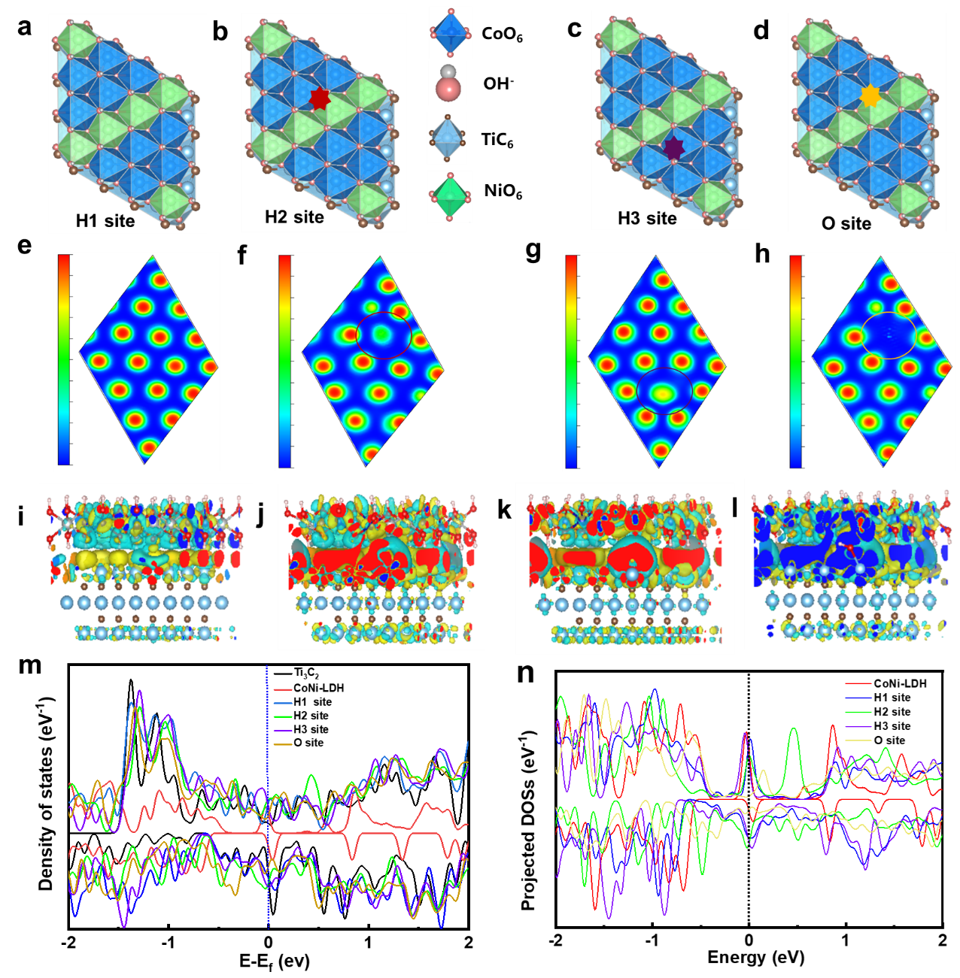

Figure 6. (a-d) Different active sites with the respective (e-h) electron localization functions and (i-l) differential charge densities at the CoNi LDH/Ti₃C₂ interface. (m, n) Density of states corresponding to different active sites at the CoNi LDH/Ti₃C₂ interface.

Furthermore, from the perspective of coordination chemistry, it is observed that the Co and Ni atoms in the CoNi LDH/Ti₃C₂ occur in octahedral positions with the Co and Ni each occupying their respective octahedral coordination environments. Notably, due to the Jahn-Teller effect, the Co and Ni orbitals experience further splitting, resulting in an uneven distribution of electrons. Consequently, when Co and Ni are located in distinct positions at the CoNi LDH- Ti₃C₂ interface, there arises the potential for varied electronic synergies between the d electrons of Co and Ni, resulting in disparate catalytic activity. This discrepancy manifests in differing adsorption capacities, activation energies of the reactants as well as activation energy barriers.
Given the distinct electronic characteristics of Co and Ni in CoNi LDH/Ti₃C₂ under an adjacent or non-adjacent coordination environment as well as the possible coexistence of oxygen and hydrogen vacancies on the surface of CoNi LDH/Ti₃C₂, various factors contribute to the complex and variable catalytic activity at the CoNi LDH/Ti₃C₂ interface. Moreover, the density of states (DOSs) analysis shows that the Ti₃C₂ are metallic as shown in Figure 6m-n. When the CoNi LDH nanosheets are integrated with Ti₃C₂ layers at various active sites, there is an enhancement in these electronic states. The increased electron density near the Fermi level signifies the improved electron transport efficiency in the CoNi LDH/Ti₃C₂ composites, which facilitates the adsorption, activation, and rapid reaction of reactant molecules at the interface.
Next, the formation energies of CoNi LDH/Ti₃C₂ complexes at various active sites (H, H1, H2, O configurations, Figures 7a-d and S11) within CoNi LDH/Ti₃C₂ composites are compared as illustrated in Figure 7a. The CoNi LDH/Ti₃C₂ interface without a vacancy (H1) has the lowest formation energy of -2.8 eV to imply the spontaneous formation during preparation process. In contrast, the formation energy of an oxygen vacancy (O) is the highest at the positions adjacent to the Co²⁺ and Ni³⁺ ions within the CoNi LDH/Ti₃C₂ interface, requiring additional energy for formation. Hence, the formation of O vacancy should be strongly concerted with other vacancies and the electrode transfer with Co/Ni ions. To elucidate the synergistic effects and reaction mechanism of different active sites in CoNi LDH/Ti₃C₂ composites, the adsorption energy and reaction free energy (ΔG) are calculated as shown in Figures 7b and S12. The adsorption energies for the intermediates, such as the OH* and OOH* species, reveal that these intermediates exhibit the strongest adsorption at the sites with oxygen vacancies adjacent to Co²⁺ and Ni³⁺ ions at the CoNi LDH/Ti₃C₂ interface, which is beneficial for facilitating rapid reactions. Moreover, the ELF and CDD analyses (Figures S13-16) indicate that among the different active sites, those with oxygen vacancies adjacent to Co²⁺ and Ni³⁺ ions exhibit the highest electron density after the adsorption of OH*, OOH*, and O* intermediates as shown in Figure S13-16. Such findings suggest the significant electron transfer at these sites. Figure 7b compares the reaction free energy (ΔG) for intermediates (OH*, OOH*, and O*) across various active sites during the four-electron transfer process. Among the different active sites, the second-step free energy at the site with an oxygen vacancy between Co and Ni ions at the CoNi LDH/Ti₃C₂ interface is the lowest, facilitating the formation of M-O bonds. The active site with an oxygen vacancy shows the highest reactivity as evidenced by the change in ΔG during the M-OOH formation. This suggests that the synergistic effects of oxygen, Co and Ni ions at the adjacent positions within the CoNi LDH/Ti₃C₂ matrix significantly enhance the catalytic activity. Moreover, the stable coordination bonds between Co²⁺ and Ni³⁺ ions with lattice oxygen ions help to maintain the catalyst's structural integrity, thereby extending its operational lifespan.
It is generally accepted that the *OH species acts as the rate-determining step in the OER. Afterwards, the Bader charges of various active sites in CoNi LDH/Ti₃C₂ composites are calculated to investigate the charge transfer characteristics of Co and Ni ions as shown in Figure 7. The Bader charges of Co and Ni ion are found to be 1.18 and 1.25 e⁻, respectively, at a site without vacancy (H, Figure 6a). After the adsorption of *OH, the Bader charges of Co and Ni ions are increased to 1.29 and 1.25 e⁻, respectively. While, if the CoNi LDH/Ti₃C₂ heterostructure with a hydrogen vacancy (H1, Figure 6b), the Bader charges of Co and Ni ions are estimated to be 1.05 and 1.24 e⁻, respectively, which are relaxed to 1.25 and 1.17 e⁻ in the following *OH adsorption. For the heterostructure with a hydrogen vacancy adjacent to the Co at the CoNi LDH/Ti₃C₂ interface (H2, Figure 6c), the average Bader charge of Co increases from the original 1.21 e⁻, to 1.25 e⁻ after the *OH adsorption as shown in Figure 7c. Then at a site with an oxygen vacancy at the CoNi LDH/Ti₃C₂ interface (O, Figure 6d), the Bader charges of Co and Ni ions are 0.94 and 1.04 e⁻, respectively, which are adjusted to 1.07 and 1.27 e⁻, respectively, upon the *OH adsorption as shown in Figure 7d. Therefore, the presence of hydrogen and oxygen vacancies adjacent to Co and Ni supplies additional electrons to the *OH species, which enhances their adsorption and activation performance. The electronic synergistic effects between Co and Ni ions account for the variations in Bader charges across different active sites (H, H1, H2 and O configurations), where a concerted behavior can be foreseen in the different active sites during catalytic process.
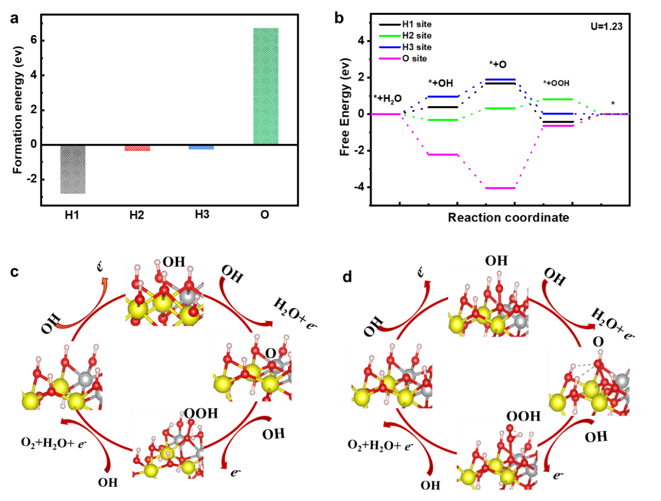

Figure 7. (a) Formation energies of different active sites at the CoNi LDH/Ti₃C₂ interface. (b) Free energy for intermediates (OH*, OOH*, and O*) across various active sites during the four-electron transfer process. (c, d) OER reaction mechanisms at CoNi LDH/Ti₃C₂ interface.

Overall, the OER mechanisms involving H and O vacancies at the adjacent sites of Co and Ni ions in CoNi LDH/Ti₃C₂ materials exhibit a typical four-electron transfer process, as illustrated in Figure 7c, d. When the LDH nanosheets are integrated with the Ti₃C₂ layers, there is a charge transfer process from the Ti₃C₂ to LDH by the different chemical potentials, which enhances the electron density at the active sites of the CoNi LDH/Ti₃C₂ interface. The increased electron density, particularly near the Fermi level, improves the electron transfer efficiency, thereby accelerates the reaction rate and enhances the kinetics and catalytic activity of the material. In parallel, the close proximity of Co and Ni ions within the CoNi LDH/Ti₃C₂ heterostructure leads to the electronic synergistic effects, which contributes to the adsorption and activation of reactants, reduction of activation energy barrier, and further enhancement on the catalytic performance.

4. Conclusions
In summary, the CoNi LDH/Ti₃C₂ composites are obtained by integrating the peeled LDH nanosheets with the single layered Ti₃C₂, thereby leveraging the unique properties of both materials. Due to the synergistic electron transfer process, the CoNi LDH/Ti₃C₂ composites deliver an obviously improved performance for OER with a lower overpotential and a reduced Tafel slope together. The DFT calculations indicate that upon the integration of LDH nanosheets with the Ti₃C₂ layer, the charge transfer occurs from the Ti₃C₂ to the LDH, which alters the local electron density and modifies the electron distribution within the composite. This leads to an increased electron density at the active sites along the LDH interface, to enhance the electron transfer efficiency within CoNi LDH/Ti₃C₂ composite.
Moreover, the proximity of Co and Ni ions within the composite creates an electronic synergistic effect, enhancing the availability of electrons to adsorption intermediates through adjacent hydrogen and oxygen vacancies. This phenomenon effectively reduces the activation energy barrier for the reaction and accelerates both the reaction rate and overall catalytic activity. As a result, the active sites adjacent to Co and Ni ions exhibit the good catalytic efficiency. Overall, the present study offers a promising strategy for designing highly efficient electrocatalysts for OER, which demonstrates the potential for practical applications in hydrogen production.

Supporting Information
The supporting information presents the XRD, LSV, and DFT data.

Notes
The authors declare no competing financial interest.

Acknowledgment
This work was supported by National Natural Science Foundation of China (22209213), Natural Science Foundation of Guangdong Province (2022A1515010405, 2024A1515010284) and the Foundation from Guangdong Provincial Key Laboratory of Materials and Technologies for Energy Conversion (MATE2023KF004).

References
1 A. Mehtab, S. A. Ali, I. Sadiq, S. Shaheen, H. Khan, M. Fazil, N. A. Pandit, F. Naaz and T. Ahmad, ACS Sustainable Resource Management, 2024, 1, 604-620.
2 V. V. Burungale, H. Bae, M. A. Gaikwad, P. Mane, J. Heo, C. Seong, S.-H. Kang, S.-W. Ryu and J.-S. Ha, Chemical engineering journal (Lausanne, Switzerland : 1996), 2024, 486, 150175.
3 R. A. Senthil, S. Jung, A. Min, A. Kumar, C. J. Moon, M. Singh and M. Y. Choi, ACS Catalysis, 2024, 14, 3320-3335.
4 Q. Zhang, W. Xiao, H. C. Fu, X. L. Li, J. L. Lei, H. Q. Luo and N. B. Li, ACS catalysis, 2023, 13, 14975-14986.
5 H. Zhang, L. Wu, R. Feng, S. Wang, C.-S. Hsu, Y. Ni, A. Ahmad, C. Zhang, H. Wu, H.-M. Chen, W. Zhang, Y. Li, P. Liu and F. Song, ACS Catalysis, 2023, 13, 6000-6012.
6 Z. Lu, J. Wang, P. Zhang, W. Guo, Y. Shen, P. Liu, J. Ji, H. Du, M. Zhao, H. Liang and J. Guo, Applied Catalysis B: Environment and Energy, 2024, 353, 124073.
7 H. T. Dao, V. H. Hoa, S. Sidra, M. Mai, M. Zharnikov and D. H. Kim, Chemical Engineering Journal, 2024, 485, 150054.
8 Z. Fan, Q. Sun, H. Yang, W. Zhu, F. Liao, Q. Shao, T. Zhang, H. Huang, T. Cheng, Y. Liu, M. Shao, M. Shao and Z. Kang, ACS Nano, 2024, 18, 5029-5039.
9 J. Yang, S. Yang, L. An, J. Zhu, J. Xiao, X. Zhao and D. Wang, ACS catalysis, 2024, 14, 3466-3474.
10 Y. Hu, T. Shen, Z. Song, Z. Wu, S. Bai, G. Liu, X. Sun, Y. Wang, S. Hu, L. Zheng and Y.-F. Song, ACS Catalysis, 2023, 13, 11195-11203.
11 S. A. K. Navodye and G. T. K. K. Gunasooriya, Journal of physical chemistry. C, 2024, 128, 6041-6052.
12 S. Kwon, K. A. Stoerzinger, R. Rao, L. Qiao, W. A. R. Goddard and Y. Shao-Horn, J Am Chem Soc, 2024, 146, 11719-11725.
13 Y. Lee, J. Suntivich, K. J. May, E. E. Perry and Y. Shao-Horn, J Phys Chem Lett, 2012, 3, 399-404.
14 W. Liu, Z. Duan and W. Wang, Journal of physical chemistry. C, 2023, 127, 5334-5342.
15 N. Todoroki, R. Kudo, K. Hayashi, M. Yokoi, N. Naraki and T. Wadayama, ACS Catalysis, 2023, 13, 11433-11440.
16 A. Mavric and C. Cui, ACS applied energy materials, 2021, 4, 12032-12055.
17 A. Farhan, A. Khalid, N. Maqsood, S. Iftekhar, H. M. A. Sharif, F. Qi, M. Sillanpää and M. B. Asif, The Science of the total environment, 2024, 912, 169160-169160.
18 Y. Liao, R. He, W. Pan, Y. Li, Y. Wang, J. Li and Y. Li, Chemical Engineering Journal, 2023, 464, 142669.
19 F. Chen, H. Liu, F. Yang, S. Che, N. Chen, C. Xu, N. Wu, Y. Sun, C. Yu and Y. Li, Chemical engineering journal (Lausanne, Switzerland : 1996), 2023, 467, 143274.
20 Q. Su, P. Wang, Q. Liu, R. Sheng, W. Cheng, J. Ding, Y. Lei and Y. Huang, Applied Catalysis B: Environment and Energy, 2024, 351, 123994.
21 Z. He, J. Zhang, Z. Gong, H. Lei, D. Zhou, N. Zhang, W. Mai, S. Zhao and Y. Chen, Nat Commun, 2022, 13, 2191.
22 R. Sanchis-Gual, D. Hunt, C. Jaramillo-Hernandez, S. A. Seijas-Da, M. Mizrahi, C. Marini, V. Oestreicher and G. Abellan, ACS Catal, 2023, 13, 10351-10363.
23 X. Lu, N. Sakai, D. Tang, X. Li, T. Taniguchi, R. Ma and T. Sasaki, ACS Appl. Mater. Interfaces, 2020, 12, 33083-33093.
24 S. Jiang, M. Zhang, C. Xu, G. Liu, K. Zhang, Z. Zhang, H. Q. Peng, B. Liu and W. Zhang, ACS Nano, 2024, 18, 16413-16449.
25 A. Hameed, M. Batool, Z. Liu, M. A. Nadeem and R. Jin, ACS Energy Letters, 2022, 7, 3311-3328.
26 S. S. Jeon, J. Lim, P. W. Kang, J. W. Lee, G. Kang and H. Lee, ACS Appl Mater Interfaces, 2021, 13, 37179-37186.
27 Y. He, L. Jia, X. Lu, C. Wang, X. Liu, G. Chen, D. Wu, Z. Wen, N. Zhang, Y. Yamauchi, T. Sasaki and R. Ma, ACS Nano, 2022, 16, 4028-4040.
28 J. Zhou, L. Yu, Q. Zhu, C. Huang and Y. Yu, J. Mater. Chem. A, 2019, 7, 18118-18125.
29 T. Zhang, L. Hang, Y. Sun, D. Men, X. Li, L. Wen, X. Lyu and Y. Li, Nanoscale Horizons, 2019, 4, 1132-1138.
30 L. Yu, H. Zhou, J. Sun, F. Qin, F. Yu, J. Bao, Y. Yu, S. Chen and Z. Ren, Energy Environ. Sci., 2017, 10, 1820-1827.
31 L. Jia, H. Wan, X. Liu, G. Chen, N. Zhang, J. Li, W. Zhou, Y. Cao, R. Ma and G. Qiu, ChemSusChem, 2019, n/a.
32 M. Hou, B. Miao, M. Asad, Y. Zhang, Q. Chen, M. Zhang, Z. Bai, Y. Zhao and G. Liu, Journal of Alloys and Compounds, 2024, 976, 173362.
33 Y. Li, G. Ni, K. Zhang, D. Wang, Q. Li and S. Wang, Journal of Alloys and Compounds, 2024, 970, 172526.
34 F. Bibi, I. A. Soomro, A. Hanan, M. N. Lakhan, A. Khan, N. R. Goraya, Z. U. Rehman, I. Hussain and K. Zhang, Journal of Materials Science & Technology, 2024, 202, 82-118.
35 A. Dey, S. Varagnolo, N. P. Power, N. Vangapally, Y. Elias, L. Damptey, B. N. Jaato, S. Gopalan, Z. Golrokhi, P. Sonar, V. Selvaraj, D. Aurbach and S. Krishnamurthy, Progress in Materials Science, 2023, 139, 101166.
36 J. Cai, J. Huang, A. Cao, Y. Wei, H. Wang, X. Li, Z. Jiang, G. I. N. Waterhouse, S. Lu and S.-Q. Zang, Applied Catalysis B: Environmental, 2023, 328, 122473.
37 H. Gu, H. Zhang, X. Wang, Q. Li, S. Chang, Y. Huang, L. Gao, Y. Cui, R. Liu and W.-L. Dai, Applied Catalysis B: Environmental, 2023, 328, 122537.
38 X. Chen, J. B. Sallach, W. Ling, X. Zhao, T. Borch and Y. Gao, Applied Catalysis B: Environment and Energy, 2024, 350, 123953.
39 J. P. Perdew, K. Burke and M. Ernzerhof, Physical Review Letters, 1997, 78, 1396-1396.
40 G. Kresse and J. Furthmüller, Computational materials science, 1996, 6, 15-50.
41 G. Kresse and J. Furthmüller, Phys Rev B Condens Matter, 1996, 54, 11169-11186.
42 P. E. Blöchl, Physical Review B, 1994, 50, 17953-17979.
43 A. Cao, W. Xu, H. Sun, Z. Jiang, F. Wang, Y. Li and X. Sun, Molecular Catalysis, 2024, 555, 113864.
44 Y. Ma, L. Wang, J. Ma, H. Wang, C. Zhang, H. Deng and H. He, ACS Catalysis, 2021, 11, 6614-6625.
45 Z. Song, Y. Peng, X. Zhao, H. Liu, C. Gao, W. Si and J. Li, ACS Catalysis, 2022, 12, 11505-11517.
46 Izumi, Momma and F. Izumi, Journal of Applied Crystallography, 2011, 6, 1272-1276.
47 X. Lu, H. Xue, H. Gong, M. Bai, D. Tang, R. Ma and T. Sasaki, Nanomicro Lett, 2020, 12, 86.
48 J. Liang, R. Ma, N. Iyi, Y. Ebina, K. Takada and T. Sasaki, Chemistry of Materials, 2009, 22, 371-378.
49 J. Cao, L. Wang, D. Li, Z. Yuan, H. Xu, J. Li, R. Chen, V. Shulga, G. Shen and W. Han, Adv. Mater., 2021, 33, 2101535.
50 M. Piccinni, S. Bellani, G. Bianca and F. Bonaccorso, Inorg Chem, 2022, 61, 4598-4608.
51 A. C. Y. Yuen, T. B. Y. Chen, B. Lin, W. Yang, I. I. Kabir, I. M. De Cachinho Cordeiro, A. E. Whitten, J. Mata, B. Yu, H.-D. Lu and G. H. Yeoh, Composites Part C: Open Access, 2021, 5, 100155.
52 J. Jian, Z. Wang, Y. Qiao, S. Gao, M. Wang, L. Chang, H. Wang and P. Nie, Green Chemistry, 2024, 26, 6713-6722.
53 Y. Liu, W. Liu, X. Gan, J. Shang and X. Cheng, Journal of Environmental Sciences, 2024, 141, 235-248.
54 Z. Wang, J. Jian, X. Wang, Y. Qiao, M. Wang, S. Gao, P. Nie and L. Chang, J. Mater. Chem. C, 2023, 11, 16384-16389.
55 L. Yu, J. F. Yang, B. Y. Guan, Y. Lu and X. W. Lou, Angew. Chem. Int. Ed., 2018, 57, 172-176.
56 B. Yan, X. Qin, T. Chen, Z. Teng, D. K. Cho, H. W. Lim, H. Hong, Y. Piao, L. Xu and J. Y. Kim, Adv. Funct. Mater., 2024, 34, 2309264.
57 B.-Q. Miao, Y.-M. Liu, T.-J. Wang, Y. Ding and Y. Chen, Nanotechnology, 2022, 33, 075401.
58 Y. Sun, Z. Wang, Q. Zhou, X. Li, D. Zhao, B. Ding and S. Wang, Heliyon, 2024, 10, e30966.
59 A. R. Manchuri, K. C. Devarayapalli, B. Kim, Y. Lim and D. S. Lee, Green Energy & Environment, 2024.

