Electrochemical Stability of Li_{5.4}(PS₄)(S_{0.4}Cl_{1.0}Br_{0.6}) in All-Solid-State Battery Comprising LiNbO₃-Coated Li(Ni_{0.8}Co_{0.1}Mn_{0.1})O₂ Cathode and Lithium Metal Anode
Naoya Masuda^{1,2,z}, Kiyoshi Kobayashi³, Futoshi Utsuno¹, Naoaki Kuwata^{2,4}
¹Research Center for Battery Materials, Idemitsu Kosan Co., Ltd, Sodegaura, Chiba 299-0293, Japan
²Graduate School of Chemical Sciences and Engineering, Hokkaido University, Sapporo, Hokkaido 060-8628, Japan
³Research Center for Electronic and Optical Materials, National Institute for Materials Science, 1-2-1, Sengen, Tsukuba, Ibaraki 305-0047, Japan
⁴Center for Green Research on Energy and Environmental Materials, National Institute for Materials Science, 1-1 Namiki, Tsukuba, Ibaraki 305-0044, Japan
^{z}Corresponding Author Email Address: naoya.masuda.3920@idemitsu.com.

Abstract
All-solid-state lithium-ion batteries are a promising next-generation technology because they have higher energy densities than their liquid-electrolyte counterparts. Recently, halogen-rich argyrodite, specifically Li_{5.4}(PS₄)(S_{0.4}Cl_{1.0}Br_{0.6}), has been reported to show higher ionic conductivities than other sulfides with argyrodite structures and electrochemical stability against lithium metal. However, the stability of Li_{5.4}(PS₄)(S_{0.4}Cl_{1.0}Br_{0.6}) against cathode active materials in all-solid-state batteries has not yet been evaluated. Herein, we report the electrochemical stability of Li_{5.4}(PS₄)(S_{0.4}Cl_{1.0}Br_{0.6}) as a solid electrolyte in an all-solid-state battery. Li(Ni_{0.8}Co_{0.1}Mn_{0.1})O₂ and lithium metal were used as the cathode and anode, respectively, and an enhancement in the discharge capacity was expected. The impedance of the battery was almost independent of the frequency above 10⁶ Hz for 50 charge/discharge cycles. These findings are a result of the constant lithium-ion resistance of Li_{5.4}(PS₄)(S_{0.4}Cl_{1.0}Br_{0.6}). X-ray diffraction analysis confirmed that no byproduct phase was formed in the cathode mixture over 50 cycles. These results demonstrate the high chemical stability of Li_{5.4}(PS₄)(S_{0.4}Cl_{1.0}Br_{0.6}) against Li(Ni_{0.8}Co_{0.1}Mn_{0.1})O₂, thereby broadening the design scope of electrolyte materials for all-solid-state lithium-ion batteries with high performance and stability.

Introduction
Over the years, various high-performance lithium-ion rechargeable batteries have been developed to address global warming^{[1]} and realize a sustainable, carbon-neutral society.^{[2]} All-solid-state lithium-ion batteries offer a potential solution to reach this goal.^{[3,4]} The performance of such batteries primarily depends on the electrochemical properties of the electrolyte.^{[5]} However, all-solid-state lithium-ion batteries have disadvantages such as low rate capabilities and energy densities. Thus, the application of such batteries is limited because of a lack of suitable electrolytes that exhibit high ionic conductivities.^{[6]} Recent studies have shown that lithium–phosphorus–sulfide solid electrolytes are promising materials ^{[7]} because of their high ionic conductivities,^{[8]} mechanical softness,^{[9]} and facile processing.^{[10]}
Among the phosphorus sulfides, various Li_{7-α}PS_{6-α}X_{α} (X = Cl, Br, I) argyrodites that exhibit high ionic conductivities have been discovered.^{[11-17]} These argyrodites are denoted as Li_{7-α}(PS₄)(S_{2-α}X_{α}).^{[18]} Recently, high lithium-ion conductivity was measured in Li_{7-x-y}(PS₄)(S_{2-x-y}Cl_{x}Br_{y}).^{[11-18]} Particularly, Li_{5.4}(PS₄)(S_{0.4}Cl_{1.0}Br_{0.6}) demonstrate the highest ionic conductivity among the Li_{7-x-y}(PS₄)(S_{2-x-y}Cl_{x}Br_{y}) systems.^{[18]} The high stability of Li_{5.4}(PS₄)(S_{0.4}Cl_{1.0}Br_{0.6}) against reaction with lithium metal has been reported.^{[18]} High Coulombic efficiency, discharge capacity, and capacity retention rate values of an all-solid-state battery using Li_{5.4}(PS₄)(S_{0.4}Cl_{1.0}Br_{0.6}) have also been reported.^{[18]} Another study used Li(Ni_{0.8}Co_{0.15}Al_{0.05})O₂ and artificial graphite (AG) as the cathode and anode, respectively, in all-solid-state batteries, as these materials are known to exhibit high Coulombic efficiencies.^{[19]} The same cathode and anode materials were used in our previous study.^{[18]}
To develop new batteries with higher energy densities, the use of a cathode that can operate at relatively high voltages (up to 0.1 V) is preferable. For example, Li(Ni_{0.8}Co_{0.1}Mn_{0.1})O₂ is a candidate material for high-voltage operation.^{[20,21]} However, its use as a cathode material requires that the Li_{5.4}(PS₄)(S_{0.4}Cl_{0.1}Br_{0.6}) electrolyte possess sufficiently high chemical stability to withstand high-voltage operation. Consequently, the applicability of this cathode material has not yet been verified.
In this study, the chemical stability of Li_{5.4}(PS₄)(S_{0.4}Cl_{1.0}Br_{0.6}) and the reactivities of Li_{5.4}(PS₄)(S_{0.4}Cl_{1.0}Br_{0.6}) and Li(Ni_{0.8}Co_{0.1}Mn_{0.1})O₂ in Li(Ni_{0.8}Co_{0.1}Mn_{0.1})O₂–Li_{5.4}(PS₄)(S_{0.4}Cl_{1.0}Br_{0.6})｜Li_{5.4}(PS₄)(S_{0.4}Cl_{1.0}Br_{0.6}) | Li batteries were investigated using battery cycling tests over 50 cycles, followed by X-ray diffraction (XRD) analysis to evaluate the phase stability.

Experimental
Synthesis of the solid electrolyte
The Li_{5.4}(PS₄)(S_{0.4}Cl_{0.1}Br_{0.6}) powder used as the electrolyte layer was synthesized using the same protocol as in our previous study.^{[18]} A composite composed of a solid electrolyte and an active material, Li(Ni_{0.8}Co_{0.1}Mn_{0.1})O₂, was employed as the cathode. Pulverized solid-electrolyte powder was used as the cathode because small-particle solid-electrolyte powders provide an effective interface with intimate contact between the active materials in the cathode layer.^{[22]}
The electrolyte powder was placed in a ZrO₂ pot (1.0 g per pot) containing a ZrO₂ ball (0.5 mm diameter; 34 g), and 10.4 mL toluene (<5 ppm of moisture) was pipetted into the pot in an argon-filled glovebox. The moisture and oxygen levels in the glovebox were below
1 ppm. The mixture was then mechanically milled using a planetary ball mill (Fritsch Pulverisette 7) at 150 rpm for 2 h to obtain a fine slurry. After ball-milling, the samples were sieved and classified into beads and slurries in an argon-filled glovebox. To obtain the Li_{5.4}(PS₄)(S_{0.4}Cl_{1.0}Br_{0.6}) powder for the cathode layer, the slurry was heated to 373 K and dried using a Schlenk bottle under vacuum.

Particle-size distribution
The particle-size distribution of the Li_{5.4}(PS₄)(S_{0.4}Cl_{1.0}Br_{0.6}) cathode powder was measured using a laser diffraction particle-size analyzer (Partica LA-960, Horiba, Japan). The measurements were performed in toluene (>99.5% purity, with a moisture content of less than 10 ppm; Fujifilm Wako Pure Chemical Corporation, Japan), as previously reported.^{[18]} Furthermore, the measurements were performed in a dry room maintained at a moisture content below 1 ppm.

Microscopy and elemental analysis
Scanning electron microscopy (SEM) measurements were performed using a Hitachi SU8220 instrument at an accelerating voltage of 2 kV and an emission current of
10 μA. Energy dispersive X-ray spectroscopy (EDS; Bruker X Flash5060FQ) was performed in the same field-of-view used to obtain the SEM images using an accelerating voltage of 10 kV and emission current of 5 μA.
Polished cross-sections of the pellet samples were prepared before SEM and EDS measurements using Ar-ion milling (IM-4000, Hitachi High-Tech). During the 5-h milling process, the accelerating voltage was 3.5 kV, and the sample was cooled to below 100 K using liquid nitrogen.

Synthesis of cathode mixtures
To improve battery performance, LiNbO₃ was coated onto the Li(Ni_{0.8}Co_{0.1}Mn_{0.1})O₂ powder particles (Shima Trading Company, Japan) using a solution containing lithium, niobium alkoxides, and ethanol, as described previously.^{[23]} The thickness of the coated layer (4.2 nm) was calculated from the combination of the volume of the solution used for the coating, the Brunauer–Emmett–Teller (BET) surface area of Li(Ni_{0.8}Co_{0.1}Mn_{0.1})O₂, and the density of LiNbO₃.
Mixed cathode powders were prepared using LiNbO₃-coated Li(Ni_{0.8}Co_{0.1}Mn_{0.1})O₂ and Li_{5.4}(PS₄)(S_{0.4}Cl_{1.0}Br_{0.6}) in weight ratios of 7:3 (70NCM-30SE), 8:2 (80NCM-20SE), and 9:1 (90NCM-10SE). The cathode mixtures were placed in a ZrO₂ pot (1.0 g per pot) containing a ZrO₂ ball (2.0 mm diameter; 34 g) in an argon-filled glovebox for dry ball-milling. The mixture was mechanically milled using a planetary ball-milling apparatus (AV-1, Asahi Rika Factory. Ltd., Tokyo, Japan) at 600 rpm for 1 h. After ball-milling, the samples were sieved and classified into beads and powders in an argon-filled glovebox.

X-ray powder diffraction analysis
Two different laboratory XRD instruments were used to analyze the powder and pellet samples. The Bragg–Brentano geometry (Bruker D2 PHASER) was used to analyze the powder samples before conducting charge/discharge cycling tests. The divergence and Soller slit were set to 0.1 mm and 0.04°, respectively. The data were collected over a diffraction angle (2θ) range of 10–100° (step size = 0.01°) at a scanning rate of 1 s per step. The samples were packed in a flat folder and sealed using Kapton tape to prevent exposure to air. All measurements were performed at room temperature (290–300 K).
The second XRD instrument was a Bruker D8 ADVANCE, which was used to analyze the pellet samples after the charge/discharge cycling tests. The pellets were exposed to a horizontal X-ray beam (parallel to the pellet surface) by changing their vertical positions. The top of the pellets was identified by measuring the scattering intensity decay. The X-ray beam irradiated the detected top position of each pellet, and measurements were performed using a Bragg–Brentano geometry, with the divergence and Soller slit set to 0.1 mm and 0.025°, respectively. The data were collected over a 2θ range of 10–60° (step size = 0.02°) at a scanning rate of 4 s per step. During the measurements, the temperature was maintained at room temperature (290–300 K). The all-solid-state battery pellets were placed in a dome-like cell to avoid exposure to air. The thickness of the cathode mixture layer was 61 μm for 90NCM-10SE and 97 μm for 70NCM-30SE, as calculated based on the reported densities of Li(Ni_{0.8}Co_{0.1}Mn_{0.1})O₂ (4.8 g/cm³) and Li_{5.4}(PS₄)(S_{0.4}Cl_{1.0}Br_{0.6}) (2.0 g/cm³), respectively.^{[18,24]} Even for the thickest cathode electrode layer of 97 μm, more than 99% of the incident X-ray intensity was diffracted. In this calculation, the mass absorption coefficient and mass fraction of each element and the densities of Li(Ni_{0.8}Co_{0.1}Mn_{0.1})O₂ and Li_{5.4}(PS₄)(S_{0.4}Cl_{1.0}Br_{0.6}) were used.^{[25]} Therefore, the entire cathode mixture layer was analyzed using XRD.

Crystallite size
The crystallite sizes were calculated from the full-width at half-maximum (FWHM) of the peaks in the XRD pattern using the whole-pattern powder fitting method.^{[26]} The diffraction peak profiles were modeled using a split-pseudo-Voigt function and an 11th-order Legendre orthogonal polynomial background model using the Rietan-FP software.^{[26]} For Li_{5.4}(PS₄)(S_{0.4}Cl_{1.0}Br_{0.6}), the crystallite size was calculated using Scherrer's equation along the (200) direction from the diffraction peak of 2θ = 25°, with a shape factor of 0.9.^{[27]}

All-solid-state battery cell fabrication and electrochemical measurements
A battery with a Li(Ni_{0.8}Co_{0.1}Mn_{0.1})O₂–Li_{5.4}(PS₄)(S_{0.4}Cl_{1.0}Br_{0.6}) | Li_{5.4}(PS₄)(S_{0.4}Cl_{1.0}Br_{0.6}) | Li structure was fabricated. The total amount of cathode active material was 18 mg. Lithium foil (10 mm diameter, 0.2 mm thickness; Honjo Metal, Japan) was used as the anode. The solid electrolyte (100 mg) was pressed into 10-mm-diameter pellets at 300 MPa. Thereafter, the cathode mixtures were pressed into 10-mm-diameter pellets at 600 MPa to form a cathode electrode layer. Finally, lithium metal was attached to the opposite side of the cathode and pressed at 100 MPa.
Electrochemical measurements were performed while the battery pellets were loaded at a pressure of 20 MPa using a screw and torque wrench. The battery was charged and discharged between 2.5 and 4.3 V at 298 K using a potentiogalvanostat (VMP-3, Biologic, France). The atmosphere contained less than 1 ppm of moisture and oxygen. The current density was fixed at 0.24 or 1.2 mA/cm², corresponding to 0.1C and 0.5C, respectively. Impedance spectra were collected using the potentiogalvanostat. The charge and discharge capacity values at the 1st, 2nd, 10th, 20th, 30th, 40th, and 50th cycles were measured at 0.1C. The values at all other cycles were measured at 0.5C to accelerate the capacity degradation. Impedance spectra were collected at the 1st, 10th, 20th, 30th, 40th, and 50th cycles under a state of charge (SOC) of 0%, 50%, and 100%. Before conducting the impedance measurements, the charge and discharge operations were stopped for 5 min. Impedance spectra were measured for the open-cell state with a voltage amplitude of 10 mV over a frequency range of 10⁶ to 0.01 Hz at 298 K. All measurements were conducted under 1 ppm of moisture and oxygen. In the case of an all-solid-state battery comprising a sulfide solid electrolyte, it has previously been reported that 300 to 600 MPa was applied to manufacture the pellet and 10 to 70 MPa during cycling.^{[18,23,28,29]}

Partial ionic and electronic conductivity measurements of cathode mixtures
The ionic conductivities of the cathode mixtures were measured using an electron-blocking cell with a Li | Li_{5.4}(PS₄)(S_{0.4}Cl_{1.0}Br_{0.6}) | Li(Ni_{0.8}Co_{0.1}Mn_{0.1})O₂–Li_{5.4}(PS₄)(S_{0.4}Cl_{1.0}Br_{0.6}) | Li_{5.4}(PS₄)(S_{0.4}Cl_{1.0}Br_{0.6}) | Li structure. Cathode mixtures (total weight: 200 mg) sandwiched with 50 mg of Li_{5.4}(PS₄)(S_{0.4}Cl_{1.0}Br_{0.6}) from both sides were pressed into 10-mm-diameter pellets under a pressure of 600 MPa. Subsequently, Li foil (10 mm φ, thickness: 0.2 mm; Honjo Metal, Japan) was applied on both ends and pressed at 100 MPa. Constant voltages (E_{app_i}) of 10, 20, 30, 40, and 50 mV were applied for 2 h. The resistance of the electron-blocking cell was calculated from the slope between E_{app_i} and current using the current and voltage values obtained after 2 h. The electron-blocking cell resistance includes the solid electrolyte and mixture resistances. The resistance of the solid electrolyte and cell length of Li_{5.4}(PS₄)(S_{0.4}Cl_{1.0}Br_{0.6}) (equivalent to 16.2 Ω and 7.4 × 10⁻² cm at 100 mg, respectively) were calculated based on the literature^{[18]} and subtracted from the electron-blocking cell resistance. The ionic conductivity was calculated using the surface area (0.785 cm²), subtracted resistance, and cell length. The measurements were performed while the electron-blocking cell was compressed under a pressure of 20 MPa using a screw and torque wrench in an atmosphere with 1 ppm of moisture and oxygen.
The electronic conductivity of the cathode composites was measured using an ion-blocking electrode of stainless steel (SUS) | Li(Ni_{0.8}Co_{0.1}Mn_{0.1})O₂–Li_{5.4}(PS₄)(S_{0.4}Cl_{1.0}Br_{0.6}) | SUS. The ion-blocking electrode (total weight: 200 mg) was pressed into 10-mm-diameter pellets under 600 MPa. Thereafter, constant voltages (E_{app_e}) of 10, 20, 30, 40, and 50 mV were applied to the electrode pellets for 2 h, and the resistance of the composite was calculated from the slope between E_{app_e} and current. In this calculation, correction of the resistance of the solid electrolyte is not needed. The measurements were performed while the electrode pellets were compressed under a pressure of 20 MPa using a screw and torque wrench in an atmosphere with 1 ppm of moisture and oxygen.

Results and Discussion
Properties of as-prepared Li_{5.4}(PS₄)(S_{0.4}Cl_{1.0}Br_{0.6}) and mixed cathode powders
Pulverized solid-electrolyte powder was used as the cathode material to ensure good interfacial contact with the active materials in the cathode layer.^{[22]} During pulverization, no byproduct phases were generated (Figure 1(a) (Ⅰ) and (II)), as evidenced by the observation of XRD peaks that are only related to Li_{5.4}(PS₄)(S_{0.4}Cl_{1.0}Br_{0.6}). The milling of the Li_{5.4}(PS₄)(S_{0.4}Cl_{1.0}Br_{0.6}) used in the cathode changes the crystallite size in relation to that of the solid electrolyte, as identified by the changes in the FWHM of the (200) peak. This peak had the highest peak intensity, which simplified distinguishing between the background and the peak using the 11th-order Legendre orthogonal polynomial background model. Mechanical milling increases the FWHM value owing to a decrease in the crystallite size from 75.6 to 53.0 nm (Figure 1(b)). A decrease in the particle size of the powder from 43^{[18]} to 1.5 μm was further confirmed by particle-size distribution and SEM analyses (results shown in Figure S1(a) and (b), respectively). The differences in the crystallite and particle sizes indicate that the particles comprised aggregated crystallites and/or polycrystals composed of several crystallites.
The XRD patterns of the cathode mixtures are shown in Figure 1(a) (III)–(V). If Li_{5.4}(PS₄)(S_{0.4}Cl_{1.0}Br_{0.6}) reacts with Li(Ni_{0.8}Co_{0.1}Mn_{0.1})O₂^{[30]} during the preparation of the mixed cathode, Li₃PO₄ should be observed as a decomposition product owing to the oxidation of the lithium–phosphorus–sulfide solid electrolyte.^{[29]} In the present case, no peaks corresponding to byproduct phases were observed in the XRD patterns of the as-prepared cathode mixtures, and only Li(Ni_{0.8}Co_{0.1}Mn_{0.1})O₂ (Figure 1(a) (VI)) and Li_{5.4}(PS₄)(S_{0.4}Cl_{1.0}Br_{0.6}) (Figure 1(a) (I) and (II)) were identified. These results indicate that Li_{5.4}(PS₄)(S_{0.4}Cl_{1.0}Br_{0.6}) is stable during pulverization and mixing with Li(Ni_{0.8}Co_{0.1}Mn_{0.1})O₂.

Charge and discharge capacities of Li(Ni_{0.8}Co_{0.1}Mn_{0.1})O₂–Li_{5.4}(PS₄)(S_{0.4}Cl_{1.0}Br_{0.6}) | Li_{5.4}(PS₄)(S_{0.4}Cl_{1.0}Br_{0.6}) | Li batteries
Before investigating the all-solid-state battery, we first measured the stability of Li_{5.4}(PS₄)(S_{0.4}Cl_{1.0}Br_{0.6}) using linear sweep voltammetry. It has previously been reported that the cyclic voltammogram of the Li_{5.5}(PS₄)(S_{1.0}Cl_{1.5}) solid electrolyte showed negligible current during the voltage sweep.^{[8]} This result indicates the stability of the Li_{5.5}(PS₄)(S_{1.0}Cl_{1.5}) solid electrolyte over the measured voltage window. The cyclic voltammogram of Li_{5.4}(PS₄)(S_{0.4}Cl_{1.0}Br_{0.6}) was measured to explore its stability during the voltage sweep. As shown in Figure S2, a negligible amount of current is observed during the voltage sweep, and the current decreased further after the second cycle. This result showed that Li_{5.4}(PS₄)(S_{0.4}Cl_{1.0}Br_{0.6}) is stable up to 10 V.
The battery using the 90NCM-10SE cathode mixture exhibited a higher discharge capacity than the other batteries, although the Coulombic efficiencies of all batteries were approximately 100% (Figure 2). The impedance spectra of the batteries using 90NCM-10SE, 80NCM-20SE, and 70NCM-30SE are shown in Figure 3(a)–(c). The resistance of the battery using 90NCM-10SE is smaller than those of the other batteries, indicating the possibility of achieving a higher capacity. The capacity retention rate is used as an indicator of cycling durability and is expressed as the discharge capacity measured during a certain cycle as a percentage of that measured during the first cycle. The capacity retention rate of the 90NCM-10SE all-solid-state battery was 91.7% at the 50th cycle.
For the battery with a Li(Ni_{0.8}Co_{0.15}Al_{0.05})O₂–Li_{5.4}(PS₄)(S_{0.4}Cl_{1.0}Br_{0.6}) | Li_{5.4}(PS₄)(S_{0.4}Cl_{1.0}Br_{0.6}) | AG–Li_{5.4}(PS₄)(S_{0.4}Cl_{1.0}Br_{0.6}) structure used in our previous study,^{[18]} the capacity retention rate and Coulombic efficiency were 96(4)% and 99.95(3)%, respectively, at the 50th cycle. The operating cut-off voltage was 4.2 V, which is lower than that of the Li(Ni_{0.8}Co_{0.1}Mn_{0.1})O₂–Li_{5.4}(PS₄)(S_{0.4}Cl_{1.0}Br_{0.6}) | Li_{5.4}(PS₄)(S_{0.4}Cl_{1.0}Br_{0.6}) | Li battery. The all-solid-state battery using Li_{5.4}(PS₄)(S_{0.4}Cl_{1.0}Br_{0.6}) as a solid electrolyte and Li(Ni_{0.8}Co_{0.1}Mn_{0.1})O₂ as a cathode active material showed the same capacity retention rate and Coulombic efficiency as those reported in our previous study,^{[18]} despite the higher cut-off voltage. Because there is no significant difference in the Coulombic efficiencies and capacity retention rates among the different battery configurations, and the operating voltage of Li(Ni_{0.8}Co_{0.1}Mn_{0.1})O₂ is higher than that of Li(Ni_{0.8}Co_{0.15}Al_{0.05})O₂, it is concluded that the Li_{5.4}(PS₄)(S_{0.4}Cl_{1.0}Br_{0.6}) solid electrolyte has high electrochemical stability.

Properties of the Li_{5.4}(PS₄)(S_{0.4}Cl_{1.0}Br_{0.6}) and cathode mixtures after charge/discharge cycling of the all-solid-state batteries
For the batteries using 90NCM-10SE, 80NCM-20SE, and 70NCM-30SE, the resistances measured at approximately 10⁶ Hz are similar (Figure 3(a)–(f)) and the calculated resistances using equivalent circuit are also similar (Tables S1–S3). It is well-known that the high-frequency impedance corresponds to the resistance of the solid electrolyte including the bulk and grain boundary resistance of Li(Ni_{0.8}Co_{0.1}Mn_{0.1})O₂–Li_{5.4}(PS₄)(S_{0.4}Cl_{1.0}Br_{0.6}) | Li_{5.4}(PS₄)(S_{0.4}Cl_{1.0}Br_{0.6}) | Li batteries.^{[18,31,32]} Therefore, the fact that the impedance values calculated from the equivalent circuit models of the batteries using 90NCM-10SE, 80NCM-20SE, and 70NCM-30SE tend to similar values above 10⁶ Hz indicates that the electrolyte resistance is independent of the amount of Li(Ni_{0.8}Co_{0.1}Mn_{0.1})O₂ in the cathodes (Tables S1–S3).
It has previously been shown that the resistance of the Li_{6.0}(PS₄)(S_{1.0}Cl_{1.0}) solid electrolyte increased from 40 to 60 Ω after 50 cycles in LiCoO₂–Li_{6.0}(PS₄)(S_{1.0}Cl_{1.0}) | Li_{6.0}(PS₄)(S_{1.0}Cl_{1.0}) | InLi batteries.^{[32]} Therein, the cut-off voltages at the high and low limits were 4.2 and 2.6 V, respectively, while for the Li(Ni_{0.8}Co_{0.1}Mn_{0.1})O₂–Li_{5.4}(PS₄)(S_{0.4}Cl_{1.0}Br_{0.6}) | Li_{5.4}(PS₄)(S_{0.4}Cl_{1.0}Br_{0.6}) | Li battery, the cut-off voltages were 4.3 and 2.5 V, respectively. A high operating voltage (up to 0.1 V) is desirable to increase the energy density of all-solid-state batteries.^{[20,21]} Compared to Li_{6.0}(PS₄)(S_{1.0}Cl_{1.0}), Li_{5.4}(PS₄)(S_{0.4}Cl_{1.0}Br_{0.6}) has higher chemical stability over a wide voltage window, as indicated by the relatively constant resistance of the solid electrolyte over 50 charge/discharge cycles.
As shown in Figure 3(a–c), the impedance spectra were reproduced by fitting with equivalent circuits (Figure S3 and Tables S1–S3). Furthermore, as explained above, the resistance of the solid-electrolyte is relatively stable during cycling and independent of the amount of Li(Ni_{0.8}Co_{0.1}Mn_{0.1})O₂ in the electrode. The difference in the impedance spectra is attributed to the different ratios of the cathode components. This indicates that the spectral features below 10⁶ Hz are related to the electrode impedance because the electrolyte resistance is independent of the amount of Li(Ni_{0.8}Co_{0.1}Mn_{0.1})O₂ in the cathodes.
The electrode impedance of all samples increases during cycling (Figure 3(a)–(c)). Our previously reported results on the stability of Li_{5.4}(PS₄)(S_{0.4}Cl_{1.0}Br_{0.6}) against lithium metal^{[18]} demonstrated that this increase in impedance was mainly caused by the cathode. As shown by the XRD patterns in Figure 4(a), no crystalline byproducts such as Li₂S, LiCl, or LiBr were formed in the cathode during 50 cycles, and all XRD peaks are attributed to Li_{5.4}(PS₄)(S_{0.4}Cl_{1.0}Br_{0.6}) and Li_{1.0}(Ni_{0.8}Co_{0.1}Mn_{0.1})O₂. Recently, it has been reported that amorphous byproducts at the interface of Li_{6.0}(PS₄)(S_{1.0}Cl_{1.0}) and Li_{1.0}(Ni_{0.6}Co_{0.2}Mn_{0.2})O₂ are generated during cycling, which can increase the impedance.^{[29,32]} However, the reason for the increased impedance during cycling observed in our battery configuration was not clarified experimentally at this stage and will be the topic of future work. For example, amorphous byproducts may have been produced during cycling, which could not be identified by XRD. It has previously been shown that the cathode resistance of an all-solid-state LiCoO₂–Li_{6.0}(PS₄)(S_{1.0}Cl_{1.0}) | Li_{6.0}(PS₄)(S_{1.0}Cl_{1.0}) | InLi battery increased from 50 to 150 Ω after 50 cycles.^{[32]} In comparison, the cathode resistance of 90NCM-10SE increased from 35 to 85 Ω after 50 cycles in a Li(Ni_{0.8}Co_{0.1}Mn_{0.1})O₂–Li_{5.4}(PS₄)(S_{0.4}Cl_{1.0}Br_{0.6}) | Li_{5.4}(PS₄)(S_{0.4}Cl_{1.0}Br_{0.6}) | Li battery configuration. After 50 cycles, the change in the cathode resistance of Li_{5.4}(PS₄)(S_{0.4}Cl_{1.0}Br_{0.6}) was smaller than that of Li_{6.0}(PS₄)(S_{1.0}Cl_{1.0}). In both the solid electrolyte and cathode layers, Li_{5.4}(PS₄)(S_{0.4}Cl_{1.0}Br_{0.6}) was more stable than Li_{6.0}(PS₄)(S_{1.0}Cl_{1.0}). Therefore, the high electrochemical stability of Li_{5.4}(PS₄)(S_{0.4}Cl_{1.0}Br_{0.6}) indicates that it has high potential for use in all-solid-state lithium-ion batteries.
A comparison of the XRD peaks of Li(Ni_{0.8}Co_{0.1}Mn_{0.1})O₂ before and after 50 cycles (Figure 4(a)) revealed anisotropic volume changes, such as an expansion of the c axis and shrinkage of the a axis, in the pattern of the 90NCM-10SE cathode mixture.^{[30]} The results of whole-pattern fitting using Rietan-FP^{[26]} to compare the XRD patterns of Li(Ni_{0.8}Co_{0.1}Mn_{0.1})O₂ obtained before and after 50 cycles showed that the c axis expanded from 14.20(2) to 14.46(1) Å and the a axis shrank from 2.873(2) to 2.820(1) Å. The discharge capacity of 70NCM-30SE was lower than those of 80NCM-20SE and 90NCM-10SE (Figure 2). Even after 50 cycles, the lattice parameters of Li(Ni_{0.8}Co_{0.1}Mn_{0.1})O₂ in 70NCM-30SE, calculated from its main XRD peaks, did not change. After 50 cycles, the XRD pattern of 70NCM-30SE shows small peaks close to one of the Li(Ni_{0.8}Co_{0.1}Mn_{0.1})O₂ peaks (2θ = 18.5°) observed in 80NCM-20SE and 90NCM-10SE as the main XRD peak (Figure 4(b)).^{[30]} This indicates that in 70NCM-30SE, the lithiation and delithiation reactions occurred only in some of the Li(Ni_{0.8}Co_{0.1}Mn_{0.1})O₂, which is consistent with the low discharge capacity of this cathode mixture (Figure 2).
No evidence of the formation of crystalline byproducts was found for any of the cathode mixtures after 50 cycles because of the high stability of Li_{5.4}(PS₄)(S_{0.4}Cl_{1.0}Br_{0.6}). Furthermore, in our experiments, amorphous PO fragments may have increased the resistivity during cycling,^{[29]} resulting in decreased discharge capacity. We plan to investigate the existence of amorphous impurities as part of a future study. The decrease in discharge capacity with a decrease in the amount of Li(Ni_{0.8}Co_{0.1}Mn_{0.1})O₂ in the cathode mixtures is explained as follows. The partial ionic and electronic conductivities of 90NCM-10SE, 80NCM-20SE, and 70NCM-30SE were measured (Figure S4). The ionic conductivity increased with a decreasing amount of Li(Ni_{0.8}Co_{0.1}Mn_{0.1})O₂ in the cathode mixtures. In contrast, the electronic conductivity exhibited a trend opposite to that of the ionic conductivity. As the amount of Li(Ni_{0.8}Co_{0.1}Mn_{0.1})O₂ in the cathode mixtures increased, the electronic conductivity of the cathode mixtures increased, increasing the discharge capacity.^{[33]} For 70NCM-30SE in particular, a low electronic conductivity reduced the discharge capacity (Figures 2 and S5). Among the 90NCM-10SE, 80NCM-20SE, and 70NCM-30SE cathode mixtures, the extent of the change in the electronic conductivity of the cathode is higher than that of the ionic conductivity. In the case of the addition of vapor grown carbon fiber (VGCF) as a carbon additive in the Li(Ni_{0.6}Co_{0.2}Mn_{0.2})O₂ and β-Li₃PS₄ cathode mixture, the discharge capacity of the battery with VGCF was 1.4 times higher than that of the battery without VGCF. ^{[33]} This report showed that a higher electronic conductivity of the cathode mixture results in a higher discharge capacity. This is consistent with our results (Figures 2 and S5).
Note that a significant number of voids were present in the solid electrolyte (Figure 5), reducing lithium permeability because of a reduction in the ionic conductivity with increasing porosity.^{[34]} Furthermore, lithiation and delithiation reactions occur at the solid electrolyte/active material interfaces inside the cathode and at the solid electrolyte/cathode interface. Voids at the solid electrolyte/cathode active material interface limit the lithiation and delithiation reactions because lithium cannot diffuse through the voids. Therefore, a manufacturing process to prevent void formation inside the Li(Ni_{0.8}Co_{0.1}Mn_{0.1})O₂–Li_{5.4}(PS₄)(S_{0.4}Cl_{1.0}Br_{0.6}) cathode layer must be developed to improve the electrode performance.
No carbon additive was introduced in this study focusing on the stability of Li_{5.4}(PS₄)(S_{0.4}Cl_{1.0}Br_{0.6}) and Li(Ni_{0.8}Co_{0.1}Mn_{0.1})O₂ because exploration of the interface reaction between LiNbO₃-coated Li(Ni_{0.8}Co_{0.1}Mn_{0.1})O₂ and carbon or Li_{5.4}(PS₄)(S_{0.4}Cl_{1.0}Br_{0.6}) and carbon was beyond the scope of this study. However the addition of a carbon additive is an efficient approach to further improve cathode performance, especially for Li(Ni_{1-x-y}Co_{x}Mn_{y})O₂ because the electronic conductivity of Li(Ni_{1-x-y}Co_{x}Mn_{y})O₂ is < 0.01 mS/cm.^{[35]}. For example, the addition of a carbon additive (3 wt%) to Li(Ni_{0.6}Co_{0.2}Mn_{0.2})O₂ and Li₃PS₄ (70:30 wt%) resulted in an increase in the discharge capacity from 100 to 145 mAh/g.^{[33]} This indicates that the electronic conductivity of Li(Ni_{0.6}Co_{0.2}Mn_{0.2})O₂ is low. The electronic conductivity of Li(Ni_{0.8}Co_{0.1}Mn_{0.1})O₂ is also <0.01 mS/cm.^{[35]} However, the ionic conductivity of Li_{5.4}(PS₄)(S_{0.4}Cl_{1.0}Br_{0.6}) (12 mS/cm) is 100 times higher than the electronic conductivity of Li(Ni_{0.8}Co_{0.1}Mn_{0.1})O₂. Insufficient electronic conductivity results in a low discharge capacity.^{[33]} To improve cathode performance, the addition of carbon additive materials with high electronic conductivity has proven to be highly effective.

Conclusions
The electrochemical stability of a new solid electrolyte, Li_{5.4}(PS₄)(S_{0.4}Cl_{1.0}Br_{0.6}), mixed with the Li(Ni_{0.8}Co_{0.1}Mn_{0.1})O₂ cathode active material was evaluated for an all-solid-state battery with a Li(Ni_{0.8}Co_{0.1}Mn_{0.1})O₂–Li_{5.4}(PS₄)(S_{0.4}Cl_{1.0}Br_{0.6}) | Li_{5.4}(PS₄)(S_{0.4}Cl_{1.0}Br_{0.6}) | Li structure. At a high frequency of ~10⁶ Hz, the resistance of the solid electrolyte remained unchanged during 50 charge/discharge cycles. No evidence of the formation of crystalline byproducts was observed in the XRD patterns of any cathode mixtures from the all-solid-state batteries after 50 cycles. These results demonstrate the superior stability of Li_{5.4}(PS₄)(S_{0.4}Cl_{1.0}Br_{0.6}) against Li(Ni_{0.8}Co_{0.1}Mn_{0.1})O₂ for all tested cathode compositions. The all-solid-state battery performance of Li(Ni_{0.8}Co_{0.1}Mn_{0.1})O₂–Li_{5.4}(PS₄)(S_{0.4}Cl_{1.0}Br_{0.6}) | Li_{5.4}(PS₄)(S_{0.4}Cl_{1.0}Br_{0.6}) | Li can be further improved by reducing the porosity of the Li_{5.4}(PS₄)(S_{0.4}Cl_{1.0}Br_{0.6}) material in the mixed cathode layer and by adding a carbon additive to enhance the discharge capacity.

References
1. M. Z. Jacobson, Energy Environ. Sci., 2, 148 (2009). https://doi.org/10.1039/B809990C
2. M. A. Hannan, M. S. H. Lipu, A. Hussain, and A. Mohamed, Renew. Sustain. Energy Rev., 78, 834-854 (2017). https://doi.org/10.1016/j.rser.2017.05.001
3. J. Janek and W. G. Zeier, Nat. Energy, 1, 16141 (2016). https://doi.org/10.1038/nenergy.2016.141
4. Y. Kato, S. Hori, T. Saito, K. Suzuki, M. Hirayama, A. Mitsui, M. Yonemura, H. Iba, and R. Kanno, Nat. Energy, 1, 16030 (2016). https://doi.org/10.1038/nenergy.2016.30
5. S. Boulineau, J. M. Tarascon, J. B. Leriche, and V. Viallet, Solid State Ionics, 242, 45 (2013). https://doi.org/10.1016/j.ssi.2013.04.012
6. P. Wang, H. Liu, S. Patel, X. Feng, P.-H. Chien, Y. Wang, and Y. Y. Hu, Chem. Mater., 32, 3833-3840 (2020). https://doi.org/10.1021/acs.chemmater.9b05331
7. X. Feng, P. -H. Chien, Y. Wang, S. Petel, P. Wang, H. Liu, M. Immediato-Scuotto, and Y. Y. Hu, Energy. Stor. Mater., 30, 67 (2020). https://doi.org/10.1016/j.ensm.2020.04.042
8. P. Adeli, J. D. Bazak, K. H. Park, I. Kochetkov, A. Huq, G. R. Goward, and L. F. Nazar, Angew. Chem. Int. Ed., 58, 8681 (2019). https://doi.org/10.1002/anie.201814222
9. P. Adeli, J. D. Bazak, A. Huq, G. R. Goward, and L. F. Nazar, Chem. Mater., 33, 146 (2021). https://doi.org/10.1021/acs.chemmater.0c03090
10. M. Suyama, A. Kato, A. Sakuda, A. Hayashi, and M. Tatsumisago, Electrochim. Acta, 286, 158 (2018). https://doi.org/10.1016/j.electacta.2018.07.227
11. V. Epp, O. Gün, H. J. Deiseroth, and M. Wilkening, J. Phys. Chem. Lett., 4, 2118 (2013). https://doi.org/10.1021/jz401003a
12. A. Gautam, M. Sadowski, M. Ghidiu, N. Minafra, A. Senyshyn, K. Albe, and W. G. Zeier, Adv. Energy Mater., 11, 2003369 (2020). https://doi.org/10.1002/aenm.202003369
13. S. V. Patel, S. Banerjee, H. Liu, P. Wang, P. H. Chien, X. Feng, J. Liu, S. P. Ong, and Y. Y. Hu, Chem. Mater., 33, 1435 (2021). https://doi.org/10.1021/acs.chemmater.0c04650
14. N. J. J. De Klerk, I. Rosłoń, and M. Wagemaker, Chem. Mater., 28, 7955 (2016). https://doi.org/10.1021/acs.chemmater.6b03630
15. M. A. Kraft, S. P. Culver, M. Calderon, F. Böcher, T. Krauskopf, A. Senyshyn, C. Dietrich, A. Zevalkink, J. Janek, and W. G. Zeier, J. Am. Chem. Soc., 139, 10909 (2017). https://doi.org/10.1021/jacs.7b06327
16. C. Yu, Y. Li, W. Li, K. R. Adair, F. Zhao, M. Willans, J. Liang, Y. Zhao, C. Wang, S. Deng, R. Li, H. Huang, S. Lu, T. K. Sham, Y. Huang, and X. Sun, Energy Stor. Mater., 30, 238 (2020). https://doi.org/10.1016/j.ensm.2020.04.014
17. Y. Subramanian, R. Rajagopal, and K. S. Ryu, J. Power Sources, 520, 230849 (2022). https://doi.org/10.1016/j.jpowsour.2021.230849
18. N. Masuda, K. Kobayashi, F. Utsuno, T. Uchikoshi, and N. Kuwata, J. Phys. Chem. C, 126, 14067-14074 (2022). https://doi.org/10.1021/acs.jpcc.2c03780
19. Y. Seino, N. Ohta, and K. Takada, J. Power Sources, 196, 6488 (2011). https://doi.org/10.1016/j.jpowsour.2011.03.090
20. W. Li, E. M. Erickson, and A. Manthiram, Nat. Energy, 5, 26 (2020). https://doi.org/10.1038/s41560-019-0513-0
21. T. Weigel, F. Schipper, E. M. Erickson, F. A. Susai, B. Markoovsky, and D. Aurbach, ACS Energy Lett., 2, 508 (2019). https://doi.org/10.1021/acsenergylett.8b02302
22. X. Yao, D. Liu, C. Wang, R. Long, G. Peng, Y. S. Hu, H. Li, L. Chen, and X. Xu, Nano Lett., 11, 7148 (2016). https://doi.org/10.1021/acs.nanolett.6b03448
23. N. Ohta, K. Takada, I. Sakaguchi, L. Zhang, R. Ma, K. Fukuda, M. Osada, and T. Sasaki, Electrochem. Commun., 9, 1786 (2007). https://doi.org/10.1016/j.elecom.2007.02.008
24. X. Zheng, X. Li, B. Zhang, Z. Wang, H. Guo, Z. Huang, G. Yan, D. Wang, and Y. Xu, Ceram. Int., 42, 644 (2016). https://doi.org/10.1016/j.ceramint.2015.08.159
25. L. Alexander and H. P. Klug, Anal. Chem., 20, 886 (1948). https://doi.org/10.1021/ac60022a002
26. F. Izumi and K. Momma, Solid State Phenom., 130, 15 (2007). https://doi.org/10.4028/www.scientific.net/SSP.130.15
27. M. Ahmadipour, M. J. Abu, M. Fariz, A. Rahman, M. F. Ain, and Z. A. Ahmad, Micro & Nano Letters, 11, 47 (2016). https://doi.org/10.1049/mnl.2015.0562
28. S. Gao, B. Liu, B. Hu, Z. Ning, D. S. Jolly, S. Zhang, J. Perera, J. Bu, J. Liu, C. Doerrer, E. Darnbrough, D. Armstrong, P. S. Grant, and P. G. Bruce, Joule, 6, 636 (2022). https://doi.org/10.1016/j.joule.2022.02.008
29. F. Walther, R. Koerver, T. Fuchs, S. Ohno, J. Sann, M. Rohnke, W. G. Zeier, and J. Janek, Chem. Mater., 31, 3745 (2019). https://doi.org/10.1021/acs.chemmater.9b00770
30. K. Märker, P. J. Reeves, C. Xu, K. J. Griffith, and C. P. Grey, Chem. Mater., 31, 2545 (2019). https://doi.org/ 10.1021/acs.chemmater.9b00140
31. R. Koerver, I. Aygün, T. Leichtweiß, C. Dietrich, W. Zhang, J. O. Binder, P. Hartmann, W. G. Zeier, and J. Janek, Chem. Mater., 29, 5574 (2017). https://doi.org/10.1021/acs.chemmater.7b00931
32. S. Wang, W. Zhang, X. Chen, D. Das, R. Ruess, A. Gautam, F. Walter, S. Ohno, R. Koerver, Q. Zhang, W. G. Zeier, F. H. Richter, C. W. Nan, and J. Janek, Adv. Energy Mater., 11, 2100654 (2021). https://doi.org/10.1002/aenm.202100654
33. F. Walther, S. Randau, Y. Schneider, J. Sann, M. Rohnke, F. H. Richter, W. G. Zeier, and J. Janex, Chem. Mater., 14, 6123 (2020). https://doi.org/10.1021/acs.chemmater.0c01825
34. A. Sakuda, A. Hayashi, T. Ohmoto, S. Hama, and M. Tatsumisago, J. Power Sources, 196, 6735 (2011). https://10.1016/j.jpowsour.2010.10.103
35. J. Zahnow, T. Bernges, A. Wagner, N. Bohn, J. R. Binder, W. G. Zeier, M. T. Elm, and J. Janek, ACS Appl. Energy Mater., 2, 1335 (2021). https://doi.org/10.1021/acsaem.0c02606

Figures and their captions
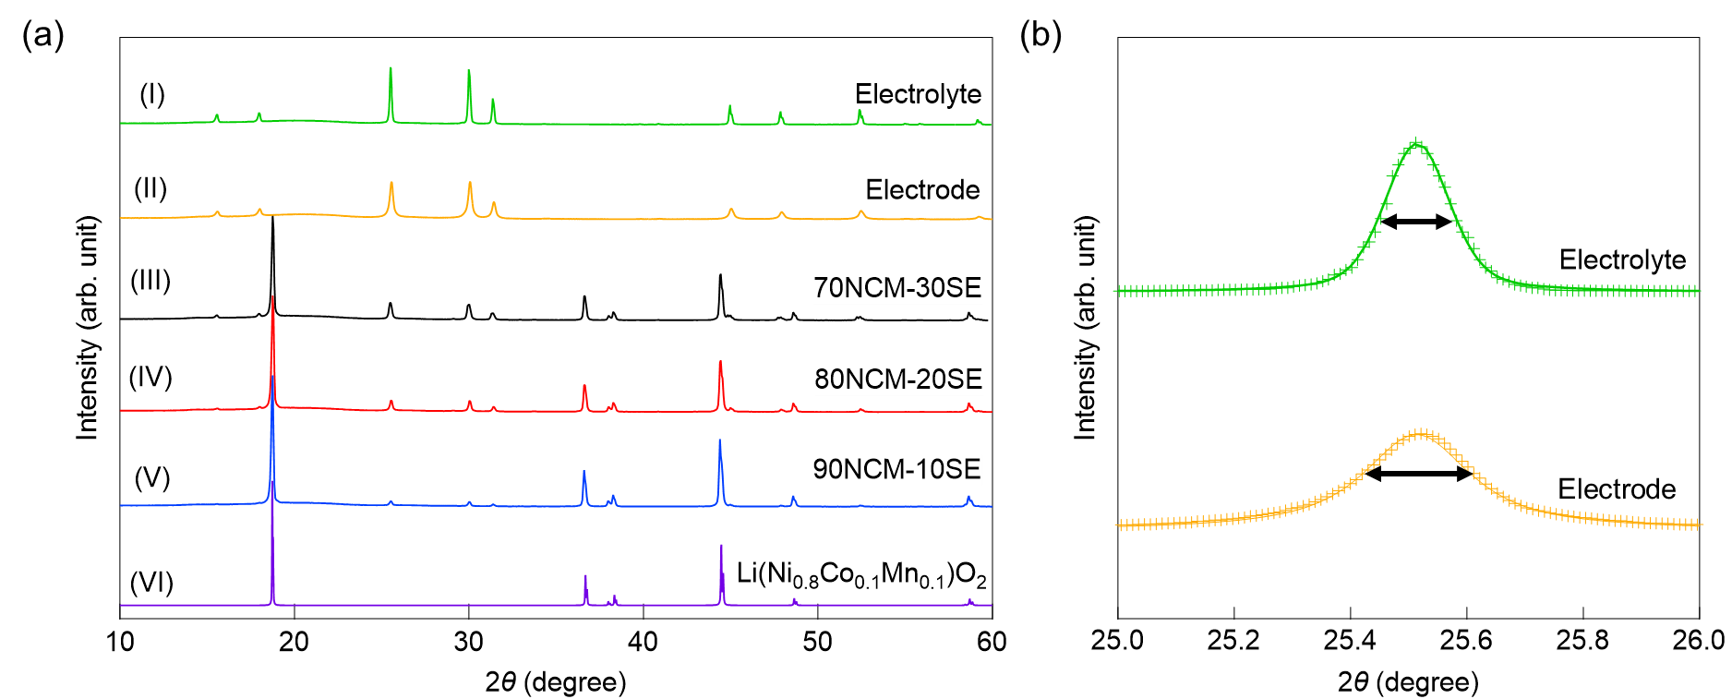
Figure 1. (a) XRD patterns of the Li_{5.4}(PS₄)(S_{0.4}Cl_{1.0}Br_{0.6}) powders used for the (I) electrolyte layer and (II) electrode layer and cathode mixtures of Li(Ni_{0.8}Co_{0.1}Mn_{0.1})O₂ and Li_{5.4}(PS₄)(S_{0.4}Cl_{1.0}Br_{0.6}): (III) 70NCM-30SE, (IV) 80NCM-20SE, and (IV) 90NCM-10SE. All measurements were performed at room temperature (290–300 K). (VI) The pattern of Li(Ni_{0.8}Co_{0.1}Mn_{0.1})O₂ (VI) was simulated using the literature lattice parameters.^{[30]} (b) FWHM values (black arrows) were obtained from the (200) XRD peaks of Li_{5.4}(PS₄)(S_{0.4}Cl_{1.0}Br_{0.6}) extracted from the XRD patterns of the electrolyte and electrode powders. Crosses represent raw XRD data and the solid lines are fitted data using the split-pseudo-Voigt function.

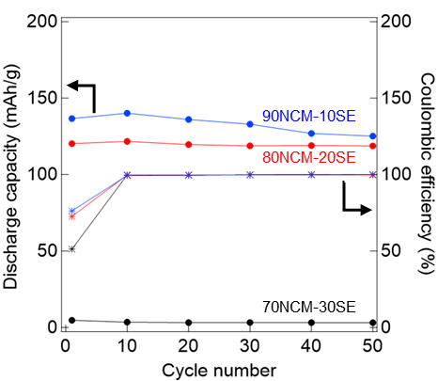
Figure 2. Cycling durability (filled circles) and Coulombic efficiency (asterisks) of the (black) 70NCM-30SE, (red) 80NCM-20SE, and (blue) 90NCM-10SE mixtures measured at 0.1C.

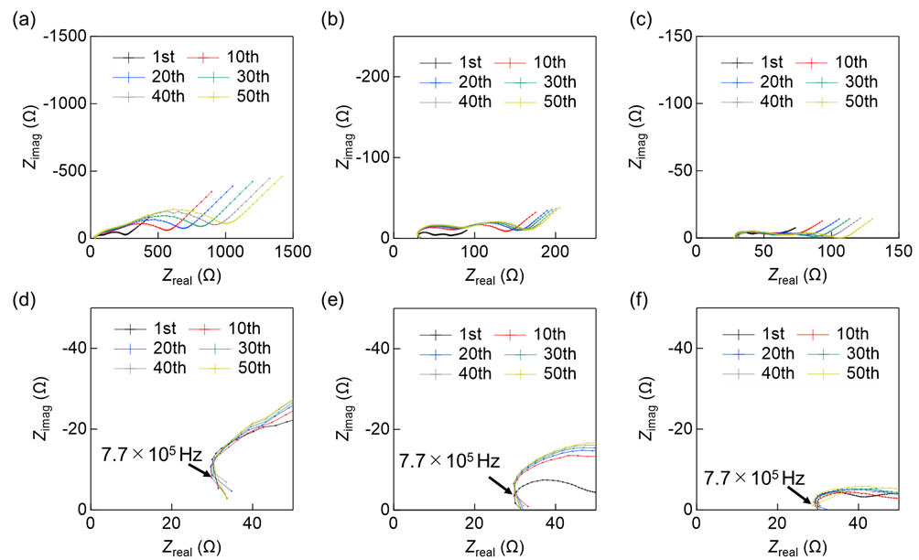
Figure 3. Impedance spectra of (a, d) 70NCM-30SE, (b, e) 80NCM-20SE, and (c, f) 90NCM-10SE mixtures measured at an equivalent of 50% SOC and a frequency range of 10⁶–0.01 Hz over 50 cycles (data for the 1st, 10th, 20th, 30th, 40th, and 50th cycles are shown).

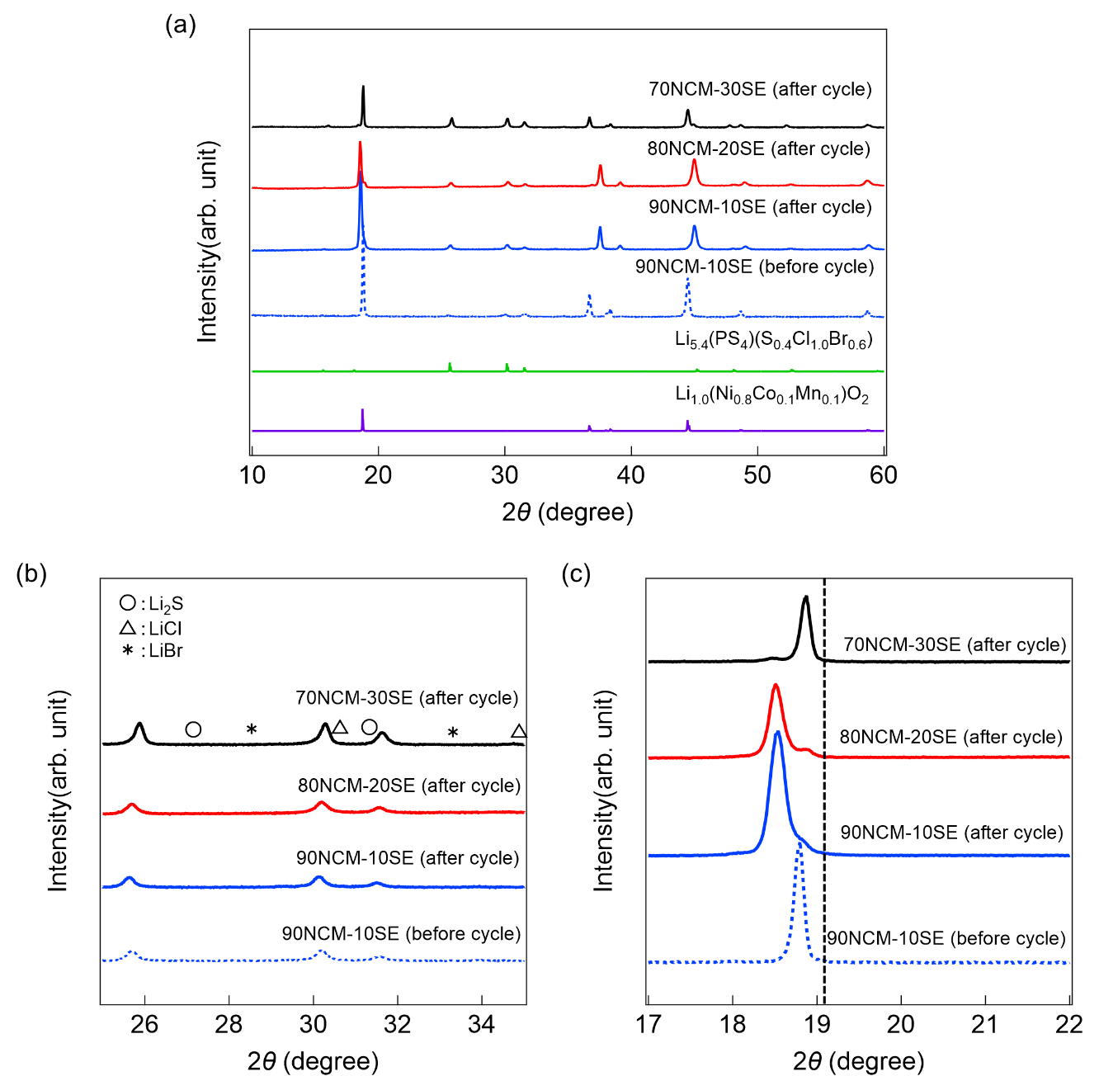
Figure 4. (a) XRD patterns of pellets of the 70NCM-30SE, 80NCM-20SE, and 90NCM-10SE cathode mixtures measured at room temperature (290–300 K) before and after cycling. The XRD pattern of Li(Ni_{0.8}Co_{0.1}Mn_{0.1})O₂ was simulated from reference data,^{[30]} and that of Li_{5.4}(PS₄)(S_{0.4}Cl_{1.0}Br_{0.6}) before cycling is shown for reference (green line). (b) Magnified view of the (003) XRD peak of Li(Ni_{0.8}Co_{0.1}Mn_{0.1})O₂ measured for the cathode mixture pellets before and after cycling. The black dashed line represents the position of the 2θ = 18.5° peak.

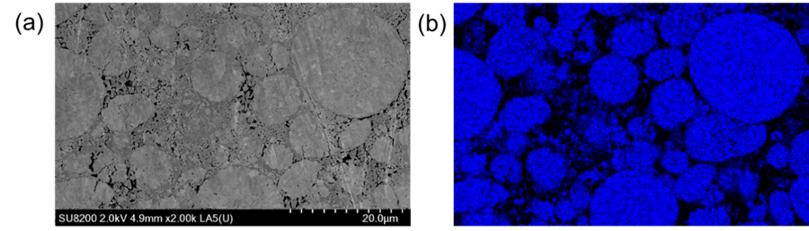
Figure 5. (a) SEM image and (b) the corresponding elemental map of Ni (blue) in the 90NCM-10SE mixture used to detect the presence of Li(Ni_{0.8}Co_{0.1}Mn_{0.1})O₂. In the SEM image, the bright areas correspond to the cathode active material, the dark gray areas o the solid electrolyte, and the black areas to voids.

