Towards high degree of c-axis orientation in MgB₂ bulks

M. A. Grigoroscuta¹, G. V. Aldica¹, M. Burdusel¹, V. Sandu¹, A. Kuncser¹, I. Pasuk¹, A.M. Ionescu¹, T. S. Suzuki², O. Vasylkiv², P. Badica^{1*}

¹National Institute of Materials Physics, 405A Street Atomistilor, 077125 Magurele, Romania
²National Institute for Materials Science, 1-2-1 Sengen, Tsukuba, Ibaraki, 305-0047, Japan

Abstract

The paper presents fabrication and characterization of spark plasma sintered textured (001) MgB₂ with a record degree of orientation of about 40 % by ultra-sonication and slip casting in high magnetic field (12 T), compared to a 16 % orientation in zero-field slip casting. Structural characterization was performed by X-ray diffraction, and electron microscopy. The analysis revealed unexpected preferred orientation also in the MgO secondary phase due to the epitaxial growth of (111) MgO on (001) MgB₂. The influence of oriented microstructure on the superconducting characteristics expressed by J_{c}, H_{irr} and on the pinning properties were assessed. High anisotropy versus sample orientation in applied magnetic field, H, was observed for the critical current density, J_{c}, irreversibility field, H_{irr}, pinning activation energy, U*, extracted from relaxation measurements, and h₀=H/H_{irr} corresponding to the maximum of the volume pinning force F_{p,max}. The zero-field critical current, J_{c0} and F_{p,max} are weakly or not dependent on the direction of H, while the other indicated parameters are significantly influenced. Results enable control of superconducting parameters by further optimization of microstructure through MgB₂ texturing as a novel and viable strategy for development of bulk MgB₂ with enhanced properties when taking advantage of its anisotropy.

Declarations of interest: none

Keywords: textured MgB₂ bulk, slip casting, spark plasma sintering, critical current density, pinning force, pinning activation energy
1. Introduction

MgB₂ occupies a special niche among practical superconductors. It has a convenient critical temperature T_{c} of 39 K, about two times higher than for the low temperature metallic superconductors (e.g. 18 K for Nb₃Sn). Therefore, this enables the use of MgB₂ in the temperature range of 15-30 K. Liquid hydrogen (20 K) can be used as a cooling agent and technologies based on it are recognized to show enormous potential for development of the future green economy. MgB₂ is a lightweight material. Its bulk density of 2.63 g/cm³ is few times lower than for other practical superconductors including high temperature superconductors (e.g. 6.3 g/cm³ for YBa₂Cu₃O₇). Hence, MgB₂ is a valuable superconductor especially for portable applications, in space, transportation, medicine, energy and others. However, to take advantage of the presented features, the improvement of the critical current density, J_{c}, and of the irreversibility field, H_{irr}, is required. Since the coherence length is relatively large in MgB₂, about 10 - 40 nm [1], introduction of size-comparable defects can promote vortex pinning and enhancement of J_{c} and H_{irr}. Literature indicates a few routes such as introduction of additives and use of different processing technologies. In the first case, precipitates of secondary phases and defects associated with them (interfaces, strain at interfaces, local non-stoichiometry, modification of the grain boundaries) or direct substitution of a component element into the crystal lattice of MgB₂ (e.g., carbon for boron [2-4]) can generate effective pinning centers. Modification of the microstructure (e.g. nano-structuring for a high density of grain boundaries as pinning centers) and enhancement of the bulk density are induced by specific technological procedures [5-23], popular being high-energy ball milling and pressure-assisted techniques. Heat treatments in reactive atmospheres are also effective for pinning centers introduction. Spark Plasma Sintering in N₂ atmosphere generated nano-precipitates of the MgB₉N phase enhancing the critical current density at high magnetic fields [24].
A novel strategy is to obtain (001) textured MgB₂ bulks with enhanced transport properties for a preferential direction [19, 25]. Samples were fabricated by magnetic field slip casting (MFSP) followed by spark plasma sintering (SPS). Textured powder-in-tube tapes obtained by mechanical deformation and annealing were also reported [26, 27]. The MgB₂ has a hexagonal, anisotropic crystal structure with (ab)-planes of boron and Mg stacked in the c-axis direction. Despite the feeble magnetic properties at room temperature of MgB₂, its anisotropy promotes orientation in MFSP [28, 29] which can be further enhanced by spark plasma sintering. In the partially oriented samples with an orientation degree of 21 %, J_{c} and H_{irr} were pushed to higher values in the favorable direction, while in the disadvantageous one, J_{c} and H_{irr} had a small suppression when compared to a randomly oriented sample [19]. These samples have also shown a complex behavior of the volume pinning force, F_{p}.
This work reports fabrication and properties of (001) MgB₂ textured bulk samples with a higher degree of orientation than in the previous attempts [19, 25]. Orientation enhancement is induced by high-energy ultrasound processing of the colloidal solution of MgB₂ in ethyl alcohol in the slip casting process. A record orientation degree of about 40 % was obtained after spark plasma sintering (SPS) in vacuum or nitrogen if a high magnetic field is applied during slip casting, compared to 16 % obtained in zero-field slip casting. The influence of oriented microstructure on superconducting characteristics J_{c} and H_{irr} and on pinning properties is assessed.

2. Material and methods

Sample processing is presented in Fig. 1. A colloidal solution of powder MgB₂ (99.5% purity, metal basis, (LTS Research Laboratories Inc. US) in ethanol was prepared under high energy ultrasound sonication (600 W) (Fig. 1 a, b). The as-prepared solution was slip casted (SC) and the resulting compact was spark plasma sintered (SPS) (sample M1, Table 1). Slip casting experiments were also performed under a magnetic field, H₀, of 12 T (Fig. 1 c). The as-resulting casted compacts were spark plasma sintered in vacuum (30 Pa) (sample M2, Table 1) or in a N₂ atmosphere (91 kPa) (sample M3, Table 1, Fig. 1 d, e). Spark plasma sintering was performed at 1150 °C for 30 min, using a FCT Systeme GmbH—HP D 5 (Germany) sintering furnace, with graphite die systems. The heating rate was 150 °C/min and the maximum uniaxial pressure applied on the disk-shaped samples (20 mm diameter and 3 mm thickness) was 95 MPa. Noteworthy is that different from our previous works [19, 25], no dispersing agent was introduced in the colloidal solution. Instead, as already mentioned, the colloidal solution was sonicated at high energy.
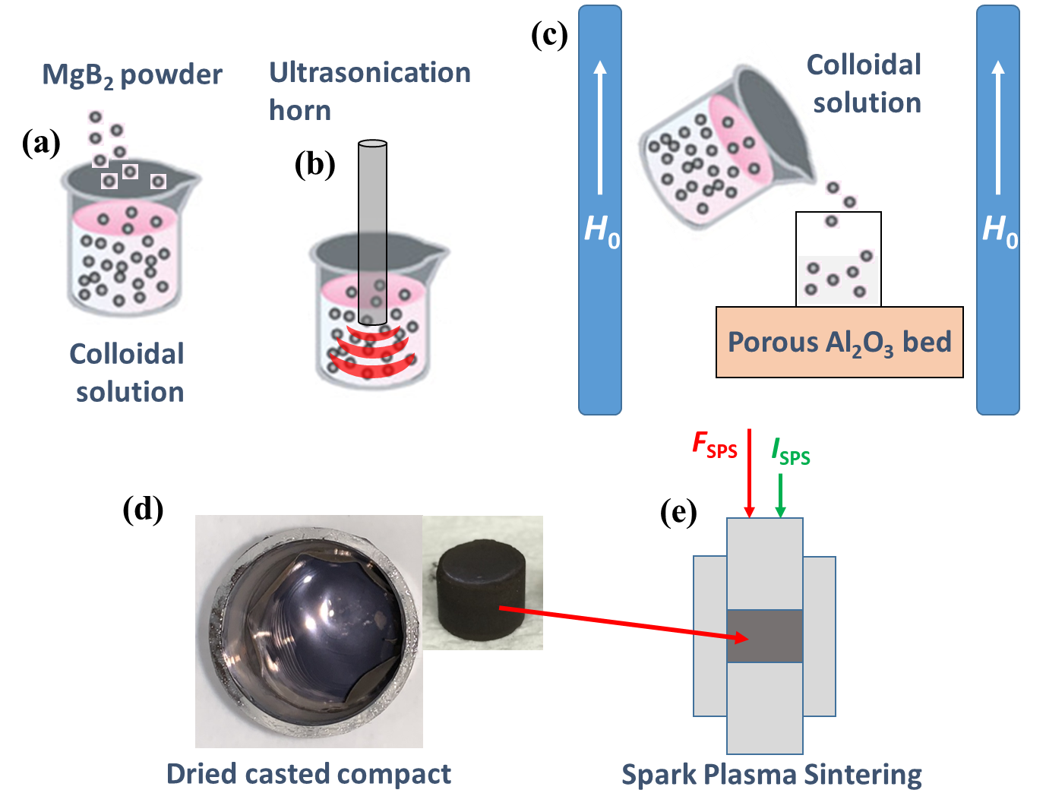
Fig. 1 Processing steps: (a) Colloidal solution preparation; (b) ultrasonication; (c) slip casting under 12 T; (d) dried casted compact; (e) Spark Plasma Sintering.

XRD patterns were obtained with a Bruker-AXS D8 ADVANCE diffractometer (Cu_{Kα} radiation). From Rietveld analysis (software MAUD 2.31 [30]) the weight fractions and the crystallite size of the detected phases, a and c lattice parameters of MgB₂, and the microstrain for MgB₂ and MgO were determined. In order to obtain a good fit by Rietveld refinement, the preferred orientation of MgB₂ and MgO had to be taken into account, and the March-Dollase orientation parameter, r [31], was extracted. We further used this parameter for the calculation of the degree of preferred orientation parameter, η, and the characteristic angle, φ [32]:
$$={[\frac{{\left(1-r\right)}^{3}}{(1-r^{3})}]}^{1/2}∙100 (\%)$$ |  | (1)
$$\cos{Φ}={[\frac{1-r}{1-r^{3}}]}^{1/2}$$ | (2)

The degree of preferred orientation, η, means the excess volume fraction of crystallites having the preferred orientation axis (which is [001] for MgB₂ and [111] for MgO, as shown below) within the surface normal and the angle φ, compared with a random sample. φ is the angle from the surface normal for which the orientation probability in a textured sample equals the orientation probability in a random sample. (For a random sample: r = 1, η = 0, φ is undefined). We expressed the orientation degree of MgB₂ also in terms of the Lotgering factor, LF [33], which is commonly used in the literature.
The apparent densities $ρ_{a}^{SPS}$ of the SPSed pellets were measured by Archimedes method (in toluene media). The relative densities R^{SPS} (%) were calculated as $R^{SPS}=ρ_{a}^{SPS}/ρ_{t}^{SPS}×100$. The theoretical densities $ρ_{t}^{SPS}$ of the composites were determined by the procedure described in ref. [34]. The phases used in calculation of the theoretical density were MgB₂ (2.63 g/cm²), MgO (3.58 g/cm²), and MgB₄ (2.49 g/cm³).
SEM Lyra3XMU and TEM JEM 2100 microscopes were employed to observe the microstructure of the samples. For SEM, bulk MgB₂ samples were polished and etched for 70 s in Royal water (aqua regia).
Magnetization measurements as a function of the applied field, m(H), at different temperatures, T, and as a function of temperature, m(T), at 0.01 T, as well as the relaxation of the magnetization, m(t), were performed with a MPMS-SQUID 7T (Quantum Design, US) magnetometer. The samples for magnetic measurements were cut from the center of the sintered disks and have approximately a cuboidal shape (∼ L x l x g = 1.1 x 1.05 x 1 mm³). To determine the critical current density, J_{c}, the Bean formula for a plate-like geometry [35] was used:
J_{c} = 20|m↑-m↓|/{Vl[1-(l/(3L)]} (3)
where m↓ and m↑ are the magnetic moments in emu for ascending and descending magnetic field respectively, in the m(H) loops, V is the sample volume in cm³, and L, l, are in cm. Flux jumps were observed in the m(H) loops on the ascending branch (one jump at ∼ 1.45 T) at temperatures below 10 K, 5 K and 15 K for samples M1, M2 and M3, respectively. They were not taken in consideration in our analysis. The pinning force is F_{p} = μ₀HJ_{c}. To avoid the complications with macro flux jumps and with estimation of |m↑-m↓| in the classic Bean model, the self-field, J_{c0} (in A/cm²), was estimated from a modified Bean relation, considering the descending branch of the hysteresis loop [36]:
J_{c} = 60⎜m↓ ⎜/(Vl) (4)
The irreversibility field, H_{irr}, is the field for which J_{c} = 100 A/cm². The pinning activation energy was determined from relaxation measurements. Samples were zero field cooled to different temperatures, a magnetic field was applied, and the decay of the magnetic moment in time, m(t), was recorded for a time window, t_{w}, of 50 min. In the range where ln(|m|) versus ln(t) is linear, the normalized vortex-creep activation energy is:
$U^{*}=-T∆\text{ln}\left(t\right)/∆\text{ln}\left(\left|m\right|\right)$ (5)
averaged over t_{w}. [37, 38]. For U*(T) an external field of 3 T was applied and U*(H) was measured at 10, 15 and 20 K.

Table 1. Samples, apparent ($ρ_{a}^{SPS}$) and relative density (R^{SPS}), Lotgering factor LF, March Dolase orientation factor r, the degree of orientation η, and the orientation angle φ of MgB₂ and MgO, microstrain (ε) in MgB₂ and MgO, phase content. The notations correspond to those in Fig. 2 a. H is applied magnetic field during magnetic measurements.

Sample | MgB₂  sample type | Apparent density, ρa^{SPS} (g/cm³) / Relative density, R^{SPS} (%) | Microstrain in MgB₂ | Microstrain in MgO | Phase Content (wt.%), Crystallite size (nm) and orientation parameters
Sample | MgB₂  sample type |  | ε(%) |  | MgB₂ |  |  | MgO |  |  | MgB₄
 |  |  |  |  | wt.% | nm | LF (%) / r /  η (%)/φ (°) MgB₂ (001) | wt.% | nm | η (%)/φ (°)  MgO (111) | wt.% | nm
M0 | raw powder | - / - | 0.075±0.005 | 0.06±0.02 | 97.0 | 113±3 | 0 / - / - / - | 1.8 | 45±4 | - / - | Mg(1.2) | -
M1 | 0 T-SC + SPS- vacuum; S_{top}  M1|| (H || H₀) | 2.678 / 100 | 0.12±0.0004 | 0.114±0.01 | 82.3 | 187±2 | 12.6 / 0.754 / 16.1 / 49 | 8.8 | 177±16 | ~0 / - | 8.9 | 92±4
M1 | 0 T-SC +SPS- vacuum; S_{side}  M1⊥ (H ⊥ H₀) | 2.678 / 100 | 0.10±0.0006 | 0.09±0.01 | 82.5 | 265±9 | - / - / - / - | 8.6 | 154±16 | - / - | 8.9 | 99±4
M2 | 12 T -SC + SPS- vacuum; S_{top}  M2|| (H || H₀) | 2.682 / 100 | 0.11±0.006 | 0.132±0.015 | 81.3 | 220±5 | 61.6 / 0.473 / 40.5 / 39.9 | 10.0 | 184±27 | 28.2 / 45 | 8.7 | 94±3
M2 | 12 T-SC + SPS- vacuum; S_{side}  M2⊥ (H ⊥ H₀) | 2.682 / 100 | 0.095±0.001 | 0.124±0.015 | 82.1 | 184±5 | - / - / - / - | 9.5 | 164±3 | - / - | 8.4 | 85±7
M3 | 12 T-SC + SPS- nitrogen; S_{top}  M3|| (H || H₀) | 2.685 / 99.9 | 0.11±0.001 | 0.121±0.012 | 80.1 | 203±1 | 60.4 / 0.482 / 39.6 / 40.2 | 10.2 | 187±37 | 28.2 / 45 | 9.7 | 90±8
M3 | 12 T-SC + SPS- nitrogen; S_{side}  M3⊥ (H ⊥ H₀) | 2.685 / 99.9 | 0.095±0.001 | 0.139±0.013 | 81.2 | 174±3 | - / - / - / - | 9.6 | 158±25 | - / - | 9.2 | 82±7

3. Results and Discussion

3.1. Structure and microstructure of the investigated samples

Two X-ray diffraction patterns were obtained for each bulk sample, one on the surface S_{top} in which case the scattering vector is parallel with the SPS uniaxial pressing force, F_{SPS}, and the processing magnetic field during slip casting, H₀, and the other on S_{side}, with the scattering vector perpendicular to F_{SPS} and H₀ (Fig. 2a). The patterns measured on S_{top} are presented in Fig. 2 b. The qualitative analysis shows the presence of the major phase MgB₂ and of MgO and MgB₄ as secondary phases. To highlight the [001] texturing of MgB₂, the intensities were represented being divided by the intensity of the (101) line, which is the most intense for a random sample. Slip casting and SPS decreases the amount of MgB₂ (Table 1) from 97 wt. % in the raw powder (sample M0) to 80.1 – 82.5 wt. % in the sintered bulks (M1, M2, and M3), while the amounts of MgB₄ and MgO increase from 1.8 and 1.2 wt. % to 8.8-10.2 and 8.4-9.7 wt. %,

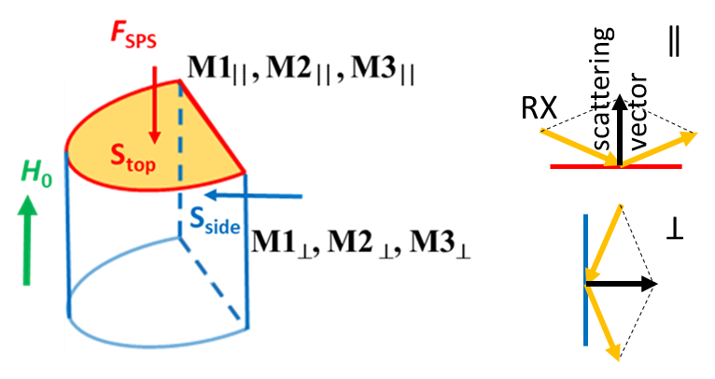  (a) | (b)
Fig. 2 (a)- Notations of the sample surfaces on which the XRD measurements were performed. (b)- XRD patterns of the samples obtained on S_{top}.

respectively. Although the amount of the secondary phases is limiting the connectivity within the samples, if properly engineered, these phases can be effective pinning centers [39, 40]. Sintered samples show (001) MgB₂ preferred orientation with the (ab) plane parallel to S_{top}. A texture with a degree of orientation η of 16.1 % (LF = 12.6 %) occurs in the sintered sample M1 (Table 1) even in the absence of the magnetic field during slip casting.

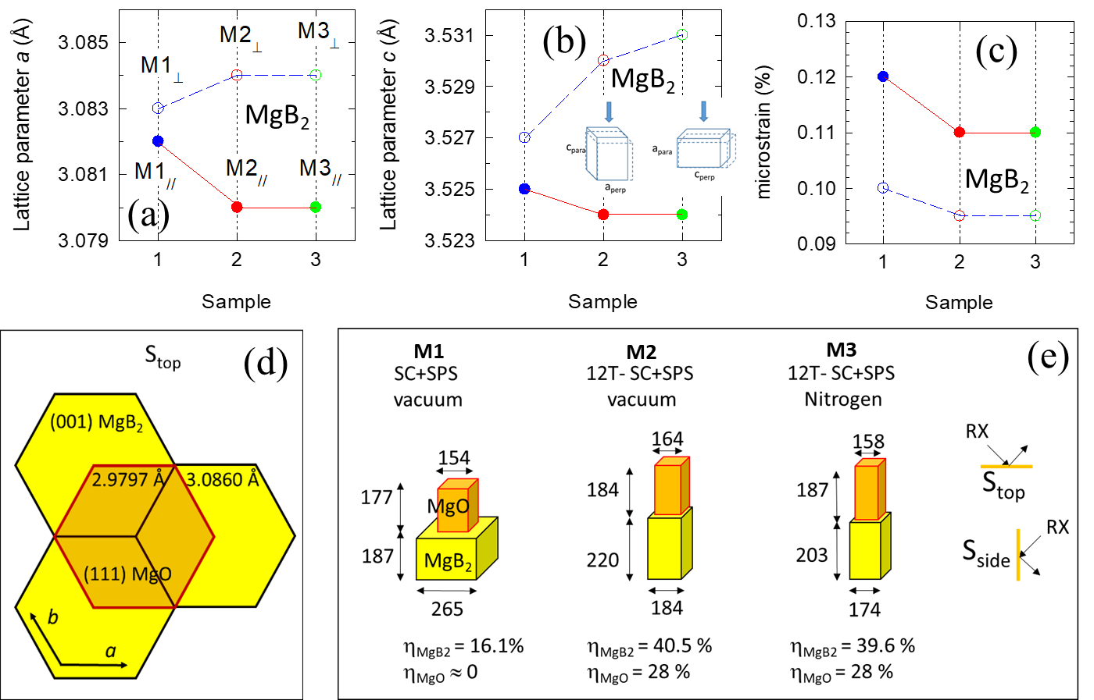
Fig. 3 Structural parameters for samples M1, M2, and M3 extracted from XRD data measured on S_{top} (//) and S_{side} (⊥), respectively: (a)- lattice parameter a of MgB₂; (b)- lattice parameter c of MgB₂. The inset in (b) explains intuitively the different values of the lattice constants obtained by XRD on the two perpendicular faces of the sample: the lattice shrinks in the SPS direction (//) and expands in the perpendicular directions (⊥). (c)- microstrain ε (%) of MgB₂; (d) Lattice matching relationship between (001) MgB₂ and (111) MgO. The distance between two neighboring Mg or B atoms in the (001) MgB₂ plane is 3.086 Å, while the distance between two oxygen or Mg atoms in the (111) MgO plane is 2.9797 Å. The two crystal planes also have compatible rotational symmetry, namely of 6th order for (001) MgB₂ and 3rd order for (111) MgO; (e)- comparison of MgB₂ and MgO crystallite sizes (in nanometers) of the textured samples.

We explain this result by the effect of the high energy ultrasonication which breaks the agglomerates of MgB₂ [41]. It is recognized that agglomeration is one of the main limiting factors for mouldability and sintering and cannot be improved in dry powders [42]. The plate-like MgB₂ grains will organize in a partially textured green compact during slip casting and will enhance their texture during subsequent SPS. Enhancement of texture during SPS of a green compact with a low orientation was addressed in an earlier work [19]. For the samples processed by slip casting under a magnetic field of 12 T and SPSed in vacuum or in N₂ atmosphere, a relatively high orientation is achieved with η of 40.5 (LF=61.6%) and 39.6 % (LF=60.4%), and φ of 39.9 and 40.2°, respectively. Therefore, the preferred orientation of MgB₂ is considerably increased in the samples obtained in a magnetic field.
Another interesting aspect is that for a good Rietveld fitting of the measured XRD patterns of the highly oriented samples M2 and M3, it was necessary to consider a preferred orientation also for MgO, with the (111) plane parallel to S_{top}. In both samples M2 and M3, an excess of about 28 % of the MgO crystallites is oriented with the <111> axes within about 45º from the surface normal (direction of H₀). Considering the texturing mode of MgB₂ and MgO, it results that the (111) crystal planes of MgO are oriented preferentially parallel to the (001) plane of MgB₂. The orientation degree of MgO is a bit worse than that of MgB₂ (η = 28 % compared to about 40 %). A closer look at the atomic structures of the (111) MgO and (001) MgB₂ planes shows excellent theoretical lattice matching that favors the epitaxial growth of MgO on MgB₂ crystallites (Fig. 3d) during SPS. The epitaxial mismatch is (3.0860-2.9797)/3.086 = 3.4%. It is expected that the epitaxial stress causes a compression strain in the (ab)-plane of MgB₂ at the interface with MgO, and a slight increase of the average MgO lattice parameter. The epitaxial growth of (001) MgB₂ thin films on (111) Si single crystal substrates with a MgO seed layer was reported in ref. [43].
Figure 3 a and b show an average decrease of the MgB₂ lattice parameters parallel to the SPS pressing force (F_{SPS}, Fig. 2a), which generates an expansion of the unit cell in the perpendicular direction (macrostrain). This behavior is valid for both a and c constants of MgB₂ because, the samples are only partially textured, and the crystallites could have different orientations to the pressing force. The effect of compression and expansion is more directly transferred to the a and c lattice constants when the unit cells (crystallites) are oriented in the two extreme positions depicted in the inset of Fig. 3 b. As the orientation degree increases, the probability that the unit cell is orientated with c parallel to the compression force increases, hence, the effect upon the values of a and c is higher. In the same key, one can comment on the decrease of the microstrain with the enhancement of texturing (Fig. 3c). Microstrain measures the dispersion of the interplanar spacings, which may originate from many sources, e.g., local lattice strain (caused, for instance, by point defects or dislocations), or structure changes near the crystallite or grain boundary, or different lattice strain in different crystallites. This last cause is probably preponderant for our partially textured and uni-axially-stressed bulk samples. The dispersion of the interplanar spacing decreases with orientation enhancement, and this is the case when measured both for S_{top} or S_{side} arrangements. In isotropic and macrostrain-free MgB₂ samples, the change in the a-lattice parameter of MgB₂ is considered an indicator of the degree of substitution of B by C [44-48]. Substitution of C for B leads to the creation of strain and distortion in the matrix because C–B bond is shorter than the B–B one. The dependence reported in the above-mentioned reports [44-48] works well for randomly oriented samples. In the case of highly c-axis oriented samples, where the uniaxial pressure generated an anisotropic distribution of the strains make the model questionable and requires additional investigation. However, it is reasonable to consider that some small amount of carbon intake e.g. from the graphite die system occurs during SPS processing in the textured samples as in the randomly oriented ones [45].
Figure 3 e summarizes the average crystallite (coherence domain) sizes in vertical and lateral directions. One can notice that the MgO lateral size is always smaller than that of MgB₂, which could be an argument in favor of MgO epitaxy on MgB₂. The column-shaped MgB₂ crystallites are the constituents of the micron-size plate-shaped grains revealed in the SEM images presented below (Fig. 4).
When measured on S_{top} and S_{side} the crystallite size of MgB₄ (83-98 nm, Table 1) shows differences and the tendencies for a certain measurement arrangement with the orientation degree are similar to those for MgB₂ although for this phase texturing was not found. Lack of correlations and explanations for the crystallite size dependencies have the origin in the complexity of the processes during processing, involving chemical reactions, solid, liquid, and gas phases, and also in the limitations in evaluation by Rietveld method of the crystallite size for the anisotropic crystals with a model that is suitable for spherical ones. A careful assessment and further studies are required.
The relative density of the samples is high, close to the theoretical value (Table 1). This is confirmed by the SEM images obtained on the highly oriented samples M2 and M3 (Fig. 4 b and Fig. 4 c2) showing few pores. Few closed pores are visible also in sample M1 (Fig. 4 a) with a lower degree of orientation, but they can be the result of chemical etching. The plate-like hexagonal grains, which were ascribed to MgB₂ phase, are visible in the SEM images of highly oriented samples M2 and M3 (Fig. 4 b, Fig. 4 c1 and Fig. 4 c2). The in-plane size of the platelets is about 1 µm. These micrographs confirm the c-axis texturing of MgB₂. We also note that samples with a higher level of orientation (e.g. M2, Fig. 4 b) are more corrosion resistant than sample M1 (Fig. 4 a). The anisotropic corrosion resistance is easy to understand from the crystal chemistry of MgB₂. The weak chemical bonding of Van der Waals type between the alternating Mg and B (ab)-planes favors a lower corrosion resistance than in the plane where the bonds are strong.

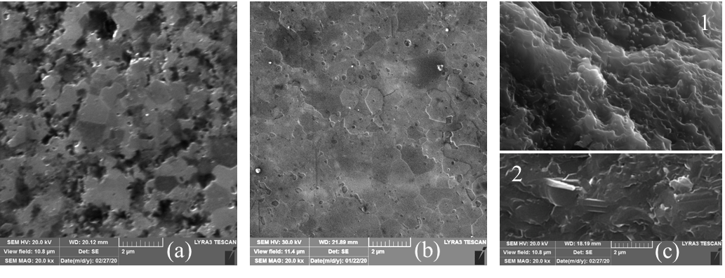
Fig. 4 SEM images taken on etched samples: (a)- S_{top} of 0T-SC+SPS vacuum; (b)- S_{top} of 12T-SC+SPS vacuum; (c)- S_{side} of 12T-SC+SPS nitrogen (1 – fractured surface and 2 – polished surface).

The general TEM image on sample M3 shows grains with flat hexagonal surfaces. (Fig. 5 a). These grains (Fig. 5 b) have the crystal structure of MgB₂ with the c axis perpendicular to the surface, as determined by selected area electron diffraction (SAED) (inset to Fig. 5 b). Other grains with a bulky appearance are ascribed to MgO (Fig. 5 c). Oxygen was also found at the grain boundaries, between MgB₂ grains (Fig. 5 d). Distribution of MgO and MgB₂ grains can be also observed by using SAED mapping (Fig. 5 g). By neglecting the MgO grains, the orientation map for MgB₂ is presented in Fig. 5 h. The color and intensity code map from (Fig. 5 f) which are based on the orientation map from Fig. 5 h indicates that most grains are (00l) textured (red color is dominant), but there are angular deviations from a perfect orientation. Indeed, the pole figure (Fig. 5 e) for (00l) MgB₂ confirms that most grains of MgB₂ are c-axis oriented since the highest intensity is for the center of the pole figure. Horizontal c-axis orientation is also present (blue color,

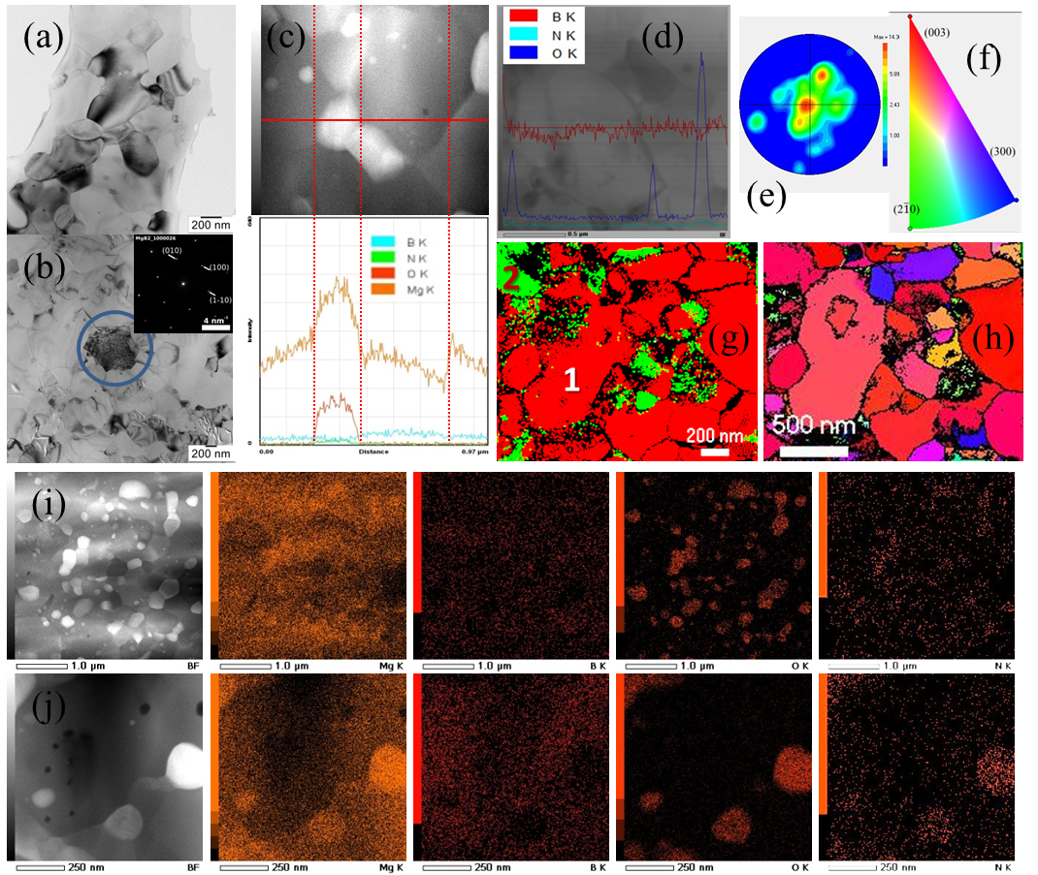
Fig. 5 TEM/EDS images on bulk sample ‘3’: (a)- general TEM image; (b)- detail showing the hexagonal surface of a MgB₂ grain as identified by SAED (inset); (c)- TEM image and line scan showing that white grains are MgO; (d)- TEM image and EDS line scan showing grain boundaries containing oxygen; (g)- SAED map that identifies the crystal structures of 1 – MgB₂ (red) and 2 – MgO (green); (h)- SAED map showing the degree of orientation of MgB₂ that corresponds to pole figure for (00l) from (e) and orientation color code from (f); (i) and (j)- TEM images at two different magnifications and EDS maps for Mg, B, O, and N.

in Fig. 5 f). Apparently in the pole figure (Fig. 5 e) are present extra peaks with orientation at about 25-40° (from the vertical) that corresponds quite well to φ of about 39° determined by XRD. Nevertheless, this result might be just a statistical artefact since the number of measured grains is limited. The MgB₂ domain sizes of about 200 nm highlighted in Fig. 5 g are close to the average lateral extent of the coherence domains of the MgB₂ resulted from XRD.
The EDS maps from Fig. 5 i, Fig. 5 j show the distribution of elements. In some cases, nitrogen seems to accompany Mg and O from relatively large regions (Fig. 5j). There is also nitrogen in smaller nano areas not following the O distribution. As reported in ref. [24], in randomly oriented samples fabricated by SPS in nitrogen these nano grains were ascribed to phase MgB₉N. The amount and size of this phase is small and due to this it cannot be clearly observed in XRD patterns (Fig. 2b). In ref. [24] the nano size of MgB₉N was determined to be comparable with the coherence length of MgB₂ (10-20 nm), and, thus, the precipitates of this phase can play the role of effective pinning centers. Confirmation of the presence of the MgB₉N phase in the samples from this work requires additional observations by electron microscopy.

3.2. Superconductivity aspects from magnetic measurements of the investigated samples

Figure 6 a shows magnetization curves with temperature. The critical temperatures T_{c} are T_{c} = 37.5 K, 38.4 K, and 38.3 K for the samples M1, M2, and M3, respectively. The slightly higher critical temperature of the samples M2 and M3 with a better texture is probably due to the slightly lower level of the microstrain [49] noticed in these samples (Fig. 3c).
The J_{c}(H) curves at 5-35 K (see e.g. curves for 5 and 20 K in Fig. 6 b, c) of all samples are pushed to higher applied fields H when the measurement is performed in parallel geometry, i.e., H || H₀, than when H ⊥ H₀, but converge to the same value at zero field. Nevertheless, a small anisotropy of zero-field critical current density J_{c0} (J_{c0, ||} > J_{c0, ⊥}) at any investigated temperature can be visualized in Fig. 6 d. Samples M2 and M3 with a higher level of orientation (η = 40.5 and 39.6 %) have a higher difference between J_{c||} and J_{c⊥} when compared with sample M1 (η = 16.1 %). At low temperatures (e.g. at 5K, Fig. 6 c) this difference is perhaps further expanded by the presence of nitrogen in sample M3. The influence of orientation can be understood based on the following observation. In a parallel field, the Lorentz force would try to move the vortices across the grain boundaries which provide a strong pinning. Hence, a high J_{c||} occurs. In the direction perpendicular to the surface, the MgB₂ platelets are defined as a high/dominant number of stacked interfaces parallel to the S_{top} surface. When the measuring field is applied in a perpendicular geometry, i.e. parallel to the (001) planes, the Lorentz force drives the vortices along the grain boundaries to positions that make the field gradient smaller and, consequently, the J_{c⊥} is smaller than in the previous case. However, this scenario should take into account also other factors such as the inhomogeneity of the lattice parameters due to doping or stoichiometry variations, inhomogeneity and anisotropy of the microstrain due to orientation and to the presence of precipitates and defects. For example, in sample M3 introduction of nitrogen modifies the grain boundaries due to the occurrence of MgB₉N nano precipitates.

(a) | (b)
(c) | (d)
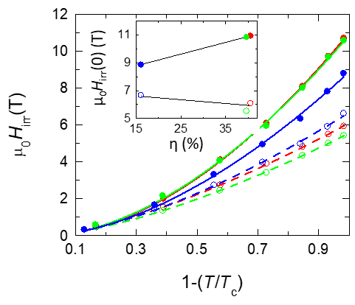  (e) | (f)
Fig. 6 (a)- Reduced magnetization curves vs. temperature; (b) and (c)- curves of critical current density J_{c}(μ₀H) at 5 K and 20 K, respectively; (d)- zero-field critical current density J_{c0} with temperature; (e)- temperature dependence of the irreversibility field H_{irr} of MgB₂ samples in the parallel and perpendicular geometries of measurements. Lines are fits with Eq. 6. Inset shows the dependence of the irreversibility fields on the degree of (001) orientation η. The lines are linear fits. All the fit parameters are shown in the Table 2; (f)- volume maximum pinning force with temperature.

The indicated factors influence the coherence length size and pinning, thus, impacting superconducting parameters.
The temperature dependence of the irreversibility field (Fig. 6 e) follows the law:
$H_{irr}=H_{irr}\left(0\right){\left[1-{\left(\frac{T}{T_{c}}\right)}^{2}\right]}^{β}$, (6)
Both H_{irr}(0) and β are strongly dependent on the orientation (Table 2). The values of β are grouped around two different values within the error of measurement: when H || H₀ the exponent is rather high β|| ≥ 1.7 , whereas for H⊥H₀, β⊥ has an average value ${\overline{β}}_{⊥}≈1.5$, which is close to the classical value of 1.5 [50, 51]. For an increasing orientation degree η, H_{irr, ||} (0) increases and H_{irr,⊥} (0) decreases (Table 2, inset to Fig. 6 e). It is noteworthy that the increase of H_{irr}(0) with orientation

Table 2 Fit parameters with eq. (6) of the irreversibility curves vs. temperature (Fig. 6 e).
Sample | μ₀H_{irr, ⊥}(0)  (T) | μ₀H_{irr, ||}(0)  (T) | β⊥ | β|| | δ
M1 | 6.67±0.07 | 8.87±0.12 | 1.54±0.04 | 1.71±0.08 | 0.13±0.01
M2 | 6.10±0.02 | 10.99±0.05 | 1.45±0.01 | 1.82±0.02 | 0.31±0.02
M3 | 5.54±0.03 | 10.85±0.11 | 1.48±0.02 | 1.70±0.05 | 0.23±0.02

η for H || H₀ (‘1||’, ‘2||’, ‘3||’) is more pronounced than decrease for H ⊥ H₀ (‘1⊥’, ‘2⊥’, ‘3⊥’) (see inset to Fig. 6 e). This result is important for practical applications and motivates the use of textured MgB₂ bulks. A linear fit of the η-dependence of the zero-temperature irreversibility H_{irr}(0) for H || H₀ and H ⊥ H₀ provides close values for a random orientation (η = 0): ${\left.H_{irr,||}\right|}_{η=0}=7.50±0.02$ and ${\left.H_{irr,⊥}\right|}_{η=0}=7.02±1.90$. A consequence of the existence of different irreversibility fields is the divergence of the current anisotropy, $γ_{J}=J_{c,||}/J_{c,⊥}$ at H_{irr,⊥}. The dependence at 20 K of γ_{J} on the reduced field h|| = H/H_{irr,||} for our samples is presented in Fig. 7 a. A second consequence is that there is a temperature dependence of the anisotropy of the H_{irr}, $γ_{H}= H_{irr}^{||}/H_{irr}^{⊥}$ described by:
$γ_{H}= γ_{H}\left(0\right){\left[1-{\left(T/T_{c}\right)}^{2}\right]}^{δ}$, (7)
with $δ=β_{||}-β_{⊥}$. The temperature dependence of γ_{H} is shown in Fig. 7 b and the values of β are gathered in Table 2.

(a) | (b)
Fig. 7 (a)- Current anisotropy γ_{J} as a function of the applied field relative to the irreversibility field for parallel direction h|| = H/H_{irr,||} at 20 K; (b)- temperature dependence of the anisotropy of the irreversibility field γ_{H} in samples M1||, M2|| and M3||. Continuous lines are fits with Eq. 7.

One observes that also the maximum pinning force F_{p, max} is slightly larger in samples with a higher level of orientation (Fig. 6 f).
Next, we present the results of the angular (α) dependence of superconducting parameters determined from magnetization loops m(H) measured at 10 and 20 K. The weak angular dependence of J_{c0} (Fig. 8 a) confirms the low field convergence of J_{c||} and J_{c⊥} mentioned above. However, for sample M2, close to α = 90 ° the curve J_{c0}(α) is approximately constant, while for

(a) | (b)
(c) | (d)
Fig. 8 Curves of: (a)- zero-field critical current density J_{c0}; (b)- irreversibility field μ₀H_{irr}; (c)- normalized pinning force F_{p}^{max}/F_{p}^{max}(90°); (d)- h₀ as a function of applied field orientation angle α (0° denotes the H || H₀ position) at 10 and 20 K for highly textured sample M2 in red and sample M3 in green.

sample M3 there is a slow increase. The reason for this effect is missing. As expected, H_{irr} displays a high angular variation (Fig. 8 b). The normalized pinning force F_{p}^{max}/F_{p}^{max}(90°) displays a split of the main peak into two peaks positioned at α_{peak} = ± 25-38° (Fig. 8 c). The values of |α_{peak}| ≤ φ (Table 1). They likely correspond also with results of the pole figure from TEM measurements (Fig. 5 e, see also text in Section 3.1): in pole figures there is a main central peak accompanied by satellite peaks. The intensity of the two better resolved satellite peaks in the pole figure is not equal and this might be the reason for different intensities of the F_{p}^{max}/F_{p}^{max}(90°) when α is positive or negative, but more research is needed. Overall, the peak of F_{p}^{max}/F_{p}^{max}(90°) without considering its split is broad and this might be convenient for applications. Following this idea, the result may suggest that from a practical viewpoint, a partially textured, but optimized (00l) MgB₂ material might be more valuable than a perfectly textured one. More research is needed to demonstrate this idea. Finally, we observe that the reduced field of the pinning force h₀ = H(F_{p, max})/H_{irr} as a function of α has a minimum at α = 0° (H || H₀). The minimum values of h₀ (Fig. 8 d) are in the range 0.12 - 0.16 (α ∼ 0°). These values are smaller than the lowest theoretical value h₀ = 0.2 corresponding to the pinning on the grain boundaries [52] which remain the dominant pinning mechanism in MgB₂ [53]). As already introduced before, the favorable direction for superconductivity in (001) oriented MgB₂ is when H || H₀ (H || c-axis) and one can take advantage of a better connectivity and of an effective use of grain boundaries for pinning. To further observe this effect in terms of the pinning behavior for different T and H, we assessed as an example the pinning activation energy U* from relaxation measurements for sample M3 and we compare the curves with those for a reference randomly oriented sample prepared by SPS without the slip casting step (Fig. 9).

Fig. 9 The pinning activation energy as a function of temperature (for an applied magnetic field of 3 T) (a) and applied magnetic field (b). Sample denoted reference is a randomly oriented sample made from the same raw material and by SPS, but without slip casting.

The activation energy U* increases with temperature in the collective (elastic) vortex-creep regime where the vortex phase is ordered [54] and decreases for plastic (dislocation mediated) creep where the vortex phase is disordered [55]. Curves for studied samples show this trend as one can observe in Fig. 9 a. The crossover at about 9 K can be understood in terms of an energy balance relation, where the thermal energy can be neglected for strongly pinned samples when T is much lower than T_{c}. Therefore, at low T, the relaxation is smaller leading to a J closer to J_{c}, the effective pinning is weak and the inter-vortex interactions play an important role, giving rise to collective pinning. At high T the energy balance changes, because J relaxes faster and U* increases. In these conditions, in the vortex system dislocations occur due to vortex pinning and the creep becomes plastic. Roughly, this dynamic crossover appears when the effective depth of the pinning potential well equals the vortex deformation energy [56]. No crossover was observed in U*(H) and U* decreases with increasing field, which is characteristic for plastic creep (Fig. 9 b).
Curves U*(H) and U*(T) measured on the oriented sample ‘3’ for the applied magnetic field in the parallel and perpendicular directions indicate on the anisotropy of U*. The pinning activation energy U* of the sample ‘3’ measured in parallel geometry (H || H₀) is higher than for the reference sample, whereas the measurement in perpendicular geometry provides a lower U*. Similar to the irreversibility field, this behavior is related to different density of barriers, namely to grain boundaries that a vortex encounters when its orientation is parallel to the plate or perpendicular on it. The values and curves shape of U* are comparable with data reported in literature for pristine, added or proton irradiated MgB₂ bulks [57-60].
4. Conclusion

The approach from this work demonstrates new possibilities for further improvements of the MgB₂ superconductor and its processing technology.
We have shown that high energy sonication during slip casting promotes (00l) orientation of the MgB₂ grains in the spark-plasma-sintered bulks. When during slip casting a magnetic field is not applied, the degree of orientation in the sintered sample attains ∼16 %. The degree of orientation is further enhanced towards high values (∼40 %), if during slip casting a high magnetic field of 12 T is applied. Some orientation was detected also for the grains of the secondary MgO phase.
Anisotropy of structural, microstructural and superconducting parameters of MgB₂ is analyzed and corroborated. The efficiency of grain boundaries on vortex pinning depends on orientation. The peak of F_{p}^{max}/F_{p}^{max}(90°) was found to be broad in the highly oriented samples from this work suggesting that for practical applications a partially textured, but optimized (00l) MgB₂ bulk might be more suitable than a material with perfect 100 % (00l) texture. This result and the pinning activation energy behavior provide the first elements necessary for design, fabrication and control of textured MgB₂ bulks.

Acknowledgements
Authors gratefully acknowledge financial support from MCI-UEFISCDI Romania, the projects PN030101 (21N/2019), 5PTE/2020 – BIOTEHKER, and POC 37_697 no. 28/01.09.2016 REBMAT.

References

[1] J.C. Loudon, S. Yazdi, T. Kasama, N. D. Zhigadlo, J. Karpinski, Measurement of the penetration depth and coherence length of MgB₂ in all directions using transmission electron microscopy, Phys. Rev. B 91 (2015) 054505. https://doi.org/10.1103/PhysRevB.91.054505.
[2] S.X. Dou, W.K. Yeoh, J. Horvat, and M. Ionescu, Effect of carbon nanotube doping on critical current density of MgB₂ superconductor, Appl. Phys. Lett. 83 (2003) 4996-4998. https://doi.org/10.1063/1.1634378.
[3] M.S.A. Hossain, J.H. Kim, X. Xu, X.L. Wang, M. Rindfleisch, M. Tomic, M.D. Sumption, E.W. Collings, S.X. Dou, Significant enhancement of H_{c2} and H_{irr} in MgB₂ + C₄H₆O₅ bulks at a low sintering temperature of 600 °C, Supercond. Sci. Technol. 20 (2007) L51. (https://doi.org/10.1088/0953-2048/20/8/L03).
[4] D. Patel, M. Shahriar, A. Hossain, A. Motaman, S. Barua, M. Shahabuddin, J.H. Kim, Rational design of MgB2 conductors toward practical applications, Cryogenics 63 (2014) 160-165. (https://doi.org/10.1016/j.cryogenics.2014.04.016).
[5] D. Rodrigues Jr., L. B. S. da Silva, V. C. V. Metzner, Eric E. Hellstrom, Superconducting properties of MgB₂ with addition of other AlB₂–type diborides and carbon sources, prepared using high energy ball milling and HIP, Physics Procedia 36 (2012) 468-474. https://doi.org/10.1016/j.phpro.2012.06.219.
[6] D. Gajda, A. Morawski, A. J. Zaleski, W. Haßler, K. Nenkov, M. A. Rindfleisch, E. Zuchowska, G. Gajda, T. Czujko, T. Cetner, M. S. A. Hossain, The critical parameters in in-situ MgB₂ wires and tapes with ex-situ MgB₂ barrier after hot isostatic pressure, cold drawing, cold rolling and doping, J. Appl. Phys. 117 (2015) 173908. https://doi.org/10.1063/1.4919364.
[7] M. S. A. Hossain, C. Senatore, M. Rindfleisch, R. Flukiger, Improvement of J_{c} by cold high pressure densification of binary, 18-filament in situ MgB₂ wires, Supercond. Sci. Technol. 24 (2011) 075013. https://doi.org/10.1088/0953-2048/24/7/075013.
[8] R. Flukiger, M. S. A. Hossain, C. Senatore, M. Rindfleisch, Improved transport properties and connectivity of in situ MgB₂ wires obtained by Cold High Pressure Densification (CHPD), Physica C 471 (2011) 1119–1123. https://doi.org/10.1016/j.physc.2011.05.139.
[9] G. Aldica, D. Batalu, S. Popa, I. Ivan, P. Nita, Y. Sakka, O. Vasylkiv, L. Miu, I. Pasuk, P. Badica, Spark plasma sintering of MgB₂ in the two-temperature route, Physica C 477 (2012) 43-50. https://doi.org/10.1016/j.physc.2012.01.023.
[10] J. G. Noudem, L. Dupont, P. Bernstein, Bulk superconductors textured and densified by Spark Plasma Sintering, Mater. Res. Soc. Symp. Proc. 1807 (2015) 7-10. https://doi.org/10.1557/opl.2015.675.
[11] J.G. Noudem, L. Dupont, L. Gozzelino, P. Bernstein, Superconducting Properties of MgB₂ Bulk Shaped by Spark Plasma Sintering, Materials Today: Proceedings 3 (2016) 545-549. https://doi.org/10.1016/j.matpr.2016.01.088.
[12] J. Schmidt, W. Schnelle, Y. Grin, R. Kniep, Pulse Plasma Synthesis and Chemical Bonding in Magnesium Diboride, Solid State Sci. 5 (2003) 535-539. https://doi.org/10.1016/S1293-2558(03)00026-8.
[13] S. Y. Lee, S.I. Yoo, Y. W. Kim, N.M. Hwang, D. Y. Kim, Preparation of Dense MgB₂ Bulk Superconductors by Spark Plasma Sintering, J. Am. Ceram. Soc. 86 (2003) 1800-1802. https://doi.org/10.1111/j.1151-2916.2003.tb03559.x.
[14] K. J. Song, C. Park, S. W. Kim, R. K. Ko, H. S. Ha, H. S. Kim, S. S. Oh, Y. K. Kwon, S. H. Moon, S. -I. Yoo, Superconducting properties of polycrystalline MgB₂ superconductors fabricated by spark plasma sintering, Physica C 426-431 (2005) 588-593. https://doi.org/10.1016/j.physc.2005.05.022.
[15] S. H. Shim, K. B. Shim, J. W. Yoon, Superconducting characteristics of polycrystalline magnesium diboride ceramics fabricated by a spark plasma sintering technique, J. Am. Ceram. Soc. 88 (2005) 858-861. https://doi.org/10.1111/j.1551-2916.2005.00220.x.
[16] H. -L. Suo, Y. Wang, H. -X. Ma, L. Ma, M. Liu, Y. Zhao, M. -L. Zhou, Study on the annealing process of in-situ MgB₂/Fe tapes by advanced spark plasma sintering (SPS) technique, Physica C 460-462 (2007) 620-622. https://doi.org/10.1016/j.physc.2007.04.204.
[17] D. K. Kang, D. W. Kim, S. H. Choi, C. J. Kim, I. S. Ahn, Phase formation of MgB₂ superconducting materials fabricated by spark plasma sintering, Met. Mater. Int. 15 (2009) 15-19. https://doi.org/10.1007/s12540-009-0015-x.
[18] D. K. Kang, D. W. Kim, C. J. Kim, I. S. Ahn, The Phase Analysis of Spark Plasma Sintered MgB₂ After Ball Milling, J. Nanosci. Nanotechnol. 10 (2010) 142-146. https://doi.org/10.1166/jnn.2010.1501.
[19] A. Murakami, J. Noudem, Z. Guesmi, T. Kudo, A. Iwamoto, Mechanical properties of MgB₂ bulk fabricated by Spark Plasma Sintering, Physics Procedia 65 (2015) 77-80. https://doi.org/10.1016/j.phpro.2015.05.128.
[20] C. Wang, Y. Ma, X. Zhang, D. Wang, Z. Gao, C. Yao, C. Wang, H. Oguro, S. Awaji, K. Watanabe, Effect of high-energy ball milling time on superconducting properties of MgB₂ with low purity boron powder, Supercond. Sci. Technol. 25 (2012) 035018. https://doi.org/10.1088/0953-2048/25/3/035018.
[21] M. A. Grigoroscuta, V. Sandu, A. Kuncser, I. Pasuk, G. Aldica, T. Suzuki, O. Vasylkiv, P. Badica, Superconducting MgB₂ textured bulk obtained by ex-situ Spark Plasma Sintering from green compacts processed by slip casting under 12 T magnetic field, Supercond. Sci. Technol. 32 (2019) 125001. https://doi.org/10.1088/1361-6668/ab4620.
[22] L. Gozzelino, B. Minetti, R. Gerbaldo, G. Ghigo, F. Laviano, G. Lopardo, C. Plapcianu, A. Agostino, S. Cagliero, M. Truccato, L. Zilberti, E. Mezzetti, Magnetic Characterization of MgB₂ Bulk Superconductor for Magnetic Field Mitigation Solutions, J. Supercond. Nov. Magn. 24 (2010) 307-312. https://doi.org/10.1007/s10948-010-0993-4.
[23] C. Plapcianu, A. Agostino, P. Badica, G. V. Aldica, E. Bonometti, G. Ieluzzi, S. Popa, M. Truccato, S. Cagliero, Y. Sakka, O. Vasylkiv, R. Vidu, Microwave Synthesis of Fullerene-Doped MgB₂, Ind. Eng. Chem. Res. 51 (2012) 11005–11010. https://doi.org/10.1021/ie3005429.
[24] P. Badica, M. Burdusel, S. Popa, I. Pasuk, I. Ivan, H. Borodianska, O. Vasylkiv, A. Kuncser, A. M. Ionescu, L. Miu, G. Aldica, Reactive spark plasma sintering of MgB₂ in nitrogen atmosphere for the enhancement of the high-field critical current density, Supercond. Sci. Technol. 29 (2016) 105020. https://doi.org/10.1088/0953-2048/29/10/105020.
[25] M. Grigoroscuta, G. Aldica, I. Pasuk, M. Burdusel, V. Sandu, A. Kuncser, T. Suzuki, O. Vasylkiv, P. Badica, Partially oriented MgB₂ superconducting bulks with addition of B₄C and cubic BN obtained by slip casting under high magnetic field and spark plasma sintering, Mater. Res. Bull. 134 (2021) 111103. https://doi.org/10.1016/j.materresbull.2020.111103.
[26] M. Eisterer, W. Häßler, and P. Kováč, Critical currents in weakly textured MgB₂: Nonlinear transport in anisotropic heterogeneous media, Phys. Rev. B 80 (2009) 174516. (https://doi.org/10.1103/PhysRevB.80.174516).
[27] W. Haßler, P. Kovac, M. Eisterer, A.B. Abrahamsen, M. Herrmann, C. Rodig, K. Nenkov, B. Holzapfel, T. Melisek, M. Kulich, M. v Zimmermann, J. Bednarcik, J.C. Grivel, Anisotropy of the critical current in MgB₂ tapes made of high energy milled precursor powder, Supercond. Sci. Technol. 23 (2010) 065011. (https://doi.org/10.1088/0953-2048/23/6/065011).
[28] Y. Sakka, T. S. Suzuki, Texture Development of Feeble Magnetic Ceramics by Colloidal Processing under High Magnetic Field, J. Ceram. Soc. Jpn. 113 (2005) 26-36. https://doi.org/10.2109/jcersj.113.26.
[29] Y. Sakka, Fabrication of Ceramics with Highly Controlled Microstructures by Advanced Fine Powder Processing, KONA Powder Part. J. 36 (2019) 114-128. https://doi.org/10.14356/kona.2019007.
[30] L. Lutterotti, Total pattern fitting for the combined size-strain-stress-texture determination in thin film diffraction, Nuclear Inst. Methods Phys. Res. B 268 (2010) 334-340. https://doi.org/10.1016/j.nimb.2009.09.053.
[31] W. A. Dollase, Correction of intensities for preferred orientation in powder diffractometry: application of the March model, J. Appl. Cryst. 19 (1986) 267-272. https://doi.org/10.1107/S0021889886089458.
[32] E. Zolotoyabko, Determination of the degree of preferred orientation within the March-Dolase approach, J. Appl. Cryst. 42 (2009) 513–518. https://doi.org/10.1107/S0021889809013727.
[33] F. K. Lotgering, Topotactical reactions with ferrimagnetic oxides having hexagonal crystal structures—I, J. Inorg. Nucl. Chem. 9 (1959) 113-123. https://doi.org/10.1016/0022-1902(59)80070-1.
[34] G. W. Marks, L. A. Monson, Effect of certain group IV oxides on dielectric constant and dissipation factor of barium titanate, 1955, Ind. Eng. Chem. 47 1611–1620. https://doi.org/10.1021/ie50548a044.
[35] C. P. Bean, Magnetization of hard superconductors. Phys. Rev. Lett. 8 (1962) 250-253. https://doi.org/10.1103/PhysRevLett.8.250.
[36] L. Miu, G. Aldica, P. Badica, I. Ivan, D. Miu, and G. Jakob, Improvement of the critical current density of spark plasma sintered MgB₂ by C₆₀ addition. Supercond. Sci. Technol. 23 (2010) 095002. https://doi.org/10.1088/0953-2048/23/9/095002.
[37] Y. Yeshurun, A. P. Malozemoff, A. Shaulov, Magnetic relaxation in high-temperature superconductors, Rev. Mod. Phys. 68 (1996) 911–949. https://doi.org/10.1103/RevModPhys.68.911.
[38] L. Miu, I. Ivan, G. Aldica, P. Badica, J. R. Groza, D. Miu, G. Jakob, H. Adrian, Analysis of magnetization relaxation in MgB₂ bulk samples obtained by electric-field assisted sintering, Physica C 468 (2008) 2279–2282. https://doi.org/10.1016/j.physc.2008.08.001.
[39] P. Kovac, I. Husek, T. Melisek, J.C. Grivel, W. Pachla, V. Strbık, R. Diduszko, J. Homeyer, N.H. Andersen, The role of MgO content in ex situ MgB₂ wires, Supercond. Sci. Technol. 17 (2004) L41–L46. (https://doi.org/10.1088/0953-2048/17/10/L03).
[40] M. Miryala, S.S. Arvapalli, P. Diko, M. Jirsa, M. Murakami, Flux Pinning and Superconducting Properties of Bulk MgB₂ with MgB₄ Addition, dv. Eng. Mater. 22 (2020) 1900750. (https://doi.org/10.1002/adem.201900750).
[41] P. Badica, N. D. Batalu, M. C. Chifiriuc, M. Burdusel, M. A. Grigoroscuta, G. Aldica, I. Pasuk, A. Kuncser, M. Enculescu, M. Popa, L. G. Marutescu, I. Gheorghe, O. Thamer, C. Bleotu, G. Gradisteanu Pircalabioru, L. Operti, V. Bonino, A. Agostino, M. Truccato, MgB₂ powders and bioevaluation of their interaction with planktonic microbes, biofilms, and tumor cells, J. Mater. Res. Technol. 12 (2021) 2168-2184. https://doi.org/10.1016/j.jmrt.2021.04.003.
[42] K. Kendall, Influence of Powder Structure on Processing and Properties of Advanced Ceramics, Powder Technology 58 (1989) 151-161. https://doi.org/10.1016/0032-5910(89)80109-3.
[43] A. J. M. van Erven, T. H. Kim, M. Muenzenberg, J. S. Moodera, Highly crystallized as-grown smooth and superconducting MgB₂ films by molecular-beam epitaxy, Appl. Phys. Lett. 81 (2002) 4982. http://dx.doi.org/10.1063/1.1530732.
[44] A. G. Bhagurkar, A. Yamamoto, L. Wang, M. Xia, A. R. Dennis, J. H. Durrell, T. A. Aljohani, N. H. Babu, D. A. Cardwell, High Trapped Fields in C-doped MgB₂ Bulk Superconductors Fabricated by Infiltration and Growth Process, Sci. Rep. 8 (2018) 13320. https://doi.org/10.1038/s41598-018-31416-3.
[45] G. Aldica, S. Popa, M. Enculescu, I. Pasuk, A. M. Ionescu, and P. Badica, Dwell Time Influence on Spark Plasma-Sintered MgB₂, J. Supercond. Nov. Mag. 31 (2018) 317-325. https://doi.org/10.1007/s10948-017-4236-9.
[46] M. Avdeev, J.D. Jorgensen, R.A. Ribeiro, S.L. Bud’ko, P.C. Canfield, Crystal chemistry of carbon-substituted MgB₂, Physica C 387 (2003) 301–306. (https://doi.org/10.1016/S0921-4534(03)00722-6.
[47] S. Lee, T. Masui, A. Yamamoto, H. Uchiyama, S. Tajima, Crystal growth of C-doped MgB₂ superconductors: Accidental doping and inhomogeneity, Physica C 412–414 (2004) 31–35 https://doi.org/10.1016/j.physc.2004.01.036.
[48] S.X. Dou, O. Shcherbakova, W.K. Yoeh, J.H. Kim, S. Soltanian, X.L. Wang, C. Senatore, R. Flukiger, M. Dhalle, O. Husnjak, E. Babic, Mechanism of enhancement in electromagnetic properties of MgB₂ by nano SiC doping, Phys. Rev. Lett. 98 (2007) 097002 https://doi.org/10.1103/PhysRevLett.98.097002.
[49] X. Z. Liao, A. Serquis, Y. T. Zhu, D. E. Peterson, M. Mueller, H. F. Xu, Strain effect on the critical superconducting temperature of MgB₂, Supercond. Sci. Technol. 17 (2004) 1026. https://doi.org/10.1088/0953-2048/17/8/014.
[50] K. A. Muller, M. Takashige, J. G. Bednorz, Flux trapping and superconductive glass state in
La₂CuO_{4−y}:Ba, Phys. Rev. Lett 58 (1987) 1143. https://doi.org/10.1103/PhysRevLett.58.1143.
[51] Y. Yeshurun, A. P. Malosemoff, Giant Flux Creep and Irreversibility in an Y-Ba-Cu-O Crystal: An Alternative to the Superconducting-Glass Model, Phys. Rev. Lett. 60 (1988) 2202. https://doi.org/10.1103/PhysRevLett.60.2202.
[52] D. Dew-Hughes, Flux pinning mechanisms in type II superconductors, The Philos. Mag.: A Journal of Theoretical Experimental and Applied Physics 3 (1974) 293. https://doi.org/10.1080/14786439808206556.
[53] D. C. Larbalestier, L. D. Cooley, M. O. Rikel, A. A. Polyanskii, J. Jiang, S. Patnaik, X. Y. Cai, D. M. Feldmann, A. Gurevich, A. A. Squitieri, M. T. Naus, C. B. Eom, E. E. Hellstrom, R. J. Cava, K. A. Regan, N. Rogado, M. A. Hayward, T. He, J. S. Slusky, P. Khalifah, K. Inumaru, M. Haas, Strongly linked current flow in polycrystalline forms of the superconductor MgB₂, Nature volume 410 (2001) 186–189. https://doi.org/10.1038/35065559.
[54] M. V. Feigel’man, V. B. Geshkenbein, A. I. Larkin, V. M. Vinokur, Theory of collective flux creep, Phys. Rev. Lett. 63 (1989) 2303-2306. https://doi.org/10.1103/PhysRevLett.63.2303.
[55] Y. Abulafia, A. Shaulov, Y. Wolfus, R. Prozorov, L. Burlachkov, Y. Yeshurun, D. Majer, E. Zeldov, H. Wühl, V. B. Geshkenbein, V. M. Vinokur, Plastic vortex creep in YBa₂Cu₃O_{7−x} crystals Phys. Rev. Lett. 77 (1996) 1596-1599. https://doi.org/10.1103/PhysRevLett.77.1596.
[56] G. Blatter, M. V. Feigel'man, V. B. Geshkenbein, A. I. Larkin, and V. M. Vinokur, Vortices in high-temperature superconductors, Rev. Mod. Phys. 66 (1994) 1125-1388. https://doi.org/10.1103/RevModPhys.66.1125.
[57] G. Pasquini, A. Serquis, A. J. Moreno, G. Serrano, and L. Civale, Carbon nanotubes effects on the relaxation properties and critical current densities of MgB₂ superconductor, J. Appl. Phys. 114 (2013) 023907. https://doi.org/10.1063/1.4813132.
[58] M. Reissner, S. Sorta, L. Bulla, T. Melišek & P. Kováč, Magnetic Characterization of Stainless Steel Reinforced Multi-core MgB₂ Wires, J. Supercond. Nov. Magn. 26 (2013) 1543–1546. https://doi.org/10.1007/s10948-012-2018-y.
[59] P. Badica, G. Aldica, M. Burdusel, S. Popa, R. F. Negrea, M. Enculescu, I. Pasuk, L. Miu, Significant enhancement of the critical current density for cubic BN addition into ex situ spark plasma sintered MgB₂, Supercond. Sci. Technol. 27 (2014) 095013. https://doi.org/10.1088/0953-2048/27/9/095013.
[60] V. Sandu, L. Craciun, A. M. Ionescu, G. Aldica, L. Miu, A. Kuncser, Superconductivity in MgB₂ irradiated with energetic protons, Physica C 528 (2016) 27–34. https://doi.org/10.1016/j.physc.2016.07.006.

