Supporting information
Half-Calcium Substitution of the CaB₆ Surface with Hydrogen: Synthesis, Structural Characterization, and Electronic Structure
Hikari Yoshioka,^{[a]} Mitsuhiro Saito,^{[b,c]} Satoshi Tominaka,^{[d]} Susumu Okada,^{[a,e]} Mina Maruyama,^{[a,e]} Yanlin Gao,^{[a,e]} Ben Slater,^{[f]} Shin-ichi Ito,^{[a]} Miwa Hikichi,^{[a]} Ryuki Tsuji,^{[a,e]} Osamu Oki,^{[a,e]} Yuichi Ikuhara,^{[b,c]} Shin-ichi Orimo,^{[c,g]} Hideo Hosono,^{[h,i]} Takahiro Kondo*^{[a,c,e]}
[a] Ms. Hikari Yoshioka, Prof. Susumu Okada, Dr. Mina Maruyama, Dr. Yanlin Gao, Dr. Shin-ichi Ito, Miwa Hikichi, Dr. Ryuki Tsuji, Dr. Osamu Oki, Prof. Takahiro Kondo*
Institute of Pure and Applied Sciences
University of Tsukuba
1-1-1, Tennodai, Tsukuba, Ibaraki 305-8573 Japan
E-mail: takahiro@ims.tsukuba.ac.jp

[b] Dr. Mitsuhiro Saito, Prof. Yuichi Ikuhara
Institute of Engineering Innovation, School of Engineering
The University of Tokyo
Bunkyo, Tokyo 113-8656, Japan

[c] Dr. Mitsuhiro Saito, Prof. Yuichi Ikuhara, Prof. Shin-ichi Orimo, Prof. Takahiro Kondo
Advanced Institute for Materials Research (AIMR)
Tohoku University
Sendai, Miyagi 980-8577 Japan

[d] Dr. Satoshi Tominaka
Center for Basic Research on Materials,
National Institute for Materials Science
1-1 Namiki, Tsukuba, Ibaraki 305-0044 Japan

[e] Prof. Susumu Okada, Dr. Mina Maruyama, Dr. Yanlin Gao, Dr. Ryuki Tsuji, Dr. Osamu Oki, Prof. Takahiro Kondo
Hydrogen Boride Research Center, Tsukuba Institute for Advanced Research (TIAR)
University of Tsukuba
1-1-1 Tennodai, Tsukuba, Ibaraki, 305-8577 Japan

[f] Prof. Ben Slater
Dept of Chemistry
University College London
WC1E 6BT, United Kingdom

[g] Prof. Shin-ichi Orimo
Institute for Materials Research
Tohoku University
2-1-1 Katahira, Aoba-ku, Sendai, Miyagi 980-8577, Japan

[h] Prof. Hideo Hosono
Research Center for Materials Nanoarchitectonics
National Institute for Materials Science
1-1 Namiki, Tsukuba, Ibaraki 305-0044 Japan

[i] Prof. Hideo Hosono
MDX Research Center for Element Strategy
Institute of Science Tokyo
4259 Nagatsuta, Midori-ku, Yokohama, Kanagawa 226-8503, Japan

Method
Synthesis of ion-exchanged sample:
CaB₆ powder (1 g, 99%, Sanyo Trading Co., Ltd.) or YB₆ powder (1 g, Kojundo Chemicals Co., Ltd.), along with sulfur-containing ion-exchange resin (60 mL, in Amberlite IR120B hydrogen form, Organo Corp.), was added to 200 mL of acetonitrile (99.8%, Kishida Chemical Co., Ltd.) under Ar atmosphere at room temperature. After stirring the mixture at 400 rpm for 4 days, the ion-exchange resin was removed by filtration using a 10 μm mesh. The sample was stored in a freezer for 2 or 3 days, after which the by-product boric acid, floating in the supernatant, was removed with a dropper. The sample was then dried in an oil bath at 343 K under Ar atmosphere, yielding a black powder as the final product. Treatments with HCl (35% Nacalai Tesque Co., Ltd.), ethylenediaminetetraacetic acid (EDTA 2Na, EDTA 4H, Wako. Co., Ltd.), and formic acid (Fuji Film Co., Ltd.) were employed to enhance the ion-exchange reactions.^{[1,2]}

Ball-milling:
Ball milling was performed using a planetary ball mill (Fritsch PL-7, Flitch, Japan) equipped with a ZrO₂ container (capacity: 20 cm³) and five ZrO₂ balls (diameter: 1 cm). CaB₆ (6 mg) was placed in the container with the balls and milled at approximately 300 K under atmospheric pressure with a rotation speed of 450 rpm. Each milling cycle involved 5 min of rotation, followed by a rest period of 30 s to prevent overheating during long-term operation. Ball milling was performed for a total of 10 h. The ball-milled sample was then used for ion-exchange reaction.

XPS Measurements:
XPS measurements were conducted using a JEOL JPS-9010 TR spectrometer equipped with an ultrahigh vacuum chamber and an Mg Kα X-ray source (1253.6 eV). The pass energy was set to 10 eV. The sample was mounted on a graphite tape, and the Shirley background was subtracted from the spectrum using SpecSurf version 1.8.3.7 (JEOL, Ltd., Japan). Incomplete contact between the graphite tape and the sample holder caused charge build-up in the sample, which resulted in a slight shift of the spectrum toward higher binding energies. Therefore, we used the C 1s peak of the graphite tape (284.6 eV) as a reference to calibrate the charge buildup.

FT-IR Measurements:
FT-IR spectra were recorded at 298 K using a Bruker Alpha spectrometer (ALPHA II, Bruker, Billerica, MA, USA) equipped with a diamond-attenuated total reflectance accessory. All measurements were conducted inside an Ar-filled glovebox to prevent sample degradation upon exposure to air or moisture.

Raman scattering characterization:
The experiment was performed using a multichannel Raman imaging system (ST Japan Inc., Japan) with an incident light wavelength of 532 nm.

XRD Measurements:
XRD patterns were recorded at 298 K using a benchtop diffractometer (MiniFlex, Rigaku, Tokyo, Japan) equipped with a Cu Kα radiation source generated by a line-focus tube. Prior to the measurement, the samples were sealed in Kapton® capsules inside an Ar-filled glovebox to prevent exposure to air and moisture. The diffraction data were acquired using a D/teX Ultra silicon strip detector (Rigaku) at a scan rate of 2.0° min⁻¹ over a 2θ range up to 90°.

TG-DTA and TPD Measurements:
The TG-DTA and TPD measurements were conducted using a thermogravimetric analyzer (STA-2500 Regulus, NETZSCH, Tokyo, Japan) under an Ar flow of 70 cc min⁻¹. The samples were heated from 298 to 1473 K at a rate of 10 K min⁻¹. The evolved gases were analyzed using a quadrupole mass spectrometer (Microvision 2, MKS, Ardech, France) connected via a capillary line to a custom-built ultrahigh vacuum chamber integrated with the TG system. The TPD profiles were monitored at an m/z value of 2. The quantification of m/z = 18 (H₂O) was not reliable due to water condensation within the capillary line.

SEM and EPMA characterization:
These experiments were performed on a JXA-8530F scanning electron microscope (SEM, JEOL, Ltd., Japan) operated at 10 or 15 kV. Elemental mapping of boron and sulfur was obtained by wavelength-dispersive spectroscopy (WDS) at each sample position. For boron detection, an intensity of 191.4 mm from the Ni/C (LDE2H) crystal was used, while sulfur was measured using an intensity of 172.05 mm from the pentaerythritol (PETH) crystal. The samples were mounted on Si wafers.

TEM, HAADF, ABF, BF, eABF, EELS, electron diffraction characterization:
To prepare a TEM sample, microcrystals were dispersed in methanol and ultrasonicated. The resulting solution was then dropped onto a carbon microgrid, allowing the crystals to attach to the grid. Direct atomic structure observations of CaB₆ along the [100] zone axis were performed on a JEOL JEM-ARM200F NEOARM scanning transmission electron microscope (STEM, JEOL Ltd., Japan) with a Cs-corrector (CEOS GmbH, Germany). The spatial point-to-point resolution in the high-angle annular dark-field (HAADF) image was close to 70 pm at 200 kV. HAADF image, annular bright field (ABF) image, bright field (BF) image, and enhanced ABF (eABF) image were captured. Electron energy loss spectroscopy (EELS) was employed to investigate the distribution of Ca and B, and energy-loss near-edge-structure (ELNES) was measured to examine the bonding state between B and H atoms.

DFT Calculations:
All theoretical calculations were performed based on the density functional theory (DFT)^{[3,4]} as implemented in the Simulation Tool for Atom Technology (STATE) program package.^{[5]} The exchange-correlation potential energy of interacting electrons was treated using the generalized gradient approximation with the Perdew-Burke-Ernzerhof functional.^{[6]} The ultrasoft pseudopotentials generated with the Vanderbilt scheme were used to describe the interaction between valence electrons and ions.^{[7]} The valence wave functions and deficit charge density were expanded using a plane-wave basis set with cutoff energies of 25 and 225 Ry, respectively. Brillouin zone integrations were carried out using 2×5×5 k meshes. The density of states (DOS) of CaB₆ and CaH_{0.5}B₆ were calculated using 19×19×19 and 10×20×20 k meshes, respectively. The DOS spectra were broadened by a Gaussian width of 0.1 eV.

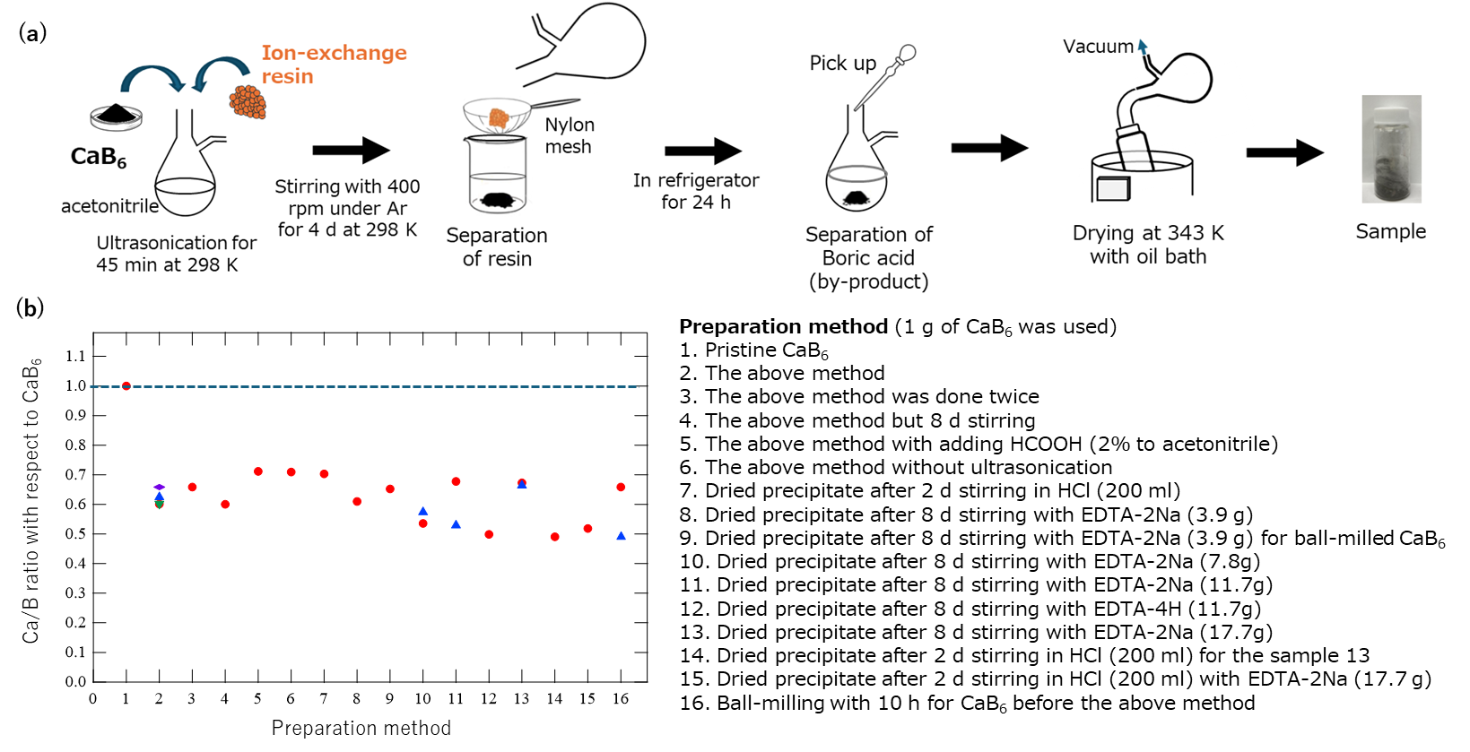

Figure S1. a) Schematic of the synthesis process (reproduced from Fig. 1a). b) Sixteen modified preparation methods and the corresponding Ca/B ratio with respect to CaB₆, as estimated by XPS analysis.

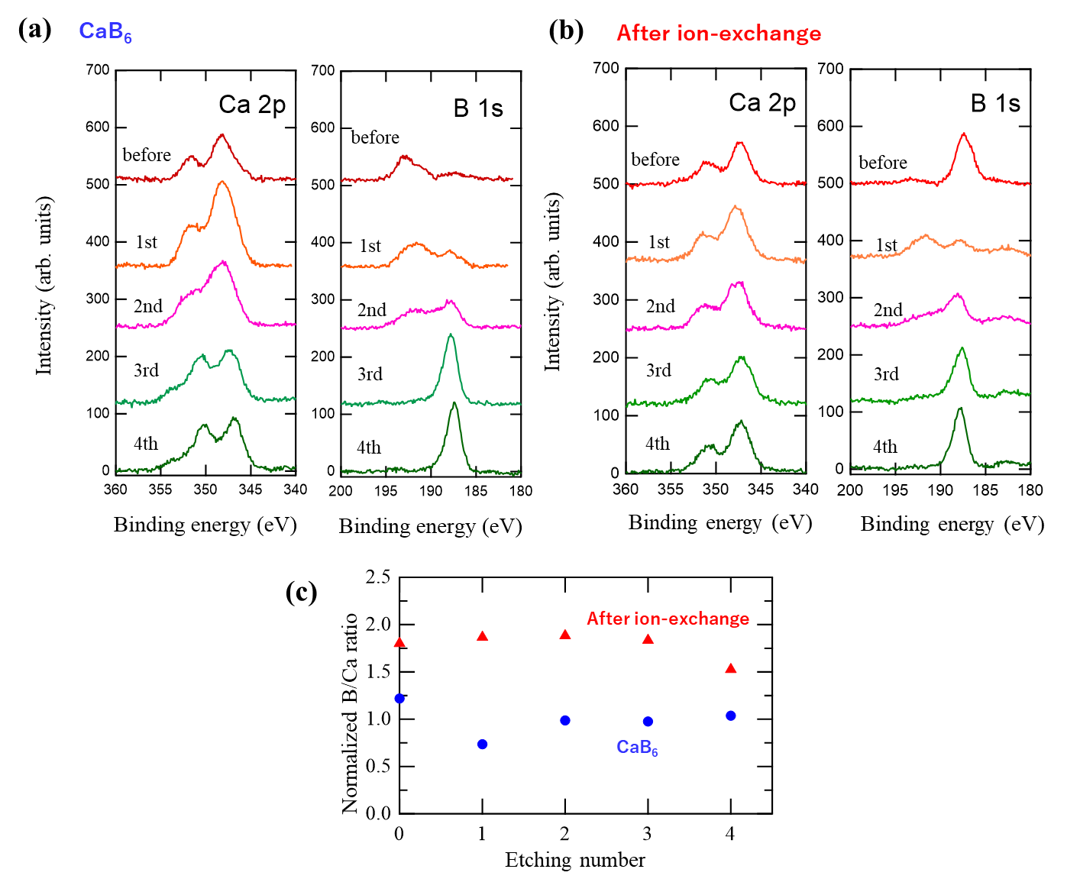

Figure S2. XPS spectra after different etching cycles for a) pristine CaB₆ and b) CaB₆ after ion exchange. c) Normalized B/Ca ratio estimated by XPS analysis as a function of etching number, where the average value from the 2nd to 4th cycles for CaB₆ was set to be 1.0 (reproduced from Fig. 1c).

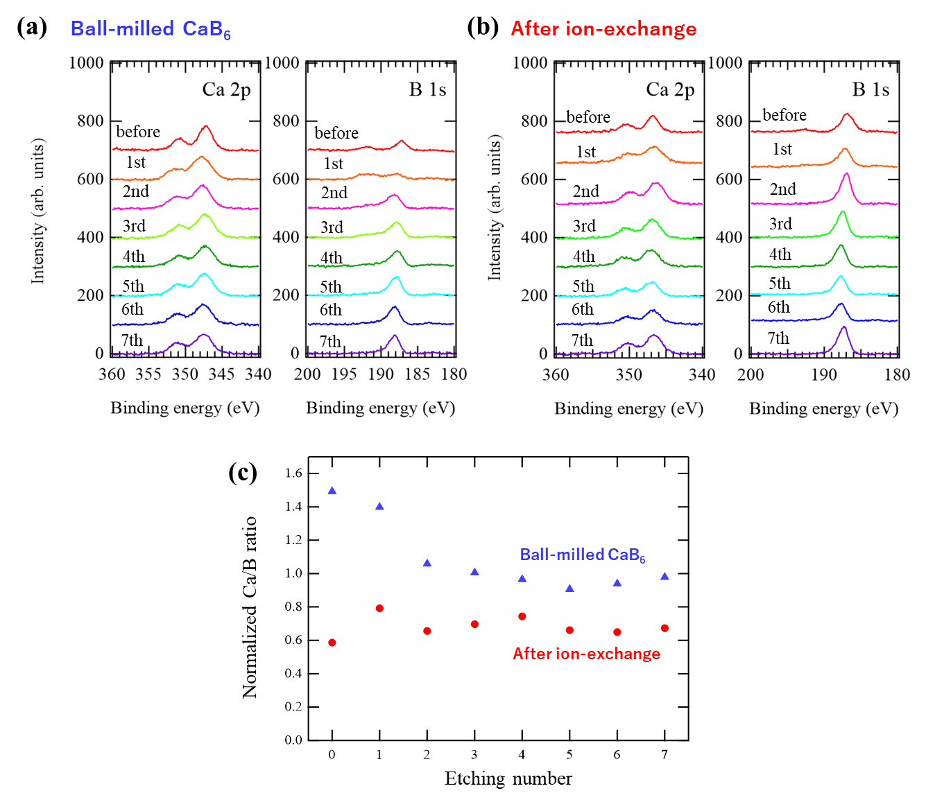
Figure S3. XPS spectra after different etching cycles for a) Ball-milled CaB₆ and b) the sample after ion exchange of ball-milled CaB₆. c) Normalized Ca/B ratio estimated by XPS analysis as a function of etching number, where the value of the 4th cycle for CaB₆ was set to be 1.0.

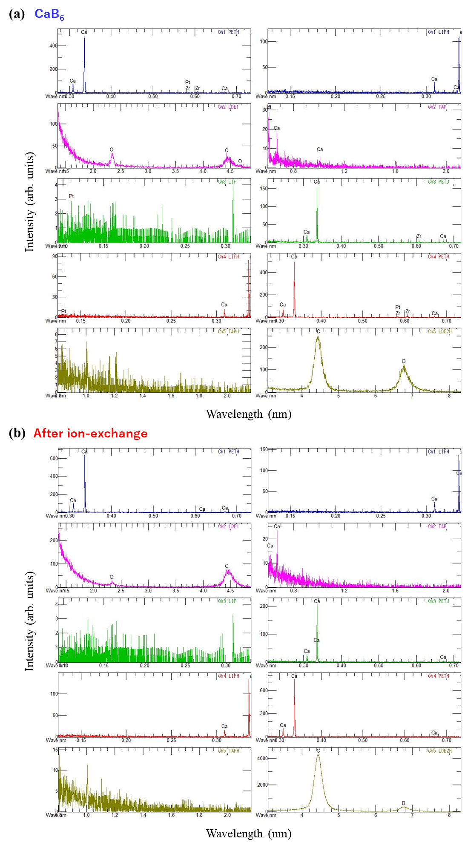

Figure S4. Quantitative EPMA analysis for a) pristine CaB₆ and for b) the sample after ion-exchange of CaB₆

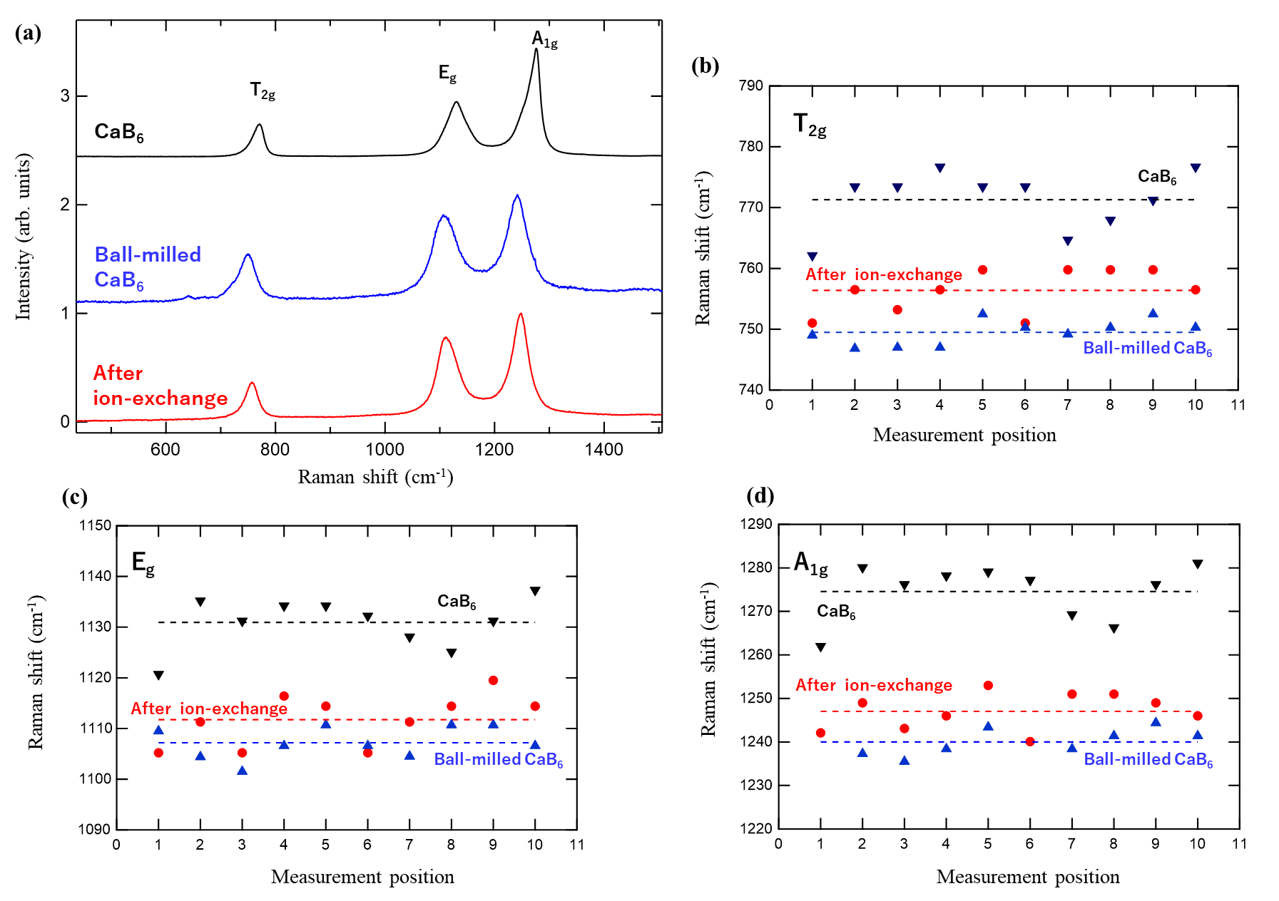

Figure S5. a) Raman scattering spectra. Raman shift in the b) T_{2g} peak, c) E_{g} peak, and d) A_{1g} peak at different measurement positions in the sample.

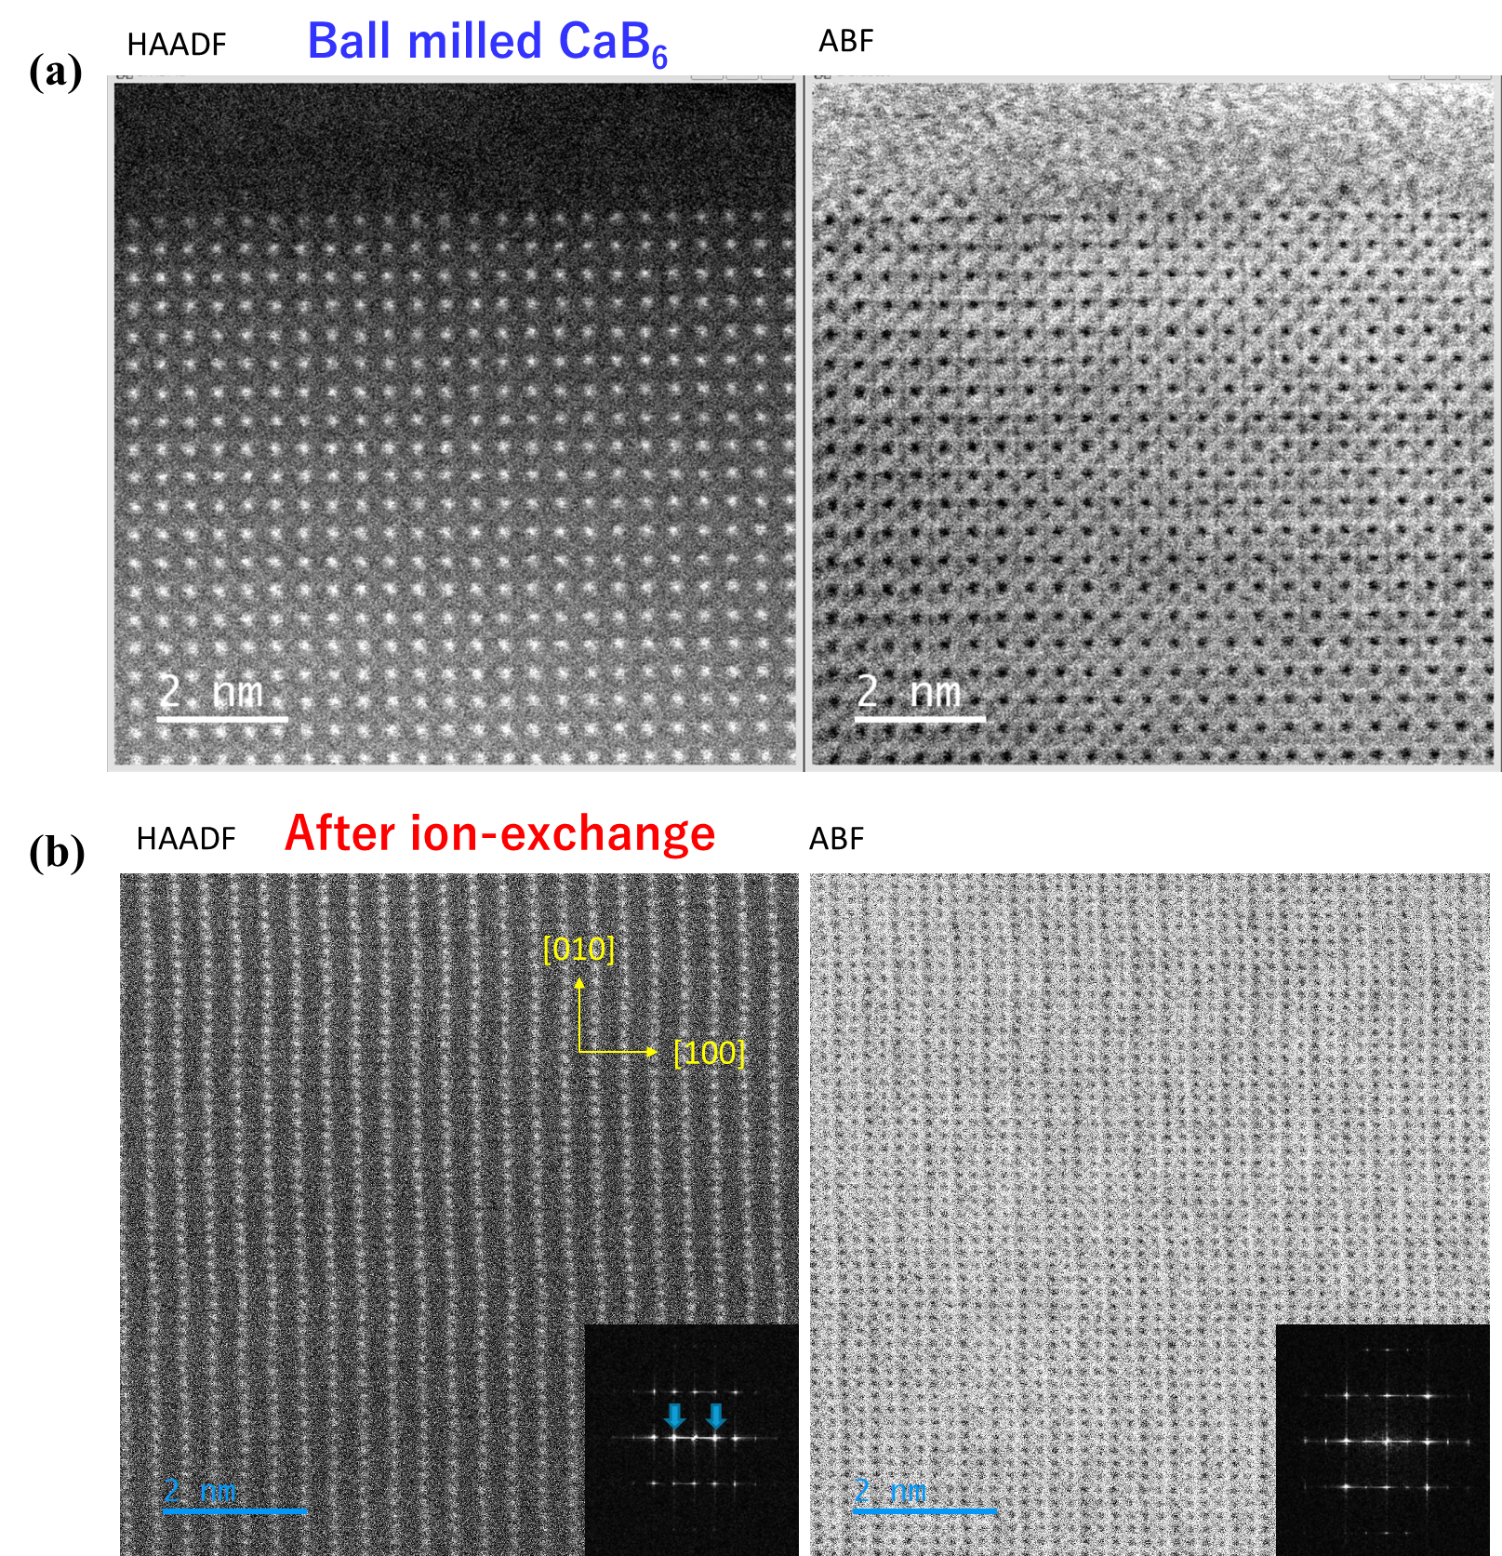

Figure S6. HAADF and ABF images of a) ball-milled CaB₆ and b) the sample after ion exchange of ball-milled CaB₆.

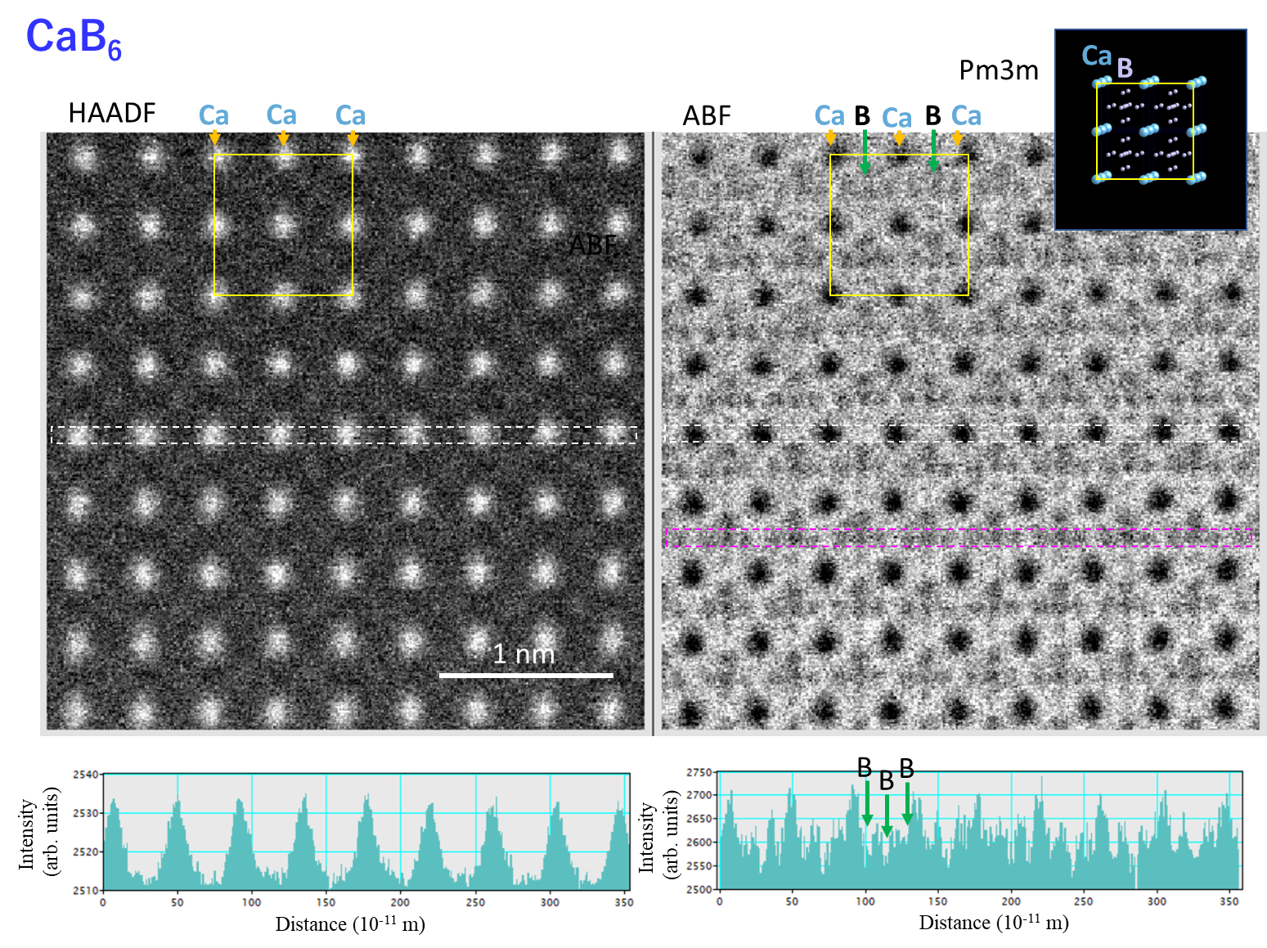

Figure S7. HAADF and ABF images with intensity line profiles on the lattice sites of CaB₆.

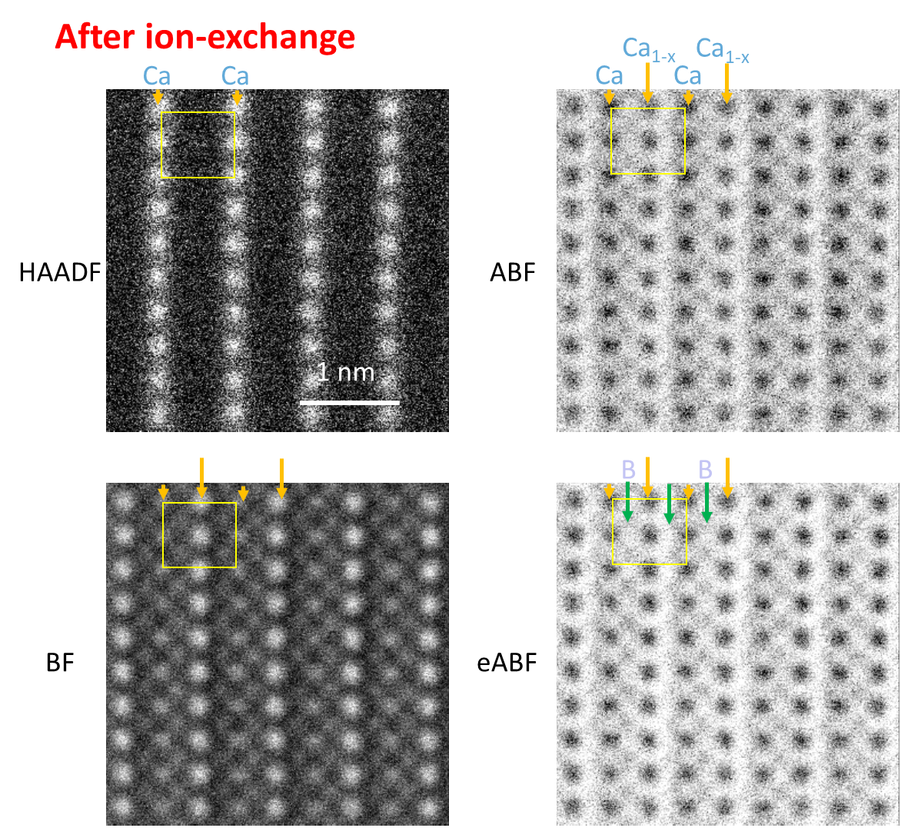

Figure S8. HAADF, ABF, BF, and eABF images for CaB₆ after ion exchange.

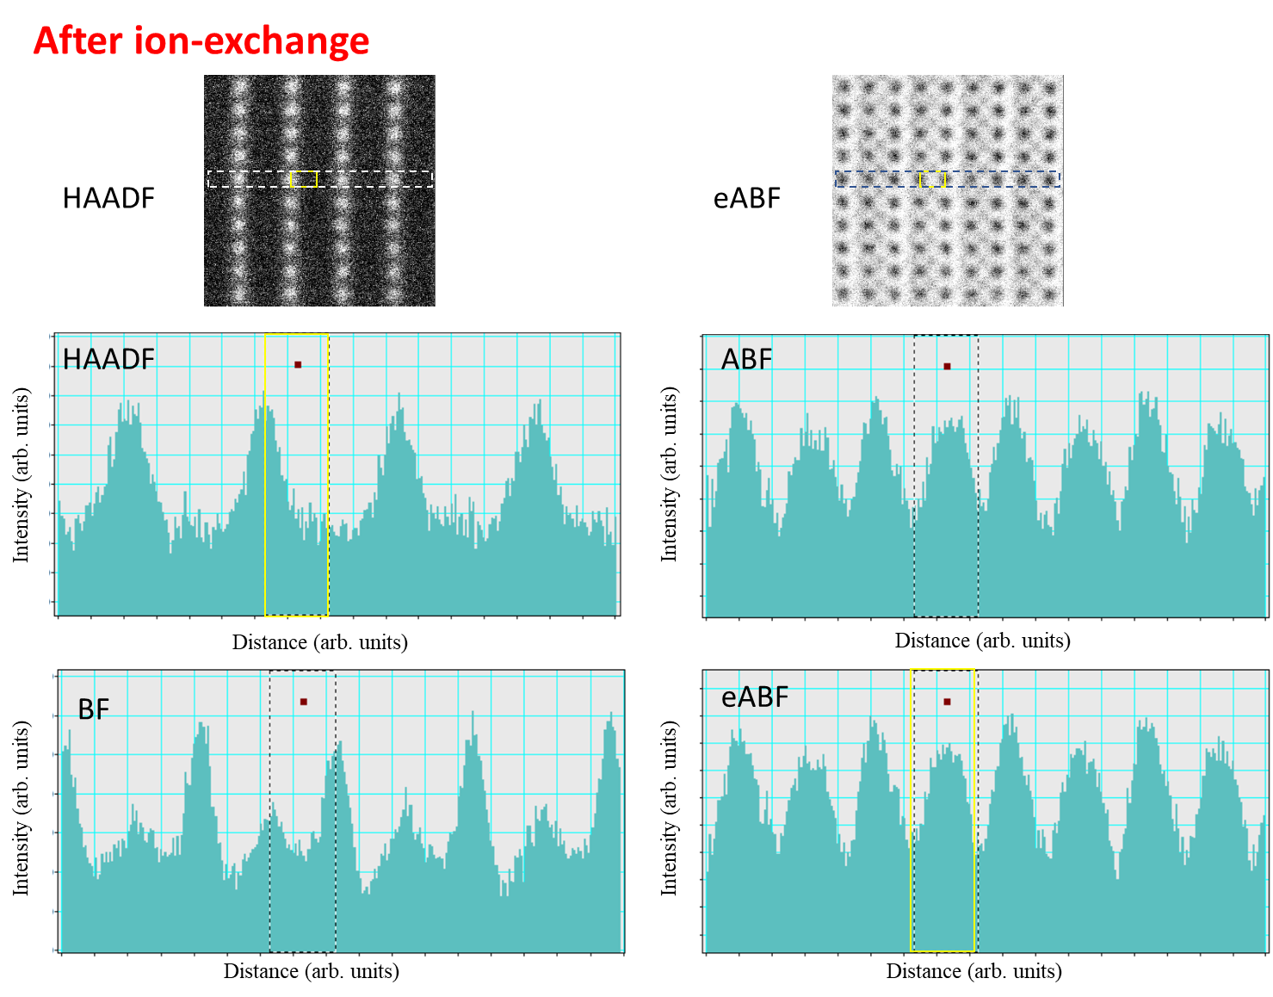

Figure S9. HAADF, ABF, BF, and eABF images for CaB₆ after ion exchange.

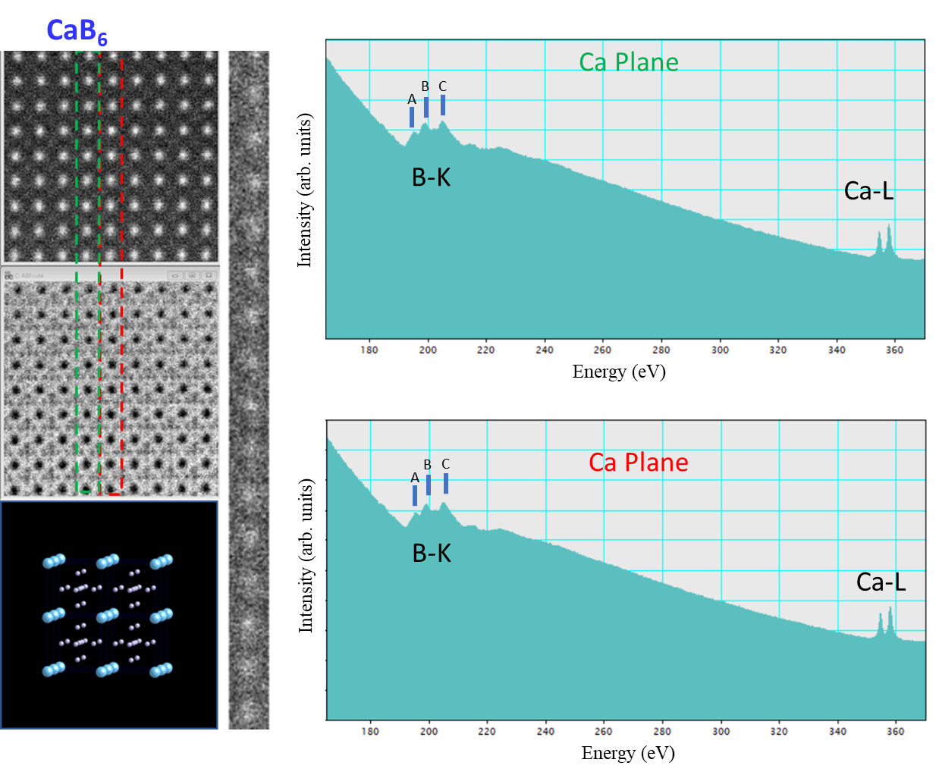

Figure S10. HAADF and eABF images and EELS spectra for CaB₆.

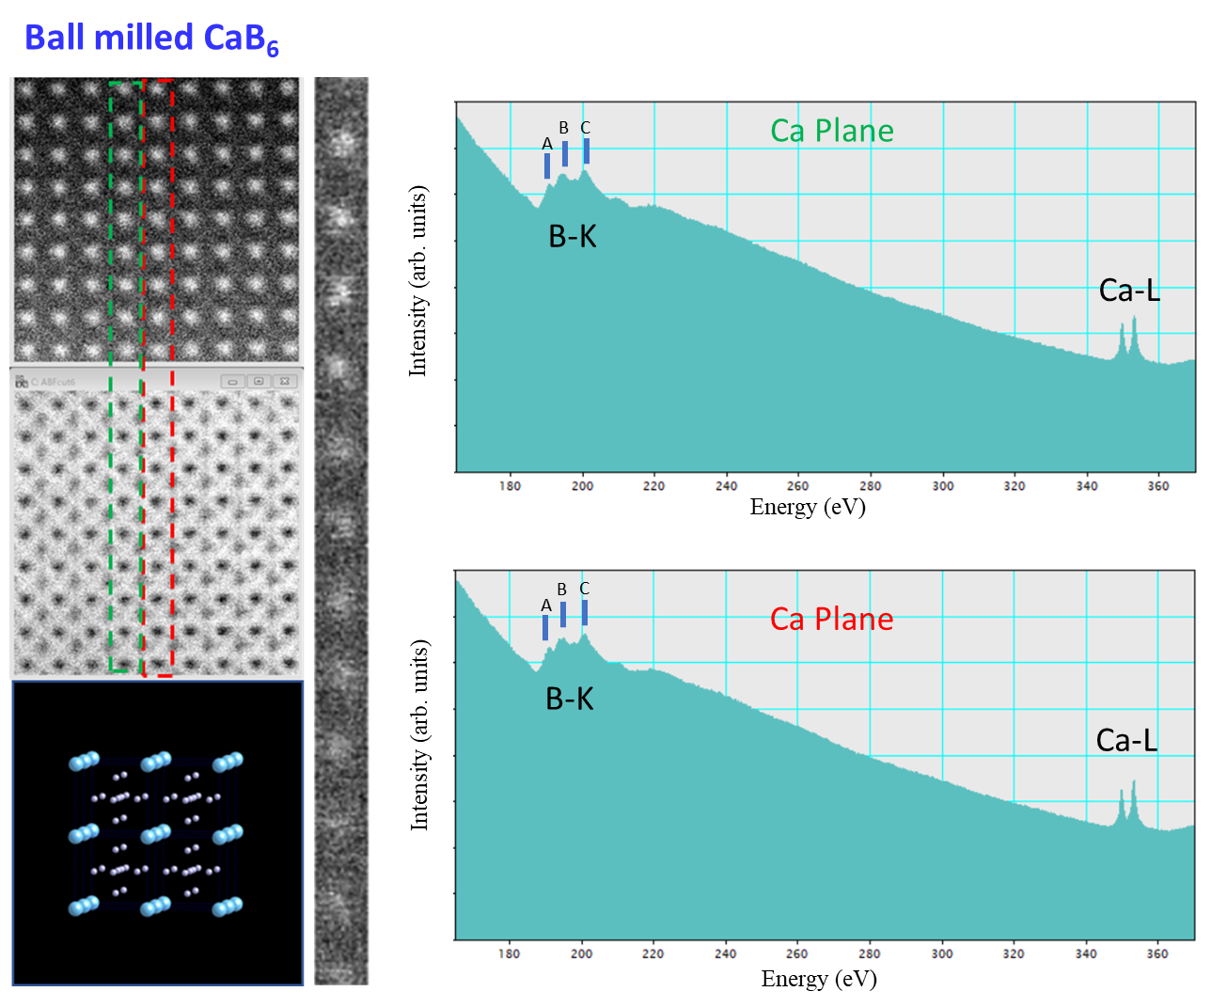

Figure S11. HAADF and eABF images and EELS spectra for ball-milled CaB₆.

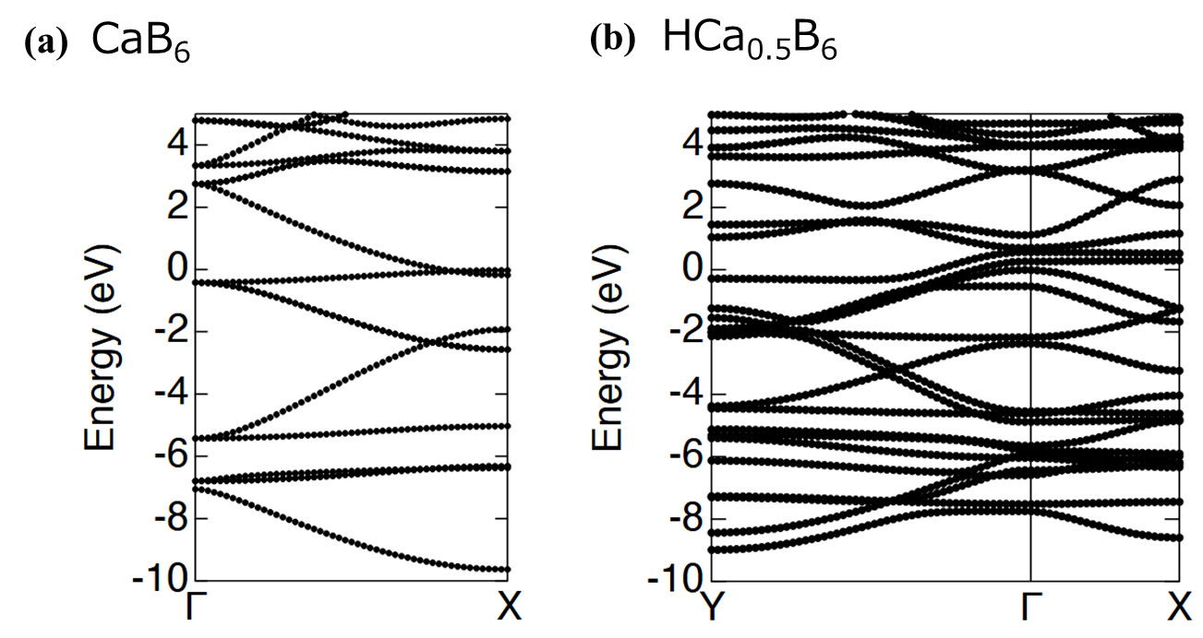

Figure S12. Electronic band structure calculated by density functional theory (DFT) for a) CaB₆ and b) HCa_{0.5}B₆. CaB₆ possesses a Dirac nodal line near the X points, indicating that it is a zero-gap semiconductor, similar as graphene. The energy is measured from that of the Fermi level.

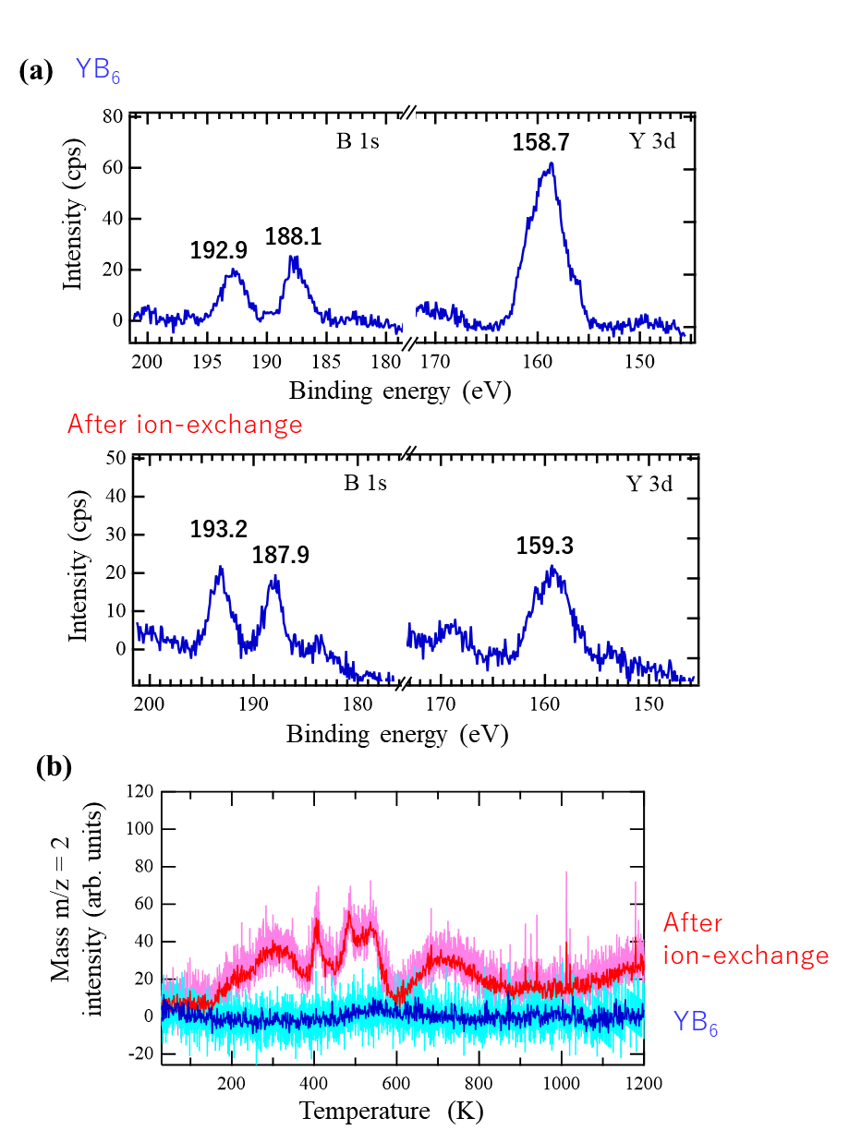

Figure S13. XPS and TPD results for YB₆ before and after ion exchange.

References

[1] R. Kawamura, A. Yamaguchi, C. Shimada, R. Ishibiki, T. Fujita, T. Kondo, M. Miyauchi, Chem. Lett. 2020, 49, 1194–1196.
[2] X. Zhang, M. Hikichi, T. Iimori, Y. Tsujikawa, M. Yuan, M. Horio, K. Yubuta, F. Komori, M. Miyauchi, T. Kondo, I. Matsuda, Molecules 2023, 28, 2985.
[3] P. Hohenberg, W. Kohn, Phys. Rev. 1964, 136, B864–B871.
[4] W. Kohn, L. J. Sham, Phys. Rev. 1965, 140, A1133–A1138.
[5] Y. Morikawa, K. Iwata, K. Terakura, Appl. Surf. Sci. 2001, 169–170, 11–15.
[6] J. P. Perdew, K. Burke, M. Ernzerhof, Phys. Rev. Lett. 1996, 77, 3865.
[7] D. Vanderbilt, Phys. Rev. B 1990, 41, 7892–7895.

