Thermally-stable mesoporous poly(ether sulfone) monoliths with nanofiber network structures
Sadaki Samitsu*
Research Center for Structural Materials, National Institute for Materials Science (NIMS), 1-2-1, Sengen, Tsukuba, Ibaraki, Japan 305-0047.
ABSTRACT: The facile fabrication of mesoporous materials using commodity polymers and improvements in the thermal and mechanical stabilities of the mesopores remain challenging. Herein, we report thermally-stable, mechanically-robust mesoporous monoliths made of commercially-available poly(ether sulfone) (PES). A PES solution dissolved in N,N-dimethylformamide spontaneously formed a physical gel upon cooling to moderate temperature and/or mixing with benzene due to partial crystallization of PES. Mesoporous monoliths obtained from this gel had a reticular structure composed of nanofibers with an average diameter of 18 nm in conjunction with a high specific surface area of 206 m²/g. The dense reticular structure showed a large total pore volume of 2.95 cm³/g, including a significant mesopore volume of 0.52 cm³/g. The nanofiber structure together with the high glass transition temperature of PES significantly enhanced the thermal stability of the mesopores, 80% of which were maintained even after aging at 150 °C for 600 hours.

INTRODUCTION
Mesoporous polymers containing small pores with radii less than 25 nm typically exhibit high specific surface areas above 50 m²/g. Due to the high surface-to-volume ratios, small pore sizes and low apparent densities of these materials, they have been considered for a number of potential applications,¹ including uses as separation membranes and molecular absorbents for water purification and gas separation,^{2–5} tissue engineering scaffolds,⁶ biomedical carriers⁷ and high-performance thermal insulators.⁸ In addition, many methods of fabricating mesoporous polymers have been developed, including most recently the selective etching of block copolymer self-assemblies.⁹ However, the application of tailor-made specialty polymers and/or complicated processes in conjunction with the synthesis of mesoporous polymer fabrication remains challenging. Direct fabrication based on the phase separation of commodity polymers is a promising technique because it involves low-cost raw materials and allows rapid production without the need for templates. Recently, we reported the fabrication of mesoporous commodity polymers using a solid-liquid phase separation method known as flash-freezing nanocrystallization.⁵ We found that, in a highly-concentrated polymer solution that was rapidly cooled down to −80 °C, the solvent molecules crystalized in the size of several tens of nanometers. The solvent nanocrystals spontaneously formed a bicontinuous structure in a glassy polymer phase, which resulted in a mesoporous polymer by solvent extraction at −80 °C. Nevertheless, because this technique requires extremely low temperatures, additional phase separation-based methods for the synthesis of mesopores would be helpful.
Another challenge associated with mesoporous polymers is improving the thermal and mechanical stabilities of the mesopores themselves. Mesopores in polymeric materials are intrinsically unstable due to the large surface energy involved, and often degrade upon aging at high temperatures or as a result of capillary compression during the drying process. Forming nanofibrous frameworks of porous polymers may represent a means of mechanically strengthening mesoporous structures by increasing the mechanical strength of the polymer while significantly raising the surface-to-volume ratio. Porous materials consisting of nanofibers have reportedly been obtained from a number of crystalline polymers, including polypropylene, high density polyethylene, poly(4-methyl-l-pentene) and poly(vinylidene fluoride),¹⁰ syndiotactic and isotactic polystyrene,^{4,11} poly(lactic acid),¹² polycarbonate,¹³ and several biopolymers.⁶ However, most of these monolithic materials contain only macropores (pores larger than 100 nm) rather than mesopores. In addition, there have been few reports regarding mesoporous polymers that are able to maintain their mesoporous structures at temperatures higher than 150 °C for prolonged periods of time.
Herein, we report thermally-stable, mechanically-strong mesoporous structures made of poly(ether sulfone) (PES), an engineering plastic with a glass transition temperature above 200 °C. This work determined that a solution of PES dissolved in N,N-dimethylformamide (DMF) spontaneously forms a physical gel upon cooling to a moderate temperature and/or mixing with benzene due to partial crystallization of PES. This gelation results in a monolithic mesoporous material following solvent extraction with methanol and vacuum drying. The product has a reticular structure made of thin nanofibers and thus exhibits a high specific surface area and enhanced mesopore volume. This nanofiber structure together with the high glass transition temperature of PES significantly improves the thermal stability of the mesopores.
EXPERIMENTAL SECTION
Preparation of sample solutions. DMF and benzene were purchased from Wako Pure Chemical Industries, Ltd. and used as received. Poly(ether sulfone) (PES, Veradel 3300) was obtained from Solvay Specialty Polymers. The chemical structure of PES is shown in Figure 1. PES pellets (60 g) were added to DMF (140 g) and vigorously stirred at room temperature for 3 h. The solution was then heated to 100 °C with further stirring overnight to ensure complete dissolution. The resulting 30 wt% solution was used as a stock solution. Prior to further use, the stock solution was again heated to 100 °C for several hours and then cooled below 50 °C. Specific amounts of DMF and/or benzene were added to dilute this solution with vigorous stirring during the addition process, followed by further stirring for 5–10 min. In the following text, we refer to the PES concentration in various solutions as a weight percentage relative to the total solution weight and the benzene ratio as the weight percentage relative to the total solvent weight.

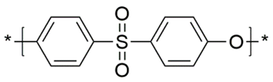
Figure 1. The chemical structure of poly(ether sulfone).
Gelation trials. The ability of a PES solution to gel was determined using the test tube inversion method. A 10 g quantity of the solution was sealed in a glass vial (diameter 25 mm, volume 20 mL) and maintained at a set temperature using an incubator. After 24 h, the vial was gently inverted and held in that position for 3 min. A sample that flowed downward was defined as a sol whereas a sample that remained in the upper part of the vial was determined to be a gel.
Fabrication of mesoporous PES monoliths. A quantity of PES solution was poured into a glass dish (diameter: 85 mm) and subsequently sealed in a polyethylene bag (thickness 0.08 mm). Incubation of this sample for 24 h at a specific temperature formed a physical gel that was removed from the dish and subjected to solvent-exchange with an excess of methanol. The gel was vacuum-dried at room temperature for several hours, resulting in a porous PES monolith. The monolith was further vacuum-dried overnight at 70 °C to ensure complete removal of the DMF and methanol. The thickness of the monolith could be roughly controlled by varying the quantity of the initial PES solution, and samples typically varied from 1.5–3.0 mm in thickness. The diameter, ζ, and thickness, t, of each monolith were measured with a digital caliper, while the weight, W, was determined using an electronic microbalance. The apparent density, ρ_{ap}, of each sample was determined by the equation ρ_{ap} = 4 × W / (π × ζ² × t). The total pore volume, V_{total}, of each specimen was calculated from the equation V_{total} = 1/ρ_{ap} − 1/ρ_{r}, where ρ_{r} is the true density of PES (1.37 g/cm³) provided by the supplier.¹⁴
Morphological and structural characterizations. The morphology of each monolith sample was assessed by immersing the specimen in ethanol for 15 min followed by freeze-fracturing in liquid nitrogen.⁵ This process filled the pores in the sample with frozen ethanol that prevented serious deformation of the mesoporous structure during freeze-fracturing. The fractured sample was fixed on a carbon tape and coated with a 1.5 nm-thick platinum layer by ion sputtering (E-1030, Hitachi). The porous morphology of the sample surface and cross-section were observed using field-emission scanning electron microscopy (FE-SEM, S-4800, Hitachi) at an acceleration voltage of 5 kV and an emission current of 10 μA.
Nitrogen adsorption isotherms of monoliths were acquired at −196 °C using a gas adsorption analyzer (BELSORP-max, MicrotracBell). The specific surface area, S_{BET}, was calculated by the Brunauer-Emmett-Teller (BET) method, using values of 28.014 and 0.162 nm² for the molecular weight and adsorption cross section of nitrogen molecules, respectively. We used Barrett-Joyner-Halenda (BJH) analysis to determine pore size distributions of the monoliths for convenience although the pore shape of the monoliths confirmed by SEM was, in fact, not cylindrical as it is assumed in BJH analysis. The volumes of pores with radii less than 25 nm and with radii of 25–100 nm are referred to as V_{meso} and V_{macro}, respectively, herein. Pores with radii greater than 100 nm could not be assessed using the nitrogen adsorption measurements performed in this study. Instead, based on the total pore volume obtained from nitrogen adsorption data, V_{N2} (= V_{meso} + V_{macro}), we estimated the volume of pores with radii larger than 100 nm, V₁₀₀, using the equation V₁₀₀ = V_{total} − V_{N2}.
Crystalline structures of a gel and a monolith were analyzed using a benchtop X-ray diffractometer (MiniFlex600, RIGAKU) operated in a continuous scanning mode. Monochromated Cu K_{α} radiation (λ 1.542 Å) generated at 40 kV and 15 mA was irradiated to samples and X-ray diffraction (XRD) patterns were taken over the 2θ of 5 – 60° with 0.02 step size at the scan speed of 2°/min for the gel and of 5°/min for the monolith. The gel sample was filled in a sample holder after gelation in a glass vial and the monolith was cold pressed at 2 MPa and room temperature for a few minutes, resulting in a dense flat sheet specimen.
Thermal properties and stability of mesoporous monoliths. The thermal properties of each monolith were determined using differential scanning calorimetry (DSC, Q2000, TA instruments). In these trials, a 5 – 10 mg quantity of the specimen was sealed in an aluminum hermetic pan and heated to 400 °C at 5 °C/min under a flow of nitrogen (50 mL/min). Thermal expansion/contraction data was collected by thermomechanical analysis (TMA, TMA402 F1 Hyperion, NETZSCH) in the compression mode under a helium atmosphere at a heating rate of 5 °C/min using specimens cut to sizes of 10 × 5 × 2 mm and applying a load of 0.02 N along the length direction (corresponding the to the in-plane direction of the monolith).
The thermal diffusivity of each monolith was measured using a laser flash analyzer (NETZSCH LFA 457 MicroFlash). The measurements were performed along the thickness direction of the monolith under a helium atmosphere at 10 °C intervals over the temperature range of 180‒220 °C. A bulk sample with no voids was prepared by aging a PES monolith for 24 h at 230 °C, which is above the glass transition temperature of PES. In order to evaluate the thermal conductivity of a substance, both the specific heat and apparent density values are required. Thus, the specific heat capacity of the monolith was determined by DSC (DSC8500, PerkinElmer) under a nitrogen flow (20 mL/min) at a heating rate of 20 °C/min. The apparent density of the sample was obtained with a high-precision electric densimeter (SD-200L, Alfa Mirage) at 25 °C. The thermal conductivity was calculated using the equation λ = C_{p} × ρ_{ap} × α, where C_{p} is specific heat, ρ_{ap} is apparent density and α is thermal diffusivity.
RESULTS AND DISCUSSION
Thermally-reversible gelation of PES solutions in DMF. The gelation characteristics of PES solutions in DMF were examined at various incubation temperatures, and Figure 2(a) presents photographic images of 30 wt% solutions after 24 h incubation. The solutions evidently retained their initial sol state at both 25 and 15 °C, although the solution was transparent at 25 °C but translucent at 15 °C. Following storage at 5 °C, a semitransparent gel was obtained that did not flow when the vial was inverted. The concentration dependence of this gelation behavior was subsequently assessed during 24 h incubation at 5 °C. While the 20 wt% solution retained its transparent sol state, both the 25 and 30 wt% specimens formed semitransparent gels. These results indicate that the physical gelation of PES solutions in DMF requires both high concentrations (25 wt% and above) and incubation at low temperature (in this case, 5 °C).
A porous monolith was fabricated from a gel obtained from a 30 wt% PES solution incubated at 5 °C for 24 h, and the ρ_{ap} of this specimen was determined to be 0.49 g/cm³, equivalent to a V_{total} of 1.32 cm³/g. Figure 2(b) shows a cross-sectional SEM image of the monolith, and demonstrates that two porous structures with domain sizes of several micrometers were heterogeneously distributed throughout the cross section. One porous structure consisted of nanosheets with thicknesses of 50 – 100 nm, while the other included nanofibers approximately 20 nm in diameter. Figure 2(c) graphs the pore size distribution of the porous monoliths as determined using nitrogen adsorption measurements. The monolith prepared from solution had a very low S_{BET} (1.9 m²/g) and a negligible V_{N2} of 0.005 cm³/g, which is consistent with the macroporous structure observed by SEM (Figure S1). In contrast, the monolith prepared from a gel precursor had an S_{BET} of 48.9 m²/g and V_{N2} of 0.12 cm³/g. This moderately high S_{BET} value resulted from the presence of nanoscale building blocks such as nanosheets and nanofibers, while the sparse reticular morphology gave a relatively low V_{meso} of 0.06 cm³/g. The monolith fabricated from a gel had a completely different structure in terms of the size and shape of the component parts as well as the interconnections compared to that made from solution. These preliminary results suggested that the use of a gel precursor is an effective means of improving the surface-to-volume ratio of a porous monolith. Thus, further optimization of the gelation process would be expected to generate PES with an entirely mesoporous structure.
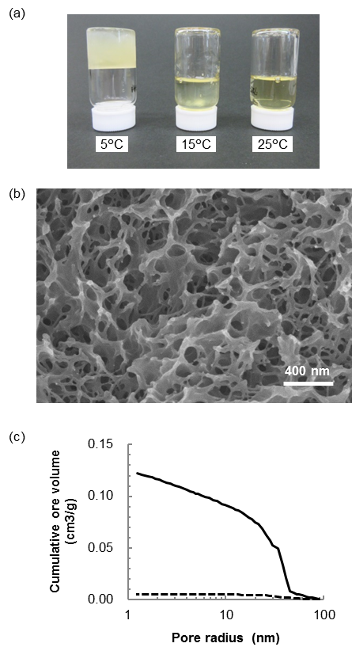
Figure 2. (a) A photographic image of 30 wt% PES solutions in DMF following 24 h incubation at 5, 15 and 25 °C. (b) A SEM image of the porous PES monolith fabricated from the gel incubated at 5 °C. (c) Cumulative pore volumes of the monoliths shown in (b) (solid line) and the monolith fabricated from a sol at 25 °C shown in Figure S1 (dashed line).
Physical gelation of PES solutions using solvent mixtures. Solvent composition is known to have a significant effect on the physical gelation of linear polymers.¹⁵ ****As discussed in Supporting Information, DMF is a good solvent for PES and benzene is a poor solvent (see Table S1). We slightly decreased PES solubility by adding a certain amount of benzene solvent to DMF solvent. We prepared PES solutions using various mixtures of DMF and benzene and examined the resulting gelation behavior following 24 h incubation at 25 °C. Figure 3(a) shows a photographic image of 20 wt% PES solutions made with varying benzene ratios. Although the solutions remained as transparent sols at benzene ratios of 10% or less, gelation was observed at benzene ratios of 20% and above. Thus, adding a suitable amount of benzene resulted in a physical gel even at room temperature, which was not observed with PES solutions containing only DMF. The gel was semitransparent at 20% benzene and became opaque at 30%. This reduced transparency at the same PES concentration may indicate that higher benzene ratio resulted in a more heterogeneous domain structure within the gel, with the presence of some domains having larger sizes and/or high refractive index variations. Figure 3(b) shows a photographic image of PES solutions containing 30% benzene. At PES concentrations of 10 wt% and above all the solutions gelled, although the transparency of the gels decreased with increasing PES concentrations. Figure 3(c) displays a sol-gel phase diagram for PES solutions that plots benzene ratios on the vertical axis and PES concentrations on the horizontal axis. Since the benzene ratio determines the PES solubility, the vertical axis essentially corresponds to the reduced temperature. While the solutions remain in the sol state in the lower left region of the diagram, they form gels in the upper right region in which both the PES concentration and benzene ratio are high. Transparent gels were obtained at the boundary between the sol and gel regions.
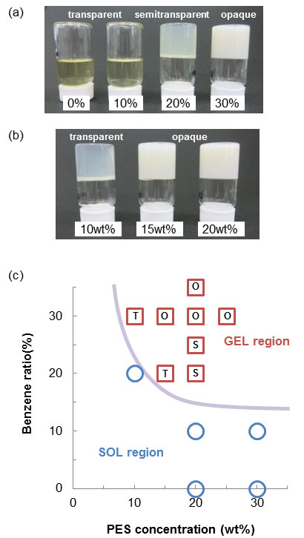
Figure 3. (a) A photographic image of 20 wt% PES solutions in DMF containing 0 – 30% benzene, following 24 h incubation at 25 °C. (b) A photographic image of 10 – 20 wt% PES solutions containing 30% benzene following 24 h incubation at 25 °C. (c) A sol-gel phase diagram for the PES solutions in conjunction with 24 h incubation at 25 °C. The blue circles and red squares respectively represent the sol and gel state. The capitals in the square symbols indicate the appearance of the gel; T: transparent, S: semitransparent, O: opaque.
Mesoporous PES monolith. A mesoporous PES monolith obtained from a gel precursor. We prepared a physical gel from a 20 wt% PES solution containing 30% benzene and obtained a mesoporous PES monolith by solvent removal of the gel precursor. Figure 4(a) and 4(b) show photographic images of the gel and the monolith, respectively. The ζ of the monolith was slightly decreased to 85% of that of the gel due to volume shrinkage during solvent removal. By measuring the ζ and t of the monolith, the V_{total} value was determined to be 2.33 cm³/g, equivalent to a ρ_{ap} of 0.33 g/cm³. Assuming the density of DMF and benzene mixture (0.929 g/cm³),¹⁶ the V_{total} of 2.33 cm³/g was equivalent to 54% of total solvent volume in an initial PES solution. The monolith was also opaque and thus less transparent than the gel. Since the solvent molecules were replaced by air during solvent removal, significant light scattering occurred in the monolith due to the significant refractive index difference between the air pockets and the PES. Figure 4(c) shows surface and cross-sectional SEM images of the monolith, in which straight bundles of densely stacked nanofibers can be seen on the surface. In contrast, a sparse reticular structure composed of curved nanofiber bundles is evident in the cross section. This reticular structure also exhibits pores with radii in the range of 20–200 nm. Several cross-sectional SEM images were obtained to allow assessments of the diameters of more than 180 nanofibers by digital image analysis, and Figure 4(d) presents a histogram of the diameters, showing a peak diameter of 18 nm. We determined the geometric specific surface area, S_{calc}, to be 152 m²/g using the equation $S_{calc} =\sum_{i}{(4 × f(d_{i}) / (ρ_{r} × d_{i}))}$,⁵ where d_{i} is the nanofiber diameter, f(d_{i}) is the probability of finding diameter d_{i}, and ρ_{r} is the true density of PES. The nitrogen adsorption-desorption isotherm of the monolith had a hysteresis loop in the relative pressure range of 0.60–0.98 and a plateau region above the pressure of 0.98 (Figure S2), both of which are the characteristics of type IV isotherm usually found in mesoporous materials. Compared with conventional mesoporous materials, the hysteresis loop of the monolith is much small possibly due to broad pore size distribution. The monolith evidently absorbed a large quantity of nitrogen, showing a maximum adsorption of 685 cm³ (STP)/g. The S_{BET} value was determined to be as high as 180 m²/g, which is similar to the S_{calc} obtained from digital image analysis (deviating by only 20%). Figure 4(e) plots the cumulative pore volume of the monolith and shows that the pore volume gradually increased over the radius range of 2–50 nm, giving a V_{meso} of 0.52 cm³/g and a V_{macro} of 0.52 cm³/g. The pore size distribution exhibits a broad peak centered around the maximum 8 nm radius. Thus, a gel precursor prepared from a solvent mixture successfully produced a PES monolith containing numerous mesopores.
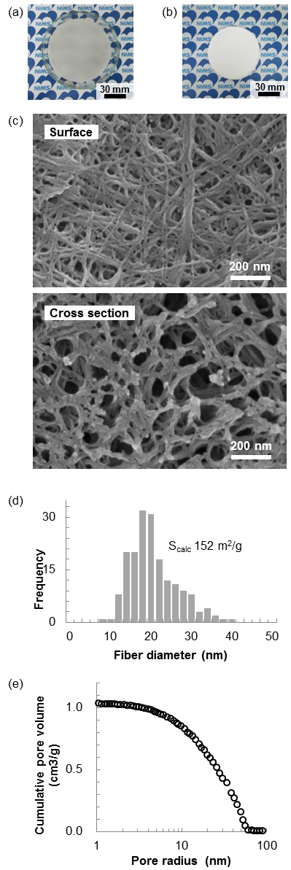
Figure 4. (a) A photographic image of a gel prepared from a 20 wt% PES solution in DMF containing 30% benzene. (b) A photographic image of a PES monolith obtained by solvent extraction with methanol followed by vacuum-drying of the gel in (a). (c) Surface and cross-sectional SEM images of the monolith in (b). (d) A histogram of the diameters of nanofibers observed in the cross-section of the monolith. The geometric specific surface area, S_{calc}, was determined to be 152 m²/g. (e) The cumulative pore volume plotted as a function of pore radius. A broad peak with a maximum at 8 nm is observed in the pore size distribution.
Gelation mechanism and the origin of nanofiber structures. Similar bundle and reticular nanofiber structures are often found in porous monoliths made of various crystalline polymers.^{4, 11, 20} Although PES is considered to be a typical amorphous polymer,¹⁷ there is at least one report of the solvent-induced crystallization of PES in dichloromethane based on XRD analysis.¹⁸ In this prior work, solvent removal by evacuation at high temperature destroyed the crystalline structure, suggesting that the PES formed a crystal complex that incorporated the dichloromethane molecules and thus could not maintain the crystalline structure without the solvent. A recent study of a model PES oligomer has proposed various possible conformations associated with different crystalline structures,¹⁹ one of which contains voids that could accommodate solvent molecules and thus form a crystal complex. A crystal complex consisting of syndiotactic polystyrene and benzene has also been previously reported.²⁰
Inspired by the previous literatures, we measured the XRD patterns of both a PES gel and a PES monolith in order to confirm whether they contain a crystalline part or not. The pattern of the gel shown in Figure 5(a) demonstrated several peaks on a broad halo pattern, clearly indicating the existence of the crystalline part of PES. Interestingly, because the gel contains 80 wt% solvent, the result proved that the gelation of the PES solution originated from the crystallization of PES. We were able to identify ten peaks using a software program (see Figure S3), the result of which is summarized in Table S2. A quite broad peak with moderate intensity was found at 2θ of 19.0°, corresponding to the d spacing of 4.6Å. The spacing is same with that found for PES crystallized in dichloromethane (4.5 Å).¹⁸ Other six peaks also agreed with the literature values within the d spacing range of 0.2 Å although the gel in the literature contains a different type of solvent and less amount of the solvent. These broad peaks probably indicate poorly formed crystallites and/or very small crystallites. In addition, their low intensity implies small amount of crystallites in the monolith. The origin of the physical gelation is the formation of the small crystallites, which effectively introduces physical crosslinks of a PES gel.
In the XRD pattern of the monolith plotted in Figure 5(b), the primary peak at 2θ of 18.3° is reduced in the intensity significantly compared with the gel sample. The monolith contained less than 0.6 % solvent, which was confirmed by TGA (see Figure S4). The almost complete removal of solvent molecules seriously degraded the X-ray crystallinity, which is consistent with the previous report.¹⁸
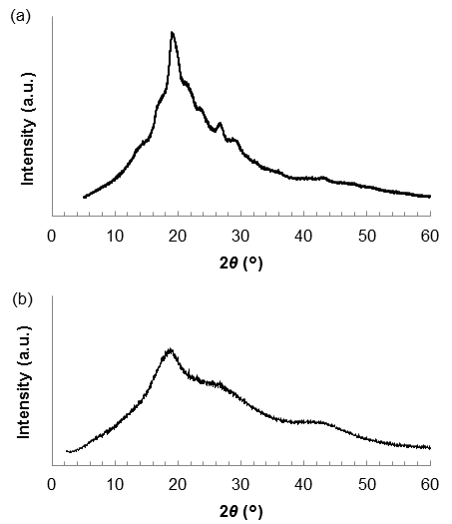
Figure 5. X-ray diffraction patterns of a PES gel precursor (a) and monolith (b). The gel and monolith shown in Figure 4(a) and (b) were used, respectively.

In contrast with the dense reticular nanofiber structures found in the monolith obtained from a high PES concentration (Figure 4(c)), the monolith obtained from a low PES concentration (10 wt%) resulted in a sparse network structure consisting of straight nanofiber bundles with lengths of approximately 1 μm (Figure 6(a)). The gelation mechanism of the PES solutions is explained by growing the network of PES nanofibers. In this process, isolated PES chains crystalize into nanofiber structures during an initial stage, after which the nanofibers form bundles and/or reticular structures by connecting with one another. At the point at which the bundles have completely penetrated throughout the sample, the solution turns into a gel. At low polymer concentrations, there are fewer nanofibers and so it is less probable that short nanofibers will connect in a random manner. Under these conditions, interactions between the nanofibers force them to align along their long axis direction and assemble into extended long bundle structures made of aligned nanofibers.
Higher benzene ratios reduce the solubility of PES and therefore promote the nucleation of PES crystals. In fact, the higher benzene ratios evidently increased the number of nanofibers, which resulted in dense reticular structures having large numbers of mesopores. Two reticular structures with different mesh sizes were generated at 35% benzene (Figure 6(b) and 6(c)). The dense domains consisted of small mesopores and enclosed the other, less dense, regions that included both macropores and mesopores. The heterogeneous domain structure is probably resulted from the successive crystallization of PES because the numbers of isolated PES chains gradually decrease on the process of the crystallization. Initially, isolated dense domains were nucleated in the homogeneous solution and began to connect with one another to form a percolating network. Subsequently, less dense domains were generated in the solution, which at that point had a lower PES concentration, surrounded by the percolating network of dense domains.
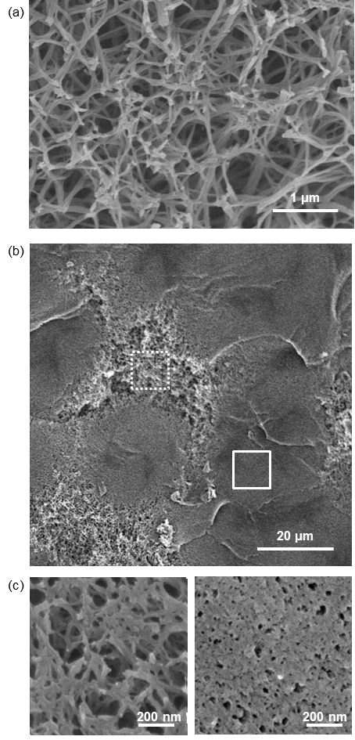
Figure 6. Cross-sectional SEM images of PES monoliths. The monoliths were fabricated using a gel precursor containing 10 wt% PES and 30% benzene (a) and a gel containing 20 wt% PES and 35% benzene (b). Image (c) was captured at high magnification from different positions in (b): the area in the dotted square (left) and the area in the solid square (right).
Effect of the benzene ratio and the PES concentration. We prepared porous monoliths using 20 wt% PES solutions containing different benzene ratios. The S_{BET} values of PES monoliths significantly increased at a 20% benzene ratio (see Figure S5(a)). Since gelation also occurred in this same percentage range (Figure 3(c)), this result indicates that a gel precursor effectively increases S_{BET} values due to the formation of a nanofiber structure. The S_{BET} values plateaued at 170 – 180 m²/g at 25 – 35% benzene. From these data, it appears that the nanofiber diameters were constant over the benzene ratios investigated, which is consistent with the SEM observations (Figure 6(c)). Figure 7(a) plots the pore size distributions of the monoliths at different benzene ratios. The monolith obtained from the gel containing 20% benzene had lower values of both V_{meso} and V_{macro} (see also Figure S5(b)). In contrast, the specimen resulting from 25% benzene contained a large amount of macropores, while that obtained from 35% benzene showed numerous mesopores. At 35% benzene, the distribution peaked at a pore radius of 5 nm. These results indicate that higher benzene ratios tend to generate smaller pores due to a dense network of nanofibers as confirmed by the SEM image (Figure 6(c)). Higher benzene ratios also decrease V_{total} due to the significant shrinkage of the gel precursor during solvent removal.
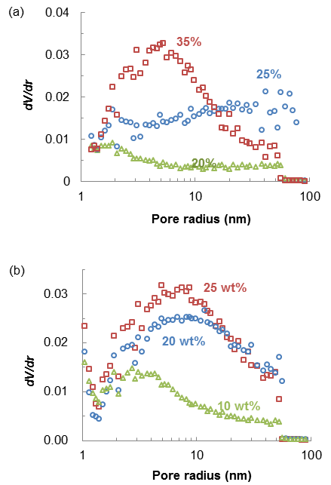
Figure 7. (a) Effects of the benzene on the pore size distribution of the monoliths obtained at benzene ratios of 20% (green triangles), 25% (blue circles) and 35% (red squares). (b) Effects of the PES concentration on the pore size distributions of the monolith obtained at different PES concentrations: 10 wt% (green triangles), 20 wt% (blue circles) and 25 wt% (red squares).
In order to examine the effect of the PES concentration, we prepared gel precursors from PES solutions containing 30% benzene and then fabricated PES monoliths using these gels. The S_{BET} values of the monoliths increased with increasing PES concentrations and reached a maximum of 206 m²/g at 25 wt% PES (see Figure S6(a)). Figure 7(b) plots the pore size distributions of the monoliths at different PES concentrations. Compared with the specimen obtained from a 10 wt% gel, the monoliths obtained from 15 – 25 wt% gels exhibited similar distributions peaked at 7 nm in radius, indicating large numbers of mesopores. The pore size distribution of the PES monolith only weakly depends on the PES concentration above 10 wt% but strongly depends on the benzene ratios because the PES solubility significantly varies with low concentration of benzene in DMF. V₁₀₀ reached a maximum of 1.29 cm³/g at 20 wt% PES and decreased with increasing concentrations (see Figure S6(b)). High PES concentrations evidently reduced the V_{total} due to the lower volume fraction of the porogenic solvent in an initial PES solution. Conversely, a low concentration produced significant shrinkage of the precursor gel during solvent removal due to the poor mechanical strength of the material. In fact, it was extremely difficult to prepare a specimen of a specific shape with the 10 wt% gel. It therefore appears that optimization of the precursor gel based on the use of a suitable PES concentration and a moderate benzene ratio is crucial to obtaining mesoporous structures having large pore volumes along with a high surface-to-volume ratio. For this reason, additional investigations were performed regarding thermal properties and stability of a mesoporous monolith obtained from a gel based on a 20 wt% PES concentration and a 30% benzene ratio, as shown in Figure 4.
Thermal properties of a mesoporous monolith. Figure 8(a) presents DSC data for the mesoporous monolith shown in Figure 4(b). The curve obtained during the initial heating scan contained the small endotherm peaked at 160 °C and continued up to 220 °C. The enthalpy change associated with the endotherm was determined to be 2.8 J/g. The shift of the baseline was found at 222 °C, which is three degrees lower than the glass transition temperature of PES.²¹ The endothermic peak generated by an amorphous polymer below its glass transition temperature is attributed to enthalpy relaxation.²² Further heating revealed a sharp endothermic peak at 285°C, probably corresponding to the melting of the crystalline part of PES monolith that was found by the XRD measurement. The enthalpy of the peak was 4.5 J/g, which is much smaller than typical enthalpy changes of crystalline polymers²³ and is consistent with the small fraction of the crystalline part suggested by the XRD measurement. After cooling to 5 °C at 5 °C/min, the sample was again heated up to 400 °C. The curve produced during this second heating scan showed no endothermic peaks but only a baseline shift at 225 °C due to the glass transition temperature of PES. It is likely to be impossible for PES to crystallize without solvents and the crystallization of PES may be too slow to be achieved by the DSC measurement in this study even if possible.

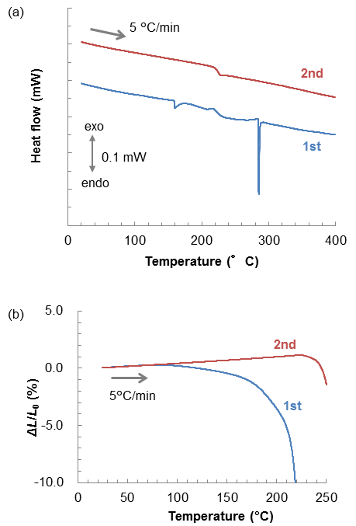
Figure 8. (a) DSC and (b) TMA data acquired from the PES monolith shown in Figure 3. Blue and red lines respectively indicate the first and second scans. ΔL/L₀ is the length expansion/contraction normalized with respect to the initial specimen length, L₀. A positive ΔL represents expansion of the sample.
Figure 8(b) shows the thermomechanical curve obtained from the mesoporous monolith. The data acquired during the first heating scan exhibit three inflection points at 88, 175 and 216 °C. The specimen slightly extended up to 88 °C, whereas it started contracting from 88 to 175 °C. The average thermal expansion coefficient was as low as −3.9×10⁻⁵ (1/°C) over the temperature range of 25–150 °C. The sample gradually contracted above 150 °C and reduced by 3.5% relative to the initial length at 200 °C. The contraction significantly increased at higher temperatures and finally exceeded the measurement limit at temperatures above 227 °C. In addition, the initial white coloration of the porous monolith transitioned to a transparent pale orange upon heating to 250 °C. These results demonstrate a complete loss of pores above 225 °C, the glass transition temperature of PES. During the second heating scan, the sample underwent a slight expansion of 1.0% at 200 °C and the plot also exhibited an inflection point at 254 °C. The average thermal expansion coefficient was 5.3×10⁻⁵ (1/°C) over the range of 25–150 °C, which agrees with the literature value of 5.5×10⁻⁵ (1/°C).²⁴ A small expansion below the glass transition temperature is typically observed for bulk specimens of amorphous polymers,²⁵ although the present monoliths actually showed a contraction due to limited thermal stability of mesopores.
The thermal stability of mesopores with respect to aging temperature. We investigated the thermal stability of the mesopores by aging the monolith at high temperatures. The macroscopic sample shape remained unchanged up to 200 °C but significant shrinkage was observed when the sample was aged at 220 °C. Quantitative characterization was performed using gas adsorption, and Figure 9(a) plots the cumulative pore volume of the monolith prior to and after aging at high temperatures for 24 h. Aging at 120 °C slightly reduced the pore volumes at all radii, while a higher aging temperature of 180 °C removed all the small mesopores (those with radii less than 10 nm). In contrast, pores with radii larger than 10 nm tended to remain intact even after 24 h. Figures 9(b) and 9(c) plot the aging temperature dependence of S_{BET} and the pore volumes, respectively. Both S_{BET} and the pore volumes only slightly decreased with increases in the aging temperatures up to 150 °C. The S_{BET} and pore volumes of the sample aged at 150 °C were found to be 70–80% of those prior to heat treatment. At 180 °C, which corresponds to 80% of the PES glass transition temperature, the pore volume was significantly reduced at radii smaller than 10 nm. Thus, it appears that mesopores with radii smaller than 10 nm had significant residual stress due to excess surface energy, resulting in low thermal stability even below the glass transition temperature. Aging temperatures of 200 °C or above decreased the pore volume even in the case of radii larger than 10 nm, and both S_{BET} and the pore volumes fell to almost nil above 220 °C due to plastic deformation of the molten PES, since amorphous mesoporous materials made of linear polymers without crosslinking cannot sustain a porous framework above their glass transition.

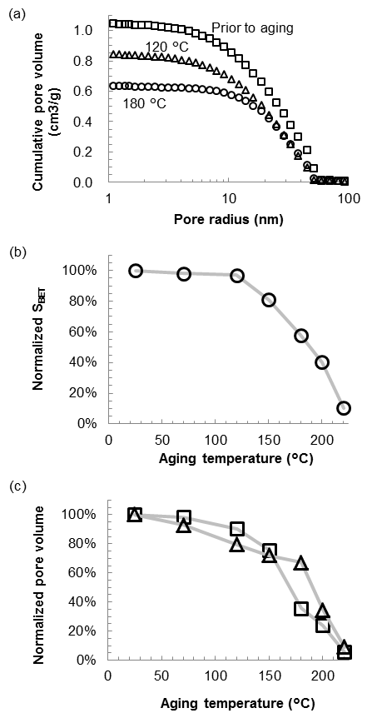
Figure 9. (a) Cumulative pore volumes of the monolith prior to aging (squares) and after 24 h aging at 120 °C (triangles) and at 180 °C (circles). (b) The normalized specific surface area, S_{BET}, and (c) normalized pore volumes of the monolith after aging at high temperatures for 24 h. Triangle and square symbols indicate the volumes of pores with radii larger than 10 nm V_{(r>10)} and smaller than 10 nm V_{(r<10)}, respectively. The as-prepared monolith initially had an S_{BET} of 180 m²/g, V_{(r>10)} of 0.85 cm³/g and V_{(r<10)} of 0.20 cm³/g, which were used to normalize the corresponding values of the aged samples.
Long-term stability of mesopores at 150 °C. Figure 10(a) plots the cumulative pore volumes of a PES monolith prior to and after aging at 150 °C. Although the initial 24 h aging resulted in the partial loss of mesopores and macropores, additional aging for 600 h did not degrade the remaining mesopores, and the resulting pore size distribution was similar to that obtained after 24 h aging. Figure 10(b) plots the normalized S_{BET}, V_{meso} and V_{macro} values as functions of aging time. These values were normalized to the initial values of the sample prior to aging. The initial 24 h aging period decreased the S_{BET} value by 19%, accompanied by a 16% reduction of the V_{meso} values. However, after long-term aging (600 h) a high S_{BET} value of 141 m²/g was retained, equivalent to 79% of the initial value. Similarly, the V_{meso} and V_{macro} were 78% and 77% of initial values after 600 h aging, respectively. Even though there was a slight reduction of these parameters during the initial 24 h aging, the mesoporous monolith maintained a large volume of mesopores as well as a high S_{BET} even after aging at 150 °C for more than 600 h.
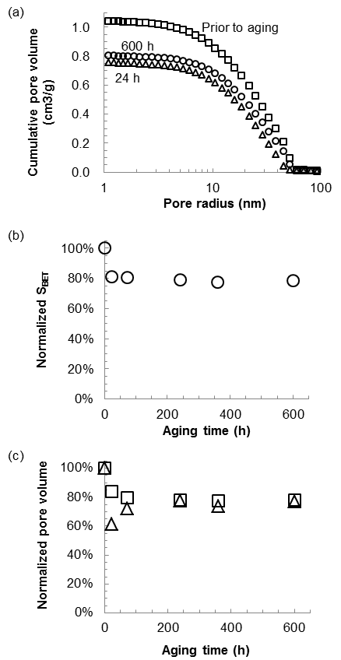
Figure 10. (a) Cumulative pore volumes of the monolith prior to aging (blue squares) and after aging at 150 °C for 24 h (triangles) and for 600 h (circles). (b) The normalized specific surface area and (c) normalized pore volumes as functions of aging time: V_{meso} (squares) and V_{macro} (triangles). The monolith initially had an S_{BET} value of 180 m²/g, V_{meso} of 0.52 cm³/g and V_{macro} of 0.52 cm³/g.

Thermal conductivity of the mesoporous monolith. Figure 11(a) plots the thermal diffusivities, α(T), of the monolith and of bulk PES without voids as a function of temperature. Over the temperature range of 180 – 200 °C, the α(T) of the monolith was nearly constant with an average value of 1.29×10⁻⁷ m²/s, which is 11% smaller than the average thermal diffusivity of the bulk sample. Since the monolith consisted of a three-dimensional framework of PES nanofibers, its lower α(T) can possibly be attributed to weak connections between the nanofibers. The α(T) of the monolith increased abruptly at 220 °C and became almost equal to that of the bulk. This rise in α(T) suggests that the nanofiber morphology was lost at 220 °C and the density of the specimen became similar to that of the bulk sample. A disappearance of mesopores at 220 °C was also observed during gas adsorption measurements (Figure 9 (c)). The thermal diffusivity of the bulk as determined in this study was slightly larger than the previously reported values,^{26–28} likely due to the use of different grades of PES and/or methods for the determination of thermal diffusivity. The specific heat of the monolith was similar to that of the bulk. The water displacement method gave a ρ_{ap} value for the bulk of 1.39 g/cm³, which was consistent with the value provided by the supplier¹⁴ and with the literature value of 1.4 g/cm³.²⁹ The ρ_{ap} of the monolith was found to be 0.43 g/cm³, which was much lower than that of the bulk.
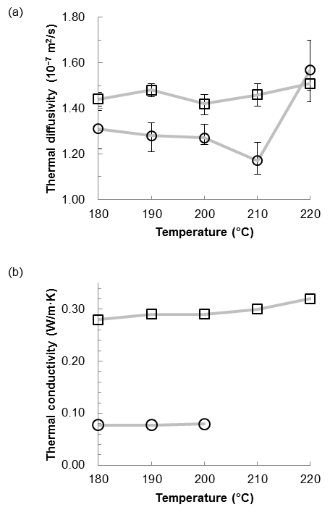
Figure 11. (a) Thermal diffusivities and (b) thermal conductivities of the monolith (circles) and bulk PES specimen (squares) at 180 – 220 °C. Error bars for the thermal diffusivities indicate the variation of five replicate trials.
Figure 11(b) plots the thermal conductivity, λ(T), of the monolith, as calculated using the equation λ(T) = C_{p}(T) × ρ_{ap} × α(T), as a function of temperature. Assuming a C_{p} of 1.40 (J/g·K), ρ_{ap} of 0.43 (g/cm³) and α of 1.29×10⁻⁷ (m²/s), the average thermal conductivity of the monolith was determined to be 0.078 W/m·K over the temperature range of 180‒200 °C. For the sake of simplicity, we neglected the temperature dependence of ρ_{ap} in these calculations. The thermal conductivity of the bulk was determined to be 0.287 W/m·K using a C_{p} of 1.42 (J/g·K), ρ_{ap} of 1.39 (g/cm³) and α of 1.45×10⁻⁷ (m²/s). Since the monolith had C_{p}, ρ_{ap} and α values that were 99%, 31% and 89% those of the bulk sample, the low λ(T) of the monolith can be primarily attributed to its low apparent density. As compared with the λ(T) values of other aerogels having similar ρ_{ap}, the λ(T) of the monolith was similar with methacrylate-based aerogels³⁰ but four times larger than the best values reported on polyurethane-based aerogel⁸ and resorcinol-formaldehyde aerogel³¹ (Figure S7). This low λ(T) at high temperatures suggests possible applications of the PES monolithic material in thermal insulation.

CONCLUSIONS
This work demonstrated the first-ever physical gelation of PES solutions in DMF. The gelation was readily obtained by cooling and/or the addition of benzene, which is driven by partial crystallization of PES in the solutions as confirmed by XRD measurements. The removal of residual solvent from the gel precursors was found to be an effective means of fabricating porous PES monoliths, and optimization of both the PES concentration and benzene ratio produced PES having a mesoporous structure. These optimized monoliths had a fine network structure composed of PES nanofibers with an average diameter of 18 nm, together with a high specific surface area of 206 m²/g and a large mesopore volume of 0.52 cm³/g. The mesopores were thermally stable due to the high glass transition temperature of PES, such that nearly 80% of the mesopores were maintained even after aging at 150 °C for 600 h. At high temperatures (180–200 °C), the monoliths exhibited 31% of the thermal conductivity of the bulk polymer due to their low apparent density, suggesting that this material may function as thermal insulation in the range of 100–200 °C.

ASSOCIATED CONTENT
Supporting Information
The Supporting Information is available free of charge on the ACS Publications website at DOI: ***.
XRD results and additional data (PDF)

AUTHOR INFORMATION
Corresponding Author
*E-mail: SAMITSU.Sadaki@nims.go.jp (S.S.)
ORICD
Sadaki Samitsu: 0000-0002-4139-1656
Notes
The authors declare no competing financial interest.
ACKNOWLEDGMENT
The author thanks Dr. Yoshitaka Matsushita at NIMS for performing XRD measurements, Prof. Kohsaku Kawakami at NIMS for instrumental support of DSC measurement, and Dr. Atsuro Takai and Prof. Masayuki Takeuchi at NIMS for instrumental support of TGA measurement. The author wishes to acknowledge financial support provided by JSPS KAKENHI grant numbers JP26410230 and JP17K06007. This work was also partly supported by the NIMS Microstructural Characterization Platform as part of the Nanotechnology Platform of the Ministry of Education, Culture, Sports, Science and Technology (MEXT), Japan.
REFERENCES
(1) Notario, B.; Pinto, J.; Rodriguez-Perez, M. A. Nanoporous Polymeric Materials: A New Class of Materials with Enhanced Properties. Prog. Mater. Sci. 2016, 78–79, 93–139.
(2) Yang, S. Y.; Ryu, I.; Kim, H. Y.; Kim, J. K.; Jang, S. K.; Russell, T. P. Nanoporous Membranes with Ultrahigh Selectivity and Flux for the Filtration of Viruses. Adv. Mater. 2006, 18 (6), 709–712.
(3) Peinemann, K. V.; Abetz, V.; Simon, P. F. W. Asymmetric Superstructure Formed in a Block Copolymer via Phase Separation. Nat. Mater. 2007, 6 (12), 992–996.
(4) Daniel, C.; Longo, S.; Ricciardi, R.; Reverchon, E.; Guerra, G. Monolithic Nanoporous Crystalline Aerogels. Macromol. Rapid Commun. 2013, 34 (15), 1194–1207.
(5) Samitsu, S.; Zhang, R.; Peng, X.; Krishnan, M. R.; Fujii, Y.; Ichinose, I. Flash Freezing Route to Mesoporous Polymer Nanofibre Networks. Nat. Commun. 2013, 4, 1–7.
(6) Liu, X.; Ma, P. X. Phase Separation, Pore Structure, and Properties of Nanofibrous Gelatin Scaffolds. Biomaterials 2009, 30 (25), 4094–4103.
(7) Liu, X.; Jin, X.; Ma, P. X. Nanofibrous Hollow Microspheres Self-Assembled from Star-Shaped Polymers as Injectable Cell Carriers for Knee Repair. Nat. Mater. 2011, 10 (5), 398–406.
(8) Biesmans, G.; Randall, D.; Francais, E.; Perrut, M. Polyurethane-Based Organic Aerogels’ Thermal Performance. J. Non. Cryst. Solids 1998, 225, 36–40.
(9) Olson, D. A.; Chen, L.; Hillmyer, M. A. Templating Nanoporous Polymers with Ordered Block Copolymers. Chem. Mater. 2008, 20 (3), 869–890.
(10) Lloyd, D. R.; Kinzer, K. E.; Tseng, H. S. Microporous Membrane Formation via Thermally Induced Phase Separation. I. Solid-Liquid Phase Separation. J. Memb. Sci. 1990, 52 (3), 239–261.
(11) Aubert, J. H. Isotactic Polystyrene Phase Diagrams and Physical Gelation. Macromolecules 1988, 21 (12), 3468–3473.
(12) Ma, P. X.; Zhang, R. Synthetic Nano-Scale Fibrous Extracellular Matrix. J. Biomed. Mater. Res. 1999, 46 (1), 60–72.
(13) Xin, Y.; Fujimoto, T.; Uyama, H. Facile Fabrication of Polycarbonate Monolith by Non-Solvent Induced Phase Separation Method. Polym. (United Kingdom) 2012, 53 (14), 2847–2853.
(14) SpecialityPolymers Solvay. Technical Data Sheet Veradel ® 3300 PREM https://www.solvay.com/en/markets-and-products/featured-products/veradel.html (accessed Nov 29, 2017).
(15) Li, S.-G.; van den Boomgaard, T.; Smolders, C. A.; Strathmann, H. Physical Gelation of Amorphous Polymers in a Mixture of Solvent and Nonsolvent. Macromolecules 1996, 29 (6), 2053–2059.
(16) Wichterle, I.; Linek, J.; Wagner, Z.; Fontaine, J.-C.; Sosnkowska-Kehiaian, K.; Kehiaian, H. V. N,N-Dimethylmethanamide C3H7NO + C6H6 Benzene. In Binary Liquid Systems of Nonelectrolytes. Part 1; Henry V. Kehiaian, Ed.; Springer Berlin Heidelberg: Berlin, Heidelberg, 2017; pp 1–1.
(17) Khayet, M.; García-Payo, M. C. X-Ray Diffraction Study of Polyethersulfone Polymer, Flat-Sheet and Hollow Fibers Prepared from the Same under Different Gas-Gaps. Desalination 2009, 245 (1–3), 494–500.
(18) Blackadder, D. A.; Ghavamikia, H.; Windle, A. H. Evidence for Crystallinity in Poly(ether Sulphone). Polymer (Guildf). 1979, 20 (6), 781–782.
(19) Benhalima, A.; Hudon, F.; Koulibaly, F.; Tessier, C.; Brisson, J. Polyethersulfone Polymers and Oligomers — Morphology and Crystallization. Can. J. Chem. 2012, 90 (10), 880–890.
(20) Daniel, C.; Deluca, M. D.; Guenet, J.-M.; Brûlet, A.; Menelle, A. Thermoreversible Gelation of Syndiotactic Polystyrene in Benzene. Polymer (Guildf). 1996, 37 (7), 1273–1280.
(21) Attwood, T. E.; Dawson, P. C.; Freeman, J. L.; Hoy, L. R. J.; Rose, J. B.; Staniland, P. A. Synthesis and Properties of Polyaryletherketones. Polymer (Guildf). 1981, 22 (8), 1096–1103.
(22) Berens, A. R.; Hodge, I. M. Effects of Annealing and Prior History on Enthalpy Relaxation in Glassy Polymers. 1. Experimental Study on Poly(vinyl Chloride). Macromolecules 1982, 15 (3), 756–761.
(23) Mandelkern, L. Crystallization of Polymers, Second Ed.; Cambridge University Press: New York, 2002.
(24) Li, L.; Yih, P.; Chung, D. D. L. Effect of the Second Filler Which Melted during Composite Fabrication on the Electrical Properties of Short Fiber Polymer-Matrix Composites. J. Electron. Mater. 1992, 21 (11), 1065–1071.
(25) Orwoll, R. A. Densities, Coefficients of Thermal Expansion, and Compressibilities of Amorphous Polymers. In Physical Properties of Polymers Handbook Second Edition; Mark, J. E., Ed.; Springer: New York, 2007; pp 93–101.
(26) Yang, Y. Thermal Conductivity. In Physical Properties of Polymers Handbook Second Edition; Mark, J. E., Ed.; Springer: New York, 2007; pp 155–163.
(27) Morikawa, J.; Tan, J.; Hashimoto, T. Study of Change in Thermal Diffusivity of Amorphous Polymers during Glass Transition. Polymer (Guildf). 1995, 36 (23), 4439–4443.
(28) Yorifuji, D.; Ando, S. Molecular Structure Dependence of out-of-Plane Thermal Diffusivities in Polyimide Films: A Key Parameter for Estimating Thermal Conductivity of Polymers. Macromolecules 2010, 43 (18), 7583–7593.
(29) Kholodovych, V.; Welsh, W. J. Densities of Amorphous and Crystalline Polymers. In Physical Properties of Polymers Handbook Second Edition; Mark, J. E., Ed.; Springer: New York, 2007; pp 611–617.
(30) Notario, B.; Pinto, J.; Solorzano, E.; De Saja, J. A.; Dumon, M.; Rodríguez-Pérez, M. A. Experimental Validation of the Knudsen Effect in Nanocellular Polymeric Foams. Polym. (United Kingdom) 2015, 56, 57–67.
(31) Lu, X.; Arduini-Schuster, M. C.; Kuhn, J.; Nilsson, O.; Fricke, J.; Pekala, R. W. Thermal Conductivity of Monolithic Organic Aerogels. Science 1992, 255 (5047), 971–972.

“for Table of Contents use only”
Thermally-stable mesoporous poly(ether sulfone) monoliths with nanofiber network structures
Sadaki Samitsu*

