Enhancement of transverse thermoelectric conversion by interface-induced spin current in ferromagnetic metal/nonmagnetic insulator hybrid-structure

Takuma Itoh, Yusuke Kozuka, Takamasa Hirai*, Ken-ichi Uchida*

Takuma Itoh, Takamasa Hirai, Ken-ichi Uchida
Research Center for Magnetic and Spintronic Materials, National Institute for Materials Science (NIMS), Tsukuba 305-0047, Japan
E-mail: HIRAI.Takamasa@nims.go.jp and UCHIDA.Kenichi@nims.go.jp

Yusuke Kozuka
Research Center for Materials Nanoarchitectonics, National Institute for Materials Science (NIMS), Tsukuba 305-0047, Japan

Ken-ichi Uchida
Department of Advanced Materials Science, Graduate School of Frontier Sciences, The University of Tokyo, Kashiwa, Chiba 277-8561, Japan

Keywords: transverse thermoelectric conversion, anomalous Ettingshausen effect, Rashba-Edelstein effect, spin Peltier effect, lock-in thermography

Transverse thermoelectric conversion phenomena including the anomalous Ettingshausen effect (AEE) and anomalous Nernst effect (ANE) in magnetic materials have been actively investigated to realize versatile cooling and energy harvesting technologies, respectively. However, further improvement of thermoelectric performance of AEE and ANE is still required, and most research efforts have focused on material exploration. Here, a new approach to improve the transverse thermoelectric conversion performance through interface engineering is reported by focusing on the transverse thermoelectric phenomena that output heat currents. A longitudinal charge current in a ferromagnetic metal Ni/nonmagnetic insulator Bi₂WO₆ hybrid-structure induces a larger transverse heat current than that of AEE in a Ni single-layer. It is indicated that the enhancement of the transverse thermoelectric conversion is due to the generation of a heat current concomitant with a spin current induced at the Ni/Bi₂WO₆ interface. This finding demonstrates that the interface of a magnetic metal/nonmagnetic insulator has a potential to improve the transverse thermoelectric performance, extending the applicability of nonmagnetic insulators to the field of spin caloritronics and thermoelectrics.

1. Introduction
Spin caloritronics, which examines the cross-correlation among charge, spin, and heat transport phenomena, has attracted attention not only for its fundamental interests in solid-state physics but also for realizing future energy harvesting and thermal management technologies.^{[1–4]} The development of spin caloritronics was triggered by the discovery of the spin Seebeck effect (SSE), which refers to the conversion of a heat current into a spin current in magnetic materials.^{[5,6]} SSE is applicable to thermoelectric technologies because the thermally excited spin current in a magnetic material (e.g., magnetic insulators such as Y₃Fe₅O₁₂) can be converted into a charge current by attaching a conductive material with large spin-orbit interaction (e.g., nonmagnetic metals such as Pt and W) to the magnetic material. As the reverse process of SSE in a nonmagnetic metal/magnetic insulator bilayer, applying a charge current to the nonmagnetic metal can generate a heat current through injecting a spin current into the magnetic material, which is referred to as the spin Peltier effect (SPE).^{[7–11]} SSE and SPE enable the interconversion between heat and charge currents in orthogonal directions via spin transport, providing various thermoelectric functionalities that cannot be realized by the conventional Seebeck and Peltier effects. Thus, the observation of SSE and SPE has opened up a new avenue in thermoelectrics: spintronic energy harvesting and thermal management.^{[3,4,12]}
Transverse thermoelectric effects using magnetic materials offer a simple device structure, which improves the durability, flexibility, and unique functionalities.^{[12–15]} One of such functionalities is that the transverse thermoelectric output can be actively controlled by manipulating the magnetization M in magnetic materials. In addition to SSE/SPE, the transverse magneto-thermoelectric applications based on the anomalous Nernst effect (ANE)^{[16–18]} and anomalous Ettingshausen effect (AEE)^{[19–21]} have been extensively studied. Here, ANE (AEE) realizes the direct transverse thermoelectric conversion in a single magnetic conductor, where a charge (heat) current is generated in the direction perpendicular to both an applied heat (charge) current and M of the magnetic conductor (Figure 1a).^{[22]} The research on transverse thermoelectric conversion has revealed several advantages in various materials in both bulk and film forms. When using bulk materials, the fact that two electrodes can be placed at a cold end of a transverse thermoelectric generator improves the stability at high temperatures.^{[23]} ANE in thin films is applicable to a heat flux sensor with extremely small thermal resistance on a flexible substrate and suitable for on-chip integration with electronic devices.^{[24–27]} However, the thermoelectric performance of ANE/AEE is still much smaller than that of the Seebeck/Peltier effect, and its further improvement is a challenging issue. Recent many efforts for transverse thermoelectric conversion using magnetic materials have been dedicated to exploring superior magnetic materials exhibiting large ANE/AEE. For example, magnetic topological materials,^{[28–31]} rare-earth permanent magnets,^{[20]} and microstructure-engineered Fe-based amorphous alloys^{[32]} are promising for ANE/AEE. Superimposition of multiple transverse thermoelectric effects by fabricating hybrid-structures or multilayers is another strategy to improve the performance of transverse thermoelectric conversion. The hybridization of ANE and SSE has been demonstrated in a junction comprising a ferromagnetic metal/ferrimagnetic insulator, e.g., Ni/Y₃Fe₅O₁₂^{[12]} and in composites of ferromagnetic metals (e.g., Ni, MnBi) containing metallic nanoparticles with strong spin-orbit interactions (e.g., Pt, Au).^{[33]} An artificial stack based on a ferromagnetic metal and nonmagnetic semiconductor, such as Co₂MnGa/Si, can provide a large transverse thermopower by superimposing a thermoelectric contribution induced by the combination of the Seebeck effect in the nonmagnetic semiconductor and the anomalous Hall effect in the ferromagnetic metal onto ANE.^{[34]} While such hybrid magneto-thermoelectric conversion processes have begun to be attempted in various hybrid-structures and materials,^{[14]} only nonmagnetic insulators have not received any attention in thermoelectrics because nonmagnetic insulators themselves cannot exhibit any thermoelectric effects.
In this study, we demonstrate a new approach to improve the transverse thermoelectric conversion: interface engineering by combining a nonmagnetic insulator to a ferromagnetic metal. Employing the lock-in thermography (LIT) technique,^{[9,35]} which can investigate transverse thermoelectric conversion performance with a focus on charge-to-heat current conversion, a signiﬁcant enhancement of the induced transverse heat current in a bilayer consisting of a ferromagnetic metal Ni and nonmagnetic insulator Bi₂WO₆ (BWO) was observed in comparison with the AEE-induced heat current in a Ni single-layer (Figure 1b). The magnetization-direction-dependent measurements of the current-induced temperature change revealed that the enhancement of the transverse thermoelectric conversion response is due to the superimposition of the AEE-induced heat current in Ni and the heat current concomitant with the spin current induced at the Ni/BWO interface despite the fact that BWO is a nonmagnetic insulator. This work will expand material candidates for transverse thermoelectric conversion to nonmagnetic insulators and provide an unconventional strategy to improve its performance.
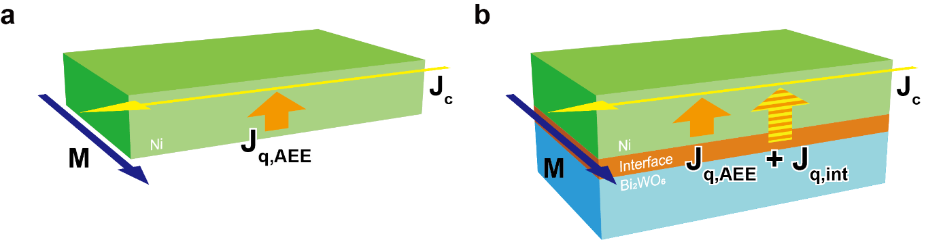

Figure 1. a,b) Schematics of the transverse thermoelectric conversion in (a) the Ni single-layer and (b) Ni/BWO hybrid-structure in an in-plane magnetized configuration. J_{c}, J_{q,AEE}, J_{q,int}, and M denote the charge current applied to the Ni layer, heat current driven by AEE, heat current driven by an interface-induced spin current, and magnetization, respectively.
2. Results and Discussion
2.1. Sample Design and Characterization
The reason why we focus on the Ni/BWO junction system in this study is that charge-to-spin conversion due to the Rashba-Edelstein effect (REE) was observed in a similar system comprising a Ni_{0.8}Fe_{0.2}/BWO bilayer.^{[36]} REE refers to the generation of spin polarization caused by an application of an external electric field or charge current via the Rashba spin-orbit coupling in a system with broken inversion symmetry, such as surfaces and interfaces.^{[37–44]} Since it was reported that Fe diffuses at the Ni_{0.8}Fe_{0.2}/BWO interface,^{[36]} we replaced Ni_{0.8}Fe_{0.2} with pure Ni to avoid any artifacts caused by the intermixing. Although BWO is a material in the Aurivillius family with various features such as robust ferroelectricity with a high Curie temperature of 950 °C and a high photocatalytic activity in the visible-light range,^{[45–48]} these functionalities are not directly used in this study. When a charge current is applied to the Ni layer, REE could induce a spin accumulation at the Ni/BWO interface, and the accumulated spin could diffuse into the Ni layer as a spin current. Here, it is known that an injection of a spin current into a ferromagnet can contribute to the transverse thermoelectric conversion through thermo-spin effects, such as SPE and spin-dependent Peltier effect (SdPE).^{[49,50]} SPE (SdPE) is a spin-to-heat current conversion phenomenon appearing due to non-equilibrium transport of magnons (conduction-electrons’ spins). If SPE and/or SdPE appear in Ni, the REE-induced spin current drives an additional heat current in the same direction as the AEE-induced heat current, providing the change in the transverse thermoelectric temperature modulation (Figure 1b). The interfacial Rashba spin-orbit interaction at the Ni/BWO interface may also directly modulate AEE in the vicinity of the interface. The spin-current-originated and AEE-originated contributions can be separated by comparing the transverse thermoelectric responses when the M is oriented in the in-plane and out-of-plane directions [hereafter referred to as in-plane magnetized and perpendicularly magnetized configurations, respectively, as discussed in Sec. 2.2 and 2.3].^{[51]} REE has also been observed at the interfaces with several nonmagnetic metals.^{[37–39,52–55]} However, nonmagnetic metals themselves do not exhibit magnetization-dependent transverse thermoelectric effects but cause the shunting effect on a charge current in hybrid structures, which potentially reduces the performance of the transverse thermoelectric conversion, depending on the layer thickness ratio and electrical conductivity. In contrast, by using insulators, we can demonstrate the REE-induced modulation of the transverse thermoelectric conversion without the degradation due to the shunting effect.
The Ni/BWO hybrid-structure was fabricated by the following processes (see also Experimental Section). The 10-nm-thick BWO film was prepared using pulsed laser deposition (PLD) on a (LaAlO₃)_{0.3}(SrAl_{0.5}Ta_{0.5}O₃)_{0.7} (LSAT) substrate with a 1-nm-thick SrRuO₃ buffer layer, followed by forming a 10-nm-thick Ni film by a radio-frequency magnetron sputtering method. At the same time, we also deposited the Ni film directly on the LSAT substrate as a reference sample. Hereafter, these samples are referred to as the Ni/BWO hybrid-structure and Ni single-layer, respectively. Figure 2a shows the X-ray diffraction pattern of the two samples. Clear diffraction peaks from the Ni layer, BWO layer, and LSAT substrate indicate epitaxial growth of all the layers. Laue fringes originating from the 10-nm-thick BWO layer give evidence of the very smooth surface. The flat surfaces of the films are also ensured by atomic force microscopy as shown in Figure 2b,c. The root mean square values of the surface roughness for the Ni single-layer and Ni/BWO hybrid-structure are 0.12 nm and 0.21 nm, respectively, which are two orders of magnitude smaller than the Ni layer thickness. Furthermore, we confirmed that the electrical resistivities of both films were almost the same, 2.2×10^{–7} and 2.1×10^{–7} Ω m for the Ni single-layer and Ni/BWO hybrid-structure, respectively, by means of the standard four-probe method. Note that the sheet resistance of the 1-nm-thick SrRuO₃ buffer layer at room temperature is approximately 10 kΩ sq^{–1},^{[56]} which is 500 times as large as that of the 10-nm-thick Ni layer used in this study (around 20 Ω sq^{–1}). Therefore, the shunting effect into the SrRuO₃ layer is negligibly small. These results allow us to compare the transport properties between the Ni single-layer and Ni/BWO hybrid-structure.

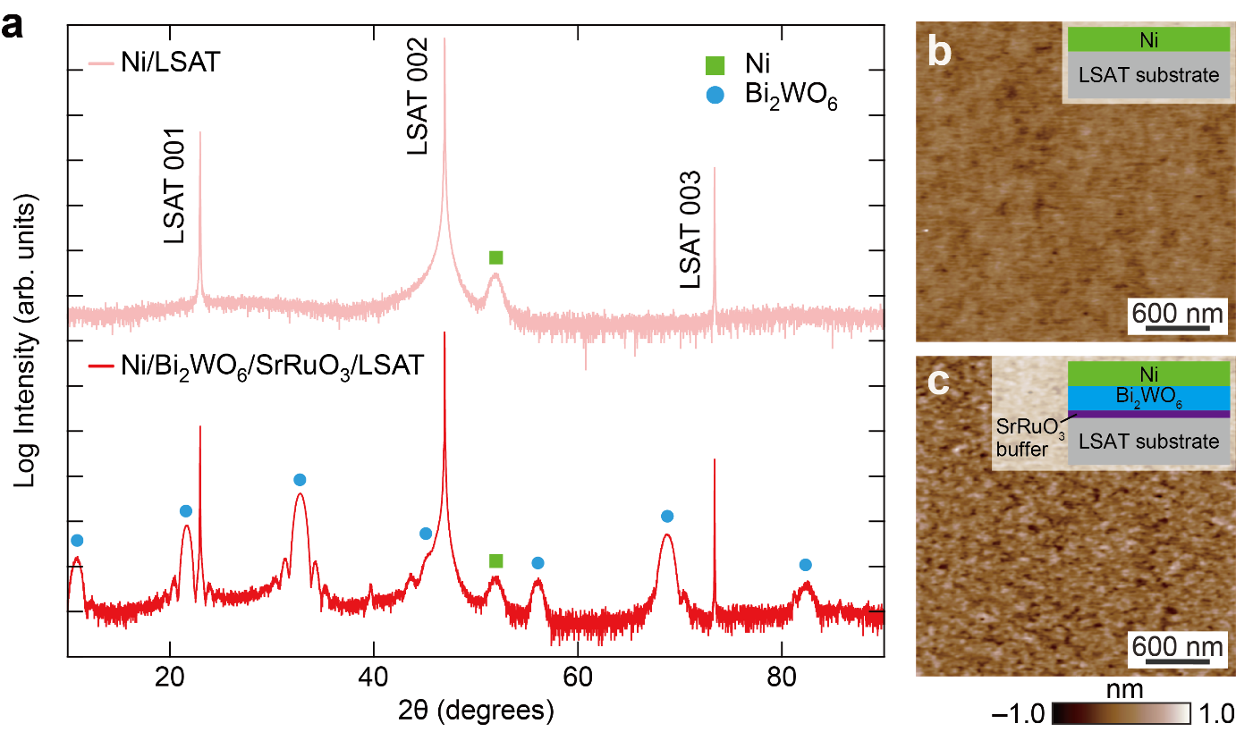

Figure 2. a) X-ray diffraction 2θ−θ scan of the Ni single-layer and Ni/BWO hybrid-structure. b,c) Topographic surface images of the (b) Ni single-layer and (c) Ni/BWO hybrid-structure, measured by atomic force microscopy. The schematics of the cross-sectional view of the stacked structures are depicted at the top-right corners in (b,c).
2.2. Transverse Thermoelectric Conversion in In-plane Magnetized Configuration
The temperature change induced by the transverse thermoelectric conversion in the Ni single-layer and Ni/BWO hybrid-structure was detected by the LIT technique (Figure 3a).^{[9,35]} LIT based on the active infrared emission microscopy enables contact-free thermal imaging with high temperature and spatial resolutions. This technique has been utilized for the observation of various thermal responses, including thermoelectric/thermo-spin conversion, caloric effects, and thermal transport phenomena.^{[57–59]} In this study, during the LIT measurements, a square-wave-modulated alternating charge current with the amplitude J_{c}, frequency f (= 25 Hz), and zero offset was applied to the Ni layer, which allows us to separate thermoelectric signals (∝J_{c}) from Joule heating (∝J_{c}²).^{[9,35]} Here, the films were patterned into two strips with a width of 0.3 mm and one end of the strips was electrically connected in series with an indium electrode to apply the charge current in opposite directions to the two strips at the same time (see Figure 3a). A magnetic field H with the magnitude H was also applied to align M of the Ni layer along the in-plane direction (x direction) orthogonal to the charge current (y direction). Thermal images oscillating with the same f as the input charge current were transferred to the processing system in real time and converted into the lock-in amplitude and phase images through Fourier analysis. The amplitude image indicates the magnitude of temperature modulation and the phase image provides sign information. Since the temperature change due to transverse thermoelectric effects such as AEE, SPE, and SdPE exhibits the H-odd dependence,^{[9,35]} we calculated A_{odd} = |A(+H)e^{−iΦ(+H)} − A(–H)e^{−iΦ(–H)}|/2 and Φ_{odd} = –arg{A(+H)e^{−iΦ(+H)} − A(–H)e^{−iΦ(–H)}} from extracted thermal images measured under positive and negative H. Note that, to keep the base temperature of the samples constant in the presence of Joule heating, the temperature of a sample stage was controlled at a temperature slightly higher than room temperature using a Peltier module (Figure S1).
Initially, we focus on the results of the LIT measurements for the Ni single-layer. Figure 3b,c shows the A_{odd} and Φ_{odd} images for the Ni single-layer at J_{c} = 35 mA and μ₀|H| = 200 mT, measured at 327 K. Clear and uniform current-induced temperature modulation depending on the J_{c} direction was observed in the strips; the sign of the temperature modulation at the left strip (heat absorbed) is opposite to that at the right strip (heat released) because of the phase difference of 180° between them, which is consistent with the feature of AEE in the in-plane magnetized configuration in previous studies.^{[35]} Open symbols in Figure 3f,g respectively represent the H dependence of the A_{odd} and Φ_{odd} values for the Ni single-layer at J_{c} = 35 mA (see also Figure S2 showing the LIT images at each |H| value). The magnitude of A_{odd} increases with the increase in H and saturates above 50 mT. The J_{c} dependence of A_{odd} and Φ_{odd} values at μ₀|H| = 200 mT is shown in Figure 3h,i, respectively (see also Figure S3 showing the LIT images at each J_{c} value). The magnitude of the A_{odd} signal is proportional to J_{c} with the constant Φ_{odd} value, which is also consistent with the behavior of AEE in the Ni samples.^{[35]} For quantitative discussions, we estimated the magnitude of A_{odd}/j_{c}, where j_{c} is the charge current density. The A_{odd}/j_{c} value for the Ni single-layer at μ₀|H| = 200 mT is 6.5×10^{–14} K m² A^{–1} (Figure 3j).
The results of the LIT experiments for the Ni/BWO hybrid-structure are summarized in Figure 3d,e and as filled symbols in Figure 3f–i. While the Φ_{odd} signal for the Ni/BWO hybrid-structure exhibits the same behaviors as that for the Ni single-layer, the A_{odd} value is considerably larger than that for the Ni single-layer. The magnitude of A_{odd}/j_{c} at μ₀|H| = 200 mT for the Ni/BWO hybrid-structure is 8.0×10^{–14} K m² A^{–1} (Figure 3j), which is approximately 23% larger than that due to AEE in the Ni single-layer. Importantly, since BWO is a nonmagnetic insulator and a charge current shunted in the SrRuO₃ buffer layer is negligible, the charge current flows only in the Ni layer in the Ni/BWO hybrid-structure. Note that, as the magnetism of SrRuO₃ appears only below 160 K,^{[60]} even a small amount of the shunting charge current does not affect the transverse magneto-thermoelectric conversion measured by LIT around room temperature. Since the tiny difference in the electrical resistivities and thickness of the Ni layer between the samples cannot explain the large difference in A_{odd}/j_{c}, these results indicate that the formation of the Ni/BWO interface contributes the enhancement of transverse thermoelectric conversion.
Herein, we discuss mechanisms for the enhancement of the transverse thermoelectric conversion in the Ni/BWO hybrid-structure. Since nonmagnetic insulator BWO itself cannot be a thermoelectric convertor or spin current generator, the Ni/BWO interface should play a key role. In a similar manner to the results for the Ni_{0.8}Fe_{0.2}/BWO bilayer used in ref. [36], REE at the Ni/BWO interface can generate a spin accumulation and resultant SPE and/or SdPE-induced heat current in the Ni layer. This additional spin-current-induced heat current may superimpose the AEE-induced heat current, resulting in the enhanced temperature modulation. The sign of the temperature modulation due to the spin-current-induced heat current is the same as that due to the AEE-induced heat current in the Ni/BWO hybrid-structure, considering the facts that the spin current generated by REE at a Ni_{0.8}Fe_{0.2}/BWO interface is the same as that induced by the spin Hall effect in Pt and that the direction of the AEE-induced heat current is the same as that of the spin-current-induced heat current in a Pt/Ni_{0.81}Fe_{0.19} bilayer.^{[36,50,61,62]} On the other hand, the interlayer mixing and electronic structure modulation near the Ni/BWO interface may also cause the change in AEE, which can be another mechanism in the enhancement of the transverse thermoelectric conversion. Because the atomic diffusion of Fe occurs and that of Ni does not occur in the Ni_{0.8}Fe_{0.2}/BWO bilayer,^{[36]} the interlayer mixing due to atomic diffusion at the interface of Ni/BWO is trivial, which is supported from almost same electrical resistivities of the Ni layers for the Ni single-layer and Ni/BWO hybrid-structure confirmed by the four-probe method. However, the modulation of the electronic band structure near the interface can be induced by the interfacial Rashba spin-orbit interaction, which may also change the magneto-thermoelectric conversion properties.^{[63,64]} Therefore, to separate these mechanisms, further quantitative investigations are required.
The most significant factor inhibiting the separation of each mechanism is that the heat current generation due to SPE/SdPE has the same symmetry as that due to AEE in the in-plane magnetized configuration. Contrary to this, in the perpendicularly magnetized configuration, since the spin polarization generated by REE is orthogonal to the magnetization of Ni, the symmetry of SPE/SdPE is not satisfied and no heat current is generated by a spin current, while AEE still appears.^{[4,51,65–67]} Therefore, to investigate the pure contribution of AEE, the LIT measurements in the perpendicularly magnetized configuration were conducted by applying H to align M along the out-of-plane direction (z direction) and the LIT signals in the Ni single-layer and Ni/BWO hybrid-structure were compared between the in-plane magnetized and perpendicularly magnetized configurations.
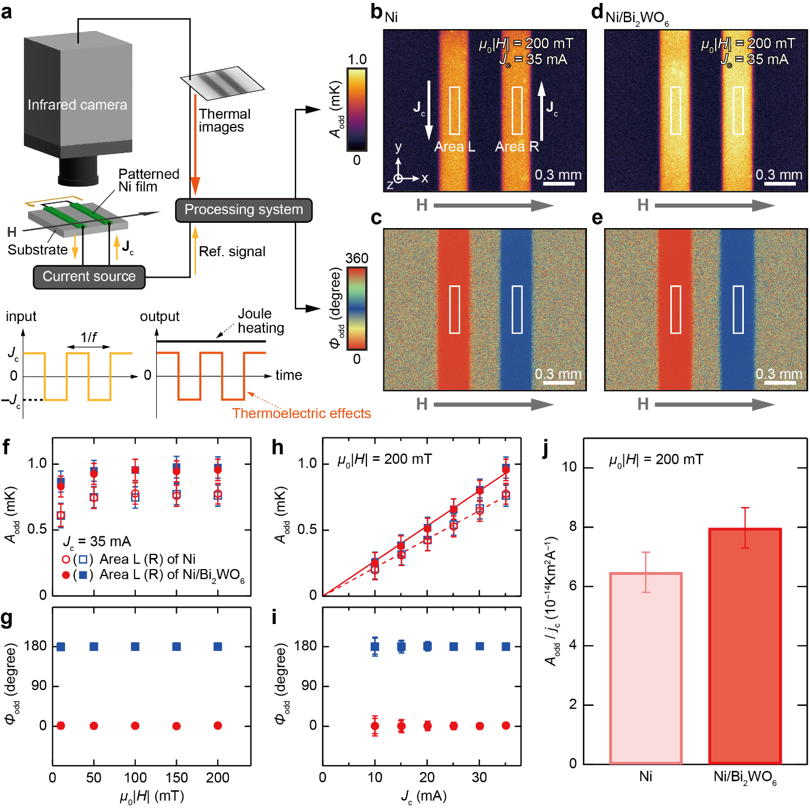

Figure 3. a) Schematic of the LIT system for measurements of the transverse thermoelectric conversion in the in-plane magnetized configuration, where a square-wave-modulated alternating charge current with J_{c}, f of 25 Hz, and zero offset was applied to the film. b–e) A_{odd} and Φ_{odd} images for the (b,c) Ni single-layer and (d,e) Ni/BWO hybrid-structure at J_{c} = 35 mA and μ₀|H| = 200 mT, measured at 327 K. f,g) H dependence of the (f) A_{odd} and (g) Φ_{odd} values for the Ni single-layer and Ni/BWO hybrid-structure at J_{c} = 35 mA, which were estimated by averaging the signals in the areas surrounded by the white rectangles in (b–e). The left and right rectangles define the areas L and R, respectively. h,i) J_{c} dependence of the (h) A_{odd} and (i) Φ_{odd} values for the Ni single-layer and Ni/BWO hybrid-structure at μ₀|H| = 200 mT. Solid and dotted lines in (h) show the results of linear ﬁtting. j) The A_{odd}/j_{c} values for the Ni single-layer and Ni/BWO hybrid-structure at μ₀|H| = 200 mT, which were estimated from the slope of the linear fitting in (h), width of strip, and thickness of the Ni layer.
2.3. Transverse Thermoelectric Conversion in Perpendicularly Magnetized Configuration
Figure 4 shows the results of the LIT measurements in the perpendicularly magnetized configuration (Figure 4g) using the same films used for the experiments in the in-plane magnetized configuration. The clear temperature modulation signals were observed to appear at the edge of the strips in both samples; the A_{odd} value becomes maximum at the edges of the strips and gradually decreases with increasing the distance from the edges (Figure 4a,d; see also the x-directional line profiles in Figure 4b,e). The Φ_{odd} values at the two edges in each strip show the 180° change (Figure 4c,f). These behaviors are consistent with the feature of AEE in the perpendicularly magnetized configuration.^{[19,51]} Importantly, the A_{odd}/j_{c} value for the Ni/BWO hybrid-structure is only 7% larger than that of the Ni single-layer (Figure 4h), which is in a margin of error bars and much smaller than the change ratio observed in the in-plane magnetized configuration. The comparison of the experimental results between the in-plane magnetized and perpendicularly magnetized configurations concludes that the distinct enhancement of A_{odd}/j_{c} in the Ni/BWO hybrid-structure in the in-plane magnetized configuration is dominantly attributed to SPE and/or SdPE via REE at the Ni/BWO interface, although the finite modulation of AEE may also exist in Ni. Note that the transverse thermoelectric coefficient in Ni may be modulated by the correction term due to the Peltier and thermal Hall effects.^{[68]} Here, the symmetry of the transverse heat current due to this correction term is the same as that of AEE, but different from that of SPE/SdPE; the former appears in both the in-plane and perpendicularly magnetized configurations and the latter only in the in-plane magnetized configuration. Thus, our conclusion remains unchanged because the existence of such a correction term cannot explain the large difference in the lock-in signals observed only in the in-plane magnetized configuration. Furthermore, we calculated the magnitude of the correction term to be 0.08 µV K^{–1} for Ni,^{[69,70]} which is much smaller than the anomalous Nernst coefficient of our Ni film (0.84 µV K^{–1}) estimated from the LIT result for the Ni single-layer using the thermal conductivity of a Ni film (27 W m^{–1} K^{–1}).^{[71]} Thus, even if the Peltier and thermal Hall effects are modulated by the Ni/Bi₂WO₆ interface, the contribution of the correction term to the transverse heat current should be much smaller than the change in AEE. The separation between magnon-driven SPE and electron-driven SdPE is still challenging in the present experiments. However, judging from the previous report for paramagnetic metal/ferromagnetic metal hybrid-structures,^{[50]} SPE might provide a dominant contribution in the enhancement of the transverse thermoelectric conversion in our Ni/BWO hybrid-structure.

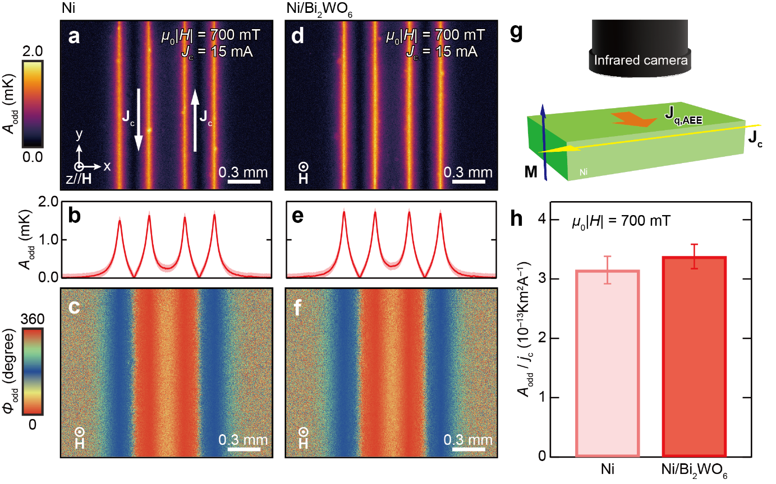

Figure 4. Results of the LIT experiments in the perpendicularly magnetized configuration. a) A_{odd} images, b) x-directional line profiles of A_{odd}, where the A_{odd} values and error bars were estimated by averaging A_{odd} signals along the y-direction in (a), and c)Φ_{odd} images at J_{c} = 15 mA, f = 25 Hz, and μ₀|H| = 700 mT for the Ni single-layer, measured at 313 K. d–f) Results for the Ni/BWO hybrid-structure. g) The experimental setup for the perpendicularly magnetized configuration. h) A_{odd}/j_{c} values for the Ni single-layer and Ni/BWO hybrid-structure in the perpendicularly magnetized configuration. The values were estimated by averaging the A_{odd} values over a range of ±1 pixel from the x position exhibiting the local maximum at each edge in (b,e).
3. Conclusion
In summary, we demonstrated the improvement of the transverse thermoelectric conversion through interface engineering in the hybrid structure consisting of ferromagnetic metal Ni and nonmagnetic insulator BWO. The LIT measurements of the current-induced temperature change focusing on the different symmetry of AEE and spin-current-induced transverse thermoelectric responses reveal that the enhancement is due mainly to the heat current generation concomitant with the spin current induced at the Ni/BWO interface, i.e., SPE and/or SdPE induced by REE. This suggests that nonmagnetic insulators, which have received no attention in thermoelectrics, have a potential to enhance the transverse thermoelectric conversion. REE is known to appear at other ferromagnetic metal/nonmagnetic insulator interfaces,^{[72,73]} which could be utilized for the improvement of the transverse thermoelectric conversion. Based on the Onsager reciprocal relation, a large transverse thermopower can also be obtained by hybridizing ANE with interface-induced spin currents utilizing nonmagnetic insulators. While the present experiments were carried out using a simple bilayer system, further improvement of the transverse thermoelectric conversion could be achieved through multilayered structures because SPE and SSE are strongly enhanced in multilayer films.^{[74,75]} Furthermore, the improvement might also appear in nanocomposites of ferromagnetic metals and nonmagnetic insulators.^{[33]} Our findings will stimulate the interface engineering of transverse thermoelectric conversion focusing on nonmagnetic insulators and build on a basis for development of the transverse thermoelectric conversion devices based on spin caloritronics.

4. Experimental Section
Sample Preparation: The epitaxial 10-nm-thick BWO film was deposited on top of the 1-nm-thick SrRuO₃ buffer layer, which improved the quality of the BWO layer, on the (001)-oriented LSAT substrate by using the PLD technique with the fourth harmonic (λ = 266 nm) of a Nd: yttrium aluminum garnet laser. The substrate temperatures during growth of BWO and SrRuO₃ deposition were maintained at 480 °C and 600 °C, and the oxygen pressures were set to 20 Pa and 13 Pa, respectively. A stoichiometric SrRuO₃ target was used to grow the SrRuO₃ buffer layer, while the BWO thin film was deposited from a Bi-rich Bi_{2.2}WO_{x} target for PLD. Subsequently, the 10-nm-thick Ni film was deposited on the BWO film by the radio-frequency sputtering method at room temperature with Ar process gas at the pressure of 0.3 Pa. At the same time, the Ni single-layer was fabricated by directly depositing the 10-nm-thick Ni film on the LSAT substrate. Before the LIT measurements, these films were patterned by photolithography and Ar ion milling techniques, and the top surfaces of the films were coated with insulating black ink having an emissivity of >0.94 to ensure the high and uniform infrared emission.
Material Characterization: The crystal structures of the Ni single-layer and Ni/BWO hybrid-structure were investigated using X-ray diffractometer (SmartLab, Rigaku) with Cu Kα radiation. The surface topography was observed using contact-mode atomic force microscopy (MFP-3D, Asylum Research), where ASYLEC.01-R2 (Oxford Instrument) cantilevers were used. Electrical resistivity measurements were conducted by means of the standard four-probe method. All the measurements were performed at room temperature and atmospheric pressure.

Supporting Information
Supporting Information is available from the Wiley Online Library or from the author.

Acknowledgements
The authors thank R. Iguchi for valuable discussions and A. Kurita for technical supports. MANA is supported by the World Premier International Research Center Initiative (WPI) of MEXT, Japan. This work was partially supported by Grant-in-Aid for Scientific Research (S) (grant no. 22H04965) from JSPS KAKENHI, Japan; ERATO “Magnetic Thermal Management Materials” (grant no. JPMJER2201) from JST, Japan.

Received: ((will be filled in by the editorial staff))
Revised: ((will be filled in by the editorial staff))
Published online: ((will be filled in by the editorial staff))
References
[1] G. E. W. Bauer, E. Saitoh, B. J. van Wees, Nat. Mater. 2012, 11, 391.
[2] S. R. Boona, R. C. Myers, J. P. Heremans, Energy Environ. Sci. 2014, 7, 885.
[3] K. Uchida Proc. Jpn. Acad., Ser. B 2021, 97, 69.
[4] K. Uchida, R. Iguchi, J. Phys. Soc. Jpn. 2021, 90, 122001.
[5] K. Uchida, S. Takahashi, K. Harii, J. Ieda, W. Koshibae, K. Ando, S. Maekawa, E. Saitoh, Nature 2008, 455, 778.
[6] K. Uchida, J. Xiao, H. Adachi, J. Ohe, S. Takahashi, J. Ieda, T. Ota, Y. Kajiwara, H. Umezawa, H. Kawai, G. E. W. Bauer, S. Maekawa, E. Saitoh, Nat. Mater. 2010, 9, 894.
[7] T. Kikkawa, H. Kiguchi, A. A. Kaverzin, R. Takahashi, E. Saitoh, Phys. Rev. Appl. 2023, 20, 054006.
[8] J. Flipse, F. K. Dejene, D. Wagenaar, G. E. W. Bauer, J. B. Youssef, B. J. van Wees, Phys Rev Lett 2014, 113, 027601.
[9] S. Daimon, R. Iguchi, T. Hioki, E. Saitoh, K. Uchida, Nat Commun 2016, 7, 13754.
[10] A. Yagmur, R. Iguchi, S. Geprägs, A. Erb, S. Daimon, E. Saitoh, R. Gross, K. Uchida, J. Phys. D: Appl. Phys. 2018, 51, 194002.
[11] K. Uchida, M. Sasaki, Y. Sakuraba, R. Iguchi, S. Daimon, E. Saitoh, M. Goto, Sci. Rep. 2018, 8, 16067.
[12] K. Uchida, H. Adachi, T. Kikkawa, A. Kirihara, M. Ishida, S. Yorozu, S. Maekawa, E. Saitoh, Proc. IEEE 2016, 104, 1946.
[13] K. Uchida, J. P. Heremans, Joule 2022, 6, 2240.
[14] K. Uchida, T. Hirai, F. Ando, H. Sepehri-Amin, Adv. Energy Mater. 2024, 14, 2302375.
[15] F. Ando, T. Hirai, K. Uchida, APL Energy 2024, 2, 016103.
[16] T. Miyasato, N. Abe, T. Fujii, A. Asamitsu, S. Onoda, Y. Onose, N. Nagaosa, Y. Tokura, Phys. Rev. Lett. 2006, 99, 086602.
[17] K. Uchida, T. Kikkawa, T. Seki, T. Oyake, J. Shiomi, Z. Qiu, K. Takanashi, E. Saitoh, Phys. Rev. B 2015, 92, 094414.
[18] M. Ikhlas, T. Tomita, T. Koretsune, M.-T. Suzuki, D. Nishio-Hamane, R. Arita, Y. Otani, S. Nakatsuji, Nat. Phys. 2017, 13, 1085.
[19] R. Modak, K. Uchida, Appl. Phys. Lett. 2020, 116, 032403.
[20] A. Miura, H. Sepehri-Amin, K. Masuda, H. Tsuchiura, Y. Miura, R. Iguchi, Y. Sakuraba, J. Shiomi, K. Hono, K. Uchida, Appl. Phys. Lett. 2019, 115, 222403.
[21] R. Nagasawa, K. Oyanagi, T. Hirai, R. Modak, S. Kobayashi, K. Uchida, Appl. Phys. Lett. 2022, 121, 062401.
[22] K. Uchida, W. Zhou, Y. Sakuraba, Appl. Phys. Lett. 2021, 118, 140504.
[23] M. R. Scudder, B. He, Y. Wang, A. Rai, D. G. Cahill, W. Windl, J. P. Heremans, J. E. Goldberger, Energy Environ. Sci. 2021, 14, 4009.
[24] W. Zhou, Y. Sakuraba, Appl. Phys. Express 2020, 13, 043001.
[25] Z. Feng, S. Minami, S. Akamatsu, A. Sakai, T. Chen, D. Nishio-Hamane, S. Nakatsuji, Adv. Funct. Mater. 2022, 32, 2206519.
[26] R. Modak, Y. Sakuraba, T. Hirai, T. Yagi, H. Sepehri-Amin, W. Zhou, H. Masuda, T. Seki, K. Takanashi, T. Ohkubo, K. Uchida, Sci. Technol. Adv. Mater. 2022, 23, 767.
[27] W. Zhou, T. Hirai, K. Uchida, Y. Sakuraba, J. Phys. D: Appl. Phys. 2022, 55, 335002.
[28] T. Asaba, V. Ivanov, S. M. Thomas, S. Y. Savrasov, J. D. Thompson, E. D. Bauer, F. Ronning, Sci. Adv. 2021, 7, eabf1467.
[29] Y. Pan, C. Le, B. He, S. J. Watzman, M. Yao, J. Gooth, J. P. Heremans, Y. Sun, C. Felser, Nat. Mater. 2022, 21, 203.
[30] A. Sakai, Y. P. Mizuta, A. A. Nugroho, R. Sihombing, T. Koretsune, M.-T. Suzuki, N. Takemori, R. Ishii, D. Nishio-Hamane, R. Arita, P. Goswami, S. Nakatsuji, Nat. Phys. 2018, 14, 1119.
[31] S. Noguchi, K. Fujiwara, Y. Yanagi, M.-T. Suzuki, T. Hirai, T. Seki, K. Uchida, A. Tsukazaki, Nat. Phys. 2024, 20, 254.
[32] R. Gautam, T. Hirai, A. Alasli, H. Nagano, T. Ohkubo, K. Uchida, H. Sepehri-Amin, Nat. Commun. 2024, 15, 2184.
[33] S. R. Boona, K. Vandaele, I. N. Boona, D. W. McComb, J. P. Heremans, Nat. Commun. 2016, 7, 13714.
[34] W. Zhou, K. Yamamoto, A. Miura, R. Iguchi, Y. Miura, K. Uchida, Y. Sakuraba, Nat. Mater. 2021, 20, 463.
[35] K. Uchida, S. Daimon, R. Iguchi, E. Saitoh, Nature 2018, 558, 95.
[36] S. Das, S. Sugimoto, V. K. Kushwaha, Y. Kozuka, S. Kasai, Apl Mater. 2023, 11, 041113.
[37] L. M. Vicente-Arche, J. Bréhin, S. Varotto, M. Cosset-Cheneau, S. Mallik, R. Salazar, P. Noël, D. C. Vaz, F. Trier, S. Bhattacharya, A. Sander, P. L. Fèvre, F. Bertran, G. Saiz, G. Ménard, N. Bergeal, A. Barthélémy, H. Li, C. Lin, D. E. Nikonov, I. A. Young, J. E. Rault, L. Vila, J. Attané, M. Bibes, Adv. Mater. 2021, 33, 2102102.
[38] T. Senapati, A. K. Karnad, K. Senapati, Nat. Commun. 2023, 14, 7415.
[39] A. Nomura, T. Tashiro, H. Nakayama, K. Ando, Appl. Phys. Lett. 2015, 106, 212403.
[40] H. Nakayama, Y. Kanno, H. An, T. Tashiro, S. Haku, A. Nomura, K. Ando, Phys. Rev. Lett. 2016, 117, 116602.
[41] I. M. Miron, G. Gaudin, S. Auffret, B. Rodmacq, A. Schuhl, S. Pizzini, J. Vogel, P. Gambardella, Nat. Mater. 2010, 9, 230.
[42] I. M. Miron, K. Garello, G. Gaudin, P.-J. Zermatten, M. V. Costache, S. Auffret, S. Bandiera, B. Rodmacq, A. Schuhl, P. Gambardella, Nature 2011, 476, 189.
[43] A. Yagmur, S. Karube, K. Uchida, K. Kondou, R. Iguchi, T. Kikkawa, Y. Otani, E. Saitoh, Appl. Phys. Lett. 2016, 108, 242409.
[44] K. Kondou, H. Tsai, H. Isshiki, Y. Otani, APL Mater. 2018, 6, 101105.
[45] M. Hamada, H. Tabata, T. Kawai, Thin Solid Films 1997, 306, 6.
[46] C. Wang, X. Ke, J. Wang, R. Liang, Z. Luo, Y. Tian, D. Yi, Q. Zhang, J. Wang, X.-F. Han, G. V. Tendeloo, L.-Q. Chen, C.-W. Nan, R. Ramesh, J. Zhang, Nat. Commun. 2016, 7, 10636.
[47] J. Jeong, J. Mun, S. Das, J. Kim, J.R. Kim, W. Peng, M. Kim, T.W. Noh, ACS Appl. Electron. Mater. 2021, 3, 1023.
[48] T. Lang, J. Yang, Y. Liu, A. Jiang, J. Wu, J. Chen, T. Xie, Q. Qiu, T. Liang, J. Chem. Phys. 2023, 159, 164707.
[49] J. Flipse, F. L. Bakker, A. Slachter, F. K. Dejene, B. J. van Wees, Nat. Nanotechnol. 2012, 7, 166.
[50] R. Iguchi, A. Yagmur, Y.-C. Lau, S. Daimon, E. Saitoh, M. Hayashi, K. Uchida, Phys. Rev. B 2018, 98, 014402.
[51] T. Seki, R. Iguchi, K. Takanashi, K. Uchida, Appl. Phys. Lett. 2018, 112, 152403.
[52] J. C. R. Sánchez, L. Vila, G. Desfonds, S. Gambarelli, J. P. Attané, J. M. D. Teresa, C. Magén, A. Fert, Nat. Commun. 2013, 4, 2944.
[53] W. Zhang, M. B. Jungfleisch, W. Jiang, J. E. Pearson, A. Hoffmann, J. Appl. Phys. 2015, 117, 17C727.
[54] M. Isasa, M. C. Martínez-Velarte, E. Villamor, C. Magén, L. Morellón, J. M. D. Teresa, M. R. Ibarra, G. Vignale, E. V. Chulkov, E. E. Krasovskii, L. E. Hueso, F. Casanova, Phys. Rev. B 2016, 93, 014420.
[55] S. Karube, N. Tezuka, M. Kohda, J. Nitta, Phys. Rev. Appl. 2020, 13, 024009.
[56] X. Shen, X. Qiu, D. Su, S. Zhou, A. Li, D. Wu, J. Appl. Phys. 2015, 117, 015307.
[57] T. Hirai, R. Iguchi, A. Miura, K. Uchida, Adv. Funct. Mater. 2022, 32, 2201116.
[58] R. Modak, M. Murata, D. Hou, A. Miura, R. Iguchi, B. Xu, R. Guo, J. Shiomi, Y. Sakuraba, K. Uchida, Appl. Phys. Rev. 2022, 9, 011414.
[59] R. Modak, T. Hirai, S. Mitani, K. Uchida, Phys. Rev. Lett. 2023, 131, 206701.
[60] J. Xia, W. Siemons, G. Koster, M. R. Beasley, A. Kapitulnik, Phys. Rev. B 2009, 79, 140407.
[61] L. Liu, T. Moriyama, D. C. Ralph, R. A. Buhrman, Phys. Rev. Lett. 2010, 106, 036601.
[62] B. Grover, B. K. Hazra, T. Ma, B. Pal, N. Bernstein, A. Rothschild, A. K. Srivastava, S. Choudhury, G. Woltersdorf, A. Capua, S. S. P. Parkin, Appl. Phys. Lett. 2022, 120.
[63] S. E. Barnes, J. Ieda, S. Maekawa, Sci. Rep. 2014, 4, 4105.
[64] T. Hirai, K. Hasegawa, S. Ota, M. Suzuki, T. Koyama, D. Chiba, Phys. Rev. B 2021, 104, 134401.
[65] T. Kikkawa, K. Uchida, Y. Shiomi, Z. Qiu, D. Hou, D. Tian, H. Nakayama, X.-F. Jin, E. Saitoh, Phys. Rev. Lett. 2013, 110, 067207.
[66] T. Kikkawa, K. Uchida, S. Daimon, Y. Shiomi, H. Adachi, Z. Qiu, D. Hou, X.-F. Jin, S. Maekawa, E. Saitoh, Phys. Rev. B 2013, 88, 214403.
[67] J. Holanda, O. Alves Santos, R. O. Cunha, J. B. S. Mendes, R. L. Rodríguez-Suárez, A. Azevedo, S. M. Rezende, Phys. Rev. B 2017, 95, 214421.
[68] M. R. Scudder, K. G. Koster, J. P. Heremans, J. E. Goldberger, Appl. Phys. Rev. 2022, 9, 021420.
[69] A. Miura, R. Iguchi, T. Seki, K. Takanashi, K. Uchida, Phys. Rev. Mater. 2020, 4, 034409.
[70] Y. Onose, Y. Shiomi, Y. Tokura, Phys. Rev. Lett. 2008, 100, 016601.
[71] A. D. Avery, S. J. Mason, D. Bassett, D. Wesenberg, B. L. Zink, Phys. Rev. B 2015, 92, 214410.
[72] S. Emori, T. Nan, A. M. Belkessam, X. Wang, A. D. Matyushov, C. J. Babroski, Y. Gao, H. Lin, N. X. Sun, Phys. Rev. B 2016, 93, 180402.
[73] M. S. Gabor, M. Belmeguenai, I. M. Miron, Phys. Rev. B 2024, 109, 104407.
[74] R. Ramos, T. Kikkawa, M. H. Aguirre, I. Lucas, A. Anadón, T. Oyake, K. Uchida, H. Adachi, J. Shiomi, P. A. Algarabel, L. Morellón, S. Maekawa, E. Saitoh, M. R. Ibarra, Phys. Rev. B 2015, 92, 220407.
[75] K. Uchida, R. Iguchi, S. Daimon, R. Ramos, A. Anadón, I. Lucas, P. A. Algarabel, L. Morellón, M. H. Aguirre, M. R. Ibarra, E. Saitoh, Phys. Rev. B 2017, 95, 184437.
Enhancement of transverse thermoelectric conversion by interface-induced spin current in ferromagnetic metal/nonmagnetic insulator hybrid-structure

Takuma Itoh, Yusuke Kozuka, Takamasa Hirai*, Ken-ichi Uchida*

This work demonstrates a new approach to improve transverse thermoelectric conversion, which is achieved simply by combining a nonmagnetic insulator to a ferromagnetic metal. This improvement is due to heat current generation concomitant with a spin current induced at the metal/insulator interface. This finding extends the applicability of nonmagnetic insulators to the field of spin caloritronics and thermoelectrics.

