Supporting Information

Room temperature large magnetodielectric and magnetoimpedance in (NiMnFeAlZn)₃O₄ high entropy oxide

Alok Kumar Sahu, Sananda Das, Sanjay Tamang, Y. K. Takahashi, Perumal Alagarsamy

Table S1: Binding energy (in eV) of different elements extracted from the XPS spectra for (NiMnFeAlZn)₃O₄ HEO.

Figure S1: Modified Arrott Plot $\left(M^{1/β} vs. {\left(\frac{μ_{0}H}{M}\right)}^{1/γ}\right)$ for (NiMnFeAlZn)₃O₄ HEO with the reliable critical exponents. The line passing through the origin is marked as T_{C}.

Figure S2: (a) $M_{SP}(T)$ and $χ_{0}^{-1}(T)$ curves versus temperature for (NiMnFeAlZn)₃O₄ HEO. The solid lines are the best fits according to eqns.(2) and (3). (b) The Kouvel-Fisher plot for $M_{SP}(T)$ and $χ_{0}^{-1}(T)$. The solid lines are the best fits according to eqn.(5) and (6). (c) Log-Log scale isothermal M(μ₀H) plot. The solid line is the best fit to eqn.(4).

Table S2: Comparison of the critical exponent values of (NiMnFeAlZn)₃O₄ HEO with those of the standard models and with some other spinel materials.

Table S3: The comparison of material type and transition temperature of the currently investigated (NiMnFeAlZn)₃O₄ HEO with the other similar materials.

Figure S3: $χ^{-1}(T)$ vs. T for (NiMnFeAlZn)₃O₄ HEO. The solid line is the fit to the eqn. (8).

Table S4: The ratio of valence states of 2⁺ and 3⁺, cation concentration, and the effective magnetic moment ($μ^{eff.}$) of individual elements for (NiMnFeAlZn)₃O₄ HEO.

Figure S4: M(H) loop at 300 K for (NiMnFeAlZn)₃O₄ HEO. For comparison, magnetization data extracted from M(T) curves under different applied magnetic fields at 300 K are also shown. The inset provides an expanded view near the origin, highlighting the hysteresis loop.

Figure S5: Initial magnetization curve at 5 K fitted to the law of approach to saturation model for (NiMnFeAlZn)₃O₄ HEO.

Figure S6: Temperature-dependent tan δ (in log scale) at different frequencies for (NiMnFeAlZn)₃O₄ HEO.

Table S5: The comparison of the material’s magnetodielectric (MD) (%) and magnetoimpedance (MZ) (%) of the currently investigated (NiMnFeAlZn)₃O₄ HEO with the other similar materials.

Table S1: Binding energy (in eV) of different elements extracted from the XPS spectra for (NiMnFeAlZn)₃O₄ HEO.

Element | Electronic state | Spectra | Binding Energy (eV) | Spin-orbit splitting (eV)
Mn 2p | 2+ | $$2p_{1/2}$$ | 653.00 | 11.54
Mn 2p | 2+ | $$2p_{3/2}$$ | 641.46 | 11.54
Mn 2p | 3+ | $$2p_{1/2}$$ | 653.90 | 11.54
Mn 2p | 3+ | $$2p_{3/2}$$ | 642.45 | 11.54
Ni 2p | 2+ | $$2p_{1/2}$$ | 872.30 | 17.79
Ni 2p | 2+ | $$2p_{3/2}$$ | 854.51 | 17.79
Ni 2p | 3+ | $$2p_{1/2}$$ | 875.17 | 17.79
Ni 2p | 3+ | $$2p_{3/2}$$ | 855.56 | 17.79
Fe 2p | 2+ | $$2p_{1/2}$$ | 723.41 | 13.07
Fe 2p | 2+ | $$2p_{3/2}$$ | 710.34 | 13.07
Fe 2p | 3+ | $$2p_{1/2}$$ | 725.43 | 13.07
Fe 2p | 3+ | $$2p_{3/2}$$ | 712.81 | 13.07
Zn 2p | 2+ | $$2p_{1/2}$$ | 1043.66 | --
Zn 2p | 2+ | $$2p_{3/2}$$ | 1020.59 | --
Zn 2p | 3+ | $$2p_{1/2}$$ | -- | --
Zn 2p | 3+ | $$2p_{3/2}$$ | -- | --
Al 2p | 2+ | $$2p_{1/2}$$ | -- | --
Al 2p | 2+ | $$2p_{3/2}$$ | -- | --
Al 2p | 3+ | $$2p_{1/2}$$ | -- | --
Al 2p | 3+ | $$2p_{3/2}$$ | 73.21 | --
O 1s | 2- | $$1s$$ | 529.63 | --
O 1s | 1- | $$1s$$ | 531.69 | --
O 1s | Others  (-OH) | -- | 532.65 | --

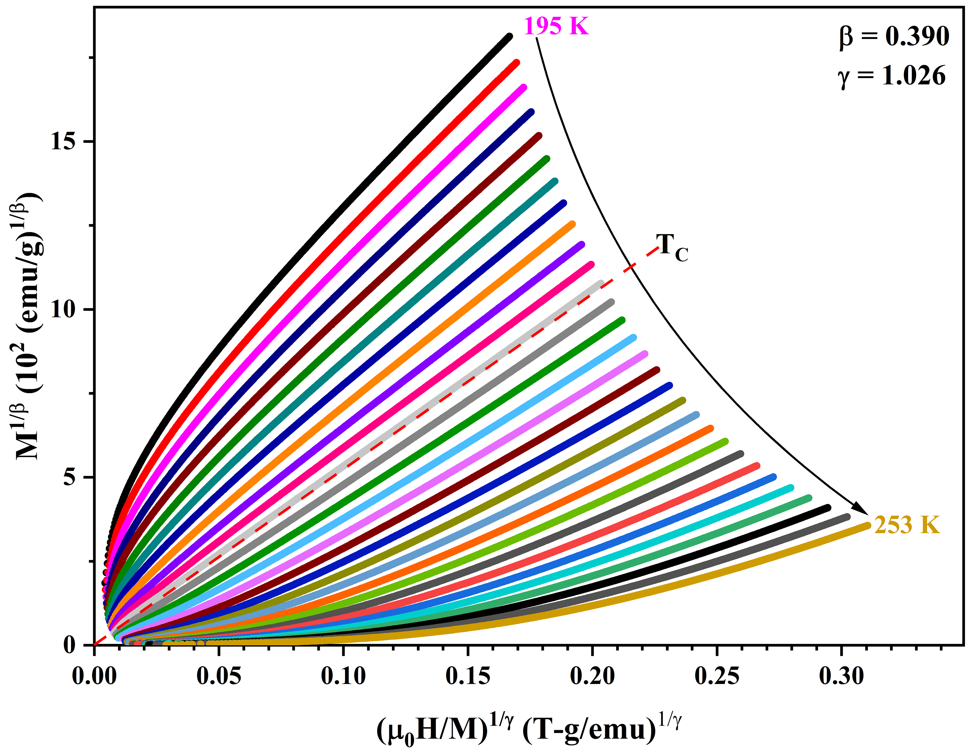
Figure S1: Modified Arrott Plot $\left(M^{1/β} vs. {\left(\frac{μ_{0}H}{M}\right)}^{1/γ}\right)$ for (NiMnFeAlZn)₃O₄ HEO with the reliable critical exponents. The line passing through the origin is marked as T_{C}.

Modified Arrott Plot method:
The isothermal magnetization data collected near the transition temperature were analysed using the Modified Arrott Plot (MAP) method to extract the critical exponents. This approach employs the following relation
$${\left(\frac{μ_{0}H}{M}\right)}^{\frac{1}{γ}}=aη+bM^{\frac{1}{β}} ;η=\left|\frac{T-T_{C}}{T_{C}}\right|$$ | (1)
where a and b are constants, $η$ is the reduced temperature, and β and γ are critical exponents. To determine reliable values of the critical exponents for the investigated samples, β and γ values were systematically tuned such that the plot of $M^{\frac{1}{β}}$ vs. ${\left(\frac{μ_{0}H}{M}\right)}^{\frac{1}{γ}}$ exhibit linear behavior in the high field region. Additionally, the isotherm corresponding to $T=T_{C}$ was constrained to pass through the origin, ensuring consistency with the scaling hypothesis. This criterion was satisfied when the critical exponent values were set to β = 0.39 and γ = 1.026.

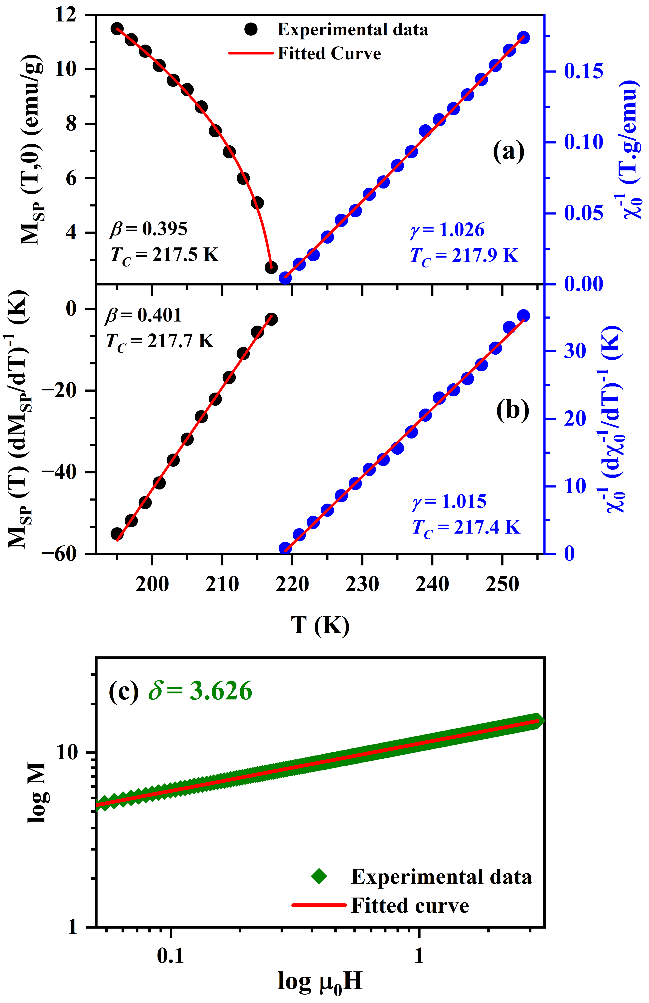
Figure S2: (a) $M_{SP}(T)$ and $χ_{0}^{-1}(T)$ curves versus temperature for (NiMnFeAlZn)₃O₄ HEO. The solid lines are the best fits according to eqns.(2) and (3). (b) The Kouvel-Fisher plot for $M_{SP}(T)$ and $χ_{0}^{-1}(T)$. The solid lines are the best fits according to eqn.(5) and (6). (c) Log-Log scale isothermal M(μ₀H) plot. The solid line is the best fit to eqn.(4).

To clarify the nature of the ferrimagnetic to paramagnetic phase transition in the (NiMnFeAlZn)₃O₄ HEO, a detailed study of the critical exponents (β,γ,δ) around the transition temperature is conducted using the power law [1] as described in eqns.(2) to (4)
$$M_{SP}\left(T\right)=M_{0}{\left(-η\right)}^{β} ; η=\frac{T-T_{C}}{T_{C}}<0$$ | (2)
$$χ_{0}^{-1}\left(T\right)=χ_{0}{\left(η\right)}^{γ} ; η=\frac{T-T_{C}}{T_{C}}>0$$ | (3)
$$M=M_{0}{\left(μ_{0}H\right)}^{1/δ} ;η=0; T=T_{C}$$ | (4)
and Kouvel-Fisher method [1] defined in the eqns.(5) to (6).
$$M_{SP}\left(T\right){\left[\frac{dM_{SP}\left(T\right)}{dT}\right]}^{-1}=\frac{T-T_{C}}{β}$$ | (5)
$$χ_{0}^{-1}\left(T\right){\left[\frac{dχ_{0}^{-1}\left(T\right)}{dT}\right]}^{-1}=\frac{T-T_{C}}{γ}$$ | (6)
While the obtained critical exponent γ is close to the mean-field model [1], the other two critical exponents β and δ do not match with any conventional model, but exhibit close agreement with Widom’s scaling relation [2] given by
$$δ=1+\frac{γ}{β}=3.597$$ | (7)
The obtained critical exponents, along with those for the standard models and other similar spinel oxide materials, are presented in Table S2 for comparison.

Table S2: Comparison of the critical exponent values of (NiMnFeAlZn)₃O₄ HEO with those of the standard models and with some other spinel materials.

Material | Technique | T_{C} (K) | γ | β | δ | Reference
Mean-field model |  |  | 1.0 | 0.5 | 3.0 | [1]
3D-Heisenberg model |  |  | 1.336 | 0.365 | 4.80 | [1]
3D-Ising model |  |  | 1.24 | 0.325 | 4.82 | [1]
Tricritical mean-field model |  |  | 1.0 | 0.25 | 5.0 | [3]
(NiMnFeAlZn)₃O₄ | MAP | 217.5 |  | 0.395 |  | Present work
 |  | 217.9 | 1.026 |  |  | Present work
 | KF | 217.7 |  | 0.401 |  | Present work
 |  | 217.4 | 1.015 |  |  | Present work
 | LL |  |  |  | 3.626 | Present work
 | WSR |  |  |  | 3.597 | Present work
MnCr₂O₄ |  | 42.88 | 1.0256 | 0.3932 | 3.55 | [4]
Ni_{0.5}Mn_{0.5}Cr₂O₄ |  | 38 | 1.00 | 0.99 | 2.01 | [5]
Ni_{0.5}Fe_{0.5}Cr₂O₄ |  | 90.19 | 0.768 | 0.496 | 2.779 | [6]
La_{0.4}Pr_{0.3}Ba_{0.3}MnO₃ |  | 244 | 1.092 | 0.694 | 2.672 | [7]
MnV₂O₄ |  | 60 | 0.909 | 0.349 | 2.913 | [8]
Cu_{1.5}Mn_{1.5}O₄ |  | 78.65 | 1.21 | 0.313 | 4.54 | [9]
TbCo_{1.9}Fe_{0.1} |  |  |  |  |  | [10]
MAP – Modified Arrott Plot; KF – Kouvel-Fisher method; LL – Log-Log scale plot at critical isotherm; WSR – Widom’s Scaling relations

Table S3: The comparison of material type and transition temperature of the currently investigated (NiMnFeAlZn)₃O₄ HEO with the other similar materials.

Sl. | Material | Type* | Transition Temperature | Ref.
1 | (CoCuMgNiZn)O | AFM | T_{N} = 106 K, 113K, 700 K | [11], [12]
2 | (CoCrFeMnNi)₃O₄ | FiM | 420 K | [13]
3 | (Fe₆Ti_{1·2}Co_{1·2}In_{1.2}Ga_{1.2}Cr_{1.2})O₁₉ | PM | 300 K | [14]
4 | La(CoCrFeMnNi)O₃ | AFM | T_{N} = 185 K | [15]
5 | (CrFeMnCoNi)₃O₄ | AFM | T_{N} = (110-180) K | [15], [16]
5 | (CrFeMnZnNi)₃O₄ | AFM | T_{N} = (110-180) K | [15], [16]
5 | (CrFeMnCoZn)₃O₄ | AFM | T_{N} = (110-180) K | [15], [16]
5 | A(CrFeMnCoNi)₃O₄  (A=Y, Gd, A, Sm, Nd, La) | AFM | T_{N} = (110-180) K | [15], [16]
6 | (AlCoCrFeMnNi)₃O₄ | FM | T_{C} = 248 K | [17]
7 | (NiMnFeAlZn)₃O₄ | FiM | T_{C} = 217.5 K | Present work
*AFM - Antiferromagnet, FiM - Ferrimagnet, FM - Ferromagnet, PM - Paramagnet

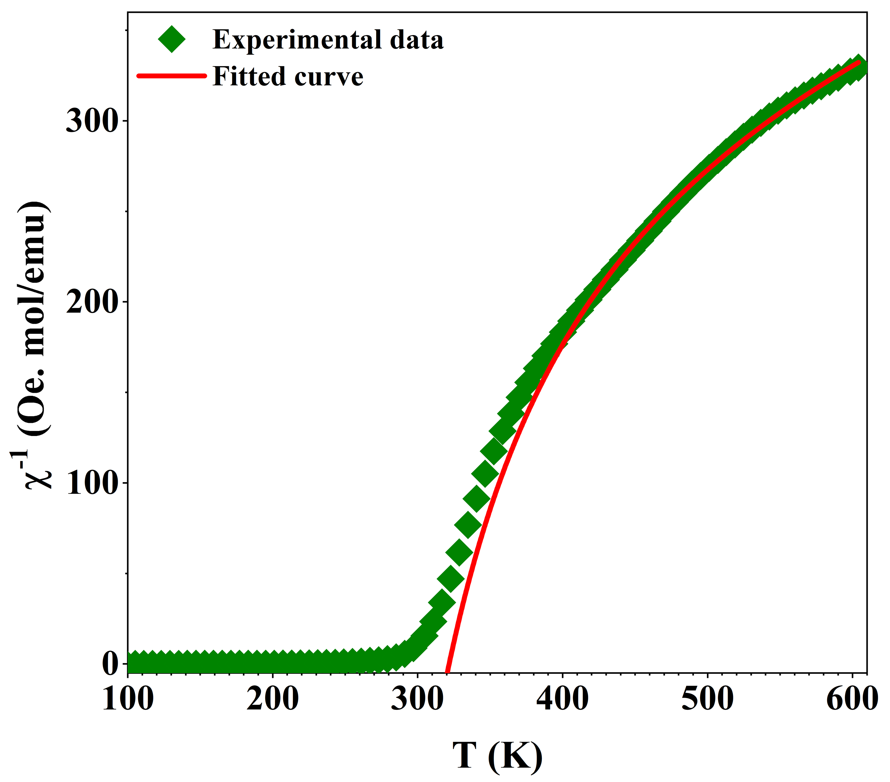
Figure S3: $χ^{-1}(T)$ vs. T for (NiMnFeAlZn)₃O₄ HEO. The solid line is the fit to the eqn. (8).

To gain deeper insight into the ferrimagnetic behavior of the system, the temperature-dependent inverse susceptibility data, $χ^{-1}(T)$ were analyzed using the modified Curie-Weiss law based on Néel’s molecular field theory, as defined in eqn.(8) [6,18].
$$χ^{-1}(T)=\frac{\left(T-θ'\right)}{C}-\frac{ξ}{\left(T-θ"\right)}$$ | (8)
Where, θ′, C, ξ and θs″ are the asymptotic Curie temperature, Curie constant, curvature of inverse susceptibility graph, and characteristic temperature (!217.5 K estimated from modified Arrott plot method). The fitting procedure resulted in the value of the Curie constant, C, as 4.64 emu K mol⁻¹ Oe⁻¹. The experimental effective paramagnetic moment $μ_{eff}^{(exp.)}$ was calculated from the Curie constant, C, using eqn.(9).
$$μ_{eff}^{(exp.)}=\sqrt{\frac{3k_{B}C}{N_{A}}}$$ | (9)
where k_{B} and N_{A} are the Boltzmann constant (=1.38×10⁻¹⁶ ergs.K⁻¹) and Avogadro’s number (=6.023×10²³ per mole), respectively. The resulting value, $μ_{eff}^{(exp.)}$=6.09 μ_{B}/f.u. shows good agreement with the theoretically estimated value $μ_{eff}^{(th.)}$=6.23 μ_{B}/f.u., calculated by considering the high-spin Mn, Ni³⁺, and Fe, along with low-spin Ni²⁺, as expressed in eqn.(10).
$$μ_{eff}^{(Th.)}=\sqrt{{0.36μ}_{{Mn}^{2+}}^{2}+{0.40μ}_{{Ni}^{2+}}^{2}+{0.33μ}_{{Fe}^{2+}}^{2}+{0.24μ}_{{Mn}^{3+}}^{2}+{0.20μ}_{{Ni}^{3+}}^{2}+{0.27μ}_{{Fe}^{3+}}^{2}}$$ | (10)
This close correspondence between experimental and theoretical values confirms that Mn, Ni³⁺, and Fe ions are in the high-spin state, while Ni²⁺ adopts a low-spin configuration.

Table S4: The ratio of valence states of 2⁺ and 3⁺, cation concentration, and the effective magnetic moment ($μ^{eff.}$) of individual elements for (NiMnFeAlZn)₃O₄ HEO.

Cation | Valence states (%) |  | Cation concentration in Spinel* |  | $$μ^{eff.}$$
Cation | 2⁺ | 3⁺ | 2⁺ | 3⁺ | 2⁺ | 3⁺
Mn | 60.46 | 39.54 | 0.36 | 0.24 | 5.92  (HS) | 4.90  (HS)
Ni | 66.57 | 33.43 | 0.40 | 0.20 | 0  (LS) | 3.87  (HS)
Fe | 55.23 | 44.77 | 0.33 | 0.27 | 4.92  (HS) | 5.92  (HS)

HS = High Spin, LS = Low Spin

*Zn²⁺ and Al³⁺ have each a concentration of 0.6 in (NiMnFeAlZn)₃O₄ HEO. However, due to its nonmagnetic nature, it is not included in the table above.

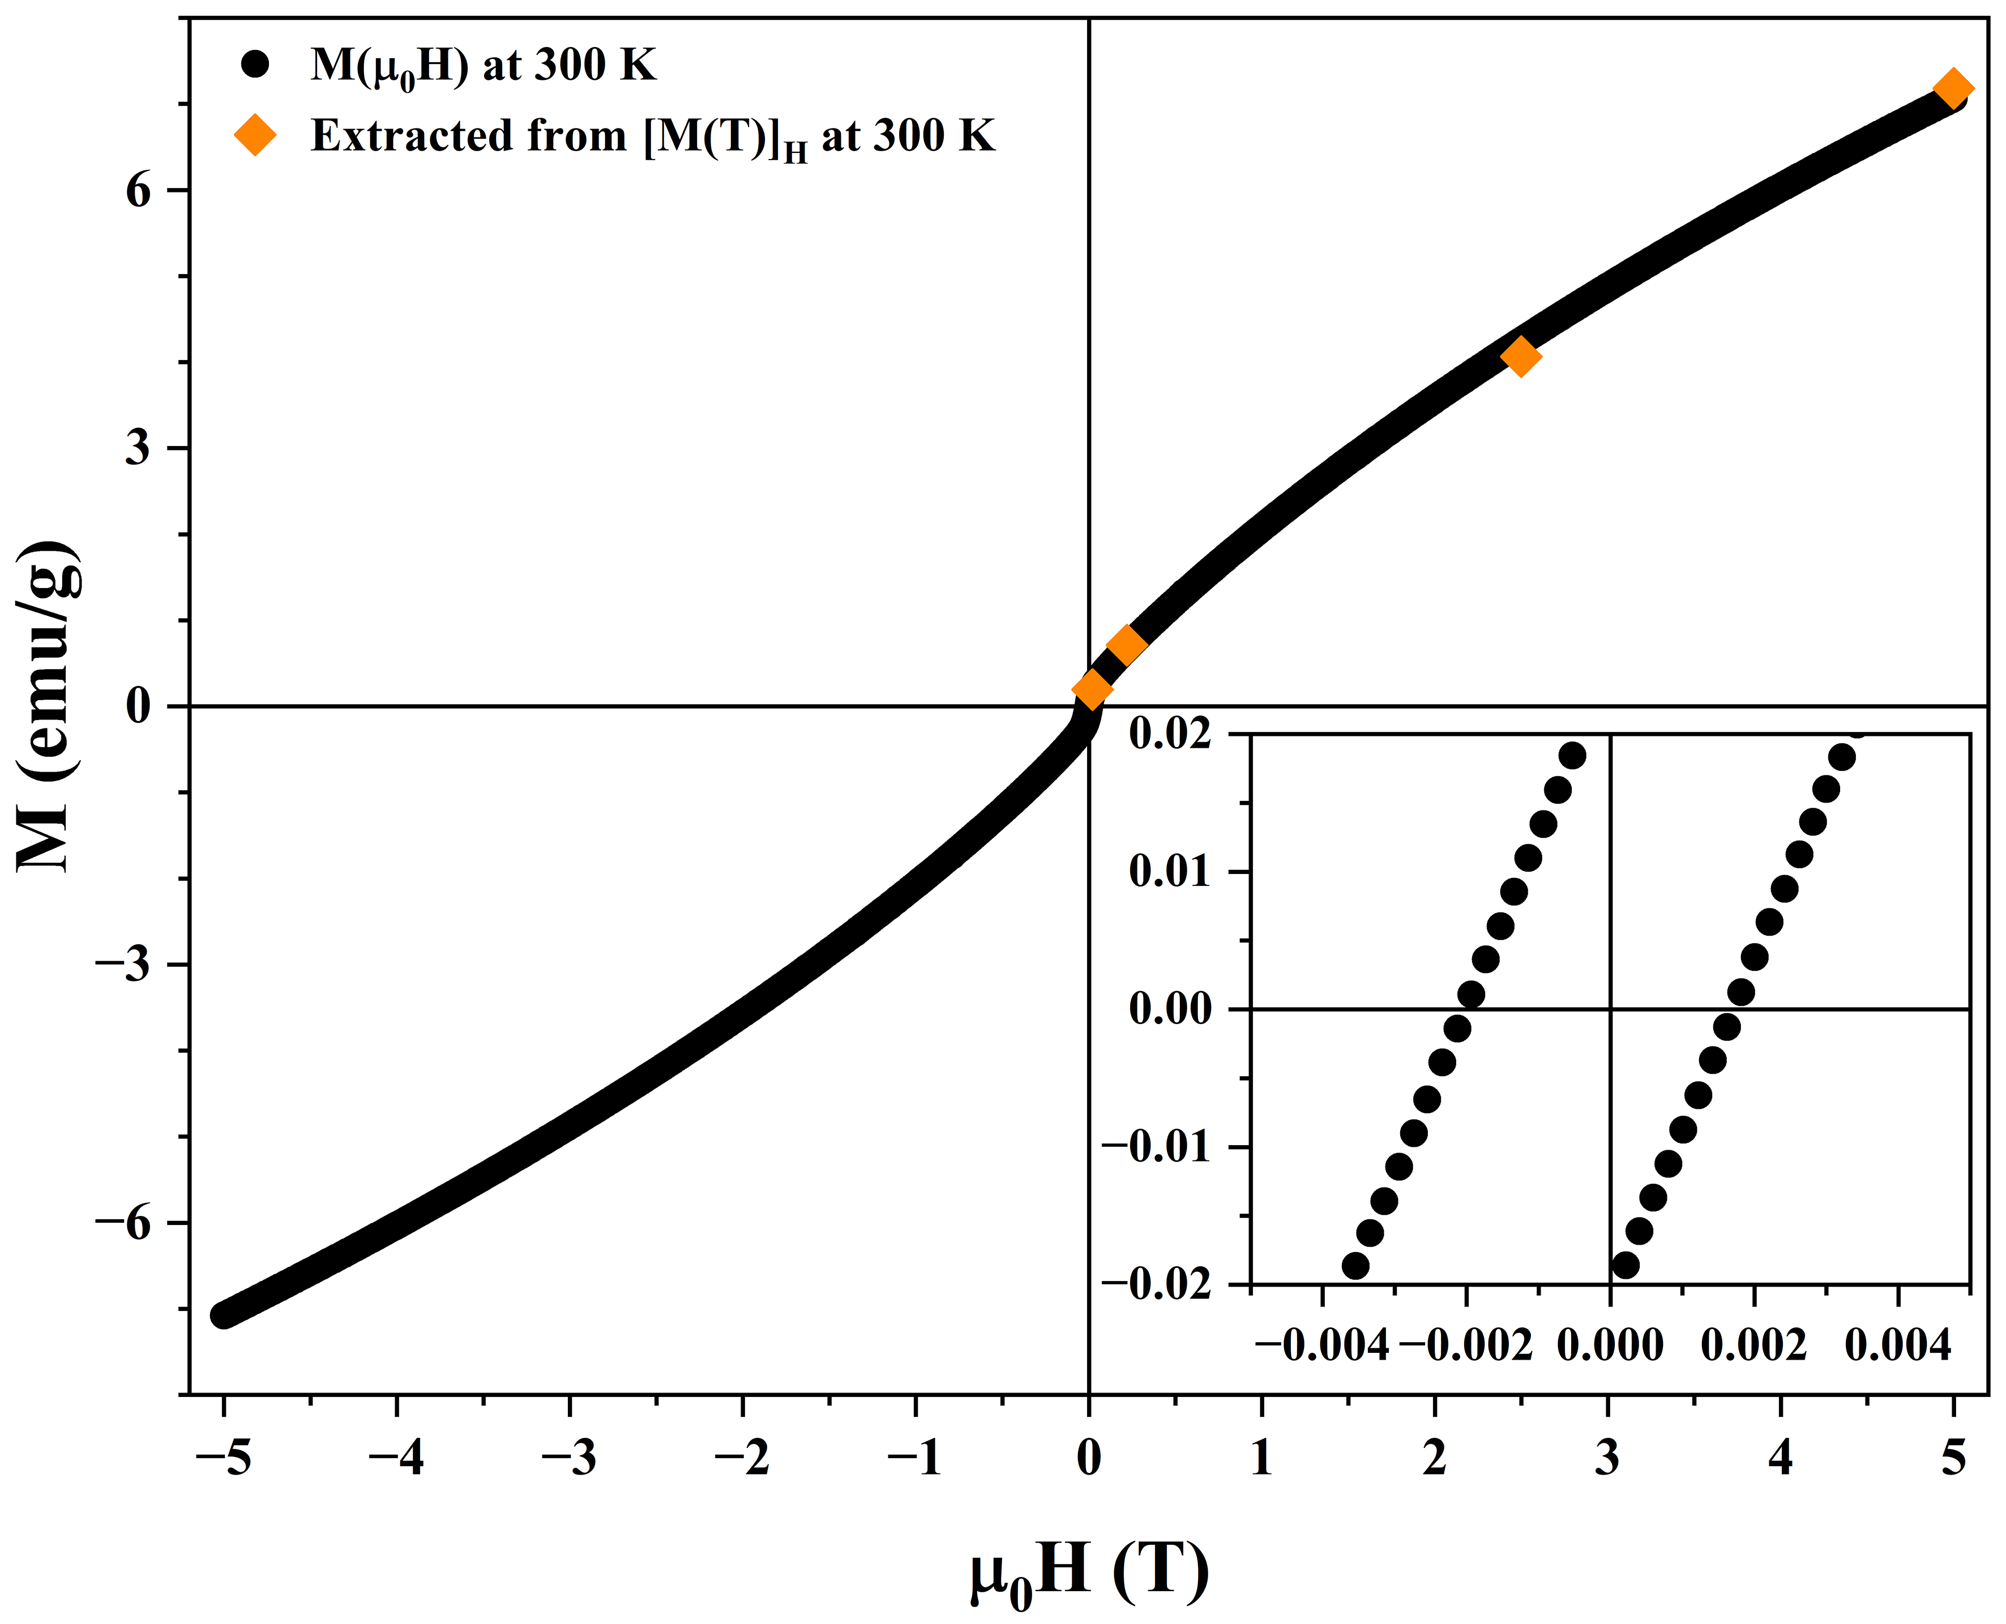
Figure S4: M(H) loop at 300 K for (NiMnFeAlZn)₃O₄ HEO. For comparison, magnetization data extracted from M(T) curves under different applied magnetic fields at 300 K are also shown. The inset provides an expanded view near the origin, highlighting the hysteresis loop.

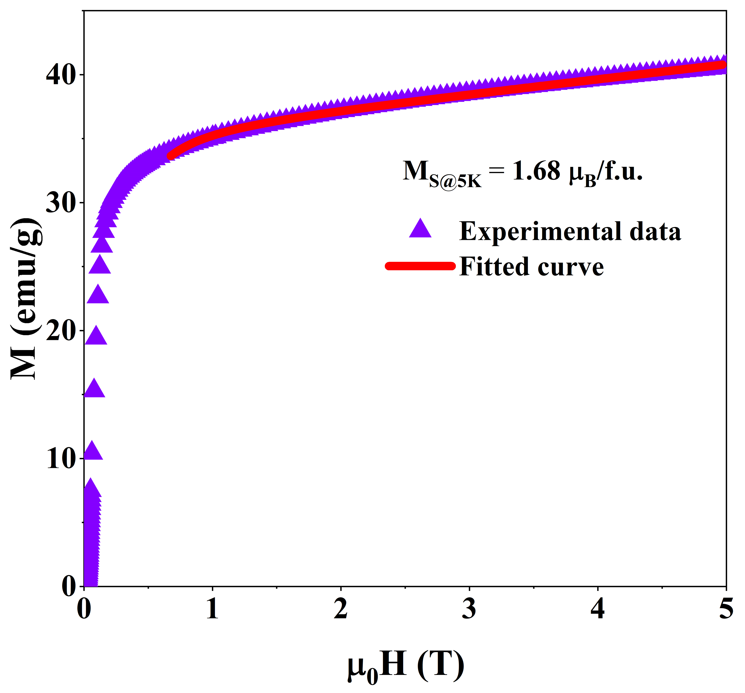
Figure S5: Initial magnetization curve at 5 K fitted to the law of approach to saturation model for (NiMnFeAlZn)₃O₄ HEO.

To extract the saturation magnetization, the initial magnetization curve obtained at 5 K is fitted with the law of approach to saturation model [19], as expressed in eqn.(11).
$$M=M_{S}\left(1-\frac{8k_{eff}^{2}}{105μ_{0}^{2}M_{S}^{2}H^{2}}\right)+χ_{hf}μ_{0}H$$ | (11)
where M_{S} is the saturation magnetization, k_{eff} is the effective magnetic anisotropy, χ_{hf} is the high-field susceptibility.

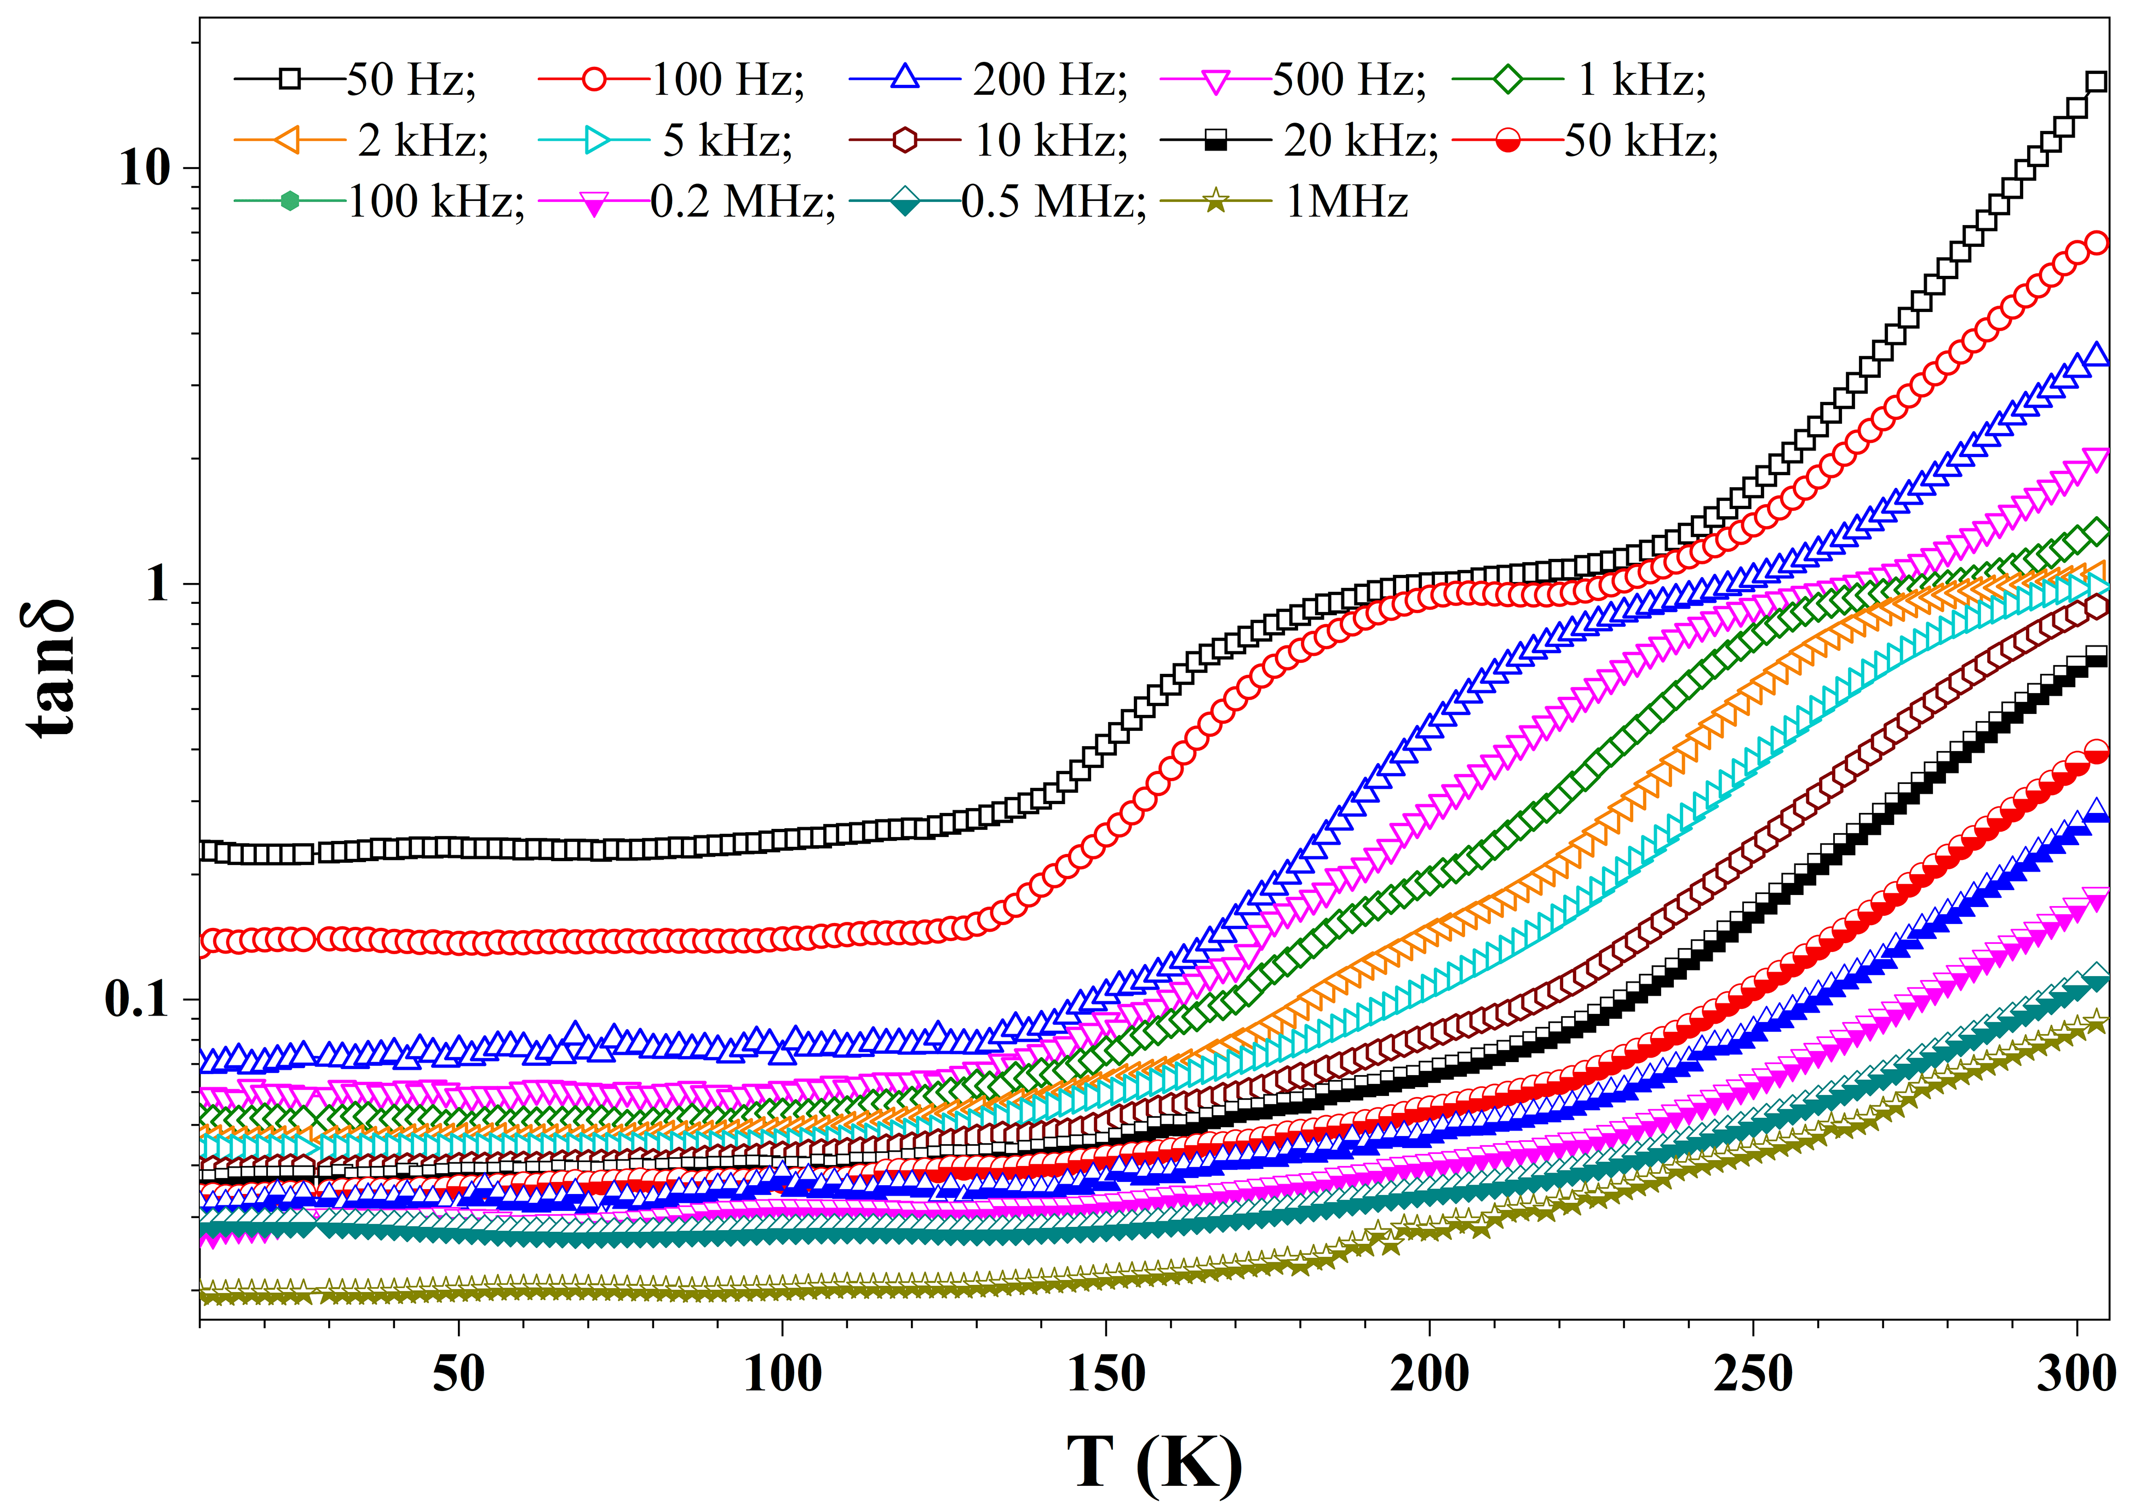
Figure S6: Temperature-dependent tan δ (in log scale) at different frequencies for (NiMnFeAlZn)₃O₄ HEO.

Table S5: The comparison of the material’s magnetodielectric (MD) (%) and magnetoimpedance (MZ) (%) of the currently investigated (NiMnFeAlZn)₃O₄ HEO with the other similar materials.

Sl. | Material | MD (%) | MZ (%) | Ref.
1 | La_{0.4}Dy_{0.1}Ca_{0.5}MnO₃ | -27% (0.6 T, all f, RT);  -40% (1.2 T, all f, RT) | -8% (0.6 T, all f, RT)  -10% (1.2 T, low f, RT)  -12% (1.2 T, high f, RT) | [20]
2 | Y_{2.7}La_{0.3}Fe₅O₁₂ | -5% (0.9 T, 10⁶ Hz, RT) | ---- | [21]
3 | BaCo₂Si₂O₇ | 0.2% (8 T, 100 KHz, 5.5K) | ---- | [22]
4 | Bi_{0.85}La_{0.15}Fe_{0.9}Co_{0.1}O₃ | 1.8% (0.8 T, 10 kHz, RT) | ---- | [23]
5 | Bi_{4.25}La_{0.75}Fe_{0.5}Co_{0.5}Ti₃O₁₅ | 8.1% (1 T, 1 kHz, RT) | ---- | [24]
6 | La_{1.2}Bi_{0.8}Mn_{1.2}Co_{0.8}O_{6.02} | 0.25% (5 T, 500 kHz, 80 K) | ---- | [25]
7 | Bi_{0.88}La_{0.05}Lu_{0.7}FeO₃ | 2.3% (0.8 T, 1 kHz, RT) | ---- | [26]
8 | [Dy(L)₂(C₂H₅OH)Cl₃]·C₂H₅OH | 0.75% (8 T, 10 kHz, 2 K) | ---- | [27]
9 | Cu₂O-CuO | -14% (9 T, 20 kHz, 320 K) | ---- | [28]
10 | NdFeO₃ | -19% (2 T, 1 kHz, RT) | ---- | [29]
11 | (NiMnFeZAl)₃O₄ | ~10.3% (2.2 T, 14kHz, RT) | -13% (2.2T, 600Hz, RT) | Present work
*f - frequency, RT - Room Temperature.

References
[1]. S.N. Kaul, “Static critical phenomena in ferromagnets with quenched disorder,” J. Magn. Magn. Mater., 53, 5 (1985). https://doi.org/10.1016/0304-8853(85)90128-3
[2]. B. Widom, “Equation of State in the Neighborhood of the Critical Point,” J. Chem. Phys., 43, 3898 (1965). https://doi.org/10.1063/1.1696618
[3]. H. Huang, Statistical Mechanics, 2nd Edition, Wiley, New York, (1987).
[4]. K. Dey, A. Indra, S. Majumdar, S. Giri, “Critical behavior and reversible magnetocaloric effect in multiferroic MnCr₂O₄,” J. Magn. Magn. Mater., 435, 15 (2017). http://dx.doi.org/10.1016/j.jmmm.2017.03.068
[5]. R. Borah, S. Ravi, “Magnetocaloric effect and critical behavior of Ni_{1−x}Mn_{x}Cr₂O₄ (x = 0, 0.10, and 0.50) compounds,” J Appl. Phys., 128, 233901 (2020). https://doi.org/10.1063/5.0021894
[6]. B. Alzahrani, K. Amira, S. Hcini, M.M. Almoneef, M.H. Dhaou, A. Mallah, M.L. Bouazizi, J. Khelifi, “Synthesis and study of microstructural analysis, magneto-optical properties, magnetocaloric and critical behaviors for the Ni_{0.5}Fe_{0.5}Cr₂O₄ spinel chromite,” J. Mater. Sci.: Mater. Electron., 33, 11365 (2022). https://doi.org/10.1007/s10854-022-08109-9
[7]. D. Mazumdar, K. Das, I. Das, “Study of magnetocaloric effect and critical exponents in polycrystalline La_{0.4}Pr_{0.3}Ba_{0.3}MnO₃ compound,” J Appl. Phys. 127, 093902 (2020). https://doi.org/10.1063/1.5142337
[8]. L. Zhang, H. Han, Z. Qu, J. Fan, L. Ling, C. Zhang, L. Pi, Y. Zhang, “Critical behavior of spinel MnV₂O₄ investigated by dc-magnetization,” J Appl. Phys., 115, 233910 (2014). https://doi.org/10.1063/1.4884339
[9]. A. Hadded, J. Massoudi, S. Gharbia, E. Dhahri, A. Tozrib, M.R. Berber, “Study of physical properties of a ferrimagnetic spinel Cu_{1.5}Mn_{1.5}O₄: spin dynamics, magnetocaloric effect and critical behavior,” RSC Advances 11 25664 (2021). https://doi.org/10.1039/D1RA03732C
[10]. M. Halder, S.M. Yusuf, M. D. Mukadam, K. Shashikala, “Magnetocaloric effect and critical behavior near the paramagnetic to ferrimagnetic phase transition temperature in TbCo_{2−𝑥}Fe_{𝑥},” Phys. Rev. B, 81, 174402 (2010).
https://doi.org/10.1103/PhysRevB.81.174402
[11] A. Mao, F. Quan, H.Z. Xiang, Z.G. Zhang, K. Kuramoto, H. Yu, and S. Ran, “Solution combustion synthesis and magnetic property of rock-salt (Co_{0.2}Cu_{0.2}Mg_{0.2}Ni_{0.2}Zn_{0.2})O high-entropy oxide nanocrystalline powder,” J. Magn. Magn. Mater., 484, 245 (2019). https://doi.org/10.1016/j.jmmm.2019.04.023
[12] N.J. Usharani, A. Bhandarkar, S. Subramanian, and S.S. Bhattacharya, “Antiferro-magnetism in a nanocrystalline high entropy oxide (CoCuMgNiZn)O: Magnetic constituents and surface anisotropy leading to lattice distortion,” Acta Mater., 200, 526 (2020). https://doi.org/10.48550/arXiv.2004.11684
[13]. A. Mao, F. Quan, H.Z. Xiang, Z.G. Zhang, K. Kuramoto, and A.L. Xiaa, “Facile synthesis and ferrimagnetic property of spinel (CoCrFeMnNi)₃O₄ high-entropy oxide nanocrystalline powder,” J. Mol. Struct., 1194, 11 (2019).
https://doi.org/10.1016/j.molstruc.2019.05.073
[14]. D.A. Vinnika, E.A. Trofimova, V.E. Zhivulina, O.V. Zaitsevaa, S.A. Gudkovaa, A.Yu. Starikova, D.A. Zherebtsova, A.A. Kirsanovaa, M. Häßnerd, and R. Niewa, “High-entropy oxide phases with magnetoplumbite structure,” Ceram. Int., 45, 12942 (2019). https://doi.org/10.1016/j.ceramint.2019.03.221
[15]. R. Witte, A. Sarkar, R. Kruk, B. Eggert, R.A. Brand, H. Wende, and H. Hahn, “High-entropy oxides: An emerging prospect for magnetic rare-earth transition metal perovskites,” Phys. Rev. Mater., 3, 1 (2019).
https://doi.org/10.1103/PhysRevMaterials.3.034406
[16]. Y. Sharma, Q. Zheng, A.R. Mazza, E. Skoropata, T. Heitmann, Z. Gai, B. Musico, P.F. Miceli, B.C. Sales, V. Keppens, M. Brahlek, and T.Z. Ward, “Magnetic anisotropy in single-crystal high-entropy perovskite oxide La(Cr_{0.2}Mn_{0.2}Fe_{0.2}Co_{0.2}Ni_{0.2})O₃ films,” Phys. Rev. Mater., 4, 14404 (2020).
https://doi.org/10.1103/PhysRevMaterials.4.014404
[17]. A. Mao, H.X. X. Experiment, H.Z.X. Experiment, Z.G. Zhang, H. Zhang, S. Ran, “A novel six-component spinel-structure high-entropy oxide with ferrimagnetic property,” J. Magn. Magn. Mater., 503, 166594 (2020).
https://doi.org/10.1016/j.jmmm.2020.166594
[18]. K.P. Patra, S. Ravi, “Effect of chromium in magnetic and dielectric properties of inverse spinel FeMn₂O₄,” Appl. Phys. A, 128, 289 (2022).
https://doi.org/10.1007/s00339-022-05401-7
[19]. H. Kronmüller, “General Micromagnetic Theory and Applications. In Materials Science and Technology, eds R.W. Cahn, P. Haasen, E.J. Kramer, (2025). https://doi.org/10.1002/9783527603978.mst0460
[20] A. Krichene, W. Boujelben, K. N. Rathod, K. Gadani, C. Chen, A. Kandasami, N.A. Shah, P.S. Solanki, “Electronic structure and room temperature colossal magnetodielectric effect in La_{0.4}Dy_{0.1}Ca_{0.5}MnO₃ manganite,” J. Alloys Compd., 999, 175022 (2024). https://doi.org/10.1016/j.jallcom.2024.175022
[21] H. Wu, F. Huang, T. Xu, R. Ti, X. Lu, Y. Kan, X. Lv, W. Zhu, J. Zhu, “Magnetic and magnetodielectric properties of Y_{3-x}La_{x}Fe₅O₁₂ ceramics,” J Appl. Phys., 117, 5–10 (2015). https://doi.org/10.1063/1.4917218
[22] M. Akaki, F. Nakamura, D. Akahoshi, H. Kuwahara, “Magnetodielectric effects in low-dimensional cobalt oxides,” Physica B Condens. Matter, 403, 1505-1507 (2008). https://doi.org/10.1016/j.physb.2007.10.178
[23] S. Shankar, M. Kumar, S. Kumar, O. P. Thakur, A. K. Ghosh, “Enhanced multiferroic properties and magneto-dielectric effect analysis of La/Co modified BiFeO₃,” J. Alloys Compd., 694, 715–720 (2017).
https://doi.org/10.1016/j.jallcom.2016.10.035
[24] X. Mao, H. Sun, W. Wang, X. Chen, Y. Lu, “Ferromagnetic, ferroelectric properties, and magneto-dielectric effect of Bi_{4.25}La_{0.75}Fe_{0.5}Co_{0.5}Ti₃O₁₅ ceramics,” Appl. Phys. Lett., 102, 072904 (2013). https://doi.org/10.1063/1.4793305
[25] A. K. Kundu, R. Ranjith, V. Pralong, V. Caignaert, B. Raveau, “Magneto-transport and magneto-dielectric effects in Bi-based perovskite manganites,” J. Mater. Chem., 18, 4280–4285 (2008). https://doi.org/10.1039/b806134c
[26] A. Kumar, K. L. Yadav, “Enhanced magnetodielectric properties of single-phase Bi_{0.95-x}La_{0.05}Lu_{x}FeO₃ multiferroic system,” J. Alloys Compd., 554, 138–141 (2013). https://doi.org/10.1016/j.jallcom.2012.11.189
[27] Y. X. Wang, Y. Ma, Y. Chai, W. Shi, Y. Sun, P. Cheng, “Observation of Magnetodielectric Effect in a Dysprosium-Based Single-Molecule Magnet,” J. Am. Chem. Soc., 140, 7795–7798 (2018).
https://doi.org/10.1021/jacs.8b04818
[28] N.S. Mukherjee, S. Kashyap, P. Deshmukh, R. Roy, S. Chatterjee, S. Mukherjee, “Negative capacitance and magnetodielectric effect in Cu₂O-CuO ceramics,” Ceram. Int., 51, 30716–30722 (2025). https://doi.org/10.1016/j.ceramint.2025.04.264
[29] P. Yadav, A. Pandey, B. Khan, R. Biswal, A. Fahad, P. Kumar, M.K. Singh, “Detailed investigation on structural, optical, dielectric and magneto-dielectric properties with enhanced magneto-impedance characteristic of NdFeO₃ nanoparticles,” Mater. Chem. and Phys., 309, 128424 (2023). https://doi.org/10.1016/j.matchemphys.2023.128424

