Hypotaxy of Wafer-scale Single Crystal Transition Metal Dichalcogenides

Donghoon Moon¹, Wonsik Lee¹, Chaesung Lim¹, Jinwoo Kim¹, Jiwoo Kim¹, Yeonjoon Jung¹, Hyun-Young Choi¹, Won Seok Choi¹, Hangyel Kim^{1,2}, Ji-Hwan Baek^{1,2}, Changheon Kim^{1,5}, Jaewoong Joo¹, Hyun-Geun Oh¹, Hajung Jang⁹, Kenji Watanabe³, Takashi Taniguchi⁴, Sukang Bae^{5,6}, Jangyup Son^{5,6,7}, Huije Ryu⁸, Junyoung Kwon⁸, Hyeonsik Cheong⁹, Jeong Woo Han^{1,2}, Hyejin Jang^{1,2}, and Gwan-Hyoung Lee^{1,2}

¹Department of Materials Science and Engineering, Seoul National University, Seoul 08826, Republic of Korea
²Research Institute for Advanced Materials (RIAM), Seoul National University, Seoul 08826, South Korea
³Research Center for Electronic and Optical Materials, National Institute for Materials Science, Tsukuba 305-0044, Japan
⁴International Center for Materials Nanoarchitectonics, National Institute for Materials Science, 1-1 Namiki, Tsukuba 305-0044, Japan
⁵Functional Composite Materials Research Center, Korea Institute of Science and Technology, Jeonbuk 55324, Republic of Korea
⁶Department of JBNU-KIST Industry-Academia Convergence Research, Jeonbuk National University, Jeonbuk 54896, Republic of Korea
⁷Division of Nano and Information Technology, KIST School University of Science and Technology (UST), Jeonbuk 55324, Republic of Korea
⁸​Samsung Advanced Institute of Technology (SAIT), Samsung Electronics Co. Ltd., Suwon 16678, Republic of Korea
⁹Department of Physics, Sogang University, Seoul 04107, Republic of Korea

*Corresponding author. E-mail: gwanlee@snu.ac.kr

Abstract
Two-dimensional (2D) semiconductors, particularly transition metal dichalcogenides (TMDs), are promising for advanced electronics beyond silicon. Traditionally, TMDs are epitaxially grown on crystalline substrates via chemical vapor deposition (CVD), but this requires post-growth transfer to target substrates, challenging thickness and scalability control. Here, we introduce "hypotaxy" (from "hypo," meaning downward, and "taxy," meaning arrangement), a method enabling wafer-scale single-crystal TMD growth directly on various substrates, including amorphous and lattice-mismatched ones, while preserving crystalline alignment with an overlying 2D template. By sulfurizing or selenizing a pre-deposited metal film under graphene, aligned TMD nuclei form, coalescing into a single-crystal film as graphene is removed. This method achieves precise MoS₂ thickness control from monolayer to hundreds of layers on diverse substrates, producing 4-inch single-crystal MoS₂ with high thermal conductivity (~120 Wm⁻¹K⁻¹) and mobility (~87 cm²V⁻¹s⁻¹). Additionally, nanopores created in graphene via oxygen plasma treatment allow MoS₂ growth at a lower temperature of 400°C, compatible with back-end-of-line (BEOL) processes. This hypotaxy approach also extends to other TMDs, such as MoSe₂, WS₂, and WSe₂, offering a novel solution to substrate limitations in conventional epitaxy and enabling wafer-scale TMDs for monolithic 3D integration.

With the advancement and increasing complexity of semiconductor fabrication technology, there is a compelling need for high quality semiconductor materials with superior electrical, thermal, and mechanical properties¹⁻³. 2D semiconductors, such as TMDs, renowned for maintaining crystallinity at the nanoscale, satisfy the rigorous requirements of contemporary semiconductor industry⁴⁻⁶. Considerable efforts have been invested in synthesizing TMDs to overcome the scalability issues associated with the exfoliation method, moving from lab-scale studies to industrial applications⁷⁻¹². The CVD is one of the most promising methods to produce 2D materials, such as graphene and TMDs. There has been a concerted effort to improve the quality of CVD-grown TMDs, focusing on thickness control, grain size enhancement, and the reduction of defects, such as grain boundaries and vacancies¹³⁻¹⁷. In this regard, epitaxy of TMDs, which is the oriented growth of TMDs on a highly crystalline substrate such as sapphire substrate^{9,18-23}, has attracted considerable attention (Fig. 1a). The TMD grains grow on a single crystal substrate, preserving crystalline alignment with the underlying material, leading to uni-directional growth of TMD grains^{9,19-24}. However, the limited choice of substrates and the consequent necessity for transfer process remain significant challenges. Furthermore, technological progress towards monolithic 3D integration based on high-quality TMD growth is a critical frontier in semiconductor development^{10,12}, highlighting the need for innovative synthesis methods.
Here, we report the growth of wafer-scale single crystal TMDs using an overlying 2D template through chalcogenization of metal films, a process we refer to as hypotaxy, which denotes the downward alignment growth of these structures (Fig. 1b). First, transition metals, such as Mo and W, are deposited on a non-crystalline substrate, such as SiO₂ and HfO₂, followed by transfer of monolayer graphene onto the metal films. (See Methods for sample preparation process). The prepared samples are chalcogenized by reactive gas (H₂S) or vaporized chalcogen (Se) at 1000℃ for 2 h. For wafer-scale growth, we used a home-built vertical CVD system, ensuring a consistent and uniform supply of chalcogen atoms (Fig. S1a and b). In the beginning of the process, the polymer residue, which originated from the graphene transfer, begins to be eliminated. Simultaneously, nanopores are generated in the graphene, which serve as supply paths for chalcogen atoms into the metal film, leading to formation of TMD nuclei aligned with the top graphene. As the nanopores of graphene expand, the aligned TMD nuclei grow and coalesce into bigger grains without formation of grain boundaries. Subsequently, the TMD layers grow downward and the graphene is completely removed, remaining the single crystal TMD film even on non-crystalline substrate. It is worth noting that the hypotaxially grown TMD layers preserve lattice-matched structure with the top graphene with decoupling to the inherent crystal structures of bottom substrates.
To confirm the effect of graphene template for hypotaxy, we sulfurized the Mo film, which is partially covered by exfoliated monolayer graphene (Extended Data Fig. 1a). The hypotaxially grown MoS₂ shows layered structure with higher crystallinity (sharper Raman peaks of A_{1g} and E¹_{2g} in Extended Data Fig. 1b and c) and smoothness (Fig. S2), compared to randomly oriented MoS₂ film grown without graphene. Absence of graphene signals in Raman and electron-loss spectroscopy (EELS) spectra indicates its complete removal during the sulfurization process (Extended Data Fig. 1c and Fig. S3). In addition, the hypotaxially grown 1L-MoS₂ exhibits much larger photoluminescence (PL) by 17 times than an exfoliated 1L-MoS₂ on the same SiO₂/Si substrate with high uniformity (Fig. S4 and 5). The Raman peak shifts in Fig. S6 show that hypotaxially grown MoS₂ is less doped compared to the exfoliated MoS₂, which corresponds to the low defect density (~ 7×10¹²) in the hypotaxially grown MoS₂ (Fig. S7).
To verify formation of nanopores in the graphene, we annealed an exfoliated monolayer graphene in a flow of H₂S at 1000ºC for different times. The Raman spectra of annealed monolayer graphene show that the D peak emerges and the G and 2D peaks decrease with increasing annealing time, resulting in complete removal of graphene after 2h (Fig. S8). Transmission electron microscopy (TEM) images of monolayer graphene annealed in H₂S reveal the formation of nanopores smaller than 5 nm within 30 min, which expand into larger holes as the annealing proceeds (Fig. S9). In contrast, when exfoliated or stacked bilayer graphene is used as a 2D template for hypotaxy, there is no formation of MoS₂ in the bilayer graphene regions due to the less damage of bilayer graphene (Fig. S10 and 11).
Figure 2 shows the step-by-step schematic of the hypotaxial growth of MoS₂ through CVD-grown single crystal monolayer graphene and corresponding TEM images, selected area electron diffraction (SAED) patterns, and cross-section TEM images. The single crystal graphene was grown on a single crystal copper foil (See the Methods and Fig. S12-15 for details). The CVD-grown graphene was transferred onto the deposited Mo film on a SiO₂ substrate using the polymethyl methacrylate (PMMA) transfer process. The sulfurization process was carried out at 1000℃ for complete removal of graphene during growth of MoS₂. The effect of temperature on the hypotaxial growth will be discussed later. After sulfurization of 30 min, there is no noticeable change in the graphene and Mo film as shown in TEM and SAED images (Fig. 2a-d). However, the emergence of D peak in Raman spectrum (Fig. S16) and TEM images (Fig. S9) indicate that the graphene is slightly damaged. After 60 min, we can observe nanoscale MoS₂ nuclei of a few nanometers (indicated by red areas) through the graphene nanopores (Fig. 2e-h). Interestingly, all MoS₂ nuclei are crystallographically aligned with the graphene as shown in the SAED pattern of Fig. 2g. The cross-section TEM image of Fig. 2h exhibits that the MoS₂ layers are grown beneath the graphene, remaining the Mo film below MoS₂, which indicate the downward sulfurization process. After 90 min, concurrent with the enlargement of nanopores in the graphene, the aligned MoS₂ nuclei coalesce into larger grains without formation of grain boundaries (Fig. 2i-j). Additional layers of MoS₂ formed downwards, maintaining crystalline alignment with the graphene (Fig. 2k-l). Finally, the Mo film was completely converted into single crystal MoS₂ layers and the graphene was eliminated after 120 min (Fig. 2m-p), which agrees with the Raman spectra of the sulfurized samples (Fig. S16). Note that the surface of hypotaxially grown MoS₂ is ultraclean compared to that of transferred TMDs, which typically contain polymer residue resulting from the transfer process (Fig. S17). It is noted that longer hypotaxy process induces no significant change in the grown MoS₂, as confirmed by the cross-section TEM and Raman spectra of Fig. S18. With the same procedure, we successfully synthesized other TMDs, such as MoSe₂, WS₂, and WSe₂ (Extended Data Fig. 2 and Fig. S19, See the Method for experimental details). Moreover, we confirmed that monolayer hexagonal boron nitride (1L-hBN) is also effective as a 2D template for hypotaxy (Fig. S20).
To elucidate the impact of a graphene nanopore on the alignment of MoS₂ nuclei, we used density functional theory (DFT) calculations (Extended Data Fig. 3). We modeled a hexagonal MoS₂ monolayer under a graphene nanopore, rotating the MoS₂ around the center of the model. The calculated total energies of the MoS₂ nucleus with varying twist angles show a significant angle-dependency. The most energetically favorable configuration with minimum energy was found at zero-degree twist angle. This optimal alignment is primarily due to the strong C-S interaction at the edge of the graphene nanopore, which results in the most uniform bond lengths at zero twist angle, as evidenced by the lowest standard deviation. These findings suggest that the graphene nanopore plays a crucial role in aligning MoS₂ nuclei into a specific orientation.
The number of MoS₂ layers can be precisely controlled by the thickness of the deposited Mo film in a linear manner (Fig. 3a). Note that the Mo thickness used in our work is a target value, not actual, as the deposited Mo films with such small thicknesses are island-like and non-uniform. Despite the uneven and non-continuous morphology of the Mo film, uniform and continuous monolayer MoS₂ can be synthesized (Fig. S21) because the deposited Mo film acts as a metal source to form the MoS₂ in the graphene micro-chamber (Fig. S22). To confirm precise thickness controllability, we incrementally varied the target Mo thickness by 0.1nm for the hypotaxy process. In the cases of 0.1-0.2 nm Mo deposition (deficient Mo atoms), MoS₂ was not observed at all, while in the case of 0.3-0.4, 0.5-0.7 nm, and 0.8 nm (excess Mo atoms as calculated in Fig. S23), fully covered 1L, 2L, and 3L MoS₂ films were observed with no multilayer patches, respectively (Fig. S24), which is also confirmed by Raman spectroscopy (Fig. S25). The inset of Fig. 3a shows that the number of layers increase with step-like relation with Mo thickness, indicating that the number of MoS₂ layers can be precisely controlled due to a broad range of Mo thicknesses that determine the number of layers. This precise thickness control can be attributed to a self-limiting process, as depicted in Figs. S26 and S27. However, further research is required to fully understand this mechanism. The Raman peak separations between ${\text{E}}_{\text{2g}}^{\text{1}}$ and A_{1g} for hypotaxially grown MoS₂ of 1-4L are consistent with previously reported values for exfoliated MoS₂ of the same number of layers²⁵ (Fig. 3b). The cross-section TEM and STEM images clearly show the highly crystalline and layered structures of the hypotaxially grown MoS₂ samples with different thicknesses from 1L to 99L (Fig. 3c and d). Note that there is no discontinuity or multilayer patches, which have been frequently observed in the TMDs grown by CVD and metal-sulfurization processes^{13,14}(See Fig. S28-30 for details). In addition, the surface uniformity and cleanness of the hypotaxially grown MoS₂ are also confirmed by optical microscopy, cross-section TEM and atomic force microscopy (AFM) for more samples (Fig. S31-33).
To investigate the effect of graphene microstructure on the hypotaxy of the MoS₂, two types of CVD-grown graphene samples, polycrystalline graphene (poly-Gr) and single crystal graphene (single-Gr), were used as 2D templates (Fig. 4a-h, See Methods for fabrication of graphene samples). In case of the poly-Gr, polycrystalline MoS₂ (poly-MoS₂) was fabricated in 4-inch wafer scale (Fig. 4a and S34), which is confirmed by EBSD (Fig. S35). To clarify crystalline relation between graphene and MoS₂ grains, we observed poly-Gr/poly-MoS₂ region, which contains remaining graphene, by the bright-field (BF) TEM (Fig. 4b). The SAED pattern in the inset indicates that the individual grains of graphene (G1 and G2) and MoS₂ (M1 and M2) are aligned to each other. The dark-field (DF) TEM images of poly-Gr and poly-MoS₂, highlighted from their diffraction spots, confirm that the MoS₂ grains mirror the microstructure of graphene (Fig. 4c and d). Similar to poly-Gr with tilted grain boundaries, the hypotaxially grown poly-MoS₂ through poly-Gr shows well-stitched grain boundaries with the identical tilt angle (Fig. S36). In contrast, when utilizing CVD-grown single crystal graphene, single crystal MoS₂ (single-MoS₂) is grown (Fig. 4e). The BF-TEM image and SAED pattern shows that the suspended MoS₂ film over a 1 μm-wide hole is a single crystal (Fig. 4f), which is also confirmed by the DF-images corresponding to the diffraction spots 1 and 2 (Fig. 4g and h). In addition, the larger areas at nine positions show the same SAED patterns, indicating that large single-MoS₂ can be fabricated through single-Gr (Fig. S37). To verify the scalability of hypotaxial growth method, we fabricated 4-inch single crystal 6L-MoS₂ using single-Gr (Fig. 4i). The Raman maps of positions (ω), intensities (I), and full-width-at-half-maximums (FWHMs) obtained at 64 positions show high uniformity and crystallinity across whole MoS₂ film (Fig. 4j-l and S38). In addition, the EBSD maps of Fig. 4m clearly show unidirectionally aligned orientation of single-MoS₂ in a large area spanning hundreds of micrometers along all directions.
As a result of identifying the tendency of nanopores to form in graphene depending on the sulfurization process temperature, it was confirmed that nanopores can be formed starting at 700℃ (Fig. S39). Consequently, the growth of MoS₂ was viable from 700℃ onwards, notwithstanding the incomplete removal of graphene. However, the formation of nanopores in the graphene did not occur at 600℃, thereby impeding the growth of MoS₂ (Extended Data Fig. 4). To enable hypotaxial growth at lower temperature, we first introduced nanopores smaller than 5 nm into the graphene using oxygen plasma treatment (Extended Data Fig. 5a, see the Method for details) ^{26,27}. This step is essential because pristine graphene does not readily form nanopores at low temperature by H₂S annealing. By using the graphene with pre-formed nanopores, we can hypotaxially grow MoS₂ at low temperature of 400℃ (Extended Data Fig. 5b-c). When the nanopores generated by oxygen plasma are too large, multiple misoriented MoS₂ nuclei of a few nanometers form within a nanopore (Fig. S40). These findings indicate that the precise control of the nanopore size is critical in the hypotaxy of TMDs, which is also in agreement with our previous DFT calculations. The unique characteristics of hypotaxial growth enable to fabricate MoS₂ layers even on various substrates, such as graphite, HfO₂, and Au film at 400ºC, which is essential for CMOS-compatible process (Extended Data Fig. 6).
To confirm that hypotaxially grown MoS₂ is a single crystal without inversion domains or twin boundaries, we conducted a series of additional measurements. Absence of twin boundary in hypotaxially grown MoS₂ was verified using DF-TEM¹⁵ (Fig. S41), diffraction intensity profiles¹⁵ (Extended Data Fig. 7), HR-TEM (Extended Data Fig. 8), second-harmonic generation (SHG) mapping^{28, 29} (Fig. S42), PL imaging³⁰ (Fig. S43). Additionally, no grain boundaries were observed after water vapor treatment at 150°C for 30 min^{31, 32} (Fig. S44). Furthermore, mild etching through vacuum annealing clarifies that hypotaxially grown MoS₂ is unidirectionally oriented³³⁻³⁶ (Extended Data Fig. 9). To elucidate how hypotaxially grown MoS₂ becomes a single crystal, we investigated evolution of the atomic structure in the synthesized MoS₂ at different temperatures (Extended Data Fig. 4, 7-9 and Fig. S39, S45-46). We found that MoS₂ nuclei with two orientations of 0º and 60º initially form twin boundaries, which then coalescence into a single crystal as these twin boundaries migrate when the growth temperature is higher than 700ºC. Our DFT calculations demonstrated that the energy required for twin boundary migration can be significantly reduced as the size of the twin boundary (or grains) decreases or when sulfur vacancies are incorporated (Fig. S47-49). Because of nanoscale size of MoS₂ nuclei separated by tens of nanometers and presence of sulfur vacancies, the hypotaxial growth facilitates grain boundary migration and coalescence into a single crystal.
To validate the quality of the hypotaxially grown MoS₂, we measured thermal and electrical properties (Fig. 5). To investigate the anisotropic thermal conductivity of the MoS₂, we used an ultrafast optical pump-probe technique, time-domain thermoreflectance (TDTR) ³⁷ (see Methods). In order to measure the temperature change using TDTR, we used an Al as a transducer on the MoS₂ film located on the SiO₂/Si substrate (see Supplementary Note for the sample geometry). The through-plane thermal conductivity of a 212-nm-thick-MoS₂ film is measured via co-aligned TDTR, where the pump and probe beams are spatially overlapped. The TDTR measurements yield the thermoreflectance changes that are in-phase (V_{in}) and out-of-phase (V_{out}) over varying time delays (Fig. S50). In the co-aligned TDTR, the ratio of these two signals (-V_{in}/V_{out}) is utilized, which obviates the necessity for analyzing the absolute value of temperature change. The plots of the ratio data (scatters) for the MoS₂ film using the co-aligned TDTR are fitted from the thermal model³⁸ (solid lines) at high (10.9 MHz, blue) and low (1.8 MHz, yellow) modulation frequencies (Fig. 5a). From the fitting at 10.9 MHz, we calculated the through-plane thermal conductivity (${\text{Λ}}_{\text{⊥}\text{, }{\text{MoS}}_{\text{2}}}$) of 1.8 ± 0.2 Wm⁻¹K⁻¹ and interfacial thermal conductance (${\text{G}}_{{\text{Al/MoS}}_{\text{2}}}$) of 30 ± 10 MWm⁻²K⁻¹ between the Al and MoS₂ film. In contrast, the MoS₂/SiO₂ interface showed a lower thermal conductance (${\text{G}}_{{\text{MoS}}_{\text{2}}{\text{/SiO}}_{\text{2}}}$) of 14 ± 5 MWm⁻²K⁻¹, which was measured from the fitting at 1.8 MHz (see Fig. S51a-b and Supplementary Note). These obtained values are consistent with previous studies on exfoliated MoS₂ flakes measured by TDTR³⁸ and Raman thermometry^{39,40}. To obtain a lateral heat spread profile, we used a beam-offset TDTR, which varies the separation between the pump and probe beams⁴¹ (Fig. 5b). The dashed line refers to the V_{in} signal at high modulation frequency (10.9 MHz) and positive time delay (+100 ps), which provides the beam spot size (1/e² radius, w₀) of pump and probe beams. By fitting the V_{out} signal (triangles) at lower modulation frequency (1.8 MHz) and negative time delay (-100 ps), we obtained a lateral heat spread profile (red solid line). Because the thermal model based on the measured parameters predicts the width of the lateral heat spread profile as a function of in-plane thermal conductivity (${\text{Λ}}_{\text{//, }\text{Mo}{\text{S}}_{\text{2}}}$) of MoS₂ film^{41,42}, we deduced the ${\text{Λ}}_{\text{//, }\text{Mo}{\text{S}}_{\text{2}}}$ of 120 ± 30 Wm⁻¹K⁻¹ (see Fig. S51c and Supplementary Note). We plotted the ${\text{Λ}}_{\text{//,} \text{Mo}{\text{S}}_{\text{2}}}$ as a function of 2w₀ in experiments or lateral sample size in calculation (Fig. 5c). It has been known that the polycrystalline structure and smaller sample size can substantially reduce the ${\text{Λ}}_{\text{//, }\text{Mo}{\text{S}}_{\text{2}}}$ due to increased scattering at grain boundaries and surfaces^{43,44}. However, the in-plane thermal conductivity of the MoS₂ measured in this study is comparable to the values of exfoliated single-crystalline MoS₂ flake and theoretical predictions, indicating the high quality and single-crystalline nature of the hypotaxially grown MoS₂⁴⁴⁻⁴⁹. For the electrical characterization of the hypotaxially grown MoS₂, we fabricated a top-gated 1L-MoS₂ field-effect transistor (FET) by integrating graphene and hBN as the electrodes and dielectric, respectively (Fig. S52, See Methods for device fabrication). Transfer curves (I_{ds}-V_{gs}) of the 1L-MoS₂ FET showed a high field-effect mobility (μ_{FE}) of 87 cm²V⁻¹s⁻¹, a substantial on/off current ratio (I_{on}/I_{off}) of ~1.4×10⁹, and a significant on-current (I_{on}) of 2.5×10⁻⁴ Aμm⁻¹ (Fig. 5d). The linear nature of the output curves in the inset indicates ohmic contact-like behaviors by the graphene contacts⁵⁰. The single crystal 1L-MoS₂ devices in this work exhibit enhanced electrical properties compared to the devices fabricated from MoS₂ grown by CVD or MOCVD techniques (Fig. 5e). To access the device performance uniformity, we fabricated an array of back-gated 1L-MoS₂ FETs (77 devices in total) on a SiO₂ (285 nm)/Si substrate, incorporating metal electrodes of Al/Cr/Au (Fig. 5f, see the Methods for device fabrication). These 1L-MoS₂ devices demonstrated similar characteristics to the top-gated devices with graphene contacts of Fig. 5d, with a notable filed-effect mobility of μ_{FE} = 79 cm²V⁻¹s⁻¹ at V_{ds} of 3 V which was applied to overcome the Schottky barrier (Extended Data Fig. 10). Remarkably, all 77 devices in the 1L-MoS₂ array were functional, achieving a 100% yield, which highlights the uniformity of the single crystal 1L-MoS₂ (Fig. S53). The distributions and maps of I_{on} and I_{on}/I_{off} across these 77 devices further confirm the consistency in their device performance (Fig. 5g) with a uniform distribution of field-effect mobilities (Fig. S54). Furthermore, 2L-MoS₂ FETs showed even higher mobility, up to μ_{FE} = 94 cm²V⁻¹s⁻¹, while maintaining a high I_{on}/I_{off} of ~10⁹ (Fig. S55). To demonstrate the BEOL compatibility of hypotaxy, MoS₂ was directly grown on a HfO₂(10 nm)/Si substrate at 400ºC, followed by the deposition of metal electrodes (Al/Cr/Au). The transfer curves (I_{ds}-V_{gs}) of the 1L-MoS₂ FET showed a high μ_{FE} of 42 cm²V⁻¹s⁻¹, I_{on}/I_{off} of ~10⁸, and I_{on} of 1.3×10⁻⁴ A μm⁻¹, demonstrating that MoS₂ synthesized at 400ºC can serve as an effective channel as shown in Fig. S56. Additionally, FETs with channels of hypotaxially grown 1L-WS₂ and 1L-WSe₂ showed their typical n-type and p-type transport characteristics, respectively (Fig. S57).
In conclusion, our study presents a significant advancement in the synthesis of 2D semiconductors, particularly TMDs, through the novel approach of hypotaxy. We successfully demonstrated the wafer-scale growth of single crystal TMD layers, including MoS₂, MoSe₂, WS₂, and WSe₂, using a graphene template, which offers improved crystallinity and uniformity compared to traditional growth methods. The resulting single crystal TMDs exhibit enhanced thermal and electrical properties. Particularly notable is the high-quality MoS₂, which shows superior electrical performance in field-effect transistors, with high mobility and consistent device characteristics across numerous samples. Furthermore, the feasibility of using hypotaxy for monolithic 3D integration and its compatibility with BEOL processes opens new avenues for semiconductor device fabrication. Our work not only provides an innovative synthesis method for high-quality TMD growth, but also marks a significant step forward in the development of next-generation semiconductor technologies.
References
1 Fiori, G. et al. Electronics based on two-dimensional materials. Nat. Nanotechnol. 9, 768-779 (2014).
2 Chhowalla, M., Jena, D. & Zhang, H. Two-dimensional semiconductors for transistors. Nat. Rev. Mater. 1, 16052 (2016).
3 Akinwande, D. et al. Graphene and two-dimensional materials for silicon technology. Nature 573, 507-518 (2019).
4 Kang, K. et al. High-mobility three-atom-thick semiconducting films with wafer-scale homogeneity. Nature 520, 656-660 (2015).
5 Manzeli, S., Ovchinnikov, D., Pasquier, D., Yazyev, O. V. & Kis, A. 2D transition metal dichalcogenides. Nat. Rev. Mater. 2, 17033 (2017).
6 Hoang, A. T. et al. Low-temperature growth of MoS₂ on polymer and thin glass substrates for flexible electronics. Nat. Nanotechnol. 18, 1439-1447 (2023).
7 Bhimanapati, G. R. et al. Recent advances in two-dimensional materials beyond graphene. ACS Nano 9, 11509-11539 (2015).
8 Zhou, J. et al. A library of atomically thin metal chalcogenides. Nature 556, 355-359 (2018).
9 Liu, L. et al. Uniform nucleation and epitaxy of bilayer molybdenum disulfide on sapphire. Nature 605, 69-75 (2022).
10 Kim, K. S. et al. Non-epitaxial single-crystal 2D material growth by geometric confinement. Nature 614, 88-94 (2023).
11 Zhou, Z. et al. Stack growth of wafer-scale van der Waals superconductor heterostructures. Nature 621, 499-505 (2023).
12 Jayachandran, D. et al. Three-dimensional integration of two-dimensional field-effect transistors. Nature 625, 276-281 (2024).
13 Zhan, Y., Liu, Z., Najmaei, S., Ajayan, P. M. & Lou, J. Large-area vapor-phase growth and characterization of MoS₂ atomic layers on a SiO₂ substrate. Small 8, 966-971 (2012).
14 Najmaei, S. et al. Vapour phase growth and grain boundary structure of molybdenum disulphide atomic layers. Nat. Mater. 12, 754-759 (2013).
15 van der Zande, A. M. et al. Grains and grain boundaries in highly crystalline monolayer molybdenum disulphide. Nat. Mater. 12, 554-561 (2013).
16 Wang, X., Feng, H., Wu, Y. & Jiao, L. Controlled synthesis of highly crystalline MoS₂ flakes by chemical vapor deposition. J. Am. Chem. Soc. 135, 5304-5307 (2013).
17 Liu, Z. et al. Strain and structure heterogeneity in MoS₂ atomic layers grown by chemical vapour deposition. Nat. Commun. 5, 5246 (2014).
18 Wang, Q. et al. Wafer-scale highly oriented monolayer MoS₂ with large domain sizes. Nano Lett. 20, 7193-7199 (2020).
19 Chubarov, M. et al. Wafer-scale epitaxial growth of unidirectional WS₂ monolayers on sapphire. ACS Nano 15, 2532-2541 (2021).
20 Li, T. et al. Epitaxial growth of wafer-scale molybdenum disulfide semiconductor single crystals on sapphire. Nat. Nanotechnol. 16, 1201-1207 (2021).
21 Zheng, P. et al. Universal epitaxy of non-centrosymmetric two-dimensional single-crystal metal dichalcogenides. Nat. Commun. 14, 592 (2023).
22 Zhu, H. et al. Step engineering for nucleation and domain orientation control in WSe₂ epitaxy on c-plane sapphire. Nat. Nanotechnol. 18, 1295-1302 (2023).
23 Fu, J.-H. et al. Oriented lateral growth of two-dimensional materials on c-plane sapphire. Nat. Nanotechnol. 18, 1289-1294 (2023).
24 Jung, Y. et al. Nucleation and growth of monolayer MoS₂ at multisteps of MoO₂ crystals by sulfurization. ACS Nano 17, 7865-7871 (2023).
25 Lee, C. et al. Anomalous lattice vibrations of single- and few-layer MoS₂. ACS Nano 4, 2695-2700 (2010).
26 Zandiatashbar, A. et al. Effect of defects on the intrinsic strength and stiffness of graphene. Nat. Commun. 5, 3186 (2014).
27 Lee, G., Yang, G., Cho, A., Han, J. W. & Kim, J. Defect-engineered graphene chemical sensors with ultrahigh sensitivity. Phys. Chem. Chem. Phys. 18, 14198-14204 (2016).
28 Karvonen, L. et al. Rapid visualization of grain boundaries in monolayer MoS₂ by multiphoton microscopy. Nat. Commun. 8, 15714 (2017).
29 Li, L. et al. Epitaxy of wafer-scale single-crystal MoS₂ monolayer via buffer layer control. Nat. Commun. 15, 1825 (2024).
30 Alexeev, E. M. et al. Imaging of interlayer coupling in van der Waals heterostructures using a bright-field optical microscope. Nano Lett. 17, 5342-5349 (2017).
31 Ly, T. H. et al. Observing grain boundaries in CVD-grown monolayer transition metal dichalcogenides. ACS Nano 8, 11401-11408 (2014).
32 Wang, J. et al. Visualizing grain boundaries in monolayer MoSe₂ using mild H₂O vapor etching. Nano Res. 11, 4082-4089 (2018).
33 Zhang, Y. et al. Controlled growth of high-quality monolayer WS₂ layers on sapphire and imaging Its grain boundary. ACS Nano 7, 8963-8971 (2013).
34 Zhang, Y. et al. Invisible growth of microstructural defects in graphene chemical vapor deposition on copper foil. Carbon 96, 237-242 (2016).
35 Li, J. et al. Facile and rigorous route to distinguish the boundary structure of monolayer MoS₂ domains by oxygen etching. Appl. Surf. Sci. 510, 145412 (2020).
36 Li, J. et al. Single-crystal MoS₂ monolayer wafer grown on Au (111) film substrates. Small 17, 2100743 (2021).
37 Cahill, D. G. Analysis of heat flow in layered structures for time-domain thermoreflectance. Rev. Sci. Instrum. 75, 5119-5122 (2004).
38 Sood, A. et al. Quasi-ballistic thermal transport across MoS₂ thin films. Nano Lett. 19, 2434-2442 (2019).
39 Yu, Y., Minhaj, T., Huang, L., Yu, Y. & Cao, L. In-plane and interfacial thermal conduction of two-dimensional transition-metal dichalcogenides. Phys. Rev. Appl. 13, 034059 (2020).
40 Yalon, E. et al. Temperature-dependent thermal boundary conductance of monolayer MoS₂ by Raman thermometry. ACS Appl. Mater. Interfaces 9, 43013-43020 (2017).
41 Feser, J. P., Liu, J. & Cahill, D. G. Pump-probe measurements of the thermal conductivity tensor for materials lacking in-plane symmetry. Rev. Sci. Instrum. 85 (2014).
42 Feser, J. P. & Cahill, D. G. Probing anisotropic heat transport using time-domain thermoreflectance with offset laser spots. Rev. Sci. Instrum. 83 (2012).
43 Sledzinska, M. et al. Thermal conductivity of MoS₂ polycrystalline nanomembranes. 2D Mater. 3, 035016 (2016).
44 Gu, X. & Yang, R. Phonon transport in single-layer transition metal dichalcogenides: A first-principles study. Appl. Phys. Lett. 105 (2014).
45 Jiang, P., Qian, X., Gu, X. & Yang, R. Probing anisotropic thermal conductivity of transition metal dichalcogenides MX₂ (M = Mo, W and X = S, Se) using time-domain thermoreflectance. Adv. Mater. 29, 1701068 (2017).
46 Liu, J., Choi, G.-M. & Cahill, D. G. Measurement of the anisotropic thermal conductivity of molybdenum disulfide by the time-resolved magneto-optic Kerr effect. J. Appl. Phys. 116 (2014).
47 Jiang, P., Qian, X. & Yang, R. Tutorial: Time-domain thermoreflectance (TDTR) for thermal property characterization of bulk and thin film materials. J. Appl. Phys. 124 (2018).
48 Yang, J., Ziade, E. & Schmidt, A. J. Uncertainty analysis of thermoreflectance measurements. Rev. Sci. Instrum. 87 (2016).
49 Lindroth, D. O. & Erhart, P. Thermal transport in van der Waals solids from first-principles calculations. Phys. Rev. B 94, 115205 (2016).
50 Cui, X. et al. Multi-terminal transport measurements of MoS₂ using a van der Waals heterostructure device platform. Nat. Nanotechnol. 10, 534-540 (2015).

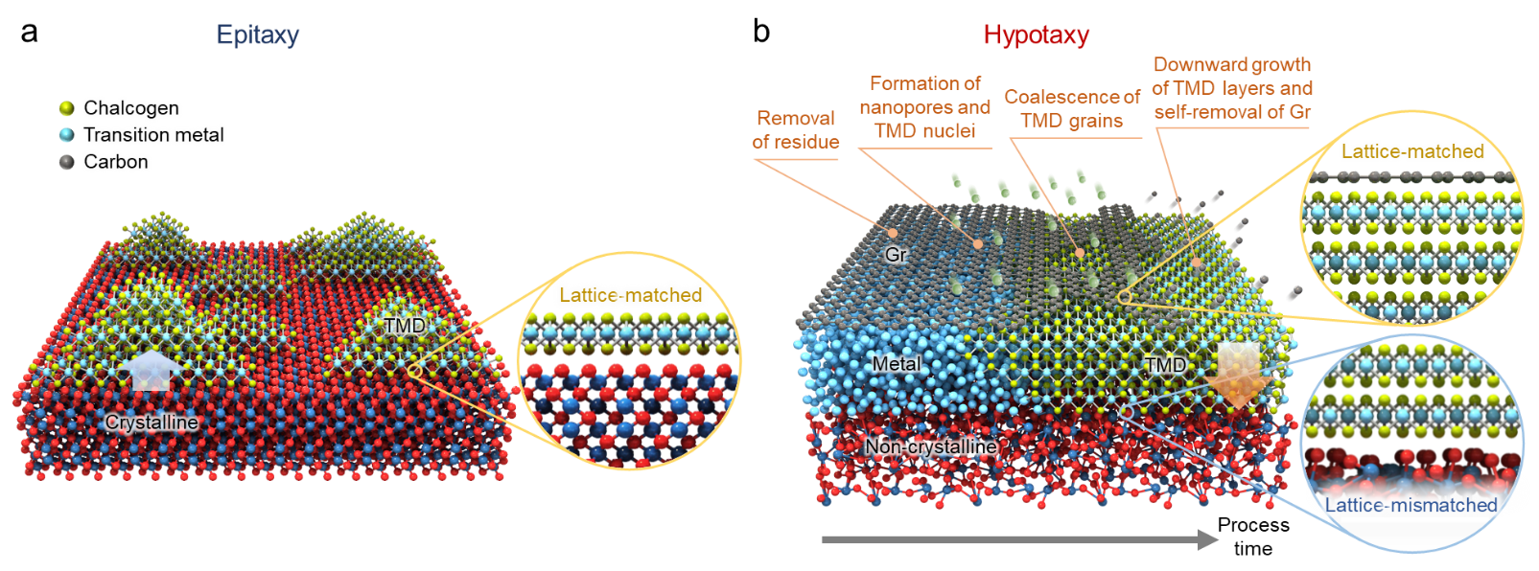
Figure Legends

Figure 1 | Growth mechanisms of epitaxy and hypotaxy. Schematics of growth mechanisms for a, conventional epitaxy and b, proposed hypotaxy.

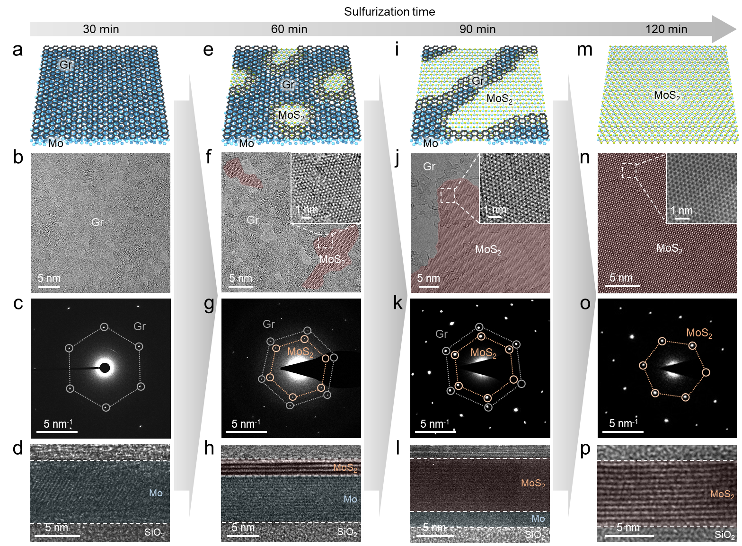
Figure 2 | Step-by-step of hypotaxial growth. a, Schematic, b, TEM image, c, SAED pattern, and d, Cross-sectional HR-TEM image of the Gr/Mo/SiO₂ sample sulfurized for 30 min. The residue induced during graphene transfer is removed. e, Schematic, f, TEM image, g, SAED pattern, and h, Cross-sectional HR-TEM image of the Gr/MoS₂/Mo/SiO₂ sample sulfurized for 60 min. Through the nanopores of < 5 nm in graphene, MoS₂ nuclei (indicated by red areas in f) form with crystalline alignment with graphene. i, Schematic, j, TEM image, k, SAED pattern, and l, Cross-sectional HR-TEM image of the Gr/MoS₂/Mo/SiO₂ sample sulfurized for 90 min. As the nanopores expand, the unidirectionally aligned MoS₂ nuclei coalesce into larger grains without formation of grain boundaries. The MoS₂ layers grow from a top region of the Mo film, remaining the Mo film at the bottom. m, Schematic, n, TEM image, o, SAED pattern, and p, Cross-sectional HR-TEM image of the Gr/MoS₂/SiO₂ sample sulfurized for 120 min. The whole Mo film transforms into layered MoS₂ film and graphene is completely removed. Note that the MoS₂ and Mo regions in cross-sectional TEM images are false-colored in red and blue, respectively.
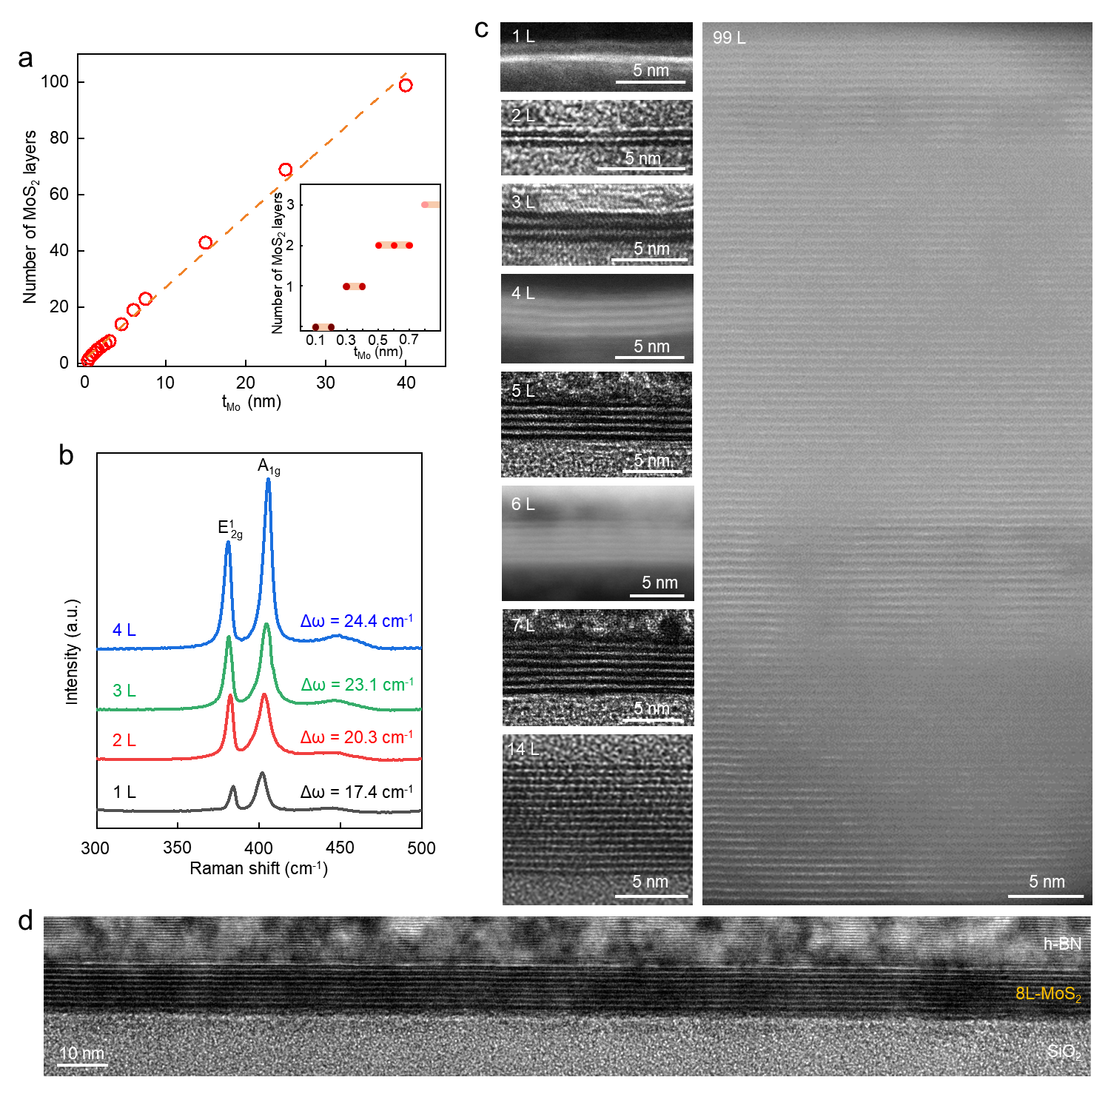
Figure 3 | Layer controllability in hypotaxial growth of MoS₂. a, Number of MoS₂ layers in hypotaxially grown MoS₂ as a function of the Mo film thickness. There is clearly a linear relation between the Mo film thickness and the layer number of MoS₂ in hypotaxial growth. The inset shows the step-like relation for 1-4L, indicating that the number of MoS₂ layers can be precisely controlled due to a broad range of Mo thicknesses that determine the number of layers. b, Raman spectra of the hypotaxially grown 1-4L MoS₂. The Raman peak separation decreases with reduced number of layers. c, Cross-sectional TEM and STEM images of the hypotaxially grown MoS₂ films with different thicknesses (1-99L). d, Cross-sectional STEM images of the grown 8L-MoS₂ covered by hBN. Across a broad area, each layer in MoS₂ shows continuous and layered structure without multilayer patches.

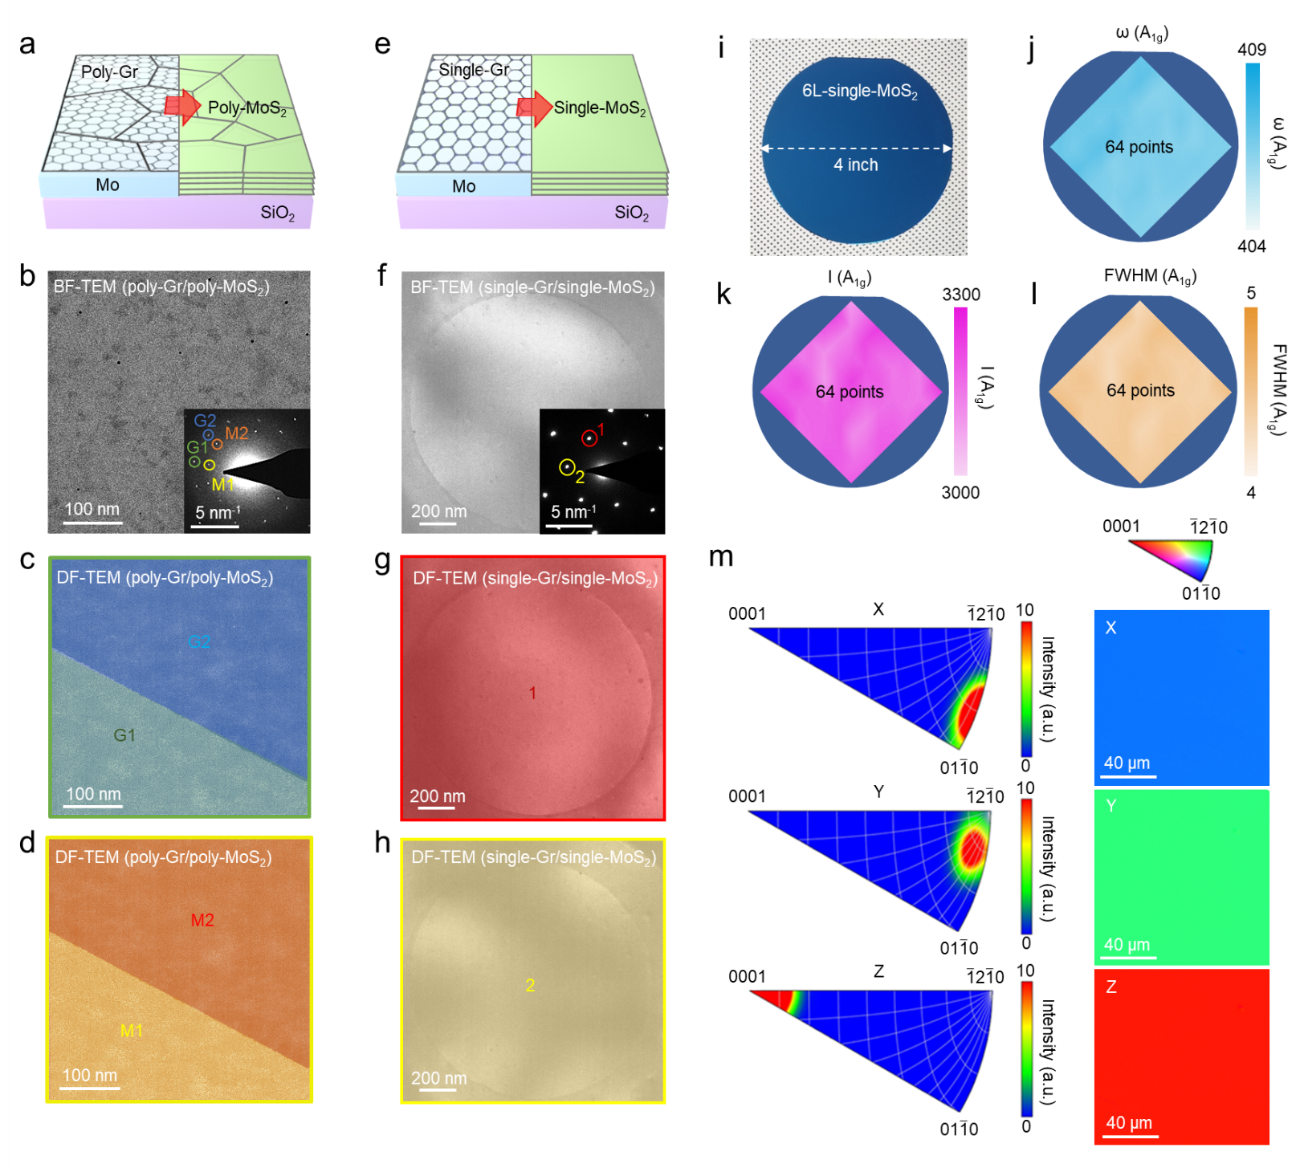
Figure 4 | Hypotaxial growth of 4-inch single crystal MoS₂. a, Schematic hypotaxial growth process of the poly-MoS₂ film through poly-Gr. b, BF-TEM image of the poly-Gr/poly-MoS₂ with its SAED pattern (inset), showing that both graphene and MoS₂ consist of two grains with different orientations as indicated by G1 and G2 for graphene and M1 and M2 for MoS₂. c, False-color DF-TEM image of poly-Gr. Each grain corresponds to the diffraction spot (G1 and G2) of the same color. d, False-color DF-TEM image of poly-MoS₂. Each grain corresponds to the diffraction spot (M1 and M2) of the same color. e, Schematic hypotaxial growth process of the single-MoS₂ film through single-Gr. f, BF-TEM image of the single-MoS₂ with its SAED pattern (inset). g,h, False-color DF-TEM images of single-MoS₂ obtained from corresponding diffraction spots (red circle 1 and yellow circle 2) in f. Note that the circles in BF- and DF-TEM images in f-h are a hole of the TEM grid, where the single-MoS₂ is suspended. i-l, Photograph of 4-inch single crystal 6L-MoS₂ hypotaxially grown through single-Gr on a SiO₂/Si wafer and Raman peak maps obtained across a wafer (64 points) from positions, intensities, and FWHMs of A_{1g} peak. m, EBSD IPFs and corresponding IPF maps of hypotaxially grown single crystal 6L-MoS₂ along X, Y, and Z directions.

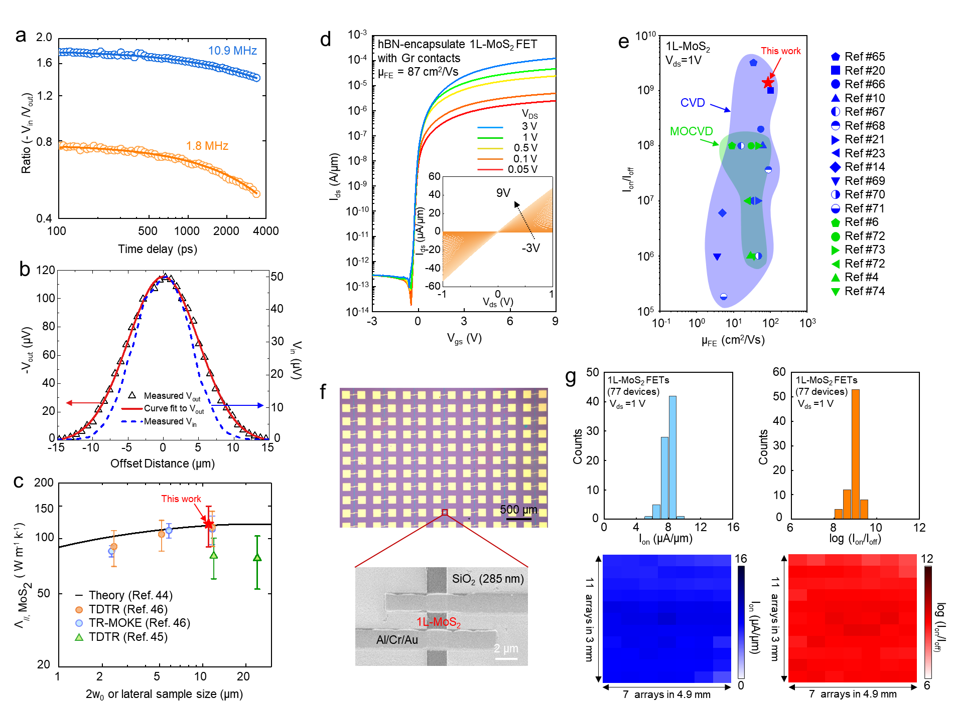
Figure 5 | Thermal and electrical properties of hypotaxially grown single-MoS₂. a, Ratio (-V_{in}/V_{out}) of 212 nm-thick single-MoS₂ measured at f = 10.9 (blue circles) and 1.8 MHz (orange circles) with varying time delay using the co-aligned TDTR method to determine the through-plane thermal conductivity. The MoS₂ film grown on a SiO₂/Si substrate was coated with Al transducer. The solid lines are the fitted curves by the thermal model. b, V_{in} signal (blue dashed line) and -V_{out} signal (triangles) measured at f = 10.9 MHz and t_{d} = 100 ps and at f = 1.8 MHz and t_{d} = -100 ps, respectively, by the beam-offset TDTR method for measurement of in-plane thermal conductivity. The red solid line is a Gaussian fitting curve to the V_{out} signal. c, In-plane thermal conductivity of the single-MoS₂ as a function of spot size (w₀) or lateral sample size. The in-plane thermal conductivities theoretically predicted and experimentally measured in previous studies are plotted for comparison. d, Transfer curves (I_{ds}-V_{gs}) of a top-gated 1L-MoS₂ FET with graphene contacts and hBN dielectric. The inset shows the output curves (I_{ds}-V_{ds}) of the same device. e, Summarized plot of I_{on}/I_{off} and μ_{FE} values from monolayer MoS₂ devices reported in the literature, with our device marked by a red star for comparison. f, Optical microscopy image of 1L-MoS₂ device array (77 devices in total) fabricated on a SiO₂ (285 nm)/Si substrate with Al/Cr/Au electrodes. The SEM image shows an enlarged view of the 1L-MoS₂ device. g, Statistical histograms and maps showing the distributions of I_{on} and I_{on}/I_{off} obtained from the 1L-MoS₂ device array in f.

Method
Preparation of monolayer graphene. We used three types of graphene samples in this work: exfoliated, CVD-grown polycrystalline, and single crystal monolayer graphene. The monolayer graphene was mechanically exfoliated from graphite using scotch tape method⁵¹. The exfoliated graphene was transferred onto pre-deposited metal films using a polydimethylsiloxane (PDMS)/polycarbonate (PC) stamp⁵². After release of the PDMS stamp, the remaining PC layer was removed in chloroform for 6 h. For a large-area monolayer graphene film, we used the CVD method⁵³. A polycrystalline monolayer graphene film was synthesized on a copper foil (Alfa Aesar) at 1050°C in vacuum under a mixture of CH₄ (1 sccm) and H₂ (100sccm) for 30 min. To fabricate a single crystal graphene, a copper foil was recrystallized by annealing at 1050°C and atmospheric pressure under a mixed gas flow of H₂ (50 sccm) and Ar (50 sccm) for 18 h, which is called the contact-free annealing (CFA) method⁵⁴. The single crystal graphene was grown on the pre-annealed copper foil at 1050°C in vacuum under a mixture of CH₄ (1 sccm) and H₂ (100 sccm) for 30 min (Fig. S13). For the transfer of CVD-grown graphene, the PMMA layer was spin-coated on the graphene/copper stack. Then, the graphene grown on the bottom side of the copper foil was etched by oxygen plasma (Femto-Science, CUTE), and the copper was etched in ammonium persulfate for 2 h, followed by rinsing in DI water⁵³. By using a PDMS stamp, the PMMA/graphene was transferred onto the pre-deposited metal film, then the PMMA layer was removed by soaking in acetone for 6 h.
Hypotaxial growth of TMDs. For hypotaxial growth of MoS₂, Mo film with desired thickness was deposited on a SiO₂/Si substrate by e-beam evaporator (Korea Vacuum Tech, KVE-E2000L). It should be noted that the Mo thickness is not the measured thickness of the deposited Mo film, but the target thickness used in our evaporator. The monolayer graphene (exfoliated or CVD-grown) was subsequently transferred onto the pre-deposited Mo film. The prepared sample was placed at the center of the vertical CVD furnace (Fig. S1a). The furnace was ramped to 1000°C under a mixture of H₂S (5 sccm) and Ar (150 sccm). Upon reaching the target temperature, the flow rates of H₂S and Ar were adjusted to 20 and 130 sccm, respectively, and maintained for 2 h. The low flow rate of H₂S (5 sccm) in the ramping stage is required to generate nanopores and prevent agglomeration of the Mo film. Note that agglomeration of the Mo films into small particles results in non-continuous (unstitched) MoS₂ film and multilayer patches. Furthermore, the excessive supply of H₂S (more than 20 sccm) during the synthesis stage hinders the full sulfurization of the Mo film, leading to residual layer of inactive Mo at the bottom. When the Mo film is thicker than 10 nm, additional sulfurization time is required: additional 40 min per 10 nm. For hypotaxial growth of MoSe₂, we used a powder of Se for selenization, which was positioned away from the center of the furnace by 20.5 cm. The furnace was ramped to 1000°C for 1 h with a mixed gas flow H₂ (5 sccm) and Ar (150 sccm), then maintained the temperature at 1000ºC with reduced flow rate of H₂ (10 sccm) for 2 h. We used the same procedures for hypotaxial growth of WS₂ and WSe₂, except for the deposition method of sputter (Korea Vacuum Tech, KVS2004L) for the W films.
Pre-formation of nanopores in graphene. To enable the growth of MoS₂ at 400℃, compatible temperature for BEOL, we pre-formed the nanopores in graphene by oxygen plasma (Extended Data Fig. 5a). During the backside etching process of graphene/copper foil, the sample was placed on a spacer, enabling supply of ionized ions through a narrow gap as we reported previously²⁶. The slow chemical etching through the gap leads to formation of nanopores with small sizes of < 5 nm. The graphene with nanopores was transferred onto the Mo film by the PDMS/PMMA transfer method as described previously.
Structural characterization. For TEM observation, the samples were prepared using PMMA transfer method⁵⁵. The TEM images and SAED patterns were obtained using Cs-corrected monochromated TEM (Thermo Fisher, Themis Z, and JEOL, JEM-ARM 200F) operating at 80 kV. For cross-sectional TEM, the samples were prepared by a focused ion beam (Thermo Fisher, Helios G4), and the protective layer of Pt or hBN was used. For measurements of Raman and PL spectra, we used Raman spectroscopy (JASCO, NRS-4500) with a 532 nm laser. For investigation of crystalline orientations in copper and MoS₂, we used the EBSD (Oxford instruments) at an accelerating voltage of 15 kV with a tilt angle of 70°. We also used the SEM (Carl Zeiss Sigma FE-SEM) operating at acceleration voltage of 2 kV and AFM (Park Systems, NX10).
Computational methods for alignment of graphene and MoS₂. The spin-polarized density functional theory (DFT) calculations were performed using Vienna ab initio Simulation Package (VASP) ^{56,57}. The generalized gradient approximation (GGA) based Perdew-Burke-Ernzerhof (PBE) functional was used for the exchange-correlation⁵⁸. To describe the electron-ion interactions, the projector augmented wave (PAW) potential^{59,60} was utilized. For the van der Waals correction, a semi-empirical DFT-D3 method was employed. A plane wave was expanded up to cutoff energy of 400 eV. Electronic occupancies were calculated with a smearing parameter of 0.05 eV with Gaussian smearing. All the calculations used 0.03 eVÅ⁻¹ as the force criteria for the all the relaxed atoms and 10⁻⁵ eV as the energy criteria for each iteration. For the lattice optimization of 2H-MoS₂ (2 × 2 × 1 unit cell) and graphene (3 × 3 unit cell), 4 × 4 × 2 and 5 × 5 × 1 Monkhorst−Pack k−point samplings⁶¹ were used, respectively. The optimized lattice parameter of MoS₂ was 3.15 Å for a-, b-axis, and 12.12 Å for c-axis. The optimized lattice parameter of graphene was 2.47 Å. For the MoS₂ alignment calculations, the hexagonal structure of MoS₂ monolayer (diameter is 1.55 nm, total 81 atoms) was used below graphene (9 × 9 unit cell) with a nanopore whose diameter is 1.23 nm. The size of MoS₂ nucleus is large enough to minimize its formation energy and the atomic distortions⁶². The S atoms in the bottom layer of MoS₂ were fixed to maintain the rotated structure of each MoS₂ nanosheet. For the MoS₂ alignment calculations with graphene, 1 × 1 × 1 Monkhorst−Pack k−point sampling⁶¹ was used.
Thermal conductivity measurements by TDTR. We used an ultrafast pulsed laser source (Mai Tai HP) with a wavelength centered at 781 nm and a repetition rate of 80 MHz and modulated the pump beam by an electro-optic modulator (EOM) at the frequency (f). By varying f and spot size (1/e² radius, w₀) of the laser beams, we achieved a higher sensitivity for through- or in-plane thermal conductivities in TDTR measurements⁴⁷. We used w₀ of 5.5 μm in all measurements to achieve higher sensitivity for through-plane thermal conductivity with f = 10.9 MHz in the co-aligned TDTR⁴⁸ and to avoid the underestimation of in-plane thermal conductivity of MoS₂ with f = 1.8 MHz in beam-offset TDTR^{45,49}. The thermal model for TDTR measurement requires the thermal conductivity (Λ), volumetric heat capacity (C), and thickness (t) of each layer composing the sample. We coated the samples with an Al transducer with a thickness of ≈ 80 nm via DC magnetron sputtering. First, ${\text{Λ}}_{\text{Al}}$ of 167 W m⁻¹ K⁻¹ was determined by using the Wiedemann-Franz law with the resistivity measured by the 4-point probe method. The thermal conductivities of SiO₂ and Si were independently measured: ${\text{Λ}}_{{\text{SiO}}_{\text{2}}}$= 1.3 Wm⁻¹K⁻¹ and ${\text{Λ}}_{\text{Si}}$ = 146 Wm⁻¹K⁻¹. We used ${\text{C}}_{\text{Al}}$, ${\text{C}}_{{\text{MoS}}_{\text{2}}}$, ${\text{C}}_{{\text{S}\text{iO}}_{\text{2}}}$, and ${\text{C}}_{\text{Si}}$ as 2.43, 1.89, 1.62, and 1.64 Jcm⁻³K⁻¹, respectively⁶³. The layer thicknesses were determined by picosecond acoustics: 81 ± 2, 212 ± 6, and 295 ± 9 nm for Al, MoS₂, and SiO₂, respectively (see Supplementary Note for details about picosecond acoustics). In the co-aligned TDTR measurement at f = 1.8 MHz, the modified ratio, defined as subtraction of V_{in} offset at negative time delay (t_{d} < 0) from V_{in} in the ratio, was used instead of the normal ratio to improve the sensitivity of ${\text{G}}_{\text{Al/}{\text{MoS}}_{\text{2}}}$, ${\text{Λ}}_{\text{⊥}\text{, }{\text{MoS}}_{\text{2}}}$, and ${\text{G}}_{{\text{MoS}}_{\text{2}}{\text{/SiO}}_{\text{2}}}$. In the beam-offset TDTR measurement, the FWHM of Gaussian curves fitted to the V_{out} data at t_{d} = -100 ps was 11.6 ± 0.1 μm.
Device fabrication and electrical measurements. For hBN-encapsulated 1L-MoS₂ FET with graphene contacts, the exfoliated hBN and graphene flakes and hypotaxially grown MoS₂ were stacked by the pick-up method⁵², followed by patterning of electrodes through e-beam lithography (Raith, Pioneer 2). For formation of graphene via contacts, we used the graphene etch stop technique with XeF₂ gas exposure as described in our reports^{52,64}. For arrays of 1L- and 2L-MoS₂ FETs, the hypotaxially grown MoS₂ was patterned by e-beam lithography and reactive ion etching (RIE) (SAMCO-10NR), followed by deposition of Al/Cr/Au (25 nm/5 nm/30 nm) as electrodes. Electrical measurements of the devices were conducted at room temperature in a vacuum (10⁻² Torr) using a parameter analyzer (Keithley, 4200A). The device performance data in Fig. 5e are selected from the literatures with CVD-grown 1L-MoS₂^{10,14,20,21,23,65-71} and MOCVD-grown 1L-MoS₂^{4,6,72-74}.

References
51 Novoselov, K. S. et al. Electric field effect in atomically thin carbon films. Science 306, 666-669 (2004).
52 Son, J. et al. Atomically precise graphene etch stops for three dimensional integrated systems from two dimensional material heterostructures. Nat. Commun. 9, 3988 (2018).
53 Lee, G.-H. et al. High-strength chemical-vapor–deposited graphene and grain boundaries. Science 340, 1073-1076 (2013).
54 Jin, S. et al. Colossal grain growth yields single-crystal metal foils by contact-free annealing. Science 362, 1021-1025 (2018).
55 Kim, H. et al. In-plane anisotropy of graphene by strong interlayer interactions with van der Waals epitaxially grown MoO₃. Sci. Adv. 9, eadg6696 (2023).
56 Kresse, G. & Furthmüller, J. Efficient iterative schemes for ab initio total-energy calculations using a plane-wave basis set. Phys. Rev. B 54, 11169-11186 (1996).
57 Sholl, D. & Steckel, J. A. Density functional theory: a practical introduction. (John Wiley & Sons, 2011).
58 Perdew, J. P., Burke, K. & Ernzerhof, M. Generalized gradient approximation made simple. Phys. Rev. Lett. 77, 3865-3868 (1996).
59 Blöchl, P. E. Projector augmented-wave method. Phys. Rev. B 50, 17953-17979 (1994).
60 Kresse, G. & Joubert, D. From ultrasoft pseudopotentials to the projector augmented-wave method. Phys. Rev. B 59, 1758-1775 (1999).
61 Monkhorst, H. J. & Pack, J. D. Special points for Brillouin-zone integrations. Phys. Rev. B 13, 5188-5192 (1976).
62 Javaid, M., Drumm, D. W., Russo, S. P. & Greentree, A. D. A study of size-dependent properties of MoS₂ monolayer nanoflakes using density-functional theory. Sci. Rep. 7, 9775 (2017).
63 Kim, J.-Y., Choi, S. M., Seo, W.-S. & Cho, W.-S. Thermal and electronic properties of exfoliated metal chalcogenides. Bull. Korean Chem. Soc. 31, 3225-3227 (2010).
64 Shin, Y. et al. Graphene via contact architecture for vertical integration of vdW heterostructure devices. Small 18, 2200882 (2022).
65 Smithe, K. K. H., English, C. D., Suryavanshi, S. V. & Pop, E. High-field transport and velocity saturation in synthetic monolayer MoS₂. Nano Lett. 18, 4516-4522 (2018).
66 Sanne, A. et al. Radio frequency transistors and circuits based on CVD MoS₂. Nano Lett. 15, 5039-5045 (2015).
67 Amani, M., Burke, R. A., Proie, R. M. & Dubey, M. Flexible integrated circuits and multifunctional electronics based on single atomic layers of MoS₂ and graphene. Nanotechnology 26, 115202 (2015).
68 Xiao, J. et al. Record-high saturation current in end-bond contacted monolayer MoS₂ transistors. Nano Res. 15, 475-481 (2022).
69 Jeon, J. et al. Layer-controlled CVD growth of large-area two-dimensional MoS₂ films. Nanoscale 7, 1688-1695 (2015).
70 Smithe, K. K. H., Suryavanshi, S. V., Muñoz Rojo, M., Tedjarati, A. D. & Pop, E. Low variability in synthetic monolayer MoS₂ devices. ACS Nano 11, 8456-8463 (2017).
71 Park, W. et al. Photoelectron spectroscopic imaging and device applications of large-area patternable single-Layer MoS₂ synthesized by chemical vapor deposition. ACS Nano 8, 4961-4968 (2014).
72 Shen, P.-C. et al. Ultralow contact resistance between semimetal and monolayer semiconductors. Nature 593, 211-217 (2021).
73 Sebastian, A., Pendurthi, R., Choudhury, T. H., Redwing, J. M. & Das, S. Benchmarking monolayer MoS₂ and WS₂ field-effect transistors. Nat. Commun. 12, 693 (2021).
74 Zhu, J. et al. Low-thermal-budget synthesis of monolayer molybdenum disulfide for silicon back-end-of-line integration on a 200 mm platform. Nat. Nanotechnol. 18, 456-463 (2023).

Acknowledgments
This work was supported by National Research Foundation of Korea Grants funded by the Korean Government (2021R1A2C3014316 and RS-2024-00401234). G.H.L. acknowledges the support from the Institute of Engineering Research (IER), Institute of Applied Physics (IAP), and Inter-University Semiconductor Research Center (ISRC) at the Seoul National University. We specially thank Prof. Y.J. Hong for naming this technology “hypotaxy”.

Author information
Authors and Affiliations
Department of Materials Science and Engineering, Seoul National University, Seoul 08826, Republic of Korea
Donghoon Moon, Wonsik Lee, Chaesung Lim, Jinwoo Kim, Jiwoo Kim, Yeonjoon Jung, Hyun-Young Choi, Won Seok Choi, Hangyel Kim, Ji-Hwan Baek, Changheon Kim, Jaewoong Joo, Hyun-Geun Oh, Jeong Woo Han, Hyejin Jang & Gwan-Hyoung Lee
Research Institute for Advanced Materials (RIAM), Seoul National University, Seoul 08826, South Korea
Hangyel Kim, Ji-Hwan Baek, Jeong Woo Han, Hyejin Jang & Gwan-Hyoung Lee
Research Center for Electronic and Optical Materials, National Institute for Materials Science, Tsukuba 305-0044, Japan
Kenji Watanabe
International Center for Materials Nanoarchitectonics, National Institute for Materials Science, 1-1 Namiki, Tsukuba 305-0044, Japan
Takashi Taniguchi
Functional Composite Materials Research Center, Korea Institute of Science and Technology, Jeonbuk 55324, Republic of Korea
Changheon Kim, Sukang Bae & Jangyup Son
Department of JBNU-KIST Industry-Academia Convergence Research, Jeonbuk National University, Jeonbuk 54896, Republic of Korea
Sukang Bae & Jangyup Son
Division of Nano and Information Technology, KIST School University of Science and Technology (UST), Jeonbuk 55324, Republic of Korea
Jangyup Son
Samsung Advanced Institute of Technology (SAIT), Samsung Electronics Co. Ltd., Suwon 16678, Republic of Korea
Huije Ryu & Junyoung Kwon
Department of Physics, Sogang University, Seoul 04107, Republic of Korea
Hajung Jang & Hyeonsik Cheong

Contributions
D.M. and G.-H.L. designed and conceived the project. W.L. and H.J. conducted thermal conductivity measurements. C.L. and J.W.H. performed DFT calculations. J.K. performed TEM imaging. J.K., C.K., S.B., Y.J., and H.-G.O. prepared graphene and TMD samples. H.-Y.C., W.S.C., J.J., H.R., and J.K. fabricated devices and performed electrical measurements. H.J. and H.C performed SHG measurements. K.W. and T.T. supplied boron nitride crystals. D.M. and G.-H.L. jointly analyzed the data and wrote the paper together through discussion with H.K. and J.-H.B.
Declaration of Competing Interest
The authors declare that they have no known competing financial interests or personal relationships that could have appeared to influence the work reported in this paper.

Data availability
Data will be made available on request.

Corresponding author
Gwan-Hyoung Lee, gwanlee@snu.ac.kr

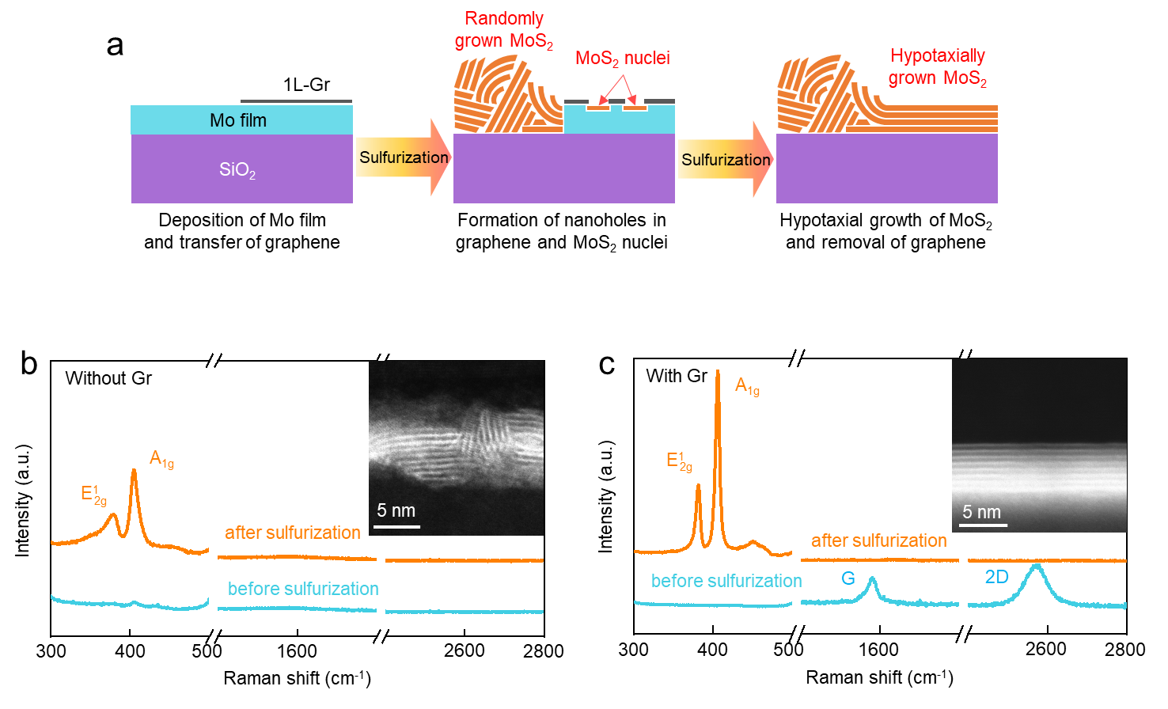
Extended Data Fig. 1 | Comparison of the MoS₂ films grown by the conventional sulfurization and the hypotaxy through graphene. a, Schematic of the MoS₂ growth processes for conventional sulfurization and hypotaxy through graphene. The Mo film deposited on a SiO₂ substrate by e-beam evaporation was partially covered by exfoliated 1L-Gr. For sulfurization, 20 sccm of H₂S and 130 sccm of argon gas were supplied at 1000℃ for 2 h. The uncovered Mo film turns into randomly oriented MoS₂ layers, while the graphene-covered Mo film transforms into a uniformly layered MoS₂ structure through the formation of MoS₂ nuclei that are crystallographically aligned with the top graphene layer. b,c, Raman spectra of conventionally sulfurized MoS₂ (b) and hypotaxially grown MoS₂ (c) before and after the sulfurization process. The cross-sectional STEM images in the insets shows the morphologies of two samples.

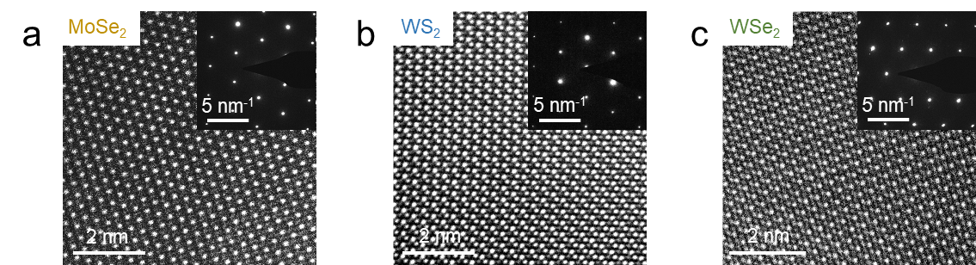
Extended Data Fig. 2 | Hypotaxial growth of MoSe₂, WS₂, and WSe₂. a-c, HR-TEM images and corresponding SAED patterns (insets) of MoSe₂ (a), WS₂ (b), and WSe₂ (c), indicating the applicability of the hypotaxial growth for a variety of TMDs.

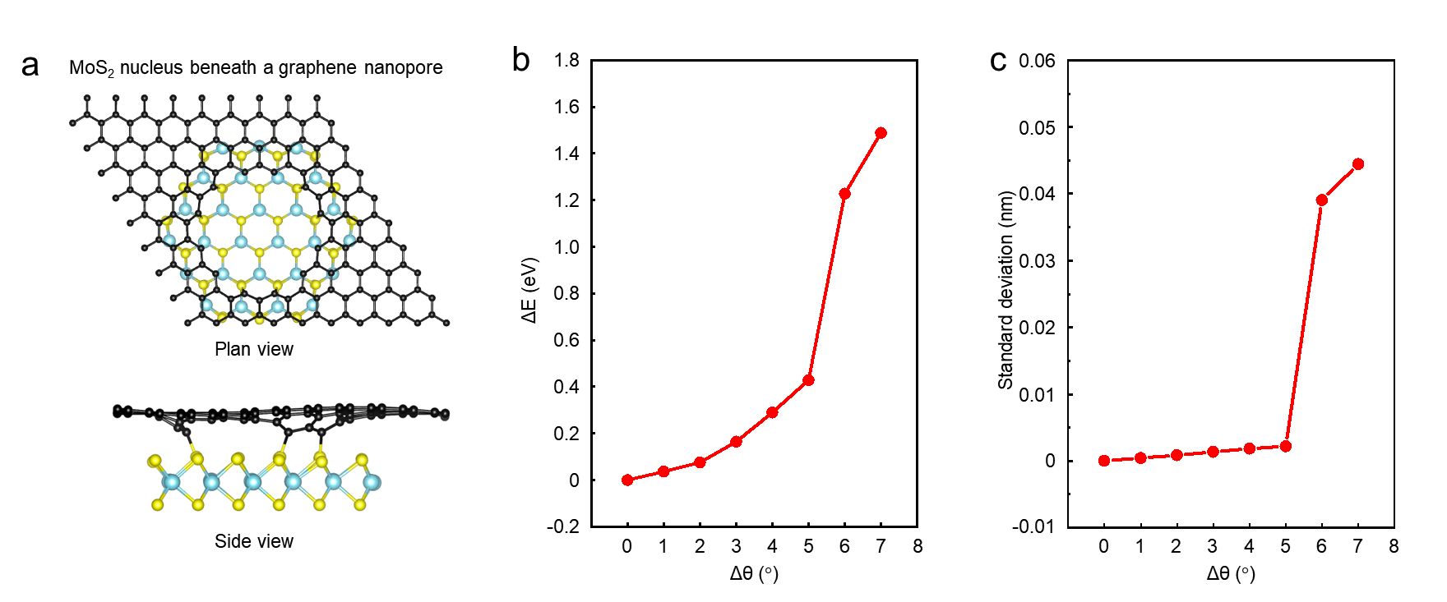
Extended Data Fig. 3 | Energetic stability of crystallographically aligned MoS₂ nucleus with a graphene nanopore. a, Optimized structure of hexagonal structure of MoS₂ monolayer below graphene with nanopores. Black, sky blue, and yellow spheres are C, Mo, and S atoms, respectively. b, Relative energies as a function of the rotation of the MoS₂ around the center of the MoS₂ nuclei. The relative energies were calculated with reference to the energy of the 0 degree of MoS₂. c, Standard deviation of bond lengths of six C-S bonds at the edge of graphene nanopore as a function of the rotation of the MoS₂.

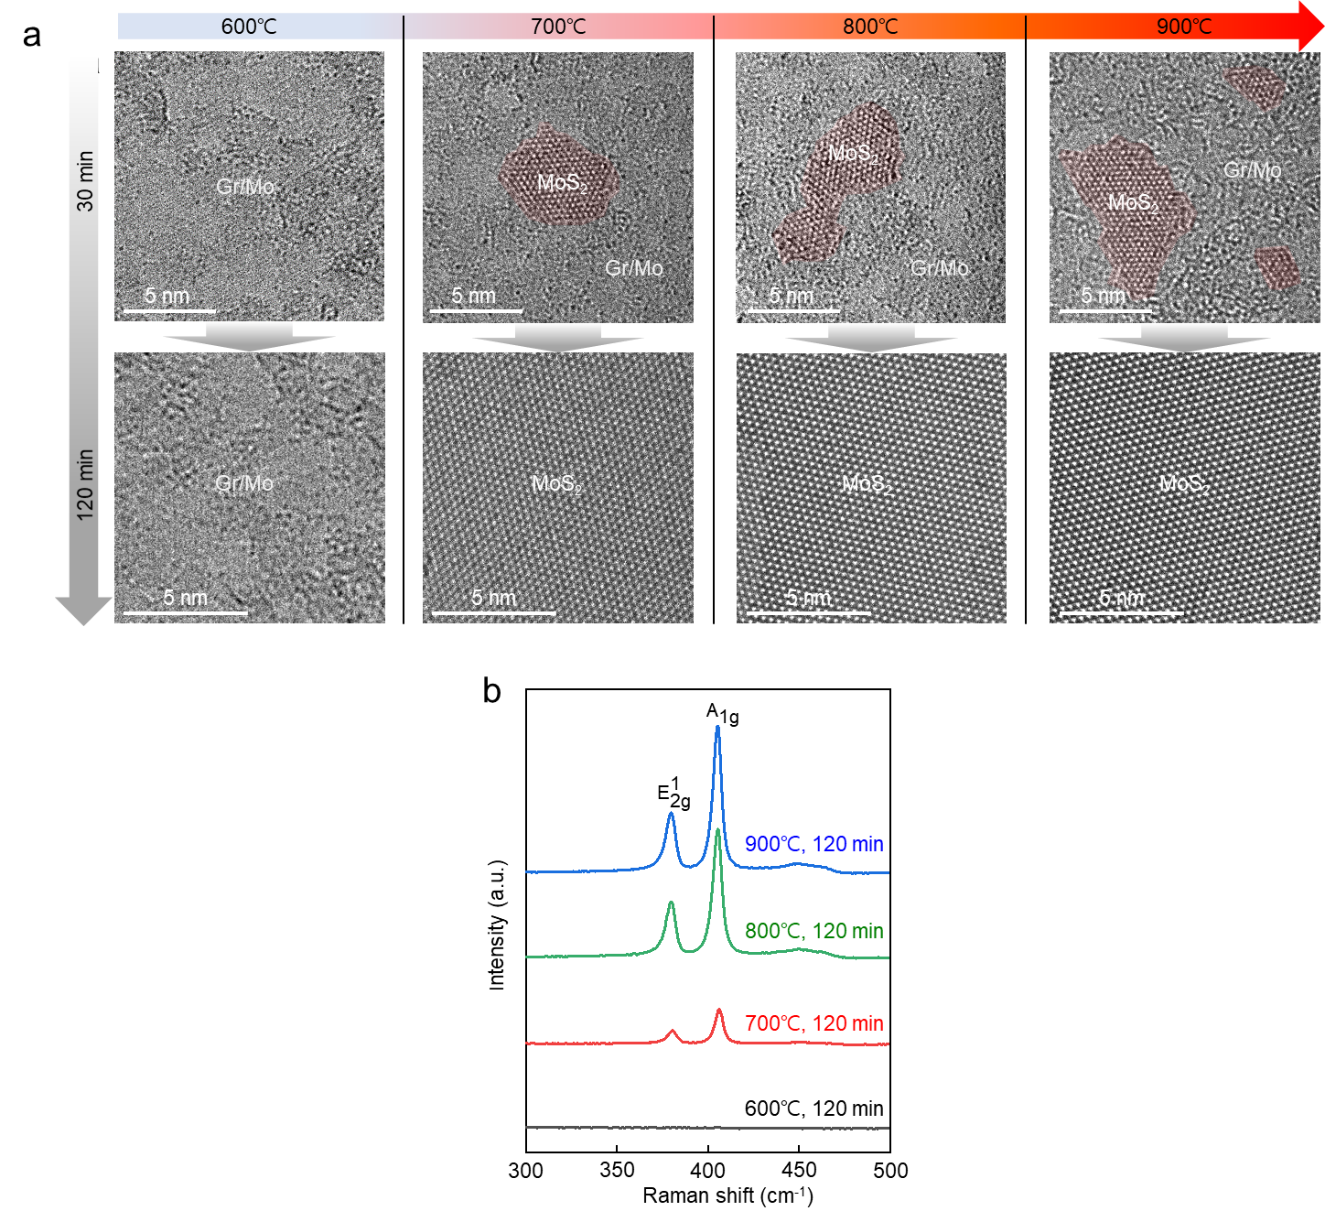
Extended Data Fig. 4 | Effect of temperature and time on the hypotaxial growth of MoS₂. a, TEM images of graphene/Mo samples sulfurized at 600, 700, 800, and 900ºC for 30 and 120 min. Because of no formation of nanopores at 600ºC, the Mo film covered by graphene was not sulfurized even after 120 min. Meanwhile, the MoS₂ was hypotaxially grown at 700-900ºC. However, graphene was partially removed at these temperatures. The TEM images were taken from the specific regions with no remaining graphene. b, Raman spectra of hypotaxially grown MoS₂ at different sulfurization temperatures. As the sulfurization temperature increases, the ${\text{E}}_{\text{2g}}^{\text{1}}$ and A_{1g} peaks of MoS₂ becomes more pronounced, indicating higher crystallinity.

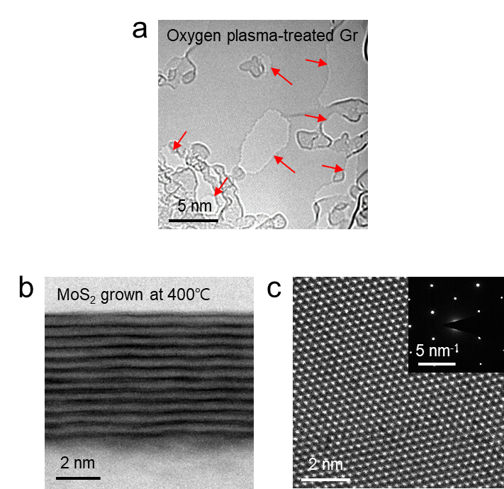
Extended Data Fig. 5 | Low-temperature hypotaxial growth of MoS₂. a, TEM image of oxygen plasma-treated graphene for generation of nanopores. The nanopores are marked by red arrows. b, Cross-sectional STEM image of hypotaxially grown MoS₂ at 400ºC through oxygen plasma-treated graphene. c, HR-TEM image and corresponding SAED pattern (inset) of the same sample.

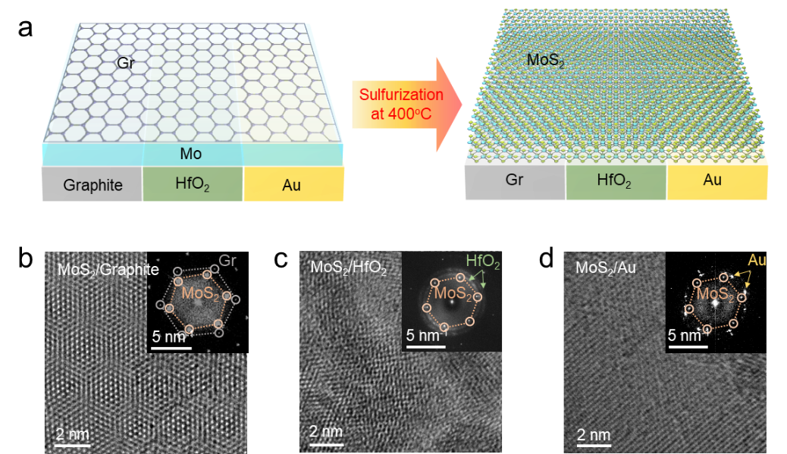
Extended Data Fig. 6 | Hypotaxial growth of MoS₂ on various substrates. a, Schematic process for hypotaxial growth of MoS₂ at 400ºC on graphite, HfO₂, and Au. b-d, HR-TEM images and corresponding FFT patterns (insets) of hypotaxially grown MoS₂ on graphite (b), HfO₂ (c), and Au (d), respectively. The 10 nm-thick HfO₂ and 50 nm-thick Au film were deposited by atomic layer deposition (ALD) method and e-beam evaporation, respectively. Thanks to the unique characteristic of hypotaxy, the MoS₂ can be grown regardless of the crystal structures of the substrates.

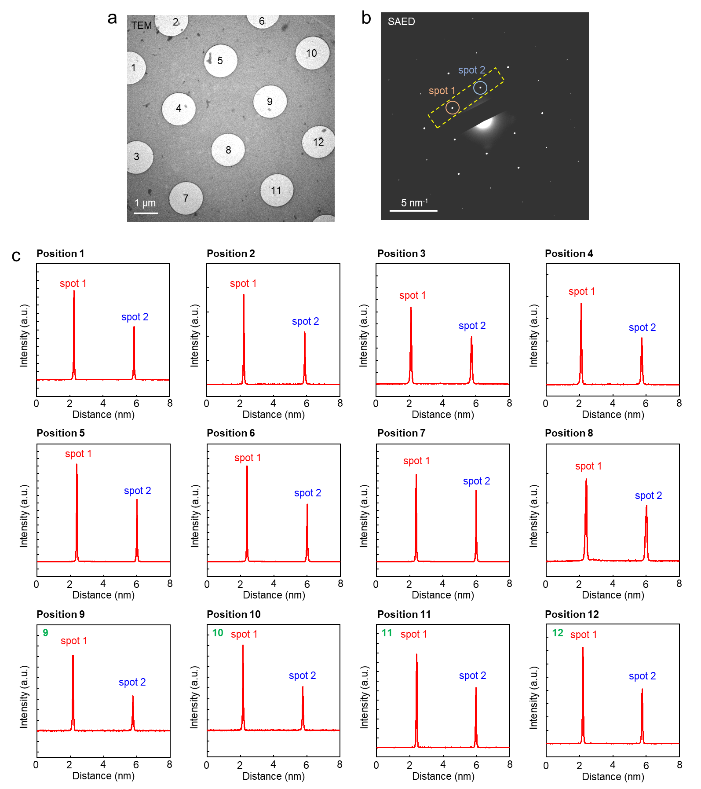
Extended Data Fig. 7 | Asymmetry analyses in diffraction profiles of SAED patterns. a, BF-TEM image of transferred 1L-MoS₂ (hypotaxially grown at 1000ºC) onto a holey TEM grid. b, Representative SAED pattern of region 1. The diffraction intensity profile of spot 1 and 2 was extracted from the yellow dashed region. c, Diffraction intensity profiles obtained from twelve regions indicated in (a). These diffraction intensity profiles show that all regions have stronger intensity at spot 1 compared to spot 2, confirming these areas have the same crystalline orientation.

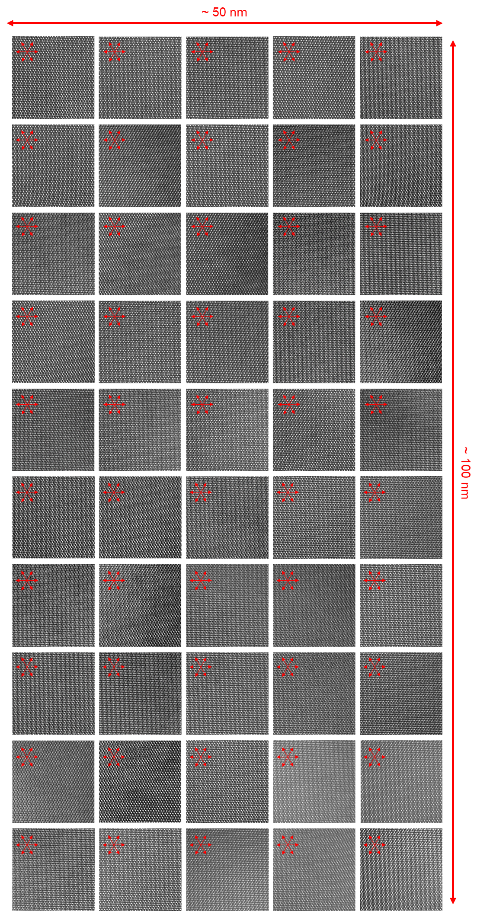
Extended Data Fig. 8 | HR-TEM images of fifty regions with the same crystalline orientation and no twin boundaries. HR-TEM images (10 nm × 10 nm) obtained from fifty regions of hypotaxially grown 1L-MoS₂ at 1000ºC show no twin boundaries and all regions exhibit the same crystalline orientation. Regarding small distance between MoS₂ nuclei (~10-20 nm), which correspond to the spacing between nanopores in graphene (Fig. 2f and Extended Data Fig. 6), absence of twin boundaries over this large area (fifty regions of 50 nm × 100 nm) strongly suggests that the hypotaxially grown MoS₂ is a single crystal with no inversion domains.

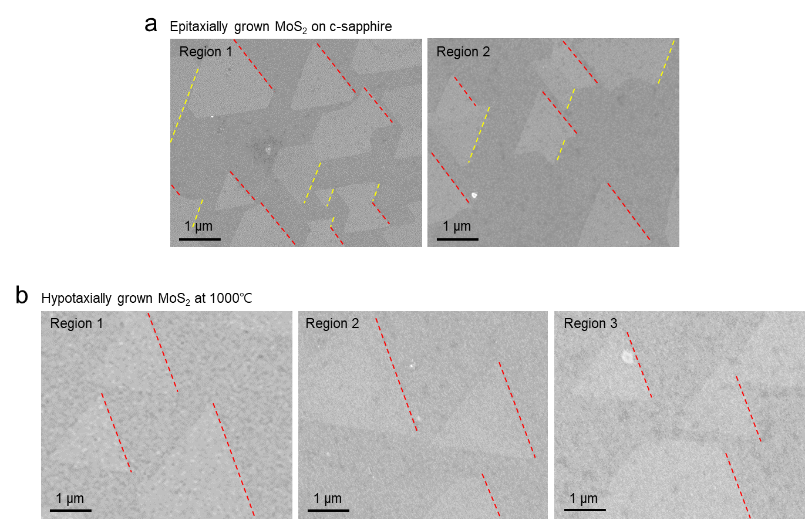
Extended Data Fig. 9 | Etching behavior of epitaxially and hypotaxially grown 1L-MoS₂. SEM images of a, epitaxially grown MoS₂ on a c-sapphire substrate and b, hypotaxially grown MoS₂ at 1000ºC after annealing at 1000℃ under low pressure of <10⁻³ Torr. The mild etching processes are widely used to visualize grain boundaries and determine crystalline orientation³³⁻³⁶. The SEM images were taken from different regions to investigate crystalline orientation of large area. The epitaxially grown 1L-MoS₂ showed two triangular etched regions with opposite directions (indicated by red and yellow dashed lines) due to presence of grains with 0˚ and 60˚ orientations on the c-sapphire substrate as shown in (a). Meanwhile, the hypotaxially grown MoS₂ exhibited unidirectional triangular shapes as shown in (b), indicating that the entire area etched by vacuum annealing is unidirectionally oriented.

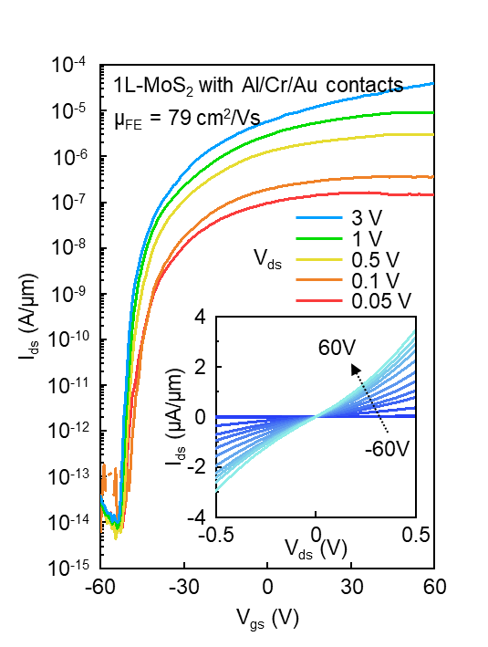
Extended Data Fig. 10 | Device performances of hypotaxial grown 1L-MoS₂ with metal electrodes of Al/Cr/Au. Transfer curves (I_{ds}-V_{gs}) of hypotaxially grown 1L-MoS₂ device with Al/Cr/Au contacts, showing high I_{on}/I_{off} of > 10⁹ and field-effect mobility of 79 cm²V⁻¹s⁻¹. The linear output curves (I_{ds}-V_{ds}) in the inset show that the metal contacts are ohmic-like.

