Enhancement of damping capacity by deformation-induced martensitic
transformation in Mg-Sc alloy
Elango Chandiran*, Yukiko Ogawa, Rintaro Ueji, Alok Singh and Hidetoshi Somekawa
National Institute for Materials Science, 1-2-1 Sengen, Tsukuba, Ibaraki 305-0047, Japan
* Corresponding author. E-mail address: CHANDIRAN.elango@nims.go.jp
Abstract
The effects different crystallographic orientations of the grains on damping capacity(tanδ) were investigated using nano-dynamic mechanical analysis in pure magnesium, hexagonal close packed structure (HCP) Mg-20Sc (at.%), and body centred cubic structure (BCC) Mg-20Sc (at.%) alloy. In comparison to HCP Mg-Sc, the grain orientation has a significant impact on the tanδ of pure Mg and BCC Mg-Sc. Furthermore, the tanδ value of pure Mg at any given frequency were higher than those of HCP and BCC Mg-Sc samples due to the absence of the solute atom Sc.

Keywords: Magnesium alloy, Dynamic mechanical analysis, Damping, Martensitic phase transformation
1. Introduction
Owing to their low density and high specific strength [1], magnesium (Mg) and its alloys are appealing structural materials for a wide range of industries where component weight reduction is required. It is also well known that Mg and its alloys have a good damping capacity [2,3]. Typically, the damping capacity of Mg and its alloys is attributed to energy dissipation resulting from dislocation motion [4,5]. It is known that dislocation motion in response to external loading are influenced by factors like solute atoms, crystal structure, precipitates and crystallographic orientation [3,6-12]. For example, addition of higher amounts of a highly soluble element in Mg, such as Al, Zn, Sn, or Cd, reduces the damping capacity because the solute atoms impede the dislocation movement due to pinning effect [7]. The hexagonal close packed structure (HCP) exhibits a higher damping capacity than the body centred cubic structure (BCC) as in Mg-Li [10] and Mg-Sc [11]. However, it is currently not yet clear how different crystallographic orientations of the grains affect the damping capacity of a material. Thus, the present research examines the effect of individual grain orientation on damping capacity in pure Mg and a model Mg-20Sc(at.%) alloy system using nano-indentation testing coupled with nano-dynamic mechanical analysis (nano-DMA). The Mg-Sc alloys were chosen for this study because they have the potential to be used in shape memory applications, and the current study advances our understanding of the effect of grain crystallographic orientation on its damping capacity. This research will also provide scientific guidance for the development of high damping capacity in magnesium and Mg-Sc alloys via texture control. It should be noted that, depending on the heat treatment, alloying Mg with more than 18 at.% Sc results in either a BCC or an HCP structure at room temperature [13-14].

2. Experimental
Pure Mg (99.96% purity) and Mg-Sc (20 at.%) alloy were used in this study. The pure Mg was extruded at high temperature, rolled into sheet, and then annealed at 748 K for 48 h. The Mg-Sc alloy was processed by cold-rolling of as-cast billet as described elsewhere [15]. Electron probe micro analyser (EPMA) was used to determine the actual composition of Mg-Sc, which is Mg-19.7 at.% Sc. From Mg-Sc sheet, samples with HCP structure were obtained by annealing at 773 K for 144 h followed by water quenching (referred to as HCP Mg-Sc), and samples with BCC structure were obtained by annealing at 963 K for 0.5 h followed by water quenching (referred to as BCC Mg-Sc). The Sc atoms in Mg were presumably in the solid solution form due to the extended annealing time (for HCP Mg-Sc) and higher annealing temperature (for BCC Mg-Sc) [15,16]. The microstructures were imaged with a SEM coupled with an electron backscatter diffraction (EBSD) detector. Imaging was performed on the normal direction plane (i.e., RD-ND plane) surface of pure Mg and Mg-Sc samples. In addition, the surface of the rolling direction plane (i.e., RD-TD plane) was utilized for imaging of pure Mg. EBSD was utilized to determine the crystallographic orientation of grains for the subsequent damping capacity measurement.
Applying nano-indentation testing equipped with nano-DMA, the internal friction (tanδ), was measured and taken as a measure of damping capacity. A conical-shaped tip with a radius of curvature of 250 nm was used for the nano-DMA. The tip initially contacted the specimen with a maximum load of 1 mN, after which an amplitude load of 150 μN was set at dynamic frequencies of 0.1 to 170 Hz. It should be noted that the nano-indenter was also equipped with an optical microscope for locating the grain of choice for internal friction measurement. At least seven tests were conducted from the same grain for each grain orientation. The surface preparation method of the sample for these measurements has previously been reported [15,17]. For selected sample conditions, TEM observations were conducted after damping capacity measurement. The TEM samples were prepared using focused ion beam (FIB) lift-out technique. TEM observations were made using a JEOL 2800 microscope with a field emission gun operated at 200 kV.

3. Results and discussion
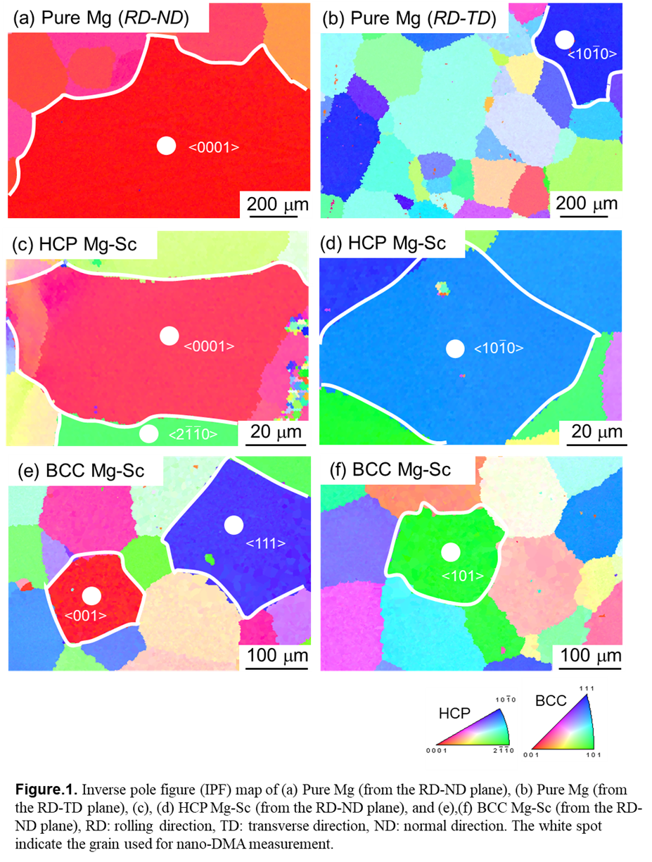
Figure 1. shows the typical microstructures in inverse pole figure (IPF) maps of the samples. It is observed that the microstructures are composed of equiaxed grains. From the IPF maps of pure Mg sample, the grains aligned with orientations close to <0001> (along TD, Fig. 1a); and <$10\overline{1}0$>, (along ND, Fig. 1b), are identified in white dot for subsequent nano-DMA test. Similarly, grains aligned with orientations close to <0001>, <$\text{2}\overline{\text{1}\text{1}}\text{0}$> and <$\text{10}\overline{\text{1}}\text{0}$> are identified in the HCP Mg-Sc sample (Figs. 1c, 1d). In the BCC Mg-Sc sample (Figs. 1e,1f), grains aligned with orientations close to <001>, <101> and <111> were identified. Table. 1 shows the precise orientations of these identified grains for nano-DMA test.
Figure 2 shows the variation of tanδ values as a function of dynamic frequency. In pure Mg sample (Fig. 2a), the tanδ values decrease continuously with increase in the dynamic frequency. The tanδ values of the grains orientated along <$10\overline{1}0$> direction are higher than those oriented along <0001> direction. In case of Mg-Sc samples (Figs. 2b and 2c), tanδ does not follow a simple trend. At first, tanδ decreases with rising frequency to a minimum near 1 Hz, and then rises to a maximum near 20 Hz. This behaviour is well documented for macroscopic damping capacity measured on bulk samples [11,18]. The tanδ of HCP Mg-Sc are low compared to pure Mg and show small grain orientation dependence. In case of BCC Mg-Sc, tanδ along <111> is higher than along the other two directions.
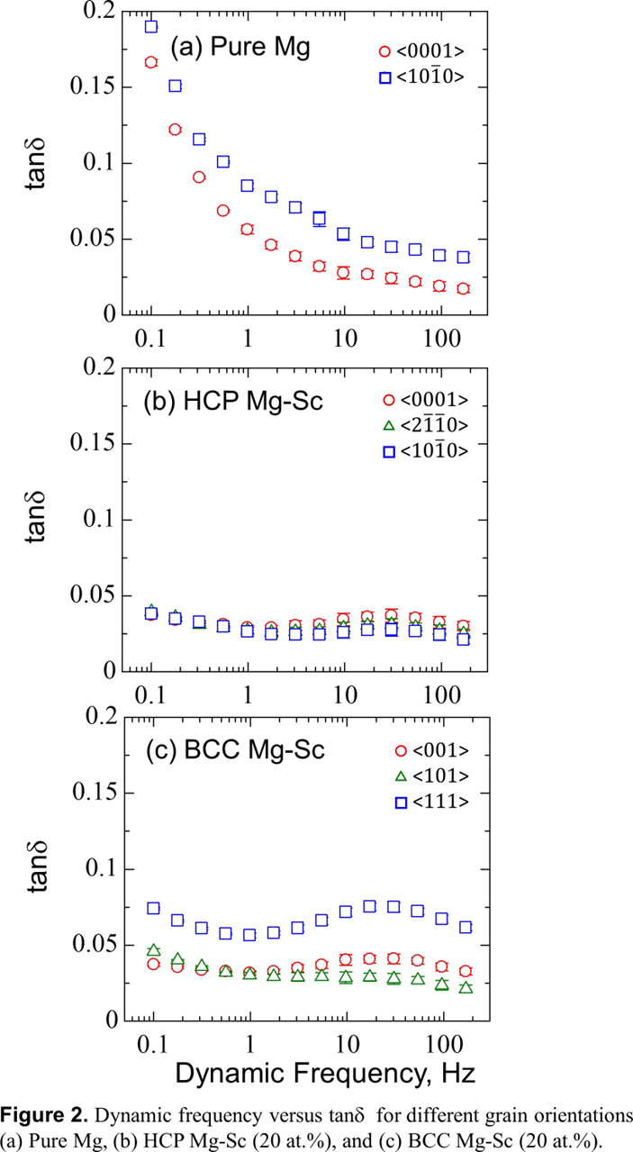
According to dislocation damping theory proposed by Granato and Lücke [19,20], the damping capacity of materials increases with a decrease in dislocation density and an increase in the distance between pinning points. Based on the relationship between tendency for dislocation generation and its interaction behaviour with respect to the crystal loading directions, it is possible to comprehend the effect of grain orientation on the damping capacity. In the case of nano-indentation of pure Mg along the <$\text{10}\overline{\text{1}}\text{0}$> direction, only the basal <a> and/or prismatic <a> dislocation was observed by Somekawa et al. [21]. For indentation along the <0001> direction, however, in addition to basal <a> dislocation, the pyramidal <c> and/or <c+a> dislocations were observed. These pyramidal dislocations are due to frequent cross-slip of the screw component of the basal <a> dislocation. Their simulation results demonstrate that indentation along <0001> results in cross-slip of the basal <a> dislocations rather than direct surface injection of a dislocation loop (along the <$\text{10}\overline{\text{1}}\text{0}$>). Furthermore, the strain hardening capacity of the <$\text{10}\overline{\text{1}}\text{0}$> loading directions is lower than that for the <0001> direction in Mg [22-24]. As a result, the observed higher damping capacity of pure Mg with grain alignment close to the <$\text{10}\overline{\text{1}}\text{0}$ > can be attributed to a limited tendency for dislocation interaction behaviour also likely, its lower strain hardening capacity. This is because each of them leads to lesser pinning of the dislocations, allowing for easy motion of dislocations during measurement and hence increased damping capacity. It should be noted that, during nano-indentation, Mg exhibits pronounced twinning [25,26], which can potentially affect damping capacity [27,28]. However, it was confirmed that such deformation twins do not form when using a conical-shaped indenter tip [21].
In HCP Mg-Sc sample (Figs. 2a-b), effect of grain orientation on the damping capacity is significantly less pronounced, compared to that of pure Mg. In HCP Mg-Sc samples, Ogawa et al [15] observed activation of <c+a> dislocation slip. The addition of Sc decreases the c/a ratio [29], which is regarded as one of the causes for the activation of the <c+a> dislocation slip [15]. Note that the c/a ratio determines the dislocation core structures and, essentially, the dislocation type in HCP structures [30]. Consequently, it is most likely that in the HCP Mg-Sc sample, due to the activation of <c+a> dislocation slip, the difference in dislocation generation and its interaction behaviour based on the crystallographic loading direction is significantly reduced, so that no clear difference is observed in terms of grain orientation and the damping capacity. The aforementioned point, however, requires further investigation. Moreover, the presence of solute Sc atoms accounts for the lower damping capacity of HCP Mg-Sc compared to pure Mg. This is because solute atoms are known to act as pinning points and impede dislocation motion [19,20], resulting in a decrease in damping capacity [7,8].
In BCC Mg-Sc (Fig. 2c), the grains orientated close to <111> direction shows significantly higher tanδ values than the <100> and <101> directions. Therefore, in the BCC Mg-Sc, the tanδ values are strongly orientation dependent. The tanδ values at any frequency in grains orientated close to <100> and <101> is close to those of HCP Mg-Sc. It is interesting to note that for the same chemical composition, the damping capacity exhibits small grain orientation dependence in the HCP Mg-Sc, but strongly dependent on grain orientation in the BCC Mg-Sc. It should be noted that the HCP and BCC Mg-Sc samples were made by quenching from different temperatures, which would cause the initial vacancy concentration to differ and the inherent hardness of these samples to vary, both of which could have affected the observed damping capacity [31,32]. However, the damping capacity within the sample should be affected mainly by crystallographic orientation of the grain.
Figures 3a-c presents SEM images taken from the nano-DMA tested regions of the BCC Mg-Sc sample. After nano-DMA, new plate-like structures (pointed by white-line) were observed in grains oriented along the <111> direction (Fig. 3c), while no such features were observed in the grains oriented along the <001> (Fig. 3a) and <101> (Fig. 3b) directions. Even after conventional nano-indentation with 1 mN load, grains oriented along the <111> direction exhibited similar plate-like structures (Fig. 3f). Furthermore, the nano-hardness of the grain aligned close to <111> was found to be 0.36 GPa, which is comparable to nano-hardness of the grain aligned close to <001> and 101>, which are 0.40 GPa and 0.39 GPa, respectively. This suggests that the formation of these plate-like structures could be the primary reason to account for the higher damping capacity observed in the BCC Mg-Sc sample with grain aligned close to the <111> direction as the hardness value is similar in these grains.

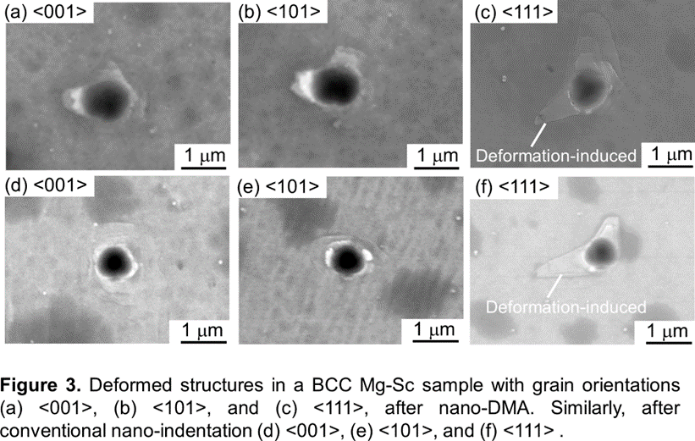
To identify these deformation-induced plate-like structures, detailed TEM observation was conducted as shown in Fig. 4. The IPF map (Fig. 4a) shows that the grain oriented along <111> direction in BCC Mg-Sc on which nano-DMA test was carried out. The SEM image shows the plate-like structures induced by nano-DMA(Fig. 4b). Three plates can be identified, at about equal angles to each other. TEM observations were conducted on a plane parallel to < 111> axis along the direction of the solid line. The BCC diffraction pattern along zone axis in Fig. 4c shows that this plane of observation is (110). Thus, it can be assumed that the three plates are growing along <110> directions from the indentation. Another diffraction pattern from region A was identified as [010] zone axis of orthorhombic martensite. These diffraction patterns show the presence of a second phase formed by martensitic transformation triggered by indentation. The high magnification image (Fig. 4d) from the red rectangle region in Fig. 4c, shows the presence of Moiré patterns.
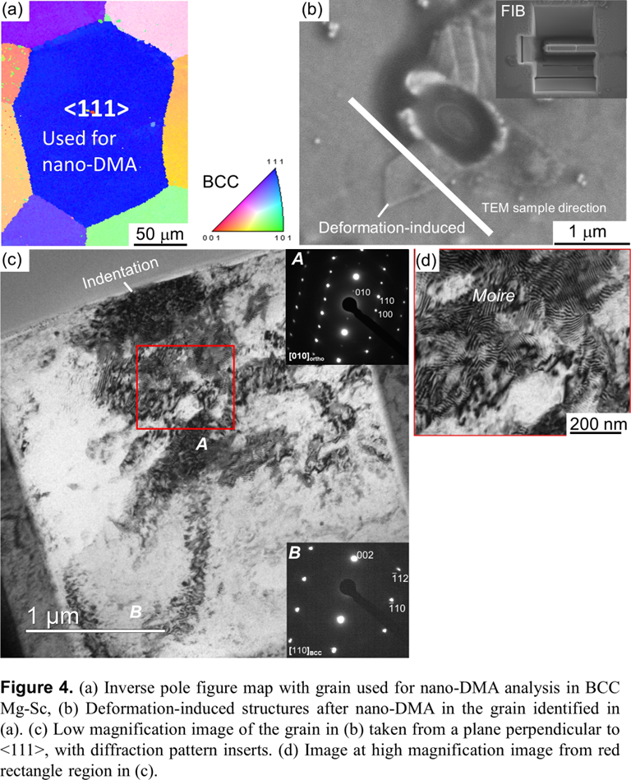
It is now evident that the higher damping capacity observed in the BCC Mg-Sc sample grain aligned close to the <111> direction is due to deformation-induced martensitic transformation. Ogawa et al. [33] showed that the required transformation strain along <111> for martensitic transformation from the BCC to the orthorhombic structure is only 3.3%, which is less than the 5.7% and 8.8% of <100> and <101> grains, respectively. Thus, deformation-induced martensitic transformation preferentially occurs in grain aligned close to the <111> direction. The presence of martensite phase is known to improve damping capacity as in alloys systems such as Fe-high Mn [34], Cu-Al-Mn [35], and Ni-Ti [36]. The movement of damping sources such as martensite variant boundaries, martensite/parent phase interfaces and stacking faults in martensite have been proposed as reasons for the increased damping capacity caused by martensite [35-38]. In Mg-Sc binary alloy,

4. Conclusion
The effect of different crystallographic orientations of the grains on the damping capacity of pure Mg, HCP Mg- Mg-20Sc (at.%), and BCC Mg- Mg-20Sc (at.%) was examined. The damping capacity of HCP Mg-Sc was found to be relatively less dependent on grain orientation, whereas it was significantly dependent on grain orientation in pure Mg and BCC Mg-Sc. In pure Mg, the limited dislocation interaction behaviour and, presumably, the lower strain hardening capacity of grains aligned close to <$\text{10}\overline{\text{1}}\text{0}$> contribute to its higher damping capacity. On the other hand, the activation of <c+a> dislocation in HCP Mg-Sc is most likely responsible for the small grain orientation dependence of the damping capacity. Deformation-induced transformation of BCC to orthorhombic martensite in grain aligned close to <111> contributed to the enhanced higher damping capacity of BCC Mg-Sc. Lastly, the addition of Sc to Mg decreases the damping capacity due to the expected dislocation pinning effect of solute Sc atoms.

Acknowledgement
The authors are grateful to Ms. Yuka Hara, National Institute for Materials Science (NIMS) for TEM sample preparations. This work was partially supported by the Japan Society for the Promotion of Science (JSPS) KAKENHI Grant Number 17J10094, 18K14032 and 22H01835.

Data availability
The datasets generated during the current study are not publicly available because the research is still ongoing but is available from the corresponding author upon reasonable request.

References
- H. Friedrich, S. Schumann, Research for a new age of magnesium in the automotive industry,J. Mater. Process. Technol., 117 (2001), pp. 276-281
- H. Watanabe, T. Sawada, Y. Sasakura, N. Ikeo, T. Mukai, Microyielding and damping capacity in magnesium, Scripta Mater., 87 (2014), pp.1-4
- K. Sugimoto, K. Niiya, T. Okamoto, K. Kishitake, A study of damping capacity in magnesium alloys, Trans. JIM, 18 (1977), pp. 277-288.
- G.D. Fan, M.Y. Zheng, X.S. Hu, K. Wu, W.M. Gan, H.G. Brokmeier, Internal friction and microplastic deformation behavior of pure magnesium processed by equal channel angular pressing, Mater. Sci. Eng. A, 561 (2013), pp. 100-108.
- X.S. Hu, Y.K. Zhang, M.Y. Zheng, K. Wu, A study of damping capacities in pure Mg and Mg–Ni alloys, Scripta Mater., 52 (11) (2005), pp. 1141-1145.
- L.B. Ren, G.F. Quan, Y.G. Xu, D.D. Yin, J.W. Lu, J.T. Dang, Effect of heat treatment and pre-deformation on damping capacity of cast Mg-Y binary alloys, J. Alloys Compd., 699 (2017), pp. 976-982.
- R. Ichikawa, T. Tanikawa, Effects of alloying elements on the damping capacity of cast magnesium alloys, J. Jpn. Inst. Light Met., 12 (1962), pp. 135-140.
- D. Wan, Y. Hu, S. Ye, Z. Li, L. Li, Y. Huang, Effect of alloying elements on magnesium alloy damping capacities at room temperature, Int. J. Miner. Metall. Mater., 26 (2019), pp. 760-765.
- R. R. Nothdurft, A. E. Schwaneke, Orientation dependence of dislocation damping in magnesium single crystals, Journal of Applied Physics 38 (1967), pp. 894-895.
- S.K. Wu, S.H. Chang, W.L. Tsia, H.Y. Bor, Low-frequency damping properties of as-extruded Mg–11.2 Li–0.95 Al–0.43 Zn magnesium alloy, Mater. Sci. Eng. A 528, (2011), pp. 6020-6025.
- Y. Ogawa, A. Singh, H. Somekawa, Damping property of phases of Mg–Sc measured by nano-DMA, MRS communications, 12 (2022), pp.1220-1224.
- H. Somekawa, D.A. Basha, A. Singh, T. Tsuru, H. Watanabe, Change in damping capacity arising from twin-boundary segregation in solid-solution magnesium alloys, Philos. Mag. Lett. 100, (2020) pp. 494-505.
- A.A. Nayeb-Hashemi, J.B. Clark, Bull. Alloy Phase Diagrams, The Mg−Sc (Magnesium-Scandium) system, 7 (1988), pp. 574-577
- Y. Ogawa, D. Ando, Y. Sutou, K. Yoshimi, J. Koike, Determination of α/β phase boundaries and mechanical characterization of Mg-Sc binary alloys, Mater. Sci. Eng. A, 670 (2016), pp. 335–341.
- B.J. Beaudry, A.H. Daane, A study of the scandium-magnesium system from 0 to 60 at. % scandium, J. Less-Common Met., 18 (1969), pp. 305-308.
- Y. Ogawa, A. Singh, H. Somekawa, Activation of non-basal <c+a> slip in coarse-grained Mg-Sc alloy, Scr. Mater., 218 (2022), 114830
- E. Chandiran, Y. Ogawa, R. Ueji, H. Somekawa, An inverse Hall-Petch relationship during room-temperature compression of commercially pure magnesium, J. Alloys Compd. 930 (2022) 167443.
- I.Yoshida, T. Ono, M. Asai, Internal friction of Ti–Ni alloys, J. Alloys Comp., 310 (2000), pp. 339-343
- A. Granato, K. Lücke, Theory of mechanical damping due to dislocations J. Appl. Phys. 27 (1956), pp. 583–593.
- A. Granato, K. Lücke, Application of dislocation theory to internal friction phenomena at high frequencies, J. Appl. Phys. 27 (1956), pp.789–805.
- H. Somekawa, T. Tsuru, A. Singh, S. Miura, and C.A. Schuh, Effect of crystal orientation on incipient plasticity during nanoindentation of magnesium, Acta Mater., 139 (2017) pp.21–29.
- F.F. Lavrentev, A. Pokhil Yu, Relation of dislocation density in different slip systems to work hardening parameters for magnesium crystals, Mater. Sci. Eng., 18 (2) (1975), pp. 261-270
- N. A. Tyapunina, E. K. Naimi, S. V. Gasparyan, G. M. Zinenkova, The orientation dependence of dislocation internal friction in real crystals. II. Hexagonal crystals, Phys. Stat. Sol. 46 (1978), pp.411-420.
- E. W. Kelley, W. F. Hosford: Tech. Report, Dept. Chem. Metall. Eng., Uni. Michigan, 1967.
- J.H. Shin, S.H. Kim, T. Ha, K. Oh, I.S. Choi, H. Han, Nanoindentation study for deformation twinning of magnesium single crystal, Scr. Mater., 68 (2013), pp. 483-486.
- C. Zambaldi, C. Zehnder, D. Raabe, Orientation dependent deformation by slip and twinning in magnesium during single crystal indentation, Acta Mater., 91 (2015), pp. 267-288.
- Q. Tian, F. Yin, T. Sakaguchi, K. Nagai, Reverse transformation behavior of a prestrained MnCu alloy, Acta Mater., 54 (2006), pp. 1805-1813.
- H. Watanabe, Y. Sasakura, N. Ikeo, T. Mukai, Effect of deformation twins on damping capacity in extruded pure magnesium, J. Alloys Compd., 626 (2015), pp. 60-64.
- S. Sandlobes, Z. Pei, M. Friak, L.F. Wang, F. Wang, S. Zaefferer, D. Raabe, J. Neuhebauer, Ductility improvement of Mg alloys by solid solution: Ab initio modelling, synthesis and mechanical properties, Acta Mater., 70 (2014), pp. 92-104.
- E. Clouet, D. Caillard, N. Chaari, F. Onimus, D. Rodney, Dislocation locking versus easy glide in titanium and zirconium, Nat. Mater., 14 (2015), pp. 931–936.
- Y. Wen, H. Xiao, H. Peng, N. Li, D. Raabe, Relationship between damping capacity and variations of vacancies concentration and segregation of carbon atom in an Fe-Mn alloy, Metall. Mater. Trans. A Phys. Metall. Mater. Sci., 46 11 (2015), pp. 4828-4833.
- J. Zhang, R. J. Perez , E. J. Lavernia, Documentation of damping capacity of metallic, ceramic and metal-matrix composite materials J. Mater. Sci., 28 (1993), pp. 2395-2404.
- Y Ogawa, D. Ando,Y. Sutou, H. Somekawa, J. Koike, Martensitic Transformation in a β-Type Mg–Sc Alloy, Shap. Mem. Superelasticity 4 (2018) pp.167–173.
- Y.-K. Lee, S.-H. Baik, J.-C. Kim, C.-S. Choi, Effects of amount of ε martensite, carbon content and cold working on damping capacity of an Fe–17% Mn martensitic alloy, J. Alloys Compd., 355 (2003), pp. 10-16
- Y. Sutou, T. Omori, N. Koeda, R. Kainuma, K. Ishida, Effects of grain size and texture on damping properties of Cu–Al–Mn-based shape memory alloys, J. Mater. Sci. Eng. A, 438–440 (2006),pp. 743-746.
- N. Igata, N. Urahashi, M. Sasaki, Y. Kogo, High damping capacity due to two-step phase transformation in Ni–Ti, Ni–Ti–Cu, and Fe–Cr–Mn alloys, J. Alloy. Comp., 355 (2003), pp. 85-89
- T. Xiao and G.P. Johari, Mechanisms of Internal Friction in a Cu-Zn-Ai Shape Memory Alloy, Metall. Trans. A, 26 (1995), pp.721–724.
- R. Gotthardt, Stacking fault formation in a faulted Cu-Zn-A1 – martensite, J. Phys. Colloques 43 (C4), (1982), pp.C4-667-C4-671.

