Supplementary material

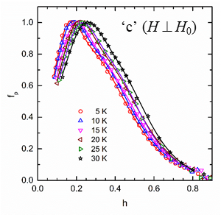  (a) | 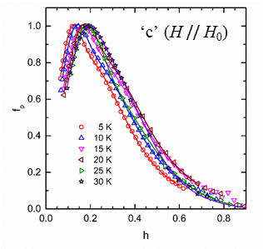  (b)
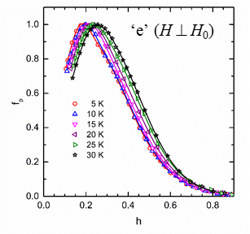  (c) | 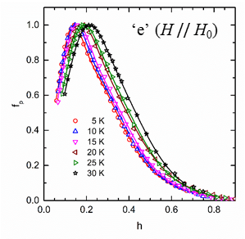  (d)
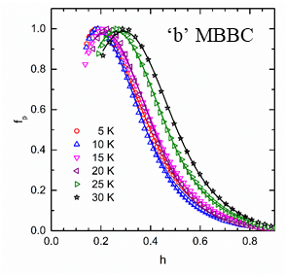  (e) | 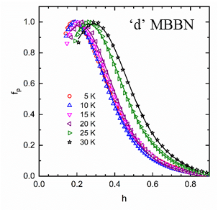  (f)

Fig. 1 (Supplementary Material) Normalized pinning force f_{p} at different temperatures as a function of reduced magnetic field h for: (a) - sample ‘c’ with B₄C, H ⊥ H₀; (b) - sample ‘c’ with B₄C, H // H₀; (c) - sample ‘e’ with c-BN, H ⊥ H₀; (d) - sample ‘e’ with c-BN, H // H₀; (e) – sample ‘b’ with B₄C; (f) - sample ‘d’ with c-BN. Continuous lines are fits with Eq. 5 where g(h) is a double Gauss function in (a)-(d) and a simple one in (e) and (f).

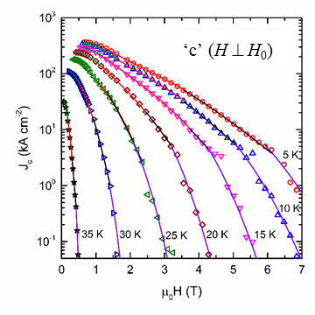  (a) | 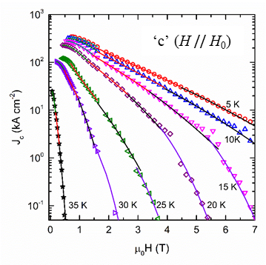  (b)
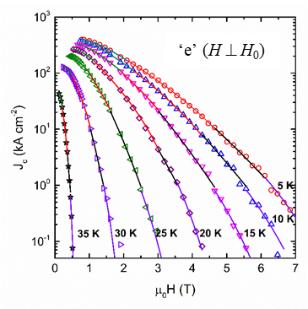  (c) | 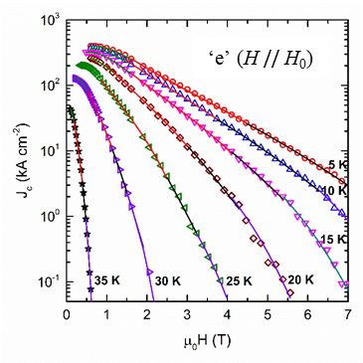  (d)

Fig. 2 (Supplementary Material) Critical current density J_{c} at different temperatures as a function of applied magnetic field µ₀H for: (a) - sample ‘c’ with B₄C, H ⊥ H₀; (b) - sample ‘c’ with B₄C, H // H₀; (c) - sample ‘e’ with c-BN, H ⊥ H₀; (d) - sample ‘e’ with c-BN, H // H₀; (e) - sample ‘b’ with B₄C; (f) - sample ‘d’ with c-BN. Continuous lines are fits with eq. (6) where g(h) is a double Gauss function.

