Reducing vertex radius of curvature for 100 nm-size square and triangular holes in GaN by shape modification
Kohei Tuzuku¹, Masataka Imura², and Hironori Okumura^{1,*}
1 Institute of Pure and Applied Sciences, University of Tsukuba, Tsukuba, Ibaraki 305-8573 Japan
2 Research Center for Functional Materials, National Institute for Materials Science, Tsukuba, Ibaraki 305-0044, Japan
*E-mail: okumura.hironori.gm@u.tsukuba.ac.jp

We fabricated arrays of circular, square, and triangular air holes in GaN by the conventional method using the electron beam lithography and reactive ion etching. The vertex radius of curvature for the square and triangular holes was reduced by shape modification. The minimum vertex radius of curvature for the 100-nm-size square and triangular holes were 17 and 11 nm, respectively.

1. Introduction
Photonic crystal (PhC) waveguides have great potential for miniaturization, low losses, and integration of photonic devices. Especially, optical waveguides using topological edge states enable reflectionless, unidirectional, and low-bending-loss propagation.¹⁻⁵⁾ Topological PhC structure prefers honeycomb arrays of equilateral triangular air holes.⁶⁻¹⁰⁾ However, the topological PhCs suffer from nanofabrication with high accuracy. Fabricated polygonal air holes have finite vertex radii (r) of curvature. As the r of the triangular hole increases, the photonic band shifts to the longer wavelength side, and the photonic bandgap decreases or disappears, causing the leakage of light through topological edge transmission. For the wavelengths of 1550 and 710 nm, the r of the triangular holes must be less than 30 and 20 nm, respectively.^{11,12)} The topological PhC waveguides at visible light wavelength require patterning with the smaller r than 20 nm.
Electron beam lithography is available to fabricate nm-scale patterns. In electron beam lithography, the precision to transfer from a designed pattern to a resist depends on acceleration voltage (V_{ac}), an electron dose (D), and the chemical properties of the resist and developer. Additionally, the collisions between incident electrons and resist molecules cause electron scattering, leading to beam broadening and proximity effects. ^{13,14)} Proximity effect correction (PEC) can improve the critical dimension uniformity of the resist pattern. PEC methods mainly have two types of electron-dose and layout-shape modifications. ¹⁵⁾ In dose-modification PEC, exposure dose locally varies according to the electron density distribution and the pattern area density. ^{16,17)} In shape-modification PEC, the exposure shape varies according to the actual D at each point. Both modification PEC methods would contribute to the fabrication of highly accurate nm-scale resist patten.
For the topological PhC waveguides in the visible light range, GaN is one of the most suitable materials due to the large bandgap energy of 3.4 eV and the commercially available large-scale wafer. The accurate transfer of patterns from the resist to a GaN layer requires a highly anisotropic etching of GaN. Photo-enhanced KOH etching, ¹⁸⁻²⁰⁾ hydrogen environment anisotropic thermal etching,^{11,21)} and thermal TMAH etching^{22,23)} are available to form anisotropic features for GaN. Compared to these chemical-based etchings, reactive ion etching (RIE) is more practical due to the process without heating, less crystal-orientation dependence, and high in-plane uniformity. For RIE of GaN, a SiO₂ hard mask is preferable due to the high etching selectivity of GaN/SiO₂ and SiO₂/resist. The optimization of the SiO₂ film thickness (t) and D are significantly important for the nanofabrication of GaN.
In this study, we fabricated arrays of circular, square, and triangular air holes in GaN by the conventional method using the electron beam lithography and RIE. The dose- and shape-modification PECs were used to reduce the r in the polygonal air holes.

2. Experimental procedure
The 3.3-μm-thick unintentional doped (UID)-GaN layers were grown on a sapphire (0001) substrate by metal-organic chemical vapor deposition (MOCVD) (SR-2328HT-RR). TMGa and NH₃ gas were used as precursors for gallium and nitrogen, respectively. The substrates were thermally cleaned for 10 min in a hydrogen atmosphere, followed by a simultaneous supply of TMGa and NH₃ for GaN growth. High-purity H₂ gas (99.9999%) was used as carrier gas. The molar flow rates of TMGa and NH₃ gas were 102 μmol min−1 and 223 mmol min−1, respectively. The chamber pressure and growth temperature, which was estimated using a pyrometer, were 100 kPa and 1125ºC, respectively.
We prepared SiO₂ films with various thicknesses as a hard mask for etching the GaN layer. The SiO₂ film was deposited by plasma CVD (PD-220NL) using the tetraethoxysilane (TEOS)/O₂ mixture gas. The chamber pressure, bias power, and sample temperature were 80 Pa, 200 W, and 350ºC, respectively. The flow rates of TEOS and O₂ gases were 5 and 195 sccm, respectively. A positive resist (AR-P6200) with dilution rate of 4.0 was applied to transfer patterns of geometric shapes. After baking the 100-nm-thick uniform resist layer at 180ºC for 5 min, a conductive polymer (ESPACER R300Z) was deposited to prevent the charging-induced pattern distortion. EBL was performed with various D using the ELS-F125 system operating at V_{ac} of 125 kV, 1 nA beam current, and 2.2 nm step size. Incident electron beam correction was applied. After removing the conductive polymer by dipping the samples in ultrapure water for 10 sec, the exposed patterns were developed at 5 ºC by Xylene, followed by rinsing in isopropanol for 30 sec. To transfer the resist pattern, the SiO₂ films were patterned at room temperature by RIE (RIE-10NR) using CHF₃ gas of 20 sccm in 2-3 Pa with RF power of 100 W. Through the SiO₂ mask, the GaN layers were etched in a 300 nm depth by inductively coupled plasma RIE (PlasmaPro 100 ALE) using the Cl₂/BCl₃ mixture gas. The chamber pressure, bias power, and sample temperature were 0.5 Pa, 200 W, and 20ºC, respectively. The flow rates of Cl₂ and BCl₃ gases were 40 and 10 sccm, respectively. The sidewall angle was 75±5º. The remaining SiO₂ mask was removed by dipping in a 50% HF solution. After coating a Pt thin film by sputtering (MPS-1S) to prevent the charge-up, the resulting patterns of the GaN layer were observed by scanning electron microscopy (SEM) (SU-8020) at a 1.5 kV acceleration voltage.
3. Results and discussion
3.1 Hole size
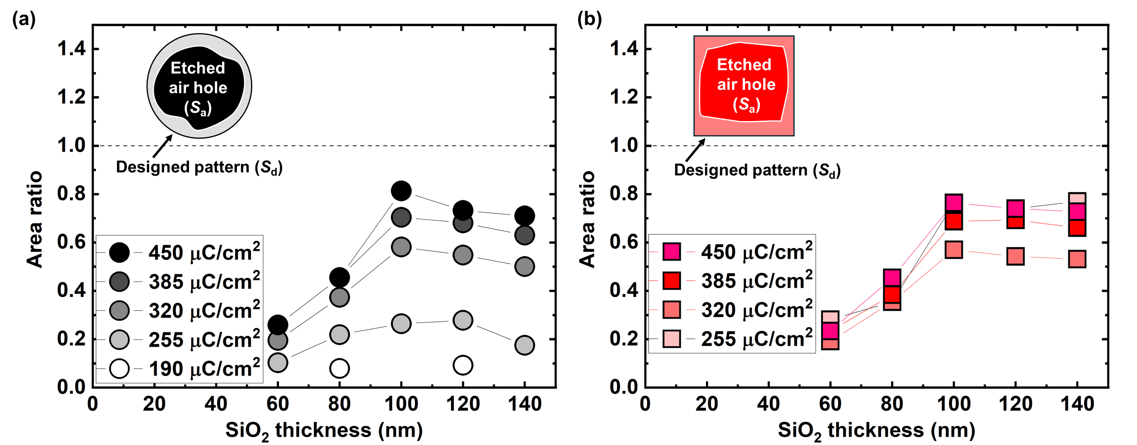
We define the difference between the area ($S_{d}$) of designed pattern and the area (S_{a}) of air holes etched in the GaN layer as an area ratio ($r_{a}=S_{a}/S_{d}$). When the area of the observed holes equals to the area of the designed pattern, the $r_{a}$ becomes 1, regardless of the hole shape. The area ratio of circular air holes with a radius of 50 nm for t = 60-140 nm is shown in Fig. 1 (a). The D was varied between 190 and 450 μC/cm². For t < 100 nm, the r_{a} increased with increasing the t. In the RIE of GaN, physical bombardment increases the etching rate of both SiO₂ mask and GaN layer, reducing the GaN/SiO₂ etching selectivity. ²⁴⁻²⁶⁾ The SiO₂ mask erosion causes the transfer of the distorted pattern to the GaN layer, reducing the r_{a}. The etching selectivity of GaN/SiO₂ can be increased by reducing the bias power and the BCl₃/Cl₂ gas ratio and increasing sample temperature.^{24, 27-29)} The high selectivity of GaN/SiO₂ would reduce the t required for GaN etching, enabling the more precise transfer to the GaN layer. For t ≥ 100 nm, the high r_{a} was obtained because the SiO₂ mask remained after GaN etching. This indicates that the GaN/SiO₂ etching selectivity is ~3 in this etching condition. The r_{a} slightly decreased with increasing the t. In the RIE of SiO₂, chemical reaction forms sloped sidewalls in the SiO₂ films.³⁰⁻³²⁾ We suggest that the hole sizes at the bottom reduce with increasing the t, transferring the smaller mask pattern to the GaN layer. The chemical reaction would be suppressed by increasing the bias power and decreasing the chamber pressure,³³⁾ leading to the steep sidewall of the SiO₂ mask and the large r_{a}. In these etching conditions of GaN and SiO₂, the r_{a} was the highest for t = 100 nm and D = 450 μC/cm².
Fig. 1: (a) Relation of area ratio for circular air holes with a diameter of 100 nm via SiO₂ mask thickness. Electron dose varied between 190 and 450 μC/cm². (b) Relation of area ratio for square air holes with a side length of 100 nm via SiO₂ mask thickness. Electron dose varied between 255 and 450 μC/cm².
The area ratio of square air holes with a side length of 100 nm for t = 60-140 nm is shown in Fig. 1 (b). The D was varied between 255 and 450 μC/cm². For t < 100 nm, the r_{a} increased with increasing the t. For t = 100–120 nm, the $r_{a}$ of circular and square holes increased with increasing the D. For low D, the designed pattern is incompletely transferred to the resist due to the underdose, ^{34,35)} causing the small r_{a}. For high D, the resist pattern is dominated by the energy deposition profile, which consists of the electron energy associated with forward scattering in the resist layer due to electron-electron interactions and backscattering from the SiO₂ mask.^{14,36)} Further away from the electron irradiation point, the energy density reduces, increasing the forward scattering. For the high V_{ac} and thin resist, the range of forward scattering becomes small.^{13,35)} At V_{ac} = 125 kV and 100-nm-thick resist, the scattering width by forward scattering is within 8 nm (supplementary data). The r_{a} increased with increasing the D, indicating the underexposure. The r_{a} reached 0.8 for D = 450 μC/cm².
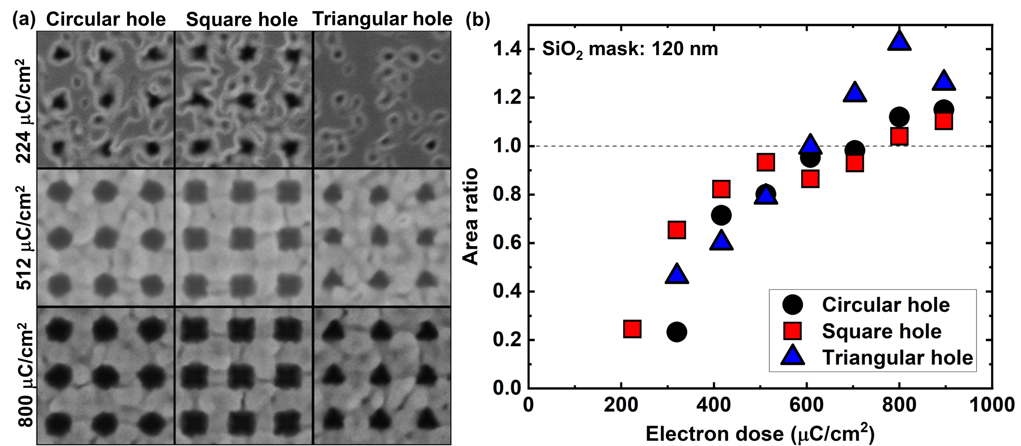
The SEM images of the GaN layers for D = 224, 512, and 800 μC/cm² are shown in Fig. 2 (a). The t was fixed at 120 nm. The D of 224 μC/cm² formed distorted hole shapes and the small hole areas (r_{a} < 1) due to the underdose, causing the transfer of the distorted pattern to the GaN layer. The D of 800 μC/cm² formed the holes with large areas (r_{a} > 1) and large curvature radius of polygon patterns due to the overdose, where excessive electron doses unintentionally react with the resist in regions beyond the designed pattern. For D = 512 μC/cm², the circular, square, and triangular holes were formed with the size close to the designed patterns due to the resist profile with steep vertical edges.
Fig. 2: (a) SEM images of circular, square, and triangular air holes for electron doses with 224, 512, and 800 μC/cm². The diameter of circular holes and the side length of square and triangular holes in designed pattern were 100 nm. (b) Relation of area ratio for circular, square, and triangular air holes via electron dose. The SiO₂ mask thickness was 120 nm.
The area ratios of the circular, square, and triangular holes in GaN under D = 224-896 μC/cm² are shown in Fig. 2 (b). The t was fixed at 120 nm. For 512 μC/cm² ≤ D ≤ 800 μC/cm², the $r_{a}$of the circular, square, and triangular holes were close to 1, suggesting the moderate exposure. The $r_{a}$ increased with increasing the D. For D > 800 μC/cm², the $r_{a}$ of the circular, square, and triangular holes were more than 1 due to the overdose, indicating an increase in the hole area. We found that the 100-nm-size air holes with the $r_{a}$ close to the designed pattern were fabricated in GaN by using t = 100-120 nm and D = 512-800 μC/cm².

3.2 Hole shape
Fabricated polygon holes have finite vertex radii of curvature. Based on the model shown in Fig. 3 (a), we calculate the r of the fabricated air hole for a square pattern with side lengths of l_{d}. From the SEM images, we determined the side lengths (a and b) of the circumscribed rectangle to the fabricated hole and the radius (R_{s}$(=r+l_{s})$) of the circumscribed circle to the fabricated hole, where l_{s} $(=\sqrt{{\left(\frac{a}{2}-r\right)}^{2}+{\left(\frac{b}{2}-r\right)}^{2}})$ is the distance between the center of the curvature circle and the center of the circumscribed circle. The calculated r of the air holes for square patterns with l_{d} = 100 nm as a function of t = 60-140 nm is shown in Fig. 3 (b). The D was varied between 255 and 450 μC/cm². The D had less effect on the r. For t < 100 nm, the r increased with increasing the t due to an increase of the hole size, while the r saturated for t ≥ 100 nm, in which the hole sizes were close to the size of the designed pattern. For t = 100-120 nm, the r was 23±2 nm. The large r results from not only suboptimum etching conditions for SiO₂ and GaN, but also insufficient electron exposure at the vertex of the square holes. This suggests the limit of the dose-modification PEC method.
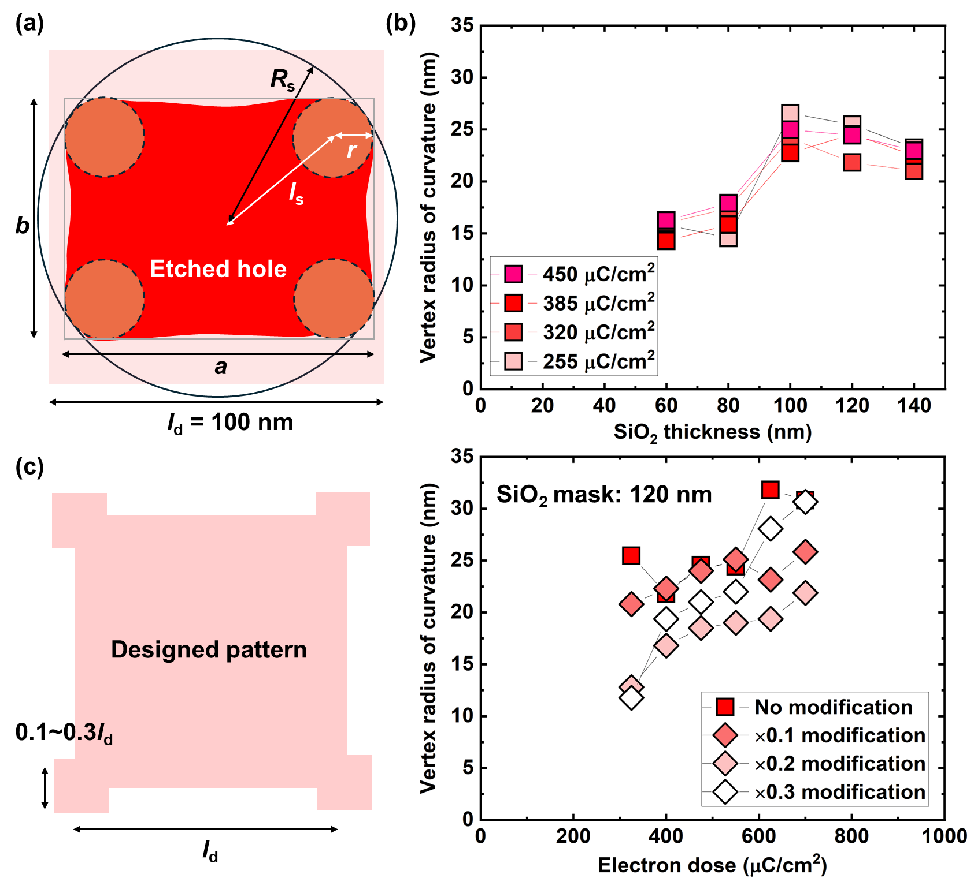
To enhance the electron exposure at the vertex of square patterns, small auxiliary squares were added at all vertexes of the original square, as shown in Fig. 3 (c). ^{15,37)} The sizes of the auxiliary squares were 0.1, 0.2, and 0.3 times the size of the original square. The D was varied between 325 and 700 μC/cm². The D < 400 μC/cm² formed the small hole areas due to the underdose. For 400 μC/cm² ≤ D ≤ 700 μC/cm², the expected hole size was obtained for all patterns. The r of the square pattern without shape modification was almost constant at 23±1 nm. For D ≥ 625 μC/cm², the r increased with increasing the D due to the overdose, corresponding to the results of hole size. The r was reduced by adding 0.2-times auxiliary squares due to the enhanced electron exposure, while that was increased by adding 0.3-times auxiliary squares was ineffective due to the overdose. We found that the 100-nm-size square air holes with the $r_{a}$ close to the designed pattern and the minimum r of 17 nm were fabricated in GaN at t = 120 nm and D = 400 μC/cm² by adding 0.2-times auxiliary squares at the vertex.
Fig. 3: (a) Schematic images of designed and fabricated square patterns. (b) Relation of curvature radius for square air holes with a diameter of 100 nm via SiO₂ mask thickness. Electron dose varied between 255 and 450 μC/cm². (c) Schematic image of modified square pattern and relation of curvature radius for square air holes with a side length of 100 nm via electron dose. The SiO₂ mask thickness was 120 nm. Electron dose varied between 325 and 700 μC/cm². "×0.1 modification" represents data for square patterns where auxiliary shapes of 0.1 times the size of the original design were added to the vertex.
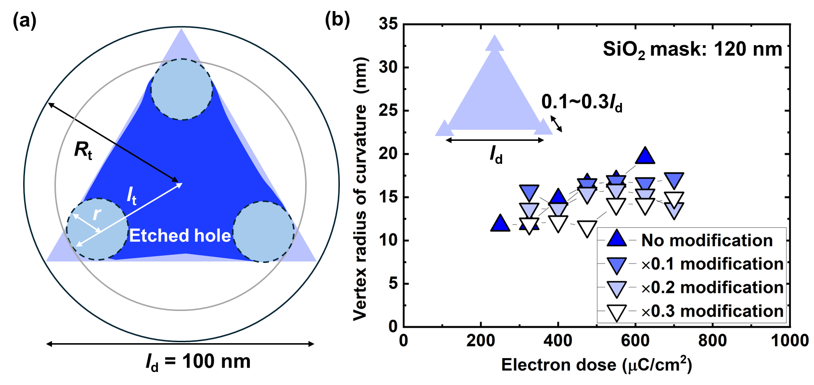
Based on the model shown in Fig. 4 (a), we calculate the r of the fabricated air hole for a designed equilateral triangular pattern with side lengths of l_{d}. From the SEM images, we determined the radius (l_{t}) of the circumscribed circle for the fabricated hole and the radius (R_{t} $(=r+l_{t})$) of the circumscribed circle for the ideal triangular hole. The calculated r of the air holes for triangular patterns with l_{d} = 100 nm as a function of D = 250-700 μC/cm² is shown in Fig. 4 (b). For 400 μC/cm² ≤ D ≤ 700 μC/cm², the expected hole size was obtained for all patterns. The r of the triangular holes was smaller than that of the square holes because of the smaller vertex angle. The r slightly increased with increasing the D. The r reduced with increasing the size of the auxiliary triangles due to the enhanced electron exposure at the vertex. We found that the 100-nm-size triangular air holes with the $r_{a}$ close to the designed pattern and the minimum r of 11 nm were fabricated in GaN at t = 120 nm and D = 475 μC/cm² by adding 0.2-times auxiliary triangles at the vertex.
Fig. 4: (a) Schematic images of designed and fabricated equilateral triangular patterns. (b) Relation of curvature radius for triangular air holes with a side length of 100 nm via electron dose. The schematic image of modified triangular pattern is inserted. Electron dose varied between 250 and 700 μC/cm². "×0.1 modification" represents data for square patterns where auxiliary shapes of 0.1 times the size of the original design were added to the vertex.
The SEM images of the circular, square, and triangular holes fabricated under the optimum conditions are shown in Fig. 5. We achieved the 100-nm-size circular holes with the r_{a} of 1±0.1, the 100-nm-size square holes with the r_{a} of 1±0.1 and the minimum r of 17 nm, and the 100-nm-size triangular holes with the r_{a} of 1±0.1 and the minimum r of 11 nm, which is comparable to or less than the other reports. ^{11,38,39)} The size and shape of the air holes were uniform in the 20 μm ×20 μm area. This homogeneity of the air hole distribution can form the high-efficient topological PhC waveguides. In the simulation, the 100-nm-size triangular holes with the r of 11 nm can generate a topological edge state at red wavelength. However, the topological PhC waveguides at green and blue wavelength require the r < 10 nm (supplementary data). Further optimization of etching conditions and thinner hard masks are necessary for the high-efficiency topological PhC waveguides at visible light wavelength.
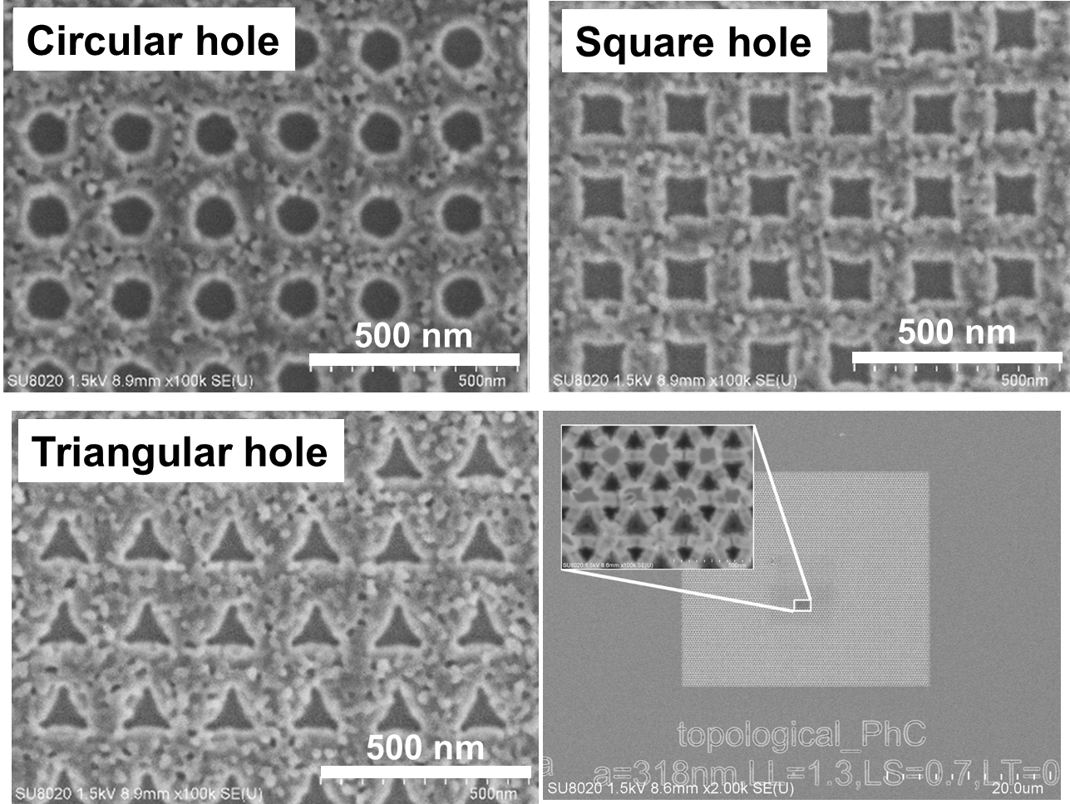
Fig. 5: SEM images of circular, square, and triangular air holes, and topological PhC waveguide with honeycomb arrays. The circular holes were fabricated at t = 120 nm and D = 512 μC/cm². The square holes were fabricated at t = 120 nm and D = 400 μC/cm² by adding 0.2-times auxiliary squares at the vertex. The triangular holes were fabricated at t = 120 nm and D = 475 μC/cm² by adding 0.3-times auxiliary triangles at the vertex. The diameter of circular holes and the side length of square and triangular holes in designed pattern were 100 nm.
4. Conclusions
We fabricated arrays of circular, square, and triangular air holes in GaN by the conventional method using the electron beam lithography and reactive ion etching. The vertex radius of curvature for the polygonal air holes was reduced by using the shape-modification PECs. We achieved the 100-nm-size circular holes with the r_{a} of 1±0.1, the 100-nm-size square holes with the r_{a} of 1±0.1 and the minimum r of 17 nm, and the 100-nm-size triangular holes with the r_{a} of 1±0.1 and the minimum r of 11 nm. The modified triangular holes have enough high accuracy to generate a topological edge state at red wavelength.

Acknowledgements
The author thanks Prof. Shuhei Ichikawa for his fruitful discussion. This work was financially supported by JSPS KAKENHI Grant Number 23H01863, the TRiSTAR program under the Strategic Professional Development Program for Young Researchers by MEXT, and the 'Advanced Research Infrastructure for Materials and Nanotechnology in Japan (ARIM)' project of MEXT (No. JPMXP1223BA0011). The processing was carried out at open facility of the National Institute for Materials Science and the University of Tsukuba.

References
1. L. Lu, J. D. Joannopoulos, and M. Soljačić, Nat. Photonics 8, 821 (2014).
2. E. Nussbaum, E. Sauer, and S. Hughes, Opt. Lett. 46, 1732 (2021).
3. M. I. Shalaev, W. Walasik, A. Tsukernik, Y. Xu, and N. M. Litchinitser, Nat. Nanotech. 14, 31 (2019).
4. L. H. Wu and X. Hu, Phys. Rev. Lett. 114, 223901 (2015).
5. Y. Yang, Y. F. Xu, T. Xu, H. X. Wang, J. H. Jiang, X. Hu, and Z. H. Hang, Phys. Rev. Lett. 120, 217401 (2018).
6. S. Iwamoto, Y. Ota, and Y. Arakawa, Opt. Mater. Express 11, 319 (2021).
7. Z. K. Shao, H. Z. Chen, S. Wang, X. R. Mao, Z. Q. Yang, S. L. Wang, X. X. Wang, X. Hu, and R. M. Ma, Nat. Nanotech. 15, 67 (2020).
8. S. Okada, H. Kagami, N. Nishiyama, X. Hu, and T. Amemiya, Opt. Express 31, 35218 (2023).
9. H. Kagami, T. Amemiya, S. Okada, N. Nishiyama, and X. Hu, Opt. Express 28, 33619 (2020).
10. T. Amemiya, S. Okada, H. Kagami, N. Nishiyama, Y. Yao, K. Sakoda, and X. Hu, Opt. Lett. 47, 2430 (2022).
11. K. Yoneta, K. Abe, T. Kudou, and A. Kikuchi, Jpn. J. Appl. Phys. 61, SC1078 (2022).
12. S. Okada, T. Amemiya, H. Kagami, Y. Wang, N. Nishiyama, and X. Hu, J. Opt. Soc. America B 39, 2464 (2022).
13. S. Okazaki, Microelectron Eng. 133, 23 (2015).
14. R. Murali, “Proximity Effect in E-beam Lithography 1 Proximity Effect in E-beam Lithography.” (2005).
15. W. Yao, H. Xu, H. Zhao, M. Tao, and J. Liu, Microelectronics J. 133, 105718 (2023).
16. M. Eissa, T. Mitarai, T. Amemiya, Y. Miyamoto, and N. Nishiyama, Jpn. J. Appl. Phys. 59, 126502 (2020).
17. W. Yao, H. Zhao, C. Hou, W. Liu, H. Xu, X. Zhang, J. Xiao, and J. Liu, IEEE TCAD 42, 218 (2023).
18. D. A. Stocker, E. F. Schubert, and J. M. Redwing, Appl. Phys. Lett. 73, 2654 (1998).
19. M. Itoh, T. Kinoshita, C. Koike, M. Takeuchi, K. Kawasaki, and Y. Aoyagi, Jpn. J. Appl. Phys. Part 1 45, 3988 (2006).
20. F. Horikiri, N. Fukuhara, H. Ohta, N. Asai, Y. Narita, T. Yoshida, T. Mishima, M. Toguchi, K. Miwa, and T. Sato, Appl. Phys. Exp. 12, 031003 (2019).
21. R. Kita, R. Hachiya, T. Mizutani, H. Furuhashi, and A. Kikuchi, Jpn. J. Appl. Phys. 54, 046501 (2015).
22. Y. Zhang, M. Sun, Z. Liu, D. Piedra, J. Hu, X. Gao, and T. Palacios, Appl. Phys. Lett. 110, 193506 (2017).
23. N. Al Taradeh, E. Frayssinet, C. Rodriguez, F. Morancho, C. Sonneville, L. V. Phung, A. Soltani, F. Tendille, Y. Cordier, and H. Maher, Energies 14, 4241 (2021).
24. S. J. Pearton, R. J. Shul, and F. Ren, MRS Internet Journal of Nitride Semiconductor Research 5, 11 (2000).
25. T. Wu, Z. B. Hao, G. Tang, and Y. Luo, Jpn. J. Appl. Phys. Part 2 42, (2003).
26. H. S. Kim, G. Y. Yeom, J. W. Lee, and T. I. Kim, J. Vac. Sci. & Tech. A 17, 2214 (1999).
27. C. D. Frye, C. E. Reinhardt, S. B. Donald, L. F. Voss, and S. E. Harrison, Mater. Sci. Semicond. Process. 144, 106564 (2022).
28. Y. Sun, X. Kang, Y. Zheng, K. Wei, P. Li, W. Wang, X. Liu, and G. Zhang, Nanomaterials 10, 657 (2020).
29. L.-B. Chang, S.-S. Liu, and M.-J. Jeng, Jpn. J. Appl. Phys. Part 1 40, 1242 (2001).
30. M. Guilmain, A. Jaouad, S. Ecoffey, and D. Drouin, Microelectron Eng. 88, 2505 (2011).
31. M. A. Rad, K. Ibrahim, and K. Mohamed, Superlattices Microstruct. 51, 597 (2012).
32.T. Ohiwa, K. Horioka, T. Arikado, I. Hasegawa, H. Okano, Jpn. J. Appl. Phys. Part 1 31, 405 (1992).
33. S. Zhou, B. Cao, and S. Liu, Appl. Surf. Sci. 257, 905 (2010).
34. A. S. Gangnaik, Y. M. Georgiev, and J. D. Holmes, Chemistry of Materials 29, 1898 (2017).
35. A. N. Broers, A. C. F. Hoole Andrew, and J. M. Ryan, Microelectron Eng. 32, 131 (1996).
36. V. R. Manfrinato, J. Wen, L. Zhang, Y. Yang, R. G. Hobbs, B. Baker, D. Su, D. Zakharov, N. J. Zaluzec, D. J. Miller, E. A. Stach, and K. K. Berggren, Nano Lett. 14, 4406 (2014).
37. G. Chen, S. Li, and X. Wang, Opt. Express 29, 17440 (2021).
38. D. R. Danielsen, A. Lyksborg-Andersen, K. E. S. Nielsen, B. S. Jessen, T. J. Booth, M. H. Doan, Y. Zhou, P. Bøggild, and L. Gammelgaard, ACS Appl. Mater. Interfaces 13, 41886 (2021).
39. S. Okada, T. Amemiya, H. Kagami, Y. Wang, N. Nishiyama, and X. Hu, J. Opt. Soc. of America B 39, 2464 (2022).

