Interfacial thermal resistance of metal-nonmetal interfaces under bidirectional heat fluxes
Yen-Ju Wu^{i,ii}, Takashi Yagi^{iii}, Yibin Xu^{ii*}
i International Center for Young Scientists (ICYS), National Institute for Materials Science (NIMS), 1-2-1 Sengen, Tsukuba, Ibaraki 305-0047, Japan
ii Center for Materials research by Information Integration (CMI2), Research and Services Division of Materials Data and Integrated System (MaDIS), National Institute for Materials Science (NIMS), 1-1 Namiki, Tsukuba, Ibaraki 305-0044, Japan
iii Research Institute for Material and Chemical Measurement, National Institute of Advanced Industrial Science and Technology (AIST), 1-1-1 Higashi, Tsukuba, Ibaraki 305-8565, Japan
*Corresponding Author
Yibin Xu, XU.Yibin@nims.go.jp

ABSTRACT
Interfacial thermal resistance (ITR) at metal/nonmetal interfaces is a crucial issue affecting the efficiency of electronic devices. We investigated the ITR of Ni/Al₂O₃ and W/Al₂O₃ interfaces under the influence of bidirectional heat fluxes, with the heat flowing from the metal to the nonmetal and vice versa, using the time domain thermoreflectance technique. An asymmetric ITR was first experimentally observed such that the ITR was larger by a factor of 1.4–1.9 when the heat was applied from the nonmetal side, relative to the metal side. The additional interfacial electron–phonon couplings induced by the temperature difference between the hot electrons and phonons, which occur upon heating from the metal side, could be one of the plausible reasons causing the asymmetry. The thermal contribution of the interfacial electron–phonon coupling is found to be comparable with the phonon–phonon coupling. This new approach may allow us to elucidate thermal rectification at metal/nonmetal interfaces, thus leading to the development of light-controlled thermal diodes.
KEYWORDS
Interfacial thermal resistance, electron-phonon coupling, phonon diodes, hot electron, light-controlled devices.

1. INTRODUCTION
Understanding the interfacial thermal properties is an important merit to improve the efficiency and performance for many applications, e.g., photovoltaic conversion[1], thermoelectric efficiency[2], and thermal management of electronics[3]. The interfacial thermal resistance (ITR) refers to the temperature discontinuity at an interface that occurs upon the application of heat flux. We can express this as ITR = ∆T/Q, where Q is the applied heat flux and ∆T is the temperature difference at the interface. The acoustic mismatch model (AMM) and diffusive mismatch model (DMM) have been utilized for predicting the ITR.[4] The former is often used for predicting the ideal interface while the latter is applied to actual interfaces with roughness, impurities, or lattice mismatches. However, the DMM incurs the over- and underpredictions at the interfaces with various degrees of similarity in terms of their phonon spectra[5], since the assumption of the phonons undergoing elastic scattering and the exclusion of electronic contribution results in failure as these factors play a dominant role, similar to the case of metal/nonmetal interfaces where the heat carriers are phonons and electrons in nonmetals and metals, respectively. There are two possible heat paths at the metal/nonmetal interfaces, one being the electron–phonon coupling at the metal side in series with the phonon–phonon coupling across the interface, and the other being the interfacial coupling between the electrons in the metal and the phonons in the nonmetal[6, 7], as shown in Fig. 1 (a). The thermal resistance of phonon–phonon coupling arises owing to the elastic and inelastic scatterings. The contributions of the thermal resistances of the two aforementioned heat paths (see Fig. 1 (a)) on the ITR have been debated for decades.
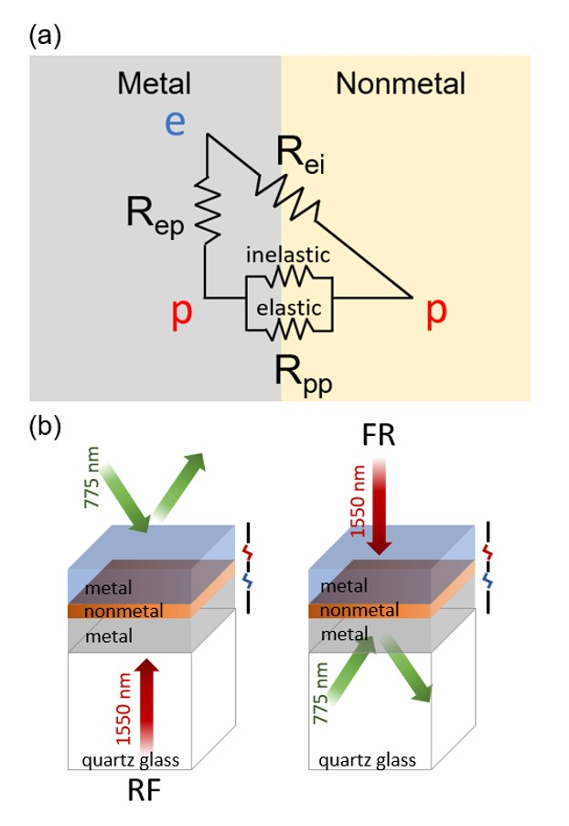
Figure 1 (a) Interfacial heat paths at the metal/nonmetal interface. R_{ep} represents the thermal resistance arising due to the electron–phonon coupling at the metal side in series with the resistance of the phonon–phonon coupling, R_{pp}, owing to the both inelastic and elastic scattering. R_{ei} represents the thermal resistance arising due to the direct interfacial coupling between the electrons (metal) and phonons (nonmetal). (b) Schematic representation of the time dependence thermoreflectance (TDTR) measurement by the rear heating-front detection (RF) and front heating-rear detection (FR) sides, using a 1550-nm pump laser and 775-nm probe laser.

A large discrepancy in the experimental and theoretical results, obtained for the ITR at metal/nonmetal interfaces was observed by Stoner and Maris in 1993.[8] They reported that the extra interfacial conductance observed with the measurements taken for the Pb/diamond and Pb/sapphire interfaces corresponds to the inelastic phonon–phonon scattering and the anharmonicity of the metal. Later, this inelastic phonon–phonon coupling effect was also found to be dominant in the interfacial thermal transport at other interfaces composed of highly dissimilar (phonon spectra) materials, thus resulting in a higher interfacial thermal conductance that exceeded the theoretical values.[9-12] In 1994, another heat path allowing direct energy transfer between electrons in metals and phonons in nonmetals was proposed by Huberman and Overhauser, to explain the discrepancy between the simulations and experiments for the Pb/diamond interface. This heat path was based on the joint vibrational mode of the nonmetals with a higher phonon-mean free path.[13] In 1998, Sergreev reported that this additional heat path is produced by the inelastic electron-boundary scattering and becomes significant with a large lattice mismatch between the phonon spectra and/or stronger e-p coupling.[14] This interfacial electron–phonon heat path was found in several interfaces, e.g., Au/Si,[15] CoSi₂/Si,[16] TiSi₂/Si,[17] and Cu/Si.[18] The direct electron–phonon interaction was also attributed to the surface state mediation in a region near the interface.[19, 20] On the other hand, the effect of electron–phonon coupling at a metal (see R_{ep} in Fig. 1 (a)) was addressed by Majumdar and Reddy in 2004 who set out to increase the thermal resistance at TiN/MgO which could be approximated by the electron–phonon coupling constant and phonon thermal conductivity of the metal.[6] Instead of increasing the thermal resistance, it was found that the electron–phonon coupling at the metal can enhance the energy communications between the phonon subsystems and make the interfacial thermal conductance greater than that of a pure phonon transport system.[21]
The discussions on thermal transport mechanisms mentioned above were based on a comparison between the results of simulations and experiments, or of those obtained using different samples. However, the complexity and uncertainty in the structural properties at interfaces make it challenging to directly compare the results of simulations and experiments. The interfaces of actual samples usually differ greatly from those of ideal interfaces assumed by a simulation. Also, the preparation methods cause discrepancies between the samples. For example, the ITRs of Au/sapphire exhibit different temperature dependencies between the epitaxial[22] and non-epitaxial samples.[8, 23] Although the electronic thermal contribution to the ITR of metal/nonmetal interfaces has been investigated for decades, the heat transport mechanisms at different metal/nonmetal interfaces remain a subject of contention. All the reported experimental work focuses on the one-directional heat flux from a metal to a nonmetal, since metal is used as the heat transducer in laser absorption and detection in the transient thermoreflectance technique (pump–probe method). In particular, the ITR of metal/nonmetal interfaces with heating from the nonmetal to the metal side has not yet been investigated.
Accordingly, the goal of this work was to investigate the ITR of metal/nonmetal interfaces subjected to bidirectional heat fluxes from both sides, i.e., the metal to nonmetal and nonmetal to metal directions. To apply the bidirectional heat fluxes to a given sample while eliminating the effects of sample differences, we used a sandwich structure (metal/nonmetal/metal) which is capable of absorbing heat from a pump laser applied to either the front or rear of the sandwich. Also, the ITRs were measured using transient thermoreflectance by switching the sample direction between the front and rear sides. Here, we used Ni/Al₂O₃ and W/Al₂O₃ interfaces since the thermoreflectance values for both Ni and W were available and Al₂O₃ is often used as a dielectric layer, adhesion layer, passivation layer, or blocking layer in electronic devices. The ITRs and thermophysical properties were determined over a temperature range of 100 to 300 K using the TDTR technique. Then, the sensitivity of the thermophysical properties was analyzed to determine their effects on the overall thermoreflectance. Also, the effects of the thermal contribution including the electron–phonon coupling at the metal, as well as the interfacial electron–phonon coupling on the ITR were discussed and compared with other references. The spatial and temporal distribution of electron and phonon temperatures were simulated at 300 K by the two-temperature model. Finally, the thermal resistances of each of the heat paths, when subjected to bidirectional heat fluxes, were estimated from the experimental results and the corresponding thermal circuit.

2. EXPERIMENTAL PROCEDURE
The samples were prepared on quartz glass substrates by using a sputtering technique (CFS-4EP-LL, Shibaura Mechatronics Corp.) at a pressure of around 6 × 10⁻⁵ Pa before deposition. The pressure was maintained at 0.4 Pa (Ar flow of 20 sccm) during the deposition process. The Al₂O₃ layer was deposited with an RF power of 200 W, while the Ni and W layers were deposited with a DC power of 50 and 100 W, respectively. The sandwich structures of the Ni/Al₂O₃/W and W/Al₂O₃/Ni were continuously deposited on the quartz glass substrates without any exposure to the atmosphere. The sputtered thicknesses of Ni, Al₂O₃, and W were 100, 10, and 100 nm, respectively. The total thickness was characterized using a surface profiler (Dektak-III, Sloan Tech.), while the density and thickness of each sandwich layer was analyzed using X-ray reflectivity (XRR function, Rigaku Corporation) and transmission electron microscopy (TEM, JEM2100F, JEOL Ltd.), respectively. The structural properties of the thin film were characterized using X-ray diffraction (Smartlab, Rigaku Corp.)
The ITR measurements were carried out using the pulsed-laser TDTR technique with a 1550-nm pump laser (5.3 mW, 20 MHz, spot diameter: 52 μm, pulse: 0.5 ps) and a 775-nm probe laser (1.5 mW, 20 MHz, spot diameter: 25 μm, pulse: 0.5 ps), in the range of 100 to 300 K (Fig. 1 (b)). The modulation frequency of the pump laser was 200 kHz. The delay between the pump and probe lasers was electronically controlled by an arbitrary function generator with a resolution of 1 ps. The lock-in thermoreflectance signals for the phase and amplitude were determined by implementing a previously reported simulation model[24-26]. The heat conduction was assumed to be one-dimensional due to the laser spot being much larger than the film thickness. The sandwich sample was measured by applying a heat flux from both the bidirectional heating and detective sides (RF and FR), as shown in Fig. 1 (b). First, we resolved the thermophysical properties of the volumetric heat capacity, thermal diffusivity, absorption coefficient and substrate effusivity by fitting the thermoreflectance signals of each (100-nm) single layer (Ni, W/quartz glass substrate). Also, we obtained the consistent thermophysical properties of the same single layer by applying a heat flux from the bidirectional sides, that is, we confirmed the ability to compare the ITR values using the RF and FR sides. The resolved thermophysical properties are listed in Table 1. Then, the ITRs of both the Ni/Al₂O₃ and W/Al₂O₃ interfaces of the sandwich structure were analyzed by utilizing the resolved thermophysical properties.
Table 1 Thermophysical properties of Ni, W, and Al₂O₃ used in the TDTR fitting.
 | Volumetric Heat capacity | Thermal diffusivity | Density | Thickness
unit | J/m³ K | m²/s | g/cm³ | nm
Ni | 3.98 × 10⁶ | 2.1 × 10⁻⁵ | 8.84 | 82
W | 2.55 × 10⁶ | 6.2 × 10⁻⁵ | 19.62 | 104
Al₂O₃ | 2.21 × 10⁶ | 4.4 × 10⁻⁶ | 2.83 | 9.66

3. RESULTS
Before measuring the ITRs of the sandwich structures, the thermal parameters of volumetric heat capacity and thermal diffusivity were characterized for each material by fitting the thermoreflectance signals obtained using a previously reported simulation model[24-26]. To simplify the parameter resolution, a single-layer sample was used for each of the Ni and W layers, after which the W/Al₂O₃/W and Ni/Al₂O₃/Ni structures were used to characterize the Al₂O₃. The specific heat capacity can be derived from the measured volumetric heat capacity and density (as obtained by XRR). The densities of the Ni (8.84 g/cm³), W (19.62 g/cm³), and Al₂O₃ (2.83 g/cm³) layers listed in Table 1 and are comparable with the reported values: 8.9 for Ni,[27] 19.3 for W,[28] and 2.95 for Al₂O₃ [29](g/cm³)). The volumetric heat capacity of the amorphous Al₂O₃ was found to be 2.21 × 10⁶ J/m³K, which is in good agreement with the 2.39 × 10⁶ J/m³K value reported by Kawasaki et al.[28] The ITRs of the metal/nonmetal interfaces were implemented by switching the front and rear sides of the sample between the pump and probe laser to introduce the bidirectional (opposing) heat fluxes. In other words, one is heating the front and detecting at the rear (FR), while the other is heating the rear and detecting at the front (RF), as illustrated in Fig. 1 (b). W/quartz glass was used to check whether we can achieve the same fitted thermophysical properties for any one given material using the FR and RF measurements. The volumetric heat capacity (Cv) and thermal diffusivity (α) of the W layer were found to be consistent with the application of the bidirectional heat flux: Cv = 2.55 ± 0.02 × 10⁶ J/m³K and α = 1.94 ± 0.1 × 10⁻⁵ m²/s for FR and Cv = 2.55 ± 0.01 × 10⁶ J/m³K and α = 1.94 ± 0.05 × 10⁻⁵ m²/s for RF. The consistent thermophysical properties confirm that the reflectivity of the metal/quartz glass interface changes rarely. Therefore, we can use the FR and RF techniques and the determined thermophysical properties by fitting the lock-in thermoreflectance signals in Table 1 to investigate the ITRs of the sandwich structures.
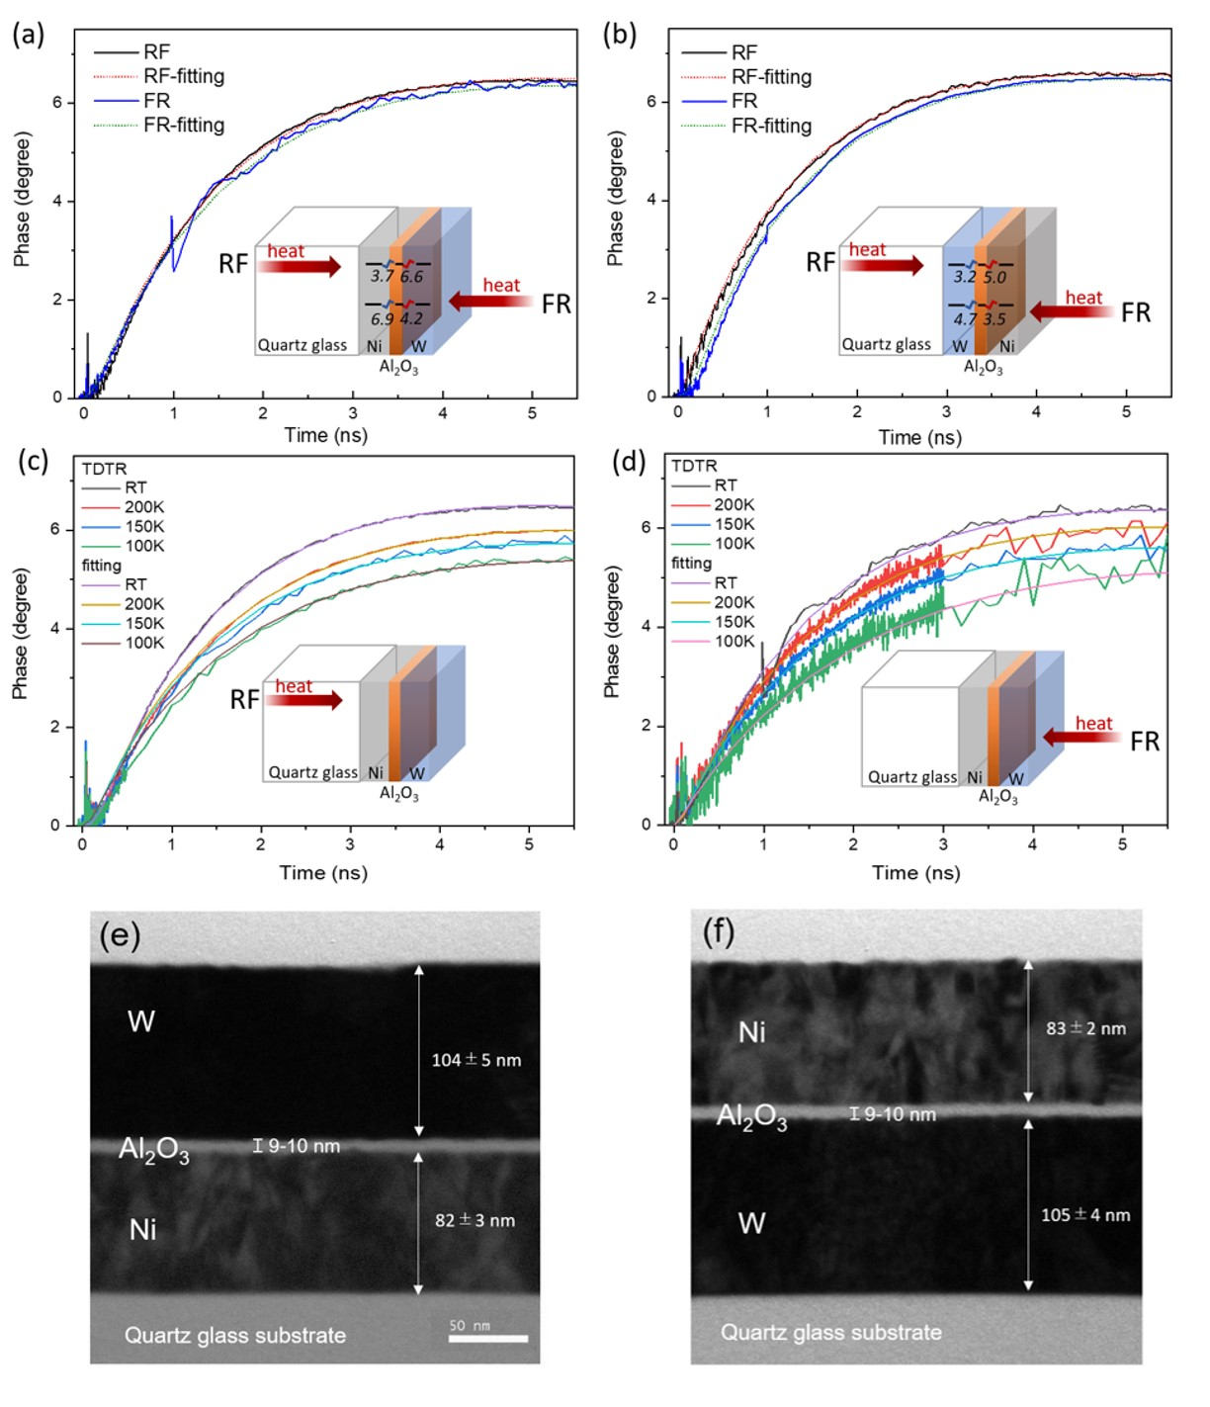
Figure 2 Thermoreflectance change versus delay, fitted using the one-dimensional heat conduction model. Experimental curves (solid line) and fits from the multilayer thermal transport model (dot line) for the (a) W/Al₂O₃/Ni/quartz glass substrate and (b) Ni/Al₂O₃/W/quartz glass substrate. The inner illustration of (a) and (b) shows the sample under RF and FR measurements and the corresponding ITRs, which can be also found in Table 2. Experimental thermoreflectance and fits of W/Al₂O₃/Ni/quartz glass substrate under (c) RF and (d) FR are observed from 100 K to room temperature (RT). The inset of (c) and (d) shows the heating direction on the sample, and the corresponding ITRs can be found in Table 3. The TEM image of (e) the W/Al₂O₃/Ni/quartz glass substrate, corresponds to the results of (a)(c)(d), while (f), Ni/Al₂O₃/W/quartz glass substrate, corresponds to the result of (b).
Fig. 2 shows the thermoreflectance signals of the phase with the fitting curves of (a) W/Al₂O₃/Ni and (b) Ni/Al₂O₃/W on quartz glass substrates as obtained from the FR and RF measurements at 300 K. The measured ITRs for the two samples are listed in Table 2. The ITRs of W/Al₂O₃ are in the range of 3.2 to 4.2 × 10⁻⁹ m²K/W, which is in good agreement with the 3.8 × 10⁻⁹ m²K/W value reported by Costescu et al.[30] Interestingly, asymmetric ITRs were observed for the W/Al₂O₃ and Ni/Al₂O₃ interfaces in both the sandwich structured samples. The consistent tendency of the ITRs confirms the asymmetry at the metal/nonmetal interfaces. All the ITRs are greater by a factor of 1.4–1.9 in the case of heating from the nonmetal side (Al₂O₃/W and Al₂O₃/Ni), relative to the heating from the metal side (W/Al₂O₃ and Ni/Al₂O₃), i.e., factor=ITR_{nonmetal→metal}/ ITR_{metal→nonmetal}.

Table 2 ITRs measured by TDTR at 300 K under RF and FR measurements. The interface shows the heat flux direction, i.e. the W/Al₂O₃ interface represents the ITR in the case of heating from the W to Al₂O₃ sides.
ITR  (m²K/GW) | W/Al₂O₃ | Al₂O₃/W | Ni/Al₂O₃ | Al₂O₃/Ni
W/Al₂O₃/Ni/quartz glass | 4.2 | 6.6 | 3.7 | 6.9
Ni/Al₂O₃/W/quartz glass | 3.2 | 4.7 | 3.5 | 5.0

Next, we analyzed the W/Al₂O₃/Ni/quartz glass which exhibits a greater asymmetry from 100 to 300 K. Fig. 2 (c) and (d) show the thermoreflectance signals of the phase with the fitting curves of W/Al₂O₃/Ni/quartz glass when subjected to bidirectional heat fluxes caused by heating from the rear (RF in Fig. 2(c)) and the front (FR in Fig. 2(d)). Note that the vibrations in the thermoreflectance signals due to the coherent phonon of the quartz substrate was observed in the FR measurements. The vibration mode was eliminated from the signal using our original signal processing, but some noise remained as shown in Fig. 2(d). The cross-section of the TEM images can be observed in Fig. 2(e) and (f), and the measured thicknesses were used in the TDTR-fitting(see Table 1). The measured ITRs, listed in Table 3, are such that both the Ni/Al₂O₃ and W/Al₂O₃ interfaces exhibit significant asymmetric properties from 100 to 300 K. The ITRs increase as the temperature decreases since fewer phonons participate in the heat transport. Fig. 3(a) shows the ITR values of the two interfaces (square: Ni/Al₂O₃, triangle: W/Al₂O₃) under the influence of bidirectional heat fluxes from 100 to 300 K. As the heat flux originates from the nonmetal side (red), the ITRs range from 6.6–16 × 10⁻⁹ m²K/W, exceeding the 3.7–8.7 × 10⁻⁹ m²K/W value obtained for heating from the metal side (blue). The ITRs of Al₂O₃/W and Ni/Al₂O₃ at 100 and 150 K exhibit larger error bars corresponding to the slight deviation in the thermoreflectance fitting for a delay of ≤ 2 ns (see Fig. 2 (c)) while those of the others exhibit little deviation (< ±1% of the fitted ITRs).
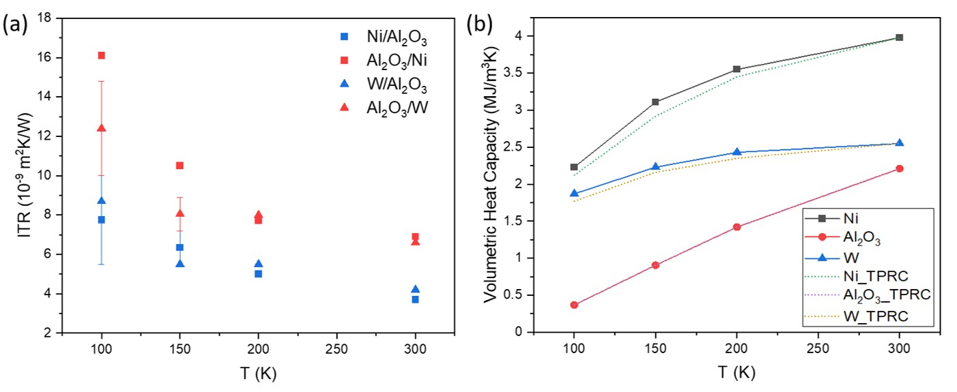
Figure 3 (a) ITRs of the two interfaces of Ni/Al₂O₃ and W/Al₂O₃ at different temperatures. The ITRs were measured at the W/Al₂O₃/Ni/quartz glass sample under FR and RF measurements, corresponding to the ITRs values listed in Table 3. The ITRs are all higher in the case of heating from the nonmetal side (red; Al₂O₃/Ni, Al₂O₃/W) relative to heating from the metal side (blue; Ni/Al₂O₃, W/Al₂O₃). Error bars indicate the standard deviations in data fitting. (b) Volumetric heat capacity against temperature. The solid line is the volumetric heat capacity as measured from the thermoreflectance signal, while the dashed line is calculated from the specific heat capacity in the TPRC data series with the density.

Table 3 ITRs of W/Al₂O₃/Ni/quartz glass measured from 100 to 300 K by TDTR. The interface shows the heat flux direction, i.e. the W/Al₂O₃ interface represents the ITR in the case of heating from the W to Al₂O₃ sides.
ITR  (m²K/GW) | W/Al₂O₃ | Al₂O₃/W | Ni/Al₂O₃ | Al₂O₃/Ni
300 K (RT) | 4.2 | 6.6 | 3.7 | 6.9
200 K | 5.5 | 8.0 | 5.0 | 7.7
150 K | 5.5 | 8.05 ± 0.85 | 6.35 ± 0.85 | 10.5
100 K | 8.7 | 12.4 ± 2.4 | 7.75 ± 2.25 | 16.0

The volumetric heat capacity determined from the thermoreflectance signals was compared with the values in the TPRC data series[31] (Fig. 3(b)). The small differences and similar correlations in the measured temperatures (solid curves) and TPRC data [31] (dashed curves) from 100 to 300 K reveal that our data is in good agreement with those presented in the thermophysical handbook. The measured volumetric heat capacity, thermal diffusivity, and effusivity of the substrates, determined from the fitting of thermoreflectance signals at various temperatures, are listed in Table 4. The thermal diffusivity decreases with an increase in the temperature, whereas the volumetric heat capacity and effusivity increase with an increase in the temperature. Further, as the temperature increases, the phonon population also increases and Umklapp scattering becomes the dominant source of phonon scattering near and above the room temperature, resulting in a shorter phonon mean free path. This supports the gradual decline of the thermal conductivity from 100 to 300 K, which can be evaluated by multiplying the volumetric heat capacity and thermal diffusivity listed in Table 4.
Table 4 Thermophysical properties derived from the TDTR measurements from 100 to 300 K.
Thermal diffusivity (× 10⁻⁵ m²/s) | 100 K | 150 K | 200 K | 300 K
Ni | 3.55 | 3.4 | 3.2 | 2.1
W | 9.7 | 8.9 | 7.7 | 6.2
Al₂O₃ | 6.53 | 5.3 | 0.98 | 0.44
Volumetric heat capacity (× 10⁶ J/m³ K) | 100 K | 150 K | 200 K | 300 K
Ni | 2.23 | 3.11 | 3.55 | 3.98
W | 1.87 | 2.23 | 2.43 | 2.55
Al₂O₃ | 0.37 | 0.91 | 1.42 | 2.21
Effusivity (J/s^{0.5} m²K) | 100 K | 150 K | 200 K | 300 K
Quartz glass | 633 | 912 | 1160 | 1510

To check the accuracy of the estimated ITRs, we also estimated the sensitivity (S) of the thermophysical properties (p) involved in the TDTR calculations. The sensitivity is that of the measured thermoreflectance signals to these properties. If the sensitivity is larger, then the thermoreflectance signals are strongly dependent on that property while a sensitivity that is close to zero indicates that the thermoreflectance signals are not affected by that property. Therefore, the sensitivity is a useful factor for ensuring accurate results. We evaluated the sensitivity from the logarithmic derivatives of the lock-in phase signal (φ) with respect to the selected properties, as given by equation (1).[32]
$$S_{p}=\frac{d(lnφ)}{d(lnp)} .(1)$$
The lock-in phase signal (φ) via TDTR is carried by the probe laser over a delay and computed as the ratio of the in-phase V_{in} and out-of-phase V_{out} signals (-V_{in}/V_{out}), which is represented by φ = tan⁻¹ (V_{out}/V_{in}). The thermophysical properties (p) include the volumetric heat capacity (Cv), interfacial thermal resistance (ITR), thermal diffusivity (α), and effusivity (ε) of the substrate. We perturbed the p individually and slightly by 1% while the other properties were kept constant. The sensitivity defined in equation (1) to the thermophysical properties of W/Al₂O₃/Ni/quartz glass substrate as a function of the delay is shown in Fig. 4. The sensitivity analysis reveals the most sensitive time range for each parameter, specifically, that Cv and ITR are sensitive over a delay range of 0.1–10 ns while α is sensitive over a delay range of 0.1–1 ns. For both the FR and RF measurements, shown in Fig. 4 (a) and (b), the Cv, ITR, and α change considerably depending on the delay while ε barely changes. The sensitivities of Cv and α of Al₂O₃ are much lower than those of Ni and W due to its small thickness, resulting in it making less contribution to the total thermoreflectance. Here, Cv and α of each material, and ε are prescribed by a single-layer sample corresponding to the TPRC data series.[31] Therefore, only the unknown ITRs are tuned for fitting the measured thermoreflectance signals of sandwiched structure samples. Note also that the sensitivity of the ITRs is as large as that of Cv for both the FR and RF cases, pointing to the importance of ITR determination and the accuracy of the ITR estimation under bidirectional heat fluxes via TDTR signals.
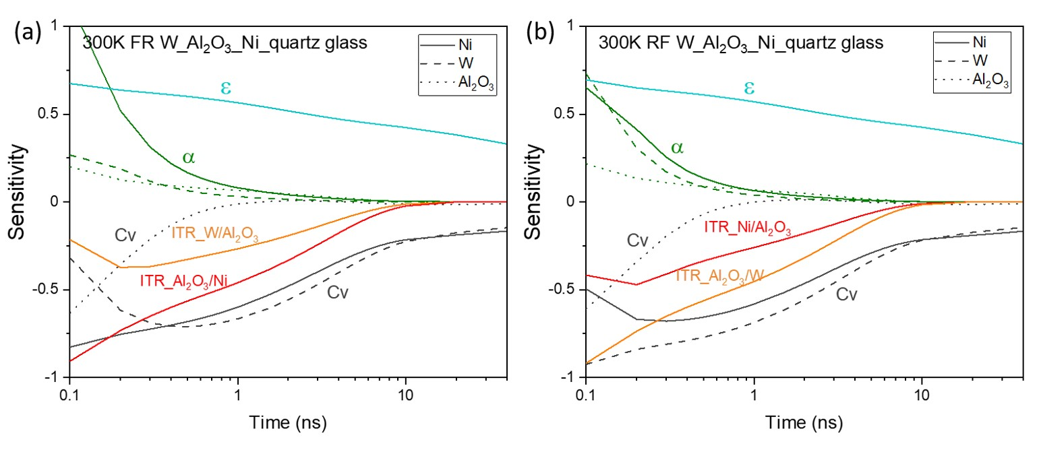
Figure 4 Sensitivity of thermophysical parameters as a function of delay (equation (1)). The TDTR signals are implemented on a W/Al₂O₃/Ni/quartz glass substrate under (a) FR and (b) RF measurements at 300 K. Cv, ITR, α, and ε represent the volumetric heat capacity (grey), interfacial thermal resistance, thermal diffusivity (green), and effusivity (light blue), respectively. Cv and α are shown as a solid line for Ni, a dashed line for W, and a dotted line for Al₂O₃.

4. DISCUSSIONS
4.1 Assumptions of asymmetry
For an asymmetry to occur, either an asymmetric heat path or a heat source should be present, and the temperature measurement should not be symmetric. When heat diffuses into the quartz glass substrate, the index of refraction changes, and as such, the reflectivity of the metal/quartz glass interface also changes. In other words, measurements performed from the back side of the sample are not only sensitive to the temperature of the metal but also sensitive to the temperature field in the substrate. To validate the ITR analysis, we measured the thermophysical properties of W/quartz glass under the bidirectional heat fluxes using TDTR. TDTR measures the thermophysical properties based on variation of reflectance with temperature (thermoreflectance). In our case, we did not vary the temperature significantly to ensure that the change in surface reflectance with temperature is linear. The pump energy was kept at approximately 0.27 J/pulse to ensure minimal sample heating (∆T ≈ 0.15 K at 300 K). Therefore, we assumed the thermal conductivity change to be negligible during the measurement. The consistent thermophysical properties of FR and RF indicates that the reflectivity of metal/quartz glass interface changes only rarely, and the heat source and measurement are symmetric.
Let us consider the various heat paths at the metal/nonmetal interfaces. Elastic phonon–phonon scattering is typically used for predicting and analyzing the interfacial thermal conductance, but the effect of inelastic scattering and electron–phonon coupling should also be considered due to the disagreement between the predictions and experiments. In particular, we observed asymmetric ITRs at a metal/nonmetal interface by applying pulse laser heating, resulting in ITRs that were greater by a factor of 1.4–1.9 in the case of heating from the nonmetal relative to heating from the metal, as listed in Table 3. This asymmetry reveals that different heat paths occur as heating from the metal with heating from the nonmetal.
The asymmetric ITR was proposed by Khvesyuk et al. They applied an elastic model of AMM and considered the critical incident angle.[33] The ITRs predicted in their study were higher in the case of heating from the nonmetal side, which is in agreement with our experimental results. However, the differences of the ITR values between the bidirectional heat fluxes are quite insignificant, that is, 6.24x10⁻¹⁰ m²K/W for W/Al₂O₃ and 3.01x10⁻¹⁰ m²K/W for Ni/Al₂O₃ at 100 K, and the difference further diminishes to approximately 2x10⁻¹¹ m²K/W at higher temperatures.[34] Hahn et al. performed molecular dynamics (MD) simulations, based on the results of which they detected an asymmetric ITR at Si/Ge interfaces. They also found that the ITR is high for the thermal transport from Ge to Si.[35] However, the difference between the hot and cold temperatures during the simulation was 400 K, which is significantly higher than that used in our experiment (∆T<0.15 K). Accordingly, the asymmetric ITR detected in our study is different from the two aforementioned cases.
The effect of inelastic scattering on ITR becomes significant at higher temperatures.[10] Landry and McGaughey found that the ITR of Si/Ge decreases when the temperature increases above 500 K via the inelastic scattering in MD simulations.[36] Compared to the measurement temperature ranging from 100 K to 300 K, the Debye temperatures of Ni, W and Al₂O₃ obtained in this study are relatively high; these temperatures were 450 K, 400K and 873 K, respectively. Although our observed ITR values of bidirectional heat fluxes are not temperature independent, whether the inelastic scattering at metal/nonmetal interfaces leads to the asymmetric ITR is still unclear. Particularly, the simulations of interfaces are complicated, and only simulated methods such as MD simulation, are available for analyzing the dynamic heat transport from opposite sides of a metal and nonmetal. Promising future directions of research include introducing phonon-phonon inelastic scattering at metal/nonmetal interfaces and combining it with the temperature gradient from opposite sides via MD simulation for more realistic calculations.
4.2 Interfacial electron-phonon coupling and two-temperature model
Let us now discuss electron-phonon coupling. It is known that, when laser pulse absorption takes place on a metal surface, the electrons initially capture a major portion of the incoming energy and are driven out of equilibrium through the metal at Fermi velocity (~10⁶ m/s). These excited electrons rapidly equilibrate via electron-electron scattering on the time scale of a few 100 fs, around the Fermi level; these electrons are called the hot electrons. Subsequently, within a few picoseconds, these electrons start relaxing through electron-phonon coupling. During this time, these electrons are not in thermal equilibrium with the phonons (i.e., the hot electrons have higher kinetic energy and temperature than phonons in the metal and nonmetal). They therefore move to deeper parts based on the strength of the electron-phonon coupling and the temperature gradient between the electrons and phonons.
The electron temperature (T_{e}) of the metal could be much higher (700–6700 K) than the phonon (lattice) temperature (T_{p}) under laser heating, depending on the material type, film thickness, and applied laser fluence.[15, 37] As a result of the presence of hot electrons, the large temperature difference between the electrons and phonons drives the heat transport from the electrons in the metal to the phonons in the nonmetal via the additional interfacial electron–phonon coupling. The direct heat transport from the hot electrons in the metal film to the phonons in the substrate is also described in the literature.[37-39] Hopkins et al. reported that a high-temperature electron system transfers the energy to the phonons in the metal and a substantial amount of energy to the substrates in Au/Si and Au/SiO₂,[37] while the interfacial thermal conductance was determined to increase linearly with the electron temperature from the transient thermoreflectance data, as analyzed with the three-temperature model.[38] Giri et al. proposed that, when the metal–electron/nonmetal–phonon coupling is involved in interfacial heat transport with a ∆T between electrons and phonons, the interfacial thermal conductance can be an order of magnitude larger than a purely phonon-driven process.[39]
The two-temperature model has been used to qualitatively analyze the electronic contribution, whereas it has also been combined with MD simulations[40] or Boltzmann transport equation (BTE) method[41] to perform more quantitative predictions of ITRs in metal/nonmetal systems. The two-temperature model presents a powerful tool in analyzing the electron-phonon coupled thermal transport with their own temperatures in spatial profile. In our systems, we estimated the values for T_{e} and T_{p} in the one-dimensional spatial and temporal distribution using a two-temperature model by utilizing the NTMpy code package[33] as shown in Fig. 5. The material parameters used in the two-temperature model are listed in Table 5. Figs. 5 (a) to (d) depict the T_{e} and T_{p} values of W and Ni in both time and space at 300 K. To estimate the temperature conditions near the interface, experimental thicknesses of 82 and 104 nm for Ni and W, respectively, were used. Corresponding to the relatively small laser fluence, the increase of T_{e} is within 10 K at surface and approximately 1-3 K at the interface, as shown in Figs. 5 (a) and (b). The temperature averaged in space against time in Figs. 5 (e) and (f) show the temperature difference between T_{e} and T_{p} during a few picoseconds (2.5-3.5 ps).
The electron-phonon coupling is usually considered contributing little to heat transfer across an interface. It is because that, in a thermal equilibrium system, the thermal conductance of electron-phonon coupling (σ_{e-p}) across an interface is usually much smaller than the thermal conductance of phonons (σ_{p-p}), therefore the heat transported by electron-phonon coupling is neglectable. As the presence of hot electrons following excitation by a laser heating at the metal, the temperature of electrons in the metal is higher than that of phonons. It may cause two effects on electron-phonon coupling: (1) increasing σ_{e-p}, since σ_{e-p} is reported as a function of temperature [37, 42]. (2) Increasing the temperature difference between the electron in the metal and the phonon in the nonmetal, so that ∆T_{e-p} > ∆T_{p-p}. As we reported in the paper, the ∆T_{e-p} estimated by two-temperature model in this study is more than ten times larger than ∆T_{p-p}. Therefore, the heat transported by electron-phonon coupling across the interface probably become significant and comparable to that by phonons.
In our experiment, when we heat the metal side by laser, hot electrons are excited. On the contrary, when the nonmetal side is heated, there is no hot electrons existing, the contribution of electron-phonon coupling should be neglectable. To be specific, by directly analyzing the ITRs of the same interface under bidirectional heat fluxes, we can estimate the electron-phonon coupling and phonon-phonon coupling separately. This ITR difference obtained by changing the direction of heat flux reveals that there is a possibility of an additional electron-phonon coupling to exist across the interface induced by the existence of hot electrons. This may result in an asymmetric ITR at metal/nonmetal interfaces. In addition, the magnitude of ITR asymmetry becomes even larger at Ni/Al₂O₃ than at W/Al₂O₃ (see Fig. 3(a)), which can be attributed to the differences in the electronic band structures and the electron–phonon coupling constant between Ni and W. The location of the Fermi level is at the high density of states in the d-band and the electron–phonon coupling is stronger (as T_{e} < 5000 K) for Ni while the Fermi level is located in a partially filled d-band with smaller electron–phonon coupling for W.[42, 43]

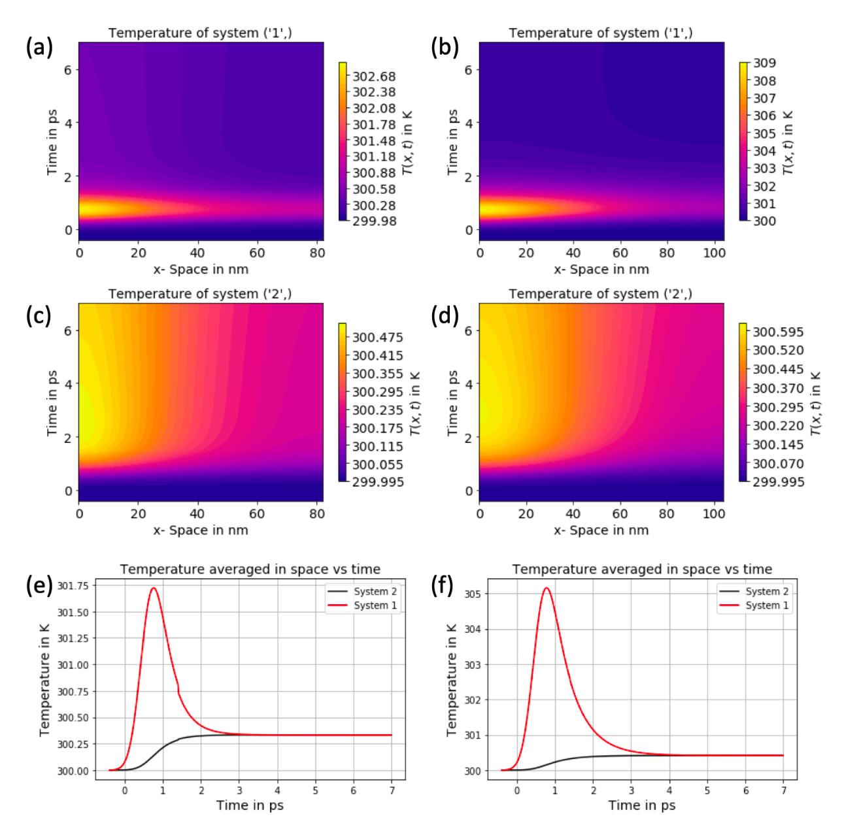
Figure 5 The spatial and temporal distribution of T_{e} and T_{p} of Ni and W thin films at 300 K by two-temperature model.[33] The plots of (a) (c) (e) are the results of Ni, and (b) (d) (f) are the results of W. The system “1” and system “2” are electron and phonon, respectively. Here an 82 nm-Ni and a 104 nm-W thin films, heated by a picosecond laser source of 1550 nm and 0.3 J/m² are estimated. The material parameters used in the two-temperature simulation are listed in Table 5.

Table 5 Material parameters for two-temperature simulation in Fig. 5
Parameter | units | Nickel | Tungsten
Thickness | nm | 82 | 104
Electron heat capacity | Jm⁻³K⁻¹ | 4E5[42] | 1.12E5[42]
Lattice heat capacity | Jm⁻³K⁻¹ | 3.98E6 | 2.55E6
Electron thermal conductivity | Wm⁻¹K⁻¹ | 67.8[43] | 132[44]
Lattice thermal conductivity | Wm⁻¹K⁻¹ | 23.2[43] | 46[44]
Electron-phonon coupling | Wm⁻³K⁻¹ | 8.46E17[42, 45] | 2E17[42]

4.3 Thermal circuit and estimated ITR
Accordingly, the various types of energy transport at metal/nonmetal interfaces under the influence of bidirectional heat fluxes are illustrated in Fig. 6 (a) and (b), and their corresponding thermal circuits are shown in Fig. 6 (c) and (d), respectively. The E_{pp} represents the energy transport of phonon–phonon coupling, including the elastic and inelastic scattering. E_{ep} is the energy transport of electron–phonon coupling at the metal near interface, and E_{ei} is the energy transport of electron (at metal)–phonon (at nonmetal) coupling directly across the interface. Since there is not sufficient proof concerning the inelastic scattering effect on the asymmetric ITR of Ni/Al₂O₃ and W/Al₂O₃ thus far, we assume that the E_{pp} is the same under all bidirectional heat fluxes. The E_{ei} is rarely significant and can therefore be neglected in the case of heating from the nonmetal, as shown in Fig. 6 (a), due to the lack of a temperature gradient between T_{e} and T_{p}. Then, we can estimate the thermal resistance of various types of energy transport according to our measured ITRs and the thermal circuits depicted in Fig. 6 (c) and (d). The ITR from a nonmetal to a metal is $R_{I,2-1}$ and the ITR from a metal to a nonmetal is $R_{I,1-2}$, where the metal and nonmetal are represented by 1 and 2, respectively. $R_{I,2-1}$, which is mainly contributed from R_{pp} in series with R_{ep}, (see Fig. 6 (c)) can be represented by equation (2),
$$\frac{1}{R_{I,2-1}}=\frac{1}{R_{ep}+R_{pp}} .(2)$$
R_{ep}, the thermal resistance of this anharmonic interaction of electron–phonon coupling at the metal side can be calculated using $1/\sqrt{Gk_{p}}$, as reported by Majumdar and Reddy,[6] where $G$ is the electron–phonon coupling constant and $k_{p}$ is the phonon (lattice) thermal conductivity of the metal. The lattice thermal conductivities at room temperature(300K) are 23.2 and 46 W/mK for Ni[43] and W,[46] respectively. The electron–phonon coupling constant has been reported to be dependent on T_{e} and sensitive to the electronic structure of the materials.[42] The electron temperature also related to the wavelength and power of the pulse laser and the thickness of the metal layer.[37, 38, 47] The electron–phonon coupling constant $G$ of Ni, 8–10.5 × 10¹⁷ W/m³K[45, 48], and of W, 1.86–5 × 10¹⁷ W/m³K[42, 49], are used for evaluating the thermal resistance of electron–phonon coupling at the metal side. The values were estimated to be 2 x 10⁻¹⁰ m²K/W for Ni and 3.3 x 10⁻¹⁰ m²K/W for W, which is one order smaller than that of series phonon–phonon coupling or the measured ITRs. Consequently, the contribution of R_{ep} on ITRs is rarely significant, especially as the electron–phonon couplings of Ni and W are strong.
$R_{I,1-2}$, which has a resistance R_{ei} (an extra energy transport (E_{ei})) in parallel with R_{ep} and R_{pp}, (see Fig. 6 (d)) can be represented using equation (3),
$$\frac{1}{R_{I,1-2}}=\frac{1}{R_{ep}+R_{pp}}+\frac{1}{R_{ei}} .(3)$$
The measured ITRs listed in Table 3 are used for $R_{I,2-1}$ and $R_{I,1-2}$. Then, R_{ei} can be approximated by using equation (2) into (3). The estimated thermal resistances of each energy transport are listed in Table 6. The estimated R_{ei} of 8.46 m²K/GW for Ni/Al₂O₃ is comparable to the calculated interfacial electron(metal)–phonon(nonmetal) coupling of 4.3–5.9 m²K/GW for Ni/Al₂O₃ reported by Li et al.[50], according to the estimation proposed by Sergreev et al.[14] In addition, we found that the thermal resistances of R_{ei} and R_{pp} are almost of the same order of magnitude, indicating that the contribution of interfacial electron–phonon coupling is comparable to the phonon–phonon coupling across the interface, which is in good agreement with the results obtained by first-principles DFT calculations.[17]
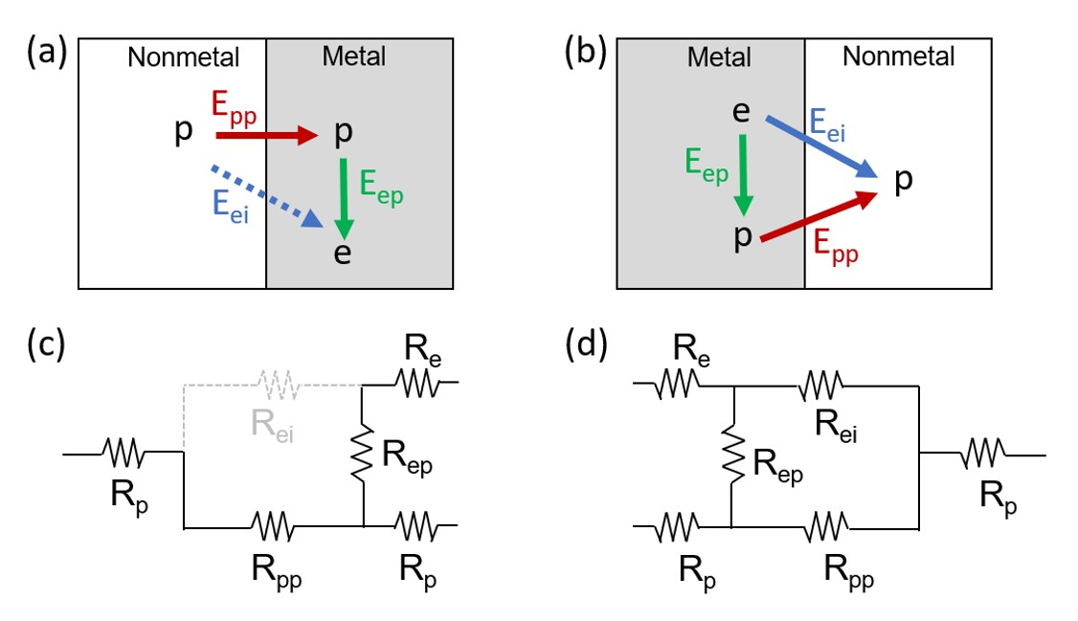
Figure 6 Energy transport and thermal circuits of metal/nonmetal interfaces in the case of (a)(c) heating from nonmetal to metal sides and (b)(d) heating from metal to nonmetal sides. E is the energy transport and R is the thermal resistance. Subscripts pp, ep, and ei represent the phonon–phonon coupling, electron–phonon coupling at the metal side, and the interfacial electron(metal)-phonon(nonmetal) coupling, respectively. The ITR in (c) can be calculated using equation (2) while the ITR in (d) can be calculated using equation (3).

Table 6 Estimated thermal resistance of each energy transport. The thermal resistance of the phonon–phonon coupling, electron–phonon coupling at the metal side, and inelastic interfacial electron–phonon coupling are R_{pp}, R_{ep}, and R_{ei}, respectively. 1 and 2 represent metal and nonmetal in the subscripts. R_{I, 1-2} and R_{I, 2-1} are the interfacial thermal resistance (ITR) in the case of heating from the metal and from nonmetal sides, respectively. Here, we used the measured ITR of W/Al₂O₃/Ni/quartz glass at 300 K as determined by TDTR, as listed in Table 3.
Unit:m²K/GW | $$R_{pp}$$  $$(≈R_{I,2-1})$$ | $R_{ep}=$ ${1/\sqrt{Gk_{p}}}_{ }$ | $$R_{ei}$$ | $$R_{I,1-2}$$ | $$R_{I,2-1}$$
Ni/Al₂O₃ | 6.70 | 0.2-0.23ª | 8.46 | 3.7 | 6.9
W/Al₂O₃ | 6.27 | 0.33^{b} | 11.55 | 4.2 | 6.6
ª Phonon (lattice) thermal conductivity $k_{p}$ of Ni is 23.2 W/mK;[43] electron–phonon coupling constant G is 8-10.5 × 10¹⁷ W/m³K.[42, 45, 48]
^{b} Phonon (lattice) thermal conductivity $k_{p}$ of W is 46 W/mK;[44] electron–phonon coupling constant G is 2 × 10¹⁷ W/m³K.[42]

We found an asymmetric ITR at the same metal/nonmetal interface subjected to bidirectional heat flux. The ITR was smaller than that obtained for heating from the metal side from 100 to 300 K, as determined by TDTR analysis. Given the presence of hot electrons resulting from the laser heating of the metal surface, the interfacial electron–phonon coupling contributes to the thermal conductance at the interface, in parallel with phonon–phonon coupling, whereas in the case of heating from the nonmetal side, the interfacial electron–phonon coupling is rarely significant. Hot electron is one of the possible assumptions; however, further investigation on the length scale of thermal equilibrium under various laser-fluences is essential for evaluate the contribution of hot electrons on interfacial thermal transport. Metals such as Cu, Ag and Au, which have high mobility and weak electron-phonon coupling, are good candidates for analyzing the effect of hot electron transport. The metal with higher thermoreflectance signals should be considered for higher accuracy. However, the effect of inelastic phonon-phonon scattering on the asymmetric ITR is still unclear. Further and more realistic MD simulation of inelastic scattering with the opposite temperature gradient should be performed for a better understanding.
Our experimental results point to the fact that the heat flux direction at the interface can significantly alter the interfacial thermal conductance and should not be ignored when considering thermal transport in systems with broken symmetries of different dominant heat carriers introduced via metal/nonmetal interfaces. This understanding will be a key merit to evaluate the efficiency of electronics and improve the thermal management. Also, the possibility of controlling the electron temperature via light will inspire new approaches for enhancing the rectification of asymmetric ITRs. Finally, the light-induced ∆T between the electrons and phonons results in an asymmetric ITR at metal/nonmetal interfaces and paves a way for the application of light-controlled thermal diodes.

5. CONCLUSIONS
The ITR at metal/nonmetal interfaces has a significant effect on the efficiency of micro/nano electronics. Both phonon and electronic thermal contributions are involved in interfacial thermal transport due to the presence of different types of dominant heat carriers in metals and nonmetals. We report the experimental results of ITR at metal/nonmetal interfaces subjected to bidirectional heat fluxes using a time domain thermoreflectance technique from 100 to 300 K for the first time. An asymmetric ITR is observed at both the Ni/Al₂O₃ and W/Al₂O₃ interfaces, and the ITR obtained with heating from the nonmetal side was larger by a factor of 1.4–1.9 compared to the heating from the metal side. The ITRs at 300 K of Ni/Al₂O₃ and W/Al₂O₃ are 3.7 and 4.2 m²K/GW with heating from the metal side whereas those of Al₂O₃/Ni and Al₂O₃/W are 6.9 and 6.6 m²K/GW with heating from the nonmetal side. The additional thermal contribution of interfacial electron–phonon coupling is one of the possible assumptions made in this study. Interfacial electron–phonon coupling is induced by hot electrons (temperature difference between T_{e} and T_{p}) when laser heating is applied at the metal side; this does not occur in the case of heating from the nonmetal side. Because T_{e} can be varied depending on the electronic structure and applied energy density, this feature makes the light-controlled thermal diodes or rectifiers achievable by material design and laser-power tuning. However, the effect of inelastic scattering on the asymmetric ITR is still unclear and is therefore worth further investigation. Finally, the findings qualitatively point to the asymmetric interfacial thermal transport at metal/nonmetal interfaces for the thermal management of electronics and provide an avenue to the development of light-controlled thermal diodes.

AUTHOR CONTRIBUTIONS
The manuscript was written through contributions of all authors. Yibin Xu and Yen-Ju Wu started the project and designed the experiments. Yen-Ju Wu synthesized the samples, performed the thermoreflectance fitting and wrote the manuscript; Takashi Yagi carried out the time domain thermoreflectance measurement. Yibin Xu performed the data analysis. All authors discussed the results presented in the paper and have given approval to the final version of the manuscript.

ACKNOWLEDGMENT
This work was supported by “Materials research by Information Integration” Initiative (MI2I) project of the Support Program for Starting Up Innovation Hub of the Japan Science and Technology Agency (JST) and partly supported from JST CREST through Grant No. JPMJCR17I2.

REFERENCES
[1] X. Zheng, T. Jiang, L. Bai, X. Chen, Z. Chen, X. Xu, D. Song, X. Xu, B. Li, Y. Yang, Enhanced thermal stability of inverted perovskite solar cells by interface modification and additive strategy, RSC Advances, 10(31) (2020) 18400-18406.
[2] W. Liu, S. Bai, Thermoelectric interface materials: A perspective to the challenge of thermoelectric power generation module, Journal of Materiomics, 5(3) (2019) 321-336.
[3] Y.J. Wu, Y.W. Lan, S.C. Hsu, C.H. Yeh, Y.S. Ku, J.C. Jiang, Y. Xu, Tuning Interfacial Thermal and Electrical Conductance across a Metal/MoS₂ Monolayer through N‐Methyl‐2‐pyrrolidone Wet Cleaning, Advanced Materials Interfaces, 7(14) (2020).
[4] H.S. Park, J. Punch, Friction factor and heat transfer in multiple microchannels with uniform flow distribution, International Journal of Heat and Mass Transfer, 51(17) (2008) 4535-4543.
[5] R.J. Stevens, A.N. Smith, P.M. Norris, Measurement of Thermal Boundary Conductance of a Series of Metal-Dielectric Interfaces by the Transient Thermoreflectance Technique, Journal of Heat Transfer, 127(3) (2005) 315-322.
[6] A. Majumdar, P. Reddy, Role of electron–phonon coupling in thermal conductance of metal–nonmetal interfaces, Applied Physics Letters, 84(23) (2004) 4768-4770.
[7] A. Giri, P.E. Hopkins, A Review of Experimental and Computational Advances in Thermal Boundary Conductance and Nanoscale Thermal Transport across Solid Interfaces, Advanced Functional Materials, 30(8) (2019).
[8] R.J. Stoner, H.J. Maris, Kapitza conductance and heat flow between solids at temperatures from 50 to 300 K, Phys Rev B Condens Matter, 48(22) (1993) 16373-16387.
[9] P.E. Hopkins, J.C. Duda, P.M. Norris, Anharmonic Phonon Interactions at Interfaces and Contributions to Thermal Boundary Conductance, Journal of Heat Transfer, 133(6) (2011).
[10] J.C. Duda, T.E. Beechem, J.L. Smoyer, P.M. Norris, P.E. Hopkins, Role of dispersion on phononic thermal boundary conductance, Journal of Applied Physics, 108(7) (2010).
[11] G.T. Hohensee, R.B. Wilson, D.G. Cahill, Thermal conductance of metal-diamond interfaces at high pressure, Nat Commun, 6 (2015) 6578.
[12] H.-K. Lyeo, D.G. Cahill, Thermal conductance of interfaces between highly dissimilar materials, Phys Rev B, 73(14) (2006).
[13] M.L. Huberman, A.W. Overhauser, Electronic Kapitza conductance at a diamond-Pb interface, Phys Rev B Condens Matter, 50(5) (1994) 2865-2873.
[14] A.V. Sergeev, Electronic Kapitza conductance due to inelastic electron-boundary scattering, Phys Rev B, 58(16) (1998) 10199-10202.
[15] L. Guo, S.L. Hodson, T.S. Fisher, X. Xu, Heat Transfer Across Metal-Dielectric Interfaces During Ultrafast-Laser Heating, Journal of Heat Transfer, 134(4) (2012).
[16] S. Sadasivam, N. Ye, J.P. Feser, J. Charles, K. Miao, T. Kubis, T.S. Fisher, Thermal transport across metal silicide-silicon interfaces: First-principles calculations and Green's function transport simulations, Phys Rev B, 95(8) (2017).
[17] S. Sadasivam, U.V. Waghmare, T.S. Fisher, Electron-phonon coupling and thermal conductance at a metal-semiconductor interface: First-principles analysis, Journal of Applied Physics, 117(13) (2015).
[18] Z. Lu, Y. Wang, X. Ruan, Metal/dielectric thermal interfacial transport considering cross-interface electron-phonon coupling: Theory, two-temperature molecular dynamics, and thermal circuit, Phys Rev B, 93(6) (2016).
[19] G.D. Mahan, Kapitza thermal resistance between a metal and a nonmetal, Phys Rev B, 79(7) (2009).
[20] T. Lu, J. Zhou, T. Nakayama, R. Yang, B. Li, Interfacial thermal conductance across metal-insulator/semiconductor interfaces due to surface states, Phys Rev B, 93(8) (2016).
[21] X. Wu, T. Luo, The importance of anharmonicity in thermal transport across solid-solid interfaces, Journal of Applied Physics, 115(1) (2014).
[22] Z. Cheng, Y.R. Koh, H. Ahmad, R. Hu, J. Shi, M.E. Liao, Y. Wang, T. Bai, R. Li, E. Lee, E.A. Clinton, C.M. Matthews, Z. Engel, L. Yates, T. Luo, M.S. Goorsky, W.A. Doolittle, Z. Tian, P.E. Hopkins, S. Graham, Thermal conductance across harmonic-matched epitaxial Al-sapphire heterointerfaces, Communications Physics, 3(1) (2020).
[23] P.E. Hopkins, P.M. Norris, R.J. Stevens, Influence of Inelastic Scattering at Metal-Dielectric Interfaces, Journal of Heat Transfer, 130(2) (2008).
[24] T. Yagi, K. Tamano, Y. Sato, N. Taketoshi, T. Baba, Y. Shigesato, Analysis on thermal properties of tin doped indium oxide films by picosecond thermoreflectance measurement, Journal of Vacuum Science & Technology A: Vacuum, Surfaces, and Films, 23(4) (2005) 1180.
[25] T. Yagi, K. Kobayashi, Relation between Lock-in Signals and Temperature of Thin Film for Pulsed Light Heating Thermoreflectance Technique, The 34th Japan Symposium on Thermophysical Properties, A112, Toyama, Nov. 7-9, 2013.
[26] T. Yagi, K. Kobayashi, Relation between Lock-in Signals and Temperature of Thin Film for Pulsed Light Heating Thermoreflectance Technique-Analysis on multi-layered films, The 38th Japan Symposium on Thermophysical Properties, A111, Tsukuba, Nov. 20-22, 2017.
[27] J.W.B. Anthony, Richard A.; Bladh, Kenneth W.; Nichols, Monte C., Handbook of Mineralogy, Mineralogical Society of America, VA, US, 1990.
[28] S. Kawasaki, Y. Yamashita, N. Oka, T. Yagi, J. Jia, N. Taketoshi, T. Baba, Y. Shigesato, Thermal Boundary Resistance of W/Al2O3Interface in W/Al2O3/W Three-Layered Thin Film and Its Dependence on Morphology, Japanese Journal of Applied Physics, 52(6R) (2013) 065802.
[29] A. Cappella, J.-L. Battaglia, V. Schick, A. Kusiak, A. Lamperti, C. Wiemer, B. Hay, High Temperature Thermal Conductivity of Amorphous Al2O3Thin Films Grown by Low Temperature ALD, Advanced Engineering Materials, 15(11) (2013) 1046-1050.
[30] R.M. Costescu, D.G. Cahill, F.H. Fabreguette, Z.A. Sechrist, S.M. George, Ultra-low thermal conductivity in W/Al2O3 nanolaminates, Science, 303(5660) (2004) 989-990.
[31] Y.S. Touloukian, Thermophysical properties of matter, in: the TPRC data series, Plenum Publishing Corporation, 1970.
[32] R.M. Costescu, M.A. Wall, D.G. Cahill, Thermal conductance of epitaxial interfaces, Phys Rev B, 67(5) (2003).
[33] L. Alber, V. Scalera, V. Unikandanunni, D. Schick, S. Bonetti, NTMpy: An open source package for solving coupled parabolic differential equations in the framework of the three-temperature model, Computer Physics Communications, 265 (2021).
[34] V.I. Khvesyuk, B. Liu, A.A. Barinov, Development of acoustic and diffuse mismatch models for predicting the Kapitza resistance, J Phys Conf Ser, 1382 (2019).
[35] K.R. Hahn, M. Puligheddu, L. Colombo, Thermal boundary resistance at Si/Ge interfaces determined by approach-to-equilibrium molecular dynamics simulations, Phys Rev B, 91(19) (2015).
[36] E.S. Landry, A.J.H. McGaughey, Thermal boundary resistance predictions from molecular dynamics simulations and theoretical calculations, Phys Rev B, 80(16) (2009).
[37] P.E. Hopkins, P.M. Norris, Substrate influence in electron–phonon coupling measurements in thin Au films, Applied Surface Science, 253(15) (2007) 6289-6294.
[38] P.E. Hopkins, J.L. Kassebaum, P.M. Norris, Effects of electron scattering at metal-nonmetal interfaces on electron-phonon equilibration in gold films, Journal of Applied Physics, 105(2) (2009).
[39] A. Giri, B.M. Foley, P.E. Hopkins, Influence of Hot Electron Scattering and Electron–Phonon Interactions on Thermal Boundary Conductance at Metal/Nonmetal Interfaces, Journal of Heat Transfer, 136(9) (2014).
[40] Y. Wang, X. Ruan, A.K. Roy, Two-temperature nonequilibrium molecular dynamics simulation of thermal transport across metal-nonmetal interfaces, Phys Rev B, 85(20) (2012).
[41] Y. Wang, Z. Lu, A.K. Roy, X. Ruan, Effect of interlayer on interfacial thermal transport and hot electron cooling in metal-dielectric systems: An electron-phonon coupling perspective, Journal of Applied Physics, 119(6) (2016).
[42] Z. Lin, L.V. Zhigilei, V. Celli, Electron-phonon coupling and electron heat capacity of metals under conditions of strong electron-phonon nonequilibrium, Phys Rev B, 77(7) (2008).
[43] Y. Wang, Z. Lu, X. Ruan, First principles calculation of lattice thermal conductivity of metals considering phonon-phonon and phonon-electron scattering, Journal of Applied Physics, 119(22) (2016).
[44] Y.N. Chen, J.L. Ma, W. Li, Understanding the thermal conductivity and Lorenz number in tungsten from first principles, Phys Rev B, 99(2) (2019).
[45] E. Beaurepaire, J. Merle, A. Daunois, J. Bigot, Ultrafast spin dynamics in ferromagnetic nickel, Phys Rev Lett, 76(22) (1996) 4250-4253.
[46] Y. Chen, J. Ma, W. Li, Understanding the thermal conductivity and Lorenz number in tungsten from first principles, Physical Review B, 99(2) (2019).
[47] J.B. Lee, K. Kang, S.H. Lee, Comparison of Theoretical Models of Electron-Phonon Coupling in Thin Gold Films Irradiated by Femtosecond Pulse Lasers, Materials Transactions, 52(3) (2011) 547-553.
[48] A.P. Caffrey, P.E. Hopkins, J.M. Klopf, P.M. Norris, Thin Film Non-Noble Transition Metal Thermophysical Properties, Microscale Thermophysical Engineering, 9(4) (2005) 365-377.
[49] J.G. Fujimoto, J.M. Liu, E.P. Ippen, N. Bloembergen, Femtosecond Laser Interaction with Metallic Tungsten and Nonequilibrium Electron and Lattice Temperatures, Physical Review Letters, 53(19) (1984) 1837-1840.
[50] X. Li, W. Park, Y. Wang, Y.P. Chen, X. Ruan, Reducing interfacial thermal resistance between metal and dielectric materials by a metal interlayer, Journal of Applied Physics, 125(4) (2019).

Graphical Abstract
