Realization of high-resistive Ni-doped GaN crystal by
hydride vapor phase epitaxy
Takafumi Odani^{1*}, Kenji Iso^{1,2}, Yuichi Oshima³, Hirotaka Ikeda¹, Tae Mochizuki¹, and
Satoru Izumisawa⁴
1 Semiconductor & Battery Application Gr., Information & Electronics Technology Center, R&D Div., Specialty Materials, Mitsubishi Chemical Corporation, Ushiku, Ibaraki 300-1295, Japan
2 Institute of Materials and Systems for Sustainability, Nagoya University, Furo-cho, Chikusa-ku, Nagoya, Aichi 464-8601, Japan
3 Research Center for Electronic and Optical Materials, National Institute for Materials Science, Tsukuba, Ibaraki 305-0044, Japan
4 Global GaN Project, Information & Electronics Div., Specialty Materials, Mitsubishi Chemical Corporation, Chiyoda, Tokyo 100-8251, Japan
*E-mail:takafumi.odani.ma@mcgc.com
Abstract
Herein, high-resistivity GaN is studied for use as an epitaxial substrate in lateral power devices. Fe-, C-, Mn-, and Zn-doped GaN monocrystals have high resistivity at a doping concentration of ~1 × 10¹⁸ cm⁻³. However, a low doping concentration is preferred for growing GaN monocrystals; therefore, other dopants for GaN that yield high resistivity at a doping concentration less than 1 × 10¹⁸ cm⁻³ must be identified. Herein, NiCl₂ is used as a precursor to grow Ni-doped GaN monocrystals on GaN substrates via hydride vapor-phase epitaxy. Two Ni-doped GaN substrates with Ni concentrations corresponding to 2.7 × 10¹⁷ and 2.9 × 10¹⁸ cm⁻³ are obtained by varying the partial pressure of NiCl₂. The resistivity of Ni-doped GaN monocrystals is measured as a function of temperature using Hall effect measurements. The GaN monocrystals doped with 2.7 × 10¹⁷ cm⁻³ of Ni have a higher resistivity than those doped with 2.9 × 10¹⁸ cm⁻³ of Ni at 600–900 K. Charge-neutrality calculations have shown that the depth of the Ni acceptor level in GaN is 1.4–1.5 eV, indicating that Ni-doped GaN monocrystals have high resistivity owing to the deep acceptor level of Ni.

- Introduction
High-electron-mobility transistors (HEMTs) with a GaN-on-GaN structure reduce leakage current owing to their low dislocation density^{[1]} and exhibit superior performance than GaN-on-SiC structures.^{[2]} The GaN-on-GaN HEMTs have a higher potential for thermal management than GaN-on-SiC HEMTs^{[3]} because they lack thermal resistance at epi-substrate interface. Although GaN-on-GaN HEMTs have garnered attention, they require high-resistivity GaN substrates.^{[4–9]} The GaN substrates grown via hydride vapor-phase epitaxy (HVPE) contain donor impurities such as Si and O.^{[10]} The GaN substrates doped with acceptors with a high ionization energy compensate for carriers from residual donors in GaN substrates, semi-insulating them. Fe-, C-, Mn-, and Zn-doped GaN substrates are semi-insulating.^{[11–22]} The resistivities of GaN doped with Fe, C, Mn, or Zn at a doping concentration of ~10¹⁸ cm⁻³ at 500 K are 1 × 10⁵, 3 × 10⁸, 1 × 10¹², and 1 × 10¹⁰ Ω cm, respectively.^{[19, 21]} However, a low doping concentration is preferable for growing bulk GaN monocrystals with low internal strain. To obtain GaN substrates with the highest resistivity, they are doped with Fe, C, and Zn at concentrations of approximately 1 × 10¹⁹, 3 × 10¹⁸, and 1 × 10¹⁸ cm⁻³, respectively,^{[21, 22]} and Mn-doped GaN substrates have the highest resistivity at a doping concentration below 1 × 10¹⁸ cm⁻³.^{[19, 22]} However, the vapor pressure of MnCl₂, which is the precursor for Mn doping, is as low as 4 × 10⁻³ atm at 800 C°. After MnCl₂ precipitates irregularly on the inner wall of the HVPE reactor, its removal is entirely difficult owing to its low vapor pressure. This may result in an unfavorable memory effect of Mn during subsequent GaN growth. Therefore, other dopants with a deep acceptor level and precursors with high vapor pressures must be identified to permit adequate control.
In this context, Ni is an ideal dopant. Similar to Fe or Mn doping,^{[19]} Ni can be doped into GaN substrates using NiCl₂ gas as the precursor. The Ni-doped GaN substrates should have high resistivity because the shell structure of Ni is similar to those of Fe and Mn. Moreover, the vapor pressure of NiCl₂ is as high as 3 × 10⁻² atm at 800 C°, which is about eight times higher than that of MnCl₂. The possibility of irregular precipitation of NiCl₂ is thus much less likely than that of MnCl₂. The Ni-doped GaN nanosheets were previously fabricated via sol–gel synthesis,^{[23]} and their electronic and magnetic properties as well as the band structure were determined using density functional theory (DFT),^{[24–27]} and the band structure of Ni-doped GaN has been calculated using DFT.^{[28]} However, the resistivity of Ni-doped GaN monocrystals has not yet been determined.
Therefore, Ni-doped GaN monocrystals were grown on GaN substrates via HVPE using NiCl₂ gas as the dopant precursor. Single-layered Ni-doped GaN substrates were obtained from thick Ni-doped GaN crystals, and their resistivities were determined by Hall effect measurements. The results showed that GaN substrates doped with Ni of about 3 × 10¹⁷ cm⁻³ doping concentration was more resistive than those doped with 3 × 10¹⁸ cm⁻³, which is attributed to the acceptor nature of the p-type dopant. Charge-neutrality calculations were performed to determine the depth of the Ni acceptor level with respect to the valence band, which revealed an acceptor level of 1.4–1.5 eV above the valence band. Thus, the high resistivity of Ni-doped GaN substrates is owing to the deep Ni acceptor level.

- Experimental section
Figure 1 schematizes the HVPE reactor used for Ni doping. A freestanding 400-μm-thick GaN seed substrate fabricated via HVPE with a c-plane main surface was set on the susceptor such that the source gas perpendicularly impinged on the substrate. Dual-zone heaters were used to control the temperature of the Ga metal container (source zone) and the substrate (growth zone). The source and growth zones were maintained at 840 °C and 1030 °C, respectively. A carbon boat with Ni wires (4N) was placed in one of the lines. The Ni wires reacted with HCl to generate NiCl₂ gas, which was used as the precursor for Ni doping. The partial pressure of NiCl₂ was controlled by the flow rates of HCl and N₂ dilution for the Ni wires. Therefore, the concentration of Ni in GaN substrates was also varied by changing the flow rates of HCl.
To grow Ni-doped GaN substrates via HVPE, the partial pressures of GaCl and NH₃ were held at 1.25 × 10⁻² and 1.56 × 10⁻¹ atm, respectively. N₂ was used as the carrier gas, and Ni-doped GaN was grown along the [0001] direction. The samples were named as shown in Table 1. Samples 1 and 2 were obtained at the input partial pressures of HCl for Ni metal of 3.13 × 10⁻⁴ and 1.25 × 10⁻³ atm, respectively. The growth rates of Samples 1 and 2 were 120 and 110 µm/h, respectively. The growth rate of Sample 2 was slightly slower than that of Sample 1 owing to an increase in the unreacted HCl amount for Ni because the reaction efficiency of HCl and Ni was not 100%. The TDDs for Ni-doped GaN substrates were estimated via MPPL measurements. However, the intensity of the near band-edge PL of Ni-doped GaN substrates was not sufficiently high to observe TDDs. Therefore, a UID GaN layer was grown followed by the Ni-doped GaN substrate to evaluate TDDs of UID GaN. During the growth of UID GaN and Ni-doped GaN layers, the partial pressures of HCl for Ni metal were set to 0 and 1.25 × 10⁻³ atm, respectively. The UID GaN and Ni-doped GaN layers were 25- and 30-µm thick, respectively. This sample was labeled as Sample 3.
Samples 1 and 2 were 350-μm-thick single-layered Ni-doped GaN wafers ground on the backside to remove the seed substrate. The full width at half maximum of the X-ray rocking curves (XRC-FWHM) for 0004 and 20$\overline{\text{2}}$1 diffractions was measured from a 2θ-ω scan acquired with an X’PERT PRO MRD instrument (PANalytical, Netherlands) in symmetric and skew-symmetric geometries. From these scans, the lattice constants a and c were also calculated. The concentrations of Ni and unintentional impurities (Si, O, and H) were measured via secondary ion mass spectrometry. The Ni-doped GaN wafers were cut into 6 × 6-mm² squares, and Ti–Au metal electrodes were deposited using an electron beam for Hall effect measurements performed at 500–900 K under vacuum (≈2 × 10⁻³ Pa) using a ResiTest 8300 instrument (Toyo Corporation, Japan). The TDD of Sample 3 was obtained from MPPL images acquired using a Confocal and Multiphoton Microscope A1MP (Nikon Solutions Corporation, Japan).

- Results and Discussion
Figure 2(a) and 2(b) shows images of the as-grown Samples 1 and 2, respectively (20 × 20-mm² squares). The layers were ~500-µm thick and red. Both samples had mirrored surfaces without any surface pits. The red layer became darker as the partial pressure of NiCl₂ gas increased. Ni was not successfully doped on the GaN substrate when H₂ was used as the carrier gas instead of N₂ owing to the decomposition of the precursor NiCl₂ (NiCl₂ + H₂ => Ni[s] + 2HCl). The use of only N₂ carrier gas, instead of a mixture of N₂ and H₂, results in parasitic deposition, making the thick ingot growth of Ni-doped GaN difficult. Table 2 shows the concentrations of Ni and unintentional impurities. By increasing the partial pressure of NiCl₂, the concentrations of Ni, Si, O, and H in the GaN host increased. The concentrations of Si and O in Samples 1 and 2 were slightly higher than those in Fe-, C-, and Mn-doped GaN grown using a mixture of N₂ and H₂ as the carrier gas.^{[19]} However, this increase could not be because of the N₂ carrier gas but because of the the decomposition of the quartz reactor used for HCl-induced Ni doping during HVPE. The flow rate of HCl used for the growth of Sample 2 exceeded that used for the growth of Sample 1, which possibly caused quartz decomposition and increased the Si and O concentrations in the GaN host. The increase in H concentration might be owing to the formation of the Ni–H complex, similar to that observed for the Mg–H complex.^{[29,} ^{30]}
Table 3 lists the lattice constants and XRC-FWHMs of the 0004 and 20$\overline{\text{2}}$1 diffractions for the unintentionally doped (UID) GaN layer and Ni-doped GaN substrate. The XRC-FWHMs of UID GaN layer were obtained from our previous study.^{[21]} The lattice constants of Ni-doped GaN substrate were nearly the same as those of the UID GaN layer, indicating that Ni doping did not distort the GaN lattice. The XRC-FWHMs of 0004 and 20$\overline{\text{2}}$1 diffractions of the Ni-doped GaN substrate were comparable with those of the UID GaN layer, implying that the threading dislocation densities (TDDs) did not increase after Ni doping. To evaluate TDD of Sample 3 in more detail, Figure 3(a) and 3(b) shows the multiphoton excitation photoluminescence (MPPL) images of the interface and the surface of Sample 3, respectively. The TDDs of the interface and surface were calculated from the MPPL images as 1.2 × 10⁶ and 1.3 × 10⁶ cm⁻², respectively. This indicates that Ni doping did not increase TDD in the GaN substrates. Moreover, the TDDs of Sample 1 and 2 did not increase because their growth conditions of Ni doping were almost similar to that of Sample 3.
Figure 4(a) and 4(b) shows the resistivity and carrier concentration, respectively, as a function of temperature for the Ni-doped GaN substrates. When the sample temperature increased from 500 to 900 K, the resistivities of Samples 1 and 2 decreased from 3.8 × 10¹¹ to 1.8 × 10⁵ Ω cm and from 1.0 × 10¹² to 7.6 × 10⁴ Ω cm, respectively. The resistivity of the GaN host with a Ni doping concentration of 2.7 × 10¹⁷ cm⁻³ exceeded that for a doping concentration of 2.9 × 10¹⁸ cm⁻³. The carrier concentration of the Ni-doped GaN substrates increased from 3.0 × 10⁶ to 3.4 × 10¹¹ cm⁻³ (Sample 1) and 4.3 × 10⁶ to 1.3 × 10¹³ cm⁻³ (Sample 2) as the temperature increased from 500 to 900 K. The GaN substrates doped with lower Ni concentrations had a lower carrier concentration when the temperature exceeded 600 K. This phenomenon confirmed using Hall effect measurements, wherein Samples 1 and 2 exhibited p-type conductivity. The resistivity of Ni-doped GaN substrate is predominantly determined by the carrier concentration because the hole mobility for impurity-doped GaN (e.g., Mn-doped GaN) is on the order of 1 cm² V⁻¹ s⁻¹.^{[22]} The resistivity increased as the hole concentration decreased with decreasing Ni doping concentration, as shown in Figure 4(b).
The depth of the Ni acceptor level is determined using the charge-neutrality condition:^{[22, 31]}
$$\begin{aligned}n+N_{A}^{-}=p+N_{D}^{+}, \#\left(1\right)\end{aligned}$$
where $N_{A}^{-}$ and $N_{D}^{+}$ are the ionized acceptor and donor concentrations, respectively, and p and n are expressed as follows:
$$\begin{aligned}n=N_{C} exp\left(\frac{E_{F}-E_{C}}{k_{B}T}\right),\#\left(2\right)\end{aligned}$$
$$\begin{aligned}N_{C}=2{\left(\frac{m_{e}^{*}k_{B}T}{2πℏ^{2}}\right)}^{\frac{3}{2}}, \#\left(3\right)\end{aligned}$$
$$\begin{aligned}p=N_{V}\exp\left(\frac{E_{V}-E_{F}}{k_{B}T}\right),\#\left(4\right)\end{aligned}$$
$$\begin{aligned}N_{V}=2{\left(\frac{m_{h}^{*}k_{B}T}{2πℏ^{2}}\right)}^{\frac{3}{2}}, \#\left(5\right)\end{aligned}$$
where $m_{e}^{*}=0.22m_{0}$ and $m_{h}^{*}=1.5m_{0}$ are the effective masses of the electron and hole, respectively, $m_{0}$ is the free-electron mass, $k_{B}$ is the Boltzmann constant, ħ is the Planck constant, $E_{F}$ is the Fermi level, and T is the absolute temperature. The band gap $E_{g}\left(T\right)$ is calculated as follows:^{[32]}
$$\begin{aligned}E_{g}\left(T\right)=E_{g}\left(0\right)+\frac{αT^{2}}{β+T},\#\left(6\right)\end{aligned}$$
where α and β are the fitting parameters depending on materials. $E_{g}\left(0\right)$, α, and β are set to 3.5 eV, −0.94 meV/K, and 791 K, respectively.^{[33]}$N_{A}^{-}$ and $N_{D}^{+}$ are expressed as follows:
$$\begin{aligned}N_{A}^{-}=\frac{N_{A}}{1+4\exp\left(\frac{E_{A}-E_{F}}{k_{B}T}\right)}, \#\left(7\right)\end{aligned}$$
$$\begin{aligned}N_{D}^{+}=N_{D},\#\left(8\right)\end{aligned}$$
where $E_{A}$ is the acceptor level. We assume that $E_{A}$ is offset from $E_{V}$ by a temperature-independent constant, $N_{A}$ is the Ni concentration, and $N_{D}$ is the sum of Si and O concentrations. The Ni acceptor levels for Samples 1 and 2 were determined to be 1.5 and 1.4 eV, respectively, using $E_{A}$ as the fitting parameter. These experimental results are consistent with those previously reported, wherein the gap between the Ni acceptor level and the top of the valence band was determined via DFT as ~1.5 eV.^{[28]} Thus, the high resistivity of Ni-doped GaN is owing to the deep Ni acceptor level.

- Conclusion
The HVPE was used to fabricate Ni-doped GaN substrates using NiCl₂ as the precursor. The crystallinity of GaN was not deteriorated owing to Ni doping. The results showed that Ni-doped monocrystalline GaN substrate was semi-insulating. The GaN doped with Ni doping concentrations of less than 1 × 10¹⁸ cm⁻³ had higher resistivity than that of 3 × 10¹⁸ cm⁻³ at 600–900 K. Thus, a relatively low concentration of Ni was sufficient to yield GaN substrates with high resistivity because Ni is a p-type dopant. The depth of the Ni acceptor level in GaN was estimated to be 1.4–1.5 eV using charge-neutrality calculations. These experimental results are consistent with the DFT results. The high resistivity of Ni-doped GaN substrates is owing to the deep acceptor level of Ni.
Acknowledgments
We thank Dr. Kakehi at Osaka Research Institute of Science and Technology for their support with the Hall effect measurements. We also thank D. Tanaka at Nagoya University for their support with charge-neutrality calculation.

References
[1] J. Kotani, J. Yaita, A. Yamada, N. Nakamura, K. Watanabe, J. Appl. Phys. 2020, 127, 23.
[2] Y. Kumazaki, T. Ohki, J. Kotani, S. Ozaki, Y. Niida, Y. Minoura, M. Nishimori, N. Okamoto, M. Sato, N. Nakamura, K. Watanabe, Appl. Phys. Express 2020, 14, 016502.
[3] N. Okamoto, A. Takahashi, Y. Minoura, Y. Kumazaki, S. Ozaki, K. Makiyama, A. Yamada, J. Kotani, T. Ohki, Y. Kawano, N. Nakamura, K. Watanabe, 2019, In Proc. CS-MANTECH Conf., 10-5.
[4] S. W. Kaun, M. H. Wong, S. Dasgupta, S. Choi, R. Chung, U. K. Mishra, J. S. Speck, Applied physics express 2011, 4, 024101.
[5] T. Kachi, J. J. Appl. Phys. 2014, 53, 100210.
[6] H. Amano, Y. Baines, E. Beam, M. Borga, T. Bouchet, P. R. Chalker, M. Charles, K. J. Chen, N. Chowdhury, R. Chu, C. D. Santi, M. M. D. Souza, S. Decoutere, L. D. Cioccio, B. Eckardt, T. Egawa, P. Fay, J. J. Freedsman, L. Guido, O. Häberlen, G. Haynes, T. Heckel, D. Hemakumara, P. Houston, J. Hu, M. Hua, Q. Huang, A. Huang, S. Jiang, H. Kawai, D. Kinzer, M. Kuball, A. Kumar, K. B. Lee, X. Li, D. Marcon, M. März, R. McCarthy, G. Meneghesso, M. Meneghini, E. Morvan, A. Nakajima, E. M. S. Narayanan, S. Oliver, T. Palacios, D. Piedra, M. Plissonnier, R. Reddy, M. Sun, I. Thayne, A. Torres, N. Trivellin, V. Unni, M. J. Uren, M. V. Hove, D. J. Wallis, J. Wang, J. Xie, S. Yagi, S. Yang, C. Youtsey, R. Yu, E. Zanoni, S. Zeltner, Y. Zhang. J. Phys. D: Appl. Phys. 2018, 51, 163001.
[7] J. Krupka, M. Zając, R. Kucharski, D. Gryglewski. AIP Adv. 2016, 8, 035313.
[8] T. J. Anderson, S. Chowdhury, O. Aktas, M. Bockowski, J. K. Hite. Electrochem. Soc. Interface 2018, 27, 43.
[9] M. Kuzuhara, J. T. Asubar, H. Tokuda. Jpn. J. Appl. Phys. 2016, 55, 070101.
[10] G. Popovici, W. Kim, A. Botchkarev, H. Tang, H. Morkoc, J. Solomon, Appl. Phys. Lett. 1997, 71, 3385-3387.
[11] P. Kordoš, M. Morvic, J. Betko, J. Novak, J. Flynn, G. R. Brandes, Appl. Phys. Lett. 2004, 85, 5616-5618.
[12] M. Horita, S. Takashima, R. Tanaka, H. Matsuyama, K. Ueno, M. Edo, T. Takahashi, M. Shimizu, J. Suda, Jpn. J. Appl. Phys. 2017, 56(3), 031001.
[13] E. Richter, E. Gridneva, M. Weyers, G. Tränkle, J. Cryst. Growth 2016, 456, 97-100.
[14] R. Piotrzkowski, M. Zajac, E. Litwin-Staszewska, M. Bockowski, Appl. Phys. Lett. 2020, 117, 012106.
[15] E. Richter, F. C. Beyer, F. Zimmermann, G. Gärtner, K. Irmscher, I. Gamov, J. Heitmann, M. Weyers, G. Tränkle, Cryst. Res. Technol. 2020, 55, 1900129.
[16] Y. Lai, D. Wang, Q. Kong, X. Luo, J. Tang, R. Liu, F. Hou, X. Wang, T. J Baker, J. Cryst Growth 2021, 573, 126216.
[17] M. Iwinska, M. Zajac, B. Lucznik, M. Fijalkowski, M. Amilusik, T. Sochacki, E. Litwin-Staszewska, R. Piotrzkowski, I. Grzegory, M. Bockowski, Jpn. J. Appl. Phys. 2019, 58, SC1047.
[18] M. Amilusik, M. Zajac, T. Sochacki, B. Lucznik, M. Fijalkowski, M. Iwinska, D. Wlodarczyk, A. K. Somakumar, A. Suchocki, M. Bockowski, Materials 2022, 15, 2379.
[19] K. Iso, H. Ikeda, T. Mochizuki, T. Odani, S. Izumisawa, Phys. Status Solidi B 2022, 2200489.
[20] N. I. Kuznetsov, A. E. Nikolaev, A. S. Zubrilov, Y. V. Melnik, V. A. Dmitriev, Appl. Phys. Lett. 1999, 75, 3138-3140.
[21] T. Odani, K. Iso, Y. Oshima, H. Ikeda, T. Mochizuki, S. Izumisawa, J. Cryst. Growth 2023, 622, 127389.
[22] D. Tanaka, K. Iso, J. Suda, J. Appl. Phys. 2023, 133, 055701.
[23] Aydın, C, Ceramics International 2018, 44, 17473-17478.
[24] H. Roohi, N. A. Ardehjani, Materials Chemistry and Physics 2022, 291, 126713.
[25] H. Roohi, N. A. Ardehjani, New Journal of Chemistry 2019, 43, 15280-15292.
[26] J. B. Li, H. X. Liu, Superlattices and Microstructures 2018, 120, 382-388.
[27] J. Wang, X. Zhang, L. Liu, Z. Wang, Superlattices and Microstructures 2021, 159, 107055.
[28] H. T. Mumu, A. Zaman, F. H. Bhuiyan, R. H. Aunkon, A. Sharif, Micro and Nanostructures 2023, 174, 207470.
[29] W. Götz, N. M. Johnson, D. P. Bour, M. McCluskey, E. E. Haller, Appl. Phys. Lett. 1996, 69, 3725-3727.
[30] C. H. Seager, S. M. Myers, B. Vaandrager, J. S. Nelson, Appl. Phys. Lett. 2002, 80, 2693-2695.
[31] S. M. Sze, K. K. Ng, Physics of Semiconductor Devices, 3rd ed. (Wiley, Hoboken, NJ, 2007).
[32] Y. P. Varshni, physica 1967, 34, 149-154.
[33] N. Nepal, J. Li, M. L. Nakarmi, J. Y. Lin, H. X. Jiang, Appl. Phys. Lett. 2005, 87, 242104.

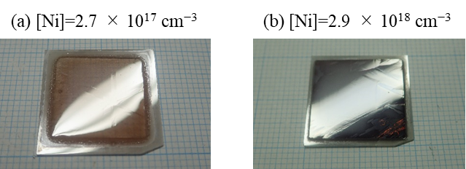
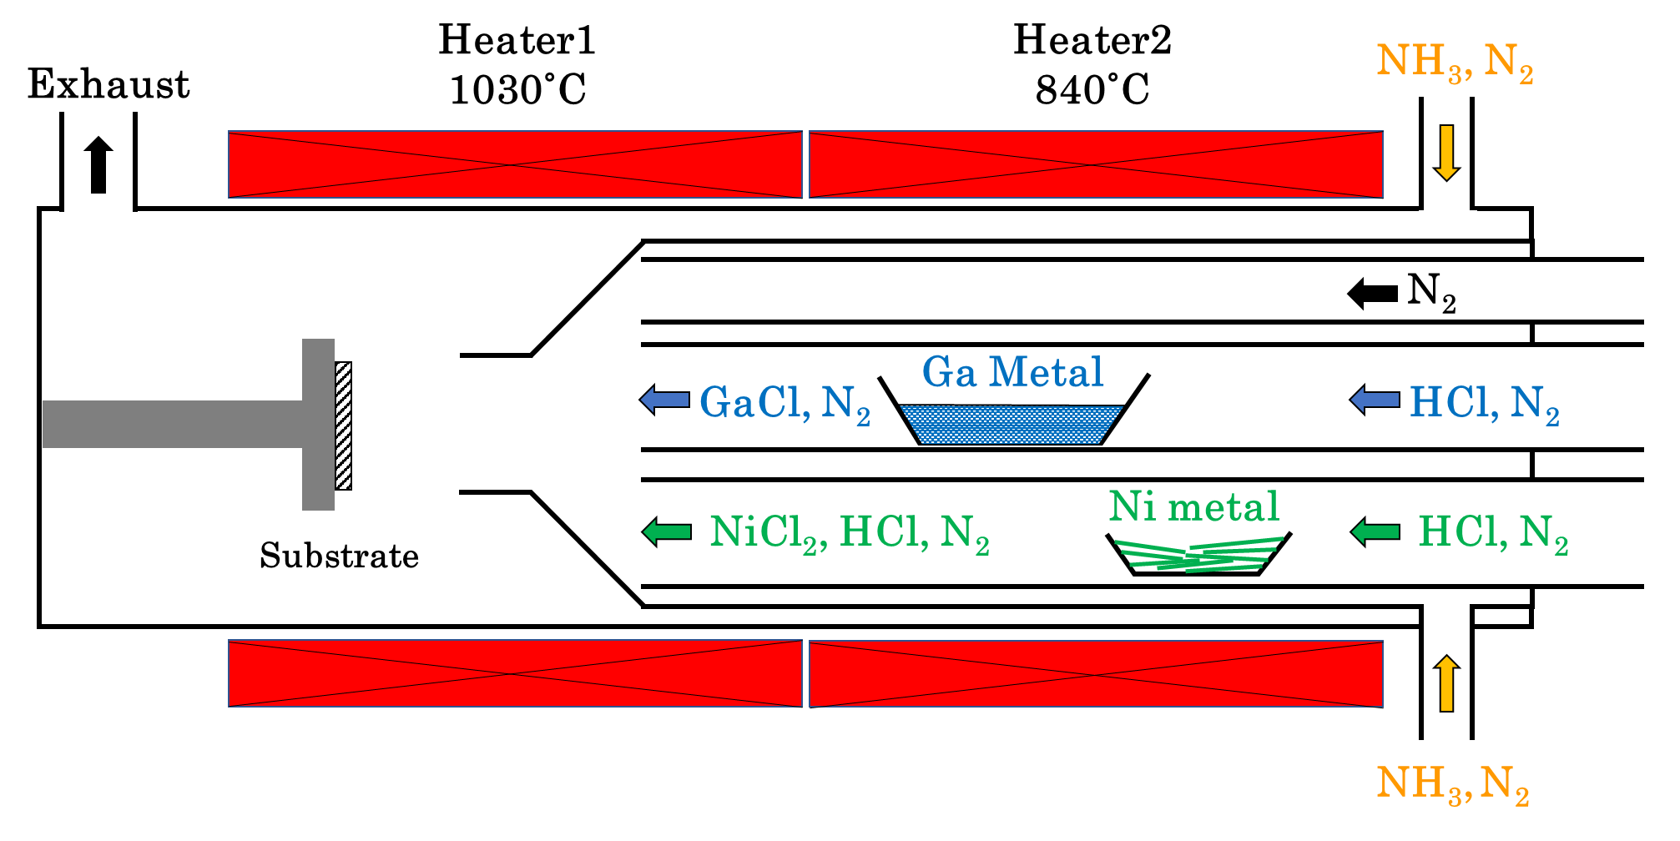
Figure 2. Bird’s-eye-view photo of (a)Sample 1 and (b)Sample 2. Grid line is 1 mm.
Figure 1. Schematic illustration of experimental equipment.

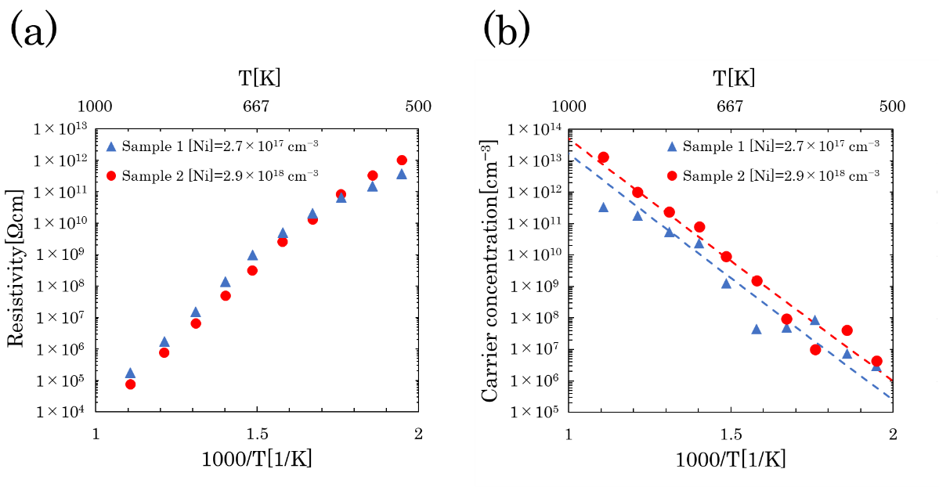
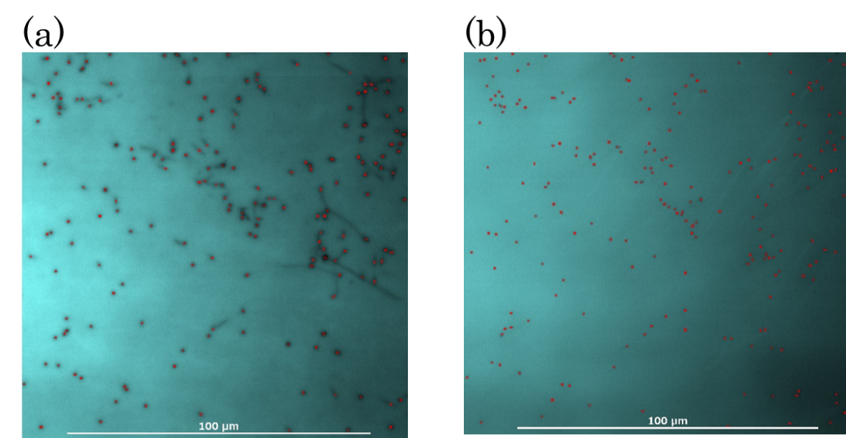
Figure 4. (a)Resistivity and (b)carrier concentration dependance for the Ni-doped GaN substrates on the temperature of Sample 1 (blue triangle) and Sample 2 (red circle). The blue and red dash lines are fitting curve (Eq. (4)) to the plots of Sample 1 and 2, respectively.
Figure 3. MPPL image of (a) interface and (b) surface of Sample 3. Each red point indicates threading dislocation.

Table 1. The table of sample.
parameter | Sample 1 | Sample 2
input partial pressure of HCl [atm] | 3.13 × 10⁻⁴ | 1.25 × 10⁻³
growth rate [µm/h] | 120 | 110

Table 2. Concentration of impurities and input partial pressure of HCl for Ni with Sample 1 and 2.
Impurity | Sample 1 | Detection Limit  (Sample 1) | Sample 2 | Detection Limit  (Sample 2)
input partial pressure of HCl [atm] | 3.13 × 10⁻⁴ | - | 1.25 × 10⁻³ | -
Ni [cm⁻³] | 2.7×10¹⁷ | 8×10¹⁴ | 2.9×10¹⁸ | 3×10¹⁵
Si [cm⁻³] | 3.0×10¹⁶ | 5×10¹⁴ | 2.0×10¹⁷ | 5×10¹⁴
O [cm⁻³] | 8.5×10¹⁵ | 6×10¹⁵ | 1.3×10¹⁶ | 6×10¹⁵
H [cm⁻³] | 6.1×10¹⁶ | 3×10¹⁶ | 1.4×10¹⁷ | 3×10¹⁶

parameter | Sample 1 | Sample 2 | UID GaN
Ni [cm⁻³] | 2.7×10¹⁷ | 2.9×10¹⁸ | -
Lattice constant a [Å] | 5.18496 | 5.18496 | 5.18495
Lattice constant c [Å] | 3.18876 | 3.18876 | 3.18873
XRC-FWHM 0004 [arc sec.] | 18.0 | 16.3 | 16.6^{[21]}
XRC-FWHM 20$\overline{\text{2}}$1 [arc sec.] | 26.2 | 27.6 | 22.3^{[21]}
Table 3. Lattice constants and XRC-FWHM values of Sample 1, Sample 2 and UID GaN.

