Critical Current Measurements on Round Cables Made with a REBCO Stack Conductor

Xudong Wang, Kiyosumi Tsuchiya, Akio Terashima, Suguru Tanabe, Nobuyuki Negishi, and Akihiro Kikuchi

Abstract—The development of high-current high-temperature superconducting (HTS) cables is a key technology for high-field accelerator magnets of 16 T or more. Recently, a flexible HTS round cable, consisting of many rare-earth barium copper oxide (REBCO) coated conductors helically wound in multiple layers on a metal core, have been manufactured by Advanced Conductor Technologies LLC as the conductor on round core (CORC®). When a commercially available coated conductor with a substrate thickness of 30 µm is applied to the CORC®, the minimum core diameter is approximately 2.4 mm without any degradation in the critical current (I_{c}). Because the engineering current density of the CORC® is highly dependent on the core diameter, the cable with a smaller core is desirable to achieve compact coil windings for high-field accelerator magnets. In this study, a REBCO stack conductor, made by soldering two coated conductors with their REBCO layers facing each other, was applied to the round cable instead of the commercially available single coated conductor. This REBCO stack conductor allows the REBCO layer to be closer to the neutral axis of the conductor, thereby reducing the strain induced in the REBCO layer by winding the conductor on the core. As a result, the REBCO stack conductor can be wound on a smaller core than the CORC®, allowing for higher current densities. This paper presents the magnetic field dependent I_{c} of the coated conductor at 4.2 K, the cable I_{c} and estimated strain of the REBCO layer as a function of the core diameter at 77 K, and the calculated cable current density made with the stack conductor.

Index Terms—High current cable, CORC®, STAR®, critical current, current density, high magnetic field, accelerator magnet.

I. INTRODUCTION
H
IGH current high-temperature superconducting (HTS) cables exceeding several kilo-amperes are required for high-field accelerator magnets. An engineering current density (J_{e}) of more than 500 A/mm² is also important to achieve a compact coil winding for a typical cos(θ) dipole magnet. Furthermore, the cable must be flexible enough to be bent to a radius of at least 20 mm and have sufficient mechanical strength to withstand the high electromagnetic forces generated by the high current and high magnetic field. To overcome these challenges, various HTS cables have been developed and their superconducting properties have been studied. In particular, the conductor on round core (CORC®) [1-3] and the symmetric tape round (STAR®) superconductor [4-6] can be bent in any direction, and their current carrying capacity can be easily increased by layering the coated conductor. The objective of this study is to develop a flexible high-current REBCO round cable for high-field accelerator magnets using the advantages of CORC® and STAR®. In the previous study, five prototype REBCO round cables made with a 2-mm-wide coated conductor and a 1.8-mm-diameter multi-wire core instead of a single core were fabricated and tested at 77 K to confirm its critical current (I_{c}) and bending characteristics [7]. The I_{c} drop of a 3-layer sample cable was only 10% in the 20-mm-radius bending test. However, the cable J_{e} was calculated to be less than 200 A/mm² at 20 T and 4.2 K even with an increased number of coated conductors. In this paper, a new cable using a REBCO stack conductor, which was made by soldering two copper-free coated conductors with their REBCO layers face-to-face, was fabricated and tested at 77 K to improve the cable J_{e}. For comparison, sample cables made using two commercially available coated conductors and one commercially available coated conductor with additional copper plating on the REBCO layer side were also measured at 77 K. Calculations of the conductor strain and the cable J_{e} are discussed together with the I_{c} measurements.

II. Experiments

A. Coated Conductor Characteristics
The specifications of the coated conductors are summarized in Table 1. Three commercially available coated conductors #1-#3, manufactured by SuperPower Inc., were used to fabricate the round cable. The conductor #4 was tested in the previous study [5]. The conductors #1-#3 had the same substrate thickness of 30 µm and different in copper thickness ranging from 0 to 20 µm. The conductor I_{c}, determined using an electric field criterion of 1.0 µV/cm, was measured by the standard four-probe method at 77 K and 4.2 K with a U-shape holder developed in the previous studies [8-10]. For the I_{c} measurements, two voltage taps spaced 30 mm apart are soldered in the center of each 120-mm-long conductor. For the test at 4.2 K, the conductor I_{c} was measured in a perpendicular magnetic field up to 18 T. Fig. 1 shows the magnetic field dependent I_{c} of the four conductors. The conductor #1 without a copper stabilizer was difficult to measure in high fields and could only be measured in 1 T due to the sudden rise in voltage. From the 1 T data, the conductor #1 showed almost the same magnetic field dependent I_{c} as the conductor #4. Using the measured I_{c} from 10 T to 18 T, the power law equation of I_{c}=kB^{-α} [11] was adopted to extrapolate the perpendicular field dependence up to 20 T at 4.2 K. The k and α listed in Table 1 are the fitting parameters. The lift factor of the conductor I_{c} was defined as I_{c} (B, 4.2 K)/I_{c} (self-field, 77 K) and was listed in Table 1 for the estimation of the cable I_{c} and J_{e} at 20 T and 4.2 K.
TABLE II
Specifications of REBCO Round Cables

REBCO cables | #1 | #2 | #3 | #4
Conductor # | 1 | 2 | 3 | 2
Conductor structure | Stack | Single | Single | Single  + 10 µm Cu
Conductor thickness (µm) ª | 80-110 | 48 | 55 | 58
Distance from REBCO layer to neutral axis (µm) ª | 5-14 | 14 | 15 | 9
Conductor I_{c} (A) ^{b}  at self-field and 77 K | 133 | 57-62 | 36-38 | 57-62
Core diameter (mm) | 1.6, 2.6 | 2.0-3.0 | 2.4-3.0 | 1.6-2.8
Winding angle (degree) | 35-40 | 35-40 | 35-40 | 35-40
Winding tension (N) | 3-5 | 3-5 | 3-5 | 3-5
ª The conductor thickness and the distance from the REBCO layer to neutral axis was measured using the micrographs as shown in Fig. 3.
^{b} The I_{c} at 77 K was measured using a 1.0 µV/cm criterion for several samples.

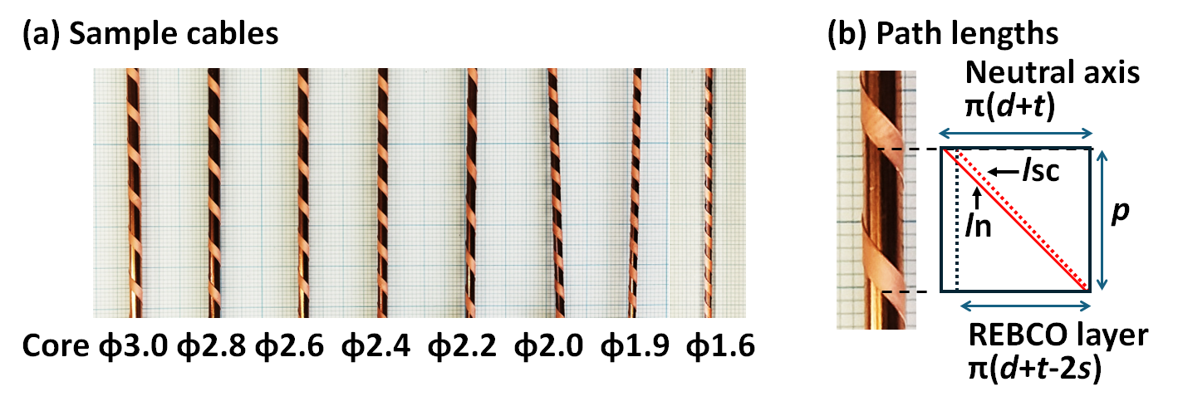
Fig. 2. Photographs of (a) the sample cables and (b) the path lengths of the REBCO layer and the neutral axis over one winding pitch.

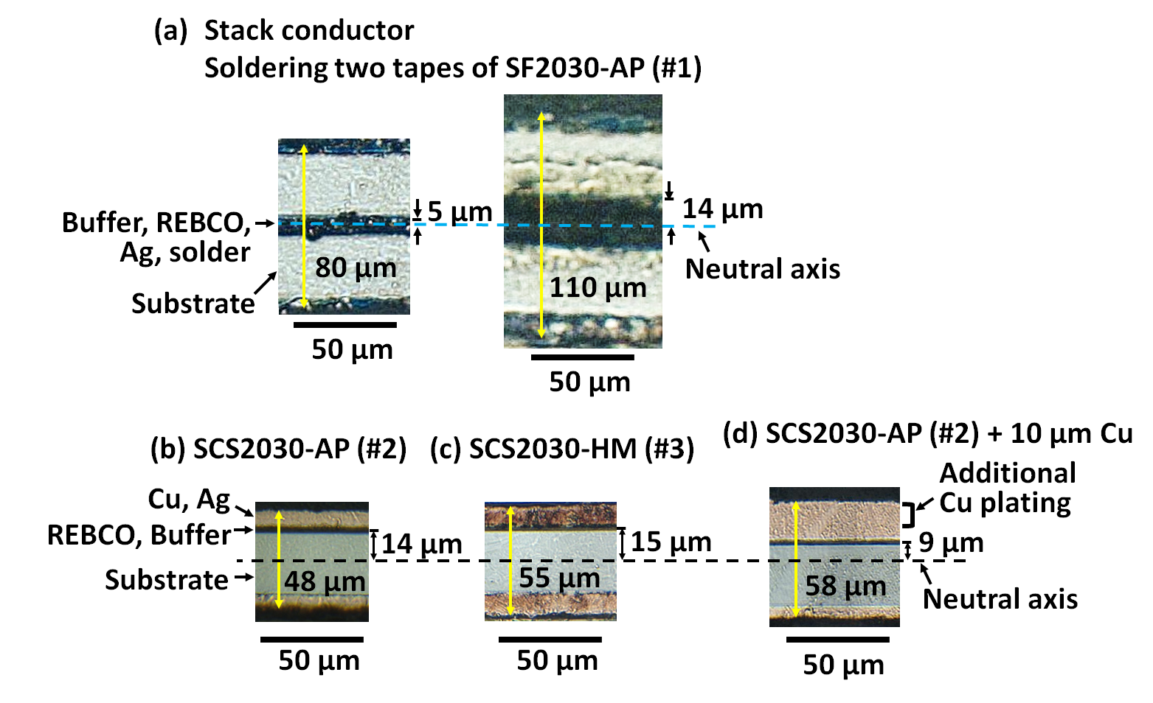
Fig. 3. Micrographs of (a) the stack conductor, (b) SCS2030-AP (#2), (c) SCS2030-HM (#3), and (d) SCS2030-AP (#2) with an additional 10 µm copper plating on the REBCO layer side.

Fig. 4. Electric field vs. transport current plots of the conductor #1 and the stack conductor made by soldering two tapes of the conductor #1 at 77 K.

B. REBCO Round Cable Properties
To investigate the degradation of cable I_{c} as a function of core diameters from 1.6 to 3.0 mm as shown in Fig. 2 (a), four types of single-layer cables #1-#4 were made as listed in Table 2. All cables were approximately 100-mm-long and had a pair of voltage taps attached to the conductor. The conductor and core were soldered together using a ring terminal at the cable ends to measure the cable I_{c} with the 1.0 µV/cm criterion. The cable #1 wound using a stack conductor made by soldering two tapes of the conductor #1 together with their REBCO layers facing each other. The stack conductor, cross-sectional micrographs of which is shown in Fig. 3 (a), was soldered at less than 150 ºC using the In_{0.52}Sn_{0.48}. The solder thickness between two tapes was approximately 5 µm and 20 µm for the for the well and poorly controlled cases, respectively. The stack conductor exhibited almost twice the I_{c} of the single tape without any degradation after the soldering process as shown in Fig. 4. The configuration of the stack conductor allows the REBCO layer to be closer to the center of the conductor thickness, which is assumed to be the neutral axis. Therefore, the stack conductor is expected to reduce the strain induced in the REBCO layer during winding. The cable #2 and #3, which had a similar configuration to the CORC®, were made using the conductors #2 and #3, respectively. The REBCO layers of the conductors #2 and #3 were wound facing the core so that they are subjected to compressive strain. Cross-sectional micrographs of the conductors #2 and #3 are shown in Fig. 3 (b) and (c). The cable #4, which had a similar configuration to the STAR®, was wound using the conductor #2 with an additional 10 µm copper plating on the REBCO layer side to reduce compressive strain. The REBCO layer of the additional copper plated tape, cross-sectional micrographs of which is shown in Fig. 3 (d), was also wound facing the core.
TABLE I
Specifications of REBCO Coated Conductors

Coated conductors | #1 | #2 | #3 | #4 [5]
Type | SF2030-AP | SCS2030-AP | SCS2030-HM | SCS2030-AP
Width (mm) | 2 | 2 | 2 | 2
Total thickness (µm) ª | 35 | 46 | 55 | 120
Substrate thickness (µm) ª | 30 | 30 | 30 | 30
Copper thickness (µm) ª | none | 10 | 20 | 80
I_{c} (A) at self-field and 77 K ^{b} | 62-68 | 57-62 | 36-38 | 54
k | - | 2818 | 4646 | 734
α | - | 0.934 | 1.035 | 0.742
lift factor (20 T, 4.2 K) | - | 2.99 | 5.44 | 1.46
ª The conductor thickness was provided by SuperPower Inc.
^{b} The I_{c} at 77 K was measured using a 1.0 µV/cm criterion for several samples.

Fig. 1. Magnetic field dependence of the conductor I_{c} measured at 4.2 K. The dotted line in the inset represents the fitting curves plotted using the fitting parameters listed in Table 1.

III. Results and Discussion

A. Cable I_{c} vs. Core Diameter
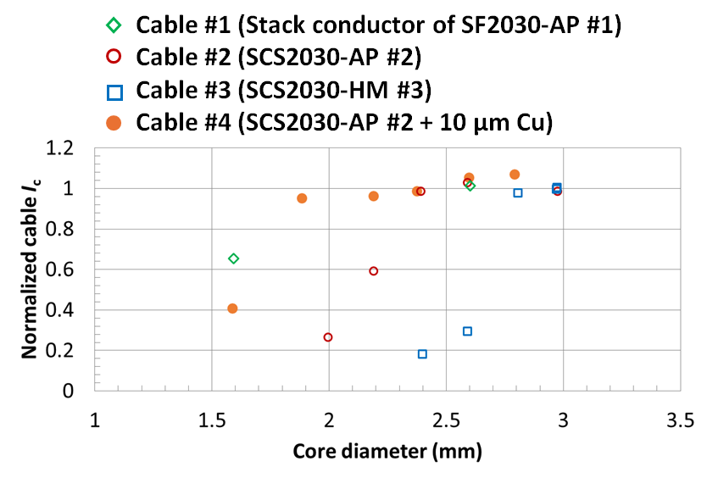
Fig. 5. The normalized cable I_{c} as a function of the core diameter of the cables #1-#4.
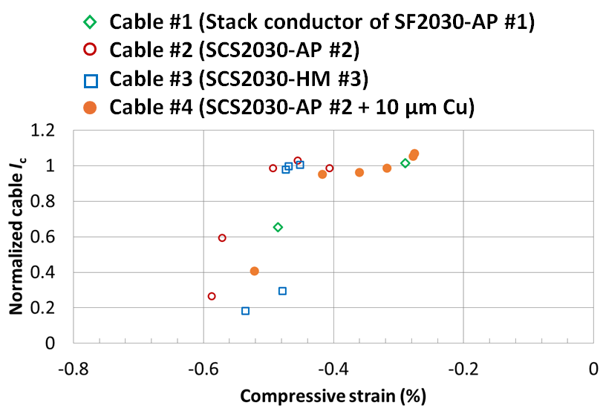
Fig. 6. The normalized cable I_{c} as a function of the calculated compressive strain in the REBCO layer of the cables #1-#4.

TABLE III
Minimum Core Diameters of Three Types of Conductors

Conductor structure | Stack | Single | Single  + 30 µm Cu
Conductor width (mm) | 2 | 2 | 2
Conductor thickness (µm) | 80 | 48 | 80 ª
Substrate thickness (µm) | 30 | 30 | 30
Distance from REBCO layer to neutral axis (µm) | 5 | 14 | 2 ª
Conductor I_{c} (A) ª  at self-field and 77 K | 72 | 36 | 36
Winding angle (degree) | 40 | 40 | 40
Gap between tapes (mm) ^{c} | 0.3 | 0.3 | 0.3
Gap between layers (mm) ^{c} | 0.01 | 0.01 | 0.01
Minimum core diameter (mm) | 1.1 | 2.9 | 1.0
ª The conductor thickness is the sum of 48 µm of the commercial tape and 30 µm of the copper plating on the REBCO layer side, including a 2 µm variation.
^{b} The I_{c} of all conductors was that of the SCS2030-HM in Table 1.
^{c} The gaps between the tapes and layers are for bending the cable to wind the coil.

Fig. 5 shows the normalized cable I_{c} as a function of the core diameter of the cables #1-#4. The cables #2 and #3, which had a similar configuration to the CORC®, could be fabricated with core diameters of 2.4 mm and 2.8 mm without any I_{c} degradation. This result is consistent with the previous study [2]. The cable #4, which had a similar configuration to the STAR®, could be fabricated with a 1.9-mm-diameter core without any I_{c} degradation. The cable #1, which wound by the stack conductor, shows better I_{c} performance than that of the cable #4 with a 1.6-mm-diameter core. Therefore, the cables #1 and #4 can be wound on smaller cores than the commercially available conductors because the REBCO layer is closer to the neutral axis. The compressive strain (ε_{sc}) in the REBCO layer along the transport current direction can be calculated from different path lengths between the REBCO layer (l_{sc}) and the neutral axis (l_{n}) as in (1-3). The p, d, t, and s represent the winding pitch, the core diameter, the conductor thickness, and the distance from the REBCO layer to neutral axis, respectively. The winding pitch varies depending on the winding angle. The path lengths of the REBCO layer and the neutral axis over one winding pitch are shown in Fig. 2 (b). The center of the conductor thickness was assumed to be the strain-free neutral axis. The conductor was assumed to be tightly wound around the core with no gaps.
$ε_{sc}={{(l}_{sc}-l}_{n})/l_{n}.$ (1)
$l_{sc}=\sqrt{p^{2}+π^{2}{\left(d+t-2s\right)}^{2}}$. (2)
$l_{n}=\sqrt{p^{2}+π^{2}{\left(d+t\right)}^{2}}$. (2)
Fig. 6 shows the normalized cable I_{c} as a function of the calculated compressive strain in the REBCO layer of the cables #1-#4. When the strain exceeded approximately -0.5%, the cable I_{c} dropped sharply for all cable types. The conductor I_{c} also degraded at strains below -0.5% in the previous study [12]. Unlike the cable I_{c}, the conductor I_{c} decreased slowly with increasing compressive strain. The main cause of this difference is seemed to be the conductor distortion and the deformation in the tape width direction, which are not considered in the strain calculation. When the cable is made up of multiple layers, it is expected that the conductor distortion and the deformation will change due to the contact between the tapes on adjacent layers. Considering the uncertainty of them, the strain limitation of the REBC layer in cable manufacturing can be set to -0.4% with a margin of 0.1% from -0.5%. As listed in Table 3, the minimum core diameters using the stack conductor, the commercially available conductor, and the additional copper plated conductor can be calculated from (1-3) with the same tape width of 2 mm. The stack conductor and the additional copper plated conductor can be wound on much smaller cores than the commercially available conductor as expected. The additional copper plated conductor is designed to center the REBCO layer across the conductor thickness with a variation of 2 µm. The minimum core diameter of the additional copper plated conductor is approximately 0.5 mm from the strain calculation but is limited to 1 mm by the core circumference and the 2-mm-wide tape.

B. Estimation of Cable I_{c} and J_{e} at 20 T and 4.2 K
The parameters shown in Table 3 were used to estimate the cable I_{c} and J_{e} for three types of the REBCO round cables. Fig. 7 shows the estimated cable I_{c} and J_{e} at 20 T and 4.2 K as a function of the cable diameter. The cable I_{c} at 20 T and 4.2 K was calculated as the product of the conductor I_{c} at 77 K and the lift factor of 5.44 obtained from Table 1, without considering the reduction due to the self-field. To provide a correction to this estimate, cable I_{c} measurements in a magnetic field will be reported in the next study. The cable J_{e} was calculated by dividing the cable I_{c} by the cable cross-sectional area including the gap. With a cable diameter of 4 mm, the cable I_{c} and J_{e} using the stack conductor are expected to achieve 13 kA and 1000 A/mm², more than twice as high as those using other conductors. For designing a 20 T cos(θ) dipole in a full HTS sector configuration, the coil current density (J_{coil}) of 400-500 A/mm² is required for a coil thickness (t_{coil}) of 72-58 mm from (4), as shown in Fig. 8. The θ is typically set to 60 degrees to eliminate the sextupole component.
(a)
(b)
Fig. 7. Estimated cable (a) I_{c} and (b) J_{e} of the three types of the REBCO round cables at 20 T and 4.2 K as a function of the cable diameter.

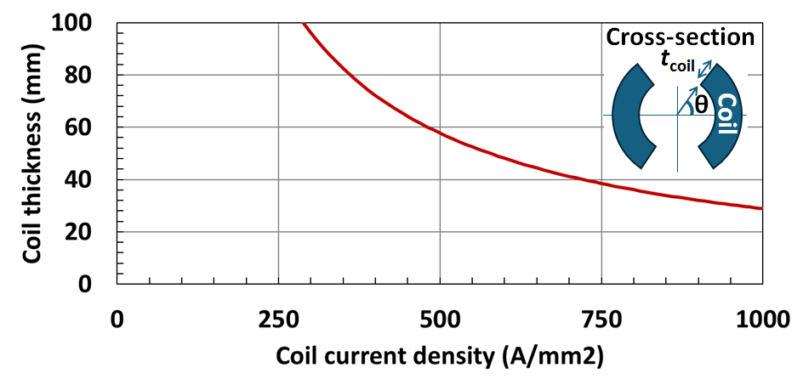
Fig. 8. Coil thickness vs. coil current density of a 20 T cos(θ) dipole designed using a full HTS sector configuration.
$B_{1}=-2μ_{0}J_{coil}t_{coil}\sin{θ}/π.$ (1)
The cable J_{e} is given by J_{coil} / (load line ratio × packing factor). When the load line ratio and the packing factor are 0.8 and 0.6, respectively, the cable J_{e} is required to be higher than 830 A/mm² for the J_{coil} of 400-500 A/mm². This extremely high requirement for the cable J_{e} is a major challenge in designing and manufacturing the coil for high-field accelerator magnets. The REBCO round cable wound using the stack conductor have the potential to meet this requirement, but many challenges must be overcome, including the manufacturing process for uniform conductor thickness and the connection between the cable and current leads.

IV. Conclusion
Three commercially available coated conductors, manufactured by SuperPower Inc., was measured at 77 K and 4.2 K. The conductor I_{c} at 20 T and 4.2 K was extrapolate from the measurement in magnetic fields up to 18 T. Four types of single-layer cables were made to investigate the degradation of the cable I_{c} as a function of the core diameter. The stack conductor, which was made by soldering two REBCO tapes together with their REBCO layers facing each other, can be wound on smaller cores than the commercially available conductor by placing the REBCO layer closer to the neutral axis. The compressive strain in the REBCO layer was estimated to be approximately -0.5% when the cable I_{c} dropped sharply for all cable types. The minimum core diameters using the stack conductor, the commercially available conductor, and the additional copper plated conductor were calculated using a strain limit of -0.4% for the REBCO layer. Using the parameters in Table 3, the cable I_{c} and J_{e} of the stack conductor are expected to achieve 13 kA and 1000 A/mm² with a cable diameter of 4 mm. According to the calculations, the cable J_{e} is required to be higher than 830 A/mm² to design a 20 T cos(θ) dipole in a full HTS sector configuration. The REBCO round cable wound using the stack conductor have the potential to meet this requirement.

Acknowledgment
The authors thank the staff of the KEK mechanical engineering center for fabricating the sample holders and the staff of the Tsukuba Magnet Laboratory at NIMS for their technical support on conducting the measurements. The authors also thank the staff of the Nomura Plating CO., LTD. for introducing the additional copper plating on the commercially available conductor.
References
- D. C. van der Laan, “YBa₂Cu₃O_{7−δ} coated conductor cabling for low ac-loss and high-field magnet applications,” Supercond. Sci. Technol., vol. 22, 2009, Art. no. 065013, doi: 10.1088/0953-2048/22/6/065013.
- J. D. Weiss, T. Mulder, H. J. ten Kate, and D. C. van er Laan, “Introduction of CORC® wires: highly flexible, round high-temperature superconducting wires for magnet and power transmission applications,” Supercond. Sci. Technol., vol. 30, 2017, Art. no. 014002, doi: 10.1088/0953-2048/30/1/014002.
- J. D. Weiss, D. C. van der Laan, D. Hazelton, A. Knoll, G. Carota, D. Abraimov, A. Francis, M. A. Small, G. Bradford, and J. Jaroszynski, “Introduction of the next generation of CORC® wires with engineering current density exceeding 650 A mm⁻² at 12 T based on SuperPower's ReBCO tapes containing substrates of 25 μm thickness,” Supercond. Sci. Technol., vol. 33, 2020, Art. no. 044001, doi: 10.1088/1361-6668/ab72c6.
- S. Kar, W. Luo, V. Selvamanickam, “Ultra-Small Diameter Round REBCO Wire With Robust Mechanical Properties,” IEEE Trans. Appl. Supercond., vol. 27, 2017, Art. no. 6603204, doi: 10.1109/TASC.2017.2669727.
- S. Kar, J. S. Sandra, W. Luo, M. Kochat, J. Jaroszynski, D. Abraimov, G. Majkic, and V. Selvamanickam, “Next-generation highly flexible round REBCO STAR wires with over 580 A mm⁻² at 4.2 K, 20 T for future compact magnets,” Supercond. Sci. Technol., vol. 32, 2019, Art. no. 10LT01, doi: 10.1088/1361-6668/ab3904.
- E. Galstyan, J. Kadiyala, M. Paidpilli, C. Goel, J. S. Sandra, V. Yerraguravagari, G. Majkic, R. Jain, S. Chen, and Y. Li, “High critical current STAR® wires with REBCO tapes by advanced MOCVD,” Supercond. Sci. Technol., vol. 36, 2023, Art. no. 055007, doi: 10.1088/1361-6668/acc4ed.
- X. Wang, K. Tsuchiya, A. Terashima, S. Tanabe, N. Negishi, and A. Kikuchi, “Critical Current Measurements of Prototype REBCO Round Cables at 77 K,” IEEE Trans. Appl. Supercond., vol. 34, 2024, Art. no. 4801205, doi: 10.1109/TASC.2023.3345848.
- K. Tsuchiya, A. Kikuchi, A. Terashima, K. Suzuki, K. Norimoto, M. Tawada, M. Masuzawa, N. Ohuchi, X. Wang, Y. Iijima, T. Takao, S. Fujita, M. Daibo, and Y. Iijima, “Critical Current Characterization of Commercial REBCO Coated Conductors at 4.2 and 77 K,” IEEE Trans. Appl. Supercond., vol. 27, 2017, Art. no. 6600205, doi: 10.1109/TASC.2016.2625762.
- K. Tsuchiya, A. Kikuchi, A. Terashima, K. Norimoto, M. Uchida, M. Tawada, M. Masuzawa, N. Ohuchi, X. Wang, T. Takao, and S. Fujita, “Critical current measurement of commercial REBCO conductors at 4.2 K,” Cryogenics, vol. 85, pp. 1-7, 2017, doi: 10.1016/j.cryogenics.2017.05.002.
- K. Tsuchiya, X. Wang, S. Fujita, A. Ichinose, K. Yamada, A. Terashima, and A. Kikuchi, “Superconducting properties of commercial REBCO-coated conductors with artificial pinning centers”, Supercond. Sci. Technol., vol. 34, 2021, Art. no. 105005, doi: 10.1088/1361-6668/ac1e65.
- C. Senatore, C. Barth, M. Bonura, M. Kulich, and G. Mondonico, “Field and temperature scaling of the critical current density in commercial REBCO coated conductors,” Supercond. Sci. Technol., vol. 29, 2016, Art. no. 014002, doi: 10.1088/0953-2048/29/1/014002.
- S. Otten, A. Kario, A. Kling, and W. Goldacker, “Bending properties of different REBCO coated conductor tapes and Roebel cables at T = 77 K,” Supercond. Sci. Technol., vol. 29, 2016, Art. no. 125003, doi: 10.1088/0953-2048/29/12/125003.

This work was supported by “MEXT Development of key element technologies to improve the performance of future accelerators Program” Japan Grant Number JPMXP1423812204. Xudong Wang, Kiyosumi Tsuchiya, and Akio Terashima are with the High Energy Accelerator Research Organization (KEK), Tsukuba, Ibaraki 305-0801, Japan (e-mail: wanxdon@post.kek.jp). Suguru Tanabe is with the Junkosha Inc., Kasama, Ibaraki 309-1603 Japan. Nobuyuki Negishi is with the Junkosha Inc., Chiyoda, Tokyo 101-0062 Japan. Akihiro Kikuchi is with the National Institute for Materials Science (NIMS), Tsukuba, Ibaraki 305-0028, Japan. Color versions of one or more of the figures in this article are available online at http://ieeexplore.ieee.org

