High-efficiency infra-red shielding and UV blocking by carbon dots assisted Cesium doped tungsten oxide nanoparticles

セシウムドープ酸化タングステンナノ粒子へのカーボンドットのアシスト効果による高効率な近赤外シールド兼UVシールド機能の創出

〇Adrija Das, Barun Kumar Barman, and Tadaaki Nagao*
¹ MANA-National Institute for Materials Science, Tsukuba City, Japan
²Department of Condensed Matter Physics, Hokkaido University, Sapporo, Japan
*Corresponding Author: NAGAO.Tadaaki@nims.go.jp

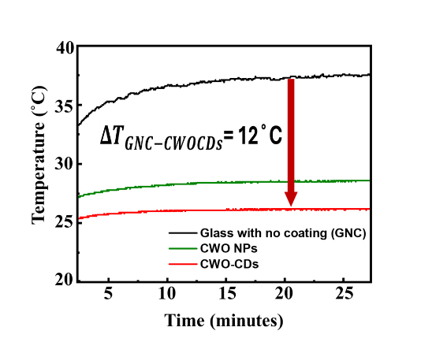
Earth is warming up! Buildings consume 30-40% of its electricity in air-conditioning. Achieving a temperature drop of only 1˚C indoors could reduce energy costs by 1-3% for an 8-hour usage. Window coatings that promote near-infrared (NIR)/thermal shielding are thus essential. Harmful UV-A (315-400 nm) radiation reaching the planetary surface is deemed a carcinogen, eliminating which is key for human health and material longevity. Transparent conductive oxide semiconductors like indium tin oxide (ITO) and cesium tungsten oxide (CWO) act as wavelength selective absorbers in the NIR while providing high transparency to visible light due to their wide band gap. But they exhibit reduced efficiency in UV-A (315-400 nm) absorption. Eco-friendly and sustainable Carbon dots (CDs) act as high-performance UV-A absorbers. In this presentation, we propose and develop a new hybrid material composed of CWO nanoparticles and CDs hereby called CWO-CDs for high performance NIR shielding and UV-A blocking properties, schematically shown in Figure 1 (a). Tungsten oxide doped with cesium exhibits high metallicity that generates localized surface plasmon resonance (LSPR) in the NIR region. This leads to a strong absorption edge around 800 nm for maximum solar heat shielding. APTES was added to CWO nanoparticles as a base material to ensure better dispersion, interparticle separation and high adhesion to glass surface generating a uniform, slightly blue tinted, transparent thin film. CDs provide very high UV-A absorption while assisting CWO particle aggregation forming larger particle clusters. This change in size affects the plasma frequency response, leading to enhanced NIR absorption observed in Figure 1(b). Furthermore, tuning the film thicknesses as CWO-CDs film achieved solar blocking efficiencies of 84.8% in the NIR and 91.2% in UV-A. Varying film thickness, increases porosity that leads to increased absorption in the NIR by virtue of internal scattering amongst particle clusters. We demonstrated the heat shielding effect by an architectural house model. Temperature vs time, as seen in Figure 1 (c), shows temperature lowering as large as 12 ˚C rendering safer and cooler indoors with high energy savings. Metal oxide semiconductors and eco-friendly carbon dots thus provide very efficient solar heat and UV blocking ideal for energy saving applications as window and skylight coatings.
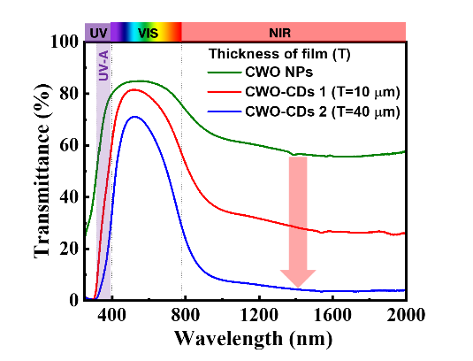
(c)
(b)
(a)
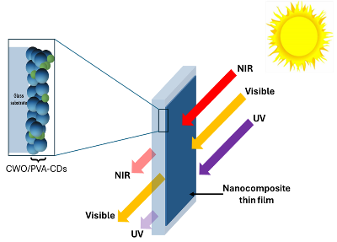

Figure. 1 (a) Selective light absorption by CWO-CDs thin film as window/skylight coating (b) UV-Vis NIR transmittance spectra of CWO NPs vs CWO-CDs (c) Temperature vs time of each different films under constant solar exposure

References
[1] Xu, J.; Raman, A.P..2021. Cell Press. 20, No. 102825.
[2] Tang,X.; Yang,T.; Yu,D.; Xiong,H.; Zhang,S.. 2024. Environ. Int.,185, No.108535.
[3] Wang, Y.; Yan, Z.; Zhang, M.; Zhang, Z.; Li, T.; Chen M.; Dong, W.2021. Nanoscale Adv., 3, 3177–3183

