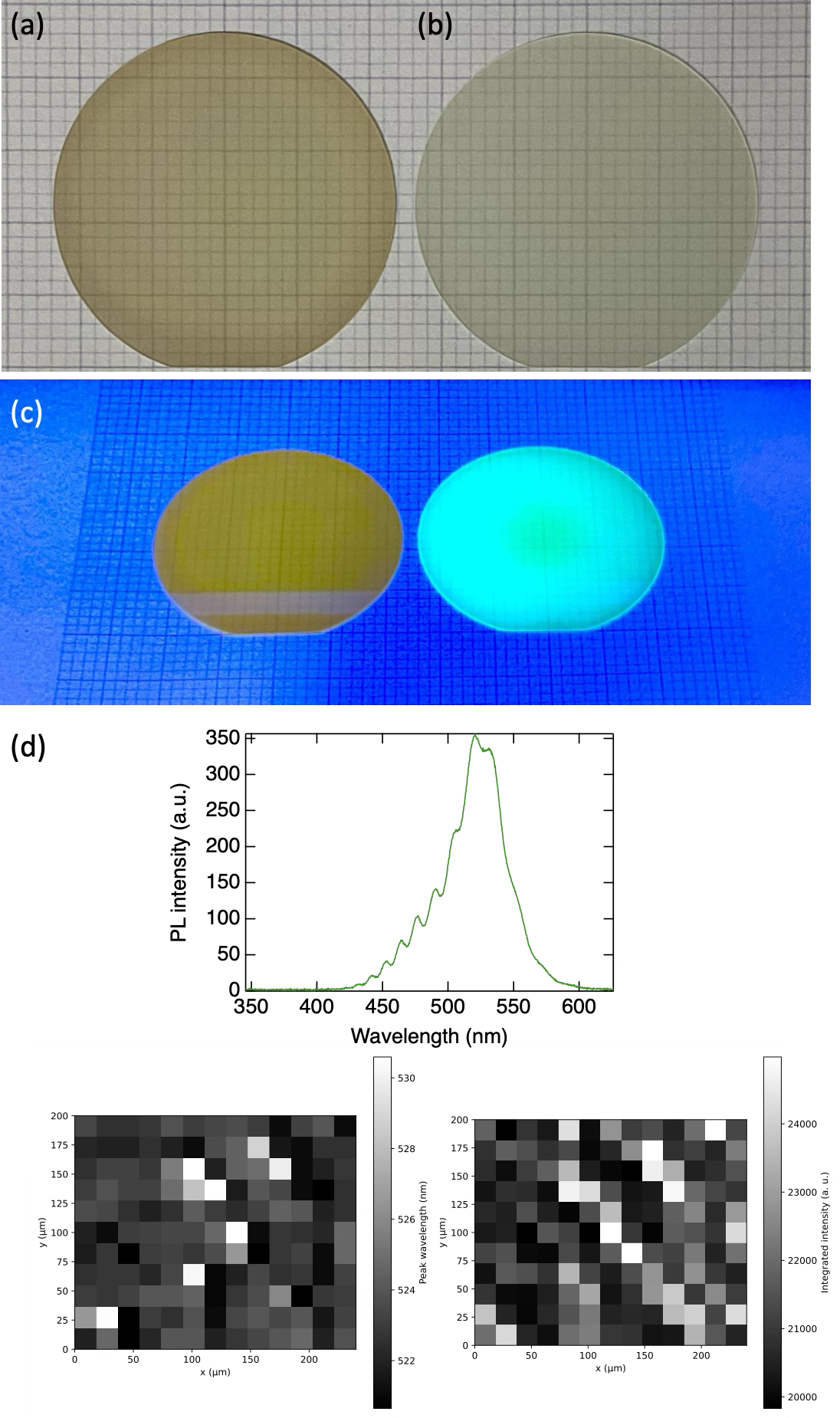

Supplementary Fig. S1 M. Imura et. al
Optical properties of MQW structures designed for 520 nm emission: (a, b) photographs of samples grown at V/III ≈ 1000 and ≈ 8000, respectively; (c) UV-excited luminescence images; and (d) He–Cd laser-excited photoluminescence spectra mapping. The low-V/III sample exhibits severe brown discoloration and weak emission, whereas the high-V/III sample emits green.

