Electron Holography Observation of Individual Ferrimagnetic Lattice Planes

Toshiaki Tanigaki¹*, Tetsuya Akashi¹, Takaho Yoshida¹, Ken Harada², Kazuo Ishizuka³,
Masahiko Ichimura¹, Kazutaka Mitsuishi⁴, Yasuhide Tomioka⁵, Xiuzhen Yu²,
Daisuke Shindo^{2,6}, Yoshinori Tokura^{2,7}, Yasukazu Murakami⁸ & Hiroyuki Shinada¹
¹Research & Development Group, Hitachi, Ltd., Hatoyama, 350-0395, Japan.
²RIKEN Center for Emergent Matter Science (CEMS), Wako, 351-0198, Japan.
³HREM Research Inc., Matsukazedai, 355-0055, Japan.
⁴National Institute for Materials Science, Tsukuba, 305-0047, Japan.
⁵National Institute of Advanced Industrial Science and Technology (AIST), Tsukuba, 305-8562, Japan.
⁶Institute of Multidisciplinary Research for Advanced Materials, Tohoku University, Sendai, 980-8577, Japan.
⁷Department of Applied Physics and Tokyo College, The University of Tokyo, Tokyo, 113-8656 Japan.
⁸Department of Applied Quantum Physics and Nuclear Engineering, Kyushu University, Fukuoka, 819-0395, Japan.

*e-mail: toshiaki.tanigaki.mv@hitachi.com

Abstract (200 words)
Atomic-scale observations in a desired local area would bring a great benefit to exploring novel fundamental materials and devices. Development of hardware-type aberration correction^{1,2} in electron microscopy has enabled local structural observations with atomic resolution ³⁻⁵ as well as chemical and vibration analysis⁶⁻⁸. As for magnetic imaging, however, atomic-level spin configuration has been analyzed by electron energy-loss spectroscopy by placing samples in strong magnetic fields⁹⁻¹¹, which destroy the nature of the magnetic ordering in the samples. Although magnetic-field-free observation can visualize intrinsic magnetic fields of an antiferromagnet by unit-cell averaging¹², it is a challenge to directly observe the magnetic field of an individual atomic layer of a non-uniform structure. Here we report that the magnetic fields of an individual lattice plane inside materials with a non-uniform structure can be observed under magnetic-field-free conditions by electron holography with a hardware-type aberration-corrector assisted by post digital aberration corrections. Magnetic phases of net magnetic moments of (111) lattice planes formed by opposite spin orderings between Fe³⁺ and Mo⁵⁺ in a ferrimagnetic double-perovskite oxide (Ba₂FeMoO₆) were successfully observed. This result opens the door to direct observations of the magnetic lattice in local areas, such as interfaces and grain boundaries, in many materials and devices.

Main (2505 words)
Analysis of the magnetic structure of a material and its associated spin configuration is an important issue¹³⁻¹⁶ not only in the fields of solid-state physics, inorganic chemistry, and spintronics but also in other fields such as materials science and engineering. The magnetic structure is generally determined by neutron scattering¹⁷ as a direct and useful probe. However, neutron scattering needs a huge volume of samples due to its small magnetic-scattering cross section. Accordingly, it is not suitable for samples that are difficult to grow as large crystal or electronic devices composed of thin films, nanoparticles, nanowires, and other such structures. For these submicrometre-scaled targets, X-ray magnetic circular dichroism (XMCD) using synchrotron-radiation-based scanning transmission X-ray microscopy has large penetration capability and element specificity. However, the spatial resolution of magnetic imaging via spectro-ptychography is in the order of nanometres, i.e., down to 7 nm¹⁸. For surface-sensitive magnetic imaging of the material, two atomic-resolution techniques are available: spin-polarized scanning tunneling microscopy^{19,20} and magnetic exchange force microscopy²¹. However, atomic-resolution observation of the magnetic structure inside materials has been a long-standing goal of magnetic characterization. For such observation, transmission electron microscopy (TEM) is a powerful tool capable of site-specific analysis²². However, atomic-scale measurement of magnetization by TEM remains a big challenge. Its status appears in sharp contrast to the rapid progress in crystal-structure analysis by TEM in the last two decades, which was triggered by the invention of aberration correction^{1,2}.
With reference to studies on magnetic structure by using atomic-scale TEM⁹⁻¹¹, electron energy-loss spectroscopy allows observation of electron magnetic circular dichroism,²³ which is analogous to XMCD, and provides information about spin and orbital angular momentum from magnetic samples. However, the strong magnetic field in the objective lens, which is usually essential for high-resolution observation, magnetizes the specimen in the direction of electron incidence; that is, the original spin configuration is lost in the many cases. Several instruments can position a specimen so that it is free from the undesired magnetic field of the objective lens²⁴⁻²⁸. The problem with these instruments is deterioration in resolution due to the large aberration of the objective lens. Accordingly, aberration corrections have enabled magnetic-field observation of local areas such as layers and nanomagnets at resolution of a few nanometres²⁹⁻³¹. Preliminary examinations of non-ferromagnetic model specimens by using a high-voltage microscope³² or a special objective lens³³ have attained atomic resolution. Although unit-cell averaging of a uniform structure has made it possible to visualize intrinsic magnetic fields of an antiferromagnet¹², the ultimate goal of electron microscopy is to obtain magnetic information from an individual atomic layer without unit-cell averaging. If that goal were reached, it would be possible to investigate unknown magnetic structures at interfaces. However, several problems must be solved first. Although many methods detect the phase shift or deflection of incident electrons due to magnetic interaction, a crystalline specimen offers additional modulations of the electron wave (including phase shift) caused by dynamical scattering due to the electrostatic-scattering potential. Undesired phase shift can also be produced by the stray magnetic field (so-called “demagnetization field”) outside the specimen and/or the electrostatic potential in the crystal. These additional phase shifts are superposed on the information about spin configuration and must be separated. Moreover, the magnetic signal at atomic scale is weak; therefore, to increase signal-to-noise ratio, high-resolution magnetic-field observation requires relatively longer observation time than that of a strong electrostatic signal of atoms. Temporal change of aberrations during multiple magnetic imagings and difficulty in setting proper focus during the observations are the limiting factors on spatial resolution. These limiting factors have made magnetic-structure analysis using an electron probe extremely challenging.
In this study, off-axis electron holography using a sophisticated 1.2-MV holography microscope with an aberration corrector (spatial resolution: 0.24 nm)^{32,34} was used for magnetic-field-free observations of the magnetic-field distributions of individual lattice plane of a ferrimagnetic double-ordered perovskite crystal Ba₂FeMoO₆. As mentioned later in greater detail, electron holography can be an ideal tool for comprehensive studies on phase shift. That is, it enables digital focus after the observations with controlled magnetizations and separation of signals arising from magnetization, electrostatic potentials, electron diffraction within the crystal, and other phenomena. Accordingly, it makes it possible to compare experimental phase images and theoretically calculated phase images concerning magnetism. The results of the above-mentioned studies provide conceptual insights for the establishment of magnetic-field observations of individual lattice plane and application of high-resolution magnetic-structure analysis from a nanometre-scale area. This study is the first step in opening a new door to investigate the veiled phenomena whose existence is to be revealed by spin configurations in magnetic materials.

Magnetic-field observation
Ba₂FeMoO₆ as the objective magnetic sample is one of the double-ordered perovskites with the formula A₂FeMoO₆ (A: Ca, Sr or Ba) that exhibit spin-polarized giant tunneling magnetoresistance at room temperature³⁵ and behave as a half metal with high Curie temperature³⁶ (330 to 345 K in the case of Ba₂FeMoO₆^{37,38}). Ba₂FeMoO₆ has a cubic structure with a₀ = 0.80747 nm³⁷ and shows an alternate ordering of FeO₆ and MoO₆ octahedra (Fig. 1a) with ferrimagnetic coupling between the spins of Fe³⁺ (3d⁵, S=5/2) and those of Mo⁵⁺ (4d¹, S=1/2). Recent calculation of its thermoelectric properties predicts that Ba₂FeMoO₆ is a high-ZT thermoelectric material³⁹. Magnetization of Ba₂FeMoO₆ at 300 K is about 0.106 T, and magnetic domains have been clearly observed by Lorentz TEM at room temperature³⁸. When the magnetization is along the [$\overline{1}\overline{1}$2] direction, opposite-directional spin moments on the Fe and Mo atoms align in the (111) lattice plane (Fig. 1b). In terms of phase analysis by electron holography, the opposite directional magnetic field on the Fe and Mo atomic planes along the (111) lattice plane (Fig. 1c) can be clearly observed with slightly tilted sample orientation from the [1$\overline{1}$0] zone axis while the (111) lattice plane is kept parallel to the projection direction.
A 1.2-MV holography electron microscope with a spherical aberration corrector^{32,34} was used for electron-holography observations of the magnetic-field distributions (Extended Data Fig. 1a). In the pulse-magnetization system²², we can reverse the direction of the magnetization in the sample without changing the geometrical configuration of the sample holder and stage, by which we can clearly separate the magnetic phases from the electrostatic ones (caused by electrostatic potentials, diffraction within the crystal and other phenomena, e.g., contaminations). The phases obtained in opposite magnetization states have different sign in the magnetic phase but the same sign in the electrostatic phase. Subtracting these phases makes it possible to determine the difference in the magnetic phases due to difference between the in-plane magnetic-field distributions before and after magnetization reversal.
A rectangular-shaped (1600×270 nm) thin sample was fabricated by using a focused ion beam (FIB), to generate [$\overline{1}\overline{1}$2] or [11$\overline{2}$] directional magnetizations in the sample (Extended Data Fig. 1 and Method). The surface-damage layers were cleaned by low-energy argon-ion beam. Thickness of the observation area was 45.0±0.1 nm (Extended Data Fig. 1d), which is suitable for observing a magnetic field of a ferrimagnetic lattice plane by a 1.2-MV holography electron microscope. The suitable condition is explained in detail in the “Magnetic-phase simulation” section.
Multiple pairs of electron holograms with opposite magnetizations states and an interference fringe with spacing of 0.079 nm were acquired at room temperature (Fig. 2a). Object waves (amplitude and phase images) were reconstructed from the holograms by using a reconstruction aperture to obtain a spatial resolution greater than 0.234 nm, which is three times the spacing of the interference fringe.
Since the magnetic phase shift is only in the order of 0.01 rad, as explained in the simulation section, the object waves were then subjected to numerical-aberration corrections to correct residual aberrations. By analyzing the power spectra and Thon diagrams⁴⁰ of the object waves, which were obtained by applying the virtual through focus of the reconstructed object wave in a thin amorphous area, it is possible to analyze and digitally correct the residual aberrations (Extended Data Fig. 2). Note that the digital-focusing condition used to maximize the phase in the crystalline area differs from the focusing condition to minimize the amplitude in the thin area due to multiscattering of the electron waves in the sample. To compare the experimental and simulated phases, the phase information before the electrostatic and magnetic phases were separated at high resolution was maximized by additional fine digital focusing. To reduce artifacts due to noise, any frequencies higher than 1/0.40 nm⁻¹ were filtered out by FFT (see Methods).
The obtained electrostatic and magnetic phases of ferrimagnetic lattice planes are shown in Figs. 2c and 2d. The lattice fringe observed in the electrostatic phase indicates Fe and Mo (111) planes. The multislice simulation described in the next section shows that the electrostatic phase of the Fe plane becomes larger than that of the Mo plane under the observation conditions stated above. The magnetic phase showing a periodic decrease at the positions of the Fe planes corresponds to the ferrimagnetic magnetic structures in the sample. The derivative of the magnetic phase (Fig. 2g) clearly shows magnetic fields of (111) ferrimagnetic lattice planes with the spacing of 0.466 nm formed by the opposite magnetic moments of Fe and Mo atoms in Ba₂FeMoO₆. Note that signals of opposite magnetic fields are superimposed in Fig. 2g and the minimum distance between the positive and negative signals of the derivative of the magnetic phase is the half of the resolution. The quantitative value of the electrostatic phase including the electrostatic phase distributions due to two-dimensional non-uniform structure with surface amorphous layers of the sample is 1.4612±0.0477 rad (peak-to-peak) (Fig. 2e). The peak-to-peak magnetic phase after subtracting the background phase slope due to the general [$\overline{1}\overline{1}$2] directional magnetization is 0.0059±0.0016 rad (Fig. 2f). The magnetic phase is clearly larger than statistical phase error σ_{φ} of 0.0010 rad. The +peak for the Mo plane and the −peak for the Fe plane of the derivatives of the magnetic phases are 0.0330±0.0088 rad/nm and −0.0462±0.0089 rad/nm, respectively. These values are also clearly larger than statistical error σ_{dφ} of 0.0079 rad/nm.

Magnetic-phase simulation
To understand the experimental results described in Figs 2d and 2g, we performed multislice simulation taking into account atomic-scale magnetic fields using the parameters of the observations and data process as same as performed in the experiment. To calculate magnetic phase due to the [$\overline{1}\overline{1}$2] directional magnetization, a supercell was created (Fig. 3a). The supercell was used to create electromagnetic phase shift per unit cell (in the manner of a “phase plate”) by combining the electrostatic and magnetic phase gratings (Fig. 3b and Extended Data Fig. 5). The electrostatic phase plate is the same as results by conventional multislice simulation; however, the magnetic phase plate was newly calculated by using first-principles density functional theory (DFT) (see Method).
The multislice simulations of the phases were performed two dimensionally for sample thickness up to 90 nm; hereafter, the one-dimensional phase profile along the [111] direction is discussed. First, the simulated electrostatic phase at the bottom of the sample, where the defocus value is defined as zero, is discussed. The electrostatic phase reverses sign successively as a function of sample thickness (Fig. 3c). The electrostatic phase of the Mo plane shows a larger phase shift than that of the Fe plane. However, from thickness of 30 to 60 nm, the Fe-phase shift becomes larger than the Mo-phase shift. As for the digital focusing to maximize the phase signal before separating the electrostatic and magnetic phases, two options for maximizing the phase either at the positions of Fe plane or the Mo plane are available. Calculating the magnetic phase for each defocus condition revealed two options: maximizing (i) the Mo phase for the thickness ranges of 0‒25 and 56‒90 nm or (ii) the Fe phase for the thickness range of 25‒56 nm (Fig. 3d). Under these digital-focusing conditions, the magnetic phase can be obtained as a reasonable signal showing the magnetic field of ferrimagnetic lattice planes; that is, the local magnetic-phase slope decreases at the positions of the Fe plane in the same manner as the total-magnetic-phase slope (Fig. 3e). The magnetic phases for sample thickness below 30 nm and around 56 nm are very weak. The suitable thickness to observe the magnetic phase is thus in the range of 35‒50 nm or greater than 65 nm. The sample thickness observed by electron holography was 45.0±0.1 nm. Accordingly, the suitable defocus is that which maximizes the amount of Fe phase, so the digital defocus was applied to the electron wave so as to meet that condition (see Method).
The peak-to-peak value of the simulated electrostatic phase for sample thickness of 45 nm is 1.4545 rad (Fig. 3f), which corresponds to the experimentally obtained value. The peak-to-peak value of the simulated magnetic phase is 0.0061 rad (Fig. 3g), which corresponds to the experimentally obtained value. The +peak for the Mo plane and the −peak for the Fe plane of the derivative of the simulated magnetic phase are 0.0338 rad/nm and −0.0484 rad/nm, respectively, which correspond to the respective experimental values. These results indicate that the magnetic field of an individual ferrimagnetic lattice plane can be observed by the electron holography combined with the additionally developed techniques of post digital aberration correction and focusing as well as of magnetic multislice simulation.

Discussion
The future possibility of magnetic-field observations at higher resolution is discussed hereafter. In this electron holography experiment, magnetic fields of 0.466-nm period in ferrimagnetic Ba₂FeMoO₆ were observed. To increase the phase sensitivity in this experiment, the spatial resolution was limited by applying a filter and Gaussian blur. The achievement of the magnetic phase imaging without applying a filter and Gaussian blur while maintaining the highest resolution of the microscope remains challenging. The envelope of the contrast-transfer function of the holography microscope used in this experiment is around 0.9 at spatial frequency of 1/0.466 nm⁻¹. Thus, the reduction of the wave (amplitude and phase) signal related to the envelope is negligible. However, if the targeted resolution approaches an information limit, the reduction of the wave-signal intensity becomes problematic. In the future development of electron microscopy, it is thus necessary to enhance the envelope function at higher spatial resolution. This enhancement of the wave-signal intensity will improve the quantitativity of phase imaging in regard to atomic-resolution magnetic-field observation. The true magnetic field in the sample can be estimated by using magnetic multislice simulations and taking into account experimental conditions and data-analysis procedures. Nevertheless, observational capability at higher resolution with quantitativity of phase imaging will lead to the better understanding of the magnetic nature of the sample.
Using electron holography with a 1.2-MV holography electron microscope with an aberration corrector, the developed pulsed magnetization and post digital aberration correction have made it possible to observe a magnetic field inside a sample with an individual ferrimagnetic lattice plane. The observed magnetic field was analyzed by multislice simulation taking into account atomic-scale magnetic fields. This high-resolution magnetic-field observation by electron holography will open up a new frontier in the field of electron microscopy and be utilized for research on a variety of fundamental and applied physics issues, including emergent electromagnetic phenomena at interfaces and boundaries in materials and devices.

Online content
Any methods, additional references, Nature Research reporting summaries, source data, extended data, supplementary information, acknowledgements, peer review information; details of author contributions and competing interests; and statements of data and code availability are available at https://doi.org/10.1038/------.

- Haider, M. et al. Electron microscopy image enhanced. Nature 392, 768-769 (1998).
- Batson, P. E., Dellby, N. & Krivanek, O. L. Sub-ångstrom resolution using aberration corrected electron optics. Nature 418, 617-620 (2002).
- Jia, C. L., Lentzen, M. & Urban, K. Atomic-resolution imaging of oxygen in perovskite ceramics. Science 299, 870–873 (2003).
- Nellist, P. D. et al. Direct sub-angstrom imaging of a crystal lattice. Science, 305, 1741 (2004).
- Shibata, N., Pennycook, S. J., Gosnnell, T. R., Painetr, G. S., Shelton, W. A. & Becher, P. F. Observation of rare-earth segregation in silicon nitride ceramics at subnanometre dimensions. Nature, 428, 730–733 (2004).
- Muller, D. A., Fitting-Kourkoutis, L., Murfitt, M., Song, J. H., Hwang, H. Y., Silcox, J., Dellby, N., Krivanek, O. L. Atomic-scale chemical imaging of composition and bonding by aberration-corrected microscopy. Science 319, 1073-1076 (2008).
- Suenaga, K. & Koshino, M. Atom-by-atom spectroscopy at graphene edge. Nature 468, 1088-1090 (2010).
- Hage, F. S., Radtke, G., Kepaptsoglou, D. M., Lazzeri, M. & Ramasse, Q. M. Single-atom vibrational spectroscopy in the scanning transmission electron microscope. Science 367, 1124-1127 (2020).
- Rusz, J. et al. Magnetic measurements with atomic-plane resolution. Nat. Commun. 7, 12672 (2016).
- Idrobo, J. C. et al. Detecting magnetic ordering with atomic size electron probes. Adv. Struct. Chem. Imag. 2, 5 (2016).
- Wang, Z. et al. Atomic scale imaging of magnetic circular chichroism by achromatic electron microscopy. Nature Mater. 21, 221-225 (2018).
- Kohno, Y., Seki, T., Findlay, S. D., Ikuhara, Y. & Shibata, N. Real-space visualization of intrinsic magnetic fields of an antiferromagnet. Nature 602, 234-239 (2022).
- Tokura, Y. & Nagaosa, N. Orbital physics in transition-metal oxides. Science 288, 462–468 (2000).
- Brinkman, A. et al. Magnetic effects at the interface between non-magnetic oxides. Nature Mater. 6, 493-496 (2007).
- Liu, L. et al. Spin-torque switching with the giant spin Hall effect of tantalum. Science 336, 555-558 (2012).
- Lee, J.-S. et al. Titanium d_{xy} ferromagnetism at the LaAlO₃/SrTiO₃ interface. Nat. Mater. 12, 703-706 (2013).
- Mühlbauer, S. et al. Skyrmion lattice in a chiral magnet. Science 323, 915–919 (2009).
- Zhu, X. H. et al. Measuring spectroscopy and magnetism of extracted and intracellular magnetosomes using soft X-ray ptychography. Proc. Natl. Acad. Sci. USA 113, E8219–E8227 (2016).
- Wiesendanger, R. et al. Topographic and magnetic-sensitive scanning tunneling microscopy study of magnetite. Science 255, 583–586 (1992).
- Heinze, S. et al. Real-space imaging of two-dimensional antiferromagnetism on the atomic scale. Science 294, 1488–1495 (2001).
- Kaiser, U., Schwarz, A. & Wiesendanger, R. Magnetic exchange force microscopy with atomic resolution. Nature 446, 522–525 (2007).
- Tanigaki, T. et al. Magnetic field observations in CoFeB/Ta layers with 0.67-nm resolution by electron holography. Sci. Rep. 7, 16598 (2017).
- Schattschneider, P. et al. Detection of magnetic circular dichroism using a transmission electron microscope. Nature 441, 486–488 (2006).
- Shirota, K., Yonezawa, A., Shibatomi, K. & Yanaka, T. Ferro-magnetic material observation lens system for CTEM with a eucentric goniometer. J. Electron Microsc. 25, 303-304 (1976).
- Harada, K. et al. Real-time observation of vortex lattices in a superconductor by electron microscopy. Nature 360, 51-53 (1992).
- Schofield, M. A., Beleggia, M., Zhu, Y. & Pozzi, G. Characterization of JEOL 2100F Lorentz-TEM for low-magnification electron holography and magnetic imaging. Ultramicroscopy 108, 625-634 (2008).
- Dunin-Borkowski, R. E. et al. Opportunities for chromatic aberration corrected high-resolution transmission electron microscopy, Lorentz microscopy and electron holography of magnetic minerals. Microsc. Microanal. 18(Suppl. 2), 1708–1709 (2012).
- Snoeck E. et al. Off-axial aberration correction using a B-COR for Lorentz and HREM modes. Microsc. Microanal. 20(Suppl. 3), 932-933 (2014).
- O’Shea, K. J. et al. Nanoscale mapping of the magnetic properties of (111)-oriented La_{0.67}Sr_{0.33}MnO₃. Nano Lett. 15, 5868-5874 (2015).
- Gatel, C., et al. Size-specific spin configurations in single iron nanomagnet: from flower to exotic vortices. Nano Lett. 15, 6952-6957 (2015).
- Nagai, T., Kimoto, K., Inoke, K. & Takeguchi, M. Real-space observation of nanoscale magnetic phase separation in dysprosium by aberration-corrected Lorentz microscopy. Phys. Rev. B 96, 100405 (2017).
- Tanigaki, T., Akashi, T., Takahashi, Y., Kawasaki, T. & Shinada, H. Quest for ultimate resolution using coherent electron waves: An aberration-corrected high-voltage electron microscope. Adv. Imaging Electron Phys. 198, 69-125 (2016).
- Shibata, N. et al. Atomic resolution electron microscopy in a magnetic field free environment. Nat. Commun. 10, 2308 (2019).
- Akashi, T. et al. Aberration corrected 1.2-MV cold field-emission transmission electron microscope with a sub-50-pm resolution. Appl. Phys. Lett. 106, 074101 (2015).
- Kobayashi, K. -I., Kimura, T., Sawada, H., Terakura, K. & Tokura, Y. Room-temperature magnetoresistance in an oxide material with an ordered double-perovskite structure. Nature 395, 677-680 (1998).
- Tomioka, Y. et al. Magnetic and electronic properties of a single crystal of ordered double perovskite Sr₂FeMoO₆. Phys. Rev. B 61, 442-427 (2000).
- Kim, S. B., Lee, B. W. & Kim, C. S. Neutron and Mössbauer studies of the double perovskite A₂FeMoO₆ (A =Sr and Ba). J Magn. Magn. Mater. 242-245, 747-750 (2002).
- Yu, X. et al. TEM study of the influence of antisite defects on magnetic domain structures in double perovskite Ba₂FeMoO₆. J Electron Microsc. 54, 61-65 (2005).
- Sahnoun, O., Bouhani-Benziane, H., Sahnoun, M. & Driz, M. Magnetic and thermoelectric properties of ordered double perovskite Ba₂FeMoO₆. J Alloy. Comp. 714, 704-708 (2017).
- Tamura, T., Kimura, Y., & Takai, Y. Development of a real-time wave field reconstruction TEM system (I): incorporation of an auto focus tracking system. Microscopy 66, 172-181 (2017).
Fig. 1 | Schematic illustrations of crystal structure and magnetic field in Ba₂FeMoO₆. a, Crystal structure of Ba₂FeMoO₆ with a double perovskite structure. b, Crystal and magnetic structures viewed from the [1$\overline{1}$0] direction with magnetization direction of [$\overline{1}\overline{1}$2]. Ferrimagnetically coupled spins of Fe⁺³ and Mo⁺⁵ cations are respectively marked by green and purple arrows. Oxygen atoms are omitted in this figure. c, Magnetic-field distributions expected to be observed in the observation direction slightly tilted from the [1$\overline{1}$0] zone axis while the (111) lattice is kept parallel to the electron beam. The color wheel indicates magnetic-field directions.

Fig. 2 | Observations of a ferrimagnetic lattice plane by electron holography. a, Full view of the electron hologram. Amorphous regions at the edge of the sample. b, Enlarged image of the area indicated by the white square in (a). Spacing of the interference fringes is 0.079 nm. c, Electrostatic phase showing Fe (yellow arrow) and Mo (purple arrow) planes of the (111) lattice. d, Magnetic phase indicating ferrimagnetic lattice planes. e and f, Line profiles and peak-to-peak histograms of electrostatic and magnetic phase at the same position indicated by the white dashed lines in c and d. g, Derivative of magnetic phase that reflects the in-plane magnetic field along the (111) lattice. The color wheel indicates how color and shade denote magnetic-field directions and strength (i.e., derivatives of magnetic-phase range 0-0.06 rad/nm in absolute values). h, Line profile and histogram of the +peak and −peak of the derivative of magnetic phase at the position indicated by the white dashed line in g. The images d and g are averaged in the (111) lattice plane with a 2.5-nm range of the sample area. Histograms are obtained from the areas indicated in Extended Data Fig. 9. The scale bar in c, d, and g is 0.5 nm.

Fig. 3 | Simulations of electrostatic and magnetic phases. a, Supercell of Ba₂FeMoO₆ used in multislice simulation of electron-wave propagation in the crystal. Oxygen atoms are omitted in this figure. b, Phase shift per unit cell under the condition observed from the [1$\overline{1}$0] direction. Note that the magnetic-phase contribution of the [$\overline{1}\overline{1}$2] directional magnetization is magnified by 10000 times to visualize its contribution. c, Electrostatic phase shift at the bottom of the sample (where the defocus value is zero) along the [111] direction calculated for sample thickness up to 90 nm. Note that the mean value is subtracted for each thickness to show the peak-to-peak phase shift. d, Electrostatic phase shift along the [111] direction with digital focus to maximize the phase signal for the post process obtaining magnetic phase. Right-side green and light-green lines indicate two types of digital-focus conditions. Phase shift at the Fe (Mo) layers is maximized in the thickness range indicated by light-green (green) lines. e, Magnetic phase shift along the [111] direction calculated with the same digital-focus conditions used in d. f, Phase profiles of electrostatic phase d at selected thickness. g, Phase profiles of magnetic phase e at selected thickness.

Methods
Preparation of a bulk sample and evaluation of its properties
A bulk Ba₂FeMoO₆ single-crystal sample was prepared by the floating-zone technique³⁸. The magnetization of the bulk crystal at 300 K is 0.106 T (about 1.2 µ_{B} per formula unit, Extended Data Fig. 6). The crystal quality for the area observed by electron holography is high enough; namely, defects and anti-phase boundaries are not present (Extended Data Fig. 7a). The atomic arrangements and elemental ordering of Ba, Fe, and Mo sites represent also high quality as clearly observed in a high-angle annular dark-field scanning transmission electron microscope (STEM) image obtained by an aberration-corrected STEM at acceleration voltage of 200 kV and elemental mapping by energy-dispersive X-ray spectroscopy (Extended Data Figs. 7c-7e). The magnetic properties of the thin TEM sample at room temperature were analyzed by electron holography with conventional sample flipping⁴¹ to separate the electrostatic and magnetic phases. Micrometer-sized magnetic domains (Extended Data Fig. 7b) were observed, and the magnetization, represented by the white dashed area in the figure, where the background phase due to the demagnetization field is small, is 0.106±0.0053 T. The magnetization was calculated from the magnetic-phase gradient and sample thickness obtained from the electrostatic phase. The magnetic-field error is due to uncertainty of sample thickness. This value is used as the magnetization of the thin sample in this study.

TEM sample preparation
The thin sample was prepared from a bulk Ba₂FeMoO₆ single-crystal sample using a focused-ion-beam scanning electron microscope (FIB-SEM NB5000, Hitachi High-Tech Co.) at acceleration voltage of 40 kV. The surface-damaged layer was cleaned by argon-ion beam thinning instrument (PIPS Model 691, Gatan Inc.) at acceleration voltage of 2.7 kV. To create [$\overline{1}\overline{1}$2] directional magnetization in the sample, the thinned sample was shaped as a rectangle with its long side along the [$\overline{1}\overline{1}$2] direction (1600×270 nm) by FIB at acceleration voltage of 5 kV. To protect the sample while the shaping it by unfocused ion beam (due to the lower acceleration voltage of 5 kV), a 300-nm-thick carbon film was placed above the thin sample by using the micromanipulator of the FIB-SEM. This setup makes it possible to produce a sharp edge with less ion-beam damage. The sample thickness to be observed was monitored by the live-view function of the SEM during FIB fabrication, and FIB fabrication was stopped when the sample thickness was around 45 nm. To reduce sample charging in electron-holography experiment, a carbon layer (5 nm in thickness) was deposited on the surface of the sample.

Electron-holography experiment
In the electron-holography experiment, a 1.2-MV holography electron microscope^{32,34} at acceleration voltage was used (as shown in Extended Data Fig. 1a). The sample was observed in the observation direction tilted three degrees (50 mrad) from the [1$\overline{1}$0] zone axis while the (111) lattice was kept parallel to the electron beam. In the figure, only one biprism is illustrated; however, in the actual experiment, a double biprism system⁴² was used to reduce the artifacts by Fresnel fringes and to allow flexible control of interference conditions. The spacing of the interference fringes was set to be 0.079 nm (Fig. 2b) to achieve the suitable resolution in the reconstructed-wave image, because the reconstructed resolution attained by the FFT method becomes three times the spacing of the interference fringes. The holograms were acquired by a direct electron detection camera (K2 Summit, Gatan Inc.) with a high values of modulation transfer function and detection quantum efficiency. Improving phase sensitivity up to the range of 2π/1000 rad by off-axis electron holography requires multiple acquisitions of electron holograms⁴³⁻⁴⁵. Each exposure time of each electron hologram was 2 s, and 15 frames were acquired as one-stack data. The pairs of data stack with the opposite directional magnetizations were acquired 10 times.
Electron holography can measure the phase shift $φ$ of an electron wave that has traversed a thin-foil specimen and the electromagnetic fields inside and outside of the specimen. With reference to the x-y-z coordinate system (i.e., x and y are parallel to the foil plane, and z is along the direction of the incident electrons), the phase φ measured in the x direction can be expressed as ⁴⁶

$φ\left(x\right)=C_{E}V_{0}t\left(x\right)-\frac{e}{ħ}\int{B_{y}(x)dS}$ , (1)

where C_{E}, V₀, t, e, , and B_{y} represent an interaction constant, mean inner potential in the crystal, specimen thickness, elementary charge, Planck’s constant divided by 2π, and the y component of magnetic flux density, respectively. The integral of Eq. (1) is calculated over a surface enclosed by two paths of the electron waves at the origin and the x position. The integral is carried out over the area enclosed by the paths of electrons ⁴⁶.
To extract information about B_{y}, the undesired signal due to the electrostatic potential (i.e., the first term of equation (1)) was removed by measuring a pair of phase images under oppositely magnetized conditions using the following equations:

$φ_{E}=\frac{φ_{↑}+φ_{↓}}{2}$, (2)
$φ_{M}=\frac{φ_{↑}-φ_{↓}}{2}$, (3)

where $φ_{E}$ and $φ_{M}$ are electrostatic and magnetic phases, and $φ_{↑}$ and $φ_{↓}$ are measured phases in forward and reversed magnetization. This extraction process of the magnetic phase leads to a simple relationship between the phase gradient and B_{y} multiplied by t:
$\frac{∂φ_{M}(x)}{∂x}=-\frac{e}{ℏ}B_{y}(x)t(x)$. (4)
The value of t(x) was determined by cross-sectional TEM observations using a thin-foil specimen (Extended Data Fig. 1d). The error in this thickness t measurement comes from the uncertainty of the measurement, which is the order of the pixel size of the image. Note that the measurement of the sample thickness using the cross-sectional TEM observation is not indicating the surface roughness of the sample. This is because the contrast of the cross-sectional TEM image is the average over the surface of the sample in the direction of electron propagation. The electrostatic phase distribution obtained by electron holography not only contains information on the thickness distribution of the sample; it also includes the electrostatic phase of the amorphous layers of the sample. Thus, it is difficult to calculate the sample thickness of the crystal part by using the electrostatic phase.

Pulse-magnetization system
To separate the electrostatic and magnetic phases, a pulse-magnetization system²² was used to reverse the magnetization in the sample without changing the geometrical configuration of the sample holder and stage. This system can suppress the drift of the sample more significantly than that in the conventional separation methods, e.g., flipping the sample and reversing the sign of the magnetic phase⁴¹, tilting the sample in the magnetic field and thereby reversing the magnetization in the sample⁴⁷, and changing the temperature across the Curie temperature⁴⁸. The electrostatic and magnetic phases could also be separated by using different acceleration voltages⁴⁹, but the resolution would be limited by the lower-voltage condition. In the test experiments to investigate the magnetic domains and its reversal by a pulsed magnetic field, rectangular-shaped thin Ba₂FeMoO₆ samples were used. A single magnetic domain in the rectangular-shaped sample was stably observed after applying the pulsed magnetic field of 207 kA/m (Extended Data Fig. 8). According to the results of this experiments, to reverse the magnetization in the Ba₂FeMoO₆ sample, a pulsed magnetic field of 207 kA/m was applied. Note that the magnetic field is not applied while the hologram is acquired.

Electron-hologram reconstruction and post digital aberration correction
The holograms were reconstructed with the FFT method using HoloWorks v5.1, namely, a plug-in for the Gatan Microscope Suite (GMS) v3.3 (Gatan Inc.). The aperture used in the reconstruction was set to allow spatial information greater than 0.234 nm to pass through.
Reconstructed object waves at the thin sample edge have amplitude and phase information (Extended Data Figs. 2a and 2b). From the amplitude or phase images only, it is difficult to identify residual aberrations introduced in the hologram acquisitions. However, through the analyses of the power spectra and Thon diagrams⁴⁰, which were obtained by applying the virtual through focus of the reconstructed object wave of a thin amorphous area, defocus (C1), two-fold astigmatism (A1), spherical aberration (C3), and fifth-order spherical aberration (C5), can be analyzed and corrected digitally (Extended Data Fig. 2).
Constant spherical aberrations (C3) and fifth-order spherical aberration (C5) were corrected in the reconstruction process for each hologram. The numerical details of aberration corrections are described in previous reports⁵⁰. The values of C3 and C5 were analyzed by using a Thon diagram⁵¹ evaluated at a thin amorphous area. The previous research⁵¹ describes C3 correction for defocus image modulation processing (DIMP), but the idea can be extended to C5 correction in electron holography. In this experiment, C3 and C5 were evaluated as −4.0 mm and 2.14 km, respectively, and they were corrected by the digital procedure (Extended Data Figs. 2i and 2j).
The possible temporal changes of the aberrations C1 and A1 (basically C1) for each hologram were evaluated using the Thon diagram, and each evaluated aberration was corrected (Extended Data Fig. 2). The minimum signal of the amplitude image at virtual focus df = 0 nm is observed for spatial frequency up to 1/0.26 nm⁻¹ (Extended Data Fig. 2h). This result shows that the maximum signal of the phase image is obtained at df = 0 nm for the same spatial frequency as we assume that the sample is thin enough. Thus, point resolution in the digitally aberration-corrected image of the thin sample area is 0.26 nm.
Slightly changing the beam tilt can change the defocus, astigmatism, and image shift. However, as described in “Theoretical simulation”, the amount of beam tilt in the experiments to evaluate the dynamical effect (i.e., changing peak-to-peak phase value by changing beam tilt) were small. Moreover, the changes of defocus and astigmatism were corrected by the digital aberration correction, and the image shift was corrected by the image alignment described in “Image alignment and separation of electrostatic and magnetic information”.
The simulation showed one of the best defocus to compare the experimental and simulation results is the defocus to maximize the Fe phase. The suitable defocus to maximize the Fe phase for sample thickness of 45 nm is df = 35 nm calculated by the multislice simulation. The condition C1 = 0 estimated from the Thon diagram for the amorphous sample indicates the middle of the sample⁵². In consideration of this phenomenon, the correction of C1 gives defocus of about df = 23 nm from the bottom of the 45-nm-thick sample; the required defocus in the final defocusing to maximize the Fe phase is thus about 12 nm. Since the error of the C1 determination was 5.0 nm, the above-described numerical procedure can find the best defocus (with high reproducibility) to maximize the Fe phase. These procedures—from reconstruction of the hologram to digital aberration correction—have been automated by using coding scripts for the Gatan Microscope Suite (GMS) v3.3 (Gatan Inc.).
The effect of the error of the digital focus on the obtained phase is discussed hereafter. The C1 error of 5.0 nm reduces the peak-to-peak value of the (111)-lattice phase by 0.15% (2.183×10⁻³ rad of the 1.4545 rad, which is the simulated peak-to-peak value of the electrostatic phase of the 45-nm-thick sample). The effects on the peak-to-peak values of the phases in multiple acquisitions are averaged by following procedure. Thus, the effect of the error of the digital focus was not distinguishable. As supporting information, the allowable magnitude of aberration coefficients is described hereafter. To satisfy π/3 limit on aberration for suppressing the reductions of the peak-to-peak values of the (111)-lattice (electrostatic and magnetic) phase to less than 50%, the C1 and A1 aberrations have to be smaller than 95 nm for the 1.2-MV holography electron microscope.
High-resolution magnetic-field observations require multislice simulation in the same manner as conventional atomic-resolution electrostatic imaging by high-resolution TEM. The obtainable phase images differ in accordance with the experimental and data-processing procedures used. For example, if digital focusing is performed under the wrong condition, the obtainable magnetic phase may give the opposite signal to the true magnetic field. Thus, to evaluate the high-resolution magnetic field, it is important to confirm the sample thickness and defocused conditions in the digital focusing.

Low-resolution magnetic phase analysis and considerations of stray magnetic field
Before high-resolution magnetic-field was analyzed, the low-resolution magnetic phase was evaluated (Extended Data Fig. 3). The obtained phase image (Extended Data Fig. 3a) shows the (111) lattice planes and an amorphous area at the edge of the sample. The low-resolution magnetic phase (Extended Data Figs. 3b and 3c) shows decreasing phase shift on the right side. The phase slope is −0.00642±0.00031 rad/nm, which is similar to the calculated phase slope of −0.00725 rad/nm by setting the [$\overline{1}\overline{1}$2] directional magnetization of 0.106 T for the thickness of 45 nm. Note that electron holography is sensitive to the magnetic field both inside and outside of the specimen. To determine the intrinsic magnetic-flux density due to the magnetic moment of Fe and Mo, it is necessary to consider the additional phase shift in the reference electron wave propagating in the stray magnetic field (outside the specimen). This additional phase was determined by simulating the three-dimensional magnetic field for a thin-foil specimen (Extended Data Fig. 4), and it was incorporated in the comprehensive study of intrinsic magnetic-flux density. There is a non-magnetic area without a phase slope at the edge of the sample including the area at which lattice images are observed in the electrostatic phase image. This magnetization reduction at the edge area is thought to be due to ion sputtering and implantation effects introduced while the sample was prepared by the ion beam.

Image alignment and separation of electrostatic and magnetic information
The procedure of whole data analysis and step-by-step obtained results are summarized in Extended Data Fig. 9. The phase images were aligned to correct sample drift and separate the electrostatic and magnetic phases. Since the limited memory of the data-proceeding computer of 32 GB, the electron holograms were reconstructed by using pixel size of 0.0312 nm/pix; i.e., 14.6 pixels are used for the (111) lattice spacing of Ba₂FeMoO₆ (0.466 nm). To align the images precisely, image shift below the pixel size was performed by giving a phase slope in a reciprocal space⁵³. Note that paired phase images with opposite magnetization for separating the electrostatic and magnetic phases were aligned by 0.001-pixel-pitch shift to minimize the mean squared error (Extended Data Fig. 9g) of the magnetic phase $φ_{M}$ (Extended Data Fig. 9f) from the $φ_{M}$ background in the non-magnetic area (alignment area) indicated by yellow lines in Extended Data Fig. 9e and the gray line with arrows in Extended Data Fig. 9f. In fine alignment, frequency higher than 1/0.40 nm⁻¹ was filtered by using the FFT method to reduce artifacts due to noise.
The obtained magnetic phase was averaged along the (111) lattice plane with 2.5-nm range (Extended Data Fig. 9h). Because the statistical error σ_{φ} of 0.0037 rad in the magnetic phase (Extended Data Fig. 9e) was evaluated by taking the standard deviation of magnetic phase in the non-magnetic area and it was close to the magnetic phase signal to be observed. The noises are additionally reduced by applying Gaussian blur along the (111) lattice plane with σ of 0.4 nm (Extended Data Figs. 9i and 9j). The derivative of the magnetic phase was obtained and used to analyze in-plane magnetic-field distributions (Fig. 2g and Extended Data Figs. 9k and 9l).

Theoretical simulation
The transmitted electron waves through the sample were simulated by multislice simulation software⁵⁴ (HREM Inc.). To include the effect of the magnetic field in the simulation, the software was modified to accommodate the magnetic phase grating (i.e., phase shift of the electron wave by the magnetic field (vector potential)), which is deduced from the calculated spin-density distributions. The spin-density distribution in the unit cell of Ba₂FeMoO₆ was calculated by using the first-principles density functional theory (DFT) with the spin-polarized generalized gradient approximation and Hubbard U term (GGA + U)⁵⁵. The single-electron Kohn-Sham equation was solved by using the Vienna Ab initio Simulation Package⁵⁶. The unit cell parameters were the same as a known crystal structure³⁷ with a 5 × 5 × 5k-point grid. The on-site Coulomb term U was 4.0 eV for iron.
In several studies, magnetic-phase shift was calculated from magnetization configuration⁵⁷⁻⁶⁰. To calculate spin density, we used the convolutional approach in Fourier space as follows. Magnetic scalar potential $∅_{D}$ of a dipole formed by x-directional single spin is expressed as

$∅_{D}\left(r\right)=∅_{D}\left(x,y,z\right)=μ_{B}\frac{x}{r^{3}}=μ_{B}\frac{x}{{(x^{2}+y^{2}+z^{2})}^{3/2}}$ , (5)

where $μ_{B}$ represents the Bohr magneton. Magnetic-field strength $h_{D}(r)$ from the dipole of the single spin is given by

$h_{D}\left(r\right)=-∇∅_{D}(r)$
$=\left(\begin{matrix}h_{D,x} \\ h_{D,y} \\ h_{D,z}\end{matrix}\right)=-\frac{μ_{B}}{{(x^{2}+y^{2}+z^{2})}^{5/2}}\left(\begin{matrix}2x^{2}-y^{2}-z^{2} \\ 3xy \\ 3xz\end{matrix}\right)$ . (6)

Since the center pixel at the dipole has a singular point, the value at the center is replaced with the pixel-averaged value $m_{D}$ given by

$m_{D,x}\left(0,0,0\right)=\frac{1}{d^{3}}\iiint_{-\frac{d}{2}}^{+\frac{d}{2}}{h_{D,x}}dx,dy,dz=\frac{4}{3}π\frac{μ_{B}}{d^{3}}$, (7)
$m_{D,y}\left(0,0,0\right)=\frac{1}{d^{3}}\iiint_{-\frac{d}{2}}^{+\frac{d}{2}}{h_{D,y}}dx,dy,dz=0$, (8)
$m_{D,z}\left(0,0,0\right)=\frac{1}{d^{3}}\iiint_{-\frac{d}{2}}^{+\frac{d}{2}}{h_{D,z}}dx,dy,dz=0$, (9)

where d is pixel size. This replacement corresponds to setting the magnetic moment of the dipole at the center pixel and gives modified $h_{D}'\left(r\right)$. Magnetic-flux density $B(r)$ in the unit cell is obtained by convoluting the spin-density distribution $s(r)$ and $h_{D}'(r)$ as

$B\left(r\right)=μ_{0}F^{-1}[F[s(r)]∙F[h_{D}'(r)]]$ , (10)

where $F$ and $F^{-1}$ denote the forward and inverse Fourier transforms, respectively. $B(r)$ is then used to calculate the magnetic phase grating $φ_{Mcell}$ of a unit cell, given by

$φ_{Mcell}\left(x,y\right)=-\frac{e}{ħ}\int{B\left(x,y,z\right)∙dS}$ . (11)

In the actual calculation, the magnetization was set in the $\left[\overline{11}2\right]$ direction. To perform a multislice simulation taking account of the background phase slope due to the magnetic field with less influences from boundaries at the unit cell, an orthogonal supercell (Fig. 3a) with the lattice vectors a’ = a/2 – b/2 (0.57 nm), b’ = 2a + 2b + 2c (2.80 nm), and c’ = − 3a/2 – 3b/2 + 3c (2.97 nm) was selected, where a, b, and c are lattice vectors of the original unit cell. The magnetic phase grating of the supercell viewed from the [100] direction, which is the same as the [110] direction in the original unit cell, was calculated from the magnetic-field distributions. The calculated spin density is shown with projection average in the [100] direction of the supercell in Extended Data Fig. 5a. Since the DFT calculates the spin distributes at absolute zero kelvin, the magnetic phase plate has to be normalized for the experimental temperature. To normalize the magnetic phase grating with magnetization of 0.106 T (about 1.2 µ_{B} per formula unit) at room temperature, the magnetic phase grating was normalized to have the phase slope of 2.57×10⁻⁴ rad across the supercell in the [010] direction, which corresponds to the [111] direction in the original unit cell. The calculated magnetic fluxes per unit cell with the [111] directional (in the original unit cell) component and the $\left[\overline{11}2\right]$ directional (in the original unit cell) component are shown in Extended Data Figs. 5b, and 5c, respectively. The integral of the Extended Data Fig. 5c in the [111] direction gives the magnetic flux of the $\left[\overline{11}2\right]$ directional component. The phase grating obtained by summing with the conventional electrostatic phase grating is shown in Extended Data Fig. 5f. As a technical note, to reduce the edge effect of the unit cell in the multislice calculation, the unit cell was enlarged twice with a reversed signal, and a periodic boundary was formed.$[11\overline{2}]$
The parameters used in the multislice simulation are consistent with those used in the electron holography experiment. Since the electron microscope is equipped with an aberration corrector and the post aberration corrections are performed, geometrical aberrations are ignored in the electron-wave simulation. A circular objective aperture used in the electron-wave simulation was 1/0.40 nm⁻¹ in radius. To calculate separated results of the electrostatic and magnetic phases, a pair of electron-wave images with opposite directional magnetizations was calculated. The electrostatic and magnetic phases were separated from that pair using equations (2) ad (3).
The effect of sample (or beam) tilting on the phases was investigated as follows. The multislice simulation indicated that electrostatic phase shift in the [111] direction is increased by sample tilt in the [111] direction (Extended Data Fig. 10c). For sample thickness of 45 nm, peak-to-peak electrostatic phase increases to 2.150 rad with sample tilt β of 0.121 mrad in the [111] direction from the orientation of the [1$\overline{1}$0] zone axis shown in Fig. 3. To maximize the phase signal for obtaining the magnetic phase, the digital-focus conditions (right side green and light green lines) were changed by a few nanometres. However, the simulated magnetic phase shift in the [111] direction is almost the same as that obtained under the non-tilted condition. The measured peak-to-peak electrostatic phase shift in the [111] direction increased from 1.4348±0.0523 rad in the first data set to 1.4928±0.0522 rad in the last data set. The results indicate that the sample (or beam) tilt as well as its effect on the obtained phase was small. The difference between the peak-to-peak phases with opposite-direction magnetizations by applying a pulsed magnetic field was negligible (namely, less than the phase change due to the sample (or beam) tilt in the order of 0.002 mrad). The experimental peak-to-peak phases of the averaged phases of $φ_{↑}$ and $φ_{↓}$ with opposite-direction magnetizations were 1.4597±0.0478 rad and 1.4627±0.0483 rad, respectively. To discuss the effect of the electrostatic phase difference between $φ_{↑}$ and $φ_{↓}$ on magnetic phase $φ_{M}$, $φ_{↑}$ and $φ_{↓}$ are simplified by using the following simple sinusoidal functions:
$φ_{↑}=A_{↑} sin(kx-θ_{↑})=φ_{E↑}+φ_{M↑}=E_{↑}sin\left(kx\right)+Msin(kx-θ_{M})$ , (12)
$φ_{↓}=A_{↓}\sin\left(kx-θ_{↓}\right)=φ_{E↓}-φ_{M↓}=E_{↓}sin\left(kx\right)-Msin(kx-θ_{M})$ , (13)
where $A_{↑}$ and $A_{↓}$ are the amplitudes of the phases with opposite-direction magnetizations, and $θ_{↑}$ and $θ_{↓}$ are the initial phases with opposite directional magnetization. Wavenumber k is given as $k=2π/d$, where d is the spacing of the (111) lattice plane. $E_{↑}$ and $E_{↓}$ are the amplitudes of the electrostatic phases with opposite-direction magnetizations and orientation tilt. M is the amplitude of the magnetic phases, where M is assumed to be kept within the small tilt of the orientation according to the simulation results (see example in Extended Data Fig. 10c). $θ_{M}$ is the initial phase of the magnetic phase and$-π/2$ according to the simulation results. Note that the background slope of the magnetic phase is omitted in these equations. Eq. (12) can be rearranged as
$$A_{↑}\sin\left(kx-θ_{↑}\right)=A_{↑}(sin\left(kx\right)\cos\left(θ_{↑}\right)-cos\left(kx\right)\sin\left(θ_{↑}\right)$$
$=E_{↑}sin\left(kx\right)+M(\sin\left(kx\right)\cos\left(θ_{M}\right)-cos⁡(kx)sin⁡(θ_{M})$ (14)
$\left\{\begin{aligned}A_{↑}\cos\left(θ_{↑}\right)=E_{↑}+Mcos(θ_{M}) \\ A_{↑}\sin\left(θ_{↑}\right)=Msin(θ_{M})\end{aligned}\right.$ (15)
$A_{↑}^{2}={(E_{↑}+Mcos(θ_{M}))}^{2}+{(Msin(θ_{M}))}^{2}={E_{↑}}^{2}+M^{2}+2E_{↑}Mcos(θ_{M})$ (16)
$\tan\left(θ_{↑}\right)=\frac{Msin(θ_{M})}{E_{↑}+Mcos(θ_{M})}$ (17)
Since $M/{E_{↑}}≪0.005$,
$A_{↑}≈E_{↑}+\frac{M^{2}}{2E_{↑}}+Mcos(θ_{M})≈E_{↑}+Mcos(θ_{M})$ (18)
$θ_{↑}≈\frac{Msin(θ_{M})}{E_{↑}}=(M/E_{↑})sin(θ_{M})≪1$ (19)
$φ_{↑}=A_{↑}(sin\left(kx\right)\cos\left(θ_{↑}\right)-cos\left(kx\right)\sin\left(θ_{↑}\right)≈A_{↑}(sin(kx)-θ_{↑}cos(kx))$ (20)
$∴φ_{↑}≈A_{↑}(sin(kx)-(M/E_{↑})sin(θ_{M})cos(kx))$ (21)
A similar rearrangement for Eq. (13) as that for Eq. (12) gives the follows:
$φ_{↓}=A_{↓}(sin\left(kx\right)\cos\left(θ_{↓}\right)-cos\left(kx\right)\sin\left(θ_{↓}\right)≈A_{↓}(sin(kx)-θ_{↓}cos(kx))$ (22)
$∴φ_{↓}≈A_{↓}(sin(kx)+(M/E_{↓})sin(θ_{M})cos(kx))$ (23)

Substituting Eqs. (21) and (23) into Eqs. (2) and (3) gives $φ_{E}$ and $φ_{M}$ as
$φ_{E}≈{(A_{↑}+A}_{↓})sin(kx)/2≈{(E_{↑}+E}_{↓})sin(kx)/2$ (24)
$φ_{M}≈(A_{↑}-A_{↓})sin(kx)/2-(A_{↑}M/E_{↑}+A_{↓}M/E_{↓})sin(θ_{M})cos(kx)/2$
$≈(A_{↑}-A_{↓})sin(kx)/2-Msin(θ_{M})cos(kx)$
$=\sqrt{{\left((A_{↑}-A_{↓})/2\right)}^{2}+{\left(Msin(θ_{M})\right)}^{2}} sin\left(kx-arcsin\left(\frac{Msin(θ_{M})}{\sqrt{{\left((A_{↑}-A_{↓})/2\right)}^{2}+{\left(Msin(θ_{M})\right)}^{2}}}\right)\right)$. (25)
If the measured difference between amplitudes $A_{↑}$ and $A_{↓}$ is 0.0015 rad, and peak-to-peak measured magnetic phase is 0.0059 rad, a shift of the initial phase of $φ_{M}$ in Eq. (25) from $π/2$ is calculated to be 0.53 rad. The difference between the peak positions of the electrostatic phase and the magnetic phase is calculated to be 0.156 nm, which corresponds to measured peak shift of 0.142±0.010 nm.

Statistical evaluations of phases and derivative of magnetic phase
The electrostatic phase and magnetic phase were statistically analysed by taking standard deviations and histograms of their peak-to-peak values in the area of W 2.8 nm × H 13.7 nm indicated by red-dashed rectangles in Extended Data Figs. 9d and 9i. Statistical error σ_{φ} of 0.0010 rad in the phase analysis was evaluated by taking the standard deviation of magnetic phase in the non-magnetic area, indicated by the white-dashed rectangle in Extended Data Fig. 9i. Phase sensitivity 3σ_{φ} is 0.0030 rad. The statistical analysis and histogram of the +peak for the Mo plane and the −peak for the Fe plane of the derivative of the magnetic phase were also performed by taking standard deviations of the peak values in the same area of W 2.8 nm × H 13.7 nm indicated by red-dashed rectangle in Extended Data Fig. 9k. Statistical error σ_{dφ} of 0.0079 rad/nm in the peak analysis of the derivative of the magnetic phase was evaluated by taking the standard deviation in the non-magnetic area indicated by the white-dashed rectangle in Extended Data Fig. 9k. The sensitivity 3σ_{dφ} of the derivative of the magnetic phase is 0.0237 rad/nm.
To indicate the challenges of the experiments keeping spatial resolution in term of the signal to noise ratio, Extended Data Figs. 11a and 11b provide the phase images free from the 1/0.40 nm⁻¹ filtering. Thus, these panels could be compared to Extended Data Figs. 9b and 9c, respectively, which were subject to both 1/0.40 nm⁻¹ filtering and in-plane averaging. The electrostatic phase (Extended Data Fig. 11c) and the magnetic phase (Extended Data Fig. 11d) were obtained from Extended Data Figs. 11a and 11b using same alignment data used to obtain Extended Data Figs. 9d and 9e. The line profile of magnetic phase in the [111] direction (Extended Data Fig. 11e) shows periodic magnetic phase of (111) lattice planes like Fig. 2f. The statistical error σ_{φ} of 0.0009 rad in this phase profile was evaluated by taking the standard deviation of magnetic phase in the non-magnetic area, indicated by the gray-dashed area in Extended Data Fig. 11e. Phase sensitivity 3σ_{φ} for this profile is 0.0027 rad. The peak-to-peak magnetic phase after subtracting the background phase slope due to the general [$\overline{1}\overline{1}$2] directional magnetization is 0.0067±0.0009 rad. The derivative of magnetic phase (Extended Data Fig. 11f) also shows periodic magnetic signal of (111) lattice planes. The statistical error σ_{dφ} of 0.0155 rad/nm in this derivative of the magnetic phase was evaluated by taking the standard deviation in the non-magnetic area indicated by the gray-dashed area in Extended Data Fig. 11f. The sensitivity 3σ_{dφ} of the derivative of the magnetic phase is 0.0465 rad/nm. The negative peak of −0.0673±0.0104 rad/nm for the Fe plane of the derivatives of the magnetic phases are larger than statistical error σ_{dφ} of 0.0155 rad/nm, however, the positive signals around 0.03 rad/nm for Mo is close to the statistical error. Although the signals indicated by arrows in Extended Data Fig. 11f maybe reflect the weaker magnetic signals of Mo than that of Fe, the quantitative analysis for these signals in high resolution data remains as an important research topic in future.

- Tonomura, A. Electron-holographic interference microscopy. Adv. Phys. 41, 59-103 (1992).
- Harada, K., Tonomura, A., Togawa, Y., Akashi, T. & Matsuda, T. Double-biprism electron interferometry. Appl. Phys. Lett. 84, 3229-3231 (2004).
- Voelkl, E. & Tang, D. Approaching routine 2π/1000 phase resolution for off-axis type holography. Ultramicroscopy, 110, 447-459 (2010).
- Suzuki, T. et al. Improvement of the accuracy of phase observation by modification of phase-shifting electron holography. Ultramicroscopy, 118, 21-25 (2012).
- Boureau, V., Staňo, M., Rouvière, J.-L., Toussaint, J.-C., Fruchart, O. & Cooper, D. High-sensitivity mapping of magnetic induction fields with nanometer-scale resolution: comparison of off-axis electron holography and pixelated differential phase contrast. J. Phys. D: Appl. Phys., 54, 085001 (2021).
- Tonomura, A. Electron holography (Springer, Heidelberg, 1999).
- Dunin-Borkowski, R. E. et al. Magnetic microstructure of magnetotactic bacteria by electron holography. Science 282, 1868-1870 (1998).
- Murakami, Y., Yoo, J. H., Shindo, D., Atou, T. & Kikuchi, M. Magnetization distribution in the mixed-phase state of hole-doped manganites. Nature 423, 965-968 (2003).
- Kohn, A., Petford-Long, A. K. & Anthony, T. C. Magnetic potential in patterned materials determined using energy-dependent Lorentz phase microscopy. Phys. Rev. B 72, 014444 (2005).
- Genz, F., Niermann, T., Buijsse, B., Freitag, B. & Lehmann, M. Advanced double-biprism holography with atomic resolution. Ultramicroscopy 147, 33–43(2014).
- Taniguchi Y., Takai, Y., Ikuta, T. & Shimizu, R. Correction of spherical aberration in HREM image using defocus-modulation image processing. J. Electron Microsc. 41, 21-29 (1992).
- Mayer, R. R., Kirkland, A. I. & Saxton, W. O. A new method for the determination of the wave aberration function for high resolution TEM 1. Measurement of the symmetric aberrations. Ultramicroscopy 92, 89-109 (2002).
- Brigham, E. O. The fast Fourier transform (New York: Prentice-Hall, 1974).
- Ishizuka, K. & Uyeda, N. A new theoretical and practical approach to the multislice method. Acta Cryst. A33, 740-749 (1977).
- Anisimov, V. I., Zaanen, J. & Andersen, O. K. Band theory and Mott insulators: Hubbard U instead of Stoner I. Phys. Rev. B 44, 943-954 (1991).
- Kresse, G. & Furthmuller, J. Efficient iterative schemes for ab initio total-energy calculations using a plane-wave basis set. Phys. Rev. B 54, 11169-11186 (1996).
- Dunin-Borkowski, R. E., McCartney, M. R., Smith, D. J. & Parkin, S. S. P. Towards quantitative electron holography of magnetic thin films using in situ magnetization reversal. Ultramicroscopy 74, 61-73 (1998).
- Mansuripur, M. Computation of electron-diffraction patterns in Lorentz electron microscopy of thin magnetic films. J. Appl. Phys. 69, 2455-2464 (1991).
- Mansuripur, M. Computation of electron-diffraction patterns in Lorentz electron microscopy of thin magnetic films (abstract). J. Appl. Phys. 69, 5890 (1991).
- Beleggia, M. Fazzini, P. F. & Pozzi, G. A Fourier approach to fields and electron optical phase-shifts calculations. Ultramicroscopy 96, 93-103 (2003).

Acknowledgements
This research was supported by a grant from the Japan Society for the Promotion of Science (JSPS) through the ‘Funding Program for World-Leading Innovative R&D on Science and Technology (FIRST Program)’ initiated by the Council for Science, Technology, and Innovation (CSTI) and by a JST CREST program (Grant Number JPMJCR 1664), Japan. X.Z.Y. was supported in part by Grants-In-Aid for Scientific Research (A) (Grant No. 19H00660) from JSPS and a JST CREST program (Grant Number JPMJCR 20T1), and Y. Tokura was supported in part by Grants-In-Aid for Scientific Research (S) (Grant No. 23H05431) from JSPS and a JST CREST program (Grant Number JPMJCR1874).
Author information
Contributions
T.T., T.A., K.H., Y.M., and H.S conceived and designed the experiments; T.T., T.A., T.Y., and Y.M. performed the experiments and carried out the analysis. T.T., T.Y., K.I., M.I., and K.M. performed the simulations. Y. Tomioka, X. Z. Y. and Y. Tokura contributed to materials design and synthesized the single crystal. All authors discussed the results and commented on the manuscript.

Ethics declarations
Competing interests
The authors declare that they have no competing financial interests.

Data availability
The data that support the findings of this study are available from the corresponding author upon request and with the permission of the Japanese Government sponsors who funded the work.
Code availability
The code used for the analyses is available from the corresponding author upon request and with the permission of the Japanese Government sponsors who funded the work.

Extended Data Fig. 1 | Experimental setup for high-resolution magnetic-field observation and transmission electron microscopic cross-sectional image of the observed sample. a, Schematic of electron-holography experiment. An 1.2-MeV coherent electron wave passes through the sample (object wave) and vacuum (reference wave). A high-resolution object wave formed by the aberration-corrected imaging system is overlapped with the reference wave by a biprism, and an electron hologram is formed at the image plane, where a direct electron-detection camera is placed. To separate the electrostatic and magnetic phases, pairs of electron holograms with opposite directional magnetizations in the sample are acquired. The magnetization direction in the sample is reversed by using a pulsed magnetic field generated by coils placed near two sides of the sample. b, Schematic of the rectangular sample used to create [$\overline{1}\overline{1}$2] or [11$\overline{2}$] directional magnetization along the (111) lattice plane. c, Full view of the cross section. The cross-sectional thin TEM sample of the area observed by electron holography was fabricated after the holography experiment. Carbon is deposited as a protection layer in the sample preparation for cross-sectional observation. d, Enlarged image of the left end of c. The black arrow indicates the observation area subjected to the high-resolution analysis of the magnetic field.

Extended Data Fig. 2 | Defocus, astigmatism, and spherical aberration corrections by electron holography. Reconstructed amplitude (a) and phase (b) images with spatial frequency up to 1/0.23 nm⁻¹. c, Fast Fourier transform (FFT) image of the amplitude image with digital defocus of −200 nm. The elongated ring pattern indicates two-fold astigmatism (A1). d, Thon diagram of the amplitude of the reconstructed wave. Minimum amplitude at df = 40 nm (yellow line) indicates that C1 in this reconstructed wave was −40 nm. Aberrations of focus (C1) and A1 values estimated from the Thon diagram are indicated in d. Aberration-corrected amplitude (e) and phase (f) images. g, FFT image of A1-corrected amplitude image with digital defocus of −200 nm. h, Thon diagram for amplitude of the C1-corrected wave. Experimental defocus (C1) was corrected, and minimum amplitude is shifted to df = 0 nm (red line). The blue pattern is the simulated Thon diagram matched with the aberration-corrected Thon diagram. It indicates the point resolution in the digitally aberration-corrected image is 0.26 nm. i, Thon diagram before spherical aberration correction. Green line shows bending of central black curve due to spherical aberrations (C3: −4.0 mm, C5: 2.14 km). j, Thon diagram after spherical aberration correction.

Extended Data Fig. 3 | Aberration-corrected single-phase image and low-resolution magnetic phase. a, Aberration-corrected phase image. The lattice image of the (111) plane is clearly seen. The scale bar is 2 nm. b, Low-resolution magnetic phase. c, Line profiles of low-resolution magnetic phase of the area indicated by the dashed light-blue rectangle. The phase slope of magnetic phase indicates [$\overline{1}\overline{1}$2] directional magnetization. A non-magnetic area is clearly visible at the edge of the sample.

Extended Data Fig. 4 | Low-resolution simulated magnetic phase. a, Rectangular model used in the simulation. The shape of the sample in the simulation was set to be similar to the experimental sample. b, Schematics of electron propagations of the object wave (φ_{O}) and reference wave (φ_{R}). The low-resolution magnetic phase was simulated considering surrounding demagnetizing field outside the sample in the ±4000-nm range in the z direction. c, Phase shift of the reference wave (φ_{R}). d, Phase shift of the object wave (φ_{O}). e, Observed phase shift (φ_{O} - φ_{R}). The background phase slopes (dashed lines) due to the demagnetization fields in φ_{O} and φ_{R} are almost the same, and those effects are subtracted from the hologram observation (φ_{O} - φ_{R}) for local high-resolution observation.

Extended Data Fig. 5 | Calculated spin distribution, magnetic flux, and electromagnetic phase grating for multislice simulation. a, Spin distribution per unit cell shown with the projection average. b, Magnetic flux with the [111] directional (in the original unit cell) component per unit cell. c, Magnetic flux with the [$\overline{1}\overline{1}$2] directional (in the original unit cell) component per unit cell. d, Electrostatic phase grating (conventional). e, Magnetic phase grating with [$\overline{1}\overline{1}$2] directional magnetization calculated by the Vienna Ab initio simulation package (VASP). The magnetic phase is magnified 10000 to visual inspection. f, Electromagnetic phase grating that is a simple sum of d and e. Please note this is not the electromagnetic phase grating used in the simulation, since the magnetic phase is amplified for visual inspection.

Extended Data Fig. 6 | Magnetization properties of bulk Ba₂FeMoO₆. The main graph is the temperature profile of magnetization for a single crystal of Ba₂FeMoO₆ taken at H//<111> = 0.5 T. The inset shows a magnetization hysteresis curve for the same crystal taken at 5 K.

Extended Data Fig. 7 | Magnetic-flux distribution in the thin Ba₂FeMoO₆ sample and atomic arrangements and elemental ordering of Ba₂FeMoO₆ sample observed in the [1$\overline{1}$0] direction. a, TEM image of the thin sample. b, Magnetic flux in the area indicated by the white rectangle in a displayed with the cosine of phase φ_{M} amplified 10 times (cos10φ_{M}). Constant flux of h/10e flows between adjacent contour lines. The white dashed rectangle indicates the area used for evaluating magnetization. c and d, High-angle annular dark-field (HAADF) scanning transmission electron microscopic (STEM) images. e, Elemental mappings of Ba, Fe and Mo obtained by STEM energy-dispersive X-ray spectroscopy. Scale bar is 0.5 nm.

Extended Data Fig. 8 | Magnetic-flux distribution in the rectangular-shaped thin Ba₂FeMoO₆ sample. a, TEM image of the thin sample with rectangular shape. b, Magnetic flux obtained after applying a pulsed magnetic field of 207 kA/m in the area indicated by the white rectangle in a, as displayed with the cosine of phase φ_{M} amplified 15 times (cos15φ_{M}). Constant flux of h/15e flows between adjacent contour lines.

Extended Data Fig. 9 | Procedure of data analysis and obtained data. a, Flow chart of data analysis. b, Phase $φ_{↑}$with +M. c, Phase $φ_{↓}$ with −M. d, Electrostatic phase. e, Magnetic phase. f, Line profiles of magnetic phase in the [111] direction in the area indicated by the yellow-dashed rectangle in e with different alignment positions for separating electrostatic and magnetic phases. g, Mean squared error of phase obtained from the $φ_{M}$ background with different alignment positions in the alignment area shown in f (also indicated by the yellow lines in e). h, Magnetic phase averaged in the (111) lattice plane with 2.5-nm range of the area indicated by the white rectangle in e. i, Magnetic phase when Gaussian blur with σ of 0.4 nm along the lattice plane after the averaging in the (111) lattice plane with 2.5-nm range for e. j, Enlarged image of the area indicated by the white rectangle in i. k, Derivative of magnetic phase i that reflects the in-plane magnetic field. l, Enlarged image of the area indicated by the white rectangle in k. The color wheel in l indicates how color and shade denote magnetic-field directions and strength (i.e., derivatives of magnetic phase range 0-0.06 rad/nm in absolute values). The areas indicated by white squares in j and l correspond to Figs. 2d and 2g. The white-dashed rectangles in i and l indicate the areas used for evaluating standard deviation. The red-dashed rectangles (W 2.8 nm × H 13.7 nm) in d, i and k show the areas used for evaluating the histograms (Fig. 2e, 2f and 2h) of the peak-to-peak values of electrostatic and magnetic phases and the +peak for the Mo plane and the −peak for the Fe plane of the derivative of the magnetic phase. The scale bar is 2 nm.

Extended Data Fig. 10 | Simulations of electrostatic and magnetic phases with sample tilt in the [111] direction. a, Electrostatic phase shift in the [111] direction without sample tilt β from the orientation of the [1$\overline{1}$0] zone axis shown in Fig. 3. Right-side green and light-green lines indicate two digital-focus conditions. Phase shifts at the Fe (Mo) layers are maximized in the thickness range indicated by the light-green (green) lines. b, Magnetic phase shift in the [111] direction without sample tilt from the orientation of the [1$\overline{1}$0] zone axis shown in Fig. 3 with the same digital focus conditions used in a. c, Electrostatic phase shift in the [111] direction with sample tilt β of 0.121 mrad in the [111] direction from the orientation of the [1$\overline{1}$0] zone axis shown in Fig. 3. Phase shifts at the Fe (Mo) layers are maximized with digital focus for the post process for obtaining magnetic phase. Right-side green and light-green lines indicate two digital-focus conditions. Phase shift at the Fe (Mo) layers is maximized in the thickness range indicated by the light-green (green) lines. d, Magnetic phase shift in the [111] direction with sample tilt β of 0.121 mrad from the orientation of the [1$\overline{1}$0] zone axis shown in Fig. 3 with the same digital focus conditions used in c.
Extended Data Fig. 11 | Phase images without applying a 1/0.4 nm⁻¹ filter and obtained data. a, Phase $φ_{↑}$with +M. b, Phase $φ_{↓}$ with −M. c, Electrostatic phase. d, Magnetic phase. e, Line profile of magnetic phase in the [111] direction (averaging width along lattice plane is 12.3 nm) in the area indicated by white rectangle in d. f, Derivative of magnetic phase profile shown in e. The gray-dashed areas in e and f indicate the areas used for evaluating standard deviation. The scale bar is 2 nm.

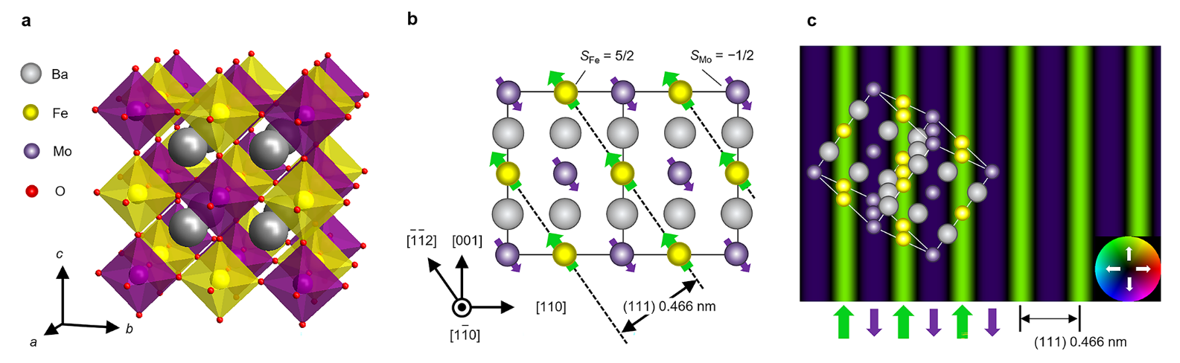

Fig. 1

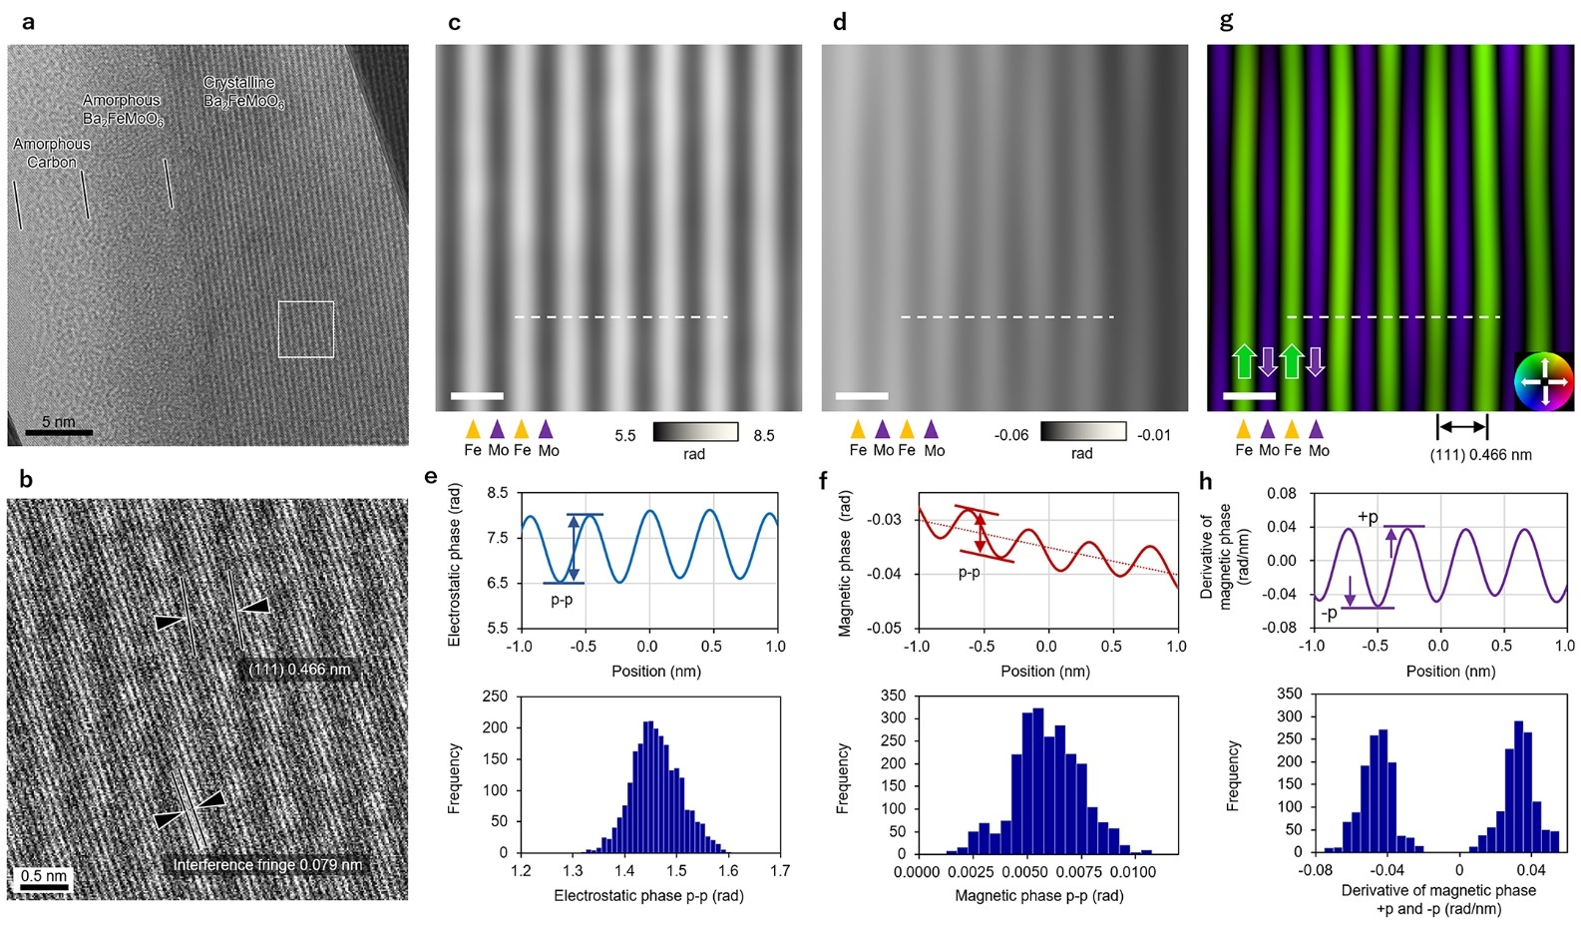
Fig. 2

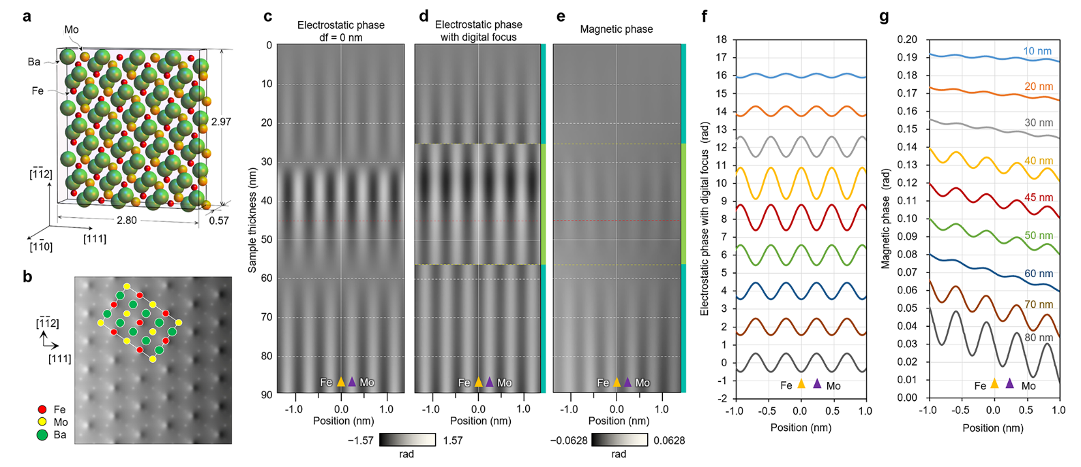

Fig. 3

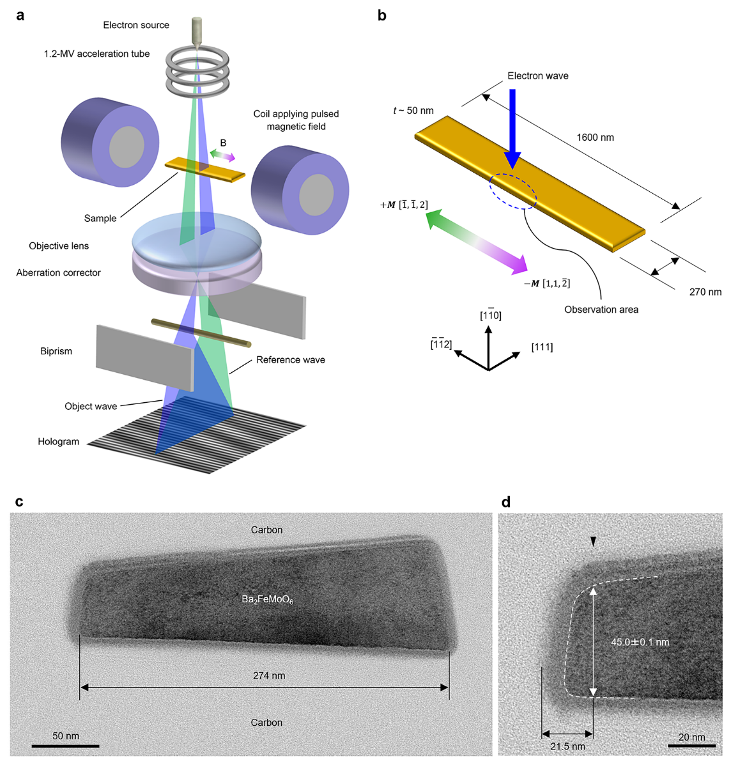

Extended Data Fig. 1

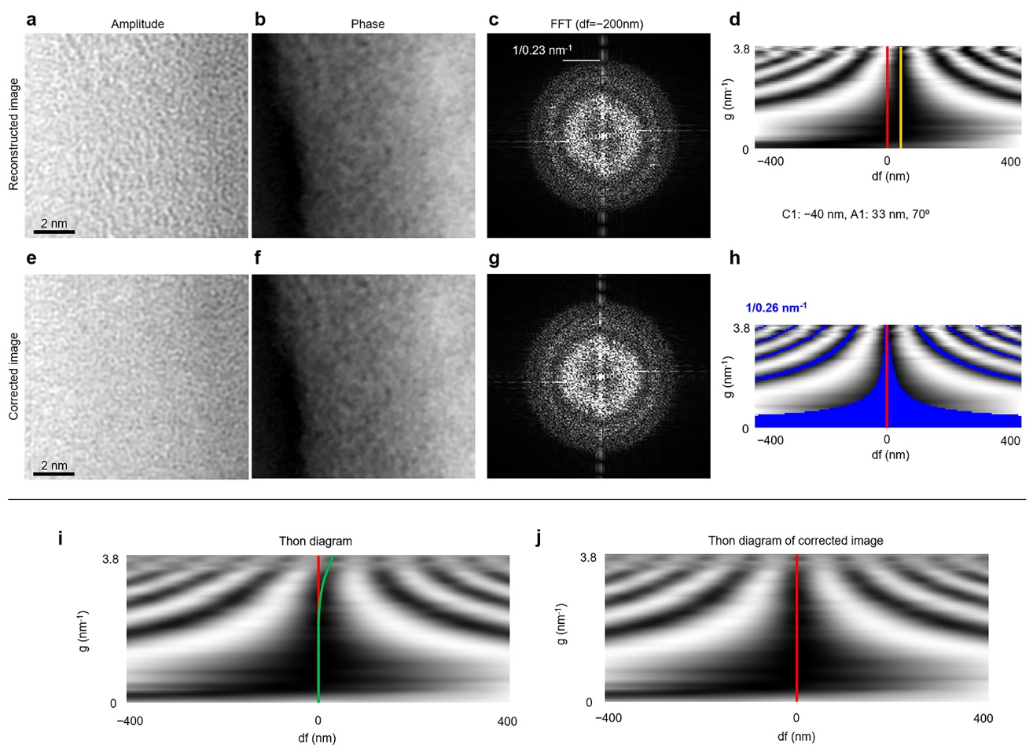

Extended Data Fig. 2

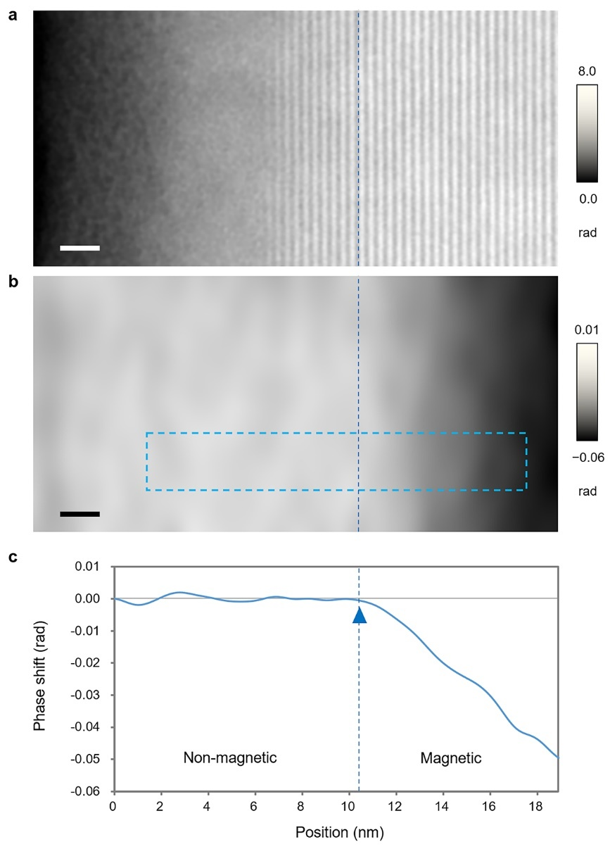
Extended Data Fig. 3

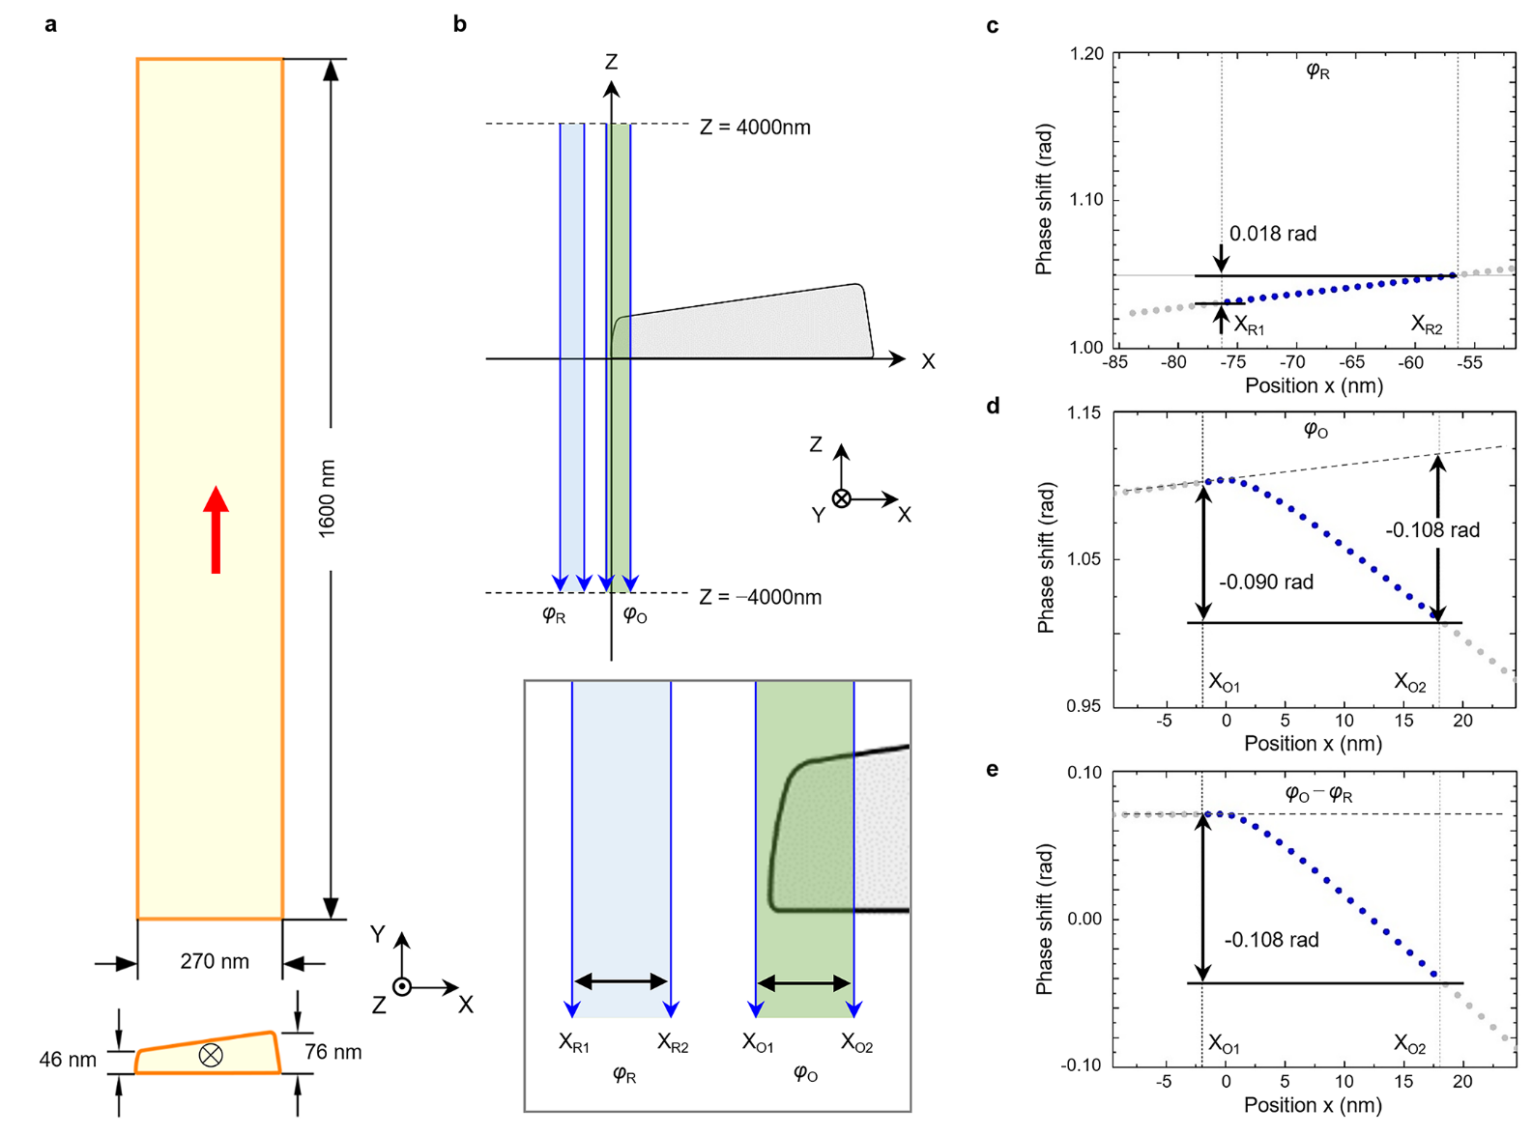
Extended Data Fig. 4

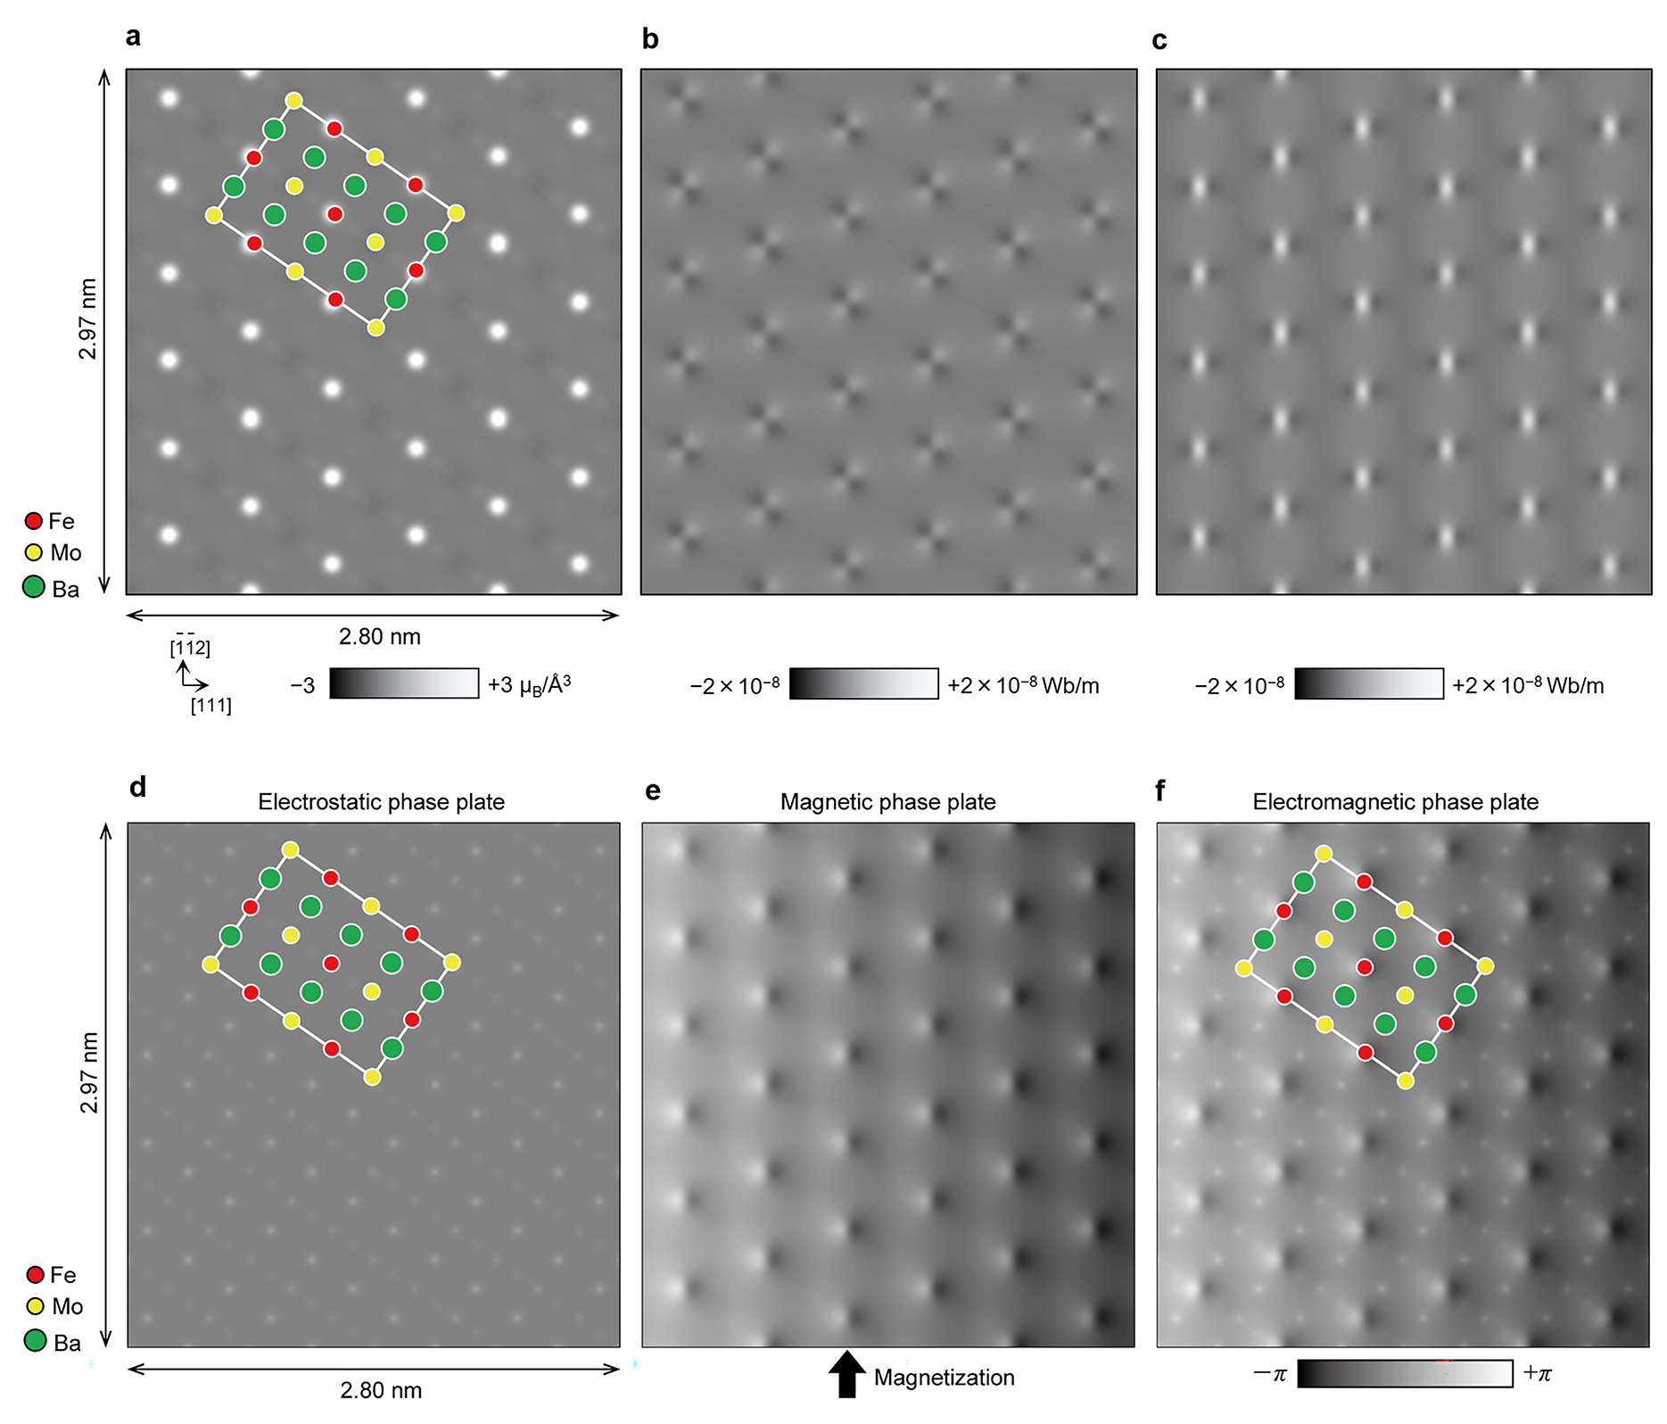
Extended Data Fig. 5

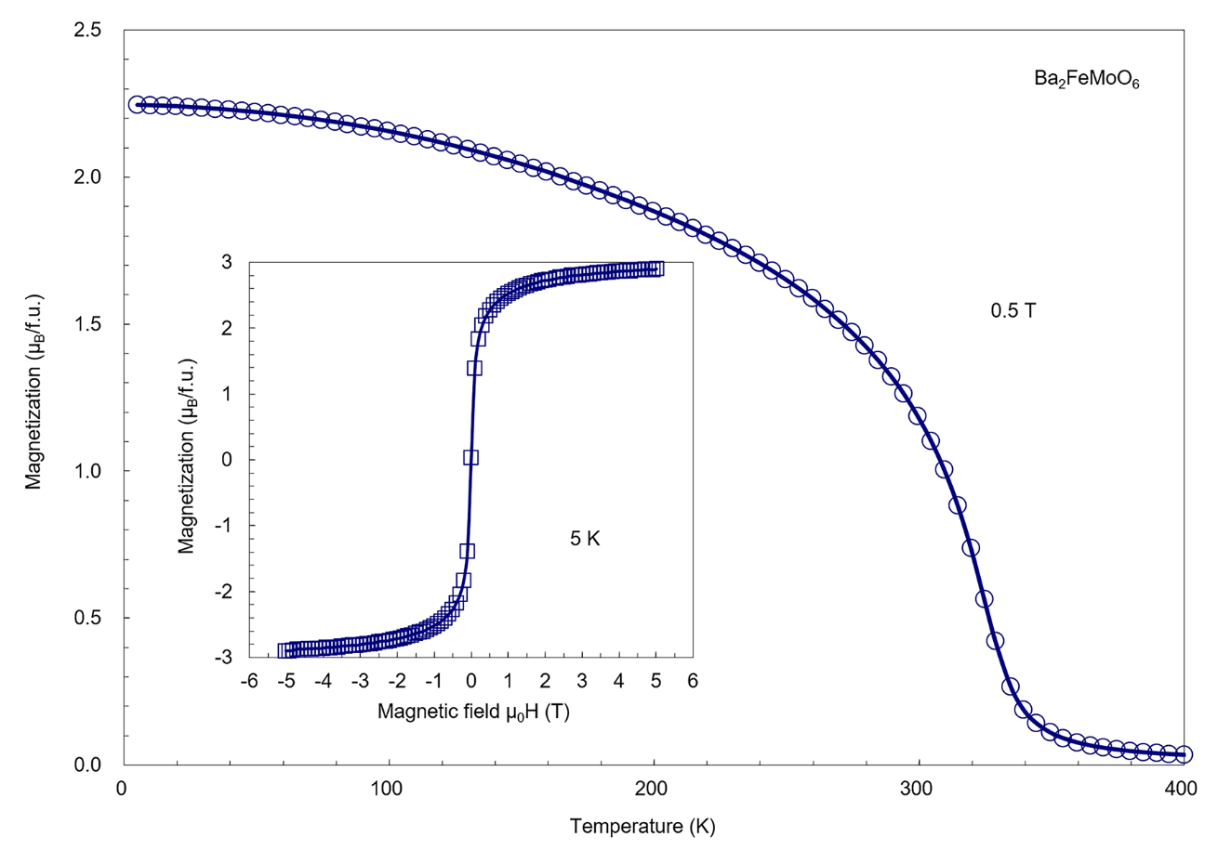
Extended Data Fig. 6

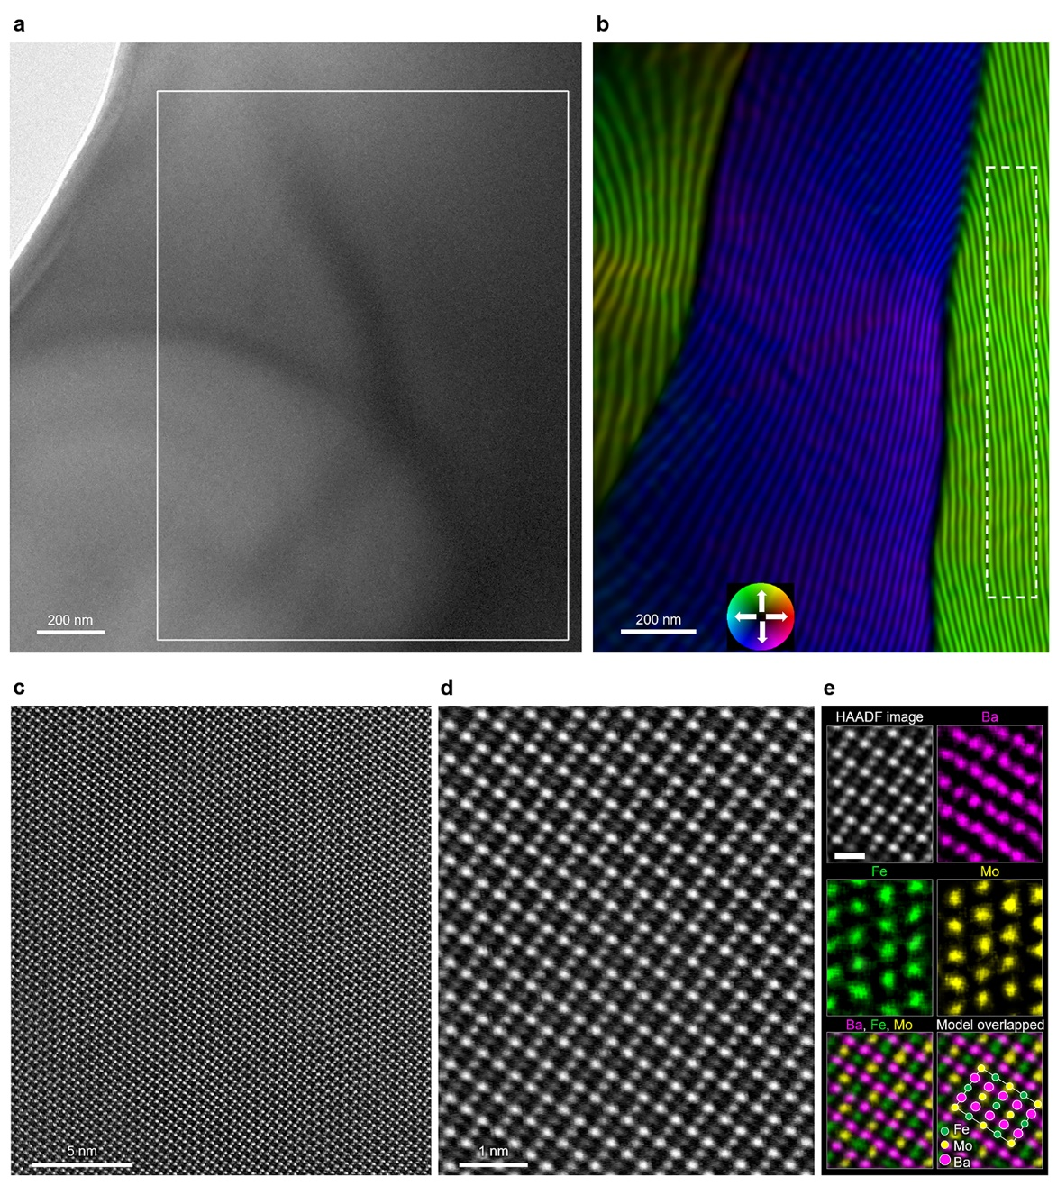
Extended Data Fig. 7

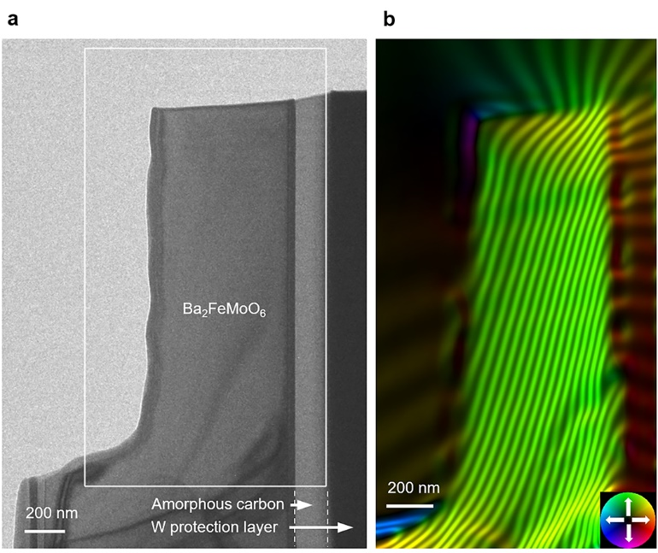
Extended Data Fig. 8

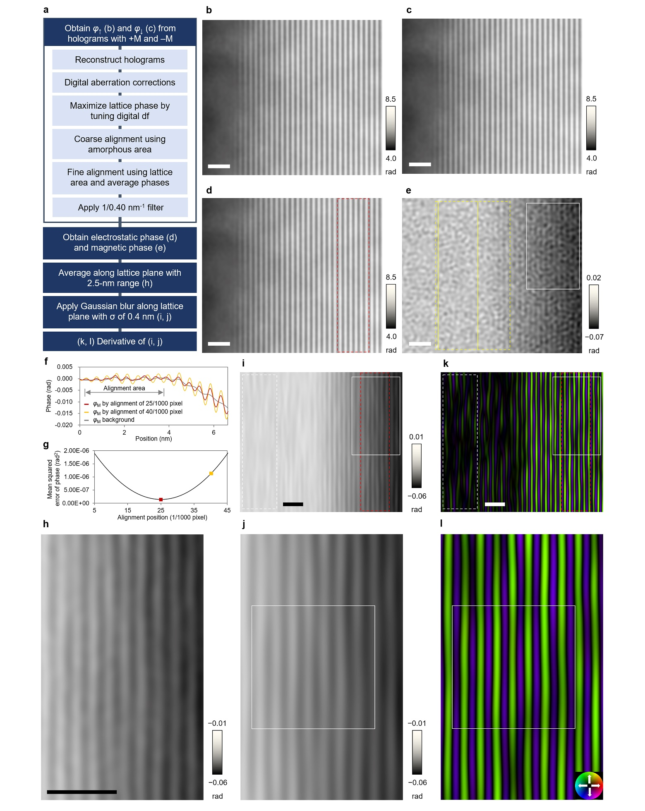
Extended Data Fig. 9

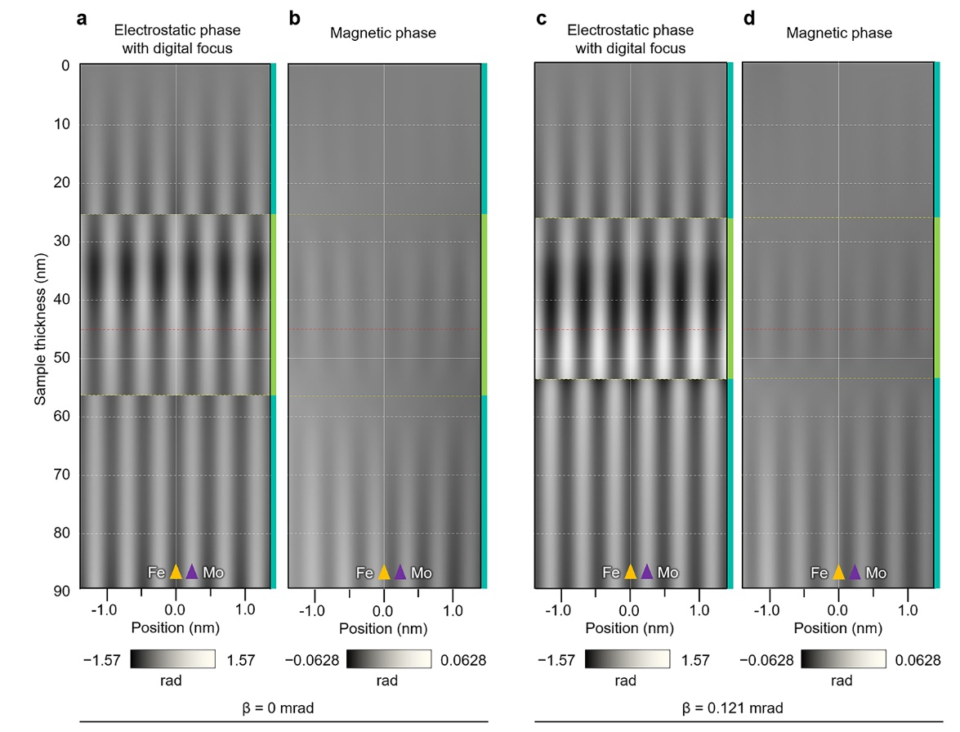
Extended Data Fig. 10

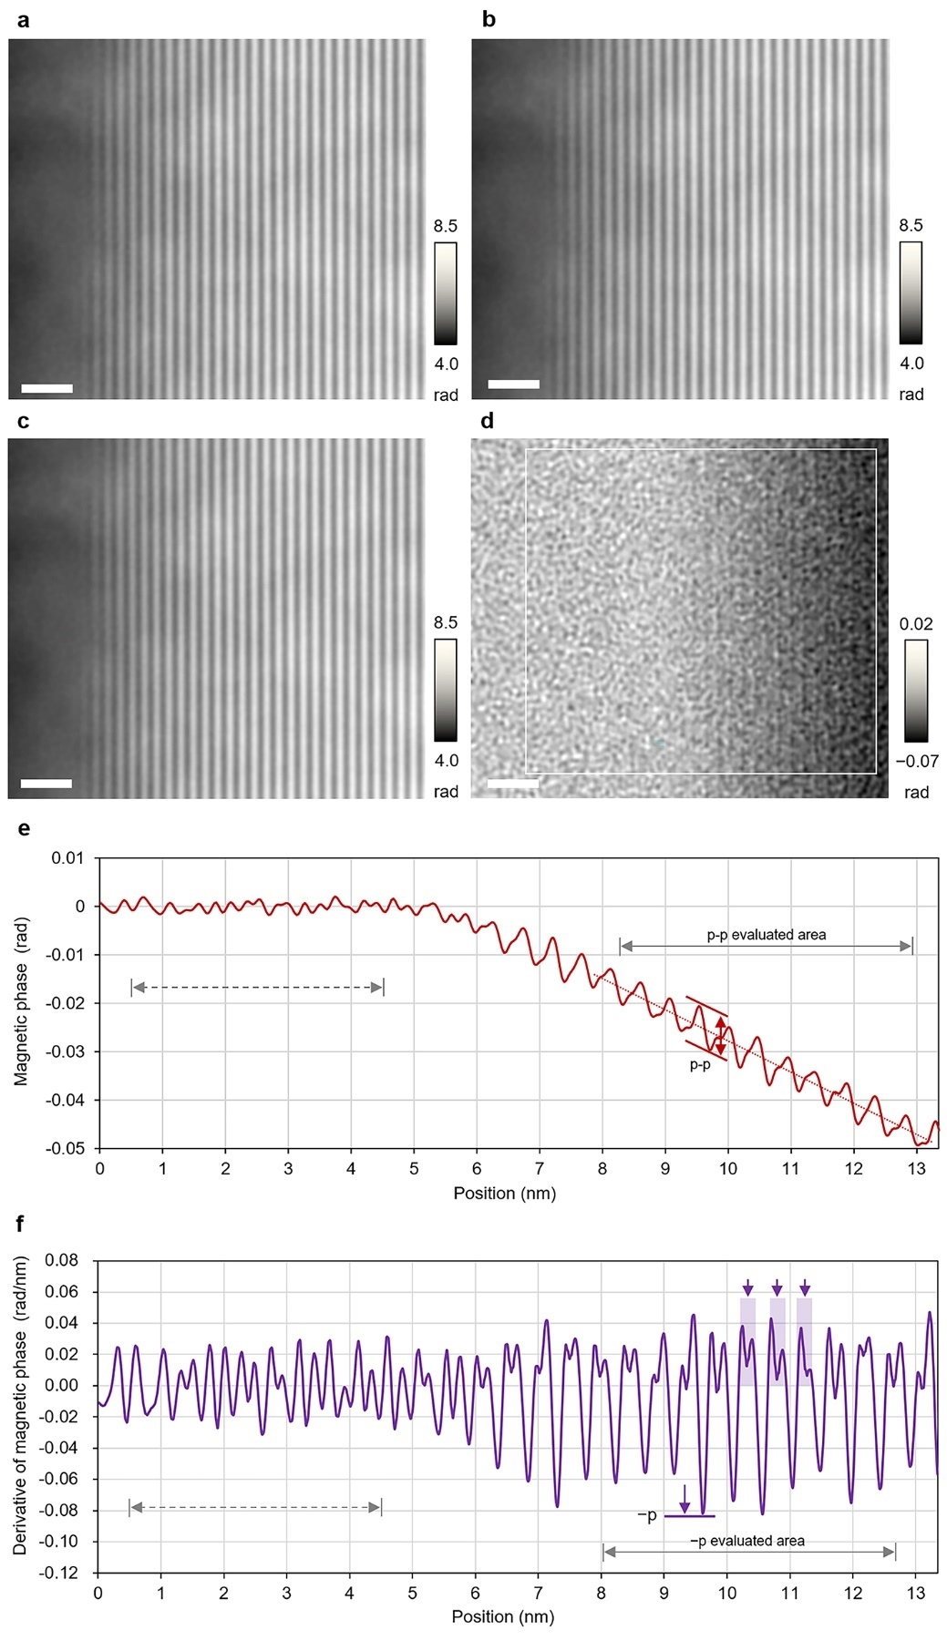
Extended Data Fig. 11

