Printing flexible Cu-Ni alloy traces with multiscale core-shell structures for high-temperature resistant interconnections
Wanli Li ^{a,b,*}, Yitian Li ª, Lingying Li ^{b}, Haidong Yan ^{c}, Jie Zhang ª, Takeo Minari ^{b,}*

ª Jiangsu Key Lab of Advanced Food Manufacturing Equipment and Technology, Jiangnan University, Wuxi 214122, China
^{b} Research Center for Functional Materials, National Institute for Materials Science, Ibaraki 3050044, Japan
^{c} Hang Zhou Global Scientific and Technological Innovation Center, Zhejiang University, Hangzhou 311200, China

E-mail: li.wanli@jiangnan.edu.cn (Wanli Li); MINARI.Takeo@nims.go.jp (Takeo Minari)

Abstract
Direct printing of flexible Cu traces is one of the most promising additive manufacturing technologies in advanced electronics because it is a cost-effective and environmentally friendly process. However, the low oxidation resistance of Cu is currently a critical issue for the preparation of high-performance metallic inks and the manufacturing of reliable printed traces. Herein, we propose a hybrid ink containing Cu/Ni complexes and Cu particles that can be directly printed onto polyimide substrates to generate high-performance Cu–Ni alloy traces by low-temperature preheating and intense pulsed-light irradiation. The nanoparticles in-situ formed by the decomposition of the complexes effectively bridge the interfaces among Cu particles, allowing the printed traces after subsequent intense pulsed-light irradiation to achieve a low resistivity of 29.4 μΩ⋅cm and excellent mechanical stability at a bending radius of 7 mm. Strikingly, the obtained Cu–Ni alloy traces achieve multiscale core–shell structures because of the heterogeneous nucleation and passivation of Ni, which enables the printed traces to maintain high conductivity and oxidation resistance even at 250 ºC in the air, showing strong potential for use in advanced electronics manufacturing.

Keywords: copper-nickel hybrid inks, multiscale core-shell structures, intense pulsed light, passivation of nickel, high-temperature reliability, advanced electronics manufacturing

1. Introduction
In the past decade, metallic conductive inks (or pastes) have drawn tremendous attention in advanced electronics manufacturing because they can be a more economical and environmentally-friendly way to directly print conductive traces compared with etching metal from metal-plated substrates^{1, 2}. They show massive potential in the green fabrication of radio frequency identification (RFID) tags³, multi-layer ceramic capacitors (MLCCs)⁴, electromagnetic (EM) shielding⁵, large-area heaters^{6, 7}, and so on. Among a wide variety of metallic conductive inks, copper (Cu) inks attract increasing attention because of their high conductivity, high electromigration resistance, and low cost^{8, 9}. However, Cu particles are easily oxidized, and especially when their size decreases to the nanoscale, the oxidation problem becomes much serious even at room temperature ¹⁰⁻¹³. The oxidation of Cu would reduce the stability of Cu inks and further hinder their low-temperature sintering, resulting in low conductivity and poor reliability of the printed Cu traces.
To relieve the oxidation problem, several kinds of particle-free Cu inks have been developed, which can avoid the oxidation problem during the preparation and storage period¹⁴⁻¹⁷. In addition, these particle-free inks can transform themselves into Cu particles at temperatures below 140 ºC and form conductive traces in a nitrogen atmosphere¹⁸⁻²¹. However, it should be noted that the metal loading of these particle-free inks is limited below 16 wt.% due to addition of organic compounds, which is a challenge for fabricating conductive traces with optional thickness. On the other hand, introduction of oxidation-resistant metal shells such as silver (Ag), nickel (Ni), and gold (Au) on Cu particles (cores) is an effective route to enhance the stability of Cu inks²²⁻²⁷. These oxidation-resistant elements improve the stability of the Cu-based inks and enhance the printed traces' long-term reliability. However, until now, neither chemical nor physical methods still face numerous obstacles in the large-scale fabrication of core-shell structures, such as incomplete coating, poor consistency, low yield, or environmental pollution.
To promote the application of Cu inks, Cu−Ag hybrid inks consisting of submicron Cu particles and Ag precursors were developed in our previous work²⁸. The Ag precursors could decompose into Ag nanoparticles at a low temperature and in-situ cover the surface of Cu particles to form Cu-core/Ag-shell structures. It simplified the manufacturing process of core-shell structures and improved the oxidation resistance of the obtained conductive traces. Most recently, the high-temperature thermal reliability of the printed Cu-Ag traces was investigated systematically, and it was found that when the aging temperature increased above 200 ºC, the oxidation of Cu occurred rapidly²⁹. In detail, because of the heavy lattice mismatch between Cu and Ag lattices, the Ag shells tend to dewet from the Cu cores at high temperatures and grow into Ag clusters^{30, 31}. Once the Cu-core/Ag-shell structures collapsed, the Cu cores would rapidly oxidize. Therefore, the metallic conductive inks community urgently needs a facile and effective route to enhance the high-temperature reliability of the printed Cu traces and promote the practical applications of Cu inks in the advanced electronics manufacturing industry.
In this study, a series of novel Cu−Ni hybrid inks consisting of submicron Cu particles and Cu−Ni complex precursors have been developed and successfully used to directly print high-temperature resistant Cu−Ni alloy traces on flexible polyimide substrates. During low-temperature preheating, the developed Cu−Ni precursors can decompose into Cu−Ni nanoalloys and realize the bonding of adjacent submicron Cu particles. After that, the intense pulsed light (IPL) irradiation was utilized to promote the sintering of the Cu particle/Cu−Ni nanoalloy structures and enhance the electrical and mechanical properties of the printed traces. Results show that the printed Cu−Ni alloy traces achieve high conductivity (29.4~79.5 μΩ cm) and outstanding flexibility (bending test at a radius of 7 mm). More importantly, the printed Cu−Ni alloy traces exhibit ultrahigh oxidation resistance because of the robust multiscale core-shell structures, enabling them to maintain high conductivity even at 250 ºC in the air. As far as we know, this is the most reliable printed Cu-based trace yet, showing massive potential in advanced electronic interconnections.

2. Results and discussion
Figure 1a shows the schematic of directly printing high-temperature resistant Cu−Ni alloy traces, including the preparation of Cu−Ni hybrid inks, screen printing, preheating, and intense pulsed light (IPL) sintering. The Cu−Ni hybrid inks are prepared by mechanical mixing of Cu/Ni complexes, submicron Cu particles, and ethylene glycol (EG) solvent with a designed weight ratio (Table 1). The whole process is simple and beneficial for mass production. The names of the prepared Cu-Ni hybrid inks are CuNi₅, CuNi₁₁, CuNi₁₈, CuNi₂₆, and CuNi₃₀, respectively, based on the Ni content. The preheating step aims to induce the evaporation of the solvent and crystal water and promote the thermal decompaction of the Cu/Ni complexes to create Cu−Ni nanoparticles in situ³². The formed nanoparticles will act as nano-welders to realize the bonding of adjacent submicron Cu particles. Subsequently, optical energies provided by IPL irradiation are selectively absorbed by submicron Cu particle/Cu−Ni nanoparticle structures. They will drive the effective sintering of these structures and produce highly conductive Cu−Ni traces without damaging the flexible substrates. Figure 1b shows a photograph of the obtained Cu−Ni traces on a transparent polyimide substrate, which is lightweight and flexible. The optical micrograph of the Cu−Ni traces in the bottom right of Figure 1b shows well-defined line edges. It indicates good printability and formability of the developed hybrid inks. The profile of the printed Cu−Ni traces was further measured (Figure 1c). The traces' width can be decreased to about 120 μm with a uniform thickness of about 2.7 μm, making them suitable for most flexible electronic applications. Figure 1d shows the X-ray diffraction (XRD) patterns of the printed traces with different Ni contents. Besides the peaks of pure Cu and Ni, no other peaks are observed in the XRD patterns, suggesting the high metallic purity of the printed traces. In addition, it is found that when the Ni content is below 18 wt.%, the peak of Ni is not apparent. It is likely because, during the decomposition of Cu/Ni complexes and IPL sintering, most Ni atoms have dissolved into the Cu phase to form a Cu−Ni solid solution alloy³³. With the increase of the Ni content, enough Ni atoms are likely to generate the Ni-rich phase, and therefore the peak of the Ni (111) becomes visible.
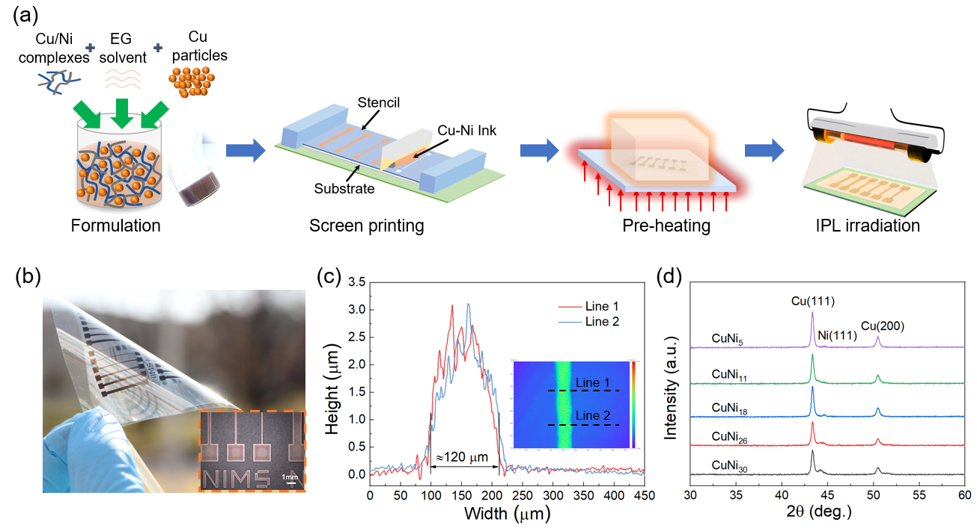
Figure 1. Printing high-temperature resistant Cu−Ni alloy traces on flexible polyimide substrates. (a) Schematic of the ink preparation, printing, and posttreatment process. (b) Photograph and optical micrograph of the printed trace with different line widths. (c) Line profiles of the printed trace. (d) XRD patterns of the printed Cu−Ni traces with different Ni contents.
Table 1 Formulas of Cu-Ni hybrid inks with different Ni contents
Names | Cu complex | Ni complex | Cu particle | MCu | MNi | Ni content
CuNi₅ | 4.41 g | 0.88 g | 1 g | 0.692 g | 0.096 g | 5.4%
CuNi₁₁ | 3.67 g | 1.83 g | 1 g | 0.576 g | 0.201 g | 11.3%
CuNi₁₈ | 2.90 g | 2.90 g | 1 g | 0.455 g | 0.319 g | 17.9%
CuNi₂₆ | 2.06 g | 4.13 g | 1 g | 0.323 g | 0.454 g | 25.5%
CuNi₃₀ | 1.60 g | 4.80 g | 1 g | 0.251 g | 0.528 g | 29.6%
Note: the metal loading of Cu from Cu complex (MCu) is about 15.7 wt.%, and the metal loading of Ni from Ni complex (MNi) is about 11 wt.%, respectively, based on the theoretical calculation and thermal analysis³².

Figure 2a shows the resistivity evolution of the printed Cu−Ni traces as a function of the input energy of the IPL irradiation. When the input energy is zero, i.e., after only preheating, the resistivity of printed traces fabricated from CuNi₅, CuNi₁₁, CuNi₁₈, CuNi₂₆, and CuNi₃₀ inks is 79, 134, 145, 172, and 259 μΩ·cm, respectively. The microstructures of the CuNi₅, CuNi₁₈, and CuNi₃₀ traces shown in Figure 2b-d suggest that the decomposition of the Cu/Ni complexes has created many nanoparticles which realize the bonding of the adjacent Cu particles to form electrical pathways successfully. The microstructure of the CuNi₅ traces appears relatively smooth. It is likely because the nanoalloys generated from the Cu/Ni complexes (Cu complex: Ni complex≈5:1) consist of the high content of Cu, and they can fuse with original Cu particles easily. In contrast, when the Ni content increases, e.g., CuNi₁₈ and CuNi₃₀ traces, the created nanoalloys contain high contents of Ni, and they tend to form individual Cu-Ni nanoalloys covered on the surface of the original Cu particles, which is also beneficial for the bonding among the adjacent Cu particles but results in high resistivity.
When the IPL irradiation is applied, the resistivity of Cu−Ni traces with high Ni contents decreases rapidly (Figure 2a). For example, when the IPL energy is 1.77 J·cm⁻², the resistivity of CuNi₅ and CuNi₁₁ traces maintain almost unchanged while that of CuNi₁₈, CuNi₂₆, and CuNi₃₀ decreases by 31~56%. It is likely because the Cu−Ni nanoalloys covering the surface of the original Cu particles could be sintered effectively to form electrical connections among adjacent Cu particles (Figure 2e). In detail, IPL irradiation employs a wide range of light wavelengths from 200 to 1300 nm, providing a high-energy density for the sintering of metal particles³⁴. The Cu-Ni nanoalloys with a high specific surface area can absorb optical energy more effectively and convert it into heat energy to drive the rapid atomic diffusion between nanoalloys and form electronic connections among adjacent Cu particles. With the increased IPL energy, the resistivity of all the printed Cu−Ni traces decreases to lower values. It is because the Cu−Ni nanoalloys are fused with Cu particles gradually with the increased IPL energy; meanwhile, robust connections among each particle are formed (Figure 2f-g), which helps to reduce the resistivity of the printed traces. Figure 2h shows XRD patterns of the CuNi₂₆ traces after IPL irradiation using different energies. It is found that with the increase of energy from 1.77 to 3.19 J·cm⁻², the peak positions of Cu (111) and Cu (200) maintain almost unchanged, while that of Ni (111) shifts from 44.5 to 44.3 °. This suggests that some Cu atoms have diffused into the Ni lattices during the IPL irradiation, which is consistent with the rapid atomic diffusion and the formation of robust connections among original Cu particles. When the IPL energy exceeds a specific value, the resistivity of the printed Cu-Ni increases as part of the metal traces peels off from the substrate (Figure S1). The difference in critical value for each kind of Cu−Ni trace is related to the different light absorption efficiency of Cu and Ni³⁵. The optimized resistivity of CuNi₅, CuNi₁₁, CuNi₁₈, CuNi₂₆, and CuNi₃₀ traces after preheating and IPL irradiation is about 29.4, 43.9, 58.7, 50.1, and 79.5 μΩ·cm, respectively. These values are about three times the standard resistivity of bulk Cu−Ni alloy with the same Ni content, which should be enough for most electronic applications.
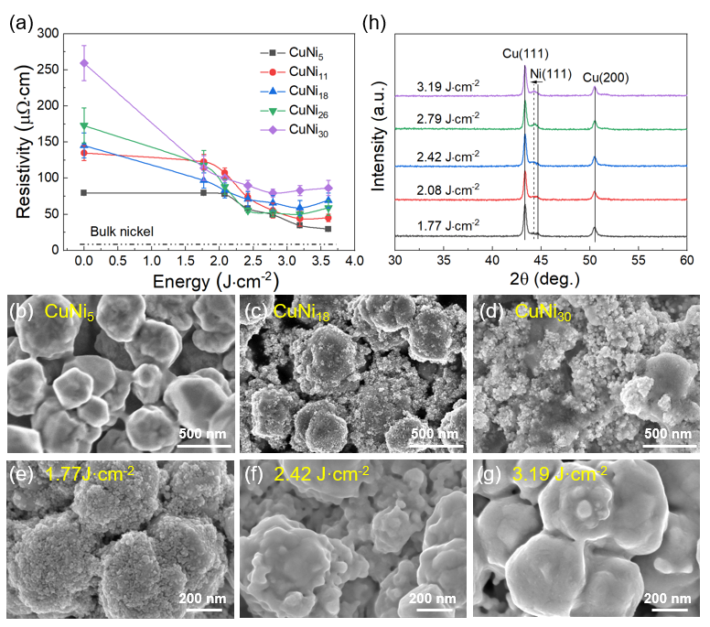
Figure 2. (a) Resistivity evolution of printed Cu−Ni traces as a function of IPL energy. FE-SEM images of the various Cu−Ni traces after preheating: (b) CuNi₅, (c) CuNi₁₈, (d) CuNi₃₀. FE-SEM images of the CuNi₂₆ traces after IPL irradiation using energies of (e) 1.77 J·cm⁻², (f) 2.42 J·cm⁻², (g) 3.19 J·cm⁻². (h) XRD patterns of the printed CuNi₂₆ traces using different IPL energies.

To gain further insight into the microstructural evolution of the printed Cu-Ni traces, transmission electron microscopy (TEM) observations and analyses were performed on the printed CuNi₂₆ traces after preheating and IPL irradiation, respectively. As shown in Figure 3a, after the preheating, besides the original Cu particles with an average size of 350 nm, many Cu-Ni nanoalloys are observed, which cover the surface of the Cu particles or fill the gaps between them. Even though these nanoalloys seem not to connect each other tightly (inset of Figure 3a), they function as nano-welders to bond the adjacent Cu particles and form electrical pathways. After the IPL irradiation, these nanoalloys are fused to form denser structures and more robust connections among Cu particles (Figure 3b and 3c), which is consistent with the enhanced conductivity of printed CuNi₂₆ traces. Moreover, it is found that there is an amorphous layer (about 2 nm) on the outside of these dense structures (Figure 3d). Figure 3e shows a scanning TEM (STEM) image of the CuNi₂₆ trace, and Figure 3f-i shows the corresponding mapping images of Cu/Ni/O, Cu, Ni, and O elements. As seen, the Ni elements tend to distribute on the surfaces of the Cu particles and create an apparent Cu@Ag core-shell structure on a submicron scale. Around these core-shell structures, there are some Cu-Ni alloy structures with uniform distribution of Cu and Ni elements. These unique structures are formed because, during the preheating, the decomposition of the Cu complex occurs first³². The in-situ formed Cu elements cover the surface of the original Cu particles by a heterogeneous nucleation mechanism or form nanoparticles by a homogeneous nucleation mechanism to fill the gap among original Cu particles (Figure 3g). With the increase of the temperature, the decomposition of the Ni complex occurs, and the in-situ formed Ni elements tend to nucleate and grow attached to the Cu particles mentioned above, resulting in the formation of the Cu@Ni core−shell structures and Cu-Ni alloy in different scales (Figure 3f and 3h). Figure 3j shows a high-resolution scanning TEM (STEM) image of the Cu-Ni alloy structure, and Figure 3k-n shows the corresponding mapping images of Cu/Ni/O, Cu, Ni, and O elements. It is found that Cu and Ni elements have a distribution over the whole observed region, and the content of the Ni seems to be much higher than that of Cu based on the brightness. For quantitative analysis, the detailed composition of the Cu-Ni alloy was determined by analyzing 4 spots, i.e., spots (A−D) marked in Figure 3j. All the spots show a high content of Ni (Figure S2). The obtained ratio between Ni and Cu is much different from that of the metal loading of the Cu/Ni complexes (about 1:1.4) in Table 1. This is likely because most Cu loading from the Cu complex has been fused with the original Cu particle, reducing Cu in the Cu-Ni alloy structure. In addition, it is found that the outside (edge) of the Cu-Ni alloy structures contains a higher O content than the inside. Since the outside of the Cu-Ni alloy structures has been observed as an amorphous layer (Figure 3d), it suggests that the amorphous layer consists of metal oxides, which are caused by oxidation during the posttreatment process. In summary, it is believed that the printed Cu-Ni traces consist of multiscale core-shell structures: Cu@Ni core-shell structures in submicron scale and Cu-Ni alloy@amorphous oxide core-shell structures in nanoscale, which are attributed to the unique Cu-Ni hybrid inks and the designed two-step posttreatment.
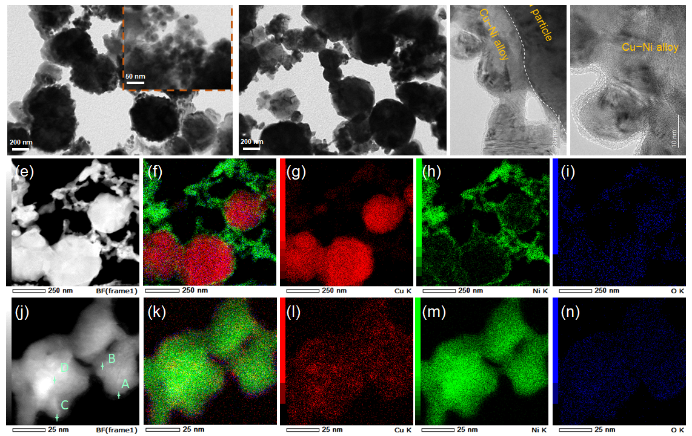
Figure 3. TEM observation of the printed CuNi₂₆ traces after (a) preheating and (b-d) subsequent IPL irradiation using the energy of 3.19 J·cm⁻². (e) STEM image of the CuNi₂₆ trace and corresponding mapping images of (f) Cu/Ni/O overlay, (g) Cu, (h) Ni, and (i) O elements. (j) High-resolution STEM image of Cu-Ni alloy and corresponding mapping images of (k) Cu/Ni/O overlay, (l) Cu, (m) Ni, and (n) O elements.

For practical applications such as flexible interconnections, tags, and heaters, the printed Cu-Ni alloy traces should have high mechanical reliability, i.e., maintain their electrical performance during bending deformations. Figure 4a shows the changes in relative resistance (R/R₀, where R₀ is the initial resistance and R is the measured resistance after the test) of the printed Cu-Ni traces during a repeated outer bending test at a radius of 7 mm. As seen, the R/R₀ of all the printed traces rapidly increases to about 1.75 in the initial stage (the first 2000 bending cycles) and then enters a stable stage with a slight increase until the end of the bending test. After 10000 cycles, the R/R₀ values of CuNi₅, CuNi₁₁, CuNi₁₈, CuNi₂₆, and CuNi₃₀ are about 1.97, 1.86, 1.79, 2, 1.83, respectively, which are comparable to the pure Cu traces³⁶. Even though the addition of the Ni element has a negative effect on the toughness of the Cu-Ni alloys, all the printed Cu-Ni alloy traces maintain high flexibility. This is likely because the printed Cu-Ni traces are porous structures (Figure S3), which can release most stress during the bending test. On the other hand, the changing trend in R/R₀ of all the printed traces is consistent with that of the first two stages of fatigue fracture³⁷. Although the porous structures of printed Cu-Ni traces help to release stress, they cause excessive stress concentration at some corners. As a result, during the outer bending test, the cyclic tensile stress will induce the initiation of fatigue cracks quickly and increase the resistance of the traces. After that, each bending cycle has the potential to cause a small crack length extension and make the traces have a relatively stable increase in resistance. Figure 4b-c shows the macro and microstructure of the middle position of the printed Cu-Ni trace after the bending test. The Cu-Ni conductive structures in this position theoretically experienced the most severe tensile stress. It is found that after 10000 bending cycles, although no macro crack is located on the surface of the trace, many microscale cracks have been observed (marked by dotted circles), which is consistent with the increase in resistance of the traces. Nevertheless, all the printed Cu-Ni traces exhibit high electrical reliability during the bending test even without any protection, which shows enormous application potential in flexible electronics.
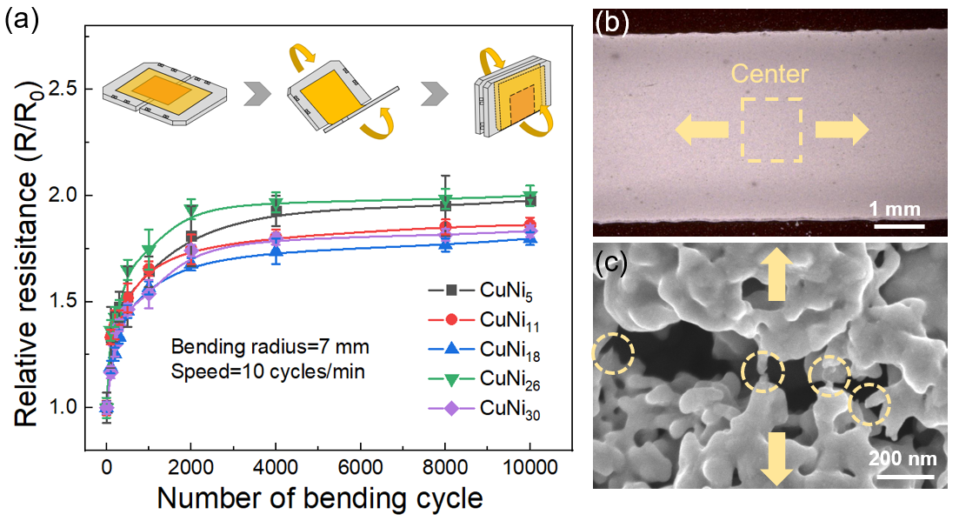
Figure 4. Mechanical properties of the printed Cu-Ni alloy traces. (a) Changes in R/R₀ of traces during a repeated outer bending test at a radius of 7 mm. (b) Optical image and (c) SEM image of the middle position of the CuNi₂₆ trace after 10000 cycles. The arrows represent the direction of the tensile stress during the outer bending test.

Besides the mechanical reliability, the high-temperature thermal stability of the printed Cu-Ni traces in the air is one of the most critical factors in evaluating the quality of printed Cu-based traces. It presents significant challenges for their practical applications in electronic devices, especially in power electronics. For comparison, pure Cu and CuAg₂₀ alloy traces were fabricated using pure Cu and Cu-Ag hybrid inks^{28, 36}. Figure 5a shows the change in R/R₀ of the printed traces during the aging test at 220 ºC. As seen, the R/R₀ of the pure Cu traces increases rapidly; after only 20 h, the pure Cu traces almost lose conductivity. By contrast, the R/R₀ of CuAg₂₀ and all Cu-Ni alloy traces show a smaller increase, and even after 45 h, their R/R₀ maintains below 10, indicating high thermal stability. It should be highlighted that the Cu-Ni traces exhibit higher stability than CuAg₂₀ traces even though Ni (5 wt.%) content is much lower than Ag’s (20 wt.%). The high reliability of Cu-Ni traces is likely attributed to the passivation of Ni shells and the robust interface between the Cu core and Ni shell. In detail, Cu@Ag core-shell structures are vulnerable to high temperatures. When the temperature increases above 200 ºC, the core-shell structure tends to split into Cu and Ag parts due to the huge lattice mismatch and high interface energy, resulting in the oxidation of the CuAg₂₀ traces²⁹⁻³¹. Compared with Cu@Ag core-shell structures, Cu@Ni core-shell structures are temperature-insensitive because of the robust interface between Cu cores and Ni shells, showing high thermal stability. When the aging temperature increases to 250 ºC (Figure 5b), the electrical performance degradation of pure Cu and CuAg₂₀ traces become much quicker, and the pure Cu traces lose conductivity after only 8 h. The R/R₀ of CuAg₂₀ traces increases to above 100 after 20 h. It is because high temperature accelerates the atom diffusion and the break of the Cu@Ag core-shell structures to cause rapid Cu oxidation. In contrast, all the Cu-Ni traces still maintain high thermal stability. Especially, when the Ni content is higher than 11 wt.%, the R/R₀ of printed traces holds below 2 even after 45 h. The high thermal stability is likely attributed to the passivation of sufficient Ni shells. When the Ni content is below 11 wt.%, the thickness of the Ni shell somewhere in the trace may not be enough to form a strong passivation layer and result in the gradual oxidation of printed traces. Therefore, printed Cu-Ni alloy traces with multiscale core-shell structures have ultrahigh thermal stability even at 250 ºC and 11 wt. % Ni in the traces is deemed to be enough for the prevention of Cu oxidation.
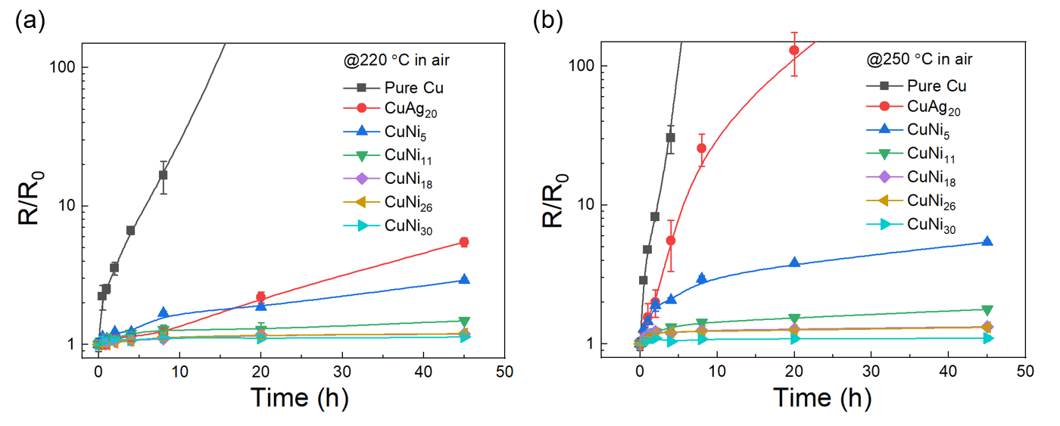
Figure 5. High-temperature thermal stability of the printed pure Cu, CuAg₂₀, and Cu-Ni alloy traces: changes in R/R₀ of traces during high-temperature tests at (a) 220 ºC and (b) 250 ºC in the air.

To further understand the ultrahigh thermal stability of the printed Cu-Ni traces, TEM observation of the CuNi₂₆ trace that was aged at 220 ºC for 80 h was conducted. As shown in Figure 6a-d, even though aged at 220 ºC for 80 h, the printed CuNi₂₆ trace maintains its multiscale core-shell structures (Cu@Ni core-shell structures in submicron scale and Cu-Ni alloy@amorphous oxide core-shell structures in nanoscale), which continually prevent the Cu from oxidation. The changed structure is that the amorphous layer becomes thicker from about 2 nm to 4 nm after the aging test (Figure 6d). Figure 6e shows a STEM image of the aged traces on a submicron scale, and Figure 6f-i shows the corresponding elemental mapping images. The distribution of Cu and Ni is consistent with the submicron core-shell structure, where Cu particles are the cores and Ni are the shells. Moreover, it is found that the O element has an apparent accumulation on the outside of the Ni shells. Figure 6j shows a high-resolution STEM image of the Cu-Ni alloy, and Figure 6k-n shows the corresponding mapping images. As seen, the Cu and Ni elements maintain a uniform distribution over the observed region, and the O element has an apparent accumulation along the grain boundaries. It is believed that the accumulation of O elements on the outside of the Ni shells and along the grain boundaries are related to the growth of the amorphous layer in Figure 6d. The oxidation of Ni forms an amorphous oxide layer (also called passivation shell), which exhibits better protective properties and hinders the further oxidation reaction. In detail, it is well known that the oxidation kinetics of Ni is controlled by chemical diffusion through the oxide layer³⁸. Compared with the crystal structure, the amorphous structure has no grain boundaries and can effectively hinder atom diffusion to reduce the oxidation rate. Therefore, the printed Cu-Ni alloy traces with multiscale core-shell structures can achieve ultrahigh oxidation resistance and maintain high conductivity even at a high temperature of 250 ºC in the air.
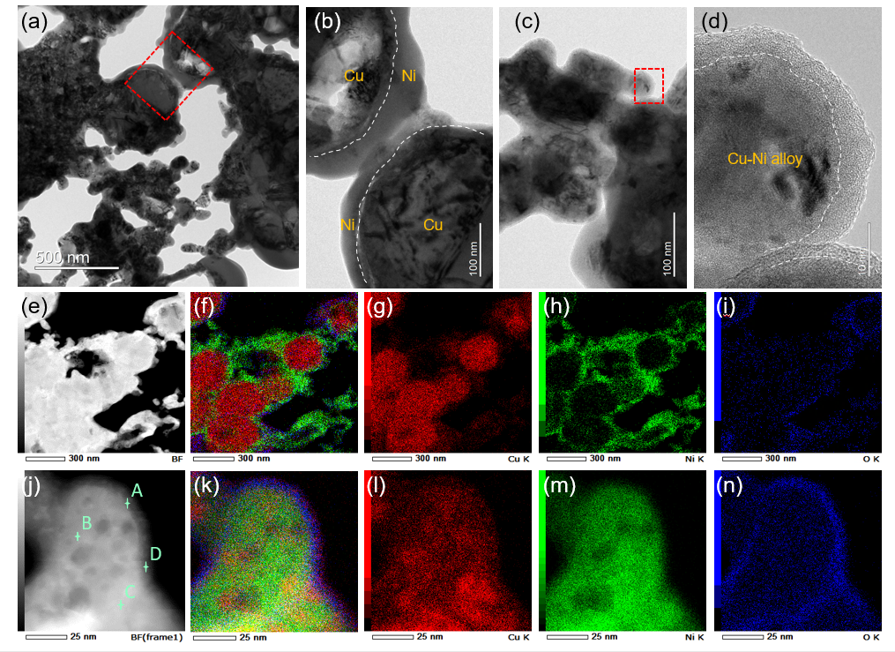
Figure 6. (a-d) TEM observation of the printed CuNi₂₆ traces after aging at 220 ºC for 80 h. (e) STEM image of the Cu-Ni trace and corresponding mapping images of (f) Cu/Ni/O, (g) Cu, (h) Ni, and (i) O elements on a submicron scale. (j) High-resolution STEM image of Cu-Ni alloy and corresponding mapping images of (k) Cu/Ni/O, (l) Cu, (m) Ni, and (n) O elements on a nanoscale.

3. Conclusions
We have successfully realized the direct printing of high-temperature resistant Cu-Ni alloy traces on flexible polyimide substrates based on the developed Cu-Ni hybrid inks and the corresponding two-step posttreatment process. The hybrid inks consist of Cu/Ni complexes, submicron Cu parties, and EG solvent. During the preheating, the decomposition of Cu/Ni complexes can create Cu-Ni nanoalloys in-situ, which cover the surface of the submicron Cu particles and function as nano-welders to realize the bonding among adjacent particles. The implementation of the IPL irradiation can drive the further sintering of Cu-Ni nanoalloys to improve the conductivity of printed Cu-Ni traces and achieve a low resistivity of 29.4~79.5 μΩ·cm depending on the Ni content. The printed Cu-Ni traces exhibit high flexibility because of the porous structure: the R/R₀ maintains below 2 after 10000 bending cycles at a radius of 7 mm. Moreover, the Cu-Ni traces show ultrahigh thermal stability because of the multiscale core-shell structures. They can maintain high conductivity and oxidation resistance even at 250 ºC in the air. The developed Cu−Ni hybrid inks and the corresponding posttreatment process relieve the oxidation problem of Cu inks and greatly enhance the high-temperature thermal stability of the printed flexible traces, which shows strong potential for practical use in advanced electronics manufacturing, such as wearable sensors and flexible three-dimensional tracks in power electronics applications.

Acknowledgments
This work was financially supported by a Grant-In-Aid for Scientific Research (No. 26286040 and 17H02769), National Natural Science Foundation of China (No. 52201289), Natural Science Foundation of Jiangsu Province (No. BK20221095) and Jiangsu Shuangchuang Talent Program (JSSCBS20210826). The TEM images were acquired at the Namiki foundry and the Electron Microscopy Analysis Station in NIMS.

4. Experimental section
4.1. Materials.
Nickel (II) formate dihydrate (C₂O₄H₂Ni·2H₂O) powders, copper (II) formate tetrahydrate (C₂O₄H₂Cu·4H₂O) powders, 2-ethylhexylamine (C₈H₁₉N) solvent, and ethylene glycol (C₂H₆O₂) solvent were purchased from Fujifilm Wako Pure Chemical. 2-Amino-2-methyl-1-propanol (C₄H₁₁NO) solvent was purchased from Nacalai Tesque. Submicron Cu particles were purchased from Mitsui Mining & Smelting. All these chemical materials were used without purification. In addition, two kinds of flexible polyimide films were used as substrates: nontransparent polyimide films were purchased from Du Pont-Tora, and their thickness is about 100 μm; transparent polyimide films were purchased from I.S.T, and their thickness is about 25 μm. Before being used as the substrates, these films were cleaned thoroughly in ethanol and distilled water with an ultrasonic cleaner for 10 min and 2 min, respectively.
4.2. Synthesis of Cu−Ni hybrid inks and two-step post-treatment process.
In this study, five kinds of Cu-Ni hybrid inks were fabricated by mixing Cu complex, Ni complex, and submicron Cu particles with different weight ratios. As shown in Table 1, the weight ratios among Cu complex, Ni complex, and submicron Cu particles are specially designed to meet two requirements: first, the weight ratio between metal loading from complex (MCu+MNi) and Cu particles is similar (0.78:1) for all the inks, which ensures a similar content of in-situ formed metal particles; second, the Ni content is variable to evaluate its effect on the properties of printed traces. Before the synthesis of Cu−Ni hybrid inks, Cu and Ni complexes were prepared first. To prepare the Cu complex, Cu (II) formate tetrahydrate powders were added to the 2-Amino-2-methyl-1-propanol solvent with a molar ratio of 1: 2, and then the mixture was stirred by a hybrid mixer (ARE-310, Thinky Corporation) for 30 min to achieve uniform Cu complex. To prepare the Ni complex, nickel (II) formate dihydrate powders were added to the ethylene glycol solvent with a weight ratio of 2:1, and the mixture was stirred by a hybrid mixer for 5 min. After that, the 2-ethylhexylamine solvent was added to the mixture, and the molar ratio between the nickel (II) formate dihydrate and the added 2-ethylhexylamine was set as 1:2. The obtained mixture was stirred by a magnetic stirrer for 24 h to achieve uniform Ni complex. To prepare Cu-Ni hybrid inks, the prepared Cu and Ni complexes and submicron Cu particles were mixed with the designed weight ratio (Table 1), and the mixture was stirred by a hybrid mixer for 30 min. The ratios between the sum of MCu and MNi and Cu particles are designed to be similar in different kinds of Cu−Ni hybrid inks, which aims to ensure the equivalent content of the in-situ formed nanoparticles and is essential for the low-temperature sintering of the hybrid inks³⁹. The prepared Cu-Ni hybrid inks were screen printed on the polyimide films. Afterward, a two-step post-treatment process consisting of preheating and intense pulsed light (IPL) irradiation was applied to realize the transformation from inks to conductive traces. The preheating process is conducted at 230 ºC for 15 min under a nitrogen atmosphere. The IPL irradiation is undertaken using a PulseForge Invent (NovaCentrix) system, which can vary the optical energy as a function of input voltage and time. In this study, the time was 2000 μs, and the voltage was changed from 320 to 420 V to supply optical energies ranging from 1.77 to 3.61 J·cm⁻².
4.3. Characterization.
The surface morphology and microstructure of the printed Cu-Ni traces were observed using a digital microscope (VHX-2000, Keyence) and a field-emission scanning electron microscope (SU8000, Hitachi High-Tech). The interface between submicron Cu particles and in-situ formed metal particles and the element distribution in the printed traces were characterized using transmission electron microscopy (TEM, JEOL-2100) and energy-dispersive X-ray spectroscopy (EDS). A focused ion beam (JEM-9320FIB, JEO) with a beam diameter of 80 μm and a standard current of 0.30–0.60 nA was used to fabricate cross-section samples for the TEM observation. The thickness and 3D profile of the printed traces were measured by white-light interference microscopy (VS1530, Hitachi). The crystal phase analysis of the printed Cu-Ni traces was performed by X-ray diffraction (XRD, Rigaku) with a Cu Kα radiation. The resistance (R) of the printed traces was measured by the four-point probe method using a resistance meter (RM3445, Hioki E.E.). The traces’ electrical resistivity (ρ) was calculated by the equation ρ = RTW/L, where L, W, and T are the traces’ length, width, and thickness, respectively. The L and W of the printed traces are 30 mm and 4 mm, respectively. The high-temperature thermal stability of the printed Cu–Ni trances was evaluated by heating them at 220 and 250 °C in the air and measuring their resistance change over time. The mechanical reliability of the printed traces was evaluated by a bending fatigue test using a tension-free folding clamshell-type jig (DMLHPCS, Yuasa System).
References
1. Ahn, B. Y.; Duoss, E. B.; Motala, M. J.; Guo, X.; Park, S.-I.; Xiong, Y.; Yoon, J.; Nuzzo, R. G.; Rogers, J. A.; Lewis, J. A., Omnidirectional Printing of Flexible, Stretchable, and Spanning Silver Microelectrodes. Science 2009, 323 (5921), 1590-1593.
2. Fukuda, K.; Someya, T., Recent Progress in the Development of Printed Thin-Film Transistors and Circuits with High-Resolution Printing Technology. Advanced Materials 2017, 29 (25), 1602736.
3. Sun, J.; Parajuli, S.; Shrestha, K.; Park, J.; Shrestha, S.; Jung, Y.; Park, H.; Koirala, G. R.; Nasir, N.; Kim, S.; Truong, H.; Jang, H.; Lee, J.; Lee, J.; Cho, G., Printed Four Key-Device Units for Unified Platform of Wireless Anti-Counterfeiting Label to Bridge in Blockchain. Advanced Materials Technologies 2022, 7 (5), 2100969.
4. Yonezawa, T.; Takeoka, S.; Kishi, H.; Ida, K.; Tomonari, M., The preparation of copper fine particle paste and its application as the inner electrode material of a multilayered ceramic capacitor. Nanotechnology 2008, 19 (14), 145706.
5. Wang, L. B.; See, K. Y.; Zhang, J. W.; Salam, B.; Lu, A. C. W., Ultrathin and Flexible Screen-Printed Metasurfaces for EMI Shielding Applications. IEEE Transactions on Electromagnetic Compatibility 2011, 53 (3), 700-705.
6. Li, W.; Yang, Y.; Zhang, B.; Li, L.; Liu, G.; Li, C.-F.; Jiu, J.; Suganuma, K., Three-Dimensional Stretchable and Transparent Conductors with Controllable Strain-Distribution Based on Template-Assisted Transfer Printing. ACS Applied Materials & Interfaces 2019, 11 (2), 2140-2148.
7. Cao, Y.; Dong, J., Programmable soft electrothermal actuators based on free-form printing of the embedded heater. Soft Matter 2021, 17 (9), 2577-2586.
8. Li, W.; Sun, Q.; Li, L.; Jiu, J.; Liu, X.-Y.; Kanehara, M.; Minari, T.; Suganuma, K., The rise of conductive copper inks: challenges and perspectives. Applied Materials Today 2020, 18, 100451.
9. Li, Z.; Chang, S.; Khuje, S.; Ren, S., Recent Advancement of Emerging Nano Copper-Based Printable Flexible Hybrid Electronics. ACS Nano 2021, 15 (4), 6211-6232.
10. Yabuki, A.; Tanaka, S., Oxidation behavior of copper nanoparticles at low temperature. Materials Research Bulletin 2011, 46 (12), 2323-2327.
11. Dabera, G. D. M. R.; Walker, M.; Sanchez, A. M.; Pereira, H. J.; Beanland, R.; Hatton, R. A., Retarding oxidation of copper nanoparticles without electrical isolation and the size dependence of work function. Nature Communications 2017, 8 (1), 1894.
12. Peng, J.; Chen, B.; Wang, Z.; Guo, J.; Wu, B.; Hao, S.; Zhang, Q.; Gu, L.; Zhou, Q.; Liu, Z.; Hong, S.; You, S.; Fu, A.; Shi, Z.; Xie, H.; Cao, D.; Lin, C.-J.; Fu, G.; Zheng, L.-S.; Jiang, Y.; Zheng, N., Surface coordination layer passivates oxidation of copper. Nature 2020, 586 (7829), 390-394.
13. Chung, K.; Bang, J.; Thacharon, A.; Song, H. Y.; Kang, S. H.; Jang, W.-S.; Dhull, N.; Thapa, D.; Ajmal, C. M.; Song, B.; Lee, S.-G.; Wang, Z.; Jetybayeva, A.; Hong, S.; Lee, K. H.; Cho, E. J.; Baik, S.; Oh, S. H.; Kim, Y.-M.; Lee, Y. H.; Kim, S.-G.; Kim, S. W., Non-oxidized bare copper nanoparticles with surface excess electrons in air. Nature Nanotechnology 2022, 17 (3), 285-291.
14. Farraj, Y.; Grouchko, M.; Magdassi, S., Self-reduction of a copper complex MOD ink for inkjet printing conductive patterns on plastics. Chemical Communications 2015, 51 (9), 1587-1590.
15. Li, W.; Yang, Y.; Zhang, B.; Li, C.-F.; Jiu, J.; Suganuma, K., Highly Densified Cu Wirings Fabricated from Air-Stable Cu Complex Ink with High Conductivity, Enhanced Oxidation Resistance, and Flexibility. Advanced Materials Interfaces 2018, 5 (19), 1800798.
16. Qi, T.; Zhang, Z.; Li, Y.; Wang, J.; Xiao, F., A low temperature self-reducible copper hydroxide amino–alcohol complex catalyzed by formic acid for conductive copper films. Journal of Materials Chemistry C 2018, 6 (42), 11320-11327.
17. Zhang, B.; Chen, C.; Li, W.; Yeom, J.; Suganuma, K., Well-Controlled Decomposition of Copper Complex Inks Enabled by Metal Nanowire Networks for Highly Compact, Conductive, and Flexible Copper Films. Advanced Materials Interfaces 2020, 7 (1), 1901550.
18. Yabuki, A.; Tanaka, S., Electrically conductive copper film prepared at low temperature by thermal decomposition of copper amine complexes with various amines. Materials Research Bulletin 2012, 47 (12), 4107-4111.
19. Paquet, C.; Lacelle, T.; Liu, X.; Deore, B.; Kell, A. J.; Lafrenière, S.; Malenfant, P. R. L., The role of amine ligands in governing film morphology and electrical properties of copper films derived from copper formate-based molecular inks. Nanoscale 2018, 10 (15), 6911-6921.
20. Li, W.; Li, C.-F.; Lang, F.; Jiu, J.; Ueshima, M.; Wang, H.; Liu, Z.-Q.; Suganuma, K., Self-catalyzed copper–silver complex inks for low-cost fabrication of highly oxidation-resistant and conductive copper–silver hybrid tracks at a low temperature below 100 °C. Nanoscale 2018, 10 (11), 5254-5263.
21. Farraj, Y.; Smooha, A.; Kamyshny, A.; Magdassi, S., Plasma-Induced Decomposition of Copper Complex Ink for the Formation of Highly Conductive Copper Tracks on Heat-Sensitive Substrates. ACS Applied Materials & Interfaces 2017, 9 (10), 8766-8773.
22. Lee, C.; Kim, N. R.; Koo, J.; Lee, Y. J.; Lee, H. M., Cu-Ag core–shell nanoparticles with enhanced oxidation stability for printed electronics. Nanotechnology 2015, 26 (45), 455601.
23. Stewart, I. E.; Ye, S.; Chen, Z.; Flowers, P. F.; Wiley, B. J., Synthesis of Cu–Ag, Cu–Au, and Cu–Pt Core–Shell Nanowires and Their Use in Transparent Conducting Films. Chemistry of Materials 2015, 27 (22), 7788-7794.
24. Kim, T. G.; Park, H. J.; Woo, K.; Jeong, S.; Choi, Y.; Lee, S. Y., Enhanced Oxidation-Resistant Cu@Ni Core–Shell Nanoparticles for Printed Flexible Electrodes. ACS Applied Materials & Interfaces 2018, 10 (1), 1059-1066.
25. Dai, X.; Xu, W.; Zhang, T.; Shi, H.; Wang, T., Room temperature sintering of Cu-Ag core-shell nanoparticles conductive inks for printed electronics. Chemical Engineering Journal 2019, 364, 310-319.
26. Zhang, H.; Tian, Y.; Wang, S.; Huang, Y.; Wen, J.; Hang, C.; Zheng, Z.; Wang, C., Highly stable flexible transparent electrode via rapid electrodeposition coating of Ag-Au alloy on copper nanowires for bifunctional electrochromic and supercapacitor device. Chemical Engineering Journal 2020, 399, 125075.
27. Jung, D. S.; Koo, H. Y.; Wang, S. E.; Park, S. B.; Kang, Y. C., Ultrasonic spray pyrolysis for air-stable copper particles and their conductive films. Acta Materialia 2021, 206, 116569.
28. Li, W.; Hu, D.; Li, L.; Li, C.-F.; Jiu, J.; Chen, C.; Ishina, T.; Sugahara, T.; Suganuma, K., Printable and Flexible Copper–Silver Alloy Electrodes with High Conductivity and Ultrahigh Oxidation Resistance. ACS Applied Materials & Interfaces 2017, 9 (29), 24711-24721.
29. Li, W.; Lang, F.; Liang, C.; Tong, K.; Yang, Y.; Jiu, J.; Zhang, J.; Wang, H.; Suganuma, K., Supersaturated solid-solution interfaces of Cu core/Ag shell structures with enhanced thermal stability and oxidation resistance. Corrosion Science 2022, 201, 110269.
30. Tsai, C.-H.; Chen, S.-Y.; Song, J.-M.; Chen, I.-G.; Lee, H.-Y., Thermal stability of Cu@Ag core–shell nanoparticles. Corrosion Science 2013, 74, 123-129.
31. Hai, H. T.; Takamura, H.; Koike, J., Oxidation behavior of Cu–Ag core–shell particles for solar cell applications. Journal of Alloys and Compounds 2013, 564, 71-77.
32. Li, W.; Li, L.; Li, F.; Kawakami, K.; Sun, Q.; Nakayama, T.; Liu, X.; Kanehara, M.; Zhang, J.; Minari, T., Self-Organizing, Environmentally Stable, and Low-Cost Copper–Nickel Complex Inks for Printed Flexible Electronics. ACS Applied Materials & Interfaces 2022, 14 (6), 8146-8156.
33. Watanabe, R.; Ishizaki, T., Enhancement of pressure-free bonding with Cu particles by the addition of Cu–Ni alloy nanoparticles. Journal of Materials Chemistry C 2014, 2 (18), 3542-3548.
34. Jang, Y.-R.; Joo, S.-J.; Chu, J.-H.; Uhm, H.-J.; Park, J.-W.; Ryu, C.-H.; Yu, M.-H.; Kim, H.-S., A Review on Intense Pulsed Light Sintering Technologies for Conductive Electrodes in Printed Electronics. International Journal of Precision Engineering and Manufacturing-Green Technology 2021, 8 (1), 327-363.
35. Tan, M. I. S. M. H.; Omar, A. F.; Rashid, M.; Hashim, U., VIS-NIR spectral and particles distribution of Au, Ag, Cu, Al and Ni nanoparticles synthesized in distilled water using laser ablation. Results in Physics 2019, 14, 102497.
36. Li, W.; Zhang, H.; Gao, Y.; Jiu, J.; Li, C.-F.; Chen, C.; Hu, D.; Goya, Y.; Wang, Y.; Koga, H.; Nagao, S.; Suganuma, K., Highly reliable and highly conductive submicron Cu particle patterns fabricated by low temperature heat-welding and subsequent flash light sinter-reinforcement. Journal of Materials Chemistry C 2017, 5 (5), 1155-1164.
37. Shanmugam, V.; Das, O.; Babu, K.; Marimuthu, U.; Veerasimman, A.; Johnson, D. J.; Neisiany, R. E.; Hedenqvist, M. S.; Ramakrishna, S.; Berto, F., Fatigue behaviour of FDM-3D printed polymers, polymeric composites and architected cellular materials. International Journal of Fatigue 2021, 143, 106007.
38. Unutulmazsoy, Y.; Merkle, R.; Fischer, D.; Mannhart, J.; Maier, J., The oxidation kinetics of thin nickel films between 250 and 500 °C. Physical Chemistry Chemical Physics 2017, 19 (13), 9045-9052.
39. Li, W.; Cong, S.; Jiu, J.; Nagao, S.; Suganuma, K., Self-reducible copper inks composed of copper–amino complexes and preset submicron copper seeds for thick conductive patterns on a flexible substrate. Journal of Materials Chemistry C 2016, 4 (37), 8802-8809.

