Unlocking ultralow thermal conductivity
Naoki Sato¹ and Takao Mori^{1,2}
1 Research Center for Materials Nanoarchitectonics (MANA), National Institute for Materials Science (NIMS), 1-1 Namiki, Tsukuba, 305-0044, Japan
2 Graduate School of Pure and Applied Science, University of Tsukuba, 1-1-1 Tennodai, Tsukuba 305-8671, Japan
Finding routes to achieve ultralow lattice thermal conductivity is vital for advanced thermal functional materials. Cheng et al. demonstrate that partial Cu occupancy and moderate atomic hopping in Cu₄TiSe₄ create intense phonon scattering without opening a convection channel, bridging fully rigid lattices and liquid-like superionic states to achieve a drastic suppression of thermal transport.

Revealing how crystalline solids can achieve extraordinarily low lattice thermal conductivity (κ_{L}) is of great interest to fields ranging from high-performance thermoelectrics to thermal barrier coatings.¹ Cu₄TiSe₄ stands out as a remarkable example: a previous experiment reported κ_{L} = 0.19 W m⁻¹ K⁻¹ near room temperature,² a value unusually low for a material that maintains a reasonably ordered crystal structure. It was not able to be computationally reproduced even when four-phonon scattering was considered with Peierls-Boltzmann transport theory.³ Ruihuan Cheng and collaborators, in a team led by Yue Chen at The University of Hong Kong, resolve this puzzle by directly tying the ultralow κ_{L} of Cu₄TiSe₄ to atomic hopping on partially occupied Cu sites—an effect on the surface subtle enough to be ignored by conventional theoretical approaches, yet demonstrated to be strong enough to significantly disrupt phonon transport.⁴
The static crystal structure and atomic dynamics of Cu₄TiSe₄ were investigated using neutron diffraction and molecular dynamics (MD) simulations with machine-learning moment tensor potential (MTP). Specifically, Cu2 sites are not statically vacant, nor do they host fully mobile ions akin to those in superionic conductors. Instead, the Cu2 atoms hop between adjacent 1a and 4e sites, with a modest diffusion coefficient that is nonetheless orders of magnitude below typical values in liquid-like superionic phases. This intermediate scenario—neither a rigid lattice nor a liquid-like diffusive sublattice^{5,6}—has been demonstrated to be effective to enhance phonon scattering strongly while limiting contribution from convective heat flux by ionic diffusion, as shown in Figure 1.
Having pinned down the partial occupancy and hopping behavior, the lattice thermal conductivity was calculated using two distinct MD-based methods: Green-Kubo equilibrium MD and the sinusoidal approach-to-equilibrium MD. Both yield results that align well with experimental thermal conductivity across the entire temperature range, and both stand in striking contrast to prior perturbative treatments that lacked a mechanism for “dynamical disorder” scattering. Analysis of the heat-flux decomposition further clarifies that almost all of the heat in Cu₄TiSe₄ is transported via atomic vibrations, not via ionic convection. Thus, unlike superionic compounds whose partial melting of sublattice may sometimes raise total κ_{L} with increasing temperature,⁷ Cu₄TiSe₄ maintains a robustly low κ_{L} because the intermediate hopping rate does not create any significant convective channel.
Such a mechanism has important implications for future materials design. The “phonon-liquid electron-crystal” concept often highlights how partial ionic sublattice melting can yield strong phonon scattering but also adds a convective thermal flux that grows with temperature due to fast ionic diffusion. In contrast, Cu₄TiSe₄ occupies a sweet spot: the mild atomic hopping is just enough to degrade phonon propagation while still avoiding significant ionic flow. As a result, the overall κ_{L} remains exceptionally low. While partial occupancy has been noted as an origin for low thermal conductivity from bonding effects,⁸ the present insights point toward a broader principle: in materials with partial or mixed site occupancy, dynamic disorder may be optimized to scatter phonons without generating additional pathways for heat. Tuning site occupancy, doping level, or the local potential landscape might thus unlock further ultralow κ_{L} states without relying on the distinct meltdown typical of superionic conductors.
Another valuable outcome of this study is the demonstration of how advanced interatomic potential, calibrated via machine learning, can capture subtle atomic dynamics within the complex structure with partially occupied sites. Here, the synergy between active learning of the MTP and large-scale MD emerges as a powerful toolkit. The approach enables a quantitative match to experimental thermal conductivities that were previously unexplained and reveals microscopic details of Cu2 dynamics that would be difficult to extract via standard ab initio MD alone.
As for the bigger picture, these findings may spur researchers to scan for other materials whose cations occupy multiple sites, or whose local environment fosters hopping phenomena in a temperature range relevant to thermoelectric devices. If moderate atomic dynamics can scatter phonons just as effectively as “rattling” or superionic conduction—yet avoid boosting thermal transport via convection—then one might imagine systematically engineering even lower κ_{L}. Perhaps doping strategies, strain fields, or off-stoichiometric variants could push Cu₄TiSe₄ or related materials closer to a “just enough hopping” regime.
To sum up, the work by Cheng et al. highlights how a seemingly modest ionic hopping process can drastically reshape phonon transport. Their results show a new dimension of structure-property relationship, one in which cations hop between neighboring sites in a partially occupied sublattice. Far from requiring liquid-like sublattice, these local jumps suffice to impede phonons severely. Crucially, the net effect is an ultralow lattice thermal conductivity that remains stable up to at least 400 K, with negligible convective thermal transport caused by fast ionic diffusion. Notably, this “in-between” behavior—neither fully rigid nor fully diffusive—resonates with other materials frontiers that blur established boundaries. For instance, both quasicrystals⁹ and organic-inorganic hybrid materials (such as hybrid perovskites),¹⁰ sit in a regime between ordered crystals and disordered glasses, and are examples how materials can exhibit glass-like thermal transport without being fully amorphous. In a similar way, the moderate atomic hopping concept illuminates a route to further utilizing emergent states not included in traditional categorization.

Declaration of Interest
The authors declare no competing interests.

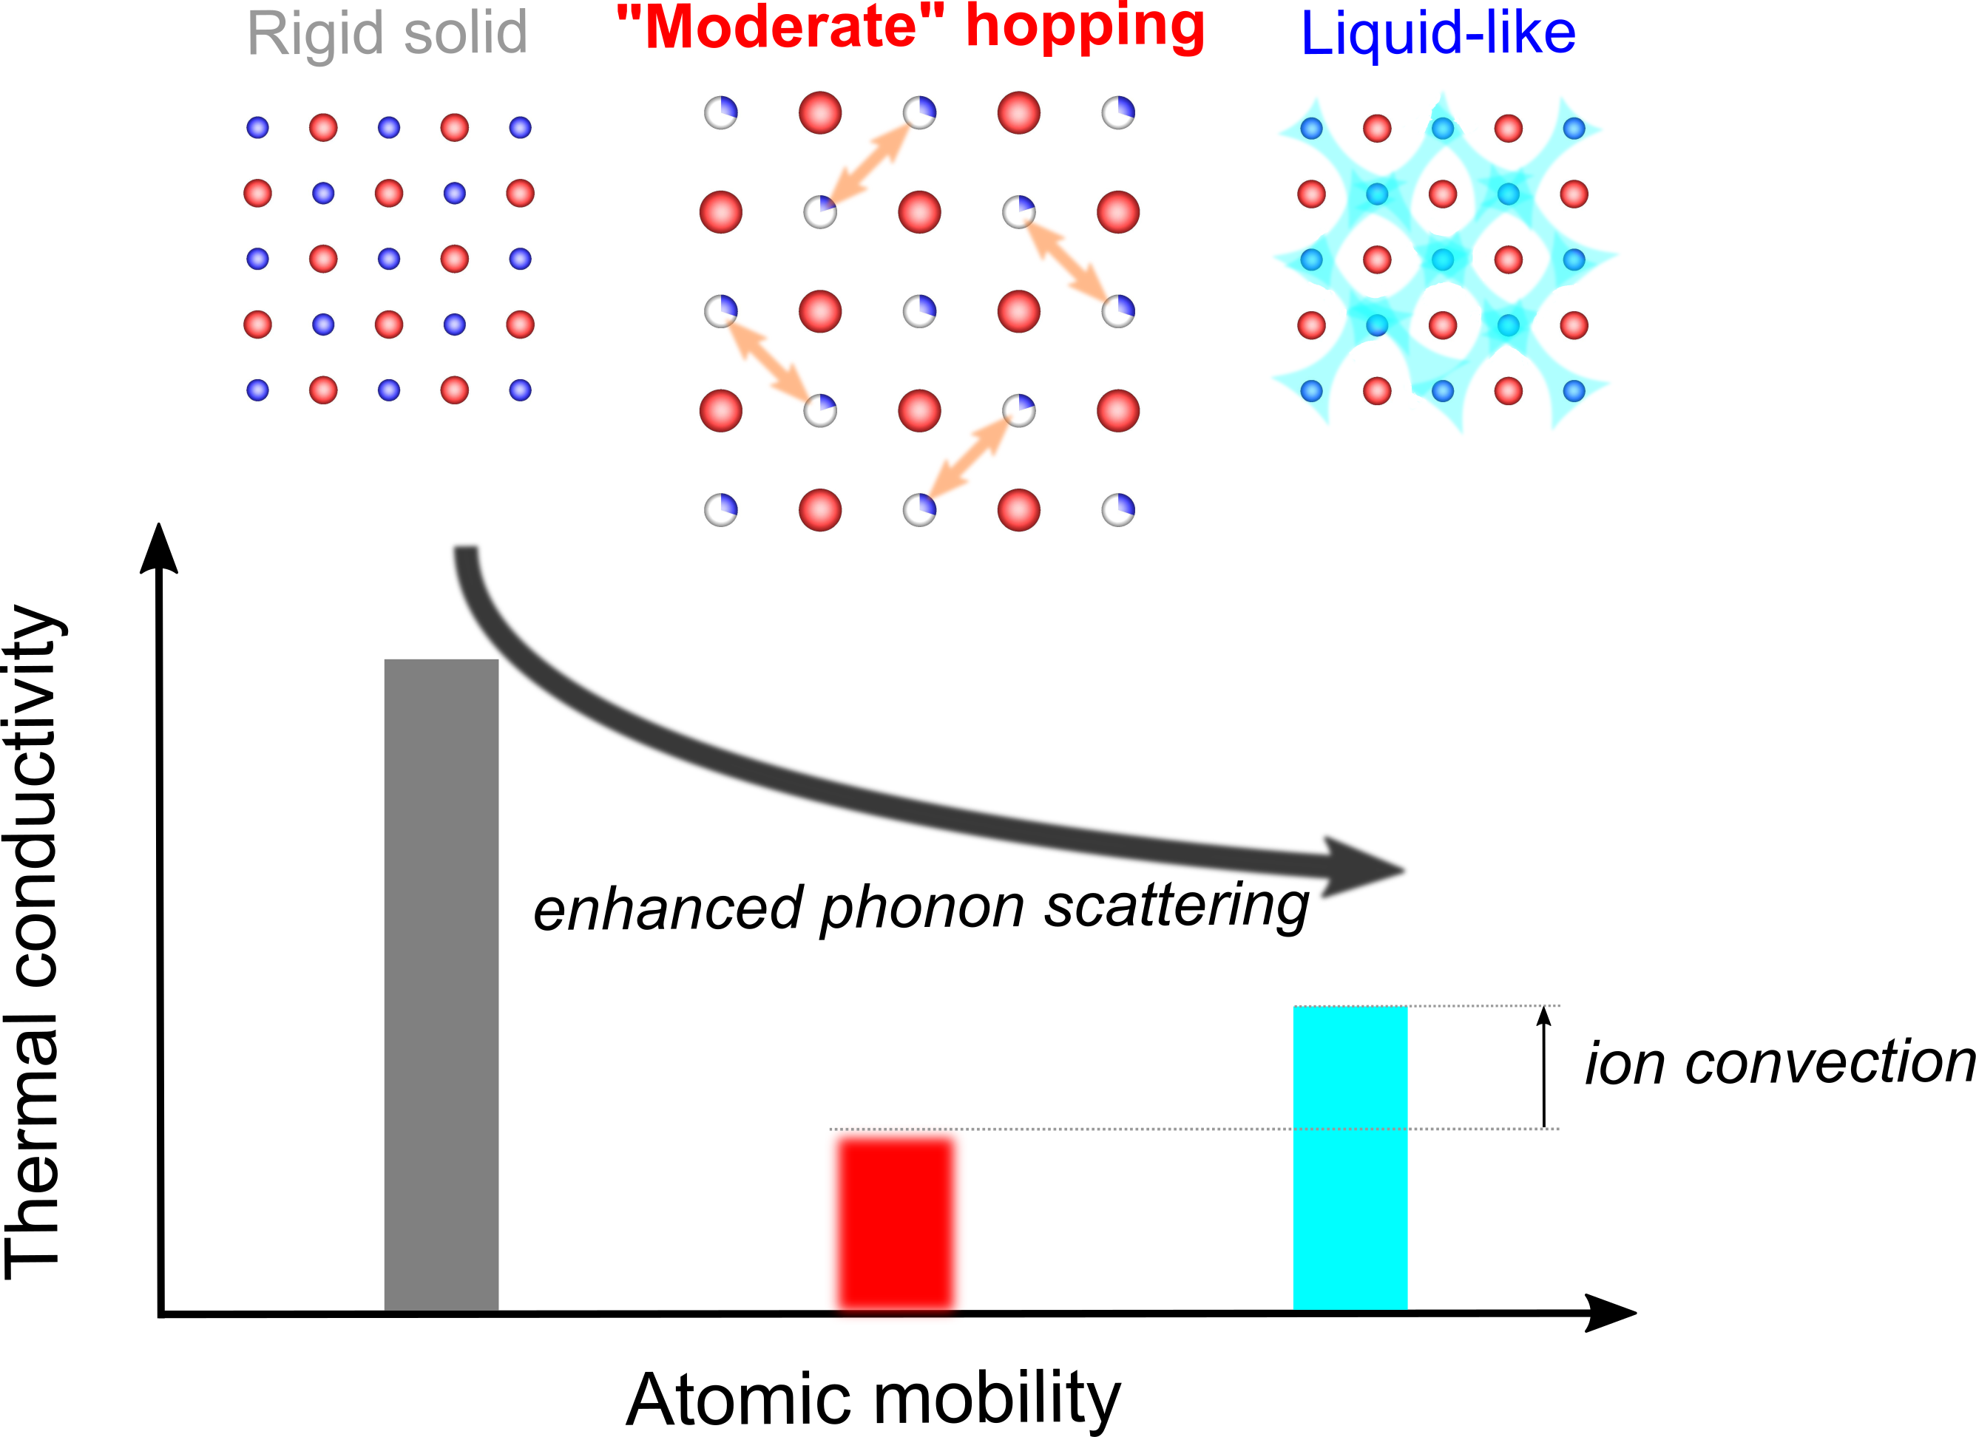
Figure 1: Schematic illustrating how atomic hopping can effectively reduce lattice thermal conductivity. Increasing atomic mobility transitions a material from a rigid solid (left) to a liquid-like superionic state (right). In the intermediate “moderate” hopping regime (center), phonon scattering is greatly enhanced while avoiding significant ionic convection, resulting in the lowest overall thermal conductivity.

References
1. Hanus, R., Gurunathan, R., Lindsay, L., Agne, M.T., Shi, J., Graham, S., and Jeffrey Snyder, G. (2021). Thermal transport in defective and disordered materials. Appl. Phys. Rev. 8, 031311.
2. Koley, B., Lakshan, A., Raghuvanshi, P.R., Singh, C., Bhattacharya, A., and Jana, P.P. (2021). Ultralow lattice thermal conductivity at room temperature in Cu4TiSe4. Angew. Chem. Int. Ed. 60, 9106–9113.
3. Chen, X.-K., Zhang, E.-M., Wu, D., and Chen, K.-Q. (2023). Strain-induced medium-temperature thermoelectric performance of Cu4TiSe4 : The role of four-phonon scattering. Phys. Rev. Appl. 19, 044052.
4. Cheng, R., Wang, W., Wang, W., Wang, X., Wang, C., Tai, S.T., Ouyang, N., Liu, Q., and Chen, Y. Atomic Hopping Induced Dynamic Disorder Phonon Scattering and Suppressed Thermal Transport in CuTiSe4. Newton.
5. Liu, H., Shi, X., Xu, F., Zhang, L., Zhang, W., Chen, L., Li, Q., Uher, C., Day, T., and Snyder, G.J. (2012). Copper ion liquid-like thermoelectrics. Nat. Mater. 11, 422–425.
6. Zhao, K., Qiu, P., Shi, X., and Chen, L. (2020). Recent advances in liquid-like thermoelectric materials. Adv. Funct. Mater. 30, 1903867.
7. Ren, Q., Gupta, M.K., Jin, M., Ding, J., Wu, J., Chen, Z., Lin, S., Fabelo, O., Rodríguez-Velamazán, J.A., Kofu, M., et al. (2023). Extreme phonon anharmonicity underpins superionic diffusion and ultralow thermal conductivity in argyrodite Ag8SnSe6. Nat. Mater. 22, 999–1006.
8. Liu, Z., Zhang, W., Gao, W., Mori, T. (2021). A material catalogue with glass-like thermal conductivity mediated by the crystallographic occupancy for thermoelectric application. Energy Environ. Sci. 14, 3579-3587.
9. Pope, A.L., and Tritt, T.M. (2006). Thermal conductivity of quasicrystalline materials. In Thermal Conductivity (Springer US), pp. 255–259.
10. Zhu, T., and Ertekin, E. (2019). Mixed phononic and non-phononic transport in hybrid lead halide perovskites: glass-crystal duality, dynamical disorder, and anharmonicity. Energy Environ. Sci. 12, 216–229.

