Enhancement of Thermoelectric Performance Through Transport Properties Decorrelation in the Quaternary Pseudo-Hollandite Chalcogenide Rb_{0.2}Ba_{0.4}Cr₅Se₈
Hugo Bouteiller,^{1,2*} Bruno Fontaine,^{3,4} Olivier Perez,¹ Sylvie Hébert,¹ Cédric Bourgès,⁵ Yoshitaka Matsushita,⁶ Takao Mori,^{7,8} Franck Gascoin,¹ Jean-François Halet,^{2,3*} and David Berthebaud^{2,9*}
¹ Laboratoire CRISMAT, ENSICAEN, UNICAEN, CNRS, Normandie Univ. (UMR 6508), Caen, France
² CNRS–Saint-Gobain–NIMS, IRL 3629, Laboratory for Innovative Key Materials and Structures (LINK), National Institute for Materials Science (NIMS), Tsukuba 305-0044, Japan
³ Univ Rennes, CNRS, Ecole Nationale Supérieure de Chimie de Rennes (ENSCR), Institut des Sciences Chimiques de Rennes (ISCR), UMR 6226, F-35000 Rennes, France
⁴ Saint-Cyr Coëtquidan Military Academy, CReC, F-56380 Guer, France
⁵ International Center for Young Scientists (ICYS), National Institute for Materials Science, 1-1 Namiki, Tsukuba, 305-0044, Japan
⁶ National Institute for Materials Science (NIMS), 1-2-1 Sengen, Tsukuba, Ibaraki 305-0047, Japan
⁷ Research Center for Materials Nanoarchitectonics (MANA), National Institute for Materials Science (NIMS), 1-1 Namiki, Tsukuba 305-0044, Japan
⁸ Graduate School of Pure and Applied Sciences, University of Tsukuba, Tsukuba 305-8671, Japan
⁹ Nantes Université, CNRS, Institut des Matériaux de Nantes Jean Rouxel, IMN, F-44000 Nantes, France

ABSTRACT: The novel quaternary compound Rb_{0.2}Ba_{0.4}Cr₅Se₈ was synthesized and characterized in both single crystal and polycrystalline forms. Crystallizing in the monoclinic crystal system (space group C2/m, cell parameters a = 18.7071(4) Å, b = 3.6030(1) Å, c = 8.9637(3) Å, β = 104.494(2) °) and isostructural to pseudo-hollandite compounds, it features mixed Rb and Ba occupancy within its one-dimensional channels. High-temperature X-ray diffraction revealed no decomposition up to 973 K, and the thermal expansion coefficient at 300 K was determined to be 2.6(1)·10⁻⁵ K⁻¹. Spin-polarized DFT calculations showed that the density of states for Rb_{0.2}Ba_{0.4}Cr₅Se₈ is more polarized than that of Ba_{0.5}Cr₅Se₈, resulting in a higher Seebeck coefficient, which was experimentally confirmed to reach a peak value of 400 µV.K⁻¹ at 620 K. Resistivity measurements indicated a degenerate semiconducting behavior below 550 K, with a resistivity peak of 100 mΩ.cm at that temperature, leading to a maximum power factor of 0.21 mW.m⁻¹.K⁻². Thermal conductivity measurements indicated low values around 0.8 W.m⁻¹.K⁻¹ in the 300 – 900 K range, resulting in a thermoelectric figure of merit of 0.22 at 873 K. Decorrelated transport properties observed in this double-inserted pseudo-hollandite compound make Rb_{0.2}Ba_{0.4}Cr₅Se₈ a good example of beneficial synergistic effects for higher thermoelectric performance.

INTRODUCTION
Transition metal chalcogenides (TMCs) have drawn significant attention in recent years for their remarkable transport properties stemming from their wide structural diversity.^{1–5} The complex structures commonly observed in TMCs are particularly compelling in the case of thermoelectric applications.^{6–8} Thermoelectric devices allow the conversion of heat into electricity and their efficiency is mostly depending on the figure of merit zT = S²T/ρ($κ_{e}$+$κ_{L}$) of the implemented materials, S being the Seebeck coefficient, ρ the resistivity, $κ_{e}$ the electric thermal conductivity, $κ_{L}$ the lattice contribution to the thermal conductivity and T the absolute temperature. Highly doped degenerate semiconductors frequently exhibit remarkable thermoelectric performance, especially in compounds characterized by complex crystal structures.⁹ Consequently, there is a growing interest in developing new materials with tailored structural features and appropriate transport properties to enhance thermoelectric efficiency.
The pursuit of high-performance thermoelectric materials has led the scientific community to explore various strategies.^{7,9–14} One of them is to target materials having large voids or channels in their crystal structure, taking advantage of two benefits: (i) heightened phonon scattering due to the structural complexity induced by a large number of atoms per unit cell, and (ii) enhanced chemical flexibility enabling precise control of the charge carrier concentration through doping using a wide range of elements.⁹ In this context, TMCs embody all the desired characteristics, and are thus the focus of this paper.
An interesting family of materials among TMCs is the pseudo-hollandite series of compounds of typical formula A_{x}M₅X₈ (A = Li, Na, K, Rb, Cs, Sr, Ba, Cd, In, Tl, Sn, and Pb; M = Sc, Ti, V, Cr; X = S, Se, Te).^{15–41} Characterized by a one-dimensional channel-like structure, these compounds consist of an anionic framework constructed from edge and face-sharing MX₆ octahedra, creating spacious channels capable of accommodating an array of diverse cations. As evidenced by the large number of metals and chalcogenides stabilized in this structure type, this family of compounds offers a large playground for tuning the charge carrier concentration while maintaining low thermal conductivities due to pronounced phonon scattering. Various chemical systems within these hollandite derivatives were explored, in particular among chromium selenides. Notably, relatively high thermoelectric performance was achieved in some of them as exemplified by the zT value of 0.5 at 800 K for Tl_{x}Cr₅Se₈.²⁴ Furthermore, it appears that deviations from the classical monoclinic C2/m pseudo-hollandite structure (referred to as A-type) have been encountered as in Ba_{0.5}Cr₅Se₈ where a lowering of symmetry was observed (space group P$\overline{1}$),^{15,25} and more recently with the examples of Cs_{x}Cr₅Te₈ compounds exhibiting a different structural arrangement (referred to as B-type), favored by the presence of large cations within the channels.⁴² Building on these findings, the exploration on the chromium selenide hollandite derivatives was pursued, aiming at the discovery of new structures and transport properties through the insertion of two distinct cations inside the channels. This strategy was encouraged by the facts that first, the presence of large atoms can amplify phonon scattering, potentially inducing a decrease in the lattice thermal conductivity, and on the other hand, might result in a degenerate semiconducting behavior by moving the Fermi level position, eventually leading to high thermoelectric performance. Consequently, the preparation of a chromium selenide hollandite derivative with the insertion of both barium and rubidium atoms was considered. In this study, the existence of a quaternary pseudo-hollandite compound (A-type) incorporating two different cations within the channels is established, and its transport properties discussed.

EXPERIMENTAL SECTION
Synthesis. Rb_{0.2}Ba_{0.4}Cr₅Se₈ single crystals were grown by the self-flux method in fused silica tubes from the Rb_{0.1}Ba_{0.5}Cr₅Se₈ nominal stoichiometry. Initially, BaSe precursor was prepared by mechanical alloying: Ba (rod, > 99 %) and Se (shots, 99.999 %) (2 x 2.5 g, balls/powder ratio 20/1, all reactants used as received from Alfa Aesar) were introduced under inert atmosphere (Ar) in 20 mL tungsten carbide jars and loaded into a planetary ball miller (Pulverisette 7 Premium line Fritsch) at 500 rpm during 30 minutes. The high purity of BaSe was confirmed by powder X-ray diffraction. Stoichiometric amounts of BaSe, Rb₂CO₃ (powder, -20 mesh, 99%), Cr (powder, -325 mesh, 99.9%) and Se (shots, 99.999%) were loaded in fused silica tubes under Ar atmosphere, then sealed under dynamic vacuum and heated at 500 °C in 6 h. The temperature was directly raised at 900 °C in 8 h and held constant for 48 h. The samples were slowly cooled to 200 °C in 96 h and allowed to reach room temperature. The result was the formation of shiny dark needles that remain stable in ambient air. Pictures of single crystals are presented in the Supplementary Information. Powder samples of Rb_{0.2}Ba_{0.4}Cr₅Se₈ (10 g) were obtained by mixing the appropriate stoichiometry from the same starting reagents as for the synthesis of single crystals. The reactants were first placed in a hardened steel grinding jar (65 mL) alongside two 12.6 mm hardened-steel balls under Ar atmosphere, and subsequently ball milled during 1 h in a SPEX 8000M vibratory mixer apparatus. The obtained powder was recovered in an Ar-filled glovebox, manually ground, pelletized in a Ø 10 mm steel die and then sealed under inert atmosphere in fused silica tubes. The mixture was heated to 200 °C at 100 °C/h and held at that temperature for 4 h. The temperature was then raised to 800 °C at a heating rate of 30 °C/h and kept constant for 48 h, before being cooled to room temperature in 8 h. It should be noted that this reaction results in the generation of CO₂ gas as a by-product, leading to an increased pressure inside the sealed silica tube. However, this increase remains limited as the stoichiometry of rubidium carbonate is very low. For instance, in a tube of 12 mm inner diameter and 12 cm length, having a free volume of about 1.36·10⁻³ m³, the resulting CO₂ pressure for the synthesis of 10 g of the title compound leads to a pressure of approx. 76 mbar, far below the atmospheric pressure. That being said, this must be kept in mind in the case of larger mass production.
Structural Characterization. Single crystals were picked up in air, isolated in silicon oil, and subsequently mounted on the goniometric head of a four-circles Rigaku XtaLAB Synergy-S diffractometer. X-ray diffraction data collection (Cu Kα (1.5418 Å) radiation) was performed on a single crystal of Rb_{0.2}Ba_{0.4}Cr₅Se₈. The CrysAlisPro software⁴³ was employed for crystal shape determination and the data reduction. Absorption corrections based on the crystal morphology were successfully applied. Only reflections with I > 3σ(I) were used for the subsequent charge-flipping structure resolution from SUPERFLIP⁴⁴ as well as the following refinement performed with Jana2006 software.⁴⁵ All parameters were refined with an instability factor of 0.025. Atomic displacement parameters (ADP) were systematically anisotropically refined. Rb and Ba atoms in Rb_{0.2}Ba_{0.4}Cr₅Se₈ evidenced a partial occupation of the 2a crystallographic site, their ADPs thus being fixed as equal and their occupation forced to be complementary with a partial occupation of the site equal to 0.6 (see the “Crystal Structure Resolution” section for more details). The powder X-ray diffraction pattern of the densified sample was measured by a Rigaku Smart Lab 3 diffractometer (Cu radiation, λ_{Kα1} = 1.5418 Å, and λ_{Kα2} = 1.5444 Å, λ_{Kα2/λKα1} ratio of 0.5) with a step size of 0.02° and a scan speed of 2 °.min⁻¹. The structural model was refined using the FULLPROF suite⁴⁶ with the Le Bail method, yielding agreement values of R_{p} = 7.6 %, R_{wp} = 11.1 % and χ² = 1.63 (11 refined parameters). High-temperature powder X-ray diffraction (HT-XRD) patterns were carried out on the post-synthesis powder up to 973 K, using a Rigaku SmartLab 9 kW (monochromatic Cu radiation, λ_{Kα1} = 1.54056 Å) under dry N₂ gas flow (1 L.min⁻¹) with a step width of 0.02 ° and a scan speed of 1 °.min⁻¹. The heating and cooling rates were 5 °C.min⁻¹ each, and the temperature was held constant for 5 minutes before each measurement.
Physical Properties Characterization. Powders of the aforementioned compound were densified in 10 mm diameter graphite dies using an SPS DrSinter apparatus with a run under vacuum at 800 °C for 10 min (heating/cooling rates of 80 °C/min), and applying a pressure of 50 MPa before heating. The density of the obtained pellet measured by the Archimedes’ method was 5.406 g.cm⁻³, resulting in a relative density of 98.9 %. Seebeck coefficient and resistivity were measured simultaneously using a ZEM5 apparatus (ULVAC) on a 3 x 3 x 10 mm shaped bar. The charge carrier concentration was measured at room temperature by a Physical Property Measurement System (PPMS) using the Hall configuration under a magnetic field ranging from −9 to 9 T. Thermal conductivity was characterized by a NETZSCH 467 HyperFlash laser-flash apparatus on 10-mm diameter and 2-mm thickness pellets, coated with graphite. The heat capacity was estimated using the Dulong-Petit law. Uncertainties on the Seebeck coefficient, resistivity, power factor and figure of merit zT are 6 %, 8 %, 14% and 20 %, respectively.
Electronic Structure Calculations. Periodic spin-polarized density functional theory (DFT) calculations were carried out to provide insights into the electrical structural properties of the title compound. Structural optimizations were first performed using the VASP software version 5.4.1 ^{47–49} with the Perdew, Burke and Ernzerhof (PBE) exchange-correlation functional⁵⁰ and a cut-off energy of 350 eV. The non-stoichiometric unit cells of Ba_{0.5}Cr₅Se₈ and Rb_{0.2}Ba_{0.4}Cr₅Se₈ were obtained from a 2 x 1 x 1 supercell (27 atoms in total) and a 1 x 5 x 1 supercell (136 atoms in total), respectively, that were sampled with a 6 x 6 x 6 Monkhorst-Pack k-points grid.⁵¹ VASP-relaxed structures were then used to compute the electronic density of states (DOS) with the WIEN2k code using the full-potential linearized augmented plane wave approach,⁵² employing the modified Becke-Johnson (mBJ) exchange-correlation potential⁵³ with a plane-wave cut-off corresponding to R_{MT}∙K_{max} = 7. Total energy convergence was achieved with a Brillouin Zone (BZ) integration mesh of 500 k-points. Electronic transport coefficients were calculated within the linearized Boltzmann transport equation using the BoltzTrap2 code⁵⁴ with a constant relaxation time for the electrons and assuming a rigid band structure^{55,56} with respect to the Fermi energy. 5000 k-points in the BZ were used to compute the band derivatives for transport calculations. The Seebeck coefficient (S) as function of the chemical potential (μ) that indicates the doping level or carrier concentration in the considered system, was calculated at 300 and 800 K. Positive and negative values of 𝜇 indicate n-type and p-type doping, respectively.
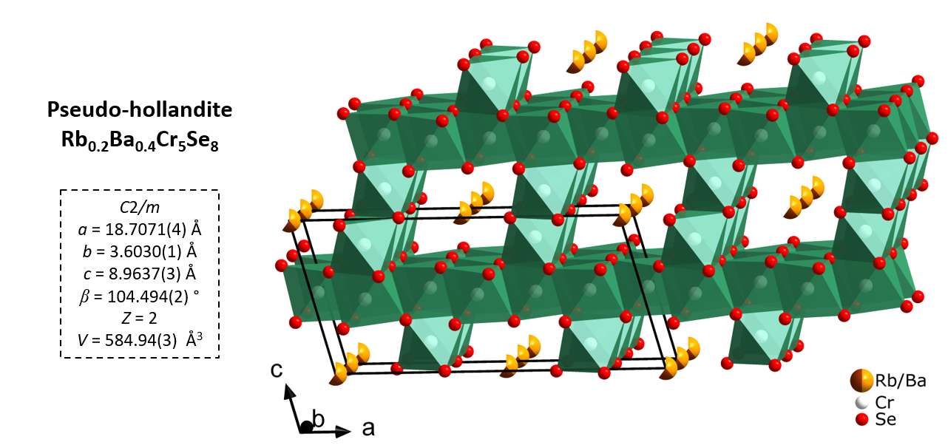
RESULTS AND DISCUSSION
Figure 1. Structural arrangement of the Rb_{0.2}Ba_{0.4}Cr₅Se₈ pseudo-hollandite compound (A-type). The partial occupancies of both Rb (brown) and Ba (orange) cations within the channels are represented by fragmented spheres.
Crystal Structure Solution and Refinement. Rb_{0.2}Ba_{0.4}Cr₅Se₈ crystallizes in the pseudo-hollandite A-type structure, as commonly encountered for the A_{x}M₅Se₈ reported structures (A = alkali/alkaline-earth, M = transition metal), with a mixed occupancy of Rb and Ba atoms on the 2a site inside the channels (Figure 1). Examination of single-crystal X-ray diffraction frames unveiled the monoclinic symmetry, which interestingly differs from that of Ba_{0.5}Cr₅Se₈ exhibiting triclinic symmetry (space group P$\overline{1}$).¹⁵ This difference led to further investigation on the possibility of either exclusive Rb insertion, supported by the existence of RbCr₅Se₈,^{17,30,31} or simultaneous insertion of both Rb and Ba. Data reduction was made in the monoclinic symmetry, using a numerical absorption correction with spherical harmonics model, and the space group was confirmed to be C2/m.
The initial structure solution obtained from Superflip yielded the expected anionic framework built of CrSe₆ octahedra, and the so-formed channels were filled with Rb atoms respective to the RbCr₅Se₈ stoichiometry at first to evaluate the possibility of being in the presence of this latter compound. Atomic positions and anisotropic ADPs were refined with an instability factor of 0.025, resulting in a refined model with a R value of 3.94 % and GOF = 3.28. Rb occupation in the channels was then refined, yielding at this point the Rb_{0.809}Cr₅Se₈ composition with R = 2.65 % and GOF = 1.71. However, this model exhibited significant electronic residues in Fourier difference maps, thus appeared unacceptable. Additionally, complementary energy dispersive X-ray spectroscopy (EDS) experiments on multiple single crystals confirmed the presence of both Rb and Ba cations. Consequently, the splitting of the Rb atom site involving a partial Rb/Ba occupation was considered. The nominal composition being Rb_{0.1}Ba_{0.5}Cr₅Se₈, 60 % of the crystallographic site (2a) is expected to be occupied by cations, therefore the total occupancy of both Rb and Ba atoms were fixed accordingly. Ba relative occupancy was adjusted such that Rb and Ba atoms occupy 10 % and 50 % of the cationic site, respectively, consistent with the Rb_{0.1}Ba_{0.5}Cr₅Se₈ nominal composition. ADPs and atomic positions of the cationic atoms were constrained to be equal. Subsequent refinement led to an improved model with an R value of 2.43 % and GOF = 1.44. Occupancies of the cationic atoms were then refined and a final refinement process including extinction correction granted the title compound Rb_{0.213(5)}Ba_{0.387(5)}Cr₅Se₈, agreement values dropping to R = 1.72 % and GOF = 1.05. Examination of Fourier difference maps confirmed minimal electronic residues (< 0.66 e⁻.Å⁻³), validating the accuracy of this structural model. Counting the charges, both Rb and Ba contributions lead to a total of 0.987 electrons conceded to the Cr₅Se₈ anionic framework, closely approaching the expected value of one electron for this polar chromium selenide as in Ba_{0.5}Cr₅Se₈. Detailed crystallographic data, including structure resolution details, are provided in Table 1. Refined coordinates and ADPs are displayed in Table 2 and the main interatomic distances are summarized in Table 3.
Table 1. Crystallographic Data of Rb_{0.2}Ba_{0.4}Cr₅Se₈ from the Single-crystal X-ray Diffraction Study
Formula | Rb_{0.2}Ba_{0.4}Cr₅Se₈
Structural type | A (pseudo-hollandite)
Molar mass (g.mol⁻¹) | 963.68
Crystal system | Monoclinic
Space group | C2/m (12)
a (Å) | 18.7071(4)
b (Å) | 3.6030(1)
c (Å) | 8.9637(3)
β (°) | 104.494(2)
V (Å³) | 584.94(3)
Z | 2
Calculated density (g.cm⁻³) | 5.4676
Data collection
T (K) | 293
Crystal description | Black needle
Crystal dimensions (mm³) | 0.016 x 0.014 x 0.163
Radiation | Cu (1.54184 Å)
μ_{(Cu Kα)} (mm⁻¹) | 76.137
2θ limits (°) | 4.86 – 75.48
hkl range | –22 < h < 22  –3 < k < 4  –11 < l < 11
Measured reflections | 5486
Data reduction
Independent reflections | 718
Independent reflections with I > 3σ(I) | 704
R_{int} | 0.0221
Transmission factors | 0.155 – 1
Refinement
R_{F}² (obs/all) | 0.0172/0.0281
R_{WP} (obs/all) | 0.0176/0.0289
Goodness of fit | 1.05
Refined parameters | 47
Δρ_{min}/Δρ_{max} (e⁻.Å⁻³) | –0.66/0.53

Crystal Structure Discussion. The existence of the double inserted Rb_{0.2}Ba_{0.4}Cr₅Se₈ crystallizing in the classical pseudo hollandite structure reveals that the presence of a large cation such as Rb (atomic radius = 2.35 Å) in the channel stabilizes this structure-type. Indeed, Ba_{0.5}Cr₅Se₈ exhibits a lowering of symmetry towards the triclinic space group P$\overline{1}$ which results from a distortion of the arrangement of CrSe₆ octahedra in the anionic framework.¹⁵ As a consequence, the distortion of the anionic framework is reduced when both Rb and Ba are inserted, this behavior being explained by the presence of Rb atoms which, even in a limited amount, stabilizes the classical pseudo-hollandite structure type (A-type). Such an effect has already been encountered, as the presence of large cation like Rb (atomic radius = 2.35 Å) or Cs (atomic radius = 2.60 Å) in the channels were proved to modify the structure from the A-type pseudo-hollandite to the B-type hollandite-like compounds, in which the arrangement of the channels differs.^{18,19,42} Notably, the range of compositions for a given structural type can be narrow, exemplified by Rb_{0.62}Cr₅Te₈ and Rb_{0.73}Cr₅Te₈ which are of A-type and B-type, respectively.^{19,20} Furthermore, it can be noted that the title compound finds a notable stability with the Rb_{0.2}Ba_{0.4}Cr₅Se₈ particular composition, involving a site occupancy of 60 % on the cation site (2a). This includes a Ba amount approximately twice as large as that of Rb, indicating that other intermediate compositions, away from classical (A²⁺)_{0.5}Cr₅Se₈ or A’Cr₅Se₈ (A = alkaline earth; A’ = alkaline), can be obtained within this family of compounds. This opens up further possibilities when considering adjusting the charge carrier concentration and doping level in such compounds.
The cell parameters of the title compound (a = 18.7071(4) Å, b = 3.6030(1) Å, c = 8.9637(3) Å, β = 104.494(2) °) closely aligns with those of other pseudo-hollandite compounds such as Tl_{x}Cr₅Se₈,²⁴ KCr₅Se₈,¹⁷ or NaCr₅Se₈.¹⁷ They are however slightly smaller than those of RbCr₅Se₈ and CsCr₅Se₈.^{17,30,31} This may be explained by both a higher amount and a larger atomic radius of the inserted cations in these two compounds. A large anisotropic atomic displacement parameter is observed along the channel direction (b-axis) as reflected by extended values of U₂₂ = 0.08 Å², manifold larger than those in other directions (Table 2). This phenomenon is recurrent in several pseudo-hollandite compounds, particularly in the cases of partially-filled compounds such as Tl_{x}Cr₅Se₈,²⁴ Tl_{x}V₅S₈,³⁴ A_{x}Cr₅Se₈ (A = Rb, Cs)²² or B-type A’_{x}Cr₅Te₈.(A’ = Rb, Cs).^{19,42} It can be attributed to the relatively low geometrical restrictions of these cations along the b-axis (channel axis) compared to other directions, due to the presence of the channel walls. In addition, it can be further accentuated by the presence of vacancies of the 2a cationic site as 40 % of the site remains unoccupied, resulting in a potential cationic disorder.
The Cr‒Se bond lengths range from 2.4814(4) to 2.6211(4) Å, consistent with those observed in other chromium selenide pseudo-hollandites (Table 3). Notably, the principal short Cr‒Cr distance in the title compound (Cr(2)‒Cr(3) = 3.0631(7) Å) is slightly longer than that in RbCr₅Se₈ (3.0568(4) Å) and CsCr₅Se₈ (3.0480(4) Å).³⁰ This trend aligns with the increasing size of the inserted cations in the ACr₅Se₈ (A = Rb/Ba, Rb, Cs) series, resulting in a larger intercationic distance in the channels (Rb/Ba‒Rb/Ba = 3.6030(1) Å, Rb‒Rb = 3.623(1) Å, Cs‒Cs = 3.637(1) Å), and a more constricted anionic framework in the pseudo-hollandites inserted with large-radius cations.
Table 2. Refined Coordinates and Atomic Displacement Parameters for Rb_{0.2}Ba_{0.4}Cr₅Se₈ (Estimated Standard Deviations are Given in Brackets).
Atom | Wyckoff  position | SOF | x | y | z | U_{iso} | U₁₁ (Å²) | U₂₂ (Å²) | U₃₃ (Å²) | U₁₃ (Å²)
Rb | 2a | 0.213(5) | 0 | 0 | 0 | 0.0426(3) | 0.0268(4) | 0.0800(7) | 0.0179(4) | 0.0000(3)
Ba | 2a | 0.387(5) | 0 | 0 | 0 | 0.0426(3) | 0.0268(4) | 0.0800(7) | 0.0179(4) | 0.0000(3)
Cr1 | 2d | 1 | 0 | ½ | ½ | 0.0096(2) | 0.0095(3) | 0.0078(4) | 0.0110(4) | 0.0014(3)
Cr2 | 4i | 1 | 0.8427(1) | 0 | 0.5174(1) | 0.0096(2) | 0.0089(3) | 0.0080(3) | 0.0118(3) | 0.0026(2)
Cr3 | 4i | 1 | 0.7951(1) | 0 | 0.1647(1) | 0.0092(2) | 0.0091(3) | 0.0078(3) | 0.0100(3) | 0.0012(2)
Se1 | 4i | 1 | 0.9262(1) | 0 | 0.3382(1) | 0.0098(2) | 0.0085(2) | 0.0078(2) | 0.0121(2) | 0.0006 (2)
Se2 | 4i | 1 | 0.9145(1) | ½ | 0.6783(1) | 0.0108(1) | 0.0103(2) | 0.0090(2) | 0.0128(2) | 0.0022(2)
Se3 | 4i | 1 | 0.6682(1) | 0 | -0.0061(1) | 0.0103(2) | 0.0110(2) | 0.0086(2) | 0.0108(2) | 0.0017 (2)
Se4 | 4i | 1 | 0.7396(1) | 0 | 0.6576(1) | 0.0093(2) | 0.0095(2) | 0.0070(2) | 0.0117(2) | 0.0032(2)

Table 3. Interatomic Distances (Å) in Rb_{0.2}Ba_{0.4}Cr₅Se₈ (Estimated Standard Deviations are Given in Brackets).
CrSe₂  layer (ab plane) | Cr1–Se1 | 2.5004(2)  x 4 | Bridging Cr–Se octahedra | Cr3–Se1 | 2.5547(4) | A–Se | Rb/Ba–Se1 | 3.6322(3)  x 2
 | Cr1–Se2 | 2.5279(4)  x 2 |  | Cr3–Se3 | 2.4819(4) |  | Rb/Ba–Se2 | 3.4369(3)  x 4
 | Cr2–Se1 | 2.5050(7) |  | Cr3–Se3 | 2.4952(4)  x 2 |  | Rb/Ba–Se3 | 3.6379(3)  x 4
 | Cr2–Se2 | 2.4814(4)  x 2 |  | Cr3–Se4 | 2.5931(4)  x 2
 | Cr2–Se4 | 2.5513(7)
 | Cr2–Se4 | 2.6211(4)  x 2
Principal short  Se–Se | Se1–Se1 | 3.4678(3) | Principal short  Cr–Cr | Cr2–Cr3 | 3.0631(7) | Principal short  A–A | A–A (A = Rb, Ba) | 3.6030(1)
 | Se4–Se4 | 3.4532(4)

Bulk Rb_{0.2}Ba_{0.4}Cr₅Se₈ investigation. A pure powdered sample of the title compound was synthesized and densified by spark plasma sintering (SPS). The powder X-ray diffraction pattern and refined structural model are displayed in Figure 2. Results suggest the presence of a single phase with the cell parameters a = 18.7128(4) Å, b = 3.6024(2) Å, c = 8.9604(2) Å and β = 104.522(1) °, comparing well with those obtained from the single-crystal X-ray diffraction study. HT-XRD patterns were measured to assess the thermal stability of the title compound, in particular possible degradation or decomposition into secondary phases with rising temperature. The results are sketched in Figure 3. Up to 973 K under inert atmosphere (N₂), Rb_{0.2}Ba_{0.4}Cr₅Se₈ exhibits no particular degradation or decomposition, as no secondary phases were detected with increasing temperature. Subsequent Le Bail refinements of the structural models matching recorded patterns were carried out and provided the evolution of the unit cell volume of the title compound with temperature variation (Figure 4). The thermal expansion coefficient of Rb_{0.2}Ba_{0.4}Cr₅Se₈ was consequently determined to be 2.6(1).10⁻⁵ K⁻¹ at 300 K. This value is of high interest as the thermal expansion of thermoelectric materials is a critical parameter in the implementation of a given material in thermoelectric devices.⁵⁷
Figure 2. Powder X-ray diffraction pattern of a densified Rb_{0.2}Ba_{0.4}Cr₅Se₈ sample, refined with the Le Bail method. The experimental data are plotted in red dots, the refined model in black, the difference curve in blue and the Bragg reflections are displayed in green bars.
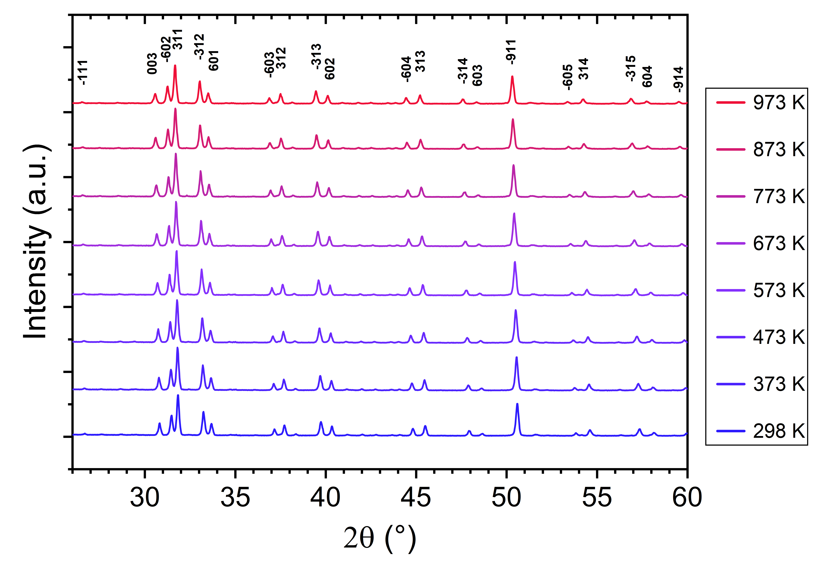
An electron dispersive X-ray spectroscopy analysis was carried out on the densified sample (Figure 5), revealing a good chemical homogeneity with the presence of all elements of the quaternary compound. Quantitative analyses performed on three different zones of the sample resulted in the averaged chemical composition Rb_{0.19(2)}Ba_{0.34(2)}Cr_{4.95(12)}Se₈, closely aligning with the composition of the title compound. Traces of CrO₂ could locally be detected, most probably resulting from the carbonate starting reactant, but remain marginal as no evidence of a CrO₂ phase could be detected with respect to powder X-ray diffraction. Additional EDS characterizations are presented in the Supplementary Information.
Figure 3. HT-XRD patterns showing the thermal stability of the crystal structure of Rb_{0.2}Ba_{0.4}Cr₅Se₈ with temperature up to 973 K.
Figure 4 - Volume of the unit cell as a function of temperature, allowing the determination of the linear thermal expansion coefficient (2.6(1).10⁻⁵ K⁻¹ at 300 K)
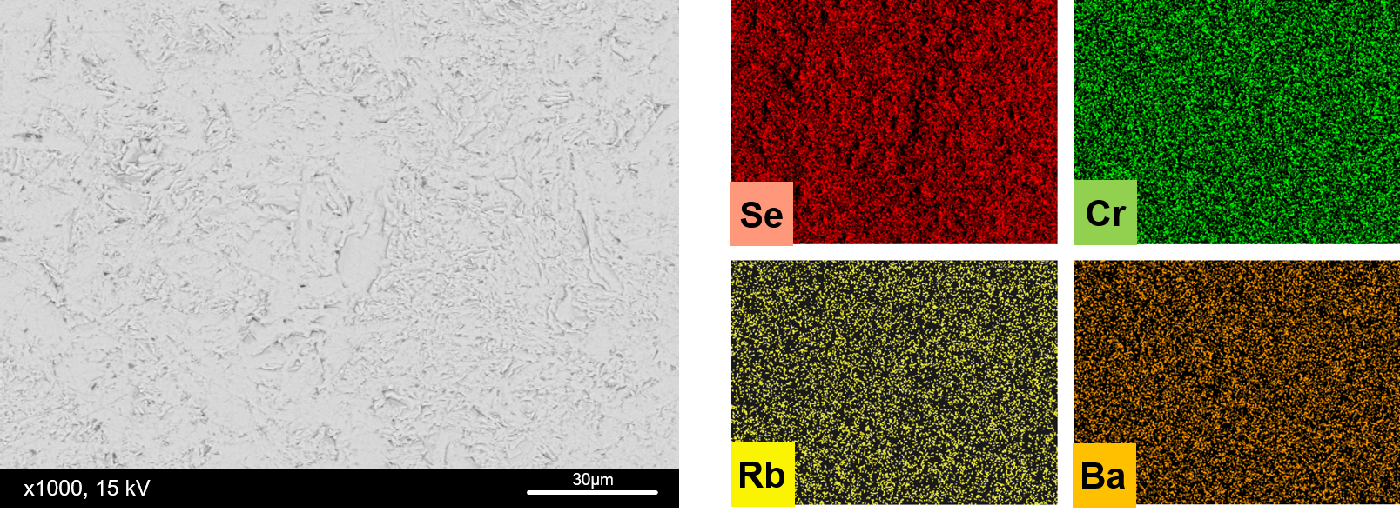
Theoretical Investigation. Density functional theory calculations were carried out to obtain insights on the expected electronic and transport properties of Rb_{0.2}Ba_{0.4}Cr₅Se₈ (see the Experimental Section for the computational details). Its density of states (DOS) is shown in Figure 6 and compared to that of isoelectronic Ba_{0.5}Cr₅Se₈. In both cases, the DOS around the Fermi level is predominantly Cr and Se in character with hardly any participation of the cations. If we assume a complete charge transfer from the inserted cation to the chromium-selenium framework ((Rb_{0.2})⁺(Ba_{0.4})²⁺[Cr₅Se₈]⁻ and (Ba_{0.5})²⁺[Cr₅Se₈]⁻), a semiconducting behavior is expected for both compounds – which was well characterized experimentally for Ba_{0.5}Cr₅Se₈.^{15,25} Indeed, this is confirmed computationally with a favorable band gap of ca. 0.5 eV for Rb_{0.2}Ba_{0.4}Cr₅Se₈ and ca. 1 eV for Ba_{0.5}Cr₅Se₈. With a smaller band gap, we expect that the resistivity of the former compound should be lower than that of the latter one. Another interesting point is that the spin-up and spin-down total and Cr-projected DOS strongly differ, demonstrating a firmly polarized DOS compared to that of Ba_{0.5}Cr₅Se₈ which shows no particular spin-related difference (see Figure 6). The computed DOS near the Fermi level suggests the presence of multiple bands with a small band-gap which could in turn lead to a significant contribution of minority carriers in the electrical conduction.
Figure 5. Energy Dispersive X-ray Spectroscopy (EDS) of a densified sample of Rb_{0.2}Ba_{0.4}Cr₅Se₈. The measured samples exhibited a chemical composition of Rb_{0.19(2)}Ba_{0.34(2)}Cr_{4.95(12)}Se₈, matching that of both nominal composition and single-crystal X-ray diffraction experiments.
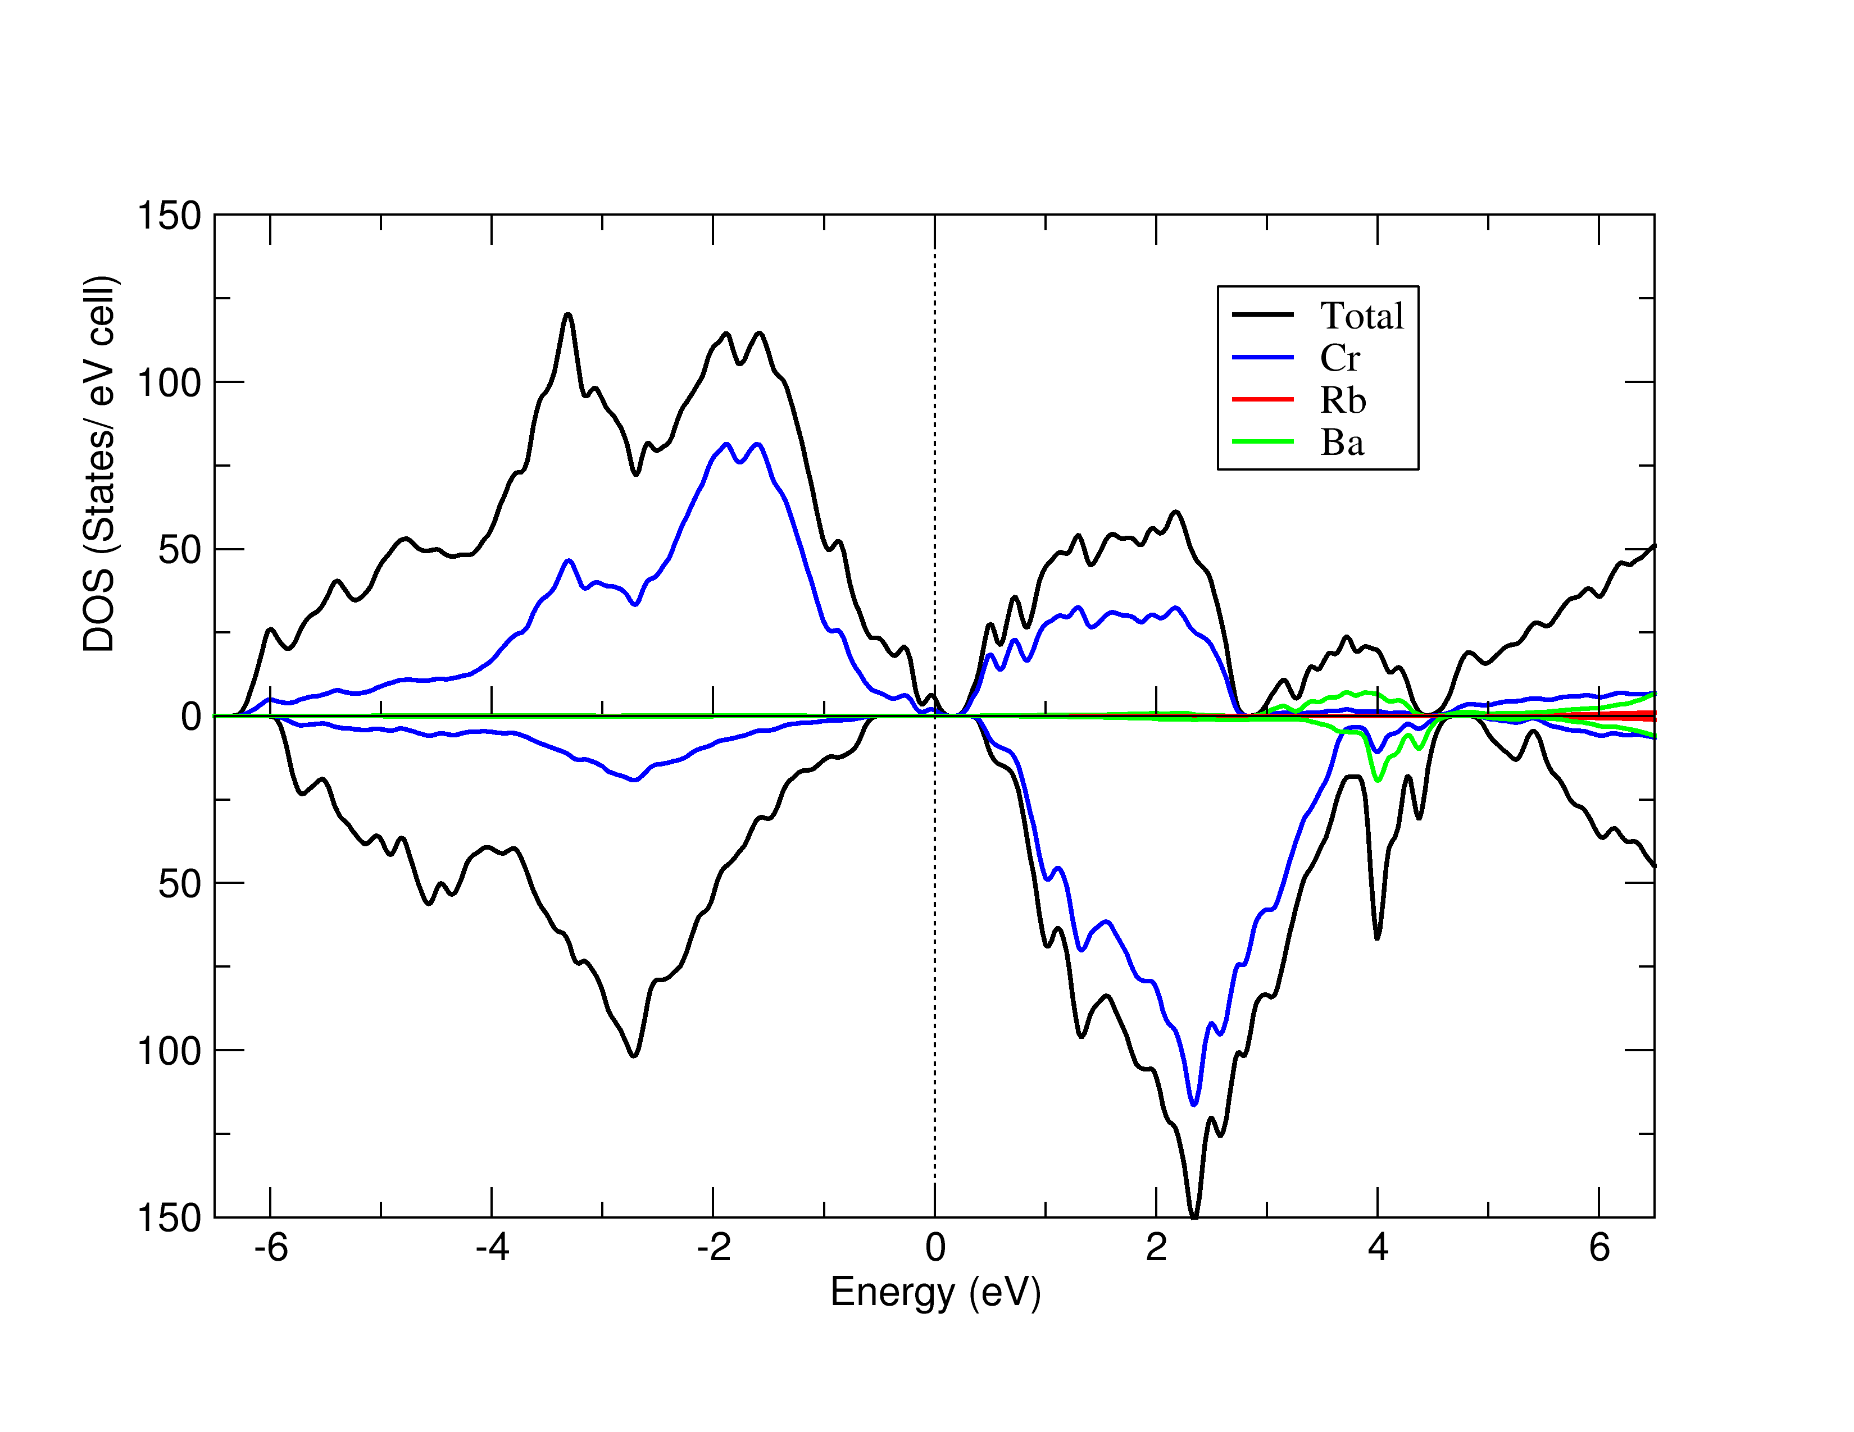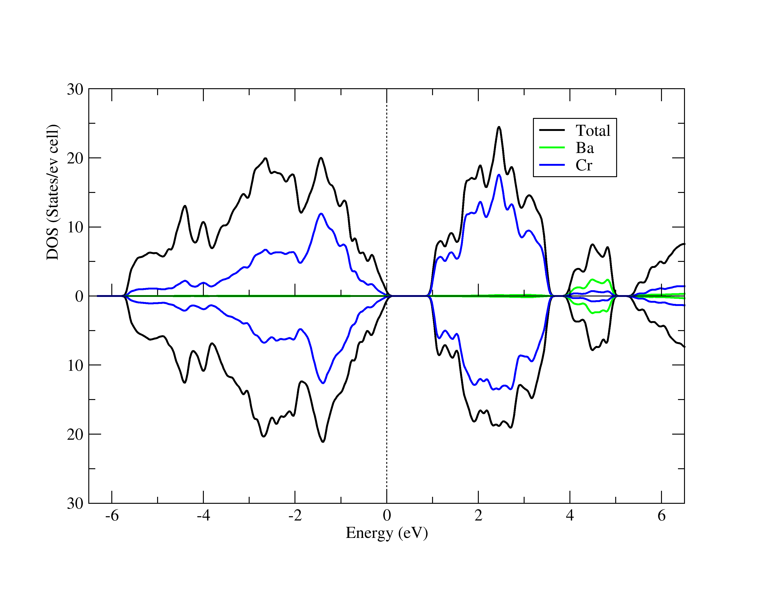
Figure 6. Spin-polarized total and atom-projected DOS of Rb_{0.2}Ba_{0.4}Cr₅Se₈ (left) and Ba_{0.5}Cr₅Se₈ (right).
The Seebeck coefficient (thermopower) as function of the chemical potential was computed for Rb_{0.2}Ba_{0.4}Cr₅Se₈ and Ba_{0.5}Cr₅Se₈ for comparison (see the Experimental Section for the computational details). As shown in Figure 7, it is very sensitive to the chemical potential and temperature. At both temperatures, high peak values of the Seebeck coefficient are computed for p-type and n-type doping at 300 K and 800 K in the vicinity of the Fermi level (μ = 0 eV), which indicates that fairly large values of S can be attained upon p-type or n-type doping. Interestingly, peak values computed for Rb_{0.2}Ba_{0.4}Cr₅Se₈ are higher than those computed for Ba_{0.5}Cr₅Se₈ (1700 vs. 1200 μV.K⁻¹ at 300 K for instance for p-type). This is in agreement with experiments which show thermopower higher for the former than for the latter (vide supra). We note as well that the S curve for Rb_{0.2}Ba_{0.4}Cr₅Se₈ is more ‘complex’ than that for Ba_{0.5}Cr₅Se₈ due a more spin-polarized DOS for the former.
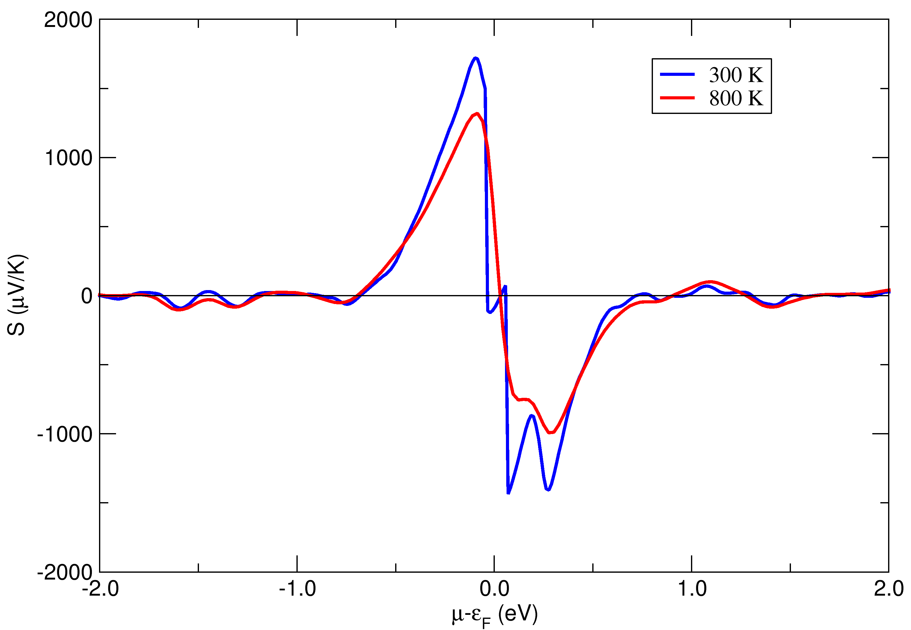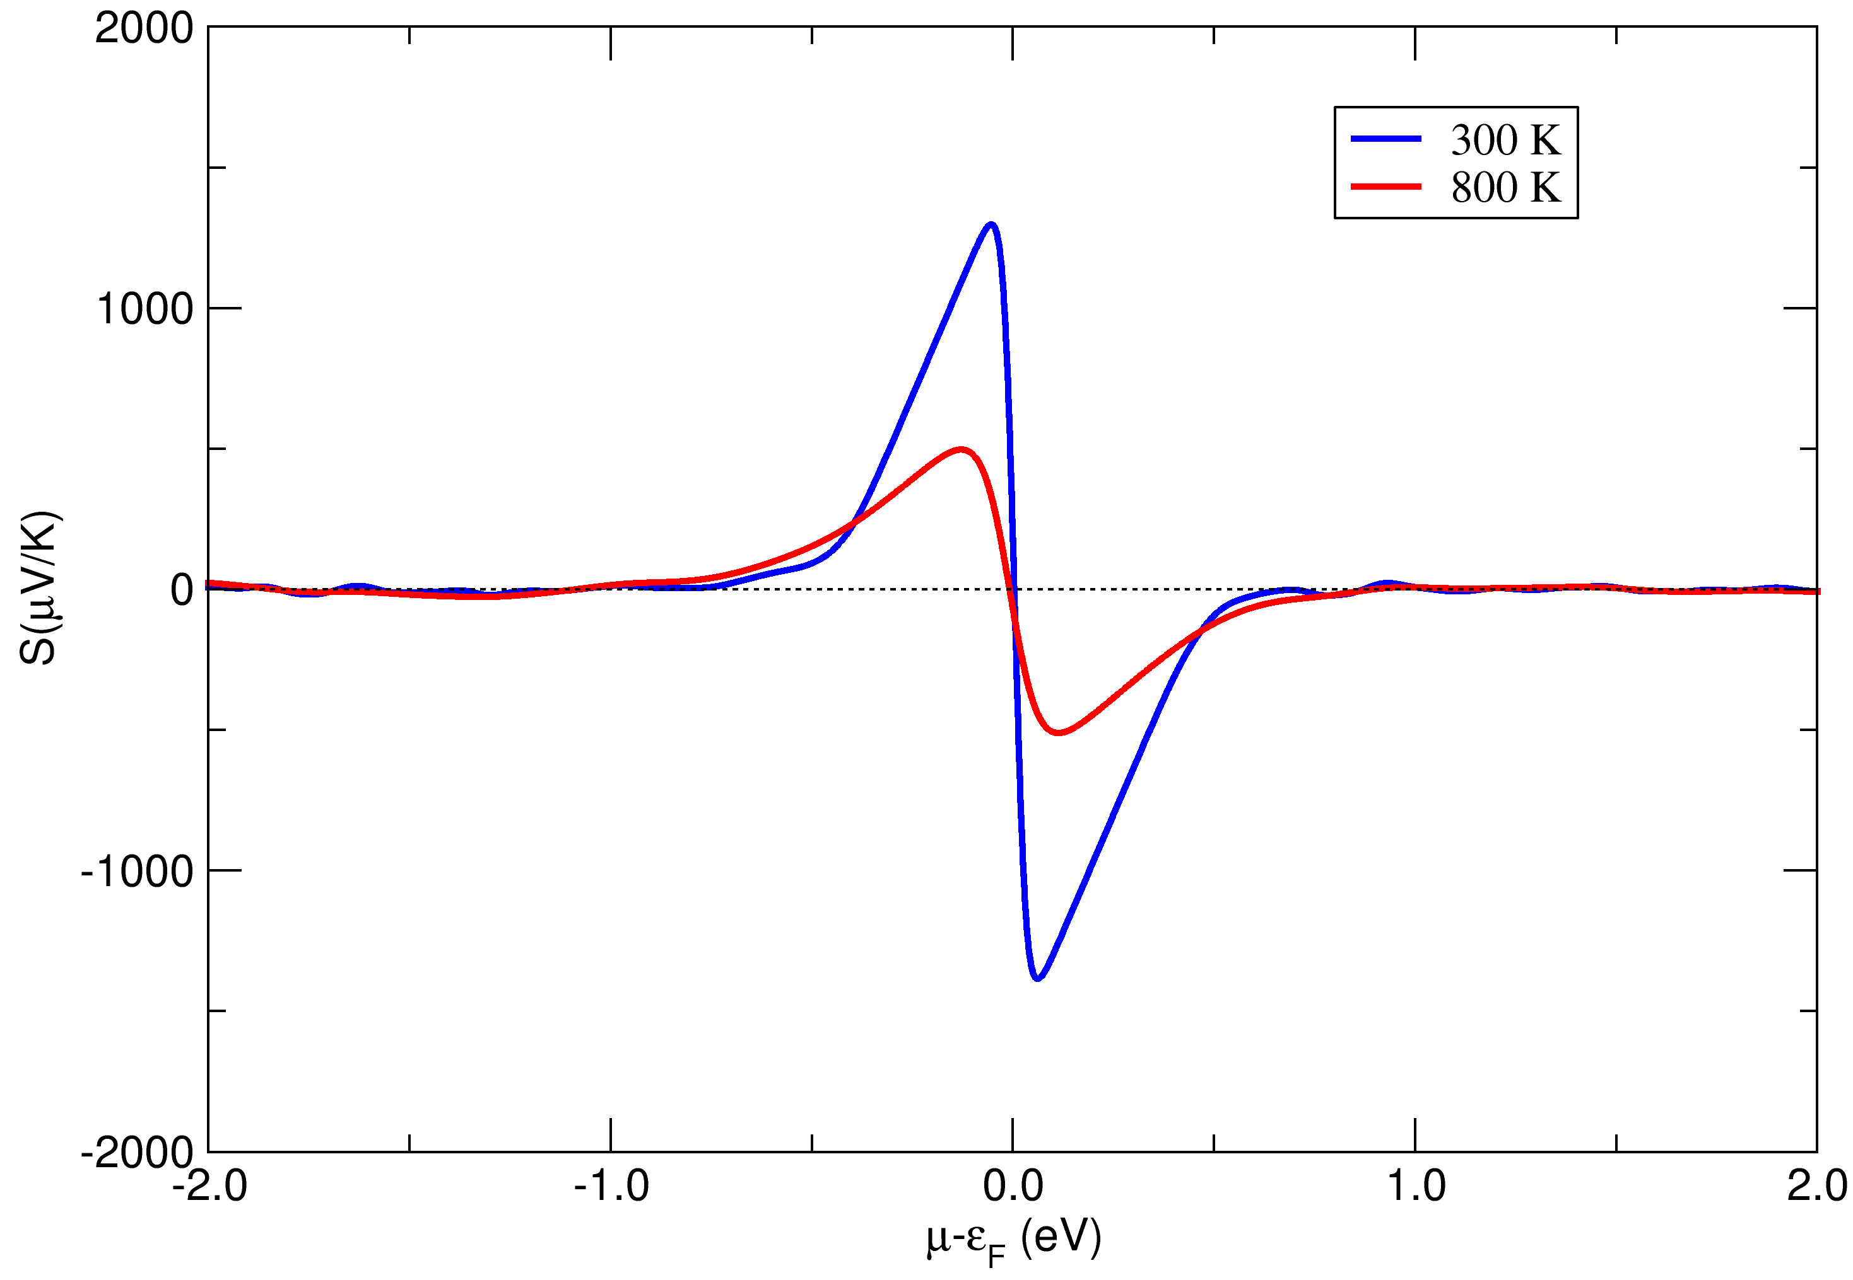
Figure 7. Seebeck coefficient (S) as a function of the chemical potential (μ) computed for Rb_{0.2}Ba_{0.4}Cr₅Se₈ (left) and Ba_{0.5}Cr₅Se₈ (right), at 300 K (blue line) and 800 K (red line).
Transport Properties. Transport properties of Rb_{0.2}Ba_{0.4}Cr₅Se₈ were measured on a densified sample. The Seebeck coefficient, electrical resistivity and resulting power factor are displayed in Figure 8, including those of other pertinent pseudo-hollandites for comparison. The Seebeck coefficient of Rb_{0.2}Ba_{0.4}Cr₅Se₈ remains positive across the entire temperature range, indicating that holes are the dominant charge carriers in this compound. Thermopower values increase with temperature until reaching a peak value of about 400 µV.K⁻¹ at 620 K, followed by a decrease at higher temperatures, attributed to the thermal activation of minority carriers. The Seebeck coefficient evolution with temperature is similar to that of Ba_{0.5}Cr₅Se₈, with the notable distinction that the absolute values for Rb_{0.2}Ba_{0.4}Cr₅Se₈ are substantially higher throughout the temperature range, an advantageous characteristic regarding thermoelectric performance. The charge carrier concentration (p) was measured to be 1.7 x 10¹⁹ cm⁻³ at 300 K. This value is slightly lower than that of Tl_{x}Cr₅Se₈ (4.5 x 10¹⁹ cm⁻³ at 300 K) for instance,²⁴ which is consistent with the increased Seebeck coefficient observed in Rb_{0.2}Ba_{0.4}Cr₅Se₈. It is however significantly higher than the value measured for Ba_{0.5}Cr₅Se₈ (4.4 x 10¹⁸ cm⁻³),¹⁵ in good agreement with the intrinsic semiconducting behavior observed in the latter compound.
The resistivity of Rb_{0.2}Ba_{0.4}Cr₅Se₈ is displayed in Figure 8b. It is measured to be about 65 mΩ.cm at room temperature, then increases with temperature to a maximum value of 100 mΩ.cm at 550 K before decreasing with further temperature elevation, revealing a transition from a degenerate semiconductor conduction mode to a non-degenerate conductive behavior above 550 K. Rb_{0.2}Ba_{0.4}Cr₅Se₈ exhibits a distinct conductive behavior compared to Ba_{0.5}Cr₅Se₈, which presents a semiconducting behavior on the entire temperature range.^{15,25} This discrepancy is attributed to a slightly different Fermi level position, expected to reside in the band gap for Ba_{0.5}Cr₅Se₈. It thus appears that the somewhat complex band structure of Rb_{0.2}Ba_{0.4}Cr₅Se₈ near the Fermi level induces the latter to lie inside the valence band, near the band edge, resulting in a degenerate semiconductor behavior below 550 K for this compound. When temperature rises up, the dispersion of the bands causes the Fermi level to shift away from the valence band, ending up in the bandgap and thus inducing a semiconducting behavior, as observed in Cu₂SnSe₃ for instance.⁵⁸ As often observed for small band-gap semiconductors,⁵⁹ the thermal activation of minority carriers above 550 K might also trigger hole-electron recombination and induce bipolar conduction, resulting in an increase of carrier concentration and a decrease of the Seebeck coefficient with temperature which is consistently observed experimentally.
Figure 8. Transport properties of Rb_{0.2}Ba_{0.4}Cr₅Se₈ and comparison with Ba_{0.5}Cr₅Se₈ and Tl_{x}Cr₅Se₈ pseudo-hollandites. a) Seebeck coefficient, b) Resistivity and c) Power Factor.
Furthermore, the electrical conduction behavior of Rb_{0.2}Ba_{0.4}Cr₅Se₈ present similarities with that of Tl_{x}Cr₅Se₈, as the latter was reported to exhibit a metallic conductive behavior due to Tl deficiency in the temperature range of 200 – 750 K.²⁴ This observation supports the fact that the Fermi level reside deeper in the valence band in Tl_{x}Cr₅Se₈ compared to Rb_{0.2}Ba_{0.4}Cr₅Se₈, resulting in an increased hole concentration, enhanced mobility, and subsequently lower resistivity in Tl_{x}Cr₅Se₈.²⁴ Rb_{0.2}Ba_{0.4}Cr₅Se₈ thus stands as an intermediate case between a semiconductor (Ba_{0.5}Cr₅Se₈) and a highly degenerated semiconductor (Tl_{x}Cr₅Se₈).
Remarkably, a clear decorrelation of the electrical transport properties can be observed in Rb_{0.2}Ba_{0.4}Cr₅Se₈, especially when compared to Ba_{0.5}Cr₅Se₈. A first decorrelation of the Seebeck coefficient and the resistivity was observed in the solid solution Ba_{0.5+x}Cr₅Se₈ (0 < x < 0.05). Indeed, the excess of Ba in the Ba_{0.5+x}Cr₅Se₈ solid solution led to a decrease in the Seebeck coefficient and an increased resistivity.²⁵ In the case of Rb_{0.2}Ba_{0.4}Cr₅Se₈, the opposite decorrelation is found, as the Seebeck coefficient is observed to increase while the resistivity decreases when compared to Ba_{0.5}Cr₅Se₈. This decorrelation might be explained by the evolution of the density of states effective mass resulting from a slight variation of the band structure near the Fermi level. In particular, the hole effective mass m* was calculated and compared for both Ba_{0.5}Cr₅Se₈ and Rb_{0.2}Ba_{0.4}Cr₅Se₈ in the parabolic band structure approximation at 300 K, yielding values of about 0.3 m₀ and 1.1 m₀, respectively. These absolute values must be taken with great care, however allow comparison between both compounds, as the higher effective mass of Rb_{0.2}Ba_{0.4}Cr₅Se₈ can be well explained by its degenerate semiconducting behavior at 300 K. Such a situation was also encountered in other several chalcogenides, including isostructural Tl_{x}Cr₅Se₈,²⁴ or the copper selenides Cu₂SnSe₃ and Cu₃SbSe₄ for instance, where a partially degenerate conductive behavior was observed as well.^{58,60,61} The synergistic increase of the Seebeck coefficient and decrease of resistivity in Rb_{0.2}Ba_{0.4}Cr₅Se₈ is beneficial for the thermoelectric properties optimization, as it leads to an enhanced maximum power factor of 0.20 mW.m⁻¹.K⁻² at 850 K, substantially higher than that of Ba_{0.5}Cr₅Se₈ (0.12 mW.m⁻¹.K⁻² at 830 K, see Figure 8c). The mobility of the charge carriers (μ) was calculated to be 5.5 cm².V⁻¹.s⁻¹ at room temperature, slightly higher than the value reported for Ba_{0.5}Cr₅Se₈ which is below 5 cm².V⁻¹.s⁻¹,²⁵ but about half that of Tl_{x}Cr₅Se₈ (10 cm².V⁻¹.s⁻¹).²⁴ This explains why the power factor still remains higher for the latter compound in the studied temperature range.
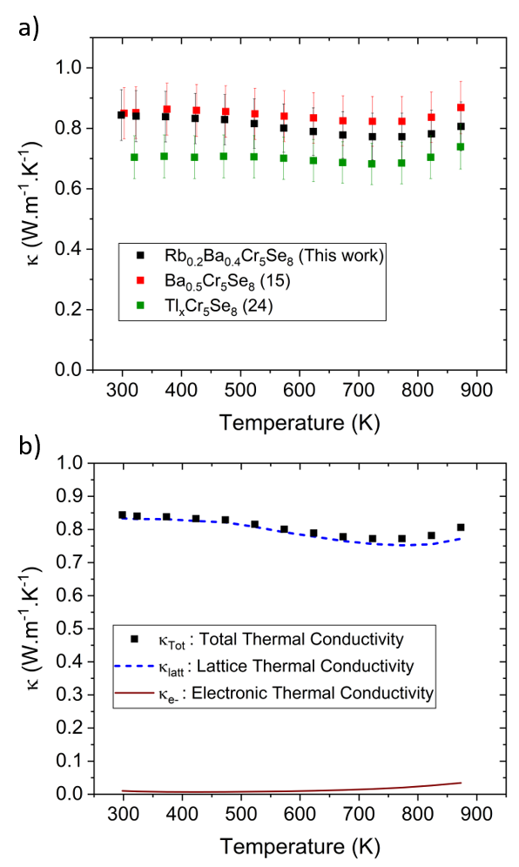
The thermal conductivity of the title compound exhibits a gradual decrease with temperature from room temperature to a minimum value of about 0.8 W.m⁻¹.K⁻¹ at 773 K (Figure 9a). Both Rb_{0.2}Ba_{0.4}Cr₅Se₈ and Ba_{0.5}Cr₅Se₈ exhibit a similar thermal conductivity behavior, with the former exhibiting slightly lower values while still falling within the standard deviation range with respect to the latter. However, this subtle decrease may stem from a heightened phonon scattering mechanism in Rb_{0.2}Ba_{0.4}Cr₅Se₈, due to the high atomic mass fluctuation inside the channels in the double-inserted pseudo-hollandite. A slight increase is also observed from 750 K upwards, consistent with the thermal activation of minority carriers contributing to the electrical thermal conductivity component (Figure 9b). Nevertheless, the total thermal conductivity remains largely dominated by the lattice thermal part which maintains low values (between 0.75 and 0.82 W.m⁻¹.K⁻¹). Notably, it can be observed that Tl_{x}Cr₅Se₈ exhibits lower thermal conductivity values, primarily caused by a heavier element (Tl) in the channel than Rb or Ba, inducing a stronger local mass fluctuation which in turn promotes phonon scattering and thus a lower lattice thermal conductivity. These characteristics result in very low thermal conductivity materials, a desirable feature for achieving high-performance thermoelectric materials.
Figure 9 – a) Total thermal conductivity of Rb_{0.2}Ba_{0.4}Cr₅Se₈, and comparison to other pseudo-hollandites (Ba_{0.5}Cr₅Se₈ and Tl_{x}Cr₅Se₈). b) Electronic and lattice contributions to the thermal conductivity of Rb_{0.2}Ba_{0.4}Cr₅Se₈.
The figure of merit of Rb_{0.2}Ba_{0.4}Cr₅Se₈ was evaluated to determine its thermoelectric efficiency (Figure 10). Values rise from about 0.05 at 300 K to a peak value of 0.22 at 873 K. In particular, its figure of merit exhibits substantially larger values than Ba_{0.5}Cr₅Se₈ on the entire temperature range. This enhancement is attributed to an enhanced power factor due to synergistic effects on the electrical transport properties and a slightly lower thermal conductivity resulting from the presence of both Rb and Ba cations inside the channels. Although its performance falls short of that of Tl_{x}Cr₅Se₈, primarily due to the high level of degeneracy leading to a low resistivity in the latter compound, Rb_{0.2}Ba_{0.4}Cr₅Se₈ presents a notably higher thermopower. These findings suggest promising avenues for future thermoelectric optimizations within the double-inserted pseudo-hollandite family of compounds.
Figure 10. Evolution of the thermoelectric figure of merit of Rb_{0.2}Ba_{0.4}Cr₅Se₈ (black) and comparison with other pseudo-hollandite compounds (Ba_{0.5}Cr₅Se₈ in red and Tl_{x}Cr₅Se₈ in green).
CONCLUSION
In this study, a novel quaternary pseudo-hollandite Rb_{0.2}Ba_{0.4}Cr₅Se₈ was successfully synthesized and characterized to elucidate its structural and transport properties. Single crystals were grown, and detailed single-crystal X-ray diffraction analysis revealed a one-dimensional structure with mixed occupancy of Rb and Ba atoms within the channels. The observed anisotropic atomic displacement parameters were attributed to atomic disorder on the cationic site 2a in the space group C2/m. Polycrystalline samples were synthesized and confirmed as single phase by powder X-ray diffraction. High-temperature X-ray diffraction patterns indicated the compound's thermal stability without decomposing into secondary phases. The thermal expansion coefficient, a critical factor for device implementation, was determined to be 2.6(1) × 10⁻⁵ K⁻¹ at 300 K, representing to the best of our knowledge the first reported value in hollandite derivatives. A theoretical investigation unveiled the density of states distribution and Seebeck coefficient of both Rb_{0.2}Ba_{0.4}Cr₅Se₈ and Ba_{0.5}Cr₅Se₈, providing insights into the transport properties of both compounds. Resistivity measurements of the title compound demonstrated an intermediate electrical conductive mode, in particular a partially degenerate semiconducting behavior from 300 to 873 K. Thermal conductivity measurements indicated values below 1 W.m⁻¹.K⁻¹, slightly lower than Ba_{0.5}Cr₅Se₈ but higher than Tl_{x}Cr₅Se₈. Conversely, the Seebeck coefficient is consistently higher, reaching a maximum of 400 µV.K⁻¹ at 620 K. The decorrelated transport properties induced by an increased hole effective mass contribute to a larger figure of merit for Rb_{0.2}Ba_{0.4}Cr₅Se₈ compared to that of Ba_{0.5}Cr₅Se₈, with a maximum value of 0.22 at 673 K, surpassing that of Ba_{0.5}Cr₅Se₈ (0.12 at 835 K). While Tl_{x}Cr₅Se₈ remains the most efficient thermoelectric material in this family of compounds, the toxicity of thallium makes Rb_{0.2}Ba_{0.4}Cr₅Se₈ a decent alternative. Overall, this study highlights the potential of double-inserted pseudo-hollandites as promising candidates for achieving high-performance thermoelectric materials.
ASSOCIATED CONTENT
Supporting Information
The Supporting Information (Crystallographic Information File) is available free of charge at https://pubs.acs.org/
AUTHOR INFORMATION
Corresponding Authors
Hugo Bouteiller – orcid.org/0009-0004-2132-2962; Email: hugo.bouteiller@univ-poitiers.fr
Jean-François Halet – orcid.org/0000-0002-2315-4200; Email: jean-francois.halet@univ-rennes.fr
David Berthebaud – orcid.org/0000-0002-2892-2125; Email: david.berthebaud@cnrs.fr

Authors
Bruno Fontaine – Email: bruno.fontaine@ensc-rennes.fr
Olivier Perez – Email: olivier.perez@ensicaen.fr
Sylvie Hébert – orcid.org/0000-0001-7412-2367; Email: sylvie.hebert@ensicaen.fr
Cédric Bourgès – orcid.org/0000-0001-9056-0420; Email: bourges.cedric@nims.go.jp
Yoshitaka Matsushita – orcid.org/ 0000-0002-4968-8905; Email: matsushita.yoshitaka@nims.go.jp
Takao Mori – orcid.org/0000-0003-2682-1846; Email: mori.takao@nims.go.jp
Franck Gascoin – orcid.org/0000-0002-9791-1358; Email: franck.gascoin@ensicaen.fr

Author Contributions
HB: conceptualization, data curation, formal analysis, investigation, methodology, validation, visualization, writing – original draft, writing – review & editing. BF: software, data curation, formal analysis, investigation, validation. OP: data curation, formal analysis, validation, writing – review & editing. SH: data curation, formal analysis, validation, writing – review & editing. CB: data curation, formal analysis, validation, writing – review & editing. YM: data curation, formal analysis, validation, writing – review & editing. TM: funding acquisition, resources, supervision, writing – review & editing. FG: conceptualization, funding acquisition, validation, project administration, resources, supervision. J-FH: conceptualization, software, data curation, formal analysis, investigation, visualization, validation, supervision, writing – review & editing. DB: conceptualization, formal analysis, investigation, methodology, visualization, project administration, resources, supervision, writing – review & editing.
ACKNOWLEDGMENTS
The authors are grateful to the Agence Nationale de la Recherche (ANR – Project HIGHTHERM – Ref ANR-18-CE05-0037) and the Japan Society for the Promotion of Science (JSPS – PE21708 and 19H05819) for financial support. Support from JST Mirai Program JPMJMI19A1 is also acknowledged.
Notes
The authors declare no competing financial interest.

REFERENCES
(1) Salarizadeh, P.; Rastgoo-Deylami, M.; Askari, M. B.; hooshyari, K. A Short Review on Transition Metal Chalcogenides/Carbon Nanocomposites for Energy Storage. Nano Futur. 2022, 6 (3), 032005.
(2) Dai, M.; Wang, R. Synthesis and Applications of Nanostructured Hollow Transition Metal Chalcogenides. Small 2021, 17 (29), 2006813.
(3) Huang, Y. L.; Chen, W.; Wee, A. T. S. Two-Dimensional Magnetic Transition Metal Chalcogenides. SmartMat 2021, 2 (2), 139–153.
(4) Lu, H.-L.; Zhang, Y.-Y.; Lin, X.; Gao, H.-J. Novel Two-Dimensional Transition Metal Chalcogenides Created by Epitaxial Growth. Sci. China Phys. Mech. Astron. 2021, 64 (10), 106801.
(5) Zhu, S.-C.; Xiao, F.-X. Transition Metal Chalcogenides Quantum Dots: Emerging Building Blocks toward Solar-to-Hydrogen Conversion. ACS Catal. 2023, 13 (11), 7269–7309.
(6) Romanenko, A. I.; Chebanova, G. E.; Chen, T.; Su, W.; Wang, H. Review of the Thermoelectric Properties of Layered Oxides and Chalcogenides. J. Phys. Appl. Phys. 2021, 55 (14), 143001.
(7) Hébert, S.; Daou, R.; Maignan, A.; Das, S.; Banerjee, A.; Klein, Y.; Bourgès, C.; Tsujii, N.; Mori, T. Thermoelectric Materials Taking Advantage of Spin Entropy: Lessons from Chalcogenides and Oxides. Sci. Technol. Adv. Mater. 2021, 22 (1), 583–596.
(8) McKeever, H.; Patil, N. N.; Palabathuni, M.; Singh, S. Functional Alkali Metal-Based Ternary Chalcogenides: Design, Properties, and Opportunities. Chem. Mater. 2023, 35 (23), 9833–9846.
(9) Snyder, G. J.; Toberer, E. S. Complex Thermoelectric Materials. Nat. Mater. 2008, 7 (2), 105–114.
(10) Dresselhaus, M. S.; Chen, G.; Tang, M. Y.; Yang, R.; Lee, H.; Wang, D.; Ren, Z.; Fleurial, J. P.; Gogna, P. New Directions for Low-Dimensional Thermoelectric Materials. Adv. Mater. 2007, 19 (8), 1043–1053.
(11) Kauzlarich, S. M.; Devlin, K. P.; Perez, C. J. Zintl Phases for Thermoelectric Applications. Thermoelectr. Energy Convers. Theor. Mech. Mater. Devices Appl. 2021, 157–182.
(12) Chen, X.; Zhou, Z.; Lin, Y. H.; Nan, C. Thermoelectric Thin Films: Promising Strategies and Related Mechanism on Boosting Energy Conversion Performance. J. Materiomics 2020, 6 (3), 494–512.
(13) Dehkordi, A. M.; Zebarjadi, M.; He, J.; Tritt, T. M. Thermoelectric Power Factor: Enhancement Mechanisms and Strategies for Higher Performance Thermoelectric Materials. 2015.
(14) Hendricks, T.; Caillat, T.; Mori, T. Keynote Review of Latest Advances in Thermoelectric Generation Materials, Devices, and Technologies 2022. Energies. 2022, 15 (19), 7307.
(15) Lefèvre, R.; Berthebaud, D.; Perez, O.; Pelloquin, D.; Hébert, S.; Gascoin, F. Polar Transition-Metal Chalcogenide: Structure and Properties of the New Pseudo-Hollandite Ba_{0.5}Cr₅Se₈. Chem. Mater. 2015, 27 (20), 7110–7118.
(16) Ohtani, T.; Onoue, S. Preparation and Magnetic Properties of the New Ternary Chalcogenides Isotypic with TlV₅S₈ and TlV₆S₈. Mater. Res. Bull. 1986, 21 (1), 69–76.
(17) Ohtani, T.; Sano, Y.; Kodama, K.; Onoue, S.; Nishihara, H. Synthesis of New Ternary Tunnel Chalcogenides by Ion Exchange Reactions and Deintercalation of the Ternary Chromium Selenides. Mater. Res. Bull. 1993, 28 (5), 501–508.
(18) Yamazaki, S.; Ueda, Y. New Ferromagnetic Chromium Chalcogenides, ACr₅Te₈ (A = K, Cs and Rb). Solid State Phenom. 2011, 170, 17–20.
(19) Gareh, J.; Boucher, F.; Evain, M.; O’Connor, C. J.; Li, S. Synthesis and Crystal Structure of the New Hollandite-like Channel Phase Rb_{0.73}Cr₅Te₈. J. Solid State Chem. 1996, 122 (1), 41–45.
(20) Boucher, F.; Gareh, J.; Gourdon, O.; Evain, M.; O’Connor, C. J. Synthesis and Crystal Structure of the Pseudo-Hollandite Rb_{0.62}Cr₅Te₈ and Analysis of the Electronic Band Structures of the Rb_{x}Cr₅Te₈ Phases. J. Solid State Chem. 1997, 131 (2), 326–334.
(21) Bensch, W.; Sander, B.; Helmer, O.; Näther, C.; Tuczek, F.; Shames, A. I.; Panich, A. M. Evidences for the Formation of Chromium in the Unusual Oxidation State Cr(IV): II. Magnetic Properties and Low-Temperature X-Ray Investigations of the Nonstoichiometric Channel Compounds Tl_{x}Cr₅Se₈ (0 ≤ x ≤ 1). J. Solid State Chem. 1999, 145 (1), 235–246.
(22) Saßmannshausen, M.; Lutz, H. D. Thermal Motion of the Univalent Metal Ions in KCr₅S₈-Type Chalcogenides, Ternary Chromium Selenides M_{x}Cr₅Se₈ (M = Rb, Cs). Z. Krist. 2000, 215 (36831), 683.
(23) Hébert, S.; Berthebaud, D.; Daou, R.; Bréard, Y.; Pelloquin, D.; Guilmeau, E.; Gascoin, F.; Lebedev, O.; Maignan, A. Searching for New Thermoelectric Materials: Some Examples among Oxides, Sulfides and Selenides. J. Phys. Condens. Matter 2015, 28 (1), 013001.
(24) Takahashi, H.; Raghavendra, N.; Gascoin, F.; Pelloquin, D.; Hébert, S.; Guilmeau, E. Transport Properties of an Intermetallic with Pseudo-Hollandite Structure as a Potential Thermoelectric Material: The Example of Tl_{x}Cr₅Se₈. Chem. Mater. 2013, 25 (9), 1809–1815.
(25) Lefèvre, R.; Berthebaud, D.; Bux, S.; Hébert, S.; Gascoin, F. Magnetic and Thermoelectric Properties of the Ternary Pseudo-Hollandite Ba_{x}Cr₅Se₈ (0.5 < x < 0.55) Solid Solution. Dalton Trans. 2016, 45 (30), 12119–12126.
(26) Maier, S.; Lefèvre, R.; Lin, X.; Nunna, R.; Berthebaud, D.; Hèbert, S.; Mar, A.; Gascoin, F. The Solid Solution Series Tl(V_{1−x}Cr_{x})₅Se₈: Crystal Structure, Magnetic and Thermoelectric Properties. J. Mater. Chem. C 2015, 3 (40), 10509–10517.
(27) Huster, J. Darstellung Und Kristallstruktur Der Alkalithiochromate (III), ACr₅S₈ (A ≙ Cs, Rb Und K). Z. Anorg. Allg. Chem. 1978, 447 (1), 89–96.
(28) Klepp, K.; Boller, H. Channel Structures Based on Octahedral Frameworks: The Crystal Structure of TlTi₅Se₈, TlV₅Se₈, and TlCr₅Se₈ and Its Relationships to TlCr₃S₅, Hollandites, and Psilomelane. J. Solid State Chem. 1983, 48 (3), 388–395.
(29) Bronsema, K. D.; Jansen, R.; Wiegers, G. A. The Preparation, Crystal Structures and Properties of the Potassium Vanadium Sulfides K_{x}V₅S₈ (0.5 ≦ x ≦ 0.7). Mater. Res. Bull. 1984, 19 (5), 555–562.
(30) Bronger, W.; Herudek, C.; Huster, J.; Schmitz, D. New Alkali Metal Chromium Chalcogenides and Their Structural Classification. Z. Für Anorg. Allg. Chem. 1993, 619 (2), 243–252.
(31) Novet, T.; Wagner, M.; Jiang, M.; Johnson, D. C. The Preparation and Properties of M’M₅X₈ (X = Se, Te; M = Cr, Ti; M’ = Li, Na, K, Rb, Cs, Cd, Sn, Pb) via Low Temperature Ion Exchange Reaction. Mater. Res. Bull. 1995, 30 (1), 65–73.
(32) Ohtani, T.; Onoue, S. The Phase Study of the Tl-V-S System and the Properties of TlV₆S₈ and TlV₅S₈ Phases. J. Solid State Chem. 1985, 59 (3), 324–331.
(33) Schramm, W.; Schöllhorn, R.; Eckert, H.; Müller-Warmuth, W. Nonstoichiometric Channel Chalcogenides Tl_{x}V₅S₈: Topotactic Redox Reactions and NMR Studies. Mater. Res. Bull. 1983, 18 (10), 1283–1289.
(34) Quint, R.; Boller, H. On the Crystal Chemistry of Hollandite-like Phases with TlV₅S₈ Structure: The Crystal Structures of Tl_{x}Ti₅S₈, Tl_{x}V₅S₈ and TlCr₅S₈. Mater. Res. Bull. 1987, 22 (11), 1499–1504.
(35) Fournès, L.; Vlasse, M.; Saux, M. Preparation, Properties and Crystal Structure of TlV₅S₈. Mater. Res. Bull. 1977, 12 (1), 1–5.
(36) Boller, H.; Klepp, K. O.; Kirchmayr, K. On the Knowledge of Two Thallium-Tellurochromites [TlCrTe₂ and TlCr₅Te₈]. Mater. Res. Bull. 1995, 30 (3), 365–371.
(37) Yamazaki, S.; Ueda, Y. Synthesis, Structures and Magnetic Properties of Pseudo-Hollandite Chromium Sulfides. J. Solid State Chem. 2010, 183 (9), 1905–1911.
(38) Lefevre, R.; Berthebaud, D.; Gascoin, F. Substitution of Indium for Chromium in TlIn_{5-x}Cr_{x}Se₈: Crystal Structure of TlIn_{4.811(5)}Cr_{0.189(5)}Se₈. Acta Crystallogr. Sect. E Crystallogr. Commun. 2017, 73 (Pt 4), 500–502.
(39) Bensch, W.; Sander, B. The Influence of Sulfur and Selenium onto the Physicochemical Properties of the Quasi-Ternary Chromium Chalcogenides TlCr₅S_{8−z}Se_{z} (z = 0–8). Solid State Sci. 2002, 4 (5), 701–708.
(40) Gray, D. L.; Ibers, J. A. Synthesis and Structure of CsTi₅Te₈: Relation to the TlV₅S₈, TlCr₃S₅, and Similar Channel Structures. J. Alloys Compd. 2007, 440 (1–2), 74–77.
(41) Babo, J.-M.; Schleid, T. Synthesis and Crystal Structure of the Rubidium Scandium Telluride RbSc₅Te₈. Z. Für Anorg. Allg. Chem. 2008, 634 (9), 1463–1465.
(42) Bouteiller, H.; Fontaine, B.; Mori, T.; Gascoin, F.; Halet, J.-F.; Berthebaud, D. Synthesis, Crystal and Electronic Structure, and Thermal Conductivity Investigation of the Hollandite-like Cs_{x}Cr₅Te₈ Phases (0.73 < x < 1). Inorg. Chem. 2023, 62 (41), 16905–16912.
(43) Oxford Diffraction - Agilent Technologies UK Ltd. CrysAlis PRO, 2014.
(44) Palatinus, L.; Chapuis, G. SUPERFLIP - A Computer Program for the Solution of Crystal Structures by Charge Flipping in Arbitrary Dimensions. J. Appl. Crystallogr. 2007, 40 (4), 786–790.
(45) Petrícek, V.; Dušek, M.; Palatinus, L. Crystallographic Computing System JANA2006: General Features. Z. Krist. 2014, 229 (5), 345–352.
(46) Rodriguez-Carvajal, J. Fullprof: A Program for Rietveld Refinement and Pattern Matching Analysis. Abstr. Satell. Meet. Powder Diffr. XV Congr. IUCr 1990, 127.
(47) Kresse, G.; Hafner, J. Ab Initio Molecular Dynamics for Liquid Metals. Phys. Rev. B 1993, 47 (1), 558-561.
(48) Kresse, G.; Furthmüller, J. Efficient Iterative Schemes for Ab Initio Total-Energy Calculations Using a Plane-Wave Basis Set. Phys. Rev. B 1996, 54 (16), 11169-11186.
(49) Kresse, G.; Furthmüller, J. Efficiency of Ab-Initio Total Energy Calculations for Metals and Semiconductors Using a Plane-Wave Basis Set. Comput. Mater. Sci. 1996, 6 (1), 15–50.
(50) Perdew, J. P.; Burke, K.; Ernzerhof, M. Generalized Gradient Approximation Made Simple. Phys. Rev. Lett. 1996, 77 (18), 3865–3868.
(51) Monkhorst, H. J.; Pack, J. D. Special Points for Brillouin-Zone Integrations. Phys. Rev. B 1976, 13 (12), 5188–5192.
(52) Blaha, P.; Schwarz, K.; Tran, F.; Laskowski, R.; Madsen, G. K. H.; Marks, L. D. WIEN2k: An APW+lo Program for Calculating the Properties of Solids. J. Chem. Phys. 2020, 152 (7), 074101.
(53) Tran, F.; Blaha, P. Accurate Band Gaps of Semiconductors and Insulators with a Semilocal Exchange-Correlation Potential. Phys. Rev. Lett. 2009, 102 (22), 226401.
(54) Madsen, G. K. H.; Carrete, J.; Verstraete, M. J. BoltzTraP2, a Program for Interpolating Band Structures and Calculating Semi-Classical Transport Coefficients. Comput. Phys. Commun. 2018, 231, 140–145.
(55) Scheidemantel, T. J.; Ambrosch-Draxl, C.; Thonhauser, T.; Badding, J. V.; Sofo, J. O. Transport Coefficients from First-Principles Calculations. Phys. Rev. B 2003, 68 (12), 125210.
(56) Madsen, G. K. H. Automated Search for New Thermoelectric Materials: The Case of LiZnSb. J. Am. Chem. Soc. 2006, 128 (37), 12140–12146.
(57) Advanced Thermoelectrics: Materials, Contacts, Devices, and Systems. Ren, Z.; Lan, Y.; Zhang, Q., Eds.; CRC Press: Boca Raton, 2017.
(58) Gurukrishna, K.; Nikhita, H. R.; Swamy, S. M. M.; Rao, A. Existence of Partially Degenerate Electrical Transport in Intermetallic Cu₂SnSe₃ Thermoelectric System Sintered at Different Temperatures. Met. Mater. Int. 2022, 28 (8), 2023–2032.
(59) CRC Handbook of Thermoelectrics. Rowe, D. M., Ed.; CRC Press: Boca Raton, 1995.
(60) Li, X. Y.; Li, D.; Xin, H. X.; Zhang, J.; Song, C. J.; Qin, X. Y. Effects of Bismuth Doping on the Thermoelectric Properties of Cu₃SbSe₄ at Moderate Temperatures. J. Alloys Compd. 2013, 561, 105–108.
(61) Li, J. M.; Li, D.; Song, C. J.; Wang, L.; Xin, H. X.; Zhang, J.; Qin, X. Y. Realized High Power Factor and Thermoelectric Performance in Cu₃SbSe₄. Intermetallics 2019, 109, 68–73.

For Table of Contents Only

Synopsis:
A novel quaternary pseudo-hollandite Rb_{0.2}Ba_{0.4}Cr₅Se₈ inserted with both Rb and Ba in the quasi-one-dimensional channel structure was synthesized and characterized in this study. A decorrelation of the transport properties was observed, leading to a significant improvement of the thermoelectric properties in this compound.

