Effects of moving magnetic materials in and out of superconducting magnet for active magnetic regenerative refrigeration system

Kyohei Natsume, Tsuyoshi Shirai, Akira Uchida, Yusuke Kimura, Yuki Emori, Hiroshi Miyazaki, Gen Nishijima, Koji Kamiya, Koichi Matsumoto, and Takenori Numazawa

Abstract— A reciprocating type active magnetic regenerative refrigeration (AMR) utilizes the magnetocaloric effect of magnetic materials which occurs during magnetization and demagnetization processes by moving magnetic materials in and out of a magnet. Estimating the induced voltage and electromagnetic force in the superconducting magnet during the reciprocation is crucial to optimize the design of the AMR system. This paper represents the behavior of the superconducting magnet during the AMR operation that the magnetic material HoAl₂ weighing 250 g enters and exits the 120 mm bore NbTi superconducting coil. The calculation and measurement results of the induced voltage and electromagnetic force in the magnetic field of 0-5 T at 25 K were reported.

Index Terms— Active magnetic regenerative refrigeration, Magnetic refrigeration, Superconducting magnet.

I. INTRODUCTION
T
he transition to a decarbonized society during this century is one of the most important challenges to reduce the risk of future climate change due to global warming. Liquid hydrogen is attracting attention as an energy carrier derived from decarbonized power generation. Magnetic refrigeration has been studied for hydrogen liquefaction, which is expected to improve the cooling efficiency.
Active Magnetic Regenerative Refrigeration (AMR) was proposed by Barclay et al [1] and allows to extend the operating temperature range compared to conventional magnetic refrigeration. In AMR system, atomized magnetic particles impregnated with helium gas are alternately magnetized and demagnetized to heat and cool. After each magnetic field change, the helium gas is forced to flow through the space between the particles, causing heat transfer between the gas and the particles, and eventually between the gas and external heat exchangers. The particles act similarly to the regenerator found in conventional regenerative refrigeration cycles such as Stirling or Brayton cycle.
In the late 20th century, studies on the design of AMR system for hydrogen liquefaction were initiated by Janda and Zhang [2],[3]. There are few research groups have worked on AMR for hydrogen liquefaction. Barclay and Holladay are leading the development of AMR system to liquefy hydrogen starting from room temperature [4],[5]. Kim and Jeong worked on the development of pulsed magnet type AMR system for hydrogen liquefaction with LN₂ precooling [6],[7]. Numazawa, Matsumoto, and Kamiya successfully developed the reciprocating type AMR system for hydrogen liquefaction in which the operating temperature range is 20-35 K [8]-[10].
In the reciprocating type AMR system, the magnetic field change on magnetic materials is obtained by moving the magnetic materials in and out of the magnet. This type has the advantage of reducing the amount of heat generated in the magnet due to AC losses. Compared to the pulsed magnet type, however, the reciprocating type is a more complicated. For instance, the magnetic material weighing 250 g enters and exits the coil in a dozen seconds in our AMR system. The evaluation of the induced voltage and electromagnetic force on the superconducting magnet during cryogenic operation is crucial for the design of the AMR system.
Our objective is to establish the design guideline of AMR system related to the electromagnetic force. In this study, to verify the calculation method of the induced voltage and the electromagnetic force, the calculation and measurement results were compared.

II. Experimental setup of AMR refrigeration
The principle of our AMR refrigeration cycle and a schematic drawing of the AMR bed are shown in Fig. 1. The AMR bed, consisting of two cylindrical containers filled with magnetic particles and a cold part between them, moves in and out of a superconducting magnet. Heat exchange gas flows between the particles. The movement of the particles in the containers is restricted by metal meshes. The refrigeration cycle is as follows. (1) The AMR bed moves downwards. The upper container enters the superconducting magnet. The magnetic particles in the upper container are magnetized and generate heat. The lower magnetic particles exit from the magnet and are demagnetized and absorb heat. (2) The pre-cooled heat exchange gas flows into the magnetic container from the bottom upwards. The gas is cooled by the heat-absorbed magnetic particles in the lower container. After the cooled gas passes through the cold part, it cools the heat-generated magnetic particles in the upper container. (3) The AMR bed moves upwards. The upper magnetic particles are demagnetized and the lower magnetic particles are magnetized. (4) The pre-cooled heat exchange gas flows from the top downwards. By repeating steps (1) to (4), a temperature gradient is created between the cold part and both hot ends.
A photograph of the magnetic HoAl₂ particles used in this study is shown in Fig. 2 (left) [11],[12]. The HoAl₂ particles were fabricated by a gas atomization process and are 300-500 µm in diameter. The B-H curve (magnetic flux density vs. magnetic field strength) calculated from the magnetic permeability of HoAl₂ at 25 K is shown in Fig. 2 (right). When the magnetic particles enter and exit the superconducting magnet, they induce a change in the magnetic field according to the magnetic susceptibility of the magnetic materials. The changes in the magnetic field cause induced voltages and electromagnetic forces in the superconducting magnet.
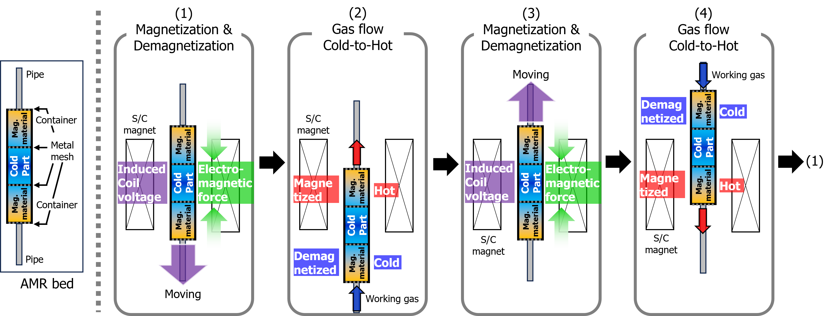
Fig. 1. AMR bed and Principle of refrigeration cycle for AMR.
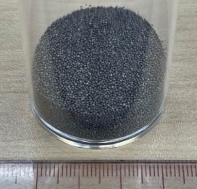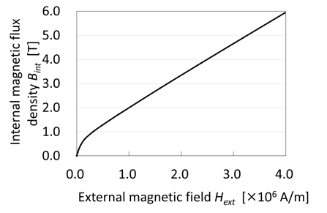
Fig. 2. HoAl₂ particles (diameter: 300-500 μm) and B-H curve calculated from the magnetic permeability of HoAl₂ at 25 K [12] (Fill rate: 61%).

A photograph and schematic diagram of the AMR apparatus we have developed are shown in Fig. 3. The AMR bed is made of stainless steel with an inner diameter of 34 mm and a length of 300 mm. They move 200 mm vertically and along the bore axis of the superconducting magnet by an actuator installed at the top of the vacuum chamber. Each container is filled with 250 g of HoAl₂ particles, corresponding to a volumetric filling rate of 61%. The heat exchange gas is pre-cooled by a single stage 20 K GM refrigerator through heat exchangers and supplied to the AMR bed at approximately 35 K. The gas flow direction is controlled by a valve system at room temperature to synchronize with the reciprocation of the actuator.
A photograph, a cross-section, and specifications of the superconducting magnet fabricated for the AMR experiments are shown in Fig. 4. The superconducting magnet consists of solenoids with 0.5 mm diameter NbTi wire. The main coil and sub coils were designed so that the magnetic field is larger than 5 T at the center of the superconducting magnet and less than 0.1 T at 200 mm from the center when the nominal current of 58 A is applied. Fig. 5 shows the magnetic field profile along the central axis of the magnet. The sub coils generate opposite direction magnetic field of the main coil.

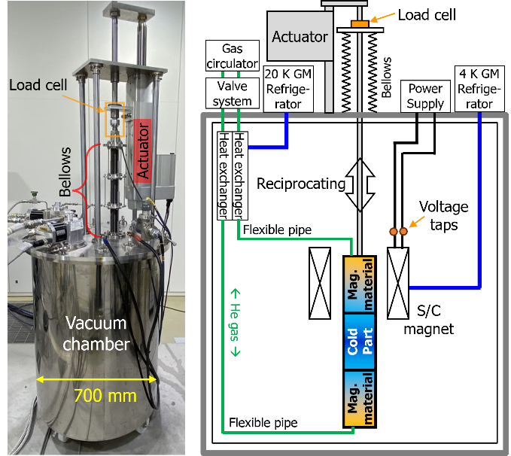
Fig. 3. Photograph and schematic diagram of developed experimental apparatus for AMR.

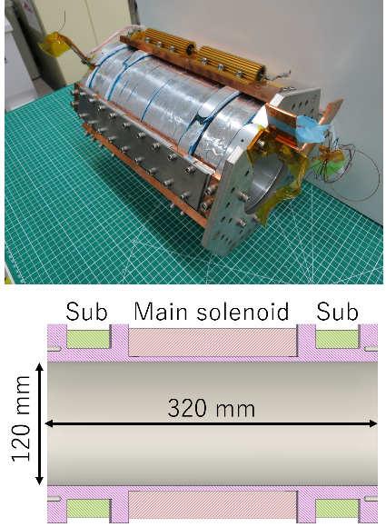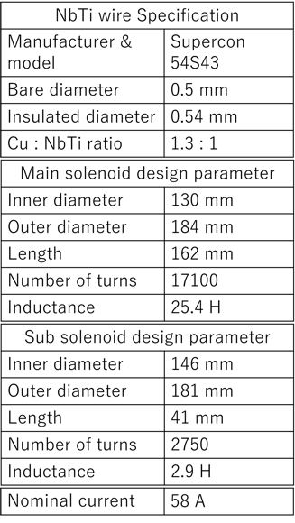
Fig. 4. Fabricated superconducting magnet for AMR. Photograph (left upper), cross section (left lower), and specifications of NbTi wire and solenoids (right).

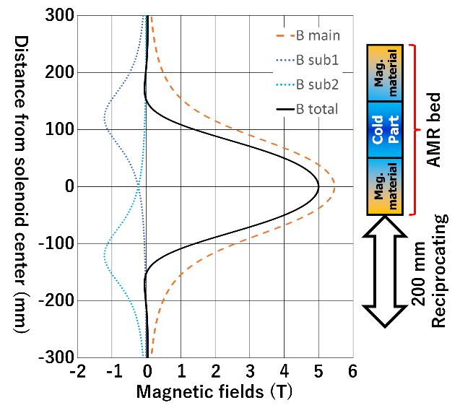
Fig. 5. Magnetic field profile along the central axis of the magnet and a schematic drawing of the reciprocating AMR bed position.

III. Calculation results
The induced voltage and the electromagnetic force generated in the superconducting magnet during the reciprocation of the AMR bed were calculated by simulating the operation of the developed AMR system. The calculation considered the B-H curve of the magnetic material shown in Fig. 2, the specification of the superconducting magnet and the AMR bed. A two-dimensional model of the cylindrical cross section is created and calculated using the finite element method with circumferential symmetry as the boundary condition. The coil protection circuit is assumed to be a 2-ohm resistor installed in parallel with the coil.
Figs. 6 and 7 show the calculated induced voltage and electromagnetic force when the AMR bed moves at 20 mm/s in a superconducting magnet operated at 5 T (58 A). This calculation assumes that the magnetic material HoAl₂ is evenly distributed in the container with the fill rate of 61%. In these figures, the AMR bed is stopped for 1.5 seconds at the beginning, turning point and end of each cycle, respectively, for a period of 24.5 seconds. The peak-to-peak value of the induced voltage is 0.21 V, and the peak-to-peak value of the electromagnetic force is 3.6 kN.

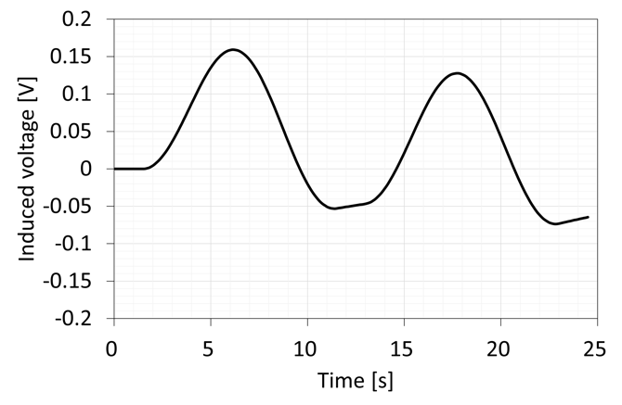
Fig. 6. Calculated induced coil voltage at 25 K and 5 T operation when AMR bed move at 20 mm/s.

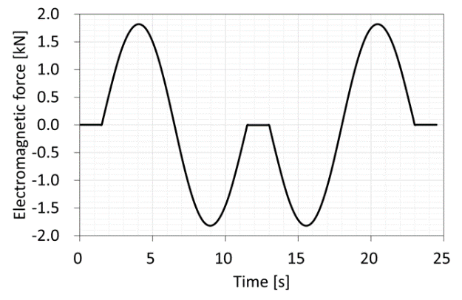
Fig. 7. Calculated electromagnetic force at 25 K and 5 T operation when AMR bed move at 20 mm/s.

IV. Experimental results
The induced voltage and electromagnetic force in the superconducting magnet during AMR operation at 25 K were measured. The induced voltages were measured by the voltage taps at both ends of the magnet. The electromagnetic force was measured by the load cell installed in the actuator shaft. These measurements were conducted in the range of 0-5 T of the magnetic field and 10-120 mm/s of the velocity of the AMR bed, as experimental parameters.
Fig. 8 shows the measured induced voltage in the magnet during one cycle of AMR operation when the moving velocity of the AMR bed is 20 mm/s. The difference in the values of the induced voltage between 1 and 5 T is small because the magnetization of the magnetic material is close to saturation. The peak-to-peak value of the induced voltage at 5 T is 0.32 V.
The measured peak-to-peak values of the induced voltage versus the velocity of the AMR bed are shown in Fig. 9. The dependence of the induced voltage on the velocity of the AMR bed is small. One possible cause of that is that the diodes installed in parallel with the coil for the magnet protection would be deteriorated somehow by magnet quenches which the magnet has experienced several times. This deteriorated protection circuit would make a kind of low-pass filter with the coil inductance and suppress the increase in induced voltage. To determine the cause, the delay time of the magnetic field with respect to the current value during magnet energization and the current-voltage characteristics of the protection circuit will be measured.
Fig. 10 shows the vertical force on the actuator load cell when the AMR bed moves at 20 mm/s. As shown in Fig. 1, since the axial direction of the electromagnetic force on the magnetic materials is in direction of the center of the superconducting magnet, the force on these two magnetic material containers is always in opposite directions each other. The load cell of the actuator measures the combined force applied to each container. The zero position is shifted to minus 0.5 kN due to the gravitational force associated with the weight of the AMR bed. The difference between the left and right peak values indicates hysteresis in the force applied to the load cell. Furthermore, this difference depends on the magnitude of the magnetic field. This hysteresis can be explained by the frictional force on the actuator shaft. Since the frictional force is always in the opposite direction of movement, the force applied to the load cell changes when the AMR bed is at the same point but moving in a different direction. Moreover, the center axis of the coil and the AMR bed cannot be perfectly aligned coaxially; therefore, AMR bed

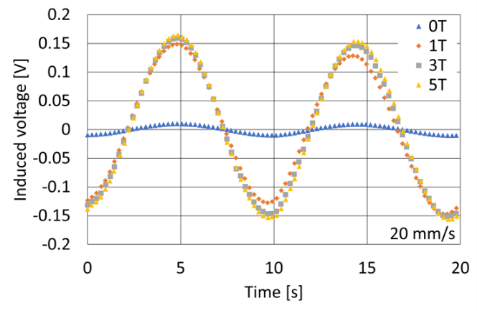
Fig. 8. Measured induced coil voltage at 25 K when AMR bed moves at 20 mm/s.

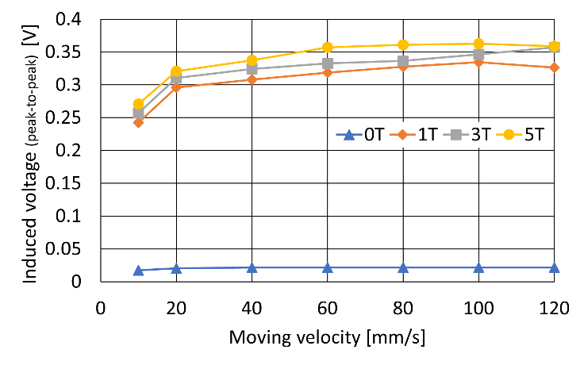
Fig. 9. Measured induced coil voltage (peak-to-peak) versus moving velocity of the AMR bed.
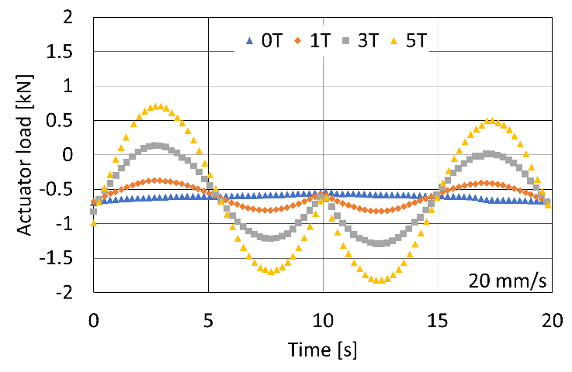
Fig. 10. Measured vertical force on actuator load cell when AMR bed moves at 20 mm/s.

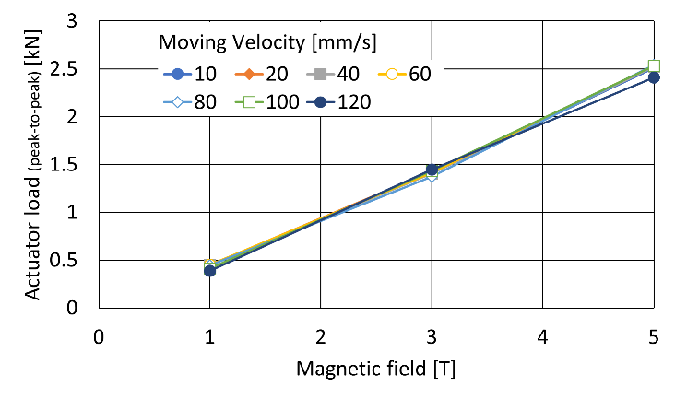
Fig. 11. Measured vertical force on actuator load cell (peak-to-peak) versus magnetic field.

is subjected to a horizontal force that depends on the amount of the displacement from the coil center and the coil current. This is why differences in peak values depending on the magnitude of the magnetic field are observed. The peak-to-peak value of the vertical force at 5 T is 2.5 kN. Fig. 11 shows the peak-to-peak values of the vertical force on the load cell of the actuator. The values do not depend on the moving speed of the AMR bed, but are proportional to the magnitude of the magnetic field, as we expected.

V. Summary
The electromagnetic force and the induced voltage in the superconducting magnet during AMR operation were measured and calculated. The measurements and calculations of the electromagnetic force is agreed qualitatively. The induced voltage measurements revealed a possibility that the diodes of the protection circuit deteriorated. This computational method is useful to design the AMR system including superconducting magnet, actuator, and the amount of magnetic material. The next step will be to calculate the horizontal forces between the AMR bed and the magnet and the heat generation due to AC losses to establish a design guideline for the AMR system.

References
- J. A. Barclay and W. A. Steyert, “Active magnetic regenerator”, U.S. Patent 4,332,135”, 1982.
- D.J. Janda, “Magnetic Liquefaction of Hydrogen”, Astronautics Corporation of America, Final Report to DOE on Contract No. DE-AC02-90CE40895, 1992.
- L. Zhang, S.A. Sherif, A.J. DeGregoria, C.B. Zimm, and T.N., Veziroglu, “Design optimization of a 0.1-ton/day active magnetic regenerative hydrogen liquefier”, Cryogenics, Vol. 40, Issues 4-5, pp. 269-278, April-May 2000, doi: 10.1016/S0011-2275(00)00039-4.
- J. Holladay, et al., “Investigation of bypass fluid flow in an active magnetic regenerative liquefier” Cryogenics, Vol. 93, pp. 34-40, July 2018, doi: 10.1016/j.cryogenics.2018.05.010.
- J. Barclay, et al., “Propane liquefaction with an active magnetic regenerative liquefier” Cryogenics, Vol. 100, pp. 69-76, June 2019. doi: 10.1016/j.cryogenics.2019.01.009.
- Y. Kim, I. Park, and S. Jeong, “Experimental investigation of two-stage active magnetic regenerative refrigerator operating between 77 K and 20 K” Cryogenics, Vol. 57, pp. 113-121, Oct. 2013, doi: 10.1016/j.cryogenics.2013.06.002.
- I. Park and S. Jeong, “Development of the active magnetic regenerative refrigerator operating between 77 K and 20 K with the conduction cooled high temperature superconducting magnet” Cryogenics, Vol. 88, pp. 106-115, Dec. 2017, doi: 10.1016/j.cryogenics.2017.09.008.
- K. Matsumoto, T. Kondo, S. Yoshida, K. Kamiya, and T. Numazawa, “Magnetic refrigerator for hydrogen liquefaction.” J. Phys: Conf. Ser., Vol. 150, 2009, Art. no. 012028, doi: 10.1088/1742-6596/150/1/012028. [Online]. Available: https://iopscience.iop.org/article/10.1088/1742-6596/150/1/012028/pdf.
- T. Numazawa, K. Kamya, T. Utaki, and K. Matsumoto, “Magnetic refrigerator for hydrogen liquefaction, Cryogenics, Vol. 62, pp. 185-192, July-Aug. 2014, doi: 10.1016/j.cryogenics.2014.03.016.
- K. Kamiya et al., “Active magnetic regenerative refrigeration using superconducting solenoid for hydrogen liquefaction” Appl. Phys. Express, Vol. 15, No. 5, April 2022, Art. no. 053001, doi: 10.35848/1882-0786/ac5723. [Online]. Available: https://iopscience.iop.org/article/10.35848/1882-0786/ac5723.
- T. Hashimoto et al., “Investigations on the Possibility of the RAl2 System as a Refrigerant in an Ericsson Type Magnetic Refrigerator”, Advances in Cryogenic Engineering Materials, vol 32, pp. 279-286, 1986. Doi: 10.1007/978-1-4613-9871-4_33.
- T. Yamamoto et al., “Magnetocaloric particles of the Laves phase compound HoAl₂ prepared by electrode induction melting gas atomization”, J. Magn. Magn. Mater., Vol. 547, April 2022, Art. No. 168906, doi: 10.1016/j.jmmm.2021.168906.

This work was supported in part by JST-Mirai Program under Grant JPMJMI18A3, (Corresponding author: Kyohei Natsume). Kyohei Natsume, Tsuyoshi Shirai, Akira Uchida, Gen Nishijima, Koji Kamiya, and Takenori Numazawa are with National Institute for Materials Science, Tsukuba, Ibaraki, Japan. (e-mail: natsume.kyohei@nims.go.jp). Yusuke Kimura, Yuki Emori, and Hiroshi Miyazaki are with Kyushu University, Fukuoka, Japan. Koichi Matsumoto is with Kanazawa University, Kanazawa, Japan. Color versions of one or more of the figures in this article are available online at http://ieeexplore.ieee.org

