Diamond MEMS magnetic Force sensor toward femtoNewton AT ROOM TEMPERATURE

Zilong Zhang¹, Zhijian Zhao¹, Meiyong Liao², Takahito Ono¹, and Masaya Toda¹
¹Tohoku University, JAPAN and
²National Institute for Materials Science, JAPAN

Abstract
This paper presents a pioneering smart magnetic force sensor that combines a single-crystal diamond (SCD) MEMS resonator with a permanent magnetic particle through magnetic field gradient effect, enabling detection of ultraweak magnetic forces down to the femtonewton (fN) range. The sensor exhibits exceptional sensitivity of 7.15×10³ ppm/(mT/mm) and low frequency fluctuation of 8.95×10⁻⁵ Hz, along with a rapid response time of 12.5 ms, making it suitable for high-precision measurements. Its design and functionality make it well-suited for diverse applications, from ultra-sensitive magnetic detection to innovative applications in miniaturized sensing systems.

KEYWORDS
Single crystal diamond, Micro-electromechanical systems (MEMS), Permanent magnetic particle, Magnetic sensor
Introduction
Magnetic force sensors play an essential role in various applications, including industrial automation, biomedical diagnostics, and environmental monitoring [1]. Current weak-force magnetic sensors, such as superconducting quantum interference device (SQUID), fluxgate, magneto-resistive, and nitrogen-vacancy sensors, face significant challenges. For the fluxgate sensors, magnetoresistance sensors, and Hall sensors, there are restrictions on sensitivity and spatial resolution [2, 3]. Another highly sensitive magnetic sensor, known as SQUID, is extensively utilized in detecting biomagnetic signals from human organs. But the SQUID requires the cryogenic cooling with complex equipment and is susceptible to electromagnetic interference [4]. For NV sensors, they can achieve high sensitivity of aN/Hz^{1/2} level. But they are difficult to control and integrate with other electronics [5, 6]. Thus, the application of magnetic sensors in weak-force is limited by the sensitivity, low response speed, high cost and the demand of a special environment for the procedure.
MEMS (micro-electromechanical systems) magnetic force sensors are particularly promising due to their miniaturization, low power consumption, and high sensitivity. These sensors are capable of detecting subtle magnetic forces, making them valuable for precision measurements in challenging environments [7]. Diamond, as a unique material for MEMS devices, has gained attention due to its exceptional properties, including high thermal conductivity, chemical stability, and biocompatibility. These attributes make diamond an ideal substrate for magnetic force sensors, as it enhances durability and reliability in extreme environments [8, 9]. Neodymium-Iron-Boron (NdFeB) particles offer a combination of high magnetic energy density, strong coercivity, excellent remanence, and temperature stability, making them ideal for high-performance MEMS magnetic sensors requiring stable magnetic fields. The magnetic field gradient effect, where the interaction exists between a magnetic moment in a material and an external magnetic field, is particularly well-suited for high-frequency operations and is highly sensitive to small magnetic force.
In this work, we present a novel magnetic force sensor that combines diamond MEMS with NdFeB magnetic particles. Our approach leverages the inherent advantages of diamond MEMS and the magnetic interactions of NdFeB particles to enhance the sensor's magnetic force response. We demonstrate the sensor's performance in terms of sensitivity and stability, evaluating its potential for applications that demand reliable, high-resolution magnetic force sensing.
DEVICE CONCEPUTATION
The magnetic force sensor is configured by coupling an SCD MEMS cantilever with an NdFeB particle, as illustrated in Fig. 1(a). For a one-clamped rectangular microresonator without external force, the resonance frequency mode can be expressed as,
F = (k₀t/L²)(E/ρ)^{1/2} (1)
wherein k₀ are 0.162 and 1.013 in the first and the second vibration modes, respectively. E and ρ are the effective Young’s modulus and the effective mass density of the cantilever, respectively. t and L are the thickness and the length of the cantilever, respectively. Alternatively, the minimum detectable force of the resonator limited by the thermomechanical noise also is given as [10, 11],
F_{min} = t(w/(lQ))^{1/2}(Eρ)^{1/4}(k_{B}TB)^{1/2} (2)
Wherein the k_{B}, T and B are the Boltzmann constant, temperature, and bandwidth, respectively. The magnetic sensing mechanism is based on the interaction between a magnetic particle mounted on the tip of a cantilever and an external magnetic field perpendicular to the cantilever’s plane, as shown in Fig. 1(b). The magnetic force acting on the particle can be described as follows [12, 13],
F = m_{z}(∂B/∂z) (3)
where the particle has a magnetic moment, aligned with a various magnetic field. The magnetic moment, m_{z}, a vector representing the magnetization M of the particle, can be determined by multiplying the particle's magnetization by its volume V. This relationship is expressed in the following equation: m_{z}=MV. Then, the magnetic force gradient can be expressed,
F’_{z} = m_{z}(∂²B/∂²z) (4)
The presence of a derivative force F’_{z} can tune the effective spring constant k_{eff} of a cantilever according to the following equation, k_{eff}=k-F’_{z}. Then, the resonance frequency shift, Δf of the NdFeB/SCD sensor due to the the magnetic force is given as,
Δf = f - f₀ = f₀(1-F’_{z}/2k)-f₀ = -f₀F’_{z}/2k (5)
Thus, the magnetic sensitivity is characterized as the resonance shift of the sensor response to varying magnetic field gradient. The SCD-based MEMS resonator based on the magnetic field gradient effect provides a promising system for magnetic force sensor with high-sensitivity and high reliability.
Fig. 1 (a) Optical image of the single crystal diamond (SCD) force sensor. (b) Schematic image of measurement setup of the magnetic force sensor. (c) Magnetic force sensing mechanism of the magnetic force sensor.

Experimental
In this work, the SCD microresonator was fabricated using the smart-cut technique, which was described in detail in our pervious works [8, 9]. In order to improve the Q factors of as-fabricated SCD microresonator, the oxygen etching was employed to effectively remove defective surface layers, including non-diamond and other imperfections [14]. These surface imperfections had a significant impact on the resonator’s performance. Following this treatment, the resonators were annealed again at 650°C for 10 hours in an oxygen environment to further improve Q-factors. The magnetic force sensor is configured by coupling an SCD MEMS resonator with an NdFeB particle. Then, through an optical microscope, a glass needle controlled by a micromanipulator is utilized to pick up a 14.5 μm-diameter Nd-Fe-B magnetic particle to SCD cantilever. The magnetic particle is precisely and stalely transferred via this non-destructive transfer method, and fixed with small amount of conductive glue. The sample was heated up to 180ºC to fix the magnetic particle on SCD cantilever. The Nd-Fe-B magnetic particle was magnetized by an application of 694 mT magnetic field. To assess the out-of-plane resonance performance of the SCD cantilever, both with and without a magnetic particle, an optical setup based on the Doppler effect was employed, as illustrated in Fig. 1(c). This setup used a focused He-Ne laser (633 nm, <1mW) directed vertically onto the substrate. A lock-in amplifier was used to capture the resonance signal. All experiments were conducted in a vacuum chamber with a pressure below 10⁻² Pa. The resonators were driven by a lead zirconate titanate (PZT) actuator. For magnetic sensing measurements, magnetic field gradients were applied using a coil connected to a DC power source.

Magnetic Force sensing
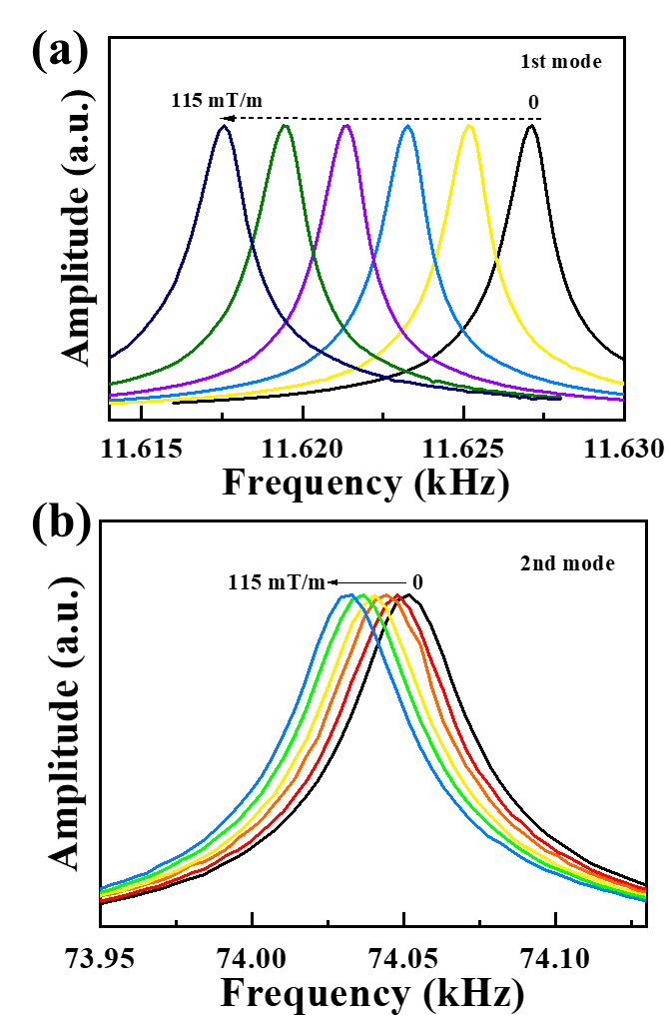
Fig. 2. Resonance spectra shift of the 1st mode (a) and the 2nd mode (b) of the SCD magnetic force sensor upon various magnetic field gradients.

The resonance frequency spectra of the 1st mode and the 2nd mode of the magnetic force sensor shift toward low frequencies under various magnetic field gradients, which are shown in Fig.2. The amplitudes of the spectra are normalized. The resonance frequencies and Q factors of the 1st mode and the 2nd mode without applying magnetic field gradient are 11627 Hz and 88306, and 740 Hz and 2000, respectively. Based on the equ. (2), the theoretical minimum detectable force (per unit bandwidth) of the 1st mode and the 2nd mode of the magnetic force sensor are 3.28×10⁻¹⁶ N/Hz^{1/2} and 1.69×10⁻¹⁵ N/Hz^{1/2}. In addition, the magnetic sensitivity of the sensor was defined as two expressions as |Δf/∂B/∂z| and |Δf/(f₀∂B/∂z)|, respectively. f₀ is the resonance frequency of sensor under no magnetic field gradient. Through the resonance spectra shifts in Fig. 2, the magnetic sensitivities of the 1st mode and the 2nd mode of magnetic force sensor are evaluated in Fig. 3. It can be seen that the absolute of resonance frequency shifts linearly increase with magnetic field gradients. For the first expression, the magnetic sensitivity of the 1st mode is 8.31×10¹ Hz/(mT/mm), which is lower than that of the 2nd mode of 1.70×10² Hz/(mT/mm). Otherwise, the magnetic sensitivity of the 1st mode is 7.15×10³ ppm/(mT/mm) is higher than that of the 2nd mode of 2.30×10³ ppm/(mT/mm) from the second expression. To some extent, the magnetic sensitivity of the magnetic force sensor cannot be enhanced by the 2nd mode.
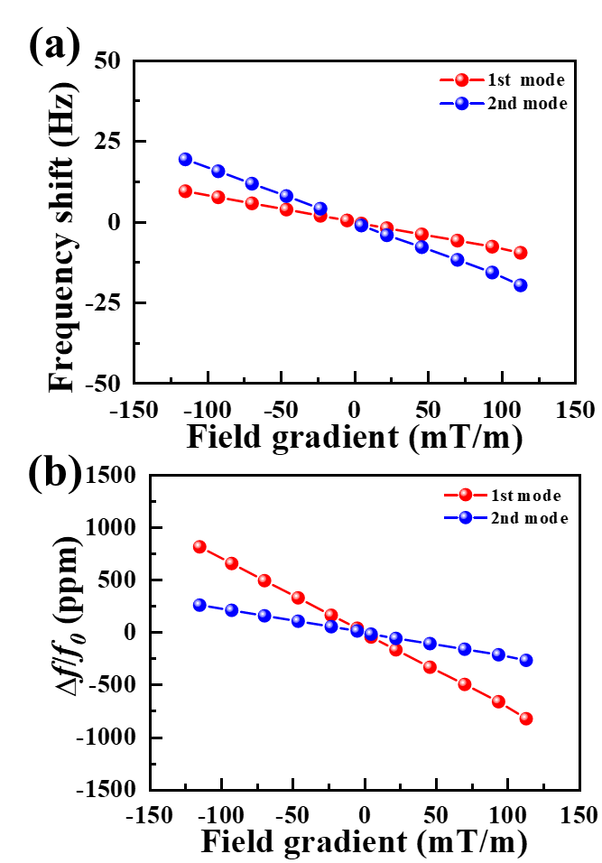
Fig. 3. Resonance frequency shift of the 1st mode (a) and the 2nd mode (b) of the SCD magnetic force sensor upon various magnetic field gradients.

In sensing applications, the smallest detectable frequency shift, Δf_{min}, depends on the accuracy of the resonance frequency measurement system. Therefore, identifying and quantifying any noise that affects the frequency stability of the resonator is essential for sensor design [15]. In this work, the Allan deviation, determined by the thermomechanical noise, is utilized the quantify the frequency stability [15, 16]. The Allan deviation of the 1st mode and the 2nd mode of the magnetic sensor force sensor are displayed in Fig. 4. It can be obtained that the Δf_{min} of the 1st mode and the 2nd mode are 8.95×10⁻⁵ Hz and 4.14×10⁻³ Hz. Based on the magnetic sensitivity expressed by the first expression, the minimum value of the sensor can achieve 1.08×10⁻⁶ mT/mm and 2.43×10⁻⁵ mT/mm for the 1st mode and the 2nd mode, respectively. In addition, according to the equation (3), the minimum detectable forces of the magnetic force sensor are 6.73×10⁻¹⁵ N and 1.52×10⁻¹³ N for the 1st mode and the 2nd mode at room temperature, respectively. For the magnetic force sensor consisting of a SCD cantilever coupling with a magnetic particle, the 1st mode is in favor of achieving minimum frequency shift and high detectable force level. Alternatively, the response time of the sensor in the 1st mode is examined, as shown in Fig. 5. It exhibits the sensor showcases the response time of 12.5 ms.
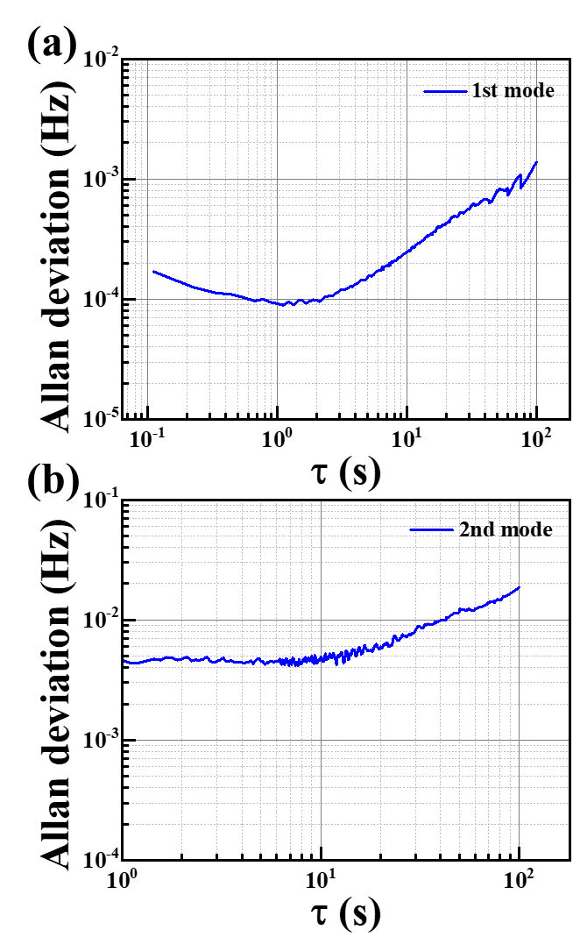
Fig. 4. Allan deviation of the 1st mode (a) and the 2nd mode (b) of the SCD magnetic force sensor

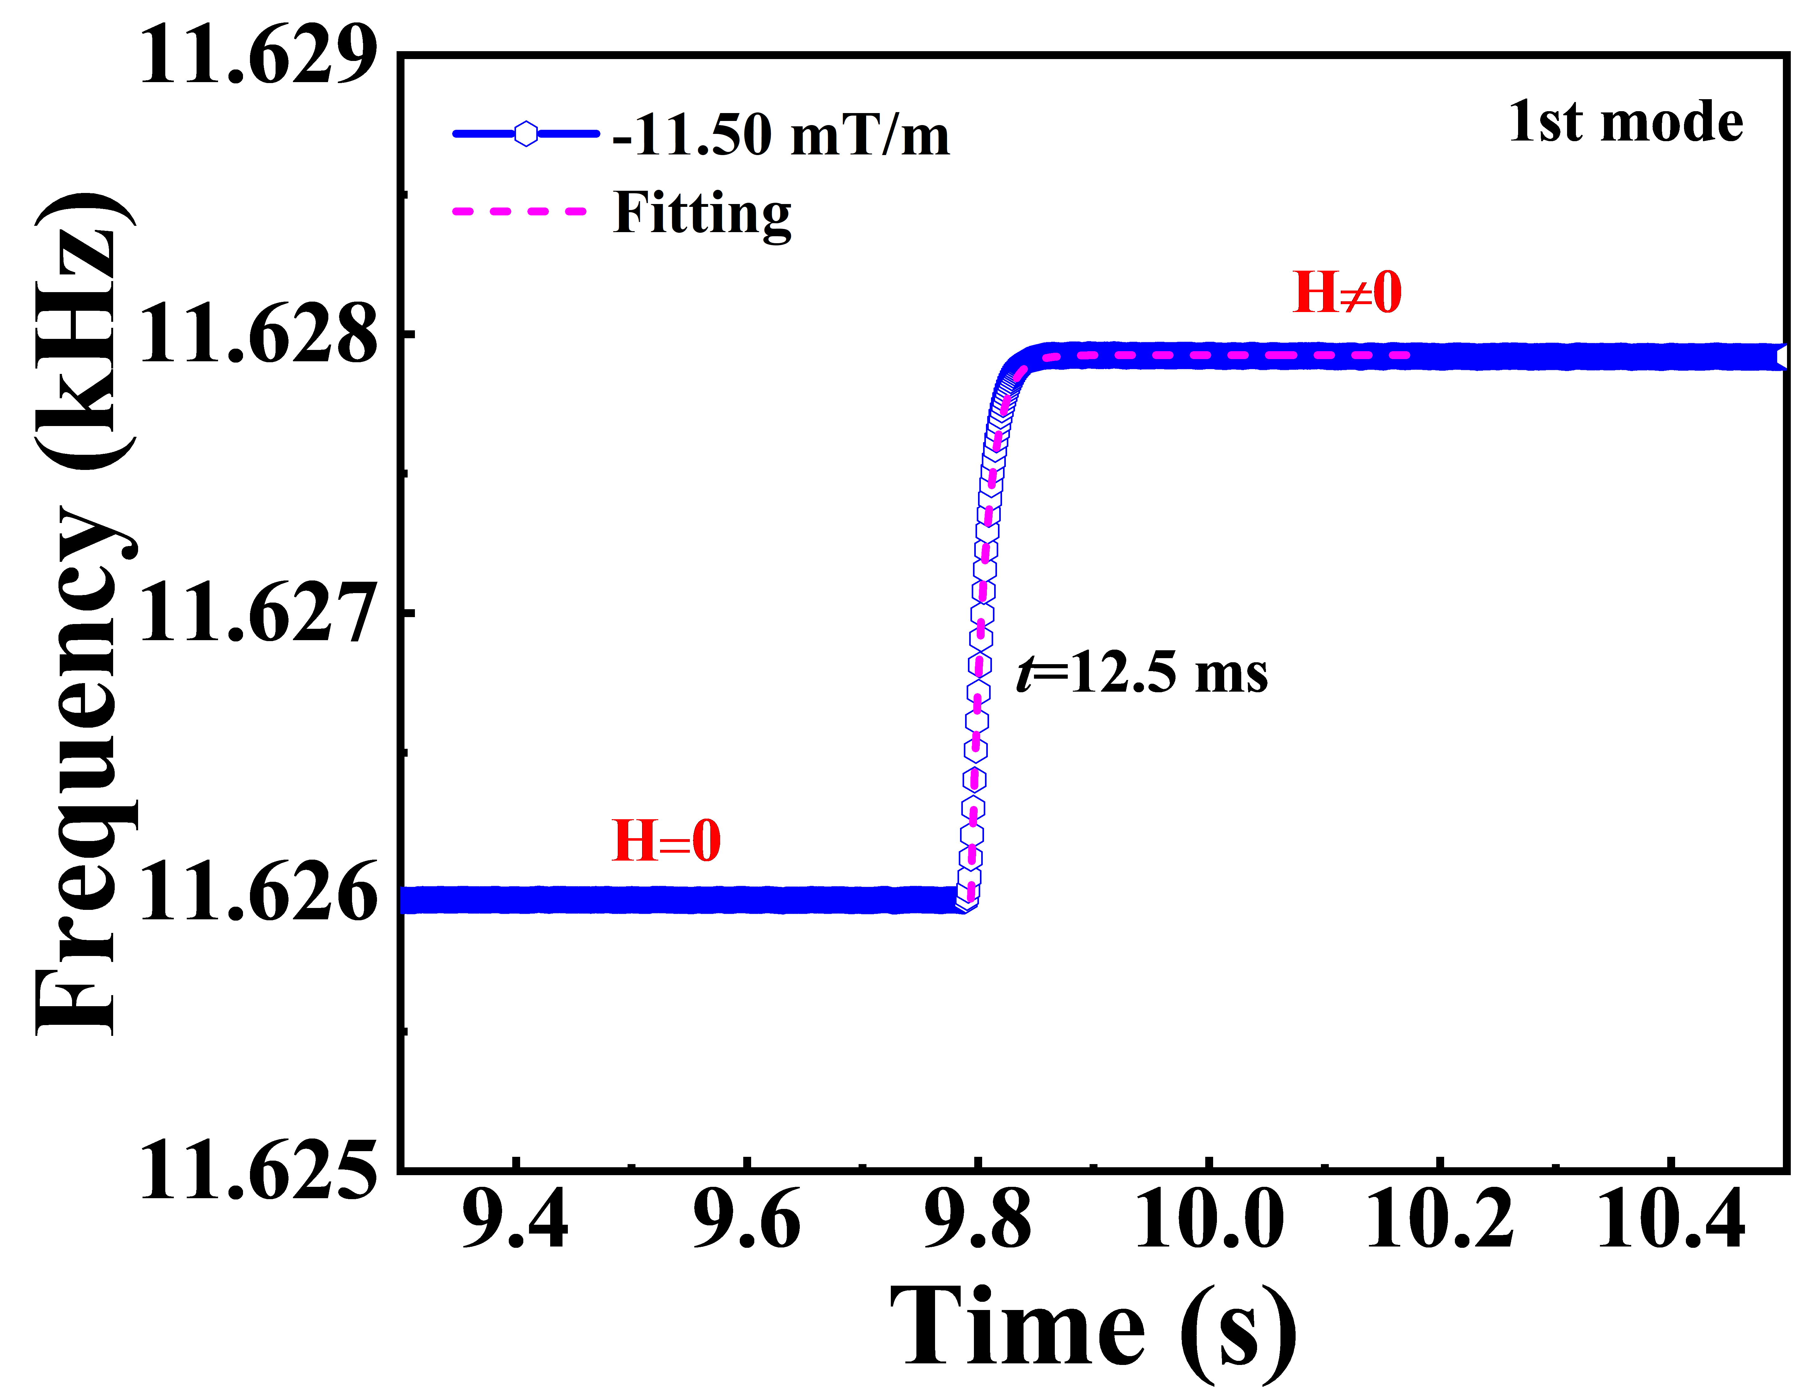
Fig. 5. Recompose time of the 1st mode of the SCD magnetic force sensor under the magnetic field gradients of -11.50 mT/m.
CONCLUSION
In summary, for the first time we developed a high-performance magnetic force sensor through the integration of a SCD MEMS cantilever with a NdFeB permeant particle. The sensing performances of two vibration modes are examined, exhibiting the magnetic sensitivity of 7.15×10³ ppm/(mT/mm) and 2.30×10³ ppm/(mT/mm) of the 1st mode and the 2nd mode, respectively. The minimum detectable frequency fluctuations of the sensor can achieve 8.95×10⁻⁵ Hz and 4.14×10⁻³ Hz, respectively, corresponding to a minimum detectable field gradient of 1.08×10⁻⁶ mT/mm and 2.43×10⁻⁵ mT/mm, respectively. Furthermore, the sensor realized a minimum force level of 6.73×10⁻¹⁵ N and 1.52×10⁻¹³ N for the 1st mode and the 2nd mode. The 1st mode of the SCD-based sensor is in in favor of achieving high detectable force level. The response time 1st mode to the magnetic field gradient showcases a level of 12.5 ms. The SCD MEMS-based magnetic force sensor demonstrates significant potential for future use in highly integrated, multifunctional, and compact sensing applications.

ACKNOWLEDGEMENTS
The authors greatly thanked Dr. Meiyong Liao (NIMS) for his help in offering the diamond MEMS cantilevers. This work was partially supported by a Grant-in-Aid of JSPS KAKENHI (Grant Number 24H00287, 22K18957, and 24K00828), Tsukuba Global Innovation Promotion Agency and Nanotechnology Platform projects sponsored by the Ministry of Education, Culture, Sports, and Technology (MEXT) of Japan.

REFERENCES

[1] Y. Wang, J. Li, and D. Viehland, "Magnetoelectrics for magnetic sensor applications: status, challenges and perspectives," Mater. Today, vol. 17, no. 6, pp. 269-275, 2014.
[2] C. Lei, J. Lei, Z. Yang, T. Wang, and Y. Zhou, "A low power micro fluxgate sensor with improved magnetic core," Microsyst. Technol., vol. 19, no. 4, pp. 591-598, 2013.
[3] A. L. Herrera-May, J. C. Soler-Balcazar, H. Vázquez-Leal, J. Martínez-Castillo, M. O. Vigueras-Zuñiga, and L. A. Aguilera-Cortés, "Recent advances of MEMS resonators for Lorentz force based magnetic field sensors: design, applications and challenges," Sensors, vol. 16, no. 9, p. 1359, 2016.
[4] M. Sekino et al., "Handheld magnetic probe with permanent magnet and Hall sensor for identifying sentinel lymph nodes in breast cancer patients," Sci. Rep., vol. 8, no. 1, pp. 1-9, 2018.
[5] F. Casola, T. Van Der Sar, and A. Yacoby, "Probing condensed matter physics with magnetometry based on nitrogen-vacancy centres in diamond," Nat. Rev. Mater., vol. 3, no. 1, pp. 1-13, 2018.
[6] J. L. Webb et al., "Optimization of a diamond nitrogen vacancy centre magnetometer for sensing of biological signals," Front. Phys., vol. 8, p. 522536, 2020.
[7] K. Zhu and A. Kiourti, "A review of magnetic field emissions from the human body: Sources, sensors, and uses," IEEE Open J. Antennas Propag., vol. 3, pp. 732-744, 2022.
[8] Z. Zhang et al., "Enhancing delta E effect at high temperatures of Galfenol/Ti/single-crystal diamond resonators for magnetic sensing," ACS Appl. Mater. Interfaces., vol. 12, no. 20, pp. 23155-23164, 2020.
[9] Z. Zhang et al., "Single-crystal diamond microelectromechanical resonator integrated with a magneto-strictive galfenol film for magnetic sensing," Carbon, vol. 152, pp. 788-795, 2019.
[10] Y. Tao, J. M. Boss, B. Moores, and C. L. Degen, "Single-crystal diamond nanomechanical resonators with quality factors exceeding one million," Nat. Commun., vol. 5, no. 1, p. 3638, 2014.
[11] S. Castelletto, L. Rosa, J. Blackledge, M. Z. Al Abri, and A. Boretti, "Advances in diamond nanofabrication for ultrasensitive devices," Microsyst. Nanoeng., vol. 3, no. 1, pp. 1-16, 2017.
[12] T. Ono and M. Esashi, "Magnetic force and optical force sensing with ultrathin silicon resonator," Rev. Sci. Instrum., vol. 74, no. 12, pp. 5141-5146, 2003.
[13] M. Toda and T. Ono, "Three-dimensional imaging of electron spin resonance-magnetic resonance force microscopy at room temperature," J. Magn. Reson., vol. 330, p. 107045, 2021.
[14] Z. Zhang, G. Chen, K. Gu, S. Koizumi, and M. Liao, "Effect of defects on Q factors of single-crystal diamond MEMS resonators," Functional Diamond, vol. 3, no. 1, p. 2221280, 2023.
[15] M. Sansa et al., "Frequency fluctuations in silicon nanoresonators," Nat. Nanotechnol., vol. 11, no. 6, pp. 552-558, 2016.
[16] P. Sadeghi, A. Demir, L. G. Villanueva, H. Kähler, and S. Schmid, "Frequency fluctuations in nanomechanical silicon nitride string resonators," Phys. Rev. B, vol. 102, no. 21, p. 214106, 2020.

CONTACT
* Masaya Toda, tel: +86-022-795-5806; toda@tohoku.ac.jp

