On-surface smooth polymerization of 5,11-bianthryl-anthradithiophene
Shoma Kasahara,^{1,3,5} Manabu Ohtomo,^{*,2,5} Ryunosuke Hayashi,¹ Naoki Fushimi,² Junichi Yamaguchi,² Kyohei Matsuo,^{1,3} Naoki Aratani,¹ Shintaro Sato,^{*,2} Hironobu Hayashi,^{*,1,4} and Hiroko Yamada^{*,1,3}
¹Division of Materials Science, Nara Institute of Science and Technology, 8916-5 Takayama-cho, Ikoma, Nara 630-0192, Japan
²Fujitsu Research, Fujitsu Ltd., 10-1 Morinosato-Wakamiya, Atsugi, Kanagawa 243-0197, Japan
³Present address: Institute for Chemical Research, Kyoto University, Uji, Kyoto 611-0011, Japan
⁴Present address: Center for Basic Research on Materials, National Institute for Materials Science (NIMS), 1-2-1 Sengen, Tsukuba, Ibaraki 305-0047, Japan
⁵These authors contributed equally.
E-mail: HAYASHI.Hironobu@nims.go.jp (H.H.), ohtomo.manabu@fujitsu.com (M.O.), sato.shintaro@fujitsu.com (S.S.), and hyamada@scl.kyoto-u.ac.jp (H.Y.)

An anthracene trimer comprising an anthradithiophene central unit has been successfully synthesized, and its structure was confirmed by single-crystal X-ray analysis. The surface-assisted reaction of the trimer on Au(111) under ultra-high vacuum conditions provided a long 5,11-bianthryl-anthradithiophene polymer with its length of more than 90 nm, owing to the efficient diffusion of the trimer on the Au(111) surface.
Keywords: On-surface synthesis, Anthracene, Polymer

The surface-assisted on-surface reaction is gaining significant interest as a powerful approach to obtaining nanocarbon materials.^{1–3} One of the attractive features of on-surface synthesis is that the precursor molecular design potentially defines the ultimate nanocarbon structure with atomic-level precision. So far, numerous nanocarbon materials such as polyacenes,^{4–8} two-dimensional polymers^{9–12}, and graphene nanoribbons (GNRs)^{12–17} were synthesized via surface-assisted reactions.
The surface-assisted reaction does not encounter solubility issues, which is often an important issue in solution-based organic chemistry.¹⁶ Alternatively, the diffusion of molecules on metal surfaces, such as Au(111), Ag(111), and Cu(111), during polymerization is crucial for obtaining long nanostructures. Sufficiently-long nanocarbon materials are required for the application in semiconducting devices. For example, although field-effect transistors of GNRs obtained by on-surface synthesis were reported, the length of GNRs was required to be improved.^{18,19} Hence, the study of the relationship between growth mechanism and precursor structure is important. The reaction mechanism of the surface-assisted reaction is as follows. First, halogenated small organic molecules, which are precursors of a target nanocarbon material, are sublimated on Au(111) surface. Then, the thermally induced dehalogenation occurs, creating biradical species. The resulting biradical species undergo polymerization to form a linear polymer on the metal surface. Here, if the precursors possess a flat structure, they are strongly adsorbed onto the substrate after deposition.¹⁶ In addition, after thermally-induced dehalogenation, the resulting biradical species often form Au-precursor organometallic complexes.^{20,21} Eventually, inefficient polymerization occurs because of the limited diffusion of precursors on the substrate. This issue can be overcome by using precursors with a cross-shaped structure.¹⁶ The appropriate distance between radical sites and the metal surface allows for an unhindered approach of the two radical species at the polymerization step, owing to the reduced interaction between the radical site and the Au(111) surface. Thus, the precursor design, where the radical moiety is considered, evidently plays an important role in synthesizing nanocarbon materials with sufficiently-long lengths.
Among the precursors for on-surface synthesis of nanocarbon materials, halogenated anthracene-based compounds are one of the most widely studied precursors because the subsequent intramolecular cyclodehydrogenation of the resulting polymer potentially generates GNRs. Interestingly, even such simple anthracene-based precursors have demonstrated variable reactivities, reflecting the nature of surface-assisted reactions.^{15,16,22–25} Therefore, understanding the relationship between the precursor structure and polymer formation is essential to synthesizing GNRs and a wide range of nanocarbon materials.
Herein, we designed an anthracene trimer comprising an anthradithiophene central unit (5,11-bis(10-bromoanthracen-9-yl)anthra[2,3-b:7,6-b′]dithiophene, BANAT) (Figure 1). In the previous report, BABAT (5-bromo-11(10-bromoanthracen-9-yl)anthra[2,3-b:7,6-b′]dithiophene) with its isomers, which are dimer counterparts of BANAT, were found to form intramolecular C–C bonding instead of anthracene polymers after annealing at 200 ºC on Au(111).²⁶ This means that BABAT exhibits a particular reactivity on Au(111), even though BABAT possesses a similar structure with the conventional DBBA (10,10′-dibromo-9,9′-bianthryl), where edges of one of the anthracene moieties of DBBA were fused with thiophene rings (Supporting Information (SI), Figure S1). First-principle density functional theory (DFT) revealed that the thiophene functionalization modified the distribution of electron density in BABAT radicals and facilitated electrophilic addition, leading to the intramolecular C–C bonding after annealing at 200 ºC.²⁶

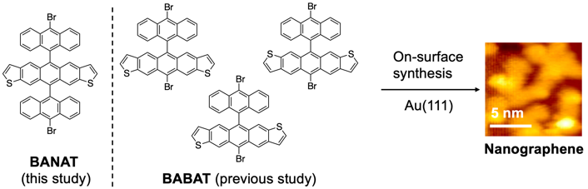
Figure 1. The chemical structures of BANAT and BABAT. STM image of nanographene synthesized from BABAT is also shown.²⁶
Here, BANAT was expected to undergo a similar polymerization process with DBBA because the radical would be generated at 10,10′-positions after debromination as seen in the case of anthracene-based trimer,^{25,27,33} providing the corresponding polymer instead of nanographene. The synthesis of BANAT was started from the reaction between isomerically pure anthra[2,3-b:7,6-b′]dithiophene-5,11-dione (1)^{28,29} and 9,10-dibromoanthracene (2)³⁰ to give intermediate diol compound 3 (Scheme 1). It should be noted here that the purification at this stage was important because the low solubility of BANAT would cause difficulty in its purification. Subsequent reductive aromatization of the diol intermediate 3 with NaI and NaH₂PO₂ afforded BANAT as a red solid in 10% yield (2 steps). Repetitive recrystallization of BANAT was performed to remove impurities, with no detectable traces of contaminations in ¹H NMR spectroscopy and high-resolution mass spectrometry. Specifically, monobrominated species should be completely removed at this stage because it could prevent the linear polymer from the elongation (SI).³⁰ Consequently, the purification process resulted in a relatively low isolated yield of BANAT.
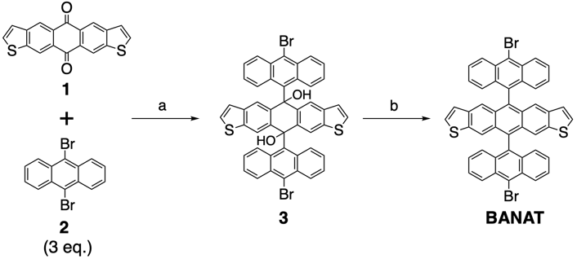
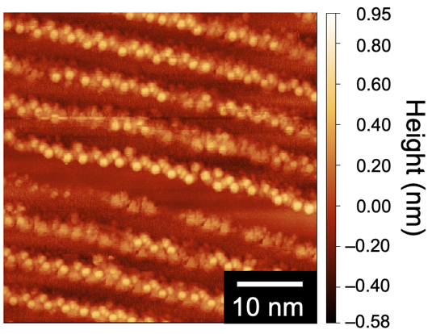
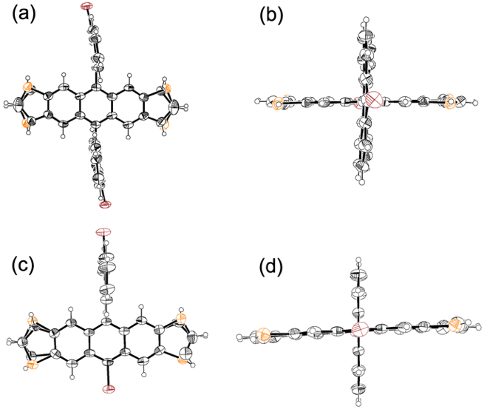
Scheme 1. Synthesis of BANAT. Reaction conditions: a) nBuLi (1 eq.), diethylether, at –15 °C, 2 h; (b) NaI, NaH₂PO₂, AcOH, reflux, 2 h, 10% (2 steps).

Figure 2. Single-crystal X-ray structures of (a) BANAT (top view), (b) BANAT (side view), (c) BABAT (top view) and (d) BABAT (side view) with 50% thermal ellipsoids. The solvent molecules were removed for clarity in panels a and b.
The solid-state structure of BANAT was confirmed by single-crystal X-ray analysis (Figures 2a and 2b, and SI).³¹ Red crystals of BANAT suitable for X-ray diffraction were obtained by slow evaporation of 2-propanol vapor into a chloroform solution of BANAT. BANAT molecules show pseudo-inversion symmetry owing to the random orientation in the packing, resulting in the disorder of thiophene rings. Importantly, BANAT has a cross-shaped structure essential for efficient radical step-growth polymerization on Au(111).
At the same time, we succeeded in obtaining single crystals of BABAT by slow evaporation of 2-propanol vapor into a chloroform solution of BABAT (Figures 2c and 2d, and SI).³² Thiophene moieties of BABAT are also disordering because it was prepared as inseparable mixtures of isomers, while the shape of BABAT resembles DBBA. The X-ray analysis indicated that the crystal roughly included the isomers as follows: both sulfur atoms are directing outside (50%), both sulfur atoms are directing inside (5%), and one of the sulfur atoms is directing outside (45%).
Surface-assisted polymerization was carried out under ultra-high vacuum (UHV) conditions at a base pressure of 2 × 10^{–8} Pa. The surfaces of Au(111)/mica substrates (Phasis, Switzerland) were cleaned by repeated cycles of 0.7 kV Ar⁺ sputtering and annealing at 450 ºC. BANAT molecules were sublimated from a Ta crucible held at ca. 370 ºC onto the Au(111) surface held at room temperature or 200 ºC.
Firstly, when BANAT molecules were deposited on Au(111) surface held at room temperature, aligned periodic protrusions were observed (Figure 3). The distance between two bright protrusions at the edge in these species is measured to be ca. 2.6–2.8 nm (Figure S2). Importantly, this value is evidently larger than the one of poly-BANAT (vide infra). Considering that the debromination of precursors unlikely took place on Au(111) held at room temperature, we judged that these aligned periodic protrusions were most probably assigned to be one-dimensional self-assembly of intact BANAT molecules.

Figure 3. STM topographic image (V_{s} = –1.5 V, I_{t} = 20 pA) of self-assembled structure of BANAT on Au(111). The STM image was taken at 77 K. The area, where stretched features by piezo creep were observed, was cut from the image.

Next, a large-scale scanning tunneling microscopy (STM) image after depositing BANAT on Au(111) held at 200 ºC was shown in Figure 4a. The formation of bright aligned periodic protrusions was observed in a magnified STM image (Figure 4b), which was attributed to the out-of-plane conformation of their anthryl and anthradithiophene moieties on Au(111). Note that thermal fluctuation lowered the resolution of STM images. In the case of anthracene-based precursors, the debromination of precursors and the subsequent formation of linear polymers occur on Au(111) at 200 ºC,^{33,34} maintaining the thiophene rings at this annealing temperature.²⁶ These results indicate that the bright aligned periodic protrusions could be assigned as poly-BANAT (Figure 4d).
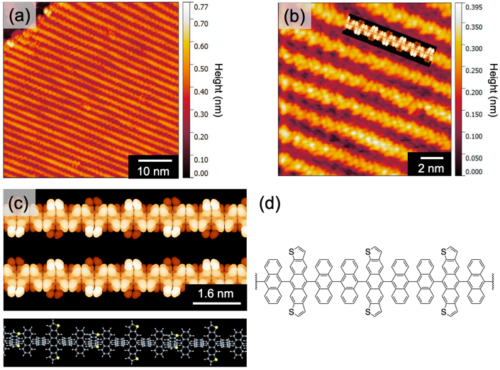
Figure 4. (a) Large-scale STM topographic image (V_{s} = –1.5 V, I_{t} = 20 pA) (b) Small-scale STM topographic image (V_{s} = –1.5 V, I_{t} = 20 pA) of BANAT deposited Au(111) surface. DFT-simulated image of poly-BANAT is overlaid in (b) as a guide to the eye. (c) DFT-simulated image of poly-BANAT by using Tersoff-Hamann approximation (top), and theoretical model of poly-BANAT (bottom). (d) Representative chemical structure of poly-BANAT. All STM images were taken at 77 K.

The STM image of poly-BANAT on Au(111) was simulated by the Tersoff-Hamann approximation (Figure 4c).³⁵ The performed simulations model is a representative structure of poly-BANAT, with the actual structure potentially possessing the randomly oriented anthradithiophene units. The direction of anthradithiophene units has no significant effect on the simulated image. The theoretical prediction indicates the aligned periodic protrusions which are attributed to the out-of-plane conformation of anthryl/anthradithiophene moieties, which could be observed in Figure 4. Here, the distance between neighboring anthradithiophene moieties in poly-BANAT is estimated to be ca. 1.2–1.3 nm by the theoretical prediction together with the X-ray single crystal analysis. Note that the theoretical prediction reflects the electron density of poly-BANAT without the interaction between a STM tip and poly-BANAT. Additionally, the anthradithiophene moiety is larger than the anthryl moiety, resulting in the fact that the bright protrusion for the edge of anthradithiophene moiety is more clearly visible compared with the one of the anthryl moiety. Considering these factors, the edge of the anthradithiophene moiety is expected to be observed at 1.2–1.3 nm spacing in the STM image. Indeed, the distance between two bright protrusions at the edge in the aligned periodic protrusions is roughly calculated to be 1.2–1.4 nm (Figure S2). The value is in good agreement with the distance between neighboring anthradithiophene moieties in poly-BANAT, although the resolution of STM images is insufficient. Here, the distance between anthradithiophene moieties should be much longer than 1.2–1.3 nm in the case of non-covalent assembly of dibrominated precursors due to the repulsion between molecules. Indeed, the self-assembled structure of BANAT molecules exhibited the longer distance (ca. 2.6–2.8 nm) between two bright protrusions at the edge (Figure 3), compared with the case of poly-BANAT. Moreover, CH–Br interactions, which are crucial for the construction of self-assemble structure, are missing in this case (vide supra). Thus, the possibility of non-covalent self-assembly could be excluded. We believe that these results complementarily support the formation of poly-BANAT.
The biradical formation at 10,10′′-positions of anthracene units in BANAT successfully leads to the polymer formation. This result indicates the importance of the design of radical moiety. More interestingly, the dehalogenation of BANAT, followed by the polymerization of resulting radical species, yielded long polymers (poly-BANAT). It should be noted that the lengths of some poly-BANATs reached to more than 90 nm, while several defects along the polymer backbone together with short polymers were also observed. The statistical analysis indicates the average length of ca. 50 nm for poly-BANAT (Figure S3). Additionally, the length distribution showed that poly-BANATs with its length more than 70 nm were frequently observed. In the case of poly-BANAT with its length more than 90 nm, approximately 70 precursors were connected in a polymer through the surface-assisted reaction, judging from X-ray single crystal analysis. This is in contrast with the fact that the surface-assisted reaction of BABAT on Au(111) afforded nanographene instead of the linear polymer (Figure 1). Indeed, “ultra-long” graphene nanoribbons reaching record values up to 200 nm has been already reported.³⁶ However, the typical average lengths of GNRs/polymer, including GNRs prepared by DBBA, often remained in the range from 20–40 nm.^{15,37,38} This implies that BANAT would pass through the efficient polymerization process. Considering the standard lithography method, nanocarbon materials with a length of more than 50 nm would be ideal for employing them as active components in electronic devices.
It is known that some factors are required to obtain extraordinarily long polymers as follows: a parallel growth of adjacent chains, an efficient diffusion of precursors on Au(111), and a large separation in temperature requirements for polymerization and cyclodehydrogenation.^{34,36} First of all, the trimer structure possibly forms the densely self-assembled packing through the “template effect”,^{33,36} owing to a different structure/size between the central anthradithiophene unit and the brominated anthracenes. This template effect might direct the parallel growth of adjacent poly-BANATs. Second, BANAT's cross-shaped structure greatly contributes to the sufficient mobility on Au(111) surface.¹⁶ Moreover, the steric effect of the anthradithiophene unit on the adsorption structure of BANAT on Au(111) resulted in more distance between radical sites and metal surface compared with the case of DBBA. This contributed to hindering the passivation of radical species, giving long polymers.
Hydrogens provided by the cyclodehydrogenation often passivate the radical sites of polymers, quenching the polymerization process. Here, the annealing condition for affording polymers is almost identical to the conventional one for brominated precursors. Thus, the third factor, a large separation in temperature requirements for polymerization and cyclodehydrogenation, could be excluded for a minor reason. Judging from these considerations, the efficient diffusion of BANAT on Au(111) together with the template effect are presumably the particular reasons for giving long polymers.
The Au(111) substrate was further annealed at 400 ºC to graphitize poly-BANAT. Instead of thiophene-containing GNR formation, randomly-oriented nanographenes were obtained regardless of the annealing process (Figure S4). In the previous report, the on-surface synthesis of sulfur-doped GNRs was achieved using 2-(thiophen-2-yl)phenyl substituted DBBA (Figure S1).³⁹ The average length was 5 nm, and the cyclodehydrogenation of the polymer provided some irregular edges, meaning the deletion of thiophene rings. In fact, the competition between C–C coupling and thiophene ring opening on Au(111) was observed as increasing the annealing temperature up to 400 ºC.⁴⁰ Thus, the ring-opening of thiophene units⁴¹ most likely influenced the cyclodehydrogenation process, disassembling the poly-BANAT structures.
In summary, an anthracene trimer comprising an anthradithiophene central unit has been successfully synthesized via 2 steps. The single-crystal X-ray analysis showed the cross-shaped structure of BANAT. The surface-assisted reaction of BANAT at 200 ºC on Au(111) provided extremely long linear polymers, while the dimer counterpart, BABAT, gave nanographenes by on-surface synthesis with the same conditions. Thus, we experimentally confirmed the importance of efficient diffusion of precursors on Au(111) surface, which is a well-known factor for giving a long polymer, by comparing the reactivities of BANAT and BABAT, and found that the template effect for BANAT also presumably contributed to the polymerization. These findings can be clues to accessing the proper precursor design for attractive nanocarbon materials.

This work was partly supported by JST CREST (No. JPMJCR15F1 (HY and SS)), JST PRESTO (No. JPMJPR21AC (HH)), and Grants-in-Aid for Scientific Research (Nos. JP20H02816 (HH), JP22K05255 (KM), JP20H02711 (NA), JP22K19067 (NA), JP20H05833 (HY), and JP20H00379 (HY). We thank Yoshiko Nishikawa and Shohei Katao (NAIST) for HR-MS measurements and X-ray diffraction analysis, respectively.

Supporting Information is available on http://dx.doi.org/10.1246/cl.******.
References and Notes
1 L. Dong, P. N. Liu, N. Lin, Acc Chem. Res. 2015, 48, 2765.
2 S. Clair, D. G. de Oteyza, Chem. Rev. 2019, 119, 4717.
3 Q. Sun, R. Zhang, J. Qiu, R. Liu, W. Xu, Adv. Mater. 2018, 30, 1705630.
4 J. I. Urgel, S. Mishra, H. Hayashi, J. Wilhelm, C. A. Pignedoli, M. di Giovannantonio, R. Widmer, M. Yamashita, N. Hieda, P. Ruffieux, H. Yamada, R. Fasel, Nat. Commun. 2019, 10. 861.
5 K. Eimre, J. I. Urgel, H. Hayashi, M. di Giovannantonio, P. Ruffieux, S. Sato, S. Otomo, Y. S. Chan, N. Aratani, D. Passerone, O. Gröning, H. Yamada, R. Fasel, C. A. Pignedoli, Nat. Commun. 2022, 13, 511.
6 R. Zuzak, R. Dorel, M. Kolmer, M. Szymonski, S. Godlewski, A. M. Echavarren, Angew. Chem., Int. Ed. 2018, 130, 10660.
7 J. Krüger, F. García, F. Eisenhut, D. Skidin, J. M. Alonso, E. Guitián, D. Pérez, G. Cuniberti, F. Moresco, D. Peña, Angew. Chem., Int. Ed. 2017, 56, 11945.
8 R. Zuzak, R. Dorel, M. Krawiec, B. Such, M. Kolmer, M. Szymonski, A. M. Echavarren, S. Godlewski, ACS Nano 2017, 11, 9321.
9 K. J. Shi, X. Zhang, C. H. Shu, D. Y. Li, X. Y. Wu, P. N. Liu, Chem. Commun. 2016, 52, 8726.
10 L. Lafferentz, V. Eberhardt, C. Dri, C. Africh, G. Comelli, F. Esch, S. Hecht, L. Grill, Nat. Chem. 2012, 4, 215.
11 J. Eichhorn, D. Nieckarz, O. Ochs, D. Samanta, M. Schmittel, P. J. Szabelski, M. Lackinger, ACS Nano 2014, 8, 7880.
12 P. Ruffieux, S. Wang, B. Yang, C. Sanchez-Sanchez, J. Liu, T. Dienel, L. Talirz, P. Shinde, C. A. Pignedoli, D. Passerone, T. Dumslaff, X. Feng, K. Müllen, R. Fasel, Nature 2016, 531, 489.
13 X. Zhou, G. Yu, Adv. Mater. 2020, 32, 1905957.
14 J. Yamaguchi, H. Hayashi, H. Jippo, A. Shiotari, M. Ohtomo, M. Sakakura, N. Hieda, N. Aratani, M. Ohfuchi, Y. Sugimoto, H. Yamada, S. Sato, Commun. Mater. 2020, 1, 36.
15 J. Cai, P. Ruffieux, R. Jaafar, M. Bieri, T. Braun, S. Blankenburg, M. Muoth, A. P. Seitsonen, M. Saleh, X. Feng, K. Müllen, R. Fasel, Nature 2010, 466, 470.
16 L. Talirz, P. Ruffieux, R. Fasel, Adv. Mater. 2016, 28, 6222.
17 A. Narita, Z. Chen, Q. Chen, K. Müllen, Chem. Sci. 2019, 10, 964.
18 J. P. Llinas, A. Fairbrother, G. Borin Barin, W. Shi, K. Lee, S. Wu, B. Yong Choi, R. Braganza, J. Lear, N. Kau, W. Choi, C. Chen, Z. Pedramrazi, T. Dumslaff, A. Narita, X. Feng, K. Müllen, F. Fischer, A. Zettl, P. Ruffieux, E. Yablonovitch, M. Crommie, R. Fasel, J. Bokor, Nat. Commun. 2017, 8, 633.
19 P. B. Bennett, Z. Pedramrazi, A. Madani, Y.-C. Chen, D. G. de Oteyza, C. Chen, F. R. Fischer, M. F. Crommie, J. Bokor, Appl. Phys. Lett. 2013, 103, 253114.
20 J. I. Urgel, M. di Giovannantonio, G. Gandus, Q. Chen, X. Liu, H. Hayashi, P. Ruffieux, S. Decurtins, A. Narita, D. Passerone, H. Yamada, S. X. Liu, K. Müllen, C. A. Pignedoli, R. Fasel, ChemPhysChem 2019, 20, 2360.
21 J. I. Urgel, H. Hayashi, M. di Giovannantonio, C. A. Pignedoli, S. Mishra, O. Deniz, M. Yamashita, T. Dienel, P. Ruffieux, H. Yamada, R. Fasel, J. Am. Chem. Soc. 2017, 139, 11658.
22 P. Han, K. Akagi, F. Federici Canova, H. Mutoh, S. Shiraki, K. Iwaya, P. S. Weiss, N. Asao, T. Hitosugi, ACS Nano 2014, 8, 9181.
23 D. G. de Oteyza, A. García-Lekue, M. Vilas-Varela, N. Merino-Díez, E. Carbonell-Sanromà, M. Corso, G. Vasseur, C. Rogero, E. Guitián, J. I. Pascual, J. E. Ortega, Y. Wakayama, D. Peña, ACS Nano 2016, 10, 9000.
24 P. H. Jacobse, A. van den Hoogenband, M.-E. Moret, R. J. M. Klein Gebbink, I. Swart, Angew. Chem., Int. Ed. 2016, 128, 13246.
25 H. Hayashi, J. Yamaguchi, H. Jippo, R. Hayashi, N. Aratani, M. Ohfuchi, S. Sato, H. Yamada, ACS Nano 2017, 11, 6204.
26 M. Ohtomo, H. Hayashi, K. Hayashi, H. Jippo, J. Zhu, R. Hayashi, J. Yamaguchi, M. Ohfuchi, H. Yamada, S. Sato, ChemPhysChem 2019, 20, 3366.
27 O. Gröning, S. Wang, X. Yao, C. A. Pignedoli, G. Borin Barin, C. Daniels, A. Cupo, V. Meunier, X. Feng, A. Narita, K. Müllen, P. Ruffieux, R. Fasel, Nature 2018, 560, 209.
28 D. Lehnherr, R. Hallani, R. McDonald, J. E. Anthony, R. R. Tykwinski, Org. Lett. 2012, 14, 62.
29 L. Chen, S. R. Puniredd, Y. Z. Tan, M. Baumgarten, U. Zschieschang, V. Enkelmann, W. Pisula, X. Feng, H. Klauk, K. Müllen, J. Am. Chem. Soc. 2012, 134, 17869.
30 O. Gröning, S. Wang, X. Yao, C. A. Pignedoli, G. Borin Barin, C. Daniels, A. Cupo, V. Meunier, X. Feng, A. Narita, K. Müllen, P. Ruffieux, R. Fasel, Nature 2018, 560, 209.
31 Crystallographic data for BANAT: C₄₈H₂₆S₂Br₂Cl₆, M_{w} = 1039.33, Triclinic, space group P-1, a = 9.2277(12), b = 11.3444(15), c = 11.5400(15) Å, α = 62.289(4)°, β = 73.586(5)°, γ = 86.924(6)°, V = 1021.6(2) Å³, T = 103 K, Z = 1, reflections measured 12678, 3722 unique. The final R₁ was 0.0719 (I > 2σ(I)), and the final wR on F² was 0.2076 (all data), GOF = 1.010.
32 Crystallographic data for BABAT: C₃₂H₁₆S₂Br₂, M_{w} = 624.39, Monoclinic, space group P2₁/c, a = 14.6651(5), b = 19.4382(6), c = 8.8652(3) Å, β = 106.581(8)°, V = 2422.06(17) Å³, T = 103 K, Z = 4, reflections measured 32333, 4443 unique. The final R₁ was 0.0637 (I > 2σ(I)), and the final wR on F² was 0.1813 (all data), GOF = 1.043.
33 M. Ohtomo, H. Jippo, H. Hayashi, J. Yamaguchi, M. Ohfuchi, H. Yamada, S. Sato, ACS Appl. Mater. Interfaces 2018, 10, 31623.
34 M. di Giovannantonio, O. Deniz, J. I. Urgel, R. Widmer, T. Dienel, S. Stolz, C. Sánchez-Sánchez, M. Muntwiler, T. Dumslaff, R. Berger, A. Narita, X. Feng, K. Müllen, P. Ruffieux, R. Fasel, ACS Nano 2018, 12, 74.
35 J. Tersoff, D. R. Hamann, Theory of the scanning tunneling microscope, 1985.
36 C. Moreno, M. Paradinas, M. Vilas-Varela, M. Panighel, G. Ceballos, D. Peña, A. Mugarza, Chem. Commun. 2018, 54, 9402.
37 A. Ishii, A. Shiotari, Y. Sugimoto, Nanoscale 2020, 12, 6651.
38 C. Ma, Z. Xiao, W. Lu, J. Huang, K. Hong, J. Bernholc, A.-P. Li, Chem. Commun. 2019, 55, 11848.
39 G. D. Nguyen, F. M. Toma, T. Cao, Z. Pedramrazi, C. Chen, D. J. Rizzo, T. Joshi, C. Bronner, Y. C. Chen, M. Favaro, S. G. Louie, F. R. Fischer, M. F. Crommie, J. Phys. Chem. C 2016, 120, 2684.
40 G. Galeotti, F. de Marchi, T. Taerum, L. v. Besteiro, M. el Garah, J. Lipton-Duffin, M. Ebrahimi, D. F. Perepichka, F. Rosei, Chem. Sci. 2019, 10, 5167.
41 P. Ji, D. Dettmann, Y.-H. Liu, G. Berti, N. P. Genesh, D. Cui, O. MacLean, D. F. Perepichka, L. Chi, F. Rosei, ACS Nano 2022, 16, 6506.

Graphical Abstract
Textual Information
A brief abstract  (required) | Surface-assisted reaction of cross-shaped precursor on Au(111) provided a long 5,11-bianthryl-anthradithiophene polymer with its length of more than 90 nm, owing to the efficient diffusion of the precursor on the Au(111) surface.
Title(required) | On-Surface Smooth Polymerization of 5,11-bianthryl-anthradithiophene
Authors’ Names(required) | Shoma Kasahara, Manabu Ohtomo, Ryunosuke Hayashi, Naoki Fushimi, Junichi Yamaguchi, Kyohei Matsuo, Kyohei Matsuo, Naoki Aratani, Shintaro Sato, Hironobu Hayashi, and Hiroko Yamada
Graphical Information
<Please insert your Graphical Abstract:
The size is limited within 100 mm width and 30 mm height, or 48 mm square>(required)

