Measuring the density, viscosity, and surface tension of molten titanates using electrostatic levitation in microgravity
Stephen K. Wilke^{1,2,*}, Abdulrahman Al-Rubkhi¹, Vrishank Menon¹, Jared Rafferty¹, Chihiro Koyama³, Takehiko Ishikawa³, Hirohisa Oda³, Robert W. Hyers^{4,5}, Richard C. Bradshaw^{4,6}, Alan L. Kastengren², Shinji Kohara⁷, Michael SanSoucie⁸, Brandon Phillips⁸, Richard Weber^{1,2}

¹ Materials Development, Inc., Evanston, IL 60202, U.S.A.
² X-ray Science Division, Advanced Photon Source, Argonne National Laboratory, Lemont, IL 60439, U.S.A.
³ Japan Aerospace Exploration Agency, Tsukuba, Japan
⁴ Department of Mechanical & Materials Engineering, Worcester Polytechnic Institute, Worcester, MA 01609 U.S.A.
⁵ RHA Materials, LLC, Winchester, MA 01890 U.S.A.
⁶ RCB Worx Consulting, Belmont, MA 02478, U.S.A.
⁷ Quantum Beam Diffraction Group, Center for Basic Research on Materials, National Institute for Materials Science, 1-2-1 Sengen, Tsukuba, Ibaraki 305-0047, Japan
⁸ NASA Marshall Space Flight Center, Huntsville, AL 35812, U.S.A.

* Corresponding author, email: swilke@matsdev.com

Rare earth and barium titanates are useful as ferroelectric, dielectric, and optical materials. Measurements of their thermophysical properties in the liquid state can help guide melt processing technologies for their manufacture and advance understanding of fragile liquids’ behavior and glass formation. Here, we report the density, thermal expansion, viscosity, and surface tension of molten BaTi₂O₅, BaTi₄O₉, and 83TiO₂-17RE₂O₃ (RE = La or Nd). Measurements were made using electrostatic levitation and droplet oscillation techniques in microgravity, which provide access to quiescent liquid droplets and deep supercooling of 510-815 K below the equilibrium melting points. Densities were measured over 900-2400 K. Viscosities were similar for all four compositions, increasing from ~10 mPa s near 2100 K to ~30 mPa s near 1750 K. Surface tensions were 450-490 dyn cm⁻¹ for the rare earth titanates, 383-395 dyn cm⁻¹ for the barium titanates, and all compositions’ surface tensions had small or negligible temperature dependence over 1700-2200 K. For solids recovered after melt quenching, X-ray microtomography revealed the fracture mechanics in crystalline products and minimal internal porosity in glass products, likely arising from entrapped gas bubbles. Internal microstructures were generally similar for products processed either in microgravity or in a terrestrial aerodynamic levitator.

Binary titanates containing either barium or rare earth (RE) elements are useful materials for a wide range of technologies, including ferroelectrics such as BaTiO₃^{1,2} and BaTi₂O₅^{3–5}, microwave dielectrics like RE₂TiO₅,⁶ and RE titanate glasses with high refractive indices (n > 2.2)^{7,8} and near-infrared transmission out to 6 μm.⁹ Titanate network glasses are also interesting for fundamental studies on glass formation, since their atomic structure comprises mostly 6-coordinated Ti-O polyhedra,¹⁰ which is atypical compared to the tetrahedral coordination found in conventional glass forming oxides such as silicates and borates.
Understanding the thermophysical properties of molten titanates is helpful for both technological applications and fundamental study. For example, knowledge of melt density, viscosity, and surface tension help design and control liquid phase processes, including additive manufacturing techniques^{11–13} that may be beneficial for space-based manufacturing.^{14–17} These properties also help validate computational models of atomic structure in the liquids, which are useful for advancing theories of glass formation and crystallization from nonequilibrium conditions.^{18–20} Measuring oxide melt thermophysical properties is challenging, however, due to the high temperatures required (typically T_{m} > 1600 K) and deleterious reactions between liquid samples and crucible materials. To overcome these experimental complications, containerless processing techniques like levitation have been employed because they circumvent sample-container interactions.^{21–25} Paired with laser beam heating, levitation is a powerful tool for assessing thermophysical properties for equilibrium liquids, as well as the supercooled state since container-induced nucleation is avoided. In this study, we use electrostatic levitation to measure the density, thermal expansion, viscosity, and surface tension of four molten titanates: 83TiO₂-17La₂O₃ (“LT”), 83TiO₂-17Nd₂O₃ (“NT”), BaTi₂O₅ (“BT2”), and BaTi₄O₉ (“BT4”).
Thermophysical property measurements were performed with the Electrostatic Levitation Furnace (ELF) operated onboard the International Space Station by the Japanese Aerospace Exploration Agency.²⁶ In ELF, three orthogonal pairs of high-voltage transducers are used to apply electrostatic force on spheroid samples ca. 2 mm in diameter, resulting in stable levitation. Samples are then heated with four 980 nm lasers, and sample surface temperature is measured with an optical pyrometer. A video of the sample silhouette is recorded using a camera and ultraviolet backlight positioned on opposite sides of the levitation position. For density analysis, individual frames are extracted from the video of each sample during cooling (i.e., after the heating lasers were turned off), and the perimeter of the silhouette is fitted with a 6th order Legendre polynomial, from which the spheroid sample’s volume is calculated.²⁷ Density and thermal expansion are then calculated based on the sample volume and mass, which was measured on Earth before and after the experiments in microgravity. This technique has been applied for several materials including Al₂O₃,²⁶ Y₂O₃,²⁸ lanthanoid sesquioxides,²⁹ Ga₂O₃,³⁰ Zr,³¹ and Au.³² Samples recovered after melt processing were also assessed with X-ray tomography to quantify internal porosity, so corrections could be applied to the volume measurements if internal pores (e.g., gas bubbles) were present.
At least two replicate samples of each RE and barium titanate were heated, melted, and cooled in ELF. Liquid densities are shown in Fig. 1(a-b). Density was measured over a wide temperature range, up to 2400 K (for LT) and as low as 900 K (for BT2). This wide range includes ~510 K of supercooling for the RE titanates and ~815 K of supercooling for the barium titanates. See Table 1 for the materials’ melting temperatures, T_{m}. LT, BT2, and BT4 all crystallized from their deeply supercooled states, evidenced by strong recalescence in the cooling curves (Fig. S1 of the Supplementary Material). NT did not recalesce, and it formed a glass. NT glass formation and atomic structure have been reported elsewhere,^{10,33} so only the liquid properties are discussed here. LT and BT2 have been vitrified by levitation techniques previously, though they crystallized in this study. For BT2, the ~2 mm sample in ELF is likely too large to obtain the critical cooling rate for vitrification.³⁴ It is surprising that LT did not vitrify, since its glass forming ability and atomic network structure are similar to NT.^{10,35}

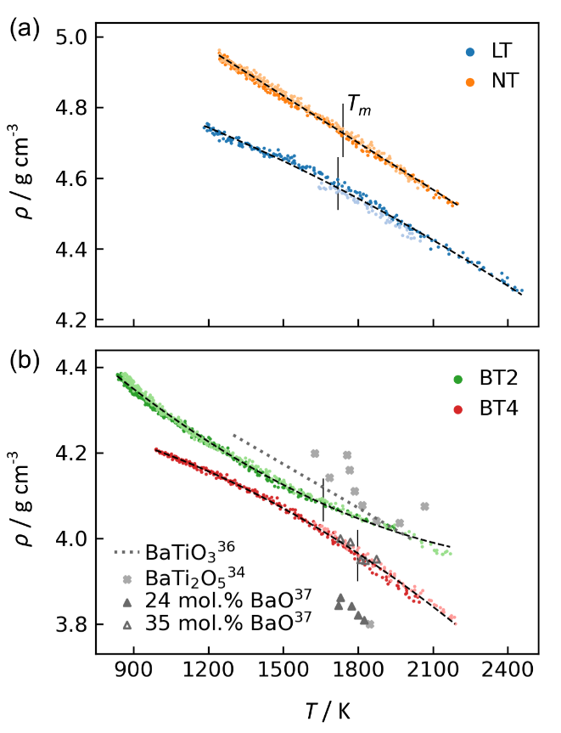
FIG. 1. Density of molten and supercooled titanates. (a) Rare earth titanates 83TiO₂-17RE₂O₃ with RE = La (“LT”) or Nd (“NT”); (b) barium titanates BaTi₂O₅ (“BT2”) and BaTi₄O₉ (“BT4”). For each composition, two replicate measurements are shown with dark/light circle markers. Least-squares fits are shown with black dashed curves, with formulae given in Table 1. Melting temperatures (T_{m}) marked with vertical black lines. In (b), prior data shown for BaTiO₃,³⁶ BaTi₂O₅,³⁴ and barium titanate containing 24 or 35 mol. % BaO.³⁷

The densities in Fig. 1 were calculated using the sample masses after melt processing. Mass loss was generally small, 0.2-3.5% (Table 1), so potential compositional shifts arising from incongruent evaporation should be negligible. Densities have also been corrected for any internal porosity found in the recovered solid samples, which was small, <0.3% (Table 1). The two replicates of each composition exhibited nearly identical density measurements, reproducible to within 1.0%. The density dependence on temperature is fitted well by a linear relationship for NT and by quadratic relationships for LT, BT2, and BT4. These empirical fits and their uncertainties are given in Table 1. No previously published data on RE titanate melt density are available for comparison here. However, the ratio of NT/LT melt densities (1.033-1.045) is close to the density ratio of the compositionally similar crystalline phases, RE₄Ti₉O₂₄ (5.178/4.97 = 1.042).^{38,39} For barium titanates, Fig. 1(b) shows melt density for BaTiO₃ measured with a terrestrial electrostatic levitator,³⁶ for BT2 measured using aerodynamic levitation,³⁴ and barium titanate with either 24 or 35 mol. % BaO measured with a maximum bubble pressure method.³⁷ For BT2, the current measurements are within 3.5% or 2.4% of the two prior reports (excluding one outlier near 1850 K), which is near or within the previously reported uncertainties of 5% and 2.3%, respectively.^{34,37} For the current measurements in ELF, the uncertainties are expected to match those described in previous studies that focused specifically on benchmarking the ELF experimental capabilities: temperature uncertainty for the melts is ± 30 K (also see Supplementary Material),³³ and density uncertainty is typically ca. 1.7%.³²

TABLE 1. Summary of melting and glass transition temperatures, mass loss from melt processing, and internal porosity that was likely present during melt density measurements. Uncertainties in the density fit parameters represent a 95% confidence interval.
Material | T_{m} (K) | T_{g} (K) | Ref. | Mass loss (%) | Porosity (%) | Density fit equation | Fit Range (K)
LT | 1720 | 1082 | ³⁵ | 1.4, 1.9 | 0.11, 0.26 | $$ρ(T)=5.01\left(4\right)$$  $$-1.41\left(48\right)×{10}^{-4}×T$$  $-6.45(1.36)×{10}^{-8}×T^{2}$ | 1180-2460
NT | 1740 | 1059 | ¹⁰ | 0.3, 1.0 | 0, 0.29 | $$ρ(T)=5.50\left(1\right)$$  $-4.43(4)×{10}^{-4}×T$ | 1240-2200
BT2 | 1660 | 960 | ³⁴ | 0.4, n/a | 0*, n/a | $$ρ(T)=4.85(1)$$  $$-6.69(14)×{10}^{-4}×T$$  $$+12.3(5)×{10}^{-8}×T^{2}$$ | 830-2170
BT4 | 1798 | n/a | ⁴⁰ | 0.2, 3.5 | 0, 0* | $$ρ(T)=4.31(2)$$  $$-0.03(26)×{10}^{-4}×T$$  $$-10.5(9)×{10}^{-8}×T^{2}$$ | 990-2190
* These samples contained a cylindrically shaped pore after melt processing, which was not present prior to solidification.

Viscosity and surface tension were measured using a droplet oscillation technique in ELF.⁴¹ While a molten sample was held isothermally, the voltage amplitude for one pair of electrostatic transducers was sinusoidally modulated. Meanwhile, changes in sample silhouette shape were monitored with a power meter and He-Ne laser backlight positioned on opposite sides of the sample. The frequency of the modulation was varied by trial-and-error until the driving force coupled with the natural resonance of the liquid sphere, which induces predominantly mode-2 oscillations.⁴² Once resonance was found, several measurements were collected for the decay of sample oscillations upon termination of the modulation driving force. For each decay, the amplitude was fit to an exponentially damped sine wave,
$$A= A_{1}e^{{-t}/τ}*sin\left[2π\left(f_{2}+\frac{df_{2}}{dt}t\right)t+ϕ\right]$$ | (1)
yielding the mode-2 resonance frequency, f₂, and characteristic decay time, τ. (The derivative ${df_{2}}/{dt}$ was included as an independent parameter in the fit to account for small shifts in the frequency over the duration of the decay period, and ${df_{2}}/{dt}$ was always equal to or nearly zero.) The fitted parameters were then used to calculate the surface tension,
$$σ=\frac{ρ{r_{0}}^{3}{(2πf_{2})}^{2}}{8}$$ | (2)
and viscosity,²²
$$η=\frac{ρ{r_{0}}^{2}}{5τ}$$ | (3)
Resonance frequencies were 134-140 Hz for LT, 132-138 Hz for NT, 120-124 Hz for BT2, and 123-130 for BT4. Characteristic decay times ranged 0.02-0.12 s. This approach with ELF has been used previously for measurements of Al₂O₃⁴¹ and Au.³²
Droplet oscillation techniques have been explored in terrestrial levitators (e.g., acoustic⁴³ and aerodynamic⁴⁴). However, these levitation techniques often have aspherical droplets and substantial fluid motion within the droplets, arising from interfacial forces between gas and sample^{45–47} or thermal gradients within samples.⁴⁸ These issues complicate the analytical expressions that relate droplet dynamics and thermophysical properties, which are based on assumptions of fluid quiescence.²² In contrast, electrostatic levitation avoids forced fluid motion, and operating in microgravity eliminates buoyancy-related convection, making the ELF a superb instrument for studying oscillations in quiescent droplets.
The viscosities of RE and barium titanates are given in Fig. 2(a-b). Droplet oscillations were collected over 1700-2200 K. This temperature range was limited on the low end by the magnitude of viscosities that can be accessed with the droplet oscillation technique, typically 10-40 mPa s depending on sample density, size, and surface tension.⁴⁹ All four titanate compositions exhibit similar viscosities: ~10 mPa s near 2100 K and increasing to ~30 mPa s as temperature decreases to 1750 K. The results in Fig. 2 show significant scatter but are generally within the 30% relative uncertainty reported for ELF viscosity measurements (see Ishikawa et al.⁴¹ for an analysis of various contributions to the overall uncertainty). One challenge for this technique is that the amplitude of droplet oscillations is small (<1% of the sample diameter), so the data must be bandpass filtered before it can be analyzed (see Supplementary Material, including Fig. S2-S4).^{32,41} Also, the droplet oscillations may not be purely mode-2, as assumed by the analytical theory. Because of the data scatter in Fig. 2, empirical fitting for the viscosity-temperature relationship was not attempted. Qualitatively, the samples’ viscosities increase with decreasing temperature at a more than linear rate. Viscosities for BT2 and BT4 agree within relative uncertainties with prior measurements of BaTiO₃ in a terrestrial electrostatic levitator,⁴⁹ shown in Fig. 2(b) with gray triangle markers.

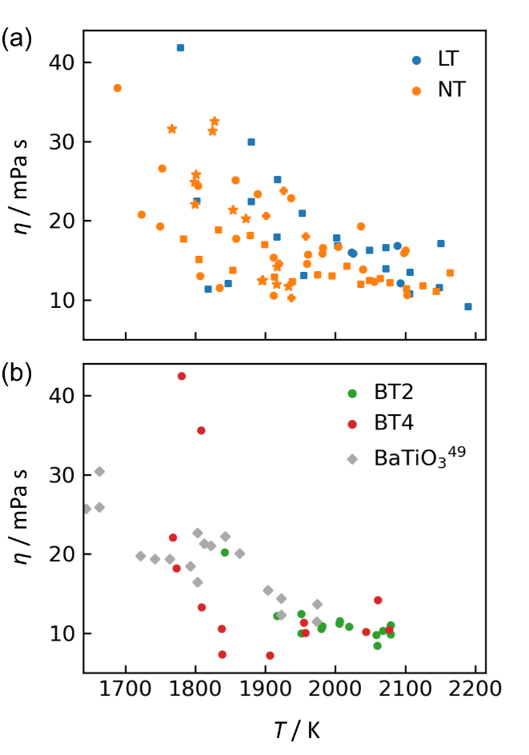
FIG. 2. Viscosity of (a) rare earth titanates LT and NT, and (b) barium titanates BT2 and BT4. Relative uncertainty is ± 30% based on prior studies.⁴¹ Marker shapes (circle, square, star, plus) indicate different replicate samples. Prior data shown for BaTiO₃.⁴⁹

Despite the 30% relative uncertainty in viscosity results, these data are useful because the range of viscosities pertinent to melt processing typically span several orders of magnitude. During vitrification by melt quenching of oxides, viscosity increases ~12 orders of magnitude.⁵⁰ For context, Fig. 3 shows the titanates’ viscosity data overlaid on an Angell plot,⁵¹ which shows the viscosity-temperature relationships for a variety of liquids, classified on a continuum of strong-to-fragile. Strong liquids like SiO₂ have viscosities with an Arrhenius relationship and lie on a straight diagonal in Fig. 3. Fragile liquids’ viscosities are highly non-Arrhenian. The RE and barium titanate liquids are quite fragile, based on the measurements reported here. This is consistent with their poor glass forming ability and unusual atomic structure for network glasses, characterized by a mean Ti-O coordination number of 5.3-5.7.^{10,34,35}
The Angell plot also helps illustrate why the ELF droplet oscillation technique is well suited for fragile oxide melts, in particular. A requirement for droplet oscillation is that the sample must be inviscid, with an Ohnesorge number less than 0.1:⁴³
$$Oh=\frac{η}{\sqrt{ρσR}}$$ | (4)
For BT2 near 2000 K, η = 12 mPa s, ρ = 4.0 g cm⁻³, σ = 385 dyn cm⁻¹, and R = 1 mm, which yields Oh = 0.0097. Similar Oh numbers are obtained for the other compositions, which confirm they are sufficiently inviscid for the analytical assumptions to be valid. More generally, the 2 mm diameter sample size used in ELF results in a maximum measurable viscosity of ~100 mPa s for typical oxide densities and surface tensions. For strong liquids, much higher temperatures relative to their glass transition would be required to reach this inviscid regime (i.e., smaller T_{g}/T in Fig. 3), and at such temperatures, sample volatilization may likely make measurements infeasible.

FIG. 3. Angell plot, showing the dependence of log₁₀(η) vs. inverse temperature after normalization to the glass transition, T_{g}. The plot is reproduced from Angell⁵¹ (reprinted with permission from AAAS) with the current work’s measurements shown with colored markers.

The surface tension for RE and barium titanates is shown in Fig. 4. LT and NT melts have surface tensions of ~470 dyn cm⁻¹; BT2 and BT4 have surface tensions of ~390 dyn cm⁻¹. Like for viscosity, Fig. 4 shows significant data scatter. Over the measured temperature range of 1700-2200 K, LT and NT surface tension measurements varied from 450-490 dyn cm⁻¹ (8.5%). BT2 and BT4 varied mostly within 383-395 dyn cm⁻¹ (3.1% variation). These variations are near or within the 6% overall relative uncertainty for ELF surface tension measurements.⁴¹ For comparison, the binary titanates’ surface tensions near T_{m} are larger than those of single component glass-forming oxides and smaller than that of the intermediate oxide Al₂O₃: using the linear relationships from Kingery,⁵² σ = 53, 55, 248, 304, and 690 dyn cm⁻¹ at T_{m} for B₂O₃, P₂O₅, GeO₂, SiO₂, and Al₂O₃, respectively.
The average trend of surface tension with temperature is nearly flat for all four titanate compositions: least-squares fitting of a linear relationship for each composition yielded slopes of -73(64), +20(29), -44(45), and -27(64) *10⁻³ dyn cm⁻¹ K⁻¹ for LT, NT, BT2, and BT4, respectively. Thus, for all compositions except LT, a zero slope was within the 95% confidence interval. This indicates that surface tension has a small or negligible temperature dependence for these four titanate compositions. The small temperature dependence is similar to that for single component oxides (e.g., ranging -21*10⁻³ dyn cm⁻¹ K⁻¹ for P₂O₅ to +56 for GeO₂).⁵² Again, comparisons to prior titanate studies are shown in Fig. 4 for BaTiO₃ (σ = 349 dyn cm⁻¹ at T_{m} with a small temperature dependence, -30*10⁻³ dyn cm⁻¹ K⁻¹)⁴⁹ and barium titanates with either 24 or 35 mol. % BaO (σ = 415-420 dyn cm⁻¹ at T_{m}).³⁷

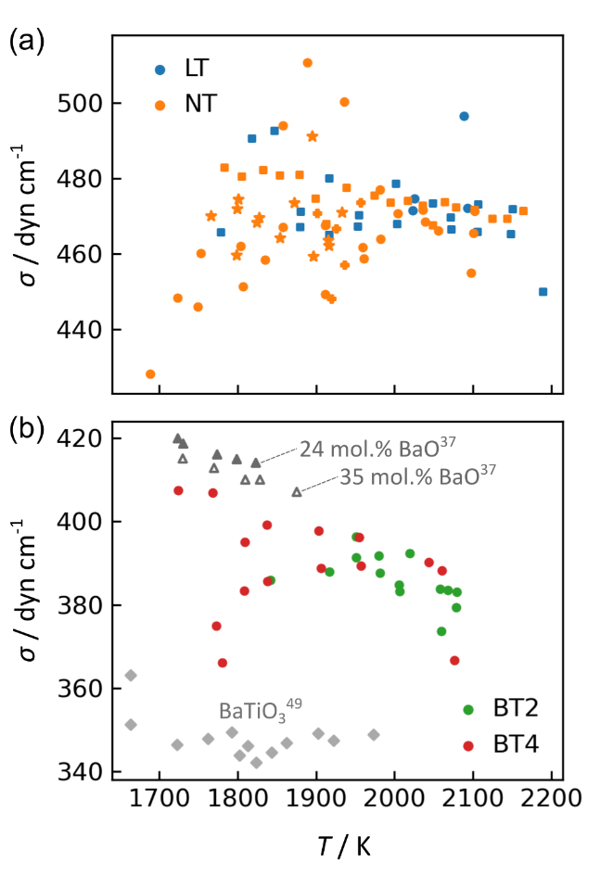
FIG. 4. Surface tension of (a) rare earth titanates LT and NT, and (b) barium titanates BT2 and BT4. Relative uncertainty is ± 6% based on prior studies.⁴¹ Marker shapes (circle, square, star, plus) indicate different replicate samples. Prior data shown for BaTiO₃⁴⁹ with gray diamond markers, and barium titanate containing 24 or 35 mol. % BaO³⁷ with filled and open gray triangle markers, respectively.

X-ray tomography was performed on recovered solid samples primarily to quantify any internal porosity, but it also provides insight into the microstructures formed from melt quenching.⁵³ Figure 5 compares cross-sections from tomography reconstructions for samples after melt processing in microgravity (in ELF) and terrestrially in an aerodynamic levitator.⁵⁴ (Videos showing the three-dimensional reconstructions are provided in the Supplementary Material.) In several samples, gas bubbles resulted in nearly spherical internal pores (e.g., LT in microgravity and all NT images in Fig. 5). These bubbles contributed at most 0.3% porosity for the microgravity samples. Bubbles in terrestrial samples were often located near the outer surface of the sample because of buoyancy in the melt (e.g., terrestrial BT2 in Fig. 5), while this tendency was not observed in microgravity samples.
The melt quenched products for LT and NT exhibit similar, mostly featureless internal structure for both processing conditions. The LT samples contain constellations of small cracks, likely arising from volume changes during crystallization and thermal stresses during cooling. BT2 and BT4 exhibit more complex microstructures. For both of these compositions, one of the two replicate microgravity samples contained a cylindrically shaped pore that stretched from the sample core out to the surface. Based on replicate comparisons in the density analysis, we deduced that these pores were a result of solidification shrinkage and were not present in the melts. In BT2, one of the microgravity samples was fractured throughout (Fig. 5, BT2 left), and the other sample underwent dramatic morphological changes during solidification (Fig. 5, BT2 right; see also a video of the solidification in the Supplementary Materials), possibly due to preferred orientations of crystal growth in the supercooled liquid. In BT4, microgravity and terrestrial samples exhibited hierarchical crack structures.

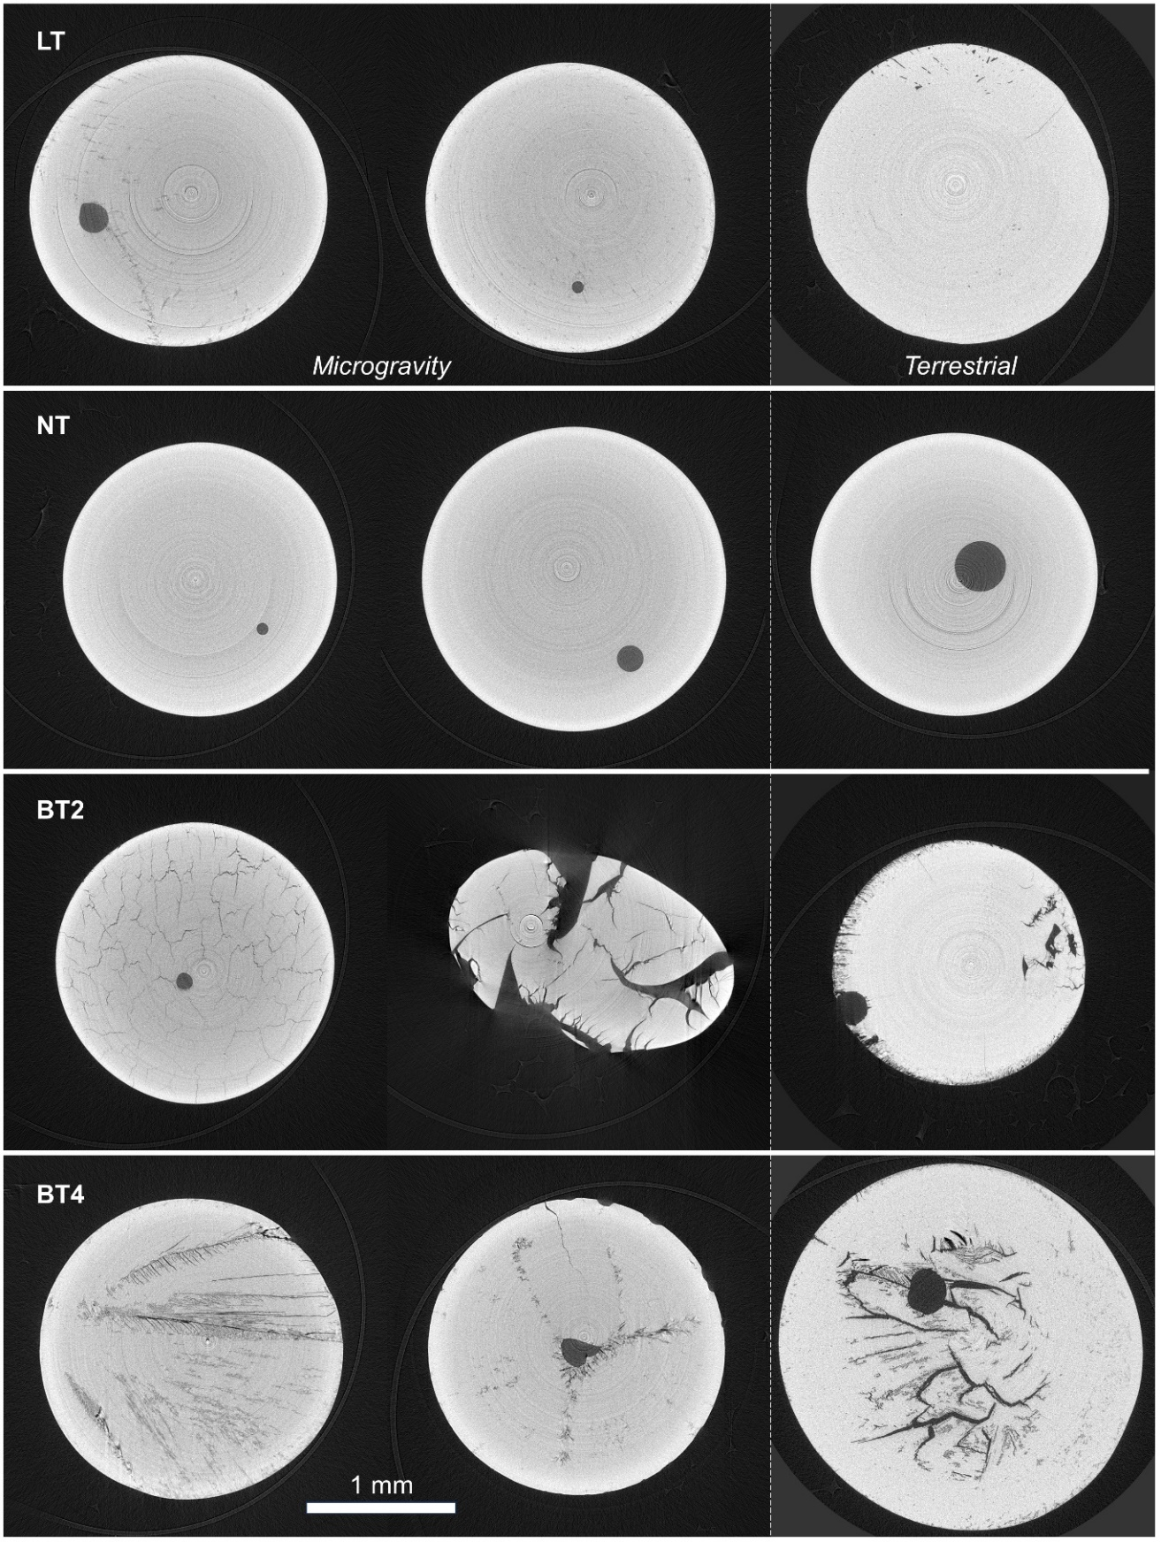
FIG. 5. X-ray tomography of titanate samples after melt quenching. For each composition, two samples processed in microgravity are compared with one terrestrially prepared sample. NT samples are glass; all others are polycrystalline.

In summary, we have measured the melt density, thermal expansion, viscosity, and surface tension for four compositions of RE and barium titanates. These thermophysical properties help design liquid phase processing technologies and for validating computational models of liquid structure and glass formation. The combination of electrostatic levitation, the microgravity environment, and droplet oscillation provide a powerful experimental approach for accessing these properties over a wide temperature range, including deeply supercooled states that are inaccessible by other techniques. This methodology is particularly well suited to fragile liquids such as these titanates, since they are difficult to supercool or vitrify by conventional means. X-ray tomography is a useful nondestructive probe of internal structure, which helps to correct density measurements for the presence of internal gas bubbles.

See the supplementary material for (1) experimental methods and data analysis; (2) cooling curves for melt quenching in ELF; (3) video animations of the samples’ three-dimensional X-ray tomography reconstructions.

This work was supported by the National Aeronautics and Space Administration (NASA, grant no. 80NSSC19K1288). ELF measurements were supported by JSPS KAKENHI (grant no. 20H05882 and 20H05878). X-ray tomography measurements were made at Sector 7-BM-B of the Advanced Photon Source, a U.S. DOE Office of Science User Facility, operated by Argonne National Laboratory under Contract No. DE-AC02-06CH11357. SEM/EDS measurements were made at the EPIC facility of Northwestern University’s NUANCE Center, which has received support from the SHyNE Resource (NSF ECCS-2025633), the IIN, and Northwestern's MRSEC program (NSF DMR-2308691). The authors would like to thank Oliver Alderman and Emma Clark for assisting with sample planning and preparation.

AUTHOR DECLARATIONS
Conflict of Interest
The authors have no conflicts to disclose.

Author Contributions
Stephen Wilke: Formal analysis (lead), Investigation (equal), Supervision (equal), Visualization (lead), Writing – original draft (lead), Writing – review & editing (equal). Abdulrahman Al-Rubkhi: Formal analysis (equal), Visualization (supporting), Writing – original draft (supporting). Vrishank Menon: Formal analysis (equal). Jared Rafferty: Formal analysis (supporting), Writing – review & editing (equal). Chihiro Koyama: Investigation (equal), Methodology (equal). Takehiko Ishikawa: Conceptualization (equal), Formal analysis (supporting), Investigation (equal), Methodology (equal), Writing – review & editing (equal). Hirohisa Oda: Project administration (equal). Robert Hyers: Formal analysis (supporting), Writing – review & editing (equal). Richard Bradshaw: Formal analysis (supporting). Alan Kastengren: Investigation (supporting), Methodology (supporting). Shinji Kohara: Conceptualization (equal), Resources (lead). Michael SanSoucie: Project administration (equal). Brandon Phillips: Project administration (equal). Richard Weber: Conceptualization (lead), Funding acquisition (lead), Investigation (equal), Project administration (lead), Supervision (equal), Writing – review & editing (equal).

DATA AVAILABILITY
The data that support the findings of this study are available from the corresponding author upon reasonable request.

REFERENCES
¹ A. von Hippel, “Ferroelectricity, Domain Structure, and Phase Transitions of Barium Titanate,” Rev. Mod. Phys. 22(3), 221–237 (1950).
² J. Yu, P.F. Paradis, T. Ishikawa, S. Yoda, Y. Saita, M. Itoh, and F. Kano, “Giant dielectric constant of hexagonal BaTiO3 crystal grown by containerless processing,” Chem. Mater. 16(21), 3973–3975 (2004).
³ T. Akashi, H. Iwata, and T. Goto, “Dielectric Property of Single Crystalline BaTi2O5 Prepared by a Floating Zone Method,” Mater. Trans. 44(8), 1644–1646 (2003).
⁴ Y. Akishige, K. Fukano, and H. Shigematsu, “New Ferroelectric BaTi2O5,” Jpn. J. Appl. Phys. 42(8A), L946 (2003).
⁵ N. Zhu, and A.R. West, “Formation and Stability of Ferroelectric BaTi2O5,” J. Am. Ceram. Soc. 93(1), 295–300 (2010).
⁶ G. Zhu, D. Chen, X. Zhu, S. Xiong, H. Xiao, L. Liu, and C. Li, “Re2TiO5: Special dielectric titanates exhibiting abnormally low permittivity and a positive coefficient of resonance frequency,” J. Am. Ceram. Soc., 1–11 (2023).
⁷ H. Kozuka, R. Ota, and N. Soga, “Preparation and Properties of Binary Oxide Glasses Containing Rare Earth Oxides,” J. Soc. Mater. Sci. Japan 35(388), 73–79 (1986).
⁸ Y. Arai, K. Itoh, S. Kohara, and J. Yu, “Refractive index calculation using the structural properties of La4Ti9O24 glass,” J. Appl. Phys. 103, 094905 (2008).
⁹ B. Topper, S.K. Wilke, M. Pettes, A. Alrubkhi, V. Menon, A. Neumann, D. Möncke, R. Weber, and A. Mafi, “Mid-infrared luminescence properties of erbium and dysprosium doped lanthanum titanate glasses,” Opt. Mater. Express 13(10), 2857–2868 (2023).
¹⁰ S.K. Wilke, O.L.G. Alderman, C.J. Benmore, J. Neuefeind, and R. Weber, “Octahedral oxide glass network in ambient pressure neodymium titanate,” Sci. Rep. 12, 8258 (2022).
¹¹ C. Zhao, K. Fezzaa, R.W. Cunningham, H. Wen, F. De Carlo, L. Chen, A.D. Rollett, and T. Sun, “Real-time monitoring of laser powder bed fusion process using high-speed X-ray imaging and diffraction,” Sci. Rep. 7, 3602 (2017).
¹² L. Levine, B. Lane, J. Heigel, K. Migler, M. Stoudt, T. Phan, R. Ricker, M. Strantza, M. Hill, F. Zhang, J. Seppala, E. Garboczi, E. Bain, D. Cole, A. Allen, J. Fox, and C. Campbell, “Outcomes and Conclusions from the 2018 AM-Bench Measurements, Challenge Problems, Modeling Submissions, and Conference,” Integr. Mater. Manuf. Innov. 9, 1–15 (2020).
¹³ M.R. Stoudt, M.E. Williams, L.E. Levine, A. Creuziger, S.A. Young, J.C. Heigel, B.M. Lane, and T.Q. Phan, “Location-Specific Microstructure Characterization Within IN625 Additive Manufacturing Benchmark Test Artifacts,” Integr. Mater. Manuf. Innov. 9, 54–69 (2020).
¹⁴ National Academies of Sciences, Engineering, and Medicine, Thriving in Space: Ensuring the Future of Biological and Physical Sciences Research, A Decadal Survey for 2023-2032 (National Academies Press, 2023).
¹⁵ E. Sacco, and S.K. Moon, “Additive manufacturing for space: status and promises,” Int. J. Adv. Manuf. Technol. 105(10), 4123–4146 (2019).
¹⁶ B. Reitz, C. Lotz, N. Gerdes, S. Linke, E. Olsen, K. Pflieger, S. Sohrt, M. Ernst, P. Taschner, J. Neumann, E. Stoll, and L. Overmeyer, “Additive Manufacturing Under Lunar Gravity and Microgravity,” Microgravity Sci. Technol. 33(2), 25 (2021).
¹⁷ M. Fateri, and A. Gebhardt, “Process Parameters Development of Selective Laser Melting of Lunar Regolith for On-Site Manufacturing Applications,” Int. J. Appl. Ceram. Technol. 12, 46–52 (2015).
¹⁸ J. Yu, Y. Arai, T. Masaki, T. Ishikawa, S. Yoda, S. Kohara, H. Taniguchi, M. Itoh, and Y. Kuroiwa, “Fabrication of BaTi2O5 glass-ceramics with unusual dielectric properties during crystallization,” Chem. Mater. 18(8), 2169–2173 (2006).
¹⁹ X. Ge, Q. Hu, W. Lu, S. Cao, L. Yang, M. Xu, M. Xia, and J. Li, “Polymorphic transition and nucleation pathway of barium dititanate (BaTi2O5) during crystallization from undercooled liquid,” Sci. Rep. 9, 7207 (2019).
²⁰ J. Marcial, and J. McCloy, “Role of short range order on crystallization of tectosilicate glasses: A diffraction study,” J. Non. Cryst. Solids 505, 131–143 (2019).
²¹ A.J. Rulison, and W.-K. Rhim, “A noncontact measurement technique for the specific heat and total hemispherical emissivity of undercooled refractory materials,” Rev. Sci. Instrum. 65(3), 695 (1994).
²² W.-K. Rhim, K. Ohsaka, P.-F. Paradis, and R.E. Spjut, “Noncontact technique for measuring surface tension and viscosity of molten materials using high temperature electrostatic levitation,” Rev. Sci. Instrum. 70(6), 2796–2801 (1999).
²³ P.-H. Haumesser, J. Bancillon, M. Daniel, M. Perez, and J.-P. Garandet, “High-temperature contactless viscosity measurements by the gas–film levitation technique: Application to oxide and metallic glasses,” Rev. Sci. Instrum. 73(9), 3275–3285 (2002).
²⁴ L. Skinner, and A.C. Barnes, “An oscillating coil system for contactless electrical conductivity measurements of aerodynamically levitated melts,” Rev. Sci. Instrum. 77(12), 123904 (2006).
²⁵ S. V. Ushakov, J. Niessen, D.G. Quirinale, R. Prieler, A. Navrotsky, and R. Telle, “Measurements of density of liquid oxides with an aero-acoustic levitator,” Materials 14, 822 (2021).
²⁶ H. Tamaru, C. Koyama, H. Saruwatari, Y. Nakamura, T. Ishikawa, and T. Takada, “Status of the Electrostatic Levitation Furnace (ELF) in the ISS-KIBO,” Microgravity Sci. Technol. 30(5), 643–651 (2018).
²⁷ S.K. Chung, D.B. Thiessen, and W.-K. Rhim, “A noncontact measurement technique for the density and thermal expansion coefficient of solid and liquid materials,” Rev. Sci. Instrum. 67(9), 3175–3181 (1996).
²⁸ H. Oda, R. Shimonishi, C. Koyama, T. Ito, and T. Ishikawa, “Determining the density of molten Y2O3 using an electrostatic levitation furnace in the International Space Station,” High Temp. - High Press. 53(3–4), 341–350 (2023).
²⁹ C. Koyama, T. Ishikawa, H. Oda, H. Saruwatari, S. Ueno, M. Oshio, Y. Watanabe, and Y. Nakata, “Densities of liquid lanthanoid sesquioxides measured with the electrostatic levitation furnace in the ISS,” J. Am. Ceram. Soc. 104, 2913–2918 (2020).
³⁰ K. Yoshida, H. Kumagai, T. Yamane, A. Hayashi, C. Koyama, H. Oda, T. Ito, and T. Ishikawa, “Thermophysical properties of molten Ga2O3 by using the electrostatic levitation furnace in the International Space Station,” Appl. Phys. Express 15(8), 085503 (2022).
³¹ J. Nawer, and D.M. Matson, “Quantifying facility performance during thermophysical property measurement of liquid Zr using Electrostatic Levitation,” High Temp. - High Press. 52(2), 123–138 (2023).
³² J. Nawer, T. Ishikawa, H. Oda, H. Saruwatari, C. Koyama, X. Xiao, S. Schneider, M. Kolbe, and D.M. Matson, “Uncertainty analysis and performance evaluation of thermophysical property measurement of liquid Au in microgravity,” Npj Microgravity 9, 38 (2023).
³³ S.K. Wilke, A. Al-Rubkhi, C. Koyama, T. Ishikawa, H. Oda, B. Topper, E.M. Tsekrekas, D. Möncke, O.L.G. Alderman, V. Menon, J. Rafferty, E. Clark, A.L. Kastengren, C.J. Benmore, J. Ilavsky, J. Neuefeind, S. Kohara, M. SanSoucie, B. Phillips, and R. Weber, “Microgravity effects on nonequilibrium melt processing of neodymium titanate: thermophysical properties, atomic structure, glass formation and crystallization,” Npj Microgravity 10, 26 (2024).
³⁴ O.L.G. Alderman, C.J. Benmore, A. Tamalonis, S. Sendelbach, S. Heald, and R. Weber, “Continuous structural transition in glass-forming molten titanate BaTi2O5,” J. Phys. Chem. C 120(47), 26974–26985 (2016).
³⁵ O.L.G. Alderman, C.J. Benmore, A. Tamalonis, and R. Weber, “Rare-earth titanate melt structure and glass formation,” Int. J. Appl. Glas. Sci. 10(4), 463–478 (2019).
³⁶ P.F. Paradis, J. Yu, T. Ishikawa, T. Aoyama, and S. Yoda, “Contactless density measurement of high-temperature BiFeO3 and BaTiO3,” Appl. Phys. A Mater. Sci. Process. 79(8), 1965–1969 (2004).
³⁷ N. Ikemiya, J. Yoshitomi, S. Hara, and K. Ogino, “Surface Tensions and Densities of Melts in TiO2-BaO and TiO2-Na2O Systems,” J. Japanese Inst. Met. 57(5), 527–532 (1993).
³⁸ R.E. Morris, J.J. Owen, and A.K. Cheetham, “The structure of La4Ti9O24 from synchrotron X-ray powder diffraction,” J. Phys. Chem. Solids 56(10), 1297–1303 (1995).
³⁹ N. Hübner, and R. Gruehn, “Nd4Ti9O24: Präparation und Struktur,” Zeitschrift Für Anorg. Und Allg. Chemie 616(10), 86–94 (1992).
⁴⁰ S. Lee, C.A. Randall, and Z.K. Liu, “Modified phase diagram for the barium oxide-titanium dioxide system for the ferroelectric barium titanate,” J. Am. Ceram. Soc. 90(8), 2589–2594 (2007).
⁴¹ T. Ishikawa, C. Koyama, H. Oda, and H. Saruwatari, “Status of the Electrostatic Levitation Furnace in the ISS - Surface Tension and Viscosity Measurements,” Int. J. Microgravity Sci. Appl. 39(1), 390101 (2022).
⁴² N. Brosius, J. Livesay, Z. Karpinski, R. Singiser, M. SanSoucie, B. Phillips, and R. Narayanan, “Characterization of oscillation modes in levitated droplets using image and non-image based techniques,” Npj Microgravity 9, 3 (2023).
⁴³ J. Kremer, A. Kilzer, and M. Petermann, “Simultaneous measurement of surface tension and viscosity using freely decaying oscillations of acoustically levitated droplets,” Rev. Sci. Instrum. 89, 015109 (2018).
⁴⁴ Y. Ohishi, F. Kargl, F. Nakamori, H. Muta, K. Kurosaki, and S. Yamanaka, “Physical properties of core-concrete systems: Al2O3-ZrO2 molten materials measured by aerodynamic levitation,” J. Nucl. Mater. 487, 121–127 (2017).
⁴⁵ A.L. Yarin, G. Brenn, O. Kastner, D. Rensink, and C. Tropea, “Evaporation of acoustically levitated droplets,” J. Fluid Mech. 399, 151–204 (1999).
⁴⁶ M.A.B. Andrade, S. Polychronopoulos, G. Memoli, and A. Marzo, “Experimental investigation of the particle oscillation instability in a single-axis acoustic levitator,” AIP Adv. 9(3), (2019).
⁴⁷ S.E. Boland, S.K. Wilke, J.A. Scott, S.M. Schlossberg, A. Ivaschenko, R.J.K. Weber, and D.W. Lipke, “A hyperbaric aerodynamic levitator for containerless materials research,” Rev. Sci. Instrum. 94, 053903 (2023).
⁴⁸ S.J. McCormack, A. Tamalonis, R.J.K. Weber, and W.M. Kriven, “Temperature gradients for thermophysical and thermochemical property measurements to 3000 °C for an aerodynamically levitated spheroid,” Rev. Sci. Instrum. 90, 15109 (2019).
⁴⁹ T. Ishikawa, J. Yu, and P.-F. Paradis, “Noncontact surface tension and viscosity measurements of molten oxides with a pressurized hybrid electrostatic-aerodynamic levitator,” Rev. Sci. Instrum. 77(5), 053901 (2006).
⁵⁰ J.C. Mauro, A. Tandia, K.D. Vargheese, Y.Z. Mauro, and M.M. Smedskjaer, “Accelerating the Design of Functional Glasses through Modeling,” Chem. Mater. 28(12), 4267–4277 (2016).
⁵¹ C.A. Angell, “Formation of Glasses from Liquids and Biopolymers,” Science 267(5206), 1924–1935 (1995).
⁵² W.D. Kingery, “Surface Tension of Some Liquid Oxides and Their Temperature Coefficients,” J. Am. Ceram. Soc. 42, 6–10 (1959).
⁵³ J.M. Bussey, M.H. Weber, N.J. Smith-Gray, J.J. Sly, and J.S. McCloy, “Examining phase separation and crystallization in glasses with X-ray nano-computed tomography,” J. Non. Cryst. Solids 600, 121987 (2023).
⁵⁴ J.K.R. Weber, A. Tamalonis, C.J. Benmore, O.L.G. Alderman, S. Sendelbach, A. Hebden, and M.A. Williamson, “Aerodynamic levitator for in situ x-ray structure measurements on high temperature and molten nuclear fuel materials,” Rev. Sci. Instrum. 87(7), 073902 (2016).

