Exploring the Effect of Temperature and Interface Atom Type on Heat Transport through the GaN/diamond Interfaces using Machine Learning Potential

ABSTRACT
Gallium nitride (GaN) electronic devices are highly sought after for high-power and high-frequency applications due to their superior performance characteristics. Despite its potential, managing heat dissipation is a major obstacle for employing GaN in high-power devices. One viable approach to address this issue is to combine GaN with a diamond heat sink. Therefore, interfacial thermal transport has emerged as a critical challenge in thermal management. In this work, a neuroevolution potential (NEP) is developed leveraging neural network, which enhances the precision of predicting thermal properties compared to traditional potential and tackles the problem of inaccurate thermal performance predictions for GaN/diamond heterostructures with traditional potential. The temperature-dependent and interface atom-dependent thermal boundary resistance (TBR) of GaN/diamond heterostructures after interfacial bonding are investigated using molecular dynamics simulations base on NEP. The TBR of the six interfaces in the GaN/diamond heterostructures has been predicted over the temperature range of 200-600K. At 300K, the TBR of different interface structures ranges from 2.22-3.26 m²·K·GW⁻¹, which is in perfect agreement with the value predicted by diffusion mismatch model theory (~3 m²·K·GW⁻¹). Furthermore, it is observed that TBR decreases with increasing temperature and exhibits an approximately linear relationship. It is also found that the TBR of the N-C bonded heterostructures at the interface are approximately 25% lower than that of the Ga-C bonded heterostructures. The mechanism behind the above phenomenon is explained by analyzing vibration density of states (VDOS). Finally, insightful optimization strategies based on temperature and GaN atomic types at the interface are proposed, laying the groundwork for better design and management of GaN/diamond heterostructures.

Introduction
GaN electronic devices are highly sought after for high-power and high-frequency applications due to their superior performance characteristics [1, 2]. As power density and device miniaturization continue to increase, the inherently low thermal conductivity of GaN is not enough to meet the requirements of high thermal performance and reliability [3]. Thus, effective thermal management is crucial for the development and commercialization of GaN-based high-power electronic and photonic devices [4]. A highly effective solution is to combine materials with high thermal conductivity with those of lower conductivity to improve heat dissipation [5-9]. Diamond is regarded as a promising option for heat sinks because of its exceptional thermal conductivity, which exceeds 2000 W·m⁻¹·K⁻¹ [10-12]. It has been demonstrated that the integration of diamond and GaN can enhance heat dissipation during device operation, significantly reducing temperature and increasing maximum power density, thereby improving device performance [13-15]. However, some nanoscale and even atomic level microscopic mechanisms still need further exploration and in-depth understanding.
Molecular dynamics (MD) simulations have been widely used to understand the microscopic mechanisms of heterostructure interface, especially interfacial heat transport [4, 16-19]. However, the reliability of MD simulations is significantly dependent on the accuracy of the interatomic potential [20]. Heterostructures are typically complex structures made up of multiple elements, which makes it challenging for traditional potentials to provide an accurate description. For example, the study by Lei et al. demonstrated that interface nanoengineering can further reduce TBR, which is widely recognized [18]. However, the TBR predicted by Lei et al. is on the order of tens of m²·K·GW⁻¹, which is an order of magnitude higher than the value predicted by diffusion mismatch model (DMM) theory (~3 m²·K·GW⁻¹) [21, 22]. Therefore, developing a potential that can more accurately describe the interfacial heat transfer in GaN/diamond heterostructures is essential. This would be highly meaningful for future researchers seeking to explore the mechanisms of interfacial heat transfer in GaN/diamond heterostructures with greater precision.
With the development of fast and powerful computers, machine learning potentials (MLPs) have been widely applied, especially in interfacial heat transport [23-26]. In this approach, machine learning (ML) is employed to reconstruct the ab initio potential energy surface, enabling precise descriptions of interatomic potentials. Compared to other machine learning algorithms, the NEP obtained through Graphics Processing Units Molecular Dynamics (GPUMD) code offers enhanced accuracy and cost-efficiency in atomistic simulations and heat transport applications [27-30].
In the present work, a NEP is constructed to investigate heat transfer at the GaN/diamond interface. It has been validated that the NEP specifically trained for GaN/diamond heterostructures provides higher accuracy compared to traditional potentials. Additionally, the influence of temperature and GaN atomic type at the interface on TBR is investigated. The TBR value range predicted using NEP is in perfect agreement with value predicted by DMM theory. Furthermore, it is observed that TBR decreases with increasing temperature and exhibits an approximately linear relationship. It is also found that the TBR of the N-C bonded heterostructures at the interface are approximately 25% lower than that of the Ga-C bonded heterostructures. This work not only provides a more accurate potential for MD simulations of heat transfer in GaN/diamond heterostructures but also offers insightful optimization strategies based on temperature and GaN atomic type at the interface, laying the groundwork for better design and management of GaN/diamond heterostructures.

Computational methods and models

2.1 NEP method
The NEP model, a type of machine learning potential, employs a single neural network and is trained using a separable natural evolution strategy [31]. The NEP model constructs the descriptor vector $q_{v}^{i}$ to generate the potential energy surface function Ui for atom i, with $q_{v}^{i}$computed using the following formula [30, 32, 33]:
$$\begin{aligned}U_{i}=\sum_{μ=1}^{N_{neu}}{ω_{μ}^{\left(1\right)}\tanh\left(\sum_{v=1}^{N_{des}}{ω_{μv}^{\left(0\right)}q_{v}^{i}-b_{μ}^{\left(0\right)}}\right)-b^{\left(1\right)}}\#\end{aligned}\left(1\right)$$
where N_{des} denotes the number of components in the descriptor vector, N_{neu} indicates the number of neurons, tanh(x) represents the activation function for the hidden layer, ω⁽⁰⁾ is the weight matrix linking the input layer to the hidden layer, ω⁽¹⁾ is the weight vector connecting the hidden layer to the output layer node U_{i}, b⁽⁰⁾ is the bias vector for the hidden layer, and b⁽¹⁾ is the bias for the output layer node U_{i}. As shown in Fig. 1(a), the NEP model includes three layers: the input layer, the hidden layer, and the output layer. For this study, the hidden layer is configured with 60 neurons.
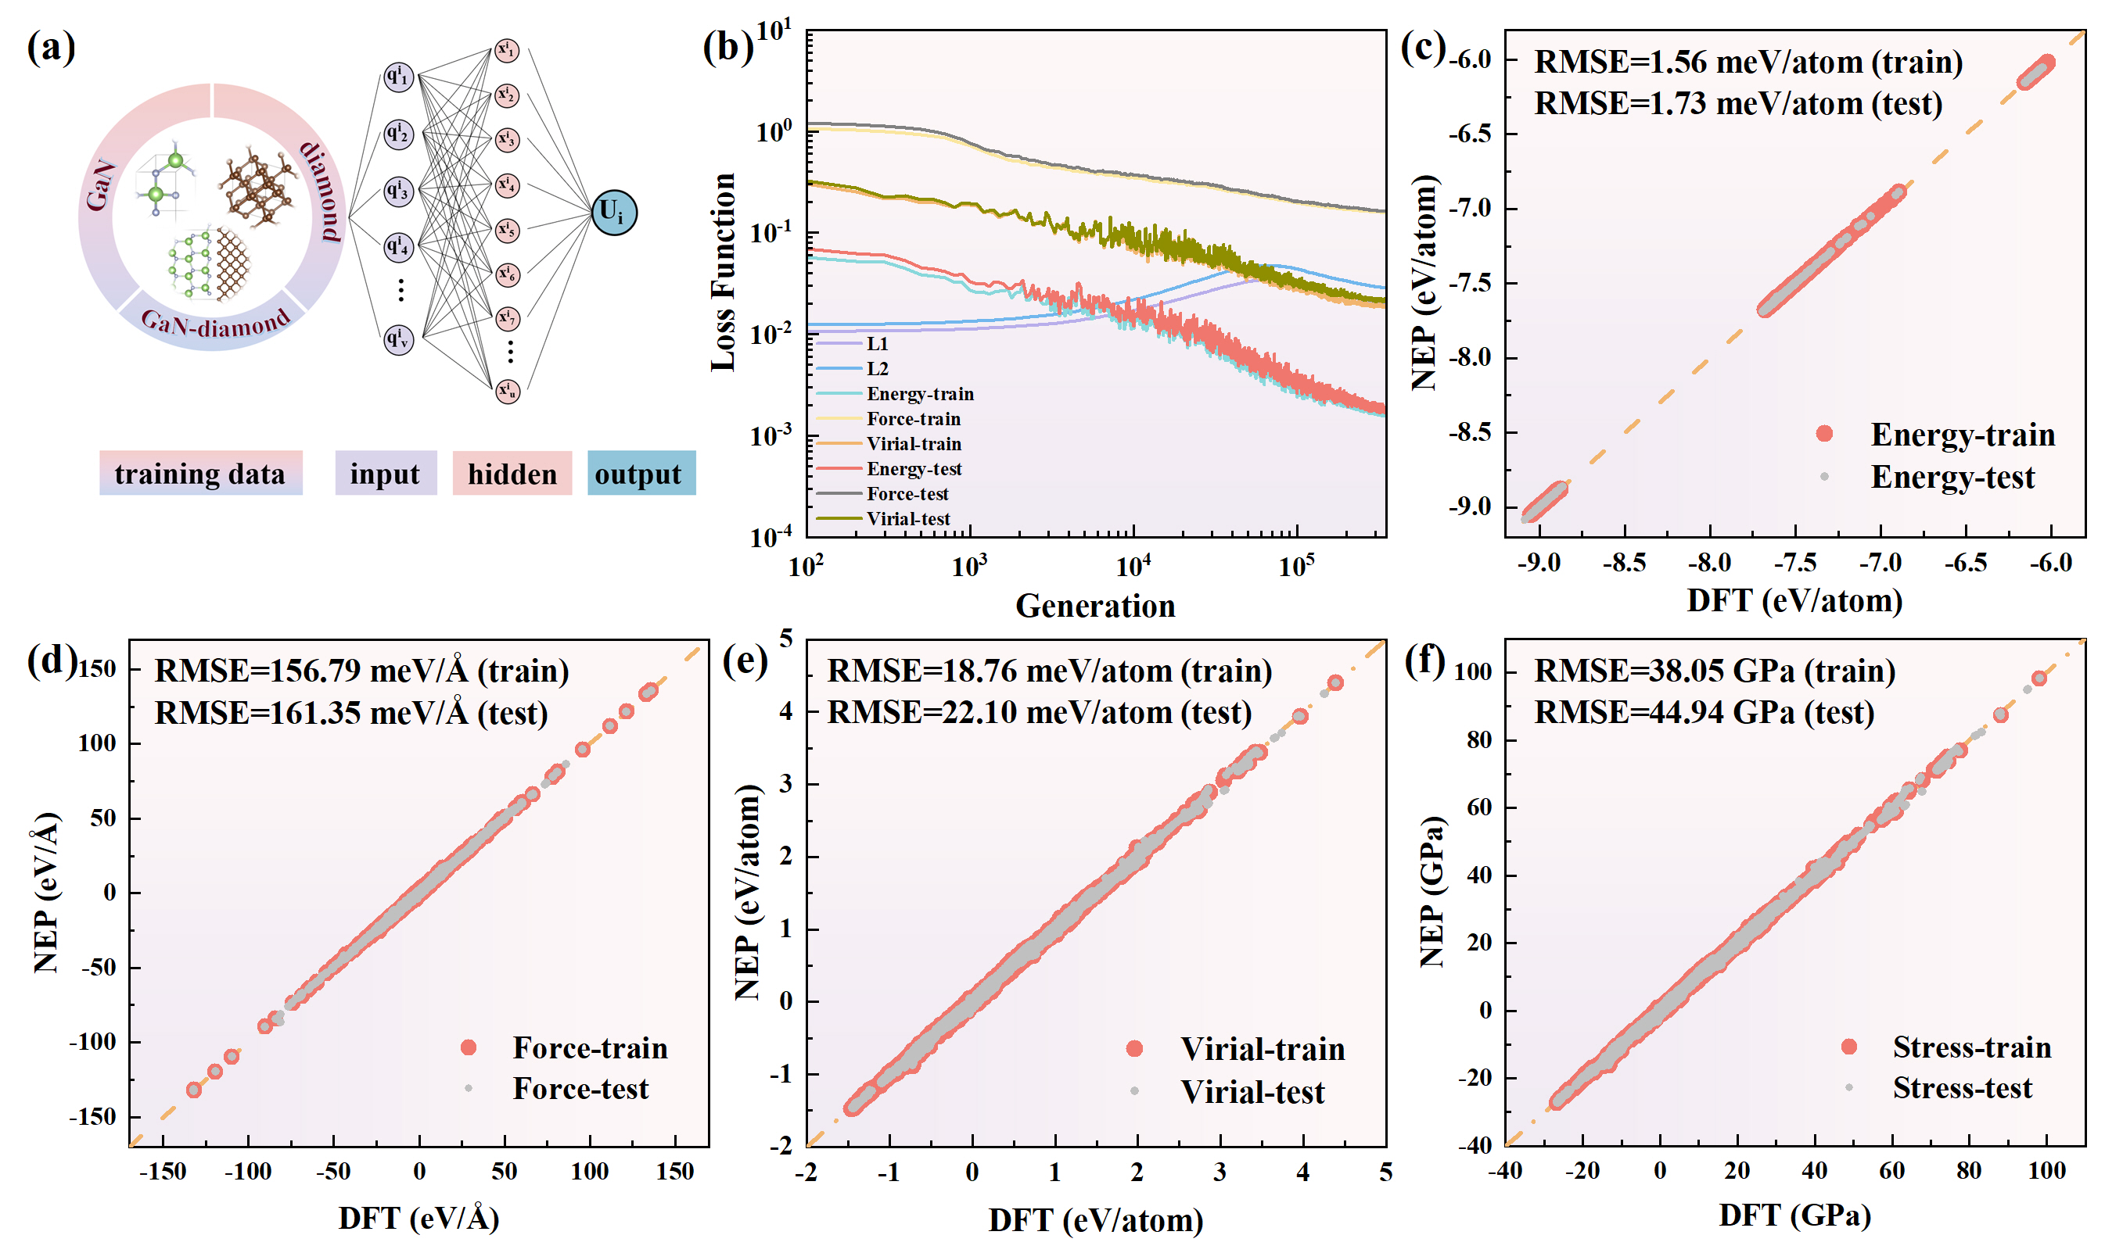
Fig. 1. (a) Simplified schematic representation of the NEP framework. (b) Evolution of loss functions during the training process. L1 and L2 are regularizations. (c)–(f) Comparison between the NEP predictions and DFT reference values of energy, force, virial, and stress for the training and test sets.

2.2 Details of training data and mechanical behavior
To investigate heat transfer at the GaN/diamond interface, a training dataset is created that includes GaN, diamond, and their heterostructures. To better align with experimental conditions, the focus is primarily placed on the (0001) planes of GaN and the (100), (110), and (111) planes of diamond. Additionally, the Ga-C and N-C bonding at the GaN/diamond interface is considered. Thus, the training dataset includes six different types of heterostructures. The temperature range for all structures in the training dataset is from 200 K to 600 K. The MD trajectories obtain through ab initio MD simulations performed with the Vienna Ab Initio Simulation Package (VASP) [34, 35], while the construction of the heterostructures in this study is primarily carried out using VASPKIT [36]. Finally, the training dataset includes 150 pristine GaN, 150 pristine diamond, and 810 heterostructures, while the test dataset includes 300 pristine GaN, 300 pristine diamond, and 1350 heterostructures.
The loss terms for energy, force, and virial relations in both the test and training datasets exhibit excellent convergence after 350,000 generations, as illustrated in Fig. 1(b). Fig. 1(c-f) present parity plots that show the correlations between the energies, atomic forces, atomic virial, and atomic stress relations predicted by the NEP and DFT, demonstrating a strong agreement. The root-mean-squared error (RMSE) for the predictions is also reported. Typically, the RMSE values for each trained MLP model are within several meV/atom for energy and several hundred meV/Å for force, indicating that the training process is satisfactory [37]. Table 1 illustrates the training hyperparameters.
Table 1. NEP training hyperparameters.
Parameter | Value | Parameter | Value
version | 3.9.4 | type | 3 Ga N C
$$r_{C}^{R}$$ | 8 Å | $$r_{C}^{A}$$ | 4 Å
$$n_{max}^{R}$$ | 12 | $$n_{max}^{A}$$ | 8
$$N_{basis}^{R}$$ | 12 | $$N_{basis}^{A}$$ | 12
$$l_{max}^{3b}$$ | 4 | $$l_{max}^{4b}$$ | 2
$$l_{max}^{5b}$$ | 0 | $$N_{neuron}$$ | 60
$$N_{batch}$$ | 1110 | $$N_{generation}$$ | 300000

2.3 Equilibrium molecular dynamics (EMD) method and models
EMD simulations are used to evaluate the thermal conductivity using the Green-Kubo method [38-40]. The Green-Kubo formula relates thermal conductivity to fluctuations in heat current via the autocorrelation function, as described by the following equation:
$$\begin{aligned}k_{α}\left(t\right)=\frac{1}{k_{B}T^{2}V}\int_{0}^{t_{0}}{<J_{α}\left(0\right)J_{α}\left(t\right)>dt}\#\left(2\right)\end{aligned}$$
where $k_{α}$represents the thermal conductivity in the α direction, $k_{B}$is the Boltzmann constant,$V$denotes the volume of the model cell, $T$is the temperature, $t_{0}$stands for the upper limit of integral, $J_{α}$ is the component of heat current $J$ in the α direction, and $<J_{α}\left(0\right)J_{α}\left(t\right)>$ denotes the ensemble average.
Diamond possesses an Fd-3m crystal symmetry, with each conventional unit cell comprising 8 carbon atoms. GaN possesses a P63mc crystal symmetry, and its conventional unit cell contains 2 gallium atoms and 2 nitrogen atoms. In the EMD simulation, the GaN system comprises 14 × 9$\sqrt{3}$ × 9 conventional unit cells, totaling 9072 atoms. Similarly, the diamond system consists of 10 × 10 × 10 conventional unit cells, amounting to 8000 atoms. In this study, cell structures are visualized using VESTA software and OVITO software [41, 42]. Periodic boundary conditions are applied in all three directions. To minimize calculation errors, 50 independent MD simulations are conducted to obtain the average κ values, with time steps of 1 fs at 300 K.

2.4 Non-equilibrium molecular dynamics (NEMD) method and models
The NEMD method, based on Fourier’s law, segments the system into three distinct regions: a heat source that continuously adds energy, a heat sink that continuously dissipates energy, and a measurement section is used to assess thermal conductivity. Maintaining strict energy conservation is crucial in NEMD simulations. If the interatomic potential is not sufficiently accurate, it will be very challenging to ensure a consistent energy flow from the heat source to the heat sink, which could lead to system instability during the simulation [43]. Therefore, NEMD simulations serve as a measure of stability for NEP. Fig. 2(b) shows that the energy values for the heat source entering the system and the heat sink exiting the system are symmetrically distributed around E = 0, in accordance with the law of energy conservation. The heat flux J_{Q} produced during the NEMD process can be expressed as:
$$\begin{aligned}J_{Q}=\frac{\left|{dQ}/{dt}\right|}{A}\#\left(3\right)\end{aligned}$$
where $\left|{dQ}/{dt}\right|$ and A denote the energy exchange rate and the area of the simulation box perpendicular to the heat fluent, respectively. To reduce the impact of variations in interface area, the interface area is standardized to a consistent size. The temperature difference ΔT is obtained from the temperature distribution in the abovementioned interface region. The TBR can be considered analogous to the thermal conductivity and be calculated as the formula [44]：
$$\begin{aligned}TBR=\frac{ΔT}{J_{Q}}\#\left(4\right)\end{aligned}$$
A time step of 0.5 fs was used. Initially, the system was relaxed for 0.1 ns using NPT (constant particles, pressure, and temperature) ensemble. In the second stage, a 0.1 ns heat bath was applied to stabilize the system temperature using NVT (constant particles, volume, and temperature) ensemble, followed by a 0.5 ns equilibration period to steady the heat flow with the Langevin thermostat. Following this, the temperature profile was obtained by running the system for 2 ns. Data were sampled every 1000 time steps and averaged every 50 points before being recorded. This procedure was repeated 80 times, and the final temperature profile was derived through averaging. Considering industrial applications, a heat source and a heat sink were positioned at the ends of the GaN and diamond, respectively. The heat flux proceeds from GaN to diamond. After heat bath, the outermost layers in the z direction on both sides were fixed to maintain contact with each other, while periodic boundary conditions were applied in the x and y directions. The model size exceeds 5 × 5 × 30 nm³ and contains over 100000 atoms (with minor variations depending on crystal orientation), as shown in Fig. 2(a). In heterogeneous structures composed of different crystal orientations, the mismatch between GaN and diamond in the x-y plane are all less than 1.5%.

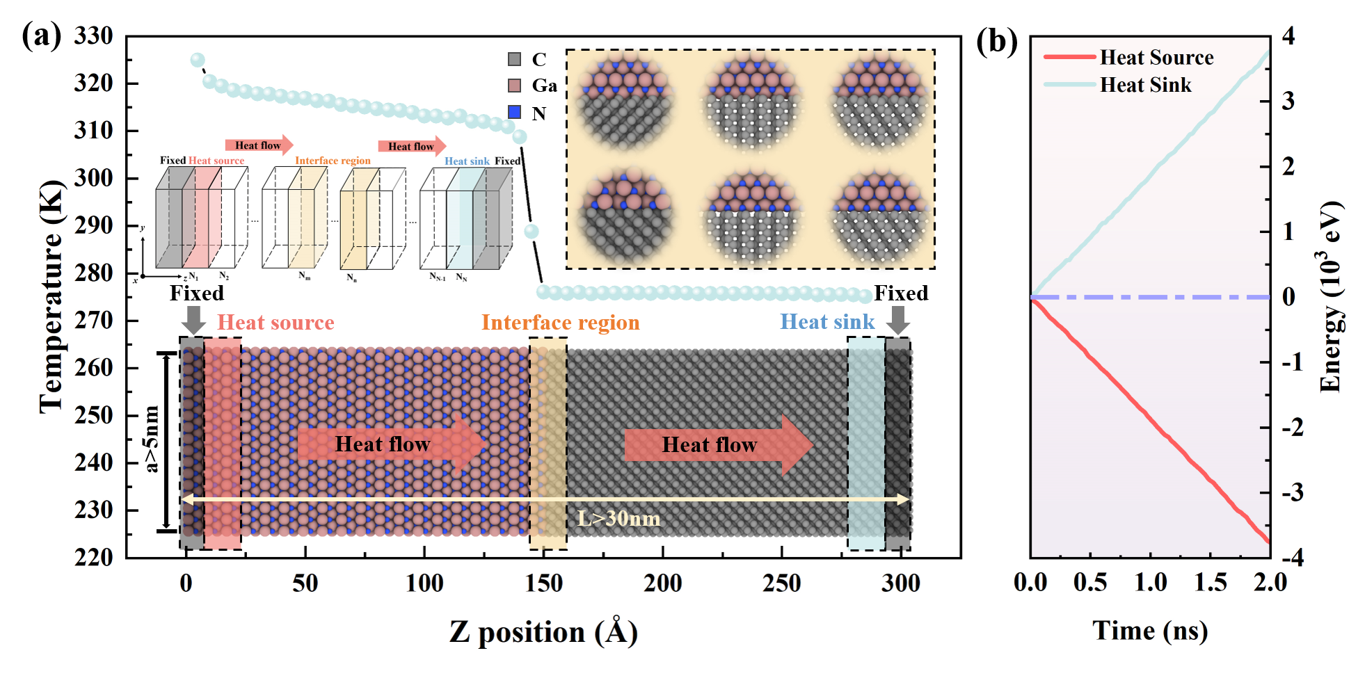
Fig. 2. (a) Schematic diagram of NEMD simulation. (b) The cumulative energy of the heat source domain and heat sink domain varying as a function of the simulation time.

Results and discussion

3.1 Bulk thermal properties
Phonon dispersion is considered a crucial thermal property and is commonly employed to evaluate interatomic potentials. As illustrated in Fig. 3(a, b), the phonon dispersion for GaN and diamond, as computed with the NEP, exhibits a high degree of alignment with the results obtained from the DFT (density functional theory) calculations. It is demonstrated that the NEP can predict the thermal properties of GaN and diamond with relative accuracy. The thermal conductivity values of diamond and GaN predicted by NEP and Tersoff potential at 300 K are shown in Fig. 3(c, d). This Tersoff potential has been widely used in previous studies [18]. In Fig. 3(e, f), it is observed that the NEP predictions for the thermal conductivity of GaN and diamond are lower than those obtained from DFT calculations. Nonetheless, both NEP predictions surpass the Tersoff potential predictions in accuracy. Based on the predicted thermal conductivity from DFT as the benchmark, the increase predicted by NEP is 20.48% for diamond and 35.52% for GaN compared to the predictions by Tersoff potential. Additionally, the thermal conductivity values predicted by NEP show outstanding consistency with the experimental results reported. In summary, the machine learning-trained NEP will exhibit superior performance compared to the traditional Tersoff potential in accurately predicting interfacial heat transfer in GaN/diamond heterostructures.

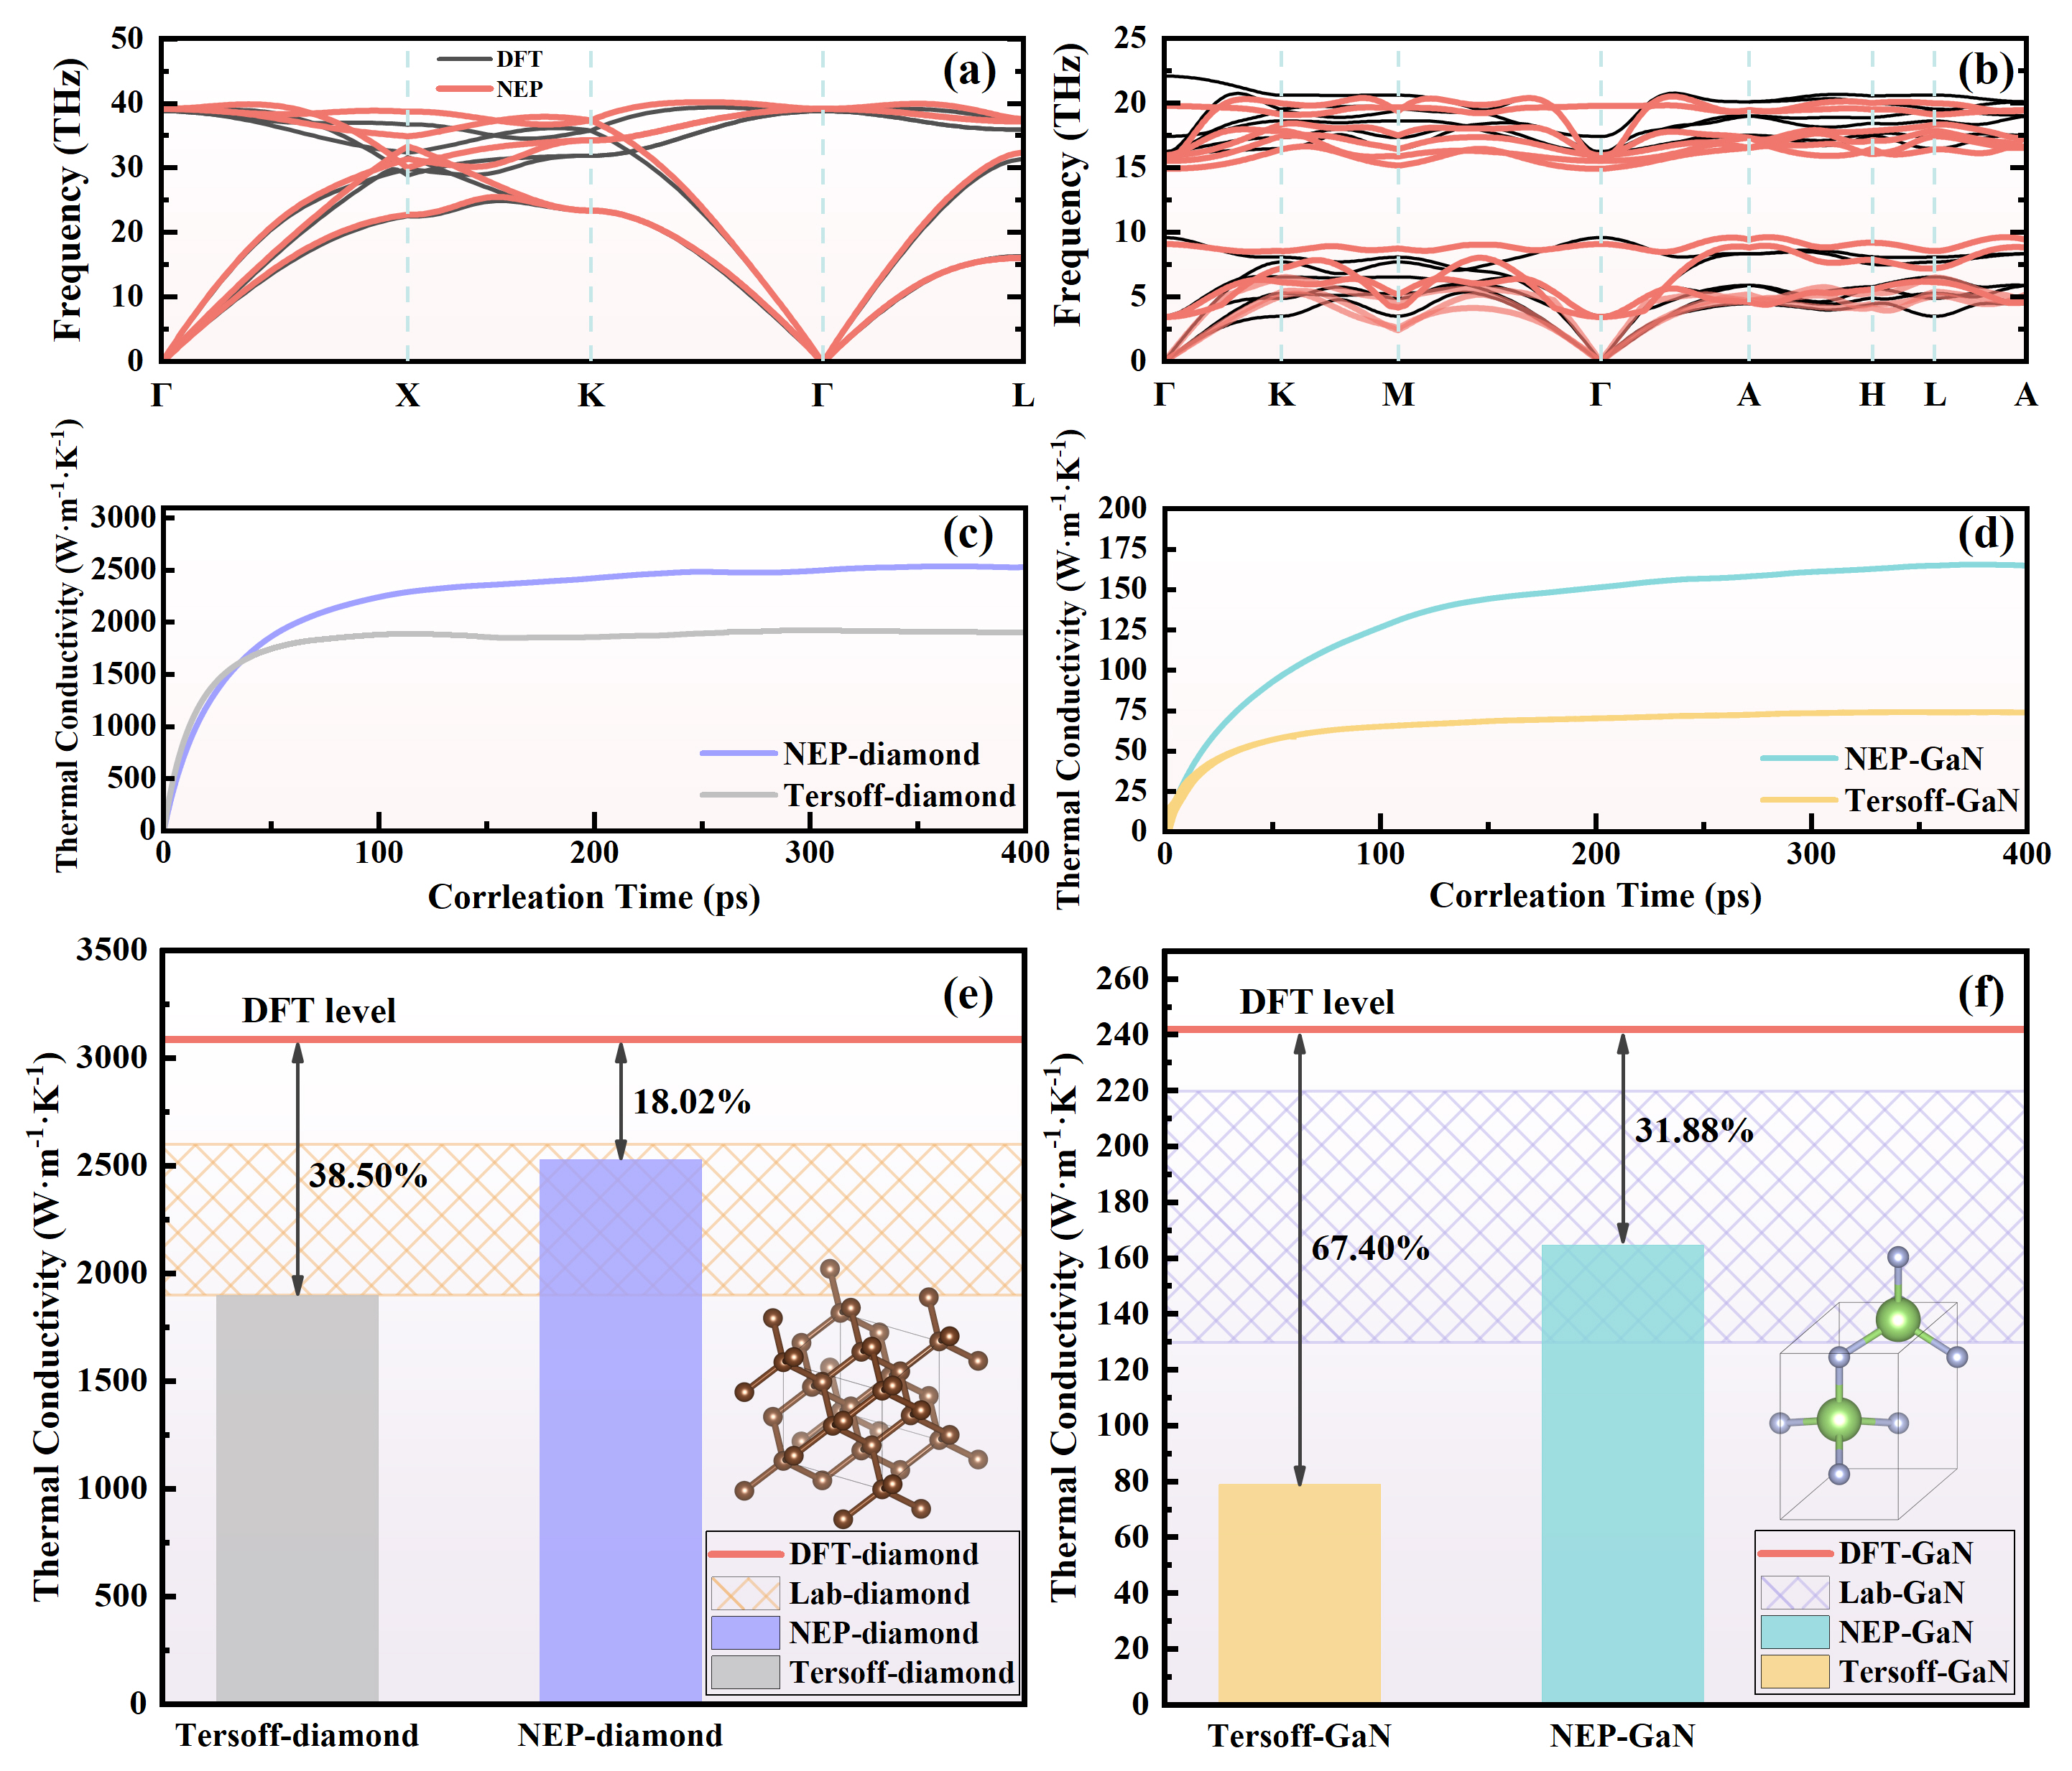
Fig. 3. Phonon dispersion of (a) diamond and (b) GaN. Thermal conductivity of (c) diamond and (d) GaN at 300 K as a function of correlation time using the Green–Kubo method, each of which is the average of 50 independent simulations. (e) A comparison between the thermal conductivity values of diamond predicted by NEP, Tersoff, DFT [10], and experimental measurements [12]. (f) A comparison between the thermal conductivity values of GaN predicted by NEP, Tersoff, DFT [45], and experimental measurements [46-50].

3.2 Heat transfer in GaN/diamond interfaces
Further investigation into the interfacial heat transfer in GaN/diamond heterostructures is conducted through NEMD simulations using NEP. Fig. 4(a) shows the TBR of heterostructures with different interface structures at different temperatures. At 300K, the TBR of different interface structures ranges from 2.22-3.26 m²·K·GW⁻¹, which is in perfect agreement with the value predicted by DMM theory (~3 m²·K·GW⁻¹) [21, 22]. This further demonstrates the credibility of the NEP we trained in studying heat transfer at the GaN/diamond heterostructure interface. In order to more clearly illustrate the effects of temperature and interface structure on TBR, Fig. 4(b) and Fig. 4(c) are plotted with temperature and interface atom type as the horizontal axes and TBR as the vertical axis, respectively. As shown in Fig. 4(a), TBR decreases with increasing temperature regardless of the interface structure. It is not difficult to observe that TBR exhibits an approximately linear relationship with temperature in the range of 200K to 600K. To further explore the reasons for this phenomenon, the VDOS of GaN and diamond at different temperatures are calculated, as shown in Fig. 5(a). Fig. 5(b-f) show the percentage of VDOS overlap between GaN and diamond at different temperatures. As the temperature increases, the percentage of VDOS overlap between GaN and diamond becomes higher. This may be the fundamental reason for the decrease in TBR with increasing temperature. Because a higher VDOS overlap enhances thermal transport across the interface [4]. In the GaN/diamond heterostructure, heat transfer primarily depends on lattice vibrations. The higher overlap of VDOS indicates that the vibrational frequencies are closer, leading to a more effective lattice vibration transmission. Furthermore, the variation of the VDOS overlap percentage with temperature is shown in Fig. 5(f). The percentage of VDOS overlap also has an approximately linear relationship with temperature, which may be the main reason why TBR has an approximately linear relationship with temperature.
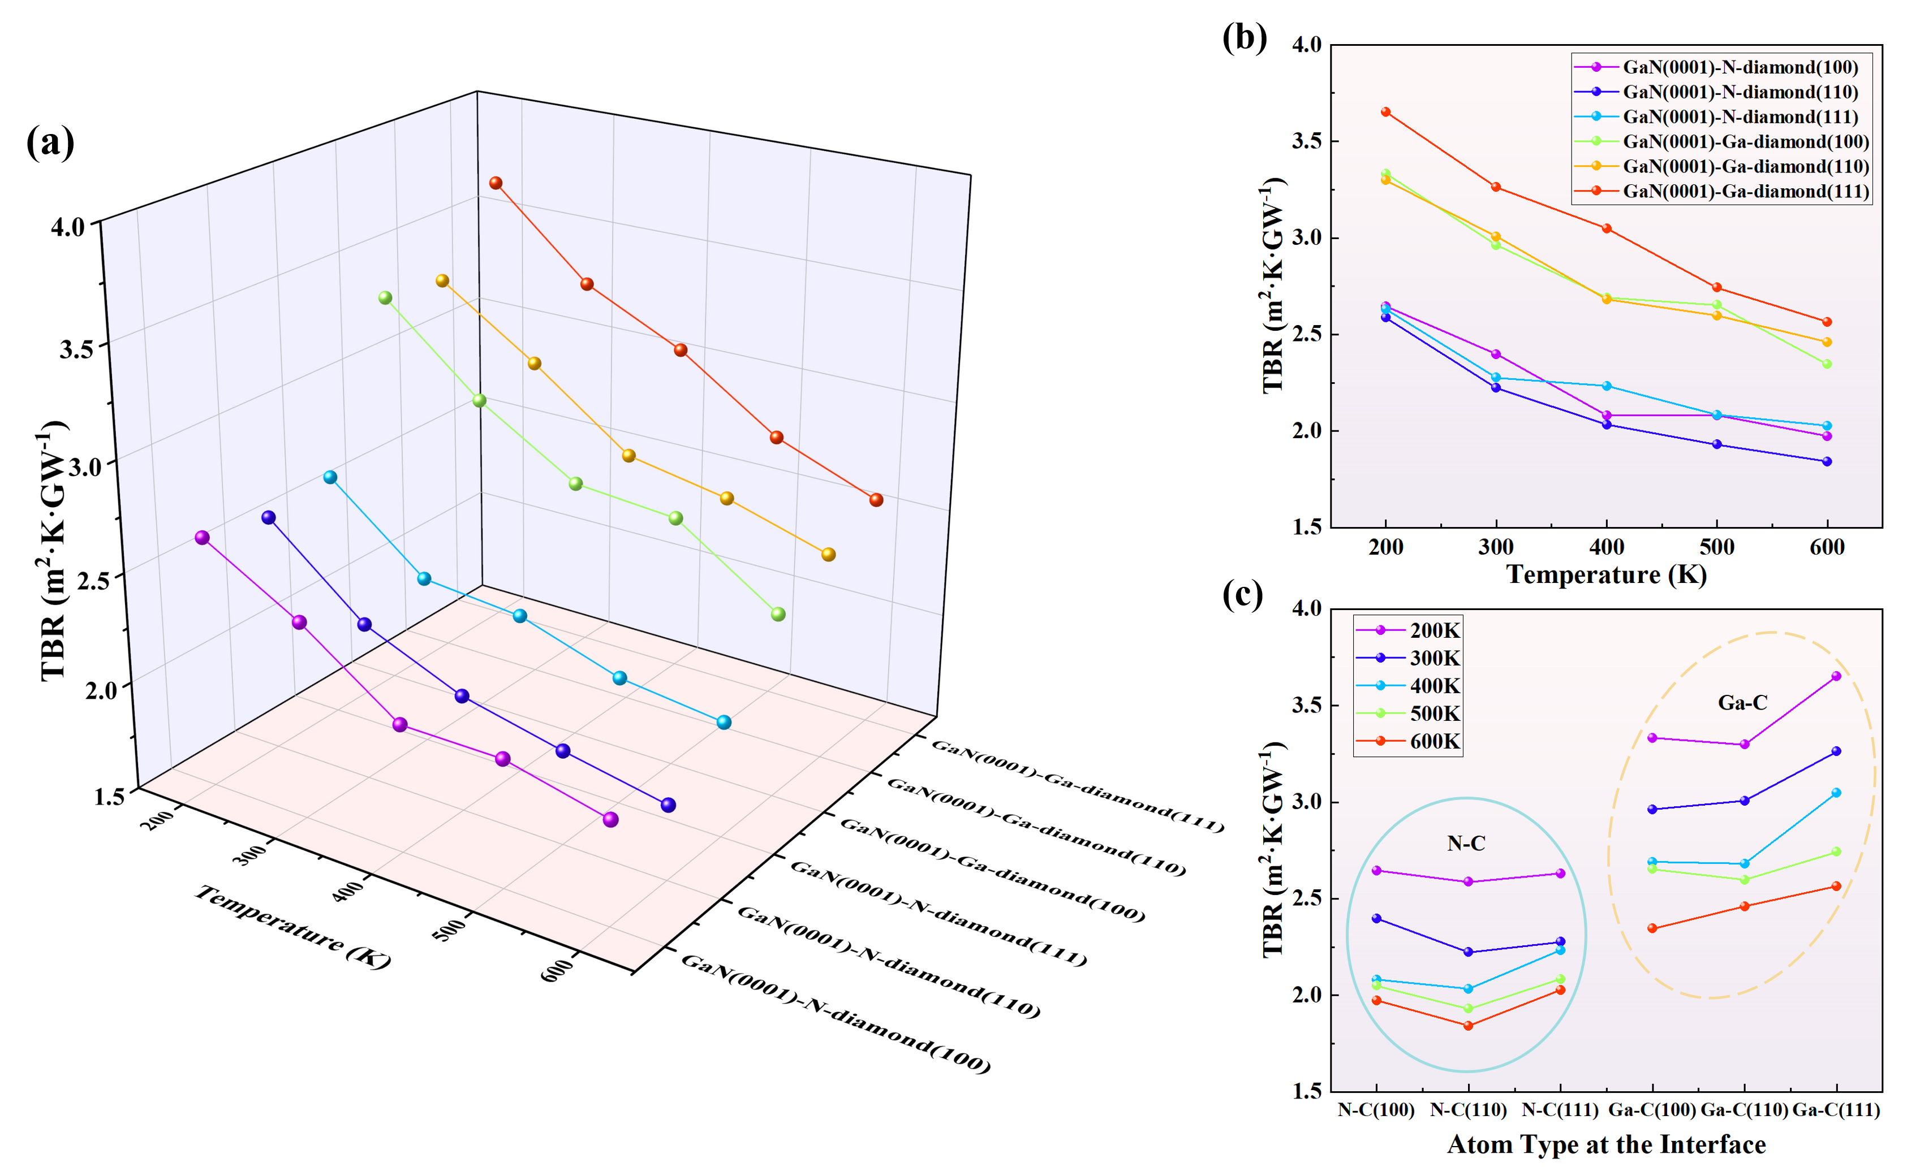
Fig. 4. (a) The TBR of heterostructures with different interface structures at different temperatures. TBR varies with (b) temperature and (c) interface atom type.

As shown in Fig. 4(c), we observe that the crystal orientation of diamond has a relatively small effect on TBR, while the atom type at the GaN interface has a significant impact on TBR. The TBR of N-C bonding is nearly 25% lower than that of Ga-C bonding. To further explore the reasons behind this phenomenon, the VDOS of GaN-Ga, GaN-N, and diamond-C are calculated, as shown in Fig. 6. The VDOS overlap between N atoms and C atoms is greater than that between Ga atoms and C atoms. The higher overlap of VDOS between N and C atoms indicates that the vibrational frequencies of N and C atoms are closer, leading to a more effective lattice vibration transmission. This is considered the primary reason for the lower TBR of N-C bonds compared to Ga-C bonds at the interface in GaN/diamond heterostructures.

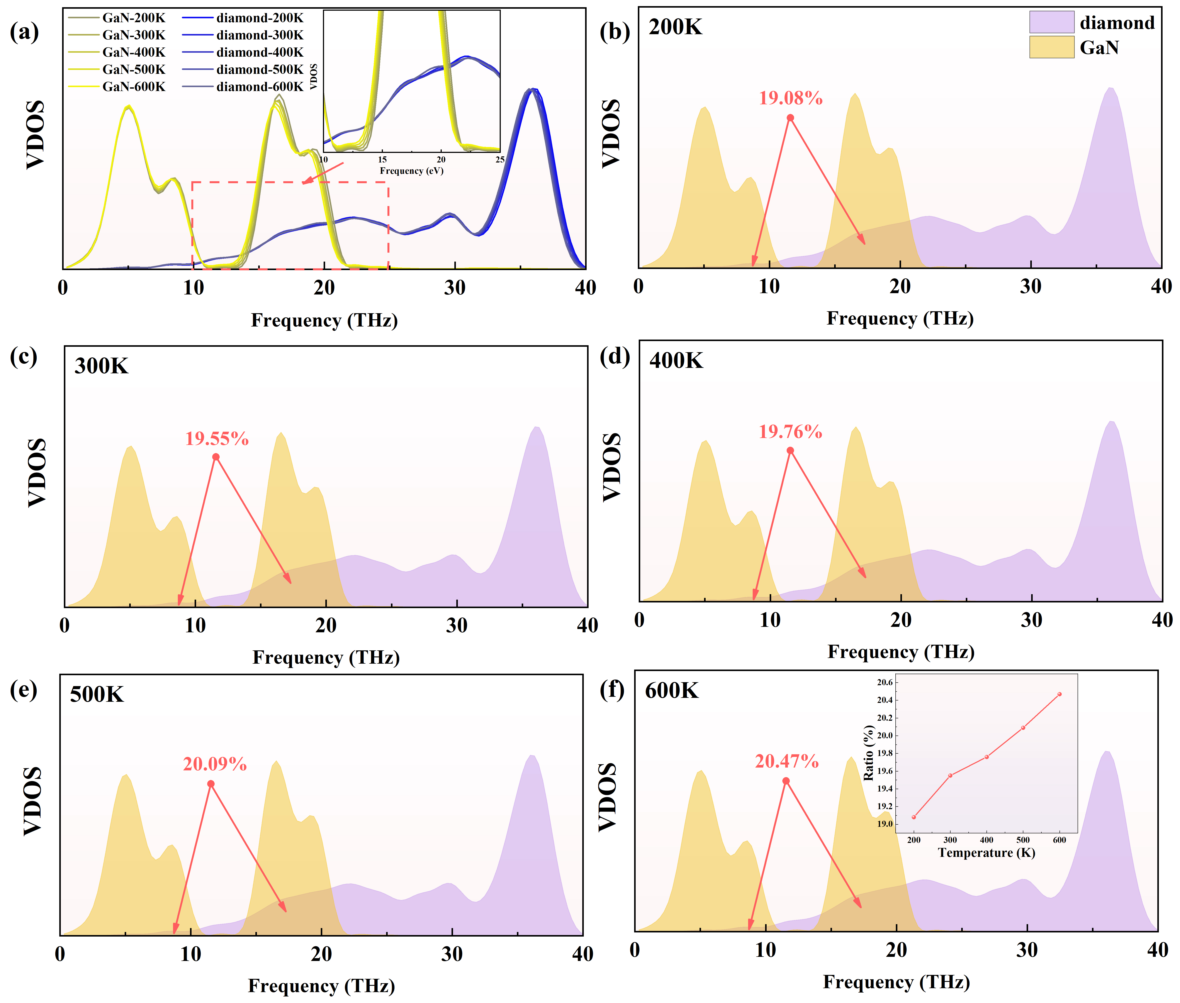
Fig. 5. (a) The VDOS of GaN and diamond at different temperature. The percentage of VDOS overlap between GaN and diamond at (b) 200K, (c) 300K, (d) 400K, (e) 500K, and (f) 600K.

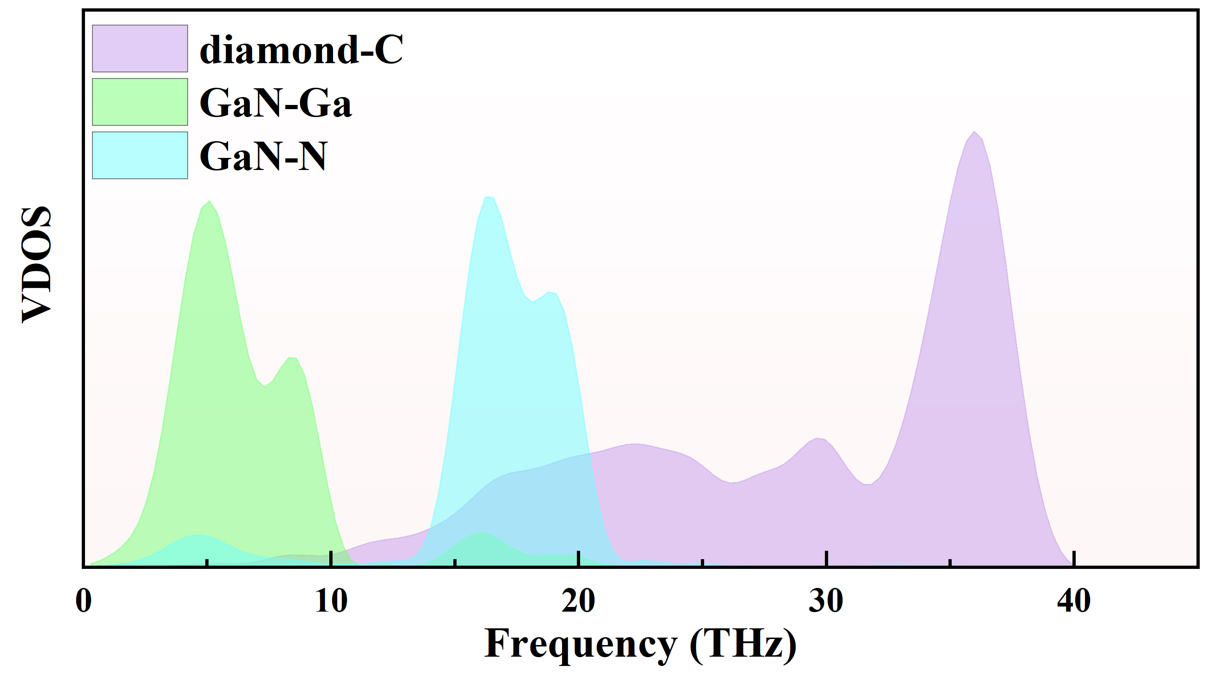
Fig. 6. The VDOS of diamond-C GaN-Ga, and GaN-N.

Conclusion
In conclusion, a NEP has been developed using GPUMD to predict the thermal transport properties at the GaN/diamond interface, based on machine learning techniques. The NEP has been used to predict the phonon dispersions of diamond and GaN, as well as the thermal conductivity at 300 K. The phonon dispersions predicted by NEP are in excellent agreement with the results predicted by DFT. Furthermore, the thermal conductivity predicted by NEP at 300 K is in excellent agreement with previously reported experimental measurement values. Although the thermal conductivity values predicted by NEP may not reach the level of DFT predictions, there is still a significant improvement compared to traditional potential.
Based on this, the TBR of the six interfaces in the GaN/diamond heterostructures has been predicted over the temperature range of 200-600K. At 300K, the TBR of different interface structures ranges from 2.22-3.26 m²·K·GW⁻¹, which is in perfect agreement with the value predicted by DMM theory (~3 m²·K·GW⁻¹). This further demonstrates the accuracy of our trained NEP in studying heat transfer at the GaN/diamond heterostructure interface. Furthermore, it was observed that TBR decreases with increasing temperature and exhibits an approximately linear relationship. By analyzing the percentage of VDOS overlap between GaN and diamond at different temperatures, the fundamental reason for this phenomenon has been identified. It was also found that the TBR of the N-C bonded heterostructures at the interface are approximately 25% lower than that of the Ga-C bonded heterostructures. By analyzing the VDOS of Ga atoms in GaN, N atoms in GaN, and C atoms in diamond, it was found that the VDOS overlap between N atoms and C atoms is higher than that between Ga atoms and C atoms. Therefore, when the interface is bonded by N atoms and C atoms, heat transfer is more efficient, resulting in a lower TBR.

Declaration of Competing Interest
The authors declare no conflict of interest.

Data Availability
The data that support the findings of this study are available from the corresponding author upon reasonable request. The potential file has been uploaded to the GitHub repository and is publicly available at https://github.com/wugai-whu/NEP-GaN-diamond-thermal-conductivity.

Acknowledgements
This work was funded by the National Natural Science Foundation of China (Grant Nos. 62004141, 52202045), the Knowledge Innovation Program of Wuhan-Shuguang (Grant Nos. 2023010201020243, 2023010201020255), the Fundamental Research Funds for the Central Universities (Grant Nos. 2042023kf0112, 2042022kf1028), the Major Program (JD) of Hubei Province (Grant No. 2023BAA009), the Hubei Natural Science Foundation (Grant No. 2022CFB606), the Open Fund of Hubei Key Laboratory of Electronic Manufacturing and Packaging Integration (Grant Nos. EMPI2024014, EMPI2024021, EMPI2023027), and the China Scholarship Council (Grant No. 202206275005). The numerical calculations in this paper have been done on the supercomputing system in the Supercomputing Center of Wuhan University.

References
[1] U.K. Mishra, P. Parikh, Y.-F. Wu, AlGaN/GaN HEMTs-an overview of device operation and applications, Proceedings of the IEEE, 90 (2002) 1022-1031.
[2] S. Pearton, F. Ren, A. Zhang, K. Lee, Fabrication and performance of GaN electronic devices, Materials Science and Engineering: R: Reports, 30 (2000) 55-212.
[3] J.C. Mendes, M. Liehr, C. Li, Diamond/GaN HEMTs: where from and where to?, Materials, 15 (2022) 415.
[4] C. Yang, J. Wang, D. Ma, Z. Li, Z. He, L. Liu, Z. Fu, J.-Y. Yang, Phonon transport across GaN-diamond interface: The nontrivial role of pre-interface vacancy-phonon scattering, International Journal of Heat and Mass Transfer, 214 (2023) 124433.
[5] J.S. Kang, M. Li, H. Wu, H. Nguyen, T. Aoki, Y. Hu, Integration of boron arsenide cooling substrates into gallium nitride devices, Nature Electronics, 4 (2021) 416-423.
[6] Y. Cui, M. Li, Y. Hu, Emerging interface materials for electronics thermal management: experiments, modeling, and new opportunities, Journal of Materials Chemistry C, 8 (2020) 10568-10586.
[7] Y. Cui, Z. Qin, H. Wu, M. Li, Y. Hu, Flexible thermal interface based on self-assembled boron arsenide for high-performance thermal management, Nature Communications, 12 (2021) 1284.
[8] J.S. Kang, H. Wu, Y. Hu, Thermal properties and phonon spectral characterization of synthetic boron phosphide for high thermal conductivity applications, Nano Letters, 17 (2017) 7507-7514.
[9] Z. Sun, D. Zhang, Z. Qi, Q. Wang, X. Sun, K. Liang, F. Dong, Y. Zhao, D. Zou, L. Li, Insight into Interfacial Heat Transfer of β-Ga₂O₃/Diamond Heterostructures via the Machine Learning Potential, ACS Applied Materials & Interfaces, 16 (2024) 31666-31676.
[10] A. Ward, D. Broido, D.A. Stewart, G. Deinzer, Ab initio theory of the lattice thermal conductivity in diamond, Physical Review B, 80 (2009) 125203.
[11] J. Xiong, Z. Qi, K. Liang, X. Sun, Z. Sun, Q. Wang, L. Chen, G. Wu, W. Shen, Molecular dynamics insights on thermal conductivities of cubic diamond, lonsdaleite and nanotwinned diamond via the machine learned potential, Chinese Physics B, 32 (2023) 680-687.
[12] D. Onn, A. Witek, Y. Qiu, T. Anthony, W. Banholzer, Some aspects of the thermal conductivity of isotopically enriched diamond single crystals, Physical Review Letters, 68 (1992) 2806.
[13] F.Z. Tijent, M. Faqir, H. Chouiyakh, E.H. Essadiqi, integration methods of GaN and diamond for thermal management optimization, ECS Journal of Solid State Science and Technology, 10 (2021) 074003.
[14] J. Liang, A. Kobayashi, Y. Shimizu, Y. Ohno, S.W. Kim, K. Koyama, M. Kasu, Y. Nagai, N. Shigekawa, Fabrication of GaN/diamond heterointerface and interfacial chemical bonding state for highly efficient device design, Advanced Materials, 33 (2021) 2104564.
[15] L. Sang, Diamond as the heat spreader for the thermal dissipation of GaN-based electronic devices, Functional Diamond, 1 (2022) 174-188.
[16] Z. Sun, X. Sun, Z. Qi, Q. Wang, R. Li, L. Li, G. Wu, W. Shen, S. Liu, Investigating thermal transport across the AlN/diamond Interface via the machine learning potential, Diamond and Related Materials, 147 (2024) 111303.
[17] Z. Qi, W. Shen, R. Li, X. Sun, L. Li, Q. Wang, G. Wu, K. Liang, AlN/diamond interface nanoengineering for reducing thermal boundary resistance by molecular dynamics simulations, Applied Surface Science, 615 (2023) 156419.
[18] L. Tao, S. Theruvakkattil Sreenivasan, R. Shahsavari, Interlaced, nanostructured interface with graphene buffer layer reduces thermal boundary resistance in nano/microelectronic systems, ACS Applied Materials & Interfaces, 9 (2017) 989-998.
[19] Z. Qi, X. Sun, Z. Sun, Q. Wang, D. Zhang, K. Liang, R. Li, D. Zou, L. Li, G. Wu, Interfacial Optimization for AlN/Diamond Heterostructures via Machine Learning Potential Molecular Dynamics Investigation of the Mechanical Properties, ACS Applied Materials & Interfaces, 16 (2024) 27998-28007.
[20] R. Li, Z. Liu, A. Rohskopf, K. Gordiz, A. Henry, E. Lee, T. Luo, A deep neural network interatomic potential for studying thermal conductivity of β-Ga₂O₃, Applied Physics Letters, 117 (2020) 152102.
[21] H. Sun, R.B. Simon, J.W. Pomeroy, D. Francis, F. Faili, D.J. Twitchen, M. Kuball, Reducing GaN-on-diamond interfacial thermal resistance for high power transistor applications, Applied Physics Letters, 106 (2015) 111906.
[22] Y. Gu, Y. Zhang, B. Hua, X. Ni, Q. Fan, X. Gu, Interface engineering enabling next generation GaN-on-diamond power devices, Journal of Electronic Materials, 50 (2021) 4239-4249.
[23] B. Mortazavi, E.V. Podryabinkin, S. Roche, T. Rabczuk, X. Zhuang, A.V. Shapeev, Machine-learning interatomic potentials enable first-principles multiscale modeling of lattice thermal conductivity in graphene/borophene heterostructures, Materials Horizons, 7 (2020) 2359-2367.
[24] J. Wu, E. Zhou, A. Huang, H. Zhang, M. Hu, G. Qin, Deep-potential enabled multiscale simulation of gallium nitride devices on boron arsenide cooling substrates, Nature Communications, 15 (2024) 2540.
[25] Z. Sun, Z. Qi, K. Liang, X. Sun, Z. Zhang, L. Li, Q. Wang, G. Zhang, G. Wu, W. Shen, A neuroevolution potential for predicting the thermal conductivity of α, β, and ε-Ga₂O₃, Applied Physics Letters, 123 (2023) 192202.
[26] Y.-J. Wu, L. Fang, Y. Xu, Predicting interfacial thermal resistance by machine learning, npj Computational Materials, 5 (2019) 56.
[27] Z. Fan, T. Siro, A. Harju, Accelerated molecular dynamics force evaluation on graphics processing units for thermal conductivity calculations, Computer Physics Communications, 184 (2013) 1414-1425.
[28] B. Mortazavi, Z. Fan, L.F.C. Pereira, A. Harju, T. Rabczuk, Amorphized graphene: a stiff material with low thermal conductivity, Carbon, 103 (2016) 318-326.
[29] Z. Fan, W. Chen, V. Vierimaa, A. Harju, Efficient molecular dynamics simulations with many-body potentials on graphics processing units, Computer Physics Communications, 218 (2017) 10-16.
[30] Z. Fan, Z. Zeng, C. Zhang, Y. Wang, K. Song, H. Dong, Y. Chen, T. Ala-Nissila, Neuroevolution machine learning potentials: Combining high accuracy and low cost in atomistic simulations and application to heat transport, Physical Review B, 104 (2021) 104309.
[31] T. Schaul, T. Glasmachers, J. Schmidhuber, High dimensions and heavy tails for natural evolution strategies, in: Proceedings of the 13th Annual Conference on Genetic and Evolutionary Computation, 2011, pp. 845-852.
[32] Z. Fan, Y. Wang, P. Ying, K. Song, J. Wang, Y. Wang, Z. Zeng, K. Xu, E. Lindgren, J.M. Rahm, GPUMD: A package for constructing accurate machine-learned potentials and performing highly efficient atomistic simulations, The Journal of Chemical Physics, 157 (2022) 114801.
[33] Z. Fan, Improving the accuracy of the neuroevolution machine learning potential for multi-component systems, Journal of Physics: Condensed Matter, 34 (2022) 125902.
[34] G. Kresse, J. Furthmüller, Efficiency of ab-initio total energy calculations for metals and semiconductors using a plane-wave basis set, Computational Materials Science, 6 (1996) 15-50.
[35] G. Kresse, D. Joubert, From ultrasoft pseudopotentials to the projector augmented-wave method, Physical Review B, 59 (1999) 1758.
[36] V. Wang, N. Xu, J.-C. Liu, G. Tang, W.-T. Geng, VASPKIT: A user-friendly interface facilitating high-throughput computing and analysis using VASP code, Computer Physics Communications, 267 (2021) 108033.
[37] H. Yanxon, D. Zagaceta, B. Tang, D.S. Matteson, Q. Zhu, PyXtal_FF: a python library for automated force field generation, Machine Learning: Science and Technology, 2 (2020) 027001.
[38] X. Yu, R. Li, T. Shiga, L. Feng, M. An, L. Zhang, J. Shiomi, N. Yang, Hybrid thermal transport characteristics of doped organic semiconductor poly (3, 4-ethylenedioxythiophene): tosylate, The Journal of Physical Chemistry C, 123 (2019) 26735-26741.
[39] R. Kubo, M. Toda, N. Hashitsume, Statistical Physics II: Nonequilibrium Statistical Mechanics, Springer Science & Business Media, Berlin, 2012.
[40] H. Meng, X. Yu, H. Feng, Z. Xue, N. Yang, Superior thermal conductivity of poly (ethylene oxide) for solid-state electrolytes: A molecular dynamics study, International Journal of Heat and Mass Transfer, 137 (2019) 1241-1246.
[41] K. Momma, F. Izumi, VESTA 3 for three-dimensional visualization of crystal, volumetric and morphology data, Journal of Applied Crystallography, 44 (2011) 1272-1276.
[42] A. Stukowski, Visualization and analysis of atomistic simulation data with OVITO–the Open Visualization Tool, Modelling and simulation in materials science and engineering, 18 (2009) 015012.
[43] W. Sha, X. Dai, S. Chen, B. Yin, F. Guo, Phonon thermal transport in two-dimensional PbTe monolayers via extensive molecular dynamics simulations with a neuroevolution potential, Materials Today Physics, 34 (2023) 101066.
[44] E.T. Swartz, R.O. Pohl, Thermal boundary resistance, Reviews of Modern Physics, 61 (1989) 605.
[45] L. Lindsay, D. Broido, T. Reinecke, Thermal conductivity and large isotope effect in GaN from first principles, Physical review letters, 109 (2012) 095901.
[46] E. Sichel, J. Pankove, Thermal conductivity of GaN, 25–360 K, Journal of physics and chemistry of solids, 38 (1977) 330.
[47] A. Jeżowski, B. Danilchenko, M. Boćkowski, I. Grzegory, S. Krukowski, T. Suski, T. Paszkiewicz, Thermal conductivity of GaN crystals in 4.2–300 K range, Solid state communications, 128 (2003) 69-73.
[48] G.A. Slack, Nonmetallic crystals with high thermal conductivity, Journal of Physics and Chemistry of Solids, 34 (1973) 321-335.
[49] C.-Y. Luo, H. Marchand, D. Clarke, S. DenBaars, Thermal conductivity of lateral epitaxial overgrown GaN films, Applied Physics Letters, 75 (1999) 4151-4153.
[50] Q. Zheng, C. Li, A. Rai, J.H. Leach, D.A. Broido, D.G. Cahill, Thermal conductivity of GaN, GaN 71, and SiC from 150 K to 850 K, Physical Review Materials, 3 (2019) 014601.

