Supporting Information
High-Quality Three-Dimensionally Cultured Cells Using Interfaces of Diblock Copolymers Containing Different Ratios of Zwitterionic N-oxides
Naoto Ogiwara ^{1,2)}, Takenobu Nakano ¹⁾,Koki Baba ¹⁾, Hidenori Noguchi ³⁾, Tsukuru Masuda²⁾, Madoka Takai²⁾*
¹⁾ Biotech business unit, Incubation center, artience Co., Ltd., 5-6-7 Chiyoda, Sakado-city, Saitama 350-0214, Japan
²⁾ Department of Bioengineering, School of Engineering, The University of Tokyo, 7-3-1 Hongo, Bunkyo-ku, Tokyo 113-8656, Japan
³⁾ Center for Green Research on Energy and Environmental Materials and Global Research Center for Environment and Energy based on Nanomaterials Science (GREEN), National Institute for Materials Science (NIMS), 1-1 Namiki, Tsukuba, Ibaraki 305-0044, Japan
*E-mail: takai@bis.t.u-tokyo.ac.jp

Table of Contents Page
1. qRT-PCR primer set list Table S1 3
2. Structural analysis of N-oxide containing diblock copolymers
Figures S1 and S2 4,5
3. Solubility test of zwitterionic polymer Figure S3 8
4. The ATR spectra of each diblock copolymer-coated surface
Figure S4 9
5. The XPS spectra of each diblock copolymer-coated surface
Figure S5 11
Table S2 12
Figure S6 13
6. Adhesion force and free energy of adhesion Table S3 14
7. Protein adsorption test using QCM-D Figure S7 16
8. Cell adhesion behavior on diblock copolymer-coated surface at low cell seeding numbers
Figure S8 17
Figure S9 18
9. Cell viability and proliferation on diblock copolymer-coated surface by WST assay
Figure S10 19
10. Cell adhesion behavior on PEG-M10 coated surface and PrimeSurface®️. Figure S11 20

qRT-PCR primer set list

Table S1. qRT-PCR primers used in this study
Primer | Direction | Sequence (5’-3’)
Glyceraldehyde-3-phosphate dehydrogenase (GAPDH) | Forward | GGTGTGAACCACGAGAAA
Glyceraldehyde-3-phosphate dehydrogenase (GAPDH) | Reverse | TGAAGTCGCAGGAGACAA
Octamer-binding transcription factor 4 (Oct4) | Forward | CAGACCACCATCTGTCGCTTC
Octamer-binding transcription factor 4 (Oct4) | Reverse | AGACTCCACCTCACACGGTTCTC
Nanog | Forward | TGCCAGTGATTTGGAGGTGAA
Nanog | Reverse | ATTTCACCTGGTGGAGTCACAGAG
Sox2/sex determining region Y (SRY)-box 2 | Forward | GTTCTAGTGGTACGTTAGGCGCTTC
Sox2/sex determining region Y (SRY)-box 2 | Reverse | TCGCCCGGAGTCTAGCTCTAAATA

Structural analysis of N-oxide containing diblock copolymers
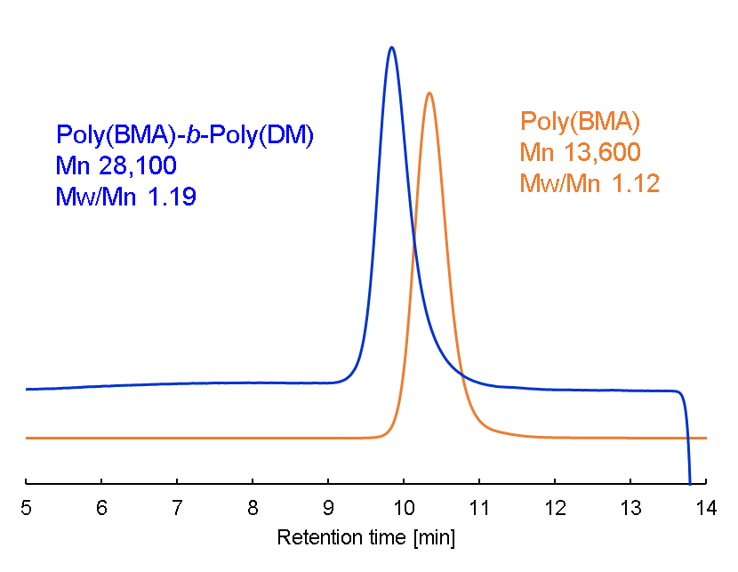

Figure S1. DMF gel permeation chromatograms of diblock copolymer poly(BMA)-block-Poly(DMAMEA) (blue curve) and its precursor poly(BMA) macro-RAFT reagent (orange curve)

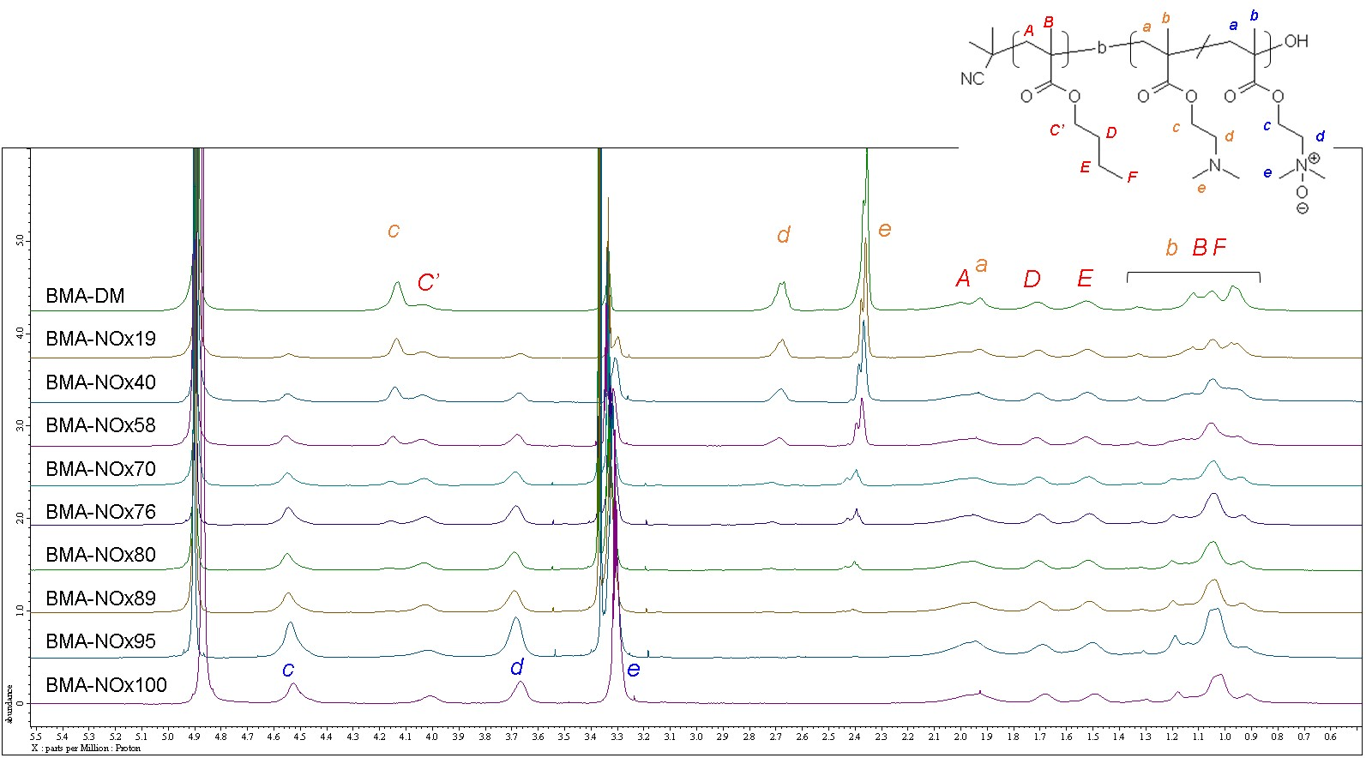

Figure S2. ¹H-NMR spectra of poly(BMA)-block-poly(DM-r-NO) diblock copolymer with various N-oxide ratios in methanol-d₄.

Solubility test of poly(DMAEMA) and zwitterionic homopolymer

Three type of zwitterionic homopolymers were synthesized and compared for solubility.
Molecular-weight-controlled poly(DMAEMA) was prepared and characterized using activators regenerated by electron transfer atom transfer radical (ARGET-ATRP) polymerization. Prior to polymerization, DMAEMA was purified using column chromatography (basic Al₂O₃) to remove the polymerization inhibitor. Two stock solutions were prepared for polymerization. One was a CuBr₂/ tris(2-pyridylmethyl)amine (TPMA) complex solution, which was prepared by mixing CuBr₂ with TPMA in a cosolvent of deionized water and 2-propanol (1:99 volumetric ratio). The second solution was an l-ascorbic acid (AA) solution prepared using a co-solvent of deionized water and 2-propanol (1:99). ARGET-ATRP was performed using fixed final concentrations of DMAEMA, CuBr₂, TPMA, and AA. Polymerization was performed using 2.0 M DMAEMA, [DMAEMA]:[CuBr₂]:[TPMA]:[ethyl 2-bromoisobutyrate]:[AA]=40000:1:2:40:1.
For the poly(DMAEMA) synthesis, with in a three-neck round bottom flask, 70.77 mL of DMAEMA, 61.64 μL of ethyl 2-bromoisobutyrate, 3 mL of a stock solution of a CuBr₂/TPMA complex (2.345 mg CuBr₂, 6.098 mg TPMA), and 200 mL of the co-solvent were added under nitrogen protection. Subsequently, 3 mL of the stock solution of AA (1.849 mg) was added to each vial. The flask was placed in a 50 °C oil bath, and the polymerization proceeded with stirring for 16 h. Polymerization was terminated by cooling the flask to 5 °C and exposing the solution to open air. The mixture was then precipitated in excess hexane as a poor solvent and purified by repeated precipitation, followed by drying in vacuo to obtain poly (DMAEMA). M_{n} and PDI were 40,200 and 1.77, respectively.
To synthesize poly(N-oxide) (poly(DMAEMA))synthesis, 1.73 g of poly(DMAEMA) was diluted with 5 g of methanol. Under nitrogen protection, 1.25 g of hydrogen peroxide aqueous solution was added and the reaction was carried out at 40 °C for 24 hours with stirring. After precipitation in excess acetone as a poor solvent, the mixture was dried in vacuo to obtain poly(NO).
For the synthesis of poly(carboxybetaine) (poly(CB)) synthesis, 1.53 g of poly(DMAEMA) was diluted in methanol (5 g) and deionized water (5 g). Under nitrogen protection, 1.13 g of sodium chloroacetate was added and the reaction was carried out at 40 °C for 24 hours with stirring. After precipitation in excess acetone as a poor solvent, the mixture was dried in vacuo to obtain poly(CB).
For the synthesis of poly(sulfobetaine) (poly(SB)) synthesis, 1.25 g of poly(DMAEMA) was diluted in methanol (5 g) and deionized water (15 g). Under nitrogen protection, 0.98 g of 1,3-Propanesultone was added and the reaction was carried out at 40 °C for 24 hours with stirring. After precipitation in excess acetone as a poor solvent, the mixture was dried in vacuo to obtain poly(SB).
Solubility tests were performed on poly (DMAEMA), poly (NO), poly (CB), and poly (SB) to determine the effects of the zwitterionic structure. Each copolymer (100 mg) was dissolved in solvent (5 mL) at 24 °C. The mixture was shaken and stirred, and dissolution was checked visually. “+, soluble” means that the polymer was completely dissolved to form a clear solution. “±, partially soluble” means that polymer was dispersed in solvent and formed a cloudy white dispersion. “-, insoluble” means that polymer has separated from the solvent and is easily distinguishable.
The results of the solubility tests are shown in Figure S9. The solubility of poly(DMAEMA) was similar to that previously reported. [1] All the zwitterionic homopolymers were soluble in water and methanol. Poly(CB), such as poly(2-methacryloyloxyethyl phosphorylcholine), has been reported to exhibit co-nonsolvent behavior in water/ethanol mixtures, [2,3] whereas poly(NO) is soluble in water/ethanol mixtures and water with high solution ionic strengths, such as in the presence of 5.0 mol/L NaCl.
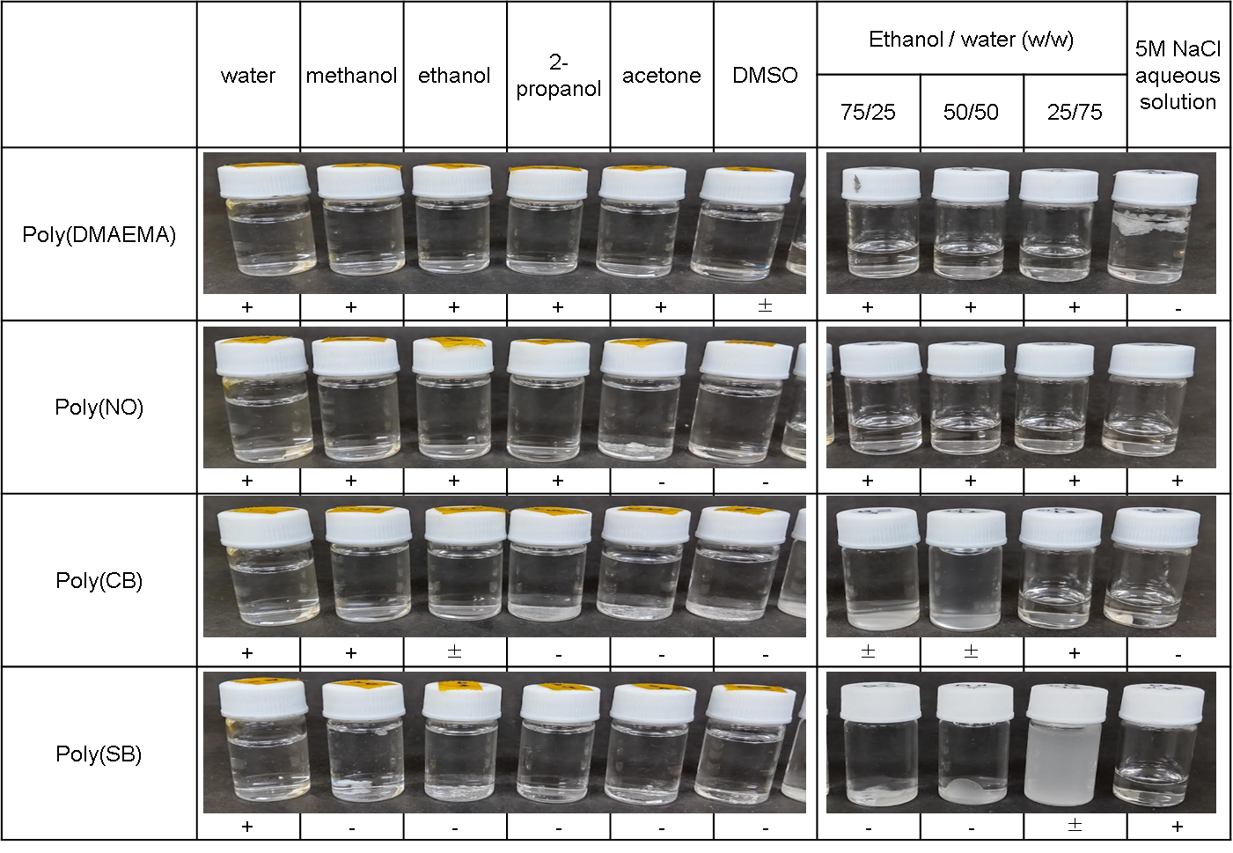

Figure S3. Solubility images of poly(DMAEMA), poly(NO), poly(CB), and poly(SB) in solvent at 24 °C. [polymer] = 20 g/L.
-: insoluble, ±: partially soluble, ＋: soluble

The ATR spectra of each diblock copolymer-coated surface
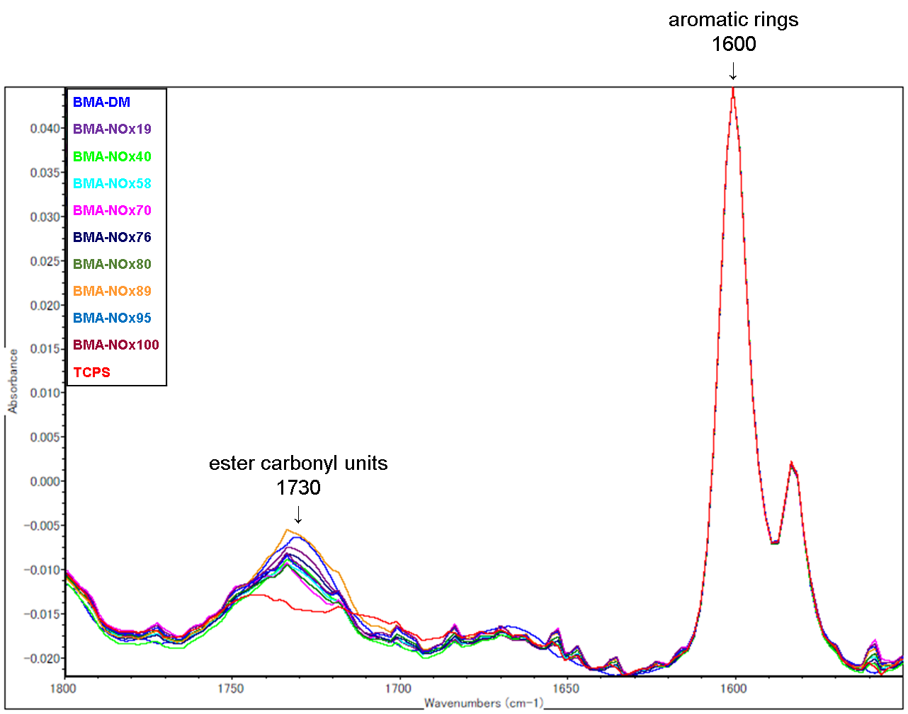
To confirm whether the polymer layer was still present on the TCPS after immersion in water, the peak intensities of I₁₇₃₀ /I₁₆₀₀ were examined.

Figure S4. FT-IR spectrum of the N-oxide containing diblock copolymer-coated surface.

The XPS spectra of each diblock copolymer-coated surface
X-ray photoelectron spectroscopy (XPS) was performed to verify the presence of each diblock copolymer. As shown in Figure S5 and Table S2, nitrogen elements (N1s) were observed on all the diblock copolymer-coated surfaces, confirming the presence of the polymer even after rinsing the TCPS dish with distilled water. Figure S6 shows the N1s narrow scan data. The N1s peak consisted of two peaks: 398.5 and 402.3 eV, attributed to DM AEMA[-N(CH₃)₂] and NO [-N+(CH₃)₂O], respectively. As shown in Figure S6, the percentage of binding energy (BE) area of NO approaches 80% as the N-oxide ratio increases, respectively. Although ¹H-NMR confirmed 100% denaturation of tertiary amino groups in BMA-NOx100, XPS suggested that approximately 20% of tertiary amino groups was in remained as the tertiary amine state in BMA-NOx100. This is attributed to the high-vacuum environment in which the XPS measurements were performed. It has been reported that the percentage of tertiary amino groups increases under high vacuum in poly(carboxybetaine), which has a zwitterionic structure similar to N-oxide. It was mentioned that the poly(carboxybetaine) degrade over a relatively short period of time within the vacuum of the XPS. [4] It has also been reported that CYP450 enzymes catalyze the reduction of N-oxide to tert-amine under hypoxic conditions. [5] Considering these facts, it is difficult to quantitatively characterize the N-oxide containing diblock copolymer-coated surface using XPS, which is performed under high vacuum.
However, it was concluded that the polymer was present on the TCPS dishes, and as the N-oxide ratio calculated by NMR increased, the ratio of amino groups on the polymer-coated surface also tended to increase.
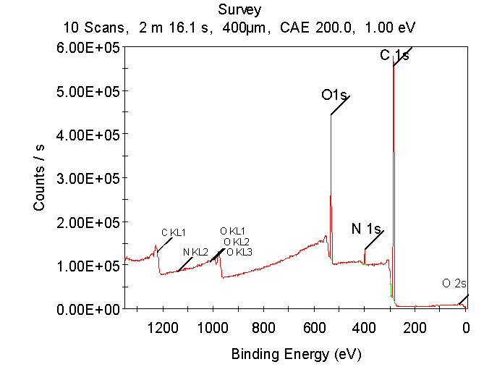
(a)

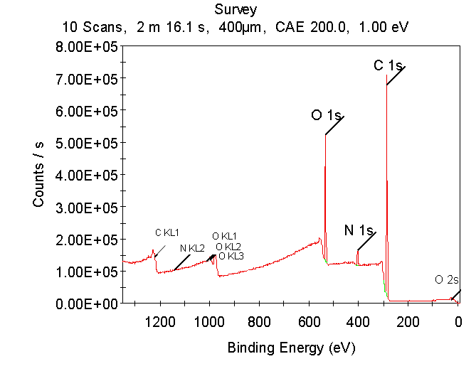
(b)

Figure S5. XPS survey spectra of BMA-DM (a) and BMA-NOx100 (b).

Table S2. Elemental surface composition of copolymer-coated surface determined from XPS.
 | Atom %
 | C1s | N1s | O1s
BMA-DM | 77.79 | 3.05 | 19.16
BMA-NOx19 | 77.09 | 3.03 | 19.57
BMA-NOx40 | 76.31 | 3.20 | 19.78
BMA-NOx58 | 74.67 | 3.34 | 21.29
BMA-NOx70 | 75.23 | 3.09 | 21.32
BMA-NOx76 | 75.05 | 3.60 | 20.21
BMA-NOx80 | 75.74 | 2.81 | 21.12
BMA-NOx89 | 75.91 | 2.71 | 21.05
BMA-NOx95 | 76.34 | 2.41 | 20.93
BMA-NOx100 | 76.09 | 3.05 | 20.53

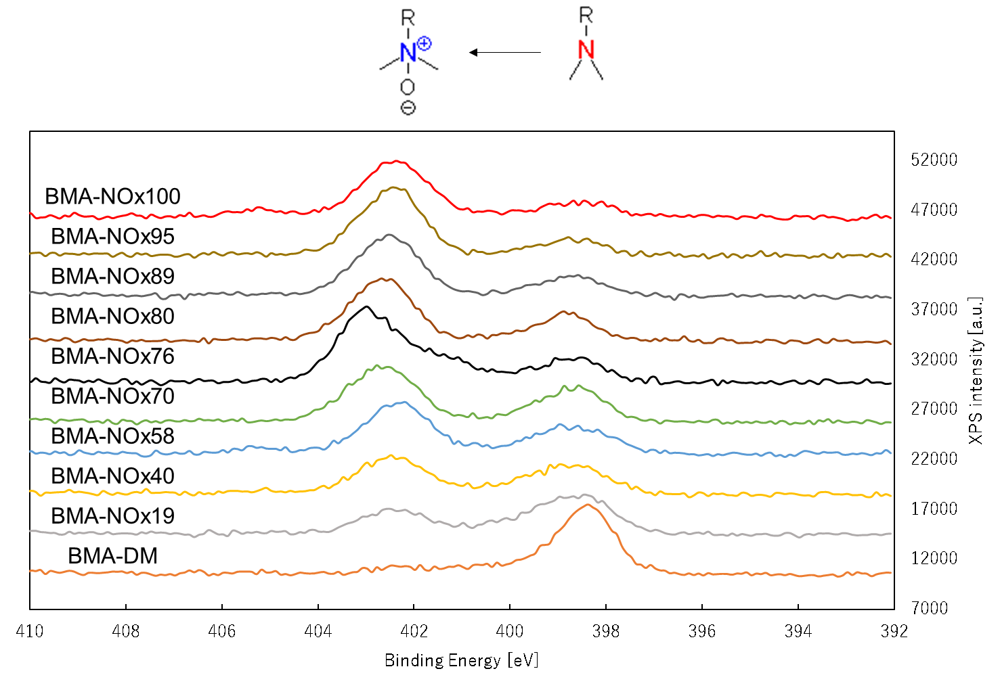

Figure S6. XPS high-resolution elemental scan of N1s of the N-Oxide containing diblock copolymer-coated surface.

Adhesion force and Free energy of adhesion of polymer-coated surfaces in water

Table S3 shows the adhesion forces (F) and free energy of adhesion (W) of polymer-coated surfaces calculated from AFM measurements in water. The F was estimated and the W was calculated by Johnson–Kendal–Roberts theory, where W = 2F/3πR for soft deformable surfaces. [6]

 | BMA-DM | BMA-NOx19 | BMA-NOx40 | BMA-NOx58 | BMA-NOx70 | BMA-NOx76 | BMA-NOx100
Adhesion force  [nN] | 11.6 | 0.96 | 0.046 | 0.030 | 0.019 | 0.046 | 0.020
Free energy of adhesion [mJ/m²] | 4.9 | 0.41 | 0.020 | 0.013 | 0.0081 | 0.020 | 0.0085
Table S3. Adhesion force and Free energy of adhesion of polymer-coated surfaces in water.

Protein adsorption test by QCM-D

In Figure S7, the time course of the resonance frequency changes and energy dissipation changes in the Alb, Lyz, Fng, and 10% FBS containing medium adsorptions were shown. Energy dissipation was determined from the decay rate of the quartz crystal oscillation, and the increase in D corresponded to a large energy loss on the QCM-D sensor substrate. Regarding the adsorption test data for Alb and Fng, little to no variation in the D value was observed for BMA-DM, whereas a significant increase was seen for BMA-NOx19. These observations can be rationalized by the adsorption-induced structural changes in Alb and Fng on the cationic polymer-coated surfaces. The Alb- or Fng-adsorbed BMA-DM surfaces became rigid, whereas the Alb- or Fng-adsorbed BMA-NOx19 surfaces did not. This variation has been described previously in the literature. [7]

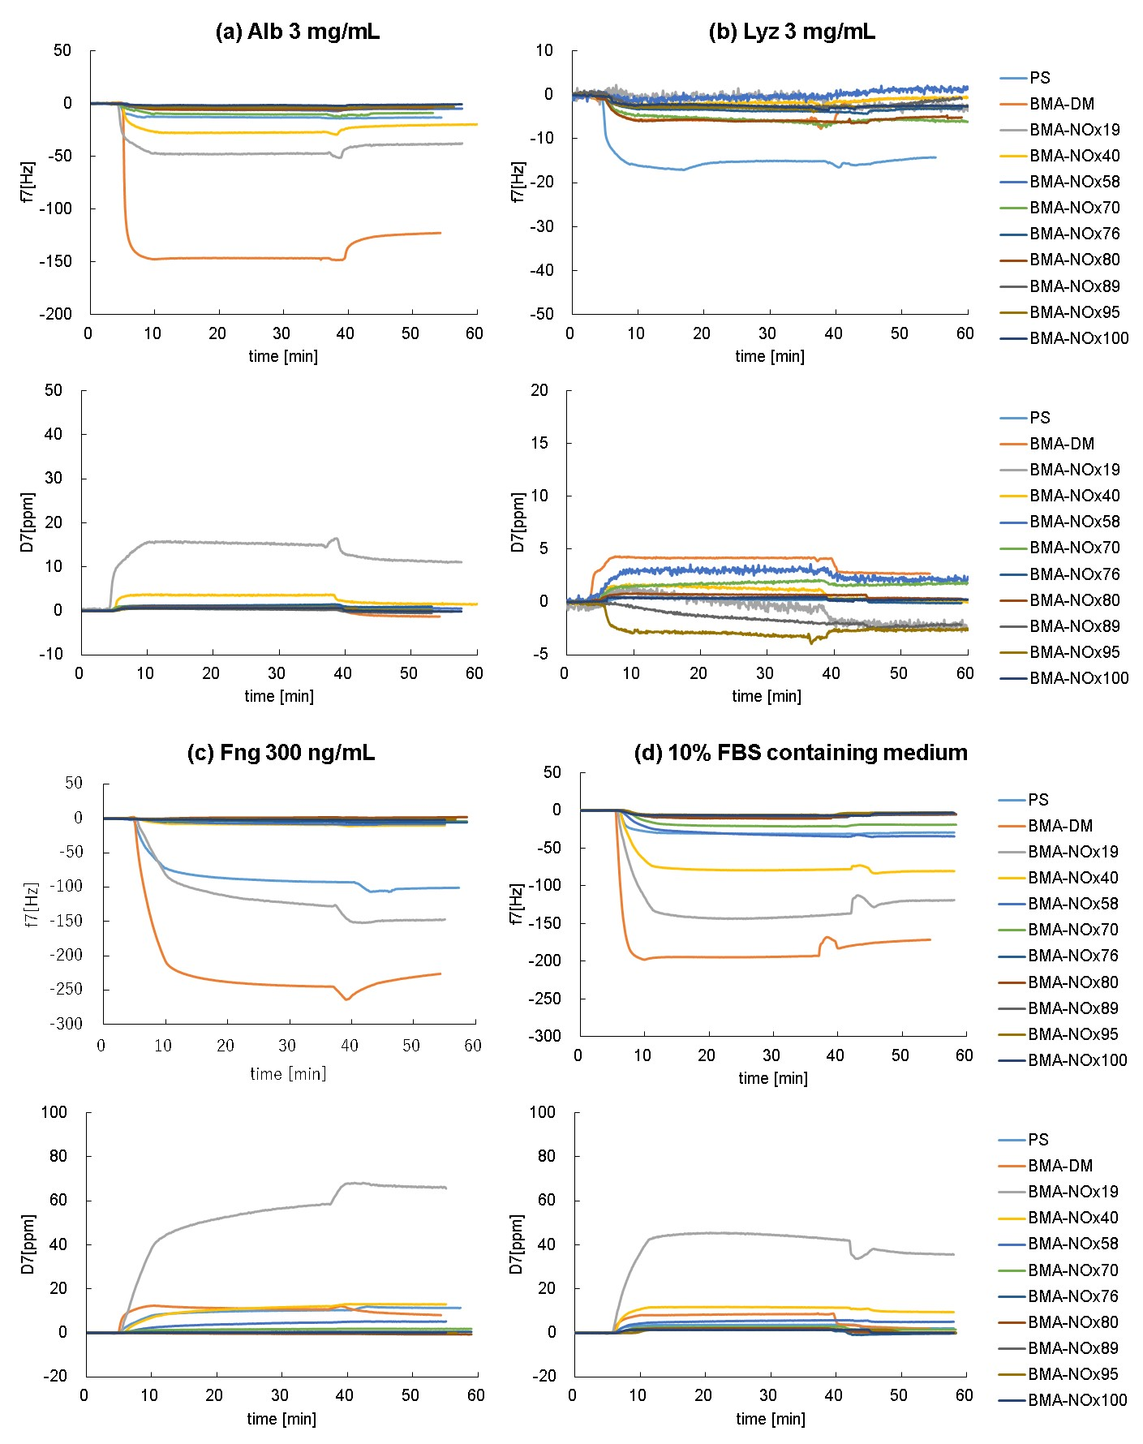
Figure S7. QCM chart of frequency change (above) and dissipation change (below) with respect to Alb (a), Lyz (b), Fng (c), and 10% FBS containing medium (d) on each diblock copolymer-coated surface.
Cell adhesion behavior on diblock copolymer-coated surface at low cell seeding numbers
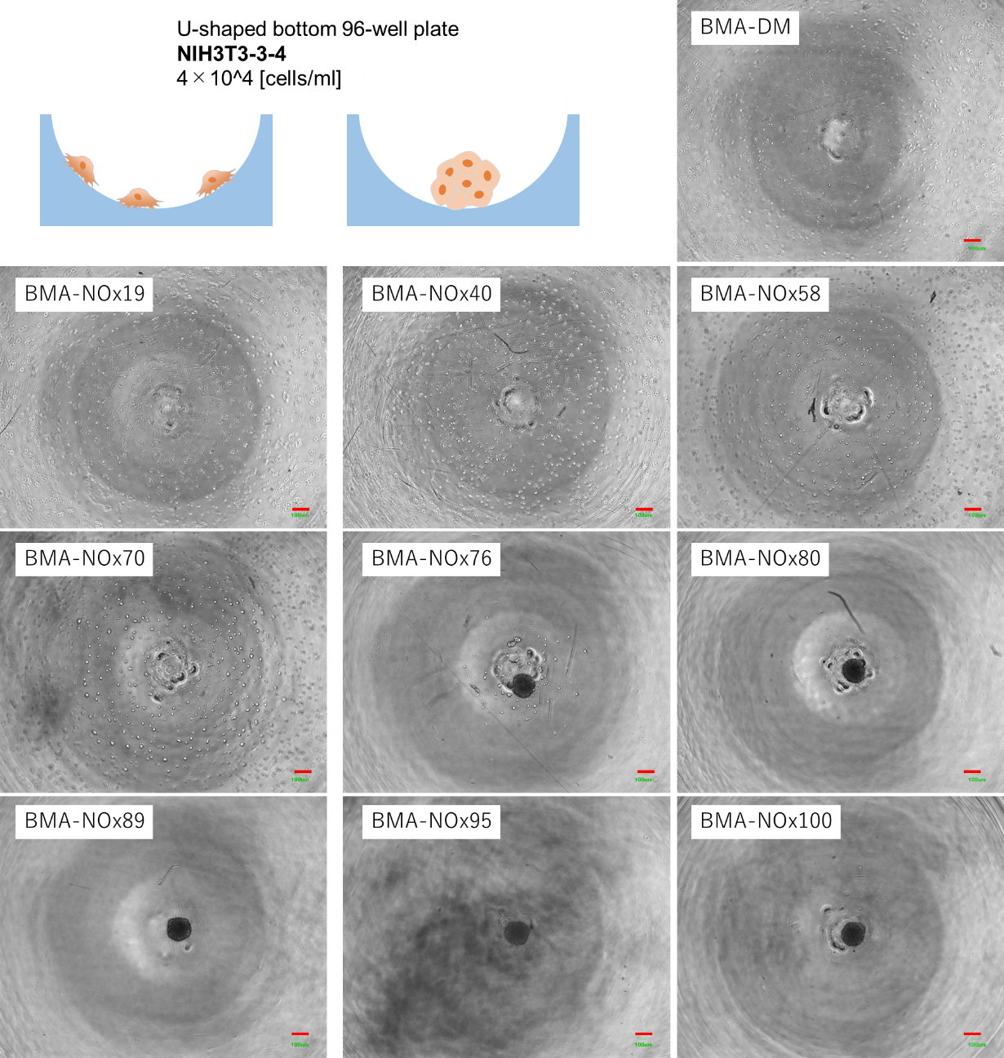
Suspensions of NIH3T3-3-4 cells and HepG2 cells were seeded and maintained at 37 °C and 5% CO₂ for 1 d. Cell aggregation and growth were observed in a phase-contrast time-lapse observation incubator equipped with a camera (BioStudio-T; Nikon Engineering, Kanagawa, Japan).

Figure S8. Phase-contrast images of NIH3T3-3-4 cells cultured at 4000 cells/well on diblock copolymer-coated surface. Images were captured 1 d after cell seeding.
Scale bar, 200 μm.
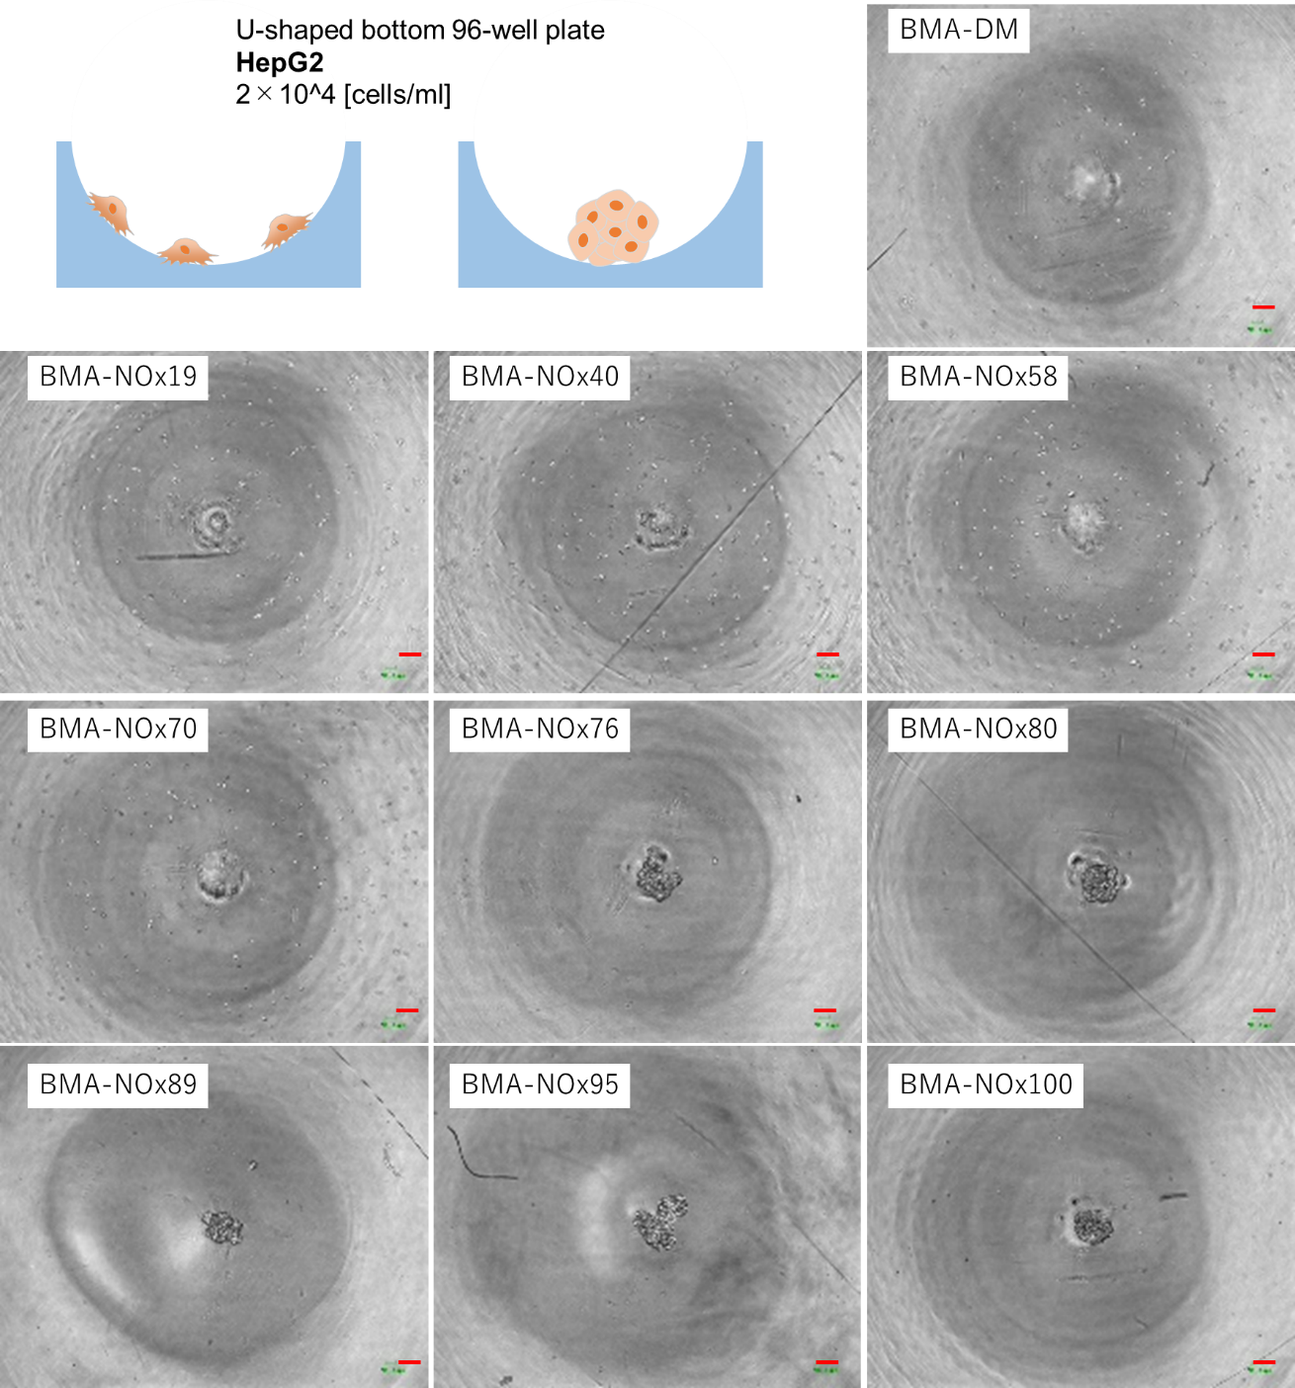
Figure S9. Phase-contrast images of HepG2 cells cultured at 2000 cells/well on diblock copolymer-coated surface. Images were captured 1 d after cell seeding.
Scale bar, 200 μm.

Cell viability and proliferation on diblock copolymer-coated surface by WST assay
A WST assay was performed to measure the relative number of living cells to discuss the proliferative potential of cell culture on the diblock copolymer-coated surface. Cell Counting Kit-8 (Dojindo, Kumamoto, Japan) was used for the WST assay, following the protocol provided by the manufacturer. Briefly, the diblock copolymers were spin-coated on TCPS dishes and then sterilized under UV light for 1 h before the cell assay. Suspensions of hUC-MSCs in DMEM supplemented with 10% FBS and 1% penicillin-streptomycin were cultured at 20,000 cells/well. The cultures were maintained at 37 °C in a 5% CO₂ atmosphere. After predetermined time, cells on diblock copolymer-coated dishes were incubated for 1 h in media containing WST-8 (10% Cell Counting Kit-8 solution), and absorbance was measured at 450 nm by a spectrophotometer. The background absorbance was also measured at 650 nm. The absorbance at 450 nm was subtracted by that at 650 nm and subjected to analysis, following the protocol of Cell Counting Kit-8.
Values are the mean + SD of three experiments (Figure S10). After 7 d after cell seeding, the increase in absorbance at 450 nm was 124%, 238%, 151%, 131%, and 120% for BMA-DM, BMA-NOx19, BMA-NOx40, BMA-NOx58, and BMA-NOx100, respectively. These results suggest that cells were hardly proliferate on the BMA-DM surface because the cells adhere very tightly to the surface by electrostatic interaction. [8] It was then found that cells hardly proliferated on the surface of BMA-NOx100, which causes the cells does not to interact with the zwitterionic surface, and cell-to-cell interactions form huge spheroids. [9] On the other hand, cells were proliferated on the surfaces with interact moderately of BMA-NOx19, BMA-NOx40, and BMA-NOx58, that is interacted moderately with cells.
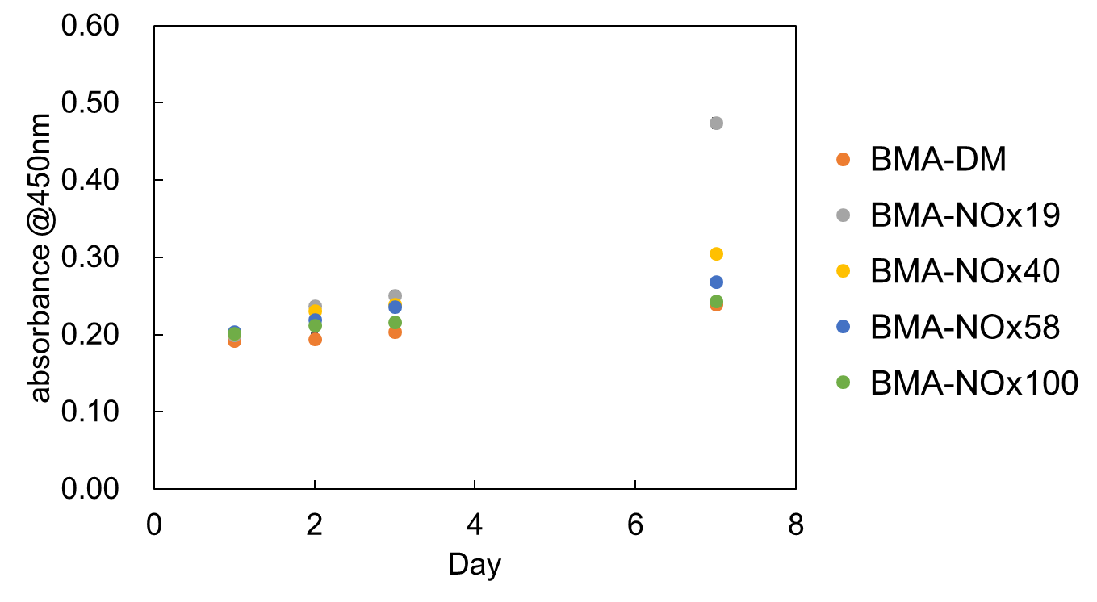
Figure S10. Cell viability of hUC-MSC cells was investigated using WST assay. Values are the mean + SD of three experiments.
Cell adhesion behavior on PEG-M10 coated surface and PrimeSurface®️.
Cell adhesion behavior was evaluated to confirm whether a surface coated with a multi-block copolymer, which is composed of poly(2-methoxyethyl acrylate) and polyethylene glycol (PEG) with a PEG feed amount of 10 wt%, named PEG-M10 is equivalent to the ultra-low attachment 96-U-well plates (PrimeSurface; Sumitomo Bakelite Co., Ltd.).
PEG-M10 was synthesized previously reported method. [10] PEG-M10 (10 mg mL⁻¹) in a 90:10 wt% ethanol-water mixture was dip-coated onto U-bottom 96-well plates and dried at 24 °C under vacuum for 2 h. The PEG-M10-coated well plate was sterilized under UV light for 1 h before the cell assay. Suspensions of NIH3T3-3-4 and HepG2 cells in DMEM supplemented with 10% FBS and 1% penicillin-streptomycin were cultured at 5,000 cells/well. The cultures were maintained at 37 °C in a 5% CO₂ atmosphere. Cell aggregation was observed using a phase-contrast microscope. (Figure S11) PrimeSurface🄬 was used for cell culture without further treatment.
In both NIH3T3-3-4 and HepG2 cells, PEG-M10-coated surfaces formed single spheroid similar to those seeded on PrimeSurface. These results revealed that the PEG-M10-coated surface exhibited the same cell adhesiveness as the ULA (Ultra Low Attachment) surface.

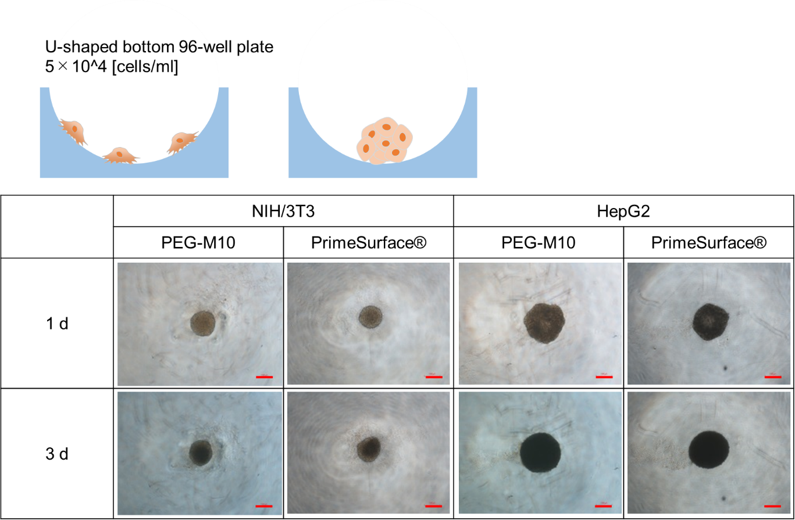
Figure S11. Phase-contrast images of NIH3T3-3-4 cells and HepG2 cells cultured at 5000 cells/well PEG-M10 coated 96-well U-bottom plates and Primesurface🄬. Images were captured at intervals of 1 d and 3 d after cell seeding. Scale bar, 200 μm.

Video S1. Time-lapse microscopy video of hUC-MSCs seeded in a 96-well U-bottom plate coated with BMA-DM.
Video S2. Time-lapse microscopy of hUC-MSCs seeded in a 96-well U-bottom plate coated with BMA-NOx19.
Video S3. Time-lapse microscopy video of hUC-MSCs seeded in a 96-well U-bottom plate coated with BMA-NOx40.
Video S4. Time-lapse microscopy of hUC-MSCs seeded in a 96-well U-bottom plate coated with BMA-NOx58.
Video S5. Time-lapse microscopy of hUC-MSCs seeded in a 96-well U-bottom plate coated with BMA-NOx70.
Video S6. Time-lapse microscopy of hUC-MSCs seeded in a 96-well U-bottom plate coated with BMA-NOx76.
Video S7. Time-lapse microscopy of hUC-MSCs seeded in a 96-well U-bottom plate coated with BMA-NOx80.
Video S8. Time-lapse microscopy of hUC-MSCs seeded in a 96-well U-bottom plate coated with BMA-NOx89.
Video S9. Time-lapse microscopy of hUC-MSCs seeded in a 96-well U-bottom plate coated with BMA-NOx95.
Video S10. Time-lapse microscopy of hUC-MSCs seeded in a 96-well U-bottom plate coated with BMA-NOx100.
References
[1] Roy, S.G.; Bauri, K.; Pal, S.; Goswami, A.; Madras, G.; De, P. Synthesis, characterization and thermal degradation of dual temperature- and pH-sensitive RAFT-made copolymers of N,N-(dimethylamino)ethyl methacrylate and methyl methacrylate. Polym. Int. 2013, 62: 463-473. DOI: 10.1002/pi.4335.
[2] Higaki, Y.; Kuraoka, N.; Masuda, T.; Nakamura, M.; Hifumi, E. Cononsolvency of poly(carboxybetaine methacrylate) in water–ethanol mixed solvents. Polym J, 2023, 55, 869–876. DOI: 10.1038/s41428-023-00780-x.
[3] Ishihara, K.; Mu, M.; Konno, T.; Inoue, Y.; Fukazawa, K. The unique hydration state of poly(2-methacryloyloxyethyl phosphorylcholine). Journal of Biomaterials Science, Polymer Edition, 2017, 28, 884–899. DOI: 10.1080/09205063.2017.1298278.
[4] van Andel, E.; Lange, S. C.; Pujari, S. P.; Tijhaar, E. J.; Smulders, M. M. J.; Savelkoul, H. F. J.; Zuilhof, H. Systematic Comparison of Zwitterionic and Non-Zwitterionic Antifouling Polymer Brushes on a Bead-Based Platform. Langmuir 2019, 35, 1181– 1191. DOI: 10.1021/acs.langmuir.8b01832.
[5] Zhang, L.; Sun, J.; Huang, W.; Zhang, S.; Deng, X.; Gao, W. Hypoxia-Triggered Bioreduction of Poly(N-oxide)–Drug Conjugates Enhances Tumor Penetration and Antitumor Efficacy. J. Am. Chem. Soc. 2023, 145 (3), 1707– 1713. DOI: 10.1021/jacs.2c10188.
[6] Johnson, K.L.; Kendall, K.; Roberts, A. D. Surface energy and the contact of elastic solids. Proc. R. Soc. Lond. 1971, A324, 301–313. DOI: 10.1098/rspa.1971.0141.
[7] Masuda, T.; Watanabe, Y.; Kozuka, Y.; Saegusa, Y.; Takai, M. Bactericidal Ability of Well-Controlled Cationic Polymer Brush Surfaces and the Interaction Analysis by Quartz Crystal Microbalance with Dissipation. Langmuir. 2023, 39, 16522-16531. DOI: 10.1021/acs.langmuir.3c02472.
[8] Z. H. Wang, W. B. Li, J. Ma, G. P. Tang, W. T. Yang, and F. J. Xu. Functionalized Nonionic Dextran Backbones by Atom Transfer Radical Polymerization for Efficient Gene Delivery. Macromolecules 2011, 44, 230-239. DOI: 10.1021/ma102419e.
[9] Jonker, AM.; Bode, SA.; Kusters, AH.; Van Hest JCM.; Löwik DWPM. Soft PEG-hydrogels with independently tunable stiffness and RGDS-content for cell adhesion studies. Macromol Biosci. 2015, 15, 1338-1347. DOI:10.1002/mabi.201500110.
[10] Ogiwara, N.; Nakano, T.; Masuda, T.; Kushiro, K.; Takai, M. Cell Spheroid Formation on the Surface of Multi-Block Copolymers Composed of Poly(2-methoxyethyl acrylate) and Polyethylene Glycol. Macromol. Biosci. 2023, 23, 2200486. DOI: 10.1002/mabi.202200486.

