Table S1. Weight loss of the implanted magnesium specimen after acid cleaning (mean ± SD, µg/mm²).
 | day 1 | day 3 | day 7
Non-hematoma group | 4.41 ± 1.22 | 10.01 ± 3.38 | 14.77 ± 3.28
Hematoma group | 6.10 ± 1.03 | 17.28 ± 3.21 | 27.31 ± 5.91
Statistical significance* | p<0.05 | p<0.01 | p<0.01

*The statistical significance between the two groups on each implantation period was decided by t-test.

Table S2. Weight gain as insoluble salts after implantation (mean ± SD) and its ratio against the weight loss decided after acid cleaning.
 | weight (µg/mm²) |  |  | ratio to weight loss (%)
 | day 1 | day 3 | day 7 | day 1 | day 3 | day 7
Non-hematoma group | 3.89 ± 1.30 | 8.89 ± 2.95 | 13.28 ± 3.15 | 86.8 ± 9.54 | 88.9 ± 5.65 | 89.8 ± 4.62
Hematoma group | 8.15 ± 3.43 | 13.37 ± 2.46 | 18.62 ± 2.31 | 135.3 ± 58.9 | 77.4 ± 3.75 | 69.4 ± 7.87
Statistical significance* | p<0.05 | p<0.05 | p<0.01 | p>0.1 | p<0.05 | p<0.05

*The statistical significance between the two groups on each implantation period was decided by t-test.

Table S3. Weight of Mg in insoluble salts quantified in the collected acid mixture (mean ± SD) and its ratio to the total weight of the insoluble salts.
 | weight (µg/mm²) |  |  | ratio to insoluble salt weight (%)
 | day 1 | day 3 | day 7 | day 1 | day 3 | day 7
Non-hematoma group | 0.710 ± 0.236 | 1.546 ± 0.608 | 2.303 ± 0.268 | 18.6 ± 3.19 | 17.2 ± 2.05 | 18.0 ± 3.82
Hematoma group | 1.527 ± 0.619 | 2.233 ± 0.601 | 3.248 ± 0.377 | 19.0 ± 2.29 | 16.6 ± 2.50 | 17.5 ± 1.48
Statistical significance* | p<0.05 | p=0.08 | p<0.01 | p>0.1 | p>0.1 | p>0.1

*The statistical significance between the two groups on each implantation period was decided by t-test.

Table S4. Weight of Ca in insoluble salts quantified in the collected acid mixture (mean ± SD) and its ratio to the total weight of the insoluble salts.
 | weight (µg/mm²) |  |  | ratio to insoluble salt weight
 | day 1 | day 3 | day 7 | day 1 | day 3 | day 7
Non-hematoma group | 0.683 ± 0.324 | 1.098 ± 0.764 | 1.419 ± 0.435 | 18.9 ± 9.37 | 12.7 ± 6.64 | 11.2 ± 4.82
Hematoma group | 0.420 ± 0.174 | 0.875 ± 0.198 | 1.406 ± 0.289 | 5.97 ± 3.13 | 6.64 ± 0.951 | 7.51 ± 0.886
Statistical significance* | p>0.1 | p>0.1 | p>0.1 | p<0.05 | P=0.08 | p>0.1

*The statistical significance between the two groups on each implantation period was decided by t-test.

Table S5. Weight of P in insoluble salts quantified in the collected acid mixture (mean ± SD) and its ratio to the total weight of the insoluble salts.
 | weight (µg/mm²) |  |  | ratio to insoluble salt weight (%)
 | day 1 | day 3 | day 7 | day 1 | day 3 | day 7
Non-hematoma group | 0.614 ± 0.084 | 0.950 ± 0.208 | 1.511 ± 0.239 | 17.1 ± 4.60 | 11.2 ± 2.24 | 11.8 ± 2.52
Hematoma group | 0.377 ± 0.094 | 0.883 ± 0.217 | 1.505 ± 0.267 | 4.60 ± 2.30 | 6.71 ± 1.68 | 8.04±5.35
Statistical significance* | p<0.01 | p>0.1 | p>0.1 | p<0.01 | p<0.01 | p<0.05

*The statistical significance between the two groups on each implantation period was decided by t-test.

Table S6. Results of EDX analysis of pure Mg specimens implanted under non-hematoma and hematoma conditions (atm. %).
 | Non-hematoma |  |  | Hematoma |  |  |  | p
 | day 1 | day 3 | day 7 | day 1 | day 3 | day 7 | day 1 | day 3 | day 7
Mg | 24.2 ± 5.4 | 8.9 ± 0.3 | 7.9 ± 1. 6 | 42.3 ± 2.7 | 12.8 ± 1.3 | 6.2 ± 0.4 | <0.05 | <0.05 | >0.1
O | 50.2 ± 2.2 | 60.9 ± 0.2 | 55.0 ± 8.5 | 30.1 ± 1.8 | 62.0 ± 3.4 | 51.0 ± 8.3 | <0.01 | >0.1 | >0.1
Ca | 1.3 ± 0.4 | 4.2 ± 0.2 | 4.5 ± 0.2 | 0.4 ± 0.0 | 1.0 ± 0.1 | 2.2 ± 0.8 | <0.05 | <0.01 | <0.05
P | 4.6 ± 0.2 | 8.2 ± 0.4 | 7.6 ± 0.3 | 1.3 ± 0.0 | 2.6 ± 0.5 | 4.2 ± 1.1 | <0.01 | <0.01 | <0.05
C | 19.7 ± 2.8 | 17.8 ± 0.9 | 25.1 ± 9.9 | 25.9 ± 1.3 | 21.6 ± 2.9 | 36.4 ± 9.6 | <0.05 | >0.1 | >0.1

*The statistical significance between the two groups on each implantation period was decided by t-test.

(a)
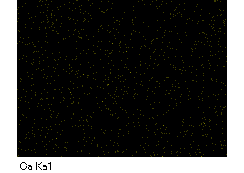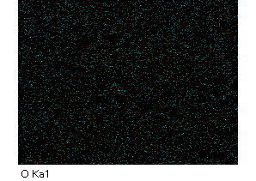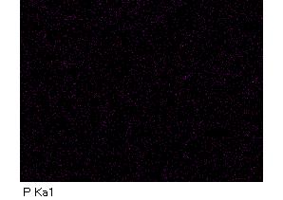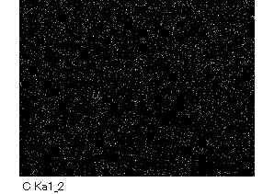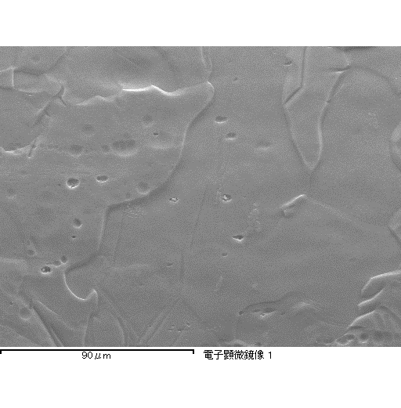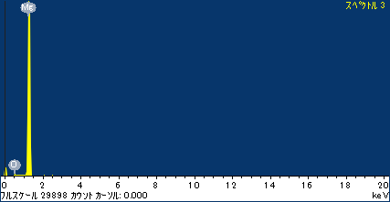
(b)
X-ray energy (kev)
Counts
20000
0
4000
8000
12000
16000
10 µm
Ca
O
C
P
Mg

Figure S1. Typical examples of the EDX analysis (a) of pure Mg specimen surface before implantation. The EDX spectrum (b) was obtained by the point analysis of a red square indicated in the SEM image in (a).

Counts
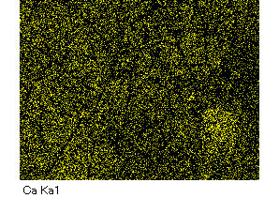
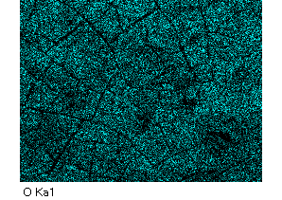
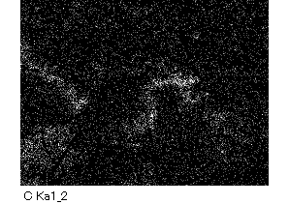
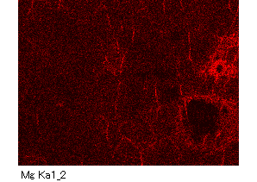
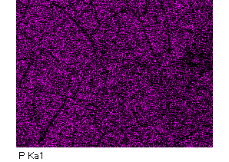
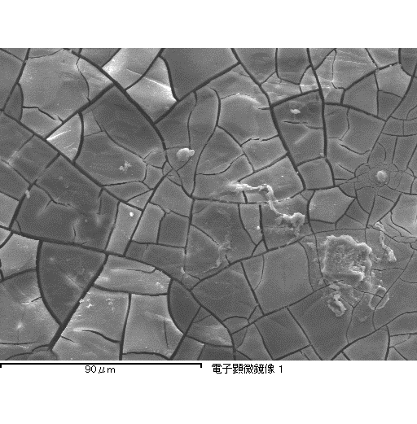
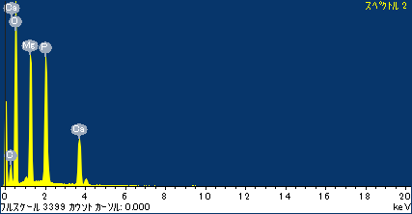
Figure S2. Typical examples of the EDX analysis (a) of pure Mg specimen surface implanted for 3 days under non-hematoma condition. The EDX spectrum (b) was obtained by the point analysis of a red square indicated in the SEM image in (a).
(b)
(a)
X-ray energy (kev)
Counts
Ca
O
C
P
Mg
0
500
1000
1500
2000
2500
3000
10 µm

Counts
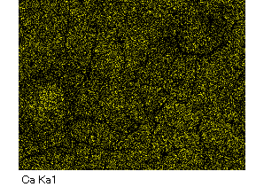
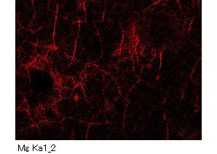
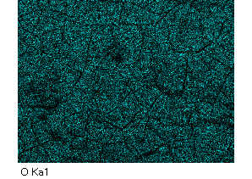
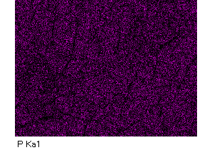
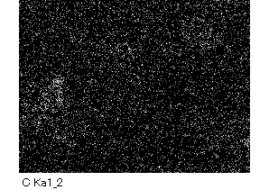
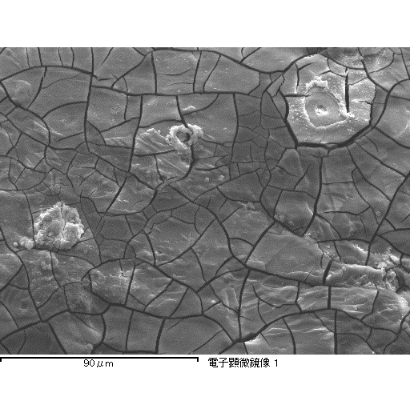
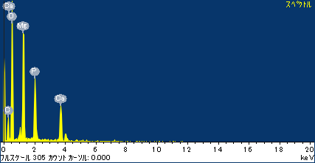
Figure S3. Typical examples of the EDX analysis (a) of pure Mg specimen surface implanted for 7 days under non-hematoma condition. The EDX spectrum (b) was obtained by the point analysis of a red square indicated in the SEM image in (a).
(a)
Ca
O
C
P
Mg
0
1000
2000
3000
4000
5000
6000
X-ray energy (kev)
Counts
10 µm
(b)
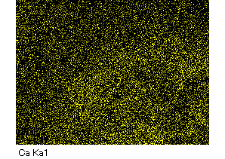
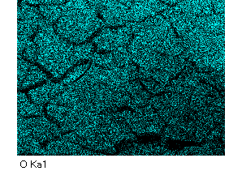
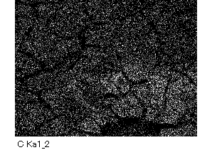
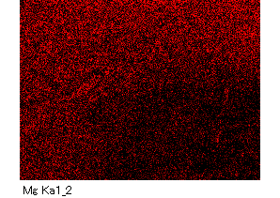
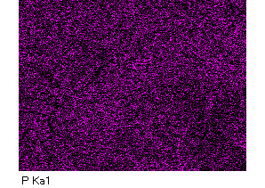
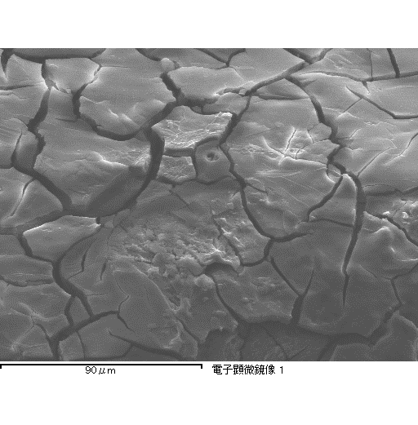
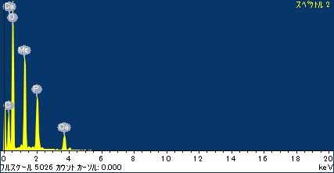
Counts
Figure S4. Typical examples of the EDX analysis (a) of pure Mg specimen surface implanted for 3 days under hematoma condition. The EDX spectrum (b) was obtained by the point analysis of a red square indicated in the SEM image in (a).
(a)
X-ray energy (kev)
Counts
Ca
O
C
P
Mg
5000
0
1000
2000
3000
4000
10 µm
(b)
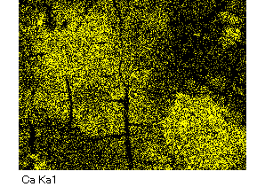
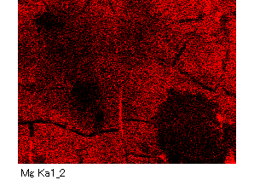
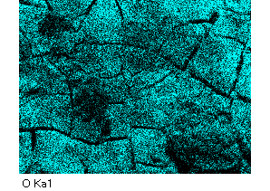
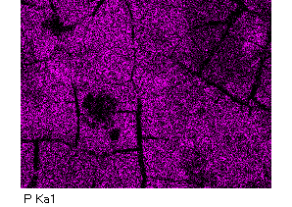
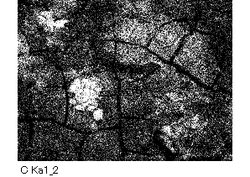
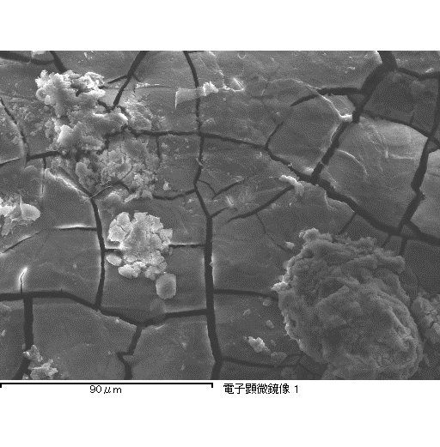
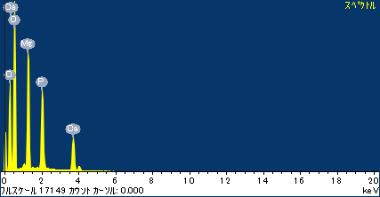
Counts
(a)
Ca
O
C
P
Mg
0
2500
5000
7500
10000
12500
15000
Counts
X-ray energy (kev)
10 µm
(b)
Figure S5. Typical examples of the EDX analysis (a) of pure Mg specimen surface implanted for 7 days under hematoma condition. The EDX spectrum (b) was obtained by the point analysis of a red square indicated in the SEM image in (a).

Raman intensity
Raman shift (cm⁻¹)
Figure S6. Raman spectra of the pure Mg specimen surface before implantation.

