Superheated steam-induced surface-accelerated amorphous-to-crystalline transition in an aluminosilicate inorganic polymer

Shingo Machida¹*, Yasuo Nagano¹, and Gaku Okuma²

¹Materials Research and Development Laboratory, Japan Fine Ceramics Center, 2-4-1, Mutsuno, Atsuta-ku, Nagoya, Aichi, 456-8587, Japan
²Research Center for Structural Materials, National Institute for Materials Science, 1‑2‑1 Sengen, Tsukuba, Ibaraki 305‑0047, Japan.

*E-mail: shingo.machida@jfcc.or.jp
Abstract:
This study demonstrates that the physical properties of amorphous materials can be effectively modulated by superheated steam and that inorganic glass, as an inorganic polymer, serves as a valuable model system for investigating thermal behavior that is not readily accessible in organic polymers. To elucidate the effects of superheated steam on glass transition and crystallization, powder compacts and plate-shaped CaO–Al₂O₃–SiO₂ (CAS) glass specimens—with a primary composition of 28.6CaO–12.6Al₂O₃–58.8SiO₂ in mol% and well-characterized crystallization behavior—were calcined at 800–1050°C under superheated steam. Thermal analysis of the powder specimens revealed that the onset temperature of the glass transition decreased by 60°C, and the first and second crystallization steps were lowered by 25 and 15°C, respectively, under superheated steam. X-ray diffraction analysis indicated that reflections from surface crystalline phases such as anorthite, wollastonite, and cristobalite appeared at lower temperatures. Additionally, photographs and scanning electron microscopy revealed an increase in the thickness of the surface crystalline layer, indicating enhanced surface crystallization under superheated steam. These results demonstrate that superheated steam promotes surface-accelerated amorphous-to-crystalline transitions of amorphous materials, as demonstrated using the CAS glass as an aluminosilicate inorganic polymer.

Introduction
Precise control in glass transition and crystallization in polymers is essential for optimizing their fundamental properties for practical applications.¹⁻⁶ This control has therefore been widely achieved by modifying chemical structures, molar mass, molecular orientation, and the degree of cross-linking, as well as by adding plasticizer―all of which require reagents and chemical processes in industrial settings. In such environments, superheated steam―a dry vapor above the boiling point―is a feasible medium for optimizing waste heating without purification. In inorganic systems, the accelerated crystallization of α-alumina (Al₂O₃)―an industrially important inorganic material―has been studied under superheated steam at temperatures above 800°C since the 1960s.⁷⁻⁹ This crystallization―the γ-to-α phase transformation―is thought to occur vis weakening of Al³⁺-O^{2—}Al³⁺ bonds through the addition of water molecules, forming Al³⁺-(O⁻H⁺)-Al³⁺ linkages that facilitate surface diffusion.⁷⁻⁹ Prior to this phenomenon, the decomposition of polymer binders used in bulk alumina materials can be accelerated under superheated steam.¹⁰ To avoid premature decomposition, the conditions for superheated steam exposure must be optimized to control the glass transition and crystallization behavior of polymers. As the concentration of superheated steam decreases, its effect on these thermal transitions becomes less pronounced. In the typical temperature range for polymer glass transition and crystallization, the suppression of superheated steam condensation is essential for maintaining precise instrument conditions. Notably, glass transition precedes crystallization in amorphous materials; however, the role of superheated steam in this process remains unclear. In this context, inorganic glass materials—regarded as inorganic polymers—offer a model system for investigating the effects of superheated steam on glass transition and crystallization in various amorphous systems. Notably, glass crystallization is classified into two types: surface and bulk crystallizations.¹¹⁻¹⁴ The former begins at the glass surface, while the latter requires nucleation agents inside the glass. The resultant materials are glass-ceramics (GCs)—composites composed of both glassy and crystalline phases―whose practical applications have been widely studied.^{12,13} Among the many GC systems, CaO―Al₂O₃―SiO₂ (CAS) GCs have been used in building materials produced via surface crystallization of glass cullet.^{12,13} Thus, the surface crystallization of CAS glass under superheated steam offers a promising route to study the effects of superheated steam on glass transition and crystallization, and to provide insights into industrial glass-making processes. In this study, such surface crystallization is investigated. CAS GC—whose crystallization behavior is already well understood—is a suitable candidate. Furthermore, to suppress crack propagation caused by thermal expansion mismatch between the surface and interior, CAS GC is chosen for its ability to undergo bulk crystallization into a single crystalline phase, offering mechanical reinforcement throughout the resultant glass material. The CAS GC with precipitated metastable CaAl₂Si₂O₈―a layered aluminosilicate composed of alternately stacked tetrahedral aluminosilicate and Ca²⁺ layers―as the bulk crystalline phase is therefore the most suitable candidate in this study.¹⁵⁻²² Additionally, the surface crystalline phase of this CAS GC are anorthite―the stable phase of CaAl₂Si₂O₈―and wollastonite (CaSiO₃), which precipitates following anorthite.¹⁵

Experimental
Materials
Calcium carbonate (CaCO₃), aluminum oxide (Al₂O₃), silica (SiO₂), and tungsten oxide (WO₃) were obtained from Wako Pure Chemical. Carbon was obtained from Kojundo Chemical Laboratory. All chemicals were used without further purification.

Sample preparation
The CAS GC containing the precipitated “Layered AluminoSilicate” (LAS) mentioned above is denoted herein as CAS GC-LAS. This GC was prepared according to a previously reported procedure.¹⁵ The melting was carried out at 1550°C for 45 min under air in an alumina crucible. The batch was prepared by mixing CaCO₃, Al₂O₃, and SiO₂ to form 50 g of 20CaO–10Al₂O₃–55SiO₂ glass (wt%) with outer percentage of 0.08 wt% WO₃ and 0.40 wt% (corresponding to 28.6CaO–12.6Al₂O₃–58.8SiO₂ in mol%, with 10.6 mol% C and 0.0175 mol% WO₃). Notably, these two additives acted as nucleation agent sources, and the bulk crystalline phase of CAS GC-LAS is known to precipitate when metallic molybdenum (Mo) or tungsten (W) act as nucleation agents, formed via the reduction of molybdenum or tungsten oxides by carbon combustion during the glass melting process.¹⁵⁻¹⁹ As a result, black glass specimens are obtained due to the presence of metallic Mo or W particles.¹⁵⁻¹⁹ To ensure glass homogeneity, the glass batch was melted twice. In the first melting step, glass cullet was obtained by pouring the melt into water and subsequently crushing it using an alumina mortar and pestle. In the second step, the melt was poured onto a brass plate pre-heated to 300°C, then immediately transferred to a furnace at 600°C and annealed at 850 °C for 30 min. cooling was performed at 1°C/min to relieve a thermal stress.
In this study, two types of glass specimens were prepared. Compacts made from glass powder forms were used to study the influence of superheated steam on glass transition and surface crystallization. Additionally, the plate glass specimens were used to emphasize the extent of surface crystallization. The annealed and cooled glass specimen described above was cut into rectangular pieces approximately 1.25 cm x 1.00 cm with a thickness of 3.00 mm. These surfaces were polished using a grinder (#400). Some of the plate glass specimens were crushed and passed through a 150 µm sieve to obtain powder specimens with visually confirmed uniformity.
Glass crystallization was performed as follows. All the heating and cooling rates during the heat treatment for crystallization were set to 5°C/h, and all the calcination experiments were conducted in a tube furnace. In this study, the superheated steam condition required the use of a carrier gas. Due to instrumental limitations, the superheated steam atmosphere was defined as 80 vol% superheated steams in synthetic air at a total flow rate of 10 mL/min. For simplicity, this condition is hereafter referred to as "under superheated steam”. Liquid water was introduced into the furnace using a liquid delivery pump (PU712 HPLC Pump, GL Science) at a flow rate of 0.02 mL/min and injected through a platinum-rhodium (Pt-Rh) needle housed in a Pt-Rh tube, which extended to the sample position inside the furnace. To prevent condensation of the superheated steam, water injection was started and stopped at 300°C during both the heating and cooling processes. Notably, a silicone tube was connected to a polypropylene bottle on the opposite side of the superheated steam inlet in the tubular furnace. After the superheated steam treatment, water was found to have accumulated in this bottle. This clearly indicates that the sample was exposed to a higher concentration of superheated steam compared to previous reports.^{23,24} For comparison, calcination under 100 vol% synthetic air was regarded as the condition “under air.” The glass powders were uniaxially compressed into compacts with a diameter of 10 mm and a thickness of 1 mm, and these compacts were calcined at 750, 800, 850, 900, 950, 1000, and 1050°C for 2 h under either air or superheated steam. For comparison, an additional 900 °C compact specimen was prepared by applying superheated steam only up to 850 °C, followed by conventional calcination and cooling under air. Plate glass specimens were heated at 1050 °C for 0, 1, 2, 3 or 6 h under air or superheated steam. For comparison, additional specimens were prepared under modified steam exposure conditions; one set where superheated steam was introduced only during heating to the target temperature (1050 °C), and another set where it was introduced only after reaching the target temperature (i.e., superheated steam was not applied during the heating and cooling processes). Both sides of all the resultant specimens were polished sequentially using #400, #1000, and #2000 grinders, followed by 0.50 and 0.17 µm diamond water dispersions, and finally with a cerium oxide-containing water dispersion to achieve mirror surfaces. All polished surfaces correspond to the mid-thickness cross-sections of each specimen. Thus, for the plate glass specimens, surface crystallization behavior was examined on the fire-formed surfaces. Regarding the plate glass specimens calcined at 1050 °C, additional specimens were prepared by polishing them just enough to smooth the surface while retaining as much of the surface crystalline phase as possible.

Characterization
The crystalline phases of the glass specimens were characterized by X-ray diffraction (XRD) using a diffractometer (Empyrean, PANalyical) operated at 40 mA and 45 kV with monochromated Cu Kα radiation. The step size and scan time were 0.01° (2θ) and 1.0 s, respectively. Specimen morphologies of glass cullet and microstructures of GC specimens were examined using field-emission scanning electron microscopy (FE-SEM: SU8000, HITACHI) at an acceleration voltage of 2.0 or 15 kV, with an electron beam energy of 10 or 30 µV, and a working distance of 8 cm for secondary or backscattered electrons (SE or BE), respectively. Prior to observation, the samples were sputter-coated with a 3-nm osmium layer. For simplicity, FE-SEM images obtained using SE or BE are hereafter referred to as SEM (SE) or SEM (BE) images, respectively. Thermal behavior of glass powder specimens passed through a 150 µm sieve was characterized using thermogravimetric (TG) and differential thermal analysis (DTA) curves, recorded on a NETZSCH TG-DTA instrument at a heating rate of 10°C/min under either Ar or Ar containing 50 vol% superheated steam, with Ar serving as the carrier gas. For simplicity, this condition is hereafter referred to as "under superheated steam." This superheated steam concentration represents an experimental limitation. Before initiating the heating process, the temperature was maintained at 150 °C to ensure thermal stabilization. Fourier-transform infrared (FT-IR) spectra were recorded on a JASCO FT-IR instrument with a resolution of 4.0 cm⁻¹ using the attenuated total reflection (ATR) method. For simplicity, FT-IR spectra are hereafter referred to as IR spectra.

Results and Discussion
Figure 1 shows TG-DTA curves of the glass powder specimens (passed through a 150 µm sieve) under Ar or superheated steam atmospheres. No significant mass changes are observed in the TG curves, while the DTA curves display an endothermic peak in the 700―800°C range and exothermic peaks in the 850―900°C and 1000―1050° ranges. According to a previous study^{15,22}, the endothermic peak corresponds to the glass transition, and the exothermic peaks correspond to the first and second crystallization temperature, respectively. Compared with the Ar condition, the onset of the glass transition is reduced by 60°C under superheated steam. The onsets of the first and second crystallization temperatures are also reduced by 25 and 15°C, respectively. These results indicate that glass transition and crystallization behaviors are accelerated in the presence of superheated steam. The effects of superheated steam on compact and plate specimens are described in the following sections.
Figure 2 shows the XRD patterns of compact specimens calcined in the 850―1050°C range under either air or superheated steam (see Sample preparation). Compared with the air condition, reflections attributed to anorthite, wollastonite, and cristobalite appear at 950°C under superheated steam, indicating accelerated surface crystallization of CAS GC-LAS under this atmosphere. Under superheated steam condition, in the 950―1050°C range, the intensities of the diffraction lines corresponding to wollastonite and cristobalite increase after the appearance of anorthite reflections. This trend is consistent with a previous study¹⁵; based on the primary composition of CAS GC-LAS used in this study (28.6CaO–12.6Al₂O₃–58.8SiO₂ in mol%), and given that Al preferentially precipitates as CaAl₂Si₂O₈ (see the introduction)^{15,17}, wollastonite (CaSiO₃) subsequently appears. In the previous study¹⁵, cristobalite reflections were absent during the surface crystallization of plate glass specimens with heating and cooling rates of 10°C/min. In contrast, the increased surface area of the powder compacts used in this study accelerated surface crystallization and promoted Ca consumption, facilitating cristobalite (SiO₂) formation.
Figure 3 shows photographs of compact specimens calcined in the 800―1050°C range. At 800°C (Figure 3a), the compact under air is easily broken, whereas the one calcined under superheated steam remains intact. However, its surface has a powdery texture. Notably, at 750 °C, the compact specimens are easily broken regardless of the calcination atmosphere. The powders loosely attached to the 800°C specimen calcined under superheated steam consist of relatively larger fragments than those on the air-calcined specimen or in the glass powder before calcination, as revealed by SEM (SE) images (Figure 4). This indicates that glass fusion²⁵⁻²⁹ is more advanced under superheated steam than under air. Considering the powdery texture of the 850°C compact under air and the glassy surface of the corresponding specimen under superheated steam (Figure 3b)―along with the lower temperature shift of the endothermic peaks in the DTA curves (Figure 1)―it is indicated that the glass transition of the CAS glass used in this study is accelerated under superheated steam.
Meanwhile, as the calcination temperature increases from 900 to 1050 °C, the compact size becomes larger under superheated steam compared to that under air. Notably, no visible differences are observed among the compact specimens calcined at 950, 1000, and 1050 °C under superheated steam; hence, the photograph of the 1000 °C specimen is not shown. This size increase is thus attributed to the effect of superheated steam. This phenomenon occurs after the glass transition, as evidenced by comparing the 900 °C compact specimen exposed to superheated steam only up to 850 °C (see Experimental) with the specimen calcined entirely under superheated steam (Figures 3c and the inset).Given the presence of numerous voids observed in the SEM (BE) image of the 1050°C specimen calcined under superheated steam―which are absent in the corresponding specimen calcined under air (Figure 5a and b)―it is indicated that superheated steam was incorporated into the glass above the glass transition point and was eventually degassed³⁰, resulting in void formation. Furthermore, the absence of significant differences in the complex microstructures―including the grain sizes of crystalline phases―between the compact specimens under air and superheated steam (Figure 5a” and b”) clearly rules out the possibility that these voids were generated as a result of volume change relaxation during crystallization.³¹ In general, water molecules is commonly added to stirred glass melts by bubbling during melting.³² Nevertheless, the resulting water content is typically less than 1 mol% in sodium-containing glasses.³³ Additionally, no significant differences are observed in the OH stretching region of compact specimens calcined the 800―900°C range (Figure S1). Moreover, although the white surface layer―which indicate surface crystalline phase―of the plate glass specimen calcined at 1060 °C for 6 h under superheated steam is approximately 100 µm thicker than that of the corresponding specimen calcined under air (Figure 6c and d), SEM (BE) images of their interiors (relatively dark regions; Figure 6) reveal that the microstructures of the bulk crystalline phases (Figure S2)—characterized by arbitrary cross-sections of house-of-cards-like assemblies of platy LAS particles with edge-to-face contacts, as revealed in previous studies¹⁵⁻¹⁹—are essentially the same. This is further supported by the XRD patterns of the plate specimens calcined at 1050 °C (Figure S3b and d), which match those reported previously. Although the PDF pattern of the bulk crystalline phase precipitated in the glass is not publicly available, it was clearly presented in earlier studies¹⁵⁻²², one of which included a detailed phase analysis.²¹ Consequently, these results indicated that superheated steam did not significantly penetrate into the inside of the glass used in this study.
As mentioned above, the thickness of the surface crystalline layer on the plate glass specimen increases under superheated steam (Figure 6a-d). This is further supported by the SEM (BE) images of the white surface layers of plate glass specimens calcined at 1050°C for 6 h (Figure 7). Figure 7b’, representing a cross-section approximately 120 µm―midway between Figure 7b and b”―corresponds closely to the difference in surface layer thickness (120 µm = 460 – 340 µm: see Figure 6a and b). The surface crystalline phases are the same as those observed in the compact specimens (Figures 2d, 2h, S3a, and S3c). The significant difference is absent in the thickness of the plate glass specimens calcined at 1050°C under air for 6 h, as well as those treated with superheated steam only up to 1050°C or only during that temperature (Figure 6c-f). Given the lack of significant differences in the microstructures of compact specimens calcined at 1050°C (Figure 5), superheated steam does not appear to affect the nucleation behavior of CAS glass with the present composition. Additionally, the surface crystallization of this glass is not promoted by the type of rapid ion diffusion discussed in alumina-based systems⁷⁻⁹ (see Introduction). Unfortunately, the fire-formed surfaces of plate glass specimens calcined for less than 3 h were not visually homogeneous. Moreover, the influence of the bulk crystalline phase on the growth of surface crystalline layers could be investigated by altering the glass composition and bulk morphology, although such changes may increase the risk of surface layer delamination. While further studies will require a wide range of glass compositions and morphologies, the results in this study indicate that continuous exposure of glass above its glass transition temperature under superheated steam is critical for accelerating surface crystallization in bulk glass materials.
Based on the results and discussion above, the possible mechanism is proposed as follows. The lower-temperature shift of the endothermic peak attributed to glass transition (Figure 1), the relatively higher strength of the compact calcined at 800°C under superheated steam compared to that under air, the presence of larger fragments in the 800°C specimen under superheated steam than in the corresponding air-calcined specimen or the uncalcined glass powder (Figure 4), and the general understanding that glass fusion begins in the initial stage of sintering via surface diffusion^{26,28,29,34-37} collectively suggest that the glass transition of amorphous materials is accelerated by enhanced surface diffusion under superheated steam. In general, a decrease in the glass transition temperature enhances ion diffusion, thereby lowering the crystallization temperature of glass.^{14,38} Therefore, the accelerated surface crystallization observed in the CAS glass used in this study is likely due to a reduction in its glass transition temperature under superheated steam. Given the unchanged surface crystallization behavior of CAS glass specimens subjected to only partial superheated steam exposure (Figure 6c–f), and the low likelihood of superheated steam penetrating into the glass, it is suggested that changes in the physical properties of the glass are governed by the atmosphere surrounding its surface region. Notably, the effects of humidity and water vapor on surface crystallization of silicate glasses have been previously discussed.^{23,24} Water vapor is considered to influence the size of nucleation sites and the crystallization rate, but it does not correlate with the number of nucleation sites—likely due to relatively low vapor concentrations and moderate temperatures used in those studies.^{23,24} Additionally, accelerated surface diffusion, as discussed in alumina systems⁷⁻⁹, cannot be excluded and may depend on the extent of surface crystalline phases.²³ Moreover, many of these studies applied water vapor during only the early stages of treatment and proceeded with crystallization in dry conditions. In contrast, continuous exposure to high concentrations of superheated steam—a dry vapor—may yield different effects across various glass compositions. Therefore, the detailed mechanisms may be further clarified by investigating a range of glass compositions, morphologies, and surface crystalline phases with precisely controlled surface roughness, as well as by examining the effects of superheated steam in the presence or absence of bulk crystalline phases. These studies are currently underway, and the results will be reported in due course.

Conclusions
This study clearly demonstrated that the physical properties of amorphous materials can be effectively controlled by superheated steam and that inorganic glass, as an inorganic polymer, serves as a useful model system for investigating thermal behavior not easily accessible in organic polymers. To clarify the effects of superheated steam, CaO–Al₂O₃–SiO₂ (CAS) glass specimens—both powder compacts and plate forms—were calcined at 800–1050°C under either superheated steam. TG-DTA analyses revealed a 60°C decrease in the onset of glass transition and 25–15°C reductions in the onset of crystallization. Complementary characterizations using X-ray diffraction, scanning electron microscopy, and surface photographs showed earlier appearance of surface crystalline phases such as anorthite, wollastonite, and cristobalite, along with thicker surface crystalline layers under superheated steam—indicating enhanced surface crystallization. These findings establish a clear relationship between superheated steam exposure and accelerated surface crystallization through the lowering of the glass transition point. Therefore, this study sheds light on the broader utility of glass materials, as inorganic polymers, for exploring thermal processes that are not easily investigated in organic systems. Furthermore, these insights pave the way for future studies aimed at tuning composition and morphology to control crystallization in a wide range of inorganic or organic amorphous materials.^{1-6,11-14,39,40}

Acknowledgement
This research was supported by Japan Fine Ceramic Center Grant for Advanced Technology Development Research (T24A4560).

Author contribution
Shingo Machida: conceptualization, data curation, investigation, writing—original draft, project administration, supervision. Yasuo Nagano: investigation. Gaku Okuma: writing—review and editing.

Conflicts of Interest
The authors declare no conflict of interest.

References
- Saalwächter, K.; Thurn-Albrecht, T.; Paul, W. Recent Progress in Understanding Polymer Crystallization. Macromol. Chem. Phys., 2023, 224, 2200424.
- Kong, D.-C.; Yang, M.-H.; Zhang, X.-S.; Du, Z.-C.; Fu, Q.; Gao, X.-Q.; Gong, J.-W. Control Polymer Properties by Entanglement: A Review. Macromol. Chem. Eng., 2021, 306, 2100536.
- Reiter, G. Some Unique Feature of Polymer Crystallization. Chem. Soc. Rev., 2014, 43, 2055-2065.
- Ungar, G.; Zeng, X.-B. Learning Polymer Crystallization with the Aid of Linear, Branched and Cyclic Model Compounds. Chem. Rev., 101, 4157-4188.
- Keller, A..; Goldbeck-Wood, G.; Hikosaka, M. Polymer Crystallization: Survey and New Trends with Wider Implications for Phase Transformations. Faraday Discuss., 1993, 95, 109-128.
- Mandelkern, L.; The Crystallization of Flexible Polymer Molecules. Chem. Rev., 1956, 5, 903-958.
- Waters, R. F.; Peri, J. B.; John, G. S.; Seelig, H. S. Alumina Structure and Activity of Platinum-Alumina Catalysts. J. Am. Ceram. Soc., 1960, 52, 415-416.
- Yanagida, H.; Yamaguchi, G.; Kubota, J. The Role of Water Vapor in Formation of Alpha Alumina from Transient Alumina. J. Ceram. Assoc. Jpn., 1966, 74, 371-378.
- Bagwell, R. B.; Messing, G. L. Effect of Seeding and Water Vapor on the Nucleation and Growth of α-Al₂O₃ from γ-Al₂O₃. J. Am. Ceram. Soc., 1999, 82, 825-832.
- Nakamura, T.; Wada, M.; Hayashi, K.; Kitaoka, S.; Nagai, T.; Yano, J.; Muto, N.; Nakahira, A. Development of Rapid Debinding Treatement Using Superheated Steam and Debinding Behavior for Alumina Molded Bodies. J. Jpn. Soc. Powder Powder Metallurgy, 2019, 66, 275-281.
- Deceanne, A. V.; Rodrigues, L. R.; Wilkinson, C. J.; Mauro, J. C.; Zanotto, E. D. Examining the Role of Nucleating Agents within Glass-Ceramic Systems. J. Non-Cryst. Solid, 2022, 591, 121714.
- Höland, W.; Beall, G. H. Glass-Ceramic Technology, 3rd ed; Höland, W.; Beall, G. H., Eds.; Wiley-America Ceramic Society: Hoboken, New Jersey, 2019; pp 67-357.
- Allix, M.; Cormier, L. Crystallization and Glas-Ceramics, In Springer Handbook of Glass, 1st ed; Musgraves, J. D., Hu, J., Calvez, L., Eds.; Springer Nature: Switzerland, 2019; pp 113-168.
- Deubener, J.; Allix, M.; Davis, M. J.; Duran, A.; Höche, T.; Honma, T.; Komatsu, T.; Krüger, S.; Mitra, I, Müller, S.; Nakane, S.; Pascual, M. J.; Schmelzeri, J. W. P., Zanotto, E. D.; Zhou, S. Updated Definition of Glass-Ceramics. J. Non. Cryst. Solids, 2018, 501, 3-10.
- Machida, S. Suppression of Surface Crystallization of CaO―Al₂O₃―SiO₂ Glass via Hydrothermal Treatment Under Acidic Conditions. Langmuir, 2024, 40, 1878-1883.
- Machida, S.; Maeda, K.; Katsumata K.; Yasumori, A. Effect of Starting Materials of Nucleation Agents on Crystallization of CaO-Al₂O₃-SiO₂ Glass. Int. J. Appl. Glass Sci., 2023, 14, 88-96.
- Machida, S.; Yamaguchi, T.; Emori, N.; Katsumata, K.; Maeda, K.; Yasumori, A. Assessment of the Crystallization Process of CaO-Al₂O₃-SiO₂ Glass Probed with Tb³⁺ Luminescence. Inorg. Chem., 2022, 61, 11478-11483.
- Machida, S.; Murayama, N.; Maeda, K.; Katsumata K.; Yasumori, A. Microstructural Control of CaO-Al₂O₃-SiO₂ Glass-Ceramics by the Amounts of Tungsten Oxide and Carbon Added as Nucleation Agent Sources. J. Ceram. Soc. Jpn., 2022, 130, 850-856.
- Machida, S.; Maeda, K.; Katsumata K.; Yasumori, A. Microstructural Control of CaO-Al₂O₃-SiO₂ Glass-Ceramics by Oxidation and Mixing with Nucleation Agents. ACS Omega, 2022, 7, 33266-33272.
- Okuma, G.; Maeda, K.; Yoshida, S.; Takeuchi, A.; Wakai, F. Morphology of Subsurface Cracks in glass-Ceramics Induced by Vickers Indentation Observed by Synchrotoron X-ray Multiscale Tomograph. Sci. Rep., 2022, 12, 6994.
- Akatsuka, K.; Yasumori, A.; Maeda, K. Structure of Crystalline CaAl₂Si₂O₈ precipitated in a CaO―Al₂O₃―SiO₂ Glass-Ceramic. Mater. Lett., 2019, 242, 163-165.
- Maeda, K, Keisanengarasu No Kessyouka Niyoru Netsu Oyobi Kikaitekitokusei No Kouzyou Ni Kansuru Kennkyuu. Doctoral Thesis, Tokyo Univ. Sci., Tokyo, 2017.
- Müller, R.; Zanotto, E. D.; Fokin, V. M. Surface Crystallization of Silicate Glasses: Nucleation Sites and Kinetics. J. Non-Cryst. Solids, 2000, 274, 208-231.
- Fujita, S.; Sakamoto, A.; Tomozawa, M.; Behavior of Water in Glass during Crystallization. J. Non-Cryst. Solids, 2003, 320, 56-63.
- Clark, T. J.; Reed, J. S. Kinetic Processes Involved in the Sintering and Crystallization of Glass Powders. J. Am. Ceram. Soc., 1986, 69, 837-846.
- Rabinovich, E. M. Review Preparation of Glass by Sintering. J. Mater. Sci., 1985, 20, 4259-4297.
- Sacks, M.; Tseng, T.-Y. Preparation of SiO₂ Glass from Model Powder Compacts: Ⅱ, Sintering. J. Am. Ceram. Soc., 1984, 67, 533-537.
- Rabinovich, E. M.; Johnson Jr., D. W.; MacChesney, J. B.; Vogel, E. M. Preparation of High-Silica Glasses from Colloidal Gels: Ⅰ, Preparation for Sintering and Properties of Sintered Glasses. J. Am. Ceram. Soc., 1983, 66, 683-688.
- Kingery, W. D.; Berg, M. Study of the Initial Stage of Sintering Solids by Viscous Flow, Evaporation-Condensation, and Self-Diffusion. J. Appl. Phys., 1955, 26, 1205-1212.
- Wolf, W. D.; Vidya, K. J.; Francis, L. F. Mechanical Properties and Failure Analysis of Alumina-Glass Dental Composites. J. Am. Ceram. Soc., 1996, 79, 1769-1776.
- Watanabe, A.; Imada, Y.; Kihara, S. Periodic Accumulation of Voids Observed in Calcium Phosphate Glass-Ceramics. J. Am. Ceram. Soc., 1986, 69, C31-C32.
- Sakka, S.; Matsushita, K.; Watanabe, T.; Kamiya, K. Effects of Small Amounts of Water on the Viscosity, Glass Transition Temperature and Vickers Hardness of Silicate Glasses. Yogyo-Kyokai-Shi, 1981, 50, 61-68.
- Deubener, J.; Behrens, H.; Müller, R. An Overview on the Effect of Dissolved Water on the Viscosity of Soda lime Silicate Melts. J. Non-Cryst. Solids: X, 2023, 19, 100195.
- Wakai, F.; Okuma , G. Rigid Body Motion of Multiple Particles in Solid-State Sintering. Acta Materialia, 2022, 235, 118092.
- Okuma ,G.; Tanaka, S.; Waki, F. Domain Coarsening in Viscos Sintering as a Result of Topological Pore Evoluation.
- Wakai, F.; Guillon, O.; Okuma ,G.; Nishiyama, N. Sintering Forces Acting among Particles during Sintering by Grain-Boundary/Surface Diffusion. J. Am. Ceram. Soc., 2019, 102, 538-547.
- Okuma, G.; Kadowaki, D.; Hondo, T.; Tanaka, S.; Wakai, F. Interface Topology for Distinguishing Stage of Sintering. Sci. Rep., 2017, 7, 11106.
- Schmelzer, J. W. P.; Abyzov, A. S.; Fokin, V. M.; Schick, C.; Zanotto, E. D. Crystallization in Glass-Forming Liquids: Effects of Fragility and Glass Transition Temperature. J. Non-Crystalline Solids, 2015, 428, 68-74.
- Li, J.; Corma, A.; Yu, J. Synthesis of New Zeolite Structures. Chem. Soc. Rev. 2015, 15, 7112-7127.
- Ma, N. Horike, S. Metal-Organic Network-Forming Glasses. Chem. Rev., 2022, 122, 4163-4203.

Figures
Figure 1. TG-DTA (dotted and solid lines) of the CAS glass powder passed through a 150 µm sieve under (a) Ar and (b) superheated steam.
Figure 2. XRD patterns of compact specimens calcined at 850, 900, 950, and 1050 °C under (a–d) air and (e–h) superheated steam, respectively.
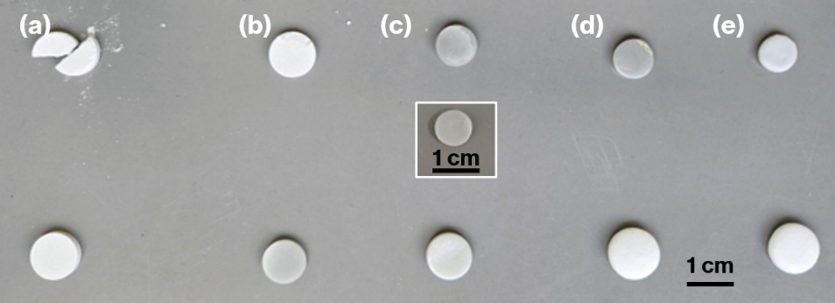
Figure 3. Photographs of compact specimens calcined at 800, 850, 900, 950, and 1050 °C (a–e), with each pair showing samples treated under air (top) and superheated steam (bottom). The inset shows the compact specimen prepared by applying superheated steam only up to 850 °C, followed by conventional calcination and cooling under air.
Figure 4. SEM (SE) images of (a) the powder specimen before calcination and the compact specimens calcined at 850°C in (b) air and (c) superheated steam.

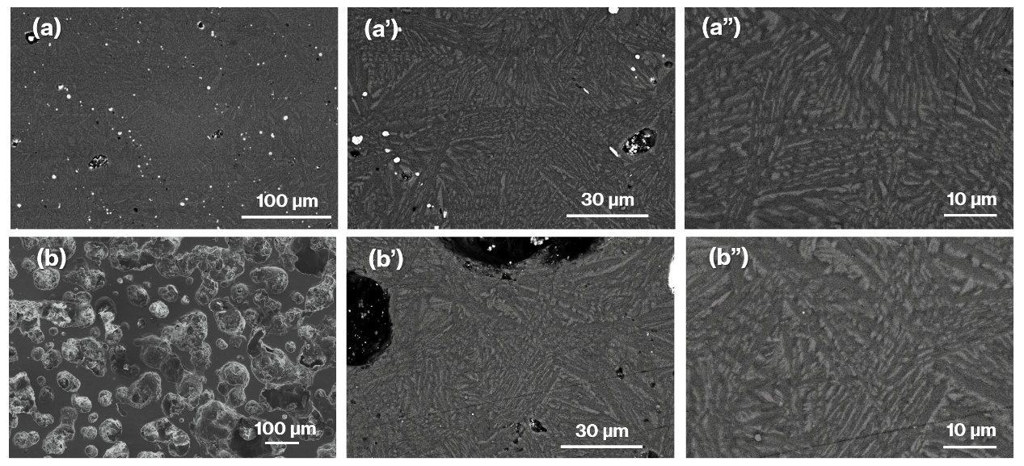
Figure 5. SEM (BE) images of the compact specimens calcined at 1050 °C under air (a) and superheated steam (b). Enlarged images are shown in (a’), (a”), (b’), and (b”), respectively.
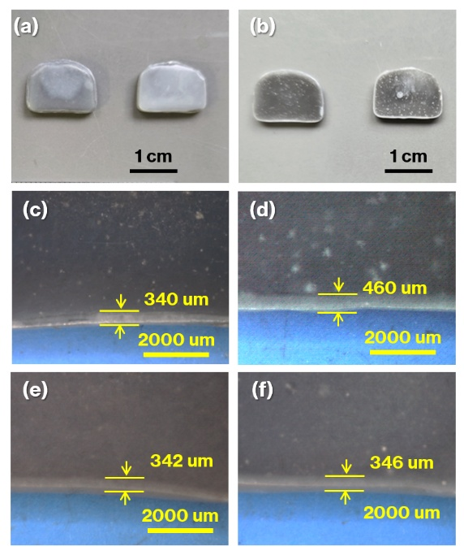
Figure 6. Photographs of (a) the surface layers and (b) the interiors of plate specimens calcined at 1050 °C for 6 h under air and superheated steam (left and right, respectively); enlarged images of their lower edges are shown in (c) and (d), along with the corresponding parts of specimens treated with superheated steam only up to 1050 °C and only during 1050 °C in (e) and (f), respectively.

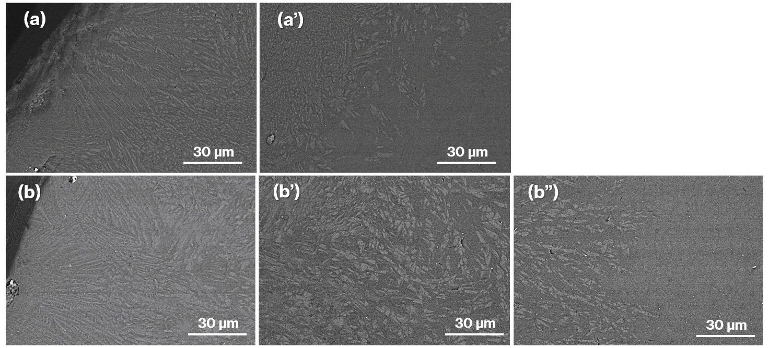
Figure 7. SEM (BE) images of the edges of the plate specimens calcined at 1050 °C for 6 h under air (a) and superheated steam (b). For the air-treated specimen, the image just below the edge is shown in (a’). For the superheated steam-treated specimen, a thicker surface layer required two depth-resolved images, shown in (b’) and (b”), respectively.

TOC
Superheated steam lowers the glass transition temperature of polymeric amorphous materials by enhancing surface ion diffusion, thereby accelerating crystallization.

