Ultra-high temperature flexure and strain driven amorphization in polycrystalline boron carbide bulks

D. Demirskyi ^{a,b,c,*}, H. Sepehri-Amin ^{c,*}, T.S. Suzuki ^{c}, K. Yoshimi ^{b} and O. Vasylkiv ^{c,*}.

(a) Advanced Institute for Materials Research (AIMR), Tohoku University, 2-1-1 Katahira, Aoba-ku, Sendai, 980-8577 Japan.
(b) Department of Materials Science and Engineering, Tohoku University, 6-6-02 Aramaki Aza Aoba, Sendai, 980-8579, Japan.
(c) National Institute for Materials Science, 1-2-1 Sengen, Tsukuba, Ibaraki 305-0047, Japan.
* Corresponding author.

The temperature dependence of the flexural strength of sintered boron carbide was studied. At temperatures above 2000ºC, B₄C showed an ultrahigh flexural strength exceeding 1GPa which was accompanied by a change in the deformation mechanism from brittle fracture to plastic deformation. Scanning transmission electron microscopy (STEM) observations revealed that the amorphization can be of microstructural origin for the observed plasticity in B₄C at temperatures above 2000 °C and a strain rate of 3·10⁻³ s⁻¹. The amorphization occurs inside of the severely deformed grains. Flexural tests below 2000 °C provided evidence for the formation of stacking faults or dislocations, which are ordinary defects after the flexural tests. The results at 2000 °C suggest that the magnitude of the tensile stresses imposed on the B₄C grains during deformation in flexure and the total strain transferred to a ceramic during the deformation process play the dominant role in the crystalline-amorphous transformation.

Keywords: boron carbide; transmission electron microscopy (TEM); crystal defects; high-temperature deformation.

Boron carbide (B₄C) and B₄C-based ceramics are some of the hardest materials known (just below diamond and cubic boron nitride). The crystal structure of boron carbide, B₄C, is rhombohedral with the R-3m space group. Due to the crystal structure and high-boron content, B₄C is also known as a lightweight ceramic. The density measured for B₄C is 2.52g/cm³; B₁₃C₂ is 2.48 g/cm³; and B_{10.4}C is 2.46 g/cm³ [1]. These excellent properties make B₄C-based ceramics suitable for various applications such as an abrasive and cutting material, wear prevention coating, and lightweight armor plates [1,2]. These applications are possible due to their high hardness, high anisotropy in elastic moduli, and a moderately low fracture toughness. Moreover, boron carbide is a neutron absorber widely used because of its high B content and its good chemical inertness.
The majority of properties, including hardness, originates from the covalent bonding in a crystal cell comprised of carbon atoms between boron icosahedra (B₁₂ or B₁₁C). As a ceramic with a strong covalent bonding, boron carbide, like diamond, has a low dislocation activity, and hence plasticity is not observed at room temperature due to a high lattice resistance [1]. At room temperature, the toughness and strength are interdependent via flaw size [3], while a more complex relation is expected at elevated temperatures. This is because intrinsic defects formed during processing or testing may lead to a different strength versus temperature dependence, including constant decrease [4] or a non-changed strength [3,5]. Typically, the high-temperature strength data have been limited to 1600 °C or less [5–7]. The question is how does the strength of B₄C change at elevated temperatures above 1600 °C? Addressing this question could open up new applications for the B₄C-based ceramics.
Furthermore, boron carbide may experience a highly localized solid-state amorphization, which is known to arise under a high strain rate / high stress [8]. This phenomenon may be a key in controlling the ability for fragmentation during shock-impacts [8,9]. Under an axial compression along with an extensive shear, a group of grains or atoms in a crystalline cell are subjected to a geometric distortion. This distortion results in altering the energy balance in the crystal causing the local phase transformation. The high strain-rate amorphization in boron carbide has been commonly observed as nano-scale bands separated by crystalline material [8]. This observation has been made under a variety of experimental conditions which are summarized in a recent review [9]. To the best of the author’s knowledge, the amorphization process of boron carbide bulks has not been reported under high-temperature conditions, at least a static high-temperature conditions.
Within this study, we undertook the investigation of the local defects in boron carbide grains using the ultra-high temperature flexural strength tests of bulk polycrystalline boron carbide up to 2000 °C. The aim is thus two-fold: first, to explore the high-temperature strength and plasticity of boron carbide at 2000 °C. Second, to attempt a new method to trigger the amorphization process in boron carbide. Particularly, we performed flexural tests at 0.8 of the absolute melting point of boron carbide and evaluated its high-temperature strength, plasticity, and microstructure origins responsible for the high temperature mechanical properties. A scanning transmission electron microscopy (STEM) investigation indicated that under ultra-high temperature flexure fairly large amorphous regions are formed within severely deformed boron carbide grains. The origin for these shear bands is due to a superposition of the total shear strain and relatively high tensile shear stresses.
A fully dense boron carbide ceramic was consolidated by a spark plasma sintering method at 1900 °C using a 10-min dwell. The grain size of the sample ranged from 1 to 10 μm. The boron addition of 25 wt.% was employed during the SPS, while 0.5 mol.% of Si was present in the as-received boron carbide powder [5]. The three-point flexural strength was determined using rectangular blocks (2 mm×2.5 mm×25 mm, ASTM C1211−13, configuration A) and a span of 16 mm was used. The tests at elevated temperatures were performed in argon. The cross-sectional specimens of B₄C for the TEM observations of the as-consolidated or the flexural tested samples were prepared by a focused ion beam (FEI Helios G4-UX) dual-beam system via the lift-out method. TEM was performed on the boron carbide samples using a FEI Titan G2 80–200 STEM equipped with a probe aberration corrector and an energy dispersive X-ray spectrometer (EDS).
To explore the ultra-high-temperature strength in boron carbide, tests were performed at various temperatures and loading rates. The results of the flexural strength tests are summarized in Table 1. We noticed that an extremely high flexural strength can be observed for the boron carbide bulks when the loading rate was 0.5 mm/min. Figure 1 illustrates the flexural strength data of boron carbide as a function of the temperature and strain-to-fracture. The data of Vasylkiv et al. [5] and Belon et al. [6] for testing at 1600 °C provided a good reference for the boron carbide at elevated temperatures. Other reports [3–7] did not report the strain-stress data. Data for various attempts at 2000 °C are presented using the 0.5 mm/min loading rate or the ~3·10⁻³ s⁻¹ strain rate. As is evident from Table 1, a baseline value of 700 MPa can be used for engineering applications, while other values, especially exceeding ~5 GPa, should be treated cautiously and should be verified by the tensile tests. Nevertheless, from the theoretical viewpoint, the theoretical strength of boron carbide using an E/10 approach [10], where E is Young’s modulus, should be at least 45 GPa at room temperature. As shown in Fig. 1(a), in addition to an ultra-high flexural strength exceeding 1GPa at the temperature of 2000 °C, a change in the deformation from brittle fraction (flexural tested samples at 1600 ºC) to a realization of some plasticity (flexural tested samples at 2000 ºC) was observed.
Representative bright field (BF) STEM images of the boron carbide specimens following the flexural test at 1600 °C are presented in Fig. 2. The BF-STEM image shown in (i) indicates the formation of twins in the as spark-plasma sintered state, noticeably the {101} twined region in (a ii). Figure 2 (a, iii, iv) shows that the segregation of Si can be seen in the grain boundary region of the bulk B₄C sample. A schematic illustration of the flexural test on the boron carbide sample at 1600 °C is shown in Fig. 2 (b) (i). We have investigated the microstructure of the region close to the fracture surface which is expected to have the highest degree of deformation. As shown in Fig. 2 (b) (ii), several micro-twins can be observed in the microstructure. These were also present in the undeformed sample.
Fig. 3 (b) shows BF-STEM images obtained from a severely-deformed region of the flexural tested sample at 2000°C (as marked in (a)). In a typical severely-deformed boron carbide grain, nano-cracks were also observed as shown in the HAADF-STEM image (Fig. 3 (c)). Si segregation is also observed, which is consistent with the grain boundary region observation in the undeformed sample (Fig. 2).
The existence of defects, common for boron carbide, such as twins and partial dislocations, can be identified in all the specimens, including as-consolidated boron carbide. These observations are consistent with previous reports for boron carbide [1,11]. After the flexural tests at the ultra-high temperature of 2000 °C, the distribution of defects strongly depended on the position for the TEM specimen probing. One can identify a heavily deformed region, and the BF-STEM images in Fig. 3 indicate the strained crystals and nucleation of amorphous islands in the B₄C grains. The undeformed region in the 2000 °C sample has only typical defects, such as twins, while the highly strained microstructure and amorphization can be seen only in the highly deformed region. Since the discontinuous nature of the lines correspond to lattice planes in selected TEM images in Figs. 2 and 3 the observed reduced contrast is due to the maximum strain [12].
Fig. 4 (a,b) show low magnification BF-STEM images obtained from a heavily deformed region of a flexural tested B₄C sample at 2000 ºC. Existence of a nano-size amorphous area is denoted by the black arrows in Fig. 4 (b). For a heavily deformed area of B₄C, the atomic resolution BF-STEM images shown in Fig. 4 (c,d) illustrate the possible steps of the amorphization mechanism during the plastic deformation process. Consider the following: the nucleation of the amorphous phase inside the grains starts with a size smaller than 2 nm via lattice distortion and the formation of dislocations in the boron carbide crystal as pointed out by the circles with broken lines in Fig. 4 (c,d). Nucleated and propagated amorphous areas inside the crystal are also denoted by the a yellow arrow in Fig. 4 (c) which can expand during the deformation parallel to the twin boundary direction. The nano-cracks can appear by further deformation in the amorphous region.
Unlike typical stress-induced features, such as microcavity formation or grain rotation, amorphous bands or shear bands are transgranular features. Some amorphized bands rotated on 90 °, suggesting that the initial zone of easy flow has rotated out of the plane of the maximum resolved shear stress. The transformation initiated by the plastic-stress at this stage of deformation localizes into zones that are better aligned with the maximum resolved shear stress direction.

Figure 4 indicates that the strain induced deformation causes randomly-oriented amorphous regions as it should when plastic deformation is being observed. Sometimes, the strain caused by the crystal–amorphous transformation was observed at the extent of 2–3 lattice spacings, yet these areas are still somehow non-symmetrical. The loss of symmetry is believed to be caused by the superposition of compressive and tensile stresses, as the TEM-images depicted in Fig. 3 show the microstructure of the tensile part of the specimen, where the bending moment and, perhaps crucially, shear tensile stress were at their maximum.

As reasoned by Patel and Cohen [13], an additional energy can be algebraically added to the activation energy for transformation if such a process is being aided by the external pressure (such as tensile or compressive stress during flexure). The value of the normal stress for the specimen evaluated by TEM after testing at 2000 °C corresponds to 1.8 GPa. This stress, compressive at the tip of the top loading bar, and tensile on the opposite side, is not the effective stress induced inside the specimen. As can be reasoned from the strength of the materials [10], e.g., for B₄C [14] or SiC [15], if the 45 ° angle between the normal and shear stresses is being observed, the effective value of stress imposed on the bar is at most 0.9 GPa.
Above 1600° C, signs of plasticity in B₄C can be observed regardless of the position of the sample from which the TEM observation was conducted. This spurs up the validity of the effect of the stress on the crystalline-amorphous transformation as the major portion of the crystalline–amorphous transformation is being observed on the tensile side. One can reason on the importance for the ‘accumulated strain’ component which is evident from the stress-strain diagram.
Under a constant strain rate, a total time exposed to the ultra-high temperature loading is directly proportional to the accumulated strain. Highly-strained B₄C specimens under compressive stresses showed creep-induced cavitation [16,17], which is also evident in the specimens deformed at 2000° C. In these studies, the amorphization in boron carbide had not yet been reported. This is due to the relatively low temperature (<1800° C) and considerably low stresses (~200 MPa). Using the reference specimens deformed at 2000° C under the comparably higher loading rates (25 mm/min), we found that these specimens flex in a brittle manner and defects common to normally deformed boron carbide at 1600° C were observed. Thus, the heat transferred to a specimen does not instantly cause amorphization.
The amorphous zones were not identified on the compressive side of the flexural bar or in the undeformed section of the bar following the ultra-high temperature flexural tests at 2000° C suggesting that the tensile stresses necessary for the crystal-amorphous transition may relax. In ref. [9], it was suggested that the amorphization induced in boron carbide via the stretching icosahedra may evolve into defects or justifiably assist in the crack formation, thus the situation observed in the present study is entirely different.
First, crack formation would occur on a macroscopic level at the tensile end independent from any crystalline–amorphous transformation as it would be at the lower temperatures. Second, normal and shear compressive stresses will not directly result in the amorphous–crystalline transformation. As noted in [13], phase transformation can be promoted in this scenario. Third, following the treatment in which tensile stresses had a higher influence over phase transformation compared with compressive stresses, the tensile stresses should assist the crystalline–amorphous transformation in boron carbide, which is confirmed by TEM observations at the tensile end. This leads to a scenario when the tensile end features amorphization in the boron carbide on a nano-scale and crack-growth induced by flexure momentum on the macroscale. Furthermore, in [18], the authors consider that there was experimental evidence that the amorphization in the boron carbide occurs first, then provides a trigger and crack path for intergranular cracking: namely, the resistance to crack propagation is lower in the amorphous boron carbide than it is for crystalline boron carbide. However, in this study, both the crack initiation and amorphization are governed by the normal and shear tensile stresses, strain rate, accumulated strain and temperature. Once any of these parameters is not contributing sufficiently during the ultra-high temperature flexural test, the amorphization will not be triggered. This can be easily confirmed by testing at a different strain rate at 2000 °C; specimens tested using the 50-fold increase in the strain rate showed a similarity in fracture at 1600 °C. The temperature, as expected, only increases chances for the transformation to occur, hence one may expect that the situation at the tensile end can be replicated at lower temperatures if the strain rate and total strain accumulated in the boron carbide matches the conditions for the 2000 °C specimen.
In summary, our findings suggest that the defect structure in boron carbide is sensitive to superposition of the tensile stresses during the flexural test. The structural analyses suggest that amorphization in boron carbide can be observed only at ultra-high temperatures, i.e., above 2000 °C. The initiation of amorphization under ultra-high temperature flexure conditions occurs inside of the severely deformed grains, which are formed in the tensile end of the bar during the flexural test. Eventually, it is believed that by tuning the strain rate for boron carbide or silicon carbide one may obtain comparable results at slightly lower temperatures, which can be a key in controlling and understanding the observed phenomenon. To replicate the observed phenomenon a lengthy plastic zone should be obtained during the high-temperature deformation process.

[1] F. Thevenot, J. Eur. Ceram. Soc. 6 (1990) 205.
[2] V. Domnich, S. Reynaud, R.A. Haber, M. Chhowalla, J. Am. Ceram. Soc. 94[11] (2011) 3605.
[3] O. Vasylkiv, D. Demirskyi, P. Badica, T. Nishimura, A.I.Y. Tok, Y. Sakka, H. Borodianska, Ceram. Int. 42(6) (2016) 7001.
[4] N. Tamari, H. Kobayashi, T. Tanaka, I. Kondoh, S. Kose, J. Ceram. Soc. Jpn. 98 (1990) 1159.
[5] O. Vasylkiv, D. Demirskyi, H. Borodianska, Y. Sakka, P Badica, J. Ceram. Soc. Jpn., 124[5] (2016) 587.
[6] R. Belon, G. Antou, N. Pradeilles, A. Maitre, D. Gosset, Ceram. Int. 43 [8] (2017) 6631.
[7] G. de With, J. Mater. Sci. 19 (1984) 457.
[8] M.W. Chen, J.W. McCauley, K.J. Hemker, Science 299 (2003) 1563.
[9] A.P. Awasthi, G. Subhash, J. Appl. Phys. 125 (2019) 215901.
[10] Th.H. Courtney. Mechanical Behavior of Materials, 2nd Edition, Waveland Press, 2005.
[11] D. Ge, V. Domnich, T. Juliano, E.A. Stach, Y. Gogotsi, Acta Mater. 52 (2004) 3921.
[12] V.A. Philips, J.A. Hugo, Acta Metall. 18 (1970) 123.
[13] J.R. Patel, M. Cohen, Acta Metall. 1[5] (1953) 531.
[14] S. Zhao, B. Kad, B.A. Remington, J.C. LaSalvia, C.E. Wehrenberg, K.D. Behler, M.A. Meyers, PNAS USA 113 (2016) 12088.
[15] S. Zhao, R. Flanagan, E.N. Hahn, B. Kad, B.A. Remington, C.E. Wehrenberg, R. Cauble, K. More, M.A. Meyers, Acta Mater. 158 (2018) 206.
[16] B. Malmal Moshtaghioun, D. Gomez Garcia, A. Dominguez Rodriguez, N.P. Padture, J. Eur. Ceram. Soc. 35 (2015) 1423.
[17] B. Malmal Moshtaghioun, D. Gomez Garcia, A. Dominguez Rodriguez, Mater. Des. 88 (2015) 287.
[18] A. Chauhan, M.C. Schaefer, R.A. Haber, K.J. Hemker, Acta Mater. 181 (2019) 207.

Table 1 Summary of ultra-high-temperature flexural tests for boron carbide
Temperature, °C | Loading rate, mm/min | Stress-strain curve | Strength, MPa
Temperature, °C | Loading rate, mm/min | Stress-strain curve | minimum | mean | maximum
25 | 0.5 | Elastic | 542 | 580 | 605
1600 | 0.5 | Elastic | 525 | 540 | 568
1800 | 0.5 | Elastic | 488 | 525 | 545
2000 | 0.5 | Plastic | 1022 | 1836 | 8400
2000 | 2.5 | Plastic | 746 | 1254 | 1688
2000 | 25 | Elastic | 636 | 672 | 724

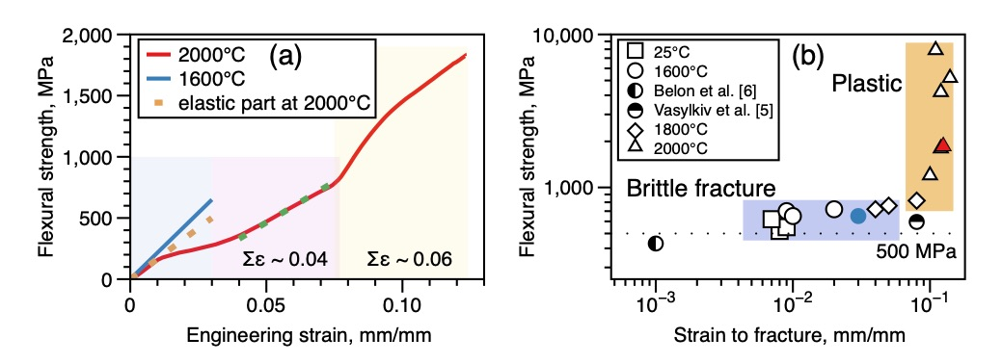
Figure 1. Effect of temperature on the strain-stress relation in monolithic boron carbide. (a) shows the typical strain-stress curves at 1600 °C and 2000 °C. (b) shows the flexural strength as a function of the temperature and total strain accumulated during the test at a 0.5mm/min rate. In (b) the closed symbols are for the specimens that were examined by transmission electron microscopy. In (b) the dotted line shows the upper limit of the monolithic additive-free boron carbide strength at room temperature (500 MPa) [1].

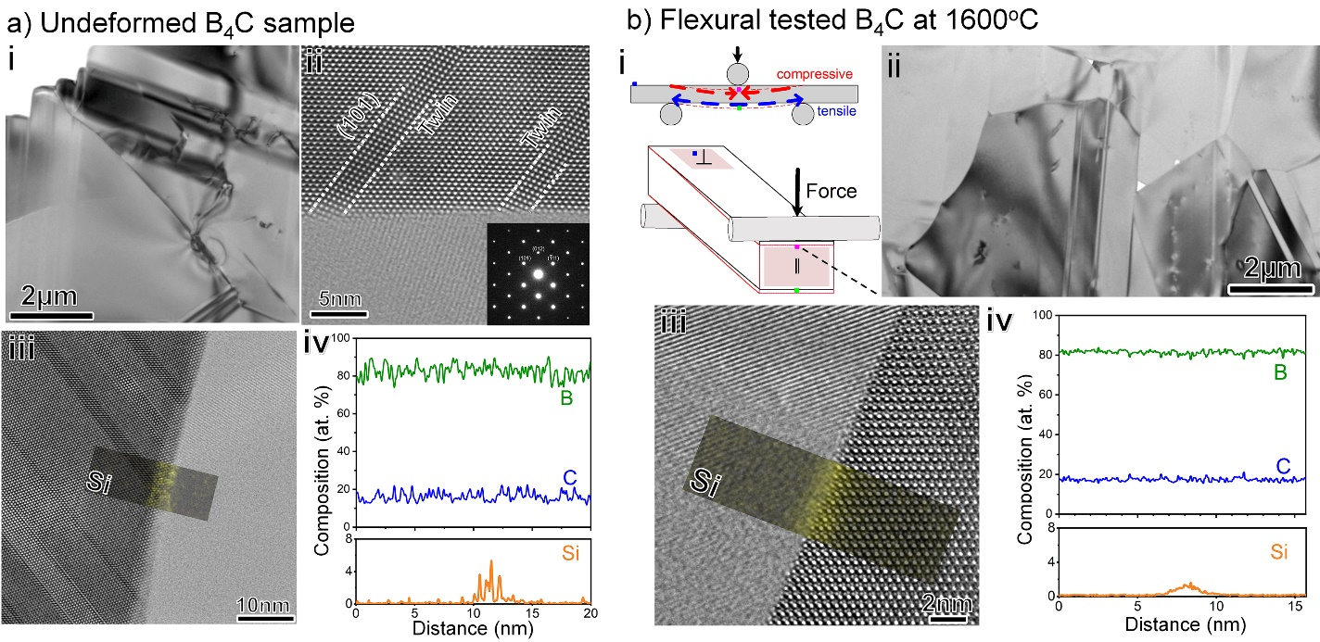
Figure 2. Effect of temperature on the defects in the boron carbide. (a) overall microstructure of B₄C sample showing (i) bright field STEM image, high resolution BF-STEM images from the grain boundary region and (iv) EDS composition line profile obtained across a grain boundary region. (b) Microstructure of flexural tested B₄C sample tested at 1600 °C (schematically shown in i), (ii)low magnification and (ii) high magnification BF-STEM images obtained from highly-deformed region. Composition line profile of constituent elements obtained from STEM-EDS is shown in (iv).

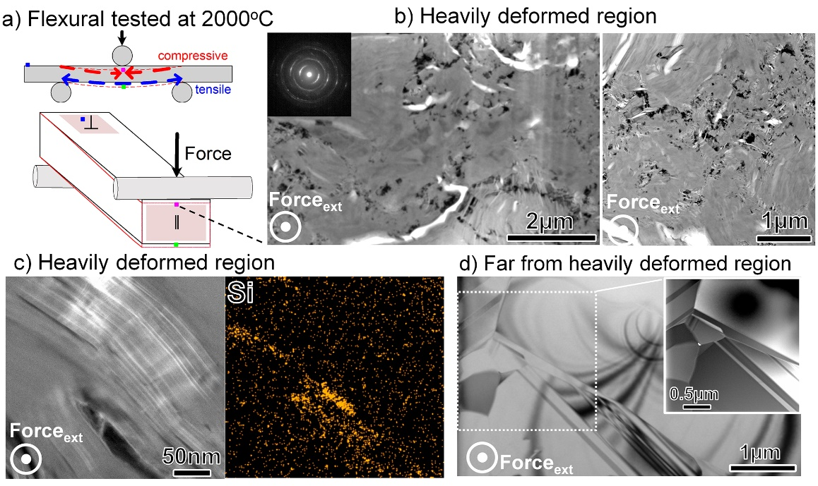
Figure 3. Defects in the boron carbide at different probing areas of the bar after the flexural test. (a) Schematic illustration of flexural tested B₄C sample at 2000 °C. (b) BF-STEM images obtained from highly deformed region. Note that the external force was in the out-of-plane direction of the TEM images. (c) high magnification ADF-STEM image and STEM-EDS map of Si. (d) BF-STEM image obtained from a region far from the heavily deformed region. Annular dark field image of selected region marked by broken lines is shown in the inset.

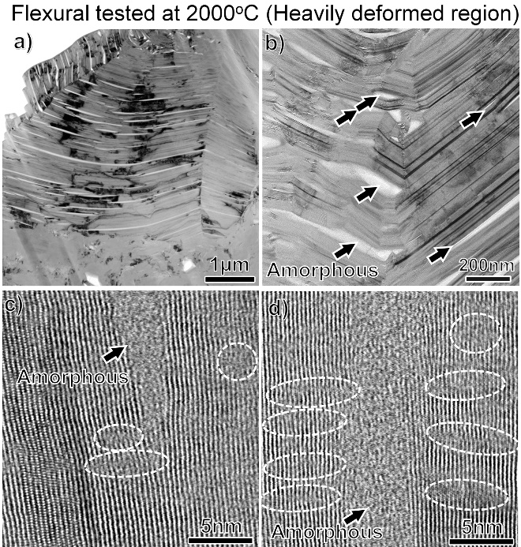
Figure 4. Structure peculiarities and amorphous zone formation inside the severely-deformed boron grains after flexural test at 2000 °C. (a,b) low and (c,d) high magnification BF-STEM images obtained from a heavily-deformed region of flexural tested B₄C sample at 2000 °C. Nucleation and propagation of amorphous region inside of the grains can be observed as denoted by the broken lines and yellow arrows in (c,d).

