High-pressure diffusion control: Na extraction from NaAlB₁₄
Masaya Fujioka¹*, Mihiro Hoshino¹, Suguru Iwasaki¹, Haruhiko Morito², Masaya Kumagai³, Yukari Katsura⁴, Khurelbaatar Zagarzusem⁵, Madoka Ono^{1,} and Junji Nishii¹
¹ Research Institute for Electronic Science, Hokkaido University, Kita 20, Nishi10, Kita-ku, Sapporo, Hokkaido 001-0020, Japan
² Institute for Materials Research, Tohoku University, 2-1-1 Katahira, Aoba-ku, Sendai 980–8577, Japan
³ SAKURA internet Research Center, SAKURA internet Inc., Tokyo Tatemono Umeda Building 11F, 1-12-12, Umeda, Kita-ku, Osaka 530-0001, Japan
⁴ National Institute for Materials Science, 1-1 Namiki, Tsukuba 305-0044, Japan
⁵ Department of Electronics, School of Information and Communication Technology, Mongolian University of Science and Technology, Ulaanbaatar 14191 Mongolia
ABSTRACT: A novel synthesis technique, called the high-pressure diffusion control (HPDC) method, was developed in this study. The method combined the high-pressure synthesis using a cubic-anvil apparatus and an anisotropic diffusion control technique; the electrical processing in high-pressure and high-temperature environments of up to 4 GPa and over 1000°C are enabled by simultaneously adjusting the temperature, pressure, and voltage. This nonequilibrium state is effective in creating metastable materials. The developed novel technique was applied to the polycrystalline NaAlB₁₄ with a boron covalent framework. Although electronic conduction is dominant in this material and no Na ion conduction is observed even at high temperatures, the HPDC method successfully extracted Na ions by utilizing the difference in bond strength between Na and B, creating the metastable material AlB₁₄ while maintaining its basic crystal structure. During the decrease in Na concentration, applying high pressure compressed the sample according to the volume change and maintained good contact at the inter-grain boundary in the polycrystalline sample, promoting Na ion diffusion. The Na extraction functioned as electron carrier modulation and significantly reduced the electrical resistivity. The developed HPDC method is expected to be applicable to various compounds with a difference in the bond strength between constituent elements and has the potential to open new avenues in the inorganic synthesis of polycrystalline metastable materials with dense sintered state and modulate their physical properties.
Introduction
The discovery and synthesis of thermodynamically metastable materials have been a major topic in materials science and engineering since Josiah Willard Gibbs formulated materials thermodynamics in 1878¹. To date, various techniques are being developed for synthesizing thermodynamically metastable materials, such as the quenching treatments from high-pressure or high-temperature stable phases², the mechanochemical processes³, and the thin film fabrication technologies⁴⁻⁵.
Furthermore, ion exchange⁶⁻⁷, introduction⁸⁻⁹, and extraction¹⁰ are also effective for synthesizing metastable materials. These reactions can be applicable in materials with a large difference in chemical bond strength between constituent elements^{7, 10}. If the diffusion of weakly bonded ions can be controlled while maintaining the basic crystal structure, a metastable phase, which cannot be obtained by simple heat treatment, would be formed, and the electron carrier density would be tuned by modulating elemental composition¹¹. This technique has the potential to flexibly change the transport properties to superconducting, metallic, semiconducting, and insulating features according to the carrier density¹².
Applying voltage is the most commonly used driving force to control diffusible ions. Although this way is useful for electron-insulating materials, such as ion conductors, it is not applicable to electron-conducting materials due to electrostatic shielding. Therefore, it is challenging to meta-stabilize electron-conducting materials by compositional change via ionic diffusion.
Anisotropic ion diffusion control technique has been reported, demonstrating homogeneous extraction of the Na ions from the large single crystalline Na–Si clathrate (Na₂₄Si₁₃₆) with metallic conductivity¹⁰. This material comprises covalent Si cages and Na ions trapped in these cages¹³, with a sufficient difference in the chemical bond strength. When the temperature reaches around 450°C, weakly bonded Na ions thermally diffuse beyond shallow activation energies, while Si atoms can maintain a robust original cage structure. Although the electric field is not available for Na extraction inside Na₂₄Si₁₃₆ due to its metallic conducting feature, a chemical potential gradient was skillfully utilized as a driving force for anisotropic Na diffusion. Na ions were homogeneously extracted from a single crystal, resulting in the metallic transport properties changing to semiconducting features due to the electron carrier tuning according to the decrease in Na concentration.
Thus, there are two key factors in controlling ion diffusion. First, the target material needs to have significantly different chemical bond strengths; when a weakly bonded ion species activate at some temperature and start thermally diffusing, the other constituent elements should maintain the original crystal structure to avoid decomposition into a more stable structural state through their interdiffusion. Second, under the temperature diffusing only weakly bonded ions, the appropriate driving forces should be applied to the diffusible ions according to the material’s features, such as an electric field for ion conductors and a chemical potential gradient for metallic materials. Such a driving force changes the isotropic thermal diffusion to the anisotropic diffusion with a high probability of movement in a particular direction¹⁰
However, problems must be solved in polycrystalline materials to apply such a meta-stabilization technique by compositional modulation using ion diffusion. First, since the macroscopic compositional modulation via ion diffusion results in a significant change in volume¹⁴, cracks or irregularities form at the grain boundaries. Such a deteriorated intergrain contact significantly suppresses the ion diffusion flow. Therefore, the synthesis using anisotropic ion diffusion is effective for materials such as glass that flexibly change shape at high temperatures¹⁵⁻¹⁷, soft layered single crystals stacked by the van der Waals force^{7, 9, 11, 18}, and substances with a structure whose volume hardly changes with the ion introduction and extraction like zeolite.
Second, although the chemical composition beyond thermodynamic constraints changes electronic properties according to the modulated carrier density, electron transport properties are also strongly influenced by inter-grain resistivity in polycrystals. Therefore, the dense sintered samples treated at a sufficiently high temperature are necessary to evaluate intrinsic conducting transport properties. However, such a heat treatment transforms the metastable state into a more thermodynamically stable state. Therefore, in investigating the transport properties, the dense sintered state and metastable state may be incompatible.
Third, during macroscopic compositional changes under high temperatures, materials absorb atmospheric gases, such as oxygen, and undergo unexpected chemical reactions that compensate for the compositional changes. These factors often impede both the ideal anisotropic ion diffusion to achieve macroscopic compositional modulation across bulk samples and the accurate characterization of transport properties.
This study combined high-pressure synthesis using a cubic multi-anvil apparatus¹⁹ and an anisotropic ion diffusion control technique and developed a novel synthesis method: the high-pressure diffusion control (HPDC) method, to address these problems. Anisotropic ion diffusion under high pressure is expected to achieve the metastable state with non-stoichiometric composition, which can tune electron carrier density, and dense sintered state reduced intergrain resistivity.
The cubic-anvil high-pressure synthesis method compresses samples up to several GPa and maintains close contact at the intergrain boundary according to the volume change, resulting in both metastable and dense sintered states. In a general case, the reaction time is considerably reduced under high-pressure conditions²⁰. One of the possible mechanisms is below; the inert surfaces of the particles in polycrystals wear away during the compression, and the clean inner areas come into contact with each other. Thus, the high pressure creates a suitable environment to promote good interdiffusion of elements between particles. Furthermore, since high-pressure synthesis is a completely closed system, it is possible to prevent unexpected chemical reactions based on the inflow of oxygen from the outside during macroscopic compositional modulation by anisotropic ion diffusion. Although a number of high-temperature and high-pressure electrochemical cells have been demonstrated in previous studies²¹⁻²⁴, these studies aimed at power generation, and the target pressure is 0.05 GPa or less. In contrast, HPDC focuses on materials synthesis. Applying pressure and temperature have been demonstrated up to 4 GPa and 1000°C, respectively, in this research. Also, these conditions can be adjusted depending on the materials.
To demonstrate our idea of achieving both metastable and dense sintered states in the polycrystalline bulk materials using HPDC, NaAlB₁₄ was selected for the following reasons. This material has a structure composed of a strongly connected covalent B framework and weakly bonded Na ions, with a large difference in chemical bond strength²⁵⁻²⁶. In addition, our previous study already established the synthesis process using Na vapor for the polycrystalline single-phased NaAlB₁₄ and revealed the unintentional extraction of a small amount of Na from the outermost surface via an annealing process²⁷. It has been experimentally suggested that a part of Na ions near the surface can move by thermal diffusion while retaining the original covalent B framework as weakly bound ionic species. When changing this isotropic thermal diffusion to anisotropic ionic diffusion by HPCD, macroscopic amounts of Na extraction from bulk polycrystalline NaAlB₁₄ can be expected. Since NaAlB₁₄ exhibits electron conductivity, not the simple voltage application but the change in chemical potential can be a driving force. Thus, NaAlB₁₄ is a promising first candidate for demonstrating the compositional modulation in electron-conducting material utilizing HPDC.
High-pressure diffusion control cell
A cubic-anvil high-pressure apparatus controls the treatment temperature by energizing a carbon heater via the upper and lower Mo electrodes, as illustrated in Figure 1a. In addition, pressure is applied from six directions via anvils (Figure 1c). Thus, the temperature and pressure can be controlled at the same time. In this study, this conventional cell is described as the high-pressure (HP) cell. The novel cell, referred to as the HPDC cell, is illustrated in Figure 1b. In this cell, the temperature can be controlled by energizing a heater through Cu or Mo electrodes on the side surface so that the upper and lower Mo electrodes are connected to the inside of the sample space, enabling electrical processing. Although it has not been previously reported whether the carbon heater could function by the power input from the side surface, the temperature rises to 1000°C with an input power of 600 W, as displayed in Figure 1d. Therefore, the novel cell can be available for materials synthesis at sufficiently high temperatures. In this way, in the pressure cell of Figure 1b, it is possible to adjust the three synthesis parameters of temperature, pressure, and voltage.
As mentioned above, the proposed technique increases the temperature up to that where only Na ions can diffuse and applies voltage to induce anisotropic diffusion. The pressure suppresses contact deterioration due to changes in volume and achieves a closed system without exchanging elements with the outside. The crystal structure of NaAlB₁₄ and Na-free AlB₁₄ was drawn using VESTA²⁸ and is presented in Figures 1e and 1f.

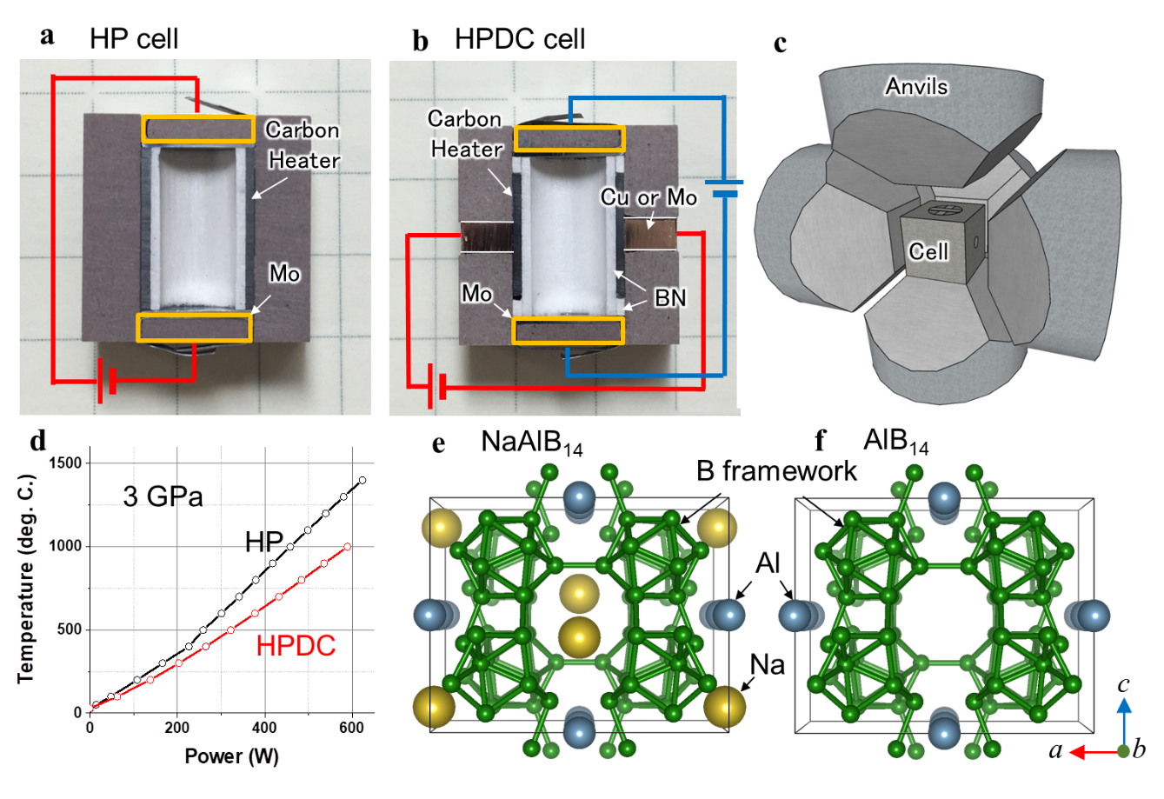
Figure 1. (a), (b) Cross section of (a) high-pressure (HP) cell and (b) high-pressure diffusion control (HPDC) cell. (c) Cubic-anvil high-pressure apparatus. (d) Relationship between power and temperature. (e), (f) Crystal structure of (e) NaAlB₁₄ and (f) AlB₁₄ viewed along the [010] directions.

characteristics of NaAlB₁₄ before and after HPDC
For preparing NaAlB₁₄, a mixture of Al and B was sintered in a Na vapor atmosphere, and the residual Al was removed with HCl. The obtained single-phase NaAlB₁₄ was annealed at 900°C under 4 GPa using an HP cell. The detailed conditions are provided in reference²⁷. The sample after the high-pressure treatment, a Y-type zeolite and a carbon-added Y-type zeolite were stacked in the sample space with φ = 4.4 mm, as illustrated in Figure 2a. The thickness of each was 0.54, 1.48, and 1.27 mm, respectively, in order from the top. The carbon-added Y-type zeolite was prepared by mixing graphite and the Y-type zeolite with a weight ratio of 1:1. To apply pressure, a cubic-anvil high-pressure apparatus, CTF-HPS/U-DC330-VD2 (C & T Factory), was used. Figure 2b presents the time dependence of the current and total charge passed. As the temperature gradually increased under 1 GPa and 5 V, the current suddenly increased at 450°C, as illustrated in Figures S1a and S1b. At this temperature, Na ions begin to diffuse within the boron framework. Then, the temperature was kept at 550°C.
The current increased up to 1.04 mA and gradually decreased over 16 h. The Na/Al ratio after Na extraction was estimated to be 0.01 by scanning electron microscopy–energy-dispersive X-ray spectroscopy (SEM–EDS) measurements using JCM-6000 (JEOL). Therefore, almost all Na was extracted by this method (Figure S2). The extracted Na ions were migrated to the cathode side through the zeolite and accumulated in the carbon-added zeolite, as shown in Figures 2c and 2d. The total charge passed during the treatment was saturated at 7.43 C, while the total charge required to extract Na ions from the sample completely was 7.34 C. The experimental result is thus in good agreement with the estimation. The Na-extracted sample is hereafter referred to as AlB₁₄ for simplicity.
Na concentration in NaAlB₁₄ gradually decreases from the cathode side, as displayed in Figure S3. Also, NaAlB₁₄ does not show any DC polarization, indicating that the electron conductivity is dominant, as shown in Figure S4. In the case of the Na-containing phosphate glasses without electron conduction, a Na concentration decreased from the anode side by applying the electric field¹⁵, and DC polarization was exhibited^{15, 17}. These experimental results indicated that the Na migration in NaAlB₁₄ is dominantly driven by not an electric field but a chemical potential gradient. Since the applied voltage is consumed in the zeolite, thermally diffused Na ions at the interface from NaAlB₁₄ immediately migrate to the cathode side along the electric field in the zeolite area. The induced Na concentration gradient in NaAlB₁₄ (Figure S3) should work as the difference in chemical potential, increasing the probability of Na migration toward the cathode side. Thus the isotropic thermal diffusion of Na ions changes to the anisotropic diffusion. This is the mechanism of Na extraction in NaAlB₁₄ with electric conduction.
X-ray diffraction (XRD) measurements were performed using MiniFlex600 with D/teX Ultra (Rigaku). The samples were harder than WC; therefore, the bulk surfaces were measured instead of their powder. In particular, AlB₁₄ was post-annealed at 500°C under N₂ atmosphere to relax the lattice distortion and obtain a better XRD profile, as displayed in Figure S9b. In addition, the results of Rietveld refinement²⁹ of the obtained XRD patterns before and after the treatment are presented in Figures 2e and 2f, respectively, and the structural parameters are summarized in Table S1 and S2. After HPDC treatment, the XRD peak shifted to the high-angle side, signifying that the lattice constant decreased due to the decrease in Na concentration. Also, the change in peak intensities was well agreed with the simulation pattern with the structural parameters in Table S2. However, the quality of the XRD data was insufficient to discuss the detailed elemental composition because high-pressure treatment broadens the XRD peaks. Therefore, the occupancy of B was fixed to 1.0, and the occupancies of Na and Al were refined considering the ratio of Na/Al obtained by SEM-EDS measurements (Figures S2b and S2c). Obtained R factors were reasonable in comparison with previous reports ^{27, 30-31}. As a result, it was confirmed that the boron covalent framework was still maintained even after Na extraction.
Other treatment conditions for HPDC were also investigated. A higher temperature promotes diffusion, but impurities were formed at 650°C and 750°C (Figure S5(a)-S5(c), S6). Also, a higher pressure maintains good contact between grains, but too high pressure at 4 GPa inhibits the Na diffusion (Figure S5(d), S5(e)). Furthermore, the current value was hardly changed even if the applied voltage was ten times higher (50V) (Figure S5(f)). This result explains that the voltage magnitude does not affect the Na diffusion in NaAlB₁₄, and the rate-determining of Na diffusion is dominated by thermal excitation and chemical potential. Thus, it is necessary to appropriately examine synthesis conditions according to the chemical bonding state of each material.
In addition, the DFT calculations ³²⁻³³ were performed assuming the Na-extracted structure without boron defects to investigate the charge neutrality. Detailed conditions are described in section 6 of the supporting information. Note that at this stage, it is challenging to evaluate quantitative boron concentration from EDS and XRD measurements. Figure S7a shows the difference in the Bader charge of each atomic site. There was no significant difference at the Al site before and after Na extraction. The Bader charge of boron sites has changed greatly after Na extraction, suggesting that the electronic state of boron compensated for the charge neutrality. In particular, the electron density decreased at the B2, B4, and B5 sites highlighted in red near the Na site in Figure S7b, reflecting the electron depletion associated with Na extraction.

Figure 2. (a) Schematic configuration of the sample space in the high-pressure diffusion control (HPDC) cell. (b) Time dependence on current and total charge passed. (c) Scanning electron microscopy image of the cross section of the HPDC cell. (d) Energy-dispersive X-ray spectroscopy mapping image of Na of (c). (e), (f) X-ray diffraction results after Rietveld refinement for (e) NaAlB₁₄ and (f) AlB₁₄. AlB₁₄ was post-annealed at 500°C under N₂ atmosphere.

Electrical properties of Na-extracted NaAlB₁₄
The electrical properties of NaAlB₁₄ before and after Na extraction were investigated. The temperature dependencies of the resistivities of the samples were measured using a handmade machine with a DC four-probe technique in Figure 3a. The DC polarization based on the Na conduction was not confirmed at measured temperatures, as shown in Figure S4. The applied constant current was 1 μA. Black, red, and green lines denote the ρ–T curves for the first, second, and third measurements of the NaAlB₁₄ sample, respectively, while blue, purple, and gray lines denote the curves for the first, second, and third measurements of the AlB₁₄ sample, respectively. All ρ–T curves displayed semiconducting behavior. In NaAlB₁₄, the electrical resistivity gradually decreased with an increasing number of cycles. No structural change was confirmed from the XRD patterns before and after resistivity measurements (Figure S8d). The origin of this behavior was thought to be the decrease in Na concentration at the surface of NaAlB₁₄ in heating up to 500°C for each resistivity measurement.
As indicated by the EDS measurement results (Figures S8a, S8b, and S8c), the Na-containing amorphous phase was formed on the surface after the resistivity measurements. This formation took in Na ions and reduced the Na concentration on the surface of NaAlB₁₄, and the surface conductivity increased due to a change in the electron carrier density. When most of the current flowed through the Na-extracted surface, it was difficult to accurately measure the resistivity of NaAlB₁₄. Therefore, it is considered that the first measurement best represents the intrinsic electric properties of NaAlB₁₄.
The resistivity measurements for AlB₁₄ revealed significantly different ρ–T curves between the heating and cooling in the first measurement. During heating up to 500°C, the resistivity decreased to 1 Ωcm. However, the cooling measurement maintained the resistivity at approximately 20 Ωcm at room temperature. Therefore, resistivity decreased by nearly 10⁵ times compared to room temperature before and after Na extraction. The ρ–T curves in the second and third measurements of AlB₁₄ were almost identical to that in the first cooling measurement. This behavior in AlB₁₄ is reasonable because there are few Na ions in the sample and no effects of a decrease in Na concentration at high temperatures on resistivity, unlike the case of NaAlB₁₄.
The large decrease in resistivity between heating and cooling in the first measurement was thought to be attributed to the hydrogen discharge and the relaxation of structural strain by annealing at 500°C. Figure S9a presents the temperature-programmed desorption mass spectrometry (TPD/MS) results. Hydrogen started discharging from the sample at 150°C, and the main peak appeared at approximately 250°C. The amount of hydrogen released corresponded to 0.06 equivalents of a sample. It was considered that protons in the zeolite were exchanged for part of the Na ions in NaAlB₁₄ during the HPDC process. Further research is required to determine how hydrogen is coordinated within the structure of AlB₁₄. Furthermore, Figure S9b presents the reflection peaks indexed as 101 before and after annealing at 500°C. The observed shoulder of the XRD peak disappeared after annealing. Although the as-treated sample exhibited structural strain due to Na extraction, annealing may have relaxed it. These irreversible changes in the initial measurement were considered to be some of the factors explaining the conduction properties of AlB₁₄. Note that there is a possibility of unintentional effects that have not yet been clarified due to the samples obtained from an unusual environment.
Figure 3. (a) Temperature dependence of resistivity for NaAlB₁₄ before and after Na extraction. Black, red, and green lines denote the ρ–T curves for the first, second, and third measurements of the NaAlB₁₄ sample, respectively, while blue, purple, and gray lines denote the curves for the first, second, and third measurements of the AlB₁₄ sample, respectively. (b) (hνα)^{0.5} as a function of hν for NaAlB₁₄ before and after Na extraction. Dotted lines denote the straight-line approximation to determine the band gap. WC impurities were introduced during the pulverization of samples due to the hardness of boron compounds.

Diffuse reflection measurements were performed using a spectrophotometer, V770 (Jasco), and the ultraviolet-visible (UV−Vis) spectra of NaAlB₁₄ and AlB₁₄ are presented in Figure 3b. Since these boride compounds are extremely hard, WC powder was mixed in the sample when ground using a WC mortar (Figure S10a). However, the diffuse reflection from WC does not affect the band gaps of NaAlB₁₄ and AlB₁₄, as illustrated in Figure S10b. The estimated band gaps were 2.2 and 1.1 eV for NaAlB₁₄ and AlB₁₄, respectively. This is also consistent with the reduction in resistivity and reveals that the electronic state was modulated by Na extraction.
Thus, an electron transport property was significantly improved by using HPDC because macroscopic compositional change via anisotropic Na diffusion tuned the electron carrier density, and also, a dense sintered state was maintained against the change in the volume, forming close contact between grain boundaries.

Conclusion
A novel synthesis method called the HPDC method was developed in this study. This synthesis method is the first to have the ability to control temperature, pressure, and voltage at the same time. The temperature can be adjusted over 1000°C by passing an electric current through the side of a cylindrical carbon heater. Pressure is applied by compression using six anvils and can be controlled up to 4 GPa using a cell assembly for a cubic-anvil apparatus. Voltage is applied to the sample space through a Mo electrode and can promote anisotropic ion diffusion. The application of high pressure creates a closed system that prevents interference from the external environment, such as the inflow of oxygen. Furthermore, although macroscopic changes in the elemental composition accompany volume change, constant pressure is applied during HPDC treatment according to these changes, and it is possible to maintain good contact between grains. This advantage is particularly important for polycrystalline materials with intergrain boundaries.
By tuning three parameters—pressure, temperature, and voltage—Na ions were extracted from polycrystalline NaAlB₁₄ while maintaining the boron covalent framework, creating the metastable material AlB₁₄. Since the NaAlB₁₄ exhibited electron-conducting properties, the chemical potential gradient in NaAlB₁₄, not the electric field, should work as the driving force of Na ion extraction from the inside of the polycrystal.
Thus, this study achieved polycrystalline AlB₁₄ with dense sintered and metastable states. Such materials are promising to transport properties due to the strong connections at grain boundaries and carrier density control according to the compositional modulation utilizing the anisotropic ion diffusion. The developed technique HPDChas the potential to open new avenues in the inorganic synthesis of metastable materials and reveal their physical properties, such as superconducting, semiconducting, ion-conducting, and thermoelectric conversion materials related to transport properties.
ASSOCIATED CONTENT
Supporting Information.
This material is available free of charge via the Internet at http://pubs.acs.org.
AUTHOR INFORMATION
Corresponding Author
* fujioka@es.hokudai.ac.jp
ACKNOWLEDGMENT
This work was supported by the Japan Science and Technology Agency (JST) CREST (Grant No. JPMJCR19J1), the Japan Society for the Promotion of Science (JSPS) (Grant No. 19H02420 and 21K19018), the GIMRT Program of the Institute for Materials Research, Tohoku University (Grant No. 202112-RDKGE-0013) and the Cooperative Research Programs "Network Joint Research Center for Materials and Devices" and "The Dynamic Alliance for Open Innovation Bridging Human, Environment, and Materials."
REFERENCES
1. Gibbs, J. W., On the equilibrium of heterogeneous substances. American Journal of Science 1878, s3-16 (96), 441-458.
2. Fujioka, M.; Ishimaru, M.; Shibuya, T.; Kamihara, Y.; Tabata, C.; Amitsuka, H.; Miura, A.; Tanaka, M.; Takano, Y.; Kaiju, H.; Nishii, J., Discovery of the Pt-Based Superconductor LaPt5As. J Am Chem Soc 2016, 138 (31), 9927-34.
3. Sakuda, A.; Hayashi, A.; Tatsumisago, M., Metastable Materials for All-Solid-State Batteries. Electrochemistry 2019, 87 (5), 247-250.
4. Kong, D.; Wang, H.; Cha, J. J.; Pasta, M.; Koski, K. J.; Yao, J.; Cui, Y., Synthesis of MoS2 and MoSe2 films with vertically aligned layers. Nano Lett 2013, 13 (3), 1341-7.
5. Biswas, M.; Nishinaka, H., Thermodynamically metastable α-, ε- (or κ-), and γ-Ga2O3: From material growth to device applications. Apl Mater 2022, 10 (6).
6. Rivest, J. B.; Jain, P. K., Cation exchange on the nanoscale: an emerging technique for new material synthesis, device fabrication, and chemical sensing. Chem Soc Rev 2013, 42 (1), 89-96.
7. Fujioka, M.; Wu, C.; Kubo, N.; Zhao, G.; Inoishi, A.; Okada, S.; Demura, S.; Sakata, H.; Ishimaru, M.; Kaiju, H.; Nishii, J., Proton-Driven Intercalation and Ion Substitution Utilizing Solid-State Electrochemical Reaction. J Am Chem Soc 2017, 139 (49), 17987-17993.
8. Lukatskaya, M. R.; Mashtalir, O.; Ren, C. E.; Dall'Agnese, Y.; Rozier, P.; Taberna, P. L.; Naguib, M.; Simon, P.; Barsoum, M. W.; Gogotsi, Y., Cation intercalation and high volumetric capacitance of two-dimensional titanium carbide. Science 2013, 341 (6153), 1502-5.
9. Zagarzusem, K.; Fujioka, M.; Shibuya, T.; Demura, S.; Adachi, S.; Takano, Y.; Jeem, M.; Ono, M.; Kaiju, H.; Nishii, J., Discovery of AgxTaS2 superconductor with stage-3 structure. 2D Materials 2020, 8 (1).
10. Iwasaki, S.; Morito, H.; Komine, T.; Morita, K.; Shibuya, T.; Nishii, J.; Fujioka, M., A Novel Technique for Controlling Anisotropic Ion Diffusion: Bulk Single-Crystalline Metallic Silicon Clathrate. Adv Mater 2022, 34 (9), 2106754.
11. Fujioka, M.; Kubo, N.; Nagao, M.; Msiska, R.; Shirakawa, N.; Demura, S.; Sakata, H.; Kaiju, H.; Nishii, J., Superconductivity in AgxTaS2 single crystals with stage structure obtained via proton-driven ion introduction. J Ceram Soc Jpn 2018, 126 (12), 963-967.
12. Fujioka, M.; Denholme, S. J.; Ozaki, T.; Okazaki, H.; Deguchi, K.; Demura, S.; Hara, H.; Watanabe, T.; Takeya, H.; Yamaguchi, T.; Kumakura, H.; Takano, Y., Phase diagram and superconductivity at 58.1 K in α-FeAs-free SmFeAsO1−xFx. Superconductor Science and Technology 2013, 26 (8).
13. Kasper, J. S.; Hagenmuller, P.; Pouchard, M.; Cros, C., Clathrate Structure of Silicon Na8Si46 and NaxSi136 (x < 11). Science 1965, 150 (3704), 1713-4.
14. Denton, A. R.; Ashcroft, N. W., Vegard's law. Phys Rev A 1991, 43 (6), 3161-3164.
15. Kinoshita, T.; Miyazaki, A.; Kawaguchi, K.; Sakai, D.; Yamaguchi, T.; Omata, T.; Ishiyama, T.; Fujioka, M.; Kaiju, H.; Nishii, J., Dense proton injection into phosphate glasses using corona discharge treatment. Appl Surf Sci 2018, 428, 718-722.
16. Omata, T.; Sharma, A.; Kinoshita, T.; Suzuki, I.; Ishiyama, T.; Kohara, S.; Ohara, K.; Ono, M.; Fang, T.; Ren, Y.; Fujioka, M.; Zhao, G.; Nishii, J., Investigating the role of GeO2 in enhancing the thermal stability and proton mobility of proton-conducting phosphate glasses. J Mater Chem A 2021, 9 (36), 20595-20606.
17. Miyazaki, A.; Kinoshita, T.; Tatebayashi, T.; Fang, T.; Ren, Y.; Ishiyama, T.; Yamaguchi, T.; Omata, T.; Fujioka, M.; Hideo, K.; Zhao, G.; Nishii, J., Thermal stability and proton conductivity of densely proton injected phosphate glasses containing rare-earth elements. Journal of Non-Crystalline Solids 2020, 541.
18. Fujioka, M.; Jeem, M.; Sato, K.; Tanaka, M.; Morita, K.; Shibuya, T.; Takahashi, K.; Iwasaki, S.; Miura, A.; Nagao, M.; Demura, S.; Sakata, H.; Ono, M.; Kaiju, H.; Nishii, J., Intercalation on Transition Metal Trichalcogenides via a Quasi‐Amorphous Phase with 1D Order. Advanced Functional Materials 2023.
19. Osugi, J.; Shimizu, K.; Inoue, K.; Yasunami, K., A compact cubic anvil high pressure apparatus. The Review of Physical Chemistry of Japan 1964, 34.
20. Demazeau, G., High Pressure and Chemical Bonding in Materials Chemistry. Zeitschrift für Naturforschung B 2006, 61 (7), 799-807.
21. Leuaa, P.; Chatzichristodoulou, C., Reversible Hydrogen and Pd Hydride Reference Electrodes with Electrochemically Supplied H2 for High Temperature and Pressure Electrochemistry. J Electrochem Soc 2022, 169 (5).
22. Chatzichristodoulou, C.; Allebrod, F.; Mogensen, M., High temperature and pressure electrochemical test station. Rev Sci Instrum 2013, 84 (5), 054101.
23. Janssen, H.; Bringmanna, J. C.; Emontsa, B.; Schroederb, V., Safety-related studies on hydrogen production in high-pressure electrolysers. Int J Hydrogen Energ 2004, 29 (7), 759-770.
24. Jensen, S. H.; Sun, X.; Ebbesen, S. D.; Knibbe, R.; Mogensen, M., Hydrogen and synthetic fuel production using pressurized solid oxide electrolysis cells. Int J Hydrogen Energ 2010, 35 (18), 9544-9549.
25. Okada, S.; Tanaka, T.; Sato, A.; Shishido, T.; Kudou, K.; Nakajima, K.; Lundström, T., Crystal growth and structure refinement of a new higher boride NaAlB14. J Alloy Compd 2005, 395 (1-2), 231-235.
26. Yuan, Z.; Hu, W.; Yu, D., High-pressure synthesis, crystal structure, and physical properties of NaAlB14 single crystals. Ceram Int 2022, 48 (2), 1771-1777.
27. Iwasaki, S.; Hoshino, M.; Morito, H.; Kumagai, M.; Katsura, Y.; Jeem, M.; Ono, M.; Nishii, J.; Fujioka, M., Electric Transport Properties of NaAlB14 with Covalent Frameworks. Inorg Chem 2022, 61 (10), 4378-4383.
28. Momma, K.; Izumi, F., VESTA 3 for three-dimensional visualization of crystal, volumetric and morphology data. J Appl Crystallogr 2011, 44, 1272-1276.
29. Izumi, F.; Momma, K., Three-Dimensional Visualization in Powder Diffraction. Solid State Phenomena 2007, 130, 15-20.
30. Hyodo, H.; Araake, S.; Hosoi, S.; Soga, K.; Sato, Y.; Terauchi, M.; Kimura, K., Structure and electronic properties of Mg-dopedβ-rhombohedral boron constructed from icosahedral clusters. Phys Rev B 2008, 77 (2).
31. Hyodo, H.; Nezu, A.; Soga, K.; Kimura, K., Self-compensation property of β-rhombohedral boron doped with high Li concentration. Solid State Sciences 2012, 14 (11-12), 1578-1583.
32. Kresse, G.; Furthmuller, J., Efficient iterative schemes for ab initio total-energy calculations using a plane-wave basis set. Phys Rev B Condens Matter 1996, 54 (16), 11169-11186.
33. Perdew, J. P.; Burke, K.; Ernzerhof, M., Generalized gradient approximation made simple. Phys Rev Lett 1996, 77 (18), 3865-3868.

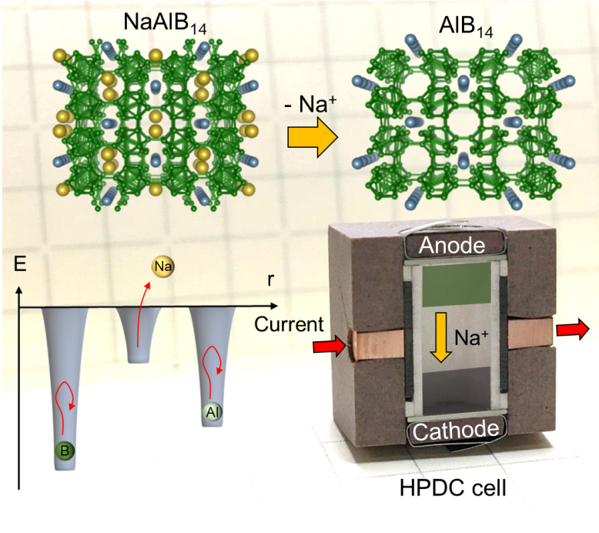
Insert Table of Contents artwork here

