Supporting Information

Ammonia Cracking Catalyzed by Ni Nanoparticles Confined in the Framework of CeO₂ Support

Hiroshi Mizoguchi,^{1,Ⅱ,*} Yuta Osawa,^{1,Ⅱ} Masato Sasase,² Naoki Ohashi,³ Masaaki Kitano,² and
Hideo Hosono^{1, 2, *}

¹Research Center for Materials Nanoarchitectonics (MANA),
National Institute for Materials Science (NIMS)
  - Namiki, Tsukuba, Ibaraki 305-0044, Japan

²MDX Research Center for Element Strategy, International Research Frontiers Initiative,
Tokyo Institute of Technology,
4259 Nagatsuta, Midori-ku, Yokohama 226-8503, Japan

³Research Center for Electronic and Optical Materials,
National Institute for Materials Science (NIMS)
  - Namiki, Tsukuba, Ibaraki 305-0044, Japan

^{Ⅱ}These authors contributed equally to this work
*Corresponding author footnote: MIZOGUCHI.Hiroshi@nims.go.jp, hosono@mces.titech.ac.jp

Table S1. Catalytic performance of Ni-based catalysts for NH₃ cracking under 1 atm.
Ni wt% | support | promoter | WHSV  (mL g⁻¹h⁻¹) | GHSV  (h⁻¹) | T (℃) | conv (%) | ref
63 | CeO₂ |  | 10000 |  | 400 | 22 | This work
72 | YO_{1.5} |  | 10000 |  | 400 | 26 | This work
58 | Al₂O₃ |  | 30000 |  | 450 | 15 | ¹
10 | Al₂O₃ |  | 240000 | 80000 | 500 | 93 | ²
10 | Al₂O₃ |  | 9000 |  | 400 | 32 | ³
58 | Al₂O₃ | Ce | 30000 |  | 450 | 28 | ¹
5 | C |  |  | 13000 | 400 | 19 | ⁴
10 | GNP |  | 15000 | 12000 | 375 | 17 | ⁵
58 | Al₂O₃ | La | 30000 |  | 450 | 26 | ⁶
20 | MgO | La | 22000 |  | 400 | 28 | ⁷
7 | MCM-41 |  | 36000 |  | 500 | 58 | ⁸
10 | CaNH |  | 15000 |  | 400 | 19 | ⁹

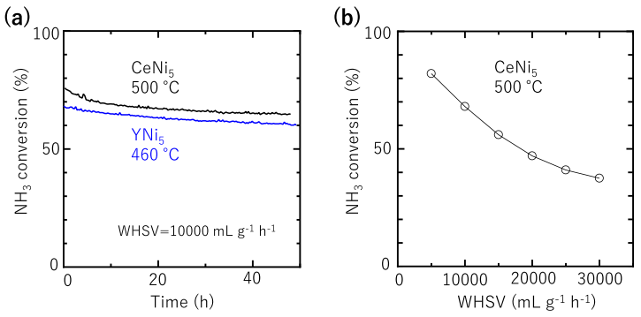
Fig. S1. (a) Time course of NH₃ cracking over RNi₅ (R = Ce or Y). (b) WHSV dependance of the conversion in NH₃ cracking over CeNi₅. As the WHSV increased, the activity decreased because of the shortening of the contact time between the catalyst and the NH₃ molecule.

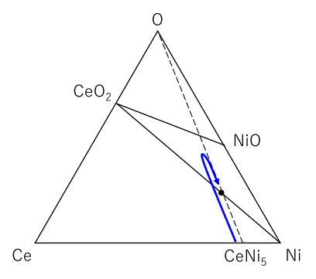

Fig. S2. Insertion and deinsertion of oxygen in CeNi₅ to enhance IM thermal decomposition at atomic scale.

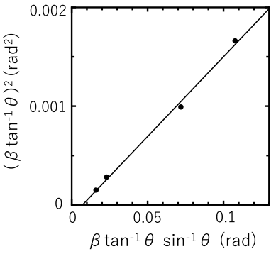
Fig. S3. Halder–Wagner plot of Ni phase in CeNi₅ catalyst to determine CS. β is spread of integral peak width.

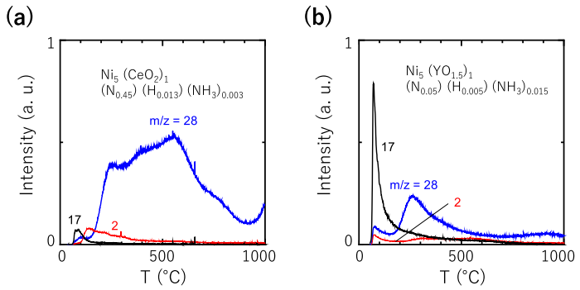
Fig. S4. TDS spectra at a specific mass-to-charge (m/z) of 2 (H₂), 17 (NH₃), or 28 (N₂)
for RNi₅ catalysts after NH₃ reaction (R = Ce (a) or Y (b)).

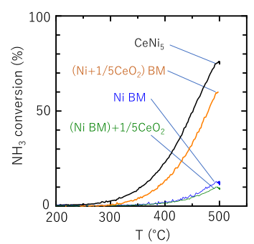
Fig. S5. Temperature dependence of the conversion in NH₃ cracking over various Ni-based catalysts at a WHSV of 10000 mL_{NH3} g_{cat}⁻¹ h⁻¹. The effect of BM is shown.

REFERENCES
1. Zheng, W.; Zhang, J.; Ge, Q.; Xu, H.; Li, W., Effects of CeO₂ Addition on Ni/Al₂O₃ Catalysts for the Reaction of Ammonia Decomposition to Hydrogen. Appl. Catal. B: Environ. 2008, 80 (1-2), 98-105.
2. Simonsen, S. B.; Chakraborty, D.; Chorkendorff, I.; Dahl, S., Alloyed Ni-Fe Nanoparticles as Catalysts for NH₃ Decomposition. Appl. Catal. A: General 2012, 447-448, 22-31.
3. Han, X.; Chu, W.; Ni, P.; Luo, S.; Zhang, T., Promoting Effects of Iridium on Nickel Based Catalyst in Ammonia Decomposition. J. Fuel Chem. Tech. 2007, 35, 691-695.
4. Bramwell, P. L.; Lentink, S.; Ngene, P.; de Jongh, P. E., Effect of Pore Confinement of LiNH₂ on Ammonia Decomposition Catalysis and the Storage of Hydrogen and Ammonia. J. Phys. Chem. C 2016, 120 (48), 27212-27220.
5. Chang, F.; Wu, H.; Pluijm, R. V.; Guo, J.; Ngene, P.; de Jongh, P. E., Effect of Pore Confinement of NaNH₂ and KNH₂ on Hydrogen Generation from Ammonia. J. Phys. Chem. C Nanomater Interfaces 2019, 123 (35), 21487-21496.
6. Zhang, J.; Xu, H.; Jin, X.; Ge, Q.; Li, W., Characterizations and Activities of the Nano-sized Ni/Al₂O₃ and Ni/La–Al₂O₃ Catalysts for NH₃ Decomposition. Appl. Catal. A: General 2005, 290 (1-2), 87-96.
7. Hu, X.; Wang, W.; Jin, Z.; Wang, X.; Si, R.; Jia, C., Transition Metal Nanoparticles Supported La-Promoted MgO as Catalysts for Hydrogen Production via Catalytic Decomposition of Ammonia. J. Energy Chem. 2019, 38, 41-49.
8. Duan, X.; Qian, G.; Liu, Y.; Ji, J.; Zhou, X.; Chen, D.; Yuan, W., Structure Sensitivity of Ammonia Decomposition over Ni Catalysts: A Computational and Experimental Study. Fuel Process. Tech. 2013, 108, 112-117.
9. Ogasawara, K.; Nakao, T.; Kishida, K.; Ye, T.; Lu, Y.; Abe, H.; Niwa, Y.; Sasase, M.; Kitano, M.; Hosono, H., Ammonia Decomposition over CaNH-Supported Ni Catalysts via an NH²⁻-Vacancy-Mediated Mars-van Krevelen Mechanism. ACS Catal. 2021, 11, 11005-11015.

