Tailored Portable Electrochemical Sensor for Dopamine Detection in Human Fluids Using Heteroatom-Doped Three-Dimensional g- C₃N₄ Hornet Nest Structure
Mohammed Y. Emran^{a*}, Ahmed Kotb^{b}, Akhilesh Babu Ganganboina^{c}, Akihiro Okamotoª, Tariq Z. Abolibda^{d}, Hassan A. H. Alzahrani^{d,e}, Sobhi M. Gomha^{d}, Chongbo Ma^{f}, Ming Zhou^{f}, Mohamed A. Shenashen^{d*}
ªResearch Center for Macromolecules and Biomaterials, National Institute for Materials Science, Tsukuba 305-0044, Ibaraki, Japan
^{b}Chemistry Department, Faculty of Science, Al-Azhar University, Assiut 71524, Egypt
^{c}International Center for Young Scientists ICYS-NAMIKI, National Institute for Materials Science, 1-1 Namiki, Tsukuba, Ibaraki, 305-0044, Japan
^{d}Department of Chemistry, Faculty of Science, Islamic University of Madinah, Madinah 42351, Saudi Arabia.
^{e}Department of Chemistry, College of Science and Arts at Khulis, University of Jeddah, P.O. Box 355, Jeddah, Saudi Arabia.
^{f}Key Laboratory of Polyoxometalate and Reticular Material Chemistry of Ministry of Education, Key Laboratory of Nanobiosensing and Nanobioanalysis at Universities of Jilin Province, Analysis and Testing Center, Department of Chemistry, Northeast Normal University, Changchun, Jilin Province 130024, China

*Corresponding authors: Mohammed Y. Emran ( EMRAN.Mohammed@nims.go.jp; mohamedyossef@azhar.edu.eg). Mohamed A. Shenashen (mashenashen@gmail.com)

Abstract
Background
There is widespread interest in portable electrochemical sensors designed for the selective monitoring of biomolecules. Dopamine (DA) is one of the neurotransmitter molecules that play a key role in the monitoring of some neuronal diseases such as Alzheimer’s and Parkinson’s diseases. Facile synthesis of the highly active surface interface to design a portable electrochemical sensor for the sensitive and selective monitoring of biomolecules (i.e, DA) in its resources such as human fluids is highly required.
Results
The sensor is based on a three-dimensional phosphorous and sulfur resembling a g-C₃N₄ hornet's nest (3D-PS-doped CNHN). The morphological structure of 3D-PS-doped CNHN features multi-open gates and numerous vacant voids, presenting a novel design reminiscent of a hornet's nest. The outer surface exhibits a heterogeneous structure with a wave orientation and rough surface texture. Each gate structure takes on a hexagonal shape with a wall size of approximately 100 nm. These structural characteristics, including high surface area and hierarchical design, facilitate the diffusion of electrolytes and enhance the binding and high loading of DA molecules on both inner and outer surfaces. The multifunctional nature of g-C₃N₄, incorporating phosphorous and sulfur atoms, contributes to a versatile surface that improves DA binding. Additionally, the phosphate and sulfate groups' functionalities enhance sensing properties, thereby outlining selectivity. The resulting portable 3D-PS-doped CNHN sensor demonstrates high sensitivity with a low limit of detection (7.8 nM) and a broad linear range spanning from 10 to 500 nM.
Significance
The portable DA sensor based on the 3D-PS-doped CNHN/SPCE exhibits excellent recovery of DA molecules in human fluids, such as human serum and urine samples, demonstrating high stability and good reproducibility. The designed portable DA sensor could find utility in the detection of DA in clinical samples, showcasing its potential for practical applications in medical settings.

Keywords: Porous g-C₃N₄; Multifunctional surface interface; Portable electrochemical sensor; Dopamine; Neuronal diseases; Biological samples
Introduction:
Determining the levels of neurotransmitters in human metabolism provides insight into several biological and neurological processes, including the function of individual neurons [1-4]. The transmission of nerve impulses between neurons via synapses is supported essentially by neurotransmitters [5, 6]. The nervous system's communication is facilitated by this transmission, which can be categorized as excitatory or inhibitory based on neuronal behavior. Neurotransmitter detection and quantification, such as that of dopamine (DA), is crucial in various contexts, such as neurobiology, clinical diagnostics, and drug research. DA specifically affects many neuronal processes, including immune system regulation, memory, learning, and passion. Monitoring DA levels in human fluids and the brain is essential for tracking neurological disorders like Alzheimer's disease, Huntington's disease, Parkinson's disease, and schizophrenia syndrome [6-9].
DA levels in various sources and receptors have been measured using a range of analytical techniques, including liquid chromatography-mass spectrometry, colorimetry, surface-enhanced resonance, chemiluminescence, electrochemiluminescence, photo-electrochemical, Raman scattering, fluorescence, and electrochemical methods [1, 10-17]. However, several of these methods have drawbacks, such as requiring sample pretreatment, sophisticated equipment, and relying on highly skilled technicians [18-20]. Electrochemical methods offer a promising solution as they are cost-effective, user-friendly, responsive, don't require sample pretreatment, can be used to develop portable devices, and are suitable for both in vitro and in-vivo tests [21-23]. Additionally, with their exceptional sensitivity, selectivity, and quick response times, electrochemical sensors have emerged as potent tools for the detection of DA [7, 9, 10, 13, 18].
The fabrication of the working electrode and surface modification present the primary development challenge for electrochemical sensor technology [24-26]. Consequently, substantial efforts have been devoted to creating a variety of active materials, including graphene, multi-walled carbon nanotubes (MWCNTs), metal oxides, metal nanoparticles, and their composites. To achieve optimal electrochemical performance, such as fast charge transfer, low surface resistance, mechanical and thermal stability, biocompatibility, low cytotoxicity for in-vivo applications, and improved sensitivity and selectivity for detecting targets such as DA [25-32]. Moreover, the surface structure, dimensions, and composition of the created materials play a crucial role in biomolecule detection, particularly DA molecules. Consequently, a large amount of recent research has been devoted to developing electrode materials that can overcome these challenges. The highly active catalytic surfaces of these materials, along with their easy and cost-effective fabrication process, make them ideal for a range of sensing and biosensing applications [33-36].
The creation and modification of carbon-based materials through a simple and cost-effective method have attracted considerable attention due to their easy production, eco-friendliness, stability, consistent nanostructure, good mechanical and thermal stability, fast charge transport, and versatile active surface [37-40]. Among the carbon materials used in biosensing and sensing applications are carbon spheres, MWCNTs, graphitic carbon nitride (g-C₃N₄), and graphene [38-41]. Heteroatom-doped carbon materials have garnered significant attention recently due to their remarkable electrochemical characteristics among the different electrode materials investigated for DA sensing [38, 42-45]. Heteroatom-doped carbon exhibits rapid charge transport, facile binding to targets, and the formation of a homogeneous catalytic surface. Surface modification of carbon-based materials through heteroatom doping, such as nitrogen (N), phosphorus (P), boron (B), sulfur (S), and metal atoms creates functionalized surfaces with excellent chemical and electrochemical properties over conventional carbon-based electrodes [42-46]. Incorporating these atoms into the carbon matrix increases active sites. It changes the electronic structure, resulting in facilitated electron transfer kinetics, enhanced electrocatalytic activity, and sensitivity, making them suitable for a range of biosensing applications [43-47].
g-C₃N₄ compounds are highly desirable as promising metal-free catalysts because of their exceptional structure, electronic qualities, stable chemical nature, simplicity in synthesis, and ease of doping modifications [48, 49]. The g-C₃N₄ compounds have an adjustable band gap energy, a high adsorption capacity, low preparation costs, and cheap raw materials [50-52]. A simple process involving the thermal polymerization of nitrogen-rich precursors like urea, melamine, cyanamide, dicyandiamide, thiourea, and ammonium thiocyanate can create g-C₃N₄ [53-58]. Doping g-C₃N₄ with other atoms can enhance charge carrier separation and utilization, thereby improving catalytic performance [58, 59]. The g-C₃N₄ nanostructures also have improved magnetic, electrical, and optical properties, which increases their versatility.
The g-C₃N₄ hybridization with metal and metal oxides was used as supporting materials for designing a DA sensor such as g-C₃N₄/MWCNTs/GO, AuNPs/g-C₃N₄, 2D g-C₃N₄/CuO, g-C₃N₄ with B and graphene quantum dots, BiPO₄/BiOCl/g-C₃N₄, CoFe₂O₄ /g-C₃N₄, and g-C₃N₄/Co [41, 60-64]. These nanocomposites exhibit highly sensitive DA detection, albeit requiring complex procedures for preparation and the inclusion of various metal and metal oxide components. Therefore, the synthesis of heteroatom-modified g-C₃N₄ presents an attractive opportunity for the large-scale production and commercialization of electrochemical sensors, which induces low cost-effectiveness and high scalability. While strides have been made in developing heteroatom-modified g-C₃N₄ for DA sensors, several challenges remain. These challenges encompass refining synthesis techniques to achieve consistent, scalable outcomes and enhancing sensor stability and selectivity in biological samples. Overcoming these obstacles is vital for broadening the utilization of carbon materials in DA sensing, furthering their importance in neuroscience and medical diagnostics.
In this work, we introduce an innovative design for a DA electrochemical sensor, emphasizing heightened sensitivity and selectivity. The proposed design integrates interdigitated heteroatom-doped carbon materials into a screen-printed carbon electrode (SPCE). The resulting heteroatom 3D-PS-doped CNHN exhibits a distinctive g-C₃N₄ hornet nest morphology, featuring a multi-open gates structure with diverse surface features. These include upside-down multi-open gates, multiple grooves, and a rough texture. These inherent characteristics provide several advantages, such as an advantageous surface-area-to-volume ratio, a porous configuration, and the establishment of an active electrode surface with short diffusion pathways. Moreover, the multi-doping of g-C₃N₄ yields functionalized materials rich in negative charges and numerous plane edge defects. This results in a highly active surface that facilitates the rapid electrooxidation of dopamine molecules. Consequently, the engineered electrode showcases exceptional sensitivity and selectivity, as evidenced by a low detection limit and a wide linear range. Significantly, it demonstrates accurate detection of dopamine secretions from biological samples, highlighting remarkable sensitivity and selectivity in practical applications.

2. Experimental:
2.1 Synthesis of 3D-PS-doped CNHN
The synthesis of 3D-PS-doped CNHN materials involved the sequential combination of various components from C, N, P, and S sources. Initially, a precursor solution was prepared by adding 4 g of phytic acid (P- and C- source) to 60 mL of Milli-Q water, stirring the mixture for 30 minutes. Subsequently, 4 g of thiourea (S-, C-, and N-source) was introduced into the phytic acid solution and stirred for an additional 30 minutes. Once complete dissolution of thiourea and phytic acid was achieved, 2 g of guanine (N- and C- source) was incorporated, and the mixture was stirred for 1 hour to ensure homogeneity.
The resulting homogeneous mixture was then subjected to drying in a petri dish at 80°C for 12 hours. The formation of 3D-PS-doped CNHN occurred through complete carbonization in a tube furnace set at 900°C (Up rate: 5°C/min – Down rate: natural without rate) for 4 hours under a flow of N₂. Following the carbonization process, the obtained 3D-PS-doped CNHN material underwent washing with a water-ethanol solution (1:1) five times and was subsequently dried in an oven at 60°C.A modification and synthesis of the g-C₃N₄ materials were carried out according to the reference [65]. This method involved annealing 5 g of melamine for 4 hours at 550 ºC at a ramping rate of 5 °C/min under a N₂ atmosphere. After washing the prepared material several times with a 1:1 mixture of water and ethanol, the material dried in an oven at 60 ºC for 24 h.

3.2. Portable electrode design of 3D-PS-doped CNHN/SPCE and measurements set up
The fabrication of a portable DA sensor was achieved through the development of a screen-printed carbon electrode (SPCE) using 3D-PS-doped CNHN. The fabrication process proceeded as follows: a) The preparation of 3D-PS-doped CNHN ink involved dispersing 10 mg of each sample in 1 mL deionized water, followed by sonication for 3 hours. The SPCE contains the 3 electrodes of working (carbon), counter (carbon), and reference (Ag/AgCl) on one chip. b) The portable 3D-PS-doped CNHN was then created by drop-casting 10 µL solutions of 3D-PS-doped CNHN ink onto the working electrode area of SPCE. The resulting electrodes were designated as 3D-PS-doped CNHN/SPCE for the portable configurations. c) To establish the reference electrode for the SPCE electrode, Ag/AgCl ink was added and heated at 80 °C for 1 minute to form a thin-film layer of Ag/AgCl. d) The stability of the designed electrodes was ensured through a 10-cycle stabilization process, employing continuous cyclic voltammetry sweeps (CV) in PBS (pH = 7.2) at a scan rate of 50 mVs^{–1} within the potential window of -0.8 to 1.8 V. The various pH solutions were prepared using PBS (free of Ca and Mg) and the pH was adjusted using HCl and NaOH. The square wave voltammetry (SWV) setup was under the following conditions: pulses height (25 mV), pulses width (200 ms), step height (10 mV), and a potential window of -0.2 to 0.6 V. The impedance spectroscopy (EIS) measurements were performed in the frequency range of 0.01 mHz into 100 kHz and applied a potential of 0.2 V. Selectivity studies of DA were conducted in PBS (pH = 7.2) using SWV in the presence of various interfering molecules such as adrenaline (AD), noradrenaline (NAD), ascorbic acid (AA), and uric acid (UA). Sequentially, these interfering molecules of 0.5 µM AD, 0.5 µM NAD, 0.5 mM AA, and 0.2 mM UA were successively mixed with DA. The ∆I(µA) values were recorded and subtracted after each addition and corresponding SWV measurement. A stability test was conducted in PBS (pH = 7.2) using SWV with a 10 nM DA solution. The 10 samples of the 10 nM DA solution were measured using the same 3D-PS-doped CNHN/SPCE sensor. Reproducibility tests were carried out in PBS (pH = 7.2) using SWV with a 200 nM DA solution. The 10 3D-PS-doped CNHN/SPCE electrodes were fabricated, and the DA (200 nM) solution was measured using these 10 electrodes with SWV at room temperature.

3.3 Real monitoring of DA in human fluids using 3D-PS-doped CNHN/SPCE
The monitoring of DA was assessed through the standard additive method in a human serum and urine sample. To prepare the serum sample, 10 µL of serum and 10 mL of PBS (pH 7.2) were mixed. Following that, DA at standard concentrations (20–100 nM) was added to the serum solution. Under ideal circumstances, DA measurements were carried out using SWV and a 3D-PS-doped CNHN electrode. In addition, to prepare the urine sample, 9 mL of PBS (pH 7.2) was added to 1 mL of urine (Samples of first-morning urine were collected from volunteers). After adding DA at various standard concentrations (50–250 nM), measurements were made using the SWV technique (n=3). The data analysis was compared to the calibration curve and presented in Table S2 and Table S3.

3. Results and Discussion:
The synthesis of 3D-PS-doped CNHN was achieved by calcining the precursors’ mixture at a high temperature (900°C) under an N₂ atmosphere after thoroughly mixing to form a homogeneous solution (Scheme S1). Phytic acid served as a source of phosphorus and carbon, interacting with thiourea, which provided sulfur, nitrogen, and carbon. A polymer consisting of nitrogen, phosphorus, carbon, and oxygen was made easier by this combination [66]. The interaction between thiourea and phytic acid contributed to enriching the designed material with multifunctional phosphorus and sulfur groups. Furthermore, urea and thiourea were employed as base materials for the pyrolysis process to create g-C₃N₄ [67-69]. Therefore, the annealing of thiourea and guanine act as the C-and N-source [14]. Guanine was mixed with a combination of phytic acid and thiourea to produce a homogeneous solution. Drying the mixture at 90°C ensured thorough mixing of all components. Furthermore, the melting point of phytic acid, which exceeds 25°C, results in the formation of a paste rich in phosphorus, carbon, nitrogen, and oxygen sources [67]. Annealing at 900°C transforms the structure into a multi-hole hornet nest-like configuration with a 3D orientation. These holes are formed through the polymerization and condensation of the mixed paste contents. Following this, 3D-PS doped CNHN is formed by annealing at 900°C. This particular structure features multiple pores resembling hornet nests, characterized by a rough surface and heterogeneously distributed open holes with hexagonal edges, resulting in various vacant structures. These surface attributes, including hierarchical porosity and high surface area, create a distinctive interface with numerous active sites and facilitate the diffusion of targets. The formation without a template and the creation of pores at high temperatures result in variations in the morphology and edge sizes. Additionally, functionalization of the g-C₃N₄ with P- and S-groups produces a multifunctional surface with strong binding to DA molecules. These chemical and physical characteristics collectively contribute to the creation of highly active surface interfaces, ideal for the sensitive and selective detection of portable DA electrochemical sensors based on 3D-PS-doped CNHN/SPCE.

3.1 Materials characterization and surface features analysis of 3D-PS-doped CNHN/SPCE
The surface morphology of 3D-PS-doped CNHN/SPCE was examined using field emission-scanning electron microscopy (FE-SEM). The overall structure and orientation of 3D-PS-doped CNHN/SPCE are revealed in the low-magnification FE-SEM image shown in Figure 1A. The exterior surface appears rugged, resembling a hornet nest structure with numerous open holes. The process involved the formation of paste followed by annealing at high temperature, leading to polymerization and subsequent carbonization accompanied by the release of gases like H₂O, H₂S, and NH₃. These gases contribute to the formation of holes both internally and externally within the hornet nest-like structure.
Figure 1B distinctly displays the heterogeneous surface with multiple wave-like features. The diameter of the open hole is ~3 µm with nanoscale edges of ~ 50 nm. Furthermore, the self-assembly formation without a soft or hard template caused variations in the size and depth of the holes in the structure. The outer holes exhibit a nanohexagonal configuration with a coarse surface. Side and vertical views demonstrate the depth of the outer holes, confirming the presence of a multi-holed hornet nest-like structure both internally and externally (Figure 1 [C&D]). Chemical composition analysis conducted through EDX-SEM reveals the elemental composition of the synthesized 3D-PS-doped CNHN material. The EDX-SEM mapping displays a uniform distribution of C-, N-, O-, S-, and P-atoms. These elemental ratios, expressed as percentages of C, N, O, P, and S at 46.74%, 19.81%, 14.23%, 17.98%, and 1.24% respectively, signify the incorporation of P and S atoms into the g-C₃N₄ structure.
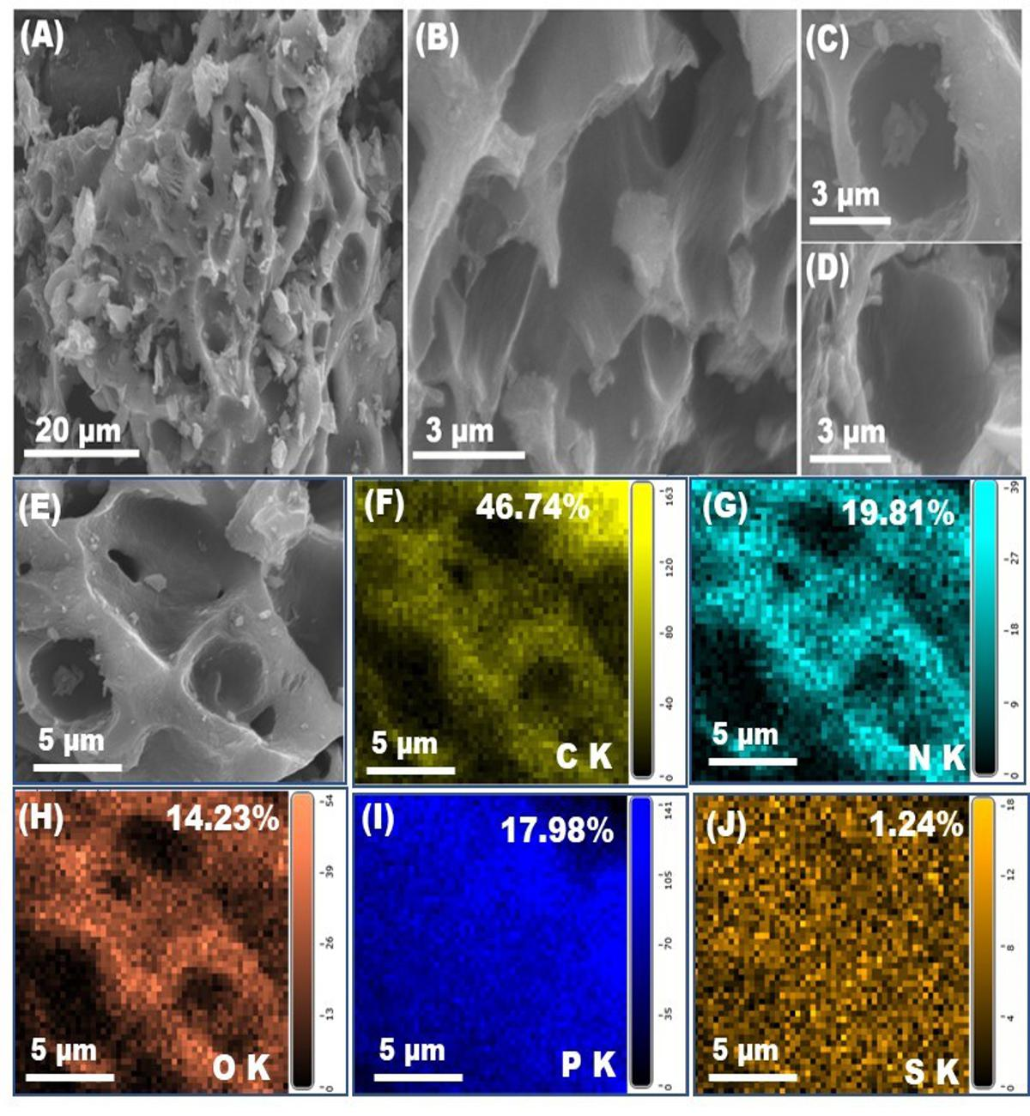
Figure 1. The FE-SEM images of 3D-PS-doped CNHN under low (A) and high (B) magnification. The FE-SEM images of open holes of 3D-PS-doped CNHN for side view (C) and vertical view (D). E) The EDX-SEM mapping of 3D-PS-doped CNHN for C K (F), N K (G), O K (H), P K (I), and S K (J).

The surface area and porosity of the prepared 3D-PS-doped CNHN were characterized using N₂ adsorption-desorption isotherm and non-local density functional theory (NLDFT). In Figure 2A, the N₂ adsorption-desorption isotherm exhibits an IV-type isotherm with an H4 hysteresis loop, indicating a high surface area of the prepared materials with mesoporous categories. The NLDFT pore size distribution highlights various pore sizes, inclosing various mesoporous distribution of 3.7, 16.03, and 30.1 nm, contributing to the surface area and indicating a hierarchical structure (Figure 2B). The specific surface area (SBET) measures 195.3 m²g^{–1} with a pore size volume of 0.351 cm³g^{–1}. The 3D-PS-doped CNHN demonstrates a substantial surface area with a hierarchical porous configuration, facilitating the diffusion and loading of targets on both inner and outer surfaces, thereby enhancing the sensitivity of the electrode design. Confirmation of the g-C₃N₄ structure doped with P and S atoms was achieved through Raman shift spectroscopy. The Raman shift spectra of 3D-PS-doped CNHN reveal three peaks at 1365, 1570, and 2665 cm^{–1} corresponding to the first-order mode of D and G, and a second mode of D bands, respectively (Figure 2C). The G band signifies the presence of the graphitic structure, while the D and D⁻ bands indicate the disruption of the graphitic structure and the formation of doping atoms and various planar edge defects [16, 37, 43]. The I_{D}/I_{G} value of 1.1 indicates the disruption of the graphitic framework of g-C₃N₄, attributed to the emergence of diverse functional groups such as phosphates and sulfates on the outer surface, along with various planar edge defects within the graphitic structure. The XRD pattern of 3D-PS-doped CNHN reveals the presence of g-C₃N₄ formation (Figure 2D). Three peaks are discernible at 2θ values of 13.4°, 28.9°, and 42.2° corresponding to {100}, {200}, and {101} planes, respectively. These findings affirm the formation of g-C₃N₄ that fits with JCPDS Card No. 87-1526 [70-72]. Therefore, the prepared material of 3D-PS-doped CNHN is composed of g-C₃N₄ doped with various heteroatoms of P- and S-atoms.

The surface composition of 3D-PS-doped CNHN was analyzed using X-ray photoelectron spectroscopy (XPS). The XPS spectrum reveals the presence of carbon, nitrogen, oxygen, phosphorus, and sulfur atoms (Figure S1A). The XPS survey of C 1s, N 1s, O 1s, P 2p, and S 2p illustrates the various bonding configurations and functionalities of the synthesized 3D-PS-doped CNHN. The C1s spectrum exhibits diverse carbon bonds, including C–C such as C–C (sp³) at 285.4 eV, N=C–N (sp²) at 284.6 eV, C–O, C–N, C–S, and C–P at 299.59 eV, and O–C=O at 288.38 eV (Figure S1B) [72, 73]. The prominent peak observed at N=¬C–N (sp2) signifies the formation of a highly structured g-C₃N₄ with diverse functionalities attributed to sulfur and phosphorus groups. The XPS analysis of N 1s reveals three peaks centered at 401.99, 400.77, and 398.78 eV, corresponding to tertiary nitrogen of N–(C3), secondary nitrogen NH–(C2), and hybridized nitrogen of N=C–N (sp²) (Figure 2E). These findings provide conclusive evidence of g-C₃N₄ formation, which serves as the foundation of the 3D-PS-doped CNHN structure. In Figure S1C, the O 1s XPS survey depicts two peaks at 532.05 and 534.01 eV, indicating the presence of various oxygen functionalities such as C–O, C=O, C–O–C, and C–O–O–H, as well as additional groups like P(OH)₃ and S(OH)₃ [3, 4, 72]. The XPS survey S 2p represents the active functionalities of the S group of C–S–C and C-SO₂–C (Figure 2F). [74]. The P 2p peaks at 130.6, 133.3, and 136.26 eV are related to the presence of various P-groups. The dominant peak at 133.3 eV is related to the P–O groups and the formation of P₄O₁₀ (136.26 eV) (Figure S1D) [44, 72, 75, 76]. These data confirm the active doping and multifunctional surface of 3D-PS-doped CNHN with S, P, N, and O groups, leading to the high interaction between the electrode surface and the detected targets such as DA.
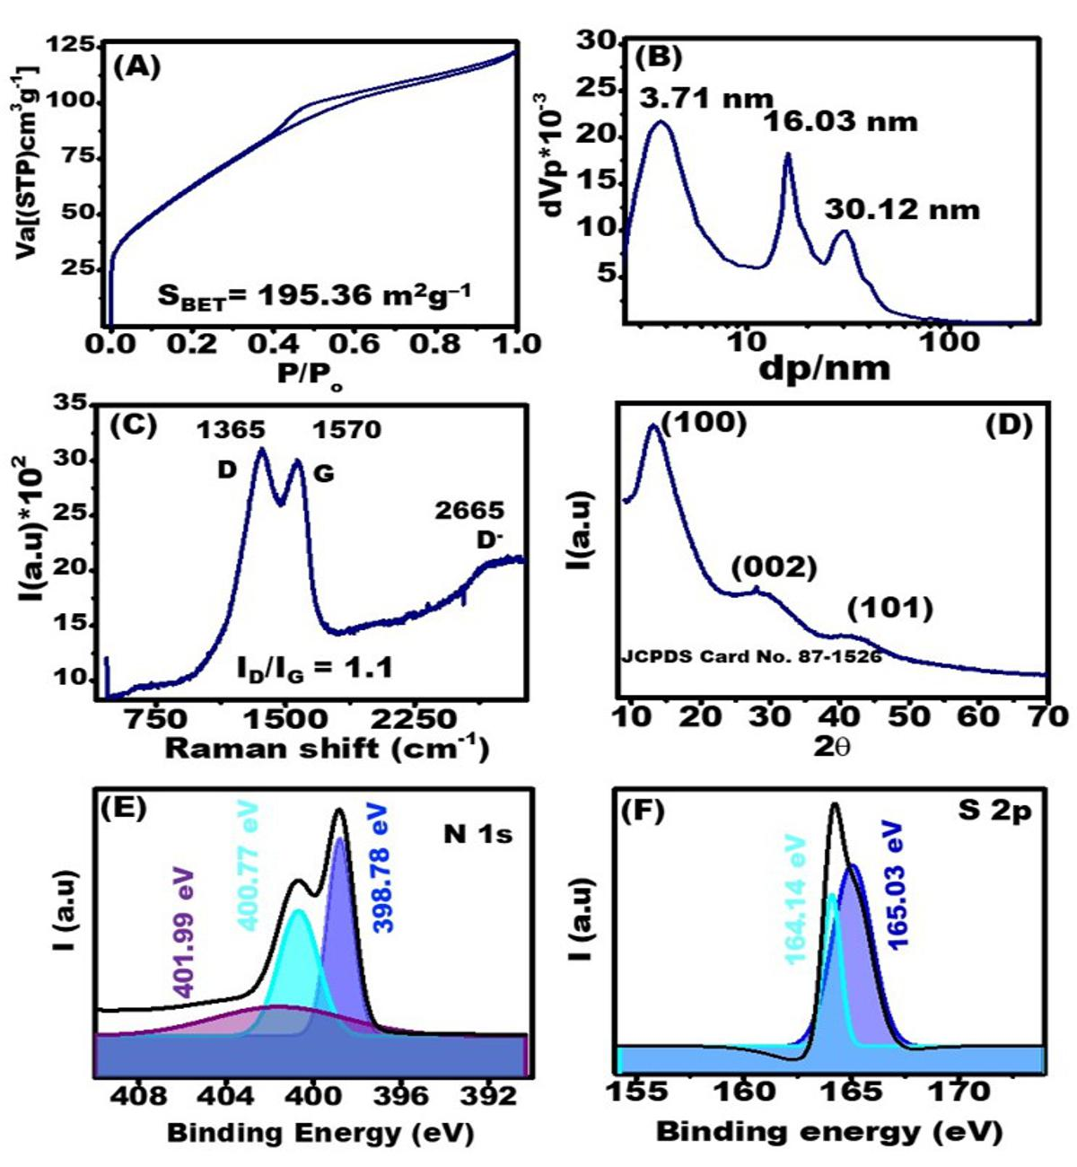
Figure 2. A) The N₂ adsorption-desorption isotherm of 3D-PS-doped CNHN. B). The NLDFT pore size distribution of 3D-PS-doped CNHN. C). The Raman shift spectrum (C) and XRD (D) of 3D-PS-doped CNHN. The XPS survey of N 1s (E) and S 2p (F).
3.2 Electrochemical statement and DA sensing using 3D-PS-doped CNHN/SPCE
The advancement of material properties, involving optimizing catalytic activity and electrochemical surface interface properties, including surface resistance and charge transport, plays a key role in designing highly active sensors. In Figure 3A, the CV-responses of 5 mM [Fe(CN)₆]³⁻/⁴⁻ in PBS (pH = 7.2) are depicted for SPCE, g-C₃N₄, and 3D-PS-doped CNHN/SPCE at a scan rate of 50 mVs⁻¹. The redox response of Fe³^{+/2+} for 3D-PS-doped CNHN/SPCE exhibits higher anodic (1a = 83.32 µA) and cathodic current values (-89.64 µA) compared to g-C₃N₄/SPCE (1a = 41.8 µA & Ic = -44.89) and SPCE (1a = 23.36 µA & Ic = -21.39). These results highlight the high catalytic activity of 3D-PS-doped CNHN/SPCE, indicating an enhanced surface interface activity. Furthermore, the redox potential difference (ΔE) between anodic and cathodic peak values for 3D-PS-doped CNHN/SPCE, g-C₃N₄/SPCE, and SPCE were measured to be 100, 235, and 226 mV, respectively. The low ΔE value of 3D-PS-doped CNHN/SPCE signifies fast charge transport, contributing to improved sensing properties. These findings provide the design of a highly active catalytic surface and rapid electron diffusion at the 3D-PS-doped CNHN surface interface, due to the active doping of g-C₃N₄ using P and S that enhances the electrocatalytic activity.
The active electrode surface area was calculated using the Randles–Sevick formula as follows [77]:
Ia (A) = 2.69 × 10⁵ n^{3/2} A₀D₀^{1/2}C₀ν^{1/2} (1)
where n is the number of electrons, D is the diffusion coefficient (cm² s⁻¹), A (cm²) is the electrode surface area, Ia (A) is the anodic peak current value, C₀ is the concentration of K₃Fe(CN)₆ (molecm⁻³), and ν (Vs⁻¹) is the scan rate. Based on these parameters, the active electrode surface areas were determined to be 1.28 x 10⁻², 2.34 x 10⁻², and 4.56 x 10⁻² cm² for SPCE, g-C₃N₄/SPCE, and 3D-PS-doped CNHN/SPCE. This data suggests that the high electrode surface area facilitates efficient charge transport and fast diffusion through the inner and outer surfaces of 3D-PS-doped CNHN/SPCE.

Confirming the surface interface activity of 3D-PS-doped CNHN/SPCE, g-C₃N₄/SPCE, and SPCE, electrochemical impedance spectroscopy (EIS) provides insights into surface resistivity and charge velocity. Figure 3B illustrates the EIS Nyquist plot for 3D-PS-doped CNHN/SPCE (wine line), g-C₃N₄/SPCE (blue line), and SPCE (black line) in PBS (pH = 7.2) containing 5 mM [Fe(CN)₆]³⁻/⁴⁻. The semicircle at high frequency represents charge transfer resistivity (Rct), while the line at low frequencies corresponds to electron diffusion at the electrode surface. Notably, the semicircle for 3D-PS-doped CNHN/SPCE is lower than that of g-C₃N₄/SPCE and SPCE, and the line is higher than that of g-C₃N₄/SPCE and SPCE. The fitting equivalent circuit contains Rs, Rct, C, and Zw as solution resistance, surface interface resistance, double-layer capacitance, and electron diffusion velocity, respectively. The fitting Rct values are 4490, 1496, and 90.49 Ω, for SPCE, g-C₃N₄/SPCE, and 3D-PS-doped CNHN/SPCE, while the Zw values are 9887, 19450, and 25650 Ωs^{-1/2}. The solution resistances are nearly identical, measuring 84.13 Ω, 82.34 Ω, and 81.79 Ω for SPCE, g-C3N4/SPCE, and 3D-PS-doped CNHN/SPCE, respectively. Additionally, the capacitance values are 7.998x10^{–6}, 2.672 x10^{–6}, and 1.4 x10^{–6} F for SPCE and 3D-PS-doped CNHN/SPCE. These findings emphasize the highly active surface modification of SPCE using 3D-PS-doped CNHN, characterized by low surface resistance, rapid charge transport, and high electron diffusion. These results are attributed to the unique surface morphology, featuring a heterogeneous surface with a rough texture, nano edges of an open hollow hornet nest structure, and multiple vacant and surface defects. Additionally, the composition, marked by multifactional surface elements such as sulfate, phosphate, N-groups, and C-O groups, further enhances the surface functionality and activity, facilitating electrolyte diffusion through porous and vacant sites.
A portable DA electrochemical sensor was investigated using CV sweeps of DA for SPCE, g-C₃N₄/SPCE, and 3D-PS-doped CNHN/SPCE at a scan rate of 50 mVs⁻¹. Figure 3C shows the CVs of 50 μM DA in PBS (pH = 7.2) for SPCE (black line), g-C₃N₄/SPCE (blue line), and 3D-PS-doped CNHN/SPCE (wine line). Notably, the redox current peak values of DA on 3D-PS-doped CNHN/SPCE surpass those of SPCE and g-C₃N₄/SPCE, demonstrating the enhanced sensing activity of 3D-PS-doped CNHN/SPCE for DA molecules. Furthermore, the CV sweep of 3D-PS-doped CNHN/SPCE, both with and without 50 μM DA in PBS (pH= 7.2), exhibits a highly sensitive response to DA molecules (Figure 3D). To probe the sensing property in-depth, CV measurements were conducted for various DA concentrations (100, 150, 200, and 250 μM) at a scan rate of 50 mVs⁻¹. Figure S2 presents an increase in both anodic (Ia) and cathodic (Ic) peak current values with rising DA concentrations, affirming that 3D-PS-doped CNHN/SPCE serves as a highly sensitive sensor for detecting DA concentrations. The portable DA sensor based on 3D-PS-doped CNHN/SPCE demonstrates rapid response, low sample volume requirements, and highly stable and reproducible response, evidenced by the systematic increase in Ia and Ic peak current values. Moreover, the multifunctional surface of 3D-PS-doped CNHN enables a high loading of DA at the electrode surface, while the open hollow surface with a porous construction facilitates the diffusion of DA molecules, contributing to an increased loading of DA at the inner and outer surfaces. These features collectively highlight the successful design of a highly sensitive portable DA sensor based on 3D-PS-doped CNHN.
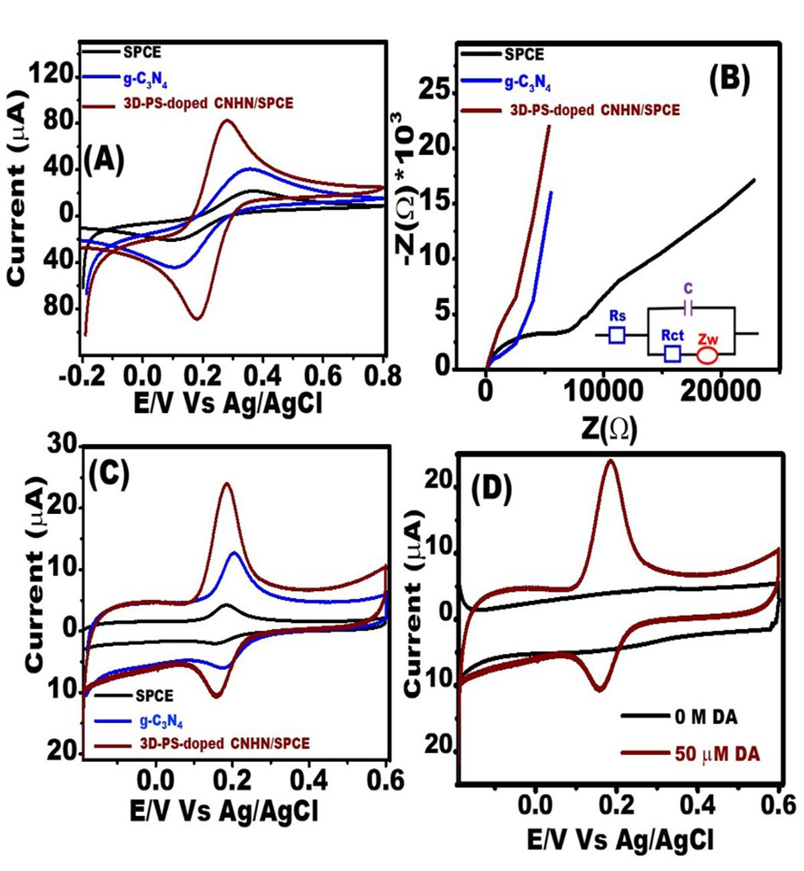
Figure 3. A) The CV measurements of SPCE (black line), g-C₃N₄ (blue line), and 3D-PS-doped CNHN/SPCE (wine line) in PBS (pH = 7.2) containing 5 mM K₃/K₄[Fe(CN)₆] at a scan rate of 50 mVs^{–1}. B) The EIS of SPCE (black line), g-C₃N₄ (blue line), and of 3D-PS-doped CNHN/SPCE (wine line) in PBS (pH = 7.2) containing 5 mM K₃/K₄[Fe(CN)₆]. Inset of B) the fitting equivalent circuit. C) The CV measurements of SPCE (black line), g-C₃N₄ (blue line), and 3D-PS-doped CNHN/SPCE (wine line) in PBS (pH = 7.2) containing 50 μM DA at a scan rate of 50 mVs^{–1}. D) The CVs of PBS (pH = 7.2) (black line) and 50 μM DA (wine line) for 3D-PS-doped CNHN/SPCE at a scan rate of 50 mVs^{–1}.
3.3 pH dependency and surface interface interaction
The pH dependency of the supporting electrolyte plays a key role in the sensing properties due to its role in the oxidation-reduction of DA at the electrode surface of 3D-PS-doped CNHN/SPCE. The effect of various pH values (5 – 8) on the redox activity of DA (50 µM) was investigated using CV at a scan rate of 100 mVs^{–1}. Figure 4A illustrates both the anodic (Ea) and cathodic (Ec) peak positions and redox (Ia and Ic) current values vary with the pH values. The Ia and Ic values fluctuated from pH 5.0 to pH 7.2 and then decreased when the value was increased up to pH = 8 (Figure 4B). Therefore, the adjusted pH at 7.2 was selected as the optimum pH, which is close to the physiological pH value. The Ea and Ec values were shifted to more negative values as the pH increased from 5 to 8. These data provide information on H⁺ participation in the redox reaction of DA at the surface interface of 3D-PS-doped CNHN. The plot of pH Vs Ea (V) shows a linear relationship with the regression equation of E(V) = 0.57 - 0.051 pH, R² = 0.98 (Figure 4B). The slope value of 51 mV fitted well with the Nernst value that provides the participation of H⁺ with the redox mechanism of ±2e–/2H⁺ [16, 37, 43, 44].
The surface interface interaction of 3D-PS-doped CNHN and DA was investigated based on the scan rate dependency in PBS (pH = 7.2). The Ia and Ic values increased with the scan rate increasing from 20 to 300 mVs^{–1} (Figure 4C). The plot of scan rate (mVs^{–1}) Vs the Ia and Ic shows a linear relationship with the regression equations of Ia (µA) = 11.45 + 0.2 ν (mVs⁻¹), R² = 0.996 (S/N = 3); and Ic (µA) = –1.13 – 0.175 ν (mVs⁻¹), R² = 0.998 (S/N = 3). These data support the main surface interaction mechanism of DA at the surface of 3D-PS-doped CNHN is the adsorption mechanism [4, 16, 43]. The Ea and Ec peak positions were slightly shifted into positive values as the scan rate values increased (20- 300 mVs^{–1}). This behavior is due to the adsorption of DA at the surface of 3D-PS-doped CNHN. The amount of adsorbed DA at the active electrode surface of 3D-PS-doped CNHN was calculated to be 12.3 nMcm² based on the equation of
I_{a} = n²F²ΓνA/4RT (2).
Moreover, the other kinetic parameters of charge transfer coefficient (α) and electron transfer rate constant (Ks) were illustrated based on the relationship of logν (Vs^{–1}) Vs Ea(V) and Ec(V) and applied to Laviron’s theory (Figure S3). The calculated α and Ks were 0.66 s and 0.35 cms⁻¹, respectively (for more details, see supporting information). These data support the role of the multifunctional surface of 3D-PS-doped CNHN in advancing the surface interaction and high loading of DA with fast charger transfer, leading to the ideal surface for designing highly active portable DA sensors with fast response time. 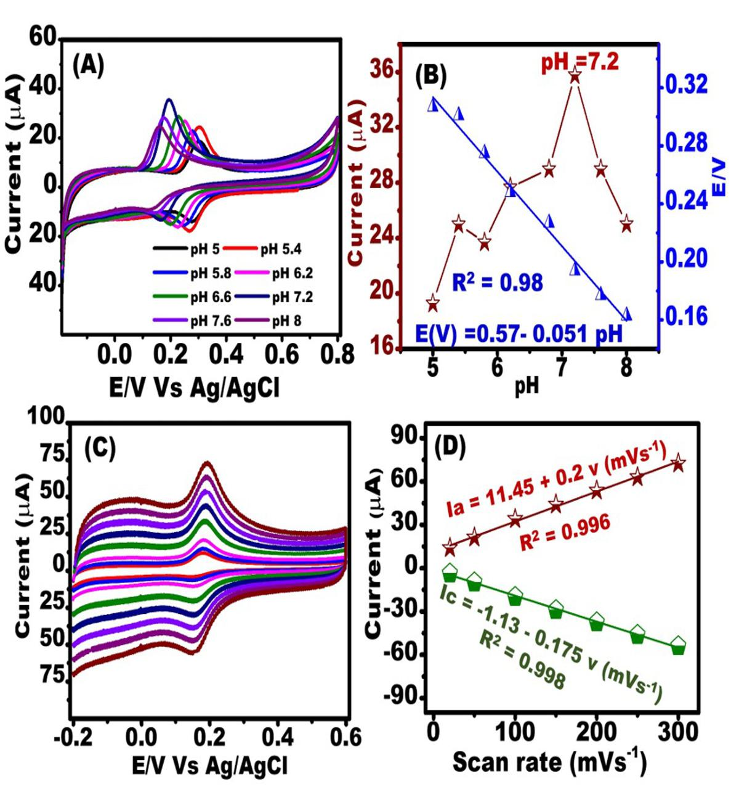
Figure 4. A) The CVs of various pH values (5-8) of 50 μM DA (PBS, pH 7.2) on 3D-PS-doped CNHN/SPCE at a scan rate of 100 mVs^{–1}. B) The plot of pH Vs Ia/μA (wine plot) and Ea/V (blue plot). C) The CVs of various scan rates (20-300 mVs^{–1}) of 50 μM DA (PBS, pH 7.2). D) The plot of scan rate (mVs^{–1}) Vs the Ia and Ic.
3.4 Sensitivity, selectivity, stability, and reproducibility studies of the designed portable DA sensor based on 3D-PS-doped CNHN/SPCE
The investigation of neuronal diseases such as schizophrenia, Alzheimer's, and Parkinson's involves assessing neurotransmitter levels in human fluids and the brain. In this context, we are in the process of developing a highly sensitive portable biosensor assay for DA utilizing 3D-PS-doped CNHN/SPCE. To achieve this, we conducted SWV measurements at various concentrations of DA to establish a calibration curve and evaluate the sensing capabilities of the portable sensor. In Figure 5A, the SWV response to various DA concentrations (10 – 500 nM) is depicted. The SWV peak current values demonstrated an increase with higher concentrations of DA, indicating a sensitive response to DA using the 3D-PS-doped CNHN/SPCE. Further analysis, shown in Figure 5B, illustrates a linear relationship between [DA]/nM and current values (μA) within the range of 10 to 500 nM. Zooming in on the concentration range of 10 to 100 nM, a linear relationship was demonstrated with the regression equation of I (μA) = 13.69 + 0.18 [DA](nM), R² = 0.975 (Figure 5C). With a wide linear range of 10 to 500 nM, the estimated limit of detection (LOD) and limit of quantification (LOQ) for the designed sensor are 7.8 nM and 76.1 nM, respectively. The LOD was calculated using the 3σ/s equation, and the LOQ was calculated using the 10σ/s equation, where σ is the standard error of intercept and s is the slope value. Table S1 provides a comparison of various DA sensors utilizing different electrode materials, including various g-C₃N₄ nanocomposites. Notably, the metal and metal oxides supported by g-C₃N₄, play a key role in enhancing the sensitivity and exhibit commendable performance as DA sensors with low limits of detection [41, 60-64]. The 3D-PS-doped CNHN/SPCE based DA sensor stands out with its low limit of detection in comparison to other sensors, covering a wide linear range. In conclusion, the 3D-PS-doped CNHN/SPCE serves as an effective portable DA sensor, demonstrating high sensitivity with a low limit of detection (7.8 nM).
Establishing a selective DA sensor in human fluids requires a meticulous consideration of its response in the presence of various interfering biomolecules such as AA, UA, AD, and NAD. Figure 5D shows the ∆I(µA) values of DA (0.5 µM) and other interfering molecules. Despite slight interference from AD (0.5 µM) and NAD (0.5 µM), as indicated by a low current difference at the same concentration, the designed sensor exhibits a selective response to DA in the presence of other neurotransmitter molecules with similar redox responses. Furthermore, the presence high concentration of 0.5 mM AA shows the low current change value, leading to the sensor's ability to selectively respond to DA even in the presence of high concentrations of AA. Additionally, the negligible response of the DA current peak after adding 0.2 mM UA demonstrates the sensor's selective response in the presence of elevated uric acid concentrations. These findings collectively validate the design of a portable, sensitive, and selective DA sensor based on 3D-PS-doped CNHN/SPCE.
The stability and reproducibility of the device were ensured through the utilization of different samples and devices. The stability of 3D-PS-doped CNHN/SPCE was studied by measuring 10 prepared DA (10 nM) samples using the SWV technique. The plot of Ia (μA) values Vs the number of samples shows a highly stable response of the portable 3D-PS-doped CNHN/SPCE with a relative standard deviation (%RSD) of 0.22 and a standard deviation (SDEV) of ± 0.02 (Figure 5E). The portable sensor's reproducibility was illustrated by designing 10 electrodes and measuring DA (200 nM) using the SWV technique. The plot of 10 electrodes Vs the Ia values (μA) shows a highly stable sensor design with %RSD = 0.19 and SDEV = ± 0.09 (Figure 5F). These outcomes strongly suggest the successful development of highly stable and reproducible portable DA sensors based on 3D-PS-doped CNHN/SPCE.
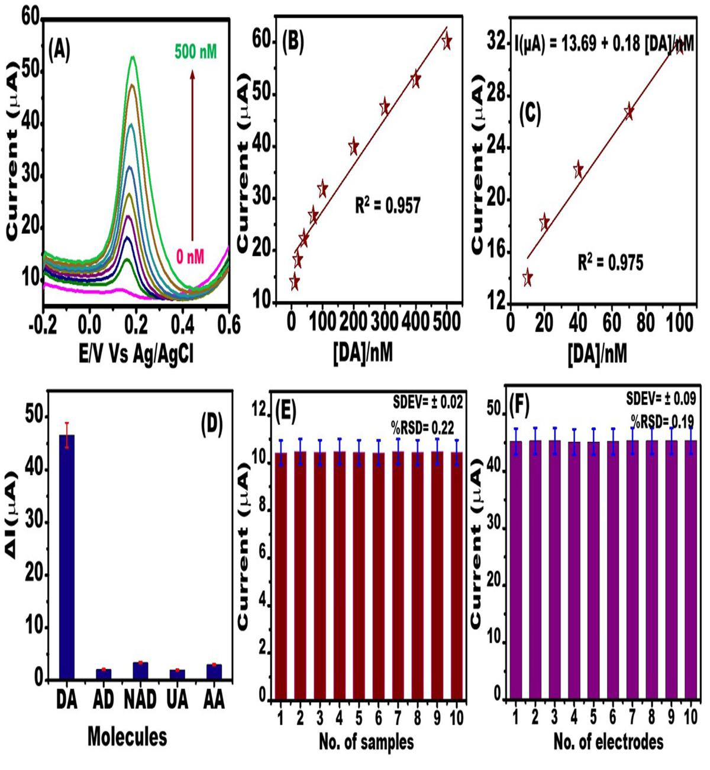
Figure 5. A) The SWV measurements of various DA concentrations (10 to 500 nM) in PBS, pH 7.2 on 3D-PS-doped CNHN/SPCE. B) The calibration plot of DA concentrations (nM) Vs the current (μA) in the range of (10 to 500 nM). C) DA concentrations (nM) Vs the current (μA) in the range of (10 to 100 nM). D) The column plot of the various interfering molecules of AD, NAD, UA, and AA Vs ∆I (µA). E) The column plot of the number of samples Vs the current values (μA) using the SWV measurements of 10 nM DA. F) The column plot of the number of electrodes Vs the current values (μA) using the SWV measurements of 200 nM DA.

3.5 Mode of action and real monitoring of DA in human fluids.
The sensitive and selective properties of the designed dopamine (DA) sensor hinge on the surface interface of 3D-PS-doped CNHN. The pH value, a critical factor in surface interface charge, significantly influences the sensor's performance. As the pH increases from 6 to 7.4, the negative zeta potential value rises, resulting in the formation of a dominant negative surface interface. This trend is corroborated by the presence of functional groups, including phosphate, sulfate, OH, and COOH, on the outer surface, all of which respond to changes in pH by deprotonating. The pH value also impacts the acid-base behavior of DA, giving rise to three forms: protonated H₃DA⁺ (pH range of 5.8 to 7.0), neutral H₂DA (pH < 5), and anion HDA– (pH > 9). These findings underscore the intricate interplay between pH, surface interface charge, and the acid-base behavior of DA, elucidating the fundamental mechanisms behind the sensor's sensitive and selective properties [74, 78, 79]. At a pH of 7.2, the predominant form of dopamine (DA) is the protonated state. Consequently, the negative charge present on the surface of 3D-PS-doped CNHN and the positive charge of DA synergistically contributes to a substantial loading of DA at the electrode surface (Scheme 1). This interplay also results in the repulsion of negatively charged molecules like ascorbic acid (AA) and uric acid (UA) due to electrostatic charge interactions [4, 14, 16]. The DA was loaded at the electrode surface and then the electrooxidation of DA from DA into quinone-DA with losing and accepting of ±2e–/2H⁺ occurred (Scheme 1).
The human serum is a complex mixture of proteins and various interfering molecules, which poses a challenge for DA analysis. To prepare the serum sample solution, 10 μL of serum was mixed with 9.90 mL of PBS (pH = 7.2). Employing the standard addition method, different concentrations of DA (10 to 100 nM) were introduced into the serum sample solution and subsequently measured using SWV. Table S2 presents the recovery of DA concentrations in human serum, exhibiting a recovery range of 99.8 to 100.25%. Table S3 shows the recovery of DA concentrations (50 to 250 nM) that added into the urine sample. The recovery was in the range of 99.48 to 99.99 %. These results highlight the efficient recovery of DA in human serum and urine samples, endorsing the potential of the portable DA sensor designed with 3D-PS-doped CNHN for screening DA levels in human fluids. The exceptional performance of the sensor can be attributed to the morphological and chemical composition of the designed electrode surface, enabling effective signaling transduction and selective capturing of DA.
Scheme 1. A) The fabricated portable electrode of an electrode system of working electrode (WE), counter electrode (CE), and reference electrode (RE) that is modified by 3D-PS-doped CNHN. B) The DA molecules exist in the human serum and urine which act as an indicator for some neuronal disorder diseases. C) The functionalized surface of 3D-PS-doped CNHN acts as the high-loading surface with facile diffusion and binding of DA at its surface. The DA molecules were oxidized at the surface of 3D-PS-doped CNHN to form the QDA. This redox process at the highly active surface of 3D-PS-doped CNHN provides a fast response and high sensing platform to detect the DA at low levels of concentrations.

Conclusion
A portable electrochemical sensor, known for its sensitivity and selectivity, is designed for the detection of DA in human fluids. Enhancing the sensor's sensitivity and selectivity towards DA molecules is largely dependent on the surface interface of the SPCE modified with 3D-PS-doped CNHN. The surface morphology, characterized by open multi-gates resembling a hornet nest, combined with the chemical composition of heteroatom-doped g-C₃N₄, creates a highly active sensor capable of detecting low concentrations of DA. With its deep open gates, nano-walls, and rough texture, the 3D hornet nest-like structure increases the surface-to-volume ratio by promoting DA molecule diffusion on its interior/exterior. Additionally, the high surface area and multi-pore structure contribute to enlarging the active surface area, providing numerous active sites. The chemical composition of heteroatom-doped g-C₃N₄-based materials enhances surface functionality, promoting binding with DA molecules, thereby improving stability and accelerating the electrooxidation process. These combined features result in a highly active surface interface that selectively and sensitively binds with DA molecules. The portable DA sensor exhibits high sensitivity, boasting a low limit of detection (7.8 nM) and a wide linear range. Moreover, in real-time monitoring of DA in human serum and urine samples, the sensor demonstrates a high recovery rate ranging from 99.48 % to 100.25%, highlighting its stability and reproducibility. Consequently, the designed portable DA sensor holds promise for clinical investigations into DA levels in human fluids.

Acknowledgment
A.K. acknowledges Science, Technology &Innovation Funding Authority (STDF) under grant number 44279. M.Z. acknowledges the support from the National Natural Science Foundation of China (no.22274018).

References

[1] A.S. Moody, B. Sharma, Multi-metal, Multi-wavelength Surface-Enhanced Raman Spectroscopy Detection of Neurotransmitters, ACS Chem.Neurosc. 9(6) (2018) 1380-1387.
[2] N.G. Mphuthi, A.S. Adekunle, E.E. Ebenso, Electrocatalytic oxidation of Epinephrine and Norepinephrine at metal oxide doped phthalocyanine/MWCNT composite sensor, Sci. Rep. 6(1) (2016) 26938.
[3] M.Y. Emran, H. Khalifa, H. Gomaa, M.A. Shenashen, N. Akhtar, M. Mekawy, A. Faheem, S.A. El-Safty, Hierarchical C-N doped NiO with dual-head echinop flowers for ultrasensitive monitoring of epinephrine in human blood serum, Microchim. Acta 184(11) (2017) 4553-4562.
[4] M.Y. Emran, M.A. Shenashen, A.I. Eid, M.M. Selim, S.A. El-Safty, Portable sensitive and selective biosensing assay of dopamine in live cells using dual phosphorus and nitrogen doped carbon urchin-like structure, Chem.Eng.J. 430 (2022) 132818.
[5] S.T. Barlow, M. Louie, R. Hao, P.A. Defnet, B. Zhang, Electrodeposited Gold on Carbon-Fiber Microelectrodes for Enhancing Amperometric Detection of Dopamine Release from Pheochromocytoma Cells, Anal.Chem. 90(16) (2018) 10049-10055.
[6] N.R. Reddy, S. Rhodes, J. Fang, Colorimetric Detection of Dopamine with J-Aggregate Nanotube-Integrated Hydrogel Thin Films, ACS Omega 5(29) (2020) 18198-18204.
[7] T.-S. Tang, X. Chen, J. Liu, I. Bezprozvanny, Dopaminergic signaling and striatal neurodegeneration in Huntington's disease, Journal of Neuroscience 27(30) (2007) 7899-7910.
[8] J.-L. Chen, X.-P. Yan, K. Meng, S.-F. Wang, Graphene Oxide Based Photoinduced Charge Transfer Label-Free Near-Infrared Fluorescent Biosensor for Dopamine, Anal. Chem. 83(22) (2011) 8787-8793.
[9] E. Talaat, M.Y. Emran, H. Gomaa, A. Kotb, A.A. Abdelwahab, M. Abdel-Hakim, E.M. Saad, M.A. Shenashen, S.A. El-Safty, Two-dimensional sulfur-doped carbon stacked sheets electrode design for potential adrenaline screening in human fluids and pharmaceutical drugs, Surf. Interfaces 36 (2023) 102481.
[10] Y. Lan, F. Yuan, T.H. Fereja, C. Wang, B. Lou, J. Li, G. Xu, Chemiluminescence of Lucigenin/Riboflavin and Its Application for Selective and Sensitive Dopamine Detection, Anal.Chem. 91(3) (2019) 2135-2139.
[11] N. Akhtar, M.Y. Emran, M.A. Shenashen, H. Khalifa, T. Osaka, A. Faheem, T. Homma, H. Kawarada, S.A. El-Safty, Fabrication of photo-electrochemical biosensors for ultrasensitive screening of mono-bioactive molecules: the effect of geometrical structures and crystal surfaces, J. Mater.Chem. B 5(39) (2017) 7985-7996.
[12] Z. Zhou, Y. Li, W. Su, B. Gu, H. Xu, C. Wu, P. Yin, H. Li, Y. Zhang, A dual-signal colorimetric and near-infrared fluorescence probe for the detection of exogenous and endogenous hydrogen peroxide in living cells, Sens. Actuat. B: Chem.280 (2019) 120-128.
[13] X.-E. Zhao, Y.-R. Suo, Simultaneous determination of monoamine and amino acid neurotransmitters in rat endbrain tissues by pre-column derivatization with high-performance liquid chromatographic fluorescence detection and mass spectrometric identification, Talanta 76(3) (2008) 690-697.
[14] M.Y. Emran, M.A. Shenashen, A. Elmarakbi, M.M. Selim, S.A. El-Safty, Nitrogen-doped carbon hollow trunk-like structure as a portable electrochemical sensor for noradrenaline detection in neuronal cells, Anal. Chim. Acta 1192 (2022) 339380.
[15] A. Pahlavan, V.K. Gupta, A.L. Sanati, F. Karimi, M. Yoosefian, M. Ghadami, ZnO/CNTs nanocomposite/ionic liquid carbon paste electrode for determination of noradrenaline in human samples, Electrochim. Acta 123 (2014) 456-462.
[16] M.Y. Emran, S.A. El-Safty, A. Elmarakbi, A. Reda, A. El Sabagh, M.A. Shenashen, Chipset Nanosensor Based on N-Doped Carbon Nanobuds for Selective Screening of Epinephrine in Human Samples, Adv. Mater. Interfaces 9(1) (2022) 2101473.
[17] Y. Zhang, W. Ren, Y.Z. Fan, J.X. Dong, H. Zhang, H.Q. Luo, N.B. Li, Label-free fluorescent discrimination and detection of epinephrine and dopamine based on bioinspired in situ copolymers and excitation wavelength switch, Anal. Chim.Acta 1054 (2019) 167-175.
[18] K.-D. Seo, M.M.D. Hossain, N.G. Gurudatt, C.S. Choi, M.J.A. Shiddiky, D.-S. Park, Y.-B. Shim, Microfluidic neurotransmitters sensor in blood plasma with mediator-immobilized conducting polymer/N, S-doped porous carbon composite, Sens.Actuat. B: Chem. 313 (2020) 128017.
[19] Y. Liu, M. Li, F. Zhang, A. Zhu, G. Shi, Development of Au Disk Nanoelectrode Down to 3 nm in Radius for Detection of Dopamine Release from a Single Cell, Anal. Chem. 87(11) (2015) 5531-5538.
[20] L. Jiang, G.W. Nelson, J. Abda, J.S. Foord, Novel Modifications to Carbon-Based Electrodes to Improve the Electrochemical Detection of Dopamine, ACS Appl. Mater. Interfaces 8(42) (2016) 28338-28348.
[21] M. Cao, W. Deng, Z. Zhu, C. Ma, J. Bai, M.Y. Emran, A. Kotb, M. Sun, M. Zhou, A Fully Integrated Handheld Electrochemical Sensing Platform for Point-of-Care Testing of Escherichia coli O157:H7, Anal. Chem. 96(13) (2024) 5340-5347.
[22] L. Zheng, M. Cao, Y. Du, Q. Liu, M.Y. Emran, A. Kotb, M. Sun, C.-B. Ma, M. Zhou, Artificial enzyme innovations in electrochemical devices: advancing wearable and portable sensing technologies, Nanoscale 16(1) (2024) 44-60.
[23] Y. Bi, M. Sun, J. Wang, Z. Zhu, J. Bai, M.Y. Emran, A. Kotb, X. Bo, M. Zhou, Universal Fully Integrated Wearable Sensor Arrays for the Multiple Electrolyte and Metabolite Monitoring in Raw Sweat, Saliva, or Urine, Anal. Chem. 95(16) (2023) 6690-6699.
[24] I.A. Mattioli, P. Cervini, É.T.G. Cavalheiro, Screen-printed disposable electrodes using graphite-polyurethane composites modified with magnetite and chitosan-coated magnetite nanoparticles for voltammetric epinephrine sensing: a comparative study, Microchim. Acta 187(6) (2020) 318.
[25] M.Y. Emran, M.A. Shenashen, S.A. El-Safty, M.M. Selim, Design of porous S-doped carbon nanostructured electrode sensor for sensitive and selective detection of guanine from DNA samples, Microp. Mesop.Mater. 320 (2021) 111097.
[26] C. Karaman, O. Karaman, N. Atar, M.L. Yola, Tailoring of cobalt phosphide anchored nitrogen and sulfur co-doped three dimensional graphene hybrid: Boosted electrocatalytic performance towards hydrogen evolution reaction, Electrochim. Acta 380 (2021) 138262.
[27] M. Keerthi, G. Boopathy, S.-M. Chen, T.-W. Chen, B.-S. Lou, A core-shell molybdenum nanoparticles entrapped f-MWCNTs hybrid nanostructured material based non-enzymatic biosensor for electrochemical detection of dopamine neurotransmitter in biological samples, Sci. Rep. 9(1) (2019) 13075.
[28] J.-M. Moon, N. Thapliyal, K.K. Hussain, R.N. Goyal, Y.-B. Shim, Conducting polymer-based electrochemical biosensors for neurotransmitters: A review, Biosens. Bioelectron. 102 (2018) 540-552.
[29] M.Y. Emran, S.A. El-Safty, M.M. Selim, M.A. Shenashen, Selective monitoring of ultra-trace guanine and adenine from hydrolyzed DNA using boron-doped carbon electrode surfaces, Sens. Actuat. B: Chem.329 (2021) 129192.
[30] M. Madej, D. Matoga, K. Skaźnik, R. Porada, B. Baś, J. Kochana, A voltammetric sensor based on mixed proton-electron conducting composite including metal-organic framework JUK-2 for determination of citalopram, Microchim. Acta 188(6) (2021) 184.
[31] Y.H. Chang, P.M. Woi, Y. Alias, The selective electrochemical detection of dopamine in the presence of ascorbic acid and uric acid using electro-polymerised-β-cyclodextrin incorporated f-MWCNTs/polyaniline modified glassy carbon electrode, Microchem. J. 148 (2019) 322-330.
[32] B. Demirkan, S. Bozkurt, K. Cellat, K. Arıkan, M. Yılmaz, A. Şavk, M.H. Çalımlı, M.S. Nas, M.N. Atalar, M.H. Alma, F. Sen, Palladium supported on polypyrrole/reduced graphene oxidenanoparticles for simultaneous biosensing application of ascorbic acid, dopamine, and uric acid, Sci. Rep. 10(1) (2020) 2946.
[33] M.A. Shenashen, M.Y. Emran, A. El Sabagh, M.M. Selim, A. Elmarakbi, S.A. El-Safty, Progress in sensory devices of pesticides, pathogens, coronavirus, and chemical additives and hazards in food assessment: Food safety concerns, Prog. Mater. Sci 124 (2022) 100866.
[34] Z. Li, Y. Guo, H. Yue, X. Gao, S. Huang, X. Zhang, Y. Yu, H. Zhang, H. Zhang, Electrochemical determination of epinephrine based on Ti₃C₂T_{x} MXene-reduced graphene oxide/ITO electrode, J. Electroanal. Chem. 895 (2021) 115425.
[35] K. Chetankumar, B.E. Kumara Swamy, S.C. Sharma, H. Adarsha, Coomassie brilliant blue G 250 modified carbon paste electrode sensor for the voltammetric detection of dihydroxybenzene isomers, Sci. Rep. 11(1) (2021) 15933.
[36] W. Zhang, G. Jia, Z. Li, C. Yuan, Y. Bai, D. Fu, Selective Electrochemical Detection of Dopamine on Polyoxometalate-Based Metal–Organic Framework and Its Composite with Reduced Graphene Oxide, Adv.Mater. Interfaces 4(10) (2017) 1601241.
[37] M.Y. Emran, M.A. Shenashen, A.A. Abdelwahab, M. Abdelmottaleb, S.A. El-Safty, Facile synthesis of microporous sulfur-doped carbon spheres as electrodes for ultrasensitive detection of ascorbic acid in food and pharmaceutical products, New J. Chem. 42(7) (2018) 5037-5044.
[38] X. Hu, M. Fan, Y. Zhu, Q. Zhu, Q. Song, Z. Dong, Biomass-derived phosphorus-doped carbon materials as efficient metal-free catalysts for selective aerobic oxidation of alcohols, Green Chem. 21(19) (2019) 5274-5283.
[39] D. Wang, N.B. Saleh, W. Sun, C.M. Park, C. Shen, N. Aich, W.J.G.M. Peijnenburg, W. Zhang, Y. Jin, C. Su, Next-Generation Multifunctional Carbon–Metal Nanohybrids for Energy and Environmental Applications, Env. Sci. Techn. 53(13) (2019) 7265-7287.
[40] S. Alim, J. Vejayan, M.M. Yusoff, A.K.M. Kafi, Recent uses of carbon nanotubes & gold nanoparticles in electrochemistry with application in biosensing: A review, Biosens.Bioelectron. 121 (2018) 125-136.
[41] M. Wang, M. Zhang, J. Zhu, J. Wang, L. Hu, T. Sun, M. Wang, Y. Tang, g-C3N4/Co Nanohybrids for Ultra-sensitive Simultaneous Detection of Uric Acid and Dopamine, ChemElectroChem 7(6) (2020) 1373-1377.
[42] Y.-N. Sun, M.-L. Zhang, L. Zhao, Z.-Y. Sui, Z.-Y. Sun, B.-H. Han, A N, P Dual-Doped Carbon with High Porosity as an Advanced Metal-Free Oxygen Reduction Catalyst, Adv. Mater. Interfaces 6(14) (2019) 1900592.
[43] M.Y. Emran, S.A. El-Safty, M.M. Selim, T. Minowa, A. Elmarakbi, M.A. Shenashen, Non-metal sensory electrode design and protocol of DNA-nucleobases in living cells exposed to oxidative stresses, Anal. Chim. Acta 1142 (2021) 143-156.
[44] M.Y. Emran, S.A. El-Safty, M.M. Selim, A. Reda, H. Morita, M.A. Shenashen, Electrochemical sensors-based phosphorus-doped carbon for determination of adenine DNA-nucleobases in living cells, Carbon 173 (2021) 1093-1104.
[45] B. Huang, X. Hu, Y. Liu, W. Qi, Z. Xie, Biomolecule-derived N/S co-doped CNT-graphene hybrids exhibiting excellent electrochemical activities, J. Power Sour. 413 (2019) 408-417.
[46] N. Akhtar, S.A. El-Safty, M.E. Abdelsalam, H. Kawarada, One-Pot Fabrication of Dendritic NiO@carbon–nitrogen Dot Electrodes for Screening Blood Glucose Level in Diabetes, Adv. Healthcare Mater.4(14) (2015) 2110-2119.
[47] J. Li, J. Jiang, H. Feng, Z. Xu, S. Tang, P. Deng, D. Qian, Facile synthesis of 3D porous nitrogen-doped graphene as an efficient electrocatalyst for adenine sensing, RSC Adv. 6(37) (2016) 31565-31573.
[48] Y. Gong, M. Li, H. Li, Y. Wang, Graphitic carbon nitride polymers: promising catalysts or catalyst supports for heterogeneous oxidation and hydrogenation, Green Chem. 17(2) (2015) 715-736.
[49] G. Yan, X. Feng, L. Xiao, W. Xi, H. Tan, H. Shi, Y. Wang, Y.J.D.T. Li, Tuning of the photocatalytic performance of gC₃N₄ by polyoxometalates under visible light, Dalton Trans. 46(46) (2017) 16019-16024.
[50] A. Alsalme, A.H. Galal, E.F. El-Sherbeny, A. Soltan, M. F. Abdel-Messih, M.A.Ahmed, Fabrication of S-scheme TiO₂/g-C₃N₄ nanocomposites for generation of hydrogen gas and removal of fluorescein dye, Diam. Relat. Mater. 122 (2022) 108819.
[51] N. Al-Zaqri, A. Alsalme, M.A. Ahmed, A.H.Galal, Construction of novel direct Z-scheme AgIO₄-g-C₃N₄ heterojunction for photocatalytic hydrogen production and photodegradation of fluorescein dye, Diam. Relat. Mater.109 (2020) 108071.
[52] A.M. Basely, M.H. Shaker, F.M. Helmy, M. F.Abdel-Messih, M.A..Ahmed, Construction of Bi₂S₃/g-C₃N₄ step S-scheme heterojunctions for photothermal decomposition of rhodamine B dye under natural sunlight radiations, Inorg. Chem. Commun. 148 (2023) 110300.
[53] Z. Zhang, D. Jiang, D. Li, M. He, M. Chen, Construction of SnNb₂O₆ nanosheet/g-C₃N₄ nanosheet two-dimensional heterostructures with improved photocatalytic activity: synergistic effect and mechanism insight, Appl. Catal. B: Env.183 (2016) 113-123.
[54] Y. Shiraishi, Y. Kofuji, H. Sakamoto, S. Tanaka, S. Ichikawa, T. Hirai, Effects of surface defects on photocatalytic H₂O₂ production by mesoporous graphitic carbon nitride under visible light irradiation, ACS Catal. 5(5) (2015) 3058-3066.
[55] J. Xiao, Y. Xie, F. Nawaz, Y. Wang, P. Du, H. Cao, Dramatic coupling of visible light with ozone on honeycomb-like porous g-C₃N₄ towards superior oxidation of water pollutants, Appl. Catal. B: Env. 183 (2016) 417-425.
[56] W. Liu, J. Shen, Q. Liu, X. Yang, H. Tang, Porous MoP network structure as co-catalyst for H₂ evolution over g-C₃N₄ nanosheets, Appl. Surf. Sci. 462 (2018) 822-830.
[57] A. Alsulmi, M.H. Shaker, A.M. Basely, M.F. Abdel-Messih, A. Sultan, M.A. Ahmed, Engineering S-scheme Ag₂CO₃/g-C₃N₄ heterojunctions sonochemically to eradicate Rhodamine B dye under solar irradiation, RSC Adv. 13(18) (2023) 12229-12243.
[58] L. Chen, M.A. Maigbay, M. Li, X. Qiu, Synthesis and modification strategies of g-C3N4 nanosheets for photocatalytic applications, Adv. Powder Mater.3(1) (2024) 100150.
[59] S. Hmamouchi, A.E. Yacoubi, M.E. Hezzat, B. Sallek, B.C.E. Idrissi, α-Fe₂O₃/g-C₃N₄ nanocomposite with type II heterojunction for methylene blue photodegradation, Chem. Phys. Impact 8 (2024) 100577.
[60] H. Wang, A. Xie, S. Li, J. Wang, K. Chen, Z. Su, N. Song, S. Luo, Three-dimensional g-C3N4/MWNTs/GO hybrid electrode as electrochemical sensor for simultaneous determination of ascorbic acid, dopamine and uric acid, Anal. Chim. Acta 1211 (2022) 339907.
[61] Z. Aryan, H. Khajehsharifi, S. Shahrokhian, AuNPs-Ultrathin/Graphitic-C₃N₄ nanosheets as a sensitive platform for electrochemical detection and determination of dopamine, Microchem.J. 198 (2024) 110087.
[62] Q. Fu, C. Wang, J. Chen, Y. Wang, C. Li, Y. Xie, P. Zhao, J. Fei, BiPO₄/BiOCl/g-C₃N₄ heterojunction based photoelectrochemical sensing of dopamine in serum samples, Coll. Surf. A: Physicochem. Eng. Aspects 656 (2023) 130456.
[63] X.B. Joseph, N.M. Umesh, S.-F. Wang, J.A. Jesila, CoFe₂O₄ supported g-C₃N₄ nanocomposite for the sensitive electrochemical detection of dopamine, New J. Chem. 45(38) (2021) 18131-18138.
[64] L. Zheng, H. Zhang, M. Won, E. Kim, M. Li, J.S. Kim, Codoping g-C₃N₄ with boron and graphene quantum dots: Enhancement of charge transfer for ultrasensitive and selective photoelectrochemical detection of dopamine, Biosens. Bioelectron. 224 (2023) 115050.
[65] A. Olufemi Oluwole, P. Khoza, O.S. Olatunji, Synthesis and characterization of g-C₃N₄ doped with activated carbon (AC) prepared from grape leaf litters for the photocatalytic degradation of enrofloxacin in aqueous systems, ChemistrySelect 7(45) (2022) e202203601.
[66] M. Zhang, Y. Liu, H. Zhao, J. Tao, N. Geng, W. Li, Y. Zhai, Pd anchored on a phytic acid/thiourea polymer as a highly active and stable catalyst for the reduction of nitroarene, ACS Appl. Mater. Interfaces 13(17) (2021) 19904-19914.
[67] A.L.M. Daneluti, J.d.R. Matos, Study of thermal behavior of phytic acid, Braz. J. Pharm. Sci. 49 (2013) 275-283.
[68] Y. Li, S. Zhu, Y. Liang, Z. Li, S. Wu, C. Chang, S. Luo, Z. Cui, One-step synthesis of Mo and S co-doped porous g-C₃N₄ nanosheets for efficient visible-light photocatalytic hydrogen evolution, Appl. Surf. Sci. 536 (2021) 147743.
[69] D. Gogoi, A.K. Shah, M. Qureshi, A.K. Golder, N.R. Peela, Silver grafted graphitic-carbon nitride ternary hetero-junction Ag/gC₃N₄(Urea)-gC₃N₄(Thiourea) with efficient charge transfer for enhanced visible-light photocatalytic green H₂ production, Appl. Surf. Sci. 558 (2021) 149900.
[70] N. Madima, K.K. Kefeni, S.B. Mishra, A.K. Mishra, TiO₂-modified g-C₃N₄ nanocomposite for photocatalytic degradation of organic dyes in aqueous solution, Heliyon 8(9) (2022) e10683.
[71] C.-Q. Xu, K. Li, W.-D. Zhang, Enhancing visible light photocatalytic activity of nitrogen-deficient g-C3N4 via thermal polymerization of acetic acid-treated melamine, J. Coll. Interface Sci. 495 (2017) 27-36.
[72] F. He, M. Wang, L. Luo, Z. Wang, S. Peng, Y. Li, Directional modulation of triazine and heptazine based carbon nitride for efficient photocatalytic H₂ evolution, Appl. Sur. Sci.562 (2021) 150103.
[73] Y. Jiao, Q. Huang, J. Wang, Z. He, Z. Li, A novel MoS2 quantum dots (QDs) decorated Z-scheme g-C3N4 nanosheet/N-doped carbon dots heterostructure photocatalyst for photocatalytic hydrogen evolution, Appl. Catal. B: Env. 247 (2019) 124-132.
[74] M.Y. Emran, M.A. Shenashen, S.A. El-Safty, M.M. Selim, T. Minowa, A. Elmarakbi, Three-Dimensional Circular Surface Curvature of a Spherule-Based Electrode for Selective Signaling and Dynamic Mobility of Norepinephrine in Living Cells, ACS Appl. Bio Mater.3(12) (2020) 8496-8506.
[75] M.Y. Emran, M.A. Shenashen, S.A. El-Safty, A. Reda, M.M. Selim, Microporous P-doped carbon spheres sensory electrode for voltammetry and amperometry adrenaline screening in human fluids, Microchim. Acta 188(4) (2021) 138.
[76] W. Liu, J. Shen, Q. Liu, X. Yang, H. Tang, Porous MoP network structure as co-catalyst for H2 evolution over g-C₃N₄ nanosheets, Appl. Surf. Sci. 462 (2018) 822-830.
[77] D. Buttry, Electroanalytical Chemistry, Vol. 17, AJ Bard, Editor, Marcel Dekker, New York, 1991.
[78] J. Szewczyk, D. Aguilar-Ferrer, E. Coy, Polydopamine films: Electrochemical growth and sensing applications, Eur. Poly. J.174 (2022) 111346.
[79] R.n. Álvarez-Diduk, A. Galano, Adrenaline and noradrenaline: protectors against oxidative stress or molecular targets?, J. Phy.Chem. B 119(8) (2015) 3479-3491.

