Surface Kinetics and Viscosity in Amorphous As₂₀Se₈₀: A Comparative Study of Bulk and Thin Films Prepared by Thermal Evaporation and Spin-Coating
Michaela Včeláková
0009-0004-1206-3436
University of Pardubice Department of Inorganic Technology Doubravice 41 Pardubice CZ
David Vaculík
0009-0000-9441-907X
University of Pardubice Department of Physical Chemistry Studentská 573 Pardubice CZ
Michal Kurka
0000-0002-2526-2723
University of Pardubice Center of Materials and Nanotechnologies Nam. Cs. Legii 573 Pardubice CZ
Jiri Jancalek
0000-0003-1455-7400
University of Pardubice Center of Materials and Nanotechnologies Nam. Cs. Legii 573 Pardubice CZ
Stanislav Slang
0000-0001-7760-2964
University of Pardubice Center of Materials and Nanotechnologies Nam. Cs. Legii 573 Pardubice CZ
Torsten Wieduwilt
0000-0002-8809-3074
Leibniz Institute of Photonic Technology Albert-Einstein-Str. 9 Jena DE
Markus Schmidt
0000-0002-5324-6405
Leibniz Institute of Photonic Technology Albert-Einstein-Str. 9 Jena DE Friedrich-Schiller-University Jena Abbe Center of Photonics and Faculty of Physics Max-Wien-Platz 1 Jena DE Friedrich-Schiller-University Jena Otto Schott Institute of Material Research Fraunhoferstr. 6 Jena DE
Hiroyo Segawa
0000-0002-7198-8410
National Institute for Materials Science Research Center for Electronic and Optical Materials Ibaraki 305-0044 Tsukuba JP
Jaroslav Barták
0000-0001-8675-1144
University of Pardubice Department of Physical Chemistry Studentská 573 Pardubice CZ
jaroslav.bartak@upce.cz

Abstract
A proper understanding of the molecular transport occurring in the near-surface region is a crucial prerequisite for the successful application of amorphous chalcogenides. This study provides information on the surface patterns decay in bulks and thin films of amorphous As₂₀Se₈₀. Single-period sinusoidal gratings were embossed into the sample surfaces, and subsequent annealing-induced decay or flattening of the surface grating was analyzed to obtain a rate constant of the process. The studies were performed in bulk samples, thermally evaporated thin films, and for the first time in solution processed chalcogenide thin films prepared by spin-coating. The obtained data provide a comparison of near-surface molecular transport in As₂₀Se₈₀ amorphous material prepared by different methods.

1. Introduction
Chalcogenide materials are well-known for their exceptional optical and electrical properties, rendering them indispensable in various technological applications. Due to their distinctive properties, including a high refractive index, extensive transmittance in the infrared (IR) region, notable optical nonlinearity ^{1,2}, photosensitivity ², low photon energy, and high ionic conductivity ^{2,3}, they can be utilized in IR optics ^{4,5}, or photonics ⁶. Chalcogenide glasses have also found practical such as diffraction gratings or are used to switch the optical properties of plasmonic systems ^{2,7,8}. These materials are also used to produce optical waveguides (e.g. for nonlinear frequency conversation ^{9,10} or microlenses, beam resistors ^{2,3,11–13} , biosensors ¹⁴, and other devices. Recently, chalcogenide glasses have been employed extensively in photovoltaic cells ^{15–18}, semiconductor electrodes, and electrodes for batteries ^{19,20} or are used to switch the optical properties of plasmonic systems ²¹. A particularly important recent application of these materials has been in the context phase-change materials (PCMs) for optoelectronics. Here, the optically induced switching between crystalline and amorphous states can be used to store information and optical recording ²². In many of the mentioned applications, thin films (TFs) are necessary. The properties of these materials are contingent upon their form or structure, which may be classified as bulk samples/TFs, or amorphous/crystalline. For most applications, high resistance to crystallization is necessary. Conversely, a material with rapid and regulated crystallization is advantageous for specific applications such as glass-ceramics ^{23,24} or phase change memories ^{25,26}.
As mentioned, many applications for chalcogenide glasses are compatible with TF. There are multiple methods for preparing TFs, which can be broadly classified into two primary categories based on the deposition mode: gas phase and liquid phase. The first category encompasses techniques reliant on physical deposition, including vacuum thermal deposition ²⁷, laser ablation ²⁸, electron ablation ²⁹, etc. The most prevalent methodology is thermal evaporation ²⁷. In this case, high-purity layers are formed with precise control of composition and thickness. The second group of TFs preparation comprises solution based techniques, including spin-coating ^{30,31}, spiral-bar coatings ³², electrospray ^{33,34}, inkjet printing ^{35,36}, etc.
The solubility of the chalcogenide material in an alkaline solvent, predominantly aliphatic amines alone or in combination with methanol or thiols, is a crucial factor for TFs preparation via solution route ^{37–39}. The spin-coating method is, in principle, a relatively straightforward and cost-effective approach. Following dissolution, the solution is deposited on a static or rotating substrate, afterwards, the substrate covered with solution is heated, and the solvent is evaporated to form a solid film. These methods offer the advantage of enabling the creation of more complex compositions through straightforward mixing of the individual solutions and/or incorporation of nanoparticles into the glass solution, thus introducing them into the resulting TFs ^{40,41}. Consequently, the properties of the prepared SC TFs are prone to variation, and the physicochemical properties may diverge considerably from those of TFs prepared by thermal evaporation ^{42,43}. Alternatively, new properties may be introduced, such as photoluminescence or photoconductivity ^{44–46}. The disadvantage of this method is that organic residues from the solvent may remain embedded in the TFs structure. Nevertheless, this can be mitigated to a certain extent by applying proper post-deposition thermal treatment ^{30,47}.
Surface mobility exerts a pivotal influence on the production and stability of materials, as well as on a multitude of other processes that must be considered for their potential utilization. Surface mobility is typically defined in terms of surface diffusion, although this is a challenging concept to quantify. Surface diffusion is frequently several orders of magnitude higher than bulk diffusion, which has a considerable impact on surface processes ^{48,49}. The temperature dependence of the diffusion coefficients is challenging to obtain. However, the derivation in terms of viscosity using the Stokes-Einstein-Eyring equation (SEE) (D ≈ η⁻¹) is a useful approach ^{50,51}.
The viscosity behavior of bulk chalcogenide samples has been extensively documented in numerous publications summarized in work of Koštál et al. ⁵². Conversely, the viscosity behavior of TFs remains relatively understudied, with only a handful of articles describing viscosity measurements in TFs ^{49,53–57}. It is predominantly assumed that the viscosity of bulk samples and TFs is equivalent. In certain compositions, such as Se ⁵⁵, Ge₂₅Se₇₅ ⁵⁷, or Se-Te system, Se₉₅Te₅⁵³, and Se₉₀Te₁₀ ⁴⁹, the viscosity of bulks and TFs remains the same. Nevertheless, the present study demonstrates that the viscosity of bulk samples and TFs differs for amorphous As₂₀Se₈₀.
In recent decades, surface mobility measurements have been conducted predominantly on organic glasses, employing a methodology whereby the flattening of a lattice embedded in the sample surface is monitored. The measurement is based on the principle of measuring the change in amplitude of a single-period sinusoidal grating, which decreases exponentially with time ⁵⁸. By conducting the experiment with gratings of varying periods, the mechanism of the smoothing process can be elucidated. A fundamentally similar type of experiment is to perform surface mobility measurements using a non-sinusoidal profile, such as holes or scratches ^{54,59}. These can be performed by nanoindentation ^{60,61} or by AFM (Atomic Force Microscope) lithography. Mullins ⁵⁸ outlined a theoretical basis for the possibility of determining the mechanism of the flattening process, even for non-sinusoidal profiles.
The present manuscript provides a study and comparison of near-surface mobility in amorphous As₂₀Se₈₀ materials prepared in different forms. Near-surface mobility is studied using a combination of nanoindentation and flattening process of a single-period grating embossed into the surface of the prepared bulk samples, as well as TFs prepared by thermal evaporation and solution processing. The near-surface viscosities in bulks and TFs are compared with the previously obtained data in bulk samples measured using classical thermomechanical analysis methods. The viscosity data are also complemented with melt viscosities measured by pressure assisted melt filling technique (PAMFT). The flattening process of patterns embossed into the surface of all prepared samples shows differences in the surface mobility between the solution processed TFs and TFs prepared by thermal evaporation. The differences may originate from the different patterns (observed by Raman spectroscopy) and by organic residua, including in spin-coated (SC) TFs.

2. Experimental

2.1. Sample preparation and characterization
The amorphous bulk samples of As₂₀Se₈₀ were prepared using a conventional melt-quenching method. Pure elements (5N, HiChem CZ) were weighed in accordance with the corresponding atomic ratio and transferred into quartz ampules, which were then evacuated and sealed. Subsequently, the quartz ampules were placed in a rocking furnace for the synthesis. The furnace was set at 800 °C with a heating rate of 10 °C·min⁻¹. Following a 20-hour period, the temperature was reduced to 400 °C for 4 hours. Subsequently, the ampules were cooled in the air. The amorphous character of the samples was confirmed by X-ray diffraction (XRD, Rigaku MiniFlex 600 with Bragg-Brentano 2θ-2θ geometry; CuKα λ = 1.5418 Å, U = 400 kV, I = 15 mA).
The As₂₀Se₈₀ thin films were prepared by thermal evaporation technique (TE, model UP-858, Tesla Corp.). Soda-lime glass slides (75 × 26 × 1) mm were used as substrates. The deposition of the thin films was conducted in a high vacuum (2 × 10⁻³ Pa) at a deposition rate of 1–2 nm·s⁻¹, with the deposition rate continuously measured by the quartz crystal microbalance technique (STM-2 Inficon). The final layer thickness was approximately 1 μm.
For solution processed thin films, the source As₂₀Se₈₀ bulk glass was powdered in an agate bowl and dissolved in a mixture of 10 vol.% methanol in n-propylamine (PAM) in the concentration of 0.1 g of glass powder per 1 ml of solution and in ethylenediamine (EDA) in the concentration of 0.2 g of glass powder per 1 ml of EDA. The dissolution process was carried out under rigorous stirring of solution for 24 h in an inert atmosphere inside a nitrogen-filled glovebox (LabMaster Pro_MB200, MBraun) to prevent possible hydrolysis or oxidation of the solutions. The glass solutions were clear, without any turbidity or precipitates. The prepared solutions were used for the deposition of thin films by a dynamic spin-coating technique using a WS-650Mz-23NPPB (Laurel) spin‑coater. The deposition was performed using 60 s spin-time and a spin‑rate of 750 RPM for the PAM solution or 1500 RPM for the EDA solution. Deposition parameters were chosen based on data from preliminary experiments with the aim of achieving films, with a thickness of at least 200 nm after annealing and maintaining specular optical quality. Immediately after deposition, thin films were annealed at 60 °C (PAM) and 100 °C (EDA) at a hot plate HP 20D (Witeg) for 20 min to evaporate excess chemically non-bonded solvent. Solution processed thin films were subsequently annealed at 100 °C (PAM) or 130 °C (EDA) to remove the chemically bonded organic residues. The deposition process and subsequent annealing were performed in the inert atmosphere of the glovebox to prevent any oxidation or hydrolysis of thin films.
The Raman spectroscopy was used to determine the differences in As₂₀Se₈₀ bulk glass and thin films structure using MultiRam (Bruker) FT-Raman spectrometer utilizing 1064 nm Nd:YAG laser excitation beam (resolution 2 cm⁻¹, 100 scans averaging). Prior the measurements, thin films were scratched off into the powder holders to improve Raman signal intensity.
The elemental composition data were obtained using a LYRA 3 scanning electron microscope (Tescan) equipped with an AZtec X-Max 20 EDX analyzer (Oxford Instruments). A 20 nm carbon coating (Leica ACE200) was employed to reduce the charging of the prepared bulk material and wires. EDX measurements were conducted at an accelerating voltage of 5 kV on five 400 × 400 µm areas. The EDX results were evaluated and averaged in AZtec software (Oxford Instruments), with the error bars representing the standard deviation from the averaged values.

2.2. Viscosity measurements

2.2.1. Nanoindentation
The near-surface viscosities were measured using nanoindentation (NI). The measurements were performed on bulk samples and thin films. The bulk samples were prepared to a size of approx. 7 × 7 mm with a maximum height of 1.9 mm. The samples had parallel surfaces polished to optical quality. Thin films were also prepared to a size of approx. 7 × 7 mm. Nanoindentation measurements were performed using Hysitron TI Premier (Bruker) instrument equipped with an X-SOL 25 heating stage (temperature stability ± 0.2 °C). The measurements were performed in a protective nitrogen atmosphere (4.5N purity). The Berkovich tip (sapphire, total included angle of 142 °) was utilized and controlled by quasi-static load mode.

2.2.2. Pressure-assisted melt filling technique (PAMFT)
PAMFT was used to measure melt viscosities in the As₂₀Se₈₀. Thin fibers (60–80 μm in diameter and 1–3 mm in length) of As₂₀Se₈₀ were prepared by drawing them directly from the melt in a protective atmosphere of N₂. The fibers were positioned within the auxiliary quartz capillary, which had an inner diameter of 80 μm and an outer diameter of 200 μm. The capillary was then spliced to the filling capillary with an inner diameter of 3 or 5.8 μm. Subsequently, the chalcogenide fibers were advanced towards the junction of the auxiliary and filling capillaries, thereby reducing the available space at the interface and minimizing the potential for measurement error. The auxiliary capillary was connected to the pressure system and purged for a period of 30 minutes with pure Ar (5N), with the objective of removing any residual air from the capillary. The capillaries were positioned on a horizontal hot plate, and argon pressure (5–40 bar) was applied to the free end of the guarding capillary to propel the melt into the filling capillary. The temperature stability of the hot plate was evaluated using multiple thermocouples positioned along its entire length.
After a predetermined time, the capillary was removed from the hotplate and the pressure was released. The length of chalcogenide material extruded into the filling capillary was measured using an optical microscope. The spliced capillaries were then placed back on the hotplate at the same temperature and Ar pressure was applied to continue the filling process. This process of extracting and reinserting the capillaries was repeated multiple times to obtain a time-dependent measurement of the filling length. Further details regarding the methodology can be found in references ^{57,62,63}.

2.3. Grating decay measurement
Surface gratings were embossed into the bulk and thin film samples (10 × 10) mm on a heating plate inside the vacuum chamber (~10³ Pa). The temperatures of hot embossing were chosen with respect to the origin of the samples (bulk: 155 °C; evaporated thin films: 140 °C; spin-coated thin films from PAM: 100 °C and spin-coated thin films from EDA: 120 °C). The pressure and time of hot embossing were fixed to values of 309 kPa and 15 min. The polydimethylsiloxane (PDMS) stamps were utilized for hot embossing over three distinct periods: 790, 803, and 1450 nm. A soft PDMS stamp was prepared from an elastomer kit (SYLGARD 184, Dow Corning) using a mixture ratio of 10:1 of the base oligomer to the curing agent. The mixture was then stirred for a period of 30 minutes and subsequently poured over the master holographic grating. Subsequently, the mixture was degassed in a vacuum and then cured in an oven for one hour at 110 °C. Subsequently, the PDMS stamps were peeled from the master grating and subjected to a hard curing procedure at 200 °C for a period of three hours ⁶⁴. The grating periods λ have been checked separately for each sample measured. The grating periods varied slightly for each sample. Therefore, the exact measured values were used for calculations the rate constants. Nevertheless, for better orientation in summarizing graphs and tables, the period values are given according to the stamps used (790, 803, and 1450 nm).
The rate constant of the investigated samples was determined by ex-situ surface grating decay (SGD) using atomic force microscopy (AFM). The samples were subjected to heating in an oven (Yamato Scientific Co., DKN302, with a temperature stability of ± 1 °C). AFM (SPA400, Hitachi High-Tech) in semi-contact mode was employed to investigate the change in height of the grating structure and for the grid period determination.
The second method for SGD measurements was the in-situ measurements of the zero-order transmittance through the diffraction grid. The samples were heated in a custom-built furnace (Vezas Co., temperature stability ± 1 °C). A Tungsten halogen light source (StellarNet) together with a fiber spectrophotometer (BLUE-wave VIS model, StellarNet) was used to study the transmittance changes. To reduce the effect of decay due to photoinduced self-diffusion and viscous flow, the probing light beam was passed through an edge and gray filter (with a transmittance ~10 %) ⁶⁵. The influence of light was proved in the second arrangement of in-situ measurements of SGD. The device for in-situ measuring was extended with a laser (408 nm) that was at 45 ° to the axis of the probing light for determination of light influence on in-situ measurements.

3. Results and Discussion

3.1. Structure and composition of TFs
Raman spectra Fig. 1 showed slight differences in the molecular structure of thin films compared to the bulk glass structure and each other. In agreement with earlier observations ⁶⁶, the spectrum contains the dominant band at 253 cm⁻¹ corresponding to the bond stretching of Se_{x} chains ⁶⁷ and Se₈ rings ³¹. The dominant band broadens to the lower values of Raman shift due to the presence of bands at 239 cm⁻¹ (intrachain bond stretching of Se chains ⁶⁷). The band at 223 cm⁻¹ corresponds with AsSe_{3/2} pyramidal units ^{31,68}. Raman spectra show that the process of thermal evaporation (TE) results in an increase in the intensity of bands of Se_{x} chains and pyramidal units AsSe_{3/2} at the expense of the intensity of Se₈ rings band due to high fragmentation of the structure during the evaporation process. On the other hand, the spectra of thin films deposited from solutions appear to be close to the spectrum of bulk glass, except that they are stretched to lower values of the Raman shift due to the presence of bands of As-As homopolar bonds in the As₄Se₃ and As₄Se₄ clusters ⁶⁹. The increase in As-As homopolar bonds and Se₈ rings is consistent with previous observations for both As-Se thin films deposited from ethylenediamine ³¹ and n-propylamine-methanol mixture ⁷⁰ solutions.
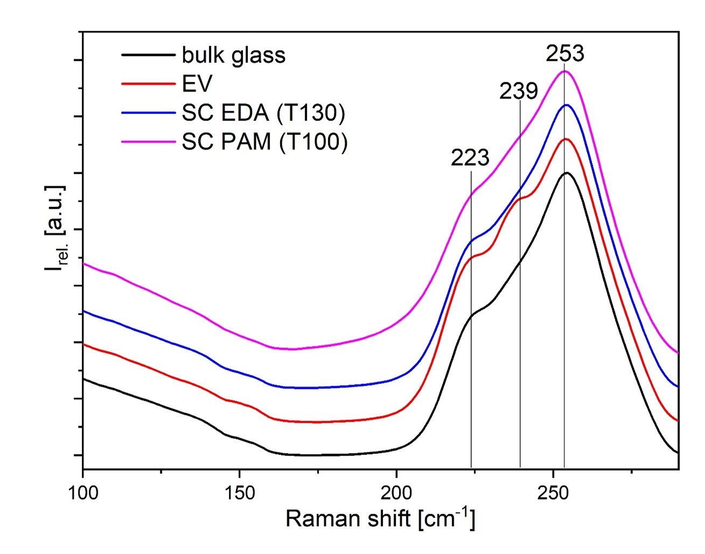
Figure 3.1: Raman spectra of As₂₀Se₈₀ for bulk sample, thermally evaporated (TE) TF, and spin-coated (SC) TFs (prepared from EDA and PAM).
The composition of the As₂₀Se₈₀ bulk glass, prepared TFs, fibers for PAMFT, and samples after PAMFT measurements was analyzed by EDX. The results of the analysis are listed in Table 1. TE TFs have a slightly higher As content than SC TFs, which possess a composition closer to bulk material. On the other hand, the SC TFs contain a small amount of organic residuals represented by carbon and nitrogen EDX signals. The presence of the nitrogen-containing organic residues is in good agreement with previous observations on solution-processed As-Se TFs from both monoamine methanol mixture ⁷⁰ and diamine solutions ^{27,70}
These nitrogen containing residues are probably formed during the dissolution process of bulk material in used amine and can influence the thermo-mechanical properties of TFs. The approx. doubled nitrogen content in the thin films deposited from the EDA solution compared to the TFs from the PAM solution is connected with the different nitrogen content in the PA (monoamine) and EDA (diamine) molecules. Regarding this, we concluded that the molecular content of organic residues from the solution of the prepared TFs is practically identical, regardless of the solvent used.
Table 3.1: The EDX relative chemical composition of bulk, PAMFT wires before and after measurements, TE films, SC PAM, and SC EDA thin films.
Atomic concentration [%]
 | As | Se | N
Bulk | 19.8 ± 0.4 | 80.2 ± 0.4 | -
PAMFT before | 19.6 ± 0.1 | 80.4 ± 0.1 | -
PAMFT after | 18.6 ± 0.1 | 81.4 ± 0.1 | -
TE TF | 23.1 ± 0.3 | 76.9 ± 0.3 | -
PAM SC TF | 21.1 ± 0.1 | 77.5 ± 0.2 | 1.4 ± 0.2
EDA SC TF | 19.8 ± 0.3 | 77.4 ± 0.2 | 2.9 ± 0.2

3.2. Viscosity measurements
The viscosities of As₂₀Se₈₀ samples were determined using two distinct techniques: nanoindentation (NI) in the glass and undercooled regions; and pressure-assisted melt filling technique (PAMFT) in the melt region. The measurements were conducted within a temperature range from 70 to 595 °C.
NI was used to measure the near-surface viscosity in thin films and bulk samples. A typical NI viscosity measurement is shown in Fig. 2. Small penetration depths are achieved by applying a minimal load to the tip. This is advantageous for TFs measurements. Small penetration depths (usually lower than 15 % of TF thickness) avoid the influence of the substrate on the resulting viscosity value. The viscosities can be calculated as follows ^{71,72} :
$$η=P/\left(4∙∂h^{2}/∂t∙tan⁡ψ\right)$$
A constant load P, within the range of 5–8000 μN was rapidly applied to the Berkovich tip (tip angle 2ψ = 142.5 °) for a specified time t, and the resulting penetration depth h, was subsequently measured.
The measured near-surface viscosities are plotted in Fig. 3 and listed in Table S1 in the Supplemental material. Comparison of the near-surface viscosities with the viscosity data measured in bulk samples using conventional thermoanalytical methods ^{73,74} shows an interesting phenomenon. The near-surface viscosities measured in bulks correspond well to the previously published data in bulks, providing an activation energy of the viscous flow of 220 ± 5 kJ·mol⁻¹ comparable to that of 241 ± 4 kJ·mol⁻¹ published by Honcova ⁷³. Nevertheless, the viscosity data obtained in TE TFs deviate significantly from the bulks, providing a lower activation energy of viscous flow, 171 ± 3 kJ·mol⁻¹. Such behavior was unexpected due to the previous data on As₂₀Se₈₀ TE TFs viscosities published by Molnar. Molnar’s data corresponded well to the bulk viscosities (Fig. 3), but viscosities of TE TFs were evaluated from the flattening of a single-period surface grating. However, Molnar used a 6 mW violet laser (408 nm) for the measurements. We believe that the laser exposure can potentially significantly impact the flattening process and thus significantly determine viscosity values. This phenomenon will be discussed later in the part dedicated to the study of decay constants of flattening of surface patterns in As₂₀Se₈₀ samples.
Unfortunately, due to the small thickness of the SC TFs, it was not possible to use NI to obtain viscosity data. Even very low forces resulted in penetration exceeding more than 40 % of the TF thickness. Using lower forces (penetration less than 40 %), the measurements were affected by the surface tension of the films.
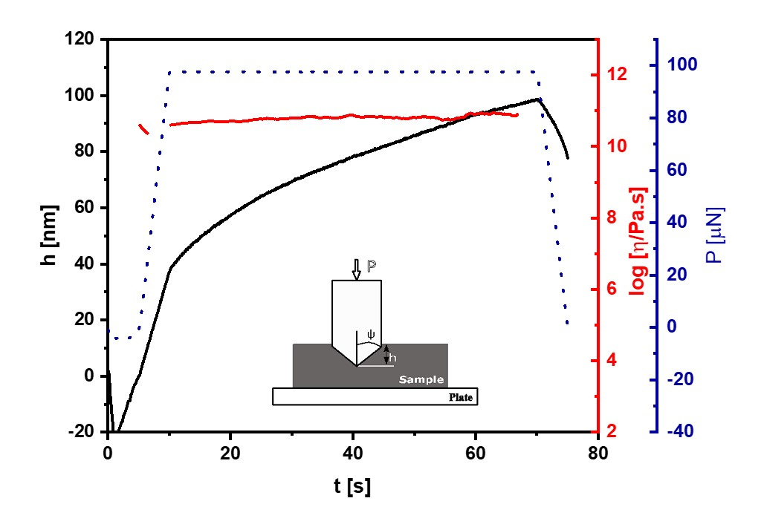
Figure 3.2: Representative experimental data for the evaluation of viscosity using NI measurements in bulk samples (data corresponds to bulk at 100 °C).
The viscosity in the melt was also measured in the 10^{-1.29}-10^{2.26} Pa∙s region using PAMFT to obtain more complex results. During the measurements, the filling length, L was recorded as a function of time, t at several different temperatures. The choice of capillary diameter 2R and applied pressure p was guided by the predicted viscosity, and the need to minimize the influence of wetting properties between the melt and the capillary ⁶². Subsequently, the viscosity was calculated from the linear correlation between L² and t^{62,63}:
$$L^{2}=\left(\left(p∙R^{2}\right)/\left(4∙η\right)\right)t$$
The viscosity values obtained from PAMFT measurements are listed in Table S1 in the Supplemental material. These data were compared with previously published viscosity data for an undercooled melt of As₂₀Se₈₀ bulks collected by Honcova ⁷³ and Musgraves ⁷⁴, as illustrated in Fig. 3. It is important to mention that Musgraves measured the viscosity data under non-isothermal conditions providing higher experimental errors in comparison to equilibrium data obtained under isothermal conditions provided by Honcova.
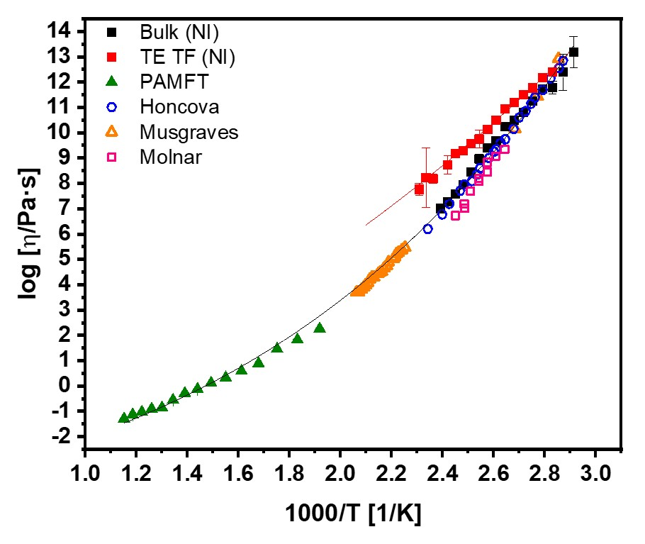
Figure 3.3: Temperature dependence of viscosities in bulk samples and TE TFs in As₂₀Se₈₀ using two techniques: nanoindentation (NI) and pressure-assisted melt filling technique (PAMFT). A comparison of the values obtained with those reported in the literature is also presented, including those from Honcova ⁷³, Musgraves ⁷⁴, and Molnar ⁵⁶.
Honcova ⁷³ showed in our previous work that As₂₀Se₈₀ belongs to the relatively strong chalcogenide glass-formers with fragility index m = 35.1 ± 0.3. In such cases, Koštál ⁵² proposed that the MYEGA (Mauro-Yue-Ellison-Gupta-Allan) equation fits better the viscosity data. Therefore, the MYEGA equation was used to describe viscosity data in As₂₀Se₈₀:
$$log⁡η=log⁡η_{0}+\left(12-log⁡η_{0}\right)·T_{12}/T·exp⁡\left[\left(m/\left(12-logη_{0}\right)-1\right)·\left(T_{12}/T-1\right)\right]$$
where η₀ is the viscosity at infinite temperature, m is the fragility index, and T₁₂ is the temperature at which the viscosity reaches the value of 10¹² Pa·s. The parameters of the MYEGA equation were found to be log(η₀/Pa·s) = -4.41 ± 0.2; T₁₂ = 82.3 ± 0.5 °C and m = 39.3 ± 0.7. The MYEGA fit covers data for near-surface viscosity in bulks, in melts, and undercooled melt and glass in bulks reported by Honcova ⁷³ [75].
Because of the difference between the viscosity values obtained from the TE TFs and bulk samples, the TE TFs viscosity values from NI were fitted by the MYEGA equation (3) separately. The parameters of the MYEGA equation were determined to be log(η₀/Pa·s) = -4.41 ± 0.00; T₁₂ = 87.3 ± 0.5 °C and m = 26.0 ± 0.6. The log(η₀/Pa·s) parameter value is a fixed value from the bulk sample fit. This is based on the assumption that at infinite temperature the viscosity data will tend to the same value.

3.3. Flattening of single-period surface gratings
Measuring the rate of surface patterns’ flattening process is a promising method for studying surface mobility in amorphous materials. The following part focuses on measurements of the flattening process of sinusoidal single-period gratings embossed into the surface of As₂₀Se₈₀ samples. The samples were prepared in different forms – bulk samples with polished surfaces, TE TFs, and TFs prepared by solution processing (denoted as spin-coated samples or SC samples). Hot embossing was used to “print” the sinusoidal grating into the surfaces of the prepared samples. The flattening process, or surface grating decay (SGD), was then studied ex-situ using atomic force microscopy (AFM) in bulks and TFs, and in-situ measuring the intensity of the transmitted light through the grating in TFs.
Different single-period gratings (𝜆 = 790, 803, and 1450 nm) were embossed into the surface of TE TFs and bulks. The decay constant of the flattening process was measured in the 90-125 °C temperature range. The measurements were performed ex-situ. A sample was annealed in a laboratory furnace at a selected temperature for a specific time. Afterwards, the sample was cooled down to the laboratory temperature and scanned by AFM. Then, the sample was returned to the furnace for further annealing. Fig. 4 A) illustrates the SGD over time, with the insert displaying AFM scans of the sample`s surface. The exponential evolution of the measured height h at time t can be described by the following equation ⁵⁸:
$$h/h_{0}=exp\left[-{\left(Kt\right)}^{β}\right]$$
In this context, h₀ represents the initial grating amplitude, K denotes the decay constant, and β signifies the stretch parameter, which is close to 1.
The AFM experiments were very tedious and time-consuming and did not allow to follow the flattening process at higher temperatures due to the high rate of the smoothing process. Therefore, transmissive optical measurements were applied. The experiments were performed on As₂₀Se₈₀ TFs with an embossed grating within a temperature range of 70 – 180 °C. The measurements were performed in-situ, when the sample was annealed in a laboratory furnace, and the intensity of the transmitted light through the sample was measured during the annealing. The progression of the experiment is illustrated in Fig. 4 B). The intensity of the diffracted light (I_{diff}) on the surface of the grid is proportional to the square of the grid height (h²) ^{75,76}. As the intensity (I) of transmitted light was measured and can be expressed as I = I∞ - I_{diff}, where the I∞ corresponds to the intensity of the transmitted light through a flat TF. The relative intensity of the transmitted light in the zero-order diffraction grid can be expressed as follows:
$$I/I_{∞}=1-exp\left[-2{\left(K·t\right)}^{β}\right]$$
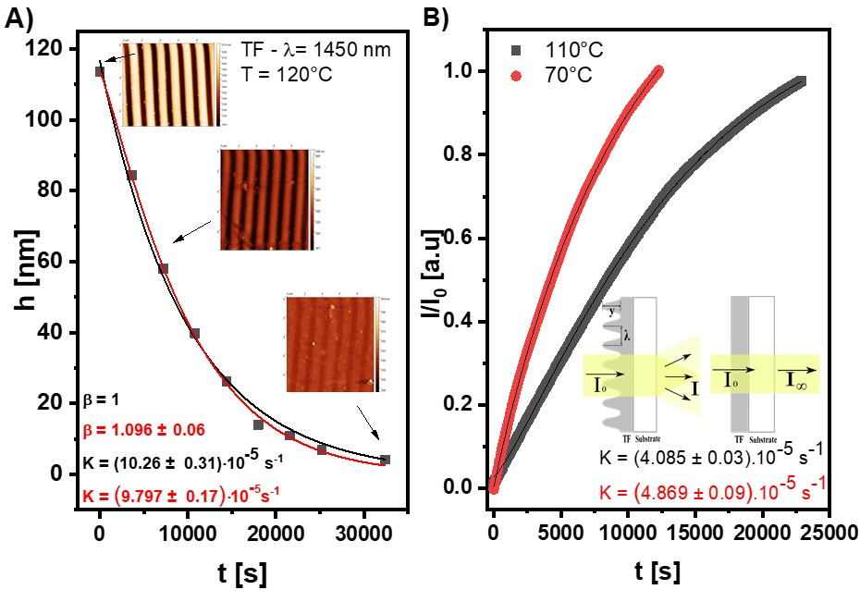
Figure 3.4: A) depicts the typical kinetics of SGD (λ = 1450 nm, T = 120 °C), obtained using AFM. The insets illustrate an AFM scans at three distinctive decay times. B) represents an example of transmission measurements for two distinct temperatures, 70 °C (PAM, λ = 790 nm) and 110 °C (TE, λ = 803nm). The inset depicts the experimental setup utilized for these measurements.
The obtained decay constant values of the flattening processes in thin films and bulk samples are listed in Table S2 in the Supplemental material. Fig. 5 A) shows the temperature dependence of the rate constants of the SGD for all the studied samples and all grating periods used. Such comparison is not illustrative enough because the decay constant depends on both, the grating period and temperature. To eliminate the grating period impact, we plot the data as a “K·𝜆” dependence on temperature (Fig. 5 B)). Such scaling provides a better understanding of the similarities and differences in the SGD for the studied samples. The results show that the SGD runs with comparable rate constants in bulk samples and TE TFs. On the other hand, SC TFs provided a few orders higher rate constants of the SGD process. The Raman analysis showed that the structure of SC TFs is close to the structure of bulk samples. Nevertheless, in SC TFs, there is a slight increase of As-As and Se-Se homopolar bonds originating from the solution processing ³¹. Also, the EDX analysis showed that some part of the solvent remained in the structure of SC TFs. Zou ³¹ showed in the As₂Se₃-EDA solution processed thin films that the EDA remains in the structure of the SC TFs even after annealing at high temperature (170 °C) under vacuum. Based on Guiton`s work ⁷⁷, Zou assumed that during the dissolution, As₂Se₃-EDA chelated molecules are created and interconnected by chalcogen-chalcogen homopolar bonds. The creation of such patterns may also be the reason for the increase in surface mobility of the studied As₂₀Se₈₀ SC TFs.
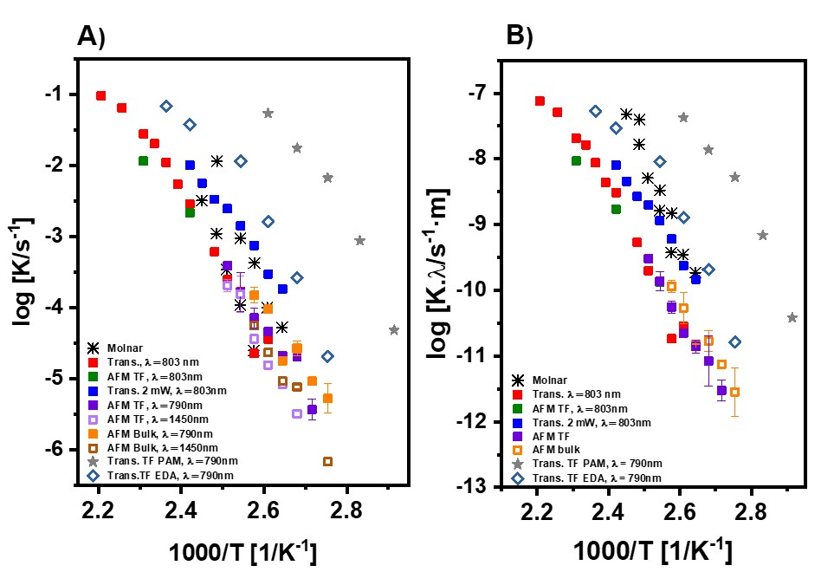
Figure 3.5: A) Temperature dependence of decay constant in As₂₀Se₈₀ samples. B) Scaling of the decay constants with respect to the surface grating period. The data are compared with the work of Molnar ⁵⁶ (see the text for more information).
Flattening of single-period gratings in As₂₀Se₈₀ thermally evaporated TFs was also studied by Molnar ⁵⁶, and his data are incorporated in Fig. 4. Molnar used grating periods of 3.5 and 15 mm. As was mentioned earlier, Molnar used the grating decay experiments to obtain viscosity data in As₂₀Se₈₀ thin films. Molnar found the viscosities in TFs to be similar to those obtained in bulks, which is inconsistent with our NI measurements. We believe that the experimental settings can explain the reason for this discrepancy. Molnar used a violet laser (408 nm) with a power of 6 mW. It is evident from Fig. 5 B) that the flattening rate observed by Molnar is much higher than the rate observed in the present measurements. Therefore, our in-situ SGD experimental setting was extended by a violet laser (used powers were 2 mW and 23 mW) to explore the light influence on the obtained decay constants values. The decay constant was measured with laser power 23 mW to prove the high influence of the laser illumination on the flattening process (see Fig. 6 ). It is evident (Fig. 5 B) and Fig. 6) that the power of used light impacts the flattening process, which is also the reason why Molnar estimated the TFs viscosities to be lower than those measured within this work using NI.
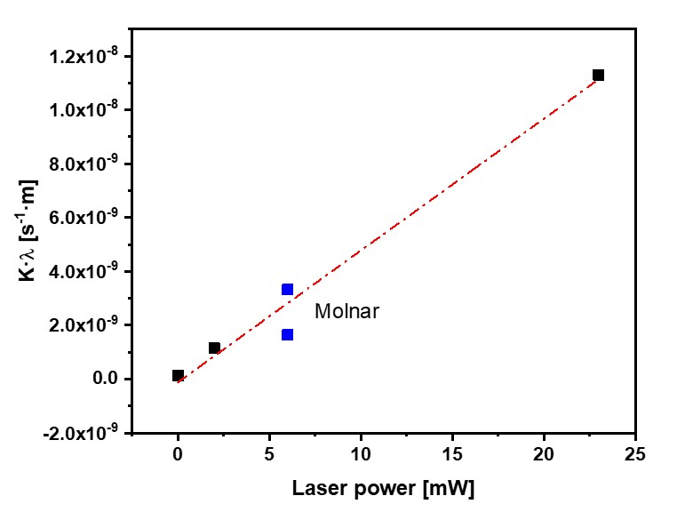
Figure 3.6: Effect of laser power on the SGD process at 120 °C. The lasers used were 0 mW (only Tungsten halogen light), 2 mW, and 23 mW (405 nm). The values obtained were compared with Molnar (6 mW, 480 nm) values ⁵⁶. The values of the rate constant are converted to “K·λ” to eliminate the effect of the grating period.

4. Conclusions
This study provided a comprehensive analysis of the viscosity in amorphous chalcogenide material As₂₀Se₈₀ using nanoindentation and pressure assisted melt filling technique. The experimental results showed that the near-surface viscosity obtained in bulk samples agrees with previously published values, while it was confirmed that the viscosity of thermally evaporated thin films (TFs) is fundamentally different. This finding contradicts the commonly accepted idea that the viscosities of thin films and bulk samples are equivalent, which has significant consequences for interpreting these materials’ mechanical and diffusion properties.
Furthermore, surface mobility in amorphous As₂₀Se₈₀ bulks, thermally evaporated TFs, and, for the first time, solution-processed TFs was explored by surface grating decay (SGD) measurements. The results demonstrated that thermally evaporated TFs exhibited similar flattening trends to bulk samples with similar rate constants of the SGD process. It was also found that laser absorption significantly influenced the smoothing process
Significant differences in SGD rate constants were identified in TFs prepared by the spin-coating method (SC TFs). The SC TFs exhibited faster decay in SGD experiments, indicating higher surface mobility than bulk samples and TE TFs. This phenomenon may be caused by the presence of homopolar As-As and Se-Se bonds, as well as residual organic solvents in the structure of the TFs, which alter the physicochemical properties of the material. To the authors’ knowledge, mobility measurements in SC TFs have not been measured before, thus providing a new insight into solution processed thin films.
The experimental findings presented in this study contribute to a deeper understanding of near-surface molecular transport mechanisms in amorphous chalcogenides which may provide significant insights for designing and optimization of these materials for optical and electronic applications.

Conflicts of Interest
There are no conflicts to declare.

Acknowledgements
This work has been supported by the Czech Science Foundation under grant no. 24-10480S; the Ministry of Education, Youth and Sports of the Czech Republic under grant no. LM2023037; by the Internal Grant Agency of the University of Pardubice under Selected Research Teams program of the University of Pardubice and under SGS project. This work was partially supported by International Cooperative Graduate Program (ICGP) in National Institute for Materials Science.

References
1 L. Tichy, H. Ticha, P. Nagels and R. Callaerts, Photoinduced changes in the short wavelength optical absorption edge of a-As2S3 and a-As2Se3 thin amorphous films, Materials Letters, 1998, 36, 294–298.
2 K. Tanaka and K. Shimakawa, Amorphous Chalcogenide Semiconductors and Related Materials, Springer International Publishing, Cham, 2021.
3 J.-L. Adam and X. Zhang, Chalcogenide Glasses: Preparation, Properties and Applications, Woodhead Publishing, 2014.
4 T. Zhou, Z. Zhu, X. Liu, Z. Liang and X. Wang, A Review of the Precision Glass Molding of Chalcogenide Glass (ChG) for Infrared Optics, Micromachines, 2018, 9, 337.
5 E. Guillevic, X. Zhang, T. Pain, L. Calvez, J.-L. Adam, J. Lucas, M. Guilloux-Viry, S. Ollivier and G. Gadret, Optimization of chalcogenide glass in the As–Se–S system for automotive applications, Optical Materials, 2009, 31, 1688–1692.
6 A. Zakery and S. R. Elliott, Optical properties and applications of chalcogenide glasses: a review, Journal of Non-Crystalline Solids, 2003, 330, 1–12.
7 N. Ostrovsky, D. Yehuda, S. Tzadka, E. Kassis, S. Joseph and M. Schvartzman, Direct Imprint of Optical Functionalities on Free-Form Chalcogenide Glasses, Advanced Optical Materials, 2019, 7, 1900652.
8 P. Sachan, R. Singh, P. K. Dwivedi and A. Sharma, Infrared microlenses and gratings of chalcogenide: confined self-organization in solution processed thin liquid films, RSC Adv., 2018, 8, 27946–27955.
9 N. Granzow, M. A. Schmidt, W. Chang, L. Wang, Q. Coulombier, J. Troles, P. Toupin, I. Hartl, K. F. Lee, M. E. Fermann, L. Wondraczek and P. S. J. Russell, Mid-infrared supercontinuum generation in As2S3-silica “nano-spike” step-index waveguide, Opt. Express, OE, 2013, 21, 10969–10977.
10 C. R. Petersen, U. Møller, I. Kubat, B. Zhou, S. Dupont, J. Ramsay, T. Benson, S. Sujecki, N. Abdel-Moneim, Z. Tang, D. Furniss, A. Seddon and O. Bang, Mid-infrared supercontinuum covering the 1.4–13.3 μm molecular fingerprint region using ultra-high NA chalcogenide step-index fibre, Nature Photon, 2014, 8, 830–834.
11 J. M. P. Almeida, E. C. Barbano, C. B. Arnold, L. Misoguti and C. R. Mendonça, Nonlinear optical waveguides in As2S3-Ag2S chalcogenide glass thin films, Opt. Mater. Express, OME, 2017, 7, 93–99.
12 H. Jain, A. Kovalskiy and M. Vlcek, in Chalcogenide Glasses, eds. J.-L. Adam and X. Zhang, Woodhead Publishing, 2014, pp. 562–596.
13 P. Jean, A. Douaud, S. LaRochelle, Y. Messaddeq and W. Shi, Silicon subwavelength grating waveguides with high-index chalcogenide glass cladding, Opt. Express, OE, 2021, 29, 20851–20862.
14 P. Lucas, G. J. Coleman, S. Jiang, T. Luo and Z. Yang, Chalcogenide glass fibers: Optical window tailoring and suitability for bio-chemical sensing, Optical Materials, 2015, 47, 530–536.
15 T. K. Todorov, S. Singh, D. M. Bishop, O. Gunawan, Y. S. Lee, T. S. Gershon, K. W. Brew, P. D. Antunez and R. Haight, Ultrathin high band gap solar cells with improved efficiencies from the world’s oldest photovoltaic material, Nat Commun, 2017, 8, 682.
16 T. Baines, G. Zoppi, L. Bowen, T. P. Shalvey, S. Mariotti, K. Durose and J. D. Major, Incorporation of CdSe layers into CdTe thin film solar cells, Solar Energy Materials and Solar Cells, 2018, 180, 196–204.
17 L. Guo, C. Grice, B. Zhang, S. Xing, L. Li, X. Qian and F. Yan, Improved stability and efficiency of CdSe/Sb2Se3 thin-film solar cells, Solar Energy, 2019, 188, 586–592.
18 H. Shiel, O. S. Hutter, L. J. Phillips, J. E. N. Swallow, L. A. H. Jones, T. J. Featherstone, M. J. Smiles, P. K. Thakur, T.-L. Lee, V. R. Dhanak, J. D. Major and T. D. Veal, Natural Band Alignments and Band Offsets of Sb2Se3 Solar Cells, ACS Appl. Energy Mater., 2020, 3, 11617–11626.
19 R. Singh, P. Kumari, M. Kumar, T. Ichikawa and A. Jain, Implementation of Bismuth Chalcogenides as an Efficient Anode: A Journey from Conventional Liquid Electrolyte to an All-Solid-State Li-Ion Battery, Molecules, 2020, 25, 3733.
20 C.-B. Chang and H.-Y. Tuan, Recent Progress on Sb- and Bi-based Chalcogenide Anodes for Potassium-Ion Batteries, Chemistry – An Asian Journal, 2022, 17, e202200170.
21 M. A. Schmidt, D. Y. Lei, L. Wondraczek, V. Nazabal and S. A. Maier, Hybrid nanoparticle–microcavity-based plasmonic nanosensors with improved detection resolution and extended remote-sensing ability, Nat Commun, 2012, 3, 1108.
22 B. Gholipour, The promise of phase-change materials, Science, 2019, 366, 186–187.
23 L. Calvez, Chalcogenide glasses and glass-ceramics: Transparent materials in the infrared for dual applications, Comptes Rendus Physique, 2017, 18, 314–322.
24 C. Lin, C. Rüssel and S. Dai, Chalcogenide glass-ceramics: Functional design and crystallization mechanism, Progress in Materials Science, 2018, 93, 1–44.
25 M. Salinga, B. Kersting, I. Ronneberger, V. P. Jonnalagadda, X. T. Vu, M. Le Gallo, I. Giannopoulos, O. Cojocaru-Mirédin, R. Mazzarello and A. Sebastian, Monatomic phase change memory, Nature Mater, 2018, 17, 681–685.
26 W. Zhang, R. Mazzarello, M. Wuttig and E. Ma, Designing crystallization in phase-change materials for universal memory and neuro-inspired computing, Nat Rev Mater, 2019, 4, 150–168.
27 J. M. González-Leal, M. Stuchlik, M. Vlcek, R. Jiménez-Garay and E. Márquez, Influence of the deposition technique on the structural and optical properties of amorphous AsS films, Applied Surface Science, 2005, 246, 348–355.
28 K. E. Youden, T. Grevatt, R. W. Eason, H. N. Rutt, R. S. Deol and G. Wylangowski, Pulsed laser deposition of Ga‐La‐S chalcogenide glass thin film optical waveguides, Applied Physics Letters, 1993, 63, 1601–1603.
29 G. Bulai, O. Pompilian, S. Gurlui, P. Nemec, V. Nazabal, N. Cimpoesu, B. Chazallon and C. Focsa, Ge-Sb-Te Chalcogenide Thin Films Deposited by Nanosecond, Picosecond, and Femtosecond Laser Ablation, Nanomaterials, 2019, 9, 676.
30 S. Song, J. Dua and C. B. Arnold, Influence of annealing conditions on the optical and structural properties of spin-coated As2S3 chalcogenide glass thin films, Opt. Express, OE, 2010, 18, 5472–5480.
31 Y. Zou, H. Lin, O. Ogbuu, L. Li, S. Danto, S. Novak, J. Novak, J. D. Musgraves, K. Richardson and J. Hu, Effect of annealing conditions on the physio-chemical properties of spin-coated As2Se3 chalcogenide glass films, Opt. Mater. Express, OME, 2012, 2, 1723–1732.
32 K. Palka, T. Syrovy, S. Schröter, S. Brückner, M. Rothhardt and M. Vlcek, Preparation of arsenic sulfide thin films for integrated optical elements by spiral bar coating, Opt. Mater. Express, OME, 2014, 4, 384–395.
33 S. Novak, D. E. Johnston, C. Li, W. Deng and K. Richardson, Deposition of Ge23Sb7S70 chalcogenide glass films by electrospray, Thin Solid Films, 2015, 588, 56–60.
34 S. Novak, P. T. Lin, C. Li, C. Lumdee, J. Hu, A. Agarwal, P. G. Kik, W. Deng and K. Richardson, Direct Electrospray Printing of Gradient Refractive Index Chalcogenide Glass Films, ACS Appl. Mater. Interfaces, 2017, 9, 26990–26995.
35 E. A. Sanchez, M. Waldmann and C. B. Arnold, Chalcogenide glass microlenses by inkjet printing, Appl. Opt., AO, 2011, 50, 1974–1978.
36 B. S. Yadav, S. R. Dey and S. R. Dhage, Inkjet printed CuIn(1-X)GaXSe2 thin film by controlled selenium distribution for improved power conversion efficiency in chalcopyrite solar cells, Applied Surface Science Advances, 2021, 6, 100144.
37 J. Jancalek, K. Palka, M. Kurka, S. Slang and M. Vlcek, Comparison of solution processed As33S67 thin films deposited using primary amines of various aliphatic chain length, Journal of Non-Crystalline Solids, 2020, 550, 120382.
38 S. Slang, K. Palka, J. Jancalek, M. Kurka and M. Vlcek, Deposition and characterization of solution processed Se-rich Ge-Se thin films with specular optical quality using multi-component solvent approach, Opt. Mater. Express, OME, 2020, 10, 2973–2986.
39 C. L. McCarthy and R. L. Brutchey, Solution processing of chalcogenide materials using thiol–amine “alkahest” solvent systems, Chemical Communications, 2017, 53, 4888–4902.
40 C. Li, S. Novak, S. A. Denisov, N. D. McClenaghan, N. Patel, A. Agarwal, K. Richardson and W. Deng, Electrospray deposition of quantum dot-doped Ge23Sb7S70 chalcogenide glass films, Thin Solid Films, 2017, 626, 194–199.
41 C. Lu, J. M. P. Almeida, N. Yao and C. Arnold, Fabrication of uniformly dispersed nanoparticle-doped chalcogenide glass, Applied Physics Letters, 2014, 105, 261906.
42 L. Strizik, T. Wagner, V. Weissova, J. Oswald, K. Palka, L. Benes, M. Krbal, R. Jambor, C. Koughia and S. O. Kasap, Solution-processed Er 3+ -doped As 3 S 7 chalcogenide films: optical properties and 1.5 μm photoluminescence activated by thermal treatment, Journal of Materials Chemistry C, 2017, 5, 8489–8497.
43 K. Palka, S. Slang, J. Jancalek and M. Vlcek, Modification of solution processed thin chalcogenide films composition by source solution doping, Journal of Non-Crystalline Solids, 2019, 517, 76–82.
44 H. Khan, P. K. Dwivedi, M. Husain and M. Zulfequar, Enhanced electrical conductivity in solution processed carbon nanotubes incorporated As2S3 glass films, J Mater Sci: Mater Electron, 2018, 29, 12993–13004.
45 S. Yakunin, D. N. Dirin, L. Protesescu, M. Sytnyk, S. Tollabimazraehno, M. Humer, F. Hackl, T. Fromherz, M. I. Bodnarchuk, M. V. Kovalenko and W. Heiss, High Infrared Photoconductivity in Films of Arsenic-Sulfide-Encapsulated Lead-Sulfide Nanocrystals, ACS Nano, 2014, 8, 12883–12894.
46 S. Novak, L. Scarpantonio, J. Novak, M. Dai Prè, A. Martucci, J. D. Musgraves, N. McClenaghan and K. Richardson, Incorporation of luminescent CdSe/ZnS core-shell quantum dots and PbS quantum dots into solution-derived chalcogenide glass films, Optical Materials Express, 2013, 3, 739–746.
47 G. C. Chern, I. Lauks and A. R. McGhie, Spin coated amorphous chalcogenide films: Thermal properties, Journal of Applied Physics, 1983, 54, 4596–4601.
48 L. Yu, Surface mobility of molecular glasses and its importance in physical stability, Advanced Drug Delivery Reviews, 2016, 100, 3–9.
49 S. Martinková, M. Včeláková, D. Vaculík, P. Pilný, M. Kurka and J. Barták, Near-surface viscosity and complex crystal growth behavior in Se90Te10 thin films and bulk surface, Materials Chemistry and Physics, 2024, 316, 129018.
50 I. S. Gutzow and J. W. P. Schmelzer, in The Vitreous State: Thermodynamics, Structure, Rheology, and Crystallization, eds. I. S. Gutzow and J. W. P. Schmelzer, Springer, Berlin, Heidelberg, 2013, pp. 417–424.
51 J. W. P. Schmelzer, A. S. Abyzov, V. M. Fokin, C. Schick and E. D. Zanotto, Crystallization in glass-forming liquids: Effects of decoupling of diffusion and viscosity on crystal growth, Journal of Non-Crystalline Solids, 2015, 429, 45–53.
52 P. Koštál, J. Shánělová and J. Málek, Viscosity of chalcogenide glass-formers, International Materials Reviews, 2020, 65, 63–101.
53 S. Martinková, D. Valdés, S. Slang, K. Pálka and J. Barták, Relationship between crystal growth and surface/volume mobilities in Se95Te5 bulk glasses and thin films, Acta Materialia, 2021, 213, 116953.
54 J. Barták, J. Málek, K. Bagchi, M. D. Ediger, Y. Li and L. Yu, Surface mobility in amorphous selenium and comparison with organic molecular glasses, The Journal of Chemical Physics, 2021, 154, 074703.
55 R. B. Stephens, The viscosity and structural relaxation rate of evaporated amorphous selenium, Journal of Applied Physics, 1978, 49, 5855–5864.
56 S. Molnar, R. Bohdan, V. Takats, Y. Kaganovskii and S. Kokenyesi, Viscosity of As20Se20 amorphous chalcogenide films, Materials Letters, 2018, 228, 384–386.
57 J. Barták, D. Vaculík, M. Vceláková, S. Martinková, T. Wieduwilt, M. A. Schmidt, M. Kurka, S. Slang, K. Palka, P. Koštál, P. Belina, P. Honcová and J. Málek, Beyond the Surface: Interconnection of Viscosity, Crystal Growth, and Diffusion in Ge25Se75 Glass-Former, J. Phys. Chem. B, DOI:10.1021/acs.jpcb.4c04268.
58 W. W. Mullins, Flattening of a Nearly Plane Solid Surface due to Capillarity, Journal of Applied Physics, 1959, 30, 77–83.
59 Z. Wang and J. H. Perepezko, Surface diffusion on a palladium-based metallic glass, Applied Physics Letters, 2024, 124, 091601.
60 G. Kumar and J. Schroers, Write and erase mechanisms for bulk metallic glass, Applied Physics Letters, 2008, 92, 031901.
61 C. E. Packard, J. Schroers and C. A. Schuh, In situ measurements of surface tension-driven shape recovery in a metallic glass, Scripta Materialia, 2009, 60, 1145–1148.
62 J. Barták, P. Koštál, D. Valdés, J. Málek, T. Wieduwilt, J. Kobelke and M. A. Schmidt, Analysis of viscosity data in As2Se3, Se and Se95Te5 chalcogenide melts using the pressure assisted melt filling technique, Journal of Non-Crystalline Solids, 2019, 511, 100–108.
63 P. Koštál, J. Barták, T. Wieduwilt, M. A. Schmidt and J. Málek, Viscosity and fragility of selected glass-forming chalcogenides, Journal of Non-Crystalline Solids, 2022, 575, 121205.
64 S. Slang, M. Kurka, J. Jancalek, J. Rodriguez-Pereira, M. Chylii, J. Houdek, J. Jemelka, R. Svoboda, J. Bartak, M. Vlcek and K. Palka, Surface analysis, oxidation resistance, and embossing of Ge-based solution-processed thin films as materials for high refractive index optical elements, Applied Surface Science, 2024, 672, 160744.
65 Y. Kaganovskii, D. L. Beke, V. Freilikher, S. Kökényesi and A. M. Korsunsky, Photo induced self-diffusion and viscosity in amorphous chalcogenide films, Mater. Res. Express, 2020, 7, 016204.
66 O. Kondrat, R. Holomb, V. Mitsa, M. Veres and N. Tsud, Structural investigation of As-Se chalcogenide thin films with different compositions: Formation, characterization and peculiarities of volume and near-surface nanolayers, Functional materials, 2017, 24, 547–554.
67 S. N. Yannopoulos and K. S. Andrikopoulos, Raman scattering study on structural and dynamical features of noncrystalline selenium, The Journal of Chemical Physics, 2004, 121, 4747–4758.
68 R. I. Alekberov, S. I. Mekhtiyeva, G. A. Isayeva and A. I. Isayev, Raman scattering in As-Se-S and As-Se-Te Chalcogenide vitreous semiconductors, Semiconductors, 2014, 48, 800–803.
69 V. Kovanda, Mir. Vlček and H. Jain, Structure of As–Se and As–P–Se glasses studied by Raman spectroscopy, Journal of Non-Crystalline Solids, 2003, 326-327, 88–92.
70 S. Slang, K. Palka, P. Janicek, M. Grinco and M. Vlcek, Solution processed As30Se70 chalcogenide glass thin films with specular optical quality: multi-component solvent approach, Opt. Mater. Express, OME, 2018, 8, 948–959.
71 F. Yang and J. C. M. Li, Viscosity of selenium measured by impression test, Journal of Non-Crystalline Solids, 1997, 212, 136–142.
72 F. Yang and J. C. M. Li, Newtonian viscosity measured by impression test, Journal of Non-Crystalline Solids, 1997, 212, 126–135.
73 P. Honcová, P. Koštál, M. Včeláková, R. Svoboda, G. Sádovská, J. Barták and J. Málek, Structural interpretation of the viscous flow and relaxation kinetics in the As-Se and Ge-Se chalcogenide systems, Journal of Non-Crystalline Solids, 2024, 643, 123188.
74 J. D. Musgraves, P. Wachtel, S. Novak, J. Wilkinson and K. Richardson, Composition dependence of the viscosity and other physical properties in the arsenic selenide glass system, Journal of Applied Physics, 2011, 110, 063503.
75 C. Huang, S. Ruan, T. Cai and L. Yu, Fast Surface Diffusion and Crystallization of Amorphous Griseofulvin, J. Phys. Chem. B, 2017, 121, 9463–9468.
76 W. Zhang and L. Yu, Surface Diffusion of Polymer Glasses, Macromolecules, 2016, 49, 731–735.
77 T. A. Guiton and C. G. Pantano, Solution/gelation of arsenic trisulfide in amine solvents, Chem. Mater., 1989, 1, 558–563.

