To be submitted to Macromolecular Rapid Communications.

Reversible Solubility Switching of a Polymer Triggered by Visible-Light Responsive Azobenzene Photochromism with Negligible Thermal Relaxation

Takeshi Ueki^{a)b)†}*, Yuna Osaka^{c)†}, Kenta Homma^{a)‡}, Shota Yamamoto^{a)}, Aya Saruwatari^{a)b)}, Hongxin Wang^{a)}, Masao Kamimura^{c)}, and Jun Nakanishi^{a)c)d)}*

- Research Center for Macromolecules and Biomaterials, National Institute of Materials and Science, 1-1 Namiki, Tsukuba, Ibaraki 305-0044 Japan
- Graduate School of Life Science, Hokkaido University, Kita 10, Nishi 8, Kita-ku, Sapporo, Hokkaido 060-0810 Japan
- Graduate School of Advanced Engineering, Tokyo University of Science, 6-3-1 Niijuku, Katsushika-ku, Tokyo 125-8585 Japan
- Graduate School of Advanced Science and Engineering, Waseda University, 3-4-1 Okubo, Shinjuku-ku, Tokyo 169-8555 Japan

†These authors equally contributed to this work.
‡Present address: Department of Applied Chemistry, Graduate School of Engineering, Osaka University, 2-1 Yamadaoka, Suita, Osaka, 565-0871 Japan, and Center for Future Innovation (CFi), Graduate School of Engineering, Osaka University, 2-1 Yamadaoka, Suita, Osaka, 565-0871 Japan

To whom correspondence should be addressed: UEKI.Takeshi@nims.go.jp (T.U.) and NAKANISHI.Jun@nims.go.jp (J.N.)
Abstract
Here, we report the reversible solubility switching of a polymer triggered by non-phototoxic visible light illumination. A photochromic polymerizable azobenzene monomer modified with four methoxy groups at the ortho-position (mAzoA) exhibiting reversible photoisomerization from trans- to cis-state with a green light (546 nm) and from cis- to trans-state with a blue light (436 nm) was successfully prepared. The free radical copolymerization of hydrophilic dimethylacrylamide (DMAAm) with mAzoA yielded a light-responsive random copolymer (P(mAzoA-r-DMAAm)), showing a reversible photochromic reaction in response to visible light illumination with the two different wavelengths. By optimizing the mAzoA contents, we found that the P(mAzoA_{10.7}-r-DMAAm)_{3.0kDa} ([mAzoA] = 10.7 mol%, M_{n} = 3.0 kDa, M_{w}/M_{n} = 1.5) displayed lower critical solution temperature (LCST)-type phase separation in phosphate buffer saline (PBS, pH 7.4). The LCST-type transition temperature (T_{c}) varied depending on the photoisomerization type of mAzoA. The T_{c} of trans- and cis-type polymer was 39.2°C and 32.9°C, respectively. The temperature window sandwiched between the two T_{c}s (bistable temperature range) was wide enough (6.3°C) and found to cover 37°C, which is the conventional mammalian cell culturing temperature. We demonstrated that the reversible solubility of P(mAzoA-r-DMAAm) changes when induced by alternative illumination of a green and blue light at 37°C. The ¹H NMR study suggested that P(mAzoA-r-DMAAm) significantly retarded the thermal relaxation from cis- to trans-type polymers, indicating that the undesired thermal mechanical property degradation of materials containing P(cis-mAzoA-r-DMAAm) could be effectively prevented. We further confirmed that Madin-Darby Canine Kidney (MDCK) cells could adhere to the P(mAzoA-r-DMA) hydrogel, confirming its non-cytotoxicity and potential for preparing a biocompatible interface. The present working principle will be useful to develop a new hydrogel platform, where cells can be reversibly stimulated either mechanically or chemically, in terms of elastic modulus or wettability, in response to visible light illumination.

Introduction
Cells alter their phenotypes (e.g., spreading, proliferation, migration, and differentiation) in response not only to biochemical but also to mechanical factors of the surrounding environment^{[1]}. Synthetic hydrogel scaffolds that mimic mechanical property changes in vivo have been actively proposed^{[2]}. Recently, materials that achieve bidirectional and reversible changes in mechanical properties have been reported. Pioneering works have developed hydrogels such as pH-responsive triblock copolymer gels^{[3]} and cyclodextrins (CDs) involving supramolecular gels^{[4]}. These studies have revealed impressive results suggesting that periodic mechanical stimulation may maintain the undifferentiation of stem cells^{[3b]} or induce periodic changes in cell spreading area^{[4b]}. However, the use of chemical stimuli inducers to cause mechanical forces limits the applicability of the material, because they must be added directly to the cell culture environment, which may cause cellular metabolic changes and complicate the experimental system. Anseth et al. reported a two-way modulus-changeable hydrogel scaffold induced by facile photo-triggers^{[5]}. To achieve reversible mechanical property changes, they combined the photocleavage reaction of nitrobenzene with subsequent photopolymerization of methacrylate pre-polymer in a cell scaffold. However, in principle, this system can induce only one cycle of modulus change, which may limit the application of repetitive mechanical stimulation to cells. Well-designed bidirectional systems that incorporate conformational changes in enzyme proteins at cross-linking have also been reported^{[6]}. However, these systems are problematic because of the risk of accidental contamination brought from insufficiently purified biopolymers and their high cost.
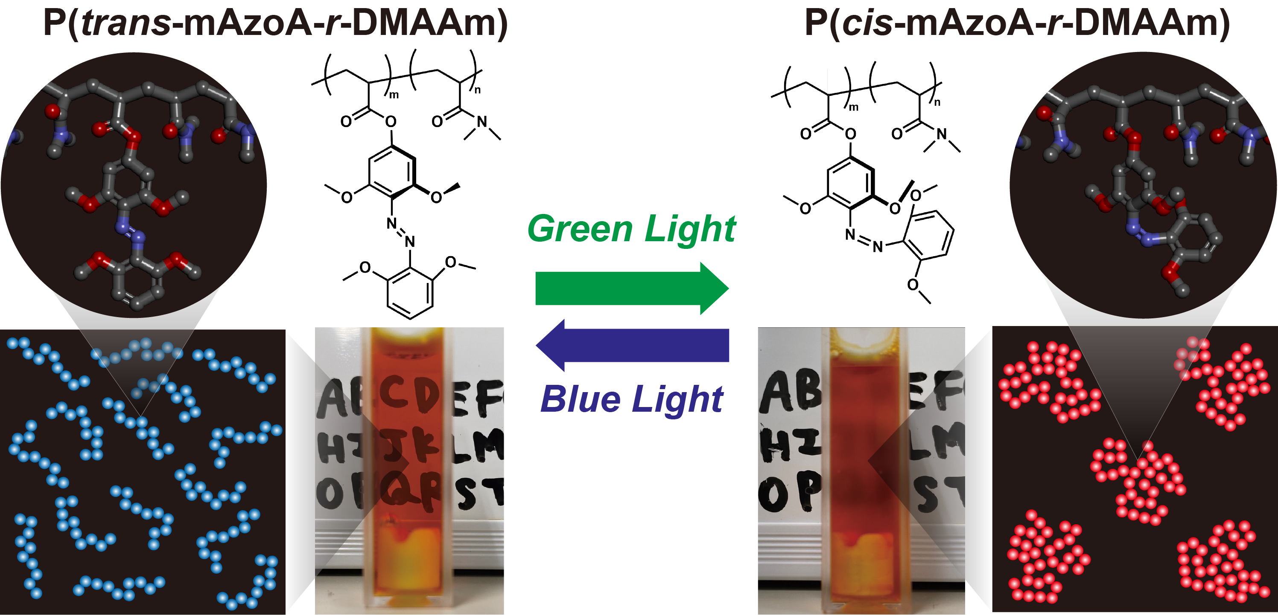
Figure 1. Conceptual illustration of phase transition of P(mAzoA-r-DMAAm) induced by visible light illumination. (Left) Under blue light illumination, the photoisomerization state of mAzoA along with the polymer becomes trans-rich, giving a transparent polymer solution with coiled conformation. (Right) When irradiated with green light, the photoisomerization state of mAzoA along with the polymer becomes cis-rich, resulting in a globule state of polymer chain and phase separation.
Azobenzene is a typical T-type (thermal type) photochromic molecule that undergoes photoisomerization with excellent cycle durability^{[7]}. If the two photoisomerization states (trans/cis) of azobenzene can be incorporated into the material, straightforward cell scaffold^{[8]} materials that can switch their mechanical (and/or chemical) properties repeatedly by simply switching the irradiation wavelengths can be realized. However, two problems are associated with the use of azobenzene as a cell scaffold. First problem is the phototoxicity of UV light that induces a π-π* transition during photoisomerization from trans- to cis-azobenzene. The second problem is the thermal instability of cis-azobenzene. Because cis-azobenzene is thermally metastable, it gradually returns to the most stable trans-azobenzene unless UV light is continuously illuminated. Hence, this problem leads to an undesirable change of the mechanical properties from cis- to trans-azobenzene-containing materials. If a mechanical property switching system that is photoisomerizable only by visible light irradiation without phototoxicity and yet displays very slow thermal relaxation can be developed, it will be possible to realize a cell scaffold that will contribute to more sophisticated mechanobiology.
Herein, we describe a light-responsive linear polymer (P(mAzoA-r-DMAAm)) containing an azobenzene derivative with four methoxy groups at the ortho-positions (Fig. 1). The polymer markedly changes its solubility in response to visible light at 37°C, a typical mammalian cell culture temperature. Various types of visible-light responsive azobenzenes have already been designed^{[9]}. In this study, we selected the methoxyazobenzene as the chromophore because it is more hydrophilic by the introduction of 4 methoxy groups and has already been attempted in hydrogel^{[10]}. When oriented toward bio-related applications, methoxy azobenzene has been pointed out to have low resistance against reduction of glutathione^{[7c, 11]}, which is present inside cells at ~10 mM. But this would not be a problem in the present study where it is used as a cell scaffold material outside of the cells. Interestingly, P(mAzoA-r-DMAAm) undergoes extremely slow thermal relaxation from the cis- to trans-type. It is able to potentially produce two thermally stable states upon photo stimulation alone, responding similarly to P-type (photochemical type) photochromic molecules, such as diarylethene, containing polymers^{[12]}. Furthermore, we prepared a P(mAzoA-r-DMAAm)-based hydrogel cell scaffold material and cultured Madin-Darby Canine Kidney (MDCK) cells at the interface. It was found that the hydrogel with mAzoA provided cell adhesion, spreading, and cell viability against visible light photo illumination.

Results and Discussion
Fig. S6 shows the change in absorption spectra of mAzoA monomer (0.03 w/v% in dimethyl sulfoxide) by visible light: irradiation of trans-rich mAzoA monomer with green light at 546 nm (6.6 mW cm⁻²) decreases the absorption based on the π-π* transition of the trans-form near 280 nm, and the absorption based on the n-π* transition that appears around 470 nm blue-shifts by 36 nm. Most azobenzene compounds, except for certain bridged azobenzene derivatives^{[13]}, have almost the same n-π* absorption wavelength for both the cis- and trans-forms; however, mAzoA is unique in that the n-π* absorption band is different. Wooley et al. reported that the n-π* transition of the cis form of 2,2',6,6'-tetramethoxy-4,4'-diamidoazobenzene, parent compound of mAzoA, is located at 460 nm, whereas that of the trans-form of the same compound is at 520 nm^{[14]}. Thus, there is as large as a 60 nm separation of the n-π* transition band between the cis- and trans-form. This is explained by the interaction between the methoxy group and the lone pair of electrons on the nitrogen in trans-2,2',6,6'-tetramethoxy-4,4'-diamidoazobenzene^{[14]}. In contrast to the highly twisted cis-form, which has four bulky methoxy groups in the ortho positions, the trans-form has an electron-donating methoxy group near the lone pair of electrons on the nitrogen. From this structural reason, it is believed that the HOMO level of the trans-form increases because of the instability of the HOMO of the trans-form, resulting in a significant red shift in the n-π* absorption band of the trans-form compared to that of the cis-form. When mAzoA in the cis-form was irradiated at 436 nm, the absorption peak based on the n-π* transition was red-shifted, and the absorption based on the π-π* transition of the trans-form recovered to the original intensity. The ¹H NMR results also confirmed the reversible photoisomerization from the cis- to trans-form by visible light irradiation (Fig. S7). The photoisomerization ability of mAzoA was maintained after polymerization: irradiation of P(mAzoA-r-DMAAm) with green light (546 nm) decreased the ratio of the trans-form in the polymer to 8%, and irradiation with blue light (436 nm) recovered the ratio to 88%. The isomerization ratio of the mAzoA groups in the polymer changes to cyclic when irradiated alternately with green (546 nm) and blue light (436 nm) (Figs. S8, S9).
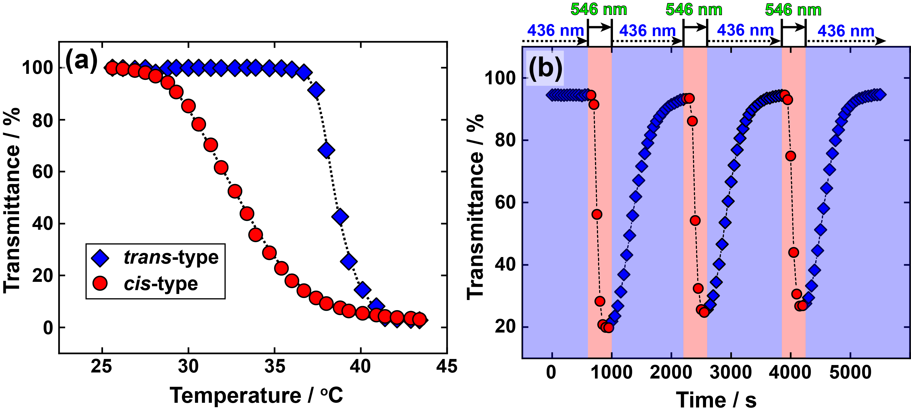
Figure 2. (a) Temperature dependence of transmittance at 700 nm for 0.5 wt% P(trans-mAzoA_{10.7}-r-DMAAm)_{3.0kDa} (blue diamond) and for 0.5 wt% P(cis-mAzoA_{10.7}-r-DMAAm)_{3.0kDa} (red circle) in PBS (pH 7.4) solution. The transmittance of 100% indicates that the solution is a single-phase (transparent), while that of 0% indicates that it is phase-separated (turbid). Scan rate: 1 °C min⁻¹. (b) Cyclic solubility changes between transparent and turbid of P(mAzo_{10.7}-r-DMAAm)_{3.0kDa} at 37°C by alternative switching between blue and green light.
The temperature and light sensitivities of P(mAzoA-r-DMAAm) were evaluated. Fig. 2(a) shows LCST-type phase transition of 0.5 wt% P(mAzoA_{10.7}-r-DMAAm)_{3.0kDa} in PBS solution. The subscript numbers indicated after mAzoA and in parentheses express the composition of mAzoA and the number average molecular weight (M_{n}) of P(mAzoA-r-DMAAm), respectively. The LCST-type transition temperature varied depending on the photoisomerization state of mAzoA. T_{c}s of trans- and cis-type were 39.2°C and 32.9°C, respectively. Thus, there is a broad enough bistable temperature range of 6.3°C. This suggests that the solubility of the polymers can be controlled by visible light illumination in the bistable temperature region. In other words, at the typical mammalian cell culture temperature of 37°C, when the mAzoA group in the polymer chain is trans (P(trans-mAzoA_{10.7}-r-DMAAm)_{3.0kDa}) under blue light illumination, the polymer becomes hydrophilic and remains in a soluble state. Conversely, green light produces a cis-type polymer (P(cis-mAzoA_{10.7}-r-DMAAm)_{3.0kDa}) which is eventually insoluble at a constant temperature and phase-separated. Thus, we attempted to demonstrate the reversible solubility changes of P(mAzoA_{10.7}-r-DMAAm)_{3.0kDa} induced only by visible light switching at a 37°C (Fig. 2(b)). The transmittance data plotted in blue region is obtained under 436 nm blue light, whereas the data in red region is obtained under 546 nm green light. It is clear that P(mAzoA_{10.7}-r-DMAAm)_{3.0kDa} can repeatedly change its solubility upon switching to visible light. The photo-induced turbidity change of the polymer (change in the affinity between the polymer and solvent) could be repeatedly induced at least three times. As previously reported, the transmittance lowering process by light irradiation occurs quickly as the polymers undergo a coil-globule transition in a transparent solution in which light stimuli are effectively absorbed into the azobenzene chromophore^{[15]}. The redissolving process of the polymers accompanying the increase in transmittance occurs slowly. This was caused by the light scattering of the polymer aggregates. The transmittance recovery process promotes the irradiation of polymer aggregates with sizes ranging from several hundred nanometers to submicrons. Therefore, light is scattered at the polymer aggregate interface and is not able to penetrate inside solution effectively. resulting in a slow dissolution process. PDMAAm (a homopolymer of DMAAm) is hydrophilic and exhibits no thermo-sensitivity at normal pressure. However, certain random copolymers based on hydrophilic monomers (DMAAm, hydroxyethyl acrylamide, and hydroxyethyl acrylate, etc.) combined with hydrophobic monomers (4-phenylazophenyl acrylate (AzoA), 4-phenylazophenyl acrylamide, tert-butyl acrylate (acrylamide), and methyl acrylate, etc.) are known to provide LCST-type thermo-sensitivity^{[16]}. Because the P(mAzoA-r-DMAAm) is also a random copolymer of hydrophilic DMAAm and hydrophobic mAzoA, it is reasonable that P(mAzoA-r-DMAAm) exhibits LCST-type phase transition.
With some exceptions^{[17]}, the LCST-type phase transition temperatures of azobenzene-containing polymers in general are observed at low temperatures for the trans-type and at high temperatures for the cis-type^{[18]}. The order of phase transition temperatures has been explained by the polarity of azobenzene^{[7a, 18a]}. Whereas Fig. 2(a) indicates a higher temperature LCST-type transition in trans-type polymer and a lower temperature transition in the cis-type polymer, meaning that the trend is the opposite of the generally observed phenomena. Regarding the reversal of the phase transition temperature with respect to the polarity of azobenzene, we have reported that not only the polarity, but also the molecular weight of the polymer has a strong influence on T_{c}^{[19]}. In the LCST-type phase transition of a random copolymer of AzoA with DMAAm (P(AzoA-r-DMAAm)), for molecular weights above 36 kDa, the order of the phase transition temperature is such general that the higher polar cis-type polymer shows a high-temperature phase transition and the lower-polarity trans-type shows a low-temperature phase transition. However, when the molecular weight was reduced to 16 kDa, the difference in the phase-transition temperature according to the photoisomerization state disappeared. For the molecular weight of less than 10 kDa, the phase transition temperature of the trans-type is finally higher than that of the cis-type^{[19]}. The molecular weight of P(mAzoA-r-DMAAm) shown in Fig. 2(a) is as low as 3.0 kDa, which is in the molecular weight region where the phase transition temperature exhibits reversal, as expected from previous reports^{[19]}. The counterintuitive phase transition temperature order of P(mAzoA_{10.7}-r-DMAAm)_{3.0kDa} was probably due to the molecular weight effect. Discussion of the effect of [mAzoA] and molecular weight of polymers (Fig. S11) on the LCST-type phase transition temperature in this system is available on the supporting information.
We also found that the thermal relaxation from the cis- to the trans-type is remarkably retarded in P(mAzoA-r-DMAAm) compared to conventional azobenzene-containing polymers. Thermal relaxation from cis- to trans-type has been a serious drawback for azobenzene-containing polymer materials because it causes undesired material aging without a trigger of light illumination. Fig. 3(a) measures the time course of the thermal relaxation process of P(mAzoA-r-DMAAm) at 37°C evaluated using ¹H NMR. For comparison, ¹H NMR spectra of the thermal relaxation of P(AzoA-r-DMAAm) with the same thermal history are also shown (Fig. 3(b)). Fig. 3(c) summarizes the decay of the ratio of cis-type azobenzene estimated from the ¹H NMR in each polymer. P(mAzoA-r-DMAAm) retained a 90.3% cis-type ratio comparable to original ratio of 92.9%, even after 66 hours thermal relaxation at 37°C. This was in sharp contrast to the case of P(AzoA-r-DMAAm) that kept only 37.5% cis-type ratio under same thermal history. Wooley et al. reported that the introduction of methoxy groups into azobenzene not only imparts visible light sensitivity but also slows down the thermal relaxation rate from cis- to trans-form in low-molecular-weight compound systems^{[14]}. Here, we have experimentally ensured remarkable thermal stability of cis-type methoxy-incorporated azobenzene even after polymerization. The thermal relaxation kinetics from cis to trans are governed by the potential energy of the ground state of the metastable cis-form and by that of the transition state in the thermal reaction from the cis- to the trans-form. The introduction of a methoxy group at the ortho-position of azobenzene was expected to make the ground state of the cis-form more stable, the transition state more unstable, or both, resulting in a slower thermal relaxation rate. A better understanding of the potential energy in each state would explain thermal stability; however, this is a topic for future research.
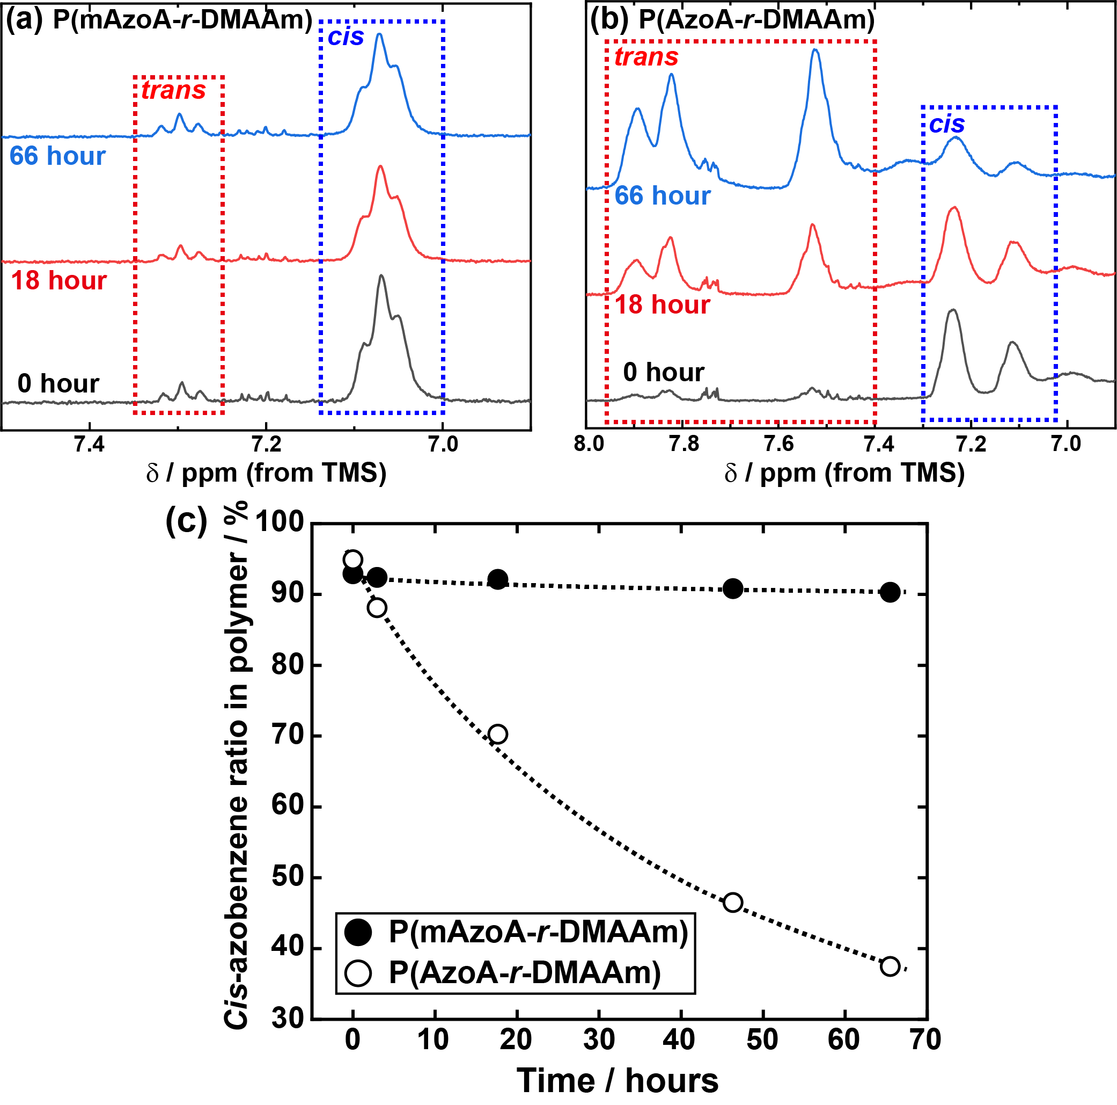
Figure 3. Change in ¹H NMR spectra at 0, 18, and 66 h during thermal relaxation process from cis- to trans-type polymer of (a) P(mAzoA-r-DMAAm) and (b) P(AzoA-r-DMAAm) incubated at 37°C. Before the measurements, P(mAzoA-r-DMAAm) and P(AzoA-r-DMAAm) were irradiated with 546 nm and 365 nm light, respectively, to reach each photo-stationary cis-type polymer. (c) Relationship between cis-azobenzene ratio in P(mAzoA-r-DMAAm) and P(AzoA-r-DMAAm). The cis-photoisomerization state was estimated from the corresponding integral intensity area of ¹H NMR spectra.
Finally, we investigated the biocompatibility of P(mAzoA-r-DMAAm)-based cell scaffold materials. A DMF pre-gel solution, including monomers, initiators, and cross-linkers, was polymerized on a glass substrate modified with 3-(trimethoxysilyl)propyl methacrylate, to which a vinylidene group was introduced. After polymerization, the solvent was replaced with PBS to obtain the P(mAzoA-r-DMAAm) hydrogel. P(mAzoA-r-DMAAm) hydrogel interface was modified with collagen by using sulfo-SANPAH to promote cell adhesion. MDCK were seeded on the P(mAzoA-r-DMAAm) hydrogel interface. For cellular phototoxicity test, MDCK were cultured on the 96 well dish and was individually exposed to UV light (365 nm, 10 mW cm⁻²), green light (546 nm, 6.6 mW cm⁻²), and blue light (436 nm, 8.9 mW cm⁻²) with the typical photo-isomerization inducing energy needed for trans- to cis- isomerization of azobenzene, for trans- to cis- isomerization of mAzoA, and for cis- to trans- isomerization of both azobenzene and mAzoA, respectively. As shown in Fig. 4(a), the cell viability, estimated from the WST assay, dropped to approximately 40% after irradiation with 365 nm light, which is a commonly used wavelength and intensity for the trans-to-cis photoisomerization of azobenzene. In contrast, the cell viability after irradiation with blue and green light remained almost the same as that of the cells cultured on the unirradiated gel interface. Fig. 4(b) shows the bright-field and fluorescence images of the live/dead assay for the MDCK culture after 24 h on the interface of the P(mAzoA-r-DMAAm) hydrogel. It can be seen that the cells adhered and spread on the P(mAzoA-r-DMAAm) hydrogel interface, retaining high cell viability. These results indicated that the collagen-coated P(mAzoA-r-DMAAm) hydrogel is an excellent biocompatible in vitro material that supports cell adhesion. We also confirmed that the photoisomerization reaction of mAzoA in response to visible light successfully proceeded in the hydrogel within 30 min (Fig. S11). Furthermore, the light irradiation required for photoisomerization is nontoxic and does not threaten cell viability. We have shown that it is possible to construct cell scaffolds that can switch between different mechanical and/or chemical states under mild conditions compared to conventional azobenzene-containing soft materials.
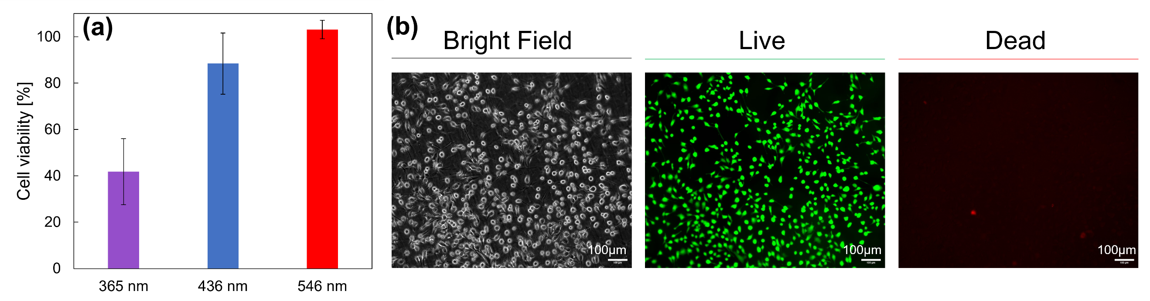
Figure 4. (a) Cellular phototoxicity test for MDCK. After 24 hours MDCK culturing on the polystyrene dish, UV light (365 nm, 10 mW cm⁻²), blue light (436 nm, 8.9 mW cm⁻²), and green light (546 nm, 6.6 mW cm⁻²) were individually irradiated to the cells. Cell viability was evaluated by WST assay by defining the signal without photoirradiation as 100% viability. (b) Bright field images and live/dead staining of MDCK 24 hours cultured on the interface of collagen-coated P(mAzoA-r-DMAAm) after irradiation of cells at green light in the conditions described above.

Conclusion
In this paper, we reported the preparation of thermo- and light-sensitive polymers based on the photoisomerization of a visible-light-responsive azobenzene with an electron-donating methoxy group at the ortho-position. P(mAzoA-r-DMAAm) exhibited an LCST-type phase transition in PBS. It was revealed that T_{c} and ΔT_{c} were controllable not only by the amount of mAzoA unit introduced but also by its molecular weight. By precise tuning of mAzoA composition and molecular weight of P(mAzoA-r-DMAAm), we have achieved cyclic soluble-insoluble changes by non-cytotoxic visible light switching at 37°C, typical mammalian cell culture temperature. For a preliminary trial of their application to cell scaffold materials and biomedical applications, we attempted cell culture on a P(mAzoA-r-DMAAm) hydrogel. Excellent adhesion and spreading of MDCK cells were observed at the interface of the P(mAzoA-r-DMAAm) hydrogel. Light irradiation at 436 nm and 546 nm, which are required for the photoisomerization of mAzoA, did not affect cell viability, demonstrating the biocompatibility of the material.

Associated Content
Supporting Information
¹H NMR of monomers and polymers; photochromic reaction of mAzoA and P(mAzoA-r-DMAAm); and table summarizing the results of the polymers. Additional discussion of molecular weight dependence on T_{c} of P(mAzoA-r-DMAAm).

Acknowledgements
This study was financially supported by JSPS KAKENHI grants (20H02804, 20K21229, and 23H02030 to T. U.; 22K14705 to S. Y.; and 22H00596 and 23K17481 to J. N.). We are grateful to Takashi Ubukata (Yokohama National University) for the fruitful discussions on the photochromism of mAzoA. We also thank to Timothy W. Silliman for his helpful assistance for the experiment.

References
[1] a)Material-based Mechanobiology, The Royal Society of Chemistry, Cambridge, CB4 0WF, UK 2022; b)D. E. Ingber, Ann Med 2003, 35, 564; c)D. H. Kim, P. K. Wong, J. Park, A. Levchenko, Y. Sun, Annu Rev Biomed Eng 2009, 11, 203; d)T. Mammoto, A. Mammoto, D. E. Ingber, Annu Rev Cell Dev Biol 2013, 29, 27.
[2] a)K. Uto, J. H. Tsui, C. A. DeForest, D. H. Kim, Prog. Polym. Sci. 2017, 65, 53; b)J. A. Burdick, W. L. Murphy, Nature communications 2012, 3, 1269; c)A. M. Rosales, K. S. Anseth, Nature Reviews Materials 2016, 1, 15012; d)P. J. LeValley, A. M. Kloxin, ACS Macro Letters 2018, 8, 7; e)O. Chaudhuri, J. Cooper-White, P. A. Janmey, D. J. Mooney, V. B. Shenoy, Nature 2020, 584, 535.
[3] a)H. Y. Yoshikawa, F. F. Rossetti, S. Kaufmann, T. Kaindl, J. Madsen, U. Engel, A. L. Lewis, S. P. Armes, M. Tanaka, J Am Chem Soc 2011, 133, 1367; b)V. Frank, S. Kaufmann, R. Wright, P. Horn, H. Y. Yoshikawa, P. Wuchter, J. Madsen, A. L. Lewis, S. P. Armes, A. D. Ho, M. Tanaka, Scientific reports 2016, 6, 24264.
[4] a)H. Shih, C. C. Lin, J Mater Chem B 2016, 4, 4969; b)M. Horning, M. Nakahata, P. Linke, A. Yamamoto, M. Veschgini, S. Kaufmann, Y. Takashima, A. Harada, M. Tanaka, Scientific reports 2017, 7, 7660.
[5] A. M. Rosales, S. L. Vega, F. W. DelRio, J. A. Burdick, K. S. Anseth, Angew. Chem. Int. Ed. 2017, 56, 12132.
[6] a)B. M. Gillette, J. A. Jensen, M. Wang, J. Tchao, S. K. Sia, Adv Mater 2010, 22, 686; b)N. Kong, Q. Peng, H. Li, Advanced Functional Materials 2014, 24, 7310.
[7] a)G. S. Kumar, D. Neckers, Chem. Rev. 1989, 89, 1915; b)V. M. Lechner, M. Nappi, P. J. Deneny, S. Folliet, J. C. K. Chu, M. J. Gaunt, Chem Rev 2022, 122, 1752; c)A. A. Beharry, G. A. Woolley, Chem. Soc. Rev. 2011, 40, 4422.
[8] a)K. Homma, A. C. Chang, S. Yamamoto, R. Tamate, T. Ueki, J. Nakanishi, Acta Biomater 2021; b)I. N. Lee, O. Dobre, D. Richards, C. Ballestrem, J. M. Curran, J. A. Hunt, S. M. Richardson, J. Swift, L. S. Wong, ACS applied materials & interfaces 2018, 10, 7765; c)A. M. Rosales, K. M. Mabry, E. M. Nehls, K. S. Anseth, Biomacromolecules 2015, 16, 798.
[9] M. Gao, D. Kwaria, Y. Norikane, Y. Yue, Natural Sciences 2022, 3, e220020.
[10] H. Yan, Y. Qiu, J. Wang, Q. Jiang, H. Wang, Y. Liao, X. Xie, Langmuir 2020, 36, 7408.
[11] a)S. Samanta, C. Qin, A. J. Lough, G. A. Woolley, Angew Chem Int Ed Engl 2012, 51, 6452; b)S. Samanta, T. M. McCormick, S. K. Schmidt, D. S. Seferos, G. A. Woolley, Chem Commun (Camb) 2013, 49, 10314.
[12] a)H. Nishi, T. Namari, S. Kobatake, J. Mater. Chem. 2011, 21, 17249; b)M. Irie, T. Fukaminato, K. Matsuda, S. Kobatake, Chem Rev 2014, 114, 12174; c)E. Siemes, O. Nevskyi, D. Sysoiev, S. K. Turnhoff, A. Oppermann, T. Huhn, W. Richtering, D. Woll, Angew. Chem. Int. Ed. 2018.
[13] R. Siewertsen, H. Neumann, B. Buchheim-Stehn, R. Herges, C. Nather, F. Renth, F. Temps, J. Am. Chem. Soc 2009, 131, 15594.
[14] A. A. Beharry, O. Sadovski, G. A. Woolley, J. Am. Chem. Soc. 2011, 133, 19684.
[15] T. Ueki, Y. Nakamura, A. Yamaguchi, K. Niitsuma, T. P. Lodge, M. Watanabe, Macromolecules 2011, 44, 6908.
[16] a)R. Kroger, H. Menzel, M. L. Hallensleben, Macromolecular Chemistry and Physics 1994, 195, 2291; b)S. Ida, D. Nishisako, A. Fujiseki, S. Kanaoka, Soft Matter 2021, 17, 6063.
[17] a)Y.-J. Liu, A. Pallier, J. Sun, S. Rudiuk, D. Baigl, M. Piel, E. Marie, C. Tribet, Soft Matter 2012, 8; b)A. Desponds, R. Freitag, Langmuir 2003, 19, 6261; c)E. Marie, C. Tribet, Chemistry Letters 2012, 41, 1093; d)T. Shimoboji, E. Larenas, T. Fowler, S. Kulkarni, A. S. Hoffman, P. S. Stayton, Proc. Natl. Acad. Sci. U S A 2002, 99, 16592; e)T. Shimoboji, Z. L. Ding, P. S. Stayton, A. S. Hoffman, Bioconjug Chem 2002, 13, 915.
[18] a)D. Kungwatchakun, M. Irie, Die Makromolekulare Chemie, Rapid Communications 1988, 9, 243; b)K. Matsubara, M. Watanabe, Y. Takeoka, Angew. Chem. Int. Ed. 2007, 46, 1688; c)J. F. Gohy, Y. Zhao, Chem. Soc. Rev. 2013, 42, 7117.
[19] K. Homma, A. C. Chang, S. Yamamoto, T. Ueki, J. Nakanishi, Macromol. Rapid Commun. 2023, 44, 2300118.

For Table of Contents Only
