Supplementary Data

A weak-solvation strategy for modulating Li ion solvation sheath to enable fast-charging Li-ion batteries

Yiyi Zheng^{a,} †, Jiapei Li ^{b, c,} †, Tian Zhang^{b, c,} †, Qiaohui Duanª, Shuyu Dongª, Zhiqiang Guan^{c,d}, Dewu Lin^{e}, Wenjun Zhang^{b,c}, Denis Y. W. Yu^{f}*

ª School of Energy and Environment, City University of Hong Kong, Tat Chee Ave, Kowloon, Hong Kong, China.
^{b} Center of Super-Diamond and Advanced Films (COSDAF), City University of Hong Kong, Tat Chee Ave, Kowloon, Hong Kong, China.
^{c} Department of Materials Science and Engineering, City University of Hong Kong, Tat Chee Ave, Kowloon, Hong Kong, China.
^{d} Department of Chemistry, City University of Hong Kong, Tat Chee Ave, Kowloon, Hong Kong, China.
^{e} State Key Laboratory of Advanced Waterproof Materials, School of Advanced Materials, Peking University, Shenzhen Graduate School, Shenzhen, China.
^{f} Research Center for Energy and Environmental Materials (GREEN), National Institute for Materials Science, Tsukuba, Ibaraki 305-0044, Japan.
* corresponding author: yu.denis@nims.go.jp
† These authors contributed equally to this work.

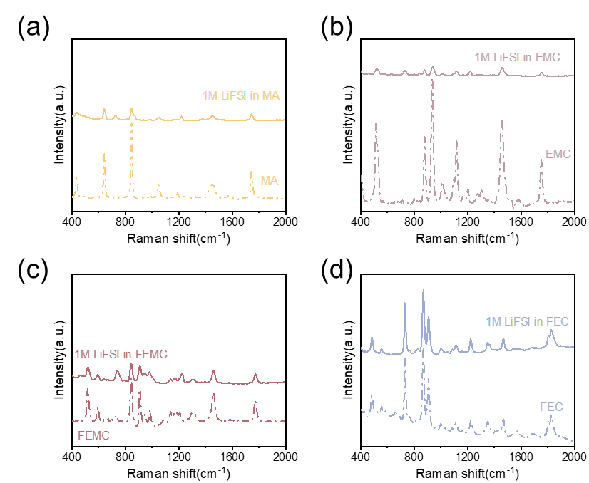
Figure S1. Raman spectra of (a) MA, (b) EMC, (c) FEMC and (d) FEC and those dissolved with 1 M LiFSI from 400 to 2000 cm⁻¹.

Figure S2. Raman spectra of 1 M LiFSI dissolved in different solvents.
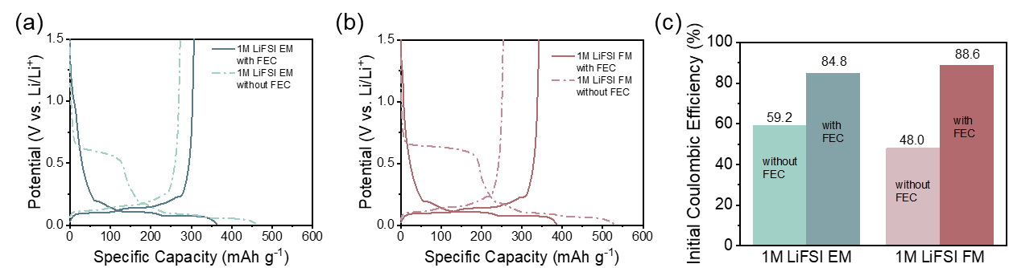
Figure S3. First charge-discharge curves of the cells using (a) 1 M LiFSI EM with or without FEC electrolyte; (b) 1 M LiFSI FM with or without FEC electrolyte; (c) initial Coulombic efficiency of the cells using different electrolytes.
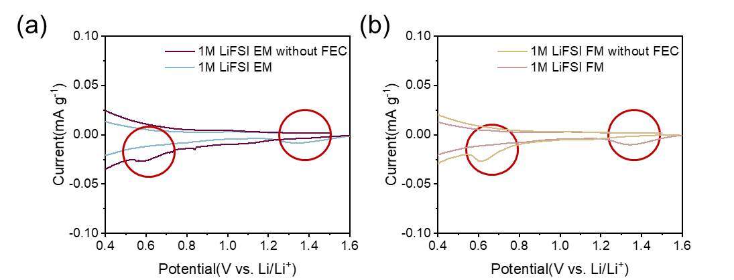
Figure S4. CV curves of the Gr | Li half cells using (a) EMC-based electrolytes and (b) FEMC-based electrolytes. Scan rate: 0.01 mV s⁻¹.

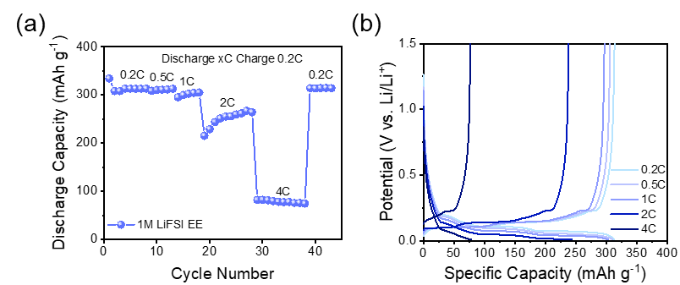
Figure S5. (a) Rate performance and (b) corresponding charge-discharge curves of the graphite electrodes with 1 M LiFSI EE electrolyte.

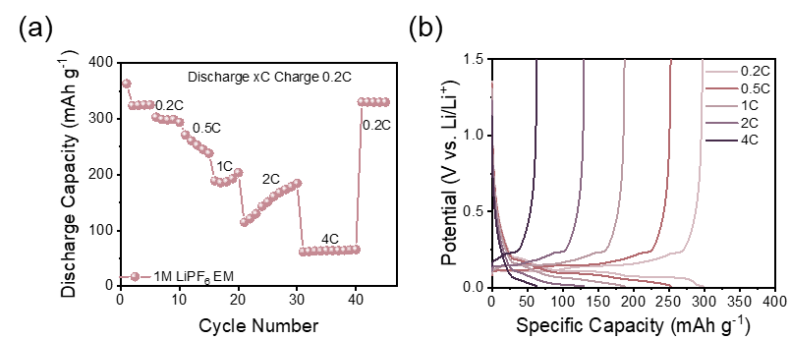
Figure S6. (a) Rate performance and (b) corresponding charge-discharge curves of the graphite electrodes with 1 M LiPF₆ EM electrolyte.

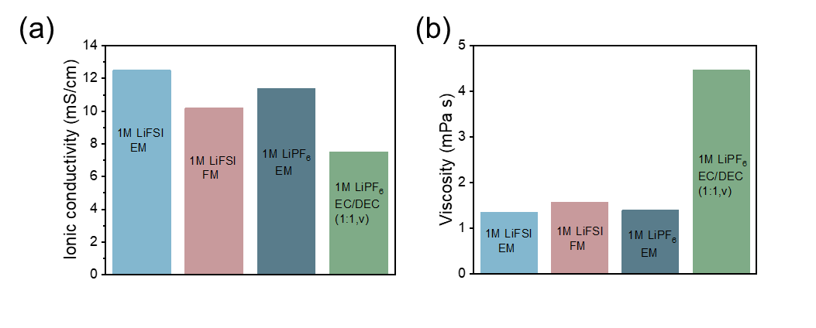
Figure S7. (a) Ionic conductivity and (b) viscosity of different electrolytes.

Figure S8. LSV curves of a coin cell with carbon-coated Al foil and Li metal with different electrolytes.
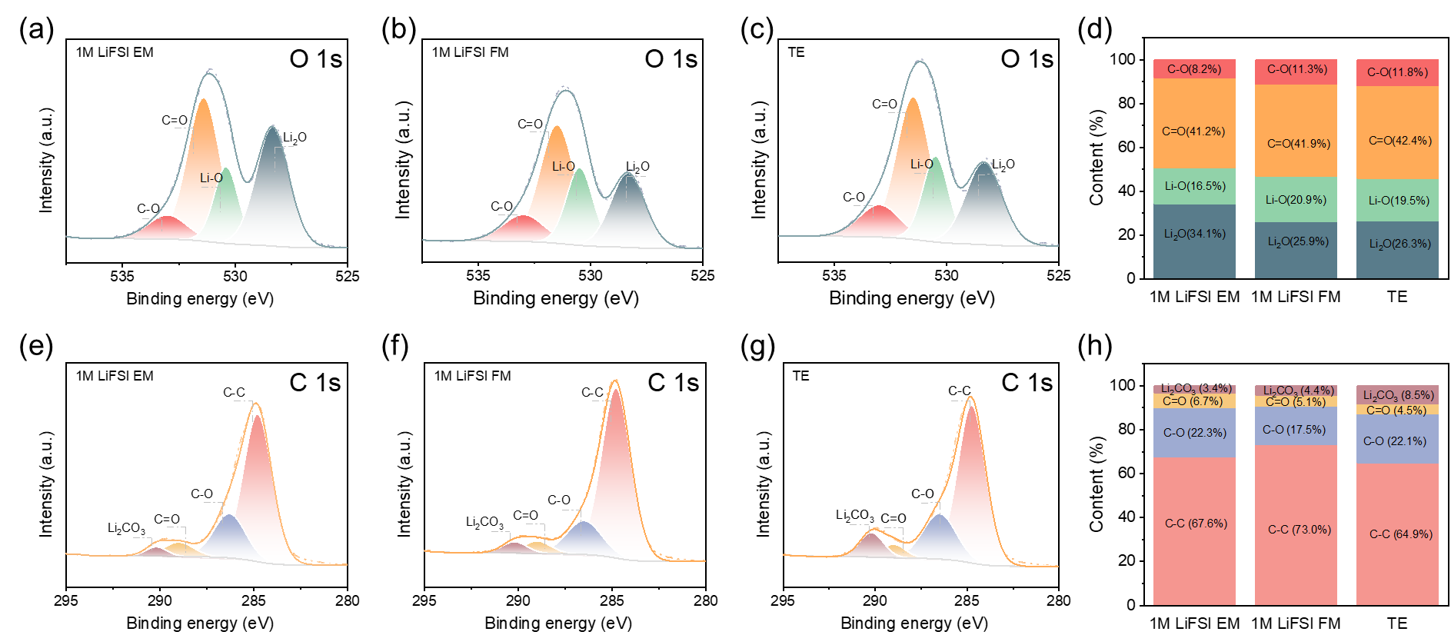
Figure S9. O 1s XPS spectra of graphite electrodes after 3 cycles at 0.1 C using different electrolytes. (a) 1 M LiFSI EM electrolyte; (b) 1 M LiFSI FM electrolyte; (c) TE electrolyte; (d) comparison of oxygen-containing substances on the surface of graphite electrodes with different electrolytes. C 1s XPS spectra of graphite electrodes after 3 cycles at 0.1 C using different electrolytes. (e) 1 M LiFSI EM electrolyte; (f) 1 M LiFSI FM electrolyte; (g) TE electrolyte; (h) comparison of carbon-containing substances on the surface of graphite electrodes with different electrolytes.

Table S1. R_{SEI} from fitting of the EIS results of the graphite half cells using different electrolytes after cycles at room temperature (typically between 23-24 °C).
 | 1 M LiFSI EM | 1 M LiFSI FM | TE
3 cycles at 0.1 C | 37.4 Ω | 29.0 Ω | 71.4 Ω
3 cycles at 0.1 C +10 cycles at 4 C | 33.3 Ω | 22.8 Ω | 61.7 Ω
Note that the R_{SEI} and R_{ct} for the second row (after 10 cycles at 4 C) differ slightly from the values in Table S2, likely because the room temperature is normally lower than 25 °C.

Table S2. R_{SEI} from fitting of the EIS results of the graphite half cells using different electrolytes at different temperatures after 10 cycles at 4 C_{graphite}.
Temperature | 1 M LiFSI EM | 1 M LiFSI FM | TE
5°C | 101.2 Ω | 50.2 Ω | 390.7 Ω
15°C | 55.8 Ω | 22.7 Ω | 151.8 Ω
25°C | 22.8 Ω | 12.7 Ω | 64.3 Ω
35°C | 14.5 Ω | 10.8 Ω | 24.9 Ω
45°C | 3.9 Ω | 4.6 Ω | 11.2 Ω

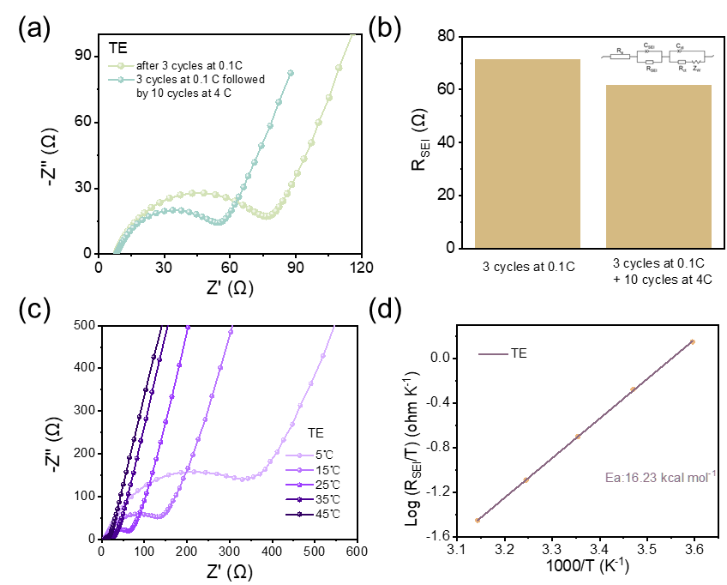
Figure S10. (a) EIS spectra of the cells with TE after cycles; (b) fitted values of R_{SEI} of graphite electrodes with TE after different cycles. (c) EIS spectra of the cells tested at different temperatures with TE; (d) plot of $\log{\frac{R_{SEI}}{T}}$ vs. 1000 T⁻¹ for graphite | Li half cells with TE.

