Appearance of spectral dip in the cathodoluminescence spectrum of negatively charged nitrogen-vacancy centers in diamonds
Jun Chen^{1, *}, Chikara Shinei^{1, a)}, Junichi Inoue¹, Hiroshi Abe²,
Takeshi Ohshima², Takashi Sekiguchi³, and Tokuyuki Teraji^{1, *}
¹ Research Center for Electronic and Optical Materials, National Institute for Materials Science, Tsukuba 305-0044, Japan
² Quantum Materials and Applications Research Center, National Institutes for Quantum Science and Technology, Takasaki, Gunma 370-1292, Japan
³ Faculty of Pure and Applied Sciences, University of Tsukuba, Tsukuba 305-8573, Japan

* Corresponding author. Tel: 81-29-860-4298. E-mail: CHEN.jun@nims.go.jp (Jun Chen)
Tel: 81-29-860-4776. E-mail: TERAJI.Tokuyuki@nims.go.jp (Tokuyuki Teraji)
a) Present address: Institute of Applied Physics, University of Tsukuba, 1-1-1 Tennodai, Tsukuba, Ibaraki, 305–8573, Japan.

Abstract
Negatively charged nitrogen-vacancy (NV⁻) centers in diamond produce a characteristic optical zero-phonon line (ZPL) at 637 nm. This emission line can be observed under optical excitation (i.e. photoluminescence), but is rarely observed under electron excitation (i.e. cathodoluminescence). This study reports that low-temperature (80 K) and low energy (5 keV) cathodoluminescence spectroscopy is able to detect emission peak or spectral dip at the ZPL of NV⁻ centers. The spectral dip was observed in the diamond samples with high concentration of NV⁻ centers produced by high-energy (2 MeV) e-beam (EB) irradiation. The effects of EB irradiation fluence, NV⁻ centers concentration and substitutional nitrogen concentration on the formation of spectral dip were discussed, and a model based on the NV⁻ absorption of NV⁰ emission sideband is proposed.
Keywords: NV⁻ centers; Diamond; Cathodoluminescence; Spectral dip
- Introduction
Nitrogen-vacancy (NV) centers, which are typical color centers in diamond crystals and have been studied for more than 50 years. The negatively charged NV⁻ centers have interesting features such as single photons emission [1], optical induced spin polarization [2], optical-spin state detection [3], long spin coherence time [4, 5], and high sensitivity as quantum sensors [6, 7]. Among the material platforms for spin-quantum technology, NV⁻ centers have attracted a great deal of attention and are leading the state-of-the-art in quantum networks [8, 9].
NV centers exist in diamonds, although the number of naturally formed NV centers is in small amount. They can also be artificially created by irradiating nitrogen-containing diamond with high energy particles such as electrons, neutrons and ions [10-13]. Over the past two decades, the defect structure and electronic structure of NV centers have been extensively studied based on various experimental methods and density functional theory calculations [14-17]. The trigonal symmetry and the ground state - excited state electronic nature of NV centers was established in early optical studies by Davies and Hamer [14]. The defect structure of NV center is described as a pair of substitutional nitrogen adjacent to a carbon vacancy orientated along the [111] direction and the point group symmetry of NV centers is C_{3v}.
In general, NV centers have two charge states, neutral NV⁰ and negative NV⁻. The zero-phonon lines (ZPLs) of the NV⁰ and NV⁻ centers are 2.156 eV (575 nm) and 1.945 eV (637 nm), respectively. The sharp ZPLs of the NV centers indicated that the optical transitions occur between discrete levels within the bandgap of diamond. The ZPL of NV⁻ centers associated with the radiative transition ³E → ³A₂, in which both the ground state (³A₂) and the excited state (³E) are spin triplet. The ZPL of NV⁰ centers associated with the radiative transition ²A → ²E, in which both the ground state (²E) and the excited state (²A) are spin doublet [15]. The ZPLs accompanied by phonon-assisted sidebands can be observed in photoluminescence spectra for both charge states [18]. On the other hand, the detection of ZPL of NV⁻ under electron [19-24] or X-ray [25] excitation was rarely observable. In fact, a large number of cathodoluminescence (CL) observations have been made on diamond crystals, ranging from bulk, thin films to nanocrystals, but few of them have detected the emission of NV⁻ centers. Only one exception was reported by Watanabe et al., who detected weak emission of NV⁻ centers at 16 K in their cryogenic CL measurement [26].
The question arises why NV⁻ emission under electron excitation is less intensive? Many studies have shown that the most likely reason is related to the ionization of NV⁻ centers. While photoluminescence involves only transitions between the ground and excited states of the NV⁻ center, whereas electron excitation involves electron and hole trapping, transitions between the ground and excited levels, as well as the structural transformations due to electron/hole trapping and release [27]. Even under optical excitation, the charge state of NV centers can change from negative to neutral due to the ionization [28-31], indicating that NV⁻ centers are not photochemically stable. A recent study using pump-probe CL spectroscopy also confirmed the conversion from NV⁻ to NV⁰ by electron excitation during CL measurements [32]. The absence of NV⁻ emission in CL spectra may be due to the ionization induced by high-energy electron beam excitation, analogous to photoionization. Recently, electroluminescence detection of NV⁻ centers has been achieved on a diamond p-i-n diode by introducing an i-layer to stabilize the negative state of NV⁻ centers [33], suggesting that the charge state of NV⁻ centers can be controlled under electrical excitation.
To realize diamond quantum devices driven electronically, revealing possible influence of electron excitation on NV⁻ centers energy level structure is very important. Most of the reported CL experiments were performed at room temperature and the spectral resolution was limited by the experimental setup. Furthermore, due to the lack of suitable diamond samples, research in this field is not comprehensive enough. Important factors such as irradiated electron fluence, concentration of NV⁻ centers and substitutional nitrogen centers (P1 centers), and their effects on the electrical and/or optical behaviors of NV⁻ centers have not been fully investigated. In this study, a comprehensive CL observation of high-quality CVD-grown diamond crystals with designed concentration of NV⁻ centers was carried out. The electron beams used for the irradiation process and the CL observation were different: a high-energy (2 MeV) electron beam was used to generate high concentration of NV⁻ centers, while a low-energy (e.g., 5 keV) electron beam was used for the CL observation. This study shows that the low-temperature and low-energy CL spectroscopy is capable of detecting the emission peak of NV⁻ centers, and a spectral dip was observed at the ZPL of NV⁻ centers for the first time.

- Material and methods
The samples were nitrogen-doped free-standing diamond crystals homoepitaxially grown by a homemade microwave plasma-assisted CVD [34-36]. The substrates were commercial (100)-oriented type-Ib high-pressure/high-temperature (HPHT) grown diamond crystals with dimension of 3.5 × 3.5 × 1.0 mm³. ¹²C isotopically enriched methane (¹²C enrichment > 99.95%) was used as carbon source, and ¹⁵N-enriched nitrogen gas (¹⁵N enrichment > 98%) as doping source. Nitrogen doping efficiency is determined by controlling the ratio of nitrogen flow rate to methane gas flow rate (N/C ratio). Detailed information on growth methods has been presented in our previous studies [36, 37]. The N/C ratio was varied from 10,000 to 40, 000 ppm in order to grow samples with different nitrogen doping concentrations. The thickness of epitaxial crystals was 0.3~0.5 mm. The CVD-grown diamond layers were separated from the HPHT substrates by laser cutting and double-side mirror polished. The NV centers were introduced by e-beam irradiation (EB) followed by high-temperature annealing (HT). EB irradiation was performed with a high-energy (2 MeV) electron beam at electron fluence of 1×10¹⁷ ~ 1×10¹⁸ e/cm², and high-temperature annealing was performed at 1350°C for 2 hours under a vacuum below 2×10⁻⁵ Pa.
Table-I listed the diamond samples used in this study. The first set of experiments (samples AG, HT and EBHT1) was to compare the difference between the pristine (sample AG) and EB irradiated (sample EBHT1) states. In addition, sample that was only annealed at high-temperature annealing (sample HT) was included. These three samples (AG, HT, and EBHT1) were initially cut from the same CVD-grown diamond crystal (N/C ratio of 10,000 ppm) and then subjected to different processes. The second set of experiments was to investigate the effects of EB irradiation fluence, the concentration of P1 centers ([P1]), and the concentration of NV⁻ centers ([NV⁻]) on the occurrence of spectral dip. Three samples (EBHT1, EBHT2, and EBHT3) were grown with different N/C ratios, and irradiated with high or low EB fluence.
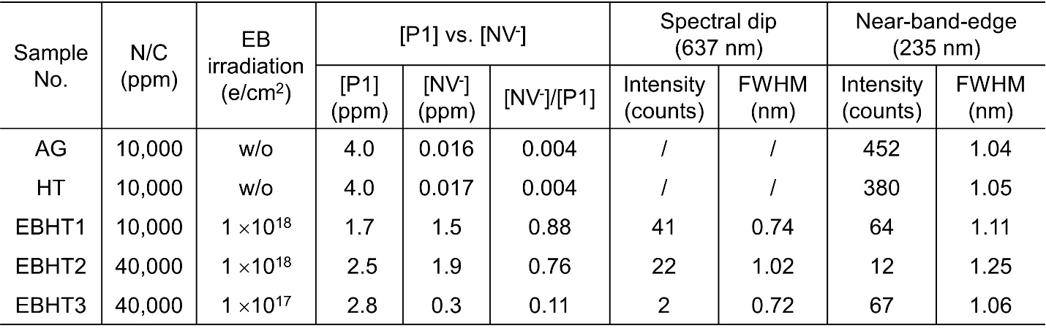
Table-I. CVD diamond samples used in this study. The N/C ratio, the fluence of EB irradiation, the concentrations of [P1] and [NV⁻], and the CL intensity of spectral dip and near-band-edge emission were listed. AG stands for as-grown, HT stands for high-temperature annealing, and EBHT stands for high-temperature annealing after EB irradiation.
The concentrations of [P1] and [NV⁻] were measured by electron paramagnetic resonance (EPR) at 300 K using an X-band EPR spectrometer (FA-100, JEOL). The excitation frequency and power of microwave were 9.428 GHz and 0.02 μW, respectively. The magnetic field modulation frequency and amplitude were 100 kHz and 0.02 mT, respectively. For more information on EPR measurements and analysis is referred to our previous study [38].
Photoluminescence (PL) measurements were performed to estimate the concentration of NV⁰ centers ([NV⁰]), since the NV⁰ centers could not be detected by EPR [39]. For this purpose, a confocal PL system with a 532 nm green laser was used (Nanofinder FLEX; Tokyo Instruments, Inc.), and a spectrometer (MS3504i; Tokyo Instruments, Inc.) was configured to the PL system. PL measurements yielded [NV⁰]/[NV⁻] ratio based on the luminescence intensities of NV⁰ and NV⁻ centers. By multiplying [NV⁰]/[NV⁻] in PL with [NV⁻] in EPR, [NV⁰] was obtained [40].
The cathodoluminescence properties of NV centers, near-band-edge emission, and nitrogen-related defect emissions were investigated using a CL spectroscopy (HORIBA MP32 CL system) attached to a Hitachi SU6600 field-emission scanning electron microscope (FE-SEM). The specimen temperature was varied from room-temperature to 80 K using a liquid nitrogen cooling stage. In the following studies, CL spectra were taken at 80 K if not mentioned. The electron beam of the SEM and the grating of the CL system were carefully selected for the different emission bands: an electron beam with an accelerating voltage of 5 kV and a probe current of 4 nA was used for the excitation of NV centers and nitrogen-related defects, whereas an electron beam of 15 kV and 80 nA was used for the near-band-edge emission. For CL spectroscopy, 300 g/mm grating was generally used, 1200 g/mm fine grating for high spectral resolution and 100 g/mm grating to cover a wide wavelength range. The CL intensity was given in total counts.
3. Results and Discussion
3.1. CL spectra of as-grown, annealed and irradiated diamonds
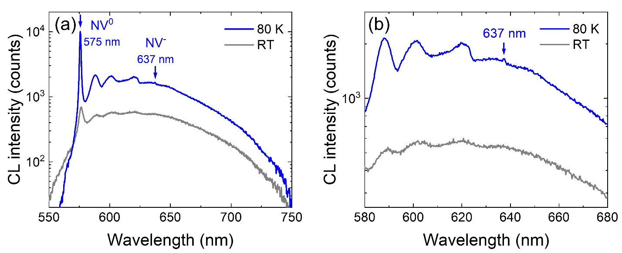
Figure 1 shows the CL spectra of an as-grown diamond sample taken at room-temperature (RT) and 80 K, respectively. For the NV⁰ centers, the ZPL (575 nm) and its sideband could be detected at both RT and 80 K. In contrast, for the NV⁻ centers, it was difficult to distinguish the ZPL of the NV⁻ centers at 637 nm from the room-temperature spectrum, and a weak emission peak at 637 nm was observed when cooled to 80 K. This suggested that although the luminescence intensity of NV⁻ centers was weak in CL experiments, it was still possible to capture the luminescence of NV⁻ centers by lowering measurement temperature.
Figure 1. CL spectra of an as-grown diamond sample taken at room-temperature (RT) and 80 K. (a) Emission bands associated with the NV⁰ and NV⁻ centers in the wavelength range of 550~750 nm; (b) Enlarged view of the spectra showing the weak emission peak at 637 nm detected in the spectrum at 80 K. The CL spectra were taken at 5 kV and 4 nA with a grating of 300 g/mm. (Color in print)
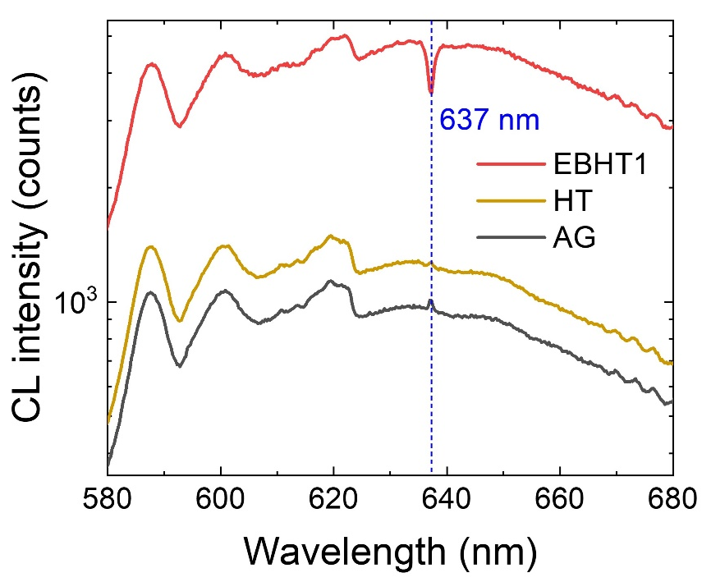
Figure 2 shows the CL spectra of the as-grown (AG), high-temperature annealed (HT), and EB irradiated and high-temperature annealed (EBHT1) samples. The CL spectra of the AG and HT samples have the same shape with a weak emission peak at 637 nm. In contrast, the CL spectrum of the EBHT1 sample showed a distinct feature of spectral dip at 637 nm. This result was contrary to expectations, as we thought that EB irradiated samples might emit stronger luminescence due to the higher concentration of NV⁻ centers.
Figure 2. CL spectra of the AG, HT, and EBHT1 samples. In the AG and HT samples, a weak emission peak was observed at 637, while in the EBHT1 sample, a spectral dip occurred at 637 nm. The CL spectra were taken at 5 kV and 4 nA with a grating of 300 g/mm. (Color in print)
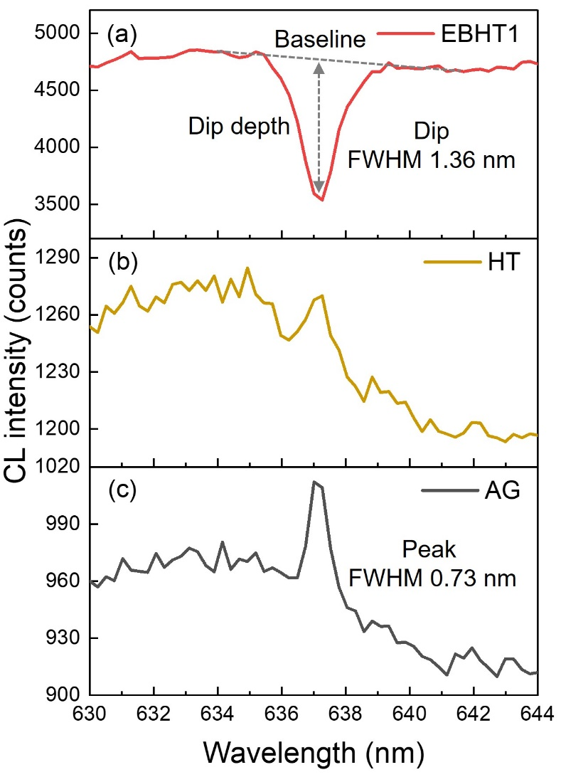
Figure 3 is an enlarged view of the spectra near 637 nm in Fig. 2, where the emission peaks and/or spectral dip can be clearly identified. In the EBHT1 sample, the CL intensity at the spectral dip was reduced about 25% (dip depth) from the baseline. By comparing the spectral shapes of the three samples, we found two important features: (1) The width of spectral dip (full width at half minimum ~ 1.36 nm) was twice the width of the emission peak (full width at half maximum ~ 0.73 nm); (2) In the AG and HT samples, the CL intensity was slightly stronger on the short-wavelength side (< 636 nm) than on the long-wavelength side (> 638 nm). In the EBHT1 sample, the intensity difference between the two sides became small, implying that the intensity of sideband was changed by the formation of spectral dip.
Figure 3. Enlarged view of the CL spectra near 637 nm in Fig. 2 clearly showed the spectral dip occurred in the EBHT1 sample (a) and the emission peaks in the HT (b) and AG (c) samples. (Color in print)
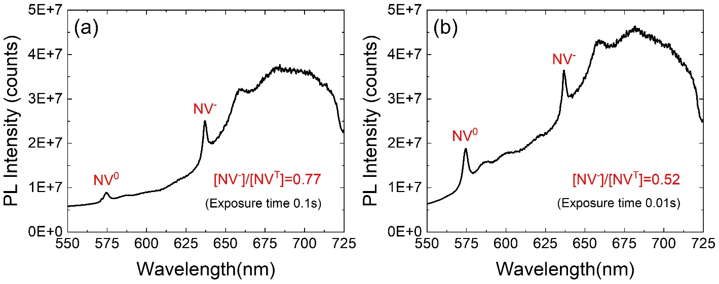
We wanted to know if the concentration ratio of [NV⁻] to [NV⁰] would affect the emission peak or spectral dip. Therefore, we investigated the concentration of NV⁰ centers in these samples by PL measurements. Figure 4 shows the PL spectra of the AG and EBHT1 samples. The normalized PL intensities of the NV⁰ and NV⁻ centers are listed in Table-II. In the AG and HT samples, the PL intensities of the NV⁰ and NV⁻ centers were low, while in the EBHT1 sample they increased by a factor of 100~300. We denoted the total concentration of NV centers by [NV^{T}], i. e., [NV^{T}]=[NV⁻]+[NV⁰]. The ratio [NV⁻]/[NV^{T}] was 0.77 in the AG sample, 0.80 in the HT sample, and 0.52 in the EBHT1 sample. This means that in the AG and HT samples, more than three-quarters of the NV centers were NV⁻, and in the EBHT1 sample half of the NV centers were NV⁻. This suggests that the absolute concentration of NV⁻ centers may be the key factor influencing the appearance of spectral dip, rather than concentration ratio of [NV⁻] to [NV⁰].
Figure 4. Photoluminescence spectra of the AG (a) and EBHT1 (b) samples taken at room temperature. [NV^{T}] denotes the total concentration of NV centers ([NV^{T}]=[NV⁻]+[NV⁰]). The ratio [NV⁻]/[NV^{T}] was 0.77 in the AG sample, and 0.52 in the EBHT1 sample. (Color in print)
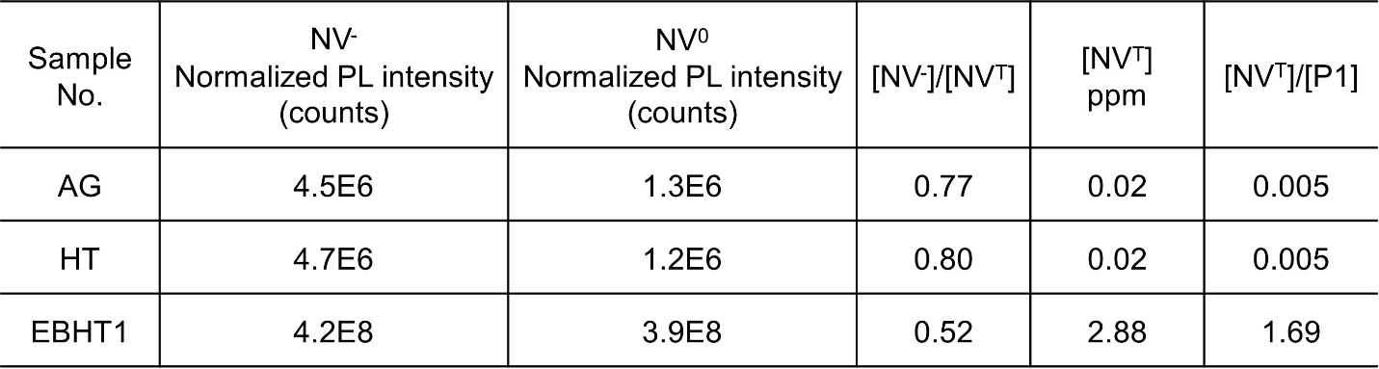
Table-II. Normalized PL intensity of the NV⁰ and NV⁻ centers in the AG, HT, and EBHT1 samples. The concentrations of NV⁰ and NV⁻ centers were derived from PL and EPR measurements.
3.2. Spectral dip in different EB irradiated diamonds
We observed diamond samples grown by CVD or high-pressure synthesis and found that spectral dip occurred in the EB irradiated samples regardless of growth method. However, the depth and width of spectral dip varied greatly from sample to sample. We have investigated different EB irradiated samples (EBHT1, EBHT2, and EBHT3 shown in Table-I) and considered the following factors such as the fluence of EB irradiation, the concentrations of P1 and NV⁻ centers. The N/C ratio was 10,000 ppm for the EBHT1, and 40, 000 ppm for the EBHT2 and EBHT3. The EB irradiation fluence was 1×10¹⁸ e/cm² for the EBHT1 and EBHT2, and 1×10¹⁷ e/cm² for the EBHT3. The concentrations of the P1 and NV⁻ centers based on EPR measurements were also listed in Table-I. The concentration [P1] in the EBHT1, EBHT2, and EBHT3 were 1.7, 2.5, and 2.8 ppm, and the concentration [NV⁻] was 1.5, 1.9, and 0.3 ppm, respectively.
Figure 5 shows the spectral dips observed in the different EB irradiated samples. The spectra were taken with a fine grating of 1200 g/mm in order to obtain a high spectral resolution. We integrated the reduced photon counts at the dips and used it to assess the strength of spectral dip. The intensities (reduced photon counts) and widths (full width at half minimum) of the spectral dips were shown in Table-I. The EBHT1 and EBHT2 samples, which were irradiated with high fluence (high concentration of NV⁻ centers), showed stronger dip intensities compared to the EBHT3 sample irradiated with low fluence (low concentration of NV⁻ centers). The intensity of spectral dip was in the order EBHT1 > EBHT2 > EBHT3. The width of spectral dip was about 0.7 nm for the EBHT1 and EBHT3, and 1.0 nm for the EBHT2. This indicates that only the density of defects has varied in these samples. In the strongly dipped spectra (EBHT1 and EBHT2), the difference between the intensities of the short- and long-wavelength sides became smaller, while in the weakly dipped spectrum (EBHT3), the intensity of the long-wavelength side was slightly low. This further suggests that the variation of the sideband intensities depends on the strength of the spectral dip.

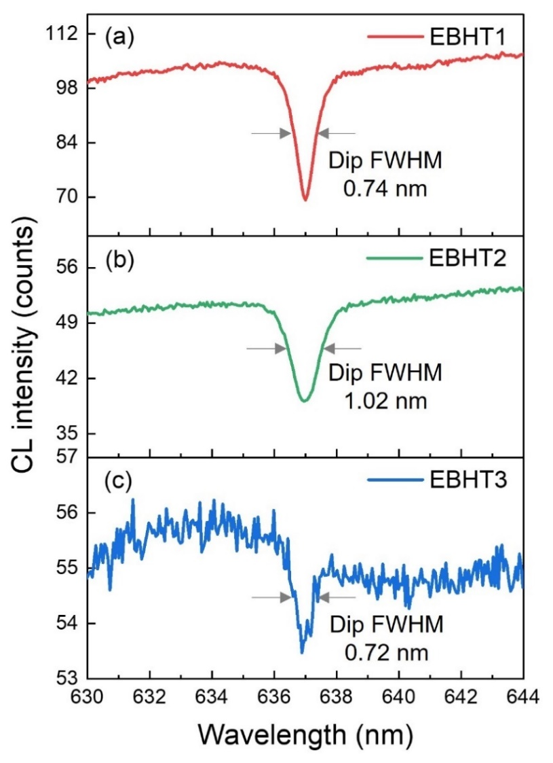
Figure 5. Spectral dips in the EB irradiated samples with different N/C ratios and electron fluences. (a) EBHT1: 10,000 ppm & 1×10¹⁸ e/cm²; (b) EBHT2: 40,000 ppm & 1×10¹⁸ e/cm²; (c) EBHT3: 40,000 ppm & 1×10¹⁷ e/cm². CL spectra were taken at 5 kV and 4 nA with a grating of 1200 g/mm. (Color in print)
3.3 Near-band-edge and nitrogen-related defect emissions
The near-band-edge and nitrogen-related defect emissions were studied in all the samples (AG, HT, EBHT1~3). The near-band-edge emission was obtained under strong excitation condition (15 kV, 80 nA) and high spectral resolution (grating 1200 g/mm). CL measurements of nitrogen-related defect emissions were performed under weak excitation conditions (5 kV, 4 nA) and low spectral resolution (grating 100 g/mm) in order to cover a wide wavelength range. Figure 6 shows the CL spectra of the near-band-edge emissions from the AG, HT, and EB irradiated (EBHT1~3) samples. The near-band-edge emission consisted of the following peaks. The peak positions at 232.8 nm (5.326 eV) and 235 nm (5.277eV) were attributed to free-exciton emission accompanied with a transverse-acoustic (TA) phonon and a transverse-optical (TO) phonon, respectively. The peaks at 242.3 nm (5.118 eV) and 250 nm (4.96 eV) were phonon replica emissions of the 235 nm peak. The near-band-edge emission intensity of EBHT1 was more than one order of magnitude lower than that of AG and HT. Since these three samples were from the same CVD crystal but undergone different post treatments, the variation in the near-band-edge emission intensity suggested that high-temperature annealing has little effect on the emission, while EB irradiation greatly suppressed near-band-edge emissions due to the introduction of a large number of NV centers.
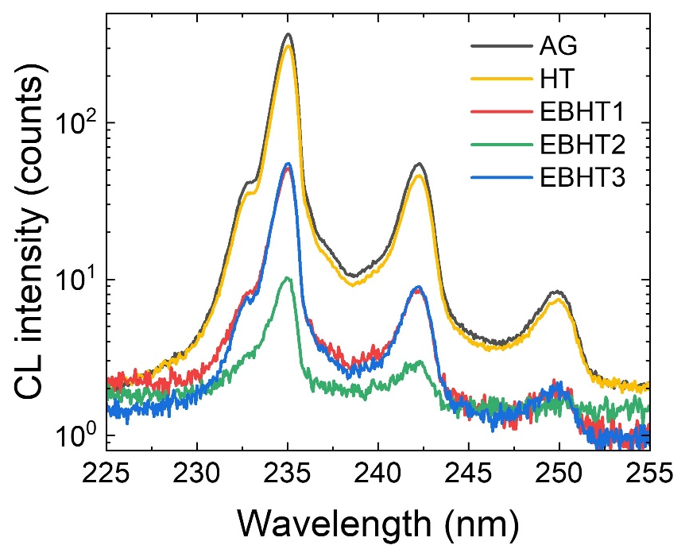
In the EB irradiated samples, the CL intensity of near-band-edge emission was in the order of EBHT1 ~ EBHT3 >> EBHT2. Although the EB irradiation fluence was the same for the EBHT1 and EBHT2, a decrease in the near-band-edge emission intensity was more obviously observed in the EBHT2. Comparison of the concentrations of P1 and NV⁻ centers showed that [P1] was in the order of EBHT3 > EBHT2 > EBHT1, while the [NV⁻] was in the order of EBHT2 > EBHT1 > EBHT3, which implied that the intensity of near-band-edge emission was not much affected by the concentration of P1 centers, but it was more likely to be suppressed with the presence of a high concentration of NV⁻ centers.
Figure 6. CL spectra of near-band-edge emission of as-grown (AG), high-temperature annealed (HT), and three EB irradiated (EBHT1~3) diamond samples. CL spectra were taken at 15 kV and 80 nA with a grating of 1200 g/mm. (Color in print)

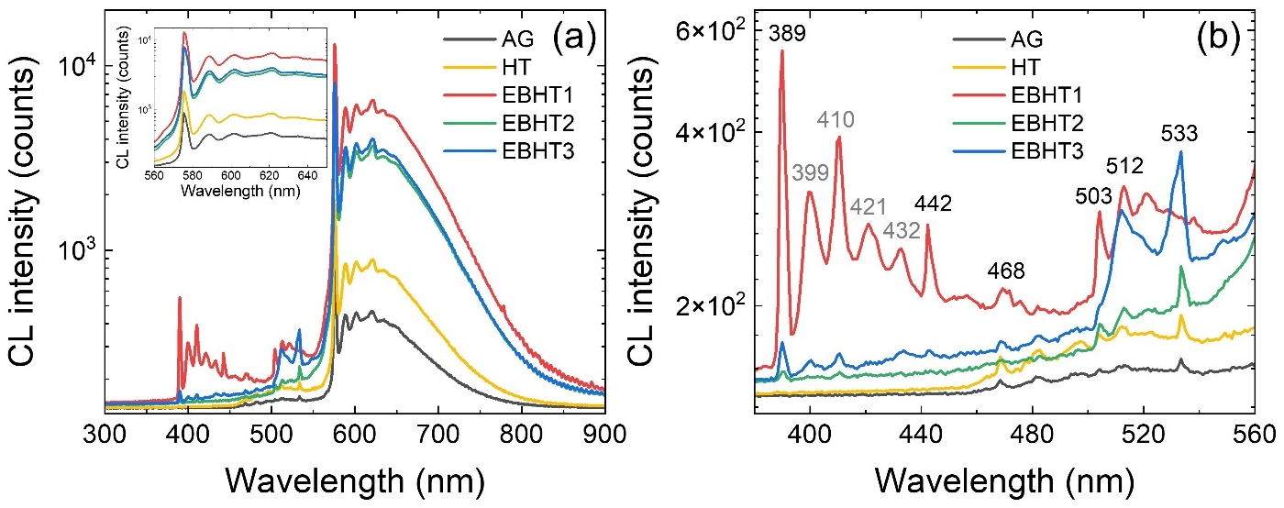
Figure 7 compares the CL spectra of nitrogen-related defect emissions. According to the wavelengths, we divided the spectra into three bands, i.e., violet band (380~450 nm), blue-green band (450~560 nm), and yellow-red band (560~800 nm). Fig. 7a shows the spectra over a wide wavelength range of 300~900 nm, and the inset is a zoomed-in view of the ZPL emission line of NV⁰ centers at 575 nm. Fig. 7b shows a magnified view of the violet and blue-green bands. Under these observation conditions, it was difficult to distinguish the emission peaks or spectral dips of NV⁻ centers.
Figure 7. Nitrogen-related defect emission bands from as-grown (AG), high-temperature annealed (HT), and EB irradiated (EBHT1~3) diamond samples. (a) CL spectra over a wide wavelength range of 300~900 nm, and the inset showed NV⁰ ZPL emission at 575 nm; (b) magnified view of the violet and blue-green emission bands in Fig. 7a. CL spectra were taken at 5 kV and 4 nA with a grating of 100 g/mm. (Color in print)
In the yellow-red band (560~800 nm) associated with NV centers, the spectra of all samples were similar in shape, with only intensity difference in the order of EBHT1 > EBHT3, EBHT2 > HT> AG. In the blue-green band (450~560 nm), the spectra became complex with the appearance of multiple emission lines associated with different types of nitrogen-related defects. Characteristic emission lines at 468 nm, 503 nm, 512 nm, and 533 nm could be identified. According to Zaitsev’s handbook [18], the emission line at 468 nm was assigned to nitrogen-related defect containing interstitial atoms; 503 nm was the well-known H3 center (NVN), which is a characteristic radiating center in diamonds; 512 nm was a defect containing B-type aggregate of nitrogen; and 533 nm was nitrogen-containing defects such as nitrogen-vacancy complexes. The intensity of these emission lines increased slightly after high-temperature annealing and further after EB irradiation. In the violet band (380~450 nm), new emission lines (389 nm, 442 nm) appeared in the EB irradiated samples especially EBHT1. The ZPL at 389 nm and its vibronic sidebands (399 nm, 410 nm, 421 nm, and 432 nm) were characteristic of irradiation damage produced in irradiated diamond. It was attributed to defects containing interstitial nitrogen or substitutional nitrogen bound to interstitial carbon; the ZPL at 442 nm resembled the line at 389 nm and was also associated with irradiation damage involving nitrogen and interstitial carbon. Overall, the CL intensities of both NV⁰ centers emission and nitrogen-related defect emissions were higher for the EBHT1 sample compared to the EBHT2 and EBHT3 samples.
3.4. Discussion - the causes of spectral dip or emission peak
First, we discuss the formation mechanism of spectral dip occurred in CL spectra. The appearance of spectral dip in this study reminded us of the spectral hole burning phenomena reported in early literatures [41-46], in which burning-like holes were created in the absorption or excitation spectra due to absorption at a particular wavelength. It is noteworthy that the reported spectral hole burning phenomena were usually observed in the absorption/excitation spectra of photoluminescence experiments, while it was rarely reported in CL experiments. Early studies have shown that spectral hole burning was due to the splitting of excited state. In the case of NV⁻ centers, it was interpreted as strain-induced splitting of ³A-³E transition [43]. As for the method of observing spectral hole burning, it is generally done under optical illumination using two lasers, one for burning and the other for detection. High resolution pump-probe lasers with ~MHz resolution were used to resolve the individual electronic transitions between different spin projections in the ground and excited states at low temperatures. However, at temperature above 40 K, these transitions were averaged out due to the dynamic Jahn-Teller effect [47]. In this study, the spectral dips were observed at 80 K and remained even at higher temperatures. The FWHM of the spectral dip is about 0.7~1 nm, which is larger than the reported linewidth of spectral hole burning. Therefore, we suspected that the formation mechanism of the spectral dip is different from that of the spectral hole burning.
Previous PL studies have reported that in the emission spectra of NV⁰ centers there was a very small contribution from the NV⁻ centers with ZPL at 637 nm probably due to absorption from the NV⁰ emission, and in addition an absorption dip at 725 nm was observed [48]. The formation of spectral dip in CL spectra may be caused by similar absorption. A possible model that explains the appearance of the spectral dip observed in this study is shown in Fig. 8. This model shows that the spectral dip appears because the sideband of the NV⁰ emission is absorbed by the NV⁻ centers.
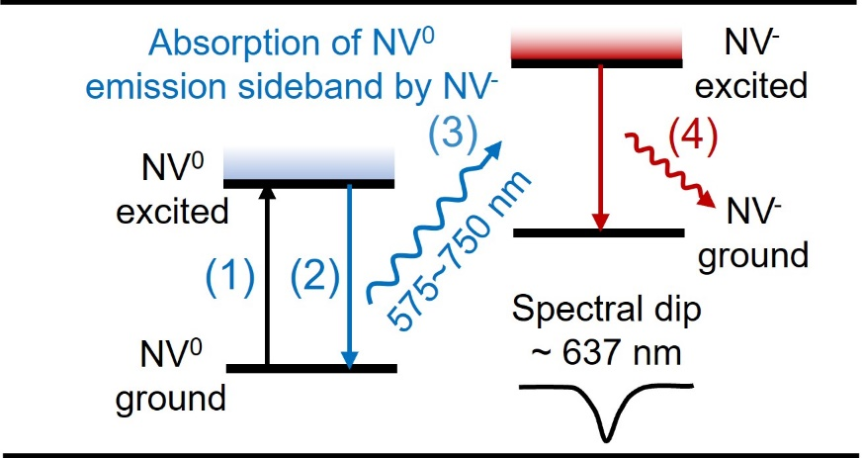
Figure 8. Schematic diagram of the formation mechanism of spectral dip with respect to the concentration of NV⁻ centers. When the concentration of NV⁻ centers is high, the absorption of NV⁰ emission sideband by NV⁻ centers becomes significant, and a spectral dip may be formed in the sideband due to the strong absorption near the ZPL wavelength (637 nm) of NV⁻ centers.
Under electron excitation in CL experiments, the following electronic and optical transitions may occur: (1) transition from the NV⁰ ground state to the excited state; (2) relaxation of the NV⁰ excited state to the ground state via photon emission; (3) absorption of the NV⁰ emission sideband by the NV⁻ centers; and (4) emission from the NV⁻ centers. In EBHT samples, there is a large number of NV⁻ centers that can effectively absorb the NV⁰ emission sideband; on the other hand, the ZPL emission of NV⁻ centers is rather weak in CL measurements because that the NV⁻ centers may be easily be converted into NV⁰ before emission. When the absorption is larger than the emission, a spectral dip may be formed. In the unirradiated samples (AG and HT), the concentrations of NV⁰ and NV⁻ centers are two orders of magnitude lower. The sideband emission from NV⁰ centers is weak, while the absorption in the low concentration NV⁻ centers is negligible and does not result in spectral dip.
The weak emission peak detected in the AG and HT samples could be attributed to the higher proportion of NV⁻ centers and the negative charge state. The charge states of NV centers depended on the concentration ratio of NV centers ([NV^{T}]) to the substituted nitrogen ([P1]). When the ratio [NV^{T}]/[P1] was less than 0.2, the negative charge state of the NV centers is easier to maintain [40]. As shown in Table-II, the [NV^{T}]/[P1] ratio was 0.005 in the AG and HT samples, so that the NV centers in these samples tended to remain in negative charge state. As a result, emission peak from the NV⁻ centers can be detected in low-temperature and low-injection CL measurements due to the weakened ionization.
Next, we discuss the factors that influence the strength of spectral dip. The spectral dip was observed only in the EB irradiated samples suggesting that EB irradiation is an important factor contributing to spectral dip. Among the EB irradiated samples, the EBHT1 and EBHT2 samples with high NV⁻ concentration more than 1.5 ppm showed stronger spectral dip than the EBHT3 sample with low concentration of 0.3 ppm. This further suggests that the concentration of NV⁻ centers plays a decisive role in the appearance of spectral dip. It is worth noting that the spectral dip intensity is not simply proportional to the fluence of EB irradiation or the concentration of NV⁻ centers. At the same EB irradiation fluence, the EBHT2 sample with a high [NV⁻] of 1.9 ppm, showed only half the spectral dip intensity of the EBHT1 sample, which has a relatively low [NV⁻] of 1.5 ppm. Therefore, there may be other factors besides the concentration of NV⁻ centers, one of which is the concentration of substitutional nitrogen (i.e., P1 centers). Since the charge state of NV centers depend on the concentration of P1 centers, and the negative charge state of the NV centers can be maintained when [P1] is high. The ratio [NV⁻]/[P1] was 0.88 for EBHT1, 0.76 for EBHT2, and 0.11 for EBHT3. It is hypothesized that in the EBHT samples with high [NV⁻]/[P1] ratio, the emission from NV⁻ centers is weaker probably due to the fast conversion of NV⁻ to NV⁰. On the other hand, in the EBHT samples with low [NV⁻]/[P1] ratio, the negative charge state of NV⁻ centers can be maintained, so the emission from the NV⁻ centers still contributes. The emission intensity may compensate the absorption intensity. In this sense, the intensity of spectral dip is the result of the competition between absorption and emission of NV⁻ centers.
Conclusions
The optical properties of NV⁻ centers in diamond samples undergone different post-treated conditions were examined by CL spectroscopy. The 637 nm ZPL of NV⁻ centers was not detected in room temperature spectra, but could be detected at low temperatures (80 K) under weak excitation conditions. The emission peak of NV⁻ centers was detected in the as-grown and high-temperature annealed diamond samples, in which the concentration of NV⁻ centers was low. On the other hand, spectral dip at the ZPL of NV⁻ centers occurred in the EB irradiated diamond samples, and this phenomenon was observed experimentally for the first-time in the CL method. The formation of spectral dip is probably due to the absorption of the NV⁰ emission sideband by the presence of high concentration of NV⁻ centers. The strength of the spectral dip is affected by the concentrations of NV⁻ centers ([NV⁻]) and the concentration ratio [NV⁻]/[P1], i.e., the higher the [NV⁻] and [NV⁻]/[P1] ratios, the more likely the strong spectral dip will form.

Acknowledgements
This work was partially supported by JST CREST (JPMJCR1773), JST Moonshot R&D (JPMJMS2062), MIC R&D for construction of a global quantum cryptography network (JPMI00316), MEXT Q-LEAP (JPMXS0118068379 and JPMXS0118067395), CSTI SIP “Promoting the application of advanced quantum technology platforms to social issues”, JSPS KAKENHI (No. 20H05661). We are very grateful to Ms. S. Manako for her help in the PL measurements.
Authorship contribution statement
Jun Chen: Conceptualization, data curation, investigation, methodology, writing - original draft; Chikara Shinei: Conceptualization, data curation, investigation, methodology, writing - review and editing; Junichi Inoue: Conceptualization, methodology, writing - review and editing; Hiroshi Abe: Methodology, writing - review and editing; Takeshi Ohshima: Methodology, writing - review and editing; Takashi Sekiguchi: Supervision, writing - review and editing; Tokuyuki Teraji: Supervision, methodology, writing - review and editing.
Declaration of competing interest
The authors declare that they have no known competing financial interests or personal relationships that could have appeared to influence the work reported in this paper
Data availability
The data that support the findings of this study will be available from the corresponding author upon reasonable request.
References
- C. Kurtsiefer, S. Mayer, P. Zarda, H. Weinfurter, Stable solid-state source of single photons, Phys. Rev. Lett. 85 (2000) 290-293, https://doi.org/10.1103/PhysRevLett.85.290.
- E. van Oort, N. B. Manson, M. Glasbeek, Optically detected spin coherence of the diamond N-V centre in its triplet ground state, J. Phys. C: Solid State Phys. 21 (1988) 4385-4389, https://doi.org/10.1088/0022-3719/21/23/020.
- A. Gruber, A. Dräbenstedt, C. Tietz, L. Fleury, J. Wrachtrup, C. von Borczyskowski, Scanning confocal optical microscopy and magnetic resonance on single defect centers, Science 276 (1997) 2012-2014, https://doi.org/10.1126/science.276.5321.2012.
- G. Balasubramanian, P. Neumann, D. Twitchen, M. Markham, R. Kolesov, N. Mizuochi, J. Isoya, J. Achard, J. Beck, J. Tissler, V. Jacques, P. R. Hemmer, F. Jelezko, J, Wrachtrup, Ultralong spin coherence time in isotopically engineered diamond, Nat. Mater. 8 (2009) 383-387, https://doi.org/10.1038/NMAT2420.
- C. E. Bradley, J. Randall, M. H. Abobeih, R. C. Berrevoets, M. J. Degen, M. A. Bakker, M. Markham, D. J. Twitchen, T. H. Taminiau, A ten-qubit solid-state spin register with quantum memory up to one minute, Phys. Rev. X 9 (2019) 031045, https://doi.org/10.1103/PhysRevX.9.031045.
- J. M. Taylor, P. Cappellaro, L. Childress, L. Jiang, D. Budker, P. R. Hemmer, A. Yacoby, R. Walsworth, M. D. Lukin, High-sensitivity diamond magnetometer with nanoscale resolution, Nat. Phys. 4 (2008) 810-816, https://doi.org/10.1038/nphys1075.
- N. Aslam, M. Pfender, P. Neumann, R. Reuter, A. Zappe, F. F. de Oliveira, A. Denisenko, H. Sumiya, S. Onoda, J. Isoya, J. Wrachtrup, Nanoscale nuclear magnetic resonance with chemical resolution, Science 357 (2017) 67-71, https://doi.org/10.1126/science.aam8697.
- G. Zhang, Y. Cheng, J. Chou, A. Gali, Material platforms for defect qubits and single-photon emitters, Appl. Phys. Rev. 7 (2020) 031308, https://doi.org/10.1063/5.0006075.
- C. Becher, W. Gao, S. Kar, C. D. Marciniak, T. Monz, J. G. Bartholomew, P. Goldner, H. Loh, E. Marcellina, K. E. J. Goh, T. S. Koh, B. Weber, Z. Mu, J.-Y. Tsai, Q. Yan, T. Huber-Loyola, S. Höfling, S. Gyger, S. Steinhauer, V. Zwiller, 2023 roadmap for materials for quantum technologies, Mater. Quantum Technol. 3 (2023) 012501, https://doi.org/10.1088/2633-4356/aca3f2.
- M. Capelli, A.H. Heffernan, T. Ohshima, H. Abe, J. Jeske, A. Hope, A.D. Greentree, P. Reineck, B.C. Gibson, Increased nitrogen-vacancy centre creation yield in diamond through electron beam irradiation at high temperature, Carbon 143 (2019) 714-719, https://doi.org/10.1016/j.carbon.2018.11.051
- H. Hanzawa, N. Umemura, Y. Nisida, H. Kanda, M. Okada, M. Kobayashi, Disorder effects of nitrogen impurities, irradiation-induced defects, and ¹³C isotope composition on the Raman spectrum in synthetic Ib diamond, Phys. Rev. B 54 (1996) 3793-3799, https://doi.org/10.1103/physrevb.54.3793.
- Y. Mita, Change of absorption spectra in type-I b diamond with heavy neutron irradiation, Phys. Rev. B 53 (1996), 11360-11364, https://doi.org/10.1103/PhysRevB.53.11360.
- J. Havlik, V. Petrakova, J. Kucka, H. Raabova, D. Panek, V. Stepan, Z. Zlamalova Cilova, P. Reineck, J. Stursa, J. Kucera, M. Hruby, P. Cigler, Extremely rapid isotropic irradiation of nanoparticles with ions generated in situ by a nuclear reaction, Nat. Commun. 9 (1) (2018) 4467, https://doi.org/10.1038/s41467-018-06789-8.
- G. Davies, M. F. Hamer, Optical studies of the 1.945 eV vibronic band in diamond, Proc. E. Soc. Lond. A. 348 (1976) 285-298, https://doi.org/10.1098/rspa.1976.0039.
- M. W. Doherty, N. B. Manson, P. Delaney, F. Jelezko, J. Wrachtrup, L. C. L. Hollenberg, The nitrogen-vacancy colour centre in diamond, Phys. Rep. 528 (2013) 1-45, https://doi.org/10.1016/j.physrep.2013.02.001.
- N. B. Manson, J. P. Harrison, M. J. Sellars, Nitrogen-vacancy center in diamond: Model of the electronic structure and associated dynamics, Phys. Rev. B 74 (2006) 104303, https://doi.org/10.1103/PhysRevB.74.104303.
- A. Gali, M. Fyta, E. Kaxiras, Ab initio supercell calculations on nitrogen-vacancy center in diamond: Electronic structure and hyperfine tensors, Phys. Rev. B77 (2008) 155206, https://doi.org/10.1103/PhysRevB.77.155206.
- A. M. Zaitsev, Optical Properties of Diamond: A Data Handbook, Springer, Berlin (2001), p. 197, https://doi.org/10.1007/978-3-662-04548-0.
- L. H. Robins, L. P. Cook, E. N. Farabaugh, A. Feldman, Cathodoluminescence of defects in diamond films and particles grown by hot-filament chemical-vapor deposition, Phys. Rev. B 39 (1989) 13367-13377, https://doi.org/10.1103/PhysRevB.39.13367.
- N. C. Burton, J. W. Steeds, G. M. Meaden, Y. G. Shreter, J. E. Butler, Strain and microstructure variation in grains of CVD diamond film, Diam. Relat. Mater. 4 (1995) 1222-1234, https://doi.org/10.1016/0925-9635(95)00300-2.
- A. Tallaire, A.T. Collins, D. Charles, J. Achard, R. Sussmann, A. Gicquel, M.E. Newton, A.M. Edmonds, R.J. Cruddace, Characterisation of high-quality thick single-crystal diamond grown by CVD with a low nitrogen addition, Diam. Relat. Mater. 15 (2006) 1700-1707, https://doi.org/10.1016/j.diamond.2006.02.005.
- L. H. G. Tizei, M. Kociak, Spectrally and spatially resolved cathodoluminescence of nanodiamonds: local variations of the NV⁰ emission properties, Nanotechnology 23 (2012) 175702, https://doi.org/10.1088/0957-4484/23/17/175702.
- S. A. Malykhin, J. Houard, R. R. Ismagilov, A. S. Orekhov, A. Vella, A. N. Obraztsov, Luminescent characteristics of needle-like single crystal diamonds, Phys. Stat. Solidi B 255 (2018) 1700189, https://doi.org/10.1002/pssb.201700189.
- N. Mizuochi, T. Makino, H. Kato, D. Takeuchi, M. Ogura, H. Okushi, M. Nothaft, P. Neumann, A. Gali, F. Jelezko, J. Wrachtrup, S. Yamasaki, Electrically driven single-photon source at room temperature in diamond, Nat. Photon. 6 (2012) 299-303, https://doi.org/10.1038/NPHOTON.2012.75.
- A. V. Osadchy, I. I. Vlasov, O. S. Kudryavtsev, V. S. Sedov, V. G. Ralchenko, S. H. Batygov, V. V. Savin, P. A. Ershov, V. A. Chaika, A. S. Narikovich, V. I. Konov, Luminescent diamond window of the sandwich type for X‑ray visualization, Appl. Phys. A 124 (2018) 807, https://doi.org/10.1007/s00339-018-2230-0.
- H. Watanabe, T. Kitamura, S. Nakashima, S. Shikata, Cathodoluminescence characterization of a nitrogen-doped homoepitaxial diamond thin film, J. Appl. Phys. 105 (2009) 093529, https://doi.org/10.1063/1.3117214.
- D. Yu Fedyanin and M. Agio, Ultrabright single-photon source on diamond with electrical pumping at room and high temperatures, New J. Phys. 18 (2016) 073012, https://doi.org/10.1088/1367-2630/18/7/073012.
- Iakoubovskii, G. J. Adriaenssens, M. Nesladek, Photochromism of vacancy-related centres in diamond, J. Phys.: Condens. Matter 12 (2000) 189-199, https://doi.org/10.1088/0953-8984/12/2/308.
- Y. Dumeige, F. Treussarta, R. Alleaume, T. Gacoin, J.-F. Roch, P. Grangier, Photo-induced creation of nitrogen-related color centers in diamond nanocrystals under femtosecond illumination, J. Lumin. 109 (2004) 61-67, https://doi.org/10.1016/j.jlumin.2004.01.020.
- N. Aslam, G. Waldherr, P. Neumann, F. Jelezko, J. Wrachtrup, Photo-induced ionization dynamics of the nitrogen vacancy defect in diamond investigated by single-shot charge state detection, New J. Phys. 15 (2013) 013064, https://doi.org/10.1088/1367-2630/15/1/013064.
- N.B. Manson, J. P. Harrison, Photo-ionization of the nitrogen-vacancy center in diamond, Diam. Relat. Mater. 14 (2005) 1705-1710, https://doi.org/10.1016/j.diamond.2005.06.027.
- M. Sola-Garcia, S. Meuret, T. Coenen, A. Polman, Electron-induced state conversion in diamond NV centers measured with pump-probe cathodoluminescence spectroscopy, ACS Photonics 7 (2020) 232-240, https://doi.org/10.1021/acsphotonics.9b01463.
- M. Haruyama, H. Kato, M. Ogura, Y. Kato, D. Takeuchi, S. Yamasaki, T. Iwasaki, H. Morishita, M. Fujiwara, N. Mizuochi, T. Makino, Electroluminescence of negatively charged single NV centers in diamond, Appl. Phys. Lett. 122 (2023) 072101, https://doi.org/10.1063/5.0138050.
- T. Teraji, T. Taniguchi, S. Koizumi, K. Watanabe, M. Liao, Y. Koide, J. Isoya, Chemical vapor deposition of ¹²C isotopically enriched polycrystalline diamond, Jpn. J. Appl. Phys. 51 (2012) 090104, https://doi.org/10.1143/JJAP.51.090104.
- T. Teraji, T. Yamamoto, K. Watanabe, Y. Koide, J. Isoya, S. Onoda, T. Ohshima, L. J. Rogers, F. Jelezko, P. Neumann, J. Wrachtrup, S. Koizumi, Homoepitaxial diamond film growth: High purity, high crystalline quality, isotopic enrichment, and single color center formation, Phy. Status Solidi A 212 (2015) 2365-2384, https://doi.org/10.1002/pssa.201532449.
- T. Teraji, C. Shinei, Nitrogen-related point defects in homoepitaxial diamond (001) freestanding single crystals, J. Appl. Phys. 133 (2023) 165101, https://doi.org/10.1063/5.0143652.
- T. Teraji, C. Shinei, Y. Masuyama, M. Miyakawa, T. Taniguchi, Nitrogen concentration control during diamond growth for NV− centre formation, Phil. Trans. R. Soc. A 382 (2023) 20220322, https://doi.org/10.1098/rsta.2022.0322.
- S. Felton, A. M. Edmonds, M. E. Newton, P. M. Martineau, D. Fisher, D. J. Twitchen, Electron paramagnetic resonance studies of the neutral nitrogen vacancy in diamond, Phys. Rev. B 77(2008) 081201 (R), https://doi.org/10.1103/PhysRevB.77.081201.
- C. Shinei, Y. Masuyama, M. Miyakawa, H. Abe, S. Ishii, S. Saiki, S. Onoda, T. Taniguchi, T. Ohshima, T. Teraji, Nitrogen related paramagnetic defects: Decoherence source of ensemble of NV⁻ center, J. Appl. Phys. 132 (2022) 214402, https://doi.org/10.1063/5.0103332.
- C. Shinei, M. Miyakawa, S. Ishii, S. Saiki, S. Onoda, T. Taniguchi, T. Ohshima, T. Teraji, Equilibrium charge state of NV centers in diamond, Appl. Phys. Lett. 119 (2021) 254001, https://doi.org/10.1063/5.0079687.
- R. T. Harley, M. J. Henderson, R. M. Macfarlane, Persistent spectral hole burning of colour centres in diamond, J. Phys. C: Solid State Phys. 17 (1984) L233-L236, https://doi.org/10.1088/0022-3719/17/8/002.
- Y. Yokota, J. S. Ma, T. Ito, A. Hiraki, A. Kurita, T. Kushida, H. Kawarada, Persistent hole burning of the nitrogen vacancy center and the 2.16 eV center of chemical-vapor deposited diamond, Appl. Phys. Lett. 61(1992) 2138-2140, https://doi.org/10.1063/1.108299.
- N.R.S. Reddy, N.B. Manson, E.R. Krausz, Two-laser spectral hole burning in a colour centre in diamond, J. Lumin 38 (1987) 46-47, https://doi.org/10.1016/0022-2313(87)90057-3.
- D. Redman, S. Brown, S. C. Rand, Origin of persistent hole burning of N-V centers in diamond, J. Opt. Soc. Am. B 9 (1992) 768-774, https://doi.org/10.1364/JOSAB.9.000768.
- N.B. Manson, C. Wei, Transient hole burning in N-V centre in diamond, J. Lumin. 58 (1994) 158-160, https://doi.org/10.1016/0022-2313(94)90385-9.
- V. Kiisk, V. Palm, A. Suisalu, I. Sildos, Peculiarities of SHB in the 637 nm line of N-V defects in CVD-grown diamond films, J. Lumin. 86 (2000) 349-353, https://doi.org/10.1016/S0022-2313(00)00178-2.
- K.M.C. Fu, C. Santori, P.E. Barclay, L.J. Rogers, N.B. Manson, R.G. Beausoleil, Observation of the dynamic Jahn-Teller effect in the excited states of nitrogen-vacancy centers in diamond, Phys. Rev. Lett. 103 (2009) 256404, https://doi.org/10.1103/PhysRevLett.103.256404.
- N.B. Manson, M. Hedges, M. S. J. Barson, R. Ahlefeldt, M.W. Doherty, H. Abe, T. Ohshima, M.J. Sellars, NV⁻-N⁺ pair centre in 1b diamond, New J. Phys. 20 (2018) 113037, https://doi.org/10.1088/1367-2630/aaec58.

