Structure-Activity Relationship in PtCo L10 Ordered Phase ORR Catalysts: Pt-rich Shell having Anisotropic Lattice Distortion Revealed by PDF and XAS Analysis

Yunfei Gao^{1†}, Mukesh Kumar^{1†*}, Neha Thakur¹, Weijie Cao¹, Toshiki Watanabe¹, Satoshi Tominaka^{2†*}, Kazutaka Sonobe², Akihiko Machida³, Ryota Sato⁴, Toshiharu Teranishi⁴, Masashi Matsumoto⁵, Hideto Imai⁵, Tomoya Uruga⁶, Yoshiharu Sakurai⁶, Yoshiharu Uchimoto¹

¹ Graduate School of Human and Environmental Studies, Kyoto University, Yoshida Nihonmatsu-cho, Sakyo-ku, Kyoto 606-8501, Japan
² Center for Basic Research on Materials, National Institute for Materials Science, Namiki, Tsukuba, Ibaraki 305-0044, Japan
³ Synchrotron Radiation Research Center, National Institutes for Quantum Science and Technology (QST), SPring-8, Sayo, Hyogo 679-5148, Japan
⁴ Institute for Chemical Research, Kyoto University, Uji, Kyoto 611-0011, Japan
⁵ Fuel Cell Cutting-Edge Research Center Technology Research Association, Aomi, Koto, Tokyo, 135-0064 Japan
⁶ Japan Synchrotron Radiation Research Institute (JASRI), Koto, Sayo, Hyogo, 679-5198, Japan

*Corresponding authors: kumar.mukesh.5x@kyoto-u.ac.jp, TOMINAKA.Satoshi@nims.go.jp

† Authors contributed equally to this work

ABSTRACT
Ordered intermetallic PtCo alloys are promising candidates for next-generation low-Pt catalysts in proton exchange membrane fuel cells (PEMFCs) due to their high activity and stability originating from ligand and strain effects. However, the influence of the ordered phase on the surface structure, especially after Pt-rich shell formation, remains poorly understood. In this study, we systematically investigated the structural and electrochemical properties of PtCo catalysts with varying degrees of ordering, prepared by controlling the annealing temperature and time. We combined X-ray diffraction (XRD), X-ray absorption spectroscopy (XAS), scanning transmission electron microscopy (STEM), and pair distribution function (PDF) analysis to elucidate the correlation between the ordering degree, the atomic structure, and the electrochemical performance. For the first time, our detailed X-ray total scattering measurements revealed the true structural characteristics of PtCo alloys, indicating that the phase types and their relative contents vary significantly with the ordering degree. The ordered PtCo catalysts develop a Pt-rich surface layer with anisotropic strain, featuring contracted Pt-Pt distances along the surface and elongated distances across the surface, which likely contributes to its enhanced ORR activity and stability compared to their disordered counterparts. The electrochemical studies and PDF analysis suggested that ordering transition occurs concurrently with particle growth, leading to an abrupt increase in the ORR activity at 350°C before forming a long-range ordered phase, suggesting that local structural changes at the particle surface play a crucial role in enhancing the ORR activity. Further, operando XAS studies confirm lesser Pt oxidation and Pt-OH formation for ordered structures than disordered ones. We believe that our findings provide new insights into the relationship between the ordering degree, particle growth, and catalytic properties of PtCo catalysts, offering guidance for the design of high-performance electrocatalysts with optimized surface structures.

Keywords: Intermetallic PtCo alloys, ordering degree, oxygen reduction reaction (ORR), X-ray absorption spectroscopy (XAS), pair distribution function (PDF)
Introduction
Proton exchange membrane fuel cells (PEMFCs) have garnered significant attention as a promising energy conversion technology for various applications, particularly in the automotive industry.¹⁻² However, the widespread adoption of PEMFCs is hindered by the high cost and limited availability of platinum (Pt), a key component of the electrocatalysts used in these devices.³⁻⁴ To address this challenge, extensive research efforts have focused on developing Pt-based alloy catalysts with reduced Pt content and enhanced catalytic activity. Alloying Pt with 3d transition metals can effectively reduce Pt usage and improve the catalytic activity through ligand and strain effects.⁵⁻⁶ However, conventional Pt-alloy catalysts often suffer from poor durability due to the leaching of the less noble metal in the harsh electrochemical environment of PEMFCs.⁷⁻⁸ In this context, Pt-based intermetallic compounds have emerged as promising candidates for next-generation PEMFC catalysts. These compounds offer a unique combination of high activity and stability owing to their well-defined atomic arrangement and strong Pt-M bonds.⁹⁻¹⁰ Among various Pt-based intermetallic compounds, PtCo alloys have shown particularly promising performance, meeting the DOE's target for over 8000 h of operation.¹
The formation of Pt-based intermetallic compounds typically involves a high-temperature annealing process to transform the disordered solid solution phase into an ordered intermetallic structure.¹⁰⁻¹² The ordered alloy catalysts are often superior to their disordered counterparts, as the ordered structures tend to induce more pronounced compressive strain due the shortening the Pt−Pt bond distance, which optimizes the adsorption strength of oxygen reduction reaction (ORR) intermediates, thereby enhancing the overall catalytic activity.^{9-10, 13} However, the high temperatures used in the annealing process often result in an increase in particle size, which can negatively affect mass activity due to the reduced surface area. Therefore, the local structural changes that occur at elevated temperatures necessitate a deeper understanding of their impact on catalytic performance. Despite the growing interest in PtCo intermetallic catalysts, a comprehensive understanding of the structural evolution during the ordering transformation remains elusive. Conventional analyses often rely on the appearance of diffraction peaks associated with the ordered phase in X-ray diffraction (XRD) patterns and qualitative or semi-quantitative estimations of the ordering degree based on the relative intensities of these peaks.¹⁴⁻¹⁵ However, these approaches provide limited insights into the detailed structural changes that occur during the ordering process. While XRD is widely used for analyzing crystalline phases ¹⁶⁻²⁰, it primarily provides information on the average structure and is less sensitive to local structural variations or the presence of amorphous phases. Moreover, the accuracy of XRD analysis can be limited for nanomaterials with small crystallite sizes, as the broad diffraction peaks make it challenging to discern subtle structural features. On the other hand, scanning transmission electron microscopy (STEM) offers high spatial resolution, enabling the visualization of individual atoms and the distinction between surface and bulk structures.²¹ However, STEM analysis is often limited to a small number of particles, making statistical analysis challenging. Moreover, it can be difficult to distinguish between amorphous and crystalline materials with unfavorable orientations or small domain sizes. Indeed, many nanomaterials, including PtCo catalysts, often exhibit non-equilibrium phases and disordered structures.²²⁻²³
This study aims to bridge this gap by providing a comprehensive understanding of the ordering transformation and its impact on the surface structure, catalytic activity, and stability of PtCo catalysts. To achieve this goal, we focus on two primary scientific objectives by synthesizing a series of PtCo catalysts with different ordering degrees by systematically varying the annealing temperature and time. Firstly, The structural changes induced by thermal treatment are rigorously analyzed through a combination of synchrotron X-ray measurements and high-resolution electron microscopy, including XRD, , STEM, and pair distribution function (PDF) analysis. In addition to the techniques commonly used in this field, we utilize XAS, which is sensitive to changes in valence state and coordination environment, and detailed PDF analysis, which offers high accuracy for nanomaterials, including amorphous and disordered phases, and enables precise determination of lattice strain. By integrating these advanced characterization techniques, we provide detailed insights into the complex structural evolution of PtCo/C catalysts under thermal and acidic treatments. To the best of our knowledge this study represents the first comprehensive structural analysis of PtCo catalysts using Pair Distribution Function (PDF) techniques, providing a full atomic-level characterization and quantifying the temperature-dependent variations in phase compositions.
Secondly, we examine how the phase transformation from a disordered solid solution to the ordered intermetallic phase affects the ORR activity and stability through the analysis of electrochemical measurements and operando XAS. It is well established that the ordered phase in PtCo catalysts can significantly enhance the catalytic performance, primarily due to the lattice strain effect in the bulk phase.^{10, 24} However, under operating conditions, particularly in the acidic environment of PEMFCs, the less noble metal (Co) tends to dissolve, leading to the formation of a Pt-rich shell on the catalyst surface.²⁵ While this Pt-rich shell is generally believed to be the active site for the ORR ²⁶⁻²⁸, the influence of the underlying ordered phase on the properties of this shell remains an open question. Specifically, it is unclear whether the presence of the ordered phase can further optimize the surface structure and electronic properties of the Pt-rich shell, leading to enhanced ORR activity and stability. This study investigates the influence of local structural changes during the annealing process on the formation of surface Pt-enriched layers and provides valuable insights that can guide the rational design of ordered alloy catalysts for enhanced activity and stability
Experimental methods
Materials and chemicals
Chloroplatinic acid hexahydrate (H₂PtCl₆.6H₂O) and cobalt chloride (CoCl₂) were obtained from Sigma-Aldrich. Vulcan XC-72 was purchased from Cabot Corporation. Perchloric acid (HClO₄,70-72 %) was purchased from Kanto Chemical Co., Inc. Ultrapure (UP), and deionized water (Milli-Q, 18.2 MΩ) was used for the catalyst synthesis and electrochemical measurements.

Synthesis of PtCo/C for different ordering degrees
To synthesize PtCo/C, 0.2 mmol H₂PtCl₆·6H₂O and 0.2 mmol CoCl₂ were dissolved in UP water with 160 mg Vulcan XC-72 as carbon support under continuous stirring. Repeating the process of magnetic stirring and sonication at 70 °C, until smooth slurry was obtained. After drying at 60 °C, the precursor was then subjected to thermal treatment at various temperatures (250 °C, 300 °C, 350 °C, 450 °C, 600 °C, and 700 °C) in 5 % H₂/N₂ atmosphere for 2 h, 10 h, and 20 h, respectively. According to the treated conditions, the samples were denoted as PtCo- “temperature”-“annealing time”, such as PtCo-700°C -2h. To investigate the relationship between the surface structure and the activity, the acid treatment was applied to pre-remove the surface dissolvable Co, making it stable during the fuel cell operation. The acid-treated samples are referred to as PtCo-“temperature”-“annealing time”-A. For example, for the synthesis of PtCo-700°C -2h-A ,20 mg of PtCo-700°C -2h was treated in 0.1 M HClO₄ for 12 h at 80 °C, followed by washing with water for five times and overnight drying at 30 °C.

Electrochemical measurements
The oxygen reduction reaction (ORR) activities of various catalysts were evaluated in a standard three-electrode assembly using a catalyst-coated glassy carbon rotating disk electrode RDE (GC RDE, HOKUTO DENKO, Japan; Φ = 5 mm) as the working electrode (WE), Pt wire as the counter electrode, and a reversible hydrogen electrode (RHE) as the reference electrode in 0.1 M HClO₄ electrolyte. Prior to any electrochemical measurements, the glassy carbon RDE surface was cleaned by polishing it with alumina micropolish (Buehler), followed by a thorough washing with deionized water. For the electrochemical measurements, the catalytic ink was prepared by dispersing the 2 mg catalyst powder in a 1:1 mixture of water and 2-propanal (2 ml) with 40 μL Nafion® solution and sonication for 30 minutes. Subsequently, 10 μL of the prepared catalytic ink was drop-coated on an RDE and dried under rotation of 400 rpm at room temperature. Before assessing the ORR performance, cleaning Cyclic Voltammetry (CV) curves were recorded by scanning from 0.02 to 1.20 V at a scan rate of 100 mV/s for 50 cycles. The final CV curve was recorded between 0.02 to 1.10 V at 50 mV/s in 0.1 M HClO₄ solution. The ORR linear sweep voltammetry (LSV) was obtained by scanning positively from 0.2 V to 1.2 V at 10 mV/s, with the rotation varying from 100 to 2500 r.p.m. in an O₂-saturated atmosphere. Specific activity (SA) at 0.9 V (vs. RHE) was calculated based on the Koutecky-Levich equation. The accelerated degradation tests (ADT) was applied using constant potential polarization at 0.65 V and 1.00 V for 3 s, respectively. After every 2,000 ADT cycles, the CV was recorded to measure the electrochemical surface area (ECSA) of the catalyst. The CO stripping measurements were conducted by purging the CO gas (99.9 %) to the cell for 20 s on the catalyst-modified electrode, after which the bubbling gas was switched to N₂ gas for 40 min to remove the residual CO in the electrolyte. Then, the CO stripping voltammetry was carried out from 0.05 to 1.00 V.

Materials Characterizations
The X-ray diffraction (XRD) characterization of the prepared catalysts was conducted at a scanning rate of 2° min⁻¹ with a step at 0.02° to analyze the structure of the catalysts with Cu Kα radiation (λ = 1.54056 Å) (Rigaku Ultima IV, Japan). Transmission electron microscopy (TEM) images were recorded by JEM-2200FS (JEOL Ltd.) at 200 kV. A JEOL-JEM-ARM200F electron microscope was used for the high-resolution (HR) TEM analysis at 200 kV. The energy-dispersive X-ray Spectroscopy (EDX) and electron energy loss spectroscopy (EELS) mapping were recorded by JEOL-Dual SDD and Gatan-GIF Quantum-ER, respectively. Inductively coupled plasma (ICP) measurements were conducted using the ICPE-9820 instrument (Shimadzu Corporation). The ex-situ and conventional operando XAS measurements of Pt L₃-edge and Co K-edge were measured by synchrotron irradiation at beamlines BL36XU of SPring-8, Japan. The operando HERFD-XAS spectra Pt L₃-edge was conducted at beamlines BL39XU using the same cell as our previous reports.²⁹ A pair of Si (220) monochromators and a total-reflection Rh mirror (4.5 mrad) were used to obtain collimated and monochromatic X-rays. Further the collected HERFD-XAS spectra were further fitted in Athena software using an arrangement equation (eq 1) for the background and two pseudo-Voigt (Gaussian−Lorentzian, GL, product) equations (eq 2) for the peaks, ³⁰ as shown in the following:
$$\frac{A_{bg}}{π}\left[\tan^{-1}\left(\frac{E-E_{bg}}{∆E_{bg}}\right)+\frac{π}{2}\right] (1)$$
$$\frac{A_{n}}{1+4m_{n}\frac{{(E-E_{n})}^{2}}{∆E_{n}^{2}}}\exp\left[-4∙ln2∙\left(1-m_{n}\right)∙\frac{{\left(E-E_{n}\right)}^{2}}{∆E_{n}^{2}}\right] (2)$$
Here, $A_{bg}$ represents the height for the arctan, adjusted to match the $μ_{E}$ within the range of 11569-11573 eV, while its position (Ebg) and width (ΔEbg) were ﬁxed. The parameters that were allowed to vary were the heights (A1, A2) and FWHM’s (ΔE1, ΔE2 ) of both peaks. The G-L mixing proportions (m1, m2) and peak positions (E1,E2) were ﬁxed.

X-ray total scattering data for obtaining pair distribution functions (PDFs) were collected using high-energy synchrotron radiation X-rays at BL22XU (λ = 0.1810 Å) in SPring-8 with a Varex Imaging XRD1621 flat panel detector with a two-second exposure time and 5 min integration time for PtCo/C catalysts. The energy was calibrated using CeO₂ (NIST 674b) through the PDF curve fitting using the PDFfit2 program ³¹ to quantify the lattice parameters and atomic pair distances. Other parameters for converting the two-dimensional data into a line profile were calibrated using CeO₂; for example, the detector distance was determined to be 225.8 mm. The samples were sealed in Cole-Parmer polyimide capillaries (1.0 mmφ). From the integrated intensities of the sample data, only the intensities of the capillary were subtracted. Polarization, oblique incidence with absorption correction for the CsI scintillator layer, and area corrections were performed. The data was then converted into 1D total scattering data using the PIXIA program.³² We assumed that the correlation of X-ray scattering from the carbon support and that from the metal particles was negligible. Thus, the total scattering data from the metal particles only were obtained by subtracting the total scattering pattern of carbon support from the patterns of the carbon-supported catalyst samples. After fluorescence and Compton scattering corrections, the data was normalized with the form factor based on the Faber-Ziman formalism calculated using atomic scattering factors with the MaterialsPDF program. ³² The structure-function, S(Q), was converted into reduced PDFs, G(r), by Fourier transforms in the Q range of 1.33–24.0 Å⁻¹.
The reduced PDF, G(r), and the total scattering data were analyzed simultaneously by curve fitting using the TOPAS program (joint refinements). The common lattice constants and phase contents were utilized in both PDF and XRD refinements, while Pt/Co atomic ratios were determined based on values obtained from Inductively coupled plasma ICP measurements (Table S1). These compositional constraints were performed by refining site occupancies, and thus, the resultant occupancies contained the information of typical site occupancies as well as phase contents. Simple isotropic atomic displacement parameters are used for the XRD structure, while isotropic ones with distance-dependent broadening parameters are used for the PDF structure as used in the PDFfit2 program ³³ (note that we used beq_PDFfit2 macro and refine delta1 value). Chebyshev polynomials (9 parameters) were used for simulating the background intensities for the XRD data not to overfit the broad features underneath the clear Bragg peaks. There are extremely broad features, which can be simulated using a cubic structure having lattice constants close to ones of pure Pt. To balance PDF fitting against XRD fitting, the weighting factor of 0.01/maximum of observed intensities was used. The refinements were repeated until reasonably good refinements were obtained, where all the peaks and broad features were simulated using the structural models and sufficiently good fitting criteria were obtained. Two kinds of fitting criteria, R-weighted (R_{wp}) and Goodness-of-fit (GOF) factors, are used to evaluate the refinements.
Results and Discussions
Synthesis and phase transition analyses by X-ray diffraction (XRD)
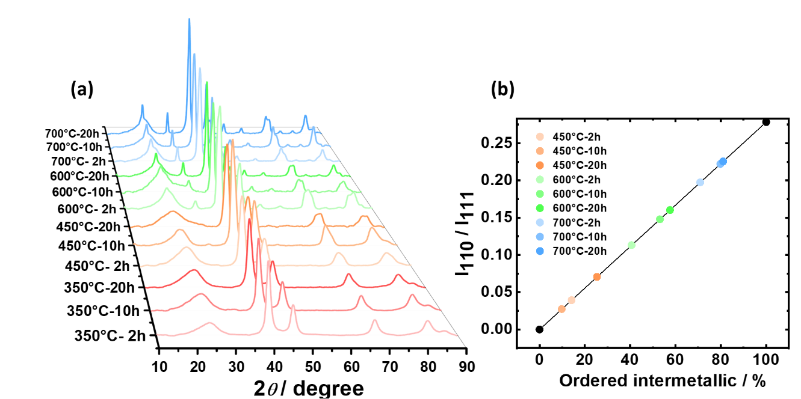
PtCo/C alloy catalysts were synthesized via a simple impregnation method, followed by thermal treatment at various temperatures and durations to achieve different degrees of alloy ordering. The powder X-ray diffraction (XRD) patterns in Figure 1a clearly show two distinct diffraction patterns. At low annealing temperatures (up to 450 °C), the Bragg peaks correspond to the typical face-centered cubic (fcc) structure of Pt alloys (space group: Fm-3m). However, for samples treated at higher temperatures, the peaks can be assigned to the L1₀ ordered PtCo phase (JCPDS: 65-8969) ¹⁸, which has a body-centered tetragonal (bct) structure (space group: P4/mmm). Although the L1₀ structure is conventionally described as bct, it can also be represented as face-centered tetragonal (fct). These two representations are equivalent and describe the same structure ³⁴, but the fct notation can be more intuitive when considering the transformation from the fcc solid solution.

Figure 1. Investigating the formation of ordered phases in PtCo catalysts via XRD analysis. (a) XRD patterns of PtCo catalysts synthesized under different conditions. (b) Ordering degree of PtCo catalysts as a function of annealing temperature and time.

To clarify the structural transformation from the fcc phase, the Bragg peaks of this tetragonal phase are indexed based on a face-centered tetragonal (fct) lattice: peak 1 (23°, 100), 2 (32.5°, 110), 3 (41.3°, 111), 4 (47.7°, 200), 5 (53.5°, 210), 6 (59°, 211), 7 (74.3°, 300), and 8 (79°, 310). Peaks 1, 2, and 5-8 are not observed in the cubic phase (space group: Fm-3m) and indicate the formation of the ordered alloy phase. With increasing annealing temperature, the peak around 2θ = 40° (hkl = 111) becomes sharper, indicating the growth of crystal size. This particle growth is natural as explained by Ostwald ripening or particle migration at high temperatures ^{10, 35}, and the trend was further analyzed using the Debye-Scherrer equation from the half-width at half maximum of the 111 reflections (Figure S2).
Regarding the phase change, the common reflection observed around 2θ = 40° (hkl = 111) positively shifted (Figure S1a), even without appearing Bragg peaks associated with the ordered phase, suggesting lattice contraction due to alloying. The appearance of diffraction peaks at 23° and 32.5° above 450 °C indicates the commencement of the phase transition to the ordered structure. This is consistent with the Pt-Co phase diagram³⁶ , which shows that the ordered phase is stable even at room temperature. While the ordered phase is thermodynamically favored even at lower temperature, the formation of the ordered phase below 450°C may be kinetically hindered due to limited atomic diffusion. The peaks at 23° and 32.5° become more pronounced with increasing temperature, signifying that the ordering ratio increases with both annealing temperature and holding time (Figure S1b).
The fraction of the ordering ratio was roughly estimated by calculating the ratio of I₁₁₀/I₁₁₁ and comparing it with the reported powder pattern (JCPDS: 65-8969) ¹⁵. It is important to emphasize that this approach provides only an approximate estimate of the ordering degree. The reference powder pattern, obtained experimentally, likely contains some degree of disorder, which can lead to an overestimation of the ordering degree in our samples. Furthermore, the comparison of peak intensities at high temperatures with those in the room-temperature database may be influenced by the Debye-Waller factor, which can affect the accuracy of the estimation. The crystallographically simulated ratio for the ideally ordered PtCo L1₀ phase can be in the range of 0.28 to 0.30, depending on atomic displacement parameters. Despite these limitations, the calculated ordering ratio (Figure 1b) shows a clear trend, increasing with both annealing temperature and holding time. This confirms that higher temperatures and longer annealing times promote the formation of the ordered phase in the PtCo catalysts. A more accurate and detailed analysis of the ordering degree and phase composition will be presented in the later section on PDF analysis.
Spatially Resolved Structural Analysis of PtCo Catalysts by scanning transmission electron microscopy (STEM)
To complement the information obtained from XRD, which provides insights into the average structure and phase composition of the PtCo catalysts, we performed high-resolution scanning transmission electron microscopy (HR-STEM) analysis. This technique allows us to directly visualize the atomic arrangement within individual catalyst particles and assess the impact of acid treatment on the microstructure.
Figure 2 shows high-angle annular dark-field (HAADF) STEM images of PtCo catalysts treated at different temperatures. In the PtCo-700°C-10h sample (Figure 2a), a layered structure with alternating Pt and Co atoms is clearly observed, providing direct evidence for the L1₀ ordered phase identified in the XRD analysis. Since the image intensity in HAADF-STEM is approximately proportional to Z^{1.7}, Pt atoms appear brighter than Co atoms. This Z-contrast allows for clear visualization of the ordered arrangement of Pt and Co in the L1₀ structure. This ordered arrangement is further confirmed by the presence of 110 superlattice diffraction spots in the fast Fourier transform (FFT) pattern (inset of Figure 2a), which are characteristic of the L1₀ phase. In contrast, the PtCo-350°C-10h sample (Figure 2b) exhibits a random distribution of Pt and Co atoms, consistent with the disordered fcc alloy identified in the XRD analysis, and these superlattice spots are absent in the FFT pattern (inset of Figure 2b).
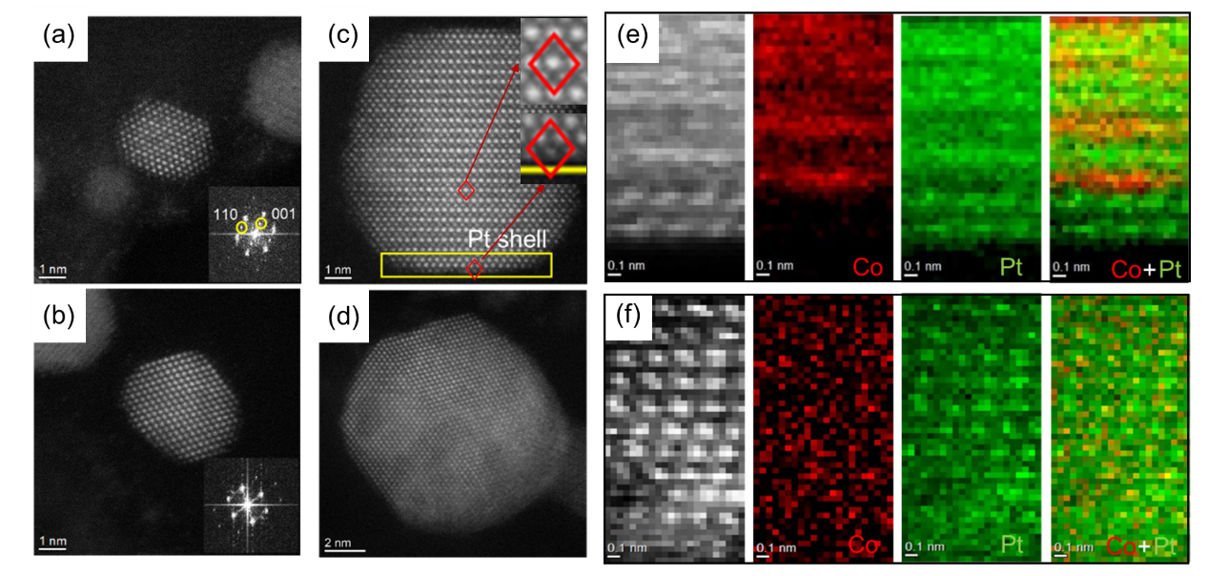

Figure 2. Spatially resolved structural analysis of PtCo catalysts by STEM. (a, b) HAADF-STEM images of the samples without acid-treatment (a,b) compared with those with acid-treatment (c, d). (a) PtCo-700°C-10h and (b) PtCo-350°C-10h catalysts. The inset in (a) shows the FFT pattern of the image. (c, d) HAADF-STEM images of acid-treated (c) PtCo-700°C-10h-A and (d) PtCo-350°C-10h-A catalysts. (e, f) Corresponding electron energy loss spectroscopy (EELS) elemental mapping images of (e) PtCo-700°C-10h-A and (f) PtCo-350°C-10h-A catalysts.

In the observed STEM images, all particles exhibit a continuous atomic arrangement from the crystalline core to the surface, with no indication of a distinct dislocation or amorphization. Note that the topmost layer of each sample seems blurred, which may be attributed to the small number of atoms in the surface layer and the increased positional displacement of these atoms. Even in the samples after acid treatment, the surface atoms appear to be arranged epitaxially with the underlying lattice, but only the ordered PtCo catalysts develop a clear Pt-rich surface layer with a thickness of 2-3 atomic layers, as shown by the intense atomic layers rather than the alternating layers (Figure 2c). This clear Pt-rich layer was straightforwardly visualized by the electron energy loss spectroscopy (EELS) mapping (Figure 2e). While these observations could be interpreted as a higher ordering degree improving the retention of Co during the acid treatment ^{12, 37-38}. In this Pt-rich layer, the metal-to-metal distance is consistent with the underlying PtCo crystal along the layer, but that across the layer is longer. This illustrates the compressed stress from the underlying alloy is clearly anisotropic. In contrast, the disordered sample does not have such a clear Co-deficient, ordered layer, showing a rather gradual decrease in Co concentration towards the surface (Figures 2d, 2f).
The EELS mapping results, combined with the HAADF-STEM images, highlight the impact of the ordering degree on the formation of the Pt-rich shell. The thinner Pt-rich layer observed in the ordered catalyst may indicate that the ordered phase, with its stronger Pt-Co bonding, can influence the structure and composition of the surface layer, even before acid treatment. This difference in the surface layer structure could have implications for the catalytic activity and stability of the PtCo catalysts. While particle size also plays a role in the dissolution behavior during acid treatment ¹⁵, the observed differences in the remaining Co ratio and atomic arrangement in the sublayers, as revealed by the STEM images, indicate that the ordering degree is a significant factor in enhancing the durability of the PtCo catalysts. Further analysis and discussion on the interplay between ordering degree and particle size will be presented in the following sections.
Electronic and Local Structural Analysis of PtCo Catalysts by X-ray absorption spectroscopy XAS
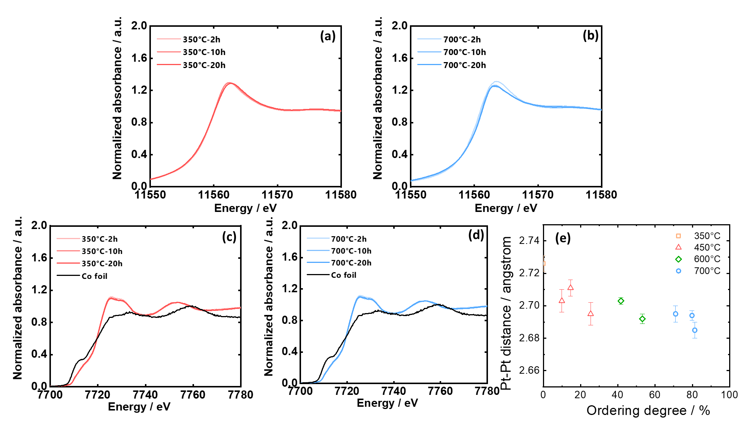
To further investigate the electronic and local structural changes associated with the formation of the ordered phase, we performed ex-situ X-ray absorption spectroscopy (XAS) analysis on acid-treated PtCo catalysts. Figures 3a and 3b show Pt L3-edge X-ray absorption near-edge structure (XANES) spectra for the PtCo catalysts treated at 350°C (disordered) and 700°C (ordered), respectively. A decrease in white line intensity is observed with increasing annealing time, which correlates with the formation of the ordered phase. This decrease is attributed to the increased interaction between Pt and Co, leading to a change in the electronic structure of Pt. The Co K-edge XANES spectra (Figures 3c and 3d) provides further evidence for this interaction. The white line peak intensity at the Co K-edge follows the order of 20 h > 10 h > 2 h. The trends observed in the Co K-edge XANES spectra also suggest changes in the electronic environment of Co with an increase in thermal treatment time. This reduction in white line intensity is more significant for the sample treated at 700°C than that at 350°C (see also Figures S3 and S4 for other samples), suggesting that a higher ordering degree contributes to a stronger interaction between Co and Pt.³⁹

Figure 3. Ex-situ XAS analysis of the PtCo alloys annealed at different temperatures. (a, b) Pt L3-edge XANES spectra of PtCo alloys treated at (a) 350 °C and (b) 700 °C for different durations (2,10 and 20 h). (c, d) Co K-edge XANES spectra of PtCo alloys treated at (c) 350 °C and (d) 700 °C for different durations (2,10 and 20 h). (e) Correlation between the ordering degree and the Pt-Pt bond distance obtained from the ex-situ EXAFS analysis for catalysts treated above 400 °C over the ranges 3.0 ≤ k ≤ 16.0 and 1.5 ≤ r ≤ 3.3 for the Pt L₃-edge.

Furthermore, to obtain quantitative structural information, we performed Fourier transform (FT) extended X-ray absorption fine structure (EXAFS) analysis. The Pt-Pt bond distance was determined by fitting the EXAFS data using the IFEFFIT code via Artemis.⁴⁰ The EXAFS data were fitted with either fcc or fct PtCo models based on the XRD results, using FEFF 7.0 (for fitting details, see Figure S5 and Tables S2 and S3). As expected, the Pt-Pt bond distance decreased with increasing annealing temperature, reflecting the lattice contraction induced by the formation of the ordered phase. Figure 3e shows the relationship between the Pt-Pt bond distance and the ordering degree for the catalysts treated above 400°C. A clear linear relationship is observed, confirming that the lattice contraction is indeed associated with the increased ordering. The EXAFS analysis also revealed that the total coordination number of Pt increases with increasing temperature, which is consistent with the particle size growth observed in the XRD results. Moreover, the increasing CN_{Co-Co} fraction with increasing ordering degree indicates a higher Co retention after acid treatment. These findings from the EXAFS analysis further support the idea that a higher ordering degree in PtCo catalysts leads to a more stable structure with a contracted lattice and higher Co retention, which could potentially improve the ORR activity as it could weaken the oxygen adsorption energy.⁴¹

Comprehensive Structural Analysis of PtCo Catalysts by X-ray Total Scattering
While XRD analysis provides valuable information about the average crystal structure and phase composition of the PtCo catalysts, it is limited in its ability to characterize local structural disorder and the presence of non-crystalline phases. To gain a more comprehensive understanding of the structural evolution of these catalysts, particularly after acid treatment, we analyzed pair distribution functions (PDFs). PDFs are highly sensitive to local atomic arrangements and can reveal subtle structural features that may not be apparent in conventional XRD patterns. We obtained PDFs of metal nanoparticles only by carefully subtracting the contribution of the carbon support from the synchrotron X-ray total scattering data. This was achieved by measuring the scattering pattern of the carbon support separately and subtracting it from the scattering patterns of the supported PtCo catalysts. This procedure ensures that the resulting PDFs primarily reflect the atomic pair correlations within the PtCo nanoparticles, allowing for a more accurate analysis of their structure.
We simultaneously analyzed both XRD patterns and PDFs to extract structural details of varying crystallinity. Combining reciprocal-space and real-space data provides a comprehensive view of atomic structure of the PtCo catalysts, including crystalline and non-crystalline components. Figures 4a and 4b illustrate a representative fitting result for PtCo-700°C-2h-A, demonstrating a good agreement between the simulated and experimental data. Notably, this fitting required at least four structural models, indicating structural inhomogeneity in the sample even after high-temperature treatment. In the simultaneous curve-fitting of the XRD pattern and the PDFs of a series of the PtCo/C catalysts (Figure S6 and S7), all the samples seem to consist of multiple phases and thus we used five different structural models (Figure 5c) for simulating them. Phase (i) was simulated using the typical fcc solid solution, consistent with the XRD analysis. Phase (ii) was simulated using a well-ordered L1₀ phase (bct), also identified in the XRD analysis. Phase (iii) was an additional tetragonal phase, where lattice parameters were close to cubic but with a slight tetragonality. This pseudo-tetragonal phase exhibited site mixing, indicating a less distinct separation of Pt and Co sites. Phase (iv) was an fcc Pt phase with lattice constants slightly shorter than pure Pt. Phase (v) was a tiny domain with an fcc structure.
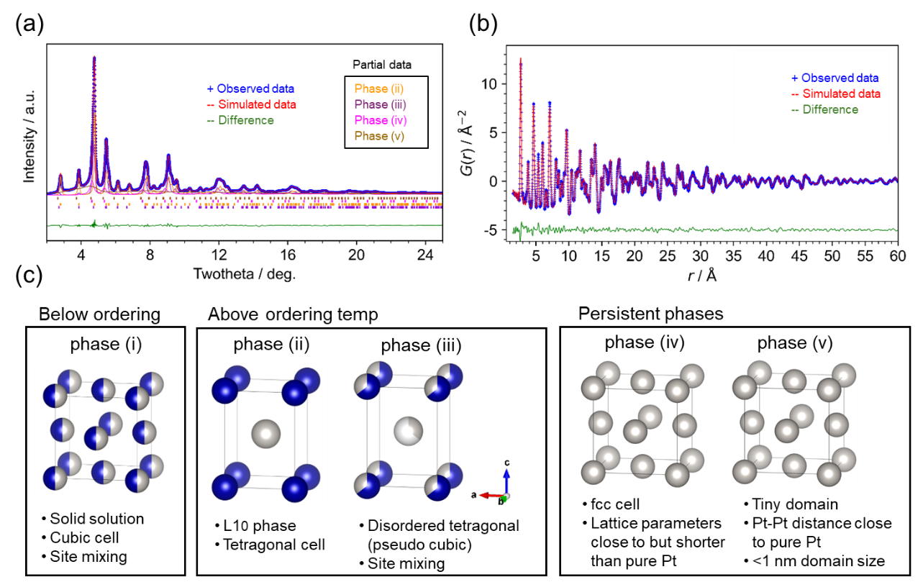
Figure 4. X-ray total scattering analyses for the PtCo/C catalysts after annealing at 700°C for 2h and subsequent acid treatment. (a) XRD curve fitting result. (b) PDF curve fitting result. The curve fitting was performed simultaneously using four common structural models. (c) The structural models used in the analyses. Below the ordering temperature, (i) a PtCo solid solution model with an fcc structure (space group: Fm-3m) is dominant. Above the ordering temperature, two tetragonal alloy models are used: (ii) a well-ordered PtCo intermetallic alloy (L1₀ phase) with a bct structure (space group: P4/mmm), and (iii) a disordered tetragonal phase with a bct structure exhibiting site mixing, similar to the solid solution. Lattice parameter is close to a cubic lattice though with a slight tetragonality. Throughout the entire temperature range, (iv) a Pt crystal phase with an fcc structure (space group: Fm-3m) and lattice parameters close to pure Pt is included. Additionally, broad features and short-range orders observed in the XRD and PDFs, respectively, suggest the presence of tiny domains with amorphous-like features. (v) A tiny domain with an fcc structure was added to model these features.

We analyzed the structural details, in particular structural changes upon thermal treatment, through the simultaneous curve-fitting of the XRD pattern and the PDFs of a series of acid-treated PtCo/C catalysts (Figure S6 and S7). Below 350°C, phase (i) is dominant, and then above 450°C, this phase disappears and is replaced by tetragonal phases of phase (ii) and phase (iii) as summarized in Figure 5a and Figure S8. The contents of these crystalline phases clearly visualize the structural ordering of the disordered solid solution (phase i) to form ordered intermetallic phase (phase ii) above 450°C (Figure 5a). The formation of disordered tetragonal phase (phase iii) at high temperatures suggests partial ordering of off-stoichiometric PtCo nanoparticles. The compositional trend summarized in Figures 5b (and Figure S8) indicates that more Co remains in the catalysts after acid treatment as temperature increases and reaches a plateau around 450°C. Note that the structural model fittings were performed with elemental ratios constrained to the values obtained from these ICP measurements. As shown in Figure 5c, the domain sizes of the phases increase abruptly around 350°C, indicating that significant particle growth occurs before the ordering transition. This observation will be further discussed in the electrochemistry section. The higher Co retention suggests the enhanced stability of the intermetallic phase against acid leaching.
Throughout the entire temperature range, an fcc structure similar to pure Pt, phase (iv), was also found. This phase probably represents a PtCo alloy with a low Co content, insufficient to induce ordering, due to compositional inhomogeneity of deposited particles. The experimental data, which exhibited broad features and short-range orders in the XRD and PDFs, respectively, could not be adequately simulated using only these crystalline phases. Thus, phase (v), a tiny domain or a disordered structure was also observed in the entire temperature range. The structural information for this phase was extracted from the PDF refinement, where it was modeled using a typical fcc with a spherical particle envelope for simulating tiny domains (domain size: <1 nm, Figure 5c and Figure S9). Note that the broad XRD feature can be modeled using an fcc Pt crystal model in the P1 space group (cubic lattice with variable site occupancy) with broad peak shapes, but this is merely a fitting artifact, indicating that it does not represent a physically meaningful structural feature. Considering the almost constant content of this phase even in the sample annealed at a high temperature, this phase may not exist as isolated small particles.

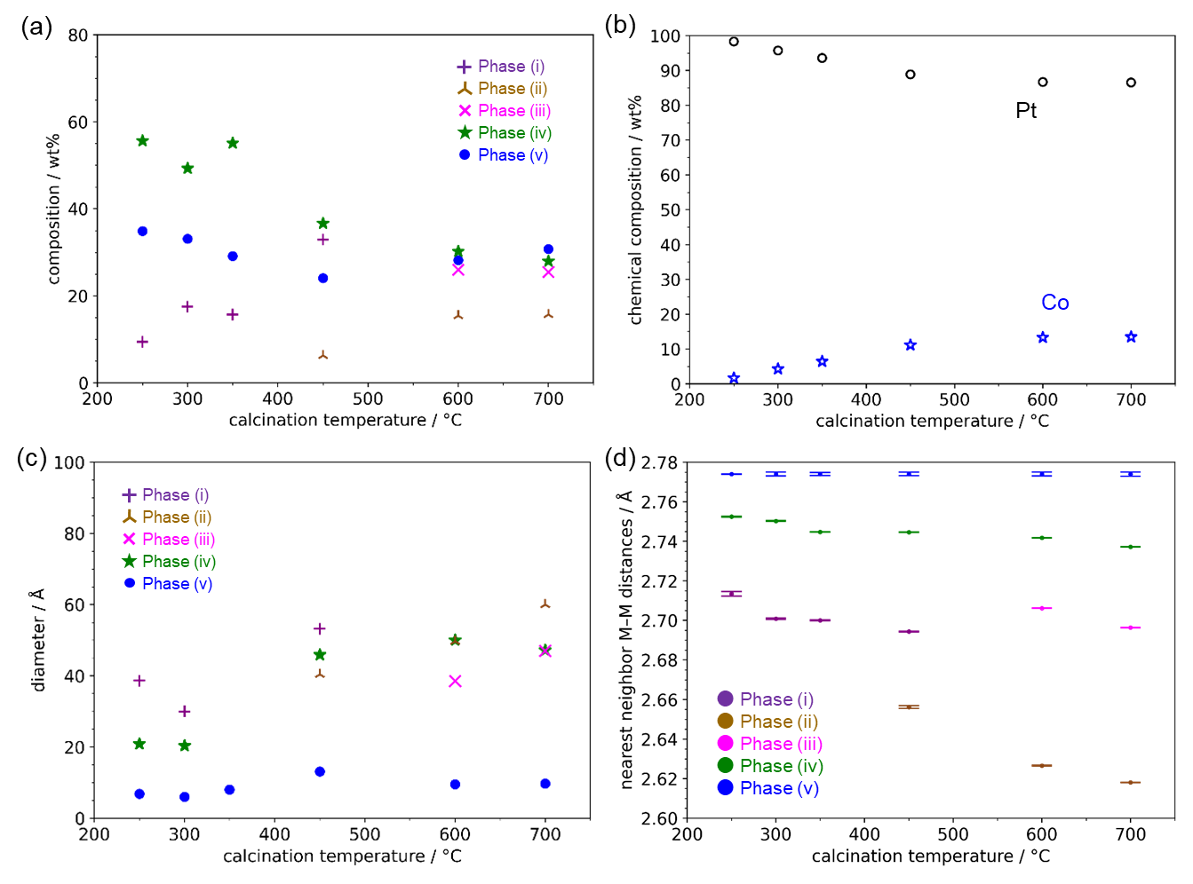
Figure 5. Structural evolution of PtCo catalysts as a function of annealing temperature. The trends of the five phases defined in Figure 4c are summarized. (a) Phase fractions (wt%) obtained from PDF analysis. (b) Chemical composition determined by ICP measurements. The elemental ratios derived from these measurements were used as constraints for the structural model fittings. (c) Domain size of the phases obtained from PDF analysis. The domain size represents the spatial extent of the region where atomic correlations can be described by a single-phase model. (d) Nearest neighbor Pt-Pt distances in each phase obtained from PDF analysis. All samples were annealed for 2 hours and subsequently treated with acid.

Figure 5d shows the nearest neighbor Pt-Pt bond distance in each phase as a function of annealing temperature (see Figures S10 and S11 for other annealing conditions). The overall trend corresponds to the Pt-Pt distance obtained by the EXAFS analyses (Figure 3e), but the PDF analyses provide more detailed information for each phase. Interestingly, the EXAFS analyses revealed that the average Pt-Pt distances monotonically and linearly decreased with increasing temperature. In contrast, the PDF analyses showed that the metal-to-metal distance in the crystalline tetragonal structure, phase (ii), exhibits a non-linear decrease upon structural transformation. The observed contraction of the Pt-Pt bond distance with increasing temperature is attributed to the transformation to the ordered phase. The observed contraction of the Pt-Pt bond distance with increasing temperature is attributed to the transformation to the ordered phase. The contracted core alloys cause compressed strain along the surface layer, as seen in the epitaxial relationship. This lattice contraction in the bct phase is consistent with the ligand and strain effects from the inner alloy phases ^{1, 42-43}, and the short metal-to-metal distance is expected to correlate with the ORR activity, as discussed in the following sections.
In the persistent tiny domain, phase (v), the metal-to-metal distance is longer than that of the alloys (Figure 5d and S11). This, combined with the STEM analyses, indicates that the atomic pairs observed as this phase should be the atomic pairs across the surface layer, while the metal-to-metal distance along the surface layer is indistinguishable from those in the underlying PtCo alloy due to the epitaxial relationship. The presence of this elongated Pt-Pt distance across the surface layer in all samples, as revealed by the PDF analysis, suggests that stress relaxation towards the surface is a common phenomenon in PtCo catalysts, regardless of the ordering degree. While this elongated distance is most clearly observed in the acid-treated ordered phase by STEM, it is reasonable to expect that the Co-deficient surface layer, grown epitaxially on the PtCo alloy, would exhibit a longer metal-to-metal distance across the layer to relieve stress perpendicular to the interface. This is consistent with the formation of a Pt skin layer during annealing under a reducing atmosphere ⁴⁴⁻⁴⁵, which is known to transform into a Pt skeleton layer, a Co-deficient surface layer (2-3 atomic layers thick), upon acid treatment.⁴⁶ Therefore, the PDF analysis likely detects this elongated Pt-Pt distance in all samples, reflecting the presence of the Pt skin layer even before acid treatment. Therefore, these PDF analyses, combined with the XRD, XAS, and STEM measurements, provide a comprehensive understanding of the structural features of the PtCo catalysts, as illustrated in Figure 6.
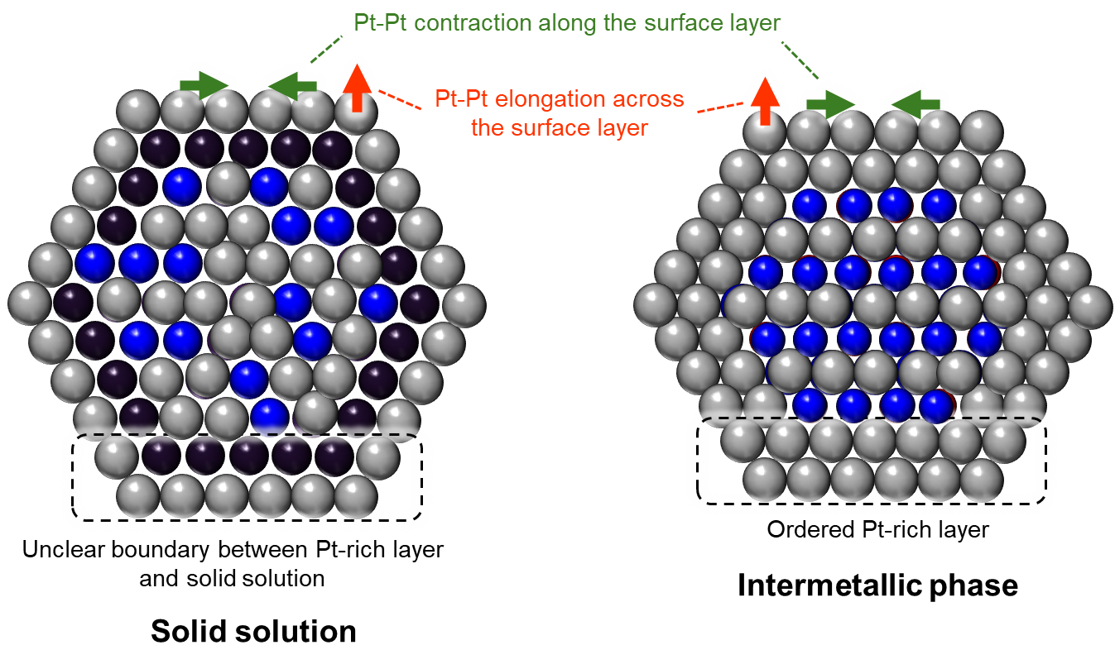

Figure 6. Schematic illustration of the atomic structure of solid solution and intermetallic PtCo catalysts, created based on comprehensive analysis results. Common features: TEM elemental analysis reveals a Pt-rich surface layer (2-3 atomic layers thick) formed by acid treatment in both catalysts. This layer is characterized by contracted Pt-Pt distances along the surface (by high-resolution TEM) and elongated Pt-Pt distances across the surface (by high-resolution TEM and PDFs), indicating anisotropic strain. The Pt-rich layer grows epitaxially on the underlying alloy substrate, as observed by TEM. (left) The Pt-rich layer in the solid solution catalyst shows a less defined structure with a gradual decrease in Co concentration towards the surface. (right) In the ordered intermetallic catalyst, the Pt-rich layer exhibits a distinct, ordered Co-deficient structure with a clear interface with the underlying alloy, as observed by TEM. PDF analysis shows that the metal-to-metal distance in the core of the intermetallic particle is more markedly contracted than in the solid solution.

To confirm that these multiple phases were not primarily caused by the acid treatment, we also analyzed the sample before acid treatment. This analysis revealed the presence of a small amount of cobalt oxide in addition to the main phases when treated at a low temperature of 350°C (Figure S12), but no significant changes in the other phases were observed. In particular, the sample annealed at 700°C for 20 h did not show a remarkable difference before and after the acid treatment (Figure S13), where no cobalt oxide was observed. A detailed comparison of the structural parameters before and after acid treatment (Tables S4-S6) reveals that the core ordered crystals, phases (ii) and (iii), remain largely unchanged, while the Pt-Pt distances in the Pt-rich fcc structure, phase (iv), and the surface Pt-Pt pairs, phase (v), become slightly longer after acid treatment. Moreover, the domain size of phase (v) decreases after acid treatment, consistent with the formation of a distinct surface layer observed by STEM. These observations indicate that the acid treatment primarily removes the cobalt oxide (Co₃O₄) in the disordered phase and promotes the formation of a well-defined, ordered Pt-rich surface layer in the ordered phase.
It is noteworthy that even after high-temperature annealing, the samples still exhibit some inhomogeneity, as evidenced by the presence of the Pt-rich fcc phase and the disordered bct phase. This inhomogeneity may arise from variations in composition among the particles. The fact that the transition to the ordered phase occurs around 450°C is in contrast to the findings in previous studies ¹⁵, where no transition was observed at this temperature. While the Pt-Co phase diagram indicates that the L1₀ phase is thermodynamically stable above approximately 450°C, the actual transition to the ordered phase is also governed by kinetic factors. In other words, while the ordered phase is thermodynamically favored at 450°C, the transition may be kinetically hindered at lower temperatures. The observed discrepancy in the transition temperature suggests that additional factors, beyond thermodynamic stability, influence the ordering process.
One possible explanation, based on the analysis of Avrami exponents in a previous study ⁴⁷, is that the nucleation of the ordered phase may be limited to specific sites, such as interfaces or grain boundaries. This is consistent with our observation that the domain size where atomic correlation can be regarded as a consistent phase, or particle size, increases abruptly at the slightly lower temperature of 350°C than the structure transition temperature from the solid solution to the ordered phase. Note that this particle coagulation was also confirmed by the surface area change by electrochemistry in the following section. This suggests that particle migration and coalescence may trigger the phase transition by providing the necessary nucleation sites for the ordered phase. Alternatively, atomic diffusion may be a rate-limiting step in the ordering kinetics, as suggested by the Avrami analysis in the previous study. It is plausible that the release of surface energy during particle growth facilitates atomic diffusion, thereby promoting the formation of the ordered phase. Overall, our observations, combined with the insights from previous kinetic studies, indicate that particle growth plays a crucial role in triggering the phase transition in the PtCo catalysts by influencing both the nucleation and growth processes of the ordered phase.
Electrochemical Characterization of PtCo Catalysts: Activity and Stability
The PDF analyses provided detailed insights into the structural evolution of the PtCo catalysts, revealing a significant particle growth upon the structural transition to the ordered phase. To further investigate this phenomenon and its impact on the electrochemical properties, we performed electrochemical characterization of the PtCo catalysts. Figures 7a and 7b display the cyclic voltammetry (CV) curves for PtCo alloy catalysts prepared by different annealing conditions. As shown in Figure S14, the electrochemical surface area (ECSA) exhibits a non-linear dependence on the annealing temperature, with a sharp decrease observed around 350°C, followed by a more gradual decrease at higher temperatures (cf. 77.2 m²/g for PtCo-250°C-2h; 25.7 m²/g for PtCo-700°C-20h). This behavior is consistent with the changes in domain size (or particle size) observed in the PDF analysis (Figure 5c) due to the increase in the particle size.

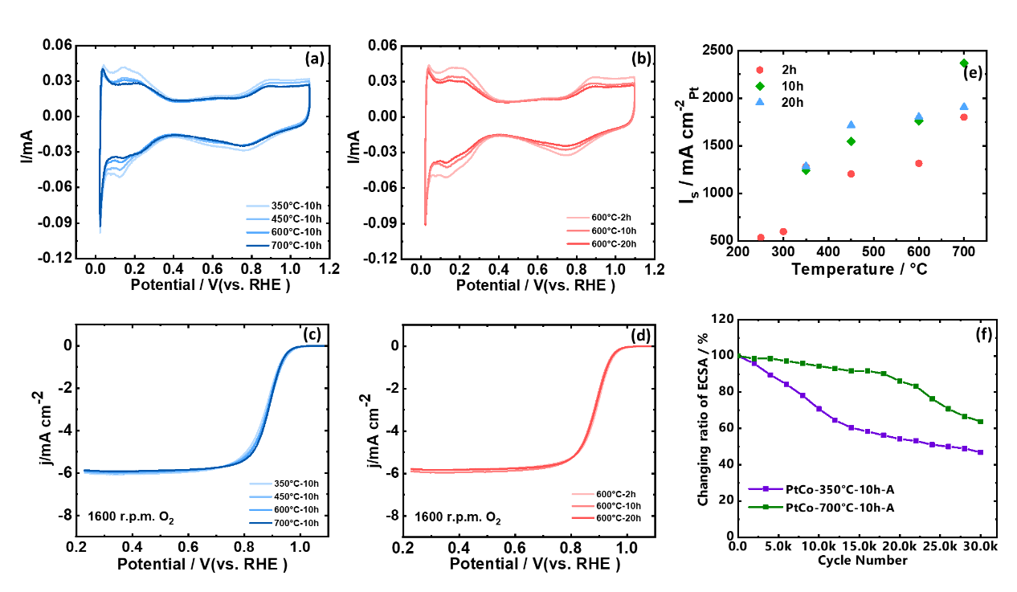
Figure 7. Electrochemical properties of the PtCo catalysts prepared at different annealing conditions. CV curves for (a) PtCo catalysts treated at different temperatures, and (b) PtCo catalysts treated at different annealing times. LSV curves for the (c) PtCo catalysts treated at different temperatures and (d) PtCo catalysts treated at different thermal times. (e) specific activity at 0.9 V for the catalysts treated at different thermal conditions, (f) ECSA loss ratio during the 30 k ADT cycles.

To evaluate the impact of structural changes on the catalytic activity, we investigated the oxygen reduction reaction (ORR) performance of the PtCo catalysts. Figures 7c and 7d show the ORR polarization curves for the PtCo catalysts annealed at different temperatures and for different durations, respectively. To quantify the activity, the specific activity (SA) and mass activity (MA) were calculated at 0.9 V. Despite the decrease in ECSA with increasing annealing temperature, the ORR activity exhibits an opposite trend, showing a significant increase in specific activity as shown in Figure 7e. This suggests that factors beyond the ECSA, such as the electronic and geometric effects and local structural changes induced by alloying and ordering, play a crucial role in determining the ORR activity. The SA exhibits an abrupt increase around 350°C, even before the bct phase is observed in the XRD and PDF analyses. Further, after an abrupt increase in SA around 350°C, a more gradual increase in ORR activity was observed at higher temperatures, which correlates with the increasing fraction of the bct phase. As evident from the above results there is a distinct temperature gap between the onset of enhanced ORR activity (350 °C) and the appearance of the bct phase. This discrepancy suggests that local structural changes at the catalyst surface preceded the formation of the long-range ordered bct phase. As discussed earlier, 350°C coincides with the onset of particle coalescence which is well supported by the XRD and PDF results (Figures 1 and 5). The particles coalescence which may trigger the nucleation of the ordered phase at the particle surface. As the particles begin to coalesce, the atomic structure at the particle surface might become more favorable for the nucleation of the ordered phase, which typically occurs at sites of high energy, such as at the surface where atoms start to arrange into a more ordered arrangement. These nuclei could induce local strain and alter the electronic structure of the surface Pt atoms, leading to enhanced ORR activity. It is important to recognize that electrochemical properties, such as ORR activity, are highly sensitive to the local atomic arrangement and electronic structure at the catalyst surface. Therefore, the initial enhancement in ORR activity at 350°C is likely driven by these local structural changes (further supported by the decrease in ECSA from 300 to 350 °C) rather than the long-range ordering of the bulk PtCo alloy. Therefore, combining XRD, PDF, and electrochemical performance, it can be concluded that the ORR activity enhancement at 350°C is due to the local structural changes due to the coalescence of particles at this temperature. This indicates that the enhancement in ORR activity is not solely due to the long-range ordering associated with the formation of the bct phase. The SA increases approximately four-fold from 533 μA/cm²_{Pt} for PtCo-250°C-2h to 2369 μA/cm²_{Pt} for PtCo-700°C-10h.
This enhancement in SA after 350°C is much larger than what would be expected from the size effect alone ⁴⁸⁻⁴⁹, suggesting that strain or ligand effects associated with the ordered phase contribute significantly to the enhanced ORR activity. In contrast to SA, the MA remains relatively constant across the different annealing temperatures (Figure S15). In a disordered alloy, Pt and Co atoms are irregularly arranged in a random manner, which can lead to a heterogeneous distribution of active sites, and some active sites may not be as catalytically efficient as other sites. As the degree of order increases, the atomic arrangement of Pt and Co becomes more regular, which may lead to a more uniform distribution of active sites on the surface. This can enhance the catalytic activity per unit of surface area (surface-specific activity) by optimizing the electronic structure of the active sites, such as improving the charge density at the surface, promoting better interaction with the reactants, or minimizing the formation of less active sites.⁵⁰ However as evident from Figure S2, ordered alloys exhibit larger particle sizes, which leads to a decrease in the total surface area available for catalysis relative to the catalyst mass. Although atomic ordering improves the efficiency of active sites, the larger particle sizes reduce the overall surface area, which limits the increase in mass-specific activity due to the competing effects of the decreasing ECSA and the increasing SA.⁵¹

The stability of the PtCo-700°C-10h and PtCo-350°C-10h catalysts was evaluated using accelerated degradation tests (ADT). As shown in Figure 7f and Figure S16, only a slight ECSA loss is observed for the PtCo-700°C-10h-A catalyst, while the PtCo-350°C-10h-A catalyst exhibits a significant ECSA loss after 30000 ADT cycles (~42% loss). The LSV curves recorded after ADT cycles (Figure S17) demonstrate that the PtCo-700°C-10h-A catalyst exhibits a slight negative shift of 12 mV for the half-wave potential (E_{1/2}) after 10k ADT cycles. In comparison, the PtCo-350°C-10h-A catalyst shows a downshift of 53 mV. The MA calculated after ADT cycles exhibit a 29% and 57% loss for the PtCo-700°C-10h-A and PtCo-350°C-10h-A catalysts, respectively (Figure S18). The dramatic degradation of the PtCo-350°C-10h-A catalyst during ADT cycles is also evident in the change of the CO stripping behaviors (Figures S19 and S20). Meanwhile, less change is observed for the PtCo-700°C-10h-A samples. These results highlight the superior stability of the ordered PtCo catalysts with higher annealing temperatures.
Operando HERFD Analysis of PtCo Catalysts under ORR Conditions
To gain further insights into the enhanced ORR activity and stability of the ordered PtCo catalysts, we employed operando X-ray absorption spectroscopy (XAS) to probe the electronic and structural changes of the catalysts under actual ORR operating conditions. This technique allows us to monitor the oxidation state of Pt and the local coordination environment around Pt atoms during the electrochemical reaction, providing valuable information on the catalyst's behavior under realistic conditions.
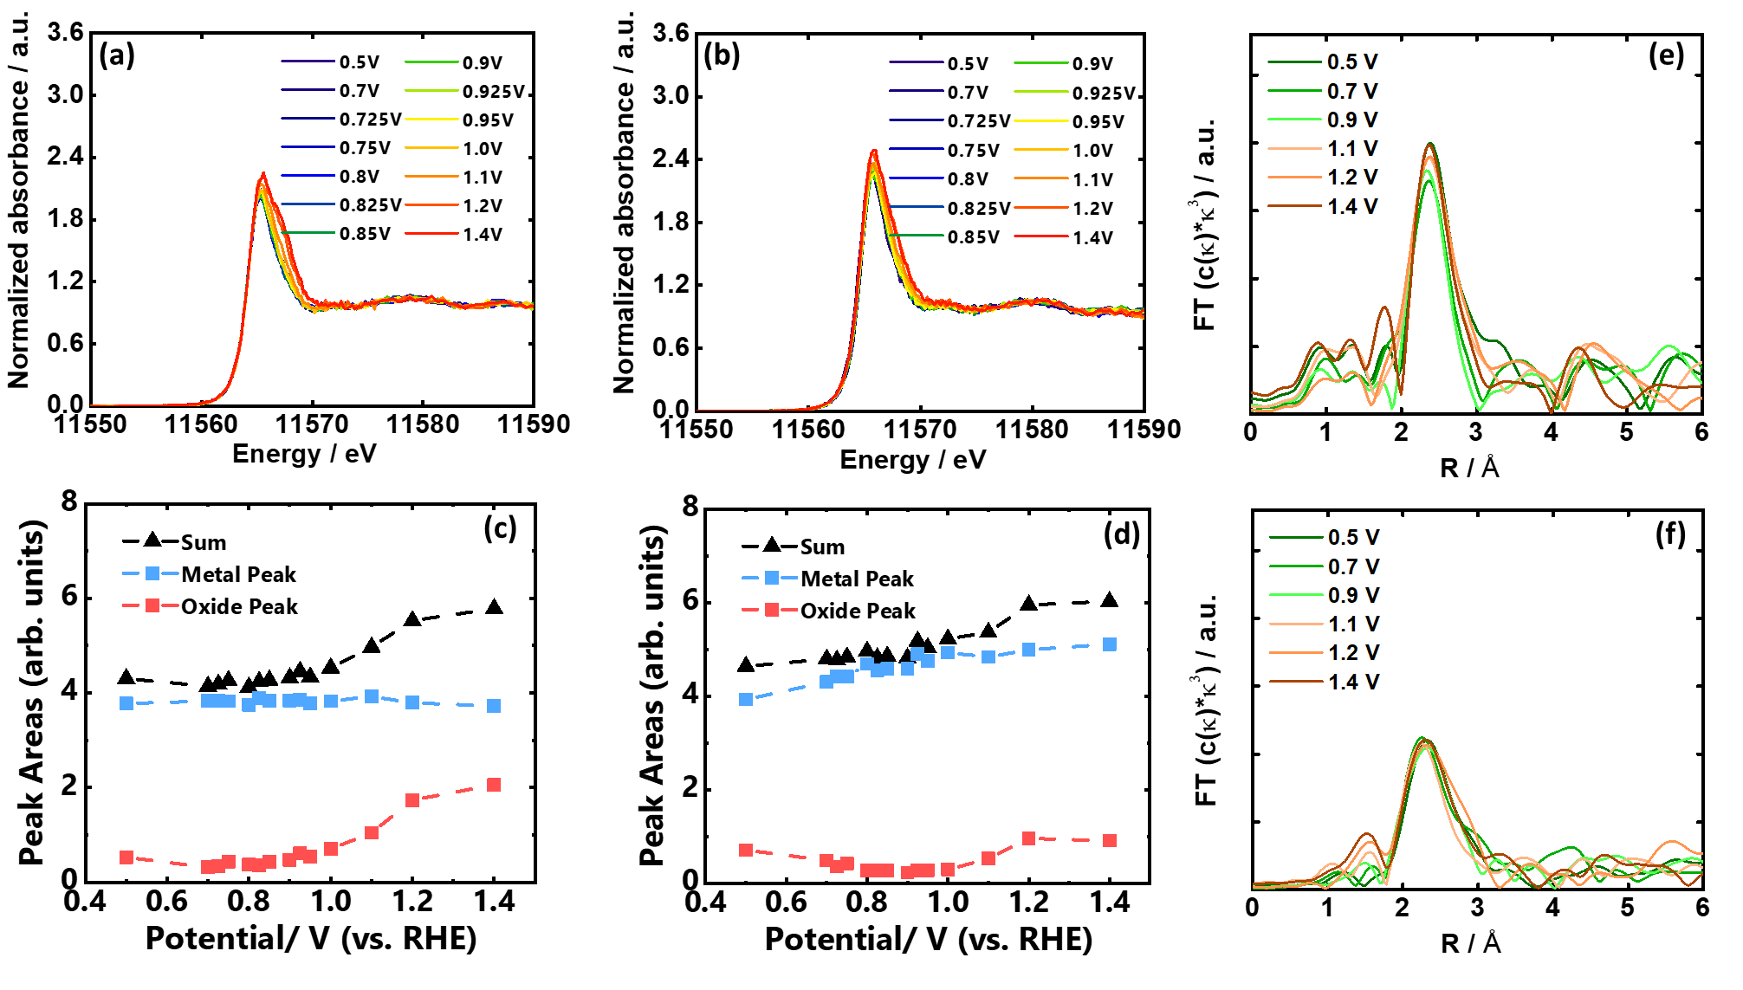

Figure 8. Operando XAS analysis of PtCo-700°C-10h-A and PtCo-350°C-10h-A catalysts during ORR. (a, b) Operando HERFD-Pt L3-edge XAS spectra for (a) PtCo-700°C-10h-A and (b) PtCo-350°C-10h-A catalysts at different potentials from 0.5 to 1.4 V under ORR conditions. (c, d) Integrated peak areas of metal peaks, oxide peaks, and sum peaks for (c) PtCo-700°C-10h-A and (d) PtCo-350°C-10h-A catalysts. (e, f) Magnitude of Fourier transformed EXAFS spectra at the Pt L3-edge for (e) PtCo-700°C-10h-A and (f) PtCo-350°C-10h-A catalysts at different potentials during ORR.

Figures 8a and 8b show the operando HERFD-XAS spectra at the Pt L3-edge for the sample prepared above the transition temperature (PtCo-700°C-10h-A) and the one prepared below it (PtCo-350°C-10h-A), respectively. As the polarization potential increases, a continuous increase in the white line intensity is observed for both catalysts, indicating the formation of Pt oxidation species. To analyze the generation of these Pt oxidations, the spectra were fitted with an arctangent function and two pseudo-Voigt peaks.⁵² During the peak fitting procedure, the fitting parameters for the metallic and oxidic components, such as their heights and full widths at half maximum (FWHM), were allowed to vary to accurately match the observed data. However, the positions of both the metal and oxide peaks, as well as the position and width of the arctangent background function, were fixed and remained constant. The areas of the fitted metallic and oxidic components, along with their sums, are presented in Figure 8 as a function of the applied potential. The peaks at 11565.5 eV and 11567.5 eV were assigned to metallic and oxidized Pt components, respectively. The integrated area for each phase is shown in Figures 8c and 8d.
These figures reveal different oxidation behaviors between the two catalysts. For PtCo-350°C-10h-A, the increase in the metal peak area suggests the generation of chemisorbed OH on the Pt surface layer, which continuously increases from 0.5 V to 1.4 V. The formation of Pt-OH species is considered to block active sites, hindering ORR activity. Conversely, the change in the metal peak for PtCo-700°C-10h-A is slight, suggesting less generation of chemisorbed OH on the catalyst with a contracted lattice structure (higher ordering degree). However, the generation of Pt oxidation species is more evident for PtCo-700°C-10h-A than for PtCo-350°C-10h-A at higher polarization potentials (from 1.1 V to 1.4 V). This distinct behavior is likely due to the strong oxyphilic properties of Co. The higher Co content in PtCo-700°C-10h-A makes Pt more prone to oxidation ²⁹. This is supported by the control experiment for the PtCo-350°C-10h catalyst without acid treatment (Figure S21), which shows a significant increase in the peak area for Pt-oxidations due to its higher Co content. We believe that the initial high stability of PtCo-700°C-10h-A despite higher Co content in the present case is due to the well-defined Pt-rich layer and higher ordering degree. However, stability started to decrease after 20 K ADT cycles. Therefore, achieving an optimal balance of Co content, atomic ordering, and Pt-rich surface protection is key to ensuring both high ORR activity and long-term stability in PtCo alloys.

Conventional operando XAS analysis was also applied to further evaluate the structural changes during operation. As shown in Figure S22a, less increase in white line intensity was observed for PtCo-700°C-10h-A from 0.5 V to 1.2 V, while a sudden increase was observed at 1.4 V due to the formation of Pt-oxidation species. Furthermore, FT-EXAFS analysis at the Pt L3-edge was performed. For PtCo-350°C-10h-A, the scattering peaks for the Pt-O path at around 1.8 Å continuously increased, suggesting the contribution of Pt-O bond formation (Figure 8f). In contrast, less change was observed for PtCo-700°C-10h-A at low operation potentials (Figure 8e), further indicating the structural stability of the ordered catalyst during ORR and illustrating the better performance of catalysts with a higher ordering degree.
Conclusion
In this study, we have conducted a comprehensive investigation into the structural evolution and electrochemical properties of PtCo catalysts with varying degrees of ordering, utilizing a combination of advanced characterization techniques, including XRD, XAS, STEM, and PDF analysis. As far as we know, this is the first detailed structural analysis study using PDF that revealed a complete picture of the atomic structure of the PtCo catalysts and quantified the temperature dependency of various phases and their composition.
The PDF analysis revealed an abrupt increase in the domain size for all phases at 350 °C consistent with the decrease in the ECSA, triggering the structural transformation leading to the ordered phase formation above 450 °C. Further ordered Pt-rich layer exhibits anisotropic strain, with contracted Pt-Pt distances along the surface and elongated Pt-Pt distances across the surface which results in higher ORR activity and stability of ordered phase. The ordered PtCo catalysts exhibit superior stability against Pt oxidation and Pt-OH formation under ORR conditions, as revealed by operando XAS analysis.
Importantly, our findings suggest that local structural changes at the particle surface, likely induced by particle coalescence, contribute significantly to the initial enhancement in ORR activity observed at 350 °C, even before the formation of the long-range ordered phase. This observation, combined with reports indicating that the nucleation of the ordered phase in this alloy system occurs at specific regions such as the surface, suggests that controlling the nucleation of the ordered phase could be a promising strategy to optimize the catalytic performance of PtCo catalysts. Specifically, by controlling the nucleation of the ordered phase, it may be possible to achieve surface properties characteristic of the ordered alloy without significantly increasing the particle size, which is generally detrimental to catalytic activity. This could be achieved through strategies such as controlling particle coalescence or surface strain engineering.
Overall, this study provides a comprehensive understanding of the interplay between particle growth, ordering transformation, and catalytic properties in PtCo catalysts. We believe that these insights will contribute to the development of advanced PtCo catalysts by implementing strategies to induce local structural changes, such as controlling particle coalescence or surface strain engineering, which could be effective in further optimizing the catalytic performance of PtCo catalysts.

Funding
This work was supported by the PEFC project (20001199-0) and the NEDO FC-Platform project (20001310-0) commissioned by the New Energy and Industrial Technology Development Organization (NEDO).

Acknowledgments
The synchrotron radiation experiments were performed at the beamline of SPring-8 with the approval of the Japan Synchrotron Radiation Research Institute (JASRI) (proposal 2018A3788, 2020A1799, 2020A1800, 2021B1036, 2022A1663, 2021A1665, 2021B3751, 2022A1020, 2022B1012, 2022B1033, 2022B1444, 2022B1031, 2022B1441, 2022B3751, 2023A1013, 2023A1044, and 2023A3751). The analysis using SPring-8 and high-resolution TEM measurements was performed under the NEDO FC-Platform.
Author Contributions
Yunfei Gao: Material synthesis, collected data, Carried out laboratory research.
Mukesh Kumar: Performed analysis, validated the data, supervised the project, wrote and revised the original draft.
Neha Thakur: Performed analysis and revised the original draft.
Weijie Cao: Performed XAS measurement
Toshiki Watanabe: Performed XAS measurement
Satoshi Tominaka: PDF measurements and analysis, validated the data, wrote and revised the original draft.
Kazutaka Sonobe: PDF measurements and analysis.
Akihiko Machida: crystal structure analysis
Ryota Sato: TEM and ICP measurements
Toshiharu Teranishi: TEM and ICP measurements
Masashi Matsumoto: High resolution TEM measurements
Hideto Imai: High resolution TEM measurements
Tomoya Uruga: HERFD-XANES measurement.
Yoshiharu Sakurai: HERFD-XANES measurement
Yoshiharu Uchimoto: Validated data, supervised the project, provided resources, and revised the manuscript

Supporting Information
XRD patterns Pt L₃-edge, Co K-edge XANES, EXAFS fitting details, Rietveld refinement and PDF fitting results, Phase fraction (wt%) and domain size obtained by the PDF fitting, CV and LSV curves before and after ADT measurements, Electrochemical CO stripping measurement, operando HERFD-Pt L₃-edge, XAS fitting parameters, Phase fraction, Domain sizes and ICP results of various PtCo alloys.

Reference
1. Yu, S.; Yang, H., Design principles for the synthesis of platinum–cobalt intermetallic nanoparticles for electrocatalytic applications. Chem. Commun. 2023, 59 (33), 4852-4871.
2. Zhuang, Y.; Yang, J.; Meng, L.; Ma, C.; Peng, L.; Chen, D.; Chen, Q., Polyaniline-derived carbon nanofibers with a high graphitization degree loading ordered PtNi intermetallic nanoparticles for oxygen reduction reaction. Ind. Chem. Mater. 2023, 1 (3), 458-464.
3. Li, C.; Yu, K.; Bird, A.; Guo, F.; Ilavsky, J.; Liu, Y.; Cullen, D. A.; Kusoglu, A.; Weber, A. Z.; Fereira, P.; Xie, J., Unraveling the Core of Fuel Cell Performance: Engineering the Ionomer/Catalyst Interface. Energy Environ. Sci. 2023,16, 2977–2990
4. Xu, G.; Yang, L.; Li, J.; Liu, C.; Xing, W.; Zhu, J., Strategies for improving stability of Pt-based catalysts for oxygen reduction reaction. Advanced Sensor and Energy Materials 2023, 2 (2), 100058.
5. Tang, M.; Zhang, S.; Chen, S., Pt utilization in proton exchange membrane fuel cells: structure impacting factors and mechanistic insights. Chem. Soc. Rev. 2022, 51 (4), 1529-1546.
6. Zhu, M.; Zhang, H.; Hu, Y.; Zhou, F.; Gao, X.; He, D.; Zhao, X.; Zhao, C.; Wang, J.; Tie, W., In Situ Nitrogen Infiltration into an Ordered Pt3Co Alloy with sp–d Hybridization to Boost Fuel Cell Performance. ACS Catal. 2024, 14 (8), 5858-5867.
7. Chattot, R.; Roiron, C.; Kumar, K.; Martin, V.; Campos Roldan, C. A.; Mirolo, M.; Martens, I.; Castanheira, L.; Viola, A.; Bacabe, R.; Cavaliere, S.; Blanchard, P.-Y.; Dubau, L.; Maillard, F.; Drnec, J., Break-In Bad: On the Conditioning of Fuel Cell Nanoalloy Catalysts. ACS Catal. 2022, 15675-15685.
8. Shokhen, V.; Strandberg, L.; Skoglundh, M.; Wickman, B., Impact of Accelerated Stress Tests on the Cathodic Catalytic Layer in a Proton Exchange Membrane (PEM) Fuel Cell Studied by Identical Location Scanning Electron Microscopy. ACS Appl. Energy Mater. 2022, 5(9), 11200–11212
9. Cheng, H.; Gui, R.; Yu, H.; Wang, C.; Liu, S.; Liu, H.; Zhou, T.; Zhang, N.; Zheng, X.; Chu, W.; Lin, Y.; Wu, H.; Wu, C.; Xie, Y., Subsize Pt-based intermetallic compound enables long-term cyclic mass activity for fuel-cell oxygen reduction. Proc. Natl. Acad. Sci. 2021, 118 (35), e2104026118.
10. Yang, C.-L.; Wang, L.-N.; Yin, P.; Liu, J.; Chen, M.-X.; Yan, Q.-Q.; Wang, Z.-S.; Xu, S.-L.; Chu, S.-Q.; Cui, C.; Ju, H.; Zhu, J.; Lin, Y.; Shui, J.; Liang, H.-W., Sulfur-anchoring synthesis of platinum intermetallic nanoparticle catalysts for fuel cells. Science 2021, 374 (6566), 459-464.
11. Hu, Y.; Shen, T.; Zhao, X.; Zhang, J.; Lu, Y.; Shen, J.; Lu, S.; Tu, Z.; Xin, H. L.; Wang, D., Combining structurally ordered intermetallics with N-doped carbon confinement for efficient and anti-poisoning electrocatalysis. Appl. Catal. B: Environ. 2020, 279, 119370.
12. Zhao, X.; Cheng, H.; Song, L.; Han, L.; Zhang, R.; Kwon, G.; Ma, L.; Ehrlich, S. N.; Frenkel, A. I.; Yang, J.; Sasaki, K.; Xin, H. L., Rhombohedral Ordered Intermetallic Nanocatalyst Boosts the Oxygen Reduction Reaction. ACS Catal. 2021, 11 (1), 184-192.
13. Zhou, Q.; Chen, M.; Wang, B.; Wu, C.; Pan, H.; Chen, Q.; Wang, Q.; Waterhouse, G. I.; Peng, L., Electronic structure engineering of Pt3Co nanoparticles via B, N co-doping of the carbon support boosts electrocatalytic methanol oxidation. Fuel 2024, 360, 130560.
14. Xiong, Y.; Yang, Y.; Joress, H.; Padgett, E.; Gupta, U.; Yarlagadda, V.; Agyeman-Budu, D. N.; Huang, X.; Moylan, T. E.; Zeng, R.; Kongkanand, A.; Escobedo, F. A.; Brock, J. D.; DiSalvo, F. J.; Muller, D. A.; Abruña, H. D., Revealing the atomic ordering of binary intermetallics using in situ heating techniques at multilength scales. Proc. Natl. Acad. Sci. 2019, 116 (6), 1974-1983.
15. Zeng, W.-J.; Wang, C.; Yan, Q.-Q.; Yin, P.; Tong, L.; Liang, H.-W., Phase diagrams guide synthesis of highly ordered intermetallic electrocatalysts: separating alloying and ordering stages. Nat. Commun. 2022, 13 (1), 7654.
16. Lin, L.-C.; Kuo, C.-H.; Hsu, Y.-H.; Hsu, L.-C.; Chen, H.-Y.; Chen, J.-L.; Pan, Y.-T., High-performance intermetallic PtCo oxygen reduction catalyst promoted by molybdenum. Appl. Catal. B: Environ. 2022, 317, 121767.
17. Wang, Z.; Yao, X.; Kang, Y.; Miao, L.; Xia, D.; Gan, L., Structurally Ordered Low-Pt Intermetallic Electrocatalysts toward Durably High Oxygen Reduction Reaction Activity. Adv. Funct. Mater. 2019, 29 (35), 1902987.
18. Liang, J.; Li, N.; Zhao, Z.; Ma, L.; Wang, X.; Li, S.; Liu, X.; Wang, T.; Du, Y.; Lu, G.; Han, J.; Huang, Y.; Su, D.; Li, Q., Tungsten-Doped L10-PtCo Ultrasmall Nanoparticles as a High-Performance Fuel Cell Cathode. Angew. Chem. Int. Ed. 2019, 58 (43), 15471-15477.
19. Jung, W. S.; Lee, W. H.; Oh, H.-S.; Popov, B. N., Highly stable and ordered intermetallic PtCo alloy catalyst supported on graphitized carbon containing Co@CN for oxygen reduction reaction. J. Mater. Chem. A 2020, 8 (38), 19833-19842.
20. Cui, Y.; Wu, Y.; Wang, Z.; Yao, X.; Wei, Y.; Kang, Y.; Du, H.; Li, J.; Gan, L., Mitigating Metal Dissolution and Redeposition of Pt-Co Catalysts in PEM Fuel Cells: Impacts of Structural Ordering and Particle Size. J. Electrochem. Soc. 2020, 167 (6), 064520.
21. Wang, D.; Xin, H. L.; Hovden, R.; Wang, H.; Yu, Y.; Muller, D. A.; DiSalvo, F. J.; Abruña, H. D., Structurally ordered intermetallic platinum–cobalt core–shell nanoparticles with enhanced activity and stability as oxygen reduction electrocatalysts. Nat. Mater. 2013, 12 (1), 81-87.
22. Pramanik, M.; Tominaka, S.; Wang, Z. L.; Takei, T.; Yamauchi, Y., Mesoporous semimetallic conductors: structural and electronic properties of cobalt phosphide systems. Angew. Chem. 2017, 129 (43), 13693-13697.
23. Tominaka, S.; Yoshikawa, H.; Matsushita, Y.; Cheetham, A. K., Topotactic reduction of oxide nanomaterials: unique structure and electronic properties of reduced TiO 2 nanoparticles. Materials Horizons 2014, 1 (1), 106-110.
24. Wang, D.; Li, Q.; Han, C.; Lu, Q.; Xing, Z.; Yang, X., Atomic and electronic modulation of self-supported nickel-vanadium layered double hydroxide to accelerate water splitting kinetics. Nat. Mater. 2019, 10 (1), 1-12.
25. Wu, Z.-P.; Shan, S.; Zang, S.-Q.; Zhong, C.-J., Dynamic Core–Shell and Alloy Structures of Multimetallic Nanomaterials and Their Catalytic Synergies. Accounts Chem. Res. 2020, 53 (12), 2913-2924.
26. Xiong, Y.; Xiao, L.; Yang, Y.; DiSalvo, F. J.; Abruña, H. D., High-Loading Intermetallic Pt3Co/C Core–Shell Nanoparticles as Enhanced Activity Electrocatalysts toward the Oxygen Reduction Reaction (ORR). Chem. Mater. 2018, 30 (5), 1532-1539.
27. Zhao, X.; Sasaki, K., Advanced Pt-Based Core–Shell Electrocatalysts for Fuel Cell Cathodes. Accounts Chem. Res. 2022, 55 (9), 1226-1236.
28. Mani, P.; Srivastava, R.; Strasser, P., Dealloyed binary PtM3 (M=Cu, Co, Ni) and ternary PtNi3M (M=Cu, Co, Fe, Cr) electrocatalysts for the oxygen reduction reaction: Performance in polymer electrolyte membrane fuel cells. J. Power Sources 2011, 196 (2), 666-673.
29. Gao, Y.; Thakur, N.; Uchiyama, T.; Cao, W.; Yamamoto, K.; Watanabe, T.; Kumar, M.; Sato, R.; Teranishi, T.; Imai, H.; Sakurai, Y.; Uchimoto, Y., Investigating Degradation Mechanisms in PtCo Alloy Catalysts: The Role of Co Content and a Pt-Rich Shell Using Operando High-Energy Resolution Fluorescence Detection X-ray Absorption Spectroscopy. ACS Appl. Mater. Interfaces 2023, 15 (45), 52473-52484.
30. Gao, Y.; Thakur, N.; Uchiyama, T.; Cao, W.; Yamamoto, K.; Watanabe, T.; Kumar, M.; Sato, R.; Teranishi, T.; Imai, H., Investigating Degradation mechanisms in PtCo Alloy catalysts: the role of co content and a Pt-rich shell using operando high-energy resolution fluorescence detection X-ray absorption spectroscopy. ACS Appl. Mater. Interfaces 2023, 15 (45), 52473-52484.
31. Farrow, C.; Juhas, P.; Liu, J.; Bryndin, D.; Božin, E.; Bloch, J.; Proffen, T.; Billinge, S., PDFfit2 and PDFgui: computer programs for studying nanostructure in crystals. J. Phys.: Condens. Matter 2007, 19 (33), 335219.
32. Tominaka, S.; Yamada, H.; Hiroi, S.; Kawaguchi, S. I.; Ohara, K., Lepidocrocite-Type Titanate Formation from Isostructural Prestructures under Hydrothermal Reactions: Observation by Synchrotron X-ray Total Scattering Analyses. ACS Omega 2018, 3 (8), 8874-8881.
33. Farrow, C. L.; Juhas, P.; Liu, J. W.; Bryndin, D.; Božin, E. S.; Bloch, J.; Proffen, T.; Billinge, S. J. L., PDFfit2 and PDFgui: computer programs for studying nanostructure in crystals. J. Phys.: Condens. Matter 2007, 19 (33), 335219.
34. Zhu, J.; Yang, Y.; Chen, L.; Xiao, W.; Liu, H.; Abruña, H. D.; Wang, D., Copper-Induced Formation of Structurally Ordered Pt–Fe–Cu Ternary Intermetallic Electrocatalysts with Tunable Phase Structure and Improved Stability. Chem. Mater. 2018, 30 (17), 5987-5995.
35. Thomson, T.; Terris, B. D.; Toney, M. F.; Raoux, S.; Baglin, J. E. E.; Lee, S. L.; Sun, S., Silicide formation and particle size growth in high-temperature-annealed, self-assembled FePt nanoparticles. J. Appl. Phys. 2004, 95 (11), 6738-6740.
36. Kim, D.; Saal, J. E.; Zhou, L.; Shang, S.; Du, Y.; Liu, Z.-K., Thermodynamic modeling of fcc order/disorder transformations in the Co–Pt system. Calphad 2011, 35 (3), 323-330.
37. He, S.; Liu, Y.; Zhan, H.; Guan, L., Direct Thermal Annealing Synthesis of Ordered Pt Alloy Nanoparticles Coated with a Thin N-Doped Carbon Shell for the Oxygen Reduction Reaction. ACS Catal. 2021, 11 (15), 9355-9365.
38. Pavlišič, A.; Jovanovič, P.; Šelih, V. S.; Šala, M.; Bele, M.; Dražić, G.; Arčon, I.; Hočevar, S.; Kokalj, A.; Hodnik, N.; Gaberšček, M., Atomically Resolved Dealloying of Structurally Ordered Pt Nanoalloy as an Oxygen Reduction Reaction Electrocatalyst. ACS Catal. 2016, 6 (8), 5530-5534.
39. Gao, Y.; Uchiyama, T.; Yamamoto, K.; Watanabe, T.; Tominaka, S.; Thakur, N.; Sato, R.; Teranishi, T.; Imai, H.; Sakurai, Y.; Uchimoto, Y., Origin of High Activity and Durability of Confined Ordered Intermetallic PtCo Catalysts for the Oxygen Reduction Reaction in Rotating Disk Electrode and Fuel Cell Operating Conditions. ACS Catal. 2023, 10988-11000.
40. Ravel, B.; Newville, M., ATHENA, ARTEMIS, HEPHAESTUS: data analysis for X-ray absorption spectroscopy using IFEFFIT. Journal of Synchrotron Radiation 2005, 12 (4), 537-541.
41. Liang, J.; Li, N.; Zhao, Z.; Ma, L.; Wang, X.; Li, S.; Liu, X.; Wang, T.; Du, Y.; Lu, G., Tungsten‐doped L10‐PtCo ultrasmall nanoparticles as a high‐performance fuel cell cathode. Angew. Chem. Int. Ed. 2019, 58 (43), 15471-15477.
42. Wise, A. M.; Richardson, P. W.; Price, S. W. T.; Chouchelamane, G.; Calvillo, L.; Hendra, P. J.; Toney, M. F.; Russell, A. E., Inhibitive effect of Pt on Pd-hydride formation of Pd@Pt core-shell electrocatalysts: An in situ EXAFS and XRD study. Electrochim. Acta 2018, 262, 27-38.
43. Kang, Y.; Wang, J.; Wei, Y.; Wu, Y.; Xia, D.; Gan, L., Engineering nanoporous and solid core-shell architectures of low-platinum alloy catalysts for high power density PEM fuel cells. Nano Research 2022.
44. Beermann, V.; Kühl, S.; Strasser, P., Tuning the Catalytic Oxygen Reduction Reaction Performance of Pt-Ni Octahedral Nanoparticles by Acid Treatments and Thermal Annealing. J. Electrochem. Soc. 2018, 165 (15), J3026.
45. Tetteh, E. B.; Gyan-Barimah, C.; Lee, H.-Y.; Kang, T.-H.; Kang, S.; Ringe, S.; Yu, J.-S., Strained Pt(221) Facet in a PtCo@Pt-Rich Catalyst Boosts Oxygen Reduction and Hydrogen Evolution Activity. ACS Appl. Mater. Interfaces 2022, 14 (22), 25246-25256.
46. Durst, J.; Lopez-Haro, M.; Dubau, L.; Chatenet, M.; Soldo-Olivier, Y.; Guétaz, L.; Bayle-Guillemaud, P.; Maillard, F., Reversibility of Pt-skin and Pt-skeleton nanostructures in acidic media. J. Phys. Chem. Lett. 2014, 5 (3), 434-439.
47. Ristau, R.; Barmak, K.; Lewis, L.; Coffey, K.; Howard, J., On the relationship of high coercivity and L1 ordered phase in CoPt and FePt thin films. J. Appl. Phys. 1999, 86 (8), 4527-4533.
48. Nesselberger, M.; Ashton, S.; Meier, J. C.; Katsounaros, I.; Mayrhofer, K. J. J.; Arenz, M., The Particle Size Effect on the Oxygen Reduction Reaction Activity of Pt Catalysts: Influence of Electrolyte and Relation to Single Crystal Models. J. Am. Chem. Soc. 2011, 133 (43), 17428-17433.
49. Xu, Z.; Zhang, H.; Zhong, H.; Lu, Q.; Wang, Y.; Su, D., Effect of particle size on the activity and durability of the Pt/C electrocatalyst for proton exchange membrane fuel cells. Appl. Catal. B: Environ. 2012, 111-112, 264-270.
50. Zeng, W.-J.; Tong, L.; Liu, J.; Liang, H.-W., Annealing-temperature-dependent relation between alloying degree, particle size, and fuel cell performance of PtCo catalysts. J. Electroanal. Chem. 2022, 922, 116728.
51. Yin, P.; Niu, X.; Li, S.-B.; Chen, K.; Zhang, X.; Zuo, M.; Zhang, L.; Liang, H.-W., Machine-learning-accelerated design of high-performance platinum intermetallic nanoparticle fuel cell catalysts. Nature Commun. 2024, 15 (1), 415.
52. Merte, L. R.; Behafarid, F.; Miller, D. J.; Friebel, D.; Cho, S.; Mbuga, F.; Sokaras, D.; Alonso-Mori, R.; Weng, T.-C.; Nordlund, D.; Nilsson, A.; Roldan Cuenya, B., Electrochemical Oxidation of Size-Selected Pt Nanoparticles Studied Using in Situ High-Energy-Resolution X-ray Absorption Spectroscopy. ACS Catal. 2012, 2 (11), 2371-2376.

Table of Contents
