Synthesis of Zirconium Boride (ZrB₂) Rod Crystals through Salt-Assisted Boro/Carbothermal Reduction

Zhibo CHEN^{1, 2}, Tohru SUZUKI^{1*, 2}, Hailong WANG^{3*}
1 Department of Nanoscience and Nanoengineering, Graduate School of Advanced Science and Engineering, Waseda University, Tokyo 169-8555, JAPAN
2 Optical Ceramics Group, National Institute for Materials Science (NIMS), Tsukuba, Ibaraki 305-0047, JAPAN
3 School of Materials Science and Engineering, Zhengzhou University, Zhengzhou 450001, CHINA

Abstract: High-aspect-ratio ZrB₂ rod crystals were synthesized via a molten-salt-mediated boro/carbothermal reduction using ZrOCl₂$∙$8H₂O/B₄C/C as the raw material and NaCl as the flux material. This synthesis may improve the poor fracture toughness of monolithic ZrB₂ ceramics. X-ray diffraction and scanning electron microscopy confirmed that the heat-treatment temperature of 1550 °C and the addition of 50 wt.% NaCl were the most effective in the preparation of ZrB₂ grains with a high aspect ratio. Thermogravimetric and differential scanning calorimetry was used to study the influence of NaCl addition, which increased the liquid-phase content. Finally, the growth of ZrB₂ grains along the c-axis into rod-like morphology at elevated temperatures was investigated by transmission electron microscopy. This work revealed that the addition of NaCl has a positive effect on the reducing of synthesis temperature and increasing of products particle size. The ZrB₂ rod crystals synthesized have diameters and aspect ratios of approximately 1 μm and 30, respectively.

Key Words: high aspect ratio; liquid phase; ZrB₂ ceramics; ZrB₂ rod crystals

- Introduction
Hypersonic technology comprises new aeronautics and astronautics technology, based on which hypersonic vehicles have been rapidly developed in recent years. These advanced systems can operate at ultrahigh speeds and temperatures with reliable thermal protection systems (TPSs) [1,2]. Thermal protection materials used in critical areas, such as wing leading edges and nose cones, must be high-temperature resistant and reusable [3].
Ceramic matrix composites and carbon-based materials have shown broad applications in the field of TPSs [4,5]. Zirconium boride (ZrB₂) is an important ultra-high-temperature ceramic in the aviation and aerospace fields due to its low theoretical density, high melting point, hardness, and thermal and electrical conductivity [6,7]. However, the low fracture toughness and poor sinterability of monolithic ZrB₂ ceramics significantly reduce their reliability and limit their applications [8]. Numerous studies have focused on using different reinforcements to improve the properties of ZrB₂ ceramics. Adding an appropriate amount of SiC can improve the oxidation resistance and mechanical properties [9,10], ZrSi₂ can improve sinterability [11,12], and using Al/ B₄C/C as sintering additives can improve the fracture toughness and flexural strength of ZrB₂ ceramics [13]. In addition, tailoring microstructure offers a viable approach to enhance the performance of ZrB₂ ceramics. Textured ceramics prepared from anisotropic raw materials have demonstrated exceptional properties along specific orientations. For instance, ZrB₂ ceramics incorporating short carbon fibers exhibited remarkable fracture toughness (7.62 ± 0.12 MPa∙m^{1/2}) [14]. The utilization of SiC whiskers and SiC-chopped fibers significantly enhanced the strength of ZrB₂ ceramics (740–770 MPa) [15]. Additionally, the introduction of carbon nanotubes resulted in a 15% increase in fracture toughness of ZrB₂ ceramics [16].
However, the grain boundary phases derived from the additives may be detrimental to the high-temperature properties of ceramic materials [17,18]. Zhu mentioned that elongated β-Si₃N₄ grains enhanced the strength and toughness of ceramic in the study on Si₃N₄ ceramics [19]. Self-toughening ZrB₂ ceramics with the highly oriented ZrB₂ grains may further improve their key characteristics [20]. Thus, the priority for this method is to synthesize anisotropic ZrB₂ grains for the preparation of textured ZrB₂ ceramics [21]. ZrB₂ single crystals may exhibit highly anisotropic morphology considering its hexagonal crystal. Hu prepared platelet ZrB₂ grains using in situ solid/liquid reaction under the catalysis of transition metal and Si powder [22]. Yang synthesized hexagonal-prism-like ZrB₂ grains combined a sol/gel route and carbothermal reduction reaction [23]. Rod-like ZrB₂ crystals were synthesized using a simple method in our previous study [24]. These crystals had diameters of 0.5–3 μm and an aspect ratio of approximately 8, and a low melting point (450 °C) intermediate B₂O₃ was formed during the heating process. With the increased temperature of the furnace, the melted intermediate provided a liquid phase, which incorporated other reactants. This promoted the boro/carbothermal reduction between Zr, B, and C, similar to the molten salt method.
A feature of the molten salt method for preparing powders is that a liquid phase accelerates the mass transfer process between the reactants and reduces the synthesis temperature and particle size of the product. Progress could be made in lower temperature and increasing the size of ZrB₂ grains by appropriately introducing more liquid phase into the boro/carbothermal reduction process. Zhang prepared nano-sized ZrB₂ particles at a low temperature of 1200 °C using MgCl₂ as salt. But the reaction also generated a by-product MgO [25]. Khanra utilized metal catalysts and NaCl to synthesize ZrB₂ whiskers with a high aspect ratio. However, the presence of residual metal catalysts may affect the sintering performance of ZrB₂ powders [26]. Liu employed NaCl and KCl as salts and used a microwave-assisted method to fabricate ZrB₂ nanorods with an aspect ratio greater than 10 at 1200 °C [27]. The selection of salts with lower melting points and minimal residue or easy removal offers distinct advantages in the preparation of ZrB₂ powders with a high aspect ratio, as well as in the subsequent sintering processes. The melting point of NaCl (801 °C) is lower than the reaction temperature for the ZrO₂ transfer to ZrB₂. Liquid NaCl distributed among other particles is expected to promote the diffusion of substances at high temperatures [28]. Low-melting point phases are also believed to promote anisotropic crystal growth [29]. Moreover, NaCl does not react with raw materials or the product ZrB₂ and can be separated from reactants due to its high solubility in water [30]. Therefore, NaCl is a promising candidate for facilitating the preparation of anisotropic ZrB₂ grains [31].
In this study, a salt-assisted boro/carbothermal reduction technique was used to improve the morphology of ZrB₂ crystals at various temperatures. ZrB₂ rod crystals with a large aspect ratio were prepared from raw materials containing Zr and B, with the addition of NaCl. Compared to the reaction without NaCl, melting NaCl provided a greater liquid phase, promoted melting, and accelerated the mass transfer of the reactants, which decreased the synthesis temperature and increased the length of the ZrB₂ rod crystals.

- Experimental procedures
2.1 Material preparation
The commercially available materials used in this study were ZrOCl₂$∙$8H₂O (AR, 99%, Aladdin, Shanghai, China), B₄C (1–10 μm, 98%), and C powders (400 mesh). B₄C and C powders were obtained from Macklin (Shanghai, China). NaCl was used as a flux (GR, 99.8%) and was obtained from Sinopharm Chemical Reagent Co., Ltd. (Shanghai, China). ZrOCl₂∙8H₂O is an exceptional source of Zr, as it can readily dissolve in anhydrous ethanol which used as solvent in this study. This approach enables the formation of a more stable slurry of mixture, and the subsequent rotary evaporation drying process was advantageous in achieving a uniformly blended raw material mixture.
Based on our previous study on the synthesis of pure ZrB₂ [24], the optimum molar ratio of ZrOCl₂$∙$8H₂O, B₄C, and C powders was 2:1.2:3. In this study, NaCl was added to the raw materials, and the mixed powder was pressed into round cakes under 10 MPa for 1 min. These reactants were then placed in an electric furnace and heated at 1350, 1400, 1450, 1500, 1550, 1600 °C and 1650 °C for 60 min under following Ar gas, respectively. The heating rate was 10 °C/min before 1000°C and 8 °C/min above 1000°C. Consequently, a series of powdered products were synthesized with variable NaCl content of 10–60 wt.%. The products were labeled as Zx-y, where x is the heat-treatment temperature, and y is the NaCl content. For example, a product synthesized from 50 wt.% NaCl and a temperature held at 1550 °C for 60 min would be Z1550-50.
The products were dispersed in distilled water at 30 °C, and the slurry was centrifuged for 1 min (3000 rpm) to remove the residual NaCl from the ZrB₂ grains after heating. The ZrB₂ grains were then separated as the precipitate from the supernatant and dried at 50 °C for 5 h before further characterization.

2.2 Characterization
Thermogravimetric and differential scanning calorimetry (TG-DSC, STA449F3, NETZSCH, Germany) was used to study the reactions between the raw materials from 25 to 1400 °C in an argon atmosphere with a heating rate of 5 °C/min. The phase constituents of the as-prepared powdered products were identified using X-ray diffraction (XRD, Empyrean, PANalytical, Netherlands). The morphology and aspect ratio of the obtained powders were observed using scanning electron microscopy (SEM, Quanta 200, FEI, Netherlands) and transmission electron microscopy (TEM, Tecnai G2 F20, FEI, Germany).

- Results and discussion
The results from the products with an initial addition of 50 wt.% NaCl obtained at 1350–1650 °C for 60 min are presented in Fig.1. And corresponding SEM of these samples are shown in Figs.2a-g. At 1350 °C, a substantial peak of ZrB₂ is observed, which is apparent from the several weak ZrO₂ peaks, indicating that the raw materials reacted incompletely. Moreover, most grains in this product exhibit irregular shapes. After that, the ZrO₂ peaks disappear when the heat-treatment temperature exceeds 1400 °C, and ZrB₂ is the only crystalline phase in the products. Our previous study has used the same conditions as those in this study to prepare the ZrB₂ grains, excluding the NaCl addition. The lowest temperature for preparing pure ZrB₂ grains was 1500 °C [24]. XRD analysis demonstrates that the inclusion of NaCl effectively decreases the temperature required for ZrB₂ synthesis, enabling the synthesis of pure ZrB₂ powders through a molten-salt-mediated boro/carbothermal reduction at a lower temperature of 1400 °C. After that, distinctive rod-shaped grains can be observed in Fig.2b, and gradually becoming predominant morphology in the product as the temperature increases. Notably, a significant enhancement in the length of rod-shaped grains is shown in product prepared at 1550 °C, which can be attributed to the elevated temperature accelerates the reaction rate and facilitates grain growth. However, the length of rod-shaped grains reduces when the temperatures exceed 1600 °C. This indicates that excessively high temperatures adversely affect the preparation of rod-like ZrB₂ grains, which may be due to the rapid evaporation of intermediate products B₂O₃ and NaCl, limits the growth of ZrB₂ crystals.
Fig.1. XRD patterns of as-prepared powders (a) Z1350-50, (b) Z1400-50,
(c) Z1450-50, (d) Z1500-50, (e) Z1550-50, (f) Z1600-50, and (g) Z1650-50.

Fig.2. SEM images of as-prepared powders (a) Z1350-50, (b) Z1400-50, (c) Z1450-50,
(d) Z1500-50, (e) Z1550-50, (f) Z1600-50, and (g) Z1650-50.

In addition to its effect on the synthesis temperature, NaCl significantly affects the morphology of ZrB₂ grains, which is apparent when comparing the morphologies of samples prepared with various NaCl contents (0-60 wt%), as depicted in Fig.3. Figs.3a and 3b show the morphology of sample Z1550-0, with a diameter and aspect ratio of approximately 0.85 μm and 8, respectively. The length of the rod-like grains increases gradually with the increasing amount of NaCl. When the addition amount reaches 50 wt%, the length of the rod-like ZrB₂ grains exceeds 30 μm, which is attributed to increasing of the reactant surrounding liquid content resulting from the addition of NaCl. Because of a low diffusion rate, high temperatures and long production periods are generally required for ceramic powder preparation with solid reactants. In this study, using B₄C as B source and reducing agent is benefit for the boro/carbothermal reduction reaction process. It produced B₂O₃ with a low melting point during heating, which provided a liquid medium for the diffusion of substances. And the addition of flux NaCl, while not directly participating in the reaction, further provided sufficient liquid phase for the reactants, leading to a more homogeneous mixing of the raw materials and accelerated migration of elements (Zr and B). However, it can be observed from the Fig.3 that the effect of adding NaCl on the length of the product ZrB₂ rod crystals is noticeable, yet it exhibits a constrained impact. When the content increases to 60 wt%, the length of the ZrB₂ rod crystal decreases. It can be inferred that the optimal experimental parameters for the preparation of ZrB₂ rod crystals with large aspect ratio in this study involve a 50 wt% NaCl addition and a synthesis temperature of 1550 °C. The obtained ZrB₂ rod crystals exhibit a diameter of approximately 1 μm and an aspect ratio of 30.
Fig.3. SEM images of as-prepared powders (a) Z1550-0, (b) the highlighted region in (a), (c) Z1550-10, (d) Z1550-20, (e) Z1550-30, (f) Z1550-40, (g) Z1550-50, and (h) Z1550-60.
TEM analysis was used to observe the direction of growth of the ZrB₂ rod crystals (from Z1550-50), and the results are shown in Fig.4. No obvious defects are observed in the lattice structure of ZrB₂ crystals (Fig.4a), which suggests that this method is suitable for ZrB₂ crystallization. Figs.4b and 4c show the selected area electron diffraction (SAED) and high-resolution TEM (HRTEM) patterns for ZrB₂ rod crystals. The lattice spacing is determined to be 3.52 Å, corresponding to the d-spacing of the (001) ZrB₂ planes. Fig.4c shows that the long axis direction of the rod grain is parallel to the <001> direction (c-axis direction) of the ZrB₂ crystals. Our previous investigation has validated the transformation of ZrB₂ morphology from an irregular shape to a rod shape along the longitudinal axis at elevated temperatures [24]. Based on this, it’s can be indicated that the growth direction of the rod ZrB₂ grains aligns with the c-axis direction in this study. According to the energy-dispersive spectroscopy (EDS) data in Fig.4c and the XRD data of this sample (Fig.1e), the amorphous phase layer adsorbed onto the grain surface might be glassy B₂O₃. The B₂O₃ intermediate is in liquid form at high temperatures, and its phase become glassy as the temperature drops, resulting in the lack of B₂O₃ detection in XRD analysis. Because NaCl was removed by evaporation at high temperatures and the subsequent washing mentioned previously, it is not detected in EDS analysis. Furthermore, the oxygen content of product grains exhibits a lower value of 2.1 wt%.
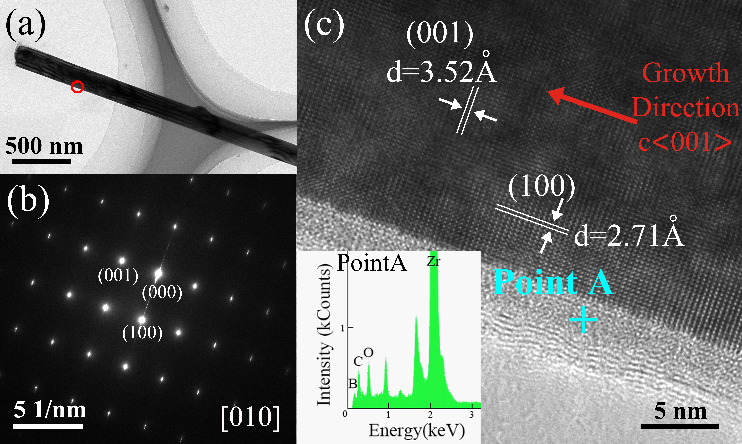
Fig.4. TEM image of a ZrB₂ rod crystal (Z1550-50 sample). (a) Individual ZrB₂ rod crystallite; (b), (c) SAED and HRTEM images of the individual ZrB₂ rod crystallite (area marked by a red circle in (a)).
The improvement in the ZrB₂ crystal morphology is attributed to a greater liquid phase among the reactants produced from the melted NaCl, which promoted the melting of reactants and contact between Zr, B, and C through diffusion. Subsequently, the nucleation and crystallization rate of ZrB₂ increased during heating. As discussed previously [24], the {001} plane of the ZrB₂ grains showed the largest growth rate under the influence of B₂O₃, which produced a rod structure. In this study, the melting of NaCl accelerated the mass transfer and growth of the ZrB₂ crystals. The growth process of the raw materials after adding 50 wt.% NaCl is shown in Fig.5. The amount of NaCl added and the heat-treatment temperature during the reaction result in different liquid contents around the reactants. An excessive amount of molten salt may cause a large distance between different reacting particles, which may decelerate the boro/carbothermal reaction [32]. In this study, heat-treatment temperature of 1550 °C and the addition of 50 wt.% NaCl are the most effective in the preparation of ZrB₂ grains with a high aspect ratio.
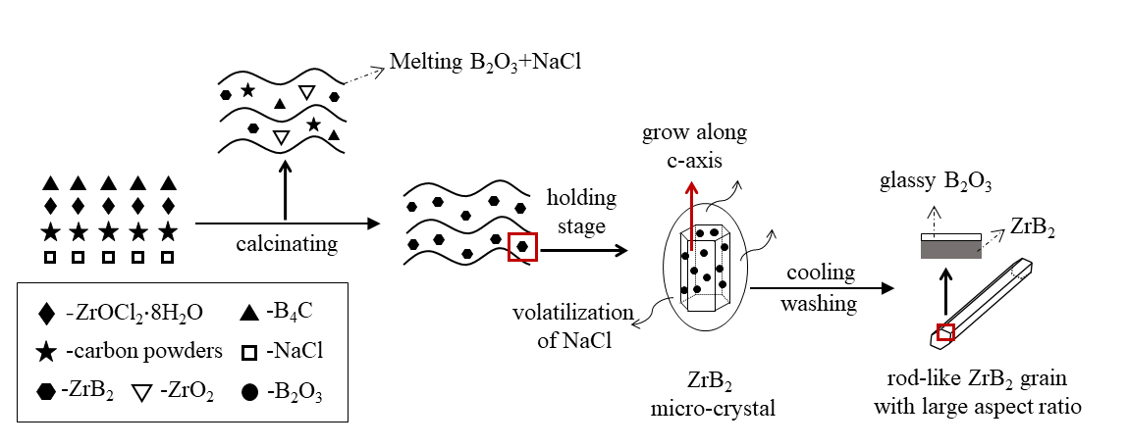
Fig.5. Schematic diagram of the growth process of the ZrB₂ powders after adding 50 wt.% NaCl.
TG-DSC analysis was performed on mixtures 1 (ZrOCl₂$∙$8H₂O/B₄C/C) and 2 (ZrOCl₂$∙$8H₂O/B₄C/C with 50 wt.% NaCl) under argon gas to study the reactions of the raw materials and the effect of NaCl during the heating stage. The results are shown in Figs.6 and 7. For mixture 1, the TG curve shows considerable weight loss below 400 °C. This weight loss is attributed to the decomposition of ZrOCl₂ and evaporation of adsorbed water, which also result in an endothermic peak at 117.2 °C in the DSC curve. In addition, two exothermic peaks are observed at 424.7 °C and 490.2 °C. The peak at 424.7 °C can be attributed to the formation of amorphous ZrO₂, while that at 490.2 °C indicates ZrO₂ crystallization from the amorphous phase to t-ZrO₂. The weak and broad exothermic peaks occurring around 950 °C may be caused by phase transformation from t-ZrO₂ to m-ZrO₂ or the growth of the ZrO₂ grain [33]. Above 1200 °C, the weight loss accelerates further, exhibiting an endothermic peak at 1297.6 °C in the DSC curve due to the boro/carbothermal reduction reaction between the raw materials. To further explore the reaction at 1200 and 1300 °C, mixture 1 was heated at 1200 °C (referred to sample 1a) and 1300 °C (referred to sample 1b), respectively. The XRD data for these samples are shown in Fig.6b. No ZrB₂ is detected for sample 1a; however, clear ZrB₂ peaks are observed for sample 1b, indicating that the reaction to synthesize ZrB₂ without adding NaCl occurs between 1200 and 1300 °C.
The reactions to form ZrB₂ are as follows;
ZrO₂ + 5/6B₄C = ZrB₂ + 2/3B₂O₃ + 5/6C (1)
ZrO₂ + B₂O₃ + 5C = ZrB₂ + 5CO (2)
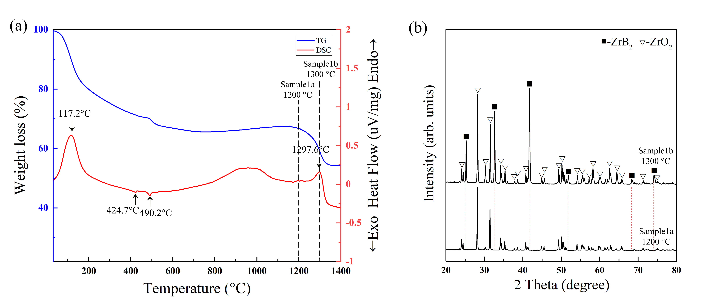
Fig.6. (a) The TG-DSC curve of mixture 1 of ZrOCl₂$∙$8H₂O/B₄C/C and (b) the XRD image of samples prepared at 1200 °C (sample 1a) and 1300 °C (sample 1b).
As shown in Fig.7, the addition of NaCl significantly affected the TG and DSC curves. The heat change and weight loss below 800 °C correspond to the evaporation of adsorbed water and formation of t-ZrO₂, which is similar to the results for mixture 1 without NaCl. However, the TG curve for mixture 2 heated below 800 °C does not show a large drop compared to that of mixture 1 because the added NaCl does not evaporate significantly below 800 °C. Subsequently, a strong endothermic peak is observed at 810 °C in the DSC curve because of the melting of NaCl [34]. In addition, weight loss intensively occurs above 800 °C due to the evaporation of the liquid phase [35]. After that, the boro/carbothermal reduction reaction of synthesis ZrB₂ occurred among mixture 2, caused heat change in DSC curve above 1100 °C accompanied by weight loss in the TG curve, which is consistent with the XRD results shown in Fig.7b. Fig.7b shows the XRD data of samples 2a and 2b, which were obtained by heating mixture 2 at 1100 °C and 1200 °C, respectively. Unlike sample 2a prepared at 1100 °C, ZrB₂ peaks are detected for sample 2b prepared at 1200 °C. This indicates that the initial temperature for the synthesis of ZrB₂ is between 1100 and 1200 °C after adding NaCl, which is nearly 100 °C lower than that of mixture 1. It may relate to the presence of melted NaCl among the reactants. The melting of NaCl accelerated the transfer of substances and promoted the reduction reaction.
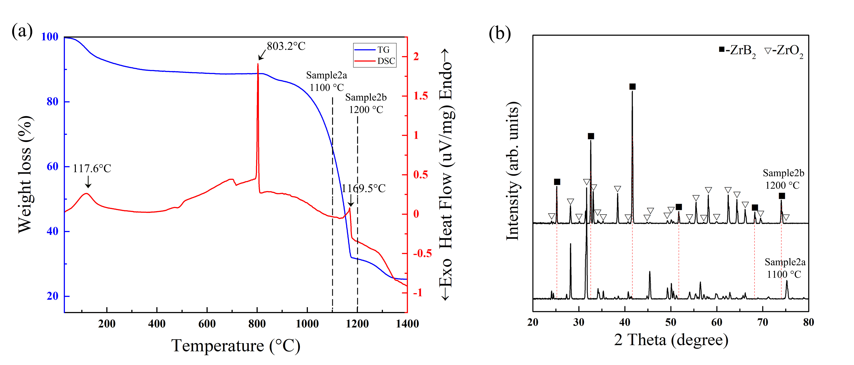
Fig.7. (a) The TG-DSC curve of mixture 2 of ZrOCl₂$∙$8H₂O/B₄C/C with 50 wt.% NaCl and (b) the XRD image of samples prepared at 1100 °C (sample 2a) and 1200 °C (sample 2b).

- Conclusion
The preparation of high-aspect-ratio ZrB₂ rod crystals with large aspect ratio via a salt-assisted boro/carbothermal reduction reaction was demonstrated by heating the raw materials (ZrOCl₂$∙$8H₂O/B₄C/C) with 50 wt.% NaCl at 1550 °C. The prepared ZrB₂ rod crystals had diameters and aspect ratios of approximately 1 μm and 30, respectively. The additional liquid phase introduced by adding NaCl is considered responsible for the reduced synthesis temperature and high aspect ratio of the final powdered products. We believe our study makes a positive contribution by providing a raw material for the synthesis of textured ZrB₂ ceramics. The subsequent study will focus on using strong magnetic field to control the alignment direction of high-aspect-ratio ZrB₂ grains in ceramics. The highly oriented grains may improve the fracture toughness and key characteristics of ZrB₂ ceramics.

Acknowledgment
The authors appreciate the financial support from the National Natural Science Foundation of China (No. 51772275).

References
- Sciti D, Guicciardi S, Bellosi A, et al. Properties of a pressureless-sintered ZrB₂-MoSi₂ ceramic composite[J]. Journal of the American Ceramic Society, 2006, 89(7):2320-2322.
- Wu W W, Sakka Y, Estili M, et al. Microstructure and high-temperature strength of textured and non-textured ZrB₂ ceramics[J]. Science and Technology of Advanced Materials, 2014, 15(1):014202.
- Opeka M M, Talmy I G and Zaykoski J A. Oxidation-based materials selection for 2000 °C$+$hypersonic aerosurfaces: Theoretical considerations and historical experience[J]. Journal of Materials Science, 2004, 39(19):5887-5904.
- Jiménez C, Mergia K, Lagos M, et al. Joining of ceramic matrix composites to high temperature ceramics for thermal protection systems[J]. Journal of the European Ceramic Society, 2016, 36(3):443-449.
- Lyle K H and Fasanella E L. Permanent set of the space shuttle thermal protection system reinforced carbon–carbon material[J]. Composites Part A: Applied Science and Manufacturing, 2009, 40(6-7):702-708.
- Guo S Q. Densification of ZrB₂-based composites and their mechanical and physical properties: A review[J]. Journal of the European Ceramic Society, 2009, 29(6):995-1011.
- Khanra A K, Pathak L C, Mishra S K, et al. Self-propagating-high-temperature synthesis (SHS) of ultrafine ZrB₂ powder[J]. Journal of Materials Science Letters, 2003, 22(17):1189-1191.
- Fahrenholtz W G, Hilmas G E, Talmy I G, et al. Refractory diborides of zirconium and hafnium[J]. Journal of the American Ceramic Society, 2007, 90(5):1347-1364.
- Wang A H, Fan B B, Feng L, et al. The fabrication and mechanical properties of SiC/ZrB₂ laminated ceramic composite prepared by spark plasma sintering[J]. Ceramics International, 2012, 38(6):5015-5022.
- Zhao X T, Gang S, Feng L, et al. ZrB₂-SiC_{w} ceramic composites synthesized by in situ reaction and spark plasma sintering[J]. International Journal of Applied Ceramic Technology, 2017, 14(5):845-850.
- Guo S Q, Kagawa Y, Nishimura T, et al. Pressureless sintering and physical properties of ZrB₂-Based composites with ZrSi₂ additive[J]. Scripta Materialia, 2008, 58(7):579-582.
- Guo S Q, Kagawa Y and Nishimura T. Mechanical behavior of two-step hot-pressed ZrB₂-based composites with ZrSi₂[J]. Journal of the European Ceramic Society, 2009, 29(4):787-794.
- Wang H L, Feng L, Lee S H, et al. ZrB₂-Al₃BC₃ composites prepared using Al-B₄C-C additives and spark plasma sintering[J]. Ceramics International, 2013, 39(1):897-901.
- Sha J J, Li J, Lv Z Z, et al. ZrB₂-based composites toughened by as-received and heat-treated short carbon fibers[J]. Journal of the European Ceramic Society, 2017, 37(2):549-558.
- Guicciardi S, Silvestroni L, Nygren M, et al. Microstructure and Toughening Mechanisms in Spark Plasma-Sintered ZrB₂ Ceramics Reinforced by SiC Whiskers or SiC-Chopped Fibers[J]. Journal of the American Ceramic Society, 2010, 93(8):2384-2391.
- Tian W B, Kan Y M, Zhang G J, et al. Effect of carbon nanotubes on the properties of ZrB₂–SiC ceramics[J]. Materials Science and Engineering A, 2008, 487(1-2):568-573.
- Ni D W, Zhang G J, Kan Y M, et al. Textured HfB₂-based ultrahigh-temperature ceramics with anisotropic oxidation behavior[J]. Scripta Materialia, 2009, 60(10): 913-916.
- Monteverde F, Guicciardi S and Bellosi A. Advances in microstructure and mechanical properties of zirconium diboride based ceramics[J], Material Science & Engineering: A, 2003, 346(1-2): 310–319.
- Zhu X W and Sakka Y. Textured silicon nitride: processing and anisotropic properties[J]. Science and Technology of Advanced Materials, 2008, 9(3): 033001.
- Ni D W, Zhang G J, Kan Y M, et al. Highly textured ZrB₂-based ultrahigh temperature ceramics via strong magnetic field alignment[J]. Scripta Materialia, 2009, 60(8): 615-618.
- Wu W W, Wang Z, Zhang G J, et al. ZrB₂-MoSi₂ composites toughened by elongated ZrB₂ grains via reactive hot pressing[J]. Scripta Materialia, 2009, 61(3):316-319.
- Hu C F, Zou J, Huang Q, et al. Synthesis of Plate-Like ZrB₂ Grains[J]. Journal of the American Ceramic Society, 2012, 95(1):85-88.
- Yang B Y, Li J P, Zhao B, et al. Synthesis of hexagonal-prism-like ZrB₂ by a sol–gel route[J]. Powder Technology, 2014, 256:522-528.
- Chen Z B, Zhao X T, Li M L, et al. Synthesis of rod-like ZrB₂ crystals by boro/carbothermal reduction[J]. Ceramics International, 2019, 45(11):13726-13731.
- Zhang S W, Khangkhamano M, Zhang H J, et al. Novel Synthesis of ZrB2 Powder Via Molten-Salt-Mediated Magnesiothermic Reduction[J]. Journal of the American Ceramic Society, 2014, 97(6):1686-1688.
- Khanra A K, Pathak L C and Godkhindi M M. Carbothermal synthesis of zirconium diboride (ZrB₂) whiskers[J]. Advances in Applied Ceramics, 2007, 106(3):155-160.
- Liu J H, Huang Z, Huo C G, et al. Low-temperature rapid synthesis of rod-like ZrB₂ powders by molten-salt and microwave co-assisted carbothermal reduction[J]. Journal of the American Ceramic Society, 2016, 99(9):2895-2898.
- Nersisyan H H, Lee J H and Won C W. A study of tungsten nanopowder formation by self-propagating high-temperature synthesis[J]. Combustion and Flame, 2005, 142(3):241-248.
- Ran S L, Biest O V D and Vleugels J. ZrB₂-SiC composites prepared by reactive pulsed electric current sintering[J]. Journal of the European Ceramic Society, 2010, 30(12):2633-2642.
- Çamurlu H E and Maglia F. Preparation of nano-size ZrB₂ powder by self-propagating high-temperature synthesis[J]. Journal of the European Ceramic Society, 2009, 29(8):1501-1506.
- Ma L, Yu J C, Guo X, Zhang Y S, et al. Effects of HBO₂ on phase and morphology of ZrB₂ powders synthesized by carbothermal reduction. Ceramics International, 2017, 43(15):12975-12978.
- Wang Y, Wu Y D, Wu K H, et al. Effect of NaCl on synthesis of ZrB₂ by a borothermal reduction reaction of ZrO₂[J]. International Journal of Minerals, Metallurgy and Materials, 2019, 26(7):831-838.
- Dong Z J, Zhang X, Huang Q, et al. Synthesis and pyrolysis behavior of a soluble polymer precursor for ultra-fine zirconium carbide powders[J]. Ceramics International, 2015, 41(6):7359-7365.
- Song S L, Fan Y L, Li R, et al. Synthesis and formation mechanism of nanocrystalline ZrB₂-Al₂O₃ composite powders via an amorphous precursor[J]. Rare Metals, 2021, 40(7):1801-1807.
- Lin Y H, Liu J H, Song S L, et al. Microstructure evolution and growth behavior of rod-shaped ZrB₂ in situ preparation of ZrB₂-SiC composite powders[J]. Ceramics International, 2019, 45(3):4016-4021.

