Probing thickness-dependent tip-induced band bending in MoS₂
Jian Liao¹, Takashi Taniguchi², Kenji Watanabe³, and Jiamin Xue¹*.
*Corresponding author: Jiamin Xue
Email: xuejm@shanghaitech.edu.cn
Affiliations
¹School of Physical Science and Technology, ShanghaiTech University, Shanghai 201210, China.
²Research Center for Materials Nanoarchitectonics, National Institute for Materials Science, 1-1 Namiki, Tsukuba 305-0044, Japan
³Research Center for Electronic and Optical Materials, National Institute for Materials Science, 1-1 Namiki, Tsukuba 305-0044, Japan
ABSTRACT: Scanning tunneling spectroscopy (STS) has played an important role in determining the electronic band structures of semiconductors. However, the tip-induced band bending (TIBB) could strongly affect the measured valence and conduction band edges, which are of vital importance for a semiconductor. In the literature, the presence or absence of the TIBB effect in a given STS measurement is often not discussed thoroughly. In this work, we quantitatively investigate the TIBB effect in MoS₂ with varying thicknesses using light-modulated contact-mode STS. Our results demonstrate that the TIBB effect is strongly dependent on the thickness of MoS₂. With thin MoS₂ of a few atomic layers (several nanometers), the TIBB approaches zero, and the measured STS can accurately reflect the band edges. While for thicker MoS2 of ~100 nm, the TIBB can be as large as ~1 eV. This work clarifies the ambiguity about the TIBB effect and provides a foundation for the interpretation of STS data on atomically thin semiconductors.
TEXT
Scanning tunneling spectroscopy (STS) has been an important tool for studying semiconductors. Combining millielectronvolt energy resolution and subnanometer spatial resolution, STS has provided a large amount of information about semiconductors regarding the band structures,^{1–3} doping,^{4,5} defects,^{6,7} and so on. However, there is an important side effect that needs to be considered properly when applying STS to the study of semiconductors, i.e., the tip-induced band bending (TIBB) effect.^{8,9} Due to the limited charge densities in semiconductors, the electric field induced by the bias voltage between the tip and sample is not efficiently screened on the sample side and has a finite penetration depth inside the semiconductor, causing the band to bend on the sample surface. This effect will make the measured band gap appear to be larger than the real gap, resulting in inaccurate measurement.^{10–12}
In the development of two-dimensional (2D) materials, STS has been playing an important role in determining the band structures of various 2D materials with different layer numbers.^{13,14} It is often assumed that TIBB does not affect the measured band gaps. The validity of this assumption is sometimes checked by varying the tip-sample distance and inspecting the possible variations of the I-V curves.^{15–17} If the band edges determined from the I-V curves remain the same at different tip-sample separations, it is taken as an indication that the TIBB is absent in the measurement. As we will show later, however, this method may not be able to reflect the real TIBB.
In this work, we use light-modulated contact-mode STS (CMSTS) to detect the TIBB on a representative 2D semiconductor, MoS₂, with different thicknesses. The van der Waals structure of MoS₂ makes the study of thickness-dependent TIBB more feasible than that with conventional bulk semiconductors. We find that the TIBB is almost absent in atomically thin semiconducting MoS₂ and increases with thicker MoS₂ flakes. Electrostatic calculations are used to explain the experimental observations. Our results strengthen the foundation of applying STS to the study of 2D semiconductors.
In conventional STS, the presence or absence of the TIBB effect is determined by varying the tip-sample distance and inspecting if the STS spectrum changes.^{15–17} By reducing the tunneling current setpoint, the tip-sample distance is enlarged. The voltage drop inside the vacuum gap increases and the TIBB effect, if present, would reduce. As a result, the measured band gap would become smaller. Such a change is seldom observed in the study of 2D semiconductors,^{15–17} which has been taken as an indication of the absence of the TIBB effect. However, the tunneling current drops exponentially with tip-sample distance. Roughly one order of magnitude reduction in tunneling current only results in 1 $Å$ increase of the tip-sample distance,¹⁸ which is not expected to change the TIBB noticeably since the tip-sample vacuum gap in normal STS is in the order of ~1 nm. To verify this expectation, a computer program numerically solving the three-dimensional tip-semiconductor electrostatic problem¹⁹ was employed (see the supplementary material for a list of relevant parameters used in the calculation). Figs. 1a and b present the computation results of potential distribution and tunneling current density at different tip-sample distances (ranging from 0.5 nm to 1.0 nm), with a tip radius of 3 nm and sample bias voltage V_{b} = +1 V. In the calculation, the semiconductor is taken to be half-infinite for $z≥0$ (blue region), while the tip is located in the vacuum ($z<0$, purple region) with varying distances away from the surface of the semiconductor at $z=0$. Far inside the semiconductor, the electrostatic potential $ϕ$ is taken to be zero, and $ϕ_{0}$ at $z=0$ is taken to be the TIBB. Notably, an increase in the tip-sample distance from 0.5 nm to 1 nm results in a four-order-of-magnitude decrease in the tunneling current density (Fig. 1b), while $ϕ_{0}$ only decreases from 0.391 eV to 0.299 eV (Fig. 1a) and the decreasing rate slows down for larger tip-sample distances. Due to the relatively small change in $ϕ_{0}$, the calculated dI/dV does not show noticeable changes (Fig. 1c). Another calculation with a larger tip radius shows similar behavior (see Fig. S1 in the supplementary material). These calculation results indicate that the common way of detecting the TIBB has its limitations.
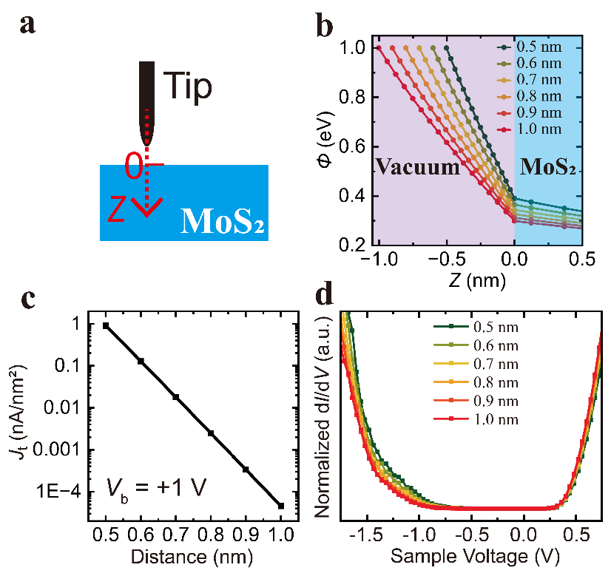
FIG. 1. Calculation results of distance-dependent tunneling behaviors with a tip radius of 3 nm. . (a) Schematic showing where the potential distribution profiles are taken. (b) The potential distribution along the z direction at different tip-sample distances (from 0.5 nm to 1.0 nm) with a tip radius of 3 nm. The purple region ($z<0$) represents the vacuum, and the blue region ($z>0$) represents the MoS₂. The MoS₂ extends to positive infinite. (c) The calculated tunneling current density (J_{t}) at different tip-sample distances with $V_{b}=+1 V$, showing an exponential decay of the current. (d) Normalized dI/dV at different tip-sample distances. The similarity between all these curves indicates that the traditional method of detecting TIBB may not be sufficient.
To detect the TIBB more accurately, we use the light-modulated STS (LM-STS),^{20–25} which has been used to detect charge carrier dynamics in bulk p-n junctions^{22,23} and photon-induced band movement in hybrid perovskite.²¹ In this technique, STS spectra are taken under dark and light-illuminated conditions. If there exists a TIBB, the two spectra will be different due to photo-excited carriers on the surface. The experimental setup for LM-STS is schematically depicted in Fig. 2(a). Thanks to its easy thickness tunability, MoS₂ is chosen as a model semiconductor to study thickness-dependent TIBB. In addition, a modified STS technique is used, namely the contact-mode STS,²⁶ instead of the conventional STS. In the contact-mode STS, the vacuum tunneling gap is replaced with a thin hexagonal boron nitride (hBN) flake, and a conductive atomic force microscope (CAFM) in mechanical contact with the hBN/MoS₂/Au stack is used to detect the tunneling current. Since the tip position is stabilized by keeping track of the force between the tip and sample instead of the sensitive tunneling current as in a conventional STS, the tunneling junction in the contact-mode STS is more immune to mechanical, thermal or light-induced fluctuations and more suitable for studying microscale devices.^{27–29}
In the experiment, MoS₂ flakes were exfoliated onto Au films, and 1.4 nm hBN flakes were transferred on top as the tunneling junction. A sample bias voltage (V_{b}) was applied to the Au substrate with the CAFM tip grounded. Unlike the conventional STS, which typically operates under ultrahigh vacuum and low temperatures, our experiments were conducted under ambient conditions. This setup allows easy light modulation of the surface charge carriers without affecting the tunneling junction, i.e., the hBN. Light from a laser diode (532 nm) with energy above the MoS₂ band gap was positioned 60˚ off-normal to the sample surface and focused onto the tunneling junction area with a spot diameter of ~0.2 mm. Contact-mode STS spectra were measured under dark, light-on (illuminated), and light-off (back to dark) conditions, yielding corresponding tunneling current (I_{t}) versus V_{b} curves. Fig. 2(b) presents a typical result for a 20 nm MoS₂ sample. At positive V_{b}, the I_{t} measured under light-on conditions (red curve) is significantly larger than that under dark conditions (black and yellow curves), with enlarging differences as V_{b} increases. In contrast, the two curves nearly overlap for negative V_{b}. These behaviors reveal the existence of TIBB in the positive V_{b} range.^{22,23} After turning the light off (in 1~3 minutes), the I_{t}-V_{b} curve is measured again (yellow curve in Fig. 2(b)), which falls on top of the curve obtained before illumination, indicating that the light did not cause any unwanted damage to the sample.
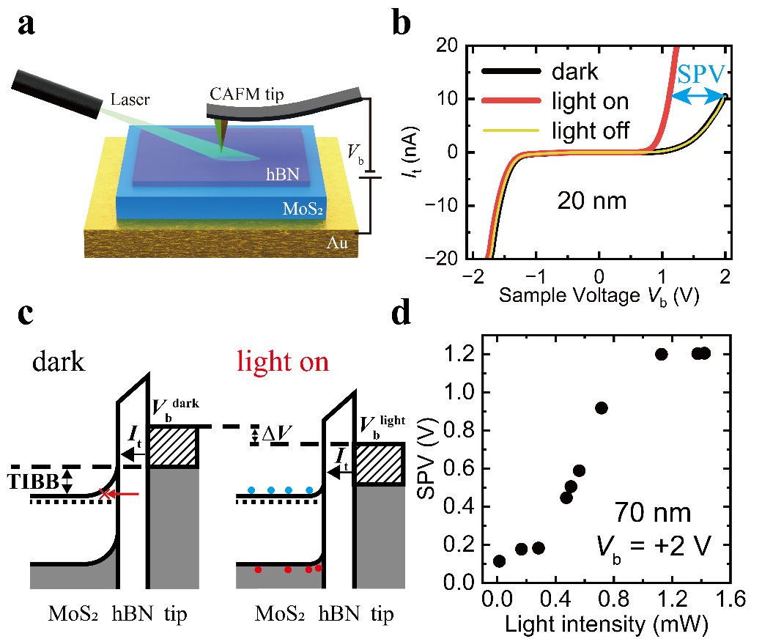
FIG. 2. Principles of LM-CMSTS. (a) Schematic of the LM-CMSTS setup. The tip is grounded, and the bias voltage V_{b} is applied to the sample. (b) Tunneling current (I_{t}) versus V_{b} curves were obtained on a 20 nm thick MoS₂ under dark (black), illuminated (red), and light-off (yellow) conditions. The blue arrow indicates the magnitude of SPV at V_{b} = +2 V. (c) One-dimensional energy band diagrams of the tunnel junction for an n-type MoS₂ with the same tunneling current under dark (left) and light-on (right) conditions (V_{b}＞0 V). Regions shaded with diagonal lines represent the electron states of the tip that produce the tunneling current. Excess electrons (blue circles) and holes (red circles) generated by light illumination are separated by the electric field originating from the TIBB and reduce the band bending at the surface. (d) Light-intensity dependence of SPV at V_{b} = +2 V measured on MoS₂ with a thickness of 70 nm.
Two schematic band diagrams in Fig. 2(c) explain the observations in Fig. 2(b). In the dark condition shown in Fig. 2(c) left, a negative tip voltage (equivalent to a positive sample bias, denoted as V_{b}^{dark}) repels electrons and induces holes at the surface of MoS₂. Due to the n-type doping of MoS₂, its surface band will be bent up, resulting in a space charge region that blocks some of the tunneling paths (represented by the red arrow in the schematic). When the light is on (Fig. 2(c) right), a large number of photo-excited charge carriers populate the surface. Driven by the built-in electric field in the TIBB region, the newly generated holes accumulate on the surface and flatten the band there. As shown in Fig. 2(c), when the same tunneling current (I_{t}) is achieved under dark and illuminated conditions, the latter requires a smaller sample bias voltage, denoted as V_{b}^{light}. The difference between V_{b}^{dark} and V_{b}^{light} for achieving the same I_{t} is defined as the surface photovoltage (SPV), which is an increasing function of V_{b}^{dark}. The blue arrow in Fig. 2(b) shows the SPV at V_{b}^{dark} = +2 V. The SPV is also a function of incident light intensity. When the light is sufficiently strong, a “flat band” condition is achieved, where the measured SPV equals the magnitude of TIBB at that specific V_{b}^{dark}. Further increasing the light intensity should no longer increase the SPV. To confirm this, a light-intensity dependence of SPV at V_{b} = +2 V is measured on a 70 nm MoS₂ flake (Fig. 2(d)). As expected, the SPV reaches a saturation value of 1.20 V when the light intensity exceeds 1.13 mW. Throughout this work, we chose the SPV at V_{b}^{dark} = +2 V as a measure of the TIBB strength.
For negative V_{b}^{dark}, the tip electric field causes electron accumulation near the sample surface. Since MoS₂ is rich in electrons, the field is efficiently screened with little band bending. As a result, no SPV is expected in the negative V_{b}^{dark} range, as seen in the data of Fig. 2(b). This observation also rules out the possibility of light-induced thermal effect since that would affect both the positive and negative biases.³⁰
To investigate the thickness dependence of TIBB, the SPV of MoS₂ with different thicknesses is measured. As illustrated in Figs. 3(a)-(d), I_{t} -V_{b} curves are obtained for MoS₂ with thicknesses of 96, 66, 13, and 3 nm, respectively. These curves exhibit two consistent characteristics similar to those in Fig. 2(b). First, the I_{t} -V_{b} curves obtained under light-off conditions (yellow curves) closely align with the ones measured under dark conditions (black curves), indicating the reliability of the measurement. Second, there is negligible SPV in the negative V_{b} range; while in the positive V_{b} range, the SPV increases with V_{b}^{dark}. The light intensity used for each sample has been adjusted to make sure that the SPV saturates. Therefore, the SPVs obtained in Fig. 3 provide measures of the TIBB at any specific V_{b}^{dark} for MoS₂ with different thicknesses. From Fig. 3, it is clear that the TIBB on thicker MoS₂ is significantly larger than that on thinner MoS₂.
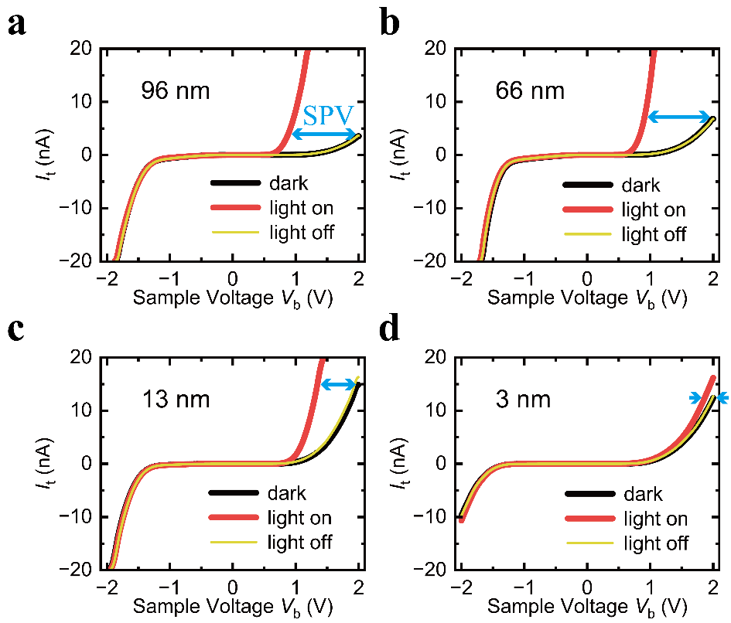
FIG. 3. I_{t} versus V_{b} curves for MoS₂ with different thicknesses under dark (black), illuminated (red), and light-off (yellow) conditions, respectively. (a) 96 nm. (b) 66 nm. (c) 13 nm. (d) 3 nm. The light intensity was adjusted to obtain saturated SPV for all the measurements.
In Fig. 4a, the thickness-dependent SPV (TIBB) at V_{b}^{dark} = +2 V is depicted, revealing that the SPV approaches 0 V for atomically thin MoS₂ and increases sharply until saturation with a value of $1.26±0.04$ V for thicker MoS₂. To understand the experimental result, a simple one-dimensional electrostatic model is adopted. In the model, the tip is treated as a gold plate, as shown in the inset of Fig. 4b. The electrostatic potential $ϕ$ satisfies Poisson’s equation throughout the stack. In the hBN, $ϕ$ linearly depends on z as no spatial charge exists there. Within MoS₂, $ϕ$ is determined by:
$$\frac{d^{2}ϕ}{dz^{2}}=\frac{−eρ}{ε_{MoS_{2}}ε_{0}}, (1)$$
where $e$ is the electron charge, $ρ$ is the charge density, $ε_{0}$ is the permittivity of vacuum, and $ε_{MoS_{2}}$ is the dielectric constant of MoS₂ (taken as 6.9).³¹ $ρ$ in MoS₂ is equal to the donor concentration $N_{D}≈1×{10}^{18} {cm}^{−3}$ since the MoS₂ is depleted of electrons at positive V_{b}. The boundary conditions for Eq. (1) differ in two scenarios. When MoS₂ is so thin that the entire MoS₂ is depleted, the electrostatic potential energy at the tip position $ϕ_{Tip}=2 eV$, and at the surface of the Au substrate $ϕ_{Au}=0 eV$. Applying these boundary conditions and matching the electric field at the MoS₂-hBN interface allows analytical solutions for Poisson’s equation within MoS₂ and hBN. The resulting electric potential distribution is depicted in Fig. 4c for a 1 nm MoS₂ sample. Here, the blue region represents MoS₂ ($z<0$), and the green region represents hBN ($z>0$). The electrostatic potential energy at the MoS₂-hBN interface (denoted as $ϕ_{00}$) is the TIBB for MoS₂ with this thickness.
In cases where the thickness of MoS₂ is larger than a depletion width $w$, the boundary conditions for Eq. (1) change to $ϕ_{Tip}=2 eV$ and the electrostatic potential energy at the boundary of the depletion width inside the MoS₂ $ϕ_{w}=0 eV$. Applying these boundary conditions to solve the Poisson’s equation, we derive the distribution of potential and the expression of $w$:
$$w=ε_{MoS_{2}} s \left(−\frac{1}{ε_{hBN}}+\sqrt{\frac{1}{ε_{hBN}^{2}}+\frac{2{ ε}_{0} ϕ_{Tip}}{ε_{MoS_{2}} s^{2} e^{2} N_{D}}}\right), (2)$$
where $ε_{hBN}$ is the dielectric constant of hBN, and $s$ is the tip-sample distance (equal to the thickness of hBN in this case). Taking $ε_{hBN}=3.58$,$ADDIN ZOTERO_ITEM CSL_CITATION \{"citationID":"F1IBlWrU","properties":\{"formattedCitation":"\backslash \backslash super 31\backslash \backslash nosupersub\{\}","plainCitation":"31","noteIndex":0\},"citationItems":[\{"id":971,"uris":["http://zotero.org/users/9383478/items/LVDMTQNM"],"itemData":\{"id":971,"type":"article−journal","abstract":"Abstract\backslash n Hexagonal boron nitride (h−BN) and semiconducting transition metal dichalcogenides (TMDs) promise greatly improved electrostatic control in future scaled electronic devices. To quantify the prospects of these materials in devices, we calculate the out−of−plane and in−plane dielectric constant from first principles for TMDs in trigonal prismatic and octahedral coordination, as well as for h−BN, with a thickness ranging from monolayer and bilayer to bulk. Both the ionic and electronic contribution to the dielectric response are computed. Our calculations show that the out−of−plane dielectric response for the transition−metal dichalcogenides is dominated by its electronic component and that the dielectric constant increases with increasing chalcogen atomic number. Overall, the out−of−plane dielectric constant of the TMDs and h−BN increases by less than 15\% as the number of layers is increased from monolayer to bulk, while the in−plane component remains unchanged. Our computations also reveal that for octahedrally coordinated TMDs the ionic (static) contribution to the dielectric response is very high (4.5 times the electronic contribution) in the in−plane direction. This indicates that semiconducting TMDs in the tetragonal phase will suffer from excessive polar−optical scattering thereby deteriorating their electronic transport properties.","container−title":"npj 2D Materials and Applications","DOI":"10.1038/s41699−018−0050−x","ISSN":"2397−7132","issue":"1","journalAbbreviation":"npj 2D Mater Appl","language":"en","page":"6","source":"DOI.org (Crossref)","title":"Dielectric properties of hexagonal boron nitride and transition metal dichalcogenides: from monolayer to bulk","title−short":"Dielectric properties of hexagonal boron nitride and transition metal dichalcogenides","volume":"2","author":[\{"family":"Laturia","given":"Akash"\},\{"family":"Van De Put","given":"Maarten L."\},\{"family":"Vandenberghe","given":"William G."\}],"issued":\{"date−parts":[["2018",3,8]]\}\}\}],"schema":"https://github.com/citation−style−language/schema/raw/master/csl−citation.json"\}$³¹ $N_{D}=1×{10}^{18}$ cm⁻³, and $s=1.4$ nm, we obtain $w≈36$ nm from Eq. (2). Fig. 4d shows the potential distribution for a 45 nm MoS₂ sample. The majority of $ϕ$ (1.74 eV) drops within MoS₂, with only a minor portion dropping across the hBN tunnel junction. When the thickness of MoS₂ exceeds $w$, $ϕ_{00}$ becomes independent of the thickness and remains at 1.74 eV. Calculated results of the thickness-dependent TIBB (Fig. 4b) closely resemble experimental findings (Fig. 4a), despite some quantitative differences in the thickness at which TIBB reaches saturation and the maximum TIBB obtained. These differences may arise from the inaccuracy introduced by the one-dimensional approximation, zero-temperature condition, and some inaccurate parameters used in the calculation. It is also worth noting that the thickness of hBN could affect the measured TIBB as shown in Fig. S2. However, the trend that TIBB decreases with thinner MoS₂ holds the same.
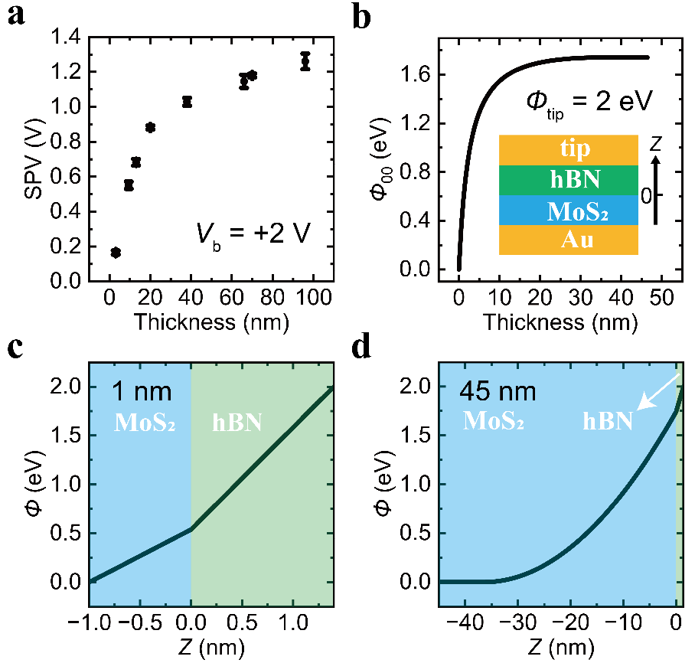
FIG. 4. Thickness-dependent SPV and model calculations. (a) Experimental results of the thickness dependence of SPV at V_{b} = +2 V. (b) Calculation results of thickness dependence of the surface potential $ϕ_{00}$ of MoS₂ with $ϕ_{Tip}=2 eV$. The one-dimensional model used is depicted in the inset. (c, d) Calculated potential distribution for 1 nm and 45 nm MoS₂ samples. The blue region ($z<0$) denotes the MoS₂ region, and the green region ($z>0$) denotes the hBN region.
TIBB is widely acknowledged as a primary source of measurement error affecting band edge positions in tunneling spectra.^{10–12} Since we have shown that TIBB depends on the sample thickness, it is natural to ask how that affects the measured band edges. To do that, numerical differentials of the I_{t} -V_{b} curves are used to obtain dI_{t}/dV_{b}. Following the conventions of band edge determination,¹⁵ the logarithm of the dI_{t}/dV_{b} are plotted in Figs. 5a and b for MoS₂ with thicknesses of 3 and 38 nm, respectively. V_{b} = 0 V denotes the Fermi level and the sharp rises at negative and positive V_{b} correspond to the valence band maximum (VBM) and conduction band minimum (CBM), respectively (see Fig. S3 for details). The log(dI/dV) curves measured under dark and light-on conditions overlap for the negative V_{b} region, indicating that TIBB does not influence the VBM. However, changes in the CBM under dark and light-on conditions correlate with MoS₂ thickness. For the 38 nm MoS₂, the CBM changes $∆E_{CBM}=E_{CBM}^{dark}−E_{CBM}^{light}=0.12±0.03 eV$ between light-on and dark conditions. Conversely, for the 3 nm MoS₂, $∆E_{CBM}=0.01±0.04 eV$. The thickness-dependent behavior of $∆E_{CBM}$ is illustrated in Fig. 5(c). It has a similar trend as the TIBB at V_{b}^{dark} = 2 V in Fig. 4(a), i.e. increasing with thickness and approaching 0 for atomically thin flakes. This behavior can be understood with the schematic in Fig. 5(d). For thinner flakes, the TIBB is weak and the band edge can be determined accurately; while for thicker flakes, the TIBB is strong and the measured gap under dark conditions is enlarged compared to its real value.
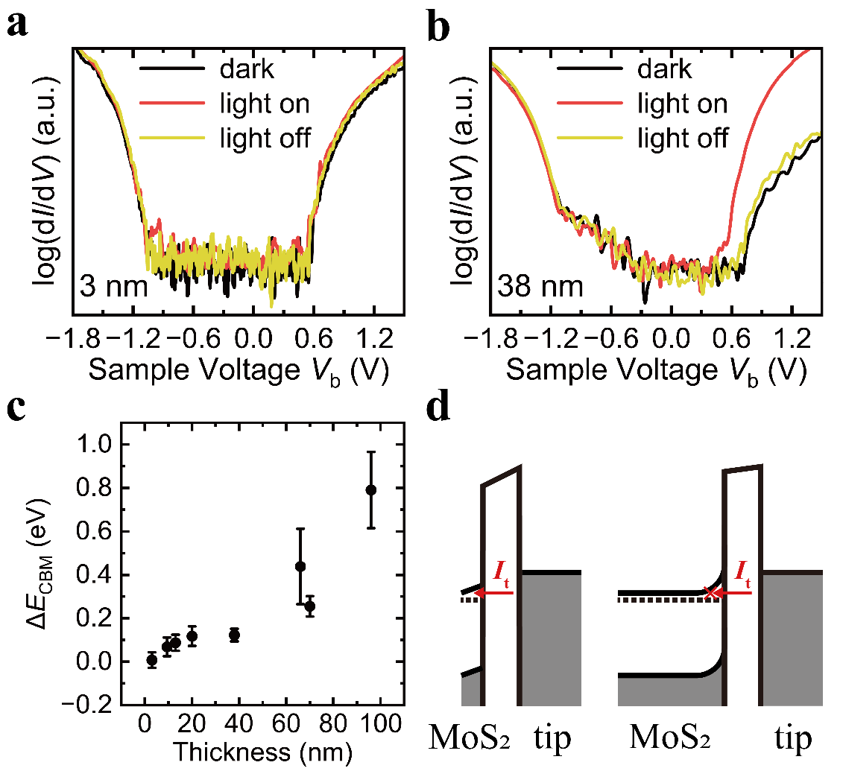
FIG. 5. Band edges affected by the TIBB. log (dI/dV) versus V_{b} curves obtained on MoS₂ with thicknesses of (a) 3 and (b) 38 nm under dark (black), illuminated (red), and light-off (yellow) conditions, respectively. (c) Experimental results of thickness dependence of $∆E_{CBM}$. (d) One-dimensional energy band diagrams of tunnel junctions with different thicknesses of MoS₂ under the same positive V_{b}. The tunneling current I_{t} can directly tunnel through the narrow depletion region of thin MoS₂ (left), but not for thick MoS₂ (right) due to a wide depletion region.
So far, we have measured MoS₂ flakes on an Au substrate. For device applications, MoS₂ flakes are typically placed on insulating substrates, such as SiO₂. The thickness-dependent TIBB of this type of sample is also measured (see Figs. S3 and S4 in the supplementary material), and behaviors similar to MoS₂ flakes on Au are obtained. Considering the totally different screening behavior between the SiO₂ and Au substrates, the similarity is an intriguing phenomenon. To clarify the mechanism, a two-dimensional electrostatic model is needed which can be solved numerically. The results in Fig. S6 closely resemble the experimental results indicating that electrostatic consideration is enough to account for the observed thickness-dependent TIBB.
To conclude, we used light-modulated contact mode STS to study the TIBB as a function of MoS₂ thickness. We showed that the conventional way of varying the tip-sample distance and measuring the I-V curves may not reflect the real TIBB. With the help of light, we found that the TIBB and the band gap determined by STS have a sensitive dependence on the semiconductor thickness. For MoS₂ of a few nanometers, the TIBB approaches zero. For thicker MoS₂ of ~100 nm, the TIBB grows to ~1 eV. The absence of TIBB in atomically thin MoS₂ flakes both on conductive (i.e. Au) and insulating (i.e. SiO₂) substrates provides a solid foundation for applying STS in the study of 2D semiconductors.

See the supplementary material for more data.

The authors thank Dr. Wujun Shi and Prof. Baile Chen for computation support and the Soft Nano Fabrication Center at ShanghaiTech University for the equipment provided. J.L. and J.X. are funded by NSFC 12074256. K.W. and T.T. acknowledge support from the JSPS KAKENHI (Grant Numbers 21H05233 and 23H02052) and World Premier International Research Center Initiative (WPI), MEXT, Japan.

AUTHOR DECLARATIONS
Conflict of Interest
The authors have no conflicts to disclose.
Author Contributions
Jian Liao: Experimental investigation; Modeling; Writing.
Takashi Taniguchi: BN growth.
Kenji Watanabe: BN growth.
Jiamin Xue: Conceptualization; Writing.
DATA AVAILABILITY
The data that support the findings of this study are available from the corresponding authors upon reasonable request.

REFERENCES
(1) Zhang, C.; Johnson, A.; Hsu, C. L.; Li, L. J.; Shih, C. K. Direct Imaging of Band Profile in Single Layer MoS₂ on Graphite: Quasiparticle Energy Gap, Metallic Edge States, and Edge Band Bending. Nano Lett. 2014, 14 (5), 2443–2447. https://doi.org/10.1021/nl501133c.
(2) Zhang, C.; Li, M.-Y.; Tersoff, J.; Han, Y.; Su, Y.; Li, L.-J.; Muller, D. A.; Shih, C.-K. Strain Distributions and Their Influence on Electronic Structures of WSe₂–MoS₂ Laterally Strained Heterojunctions. Nature Nanotech 2018, 13 (2), 152–158. https://doi.org/10.1038/s41565-017-0022-x.
(3) Zhang, Z.; Wang, Y.; Watanabe, K.; Taniguchi, T.; Ueno, K.; Tutuc, E.; LeRoy, B. J. Flat Bands in Twisted Bilayer Transition Metal Dichalcogenides. Nat. Phys. 2020, 16 (11), 1093–1096. https://doi.org/10.1038/s41567-020-0958-x.
(4) Zhao, L.; He, R.; Rim, K. T.; Schiros, T.; Kim, K. S.; Zhou, H.; Gutiérrez, C.; Chockalingam, S. P.; Arguello, C. J.; Pálová, L.; Nordlund, D.; Hybertsen, M. S.; Reichman, D. R.; Heinz, T. F.; Kim, P.; Pinczuk, A.; Flynn, G. W.; Pasupathy, A. N. Visualizing Individual Nitrogen Dopants in Monolayer Graphene. Science 2011, 333 (6045), 999–1003. https://doi.org/10.1126/science.1208759.
(5) Zhou, X.; Shi, J.; Qi, Y.; Liu, M.; Ma, D.; Zhang, Y.; Ji, Q.; Zhang, Z.; Li, C.; Liu, Z.; Zhang, Y. Periodic Modulation of the Doping Level in Striped MoS₂ Superstructures. ACS Nano 2016, 10 (3), 3461–3468. https://doi.org/10.1021/acsnano.5b07545.
(6) Xiang, F.; Huberich, L.; Vargas, P. A.; Torsi, R.; Allerbeck, J.; Tan, A. M. Z.; Dong, C.; Ruffieux, P.; Fasel, R.; Gröning, O.; Lin, Y. C.; Hennig, R. G.; Robinson, J. A.; Schuler, B. Charge State-Dependent Symmetry Breaking of Atomic Defects in Transition Metal Dichalcogenides. Nat Commun 2024, 15 (1), 2738. https://doi.org/10.1038/s41467-024-47039-4.
(7) Zhang, S.; Wang, C. G.; Li, M. Y.; Huang, D.; Li, L. J.; Ji, W.; Wu, S. Defect Structure of Localized Excitons in a WSe₂ Monolayer. Phys. Rev. Lett. 2017, 119 (4), 046101. https://doi.org/10.1103/PhysRevLett.119.046101.
(8) Bell, L. D.; Kaiser, W. J.; Hecht, M. H.; Grunthaner, F. J. Direct Control and Characterization of a Schottky Barrier by Scanning Tunneling Microscopy. Applied Physics Letters 1988, 52 (4), 278–280. https://doi.org/10.1063/1.99493.
(9) Feenstra, R. M.; Dong, Y.; Semtsiv, M. P.; Masselink, W. T. Influence of Tip-Induced Band Bending on Tunnelling Spectra of Semiconductor Surfaces. Nanotechnology 2007, 18 (4), 044015. https://doi.org/10.1088/0957-4484/18/4/044015.
(10) Battisti, I.; Bastiaans, K. M.; Fedoseev, V.; De La Torre, A.; Iliopoulos, N.; Tamai, A.; Hunter, E. C.; Perry, R. S.; Zaanen, J.; Baumberger, F.; Allan, M. P. Universality of Pseudogap and Emergent Order in Lightly Doped Mott Insulators. Nature Phys 2017, 13 (1), 21–25. https://doi.org/10.1038/nphys3894.
(11) Feenstra, R. M. Tunneling Spectroscopy of the GaAs(110) Surface. J. Vac. Sci. Technol. B 1987, 5 (4), 923. https://doi.org/10.1116/1.583691.
(12) Yoshida, S.; Terada, Y.; Yokota, M.; Takeuchi, O.; Mera, Y.; Shigekawa, H. Direct Probing of Transient Photocurrent Dynamics in P-WSe₂ by Time-Resolved Scanning Tunneling Microscopy. Appl. Phys. Express 2013, 6 (1), 016601. https://doi.org/10.7567/APEX.6.016601.
(13) Huang, Y. L.; Chen, Y.; Zhang, W.; Quek, S. Y.; Chen, C. H.; Li, L. J.; Hsu, W. T.; Chang, W. H.; Zheng, Y. J.; Chen, W.; Wee, A. T. S. Bandgap Tunability at Single-Layer Molybdenum Disulphide Grain Boundaries. Nat Commun 2015, 6 (1), 6298. https://doi.org/10.1038/ncomms7298.
(14) Li, J.; Kolekar, S.; Ghorbani-Asl, M.; Lehnert, T.; Biskupek, J.; Kaiser, U.; Krasheninnikov, A. V.; Batzill, M. Layer-Dependent Band Gaps of Platinum Dichalcogenides. ACS Nano 2021, 15 (8), 13249–13259. https://doi.org/10.1021/acsnano.1c02971.
(15) Ugeda, M. M.; Bradley, A. J.; Shi, S. F.; Da Jornada, F. H.; Zhang, Y.; Qiu, D. Y.; Ruan, W.; Mo, S. K.; Hussain, Z.; Shen, Z. X.; Wang, F.; Louie, S. G.; Crommie, M. F. Giant Bandgap Renormalization and Excitonic Effects in a Monolayer Transition Metal Dichalcogenide Semiconductor. Nature Mater 2014, 13 (12), 1091–1095. https://doi.org/10.1038/nmat4061.
(16) Liu, Y.; Qiu, Z.; Carvalho, A.; Bao, Y.; Xu, H.; Tan, S. J. R.; Liu, W.; Castro Neto, A. H.; Loh, K. P.; Lu, J. Gate-Tunable Giant Stark Effect in Few-Layer Black Phosphorus. Nano Lett. 2017, 17 (3), 1970–1977. https://doi.org/10.1021/acs.nanolett.6b05381.
(17) Mu, D.; Zhou, W.; Liu, Y.; Li, J.; Yang, M.; Zhuang, J.; Du, Y.; Zhong, J. Resolving the Intrinsic Bandgap and Edge Effect of BiI₃ Film Epitaxially Grown on Graphene. Materials Today Physics 2021, 20, 100454. https://doi.org/10.1016/j.mtphys.2021.100454.
(18) Chen, C. J. Introduction to Scanning Tunneling Microscopy, 3rd ed.; Oxford University Press, 2021. https://doi.org/10.1093/oso/9780198856559.001.0001.
(19) Ishida, N.; Sueoka, K.; Feenstra, R. M. Influence of Surface States on Tunneling Spectra of N-Type GaAs(110) Surfaces. Phys. Rev. B 2009, 80 (7), 075320. https://doi.org/10.1103/PhysRevB.80.075320.
(20) Takeuchi, O.; Yoshida, S.; Shigekawa, H. Light-Modulated Scanning Tunneling Spectroscopy for Nanoscale Imaging of Surface Photovoltage. Appl. Phys. Lett. 2004, 84 (18), 3645–3647. https://doi.org/10.1063/1.1737063.
(21) Shih, M. C.; Li, S. S.; Hsieh, C. H.; Wang, Y. C.; Yang, H. D.; Chiu, Y. P.; Chang, C. S.; Chen, C. W. Spatially Resolved Imaging on Photocarrier Generations and Band Alignments at Perovskite/PbI₂ Heterointerfaces of Perovskite Solar Cells by Light-Modulated Scanning Tunneling Microscopy. Nano Lett. 2017, 17 (2), 1154–1160. https://doi.org/10.1021/acs.nanolett.6b04803.
(22) Yoshida, S.; Kanitani, Y.; Oshima, R.; Okada, Y.; Takeuchi, O.; Shigekawa, H. Microscopic Basis for the Mechanism of Carrier Dynamics in an Operating P−n Junction Examined by Using Light-Modulated Scanning Tunneling Spectroscopy. Phys. Rev. Lett. 2007, 98 (2), 026802. https://doi.org/10.1103/PhysRevLett.98.026802.
(23) Jäger, N. D.; Marso, M.; Salmeron, M.; Weber, E. R.; Urban, K.; Ebert, Ph. Physics of Imaging p − n Junctions by Scanning Tunneling Microscopy and Spectroscopy. Phys. Rev. B 2003, 67 (16), 165307. https://doi.org/10.1103/PhysRevB.67.165307.
(24) Schnedler, M.; Portz, V.; Weidlich, P. H.; Dunin-Borkowski, R. E.; Ebert, P. Quantitative Description of Photoexcited Scanning Tunneling Spectroscopy and Its Application to the GaAs(110) Surface. Phys. Rev. B 2015.
(25) Schnedler, M.; Dunin-Borkowski, R. E.; Ebert, P. Importance of Quantum Correction for the Quantitative Simulation of Photoexcited Scanning Tunneling Spectra of Semiconductor Surfaces. Phys. Rev. B 2016.
(26) Li, R.; Taniguchi, T.; Watanabe, K.; Xue, J. Detecting Band Profiles of Devices with Conductive Atomic Force Microscopy. Review of Scientific Instruments 2020, 91 (7), 073702. https://doi.org/10.1063/5.0008412.
(27) Wang, K.; Taniguchi, T.; Watanabe, K.; Xue, J. Natural p–n Junctions at the MoS₂ Flake Edges. ACS Appl. Mater. Interfaces 2022. https://doi.org/10.1021/acsami.2c09457.
(28) Sun, X.; Chen, Y.; Li, Z.; Han, Y.; Zhou, Q.; Wang, B.; Taniguchi, T.; Watanabe, K.; Zhao, A.; Wang, J.; Liu, Y.; Xue, J. Visualizing Band Profiles of Gate-Tunable Junctions in MoS₂/WSe₂ Heterostructure Transistors. ACS Nano 2021, 15 (10), 16314–16321. https://doi.org/10.1021/acsnano.1c05491.
(29) Sun, X.; Chen, Y.; Zhao, D.; Taniguchi, T.; Watanabe, K.; Wang, J.; Xue, J. Measuring Band Modulation of MoS₂ with Ferroelectric Gates. Nano Lett. 2023, 23 (6), 2114–2120. https://doi.org/10.1021/acs.nanolett.2c04326.
(30) Grafström, S. Photoassisted Scanning Tunneling Microscopy. Journal of Applied Physics 2002, 91 (4), 1717–1753. https://doi.org/10.1063/1.1432113.
(31) Laturia, A.; Van De Put, M. L.; Vandenberghe, W. G. Dielectric Properties of Hexagonal Boron Nitride and Transition Metal Dichalcogenides: From Monolayer to Bulk. npj 2D Mater Appl 2018, 2 (1), 6. https://doi.org/10.1038/s41699-018-0050-x.

