Ionic Liquid Crystal–Polymer Composite Electromechanical Actuators: Design of Two-Dimensional Molecular Assemblies for Efficient Ion Transport and Effect of Electrodes on Actuator Performance
Chengyang Liu^{1,2} and Masafumi Yoshio*^{1,2,3}
¹ Research Center for Macromolecules & Biomaterials, National Institute for Materials Science, 1-2-1 Sengen, Tsukuba, Ibaraki 305-0047, Japan.
² Graduate School of Chemical Sciences and Engineering, Hokkaido University, Kita 13, Nishi 8, Kita-ku, Sapporo, Hokkaido 060-8628, Japan
³ Japan Science and Technology Agency, PRESTO, 4-1-8 Honcho, Kawaguchi, Saitama, 332-0012, Japan
KEYWORDS: actuators, liquid crystal, lithium-ion transport, ionic liquid, polymer composites.

ABSTRACT: We present the development of free-standing ionic liquid crystal–polymer composite electrolyte films, aimed at achieving high frequency response electromechanical actuators. Our approach entails designing novel layered ionic liquid-crystalline (LC) assemblies by complexing a mesomorphic dimethylphosphate with either a lithium salt or a room-temperature ionic liquid through the formation of ion-dipole interactions or hydrogen bonds. These electrolytes, exhibiting room-temperature ionic conductivities on the order of 10^{–4} S cm^{–1} and wide LC temperature ranges up to 77 °C, were successfully integrated into porous polymer networks. We systematically investigated the impact of ions and electrodes on the performance of ionic electroactive actuators. Specifically, the Li⁺-based liquid crystal–polymer composite actuator with PEDOT:PSS electrodes demonstrated the highest bending deformation, achieving a strain of 0.68% and exhibiting a broad frequency response up to 110 Hz, with a peak-to-peak displacement of 3 μm. In contrast, the ionic liquid-based liquid crystal–polymer composite actuator with active carbon electrodes showcased a bending response at a maximum frequency of 50 Hz and a force generation of 0.48 mN, without exhibiting the back relaxation phenomenon. These findings offer valuable insights for advancing high-performance electromechanical systems, with applications ranging from soft robotics to haptic interfaces.
INTRODUCTION
The pursuit of efficient ion transport pathways within organic and inorganic thin films has garnered significant attention as a strategic approach to improving energy efficiency in batteries, energy harvesting, actuators, water treatments, and more^{1–12}. In the realm of energy device technologies, various nanostructured polymers have been recognized for their ability to provide high ionic conductivity and mechanical robustness. This category encompasses block ionomers, ionic covalent organic frameworks, supramolecular polymers, and ionic liquid-crystalline (LC) polymers^{13–21}. Among them, liquid crystals stand out as particular promising due to their large-area orientation achievable through diverse external stimuli such as mechanical shear, light, and electric and magnetic fields^{22–26}. Nanostructured LC polymers featuring continuous ion-conductive channel networks have been prepared by photopolymerization of thermotropic liquid crystals tethering oligo(ethylene oxide) chains complexed with lithium salts²⁷ and lyotropic liquid crystals incorporating liquid electrolytes such as ionic liquids²⁸ and cyclic carbonates²⁹. However, the development of flexible and mechanically durable LC polymer membranes for soft actuator applications is still in its early stage.
Soft polymer actuators hold significant promise in artificial muscles, soft robotics, and haptic devices^{30–32}. Ionic electroactive polymer (iEAP) actuators present distinct advantages over alternative electroactive polymer actuators, such as dielectric elastomers and ferroelectric polymers. These benefits include silent, large bending deformations achievable at low operating voltages (< 2 V), high energy efficiency, and enhanced safety features. While high-performance iEAP actuators can achieve substantial bending deformations using polymer electrolytes rich in ionic liquids, addressing challenges related to limited frequency response and weak generating force remains a significant hurdle^{33,34}.
In response to these challenges, we have recently developed innovative lithium ion-conducting liquid crystal–polymer composite electrolyte membranes tailored for high-frequency soft ionic actuators with potential haptic feedback applications³⁵. By leveraging the self-assembly of a phosphate-based liquid crystal and vinyl polymers, we have successfully generated free-standing membranes with microphase-separated bicontinuous domains. Within these domains, the liquid crystal forms two-dimensional oriented lithium-ion pathways across the membrane, embedded in a porous polymer matrix. These membranes were then sandwiched between conductive polymer electrodes (poly(3,4-ethylenedioxythiophene) doped with poly(styrenesulfonic acid) - PEDOT:PSS). The resulting trilayer film exhibited significant bending deformations attributed to efficient lithium-ion diffusion, demonstrating rapid responsiveness at frequencies up to 80 Hz under an applied alternating current voltage of 2 V and yielding a moderate output force of 0.35 mN when a 2 V alternating current vias was applied. While each of these properties positions our materials as strong competitors with the best examples reported in the literature, the use of ion-conductive low-molecular weight liquid crystals–polymer composite electrolyte is unprecedented. Despite their advantages, there is still a need to enhance displacement and force generation, especially at optimal sensitive frequencies ranging from 30 to 250 Hz, to enable their effective use as haptic interfaces. The typical threshold for tactile sensation on human fingertips is known to be within the range of 1–100 mN, accompanied by a displacement of at least 2 µm³⁶. Additionally, improving thermal stability associated with the thermal phase transition of liquid crystals is crucial. Furthermore, optimizing electrode selection, particularly focusing on material compatibility with the electrolyte and ionic capacitance, and gaining insights into the actuation mechanism are essential steps to enhance the overall performance of these actuators.
In this study, we advanced our research by engineering novel two-dimensional assemblies of a dimethylphosphate-based liquid crystal (POMe), combined with either an ionic liquid (BMImPF₆) or a lithium salt (LiTFSI), as illustrated in Figure 1A and B. These liquid crystals, complexed with salts through either hydrogen bonds or ion–dipole interactions, were hybridized with polymer blends of poly(vinyl chloride) (PVC) and poly(vinylidene fluoride-co-hexafluoropropylene) (PVDF-HFP) to form microphase-separated composite electrolytes (Figure 1C). By sandwiching the electrolytes between a pair of free-standing PEDOT:PSS electrodes or active carbon (AC) film electrodes (see Figure 1D and E), we successfully obtained stable actuators with remarkable long-term durability. For the LiTFSI-containing liquid crystal–polymer composite/PEDOT:PSS actuator, improved performance was achieved, demonstrating a maximum strain of 0.68% at ±2 V and 0.1 Hz, with a peak-to-peak bending displacement of 3 μm at 110 Hz. Conversely, the utilization of BMImPF₆-contaninig liquid crystal–polymer composite electrolyte proved more effective with AC electrodes, achieving a bending strain of 0.34% at ±2 V and 0.1 Hz, along with a maximum operating frequency of 50 Hz and high force generation of 0.48 mN without encountering back relaxation observed for PEDOT:PSS-based actuators. This work establishes a promising design strategy for nanostructured electrolytes and a straightforward processing method to develop high-frequency responsive actuators, making a substantial advancement in the field of electroactive soft polymer actuators.

Figure 1. (A) Molecular structures of mesogenic molecules containing ion-conductive phosphate moieties (POMe (n = 0) and previously reported POEt (n = 1)), along with ions (BMImPF₆ and LiTFSI). (B) Illustration of the self-assembly of mesogenic molecules and ions through the ion-dipole interactions, forming nanosegregated layered liquid crystals that create two-dimensional ion-transport pathways. (C) Fabrication of ionic liquid crystal–polymer composite electrolyte membranes with microphase-separated structures, including a picture of the resulting composite film. An 80 wt% layered liquid crystal, comprising an equimolar mixture of POMe and either BMImPF₆ or LiTFSI, is immobilized in the porous polymer matrix consisting of 5 wt% PVDF-HFP and 15 wt% PVC mixture. (D) Fabrication of free-standing PEDOT:PSS film electrodes: PEDOT:PSS aqueous solution with 6 vol% ethylene glycol was drop-casted on a glass dish confined by polyimide tape and annealed at 120 °C for 8 h. Free-standing carbon-based film electrodes were prepared by drop-casting a NMP suspension of 25 wt% active carbon, 5 wt % conductive carbon black, and 40 wt% PVDF polymer binder, along with either 30 wt% LiTFSI or 30 wt% BMImPF₆ onto a polyimide tape-attached glass dish or a Teflon dish, followed by solvent evaporation under reduced pressure at 80 °C. (E) Illustration of iEAP actuator fabrication based on the liquid crystal–polymer composite sandwiched between PEDOT:PSS or activated carbon electrodes using a pressing method. Actuator deformation under electric fields results from an asymmetric volume change of electrodes and electrolyte triggered by ion diffusion inside the electrolyte membrane, Faradaic reactions of PEDOT:PSS electrodes, and/or the formation of electric double layer capacitance.
RESULT AND DISCUSSION
Materials Design. Our molecular designs for the ion-conductive liquid crystal incorporate polar phosphate moieties linked to a rigid rodlike mesogen through an alkyl spacer, promoting nanosegregation and enhancing ion transport properties. In the present study, our aim is to enhance the thermal stability of the liquid crystal phase without inducing crystallization while simultaneously increase the conductivity. This improvement could enable stable actuation across a wide temperature range and in the high frequency region.
In our prior design, the mesogen was linked to the polar diethylphosphate (POEt). The equimolar mixture of POEt and LiTFSI exhibited a smectic A (SmA) phase below 40 °C. In the new design (POMe), we replaced the larger diethylphosphate moiety with the smaller dimethylphosphate, and complexed it with either LiTFSI or an ionic liquid, BMImPF₆, resulting in improved thermal stability and conductivity within the SmA phases. BMImPF₆ was selected due to its molecular weight comparable to LiTFSI. Fixing the number of ions inside the electrolyte membrane is crucial for comparing actuation performance.

Liquid-Crystalline Properties. The LC properties of mesogenic compounds containing phosphate moieties (POMe and POEt) and their mixtures with BMImPF₆ or LiTFSI (POMe/BMImPF₆(x), POMe/LiTFSI(x), POEt/BMImPF₆(x), and POEt/LiTFSI(x), x denotes the mole% of salts in the mixture) were examined by polarized optical microscope (POM) observation, differential scanning calorimetry (DSC), and X-ray diffraction (XRD) measurements. The phase diagrams, depicting the phase transition temperatures as a function of the mol% of salts, are provided in the Supporting Information (Figure S1 and S2, Supporting Information). The phase transition behaviors of the phosphates and the equimolar complexes with salts (x = 50) are summarized in Table 1. Additionally, their corresponding DSC charts can be found in the Supporting Information (Figure S3, Supporting Information).
Compound POMe was obtained as a crystalline solid at room temperature, exhibiting a monotropic SmA phase between 48 and 6 °C upon cooling, while POEt showed a monotropic SmA from 18 to –10 °C. In contrast, POMe/BMImPF₆(50) and POMe/LiTFSI(50) displayed an enantiotropic SmA phase over broader temperature ranges on heating and cooling processes, accompanied by focal conic textures at room temperature under a polarized optical microscope (Figure 2). Notably, for POMe/LiTFSI(50), a smectic B (SmB) phase formed below the temperature of SmA phase, remaining non-crystalline even below –50 °C. The thermal stabilization of the LC phases can be attributed to the ion–dipole interactions between the phosphate ester group and either the imidazolium cation or lithium-ion. The isotropization temperature of POMe/BMImPF₆(50) was slightly higher than that of POMe/LiTFSI(50), possibly due to the formation of hydrogen bonds between the hydrogen atoms on the imidazolium cation and the oxygen atoms of the phosphate moiety. As anticipated, the substitution of the larger diethylphosphate moiety with the smaller dimethylphosphate moiety shifted the temperature range of SmA phase upwards, attributed to the reduced steric hindrance. For instance, POMe/BMImPF₆(50) exhibited an SmA phase between 77 and –13 °C, while the SmA phase of POEt/BMImPF₆(50) formed between 49 and –46 °C. The transition temperatures from the isotropic liquid (Iso) phase to the SmA phase and from the SmA to the SmB phase for POMe/LiTFSI(50) were also higher than those of POEt/LiTFSI(50).

Table 1. LC Properties of Mesogenic Compounds (POMe and POEt) and Its Equimolar Mixtures with BMImPF₆ or LiTFSI
Materials | Phase Transition Behavior^{b,c}
POMe | Cr 6 (16.6) SmA 48 (6.4) Iso
POMe/BMImPF₆(50) | Cr –13 (20.9) SmA 77 (1.8) Iso
POMe/LiTFSI(50) | SmB 7 (0.5) SmA 75 (1.8) Iso
POEtª | Cr –27 (18.2) SmB –10 (1.7) SmA 18 (2.4) Iso
POEt/BMImPF₆(50) | Cr –46 (15.7) SmA 49 (2.3) Iso
POEt/LiTFSI(50)ª | SmB –9 (0.3) SmA 40 (2.6) Iso
ªCompound POEt and the equimolar mixture POEt/LiTFSI(50) were previously reported. ^{b}Transition temperatures (°C) and transition enthalpies (kJ mol^{–1}, within parentheses) were determined using DSC on cooling at a scan rate of 10 °C min^{–1}. ^{c}Iso: isotropic; SmA: smectic A; SmB: smectic B; Cr: crystal.

XRD measurements of POMe-salt mixtures at ambient temperature confirmed the layer structures in the SmA phases. The XRD pattern of POMe/LiTFSI(50) in the middle panel of Figure 2A displays three peaks at 40.5, 20.5, and 13.8 Å corresponding to the (001), (002), and (003) reflections with an estimated layer distance of 41 Å. This value is smaller than twice the molecular length with the fully extended conformation (26 Å calculated by DFT, Figure S4, Supporting Information) by 13 Å. It is suggested that POMe/LiTFSI(50) forms an interdigitated bilayer structure of mesogens with lithium ion-coordinating phosphate layers, as illustrated in the right panel of Figure 2A. Notably, the estimated layer distance of POMe/LiTFSI(50) matches the value reported for POEt/LiTFSI(50), despite the expected difference in the bulkiness of phosphate moieties.
In contrast, in the XRD pattern of POMe/BMImPF₆(50) depicted in Figure 2B, two peaks at 59.2 and 30.2 Å correspond to the (001) and (002) reflections, resulting in a calculated layer distance of approximately 60 Å. This value is notably larger than that of POMe/LiTFSI(50) (41 Å). It is hypothesized that POMe/BMImPF₆(50) in the SmA phase forms bilayer mesogenic structures incorporating nanophase-segregated ionic liquid layers, as illustrated in the right panel of Figure 2B. On the other hand, the layer distance of POEt/BMImPF₆(50) was estimated to be 52 Å (Figure S5, Supporting Information), suggesting the formation of an interdigitated bilayer expanded compared to POEt/LiTFSI(50).
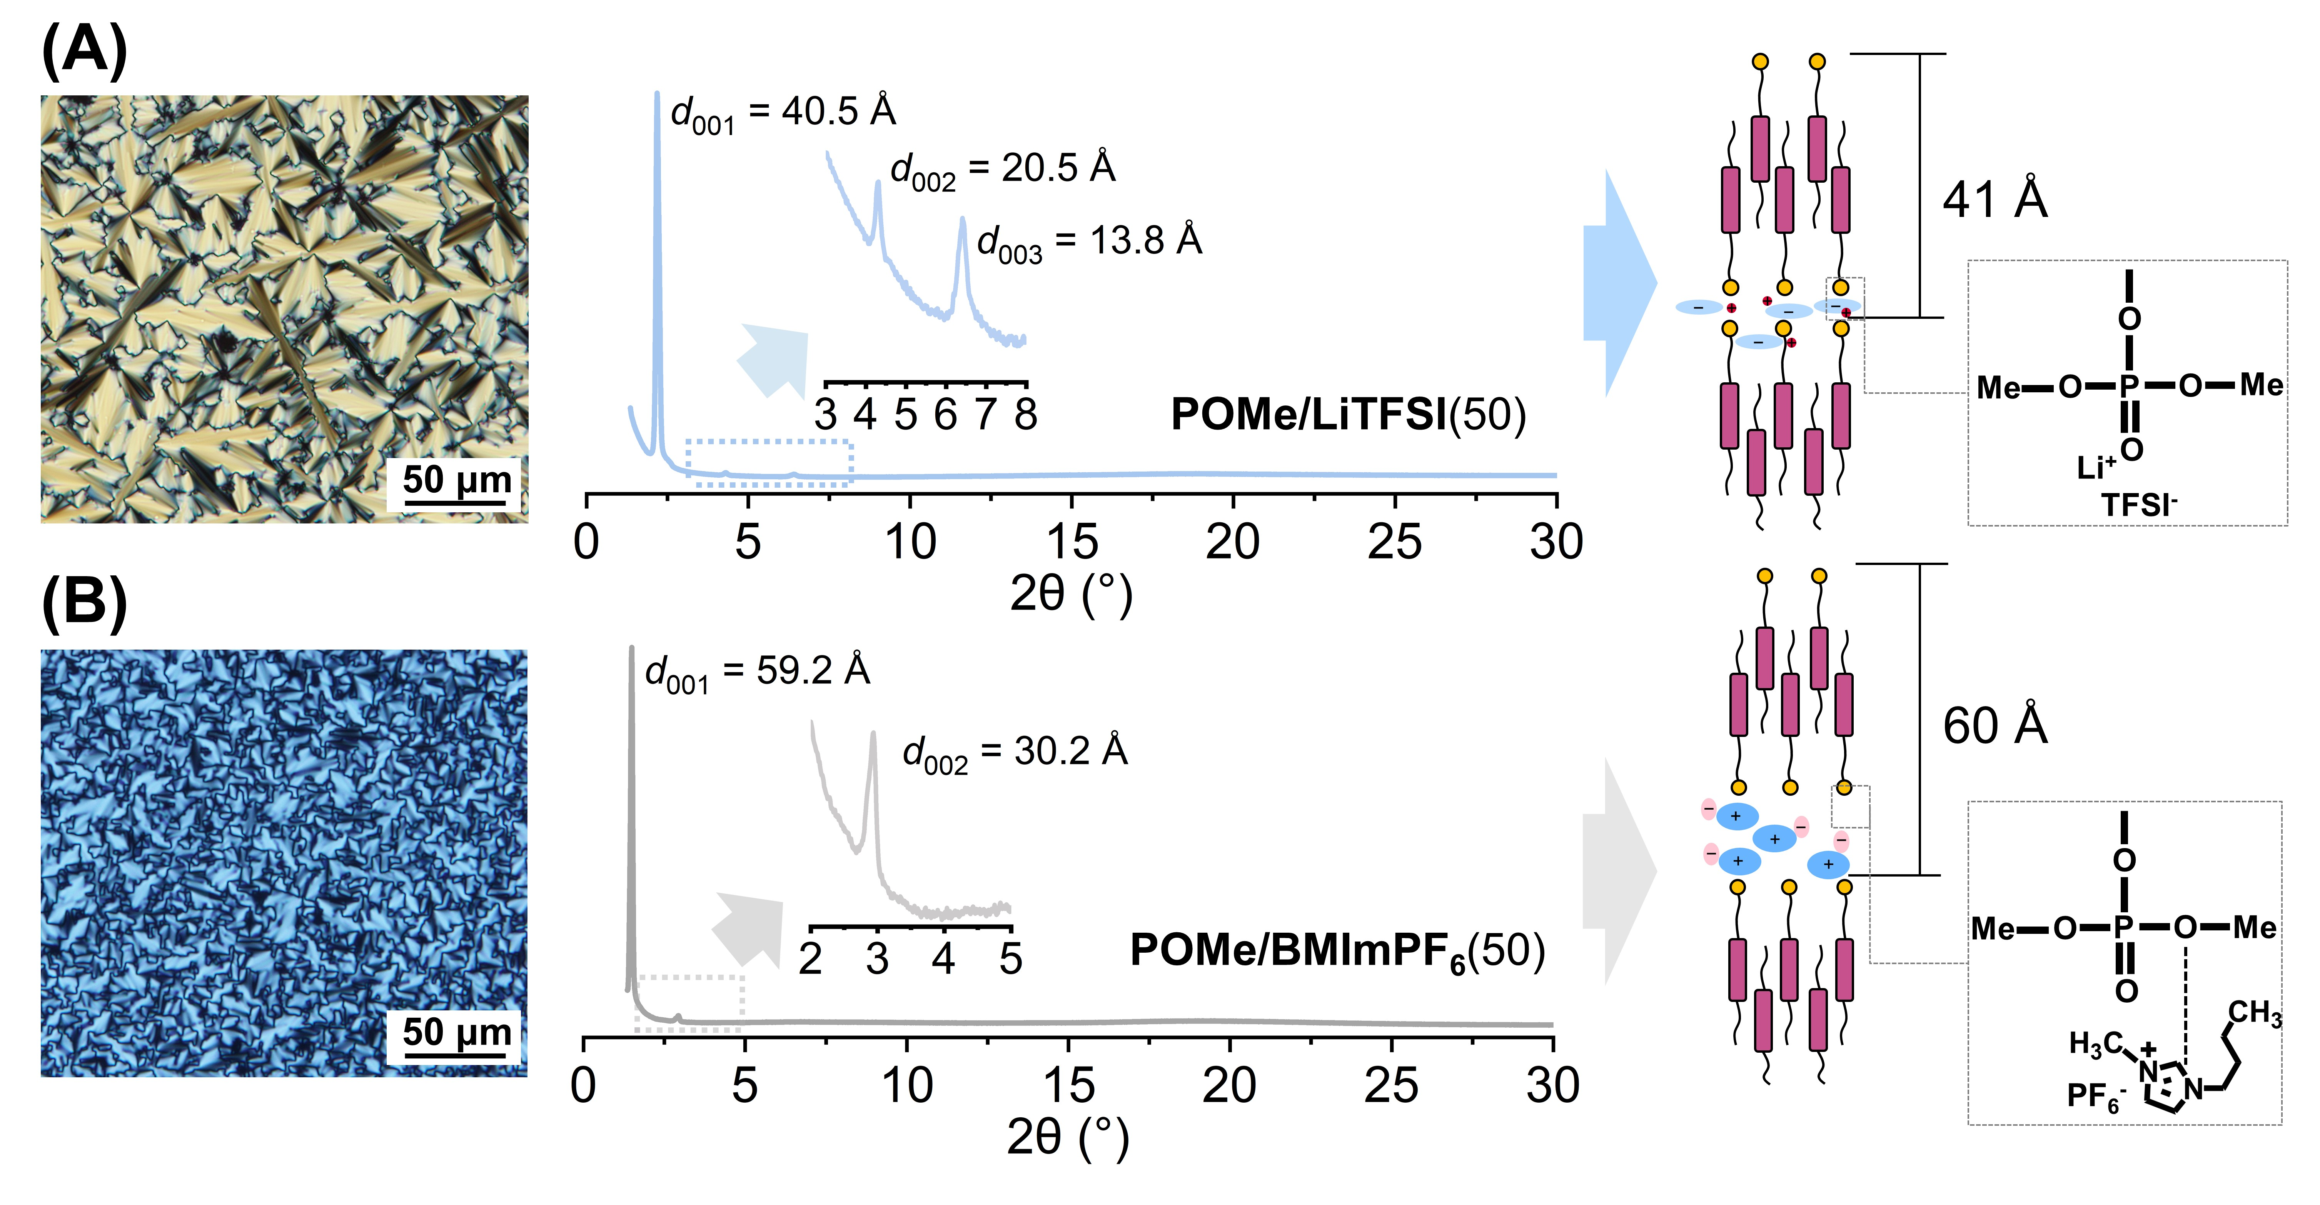

Figure 2. POM image, XRD pattern, and the possible self-assembled layered structure for (A) POMe/LiTFSI(50) and (B) POMe/BMImPF₆(50).
Fourier transform infrared (FT-IR) absorption spectroscopy is invaluable for elucidating intermolecular interactions between the phosphate moieties and salts. The P=O stretching vibration at 1244 cm^{–1} observed for POMe and POEt alone shifts to 1229 cm^{–1} upon the addition of LiTFSI (Figure S6, Supporting Information). Furthermore, the SO₂ asymmetric vibration peaks of TFSI anion observed at 1343 and 1322 cm⁻¹ for LiTFSI shift to 1350 and 1330 cm⁻¹, respectively, for POMe/LiTFSI(50) and POEt/LiTFSI(50). Similarly, the symmetrical vibration peak of SO₂ group shows a high wavenumber shift from 1127 cm^{–1} for LiTFSI to 1136 cm⁻¹ for POMe/LiTFSI(50) and POEt/LiTFSI(50). These results suggest the complexation of LiTFSI with phosphate moieties through ion-dipole interactions.
In contrast, when BMImPF₆ is mixed with POMe or POEt, the P=O stretching peak does not exhibit the low wavenumber shift observed in the LiTFSI-based mixtures, while the in-plane bending vibrations of the ether CH₃–O–P bond shifts from 1177 to 1169 cm⁻¹. Additionally, the stretching vibrations of the PF₆ anion at 816 and 555 cm^{–1} observed for BMImPF₆ shift to 830 and 557 cm⁻¹ upon mixing with the mesogenic phosphates, respectively. This low wavenumber shift of the ether peak and high wavenumber shift of the PF₆ anion peaks are believed to result from the dissociation of the ionic liquid and its exchange of hydrogen bonded pairs, such as a C–H∙∙∙O hydrogen bond between the BMIm cation and the phosphate moieties. In addition, upon comparing the spectra of POMe/BMImPF₆(50) and pure BMImPF₆, we observed a subtle shift in the peak of asymmetric stretching of C_{4,5}-H on BMIm⁺ from 3171 to 3169 cm^{–1}, along with broadening upon mixing with POMe. Additionally, we noted a shift in the peak of stretching vibration of C₂-H from 3124 to 3120 cm^{–1} upon mixing with POMe. These shifts in the low-wavenumber C-H stretching absorption bands also suggest a weakening of the interaction between the hydrogen on the imidazolium ring and the PF₆ anion, accompanied by the concurrent formation of hydrogen bonds with the oxygen of P−O−CH₃.

Ion-Transport Properties of Mesogenic Phosphate-Salt Mixtures. The ionic conductivities of the mesogenic phosphates complexed with LiTFSI or BMImPF₆ were evaluated using electrochemical impedance spectroscopy. Within the measurement cell comprising a pair of indium tin oxide electrodes, the LC samples exhibit a random orientation in the SmA phase. As depicted in Figure 3A, the room-temperature ionic conductivities of POMe and POEt-based salt mixtures are plotted against the mole % of LiTFSI or BMImPF₆. Remarkably, an increase in salt concentration corresponds to a rise in ionic conductivities. This stands in contrast to conventional electrolytes, such as those containing alkaline metal salts combined with poly(ethylene oxide) and organic carbonates, which typically experience decreased conductivity with increasing salt content^{8,37}. The unusual increase in conductivity observed for the mesogenic phosphates may be attributed to the weak coordination between the phosphates and ions.
Among the mixtures, POMe/BMImPF₆(50) exhibits the highest room-temperature conductivity of 3.1×10⁻⁴ S cm⁻¹, closely approaching that of POEt/BMImPF₆(50). The conductivities of POMe/BMImPF₆(x) are slightly higher than those of POEt/BMImPF₆(x). Furthermore, the interlayer distances of POMe/BMImPF₆(x) are larger than those of POEt/BMImPF₆(x) (Figure S5, Supporting Information). Assuming that the packing of mesogenic layers remains unchanged when varying the ionic liquids, the width of the ionic liquid layer in POMe-based mixtures is expected to be larger compared to that in POEt-based mixtures, consequently resulting in higher ionic conductivities for POMe/BMImPF₆(x).
In contrast, the LiTFSI-based mixtures show relatively lower conductivities compared to the BMImPF₆-based mixtures. This lower conductivity observed in the LiTFSI mixtures can be attributed to the closer and stronger interactions between the smaller lithium ions and the phosphates, contrasting with the hydrogen bonded interactions in the ionic liquid mixtures. Additionally, the ionic conductivities of POMe/LiTFSI(x) are lower than those of POEt/LiTFSI(x). This difference may be attributed to the stronger cation–dipole interactions between lithium ions and the less sterically hindered POMe, which has a higher dielectric constant compared to the POEt mixtures.
Temperature-dependent ionic conductivities of equimolar mixtures of mesogenic phosphates and salts were investigated, revealing an increase in conductivity with rising temperature. However, it was observed that all the mixtures exhibit a decrease in conductivity at the SmA-Iso phase transition, indicated by dashed lines (Figure 3B), attributed to the disruption of ion pathways in the SmA phase.
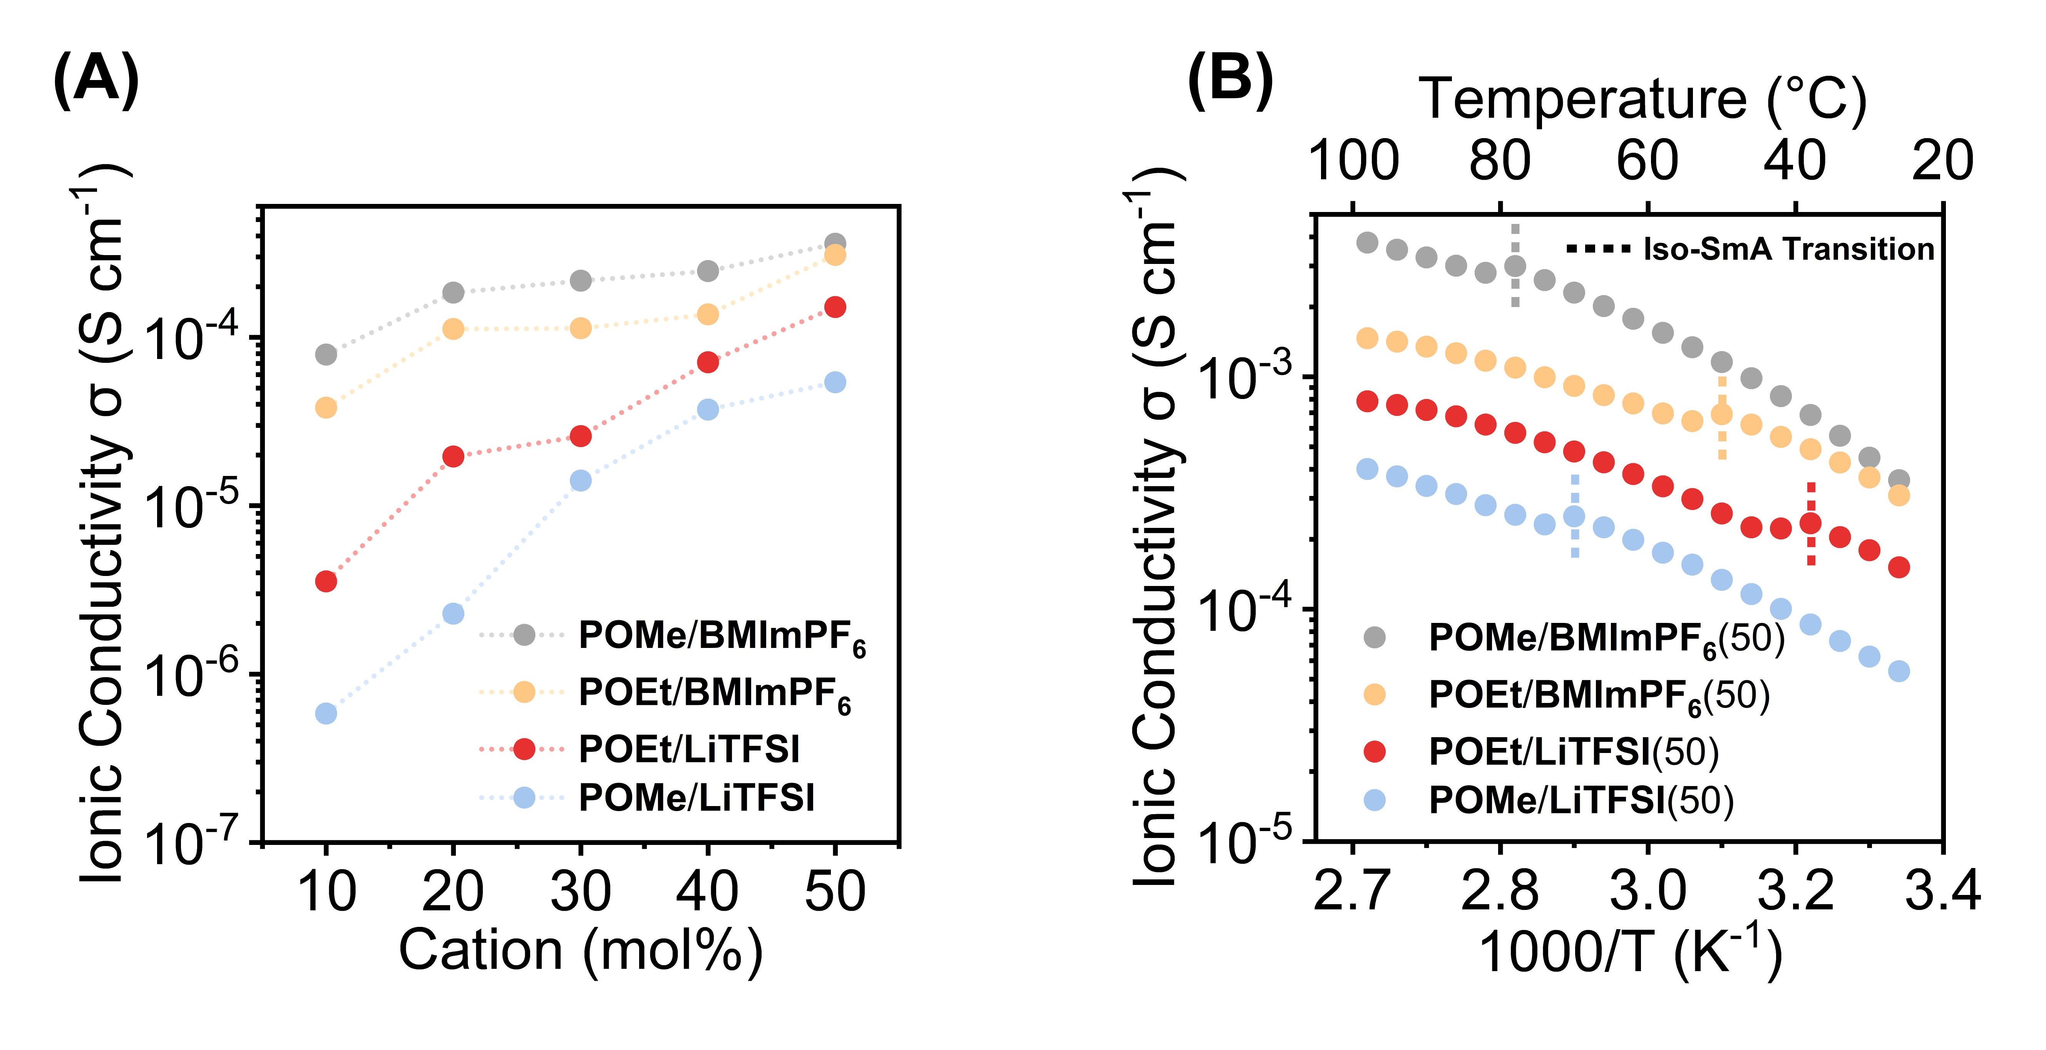
Figure 3. (A) Ionic conductivities at room temperature for the POMe and POEt-based salt mixtures as a function of mole% of salts: POMe/BMImPF₆(x) (gray), POEt/ BMImPF₆(x) (orange), POEt/LiTFSI(x) (red), and POMe/LiTFSI(x) (blue). (B) Temperature-dependent ionic conductivities of equimolar salt mixtures: POMe/BMImPF₆(50) (gray), POEt/BMImPF₆(50) (orange), POEt/LiTFSI(50) (red), and POMe/LiTFSI(50) (blue).

Characterization of Liquid Crystal–Polymer Composites. We successfully prepared free-standing liquid crystal–polymer composite electrolytes characterized by microphase-separated bicontinuous domains of liquid crystals and polymer networks (as depicted in Figure 1C for the POMe/BMImPF₆(50)–polymer composite), using the similar methodology outlined in our recent paper. This process involved casting a tetrahydrofuran solution containing 15 wt% PVC, 5 wt% PVDF-HFP, and either 80 wt% POMe/LiTFSI(50) or POMe/BMImPF₆(50). Regardless of the difference in the ionic species, it was observed that these liquid crystals exhibit a randomly oriented planar configuration along the surface of composite films (Figure S7, Supporting Information), suggesting the formation of vertically aligned ion pathways across the membranes.
Furthermore, we confirmed that the incorporation of the polymer networks in this new series of liquid crystals did not significantly reduce ionic conductivities (Figure S8, Supporting Information). The POMe/BMImPF₆(50)–polymer composite exhibits a room-temperature ionic conductivity of 1.7×10⁻⁴ S cm⁻¹, while POMe/BMImPF₆(50) alone shows 3.1×10⁻⁴ S cm⁻¹. Similarly, the conductivities of POMe/LiTFSI(50)–polymer composite and POMe/LiTFSI(50) were measured at 3.3×10⁻⁵ and 5.4 ×10⁻⁵ S cm⁻¹, respectively.
Moreover, we discovered that these organophosphate-based ionic liquid crystal–polymer composite films are non-flammable when exposed to fire, and thermal shrinkage of the films was observed (Figure S9, Supporting Information). The non-flammability of the composite electrolytes underscores the advantage of immobilizing flame-retardant organophosphate-based liquid crystals within the polymer scaffold.

Actuation Performances. The ionic liquid crystal–polymer composite electrolytes based on POMe/LiTFSI(50) and POMe/BMImPF₆(50) were sandwiched between two distinct sets of free-standing electrodes: 5 ± 1 μm-thick PEDOT:PSS electrodes and 25 ± 2 μm-thick active carbon (AC) electrodes. The AC electrode comprises 25 wt% active carbon, 5 wt% conductive Ketjenblack, 40 wt% PVDF polymer binder, and 30 wt% LiTFSI or BMImPF₆ as a supporting electrolyte. Despite attempts to achieve a thinner AC electrode similar to the thickness of the PEDOT:PSS electrode, it proved unsuccessful. These trilayer films were carefully compressed to fabricate iEAP actuators, resulting in a total thickness of 55 ± 2 μm for PEDOT:PSS-based actuators and 100 ± 4 μm for AC-based ones. Importantly, the ionic liquid crystal–polymer composites exhibited excellent adhesion to both the PEDOT:PSS and AC electrodes, with no delamination observed during the actuation test.
Figure 4A displays a photograph of the POMe/LiTFSI(50)-based ionic liquid crystal–polymer composite actuator with PEDOT:PSS electrodes under an alternating current square voltage of 2 V at a frequency of 0.1 Hz in ambient conditions. The actuator exhibited a significant bending deformation towards the anode side when a positive vias was applied, showcasing a maximum curvature of 0.1 mm⁻¹. The calculated strain value was 0.68 %, monitored at 8 mm from the clamped end of the actuator. This bending motion primarily occurred due to the diffusion and accumulation of lithium ions on the cathode and the Faradaic reactions of the PEDOT:PSS electrode, as discussed later.
Figure 4B illustrates the peak-to-peak bending displacements of the POMe/LiTFSI(50)-based ionic liquid crystal–polymer composite actuator with PEDOT:PSS electrodes under an alternating current square voltage of 2 V. It demonstrates a high-frequency response up to 110 Hz, achieving a displacement of 3 µm at a distance of 12 mm from the clamped end of the actuator. This broad frequency response is remarkable in the realm of flexible iEAP actuators (Table S1, Supporting Information). Moreover, a slight increase in displacement is observed within resonant frequencies of 20–30 Hz, although the displacement decreased with increasing frequency. Furthermore, this composite actuator demonstrated long-term cycling stability at 1 Hz with no significant strain degradation after 14000 cycles, as shown in Figure 4C.
In contrast, the POMe/BMImPF₆(50)-based ionic liquid crystal–polymer composite actuator with PEDOT:PSS electrodes showed a peak-to-peak displacement of merely 0.15 mm when subjected to an alternating current 2 V at 1 Hz (Figure 4D, blue line), which is one-hundredth of the displacement of POMe/LiTFSI(50)-based ionic liquid crystal–polymer composite/PEDOT:PSS actuator (Figure 4D, red line).
The significant difference in actuator displacement attributed to electrolyte variation is believed to arise from the ease of ion insertion into the PEDOT:PSS cathode and the occurrence of reduction reactions of cationic PEDOT. The functionality of the PEDOT:PSS-based actuator primarily relies on the mechanism of PEDOT⁺:PSS⁻ + M⁺ ⇔ PEDOT + M⁺ PSS⁻, where the cation M⁺ serves as the principal driving ion³⁸. However, if ions encounter resistance upon entering the electrodes, the actuator’s performance will inevitably diminish. Figure 4E presents Nyquist plots derived from the electrochemical impedance spectroscopy of the PEDOT:PSS-based actuators. In these plots, the first semicircles with a smaller diameter in the high-frequency region signify bulk electrolyte resistances, the second intermediate-frequency semicircles indicate charge transfer resistances at the electrolyte/electrode interface, and low-frequency arcs extending infinitely may be ascribed to occur from the Warburg impedance arising from the semi-infinite diffusion of ions at the electrode. Upon comparison, we observe that the semicircle diameter corresponding to the charge transfer resistance for the actuator incorporating the POMe/BMImPF₆(50)-based ionic liquid crystal–polymer composite reaches 4510 Ω. Conversely, for the actuator with POMe/LiTFSI(50)-based ionic liquid crystal–polymer composite, it is only 780 Ω. Despite the higher ion conductance of POMe/BMImPF₆(50), its notably high charge transfer resistance primarily contributes to its suboptimal actuation performance. Important factors affecting charge transfer resistance include the matching of electrode pore sizes with ion dimensions^{39,40}, where smaller lithium ion (volume is 1.0 Å³) can easily move in and out of PEDOT:PSS electrode, while the larger BMIm⁺ cation (volume is 116 Å³) may encounter difficulties due to its size.
Moreover, capacitance plays a significant role in influencing actuation behavior. The cyclic voltammetry (CV) profiles in Figure 4F reveal that the specific gravimetric capacitance of the POMe/LiTFSI(50)-based actuator with PEDOT:PSS electrodes is 16.3 F g^{–1}, notably superior to that of the POMe/BMImPF₆(50)-based actuator, which stands at only 4.0 F g^{–1}. Additionally, the CV profile for the POMe/LiTFSI(50)-based actuator more closely resembles a rectangle, indicating lower leakage current and improved capacitive characteristics. Furthermore, in the CV profile of POMe/LiTFSI(50)-based actuator, redox peaks are discernible around ±0.5 V, indicating that the actuator possesses the dual attributes of electric double layer capacitance and pseudo-capacitance^{41–44}.
The blocking force of the ionic liquid crystal–polymer composite actuators with PEDOT:PSS electrodes was evaluated. Upon applying a DC voltage of 2 V, the POMe/LiTFSI(50)-based actuator displayed a blocking force of 0.56 mN, while the POMe/BMIm(50)-based actuator reached a maximum blocking force of approximately 0.40 mN (Figure S10, Supporting Information). These values surpass the reported 0.35 mN for the POEt/LiTFSI(50)-based actuator and the range of 0.27–0.28 mN for photocured LC polymer actuators with one and three dimensionally ion-transporting channels^{7,35}. However, the POMe/LiTFSI(50)-based actuator exhibited a gradual decrease in the generated force over time when a DC voltage was applied. This back relaxation behavior may be attributed to the slow migration of TFSI anions within the liquid crystal–polymer composite matrix towards the anode side, leading to a reduction in the difference in volume changes between the cathode and anode.

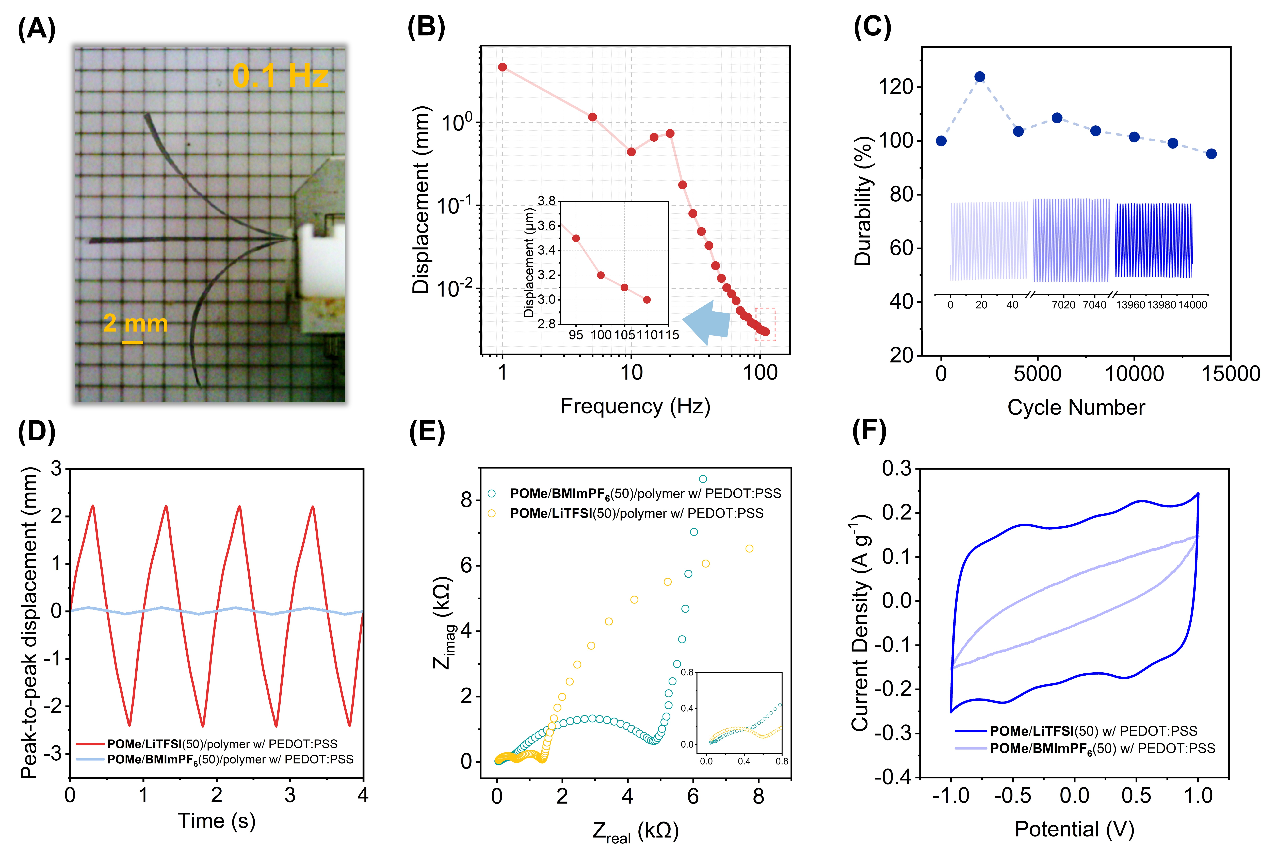
Figure 4. Actuation performance of the PEDOT:PSS-based actuator with POMe-based electrolytes. (A) Photograph of the bending actuator based on the POMe/LiTFSI(50)-based ionic liquid crystal–polymer composite under ± 2 V at 0.1 Hz. (B) Peak-to-peak displacements of the POMe/LiTFSI(50)-based actuator in the frequency range of 1–110 Hz under ± 2 V. The bending displacement was measured by a laser displacement meter at 12 mm from the clamped end. (C) Cycle durability of the POMe/LiTFSI(50)-based actuator under an alternating current 2 V at 1 Hz. (D) Actuation performances of the PEDOT:PSS-based actuators using POMe/LiTFSI(50) and POMe/BMImPF₆(50)–polymer composite electrolytes under ±2 V at 1 Hz. (E) Nyquist plots of the POMe/LiTFSI(50) and POMe/BMImPF₆(50)-based actuators. (F) Cyclic voltammetry profiles of the POMe/LiTFSI(50) and POMe/BMImPF₆(50)-based actuators with PEDOT:PSS electrodes at the scan rate of 10 mV s^{–1}.

To investigate how electrodes affect the electromechanical performance of the ionic liquid crystal–polymer composite actuators, we conducted a comparative study between the POMe/LiTFSI(50) and POMe/BMImPF₆(50)-based actuators, employing AC electrodes made of high-surface-active carbon with a BET surface area of 1692 m² g^{–1}. Our findings revealed that the POMe/BMImPF₆(50)-based actuator with AC electrodes outperformed its POMe/LiTFSI(50)-based counterpart, attributed to its larger electric double layer capacitance. When a +2 V DC vias was applied to the anode, the POMe/BMImPF₆(50)-based actuator with AC electrodes bent towards the anode side, achieving a peak-to-peak displacement of 10.6 mm from ‒2 V to +2 V DC vias (Figure 5A, upper panel). A photograph depicting the bending actuator under a ±2 V DC vias is provided in the Supporting Information (Figure S11, Supporting Information). In contrast, the POMe/LiTFSI(50)-based actuator with AC electrodes exhibited a mere 0.13 mm bending displacement towards the cathode direction with back relaxation when a +2 V vias was applied to the anode (Figure 5A, lower panel). This bending direction contrasts with that observed in the PEDOT:PSS-based actuators. The bending behavior of POMe/LiTFSI(50)-based actuator with AC electrodes towards the cathode is presumed to result from the expansion of the anodic AC electrode due to the accumulation of the larger TFSI anions, which exceed the size of lithium ion.

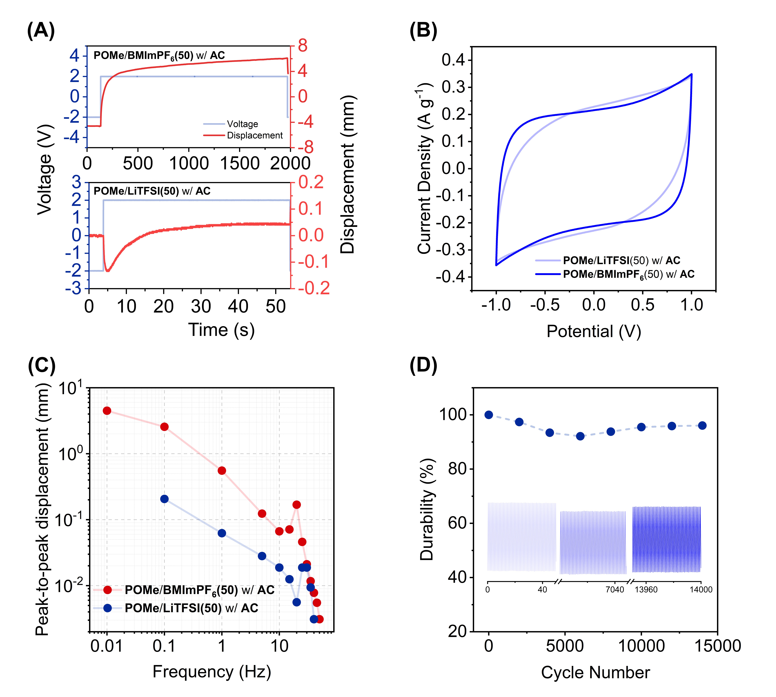
Figure 5. Actuation performances of the AC-based actuators with POMe-based electrolytes. (A) Displacement changes over time for the POMe/BMImPF₆(50) and POMe/LiTFSI(50)–polymer composite actuators under applying a 2 V DC vias. The bending displacement was measured by a laser displacement meter at 12 mm from the clamped end. (B) Cyclic voltammograms of the actuators at the scan rate of 10 mV s⁻¹. (C) Frequency-dependent peak-to-peak displacements of the actuators under applying ±2 V. (D) Cycle stability of the bending actuation for the POMe/BMImPF₆(50)–polymer composite actuator under ±2 V at 1 Hz. The bending strain for each cycle is normalized by the initial strain value.
We conducted additional analysis on the bending displacements of these actuators under an alternating current square wave voltage of ± 2 V at 1 Hz (Figure S12, Supporting Information). The displacement of POMe/BMImPF₆(50)-based actuator with AC electrodes exhibited a linear increase over time, whereas the POMe/LiTFSI(50)-based actuator demonstrated a gradual displacement increase, reaching saturation around 0.25 seconds.
Electrochemical impedance spectra of these actuators were analyzed to gain insights into charge transfer and ion diffusion (Figure S13, Supporting Information). The Nyquist plot of the POMe/BMImPF₆(50)–polymer composite actuator showed a 45° sloped straight line in the frequency range between 20 kHz to 1Hz, indicating ion diffusion behavior within the AC electrode. In contrast, the spectrum for the POMe/LiTFSI(50)–polymer composite actuator depicted a charge transfer semicircle within the same frequency range. These results suggest that the former functions as a pure electric double layer capacitance, while the latter may operate as a hybrid capacitor.
The gravimetric capacitance of these actuators was determined by CV measurements (Figure 5B). Notably, their specific capacitance values do not differ significantly. The capacitance of POMe/BMImPF₆(50) and POMe/LiTFSI(50)-based actuators with AC electrodes are 21.2 and 19.7 F g^{–1}, respectively, exceeding that of POMe/LiTFSI(50)-based actuator with PEDOT:PSS (16.3 F g^{–1}). However, the CV profile for the POMe/BMImPF₆(50)-based actuator more closely resembles a rectangle, whereas the curve for the POMe/LiTFSI(50)-based actuator is more fusiform in shape. This difference can be attributed to the higher ionic conductivity of the POMe/BMImPF₆(50)–polymer composite electrolyte, which facilitates faster ion movement and results in less leakage current.
Frequency-dependent displacements were further examined for these actuators (Figure 5C). The POMe/BMImPF₆(50)-based actuator shows a broader frequency response up to 50 Hz and a greater displacement, while the response limit of the POMe/LiTFSI(50)-based actuators was 40 Hz. Furthermore, the POMe/BMImPF₆(50)-based actuator demonstrates good durability with only 4% strain degradation over 14,000 cycles at ±2 V at 1 Hz (Figure 5D).
The utilization of porous AC electrodes has demonstrated a positive impact on enhancing the ionic capacity of actuators. More significantly, the issue of back relaxation observed in the PEDOT:PSS-based actuators has been effectively addressed in the AC electrode-based actuator incorporating the POMe/BMImPF₆(50)–polymer composite (Figure S10, Supporting Information). Its blocking force gradually increased over time upon the application of a 2 V DC vias, reaching approximately 0.48 mN. Developing a fabrication process for a 5 µm-thick AC electrode film with good mechanical stiffness could pave the way for the improved iEAP actuator that combine the contradictory functionalities such as high response time, high displacement in a broad frequency range, and high force generation, thus offering advancements for the next generation of iEAP actuators indented for haptic applications. As an application of the actuators, we have developed a ring-shaped haptic interface utilizing a POMe/LiTFSI(50)-based actuator with PEDOT:PSS electrodes (Figure 6). This ring securely mounts five actuators onto the current collecting copper electrodes of the ring. By applying voltage to both sides of the ring, the actuators are driven to create tactile sensations upon touching the fingers. As depicted in the photographs, when a negative voltage is applied to the inner side of the ring, the actuators bend away from the fingers and do not exert force on them. Conversely, when a positive voltage is applied to the inner side of the ring, the actuators bend towards the fingers. At this point, the actuators make contact with the fingers, resulting in the generation of tactile sensations.
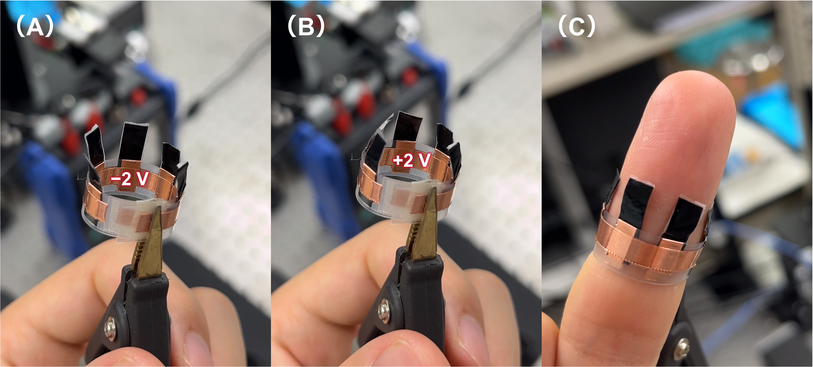
Figure 6. Photographs of a ring-shaped haptic interface utilizing a POMe/LiTFSI(50)-based actuator with PEDOT:PSS electrodes: (A) Application of −2 V on the inner side of the ring. (B) Application of +2 V on the inner side of the ring. (C) Placement of the ring-shaped haptic interface on the finger, with the actuators driven to make contact with the skin.

CONCLUSIONS
In this research, we have made significant discoveries regarding the formation of SmA phases in POMe complexes with both LiTFSI and the room-temperature ionic liquid BMImPF₆. Notably, the clearing temperatures of the POMe-based liquid crystals were found to be considerably higher than those of POEt complexes. The ionic conductivities of POMe complex with BMImPF₆ surpassed 3.0×10⁻⁴ S cm^{–1}. Our investigation revealed that the performance of ionic actuators is profoundly influenced by the species of mobile ions and the materials of the electrodes.
We examined novel ionic liquid crystal–polymer composite actuators based on POMe/LiTFSI and POMe/BMImPF₆ with both PEDOT:PSS and AC electrodes. The POMe/LiTFSI-based composite with PEDOT:PSS electrodes exhibited superior actuation performance compared to the corresponding activated carbon actuator. Specifically, the PEDOT:PSS actuator achieved a bending strain value of 0.68 % when an square wave voltage of 2 V was applied at 0.1 Hz, with the maximum response frequency reaching 110 Hz and a displacement of 3 µm. On the other hand, the POMe/BMImPF₆-based composite with AC electrodes demonstrated superior actuation performance compared to the PEDOT:PSS-based actuator, exhibiting a bending strain of 0.34 % at 2 V and 0.1 Hz, along with a maximum response frequency of 50 Hz.
Overall, among the examined systems in this study, the combination of the POMe/LiTFSI-based composite electrolyte and PEDOT:PSS electrode provided the highest strain and actuation speed. This can be attributed to the small size of lithium ions, which can easily penetrate the PEDOT:PSS electrode, enabling the formation of capacitance and inducing redox reactions in PEDOT:PSS. In contrast, activated carbon electrodes allow for electric double layer capacitance.
The findings from this research hold substantial significance for future advancements in the design of LC molecules for ion transport, the selection of ions and electrodes, and even the development of flexible iEAP actuators. These insights open up new avenues and provide innovative directions in this field, thereby contributing to its progression.

EXPERIMENTAL SECTION
General methods. Nuclear magnetic resonance (NMR) spectra were acquired using a JEOL ECZ 400S spectrometer. Chemical shifts (δ) are reported in ppm with respect to internal or external standards for CDCl₃ solutions: tetramethylsilane (δ = 0 ppm) for ¹H NMR (400 MHz), CHCl₃ (δ = 77.0 ppm) for ¹³C NMR (100 MHz). Elemental analysis for C, H and N was conducted using an ELEMENTAR vario EL cube. Polarized optical microscopy (POM) observations were performed with an Olympus BX51N-31P-O3 microscope equipped with a DP22 digital camera and a LINKAM T95-HS, LTS420E temperature control system. Differential scanning calorimetry (DSC) measurements were carried out using a NETZSCH DSC-3500 Sirius system coupled with a liquid nitrogen cryo-system, employing heating and cooling rates of 10 °C/min. X-ray diffraction (XRD) patterns within a constrained angular range of 2θ = 1−30° were recorded using a Rigaku MiniFlex 600 diffractometer equipped with Ni-filtered Cu Kα radiation. Fourier transform infrared (FT-IR) spectra were acquired with a Bruker ALPHA II spectrometer.
Materials. 4-(trans-4-Pentylcyclohexyl)phenol, 6-chloro-1-hexanol, diethyl chlorophosphate, dimethyl chlorophosphate, and 1-butyl-3-methylimidazolium hexafluorophosphate (BMImPF₆) were obtained from Tokyo Chemical Industry (TCI, Japan). Kanto Chemical (Cica, Japan) supplied 1,4-diazabicyclo[2.2.2]octane, NaI, K₂CO₃, N,N-dimethylformamide (DMF), acetone, tetrahydrofuran (THF), lithium bis(trifluoromethanesulfonyl)imide (LiTFSI), and ethylene glycol. Poly(vinyl chloride) (PVC) was acquired from Sigma Aldrich. Poly(3,4-ethylenedioxythiophene) polystyrene sulfonate (PEDOT:PSS, Clevios™ PH1000) was procured from Heraeus. Polyvinylidene difluoride (PVDF) and activated carbon (AB520Y) was purchased from MTI Corporation. Electro-conductive carbon black (KETJENBLACK EC600JD) was obtained from LION Specialty Chemicals Co. Ltd.. Poly(vinylidene fluoride-co-hexafluoropropylene) (PVDF-HFP, Kynar Flex® 2801-00 from Arkema) was provided by Tokyo Zairyo, Japan.
Synthesis of 6-{4-(trans-4-Pentylcyclohexyl)phenyloxy}hexane-1-ol. In a 100 mL flask, 4-(trans-4-pentylcyclohexyl)phenol (3.66 g, 14.87 mmol), 6-chloro-1-hexanol (2.51 g, 18.34 mmol), K₂CO₃ (6.17 g, 44.61 mmol), NaI (0.28g, 1.83 mmol), and anhydrous DMF (30 mL) were combined. The mixture was stirred at 75 °C for 24 hours under an argon atmosphere. Following this, the reaction mixture was diluted with ethyl acetate (EtOAc) and washed with a saturated solution of NH₄Cl in water. The resulting organic phase was extracted, dried over anhydrous MgSO₄, and then filtered. After vacuum concentration, the residue was purified using silica gel column chromatography (eluted with a gradient of n-hexane/EtOAc from 1/0 to 5/2). This procedure yielded a titled compound as a white solid (4.58 g, 13.2 mmol, 89% yield).
Synthesis of dimethyl {6-{4-(trans-4-pentylcyclohexyl)phenyloxy}hexyl} phosphate (POMe). To a solution of 6-{4-(trans-4-pentylcyclohexyl)phenyloxy}hexane-1-ol (1.00 g, 2.89 mmol) and 1,4-diazabicyclo[2.2.2]octane (0.61 g, 5.45 mmol) in dry THF (35 mL) under an argon atmosphere, dimethyl chlorophosphate (0.47 mL, 4.33 mmol) was added dropwise at room temperature with stirring. The reaction mixture was stirred for 16 hours. Afterwards, it was diluted with CHCl₃ and washed successively with a 5% HCl aqueous solution and deionized water. The resulting organic phase was dried over anhydrous MgSO₄, filtered, and concentrated under reduced pressure. The residue was purified by silica gel column chromatography (n-hexane/EtOAc = 65/35−50/50) and recycling preparative GPC (eluted with CHCl₃), affording POMe as a white solid (1.34 g, 2.79 mmol, 64% yield). ¹H NMR (400 MHz, CDCl₃): δ = 7.10 (dt, J = 9.5, 2.4 Hz, 2H; ArH), 6.80 (dt, J = 9.3, 2.5 Hz, 2H; ArH), 4.05 (q, J = 6.7 Hz, 2H; CH₂), 3.95-3.89 (m, 2H; CH₂), 3.75 (dd, J = 14.9, 3.9 Hz, 6H, CH₃), 2.39 (tt, J = 12.1, 3.1 Hz, 1H; CH), 1.86-1.68 (m, 8H; CH₂), 1.53-1.17 (m, 15H, CH, CH₂), 1.02 (ddd, J = 24.0, 12.8, 3.2 Hz, 2H; CH₂), 0.90 (q, J = 7.3 Hz, 3H, CH₃). ¹³C NMR (100 MHz, CDCl₃): δ = 157.2, 140.1, 127.7, 114.3, 77.5, 77.2, 76.8, 67.9, 67.9, 67.7, 54.3, 54.2, 43.8, 37.5, 37.4, 34.7, 33.7, 32.3, 30.3, 30.2, 29.3, 26.7, 25.7, 25.3, 22.8, 14.2. Elemental analysis calculated for C₂₅H₄₃O₅P: C, 66.05; H, 9.53%; found: C, 66.75; H, 9.23%.
Preparation of Ionic Liquid Crystals. Mesogenic phosphate (POMe or POEt) was mixed with an acetone solution of either BMImPF₆ or LiTFSI at molar ratios of 9:1, 8:2, 7:3, 6:4, and 5:5. Subsequently, these solutions were subjected to gradual evaporation in an oven at 80 °C for 3 hours, followed by vacuum drying at the same temperature for an additional 9 hours to obtain ionic liquid crystals with varied components and proportions.
Preparation of Ionic Liquid Crystal–Polymer Composite Membranes. 12 mg of ionic liquid crystal was mixed with PVC and PVDF-HFP solutions (both at a concentration of 0.04 mg μL^{–1} in THF) at a mass ratio of 80:15:5, supplemented with 300 μL THF for dilution. Subsequently, approximately two-thirds of the solution was evaporated at 80 °C. The resulting partially evaporated solution was then deposited onto a glass substrate, covering an area of 10 mm×25 mm. The residual solvent was then evaporated in an oven at 80 °C for 2 hours, followed by vacuum drying at the same temperature for an additional 12 hours. Free-standing ionic liquid crystal–polymer composite films with the thickness of 45 ± 2µm were obtained by peeling them off from the substrate.
Preparation of PEDOT:PSS Electrodes. An aqueous solution of PEDOT:PSS (Clevios™ PH1000) and ethylene glycol were mixed in a volume ratio of 94:6, followed by stirring for 30 minutes to ensure complete mixing. Using a glass substrate, 1.8 mL of this mixture was dropped in a confined area measuring 5 mm×5 mm. Subsequently, the substrate was dried at 80°C for 5 hours. Deionized water was then dropped onto the substrate, and the gel-like PEDOT:PSS film was transferred to a Teflon substrate. The film was then subjected to heat at 120 °C for 7 hours, resulting in the production of a 5 ± 1 µm-thick PEDOT:PSS electrode film with a conductivity of 500 S cm^{–1}.
Preparation of AC Electrodes. A mixture of AC, PVDF solution in NMP (0.03 mg mL^{–1}), BMImPF₆ or LiTFSI, and a conductive agent (Ketjenblack) was prepared in a ratio of 25:40:30:5. To dilute the mixture, an amount of NMP solvent equal to one-fifth of the PVDF solution volume was added. Teflon (for BMImPF₆ contained slurry) or polyimide (for LiTFSI slurry) was used as the substrate, onto which 400 µL of the mixture was dropped within a circular area with a radius of 25 mm. This was then heated in a vacuum drying oven up to 110 °C. After 10 hours, an AC-based composite electrode was obtained. The conductivities of AC films containing BMImPF₆ and LiTFSI with the thickness of 25 ± 2 μm were measured as 1.0 S cm^{–1} and 0.3 S cm^{–1}, respectively.
Preparation of Actuators. An electrolyte membrane was sandwiched between two electrode pieces and then subjected to hot pressing at 30 °C (AS ONE Co., Small hot press machine H300-10D). The resulting actuator was shaped into a rectangle with dimensions of 20 mm×4 mm. The thickness of the PEDOT:PSS-based actuator was measured to be 55 ± 2μm, while the thickness of the AC-based actuator was measured to be 100 ± 4μm.
Electrochemical Impedance Spectroscopy (EIS) Measurements. EIS measurements were carried out using a Metrohm AUTOLAB PGSTAT128N impedance analyzer. The frequency range was 10²–10⁷ Hz and the applied voltage was 5 mV. The liquid crystal sample was sandwiched between a pair of indium tin oxide (ITO)-coated glass substrates using a 58 μm-thick polyimide tape spacer with a 3 mm-diameter hole. The EIS measurements of the liquid crystal/polymer composite electrolyte membranes and actuators were conducted using a Swagelok-type two electrode cell (2E-Cell-SUS, Eager Corporation).
The ionic conductivity (σ, S cm^{–1}) was calculated using the following formula³⁵: σ = L/(R_{b}∙A), where L refers to the sample thickness (cm), R_{b} is the bulk resistance of the electrolyte, and A is the sample area (cm²). The R_{b} value was obtained from the intercept of a semicircle on the real axis of impedance in the Nyquist plots.
Cyclic Voltammetry Measurements. The actuator was sandwiched between two stainless steel electrodes and placed in a Swagelok-type two-electrode cell (2E-Cell-SUS, Eager Corporation) to measure the cyclic voltammograms using an electrochemical workstation (Autolab PGSTAT302N) in a potential range of 1 to −1 V at scan rates varying from 10 to 50 mV s⁻¹. The specific gravimetric capacitance (C_{m}, F g^{–1}) was calculated by the following equation: ${\text{C}}_{\text{m}} \text{=}\int{\frac{\text{I}\text{d}\text{V}}{\text{2}\text{vmV}}}$, where I (A) is the response current, V (V) is the voltage window, v (V s^{–1}) denotes the sweep rate of voltage, and m (g) is mass of active electrode material in one electrode.
Actuator Performance Test. The actuator was clamped with two stainless-steel electrodes, each equipped with a piece of copper foil, and connected to a potentiostat (Hokuto Denko, HAL3001A). Alternating current square voltages generated by a function generator (YOKOGAWA FG400 30MHz) were input to the potentiostat. Bending displacement of the actuators was measured using a laser displacement meter (Keyence, LK-HD500). The laser was irradiated perpendicular to the actuator surface at a distance of 12 mm from the electrode. The signals of voltage, current, and displacement of actuator were recorded in a digital data logger (HIOKI LR8880). The actuation was captured using a USB microscope camera (Sanwa Supply, 400-CAM058, Japan). The peak-to-peak strain (ε) was computed using the formula⁷: ε = 2δd ×100/(δ²+L²), where δ represents the peak-to-peak displacement (mm), d denotes the thickness of the actuator (mm), and L signifies the distance (mm) from the clamped end of the actuator to the laser irradiation point. The blocking force was measured by the load sensor connected to a force detection monitor (KYOWA LTS-50GA/KYOWA WGA-680A).
Preparation of Ring-shaped Haptic Interface. Two rectangular polypropylene (PP) thick film, each measuring 70 mm × 8 mm, were prepared. Along the long sides of each film, five pieces of copper adhesive tape, each measuring 8 mm × 4 mm, were affixed with a 10 mm spacing between each pair. The copper tape covered both sides of the film. The five pieces on one side were interconnected by copper tape. The same method was applied to the other PP film. One of the PP films was wrapped into a loop resembling the circumference of a finger, with the side where the copper tape was connected facing inward. Five actuators, each measuring 15 mm × 5 mm, were fully covered on the positions where the copper tape was adhered. The other PP film was wrapped into a loop, aligning the positions of the copper tape with the actuators, with the side where the copper tape was connected facing outward.

ASSOCIATED CONTENTS
Supporting Information.
DSC analytical graphs of the liquid crystals, molecule structure of POMe, d-spacing graph, FT-IR spectra, POM textures and Nyquist plots of the liquid crystal–polymer composite electrolytes, photographs of flammability test, blocking forces, performance photograph of the POMe/BMImPF6(50)–polymer composite actuator, bending displacements and Nyquist plots of AC electrode-based actuators are shown in the Supporting Information (PDF), Bending performance video Movie (MP4) is also provided as supporting contents.
AUTHOR INFORMATION
Corresponding author
Masafumi Yoshio ‒ Research Center for Macromolecules & Biomaterials, National Institute for Materials Science, 1-2-1 Sengen, Tsukuba, Ibaraki 305-0047, Japan; Graduate School of Chemical Sciences and Engineering, Hokkaido University, Kita 13, Nishi 8, Kita-ku, Sapporo, Hokkaido 060-8628, Japan; Japan Science and Technology Agency, PRESTO, 4-1-8 Honcho, Kawaguchi, Saitama, 332-0012, Japan; 8628, Japan; orcid.org/0000-0002-1442-4352;
Email: YOSHIO.Masafumi@nims.go.jp
Author
Chengyang Liu ‒ Research Center for Macromolecules & Biomaterials, National Institute for Materials Science, 1-2-1 Sengen, Tsukuba, Ibaraki 305-0047, Japan; Graduate School of Chemical Sciences and Engineering, Hokkaido University, Kita 13, Nishi 8, Kita-ku, Sapporo, Hokkaido 060-8628, Japan.
Author Contributions
M.Y. conceived the idea, designed the project, and supervised this study. Investigation, writing, review and editing were done by M.Y. and C.L.
Funding
This work was supported by JST, PRESTO (Grant Number JPMJPR23QB) and JSPS KAKENHI (Grant Number 21H02021) and Iketani Science and Technology Foundation (no. 0351202-A).
TOC
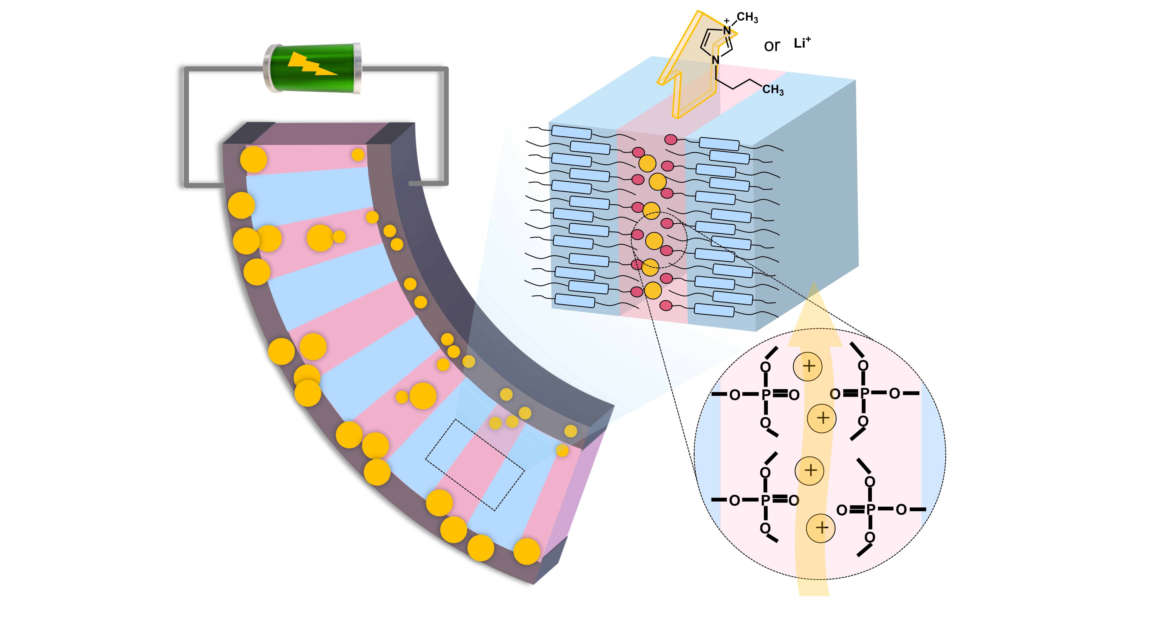
This study developed layered liquid crystal–polymer composite electrolytes, incorporating mesogenic phosphates with lithium salt or ionic liquid, along with vinyl polymers. Utilized in ionic electroactive polymer actuators with diverse electrodes, these electrolytes exhibit impressive ionic conductivity around 10⁻⁴ S cm⁻¹. Remarkably, PEDOT:PSS-based actuators achieve a peak-to-peak bending strain of 0.68% and operate at frequencies up to 110 Hz, demonstrating exceptional performance.

REFERENCES
(1) Kumari, A.; Pani, I.; Lone, M. U.; Aggarwal, A.; Pal, S. K.; Roy, R. K. Architectural Effect on Self-Assembly and Biorecognition of Randomly Grafted Linear and Branched Polymers at Liquid Crystal–Water Interfaces. ACS Appl. Mater. Interfaces 2023, 15 (26), 31233–31242. https://doi.org/10.1021/acsami.3c04672.
(2) Kim, W.; Im, J.; Kim, H.; Choi, J.; Choi, Y.; Kim, Y. Liquid Crystalline Systems from Nature and Interaction of Living Organisms with Liquid Crystals. Adv. Mater. 2023, 35 (4), 2204275. https://doi.org/10.1002/adma.202204275.
(3) Ketkar, P. M.; Epps, T. H. Nanostructured Block Polymer Electrolytes: Tailoring Self-Assembly to Unlock the Potential in Lithium-Ion Batteries. Acc. Chem. Res. 2021, 54 (23), 4342–4353. https://doi.org/10.1021/acs.accounts.1c00468.
(4) Xiao, J.; Cong, M.; Li, M.; Zhang, X.; Zhang, Y.; Zhao, X.; Lu, W.; Guo, Z.; Liang, X.; Qing, G. Self‐Assembled Nanoporous Metal–Organic Framework Monolayer Film for Osmotic Energy Harvesting. Adv. Funct. Mater. 2024, 34 (2), 2307996. https://doi.org/10.1002/adfm.202307996.
(5) Nie, Y.; Yang, T.; Luo, D.; Liu, Y.; Ma, Q.; Yang, L.; Yao, Y.; Huang, R.; Li, Z.; Akinoglu, E. M.; Wen, G.; Ren, B.; Zhu, N.; Li, M.; Liao, H.; Tan, L.; Wang, X.; Chen, Z. Tailoring Vertically Aligned Inorganic‐Polymer Nanocomposites with Abundant Lewis Acid Sites for Ultra‐Stable Solid‐State Lithium Metal Batteries. Adv. Energy Mater. 2023, 13 (13), 2204218. https://doi.org/10.1002/aenm.202204218.
(6) Kato, T.; Yoshio, M.; Ichikawa, T.; Soberats, B.; Ohno, H.; Funahashi, M. Transport of Ions and Electrons in Nanostructured Liquid Crystals. Nat. Rev. Mater. 2017, 2 (4), 17001. https://doi.org/10.1038/natrevmats.2017.1.
(7) Wu, C.-H.; Meng, W.; Yoshio, M. Low-Voltage-Driven Actuators Using Photo-Cross-Linked Ionic Columnar Liquid-Crystalline Polymer Films. ACS Mater. Lett. 2022, 4 (1), 153–158. https://doi.org/10.1021/acsmaterialslett.1c00565.
(8) Sakuda, J.; Hosono, E.; Yoshio, M.; Ichikawa, T.; Matsumoto, T.; Ohno, H.; Zhou, H.; Kato, T. Liquid-Crystalline Electrolytes for Lithium-Ion Batteries: Ordered Assemblies of a Mesogen-Containing Carbonate and a Lithium Salt. Adv. Funct. Mater. 2015, 25 (8), 1206–1212. https://doi.org/10.1002/adfm.201402509.
(9) Yoshio, M.; Kato, T. Liquid Crystals as Ion Conductors. In Handbook of Liquid Crystals; Goodby, J. W., Tschierske, C., Raynes, P., Gleeson, H., Kato, T., Collings, P. J., Eds.; Wiley-VCH Verlag GmbH & Co. KGaA: Weinheim, Germany, 2014; pp 1–23. https://doi.org/10.1002/9783527671403.hlc148.
(10) Yang, H.; Wu, N. Ionic Conductivity and Ion Transport Mechanisms of Solid‐state Lithium‐ion Battery Electrolytes: A Review. Energy Sci. & Eng. 2022, 10 (5), 1643–1671. https://doi.org/10.1002/ese3.1163.
(11) Lu, J.; Xu, H.; Yu, H.; Hu, X.; Xia, J.; Zhu, Y.; Wang, F.; Wu, H.-A.; Jiang, L.; Wang, H. Ultrafast Rectifying Counter-Directional Transport of Proton and Metal Ions in Metal-Organic Framework–Based Nanochannels. Sci. Adv. 2022, 8 (14), eabl5070. https://doi.org/10.1126/sciadv.abl5070.
(12) Gin, D. L.; Lu, X.; Nemade, P. R.; Pecinovsky, C. S.; Xu, Y.; Zhou, M. Recent Advances in the Design of Polymerizable Lyotropic Liquid‐Crystal Assemblies for Heterogeneous Catalysis and Selective Separations. Adv. Funct. Mater. 2006, 16 (7), 865–878. https://doi.org/10.1002/adfm.200500280.
(13) Yoshio, M.; Wu, C.; Liu, C. Mechanically Tough Micellar Cubic Liquid‐Crystalline Polymer Electrolytes for Electromechanical Actuators. Adv. Funct. Mater. 2024, 2314087. https://doi.org/10.1002/adfm.202314087.
(14) Zhao, L.; Du, Y.; Zhao, E.; Li, C.; Sun, Z.; Li, Y.; Li, H. Dynamic Supramolecular Polymer Electrolyte to Boost Ion Transport Kinetics and Interfacial Stability for Solid‐State Batteries. Adv. Funct. Mater. 2023, 33 (30), 2214881. https://doi.org/10.1002/adfm.202214881.
(15) Zhu, T.; Kong, Y.; Lyu, B.; Cao, L.; Shi, B.; Wang, X.; Pang, X.; Fan, C.; Yang, C.; Wu, H.; Jiang, Z. 3D Covalent Organic Framework Membrane with Fast and Selective Ion Transport. Nat. Commun. 2023, 14 (1), 5926. https://doi.org/10.1038/s41467-023-41555-5.
(16) Janietz, S.; Brening, T.; Schiestel, Th.; Götz, T. Block Copoly(Phenylquinoxaline)s as Potential Ionomers for Proton Exchange Membranes. Polymer 2023, 271, 125794. https://doi.org/10.1016/j.polymer.2023.125794.
(17) Stoeva, Z.; Lu, Z.; Ingram, M. D.; Imrie, C. T. A New Polymer Electrolyte Based on a Discotic Liquid Crystal Triblock Copolymer. Electrochim. Acta 2013, 93, 279–286. https://doi.org/10.1016/j.electacta.2013.01.060.
(18) Strauss, M. J.; Hwang, I.; Evans, A. M.; Natraj, A.; Aguilar-Enriquez, X.; Castano, I.; Roesner, E. K.; Choi, J. W.; Dichtel, W. R. Lithium-Conducting Self-Assembled Organic Nanotubes. J. Am. Chem. Soc. 2021, 143 (42), 17655–17665. https://doi.org/10.1021/jacs.1c08058.
(19) Lee, C. J.; Hong, S. J.; Song, J.; Yoon, K. S.; Oh, K.-H.; Lee, J. Y.; Yoon, S. J.; Hong, Y. T.; Lee, S.-Y.; Yu, D. M.; So, S. Porous Polyethylene Supports in Reinforcement of Multiblock Hydrocarbon Ionomers for Proton Exchange Membranes. Langmuir 2023, 39 (51), 18834–18845. https://doi.org/10.1021/acs.langmuir.3c02540.
(20) Kang, H.; Wang, S.; Li, C.; Wang, K.; Sun, J. Direct-Write Printed Slippery Surface for Assembling a High-Quality Graphene Structure and Its Application in Flexible Electric Actuators. Langmuir 2024, 40 (12), 6571–6581. https://doi.org/10.1021/acs.langmuir.4c00213.
(21) Chen, C.; Chu, F.; Zhang, Y.; Ma, M.; Sun, R.; Jia, P.; Sun, J. Fabricating Flexible Strain Sensor with Direct Writing Graphene/Carbon Nanotube Aerogel. ACS Appl. Electron. Mater. 2023, 5 (3), 1429–1436. https://doi.org/10.1021/acsaelm.2c01338.
(22) Ramón-Gimenez, L.; Storz, R.; Haberl, J.; Finkelmann, H.; Hoffmann, A. Anisotropic Ionic Mobility of Lithium Salts in Lamellar Liquid Crystalline Polymer Networks. Macromol. Rapid Commun. 2012, 33 (5), 386–391. https://doi.org/10.1002/marc.201100792.
(23) Alaasar, M.; Darweesh, A. F.; Cao, Y.; Iakoubovskii, K.; Yoshio, M. Electric Field- and Light-Responsive Oxadiazole Bent-Core Polycatenar Liquid Crystals. J. Mater. Chem. C 2024, 12 (4), 1523–1532. https://doi.org/10.1039/D3TC04349E.
(24) Suwa, S.; Liu, C.; Yoshio, M. Anisotropic Ion-Conductive Supramolecular Columnar Liquid Crystals Composed of a Benzonitrile Derivative and Ionic Liquids. Mater. Today Chem. 2023, 34, 101829. https://doi.org/10.1016/j.mtchem.2023.101829.
(25) Uchida, Y.; Tamura, R.; Ikuma, N.; Shimono, S.; Yamauchi, J.; Shimbo, Y.; Takezoe, H.; Aoki, Y.; Nohira, H. Magnetic-Field-Induced Molecular Alignment in an Achiral Liquid Crystal Spin-Labeled by a Nitroxyl Group in the Mesogen Core. J. Mater. Chem. 2009, 19 (3), 415–418. https://doi.org/10.1039/B809502G.
(26) Kato, T.; Uchida, J.; Ichikawa, T.; Sakamoto, T. Functional Liquid Crystals towards the Next Generation of Materials. Angew. Chem. Int. Ed. 2018, 57 (16), 4355–4371. https://doi.org/10.1002/anie.201711163.
(27) Kishimoto, K.; Suzawa, T.; Yokota, T.; Mukai, T.; Ohno, H.; Kato, T. Nano-Segregated Polymeric Film Exhibiting High Ionic Conductivities. J. Am. Chem. Soc. 2005, 127 (44), 15618–15623. https://doi.org/10.1021/ja0549594.
(28) Yamashita, A.; Yoshio, M.; Shimizu, S.; Ichikawa, T.; Ohno, H.; Kato, T. Columnar Nanostructured Polymer Films Containing Ionic Liquids in Supramolecular One-Dimensional Nanochannels. J. Polym. Sci. Part A: Polym. Chem. 2015, 53 (2), 366–371. https://doi.org/10.1002/pola.27380.
(29) Kerr, R. L.; Miller, S. A.; Shoemaker, R. K.; Elliott, B. J.; Gin, D. L. New Type of Li Ion Conductor with 3D Interconnected Nanopores via Polymerization of a Liquid Organic Electrolyte-Filled Lyotropic Liquid-Crystal Assembly. J. Am. Chem. Soc. 2009, 131 (44), 15972–15973. https://doi.org/10.1021/ja905208f.
(30) Mirvakili, S. M.; Hunter, I. W. Artificial Muscles: Mechanisms, Applications, and Challenges. Adv. Mater. 2018, 30 (6), 1704407. https://doi.org/10.1002/adma.201704407.
(31) Tan, M. W. M.; Bark, H.; Thangavel, G.; Gong, X.; Lee, P. S. Photothermal Modulated Dielectric Elastomer Actuator for Resilient Soft Robots. Nat. Commun. 2022, 13 (1), 6769. https://doi.org/10.1038/s41467-022-34301-w.
(32) Shouji, Y.; Sekine, T.; Ito, K.; Ito, N.; Yasuda, T.; Wang, Y.; Takeda, Y.; Kumaki, D.; Santos, F. D. D.; Miyabo, A.; Tokito, S. Fast Response, High‐Power Tunable Ultrathin Soft Actuator by Functional Piezoelectric Material Composite for Haptic Device Application. Adv. Elect. Mater. 2023, 2201040. https://doi.org/10.1002/aelm.202201040.
(33) Ahn, J.; Gu, J.; Choi, J.; Han, C.; Jeong, Y.; Park, J.; Cho, S.; Oh, Y. S.; Jeong, J.; Amjadi, M.; Park, I. A Review of Recent Advances in Electrically Driven Polymer‐Based Flexible Actuators: Smart Materials, Structures, and Their Applications. Adv. Mater. Technol. 2022, 7 (11), 2200041. https://doi.org/10.1002/admt.202200041.
(34) Cao, S.; Aimi, J.; Yoshio, M. Electroactive Soft Actuators Based on Columnar Ionic Liquid Crystal/Polymer Composite Membrane Electrolytes Forming 3D Continuous Ionic Channels. ACS Appl. Mater. Interfaces 2022, 14 (38), 43701–43710. https://doi.org/10.1021/acsami.2c11029.
(35) Liu, C.; Cao, S.; Yoshio, M. Ion‐Conducting Non‐Flammable Liquid Crystal–Polymer Composites for High‐Frequency Soft Actuators. Adv. Funct. Mater. 2023, 33 (25), 2300538. https://doi.org/10.1002/adfm.202300538.
(36) Ankit; Ho, T. Y. K.; Nirmal, A.; Kulkarni, M. R.; Accoto, D.; Mathews, N. Soft Actuator Materials for Electrically Driven Haptic Interfaces. Adv. Intell. Syst. 2022, 4 (2), 2100061. https://doi.org/10.1002/aisy.202100061.
(37) Lascaud, S.; Perrier, M.; Vallee, A.; Besner, S.; Prud’homme, J.; Armand, M. Phase Diagrams and Conductivity Behavior of Poly(Ethylene Oxide)-Molten Salt Rubbery Electrolytes. Macromolecules 1994, 27 (25), 7469–7477. https://doi.org/10.1021/ma00103a034.
(38) Seurre, L.; Aréna, H.; Ghenna, S.; Soyer, C.; Grondel, S.; Plesse, C.; Nguyen, G. T. M.; Vidal, F.; Cattan, E. Behavior of Conducting Polymer-Based Micro-Actuators under a DC Voltage. Sens. Actuators B: Chem. 2023, 380, 133338. https://doi.org/10.1016/j.snb.2023.133338.
(39) Palumbiny, C. M.; Liu, F.; Russell, T. P.; Hexemer, A.; Wang, C.; Müller-Buschbaum, P. The Crystallization of PEDOT:PSS Polymeric Electrodes Probed In Situ during Printing. Adv. Mater. 2015, 27 (22), 3391–3397. https://doi.org/10.1002/adma.201500315.
(40) Okuzaki, H.; Suzuki, H.; Ito, T. Electromechanical Properties of Poly(3,4-Ethylenedioxythiophene)/Poly(4-Styrene Sulfonate) Films. J. Phys. Chem. B 2009, 113 (33), 11378–11383. https://doi.org/10.1021/jp902845x.
(41) Zuo, J.; Shen, Y.; Gao, J.; Song, H.; Ye, Z.; Liang, Y.; Zhang, S. Highly Sensitive Determination of Paracetamol, Uric Acid, Dopamine, and Catechol Based on Flexible Plastic Electrochemical Sensors. Anal. Bioanal. Chem. 2022, 414 (19), 5917–5928. https://doi.org/10.1007/s00216-022-04157-6.
(42) Berggren, M.; Malliaras, G. G. How Conducting Polymer Electrodes Operate. Science 2019, 364 (6437), 233–234. https://doi.org/10.1126/science.aaw9295.
(43) Manjakkal, L.; Pullanchiyodan, A.; Yogeswaran, N.; Hosseini, E. S.; Dahiya, R. A Wearable Supercapacitor Based on Conductive PEDOT:PSS‐Coated Cloth and a Sweat Electrolyte. Adv. Mater. 2020, 32 (24), 1907254. https://doi.org/10.1002/adma.201907254.
(44) Maziz, A.; Plesse, C.; Soyer, C.; Chevrot, C.; Teyssié, D.; Cattan, E.; Vidal, F. Demonstrating kHz Frequency Actuation for Conducting Polymer Microactuators. Adv. Funct. Mater. 2014, 24 (30), 4851–4859. https://doi.org/10.1002/adfm.201400373.

