Tuning Thermoelectric Performance via InTe Addition in (GeTe)_{1-x}(InTe)_{x} Composites: An Effective Medium Theory Approach

Song Yi Back^{1,2}, Takao Mori^{2,3*} Jong-Soo Rhyee^{1,*}

¹Dept. of Applied Physics and Institute of Natural Sciences, Kyung Hee University, Yong-in 17104, South Korea
²International Center for Materials Nanoarchitectonics (WPI-MANA), National Institute for Materials Science (NIMS), 1-1 Namiki, Tsukuba, Ibaraki 305-0044, Japan
³Graduate School of Pure and Applied Science, University of Tsukuba, 1-1-1 Tennodai, Tsukuba, Ibaraki 305–8671, Japan

Corresponding author:

Abstract
In this study, we selected the p-type semiconductor InTe as a partner material for GeTe composites and investigated the thermoelectric performance of the (GeTe)_{1-x}(InTe)_{x} (x=0, 0.02, 0.04, 0.06, and 0.08) composites. Interestingly, we observed intriguing phenomena that a small amount of InTe has a significant influence on the thermoelectric properties as the primary host matrix in the (GeTe)_{1-x}(InTe)_{x} (x=0.02, 0.04, 0.06, and 0.08) composites. With a low content of InTe, which possesses lower thermal and electrical conductivity compared to GeTe, the thermoelectric properties of the (GeTe)_{1-x}(InTe)_{x} (x=0.02, 0.04, 0.06, and 0.08) composites are primarily influenced by the properties of InTe. We quantitatively interpreted the electrical conductivity of the (GeTe)_{1-x}(InTe)_{x} (x=0.02, 0.04, 0.06, and 0.08) composites through effective medium theory (EMT). It is found that the effective media of the (GeTe)_{1-x}(InTe)_{x} (x=0.02, 0.04, 0.06, and 0.08) composites is an asymmetric medium insulator, which exhibits GeTe is distributed in InTe matrix. The addition of InTe into GeTe reveals a significant decrease in total thermal conductivity due to reductions in both electronic and lattice thermal conductivity. Particularly, the decrease in lattice thermal conductivity was attributed to an increase in internal strain within the lattice induced by the addition of InTe. Consequently, the zT values of the composite significantly increase across all temperature ranges. This study suggests that developing composites is an effective approach for enhancing thermoelectric performance, comparable to elemental doping, and demonstrates the ability to analyze the electrical properties of composite materials using EMT.

Introduction
Thermoelectric materials represent a vital key within sustainable energy research, offering a promising way for the direct conversion of heat into electricity and facilitating advancements in solid-state cooling technologies. Evaluation of their efficiency is the thermoelectric figure-of-merit, $ZT$, articulated by the formula $ZT=S^{2}T/{(κ}_{e}+κ_{L})ρ$, where $S$, $T$, $ρ$, $κ_{e}$, and $κ_{L}$ denoting the Seebeck coefficient, temperature, resistivity, electronic thermal conductivity, and lattice thermal conductivity, respectively. The pursuit of high ZT values requires an approach: reducing $κ_{L}$ to decrease heat loss while preserving a high power factor, $S^{2}/ρ$.
Effective strategies have been developed to weaken lattice thermal conductivity, utilizing nanostructuring methodologies,^{1–5} grain boundary engineering,^{6–8} manipulation of anharmonic lattice vibrations.^{8–12} These attempts are aimed at disrupting the propagation of acoustic phonons, thereby impeding thermal transport without affecting electronic characteristics. Simultaneously, efforts to boost the power factor have been achieved through the creation of resonant levels,^{13–15} electronic band structure engineering,^{16–18} and employing the carrier filtering effect.^{19–22} The synergy of reduced lattice thermal conductivity and augmented power factor has been reported through phenomena such as Peierls distortion²³ and selective charge Anderson localization,²⁴ offering intriguing prospects for thermoelectric optimization. In addition, magnetic interactions have emerged as a compelling approach for boosting thermoelectric performance, employing phenomena such as the anomalous Nernst effect and spin-dependent transport mechanisms.^{25–27}
GeTe-based compounds are promising TE materials for mid-temperature power generation applications (500~800 K), owing to its non-toxic nature and potential to achieve high thermoelectric performance. Despite the exceptional thermoelectric figure-of-merit (ZT) values reported for PbTe-based materials, the toxicity of lead has limited their practical applications. Consequently, there is a growing interest in exploring alternative materials, with GeTe emerging as a promising candidate due to its favorable ZT values within the mid-temperature range.
Efforts to optimize the thermoelectric performance of GeTe have focused on modifying its intrinsic defects, particularly the formation of Ge vacancies,²⁸ which adversely impact carrier concentration and electronic transport properties. Various strategies, including annealing processes and doping with elements such as Bi,²⁹ In,³⁰ Sb,³¹ and I¹² have been employed to control carrier concentration and manipulate the electronic band structure of GeTe. Furthermore, the modulation of structural phase transition temperatures through entropy engineering has shown promise in enhancing thermoelectric properties.³² Moreover, the reduction of lattice thermal conductivity has further achieved in GeTe-based thermoelectric materials. Innovative approaches, such as multi-dimensional defect structures induced by Sb and Cu co-doping³³, phonon dispersion engineering in composites,³⁴ and local structural distortion induced by dopants like Cd,³⁵ have demonstrated effective phonon scattering mechanisms, thereby reducing thermal conductivity. The incorporation of lone-pair electrons from dopants such as Al in GeTe enhances interactions with acoustic and optical phonons, leading to strengthened phonon scattering mechanisms.³⁶ Studies with FeGe₂ and GeTe composites have revealed that the phonon dispersion of the secondary phase FeGe₂ can induce multiscale phonon scattering.³⁷ The introduction of LiSbTe₂ into GeTe decreases the effect of lone-pair electron and induces the room temperature cubic GeTe, which thereby enhancing multi-band scattering and phonon scattering mechanism.³⁸
We investigated the thermoelectric performance of the (GeTe)_{1-x}(InTe)_{x} (x=0, 0.02, 0.04, 0.06, and 0.08) composites. Through Bruggeman’s asymmetry effective medium theory (EMT), the electrical conductivity of the (GeTe)_{1-x}(InTe)_{x} (x=0.02, 0.04, 0.06, and 0.08) composites was quantitatively interpreted. It reveals that even a minor amount of InTe significantly influenced the properties, acting as the host matrix. The thermal conductivity is suppressed by the addition of InTe, which caused by the increase in lattice strain. The optimized charge carrier concentration leads to the considerable decrease in the electronic thermal conductivity. As a result, the zT values of x=0.02 and 0.04 are significantly enhanced. These findings underscore the effectiveness of composite development in enhancing thermoelectric performance and the utility of EMT for analyzing composite material properties.

Experimental details
The sealed quartz ampoules containing Ge and Te kept heating at 1223 K for 7 hours and were at that temperature for 24 hours, and then cooling to room temperature. The resulting quartz ample with GeTe ingots were annealed at 900 K for 24 hours and air-quenched. The quartz ampules with InTe, consisting of In and Te, was sealed under vacuum, then maintained at 1123 K for 24 hours in a rocking furnace and slowly cooled for 30 hours. GeTe and InTe were ground into powders by hand, mixed with a hexane solvent at 80 RPM according to the ratio (GeTe)_{1-x}(InTe)_{x} (x = 0, 0.02, 0.04, 0.06, and 0.08). The resulting ingots were finely powdered by hand and loaded into a carbon mold with a diameter of 12.7 mm for vacuum hot-pressing (HP). The samples within the carbon molds were heated up to 813 K for 60 minutes, maintained at this temperature for an additional 30 minutes under a uniaxial pressure of 50 MPa. Subsequently, the sintered samples achieved high densities above 98% of theoretical density. To measure thermoelectric properties, the samples were precisely cut and polished along the parallel direction to the applied uniaxial pressure.
Powder X-ray diffraction analysis was conducted using Cu Kα radiation (D8 Advance, Bruker, Germany) within a 2θ range of 20-70°, scanning at a rate of 2° per minute. X-ray photoelectron spectroscopy (XPS) was performed with K-Alpha (Thermo Electron). Temperature-dependent measurements of electrical resistivity ($ρ$) and Seebeck coefficient ($S$) were conducted using a thermoelectric measurement system (ZEM-3, ULVAC-RICO, Japan) in a high-purity helium (99.999%) atmosphere. Hall resistivity $ρ_{xy}$ and heat capacity ($C_{p}$) were determined using a physical property measurement system (PPMS Dynacool 14 T, Quantum Design, U.S.A.) under a sweeping magnetic field ranging from $-5$ T to $5$ T. The Hall carrier concentration $n_{H}$ and mobility $μ_{H}$ were derived from the relationship $n_{H}=-1/(eR_{H})$ and $μ_{H}=1/(ρ{en}_{H})$ where $R_{H}=ρ_{xy}/H$ represents the Hall coefficient. Total thermal conductivity ($κ$) was estimated as the sum of lattice thermal conductivity ($κ_{L}$) and electronic thermal conductivity ($κ_{e}$). The electronic thermal conductivity, governed by the Wiedemann-Franz law as $κ_{e}=LσT$, where $L$ and $σ$ denote the Lorenz number and electrical conductivity, respectively. Total thermal conductivity was determined using the expression $κ=dC_{p}λ$, where d represents the sample density, $C_{p}$ is the heat capacity at high temperature, and λ denotes thermal diffusivity. Thermal diffusivity measurements were performed via the laser flash diffusivity method (LFA-447, Netzsch, Germany). The lattice thermal conductivity is obtained by subtracting the electronic part from the total thermal conductivity.

Results
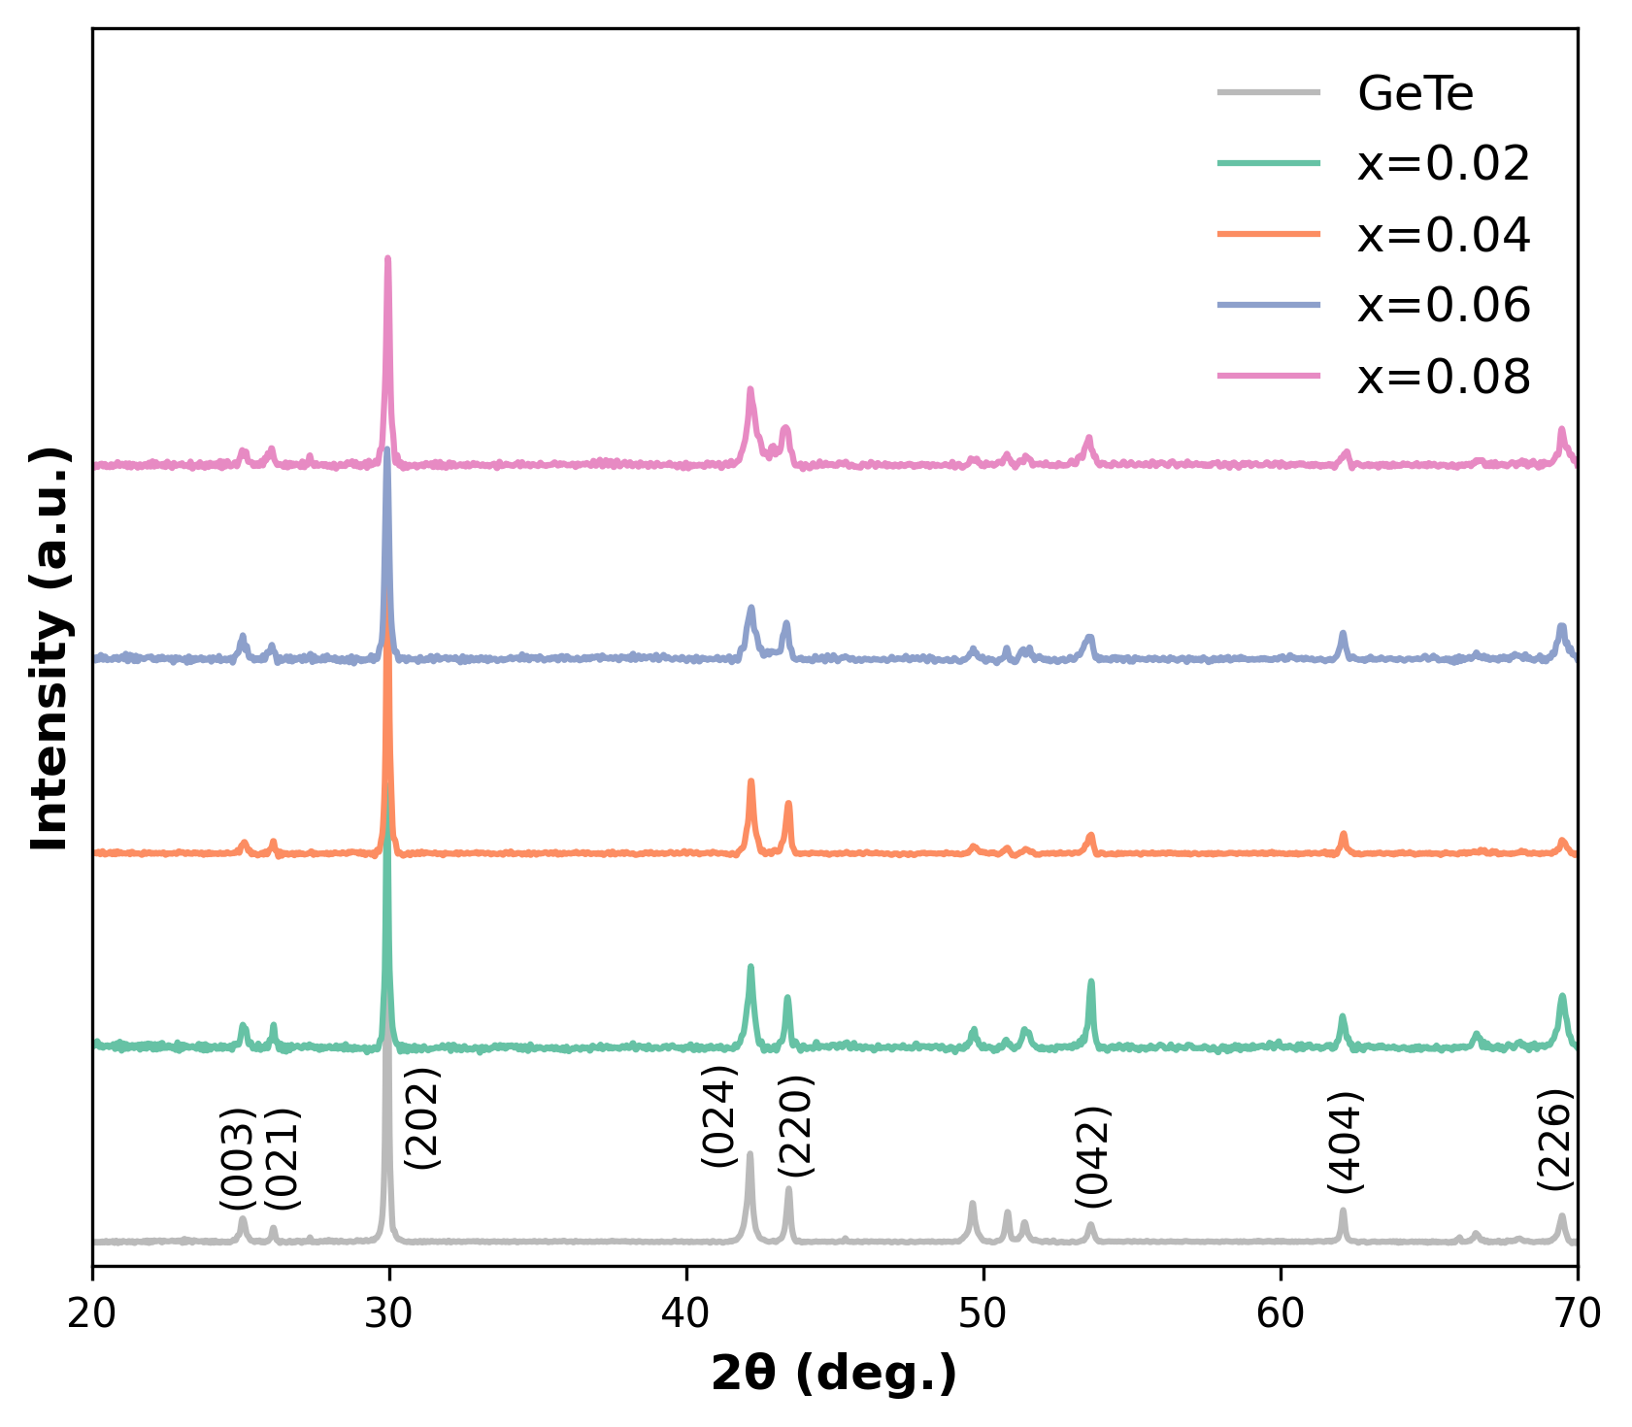
Figure 1. XRD patterns of the (GeTe)_{1-x}(InTe)_{x} (x=0, 0.02, 0.04, 0.06 and 0.08) composites.
The XRD patterns of the (GeTe)_{1-x}(InTe)_{x} (x=0, 0.02, 0.04, 0.06 and 0.08) composites are depicted in Figure 1. Interestingly, XRD patterns of InTe were not observed in all samples, remarkably, even in the sample with the highest addition of 8% InTe. There are no Ge peaks in the (GeTe)_{1-x}(InTe)_{x} composites (x=0.02, 0.04, 0.06 and 0.08). The average crystallite size (D) and internal strain (ε) are calculated by Williamson-Hall method from powder XRD patterns using the following equation:³⁹
$βcos⁡(θ)=4ε∙sin⁡(θ)+\frac{λ}{D}$ (1)
where $β$, $θ$, $ε$, $λ$, and $D$ are the full width half maximum, the angle of the diffraction peak (in radians), the micro-strain rate, the wavelength of the radiation and the average crystallite size. The obtained values for $ε$ and $D$ are listed in Table 1. The average crystallite size decreases from 9.66 $μ$m to 5.27 $μ$m as the value of x increases from 0 to 0.08. The internal strain of composites shows an increase from 0.14 % to 0.26 % for x=0 and x=0.08, respectively. Although InTe is not detectable in XRD patterns, the variations in $ε$ and $D$ values indicate that the addition of InTe into the GeTe matrix induces strain in the materials and affects the formation of crystallite size. To confirm the presence and quantify the amount of InTe within the GeTe matrix, XPS measurements of (GeTe)_{1-x}(InTe)_{x} (x=0.02, 0.04, 0.06 and 0.08) were conducted and the results are illustrated in Figure S1. The chemical composition was obtained by the XPS analysis spectra, and the results are listed in Table S1. As the content of InTe increases, the atomic percentage of In also increases. The estimation of In quantity from XPS consistently tracks with the variation in x values.

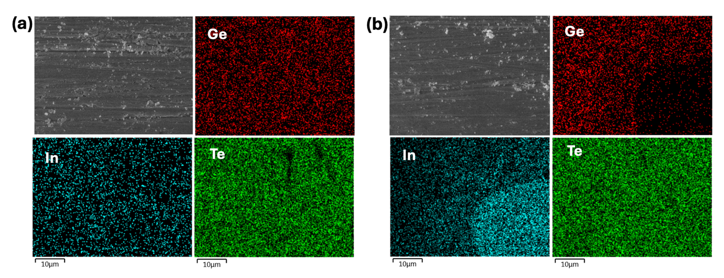
Figure 2 SEM images and elemental mapping images using EDX of the (GeTe)_{0.96}(InTe)_{0.04} composites.
Figure 2 illustrates the scanning electron microscopy (SEM) images and energy dispersive X-ray analysis (EDX) results of the (GeTe)_{0.96}(InTe)_{0.04} composites. The uniform distribution of all elements Ge, Te, and In is observed, as shown in Figure 2(a). According to the EDX results, the atomic percentages of the (GeTe)_{0.96}(InTe)_{0.04} composites are Ge:In:Te=49.61:2.15:48.24. When converted to molar ratios, this corresponds to Ge_{1.09}Te and InTe. Assuming Ge precipitation, it can be approximated as Ge + (GeTe)_{0.96} + (InTe)_{0.04}, which is consistent with the stoichiometric composition of the (GeTe)_{0.96}(InTe)_{0.04} composites. However, as shown in Figure 2(b), some regions of non-uniform In distribution were also identified. While Te shows overall uniformity, Ge is less dispersed in regions where In is more dominant. This indicates that InTe does not exist in a perfectly homogeneous distribution within the GeTe matrix, which affects the carrier transport properties.

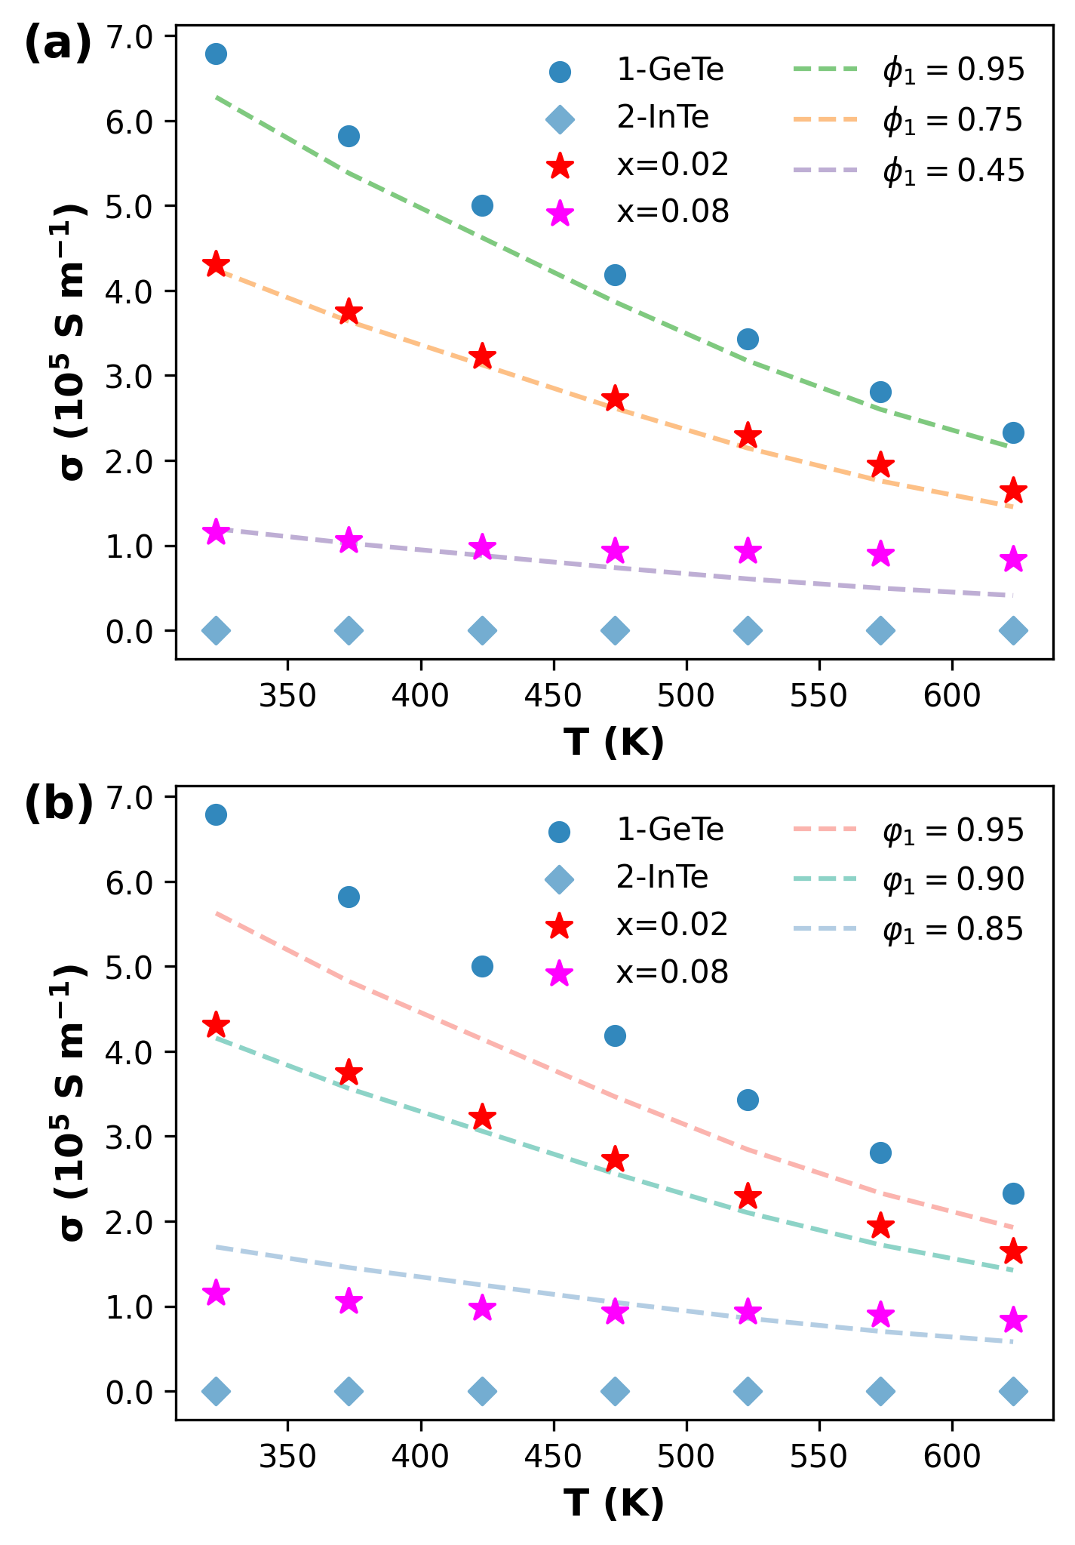
Figure 3. The electrical conductivity with the effective electrical conductivity by using (a) EMT and (b) GEMT of the x=0.02 and 0.08. (Dashed lines show the calculated effective electrical conductivity and scatters are experimental values of electrical resistivity.)
One of the most representative methods for understanding the electrical transport properties of materials with multiple phases is the application of effective medium theory (EMT).⁴⁰ Effective medium theory is a model that explains the electrical properties of a composite composed of two materials with different electrical characteristics. Using the following equation, the effective electrical conductivity, $σ_{e}$, of composites can be estimated:
$ϕ_{1}\frac{σ_{1}-σ_{e}}{σ_{1}+2σ_{e}}+ϕ_{2}\frac{σ_{2}-σ_{e}}{σ_{2}+2σ_{e}}=0$ (2)
where $σ_{1}$ and $σ_{2}$ are the electrical conductivity of phase 1 and phase 2, and $ϕ_{1}$ and $ϕ_{2}$ are the volume fractions of phase 1 and phase 2, respectively. We use the phase 1 as GeTe and phase 2 as InTe in this paper. The calculated effective electrical conductivity with 0.95, 0.75 and 0.45 of $ϕ_{1}$ are plotted in dashed lines, as shown in Figure 3(a). The effective conductivity calculated by EMT does not fit to the electrical conductivity of the (GeTe)_{1-x}(InTe)_{x} composites (x=0.02 and 0.08). If we were to employ EMT to characterize the electrical conductivity, the addition with only 2% InTe would be interpreted as if InTe were present at a concentration of 40% in the composites: (GeTe)_{0.60}(InTe)_{0.40} composites. A generalized effective medium theory (GEMT) provides the electrical conductivity of composite materials based on the elements of the percolation theory.^{41,42} The GEMT leads to the following formula:
$ϕ_{1}\frac{σ_{1}^{1/t}-σ_{e}^{1/t}}{σ_{1}^{1/t}+Aσ_{e}^{1/t}}+ϕ_{2}\frac{σ_{2}^{1/t}-σ_{2}^{1/t}}{σ_{2}^{1/t}+Aσ_{e}^{1/t}}=0$ (3)
where A is a constant ($A=(1-ϕ_{c})/ϕ_{c}$) that depends on the actual percolation threshold $φ_{c}$ of the phase 2 in the phase 1. The parameter $t$ represents the asymmetry of the microstructure in terms of connection between the grains. The calculated effective conductivity for volume fractions of phase 1 at 95 %, 90 % and 85 % is depicted in Figure 3(b). These results reveal a significant discrepancy between the experimental and the analyzed quantitative values. Specifically, the composite with x=0.02 exhibits $σ_{e}$ with 95 % of $ϕ_{1}$, and the composite with x=0.08 shows the $σ_{e}$ with 85 % of $ϕ_{1}$, indicating that neither composite fit well with the analyzed values by the GEMT. The GEMT equation can be practically applied to a wide range of experimental results, where both $σ_{1}$ and $σ_{2}$ are finite which occurs very frequently. However, it is noteworthy that the GEMT reduces to the symmetry and asymmetry conductor.⁴²
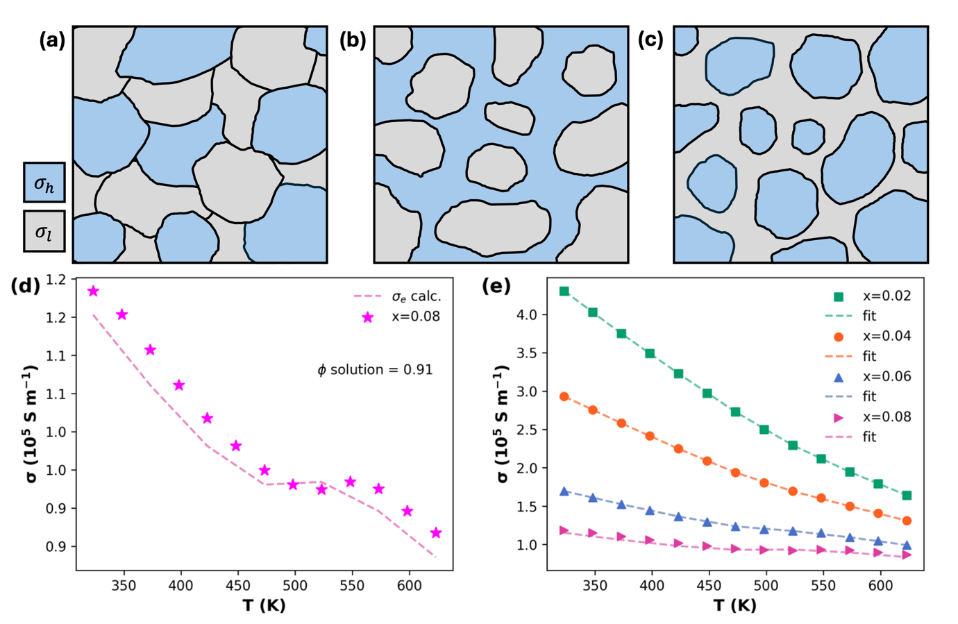
Figure 4. Schematics of effective media for Bruggeman's (a) symmetric, (b) and (c) asymmetric medium theory.⁴² Temperature dependent electrical conductivity of (d) x=0.08 and (e) x=0.02, 0.04, 0.06, and 0.08 of (GeTe)_{1-x}(InTe)_{x} composites with the Bruggeman’s asymmetric effective electrical conductivity
We applied Bruggeman’s symmetry and asymmetry effective medium theory to describe the electrical conductivity of the (GeTe)_{1-x}(InTe)_{x} composites (x=0.02, 0.04, 0.06 and 0.08). Symmetry effective medium theory assumes that the electrical properties between the two phases are symmetrical. Asymmetry effective medium theory deals with cases where the electrical properties between the two phases are not symmetrical. This can occur when the two phases have different electrical characteristics or when their interaction is asymmetrical. Asymmetric theory is more complex than symmetric theory and considers additional parameters to explain the electrical properties of the composite. The schematics in figure 4(a)-(c) illustrate the features of symmetry and asymmetry effective medium theory. When both phases have symmetric electrical conductivity and the dispersed matrix has random basis of orientations, the effective medium looks like Figure 4(a). The effective conductivity in symmetry EMT is expressed as:
$σ_{e}=σ_{h}\left[1-\left(\frac{3}{2}\right)f\right]=σ_{h}\left[1-f\left(1-L_{f}\right)\right]$ (4)
where $σ_{h}$, $f$ and $L_{f}$ are the electrical conductivity of high-conductivity phase, the volume fraction of the poor-conductivity phase and demagnetization of depolarization coefficient characterizing the low-conductivity phase, respectively. In the asymmetry effective medium, there exist two types of media: one being the asymmetric medium conductor host (Figure 4(b), when the electrical conductivity of low-conductivity phase, $σ_{l}$, can be assumed to be zero), and the asymmetry medium insulator (Figure 4(c), when the resistivity of high-conductivity phase, $ρ_{l}$, is set to zero). The effective conductivity in cases of asymmetric medium conductor host is given by:
$σ_{e}=σ_{h}{(1-f)}^{3/2}=σ_{h}{(1-f)}^{1/(1-L_{f})}=σ_{h}{(1-f)}^{m_{f}}$ (5)
where $m_{f}$ is the exponent for randomly orientated low-conductivity ellipsoids. For the cases of asymmetry medium insulator, the effective resistivity is determined by:
$ρ_{e}=ρ_{h}{\left(1-ϕ\right)}^{3}=ρ_{h}{\left(1-ϕ\right)}^{1/L_{ϕ}}=ρ_{h}{\left(1-ϕ\right)}^{m_{ϕ}}$ (6)
where $ρ_{h}$, $ϕ$ and $m_{ϕ}$ are the electrical resistivity of low-conductivity phase, the volume fraction of high-conductivity phase and the exponent for randomly orientated high-conductivity ellipsoids, respectively.
At a glance, although the electrical conductivity of GeTe is considerably higher than that of InTe, it is apparent that InTe, which exhibits low electrical conductivity, notably influences the electrical conductivity in the (GeTe)_{1-x}(InTe)_{x} (x=0, 0.02, 0.04, 0.06 and 0.08) composites. For instance, when x=0.02, the electrical conductivity markedly decreased compared to that of pure GeTe, as shown in Figure 3. Consequently, it is expected that the resistivity of the (GeTe)_{1-x}(InTe)_{x} (x=0, 0.02, 0.04, 0.06 and 0.08) composites aligns with asymmetric medium conductor host cases (Figure 4(a)). Moreover, both the EMT and the GEMT suggest that there is a substantial amount of InTe compared to the actual chemical composition. The parameters when we solve the equations are listed in Table S2. The parameters related to symmetry EMT lack physical significance. While the parameters obtained from the case of an asymmetric medium with a conductor host exhibit similarity with the experimental values, the case of an asymmetric medium with an insulator conductor host aligns much more closely with the experimental data. Therefore, we fit the electrical conductivity of the (GeTe)_{1-x}(InTe)_{x} (x=0, 0.02, 0.04, 0.06 and 0.08) composites with the effective electrical conductivity from the asymmetry medium insulator conductor host.
In Figure 4(d), we can see the experimental data of x=0.08 is well-fitted with the analyzed electrical conductivity, and the obtained solution, $ϕ$, is also a reasonable value, suggesting that the effective medium of of the (GeTe)_{1-x}(InTe)_{x} (x=0, 0.02, 0.04, 0.06 and 0.08) composites is a case of symmetry medium insulator host, as shown in Figure 4(c). The measured electrical conductivity of the (GeTe)_{1-x}(InTe)_{x} (x=0, 0.02, 0.04, 0.06 and 0.08) composites aligns well with the calculated effective electrical conductivity by the symmetry medium insulator host, as depicted in Figure 4(e). Hence, it can be inferred that the effective medium of the (GeTe)_{1-x}(InTe)_{x} (x=0, 0.02, 0.04, 0.06 and 0.08) composites corresponds to the asymmetric medium insulator case. In other words, the small amount of InTe, which exhibits a much lower electrical conductivity compared to that of GeTe, is distributed as a host matrix within the (GeTe)_{1-x}(InTe)_{x} (x=0, 0.02, 0.04, 0.06 and 0.08) composites. As observed in the EDX results, InTe was found to be asymmetrically distributed within the GeTe matrix, suggesting that this may have contributed to the distinctive electrical conductivity characteristics of within the (GeTe)_{1-x}(InTe)_{x} (x=0, 0.02, 0.04, 0.06 and 0.08) composites.

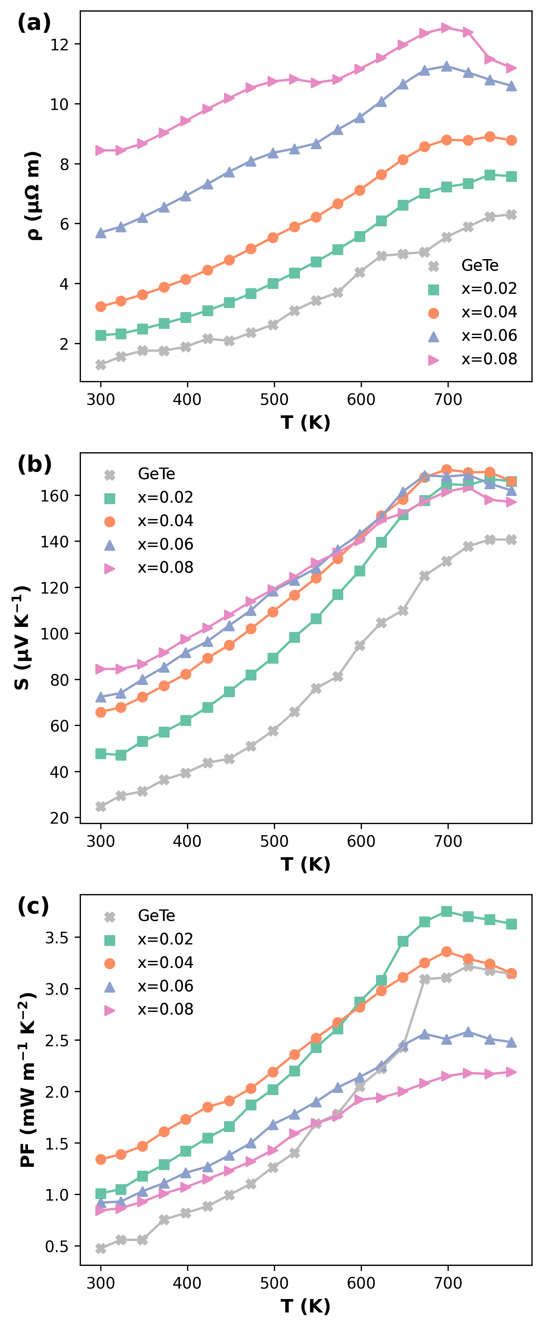
Figure 5. Temperature dependent (a) electrical resistivity, (b) Seebeck coefficient, and (c) power factor (PF) of (GeTe)_{1-x}(InTe)_{x} composites (x=0, 0.02, 0.04, 0.06, and 0.08)
The temperature dependent electrical resistivity, Seebeck coefficient and power factor (PF) are depicted in Figure 5 (a), (b) and (c). The electrical resistivity and Seebeck coefficient are increased as increasing the content of InTe. As the content of InTe increases, the charge carrier concentration gradually decreases from 6.73 x 10²⁰ cm⁻³ to 3.71 x 10²⁰ cm⁻³. The carrier mobility decreases significantly from 78 cm² V⁻² s⁻¹ in GeTe to 48 cm² V⁻² s⁻¹ with the addition of a minimal amount of InTe at x=0.02 and decreases to 33 cm² V⁻² s⁻¹ (x=0.04), 26 cm² V⁻² s⁻¹ (x=0.06), and 20 cm² V⁻² s⁻¹ (x=0.08), as listed in Table 2. The weighted mobility of (GeTe)_{1-x}(InTe)_{x} composites (x=0.02, 0.04, 0.06, and 0.08) also decreases as x increases, as shown in Figure S3. The decrease in charge carrier concentration suggests a reduction in Ge vacancy formation, leading to the increase in electrical resistivity and Seebeck coefficient. The density of state effective mass increases along with the decrease in charge carrier mobility, as listed in Table 2. The significant decrease in carrier mobility, induced by the addition of a small amount of InTe, can be attributed to the effective media's configuration resembling the addition of GeTe within the InTe host matrix, as discussed in the EMT analysis part. The simultaneous increase in charge carrier concentration and carrier mobility is unexpected because these two parameters typically have an inverse relationship. Furthermore, the rate of increase in electrical resistivity is more profound than that of the Seebeck coefficient. Composite materials consist of two phases form a more complex matrix compared to materials substituted elements, which implies the charge carrier transport may be more influenced compared to doped materials. Additionally, the significant increase in electrical resistivity can be explained using Bruggeman EMT alongside the variation in charge carrier concentration. The effective electrical conductivity appears to reflect the characteristics of InTe, as we discussed Figure 4, which provides that the main matrix for electronic transport properties is InTe rather than the actual matrix GeTe. Consequently, we interpreted the (GeTe)_{1-x}(InTe)_{x} (x=0, 0.02, 0.04, 0.06 and 0.08) composites’ media using Bruggeman's EMT as containing a higher proportion of InTe than was actually added, which could account for the decrease in charge carrier mobility. Therefore, the noticeable increase in electrical resistivity of the (GeTe)_{1-x}(InTe)_{x} (x=0, 0.02, 0.04, 0.06 and 0.08) composites can be attributed to the suppression of Ge vacancy formation and the decrease in charge carrier mobility. As a result, the power factor was enhanced due to the decreased Seebeck coefficient and the significant decrease in electrical resistivity, particularly for x=0.02 and 0.04, which increased across the entire temperature range.

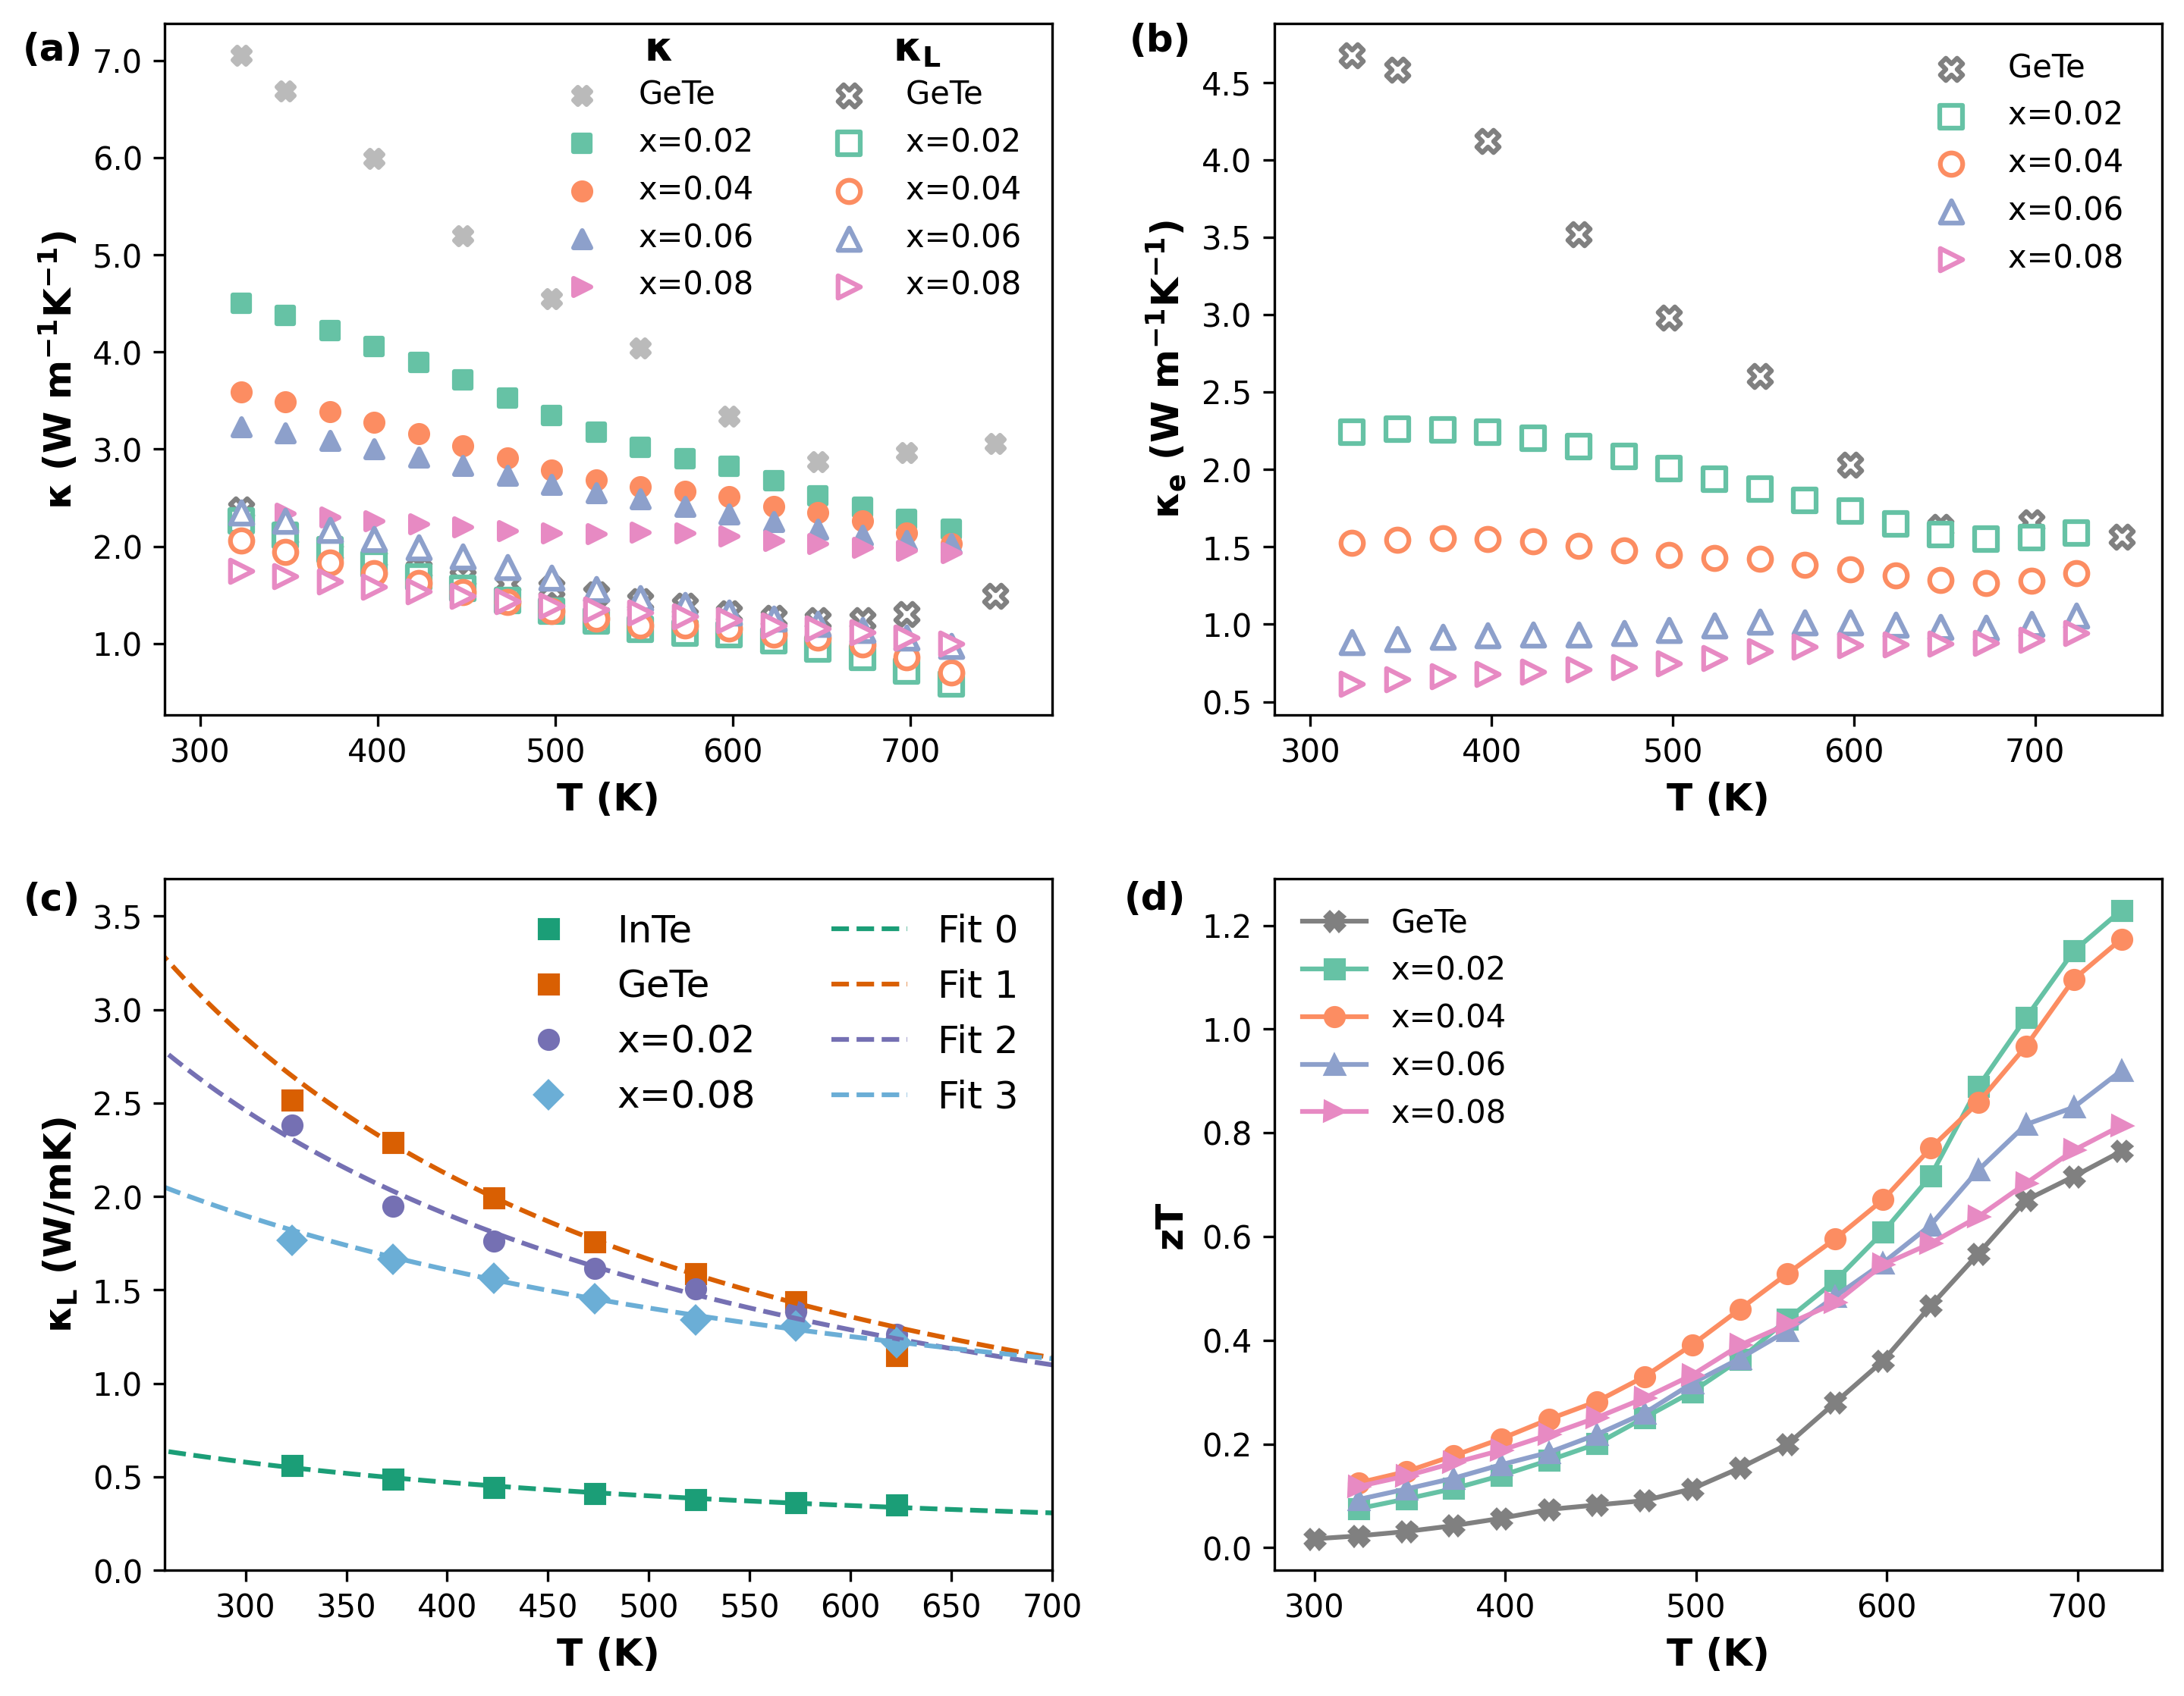
Figure 6. Temperature dependent of (a) total and lattice thermal conductivity, (b) electronic thermal conductivity of (GeTe)_{1-x}(InTe)_{x} composites (x=0, 0.02, 0.04, 0.06, and 0.08). (c) The lattice thermal conductivity fitted by Debye-Callaway model. (d) Temperature dependent zT of (GeTe)_{1-x}(InTe)_{x} composites (x=0, 0.02, 0.04, 0.06, and 0.08).
The temperature-dependent total thermal conductivity and lattice thermal conductivity are depicted in Figure 6(a), and the temperature-dependent electronic thermal conductivity is illustrated in Figure 6(b). The electronic thermal conductivity was calculated using the Wiedemann-Franz’s law, $κ_{e}=L_{0}Tσ$, where $L_{0}$ is the Lorenz number. We used a single parabolic band model with the Fermi integral to estimate the accurate Lorenz number in semiconductors.⁴³ The calculated Lorenz number is plotted in Figure S5. The lattice thermal conductivity, $κ_{L}$, was obtained by subtracting the electronic part from the total thermal conductivity. The total thermal conductivity of the (GeTe)_{1-x}(InTe)_{x} (x=0.02, 0.04, 0.06 and 0.08) composites is significantly reduced due to the decrease of both electronic and lattice thermal conductivity. In particular, the addition of InTe optimized the charge carrier concentration, preventing the formation of excess charge carriers and greatly reducing electrical resistivity. This leads to a significant decrease in electronic thermal conductivity.
The lattice thermal conductivity can be written as by using the Debye-Callaway model:¹¹
$κ_{lat}=\frac{k_{B}}{2π^{2}v_{s}}{(\frac{k_{B}T}{ℏ})}^{3}\int_{0}^{θ_{D}/T}{τ_{tot}(x)\frac{x^{4}e^{x}}{{(e^{x}-1)}^{2}}dx}$ (7)
where x=$ℏω/k_{B}T$, $θ_{D}$ is the Debye temperature, and $ω$ is the phonon frequency. The $τ_{tot}(x)$ is the reciprocal sum of the relaxation times of scattering mechanisms according to the Matthiessen’s rule:
${τ_{tot}}^{-1}={τ_{U}}^{-1}+{τ_{D}}^{-1}{{+τ}_{B}}^{-1}+⋯$ (8)
where ${τ_{U}}^{-1}$, ${τ_{D}}^{-1}$ and ${τ_{B}}^{-1}$ are the contributions from the Umklapp scattering, lattice-defect scattering and boundary scattering, respectively. The reciprocal relaxation time of lattice-defect is ${τ_{PD}}^{-1}=\frac{V_{av}Γ}{4π{v_{s}}^{3}}ω^{4}$ where $Γ$ is a scattering parameter that characterizes the mass fluctuation and strain fluctuation within the lattice, given by the equation of $Γ=Γ_{MF}+Γ_{SF}$. (Detailed information regarding the relaxation time can be found in the Supplementary Information.) The large mass and strain fluctuations lead to the short scattering time. The scattering parameter $Γ_{SF}$ increased from 0.155 (x=0) to 0.261 (x=0.02) and further to 0.293 (x=0.08) as the amount of InTe, x, increased. This increase of scattering parameters $Γ_{SF}$ is consistent with the increase in internal strain of (GeTe)_{1-x}(InTe)_{x} (x=0.02, 0.04, 0.06 and 0.08) composite as confirmed by XRD pattern analysis. Moreover, the non-uniform distribution of InTe observed in the EDX results also might contribute to an increase in lattice strain of the (GeTe)_{1-x}(InTe)_{x} (x=0.02, 0.04, 0.06 and 0.08) composite. Therefore, the decrease in lattice thermal conductivity can be interpreted as a result of the strain effect induced by the addition of InTe.

Conclusion
This study explored the thermoelectric properties of the (GeTe)_{1-x}(InTe)_{x} (x=0, 0.02, 0.04, 0.06, and 0.08) composites. InTe exhibits a significant influence on the thermoelectric properties, serving as the primary matrix in the (GeTe)_{1-x}(InTe)_{x} (x=0.02, 0.04, 0.06, and 0.08) composites. Utilizing effective medium theory (EMT), we quantified the electrical conductivity, revealing that the asymmetry medium insulator host. The significant decrease in total thermal conductivity is attributed to reductions in both electronic and lattice thermal conductivity.

Table
Table 1. Lattice parameters, internal strain (ε) and average crystallite size (D) of (GeTe)_{1-x}(InTe)_{x} (x=0, 0.02, 0.04, 0.06, and 0.08) composites.
x | a (Å) | c (Å) | V ($Å^{3}$) | Internal strain (%) | Crystallite size ($μ$m)
0 | 4.164 | 10.658 | 160.091 | 0.14 | 9.56
0.02 | 4.193 | 10.531 | 160.400 | 0.18 | 7.34
0.04 | 4.159 | 10.714 | 160.525 | 0.20 | 6.74
0.06 | 4.171 | 10.637 | 160.313 | 0.26 | 5.08
0.08 | 4.172 | 10.624 | 160.186 | 0.25 | 5.27

Table 2. Hall carrier concentration, Hall mobility and effective mass of (GeTe)_{1-x}(InTe)_{x} (x=0, 0.02, 0.04, 0.06, and 0.08) composites at room temperature.
x | 0 | 0.02 | 0.04 | 0.06 | 0.08
$n_{H}$ (10²⁰ cm⁻³) | 6.73 | 6.27 | 5.88 | 4.18 | 3.71
$μ_{H}$(cm² V⁻¹ s⁻¹) | 78 | 44 | 33 | 26 | 20
m* (m_{e}) | 1.19 | 1.74 | 2.29 | 2.01 | 2.17

Acknowledgements
This research was supported by JST Mirai Program, Japan (grant number JPMJMI19A1) and the National Research Foundation of Korea (NRF) funded by the Ministry of Educa-tion, Science and Technology (NRF-2022M3C1A3091988). Thanks to Mr. Wenhao Zhang for helpful discussions on performing the calculation of lattice thermal conductivity. We acknowledge Mr. for the XPS interpretation and helpful discussion.

Authorship contribution statement
Song Yi Back: Conceptualization, Data Curation, Formal Analysis, Investigation, Methodology, Writing – Original Draft, Editing, Takao Mori: Funding Acquisition, Supervision, Writing – Review, Jong-Soo Rhyee: Funding Acquisition, Supervision, Writing – Review

References
(1) Poudel, B.; Hao, Q.; Ma, Y.; Lan, Y.; Minnich, A.; Yu, B.; Yan, X.; Wang, D.; Muto, A.; Vashaee, D.; Chen, X.; Liu, J.; Dresselhaus, M. S.; Chen, G.; Ren, Z. High-Thermoelectric Performance of Nanostructured Bismuth Antimony Telluride Bulk Alloys. Science 2008, 320 (5876), 634–638. https://doi.org/10.1126/science.1156446.
(2) Biswas, K.; He, J.; Wang, G.; Lo, S.-H.; Uher, C.; Dravid, V. P.; Kanatzidis, M. G. High Thermoelectric Figure of Merit in Nanostructured P-Type PbTe–MTe (M = Ca, Ba). Energy Environ. Sci. 2011, 4 (11), 4675. https://doi.org/10.1039/c1ee02297k.
(3) Shuai, J.; Kim, H. S.; Lan, Y.; Chen, S.; Liu, Y.; Zhao, H.; Sui, J.; Ren, Z. Study on Thermoelectric Performance by Na Doping in Nanostructured Mg1-Na Ag0.97Sb0.99. Nano Energy 2015, 11, 640–646. https://doi.org/10.1016/j.nanoen.2014.11.027.
(4) Shi, X.; Wu, A.; Liu, W.; Moshwan, R.; Wang, Y.; Chen, Z.-G.; Zou, J. Polycrystalline SnSe with Extraordinary Thermoelectric Property via Nanoporous Design. ACS Nano 2018, 12 (11), 11417–11425. https://doi.org/10.1021/acsnano.8b06387.
(5) Back, S. Y.; Yun, J. H.; Cho, H.; Kim, G.; Rhyee, J.-S. Phonon Scattering and Suppression of Bipolar Effect in MgO/VO2 Nanoparticle Dispersed p-Type Bi0.5Sb1.5Te3 Composites. Materials 2021, 14 (10), 2506. https://doi.org/10.3390/ma14102506.
(6) Kanatzidis, M. G. Nanostructured Thermoelectrics: The New Paradigm? Chem. Mater. 2010, 22 (3), 648–659. https://doi.org/10.1021/cm902195j.
(7) Biswas, K.; He, J.; Blum, I. D.; Wu, C.-I.; Hogan, T. P.; Seidman, D. N.; Dravid, V. P.; Kanatzidis, M. G. High-Performance Bulk Thermoelectrics with All-Scale Hierarchical Architectures. Nature 2012, 489 (7416), 414–418. https://doi.org/10.1038/nature11439.
(8) Lee, S.; Esfarjani, K.; Luo, T.; Zhou, J.; Tian, Z.; Chen, G. Resonant Bonding Leads to Low Lattice Thermal Conductivity. Nat. Commun. 2014, 5 (1), 3525. https://doi.org/10.1038/ncomms4525.
(9) Morelli, D. T.; Jovovic, V.; Heremans, J. P. Intrinsically Minimal Thermal Conductivity in Cubic I − V − VI 2 Semiconductors. Phys. Rev. Lett. 2008, 101 (3), 035901. https://doi.org/10.1103/PhysRevLett.101.035901.
(10) Zhao, L.-D.; Lo, S.-H.; Zhang, Y.; Sun, H.; Tan, G.; Uher, C.; Wolverton, C.; Dravid, V. P.; Kanatzidis, M. G. Ultralow Thermal Conductivity and High Thermoelectric Figure of Merit in SnSe Crystals. Nature 2014, 508 (7496), 373–377. https://doi.org/10.1038/nature13184.
(11) Delaire, O.; Ma, J.; Marty, K.; May, A. F.; McGuire, M. A.; Du, M.-H.; Singh, D. J.; Podlesnyak, A.; Ehlers, G.; Lumsden, M. D.; Sales, B. C. Giant Anharmonic Phonon Scattering in PbTe. Nat. Mater. 2011, 10 (8), 614–619. https://doi.org/10.1038/nmat3035.
(12) Back, S. Y.; Yun, J. H.; Cho, H.; Byeon, S.; Jin, H.; Rhyee, J.-S. High Thermoelectric Performance by Chemical Potential Tuning and Lattice Anharmonicity in GeTe _{1−x} I _{x} Compounds. Inorg. Chem. Front. 2021, 8 (5), 1205–1214. https://doi.org/10.1039/D0QI01281E.
(13) Heremans, J. P.; Jovovic, V.; Toberer, E. S.; Saramat, A.; Kurosaki, K.; Charoenphakdee, A.; Yamanaka, S.; Snyder, G. J. High Lattice Anharmonicity_resonant Bonding. Science 2008, 321 (5888), 554–557. https://doi.org/10.1126/science.1159725.
(14) Heremans, J. P.; Wiendlocha, B.; Chamoire, A. M. Resonant Levels in Bulk Thermoelectric Semiconductors. Energy Env. Sci 2012, 5 (2), 5510–5530. https://doi.org/10.1039/C1EE02612G.
(15) Zhang, Q.; Liao, B.; Lan, Y.; Lukas, K.; Liu, W.; Esfarjani, K.; Opeil, C.; Broido, D.; Chen, G.; Ren, Z. High Thermoelectric Performance by Resonant Dopant Indium in Nanostructured SnTe. Proc. Natl. Acad. Sci. 2013, 110 (33), 13261–13266. https://doi.org/10.1073/pnas.1305735110.
(16) Pei, Y.; Shi, X.; LaLonde, A.; Wang, H.; Chen, L.; Snyder, G. J. Convergence of Electronic Bands for High Performance Bulk Thermoelectrics. Nature 2011, 473 (7345), 66–69. https://doi.org/10.1038/nature09996.
(17) Liu, W.; Tan, X.; Yin, K.; Liu, H.; Tang, X.; Shi, J.; Zhang, Q.; Uher, C. Convergence of Conduction Bands as a Means of Enhancing Thermoelectric Performance of n -Type Mg 2 Si 1 − x Sn x Solid Solutions. Phys. Rev. Lett. 2012, 108 (16), 166601. https://doi.org/10.1103/PhysRevLett.108.166601.
(18) Fu, C.; Zhu, T.; Liu, Y.; Xie, H.; Zhao, X. Band Engineering of High Performance P-Type FeNbSb Based Half-Heusler Thermoelectric Materials for Figure of Merit zT > 1. Energy Environ. Sci. 2015, 8 (1), 216–220. https://doi.org/10.1039/C4EE03042G.
(19) Yoshimasa Nishio, Y. N.; Tohru Hirano, T. H. Improvement of the Efficiency of Thermoelectric Energy Conversion by Utilizing Potential Barriers. Jpn. J. Appl. Phys. 1997, 36 (1R), 170–174. https://doi.org/10.1143/JJAP.36.170.
(20) Kishimoto, K.; Koyanagi, T. Preparation of Sintered Degenerate n -Type PbTe with a Small Grain Size and Its Thermoelectric Properties. J. Appl. Phys. 2002, 92 (5), 2544–2549. https://doi.org/10.1063/1.1499206.
(21) Sun, Y.; Cheng, H.; Gao, S.; Liu, Q.; Sun, Z.; Xiao, C.; Wu, C.; Wei, S.; Xie, Y. Atomically Thick Bismuth Selenide Freestanding Single Layers Achieving Enhanced Thermoelectric Energy Harvesting. J. Am. Chem. Soc. 2012, 134 (50), 20294–20297. https://doi.org/10.1021/ja3102049.
(22) Mao, J.; Wang, Y.; Kim, H. S.; Liu, Z.; Saparamadu, U.; Tian, F.; Dahal, K.; Sun, J.; Chen, S.; Liu, W.; Ren, Z. High Thermoelectric Power Factor in Cu–Ni Alloy Originate from Potential Barrier Scattering of Twin Boundaries. Nano Energy 2015, 17, 279–289. https://doi.org/10.1016/j.nanoen.2015.09.003.
(23) Rhyee, J.-S.; Lee, K. H.; Lee, S. M.; Cho, E.; Kim, S. I.; Lee, E.; Kwon, Y. S.; Shim, J. H.; Kotliar, G. Peierls Distortion as a Route to High Thermoelectric Performance in In4Se3-δ Crystals. Nature 2009, 459 (7249), 965–968. https://doi.org/10.1038/nature08088.
(24) Lee, M. H.; Yun, J. H.; Kim, G.; Lee, J. E.; Park, S.-D.; Reith, H.; Schierning, G.; Nielsch, K.; Ko, W.; Li, A.-P.; Rhyee, J.-S. Synergetic Enhancement of Thermoelectric Performance by Selective Charge Anderson Localization–Delocalization Transition in n-Type Bi-Doped PbTe/Ag ₂ Te Nanocomposite. ACS Nano 2019, 13 (4), 3806–3815. https://doi.org/10.1021/acsnano.8b08579.
(25) Duan, S.; Yin, Y.; Liu, G.-Q.; Man, N.; Cai, J.; Tan, X.; Guo, K.; Yang, X.; Jiang, J. Anomalous Thermopower and High ZT in GeMnTe ₂ Driven by Spin’s Thermodynamic Entropy. Research 2021, 2021, 2021/1949070. https://doi.org/10.34133/2021/1949070.
(26) Tsujii, N.; Nishide, A.; Hayakawa, J.; Mori, T. Observation of Enhanced Thermopower Due to Spin Fluctuation in Weak Itinerant Ferromagnet. Sci. Adv. 2019, 5 (2), eaat5935. https://doi.org/10.1126/sciadv.aat5935.
(27) Gao, W.; Liu, Z.; Baba, T.; Guo, Q.; Tang, D.-M.; Kawamoto, N.; Bauer, E.; Tsujii, N.; Mori, T. Significant Off-Stoichiometry Effect Leading to the N-Type Conduction and Ferromagnetic Properties in Titanium Doped Fe2VAl Thin Films. Acta Mater. 2020, 200, 848–856. https://doi.org/10.1016/j.actamat.2020.09.067.
(28) Shuai, J.; Sun, Y.; Tan, X.; Mori, T. Manipulating the Ge Vacancies and Ge Precipitates through Cr Doping for Realizing the High‐Performance GeTe Thermoelectric Material. Small 2020, 16 (13), 1906921. https://doi.org/10.1002/smll.201906921.
(29) Perumal, S.; Bellare, P.; Shenoy, U. S.; Waghmare, U. V.; Biswas, K. Low Thermal Conductivity and High Thermoelectric Performance in Sb and Bi Co-Doped GeTe: Complementary Effect of Band Convergence and Nanostructuring.
(30) Wu, L.; Li, X.; Wang, S.; Zhang, T.; Yang, J.; Zhang, W.; Chen, L.; Yang, J. Resonant Level-Induced High Thermoelectric Response in Indium-Doped GeTe. NPG Asia Mater. 2017, 9 (1), e343–e343. https://doi.org/10.1038/am.2016.203.
(31) Li, J.; Zhang, X.; Lin, S.; Chen, Z.; Pei, Y. Realizing the Superior Thermoelectric Performance of GeTe by Sb-Doping and Se-Alloying.
(32) Wang, L.; Fang, S.; Li, J.; Hu, L.; Liu, F.; Xu, W.; Mori, T.; Zhang, C. Anomalous Enhancement of Thermoelectric Performance in GeTe with Specific Interaxial Angle and Atomic Displacement Synergy. Cell Rep. Phys. Sci. 2022, 3 (9), 101009. https://doi.org/10.1016/j.xcrp.2022.101009.
(33) Fan, Y.; Xie, C.; Zhang, T.; Yang, X.; Chen, Z.; Tang, X.; Tan, G. Contrasting the Roles of Cu Interstitials and Sb Substitutions in Regulating Ferroelectric Distortions and Thermoelectric Properties of α-GeTe. ACS Appl. Energy Mater. 2023, 6 (7), 4065–4071. https://doi.org/10.1021/acsaem.3c00323.
(34) Zhang, C.; Yan, G.; Wang, Y.; Wu, X.; Hu, L.; Liu, F.; Ao, W.; Cojocaru‐Mirédin, O.; Wuttig, M.; Snyder, G. J.; Yu, Y. Grain Boundary Complexions Enable a Simultaneous Optimization of Electron and Phonon Transport Leading to High‐Performance GeTe Thermoelectric Devices. Adv. Energy Mater. 2023, 13 (3), 2203361. https://doi.org/10.1002/aenm.202203361.
(35) Nshimyimana, E.; Hao, S.; Su, X.; Zhang, C.; Liu, W.; Yan, Y.; Uher, C.; Wolverton, C.; Kanatzidis, M. G.; Tang, X. Discordant Nature of Cd in GeTe Enhances Phonon Scattering and Improves Band Convergence for High Thermoelectric Performance. J. Mater. Chem. A 2020, 8 (3), 1193–1204. https://doi.org/10.1039/C9TA10436D.
(36) Dou, Y.; Li, J.; Xie, Y.; Wu, X.; Hu, L.; Liu, F.; Ao, W.; Liu, Y.; Zhang, C. Lone-Pair Engineering: Achieving Ultralow Lattice Thermal Conductivity and Enhanced Thermoelectric Performance in Al-Doped GeTe-Based Alloys. Mater. Today Phys. 2021, 20, 100497. https://doi.org/10.1016/j.mtphys.2021.100497.
(37) Xie, L.; Liu, R.; Zhu, C.; Bu, Z.; Qiu, W.; Liu, J.; Xu, F.; Pei, Y.; Bai, S.; Chen, L. Enhanced Thermoelectric Performance in Ge _{0.955−} _{x} Sb _{x} Te/FeGe ₂ Composites Enabled by Hierarchical Defects. Small 2021, 17 (25), 2100915. https://doi.org/10.1002/smll.202100915.
(38) Liu, M.; Zhu, J.; Cui, B.; Guo, F.; Liu, Z.; Zhu, Y.; Guo, M.; Sun, Y.; Zhang, Q.; Zhang, Y.; Cai, W.; Sui, J. High-Performance Lead-Free Cubic GeTe-Based Thermoelectric Alloy. Cell Rep. Phys. Sci. 2022, 3 (6), 100902. https://doi.org/10.1016/j.xcrp.2022.100902.
(39) Waseda, Y.; Matsubara, E.; Shinoda, K. X-Ray Diffraction Crystallography: Introduction, Examples and Solved Problems; Springer Berlin Heidelberg: Berlin, Heidelberg, 2011. https://doi.org/10.1007/978-3-642-16635-8.
(40) Landauer, R. The Electrical Resistance of Binary Metallic Mixtures. J. Appl. Phys. 1952, 23 (7), 779–784. https://doi.org/10.1063/1.1702301.
(41) McLachlan, D. S. An Equation for the Conductivity of Binary Mixtures with Anisotropic Grain Structures. J. Phys. C Solid State Phys. 1987, 20 (7), 865–877. https://doi.org/10.1088/0022-3719/20/7/004.
(42) McLachlan, D. S.; Blaszkiewicz, M.; Newnham, R. E. Electrical Resistivity of Composites. J. Am. Ceram. Soc. 1990, 73 (8), 2187–2203. https://doi.org/10.1111/j.1151-2916.1990.tb07576.x.
(43) Kim, H.-S.; Gibbs, Z. M.; Tang, Y.; Wang, H.; Snyder, G. J. Characterization of Lorenz Number with Seebeck Coefficient Measurement. APL Mater. 2015, 3 (4), 041506. https://doi.org/10.1063/1.4908244.

