Title: Harnessing DNA and Energy Cargo: Unveiling the Active Biogenesis and Applications of Bacterial Extracellular Vesicles
Sotaro Takano¹, Akihiro Okamoto^{1,2,3,4}

¹Research Center for Macromolecules and Biomaterials, National Institute for Materials Science, Tsukuba, Japan
²Graduate School of Chemical Sciences and Engineering, Hokkaido University, Sapporo, Japan
³Graduate School of Science and Engineering, College of Science and Engineering, University of Tsukuba
⁴Institute of Innovation for Future Earth (IRFE) and Laboratory for Integrated Science and Materials (LiSM), Tokyo Institute of Technology

Introduction
Human microbiota, akin to human cells releasing exosomes, produces spherical biological nanoparticles,cbacterial extracellular vesicles (BEVs). These BEVs are composed of lipid bilayers and encapsulate a variety of biological molecules from their source cells such as signaling molecules, genetic materials, and proteins. BEVs have been known to contribute to diverse biological processes in the human body by mediating both microbe-microbe and host-microbe interactions (1, 2). Yet, while the importance of their cargo is well-recognized, the question remains: do bacteria actively biosynthesize the BEVs to control their cargo on purpose?
Recent studies have been demonstrated that BEVs are not just the by-products of cell-lysis or imbalance in local cell membrane properties but produced via various types of regulations (Fig. 1) (1). Genetic alterations can either enhance or inhibit the formation of BEVs (Kitagawa et al., 2010; Kulp et al., 2015), and evidence points to the selective, rather than random, packaging of certain molecules like proteins and lipids within BEVs (1, 3-5). However, selective packaging into BEVs is still under debate due to the ambiguity of its underlying mechanisms, which could be interpreted as either spontaneous (physical) responses to environmental contexts or as part of a tightly regulated biological process.
In this chapter, we pivot our focus to the functional attributes of BEVs, setting aside the intricacies of their assembly mechanisms, to consider the possibility of an active BEV production strategy. We will focus on “bacterial DNA cargo”, which potentially has versatile roles including ecological functions in the context of microbiota, and “electron cargo”, crucial for anaerobic metabolism and cell survival. Additionally, we will also showcase their emerging applications of these BEVs’function for diagnosis, novel drug-delivery carriers or vaccines. These recent advances in BEV application have shed light on their great potential for medical.

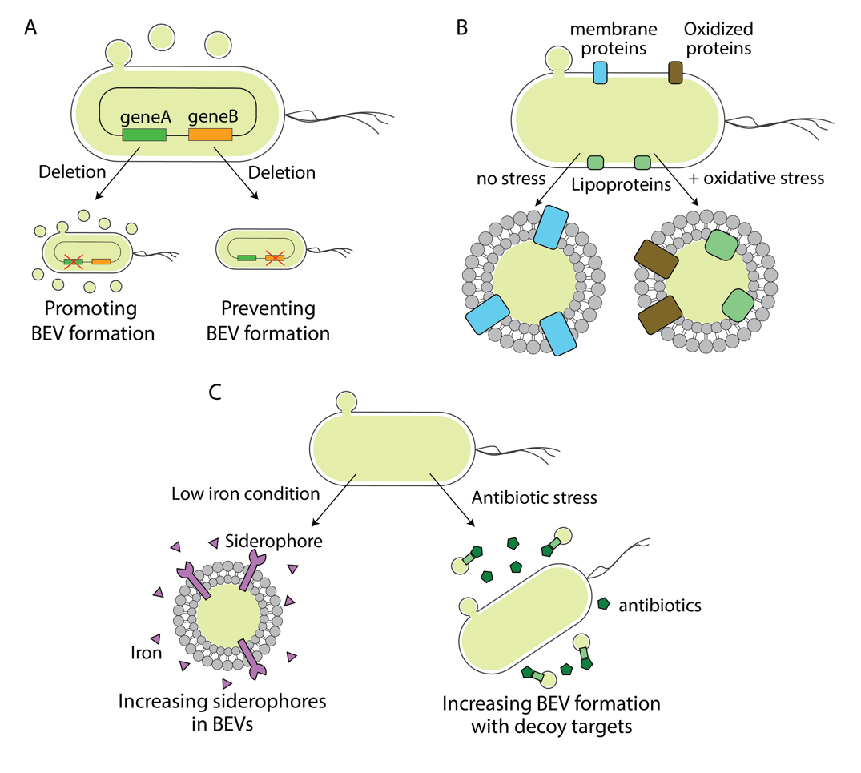
Fig. 1 Observations for BEV biogenesis modified by intracellular and extracellular perturbation. (A) There are cases where genetic disruption promotes or suppresses the BEV-biogenesis. (B) The imposition of stress usually leads to the package of different cellular contents. (C) The environmental changes cause the enhancement of loading specific molecules into BEVs or BEV-biogenesis itself. Some of those work as a benefit for the bacterial population.

DNA in BEVs as a key mediator of gene exchange among microbiota
Historically, intercellular transfer of genetic materials has been considered as the product of mainly three molecular mechanisms: natural transformation, conjugation, and transduction. Each of those mechanisms required specific molecular machinery, genetic elements, and phenotypic traits, resulting in several “barriers” to gene transfer. Natural transformation is the active process of introducing extracellular free DNA fragments, which are ubiquitously produced by bacterial cells (e.g., cell lysis) and present in the environment. However, the natural transformation usually requires expressions of a set of proteins (e.g., type VI pili) for recipient cells (6), and the number of bacterial strains that can be transformable via free DNA uptake is limited to date (7). Gene transfer via conjugation also needs a set of molecular types of machinery and mobile genetic elements (e.g., plasmids), limiting their prevalence in microbiota and the type of transferrable genes. Transduction via bacteriophages does not require a specific set of machinery for bacterial cells but its efficiency strongly depends on phage-host specificity, which could be very high (i.e., nearly one-to-one basis) (8). The formation of “nanotubes”, enabling the cells to interexchange cytoplasmic content, was discovered as a new mechanism of gene transfer between bacterial cells, yet it has been observed in a limited number of species (9).
Compared to these mechanisms, BEVs have different characteristics, and potentially work more efficiently for gene transfer. BEV biogenesis is currently appreciated as a universal mechanism observed among bacteria with several generation routes, including pervasive biological events under stressful conditions such as cell death and prophage induction (10). Recently, Tran and Boedicker explored the relationship between the gene transfer efficiency via BEV and donor-recipient relatedness and found that HGT via BEV could occur between phylogenetically distant bacterial species (11). Those studies suggest the pervasiveness of BEV biogenesis and extensive targets among microbiota.
Evidence suggests that various organisms within the human microbiome, both harmful and beneficial, produce BEVs (12-17). DNA in BEVs plays a crucial role in microbiota such as transferring genetic materials among microbial populations by horizontal gene transfer (HGT). From decades ago, the capability of BEVs for transferring the packaged DNA to target cells was reported (18-25). Some of those studies observed that BEVs can transfer beneficial genes and provide novel phenotypes to target cells such as antibiotic resistance (18), degrading macromolecule substrates (20), and virulence (26). These genetic exchanges can lead to significant phenotypic changes and improved survival for the recipient cells, which may, in turn, affect the biological environment of the BEV-producing microbes within the microbiome. This suggests that HGT via BEVs is not a random process but is likely regulated to benefit the producing organisms (Fig. 2A).
The preferential packaging of certain genomic regions could restrict HGT. Although the mechanisms for this selective gene presence are unknown, studies have noted a non-uniform distribution of DNA within BEVs (27-30), which could impede the transfer of specific genes. Also, The DNA content within BEVs may present barriers or biases to gene transfer. Research has largely focused on plasmid DNA due to its smaller size and autonomy from chromosomal DNA, which facilitates its incorporation into BEVs (11, 18, 19, 22, 23, 31). Conversely, chromosomal DNA is less frequently reported in BEVs, and its packaging is not well understood, potentially limiting the range of genes transferable via BEVs. More comprehensive and detailed investigations of genetic materials in BEVs would be necessary to estimate the impact of DNA cargo in BEVs on HGT. Also, our knowledge about donor-recipient range of BEV-mediated HGT is still limited.

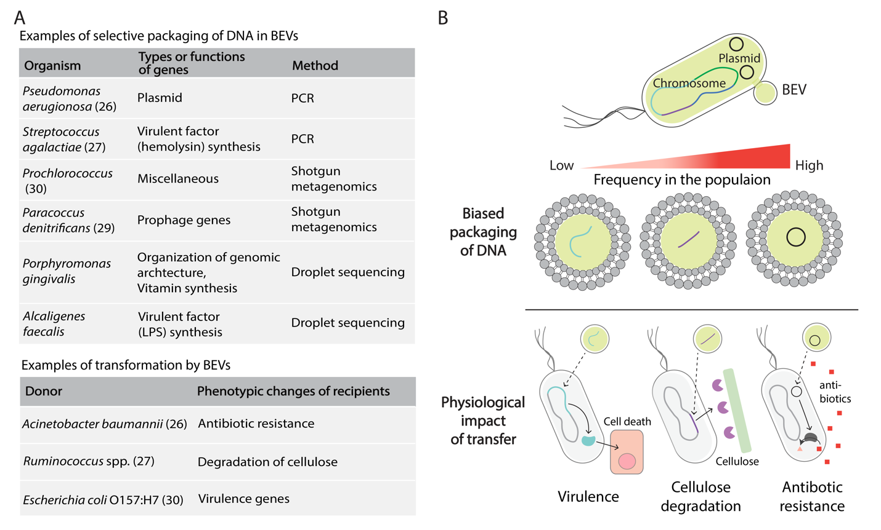Fig. 2 Selectively packaged DNA in BEVs and its impact on the phenotypic changes via horizontal gene transfer. (A) Examples of selectively packaged DNA in BEVs and resulting phenotypic changes in recipient cells that were reported in previous studies. (B) Schematics of biased packaging of DNA and physiological impacts by the gene transfers. Several studies reported the prevalence of circularized DNA (e.g., plasmid) in BEVs and bias in the loaded genomic regions, which constraints the transferability of genes. The recipient cells of BEVs obtained beneficial functions for their survival such as virulence, macromolecule degradation, and antibiotic resistance.

Single particle DNA content support the HGT function in BEVs
As evidence for horizontal gene transfer (HGT) in pure cultures increases, its prevalence and the particular genes often transferred within the microbiome are still unconfirmed. This uncertainty arises from the limitations of standard metagenomic techniques, which measure the overall DNA content in bacterial extracellular vesicles (BEVs) but fail to identify specific gene sets within individual vesicles. Because the effectiveness of HGT hinges on the quantity of BEVs containing the desired genes, a metagenomic strategy focused solely on total gene quantities cannot sufficiently determine the likelihood of gene transfer in the microbiome.
One possible approach to this end is to analyze each particle by single-cell-genomics techniques such as droplet sequencing methods (32-34). Those methods were recently used for the characterization of a single-cell bacterial genome by whole genome amplification (WGA) with low contamination and biased amplification risk. In the recent pilot studies, such droplet DNA sequencing technique was applied to characterize DNA sequences that were internally stored in a single BEV (Refs Takano biorxiv). One major advantage of this method is analyzing low-amount DNA in BEVs by whole genome amplification (WGA) that were usually difficult to detect in other approaches. For instance, the current study focusing on BEVs from Porphyromonas gingivalis (P. gingivalis), a prominent pathogen of periodontitis, revealed that over 60 % of BEVs contained chromosomal DNA of parental bacteria and coded ~50 genes on average. This percentage was estimated by staining the BEV-containing droplets with DNA dye after WGA (Refs Takano biorxiv). Notably, the direct staining of BEVs can detect quite a lower percentage of the positively stained particles by DNA dye. In the case of P. gingivalis, only ≈ 1% of BEVs were estimated as DNA-contained using nanoparticle tracking analysis (Refs Takano biorxiv). The study using epifluorescence microscopy also detected less than 1 % of BEVs with DNA fluorescence in other bacterial cases (35). This is reasonable because the length of contained DNA usually affects the results of the fluorescence staining method (36). Droplet sequencing detected BEVs containing less than 10 kbp of the genomic regions and the DNA content of such BEVs would be below the detection limit of the direct fluorescence staining. Those results suggest that packaging of chromosomal DNA into BEVs is a more prevalent event than previously reported (35).
The droplet sequencing analysis also captured considerable heterogeneity in loaded DNA length and region among the BEV population isolated from the same bacterial culture (Refs Takano biorxiv). Meanwhile, statistical screening revealed the presence of 10 ~ 30 kbp genomic regions that were frequently detected among the BEV population, which indicates that there is enrichment of specific loci in the host bacterial genome in BEVs. The presence of such a “genetic barcode” was observed in both a bacterial pure culture system and oral microbiota (Refs Takano biorxiv), suggesting that the bias in the loaded chromosomal region is ubiquitous among BEVs in nature. Interestingly, the packaged genes showed quite similar functions to each other. In the case of P. gingivalis, genes related to DNA integration are significantly enriched (Fig 2). Since those gene sets directly affect genome organization, the prevalence of those genes in BEVs implicitly explains their association with HGT. The enrichment of gene clusters associated with specific metabolism or virulence was also found in several bacterial cases. Importantly, those genes are located on the host chromosome and not plasmid or mobile genetic element, and thus BEVs can work as mediators of chromosomal gene transfer among bacterial populations, yet the mechanism of the selective packaging of chromosomal DNA is still under debate. Taken together, those observations indicate that packaging of the host chromosomal DNA would frequently occur but the propensity of loading into BEVs is different depending on genomic loci, resulting in the functional bias in the DNA cargo of BEVs.

DNA cargo in BEVs for human cells: immunogenic and potential carcinogenic materials
BEVs from the commensal microbiota (e.g., gut microbiota) spread to the whole human body by transmigrating to the bloodstream (16, 37) and can interact with various host human cells via their molecular cargoes (38, 39), and thus have a potential impact on systemic disease (40). This high permeability of BEVs over the epithelial barrier compared to the parental bacterial cells would result from their relatively small size (≈ 100 nm). Tulkens et al. reported that BEVs produced by gut bacteria residing in the lumen space can cross the epithelial barrier when the barrier is dysfunctionalized by intestinal bowel disease (41), and then subsequently interact with wide-range of host immune cells and migrate to other organs (e.g., brain and liver) via systemic circulation. It is usually known that specific types of bacterial DNA (e.g., CpG DNA) possess immunostimulatory properties (42, 43), and it is possible that BEVs can modulate the host immune response by transferring such DNA molecules to host cells. Several routes for the entry into host cells have been suggested such as endocytosis and membrane fusion (44), suggesting that the translocation of DNA cargo into the host cells is not a rare event. The fact that BEV-associated DNA can translocate into the nucleus of host mammalian cells (28), implicating that those DNA molecules work as carcinogenic materials through the integration into the host chromosome (40, 45).
Recently, the presence of BEVs in the bloodstream gained great attention both the causes of diseases and promising targets for diagnosis (40, 41), and their internal DNA would be also potential biomarkers. Circulating bacterial DNA in the bloodstream has attracted a novel reservoir of biomarkers, and a recent study explored the correlation between profiles of microbial reads and cancer types (46), although its origin is still controversial. It is highly possible that some of those microbial reads derived from circulating BEVs translocated from the gut lumen. Compared to free circulating bacterial DNA, bacterial DNA packaged into BEVs potentially contains more multiparametric information because it implicitly explains the presence of other molecular cargo (e.g., virulence factors) from the same parental bacterial cells, some of which have a greater health impact. Although exploring BEV-derived DNA in the systemic circulation would harbor unique microbiome signatures depending on the host health status, comprehensive analysis by omics approach is technically difficult due to the quite low concentration of BEVs in human blood (10⁶ particles/mL in the plasma) (47).
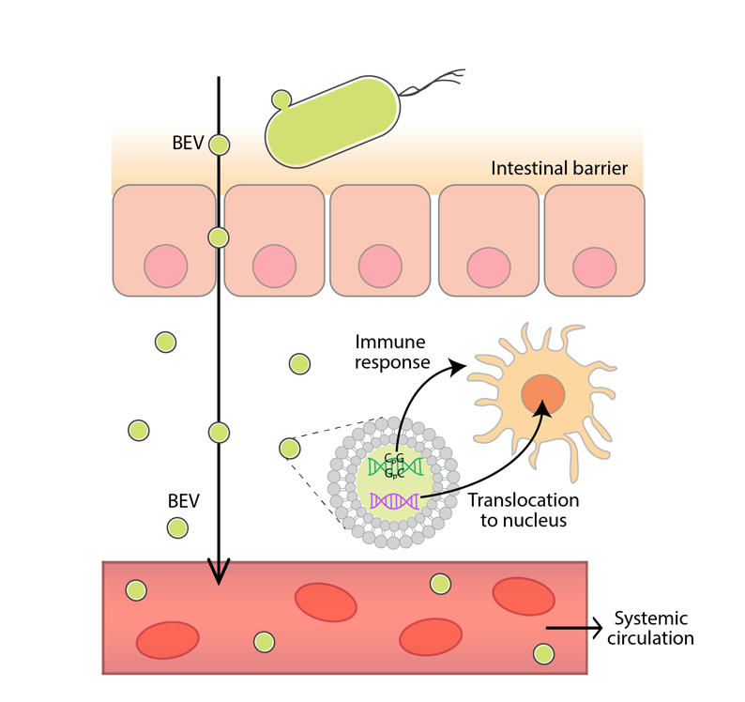
Fig. 3 High permeability of BEVs into intestinal barrier enable direct host-bacteria interactions in whole human body. By the dysfunctionalization of the epithelial barrier, BEVs can migrate into lamina propria and directly interact with immune cells. BEVs can also transmigrate into the systemic circulation and propagate in whole human body. The loaded DNA into BEVs potentially cause the immune response and can translocate into the host nucleus.

DNA in BEVs for understanding their origin in microbiota
In the meantime, profiling the origins of BEVs in human body has been attracted as a novel approach for inferring one’s health-status. Among the molecular cargo of BEVs, DNA is generally appreciated as a promising target for comprehensive and high-throughput profiling (e.g., next-generation sequencing). Especially, in the case of microbiota, profiling DNA has been a standard approach to characterize its taxonomic composition. With a similar idea to this, the internally encapsulated DNA is one of the most promising targets for understanding the taxonomic origins of BEVs. Recently, many studies have analyzed BEV-associated DNA isolated from human body fluids such as blood, urea, and sputum to characterize the possible origins and further understand their association with systemic diseases (48-54). One technical disadvantage of those analyses is targeting only 16S rRNA sequences, which have long been used as the “Gold standard” of marker genes in the microbial ecology field. The bacterial 16S rRNA gene is ≈ 1500 bp in length, consisting of 9 hypervariable regions (usually known as V1-V9) in between conserved sequences. 16S rRNA gene is highly conserved among bacteria, and the DNA sequences of the variable regions are usually species-specific, those unique characteristics enable us to exploit this gene to depict phylogenetic composition in microbiota. The presence of the conserved regions and the comparatively short length of this marker gene also allow low-cost and rapid analysis in combination with next-generation sequencing. However, it is rather likely that vesicles encompassing such a narrow range of genetic regions would be a rare case. Recent studies revealed that specific genomic regions of parent bacteria were enriched in their BEVs (27-29). If this is general among bacteria, there would be a bias in the abundance of every coding sequence including 16S rRNA sequences by bacterial species, and taxonomic profiling using 16S rRNA sequences would be potentially limited to the identification of bacterial species whose BEVs frequently contain 16S rRNA. Comprehensive genomic analysis such as shotgun metagenome sequencing would be the alternative approach to characterize the taxonomic composition of the BEV population, but this method also potentially harbors the bias resulting from the difference in loaded DNA length and quantity in BEVs. Indeed, Biller et al. reported that the length of packaged DNA is different depending on bacterial species (35). Since those potential heterogeneities in the genetic content in BEVs implicitly explain the risk of the conventional bulk metagenomics approach for profiling the origins of BEVs in microbiota, understanding the fundamental properties of BEV-derived DNA is a key to develop more reliable approach for taxonomic annotation.
While there has been no established method to identify possible BEV producers in the context of microbiota due to the lack of a method to analyze DNA from low-biomass to date, taxonomic annotation of sequence reads from each droplet provided the possible producers of BEVs in human microbiota (Ref Takano biorxiv), and thus the droplet sequencing method would be one possible approach to overcome such a technical difficulty. In the case of BEVs from the periodontal oral biofilm, a taxonomic profile of BEVs with DNA was quite different from that in the microbiome even though both samples were derived from the same biofilm (Ref Takano biorxiv). Thus, it is quite possible that the minor bacterial group in the oral biofilm more actively produces BEVs than the major bacterial group. Importantly, there were several oral pathogens that were only detected in the BEV fraction but not in the bacterial cell fraction (Ref Takano biorxiv). Therefore, taxonomic profiles in the DNA cargo of BEVs could monitor distinct signatures of the host health status from those captured by microbiome analysis. Though packaging of genomic regions on the host chromosome was observed in most of the BEV particles, loading of the 16S rRNA gene was rarely detected in the previous study focusing on the oral microbiota (Ref Takano biorxiv). These results suggest the technical limitation of taxonomic identification by 16S rRNA-based methods such as amplicon sequencing.

DNA barcodes in BEVs as possible novel biomarkers
The application of biological nanoparticles for health diagnosis recently has been one trending topic (55). Especially, clinical applications for biological nanoparticles such as exosomes have recently attracted great attention (56). However, more reliable and specific biomarkers are still missing for practical implementation in clinical diagnosis. BEVs are produced by a wide range of bacteria (10), and are also ubiquitous nanoparticles in body fluids taking critical health impact (1). A recent study also reported the presence of “DNA barcodes” in BEVs (Ref Takano biorxiv), which could work as marker genes in the detection of specific BEVs. Given the microflora has a genetic diversity that exceeds that of human cells by two orders of magnitude (57), BEV-associated biological molecules could bring higher specificity as biomarkers compared to eukaryotic extracellular vesicles.
Recently, differences in BEV-DNA signatures based on health status were explored using human oral saliva (Ref Takano biorxiv). Around 800 BEVs collected from healthy people and periodontal patients were analyzed by droplet sequencing, and the distinct taxonomic composition of DNA in BEVs between healthy and periodontal saliva was observed. Moreover, the taxonomic compositions of the microbial cells isolated from the same saliva samples were quite similar between healthy people and periodontal patients, and the observed difference in the taxonomic signature between healthy and periodontal samples was more significant in BEVs than microbiome. Those results suggest that DNA in BEVs possessed more discriminatory signatures depending on the health status. Detailed analysis of the DNA cargo in BEVs further revealed that the enriched genomic regions in BEVs from the same bacterial species are different depending on the oral health status (Ref Takano biorxiv). The presence of enriched loci in the host bacterial chromosome and distinct taxonomic profiles in DNA cargo depending on the health status demonstrate that a “genetic barcode” in BEV-derived DNA has great potential for a diagnosis target. While droplet sequencing would be one promising approach for mining reliable biomarkers from BEVs, it is costly to apply this method for larger-scale cohort studies. Therefore, the combination with conventional metagenomics or quantitative PCR would be more validatable (e.g., screening the barcodes by detailed analysis with droplet sequencing with a small sample size, then validating that by metagenomics or PCR with a large sample size). Also, it should be tested how much BEV-DNA profiles can increase predictability in diagnostic models when combined with other information that is regarded as a promising target (e.g., miRNA profiles in exosomes).
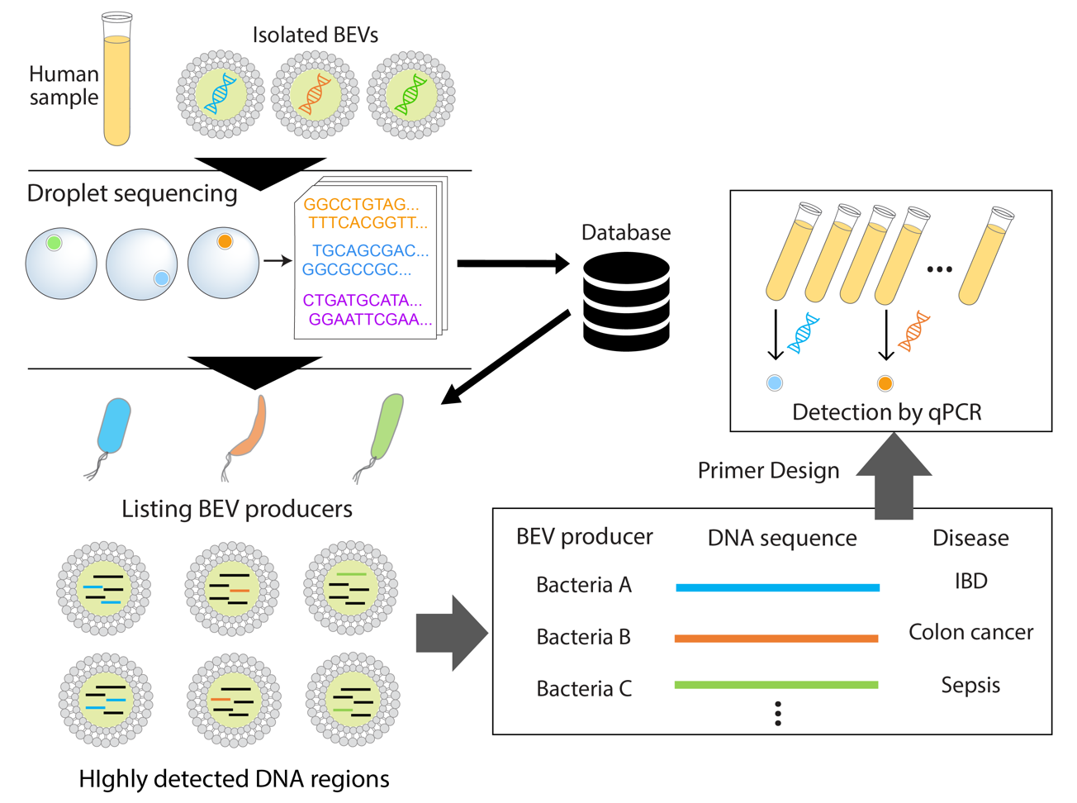
Fig. 4 Application of “DNA barcode” for diagnosis. Droplet sequencing enable comprehensive profiling of internal DNA in BEVs, and it is possible to characterize both BEV producers and highly detected DNA regions in BEVs. Such “DNA barcodes” can be applicable for the simpler and lower-cost detection method such as quantitative PCR in large-scale cohort study.
Redox-active BEV for supporting energy acquisition under anaerobic condition
In addition to vesicles, bacteria have been reported to produce nanoparticles possessing physicochemical properties such as metal conductivity, a subject that has been increasingly studied in recent years (58-61). These entities exhibit capabilities such as aiding metabolism in environments where soluble electron acceptors and donors are depleted. Should BEVs exhibit such functionalities, it would suggest that their formation is less a response to extrinsic stimuli and more a critical outcome driven by intrinsic necessities for the maintenance of biological systems. This perspective lends substantial support to the notion that the genesis of BEVs is an evolutionarily conserved attribute, essential for the sustenance of microbial life under energy-limited conditions. A prominent instance of this phenomenon is observed in electroactive bacteria that utilize BEVs to transfer electrons, effectively turning these vesicles into electron carriers (62, 63).
Electrogenic bacteria are specialized microbes with the capability to exchange electrons with external solid materials like electrodes or minerals (64). Unlike traditional electron acceptors like oxygen that can permeate the cell membrane, these bacteria exploit solid materials, which cannot intrude the cell. One might wonder how these bacteria manage to transfer their intracellular reducing power externally. These bacteria usually possess transmembrane electron transport enzymes that efficiently convey electrons from inside the cell to the exterior (Fig 5A) (65-67). This distinctive characteristic enables these bacteria to serve as electrode catalysts, paving the way for innovative bioprocesses like microbial fuel cells, which simultaneously generate electricity and treat wastewater, and microbial electrode synthesis, which produces valuable substances from CO₂ (68).
The outer-membrane cytochrome complex enzyme of electrogenic bacteria. This complex contains a chain of around twenty heme iron units, forming a “molecular wire” through the outer membrane, enabling electron transfer to extracellular electron acceptor or redox catalysis. BEVs produced by Shewanella, therefore endowed with the OMCs, have been reported to concurrently conduct hydrogen oxidation and iron-reduction reactions. Though these MVs do not proliferate, they mimic live bacteria in driving metabolic reactions, possibly accelerating iron dissolution reactions in the environment.
Recent studies highlight microbes' ability to produce redox-active nanoparticles pivotal for anaerobic respiration (62, 63). Some bacteria like Shewanella oneidensis MR-1, with membrane-bound redox-active enzymes, outer-membrane cytochromes (OMCs), release BEVs that facilitate extracellular electron transport. Electroactive bacteria also produce nano wires, chain-like structures of MVs, as revealed by cryo-electron microscopy in Shewanella strains (69) (Fig 5B). These nano wires, even in desiccated conditions, have been found to exhibit electrical conductivity. Moreover, they have been associated with bacteria known to corrode iron (70) (Fig 5C). Intercellular electron transfer mediated by nano wires has been suggested as a possible mechanism for electrical symbiosis (Fig 5D). While the nanowire here is not proposed to be made with BEVs (71), a similar symbiosis may occur with BEVs (72). This electron exchange is crucial in certain ecological niches, often involving different species. This electrical symbiosis can extend survival in specific environmental conditions. Thus, electron transport by BEVs is considered to play a significant role in the metabolism of electrogenic bacteria, functioning through active production and regulation by the microbes.
Furthermore, human microbiomes also contain electroactive bacteria. Some, such as Klebsiella pneumoniae and Enterococcus avium, have been isolated from human intestines (73). Others, like Aggregatibacter actinomycetemcomitans and Porphyromonas gingivalis, are frequently found in human oral microbiomes and are known pathogens that form BEVs in biofilm (72). While the significance of BEV-mediated electron transfer in such contexts remains under investigation, it offers a compelling avenue for understanding microbial interactions, pathogenicity and energy conservation in biofilm.

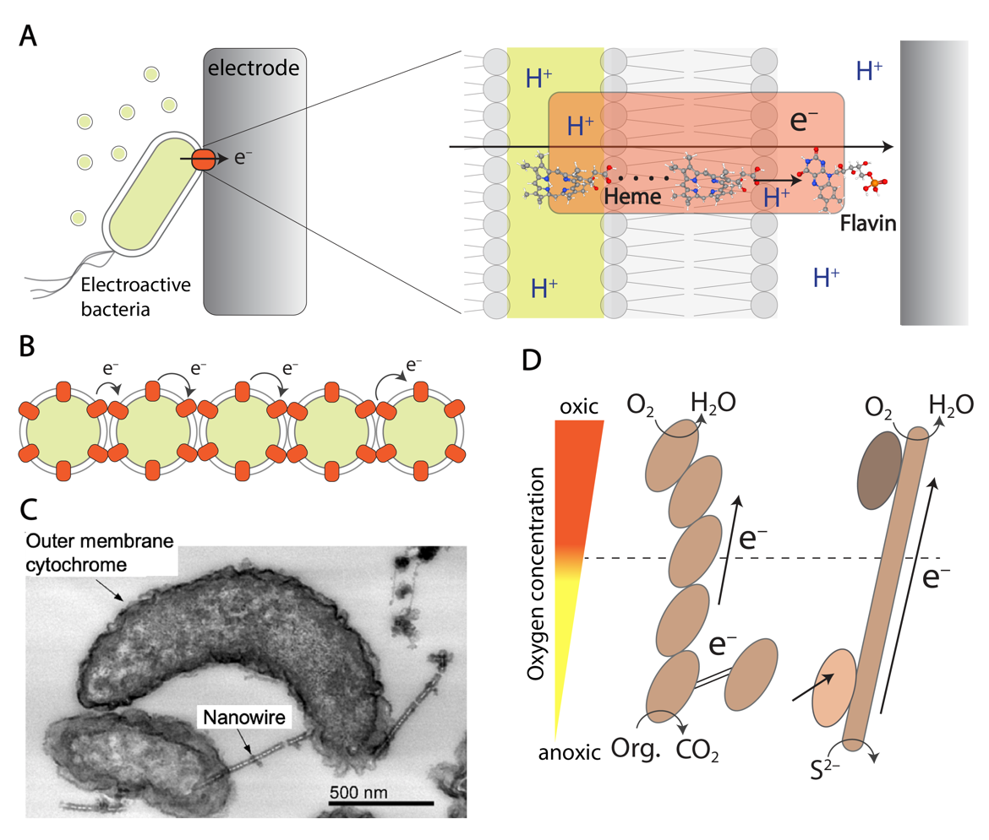
Fig. 5 BEVs with Outer Membrane Cytochromes (OMCs) from Electrogenic Bacteria. A) The model electrogenic bacterium Shewanella oneidensis MR-1 facilitates extracellular electron transfer via OMCs. OMCs receive reducing power from the periplasmic space, transferring electrons from the heme reaction centers to the flavin molecules, and subsequently to the electrode surface. Chemical structures were generated in PubChem (74). B) The formation of wire-like structures extending from the cell surface is observed when BEVs containing OMCs connect. It is believed that electrons are transported through these surface BEVs via OMCs. C) The transmission electron microscopy image shows the nanowires of iron-oxidizing bacteria, specifically Desulfovibrio ferrophilus IS5 strain, which have been selectively stained to visualize redox reactions (70). D) A conceptual diagram depicting electrical symbiosis through intercellular electron transfer mediated by BEVs, nanowires (71) and filamentous bacteria (75). Under anaerobic conditions, bacteria can transfer electrons to symbiotic partners or cable bacteria, enabling them to respire using oxygen.

Redox BEVs for photocatalytic therapy
Redox-active bacterial extracellular vesicles (BEVs) show potential for improving microbial fuel cell efficiency, but their low recovery yield has been a challenge. The Liposome fusion-induced Membrane Exchange (LIME) technique (Ref Wei-Peng Li biorxiv) successfully integrates outer membrane cytochromes (OMCs) from S. oneidensis MR-1 into high-yield membrane-integrated liposomes (MILs). This allows even non-electrogenic bacteria like Escherichia coli to produce electrical currents (62, 63). Furthering BEV applications, titanium dioxide nanoparticles (NPs) coated with OMC-enriched MILs have demonstrated enhanced photocatalytic activity under X-ray irradiation, increasing superoxide anion production (76). This suggests potential uses in radiocatalytic systems for medical treatments, such as orthotopic liver tumor therapy, showcasing BEVs' promise for diverse technological applications.

Future perspective
In this chapter, we have compiled potential evidence supporting the active biological production of BEVs, highlighting research on their DNA and energy contents. These functions are closely linked to microbial physiology and strongly indicate that BEVs are actively produced. However, the mechanisms behind DNA encapsulation and the formation of conductive nanowires remain to be fully elucidated, which would provide additional proof of BEVs' active production. Additionally, we have presented associated applications of BEVs. As our understanding of the function and role of BEVs deepens, the scope of these applications is expected to broaden.

References
1. Schwechheimer C, Kuehn MJ. Outer-membrane vesicles from Gram-negative bacteria: biogenesis and functions. Nat Rev Microbiol. 2015;13(10):605-19.
2. Cuesta CM, Guerri C, Urena J, Pascual M. Role of Microbiota-Derived Extracellular Vesicles in Gut-Brain Communication. Int J Mol Sci. 2021;22(8).
3. Bonnington KE, Kuehn MJ. Outer Membrane Vesicle Production Facilitates LPS Remodeling and Outer Membrane Maintenance in Salmonella during Environmental Transitions. mBio. 2016;7(5).
4. Orench-Rivera N, Kuehn MJ. Differential Packaging Into Outer Membrane Vesicles Upon Oxidative Stress Reveals a General Mechanism for Cargo Selectivity. Front Microbiol. 2021;12:561863.
5. Naradasu D, Miran W, Sharma S, Takenawa S, Soma T, Nomura N, et al. Biogenesis of Outer Membrane Vesicles Concentrates the Unsaturated Fatty Acid of Phosphatidylinositol in. Front Microbiol. 2021;12.
6. Mell JC, Redfield RJ. Natural competence and the evolution of DNA uptake specificity. J Bacteriol. 2014;196(8):1471-83.
7. Johnsborg O, Eldholm V, Havarstein LS. Natural genetic transformation: prevalence, mechanisms and function. Res Microbiol. 2007;158(10):767-78.
8. Koskella B, Meaden S. Understanding bacteriophage specificity in natural microbial communities. Viruses. 2013;5(3):806-23.
9. Dubey GP, Ben-Yehuda S. Intercellular nanotubes mediate bacterial communication. Cell. 2011;144(4):590-600.
10. Toyofuku M, Nomura N, Eberl L. Types and origins of bacterial membrane vesicles. Nat Rev Microbiol. 2019;17(1):13-24.
11. Tran F, Boedicker JQ. Genetic cargo and bacterial species set the rate of vesicle-mediated horizontal gene transfer. Sci Rep. 2017;7(1):8813.
12. Grenier D, Mayrand D. Functional characterization of extracellular vesicles produced by Bacteroides gingivalis. Infect Immun. 1987;55(1):111-7.
13. Engevik MA, Danhof HA, Ruan W, Engevik AC, Chang-Graham AL, Engevik KA, et al. Fusobacterium nucleatum Secretes Outer Membrane Vesicles and Promotes Intestinal Inflammation. mBio. 2021;12(2).
14. Liao S, Klein MI, Heim KP, Fan Y, Bitoun JP, Ahn SJ, et al. Streptococcus mutans extracellular DNA is upregulated during growth in biofilms, actively released via membrane vesicles, and influenced by components of the protein secretion machinery. J Bacteriol. 2014;196(13):2355-66.
15. Naradasu D, Miran W, Sharma S, Takenawa S, Soma T, Nomura N, et al. Biogenesis of Outer Membrane Vesicles Concentrates the Unsaturated Fatty Acid of Phosphatidylinositol in Capnocytophaga ochracea. Front Microbiol. 2021;12:682685.
16. Jones EJ, Booth C, Fonseca S, Parker A, Cross K, Miquel-Clopes A, et al. The Uptake, Trafficking, and Biodistribution of Bacteroides thetaiotaomicron Generated Outer Membrane Vesicles. Front Microbiol. 2020;11:57.
17. Carvalho AL, Fonseca S, Miquel-Clopes A, Cross K, Kok KS, Wegmann U, et al. Bioengineering commensal bacteria-derived outer membrane vesicles for delivery of biologics to the gastrointestinal and respiratory tract. J Extracell Vesicles. 2019;8(1):1632100.
18. Rumbo C, Fernandez-Moreira E, Merino M, Poza M, Mendez JA, Soares NC, et al. Horizontal transfer of the OXA-24 carbapenemase gene via outer membrane vesicles: a new mechanism of dissemination of carbapenem resistance genes in Acinetobacter baumannii. Antimicrob Agents Chemother. 2011;55(7):3084-90.
19. Fulsundar S, Harms K, Flaten GE, Johnsen PJ, Chopade BA, Nielsen KM. Gene transfer potential of outer membrane vesicles of Acinetobacter baylyi and effects of stress on vesiculation. Appl Environ Microbiol. 2014;80(11):3469-83.
20. Klieve AV, Yokoyama MT, Forster RJ, Ouwerkerk D, Bain PA, Mawhinney EL. Naturally occurring DNA transfer system associated with membrane vesicles in cellulolytic Ruminococcus spp. of ruminal origin. Appl Environ Microbiol. 2005;71(8):4248-53.
21. Chiura HX, Kogure K, Hagemann S, Ellinger A, Velimirov B. Evidence for particle-induced horizontal gene transfer and serial transduction between bacteria. Fems Microbiology Ecology. 2011;76(3):576-91.
22. Kahn ME, Barany F, Smith HO. Transformasomes: specialized membranous structures that protect DNA during Haemophilus transformation. Proc Natl Acad Sci U S A. 1983;80(22):6927-31.
23. Dorward DW, Garon CF, Judd RC. Export and intercellular transfer of DNA via membrane blebs of Neisseria gonorrhoeae. J Bacteriol. 1989;171(5):2499-505.
24. Kadurugamuwa JL, Beveridge TJ. Virulence factors are released from Pseudomonas aeruginosa in association with membrane vesicles during normal growth and exposure to gentamicin: a novel mechanism of enzyme secretion. J Bacteriol. 1995;177(14):3998-4008.
25. Kolling GL, Matthews KR. Export of virulence genes and Shiga toxin by membrane vesicles of Escherichia coli O157:H7. Appl Environ Microbiol. 1999;65(5):1843-8.
26. Yaron S, Kolling GL, Simon L, Matthews KR. Vesicle-mediated transfer of virulence genes from Escherichia coli O157:H7 to other enteric bacteria. Appl Environ Microbiol. 2000;66(10):4414-20.
27. Surve MV, Anil A, Kamath KG, Bhutda S, Sthanam LK, Pradhan A, et al. Membrane Vesicles of Group B Streptococcus Disrupt Feto-Maternal Barrier Leading to Preterm Birth. PLoS Pathog. 2016;12(9):e1005816.
28. Bitto NJ, Chapman R, Pidot S, Costin A, Lo C, Choi J, et al. Bacterial membrane vesicles transport their DNA cargo into host cells. Sci Rep. 2017;7(1):7072.
29. Yasuda M, Yamamoto T, Nagakubo T, Morinaga K, Obana N, Nomura N, et al. Phage Genes Induce Quorum Sensing Signal Release through Membrane Vesicle Formation. Microbes Environ. 2022;37(1).
30. Biller SJ, Schubotz F, Roggensack SE, Thompson AW, Summons RE, Chisholm SW. Bacterial vesicles in marine ecosystems. Science. 2014;343(6167):183-6.
31. Renelli M, Matias V, Lo RY, Beveridge TJ. DNA-containing membrane vesicles of Pseudomonas aeruginosa PAO1 and their genetic transformation potential. Microbiology (Reading). 2004;150(Pt 7):2161-9.
32. Hosokawa M, Nishikawa Y, Kogawa M, Takeyama H. Massively parallel whole genome amplification for single-cell sequencing using droplet microfluidics. Sci Rep. 2017;7(1):5199.
33. Gole J, Gore A, Richards A, Chiu YJ, Fung HL, Bushman D, et al. Massively parallel polymerase cloning and genome sequencing of single cells using nanoliter microwells. Nat Biotechnol. 2013;31(12):1126-32.
34. Macosko EZ, Basu A, Satija R, Nemesh J, Shekhar K, Goldman M, et al. Highly Parallel Genome-wide Expression Profiling of Individual Cells Using Nanoliter Droplets. Cell. 2015;161(5):1202-14.
35. Biller SJ, McDaniel LD, Breitbart M, Rogers E, Paul JH, Chisholm SW. Membrane vesicles in sea water: heterogeneous DNA content and implications for viral abundance estimates. ISME J. 2017;11(2):394-404.
36. Tomaru Y, Nagasaki K. Flow cytometric detection and enumeration of DNA and RNA viruses infecting marine eukaryotic microalgae. J Oceanogr. 2007;63(2):215-21.
37. Jang SC, Kim SR, Yoon YJ, Park KS, Kim JH, Lee J, et al. In vivo kinetic biodistribution of nano-sized outer membrane vesicles derived from bacteria. Small. 2015;11(4):456-61.
38. Kim OY, Park HT, Dinh NTH, Choi SJ, Lee J, Kim JH, et al. Bacterial outer membrane vesicles suppress tumor by interferon-gamma-mediated antitumor response. Nat Commun. 2017;8(1):626.
39. Shen Y, Giardino Torchia ML, Lawson GW, Karp CL, Ashwell JD, Mazmanian SK. Outer membrane vesicles of a human commensal mediate immune regulation and disease protection. Cell Host Microbe. 2012;12(4):509-20.
40. Chronopoulos A, Kalluri R. Emerging role of bacterial extracellular vesicles in cancer. Oncogene. 2020;39(46):6951-60.
41. Tulkens J, Vergauwen G, Van Deun J, Geeurickx E, Dhondt B, Lippens L, et al. Increased levels of systemic LPS-positive bacterial extracellular vesicles in patients with intestinal barrier dysfunction. Gut. 2020;69(1):191-3.
42. Hacker G, Redecke V, Hacker H. Activation of the immune system by bacterial CpG-DNA. Immunology. 2002;105(3):245-51.
43. Paludan SR, Reinert LS, Hornung V. DNA-stimulated cell death: implications for host defence, inflammatory diseases and cancer. Nat Rev Immunol. 2019;19(3):141-53.
44. O'Donoghue EJ, Krachler AM. Mechanisms of outer membrane vesicle entry into host cells. Cell Microbiol. 2016;18(11):1508-17.
45. Riley DR, Sieber KB, Robinson KM, White JR, Ganesan A, Nourbakhsh S, et al. Bacteria-human somatic cell lateral gene transfer is enriched in cancer samples. PLoS Comput Biol. 2013;9(6):e1003107.
46. Poore GD, Kopylova E, Zhu Q, Carpenter C, Fraraccio S, Wandro S, et al. Microbiome analyses of blood and tissues suggest cancer diagnostic approach. Nature. 2020;579(7800):567-74.
47. Tulkens J, De Wever O, Hendrix A. Analyzing bacterial extracellular vesicles in human body fluids by orthogonal biophysical separation and biochemical characterization. Nat Protoc. 2020;15(1):40-67.
48. Kim SI, Kang N, Leem S, Yang J, Jo H, Lee M, et al. Metagenomic Analysis of Serum Microbe-Derived Extracellular Vesicles and Diagnostic Models to Differentiate Ovarian Cancer and Benign Ovarian Tumor. Cancers (Basel). 2020;12(5).
49. Lee H, Lee HK, Min SK, Lee WH. 16S rDNA microbiome composition pattern analysis as a diagnostic biomarker for biliary tract cancer. World J Surg Oncol. 2020;18(1):19.
50. Lee JH, Choi JP, Yang J, Won HK, Park CS, Song WJ, et al. Metagenome analysis using serum extracellular vesicles identified distinct microbiota in asthmatics. Sci Rep. 2020;10(1):15125.
51. Philley JV, Kannan A, Olusola P, McGaha P, Singh KP, Samten B, et al. Microbiome Diversity in Sputum of Nontuberculous Mycobacteria Infected Women with a History of Breast Cancer. Cell Physiol Biochem. 2019;52(2):263-79.
52. Choi HI, Choi JP, Seo J, Kim BJ, Rho M, Han JK, et al. Helicobacter pylori-derived extracellular vesicles increased in the gastric juices of gastric adenocarcinoma patients and induced inflammation mainly via specific targeting of gastric epithelial cells. Exp Mol Med. 2017;49(5):e330.
53. Samra M, Nam SK, Lim DH, Kim DH, Yang J, Kim YK, et al. Urine Bacteria-Derived Extracellular Vesicles and Allergic Airway Diseases in Children. Int Arch Allergy Immunol. 2019;178(2):150-8.
54. Jones E, Stentz R, Telatin A, Savva GM, Booth C, Baker D, et al. The Origin of Plasma-Derived Bacterial Extracellular Vesicles in Healthy Individuals and Patients with Inflammatory Bowel Disease: A Pilot Study. Genes (Basel). 2021;12(10).
55. Zhou BT, Xu KL, Zheng X, Chen T, Wang J, Song YM, et al. Application of exosomes as liquid biopsy in clinical diagnosis. Signal Transduct Tar. 2020;5(1).
56. Herrmann IK, Wood MJA, Fuhrmann G. Extracellular vesicles as a next-generation drug delivery platform. Nat Nanotechnol. 2021;16(7):748-59.
57. Gilbert JA, Blaser MJ, Caporaso JG, Jansson JK, Lynch SV, Knight R. Current understanding of the human microbiome. Nat Med. 2018;24(4):392-400.
58. Deng X, Luo D, Okamoto A. Defined and unknown roles of conductive nanoparticles for the enhancement of microbial current generation: A review. Bioresour Technol. 2022;350:126844.
59. Murugan M, Miran W, Masuda T, Lee DS, Okamoto A. Biosynthesized Iron Sulfide Nanocluster Enhanced Anodic Current Generation by Sulfate Reducing Bacteria in Microbial Fuel Cells. Chemelectrochem. 2018;5(24):4015-20.
60. Deng X, Dohmae N, Kaksonen AH, Okamoto A. Biogenic Iron Sulfide Nanoparticles to Enable Extracellular Electron Uptake in Sulfate-Reducing Bacteria. Angew Chem Int Edit. 2020;59(15):5995-9.
61. Cao B, Zhao Z, Peng L, Shiu HY, Ding M, Song F, et al. Silver nanoparticles boost charge-extraction efficiency in Shewanella microbial fuel cells. Science. 2021;373(6561):1336-40.
62. Liu X, Jing X, Ye Y, Zhan J, Ye J, Zhou S. Bacterial Vesicles Mediate Extracellular Electron Transfer. Environmental Science & Technology Letters. 2020;7(1):27-34.
63. Yu H, Lu Y, Lan F, Wang Y, Hu C, Mao L, et al. Engineering Outer Membrane Vesicles to Increase Extracellular Electron Transfer of Shewanella oneidensis. ACS Synthetic Biology. 2023;12(6):1645-56.
64. Shi L, Dong HL, Reguera G, Beyenal H, Lu AH, Liu J, et al. Extracellular electron transfer mechanisms between microorganisms and minerals. Nature Reviews Microbiology. 2016;14(10):651-62.
65. Hartshorne RS, Reardon CL, Ross D, Nuester J, Clarke TA, Gates AJ, et al. Characterization of an electron conduit between bacteria and the extracellular environment. P Natl Acad Sci USA. 2009;106(52):22169-74.
66. Edwards MJ, White GF, Butt JN, Richardson DJ, Clarke TA. The Crystal Structure of a Biological Insulated Transmembrane Molecular Wire. Cell. 2020;181(3):665-+.
67. Okamoto A, Hashimoto K, Nealson KH, Nakamura R. Rate enhancement of bacterial extracellular electron transport involves bound flavin semiquinones. P Natl Acad Sci USA. 2013;110(19):7856-61.
68. Rabaey K, Rozendal RA. Microbial electrosynthesis — revisiting the electrical route for microbial production. 2010:1-11.
69. Subramanian P, Pirbadian S, El-Naggar MY, Jensen GJ. Ultrastructure of
MR-1 nanowires revealed by electron cryotomography. P Natl Acad Sci USA. 2018;115(14):E3246-E55.
70. Deng X, Dohmae N, Nealson KH, Hashimoto K, Okamoto A. Multi-heme cytochromes provide a pathway for survival in energy-limited environments. Sci Adv. 2018;4(2).
71. Wegener G, Krukenberg V, Riedel D, Tegetmeyer HE, Boetius A. Intercellular wiring enables electron transfer between methanotrophic archaea and bacteria. Nature. 2015;526(7574):587-90.
72. Miran W, Naradasu D, Okamoto A. Pathogens electrogenicity as a tool for in-situ metabolic activity monitoring and drug assessment in biofilms. Iscience. 2021;24(2).
73. Naradasu D, Miran W, Sakamoto M, Okamoto A. Isolation and Characterization of Human Gut Bacteria Capable of Extracellular Electron Transport by Electrochemical Techniques. Front Microbiol. 2018;9.
74. Kim S, Chen J, Cheng T, Gindulyte A, He J, He S, et al. PubChem 2023 update. Nucleic Acids Res. 2023;51(D1):D1373-D80.
75. Pfeffer C, Larsen S, Song J, Dong M, Besenbacher F, Meyer RL, et al. Filamentous bacteria transport electrons over centimetre distances. Nature. 2012;491(7423):218-21.
76. Chen YC, Li YT, Lee CL, Kuo YT, Ho CL, Lin WC, et al. Electroactive membrane fusion-liposome for increased electron transfer to enhance radiodynamic therapy. Nat Nanotechnol. 2023.

