Noncoplanar magnetic structures in Mn₄N epitaxial films evaluated by alternating magnetic force microscopy

Shinji Isogami*
Research Center for Magnetic and Spintronic Materials, National Institute for Materials Science, Sengen 1-2-1, Tsukuba, Ibaraki 305-0047, Japan

Kosuke Imamura, Ryota Kuwayama, Kouta Abe, and Mitsuru Ohtake
Faculty of Engineering, Yokohama National University, Tokiwadai 79-5, Hodogaya, Yokohama, Kanagawa 240-8501, Japan

Marina V. Makarova, and Hitoshi Saito
Department of Mathematical Science and Electrical-Electronic-Computer Engineering, Graduate School of Engineering Science, Akita University, Akita 010-8502, Japan

*Corresponding author : isogami.shinji@nims.go.jp

<Abstract>
Noncoplanar magnetic structures in the Mn₄N epitaxial thin films grown on the 001-oriented MgO and SrTiO₃ (STO) substrates were studied, based on the measurements of topological Hall effect (THE) and the observation of magnetic domain nucleation. The typical nucleation diameter of domain was determined using an alternating magnetic force microscope, which proved advantageous for the visualization of the domain with an out-of-plane magnetic component. The nucleation diameter of the domains on the MgO substrate were ~150 nm for the thickness of 30 nm and ~110 nm for 10 nm, while ~130 nm for 30 nm on the STO substrate. The value of THE was one or two orders of magnitude larger than that estimated based on the nucleation diameter, indicating that the existence of a noncoplanar magnetic structure is the primary factor contributing to the THE in the Mn₄N films, comparing to the effect from domain nucleation. The noncoplanar magnetic structure was more pronounced with decreasing thickness and substrate-induced strain.

<Main text>
I. Introduction
The future of spintronic devices, such as magnetic memories driven by the current-induced spin-orbit torque (SOT), will depend on the development of high-integration and low-power-consumption technologies. One method for achieving this is by reducing the critical current density for magnetization switching ($J_{c}∝\frac{2e}{ℏ}\frac{K_{u}t}{θ_{SH}}$),¹ which is governed by the uniaxial perpendicular magnetic anisotropy (K_{u} = M_{s}H_{k}/2) of the magnetic layers, where M_{s}, H_{k}, t, and θ_{SH} represent the saturation magnetization, perpendicular magnetic anisotropy field, thickness of magnetic layer and spin-Hall angle, respectively. It can be seen that both low M_{s} and H_{k} are indispensable for low J_{c}. A promising material to be considered is the ferrimagnet with low M_{s}, due to the antiparallel magnetic configuration of two sublattices. Conversely, the magnitude of H_{k} is strongly dependent on the magnetic structure of magnetic materials in general. Therefore, it would be beneficial to focus on exploring the specific magnetic structure for low H_{k.}
The Mn₄N, one of the transition metal nitrides, has been the subject of interest in the field of spintronics due to its low M_{s} and the magnetic easy-axis pointing along the film plane normal, namely, the perpendicular magnetic anisotropy (PMA).²⁻⁴ The demonstration of the SOT-based magnetization switching in the Mn₄N layer has been made in heterostructures with a spin-Hall heavy metal layer.⁵ Significantly fast domain wall propagation driven by spin-transfer torque has been demonstrated in Mn₄N nanowires.⁶ In addition to these pioneering works, further efficient current-driven magnetization switching has been observed in (111)-oriented Mn₄N epitaxial thin films.⁷ This can be attributed to the decrease in PMA resulting from a change in magnetic structure from collinear to noncoplanar alignment. In the (111)-oriented Mn₄N film, the magnetic easy-axis does not point along the [111] direction, resulting in a lower PMA compared to the conventional Mn₄N film with a collinear magnetic structure. It can be reasonably deduced, therefore, that the development of a noncoplanar magnetic structure in ferrimagnets would be a key factor in achieving both low H_{k} and low M_{s}.
Although the Mn₄N has attracted attention due to its collinear ferrimagnetism so far, the noncoplanar ferrimagnetism is recently suggested as one of the possible magnetic structures.⁸ One of two Mn sublattices in the antiperovskite Mn₄N unit cell dominates the noncoplanar, while the other does the collinear magnetic structures, and they are aligned in antiferromagnetic configuration. These are also supported by the calculation of magneto-optical Kerr effect spectrum,⁹ suggesting that the noncoplanar ferrimagnetism could not be ignored for a recent framework of Mn₄N systems. The x-ray circular dichroism at synchrotron radiation facility is employed as well,¹⁰ however, it has been still challenging to determine a specific magnetic structure directly by experiments. The topological Hall effect (THE), which emerges due to the presence of noncoplanar magnetic structures, is considered one of the useful methods to date. In the case of Mn₄N films, the THE was reported in various manipulated systems with the mechanically coupled PMN-PT substrate,¹¹ the local symmetry breaking caused by interstitial boron,¹² and the thickness variation.¹⁰ Nevertheless, it should be noted that the THE can be observed not only by the noncoplanar magnetic structures but also by the presence of skyrmion bubbles that is stabilized by the topological spin textures.¹³ The skyrmion bubbles have been extensively studied for the Mn₄N films, and the diameter is reported to be ~100 nm, which is tunable by the adjacent nonmagnetic heavy metal layers through the modulation of interfacial Dzyaloshinskii–Moriya interaction (DMI).¹⁴ In addition, the nanometric hedgehog-antihedgehog pairs that originate from frustrated exchange interactions between arbitrary Mn spins, rather than the DMI, are responsible for metastable topological textures such as skyrmions even in the bulk Mn₄N.¹⁵ Under such wide-ranging circumstances, therefore, it remains uncertain which of the two contributions plays the dominant role for THE: the noncoplanar magnetic structure or the skyrmion bubbles in the Mn₄N thin films.
In this study, we aim to elucidate the dominant magnetic structure that contributes to the THE in the Mn₄N films, based on the comparative study of the nucleation size of magnetic domains using different film thickness and substrates. In order to determine the domain size with sufficient high resolution, it is crucial to identify the magnetic field that is aligned with the normal to the film plane. While conventional MFM has been employed using ferromagnetic tips to detect both in-plane and out-of-plane magnetic stray fields, this study employed a newly developed alternating MFM (A-MFM) system, which is more effective at detecting the out-of-plane magnetic stray field, owing to the magnetic properties of the superparamagnetic tips and lock-in detection for the signal modulated by AC magnetic field. In addition to such resolution advantages, the system allows us to directly obtain the absolute value of the magnetic field and the direction angle from domains, which can eliminate the signal subtraction procedures for high contrast images.
It has been expected that magnetic structure can be tailored by thickness and substrate-induced lattice strain. Therefore, the magnetic structure elucidated in this study could provide another avenue for the development of a tailor-made spintronic devices using ferrimagnets for low J_{c} in the future.
II. Experimental procedures
Mn₄N films with thicknesses of 4, 10, and 30 nm were deposited on single-crystal MgO (001-oriented) and SrTiO₃ (STO) substrates via reactive nitridation sputtering at a substrate temperature of 500°C. Subsequently, a 2 nm thick MgO film was deposited as a capping layer. The flow rates of N₂ and Ar gas were in a ratio of 35%. Structural analysis was conducted via X-ray diffraction (XRD) with Cu-Kα radiation. Magnetic properties were measured with a superconducting quantum interference device vibrating sample magnetometer (SQUID-VSM) at room temperature. Anomalous Hall resistivity (ρ_{xy}) was measured using a physical property measurement system (PPMS).
Surface morphology and magnetic domain structures of the Mn₄N films were observed via the A-MFM ¹⁶ with Si tip with 40 N/m spring constant coated by the superparamagnetic (SP) Co-GdO_{x} granular film,¹⁷ which is magnetized by the external AC magnetic field [H_{e}^{ac} = H₀^{ac}cos(ω_{m}t)] from the electromagnet and the stray DC field from the sample (H_{s}^{dc}) (Fig. 1). The H₀^{ac} and off-resonance angular frequency ω_{m} in this study are 200 ~ 500 Oe and 89 Hz, respectively. The tip oscillation at near-resonance frequency is ω_{d} ~ 300 kHz, which is modulated to be $ω_{d}+Δωcos⁡(ω_{m}t+θ)$ by the external H_{s}^{dc} + H_{e}^{ac}. Then the oscillation is detected at the photo diode (PD) and the periodical frequency change of Δω(ω_{m}) from ω_{d} is extracted by the phase locked loop (PLL). The lock-in amplifier extracts the periodical components of ω_{m} and converts them to R (amplitude) and θ (phase) outputs, which respectively allows the separation of intensity and polarity of magnetic stray fields (up or down direction that is perpendicular to the film plane) from the samples. This is one of the advantages for the A-MFM that cannot be achieved by the conventional MFM system. Note that the SP-tip end is periodically magnetized along H_{s}^{dc} + H_{e}^{ac} pointing in perpendicular to the film plane (z-direction), and the absence of magnetic hysteresis properties in the Co-GdO_{x} layer allows the detection of weak magnetic fields. Therefore, the R and θ outputs in the A-MFM system purely indicate the components with z-direction, resulting in the better spatial resolution comparing to the conventional MFM system, in which a conventional hard-magnetic MFM tip, magnetized in a specific magnetic easy-axis regardless of various stray fields from samples,¹⁸ cannot detect the z-component of magnetic fields from samples. The representative spatial resolution is evaluated to be 10 ~ 20 nm with the signal to noise ratio of 35 ~ 38 dB for the conventional MFM, while that is 2.5 ~ 5 nm with ~58 dB for our A-MFM,¹⁹ which allows us to eliminate the signal subtraction procedure to obtain high contrast, direct, and reliable MFM images.
III. Results and discussions
A. Film thickness dependent Mn₄N crystal structures
Figures 2(a) and 2(b) show the out-of-plane and in-plane XRD profiles for the Mn₄N thin films on MgO substrates. The peaks observed at 2θ/ω ≈ 23°, 47°, and 106° can be attributed to the diffraction from Mn₄N (001), (002), and (004), respectively. However, the crystal order parameters (S) based on the out-of-plane diffraction intensity of (100) and (200) were estimated to be ~0.76 and ~0.70 for 10 nm and 30 nm, respectively. This suggests that the pure Mn₄N phase can be dominant in the entire film. The estimation method of S is shown in the previous papers.²⁰ Despite the peak intensity of the Mn₄N (100) superlattice being relatively weak in the 4-nm-thick film, the RHEED pattern originating from the superlattice was clearly visible, as shown in Fig. 3(a1). Figure 2(c) shows the thickness-dependent variation in the in-plane (a) and out-of-plane (c) lattice parameters of Mn₄N films. It can be observed that a is consistently larger than c for all film thicknesses, indicating the presence of tensile strain induced by the MgO substrates with a lattice parameter of ~0.42 nm. The thickness dependence of the axial ratio of c/a is shown in Fig. 1(d). The c/a was ~0.99 for the thicknesses of 10 nm and 30 nm. For a thickness of 4 nm, the ratio increased to ~1.0. As previously reported on the epitaxial growth of Fe₄N films with the same antiperovskite structure as Mn₄N, it can be inferred that the lattice mismatch between the MgO substrate and Mn₄N film can be relaxed by forming misfit dislocations at the initial growth layer with a thickness of less than 4 nm.²¹ Note that the c/a reached a saturation point at a thickness of 10 nm, which may represent the effective thickness for strain relaxation into a stable structure with c/a ≈ 0.99.
Figures 3(a1)-3(a3) show the RHEED patterns for the Mn₄N films deposited on MgO substrates, with the electron beam oriented parallel to the [100] direction of the Mn₄N unit cell. The samples with MgO substrates exhibited clear streak patterns originating from both the superlattice (indicated by arrows) and the fundamental lattice. Therefore, an atomic-ordered Mn₄N film was formed even with a thickness down to 4 nm. The XRD peak originating from the (001) superlattice was not observed [Fig. 2(a)] for 4 nm, which may be attributed to its weak XRD signal intensity in comparison to the noise, due to the extremely thin thickness. Figures 3(b1)-3(b3) present the same results, but with STO substrates. While the overall intensity was reduced in comparison to the results obtained with MgO substrates, streaks attributable to the superlattice were observed, as indicated by the arrows between the streaks originating from the fundamental lattice. Furthermore, diffraction from the (003) superlattice was also observed, indicating that an atomic-ordered Mn₄N film was formed in both the 4 nm thick samples on the STO and MgO substrates.
B. Thickness dependent magnetic properties of Mn₄N thin films
Figure 4(a) shows the representative magnetic hysteresis loops (M-H loops) for the 30-nm-thick Mn₄N film on the MgO substrate at 300 K, wherein a magnetic field was applied along both the in-plane and out-of-plane directions. The saturation field was observed to be ~0.6 T for the out-of-plane direction and ~7 T for the in-plane direction, indicating a clear PMA with the easy-axis oriented in the out-of-plane direction. The saturation magnetization was ~0.15 T, which was close to the calculated value previously reported.²² Figure 4(b) shows the same measurement as Fig. 4(a), but for the film on the STO substrate. The saturation field was observed to be ~1.5 T for out-of-plane and ~4 T for in-plane, indicating a reduction in PMA relative to the film on the MgO substrate. Figure 4(c) shows the correlation between K_{u} and the thickness of Mn₄N (t). The K_{u} is estimated from the in-plane and out-of-plane M-H loops in Figs. 4(a) and 4(b) by using following equations,
$K_{u}=K_{u}^{eff}+\frac{μ_{0}M_{s}^{2}}{2}$ , (1)
$K_{u}^{eff}={\left(μ_{0}\int_{0}^{M_{s}}{H dm}\right)}_{hard-axis}-{\left(μ_{0}\int_{0}^{M_{s}}{H dm}\right)}_{easy-axis}$ , (2)
where the second term of Eq. (1) represents the demagnetization component. The K_{u} was found to be 0.19 MJ/m³ for t = 30 nm on the MgO substrate. This value was confirmed to be in agreement with previous results for the Mn₄N film on the MgO substrate.²³ It was revealed that the K_{u} decreased with decreasing t, resulting in a negligible value, especially for 4 nm. A number of potential mechanisms may be considered to explain this thickness dependence. One such mechanism is the change in the magnetic structure due to the reduction in thickness, which is strongly influenced by the lattice constant and/or lattice distortion. It should be noted that the in-plane lattice mismatch at the interface between the MgO substrate and Mn₄N film gives rise to in-plane lattice expansion of the Mn₄N crystal and misfit dislocations near the interface. In contrast, the portion of the film far from the interface exhibits lattice relaxation.²¹ Consequently, the magnetic structure of the Mn₄N film near the interface may differ from the collinear ferrimagnetic structure. This results in a decrease in K_{u} as the thickness decreases. In addition to the t dependence, the STO substrate exhibited a weaker K_{u} than the MgO substrate for t values exceeding 10 nm [Fig. 4(c)]. The discrepancy can be attributed to substrate-induced residual strain, as previously reported.²¹ Specifically, sufficient substrate-induced strain from the MgO substrate is responsible for the axial ratio c/a ≈ 0.99, resulting in a collinear magnetic structure with high K_{u} in the Mn₄N films. Conversely, the c/a deviates from 0.99, approaching 1, due to less substrate-induced strain from the STO substrate, resulting in a weak K_{u}.
C. Thickness and strain dependence of topological Hall effect
Figure 5(a) shows the representative anomalous Hall (ρ_{xy}^{AHE}) and topological Hall resistivity (ρ_{xy}^{THE}) as a function of the out-of-plane magnetic field (H_{z}) for the Mn₄N film with a thickness of 30 nm on the MgO substrate. In this analysis, we assume that ρ_{xy} consists of three distinct components, which are the ordinary Hall effect (OHE), the AHE and the THE, i.e.,
$ρ_{xy}=R_{0}H+R_{s}M+ρ_{xy}^{THE}$, (3)
where R₀ and R_{s} correspond to the coefficients of OHE and AHE, respectively. To extract ρ_{xy}^{THE} from ρ_{xy}, a fitting was performed to the experimentally obtained out-of-plane M-H loops using Eq. (3). Sizeable anomaly emerged in the μ₀H_{z} regime from 0 T to 0.5 T, as shown by the red symbols, suggesting the potential presence of topological spin textures, such as skyrmions and/or noncoplanar magnetic structures in the Mn₄N film. This measurement aligns with the predictions of previous reports.^{12,24} Figure 5(b) shows the same measurements as those presented in Fig. 5(a), but for the film on the STO substrate. The magnitude of ρ_{xy}^{THE} was found to be enhanced, and the dependence of this on t is summarized in Fig. 5(c). The ρ_{xy}^{THE} of ~0.2 (~1) was observed for the 30-nm-thick films on the MgO (STO) substrate, which exhibited an increase with decreasing thickness, regardless of the substrates. Figure 5(d) shows the ratio of ρ_{xy}^{THE} to ρ_{xy}^{AHE} (ρ_{xy}^{THE}/ρ_{xy}^{AHE}), which exhibits a similar t dependence as shown in Fig. 5(c). In addition to the thickness dependence, the ρ_{xy}^{THE} on the STO substrate was observed to be larger than that on the MgO substrate for film thicknesses of 10 nm and 30 nm. This suggests a correlation between substrate-induced strain and the magnitude of ρ_{xy}^{THE}, as previously discussed in Fig. 4 (see section E for further details).
D. Nucleation of magnetic domains observed via A-MFM
The THE is attributed to topological spin textures, such as skyrmion bubbles. To directly access the size of topological spin textures, the nucleation of magnetic domain is observed via an A-MFM. Figure 6(a1) shows the height image of a 30-nm-thick Mn₄N film on the MgO substrate, indicating flat surface without significant morphology originating from grain growth. Figures 6(a2) and 6(a3) present the A-MFM signal amplitude and phase of the same surface position, corresponding to the magnitude and polarity of the z-component of the stray field gradient from the domains. The observation of circular-shaped contrast indicates the presence of strong magnetic moments oriented in the negative z-direction, which are surrounded by a matrix part with small magnetic moments oriented in the positive z-direction. In the magnetization reversal process in the magnetic thin film with PMA, the domain nucleation happens, followed by the domain wall propagates to spread the domain size. The nucleation pattern can be determined by the superposition of applied field, PMA and DMI, and the circular shaped domains could be one of the expected patterns at the specific condition among them. The A-MFM observation was carried out at the remanent state, i.e., H = 0 T, in which the magnetization starts to decrease. Moreover, the magnitude of the magnetic moment inside the circular domain was much larger than that in the matrix part of the Mn₄N film, which might be attributed to the energetically stable perpendicular magnetic moment in the circular domains. We thus conclude that the observed pattern represents the nucleation of magnetic domains in the Mn₄N films. The line profiles of S1 and S2 in Fig. 6(a4) exhibit diameters of ~150 nm and ~160 nm, respectively. Similar to the thickness with 30 nm, the surface morphology is observed to be sufficiently smooth for a thickness of 10 nm as well [Fig. 6(b1)]. The domain boundary observed in Figs. 6(b2) and 6(b3) suggests that the stray field is tilted with respect to the film surface normal. This is evidenced by the broader line profile of S3 corresponding to the domain boundary. The diameter is determined to be ~110 nm [Fig. 6(b4)], which is smaller than that observed for the Mn₄N film with 30 nm [Fig. 6(a4)]. Figures 6(c1)-6(c4) present the same data for the film on the STO substrate. Although numerous grains are visible in the height image [Fig. 6(c1)], this does not align with the contrast patterns observed in the amplitude image [Fig. 6(c2)]. Consequently, the surface morphology is not a contributing factor to the magnetic domains. The domain boundary was not as clearly defined as in the case of the 10-nm-thick Mn₄N film on the MgO substrate [Fig. 6(b3)]. Based on the line profiles of S4 and S5 in Fig. 6(c4), the diameter is estimated to be ~130 nm. These findings corroborate the hypothesis that the nucleation size of magnetic domains is influenced by both the substrate type and the thickness.
E. Estimation of ρ_{xy}^{THE} based on the nucleation size of domain
The THE emerges due to not only the presence of skyrmions but also noncoplanar magnetic structures. To discuss the relationship between the THE and skyrmions in the 001-oriented Mn₄N thin films, the ρ_{xy}^{THE} was evaluated by contrasting it with the AHE data shown in Fig. 5. The THE originating from a skyrmion is given by^{25,26}
$ρ_{xy}^{THE}=n_{sky}R_{0}PB_{eff}$ ,
$B_{eff}=\frac{2\left(h/e\right)}{A_{sky}}$ , (4)
$A_{sky}=π{\left(\frac{λ}{2}\right)}^{2}$,
where n_{sky}, R₀, P, and B_{eff} represent the relative skyrmion density, the normal Hall resistivity, the spin polarization for the entire magnetization of the film, and the effective field of skyrmions, respectively. The B_{eff} is given by the Plank’s constant (h), the elementary charge (e), and the skyrmion area (A_{sky}) with its diameter (λ). The n_{sky} = 1 is for an isolated skyrmions, while n_{sky} < 1 is for a coplanar spin texture. Therefore, the comparison between the ρ_{xy}^{THE} using Eq. (4) and the experimentally obtained ρ_{xy}^{THE} allow us to reveal a possible dominant origin of THE in the Mn₄N thin films. Table I summarizes each parameter to estimate ρ_{xy}^{THE} using Eq. (4), where we assumed n_{sky} = 1, P = 1, and the R₀ = 0.04 (μΩ cm)/T. Because the parameter P was unknown, we employed the value of 1 as a maximum value. Therefore, the ρ_{xy}^{THE} estimated using Eq. (4) indicates the possible maximum value expected. The results increased with decreasing the thickness of Mn₄N, which can be attributed to the enhanced B_{eff} due to the smaller λ for thinner thickness. Such thickness dependence is consistent with that obtained from the measurements in Fig. 5,
TABLE I Comparison of ρ_{xy}^{THE} obtained from Eq. (4) and the experiments in Fig. 5.
Substrate | Thickness | λ  (nm) | A_{sky}  (nm²) | B_{eff}  (mT) | $ρ_{xy}^{THE}$ [Eq. (4)]  (μΩ cm) | $ρ_{xy}^{THE}$ [Fig. 5]  (μΩ cm)
MgO | 30 nm | 156 | 7650 | 54.1 | 2.16$×$10⁻³ | 1.31$×$10⁻¹
MgO | 10 nm | 108 | 3660 | 113 | 4.51$×$10⁻³ | 3.11$×$10⁻¹
STO | 30 nm | 132 | 5470 | 75.6 | 3.02$×$10⁻³ | 9.78$×$10⁻¹

while the magnitude of which is one or two orders of magnitude larger than that estimated using Eq. (4). Although the (001)-oriented Mn₄N thin films have long been known to exhibit collinear ferrimagnetic properties, with the magnetic easy-axis oriented along the film plane normal,²⁷ recent studies have proposed the existence of additional noncoplanar ferrimagnetic structures. These structures are thought to result from frustrated antiferromagnetic interactions,¹⁵ the presence of crystal defects,²⁸ and strain effects.¹¹ It can thus be deduced that the mechanism responsible for the considerable ρ_{xy}^{THE} observed in Fig. 5 is likely to be dominated by noncoplanar magnetic structures, while skyrmions give minor contributions to the THE, if any.
On the other hand, it has been reported that the inhomogeneous magnetization due to extrinsic origins, such as a layer dependent internal molecular filed,²⁹ crystal defects,³⁰ and thickness variation,³² also cause the THE. In the present sample, however, the crystal field and thickness variation can be ruled out now, because of its continuous film thickness without any wedge type layer structure. On the other hand, the defects such as dislocation may form at the MgO/Mn₄N interfaces due to a large in-plane lattice mismatch of ~6 %, which was confirmed by the high-resolution cross-sectional TEM observation for the Fe₄N film with the same crystal structure.²² However, the dislocation appears only near the interface with less than 1 nm thickness range, resulting in the strain-free Mn₄N without misfit dislocations at the bulk part of the layer. This means that the substrate-induced strain could be relaxed by forming the dislocations. Influences from the defects at the interface are more minor as the thickness of Mn₄N film increases, therefore, the noncoplanar magnetic structure is the major origin for the present THE. This can be confirmed by the fact that the ρ_{xy}^{THE} for 10 nm is larger than that for 30 nm in Table I.
As for the substrate dependence, small lattice mismatch (free of strain) in the STO/Mn₄N increased the THE, suggesting more pronounced noncoplanar magnetic structure comparing to the MgO/Mn₄N. This can be explained by the previous study on neutron diffraction that reveals the noncoplanar magnetic structure for the cubic Mn₄N crystal as a ground state.^{27,28} It is thus inferred that the noncoplanar magnetic structure could be attributed to two causes, which are the dislocation due to large mismatch at interfaces and the cubic crystals due to strain-free interfaces. Furthermore, the effect from the noncoplanar magnetic structure is suppressed by increasing the film thickness due to the strain relaxation.
IV. Summary.
Magnetic domain nucleation for the various thickness of Mn₄N epitaxial films on MgO and STO substrate was observed using A-MFM, that allows us to detect the magnetic stray fields pointing in perpendicular directions to the film plane. The PMA suppressed with decreasing the thickness, indicating more predominant noncoplanar magnetic structure. The PMA for STO substrate was smaller than that for MgO substrate, which can be attributed to the less in-plane lattice mismatch between STO and Mn₄N. The estimated ρ_{xy}^{THE} based on the measurements of AHE was one or two orders of magnitude larger than that based on the nucleation diameter of domains. These results led us to conclude that the noncoplanar magnetic structure play a major role for THE comparing to the skyrmion bubbles, which is more pronounced with decreasing thickness and lattice strain in the epitaxial (001)-oriented Mn₄N thin films. The magnetic structure elucidated in this study could provide another avenue for the development of a tailor-made spintronic devices using ferrimagnets in the future.
<Acknowledgement>
This work was supported by KAKENHI Grants-in-Aid No. 23K22803 from the Japan Society for the Promotion of Science (JSPS). Part of this work was carried out under the Cooperative Research Project Program of the RIEC, Tohoku University.
<Data Availability>
The data that support the findings of this study are available from the corresponding author upon reasonable request.
<References>
- K.-S. Lee, S.-W. Lee, B.-C. Min, and K.-J. Lee, Appl. Phys. Lett. 102, 112410 (2013).
- S. Isogami, and Y. K. Takahashi, Adv. Electron. Mater. 9, 2200515 (2023).
- K. Ito, S. Honda, and T. Suemasu, Nanotechnology 33, 062001 (2022).
- Z. Zhang, and W. Mi, J. Phys. D: Appl. Phys. 55, 013001 (2022).
- H. Bai, T. Xu, Y. Dong, H.-A. Zhou, and W. Jiang, Adv. Electron. Mater. 8, 2100772 (2022).
- S. Ghosh, T. Komori, A. Hallal, J. P. Garcia, T. Gushi, T. Hirose, H. Mitarai, H. Okuno, J. Vogel, M. Chshiev, J. P. Attané, L. Vila, T. Suemasu, and S. Pizzin, Nano Lett. 21, 2580 (2021).
- S. Isogami, N. Rajamanickam, Y. Kozuka, and Y. K. Takahashi, AIP Adv. 11, 105314 (2021).
- Y. He, S. Lenne, Z. Gercsi, G. Atcheson, J. O’Brien, D. Fruchart, K. Rode, and J. M. D. Coey, Phys. Rev. B 106, L060409 (2022).
- J. Zemen, J. Appl. Phys. 134, 203902 (2023).
- T. Yasuda, K. Amemiya, and T. Suemasu, Appl. Phys. Lett. 123, 122404 (2023).
- G. L. Wang, S. X. Wu, W. Q. Zhou, H. W. Li, D. Li, T. Dai, S. D. Kang, S. Dang, X. Y. Ma, P. Hu, and S. W. Li, Appl. Phys. Lett. 113, 122403 (2018).
- S. Isogami, M. Ohtake, and Y. K. Takahashi, J. Appl. Phys. 131, 073904 (2022).
- Y. He, S. Schneider, T. Helm, J. Gayles, D. Wolf, I. Soldatov, H. Borrmann, W. Schnelle, R. Schaefer, G. H. Fecher, B. Rellinghaus, C. Felser, Acta Materiallia 226, 117619 (2022).
- C. T. Ma, T. Q. Hartnett, W. Zhou, P. V. Balachandran, and S. J. Poon, Appl. Phys. Lett. 119, 192406 (2021).
- T. Bayaraa, C. Xu, and L. Bellaiche, Phys. Rev. Lett. 127, 217204 (2021).
- H. Saito, H. Ikeya, G. Egawa, S. Ishio, and S. Yoshimura, J. Appl. Phys. 105, 07D524 (2009).
- Y. Cao, P. Kumar, Y. Zhao, Y. Suzuki, S. Yoshimura, H. Saito, J. Magn. Magn. Mater. 462, 119 (2018).
- Y. Cao, Y. Zhao, J. Tang, H. Du, Y. Zhou, and H. Saito, Ultramicroscopy 212, 112980 (2020).
- M.V. Makarova, Y. Akaishi, T. Ikarashi, K.S. Rao, S. Yoshimura, H. Saito, J. Magn. Magn. Mater. 471, 209 (2019).
- S. Isogami, A. Anzai, T. Gushi, T. Komori, and T. Suemasu, Jpn. J. Appl. Phys. 57, 120305 (2018).
- I. Suzuki, J. Uzuhashi, T. Ohkubo, and S. Isogami, Mater. Res. Express 6, 106446 (2019).
- S. Isogami, K. Masuda, and Y. Miura, Phys. Rev. Mater. 4, 014406 (2020).
- T. Hirose, T. Komori, T. Gushi, A. Anzai, K. Toko, and T. Suemasu, AIP Adv. 10, 025117 (2020).
- R. Zhang, Y. He, D. Fruchart, J. M. D. Coey, and Z. Gercsi, Acta Mater. 234, 118021 (2022).
- P. Bruno, V.K. Dugaev, and M. Taillefumier, Phys. Rev. Lett. 93, 096806 (2004).
- B. W. Qiang, N. Togashi, S. Momose, T. Wada, T. Hajiri, M. Kuwahara, and H. Asano, Appl. Phys. Lett. 117, 142401 (2020).
- M. Uhl, S. F. Matar, and P. Mohn, Phys. Rev. B 55, 2995 (1997).
- C. Li, Y. Yang, L. Lv, H. Huang, Z. Wang, and S. Yang, J. Alloys Compd. 457, 57 (2008).
- N. Bhattacharya, and S. Middey, J. Magn. Magn. Mater. 549 168981 (2022).
- G. Kimbel, C. Kim, W. Wu, M. Cuoco, and J. W. A. Robinson, Commun. Mater. 3, 19 (2022).

<Figure captions>
Figure 1. Measurement setups for the alternating magnetic force microscopy (A-MFM).

Figure 2. (a, b) Out-of-plane (a), and in-plane (b) x-ray diffraction (XRD) profiles for the Mn₄N films with 4, 10, and 30 nm thickness deposited on MgO substrates. (c) Mn₄N film thickness (t) dependence of out-of-plane (c) and in-plane (a) lattice parameters. (d) Mn₄N thickness dependence of the axis ratio (c/a).

Figure 3. (a1-a3) RHEED patterns for the Mn₄N films on MgO substrates with the electron beam in [100] direction. (b1-b3) The same as Figs. 3(a1-a3), but regarding the films on STO substrates.

Figure 4. (a, b) Magnetic hysteresis loops for the 30-nm-thick Mn₄N films on MgO substrate (a) and STO substrate (b). (c) Unidirectional magnetic anisotropy density (K_{u}) evaluated from both the in-plane and out-of-plane magnetic hysteresis loops as a function of the film thickness (t).

Figure 5. (a, b) Anomalous Hall resistivity (ρ_{xy}^{AHE}) and topological Hall resistivity (ρ_{xy}^{THE}) for the 30-nm-thick Mn₄N films on the MgO substrate (a) and STO substrate (b). (c, d) Mn₄N thickness (t) dependences of the ρ_{xy}^{THE} (c) and the ratio ρ_{xy}^{THE}/ρ_{xy}^{AHE} (d).
Figure 6. (a1-a3) Height (a1), amplitude (a2), and phase (a3) images of A-MFM for the 30-nm-thick Mn₄N film on MgO substrate. (a4) Line profiles of two different domains depicted by solid lines in Fig. 6(a3). (b1-b4) The same as Fig. 6(a1-a4), but regarding the 10-nm-thick Mn₄N films. (c1-c3) The same as Fig. 6(a1-a4), but regarding the films on STO substrates.

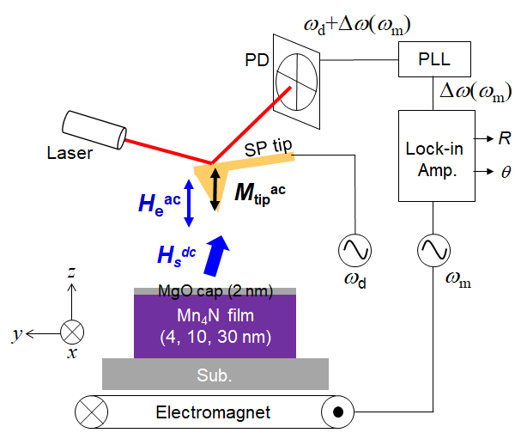

Fig. 1

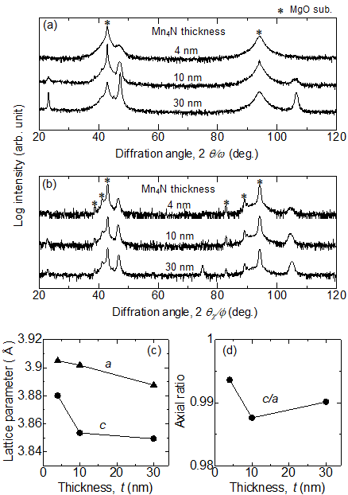

Fig. 2

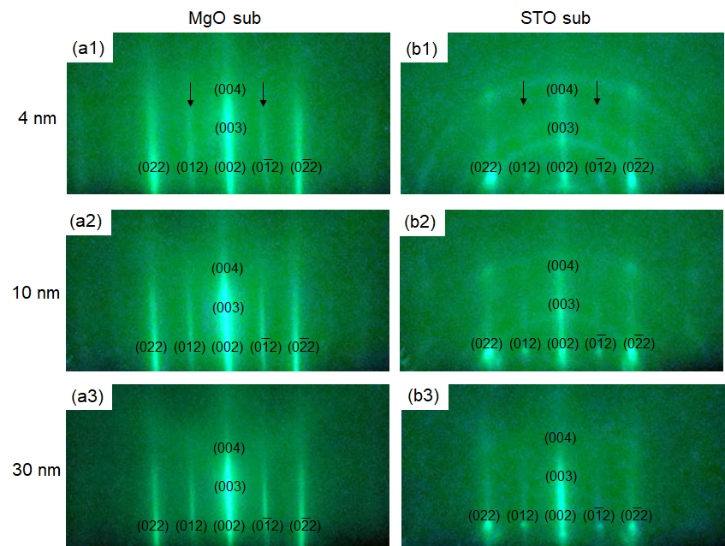

Fig. 3

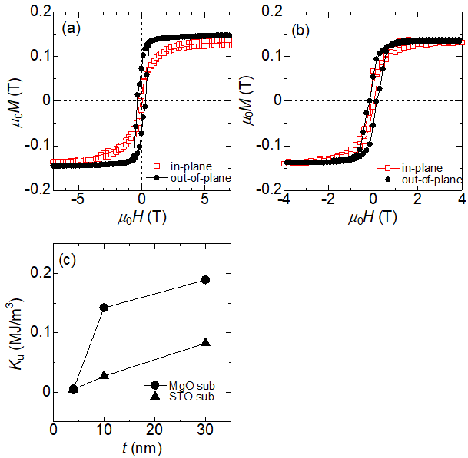

Fig. 4

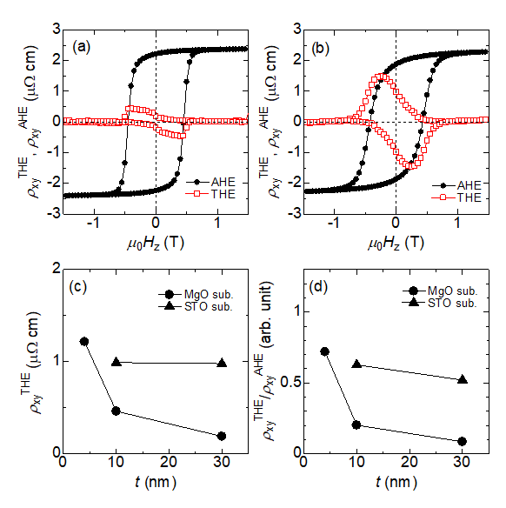

Fig. 5

Fig. 6

