Cross-sectional microstructure observation of YBa₂Cu₃O_{7-δ} multifilament films fabricated on Nb stripes

T. Wadaª, H. Fujimotoª, Y. Kawaharaª, A. Matsumoto^{b}, S. Ooi^{b}, M. Tachiki^{b}, R. Teranishiª

a; Department of Materials, Kyushu University, Fukuoka 819-0395, Japan
b; National Institute for Materials Science, Tsukuba 305-0047, Japan
* Corresponding author: teranishi.ryo.438@m.kyushu-u.ac.jp

Abstract:
A bottom-up approach was employed to achieve multifilamentation aimed at reducing the alternating current (AC) losses of REBa₂Cu₃O_{7-δ} coated conductors. Nb stripes were fabricated on SrTiO₃ substrates, followed by the deposition of YBa₂Cu₃O₇_{-δ} (YBCO) thin films via the metal-organic deposition method. The films were subsequently evaluated and analyzed. Surface observations using scanning electron microscopy revealed a linear dark contrast on the stripes, distinct from the YBCO matrix. Furthermore, selected area electron diffraction patterns and scanning transmission electron microscopy-energy dispersive X-ray spectroscopy analyses confirmed the presence of multiple Y–Cu–O and Cu–O particles in the YBCO phase on a ~4 μm-wide Nb stripe. In addition, the formation of voids and Ba₅Nb₄O₁₅ was observed in the ~4 μm Nb stripe. On a wider Nb stripe (~13 μm), only Y–Cu–O and Cu–O phases and cracks were observed, along with relatively large voids and the formation of Ba₅Nb₄O₁₅. This study provides a fundamental understanding of multifilamented YBCO thin films and offers important insights into reducing AC losses.

Keywords:
YBa₂Cu₃O_{7-δ} superconducting film
Multifilamentation
Film growth
Microstructure
Cross-sectional TEM

Highlights:
- Cross-sectional TEM Nb stripes were patterned on SrTiO₃ substrates by photolithography, achieving multifilamented YBa₂Cu₃O₇₋_{δ} thin films.

- Cross-sectional TEM revealed Nb–BaO reactions causing local compositional deviation and non-superconducting phases.

- Wider Nb stripes promoted a larger non-superconducting phase and exhibited a strong effect on multifilamentation.

1. Introduction
REBa₂Cu₃O₇_{-δ} (REBCO, RE: rare earth element such as Y and Gd) are type-II superconductors with a triple perovskite structure that exhibit high critical current density (Jc) even under high-temperature and high-magnetic-field conditions [1]. Epitaxial growth of REBCO thin films on substrates with closely matched lattice constants promotes the in-plane alignment of the CuO₂ planes, thereby contributing to high Jc [1,2]. Owing to this property, REBCO coated conductors (CCs) are considered promising candidates for applications in both direct current (DC) and alternating current (AC) superconducting wires for coils [3,4]. However, significant AC losses remain a major challenge in AC applications [5−7]. These losses arise from electromagnetic induction caused by changing currents and magnetic fields, which leads to continuous work by Lorentz forces on penetrated magnetic flux, resulting in substantial energy dissipation.
To address this issue, multifilamentation of REBCO thin films has been proposed as it effectively shortens the distance over which the magnetic flux can move [7−9]. The work exerted on the magnetic flux can be reduced by limiting its motion under Lorentz forces, thereby decreasing energy losses in superconducting wires. Currently, multifilamentation is actived by top-down approaches through mechanical and chemical methods such as laser scribing and scratching [10−12]. For example, REBCO films divided into five filaments by laser scribing have been reported to successfully reduce AC losses by one-fifth [10]. However, these techniques require precise post-deposition cutting, which makes the fabrication process highly complex [13,14]. Moreover, reduced Jc due to laser heat, mechanical pressure, and dross formation also poses significant challenges [13−16].
In contrast, bottom-up approaches such as inkjet and two-level undercut-profile methods have been explored to overcome these disadvantages [17−19]. However, the large width of insulating stripes has limited the applicability of these methods [20,21]. To address this, we investigated another bottom-up approach to achieve multifilamentation during REBCO crystallization. In this approach, each filament composed of a narrow, stripe-shaped polycrystalline metal is deposited onto the substrate, followed by deposition of the REBCO layer. Multifilamented REBCO thin films can thus be fabricated because this method selectively induces the formation of non-superconducting phases on the stripes [22−25]. As a result, the distance over which magnetic flux can move under Lorentz forces is reduced, leading to a significant decrease in AC losses. In addition, this method applies multifilamentation to the substrate prior to REBCO film deposition via photolithography, preventing Jc reduction caused by mechanical or thermal effects. It also enables finer filament widths in REBCO-coated conductors compared with both top-down and earlier bottom-up approaches [24]. Transmission electron microscopy (TEM) observations have shown that non-superconducting phases tend to form as randomly oriented YBCO phases on Zr stripes [25,26]. However, for REBCO thin films fabricated using our bottom-up approach, the mechanism by which non-superconducting phases form on the stripes, and the influence of stripe width on the REBCO layer, remains insufficiently understood [23,25].
Therefore, this study aims to investigate the microstructure of non-superconducting phases on the stripes and to clarify how stripe widths affect REBCO thin films during crystallization. This paper is organized into the following sections: Methods, Results, and Discussion (including magneto-optical (MO) imaging, structural analysis by X-ray diffraction (XRD), surface observation by scanning electron microscopy (SEM), and cross-sectional scanning transmission electron microscopy(STEM), and Conclusion.

2. Methods
Two types of YBCO thin films with Nb stripes were prepared. To justify the choice of Nb as the stripe material, we note that Ba–Nb–O reactions have been experimentally reported, suggesting that Nb can promote Ba consumption from the YBCO precursor. In addition, Materials Project data show that Ba–Nb–O compounds possess lower formation Gibbs energies than Ba–Zr–O compounds, indicating stronger reactivity toward BaO [27−34]. Based on these considerations, Nb was selected as the stripe material, as it allows a clearer evaluation of our hypothesis that BaO depletion promotes the formation of non-superconducting phases on the stripes.
Figure 1 shows the diagrams of the photolithographic patterning process [26]. First, a photoresist (OFPR700LB, Tokyo Ohka Kogyo Co., Ltd.) was coated onto a 5 mm × 5 mm SrTiO₃ (STO) (100) substrate. The photoresist layer was then patterned into longitudinal stripes using a maskless lithography system (DL-1000, Nano System Solutions Corporation). After developing the pattern with tetramethyl ammonium hydroxide, the ultraviolet-exposed regions were removed. A thin Nb film was subsequently deposited at room temperature onto the substrate using a DC magnetron sputtering system (CFD-4EP-LL (4G), Shibaura Mechatronics Co., Ltd.). Finally, Nb stripes aligned in the longitudinal direction were obtained by lifting off the remaining photoresist with a solvent. We prepared two kinds of substrates with Nb stripes arranged in patterns A and B as shown in Figure 1. In pattern A, multiple Nb stripes with ~4 μm widths were formed, and these stripes were symmetrically patterned on both sides, with higher density toward the center, to confirm the operability of photolithography. In pattern B, four Nb stripes with ~1–10 μm widths were produced as shown in Figure 1. In pattern A and B, Nb stripe heights were ~0.087 μm heights and ~0.065–0.20 μm heights, respectively. Pattern A was designed to explore the minimum stripe width achievable by photolithography. By systematically reducing the stripe width, we confirmed that the practical fabrication limit was ~1–5 μm. Pattern B was designed to investigate how the spacing between neighboring stripes affects the formation of superconducting and non-superconducting phases, as well as the resulting filamentation behavior of the YBCO layer. The Nb-1 and Nb-10 samples refer to the stripes in pattern B with designed widths of 1 and 10 μm, respectively. The actual stripe widths of the Nb-1 and Nb-10 samples were ~ 4 and 13 μm, respectively. For the Nb-1 sample, the stripe width was confirmed by both SE-SEM images and energy dispersive X-ray spectroscopy (EDS) mapping, while for the Nb-10 sample, SEM-EDS mapping was used to determine the stripe width. The difference between the designed and actual stripe widths is attributed to diffraction-induced pattern broadening during the ultraviolet-exposure and development processes in maskless lithography.
Subsequently, YBCO thin films were fabricated on the patterned substrates using the trifluoroacetic acid metal-organic deposition (TFA-MOD) method. The heat treatment process for crystallizing YBCO films via the TFA-MOD method is illustrated in Figure 2. The MOD precursor solution was prepared by dissolving Y₂O₃ and BaO in trifluoroacetic acid, and CuO in 2-ethylhexanoic acid, followed by mixing the two organic solutions in 1-methoxy-2-propanol to obtain a concentration of 1.1 M. The molar ratio of Y: Ba: Cu was set to 1: 1.5: 3.
During YBCO film formation, the solution was dropped onto the substrate and spin-coated at 3000 rpm for 2 min. The coated substrates were then calcined at 703 K under a pure oxygen atmosphere to form the precursor films. This process was repeated thrice. The calcined samples were crystallized at 1053 K in a 0.1% oxygen/Ar atmosphere, followed by annealing in oxygen at 723 K.
For comparison, a YBCO film was also fabricated on an STO substrate without Nb stripes under the same coating and heat-treatment conditions. The XRD pattern of this reference sample was measured to evaluate the effect of Nb stripes.
MO imaging of YBCO with pattern A was obtained at 10 K under 400 Oe to examine magnetic multifilamentation. Structural and compositional analyses were performed on pattern B. XRD measurements were carried out on the YBCO-deposited surface using a RINT2200HF system (Rigaku, Japan) with a Cu-K_{α} radiation source at 30 kV and 30 mA. Secondary-electron (SE) images were acquired from the deposited surface using an Ultra55 operated at 10–15 kV, equipped with a field emission gun. The working distance for SE imaging was set to 8.5 mm.
Thin-foil specimens for TEM were prepared by a focused ion beam (FIB) lift-out method using a FEI Helios 5 UX dual-beam instrument. Bright-field TEM (BF-TEM) images, selected-area electron diffraction patterns (SAEDp), and STEM observations were obtained using a JEM-ARM200CF (JEOL, Japan) equipped with a cold field emission gun and a spherical aberration corrector (CEOS, Germany) for the electron probe and operated at 80 or 200 kV. High-angle annular dark-field (HAADF) imaging with a collection semi-angle of 52–148 mrad and a convergence semi-angle of 25 mrad was employed to characterize the cross-section of the deposited specimen. EDS was used to acquire the elemental distribution maps of cross-sectional YBCO with Nb stripes using a twin silicon drift detector with a collection solid angle of 2.0 sr (Centurio Large Angle SDD-EDS, JEOL, Japan). The chemical compositions of YBCO and Ba₅Nb₄O₁₅ were quantified from the raw-count EDS maps using the Cliff-Lorimer method.

3. Results and Discussion
3.1 MO image of YBCO with Nb stripes
Figure 3 shows MO imaging of a YBCO thin film with pattern A at 10 K under 400 Oe, where brighter contrast corresponds to higher magnetic flux density. Magnetic flux penetration along the Nb stripes is clearly observed as band-like bright contrasts, with dendritic penetration patterns visible near the Nb stripes. In other words, MO observation confirms the achievement of multifilamentation through the selective suppression of superconductivity on the Nb stripes patterned by photolithography.
The number and spacing of the band-like bright contrasts indicating magnetic flux penetration along the Nb stripes are consistent with those described in section 2 (Methods). In addition, the homogeneous appearance at the four corners of the sample results from trimming before MO observation. During spin-coating with the MOD method, the coating solution tends to accumulate at the substrate corners. If MO observation is performed in this state, height inhomogeneity can occur, reducing image contrast.
In the following sections, we examine the microstructure of YBCO thin films around the Nb stripes of pattern B in greater detail and discuss the factors leading to multifilamentation.

3.2 XRD characterization of a YBCO thin film with Nb stripes
The phases formed in the YBCO thin films without Nb stripes and with pattern B were identified using XRD, as shown in Figures 4 (a) and (b), respectively. The θ–2θ scan in Figures 4 (a) and (b) revealed several peaks corresponding to c-axis-oriented YBCO ((00l) YBCO reflection). In addition, secondary phases such as Y₂Cu₂O₅, CuO, Y₂BaCuO₅, and Ba₂CuO₃ were identified in Figure 4 (a), whereas Y₂Cu₂O₅, CuO, and Ba₂CuO₃ were detected in Figure 4 (b). No peaks attributable to Nb-related secondary phases were observed in Figure 4 (b), likely due to the very small amount or absence of Nb incorporated into the YBCO thin film. The presence of peaks corresponding to Y₂Cu₂O₅ and CuO in both films suggests that some of the MOD precursors were not fully converted into YBCO, as Y₂Cu₂O₅ and CuO are typically produced as intermediate phases prior to YBCO crystallization. The detections of Ba₂CuO₃ indicate that BaO precursors remained, supporting the formation of Ba-related secondary phases in the fabricated YBCO thin film.

3.3 Plan-view SEM characterization of the fabricated YBCO thin films
The surface microstructures of YBCO thin films with pattern B were examined using SEM. Figures 5 (a) and 5 (b) show SE images of Nb stripes with designed widths of 1 and 10 μm (the Nb-1 and Nb-10 samples), respectively.
In Figures 5 (a) and 5(b), band-like dark contrast regions are observed from top to bottom, as indicated by the red arrows. Figure 5 (b) also shows cracks at the position marked by the yellow square, in addition to the dark contrast region. The widths of the dark contrast regions and the crack regions are also summarized in Figure 5.
Figure 6 shows the elemental distribution maps obtained by SEM-EDS from the regions shown in Figure 5. In Figure 6 (a), Ba is depleted, while Y, Cu, and Nb are enriched in the band-like dark contrast. The elemental distribution of Cu exhibits granular features, possibly corresponding to CuO particles. The enrichment of Nb suggests the presence of Nb stripes beneath the band-like dark contrasts, and the depletion of Ba indicates that Ba transports from the YBCO films to the Nb stripes. These chemical components and transport processes likely lead to supersaturated Y within the YBCO films, which may form Y₂Cu₅O₅ particles, consistent with the Y enrichment observed in the EDS analysis.
These EDS results are generally consistent with those observed in the Nb-10 sample shown in Figure 5 (b). Co-enrichment of Nb and Ba was observed at the cracked regions in Figure 6 (b), supporting the transport of Ba from the YBCO films to the Nb stripes. These cracks are considered to result from strain induced by the formation of high-density Cu-O particles.
Also, the Nb elemental maps in Figures 6 (a) and (b) show that the stripe widths of Nb-1 and Nb-10 samples were ~4 and ~13 μm, respectively, although their designed widths were 1 and 10 μm, respectively.
The obtained stripe widths (4 and 13 μm) are significantly narrower than those achieved by conventional methods such as laser scribing (~40 μm) and inkjet printing (~100 μm) [10,20]. This demonstrates the potential of the present approach for forming finer and more uniform superconducting filaments.

3.4 Cross-sectional (S)TEM characterizations of the YBCO thin film with Nb stripes
A cross-sectional analysis of a YBCO thin film with pattern B was performed using STEM to examine the microstructures in more detail. Figures 7 (a) and 7 (b) show cross-sectional HAADF-STEM images near the Nb-1 and Nb-10 samples, respectively. These images indicate the presence of metal stripes and a relatively thinner YBCO film on the stripes compared with the STO substrate, as identified from contrast differences. The width of the stripe in the Nb-1 sample was measured to be 3.78 μm, which is consistent with the dark contrast region observed in the SEM results shown in Figures 5 and 6. These values differ slightly from the nominal patterning widths set during fabrication, as described in section 2 (Methods).
As shown in Figure 7 (b), the YBCO layer terminates at the region outlined by dotted lines, corresponding to the surface cracks observed in the SEM images shown in Figure 5 (b). Examination of the surface morphology of the YBCO layer in Figures 7 (a) and 7 (b) shows that the YBCO surface on the Nb appears relatively rough.
The yellow arrows in Figures 7 (a) and 7 (b) indicate the thicknesses of the areas with and without the Nb stripe on the STO substrate. In Figure 7 (a), the measured thicknesses with and without the stripe are 0.67 and 0.51 μm, respectively. Similarly, in Figure 7 (b), the measured thicknesses are 1.87 and 0.50 μm, respectively.
Multiple particle-like contrasts are observed in the specimen with a 1 μm-wide-Nb stripe (Figure 7 (a)) but are not observed in the specimen with a 10 μm-wide-Nb stripe (Figure 7 (b)). Table 1 summarizes the statistics of the particles observed above the stripes and on the STO substrate in Figure 7 (a). From Table 1, particle diameters on the Nb stripe and on STO near the Nb stripe are 130 and 110 nm, respectively. Similarly, the volume number densities on the Nb stripe and on STO are 3.5×10⁻⁷ and 4.2×10⁻⁷ nm⁻³, assuming the film thickness is 100 nm, and the area fractions on the Nb stripe and on STO are 0.45 and 0.40, respectively. These relatively consistent values indicate that nearly the same amount of Ba in YBCO precursor on the Nb stripe and adjacent STO diffuses into the Nb stripe during crystallization. In addition, the widths of the penetrated magnetic flux in Figure 3 are considered to be heterogeneously distributed due to the presence of non-superconducting phases near the Nb stripes.

3.5 STEM-EDS and TEM-SAEDp
Figure 8 shows elemental distribution maps obtained by STEM-EDS in the blue dotted-line regions marked in Figure 7. Figures 8 (a) and 8 (b) indicate that O and Ba are homogeneously distributed within the Nb stripes. The STEM-EDS results suggest that Ba–Nb–O phases formed in the stripes after crystallization. These phases likely originated from the reaction between BaO (a YBCO precursor) and Nb₂O₅, the most thermodynamically stable oxides of Nb [27−31]. Consequently, the product is presumed to be Ba₅Nb₄O₁₅, which is the most thermodynamically stable compound in the Ba–Nb–O system [27−34]. This formation was confirmed by SAEDp and BF-TEM analyses, obtained from the reference regions marked with red circles in Figure 7, with results shown in Figure 9. Figures 9 (a) and 9 (c) demonstrate the formation of Ba₅Nb₄O₁₅ in the Nb stripes. These findings are consistent with the Nb/Ba atomic ratio of ~0.7–0.9 derived from EDS using the Cliff–Lorimer method (Figure 8). Furthermore, Figures 9 (e) and 9 (f) show the HR-TEM images and FFT patterns obtained from the Nb stripe designed with a width of 2 μm in pattern B. The FFT patterns obtained from the monocrystalline phases were with the zone axis [-1 5 -4] and [2-4-1]. The formation of Ba₅Nb₄O₁₅ proceeded according to the following reactions:
$$2Nb+\frac{5}{2}O_{2}→{Nb}_{2}O_{5}-2052.53 kJ/mol⋯(1)$$
$$5BaO+{2Nb}_{2}O_{5}→{Ba}_{5}{Nb}_{4}O_{15}-746.989 kJ/mol⋯(2)$$
Table 2 presents predicted formation energies of BaO, Nb₂O₅, and Ba₅Nb₄O₁₅ from the Material Project database [27−33]. The negative formation energy of Ba₅Nb₄O₁₅ in reaction (2) (0 K, 0 atm) indicates a thermodynamic driving force for Ba diffusion into the stripes.
Elemental mapping in Figure 8 (a) reveals enrichment of Y–Ba–C–O compounds in the matrix phase on the stripes. In contrast, Figure 8 (b) shows complete Ba deficiency in the stripes, suggesting the formation of Y–Cu–O and Cu–O phases. Elemental distributions of particles on the stripes indicated Ba depletion with enrichment of Y, Cu, and O, consistent with Cu–O and Y–Cu–O phases. These results suggest that during YBCO crystallization, O and Ba diffuse into the stripe materials and react with them, leading to local Ba depletion on the stripes and the formation of non-superconducting Cu–O and Y–Cu–O phases. Additionally, void formation, associated with elemental depletion, was observed in both Nb stripes (red arrows in Figures 8 (a) and 8 (b)). Table 3 lists the molar volumes of BaO, Nb₂O₅, and Ba₅Nb₄O₁₅ along with the corresponding volume expansion ratios. The overall volume shrinkage ratio of the reaction from BaO and Nb₂O₅ to Ba₅Nb₄O₁₅ is ~0.84, suggesting that the voids formed through molar volume reduction during the reaction [27−33].
Furthermore, the observed difference in microstructures between the Nb-1 and Nb-10 samples can be attributed to variations in the driving force for Ba diffusion, which depend on the Nb volume. The primary objective of this study is to fabricate a multi-filamentary structure by intentionally forming non-superconducting phases (Y–Cu–O and Cu–O) on the Nb stripes. As shown in Figures 6, 7, and 8, the Nb-1 sample exhibits a composite microstructure consisting of YBCO and non-superconducting phases on the stripe, whereas the Nb-10 sample contains only non-superconducting phases and cracks on the stripes. This difference indicates that the amount of BaO diffusion into the Nb stripes increases with the Nb volume. In the Nb-10 sample, the larger Nb volume enhances BaO diffusion, leading to the formation of relatively large non-superconducting regions on the stripes. The accompanying volumetric shrinkage during the formation of Cu–O and Y–Cu–O compounds likely generates cracks on the stripes.
In summary, non-superconducting phases (Cu–O and Y–Cu–O) can be generated on stripes using this bottom-up approach. The surface morphology, as well as the number density and size of these non-superconducting particles, depend on the chemical reactions between the stripe material and Ba, as well as stripe width. For more effective multifilamentation in YBCO films, finer and more densely distributed non-superconducting phases are required. Thus, further investigations into stripe materials, widths, and heat-treatment conditions are essential.

4. Conclusion
In this study, the fundamental mechanism of bottom-up multifilamentation in YBCO thin films was investigated by fabricating YBCO with Nb stripes and analyzing their microstructures in detail using electron microscopy. A common observation across both 1 and 10 μm-wide Nb stripes samples was that Ba diffused from the YBCO layer into the stripe regions during crystallization, leading to local Ba deficiency on the stripes. This deficiency promoted the formation of non-superconducting phases such as Y–Cu–O and Cu–O. Multiple voids were observed in the stripes, which were attributed to volume shrinkage of the stripe materials before and after heat treatment. To examine the effect of stripe width, Nb stripes with widths of approximately 4 and 13 μm were investigated. In both cases, Ba diffusion into the stripes was confirmed; however, Y–Cu–O and Cu–O particles were observed in the YBCO matrix on 4 μm-wide Nb stripes, whereas cracks and non-superconducting phases (Y–Cu–O and Cu–O) were observed on the 13 μm-wide Nb stripes, with no YBCO phase detected. These results indicate that increasing stripe width promotes the expansion of the non-superconducting regions on the stripes.
Overall, these findings demonstrate that Ba diffusion into stripe materials during heat treatment disturbs the chemical composition required for YBCO formation, resulting in the generation of non-superconducting phases such as Y–Cu–O and Cu–O on the stripes. This study provides fundamental insights into the bottom-up approach for multifilamentation and offers valuable design guidelines for reducing AC losses and enhancing the performance of REBCO CCs.

Acknowledgement
This work was supported in part by JSPS KAKENHI under Grant 22H02019, in part by the Joint Research Hub Program of the National Institute for Materials Science, Japan, and in part by the Ultra-microscopy Research Center (URC) of Kyushu University, Japan.

References
[1] K. Wang, H. Dong, D. Huang, H. Shang, B. Xie, Q. Zou, L. Zhang, C. Feng, H. Gu, F. Ding, Advances in second-generation high-temperature superconducting tapes and their applications in high-field magnets, Soft Sci. 2 (2022) 12. https://doi.org/10.20517/ss.2022.10.
[2] A.K. Jha, K. Matsumoto, Superconductive REBCO thin films and their nanocomposites: The role of rare-earth oxides in promoting sustainable energy, Front. Phys. 7 (2019) 1–21. https://doi.org/10.3389/fphy.2019.00082.
[3] M. Iwakuma, H. Hayashi, H. Okamoto, A. Tomioka, M. Konno, T. Saito, Y. Iijima, Y. Suzuki, S. Yoshida, Y. Yamada, T. Izumi, Y. Shiohara, Development of REBCO superconducting power transformers in Japan, Phys. C. 469 (2009) 1726–1732. https://doi.org/10.1016/j.physc.2009.05.246.
[4] H.W. Weijers, U.P. Trociewitz, W.D. Markiewicz, J. Jiang, D. Myers, E.E. Hellstrom, A. Xu, J. Jaroszynski, P. Noyes, Y. Viouchkov, D.C. Larbalestier, High field magnets with HTS conductors, IEEE Trans. Appl. Supercond. 20 (2010) 576–582. https://doi.org/10.1109/TASC.2010.2043080.
[5] M.D. Sumption, E.W. Collings, P.N. Barnes, AC loss in striped (filamentary) YBCO coated conductors leading to designs for high frequencies and field-sweep amplitudes, Supercond. Sci. Technol. 18 (2005) 122–134. https://doi.org/10.1088/0953-2048/18/1/020.
[6] R. Oishi, K. Jingami, H. Miyazaki, M. Iwakuma, S. Miura, H. Sasa, K. Yoshida, M. Daibo, S. Fujita, Evaluation of the AC loss characteristics of multifilamentary REBCO tapes by the mechanical scratching of MgO areas, IEEE Trans. Appl. Supercond. 34 (2024) 1–6. https://doi.org/10.1109/TASC.2024.3370097.
[7] F. Grilli, A. Kario, How filaments can reduce AC losses in HTS coated conductors: A review, Supercond. Sci. Technol. 29 (2016) 083002. https://doi.org/10.1088/0953-2048/29/8/083002.
[8] N. Amemiya, S. Kasai, K. Yoda, Z. Jiang, G.A. Levin, P.N. Barnes, C.E. Oberly, AC loss reduction of YBCO coated conductors by multifilamentary structure, Supercond. Sci. Technol. 17 (2004) 1464–1471. https://doi.org/10.1088/0953-2048/17/12/018.
[9] J. Herrmann, K.-H. Müller, N. Savvides, S. Gnanarajan, A. Thorley, A. Katsaros, A. Katsaros, AC losses of YBCO strips on YSZ/Hastelloy substrates, Phys. C. 341–348 (2000) 2493–2494. https://doi.org/10.1016/S0921-4534(00)01284-3.
[10] M. Vojenčiak, A. Kario, B. Ringsdorf, R. Nast, D.C. van der Laan, J. Scheiter, A. Jung, B. Runtsch, F. Gömöry, W. Goldacker, Magnetization ac loss reduction in HTS CORC® cables made of striated coated conductors, Supercond. Sci. Technol. 28 (2015) 104006. https://doi.org/10.1088/0953-2048/28/10/104006.
[11] Y. Zhang, R.C. Duckworth, T.T. Ha, F. A. List, M. J. Gouge, Y. Chen, X. Xiong, V. Selvamanickam, A. Polyanskii, AC Loss Reduction in Filamentized YBCO Coated Conductors With Virtual Transverse Cross-Cuts, IEEE Trans. Appl. Supercond., 21 (2011) 3301–3306.
https://doi.org/10.1109/TASC.2010.2087739.
[12] C. Kurihara, S. Fujita, N. Nakamura, M. Igarashi, Y. Iijima, K. Higashikawa, D. Uetsuhara, T. Kiss, M. Iwakuma, Multi-filamentary REBCO tapes fabricated by scratching a buffer layer along the tape longitudinal direction, Phys. C. 530 (2016) 68–71. https://doi.org/10.1016/j.physc.2016.08.006.
[13] K. Suzuki, J. Matsuda, M. Yoshizumi, T. Izumi, Y. Shiohara, M. Iwakuma, A. Ibi, S. Miyata, Y. Yamada, Development of a laser scribing process of coated conductors for the reduction of AC losses, Supercond. Sci. Technol. 20 (2007) 822–826. https://doi.org/10.1088/0953-2048/20/8/017.
[14] Z. Li, Z. Zhang, S. Wei, P. Gao, Y. Bu, D. Wang, G. Xiao, J. Wan, H. Jin, J. Qin, C. Zhou, Performance study of REBCO multi-filament tapes/CORC cables prepared by reel-to-reel mechanical incision, Cryogenics. 139 (2024) 103799. https://doi.org/10.1016/j.cryogenics.2024.103799.
[15] R. Nast, M. Vojenčiak, E. Demencik, A. Kario, B. Ringsdorf, A. Jung, B. Runtsch, F. Grilli, W. Goldacker, Influence of laser striations on the properties of coated conductors, J. Phys. Conf. Ser. 507 (2014) 022023. https://doi.org/10.1088/1742-6596/507/2/022023.
[16] G.A. Levin, P.N. Barnes, J.W. Kell, N. Amemiya, Z. Jiang, K. Yoda, F. Kimura, Multifilament YBa₂Cu₃O_{6+x}-coated conductors with minimized coupling losses, Appl. Phys. Lett. 89 (2006) 012506. https://doi.org/10.1063/1.2219393.
[17] R.C. Duckworth, F.A. List III, M.P. Paranthaman, M.W. Rupich, W. Zhang, Y.Y. Xie, V. Selvamanickam, Low ac loss geometries in YBCO coated conductors, Phys. C. 463–465 (2007) 755–760. https://doi.org/10.1016/j.physc.2007.03.499.
[18] X. Cai, I. Kesgin, R. Schmidt, Y. Chen, V. Selvamanickam, Completely etch-free fabrication of multifilamentary coated conductor using inkjet printing and electrodeposition, IEEE Trans. Appl. Supercond. 23 (2013) 6603005. https://doi.org/10.1109/TASC.2013.2244638.
[19] A.C. Wulff, J.H. Lundeman, J.B. Hansen, O.V. Mishin, Y. Zhao, R. Mohajeri, J.C. Grivel, A two-level Undercut-profile substrate for chemical-solution-based filamentary coated conductors, IEEE Trans. Appl. Supercond. 26 (2016) 1–4. https://doi.org/10.1109/TASC.2016.2536938.
[20] R.C. Duckworth, M.P. Paranthaman, M.S. Bhuiyan, F.A. List III, M.J. Gouge, AC losses in YBCO coated conductor with inkjet filaments, in: IEEE Trans. Appl. Supercond. 17 (2007) 3159–3162. https://doi.org/10.1109/TASC.2007.897989.
[21] A.C. Wulff, M. Solovyov, F. Gömöry, A.B. Abrahamsen, O.V. Mishin, A. Usoskin, A. Rutt, J.H. Lundeman, K. Thydén, J.B. Hansen, J.C. Grivel, Two level undercut-profile substrate for filamentary YBa₂Cu₃O₇ coated conductors, Supercond. Sci. Technol. 28 (2015) 072001. https://doi.org/10.1088/0953-2048/28/7/072001.
[22] Ľ. Kopera, V. Šmatko, W. Prusseit, M. Polák, R. Semerad, V. Štrbík, J. Šouc, In situ patterning of filamentary YBCO coated conductors, Phys. C. 468 (2008) 2351–2355. https://doi.org/10.1016/j.physc.2008.08.013.
[23] A. Matsumoto, M. Tachiki, S. Ooi, R. Teranishi, M. Inoue, Microstructural study of YBCO thin films with stripe-patterned substrates for ultra-fine multi-filaments, IEEE Trans. Appl. Supercond. 34 (2024) 1–4. https://doi.org/10.1109/TASC.2024.3366159.
[24] S.K.H. Lam, B. Sankrithyan, HTSC devices fabricated by selective epitaxial growth, Supercond. Sci. Technol. 12 (1999) 215–218. https://doi.org/10.1088/0953-2048/12/4/007.
[25] H. Fujimoto, A. Matsumoto, S. Ooi, M. Tachiki, M. Inoue, R. Teranishi, Consideration of magnetic flux distribution in multi−filamented YBa₂Cu₃O_{7−δ} films by controlling crystal array using surface−modified substrate, IEEE Trans. Appl. Supercond. 34 (2024) 1–4. https://doi.org/10.1109/TASC.2024.3362729.
[26] A. Matsumoto, M. Tachiki, S. Ooi, Development of YBCO patterned multi-filamentary film using photolithography method, IEEE Trans. Appl. Supercond. 33 (2023) 1–4. https://doi.org/10.1109/TASC.2023.3244515.
[27] M.K. Horton, P. Huck, R.X. Yang, J.M. Munro, S. Dwaraknath, A.M. Ganose, R.S. Kingsbury, M. Wen, J.X. Shen, T.S. Mathis, A.D. Kaplan, K. Berket, J. Riebesell, J. George, A.S. Rosen, E.W.C. Spotte-Smith, M.J. McDermott, O.A. Cohen, A. Dunn, M.C. Kuner, G.-M. Rignanese, G. Petretto, D. Waroquiers, S.M. Griffin, J.B. Neaton, D.C. Chrzan, M. Asta, G. Hautier, S. Cholia, G. Ceder, S.P. Ong, A. Jain, K.A. Persson, Accelerated data-driven materials science with the Materials Project, Nat. Mater. 24, July (2025) 1522–1532. https://doi.org/10.1038/s41563-025-02272-0.
[28] A. Jain, S.P. Ong, G. Hautier, W. Chen, W.D. Richards, S. Dacek, S. Cholia, D. Gunter, D. Skinner, G. Ceder, K.A. Persson, Commentary: The Materials Project: A materials genome approach to accelerating materials innovation, APL Mater. 1 (2013) 011002. https://doi.org/10.1063/1.4812323.
[29] A. Jain, G. Hautier, S.P. Ong, C.J. Moore, C.C. Fischer, K.A. Persson, G. Ceder, Formation enthalpies by mixing GGA and GGA + U calculations, Phys. Rev. B. 84 (2011) 045115. https://doi.org/10.1103/PhysRevB.84.045115.
[30] A. Wang, R. Kingsbury, M. McDermott, M. Horton, A. Jain, S.P. Ong, S. Dwaraknath, K.A. Persson, A framework for quantifying uncertainty in DFT energy corrections, Sci. Rep. 11 (2021) 15496. https://doi.org/10.1038/s41598-021-94550-5.
[31] Materials data on Nb₂O₅ by materials project. United States: N. p, 2020 (accessed 18 August 2025). https://doi.org/10.17188/1269138.
[32] Materials data on BaO by materials project. United States: N. p, 2020 (accessed 18 August 2025). https://doi.org/10.17188/1189576.
[33] Materials data on Ba₅Nb₄O₁₅ by materials project. United States: N. p, 2020 (accessed 18 August 2025). https://doi.org/10.17188/1207019.
[34] R.S. Roth, J.L. Waring, Phase equilibrium relations in the binary system barium oxide-niobium pentoxide, J. Res. Natl Bur. Stand. A Phys. Chem. 65A (1961) 337–344. https://doi.org/10.6028/jres.065A.036.

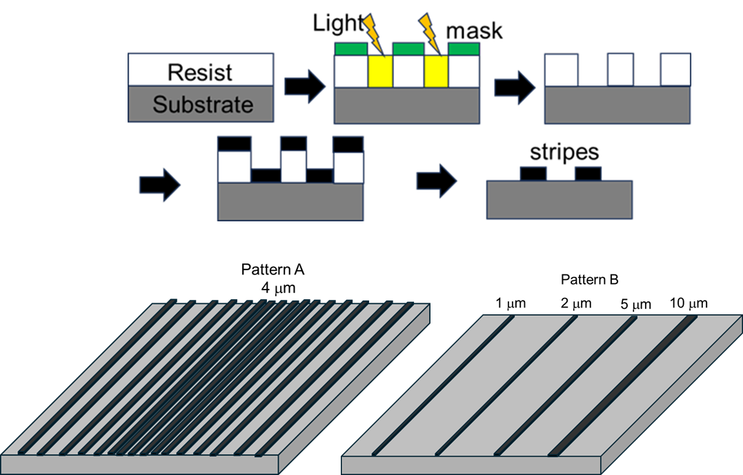
Figure 1. Photolithography process used to prepare an SrTiO₃ substrate with Nb stripes
and Nb stripes arrangement of pattern A and pattern B.

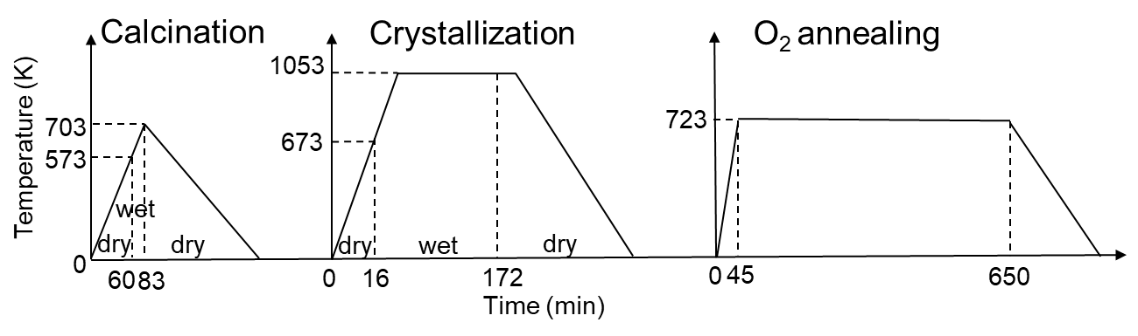
Figure 2. Thermal history of YBCO film growth.
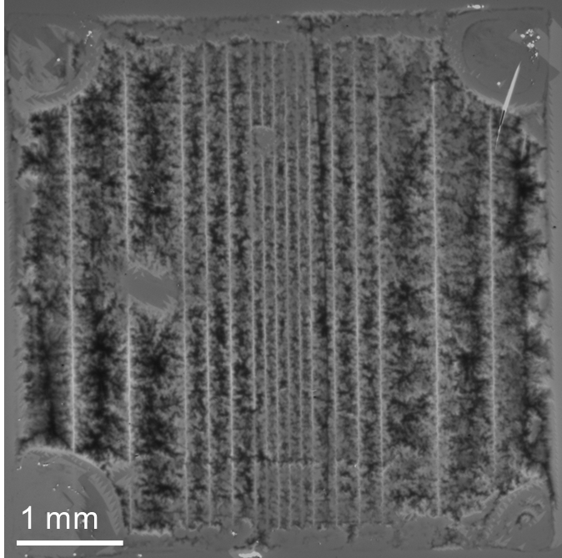
Figure 3. MO image of a YBCO with pattern A at 10 K under 400 Oe.
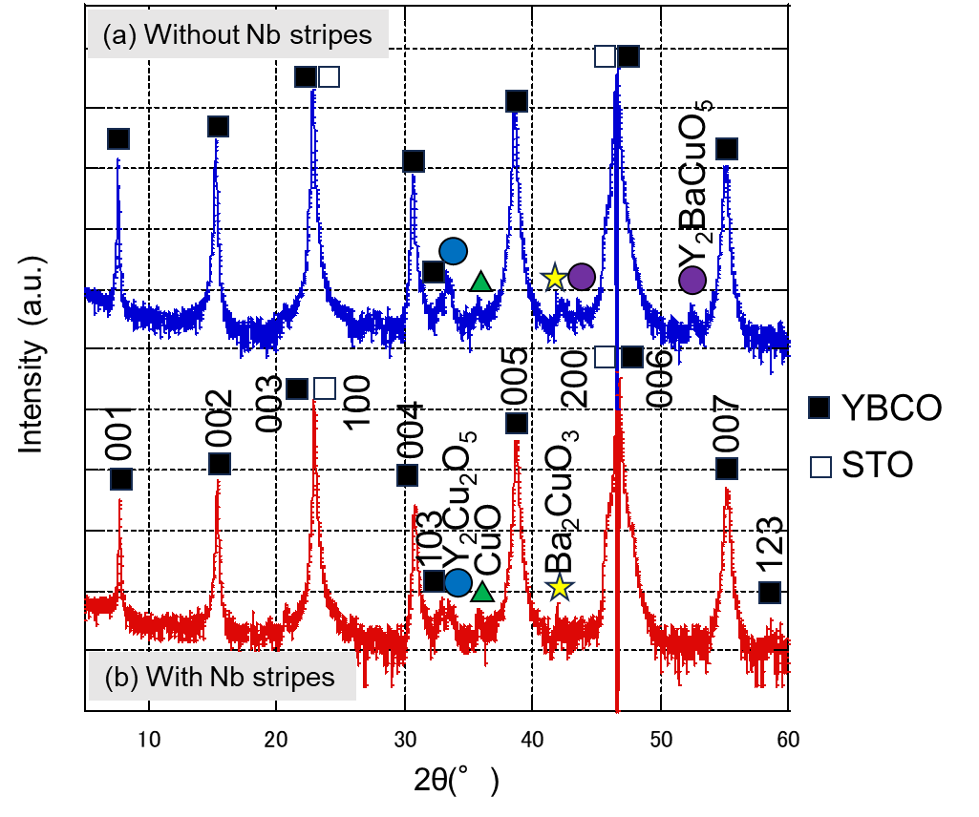
Figure 4. XRD θ–2θ scan of a YBCO thin film (a) without and (b) with Nb stripes (pattern B).

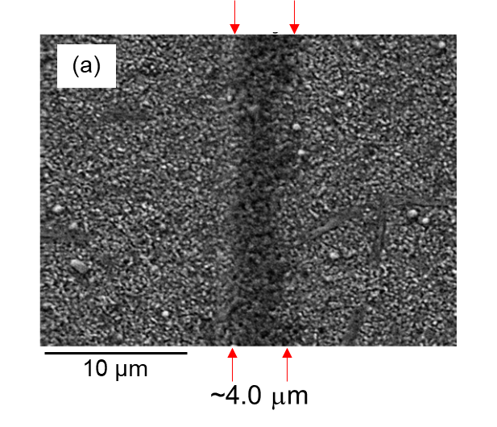

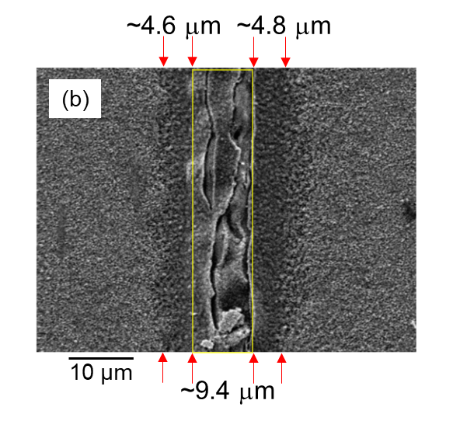
Figure 5. SEM-secondary electron (SE) images of a YBCO thin film with pattern B:
(a) Nb-1 sample; (b) Nb-10 sample.
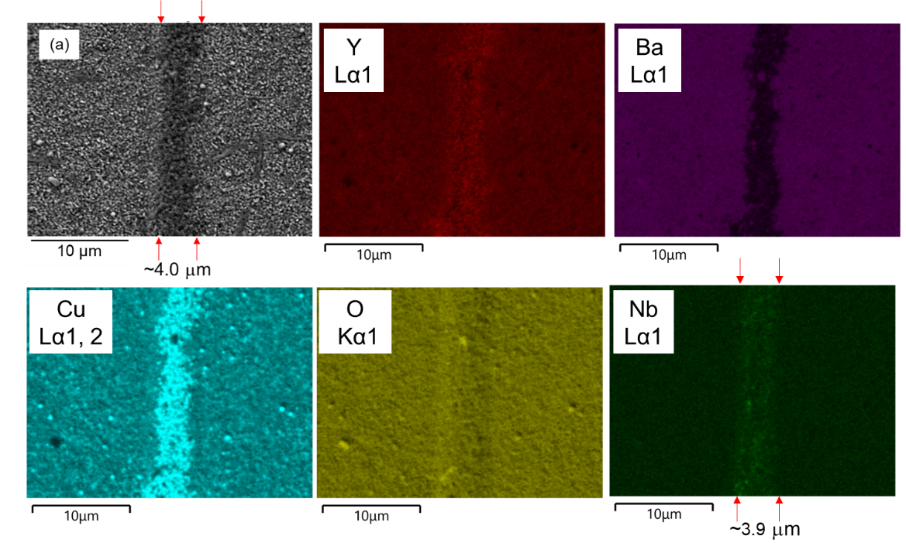
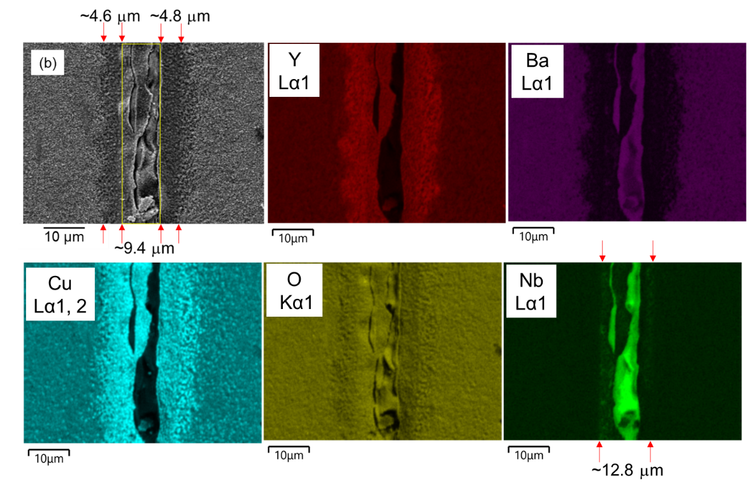
Figure 6. SEM-EDS elemental maps corresponding to the regions shown in Figure 5:
(a) Nb-1 sample; (b) Nb-10 sample.

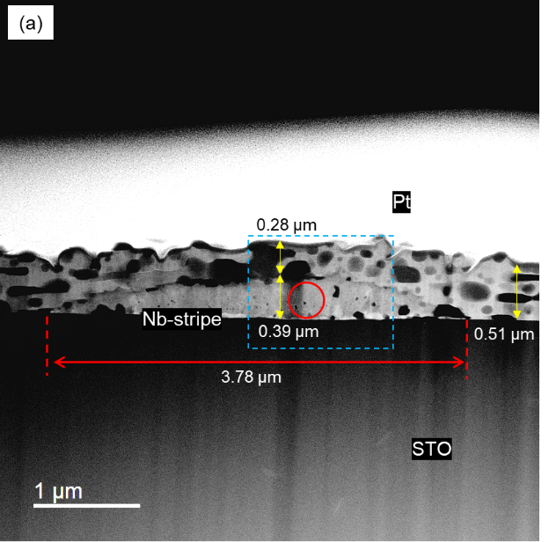
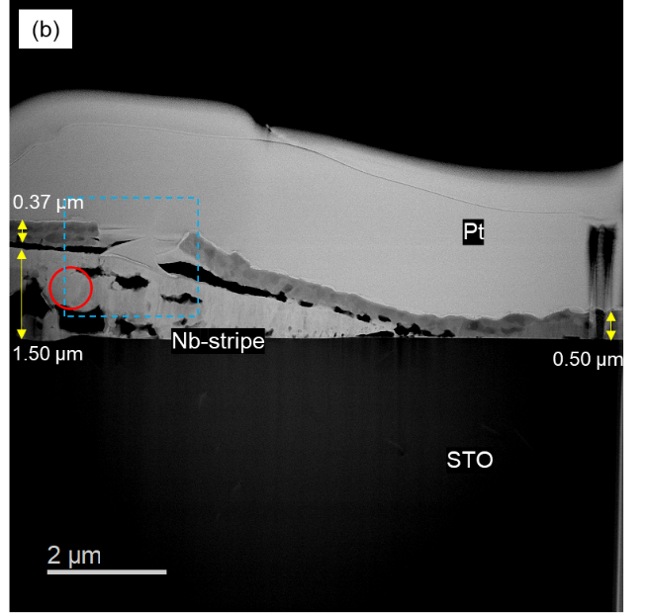

Figure 7. HAADF-STEM images of a YBCO thin film with pattern B:
(a) Nb-1 sample; (b) Nb-10 sample.
.
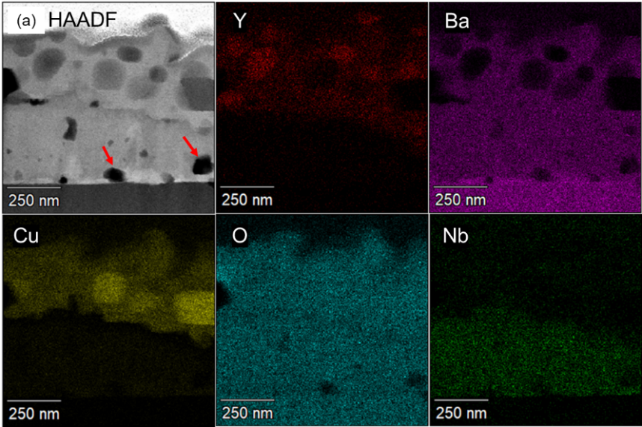
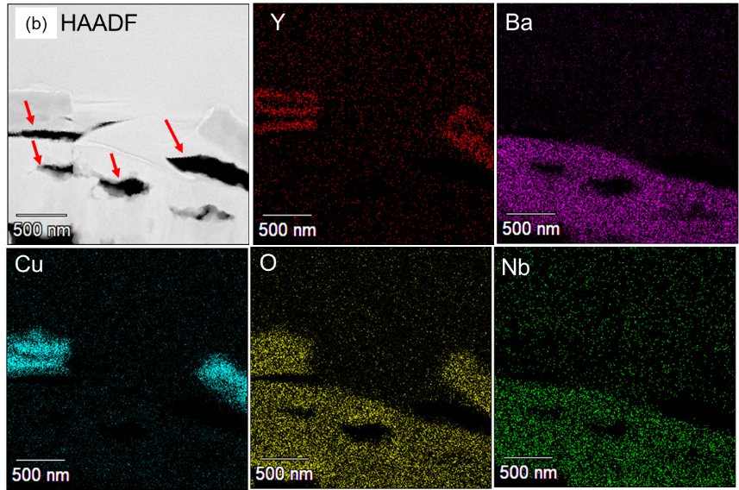

Figures 8. STEM-EDS elemental maps acquired from the blue box regions in Figure 7:
(a) Nb-1 sample; (b) Nb-10 sample.
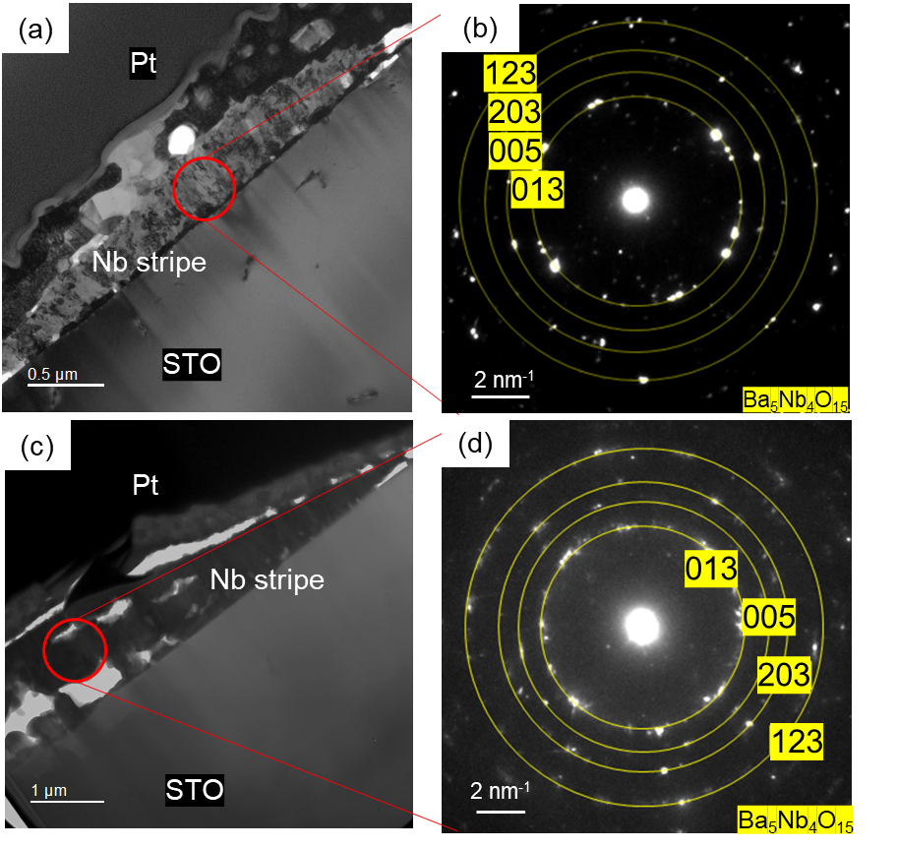
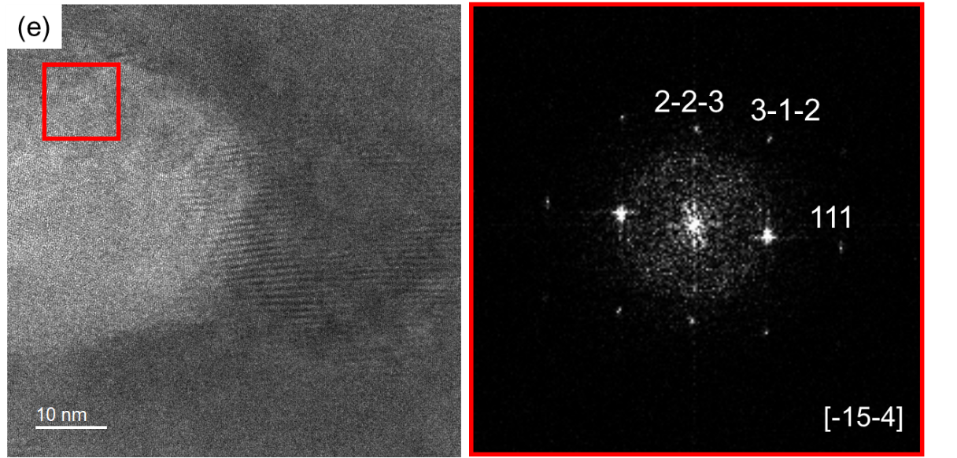
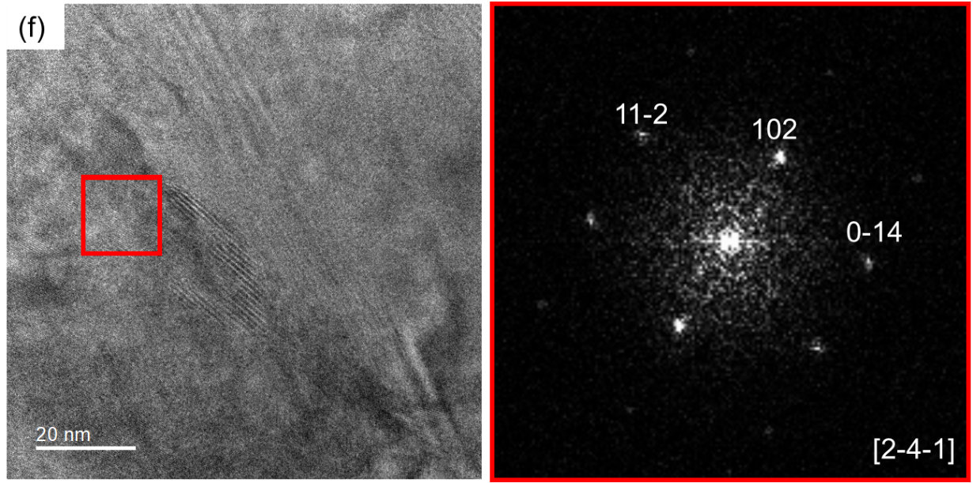
Figure 9. BF-TEM images and SAEDp
acquired from the red-circled regions in Figure 7:
(a, b) Nb-1 sample; (c, d) Nb-10 sample; (e, f) HR-TEM images and FFT patterns of Nb stripe designed with 2 μm widths in pattern B with the zone axis [-1 5 -4] and [2-4-1], respectively.

Table 1. Characteristics of particles in the YBCO layer on Nb stripes and on STO near Nb stripes, obtained from Figure 7. The thin-foil specimens (~100 nm) were prepared for TEM observation.
 | Nb | STO
Number of particles (-) | 23 | 36
Short diameter (nm) | 100 | 88
Long diameter (nm) | 150 | 130
Diameter (nm) | 130 ± 69 | 110 ± 49
Particle size (nm²) | 1.3×10⁴ | 9.5×10³
Volume number density (particles/nm³) | 3.5×10⁻⁷ | 4.2×10⁻⁷
Horizontal length of  a reference area (nm) | 2.6×10³ | 1.7×10³
Vertical length of  a reference area (nm) | 250 | 500
Reference area (nm²) | 6.5×10⁵ | 8.5×10⁵
Area fraction (-) | 0.45 | 0.40

Table 2. Predicted formation energies of selected materials at 0 K and 0 atm, obtained from the Material Project database [27−33].
 | Predicted formation energy (kJ/mol)
BaO | -544.949
Nb₂O₅ | -2052.53
Ba₅Nb₄O₁₅ | -7576.80

Table 3. Molar volumes of selected materials and volume expansion ratio of Nb stripes during the transformation from Nb₂O₅ to Ba₅Nb₄O₁₅ [27−33].
 | Molar volume(cm³/mol) | Volume expansion rate (-)
Ba₅Nb₄O₁₅/Nb₂O₅, BaO | 217.1/62.64, 26.65 | 0.84

Supplementary
This supplementary document provides additional explanations regarding verifying repeatability in this study, along with additional experiments Ba diffusion timing and I-V measurement across the Nb stripes.

1.Repeatability check
Figure S1 shows wide-area SEM-EDS elemental maps of (a) the Nb-1 sample and (b) Nb-10 sample. These maps confirm the repeatability of the characteristic microstructures across each sample. In the Nb-1 sample, Cu–O regions interpreted as Cu–O particles are consistently observed on the Nb stripes over the entire region. For Nb-10, continuous non-superconducting phases and cracks covering the stripes are uniformly detected, demonstrating that these features are not limited to localized areas but represent the overall microstructure of each sample.

2. Ba diffusion timing
To investigate the Ba diffusion timing, the heat treatment completion time was varied during sample preparation. Figure S2. shows the heat treatment conditions of (a) Calcination (b) 10 min crystallization (c) 40 min crystallization. ((b) and (c) were quenched.) In addition, Figure S3. Shows Cross-sectional STEM-EDS elemental maps of (a) Calcination (b) 10 min crystallization (c) 40 min crystallization. In Figure S3 (a), Ba does not diffuse into Nb stripe after calcination, but it was found that Nb was oxidized, indicating that the driving force is insufficient for formation as a Ba–Nb–O compounds at this temperature. In Figure S3 (b), Ba has diffused into the Nb stripes, forming Ba–Nb–O compounds, however, a region where Ba has partially failed to diffuse was observed at the center of the stripe. In addition, Cu-O and Y-Cu-O regions were formed on the stripe and YBCO layer had not yet been crystallized in Figure S3 (b). Furthermore, Ba had completely diffused within the stripe in Figure S3 (c) and YBCO layer was partially crystallized. These findings clarify that Ba can diffuse into Nb stripes before YBCO layer is crystallized, forming non-superconducting regions.
The stripe widths used in this additional experiment were (a) 4.7 μm, (b) 6.3 μm, and (c) 6.5 μm, respectively, and these values were measured by SEM.
3. I-V measurement across the Nb stripes
Figure S4 shows the schematic and the result of the four-terminal I–V measurement performed across the Nb stripe at self-field and 77.3 K. The obtained I–V curve exhibits a linear relationship with a measured resistance of 1.92 × 10⁻³ Ω. Using the film thickness (1.0 × 10⁻⁶ m), stripe width (2.5 × 10⁻³ m), and terminal spacing (1.96 × 10⁻² m), the specific resistivity was calculated to be 0.25 μΩ·cm. This value is close to the theoretical resistivity of Ag (~0.3 μΩ·cm), indicating that the current flows primarily through the Ag layer rather than the YBCO film. This behavior suggests that the non-superconducting phases formed on the stripe, such as Y–Cu–O and Cu–O, act effectively as insulating layers and prevent current from passing through the YBCO layer.

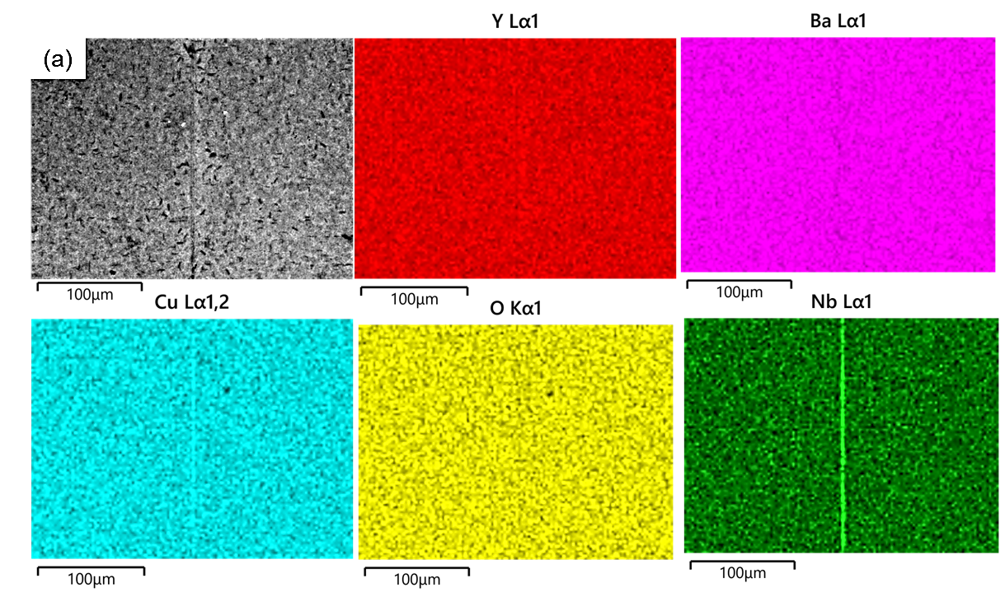
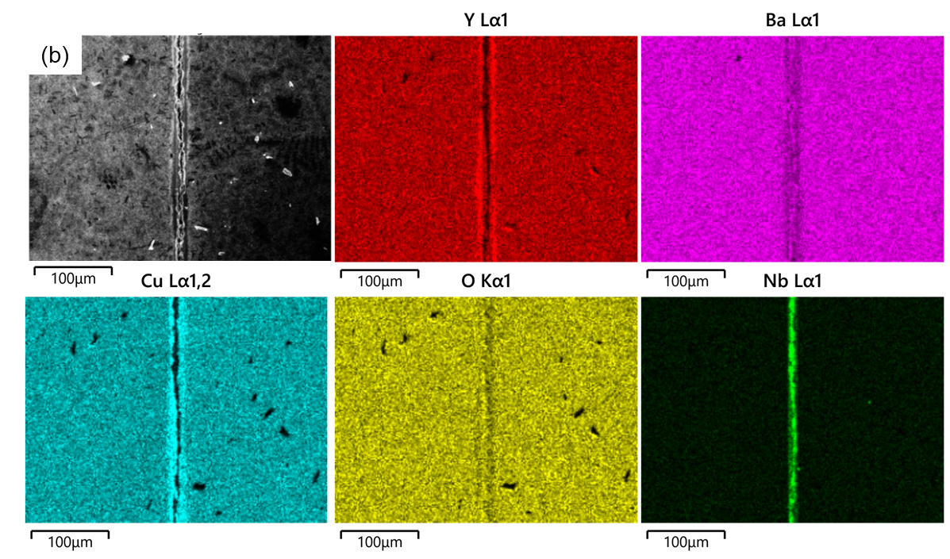
Figure S1. SEM-EDS elemental maps (low magnification):
(a) Nb-1 sample and (b) Nb-10 sample.

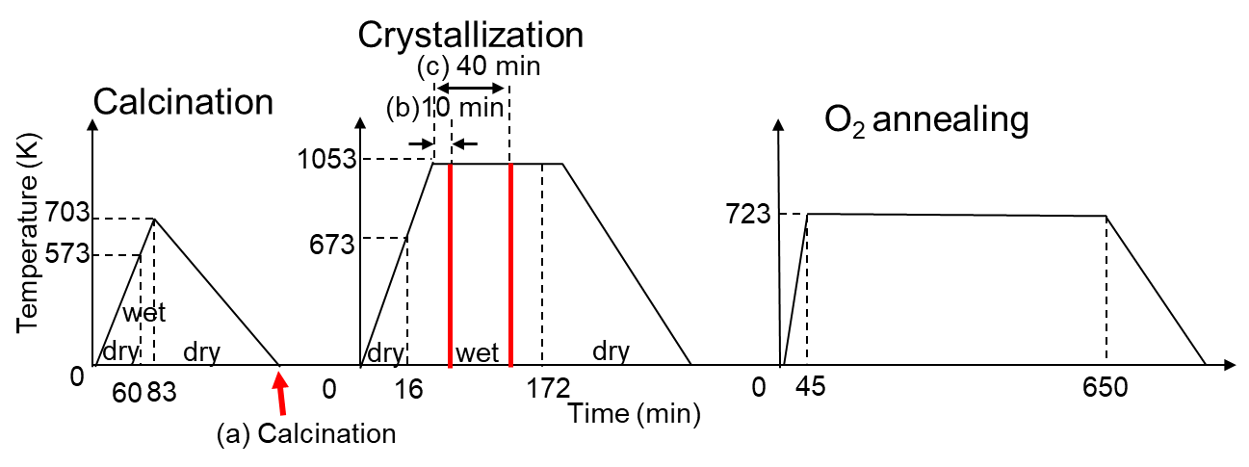
Figure S2. Heat-treatment conditions:
- Calcination, (b) 10 min crystallization, and (c) 40 min crystallization.

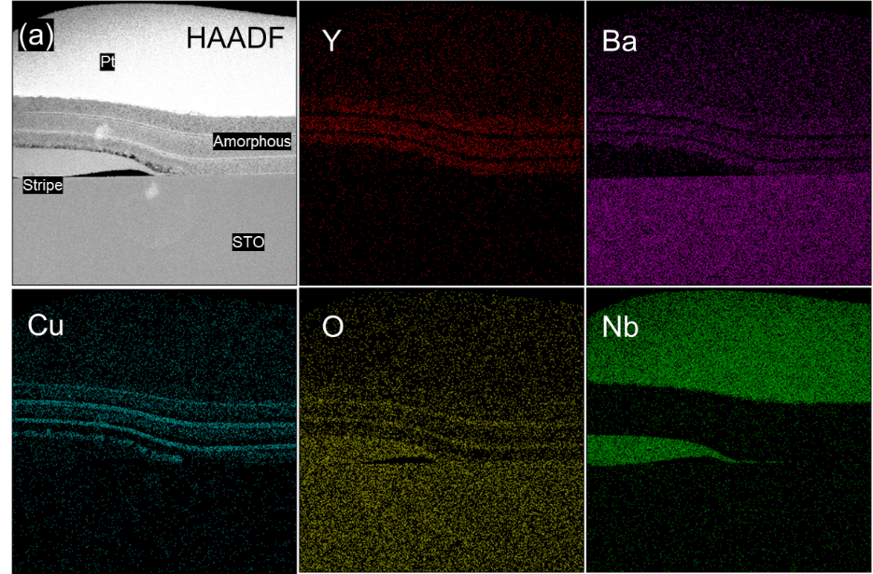
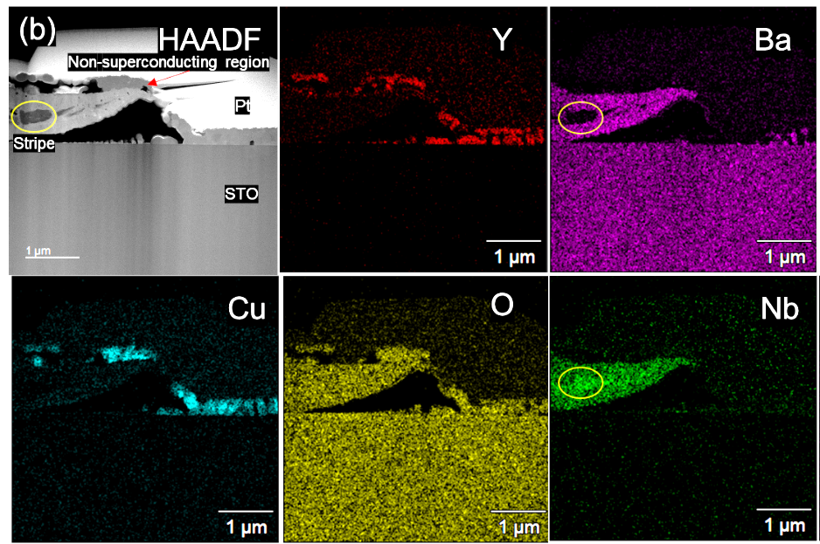
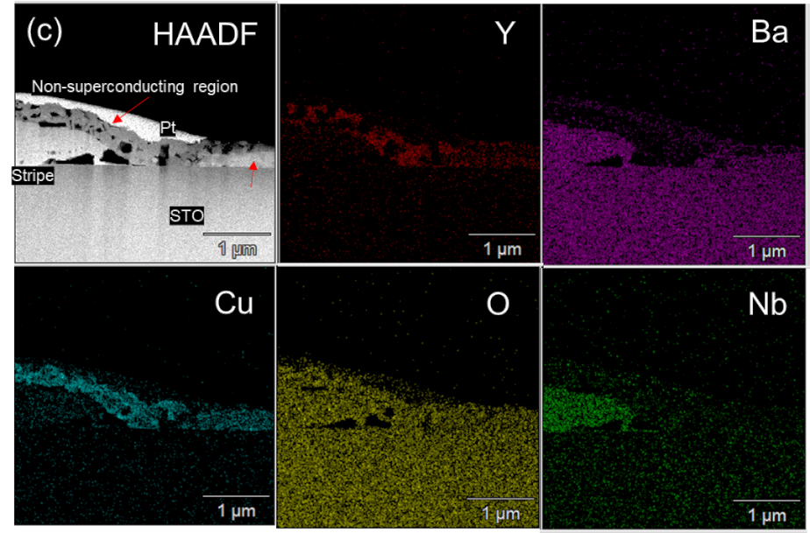
Figure S3. Cross-sectional STEM-EDS elemental maps:
- Calcination, (b) 10 min crystallization, and (c) 40 min crystallization.

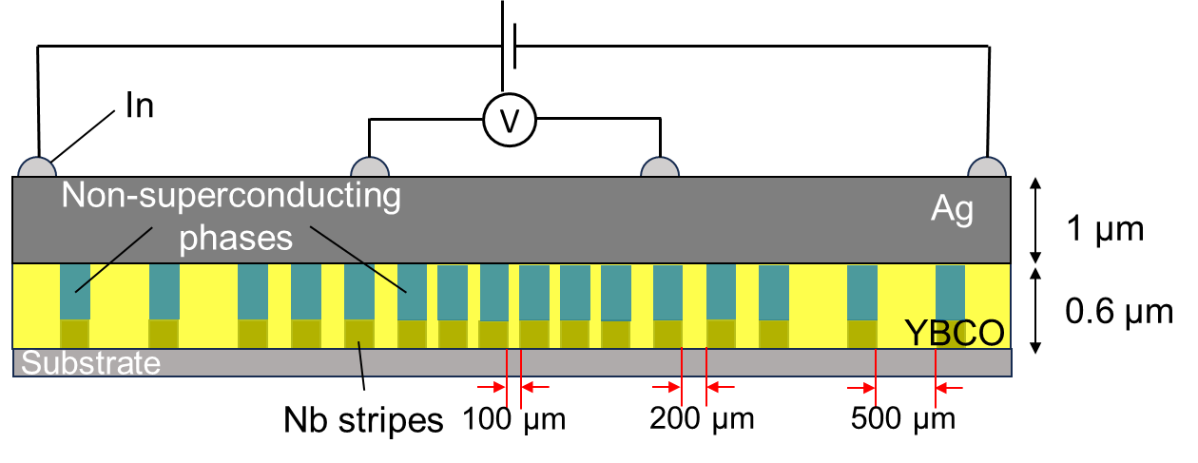
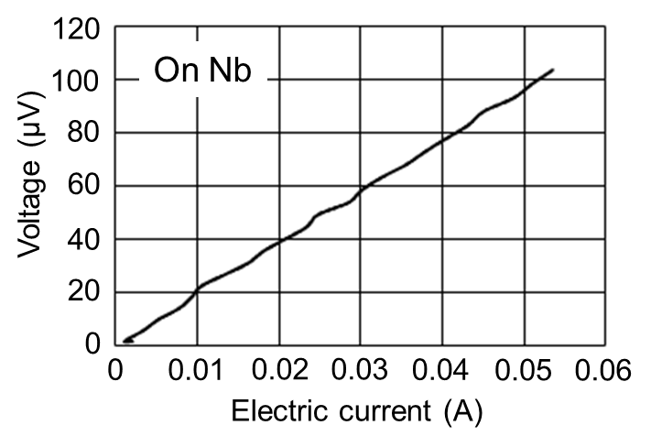
Figure S4. The schematic diagram and result of I-V measurement across the Nb stripe region by the four-terminal method at self- field and 77.3 K.

